Phylogeny of the asexual lineage Murrayidae (Macrobiotoidea, Eutardigrada) with the description of Paramurrayon gen. nov. and Paramurrayon meieri sp. nov.

Roberto Guidetti^{1,2}, Ilaria Giovannini¹, Valeria Del Papa¹, Torbjørn Ekrem³, Diane R. Nelson⁴, Lorena Rebecchi^{1,2}, Michele Cesari^{1,2}

¹Department of Life Sciences, University of Modena and Reggio Emilia, 41125, Modena, Italy.
² NBFC, National Biodiversity Future Center, Palermo 90133, Italy.
³Department of Natural History, NTNU University Museum, Norwegian University of Science and Technology, NO-7491, Trondheim, Norway.
⁴Department of Biological Sciences, East Tennessee State University, Johnson City, Tennessee, USA.

Corresponding author: Ilaria Giovannini, ilaria.giovannini@unimore.it, Department of Life Sciences, University of Modena and Reggio Emilia,via Campi 213/D, 4125, Modena, Italy

Running title: Phylogeny of the asexual lineage Murrayidae

Abstract.
The peculiar family Murrayidae (Murrayon, Dactylobiotus, Macroversum) contains relatively rare species living in hydrophilic and freshwater habitats on all continents and contains two of the six exclusively freshwater tardigrade genera. This family probably represents an example of the evolution and persistence of an asexual lineage that differentiated into several taxa without sexual reproduction. Analyses of nuclear and mitochondrial genes (18S, 28S, ITS2, cox1) and the increase of five taxa to the phylogenetic analyses of Murrayidae led us to infer that Murrayon is polyphyletic, being composed of two “species groups” that also find morphological supports: the “dianeae group” characterized by peculiar egg processes (rod-shaped and covered with a cuticular layer), animals with large, evident epicuticular pillars and small claws; the “pullari group” characterized by conical egg processes, animals with very small epicuticular pillars and proportionally larger and longer claws. This latter group is a sister group to Dactylobiotus. Within the genus only Murrayon hastatus has an uncertain position with eggs of “dianeae group” and animals of “pullari group”. We propose the erection of Paramurrayon gen. nov. (for the “dianeae group” of species), the emendation of Murrayon, and new taxonomic keys for both genera. Possible scenarios of the evolution of the taxa within Murrayidae are hypothesised based on synapomorphic characters. Paramurrayon meieri sp. nov. from Norway is described with an integrative approach. Photographs of type material of Murrayon stellatus, Murrayon nocentiniae, Murrayon ovoglabellus and Macroversum mirum are shown for the first time, together with descriptions of new characters. Murrayon hibernicus is considered as nomen dubium, and Murrayon hyperoncus is transferred to Macrobiotus pending further analyses.

Key words: molecular phylogeny, species delimitation, asexual lineages, synapomorphy, Macroversum, Dactylobiotus, parthenogenesis

Short summary
The Murrayidae (Murrayon, Dactylobiotus, Macroversum) contains hydrophilic and freshwater species and probably represents an example of the evolution of an asexual lineage. Thanks to the integrative description of a new Norwegian species (Paramurrayon meieri sp. nov.), we were able to perform multigene phylogenetic analyses of the family identifying a new evolutionary line. This led to the erection of Paramurrayon gen. nov. and to develop possible scenarios of the evolution of the taxa within Murrayidae based on synapomorphic characters. New original pictures of several species of Murrayon together with descriptions of new characters allowed a better definition of the species.

Introduction
The family Murrayidae (Macrobiotoidea, Eutardigrada) contains relatively rare species living in terrestrial hydrophilic and freshwater habitats (e.g. mosses, liverworts, leaf-litter, lakes, streams) in all continents (Kaczmarek et al. 2014, 2015, 2016; McInnes et al. 2017; Nelson et al. 2020). The family comprises three genera: the limnic Dactylobiotus with 14 species, the limnic and monospecific Macroversum, and the limnic/hydrophilic Murrayon with eight species (Degma and Guidetti 2022). Dactylobiotus and Macroversum, two of the six exclusively freshwater genera in Tardigrada, are both in Murrayidae (the others, Carphania, Thulinius, Pseudobiotus and Grevenius, belong to other families).
Murrayidae is an evolutionarily interesting taxon. So far, no males have been found and parthenogenesis is confirmed for several species. Thus, the family likely represents an asexual lineage that has differentiated into at least three genera and 20 species without sexual reproduction (Guidetti et al. 2000, 2005; Altiero et al. 2018), populating both freshwater and hydrophilic habitats all around the world. The apparent adaptation and preference for limnic habitats, with the reduced danger of dehydration, probably is the cause for the limited anhydrobiotic capabilities of the species in this family tested so far (Guidetti et al. 2011; Bertolani et al. 2019).
The taxon Murrayinae was erected as subfamily by Guidetti et al. (2000) based on the presence of epicuticular pillar-like structures and the two branches of the double claws diverging immediately after a short basal portion. Within tardigrades, this taxon was one of the first to be investigated using molecular analyses and was raised to family level based on phylogenetic evidence by Guidetti et al. (2005), who described Murrayidae using an integrative approach. Murrayidae was included in the superfamily Macrobiotoidea by Marley et al. (2011) based on phylogenetic analyses using 18S rRNA sequence data and morphological characteristics.
Although Murrayon pullari (Murray, 1907) was the first tardigrade species from which the cox1 sequence was obtained (Guidetti et al. 2005), only a few species of Murrayidae have been analysed with molecular techniques (Guidetti et el. 2005; Sands et al. 2008; Guil and Giribet 2012; Bertolani et al. 2014; Guil et al. 2019; Kihm et al. 2020; Pogwizd and Stec 2020; Stec et al. 2020). Previous studies have shown that Murrayidae contains two main phylogenetic lineages (Bertolani et al. 2014; Stec et al. 2020): one group containing the Dactylobiotus species and M. pullari; the other containing Murrayon dianeae (Kristensen, 1982) as a sister taxon (no molecular data are available for Macroversum). Thus, a monophyletic Dactylobiotus apparently was included in a paraphyletic Murrayon, although the number of taxa used in the analyses was insufficient to produce conclusive results. Morphological cladistic analyses identified a close relationship between Murrayon and Dactylobiotus, but failed to group Macroversum with these two genera, probably due to homoplastic characters (Guil et al. 2013).
For a better understanding of the evolution of the family Murrayidae, we present the discovery of a new species from Norway initially placed in the genus Murrayon. Careful observations and comparison of type material of species in Murrayidae led us to perform molecular phylogenetic analyses of the family. Based on the results and the morphological characteristics of the analysed species, we propose the erection of a new species and a new genus to ensure monophyletic genera in Murrayidae.

Material and Methods
Specimen extraction, slide mounting and morphological identification
Several specimens of different species ascribable to Murrayon and Dactylobiotus were extracted from samples collected in Norway, Italy, Scotland and the USA (Tab. 1). To extract tardigrades from their substrates, fragments of the moss sample were placed in distilled water for about half an hour. After soaking, the samples were sieved (sieve meshes: 500 μm and 38 μm) to separate tardigrades and eggs from the substrate. Animals and eggs were then isolated using a needle and removed with a glass pipette under a stereomicroscope. Specimens were used for molecular analyses or mounted on slides in Hoyer’s fluid for observation and measurements, both carried out under phase contrast [PhC] and differential interference contrast [DIC] with a Leica DM RB microscope equipped with a Nikon DS-Fi 1 or an AmScope MU1803 digital camera, at the Department of Life Sciences, University of Modena and Reggio Emilia (UNIMORE). Morphometric data of animals were recorded according to Kaczmarek and Michalczyk (2017) and handled using the ‘Parachela’ ver. 1.6 template available from the Tardigrada Register (Michalczyk and Kaczmarek 2013), updated with Thorpe’s normalization of the data (as in Massa et al. 2021) according to Bartels et al. (2011).
For comparative purpose, the type material of the following species was observed: paratypes of Murrayon nocentiniae (Ramazzotti, 1961) (slide CT6084 with an animal) and Murrayon ovoglabellus (Biserov, 1988) (slide CT14659 with an animal and three eggs) from the Maucci collection (Natural History Museum, Verona, Italy); paratypes of M. nocentiniae (slide Tipo115 with an animal and two eggs) from the Ramazzotti collection (Natural History Museum, Verona, Italy); paratypes of M. ovoglabellus (slide 968-12 with four eggs) and Murrayon stellatus Guidetti, 1998 (slide 5N08B-s28 with an egg) from the Bertolani collection (Department of Life Sciences, UNIMORE, Modena, Italy); the holotype of Macroversum mirum Pilato & Catanzaro, 1988 (slide 4084 with an animal) from the Binda and Pilato collection (Department of Biological, Geological and Environmental Sciences "Marcello La Greca", University of Catania, Catania, Italy). Other specimens, not belonging to the type series, were investigated: Murrayon hibernicus (Murray, 1911), slide CT9840 from Steinkjer, Norway (Maucci collection); Murrayon hastatus (Murray, 1907) slide C1178 from Trento, Italy (animal + egg), M. dianeae slides C881, C991 from Modena, Italy (animals), M. pullari slide C2573 from Trento, Italy (animal + egg), slide C2605 from Alpine Stelvio pass, Italy (egg) (Bertolani collection); M. pullari slide Tipo143 from Lake Tanganyika, Ruwenzori Mt., Africa (Ramazzotti collection).

DNA extraction, PCR and sequencing
Prior to molecular analysis, individuals were observed and identified with LM using the method described in Cesari et al. (2011) to obtain photo voucher specimens. Genomic DNA was extracted from 13 animals of 5 species (Tab. 2). The extractions were performed using the kit QuickExtract™ DNA Extraction Solution (Lucigen, WI, USA), following the manufacturer’s protocol. Molecular investigations were carried out using fragments of three nuclear genes (18S, 28S, ITS2) and a mitochondrial gene (cox1). The 18S gene was amplified using the primers SSU_F04 (5’-GCTTGTCTCAAAGATTAAGCC-3’) and SSU_R26 (5’-CATTCTTGGCAAATGCTTTCG-3’), with PCR protocols described in Bertolani et al. (2014). The 28S gene using primers 28S 4.8aF (5'-ACC TAT TCT CAA ACT TTA AAT GG-3') and 28S 7bR (5'-GAC TTC CCT TAC CTA CAT-3'), with PCR protocols described in Guidetti et al. (2014). The ITS2 gene was amplified utilizing primers ITS3 (5'-GCA TCG ATG AAG AAC GCA G-3) and ITS4 (5'-AGT TTY TTT TCC TCC GCT TA-3'), with PCR protocols described in Wełnicz et al. (2011). The cox1 gene was amplified using primers LCO 1490 (5’-GGTCAACAAATCATAAAGATATTGG-3’) and HCO 2198 (5’-TAAACTTCAGGGTGACCAAAAAATCA-3’), [Folmer et al., (1994)] and PCR protocols described in Cesari et al. (2009). The amplified products were gel purified using the Wizard Gel and PCR cleaning kit (Promega, Madison, WI, USA). Sequencing reactions were performed using the ABI Prism BigDye Terminator v. 1.1 Sequencing Kit (Applied Biosystems™) on purified amplicons Each sequencing reaction contained 0.2 μM of a single PCR primer to initiate the sequencing reaction, 2 μL of BigDye, 70 ng of purified products, 4 μL of 5x BigDye Terminator v.1.1 Sequencing Buffer and H₂O for a final volume of 20 μL. Cycling conditions for sequencing reactions consisted of 25 cycles of 96 °C for 10 s, 50 °C for 5 s and 60 °C for 4 min. Both strands were sequenced using ABI Prism 3100 (Applied Biosystems™). GenBank Accession numbers of the nucleotide sequences of the newly analysed specimens are: for cox1 OP379716-28 (13 sequences); for ITS2 OP390258-68 (11 sequences); for 18S OP380708-18 (11 sequences); for 28S OP380720-33 (14 sequences) (for more delails see Supplementary material Tab. S1).

Phylogenetic and species delimitation analyses
For phylogenetic analyses, the more conservative genes 18S and 28S were used, while for species identification and delimitation analyses the more variable cox1 and ITS2 genes were used. The 18S and 28S nucleotide sequences were aligned with the MAFFT algorithm (Katoh et al. 2002) as implemented in the MAFFT online service (Katoh et al. 2019) and checked by visual inspection. Sequences of the total genome of Ramazzottius varieornatus Bertolani & Kinchin, 1993 (Eutardigrada, Parachela, Hypsibioidea; GenBank A.N.: BDGG01000030 for both genes) were used as outgroup. Other tardigrade sequences from GenBank of Macrobiotoidea were also included in the analysis for comparisons (Table S1 Supporting information). A Bayesian inference (BI) dendrogram was computed with the program MrBayes (Ronquist et al. 2012) version 3.2.7a on the CIPRES Science Gateway Portal (http://www.phylo.org/sub_sections/portal/). Best fit model evaluations were performed considering the Akaike Information Criterion and Bayes Information Criterion (jModeltest 2.1.7; Darriba et al. 2012) which identified the GTR + Gamma model as the most suitable for both genes. Two independent runs, each of four Metropolis-coupled Markov chains Monte Carlo method, were launched for 70 × 10⁷ generations, trees were sampled every 1000 generations. Convergence of runs was assessed by tracking average standard deviation of split frequencies between runs and by plotting the log likelihood of sampled trees in Tracer v1.5 (Rambaut and Drummond 2007), and the first 7 × 10⁶ sampled generations were discarded as burn-in. A maximum likelihood (ML) analysis was performed with the program RAxML v7.2.4 (Stamatakis 2006) on the CIPRES Science Gateway Portal using the GTR + Gamma model. Bootstrap resampling with 1000 replicates was completed via the rapid bootstrap procedure of Stamatakis et al. (2008) to assign support to branches in the ML tree.
For cox1 sequences, chromatograms were checked for the presence of ambiguous bases, as sequences were translated to amino acids by using the invertebrate mitochondrial code implemented in MEGA X (Kumar et al. 2018) to check for the presence of stop codons and therefore of pseudogenes. Nucleotide sequences of cox1 were aligned with the MAFFT algorithm as described above, the ITS2 sequences were aligned with the ClustalW algorithm implemented in MEGAX and checked by visual inspection. For appropriate molecular comparisons, we included in our analysis cox1 and ITS2 sequences from GenBank pertaining to other Murrayidae specimens (Table S1 Supporting information). Pairwise nucleotide sequence divergences between scored haplotypes were calculated using p-distance by using MEGA X.
Putative species were inferred by using Assemble Species by Automatic Partitioning method (ASAP; Puillandre et al. 2021). In this distance-based method, cox1 sequences were sorted into hypothetical species based on the barcode gap (i.e. whenever the divergence among organisms belonging to the same species is smaller than divergence among organisms from different species). The method first detects the barcode gap as the first significant gap beyond a model-based one-sided confidence limit for intraspecific divergence, and then uses it to produce several partitions of the data. The ASAP then computes an ad hoc ASAP-score for each defining partition, with the lower score indicating the better partition. The analysis was performed on the ASAP website (https://bioinfo.mnhn.fr/abi/public/asap/ ), using p-distances as distance unit.

Results
Molecular characterization of the new species and the newly analysed specimens
Matrixes with p-distances comparing the new sequences of cox1 and ITS2 with those available in GenBank belonging to Murrayidae (i.e., Dactylobiotus and Murrayon specimens) are provided in Tab. S2 Supplementary material. For cox1, the p-distances between the two populations of the new species from Norway (samples 282 and 247) was 0.8–1.5%, while the p-distance within each population ranged from 0–0.3% and 0% for samples 282 and 247, respectively. The p-distance between sequences of the new Norwegian species and a Spanish specimen from GenBank (identified as M. cf. dianeae) was 0.2–2.1%, and the new species and M. cf. pullari specimens from Italy and Scotland ranged from 17.7–19.3% (Tab. S2). The two specimens of M. cf. pullari from Glendoebeg and Oban (Scotland) had a p-distance of 16.3%, these two specimens had a p-distance of 12.8–18.0% in comparison to the Italian M. cf. pullari specimens.
The ASAP analysis (Tab. 2) identified four species within Murrayon according to the available cox1 sequences, corresponding to: i) the new species from Norway (together with the specimen from Spain identified as M. cf. dianeae); ii) M. cf. pullari from Italy (from two populations found in Northern Italy in localities 56 km apart along the Apennine ridge; Guidetti et al. 2005; Stec et al. 2020); iii) M. cf. pullari from Glendoebeg (Scotland); iv) M. cf. pullari from Oban (Scotland). Therefore, according to the ASAP analysis, there are at least three species similar to M. pullari (species ii, iii, and iv); we call this group of similar species as “pullari complex”.
Based on ITS2, all four specimens of the new species from Norway have the same haplotype. The p-distances range from 16.1–23.7% with respect to the M. cf. pullari specimens from Oban and Glendoebeg (Scotland), which in turn differ from each other by a p-distance of 18.4%.
The two Italian specimens of D. parthenogeneticus obtained in this study have the same cox1 haplotype, which is very similar (p-distance 0.2–1.8%) to those available in GenBank corresponding to specimens identified as D. parthenogeneticus collected in Italy, England, France and Poland (Tab. S2).
The two specimens of Dactylobiotus grandipes (Schuster et al., 1978), from the locus typicus of this species (Lake Tahoe, California, USA), have a p-distance of 0.3% and differ from all the other sequences of Dactylobiotus for a p-distance of 10.0–19.3% (Tab. S2).
The ASAP analysis (Tab. 2) identified four species within Dactylobiotus according to the available cox1 sequences, corresponding to: i) D. grandipes + Dactylobiotus selenicus Bertolani, 1982 from Finland (they are together because, although their p-distance ranged from 10.0–10.2%, ASAP identified a threshold of 11.4%); ii) Dactylobiotus ovimutans Kihm et al., 2020 (from the locus typicus in Antarctica); iii) D. parthenogeneticus from several European areas.
For ITS2 (Tab. S2), all three newly sequenced specimens of D. parthenogeneticus have the same haplotype, which is the same or very similar (p-distance 0–1.0%) to those in GenBank for D. parthenogeneticus from Poland, France, and England. The two newly sequenced specimens of D. grandipes from the type locality have the same haplotype, which differs from D. parthenogeneticus by having a p-distance of 1.1–2.2% and from D. selenicus from Finland of 0.9%.

Phylogenetic analyses
Phylogenetic molecular analyses of Macrobiotoidea were carried out with Bayesian and Maximum Likelihood inferences on a3668 bp dataset comprising sequences of 18S (1853 bp) and 28S (1815 bp). Both approaches display the same topology for the relationships of the considered taxa but with different support values for some of the branches (Fig. 1). Tree topology of the relationships between the families is essentially similar as those determined by Guidetti et al. (2021) and Stec et al. (2020, 2021), but differs in not supporting the family Macrobiotidae. At the base of the superfamily, there is an unresolved node with five well supported branches, Macrobiotus+Xerobiotus, Sisubiotus, Mesobiotus, Minibiotus+Tenuibiotus+Paramacrobiotus, and a branch leading to a cluster grouping the families Richtersiusidae (Richtersius+Diaforobiotus), Adorybiotidae (Adorybiotus+Crenubiotus) and Murrayidae (Murrayon+Dactylobiotus). In this last cluster, Adorybiotidae is the sister taxon of Murrayidae. Within Murrayidae, two main clusters are present (Fig. 1), one grouping sequences of the new Norwegian species and M. dianeae, the other formed by the sequences of M. pullari (or M. cf. pullari) in a sister group relationship with the sequences of Dactylobiotus species [D. parthenogeneticus, D. grandipes, D. selenicus, D. ovimutans, Dactylobiotus ambiguus (Murray, 1910), and Dactylobiotus octavi Guidetti et al., 2006)]. It has to be underlined that from these analyses the genera Minibiotus and Diaforobiotus resulted as non-monophyletic (Figure S1 Supplementary file) and D. ovimutans (from Antarctica) formed a not well supported cluster with the other species of its genus (Fig. 1).

Taxonomy of Murrayon Bertolani & Pilato
A new species from Norway attributable to Murrayon was found in this study. Based on the data reported in the Results and Discussion sections, this new species and other species of Murrayon are ascribed to a new genus; both the new genus (Paramurrayon gen. nov.) and the new species (Paramurrayon meieri sp. nov.) are described below in the “Diagnoses and descriptions of new taxa” section.
According to the checklist of Tardigrada (Bertolani and Guidetti 2005; Degma et al. 2007; Degma & Guidetti 2022), in Murrayon there are eight species: M. pullari (type species), M. dianeae, M. hastatus, M. hibernicus, Murrayon hyperoncus Meyer et al., 2014, M. nocentiniae, M. ovoglabellus, and M. stellatus.
Based on the data in literature and the observations of type material, some taxonomic considerations on some species of Murrayon are reported below.

Murrayon hibernicus Murray
Murray (1911) described the former Macrobiotus hibernicus from Ireland based on a “young squeezed out of the egg”, reporting that cuticular structures of the animal (necessary for taxonomic identification) may not have been fully developed. In the original description (Murray 1911), the characteristics of the cuticle are not mentioned and the presence of three macroplacoids (“nearly equal, about twice as long as broad”) and a “comma” (microplacoid) are reported. However, in the original drawings, the microplacoid is not present, and the third macroplacoid seems larger than the others (fig. 15b in Murray 1911). Twenty-four years later, based on French specimens, Cuénot (1932) reported the presence of dots (very fine grains) on the cuticle surface forming dorsolateral bands. He also reported the presence of three macroplacoids (the third the longest, the second the shortest and in contact with the first), and the absence or presence of a microplacoid (it was drawn as a very small dot; fig. 55 in Cunéot 1932). Based on western Canadian animals (eggs were not found) from Vancouver Is. (British Columbia), Kathman (1990) was the only one to report an extension of the dorsolateral band of larger dots onto the dorsal surface of the legs. Sixty-one years after Murray’s description of the species, Argue (1972), based on eastern Canadian specimens (New Brunswick), reported that the egg processes were “often prolonged with hairs” (a.k.a. with long spines or with thin threadlike appendages; Fig. 2F). One year later, using Italian specimens, the buccal armature of M. hibernicus was described by Pilato (1973). Only in 1998, Macrobiotus hibernicus was transferred to Murrayon (Guidetti 1998).
Almost no images are available of animals and eggs of M. hibernicus. There are only three drawings of an animal: those in lateral view in Cunéot (1932) (most subsequent drawings were based on this drawing, e.g. Marcus (1936), Ramazzotti and Maucci (1983), Maucci (1986); Séméria (2003), and Kathman (1990), and in ventral view in Dastych (1988). While there are several drawings of eggs by Murray (1911), Cunéot (1932), Marcus (1936), Maucci (1986) and Dastych (1988), but only Dastych showed the “hairs” on process tips. The monographs on tardigrades by Thulin (1928), Marcus (1929, 1936), Ramazzotti (1972) and Ramazzotti and Maucci (1983) report the presence of a dorsolateral band of dots on the cuticle for this species but not the presence of the “hairs” on the egg processes. The only photographs of M. hibernicus are those reported by Argue (1972) of the feeding apparatus, the close-up of the cuticle of an animal, and the eggs. Egg processes of Canadian specimens in the pictures in Argue (1972) look different in shape (in particular in their distal portions) from those found in our Norwegian sample (see below). These two types of eggs led to the hypothesis of the presence of more than one species having the general characters attributed to M. hibernicus. Based to the numerous reports from different regions in the Holarctic, Kaczmarek et al. (2016) hypothesized the presence of a species complex related to M. hibernicus.
Cunéot (1932), Argue (1972), Pilato (1973), and Kathman (1990) added new characters to the first description of M. hibernicus by Murray (1911), using specimens collected from different areas of the world (all far from the type locality); therefore, the species described by Murray (1911) is not necessarily the same (although similar) to the species recorded by those authors. Moreover, according to Morgan (1977), no type material of M. hibernicus is available in the Natural Museum of Scotland, where most of the type series of James Murray are still available.
For all the above-mentioned reasons (i.e. the partial and incomplete description of the species from an animal artificially extracted from its egg, absence of type material, addition by other authors of characters from specimens collected in different areas, probable presence of a species complex), M. hibernicus needs taxonomic revision and, awaiting new data, we propose this species to be considered nomen dubium.

Murrayon hyperoncus Meyer, Domingue & Hinton
Meyer et al. (2014) reported the presence of cuticular pillars and a hook on the ventral margin of the strengthening bar of the buccal tube in Murrayon hyperoncus, but these characters are not visible in any figures in the paper. The claws were defined as Murrayon type (or pullari type), but there is no picture of the claws in lateral view in which the laminar (quadrangular) stalk is visible. In M. hyperoncus, there are also characters not present in any other species of the genus (or even of the family), such as a large microplacoid (absent in Murrayon and Murrayidae) and a buccal armature very similar to those found in most Macrobiotidae (i.e. an anterior and a posterior bands of small teeth evident, as in e.g. Macrobiotus and Paramacrobiotus), while in the other species of the genus the armature is absent or very weak. Moreover, the eggs of this species are unknown. For the above-mentioned reasons and since M. hyperoncus has characters similar to those of Macrobiotus species, we propose to transfer M. hyperoncus to the genus Macrobiotus (Macrobiotus hyperoncus comb. n.) pending further analyses.

Murrayon nocentiniae Ramazzotti
Observation of paratypes (in lateral view) revealed that the cuticle is smooth, without dots or visible epicuticular pillars. Buccal armature is not visible. Pharyngeal apophyses are large, the two macroplacoids are wide, the first has an evident constriction at about half of its length, and the second has a subterminal constriction (Figs 3A, B). Claws have small smooth lunules (proportionally larger on hind legs) and evident accessory points on the main branches (Figs 3C, D). Eggs have a diameter of about 66 µm without ornamentations (61 µm according to Ramazzotti 1961), egg processes are in shape of small cones, about 3–4 µm height and 2–3 µm in diameter at the base, their tips can be bi- or trifurcated (Fig. 3E). There are about 28–30 processes (35–40 according to Ramazzotti 1961) on the circumference of the eggs (Fig. 3F).

Murrayon ovoglabellus Biserov
Observation of paratypes revealed that in contrast to what was reported in the original description, eggs attributed by Biserov (1988) to this species are not completely smooth (Fig. 3L). The eggs have faint, scattered conical processes of different shapes and size (generally in the shape of long thin cones) that are irregularly spread on the egg surface (Fig. 3K). We confirm that the animals have a smooth cuticle, without dots or visible epicuticular pillars. In the buccal armature, the first band of teeth is not visible, the second band is barely visible, dorsally the central transverse crest is large and round and the lateral crests are in the shape of a small dash, ventrally the central crest is a small dot and the lateral crests are very narrow (Fig. 3G). Pharyngeal apophyses are small; the two macroplacoids are long, straight, and thin; the first macroplacoid has an indentation at about half of its length, the second in its sub-terminal portion (Figs 3G, H). The claws are large with relatively large smooth lunules (proportionally larger on the hind legs), and evident accessory points on the main branches (Figs 3I, J).

Discussion
Compared to previous studies, our molecular phylogeny of Murrayidae includes more taxa and confirms the paraphyletic status of the genus Murrayon with respect to Dactylobiotus. As also reported by Bertolani et al. (2014), species assigned to Murrayon belong to two different phylogenetic lineages: species of the pullari-complex forming a sister group to the species of Dactylobiotus and not grouping with the new species from Norway and M. dianeae, which are clustered together.
The results from the molecular analyses are supported by morphological characteristics of the taxa. In fact, based on egg and animal morphologies, two groups can be identified in Murrayon: the dianeae-group (M. dianeae, M. stellatus, and the new Norwegian species; Figs 2, 4, 5) and the pullari-group (M. pullari, with the other undescribed species of the “pullari complex”, M. nocentiniae, M. ovoglabellus; Figs 3, 6). The dianeae-group is characterized by egg processes (Figs 2, 6) that are more or less cylindrical with enlarged apices (rod- or chalice-shaped) covered with a cuticular layer that connects the apex of the processes to the egg surface (in the past these processes were considered immersed in a hyaline matrix), the adults have large, evident (with LM) epicuticular pillars (Figs 2, 4), which produce a pattern of dots on the animal surface, small claws (Figs 2, 4), and are commonly found in terrestrial/hydrophilic habitats. The pullari-group is characterized by eggs with conical processes (even reduced as in M. ovoglabellus; Figs 3, 6), the adults have a smooth cuticle without dots (with LM), although the epicuticular pillars are present (Guidetti et al. 2000), proportionally larger and longer claws (Figs 3, 6), and are commonly found in freshwater habitats. Murrayon hastatus (Fig. 6G) has an uncertain position: based on adult morphology it could belong to the pullari-group, while based on egg morphology it could belong to the dianeae-group. Egg processes similar to those found in M. hastatus and in the species of the dianeae-group are present in taxa belonging to other distantly related lineages: e.g. several Minibiotus species (Macrobiotidae; see Claxton 1998), Eohypsibius nadjae Kristensen, 1982 (Eohypsibiidae), and Oreella mollis Murray, 1910 (Carphaniidae, Heterotardigrada); the eggs of the latter two species are described in Bertolani et al. (1996), for Oreella see also Dastych et al. (1998).
Our molecular phylogeny places the species of the pullari-complex as a sister group to Dactylobiotus (Fig. 1). The morphology of the egg processes of M. pullari (i.e. conical; Fig. 6B) is the same or very similar to that of Dactylobiotus species (e.g. see D. parthenogeneticus, D. dispar, Dactylobiotus vulcanus Kaczmarek et al., 2012). The egg processes of D. octavi can be considered as cones not completely everted, similar to the egg of D. ovimutans (Kihm et al. 2020). The cluster (pullari-complex + Dactylobiotus spp.; Fig. 1) is characterized by egg processes in shape of cones and epicuticular pillars not visible with light microscopy (Dactylobiotus species have epicuticular pillars visible only with electron microscopy; Guidetti et al. 2000). Moreover, Dactylobiotus species (e.g. D. dispar, D. parthenogeneticus) and M. ovoglabellus and M. pullari (Murray 1907; Bertolani 1982; Biserov 1988) usually release free eggs but can release eggs within their old cuticle (exuviae), while M. hastatus releases free eggs but sometimes releases eggs into the exuviae of small crustaceans, probably ostracods (Fig. 6C; Murray 1907; Bertolani 1982).
Nevertheless, claw morphology of the species in the pullari-group (V-shaped) is different from that of Dactylobiotus or Macroversum species (L-shaped; Figs 7C-G), while it is more similar to that of the dianeae-group (V-shaped; see description below in “Diagnoses and descriptions of new taxa”).
For all the above-mentioned reasons, we propose the erection of the new genus Paramurrayon for the dianeae-group and consequently to emend the diagnosis of Murrayon (see below in “Diagnoses and descriptions of new taxa”). By doing so, we retain the natural (monophyletic) genus-level groups that are morphologically defined and present a more resolved classification compared to the alternative scenario of regrouping all Murrayon and Dactylobiotus species into one genus.
Based on the molecular phylogeny, two possible parsimonious evolutionary scenarios for the family Murrayidae can be hypothesised (Figs 7A, B), differing by the unknown ancestral status of the egg processes and claw sizes.
For Murrayidae, the results of this study partially resolve the taxonomic paradox underlined by Guidetti et al. (2006): “there are closely related species, which share a very similar morphology of the animals but clearly differ in their egg morphology. Conversely there are species belonging to different evolutionary lines that have similar eggs, but very different adult morphology”. The paradox is only partially solved because M. hastatus has adults similar to Murrayon and eggs similar to Paramurrayon gen. nov., unfortunately, there are no molecular data for M. hastatus. In Macrobiotoidea, there are genera (e.g. Macrobiotus, Minibiotus) in which species have very similar adult morphology but different egg morphology, the opposite condition (i.e. very similar egg morphology and different animal morphology) is present only for the genus Xerobiotus, whose taxonomic status is debated (Stec et al. 2021, 2022; Massa et al. 2021). For this reason, the species M. hastatus is retained in the genus Murrayon awaiting molecular confirmation.
Recent advances in clarifying tardigrade systematics (see Degma & Guidetti 2022), obtained due to the integrative taxonomic approach and molecular phylogenetics, have resulted in a more uniform morphological characters in eggs and adults within each taxon. Nevertheless, in spite of these achievements, the “taxonomic paradox” still persists in several taxa (e.g. of Macrobiotidae and Eohypsibiidae). From an evolutionary point of view, this paradox generates further questions related to the speciation processes, monophyly and definition of taxa, as well as the mosaic-like evolution of the adult and egg characters in tardigrades.

Diagnoses and descriptions of new taxa
Murrayon Bertolani & Pilato (emended diagnosis)
Claws of Murrayon type (= pullari type): basal section of the double claw appears as a trapezoidal lamina; primary and secondary branches similar in length and joined to each other for a very short portion, forming an acute angle (V-shaped); lunules present. Two macroplacoids in the pharynx. Epicuticular pillar-like structure not visible with light microscopy.
Species composition: M. pullari (type species), M. hastatus, M. nocentiniae, M. ovoglabellus.
Remarks: The species have conical egg processes (except M. hastatus) and are found in freshwater or hydrophilic habitats. Eggs of M. hastatus have rod-shaped processes covered by a cuticular lamina. Murrayon hastatus species is retained in this genus pending molecular confirmation.

Paramurrayon gen. nov.
ZooBank: XXXXXXXXXXXXXXXXXXXXXX
Small claws of the Murrayon type (= pullari type): basal section of the double claw appears as a trapezoidal lamina; primary and secondary branches similar in length and joined to each other for a very short portion, forming an acute angle (V-shaped); lunules present. Three macroplacoids in the pharynx. Epicuticular pillar-like structure visible with light microscopy (dorsally as dots, laterally as pillars). Eggs with chalice-shaped rod processes covered by a thin cuticular lamina (like a blanket), connecting the distal part of the chalice-shaped rods to the egg surface.
Species composition: P. dianeae comb. n. (type species), P. meieri sp. nov., P. stellatus comb. n., P. hibernicus comb. n. (nomen dubium).
Remarks: All species are found in terrestrial/hydrophilic habitats. Each egg process has a long, thin threadlike filament on its dorsal margin.
Etymology: Para (near or resembling; in Greek) + Murrayon.

Paramurrayon meieri sp. nov. (Figs 4, 5; morphometric data in Tab. 3)
ZooBank: XXXXXXXXXXXXXXXXXXXXXX
Holotype: slide 282s36a
Paratypes: 31 animals mounted on slides in Hoyer’s medium and 11 eggs mounted in Faure Berlese’s or Hoyer’s medium, in addition to the five specimens used for molecular analysis.
Type locality: site 72 of the Geitaknottane Nature Reserve (Kvam, Hordaland, Norway), N 60.11139°, E 5.86491°, 126 m a.s.l., lichen sample 282, composed by a mix of Lobaria virens (With.) J.R. Laundon and Lobaria pulmonaria (L.) Hoffm., collected on 14th August 2017, on the bark of a hazel tree (Corylus avellana L.) in a broad-leaved deciduous forest.
Additional locality: site S Førlandsvatnet of Førland/Sletthei Landscape Protection Area (Lund, Rogaland, Norway), N 58.55935°, E 6.43991°, 273 m a.s.l., bryophyte sample 247 [mix of Hylocomium splendens (Hedw.) Schimp., Barbilophozia lycopodioides (Wallr.) Loeske + Rhytidiadelphus loreus (Hedw.) Warnst.], collected on 12th August 2017, on a boulder in a Betula pubescens Ehrh. Forest.
Etymology: The species is dedicated to the Norwegian tardigradologist Terje Meier for his passion for water bears.
Type repositories: the holotype (slide 282s36) and 10 paratypes are deposited in the collection of the NTNU University Museum (NTNU-VM), Trondheim, Norway, 10 paratypes deposited in the Bertolani Collection (Department of Life Sciences, University of Modena and Reggio Emilia, Italy), 5 paratypes in the tardigrade slide collections of the Natural History Museum of Verona (Italy).
Description: animals from 140 µm to 241 µm in length, colourless, eye-spots visible in eight of the 32 animals mounted on slides. The entire cuticle surface presents a fine punctation, each dot representing the head of an epicuticular pillar (Figs 4A, C). The dorsal dots generally have smaller diameters than those on the ventral region of the body. There is an evident dorsolateral band of large dots (corresponding to larger pillars) that runs continuously along each side of the body (Fig. 4A); the two dorsolateral bands are in contact on the dorsal part of the cephalic region (Fig. 4C) and on the dorsal portion of the last body segment, in alignment with the hind legs. Each band is wider where each leg is located, extending almost to the proximal portion of the legs (Fig. 4A). The central region of the band has the larger pillars that can reach 1 µm in height (visible with LM in lateral view; Fig. 4A).
The buccal ring of the feeding apparatus is characterized by 10 small, barely visible peribuccal lamellae. The buccal tube is relatively large. The buccal armature, identifiable in larger specimens, is formed by three small dorsal transverse crests (two laterals and one central anterior to the other two; Fig. 4F) and two very small, rounded teeth corresponding to the ventral-lateral crests (Fig. 4G); other components of the buccal armature are not visible with LM. In lateral view, the ventral lamina (strengthening bar) has the hook-shaped apophysis (typical for the family) in the anterior region (Fig. 4H). The two stylet supports (about 9 µm long) are inserted on the buccal tube at about 2/3 of its length and have a bifurcated end connected to the stylet furca (Fig. 4D). The stylet furca has two evident additional rounded apophyses on the furca branches. The pharyngeal bulb contains large apophyses and three macroplacoids, the first is the longest and the second the shortest (Fig. 4E). They are rod-shaped in lateral view. In frontal view, the first macroplacoid is posteriorly enlarged, the second is quadrangular (sometime almost rounded) and positioned very close to the first, and the third has a subterminal constriction (Fig. 4E).
The claws are small and of the pullari type (V-shaped and with a squared peduncle in lateral view; Fig. 4H-J), with small lunules (proximally thinner and distally thicker; Fig. 4K), and evident accessory points on the main branches. In lateral view, the first three pair of legs display a longitudinal thickening connected to the external claw, this thickening appears located within the cuticular layer of the leg (Fig. 4J).
Eggs are laid freely (Fig. 5). They have a diameter (without processes) of ca. 50-59 µm. The egg shell is covered with lines of chalice-shaped rod processes (4-5 µm in height), which form an irregular pattern on the surface of the egg, not always delimiting closed areas (Figs 5A, C, E, G). Chalice-shaped rod processes have an enlarged distal head with a variable diameter (Figs 5D, H). Each line of rods is covered by a thin cuticular lamina (like a type of blanket), connecting the distal part of the chalice-shaped rods to the egg surface (Figs 5B, C, D, F). Each rod has a thin threadlike filament of variable length (up to 8.9–10 µm long) on its dorsal margin (Figs 5D, H). The surface between the rod lines appears smooth.

Differential diagnosis
The new species has a unique mix of characters that identified it as new to science; in particular, Paramurrayon meieri sp. nov. differs from Paramurrayon dianeae comb. n. (Figs 2A, D) by having the evident dorsolateral band of large dots on the cuticular surface; from Paramurrayon stellatus comb. n. (Fig. 2E) by having a less evident band of dorsolateral dots (star-shaped in frontal view in P. stellatus comb. n.) on the cuticular surface due to the smaller size of the cuticular pillars that form the bands, and by the egg processes that are larger, longer and with a larger base and head, bearing a longer threadlike filament (Figs 2A, 5A-H).

Identification keys of Murrayidae Guidetti, Rebecchi & Bertolani
The family Murrayidae is characterized by animals with V-shaped or L-shaped double claws, with the two branches diverging immediately after a short common basal section; ventral deep indentation on the ventral lamina; buccal tube completely rigid; epicuticular layer with pillar-like structures, sometimes visible only at ultrastructural level (Bertolani et al. 2014).
There are four genera in the family: Murrayon (type genus), Dactylobiotus, Macroversum, and Paramurrayon gen. nov.

1. Primary and secondary branches of claws similar in length (the primary can be slightly longer) and forming an acute angle (V-shaped claw) (Figs 3D, I, 6D, G) …………………………… 2
– Primary branch almost two times (or more) longer than secondary branch (L-shaped claw; Fig. 7G), each pair of claws connected with a cuticular bar (Figs 7E) ……………….……………… 3
2(1). Epicuticular pillar-like structure visible with light microscopy (dorsally as dots, laterally as pillars; Figs 2D, 4A), eggs with chalice-shaped rod processes covered by a thin cuticular lamina (like a blanket), connecting the distal part of the chalice-shaped rods to the egg surface* (Figs 2E, F, 5A-H.) …………………………………………………………… Paramurrayon gen. nov.
– Epicuticular pillar-like structure not visible with light microscopy egg surface with conical (even small) or rod-shaped processes………………………………………………………………… Murrayon
3(1). Lunules of the claws absent ……………………………………………………………………. Dactyolobiotus
– Lunules of the claws present (Fig. 7E) …………………………………………….………………. Macroversum

* Murrayon hastatus has also this kind of egg (Fig. 6F).

Murrayon Bertolani & Pilato
1. Slender macroplacoids, i.e. first macroplacoid at least four (or more) times longer than wide (Fig. 3H); egg surface with small, very thin, sparse conical processes (Fig. 3L) ………………………………………………………………………………………………………………… M. ovoglabellus
– Stumpy macroplacoids, i.e. first macroplacoid about two times longer than wide (Figs 3A, 6A); egg with numerous, evident processes ……………………….………………….………………………. 2
2(1). Egg processes large, rod-shaped and covered by a cuticular lamina (Fig. 6F) … M. hastatus
– Egg processes conical or spiniform in shape ..……………………………………………………………………. 3
3(2). Eggs with small, conical processes (Fig. 6B) ……………………………………………………… M. pullari
– Eggs with long conical processes bifurcated at the extremities (Fig. 3F) ………… M. nocentiniae

Paramurrayon gen n.
Paramurrayon hibernicus comb. n. sp. dub. is not considered in the key due to the reasons reported above.
1. Cuticle uniformly and finely punctuated with small dots/pillar-heads … P. dianeae comb. n.
– Cuticle with an evident dorsolateral band of larger dots/pillar-heads ……………………………… 2
2(1). Pillar-heads in the central portion of the dorsolateral band of dots, large and very evident, star-shaped in dorsal view; egg processes in shape of small rods° ………. P. stellatus comb n.
– Pillar-heads in the central portion of the dorsolateral band of dots not star-shaped in dorsal view; egg processes chalice-shaped with wide head bearing a very long filament (generally longer than the process height) ……………………………………………………………… P. meieri sp. nov.

° only one egg was found, intraspecific variability unknown.

For an identification key of Dactylobiotus species see Kaczmarek et al. (2012).
Macroversum contains only one species: Macroversum mirum (Fig. 7).

List of the online Supplemental material
Table S1. GenBank accession numbers of the sequences produced in this study and of the Macrobiotoidea sequences used in phylogenetic analyses.
Table S2. Uncorrected p-distance of cox1 and ITS2 computed among Murrayidae (Murrayon, Paramurrayon gen. nov. and Dactylobiotus) species.
Table S3. Morphometric data of Paramurrayon meieri sp. nov.
Figure S1. Phylogenetic relatioships (enlargement of Fig. 1) between Minibiotus+Tenuibiotus+Paramacrobiotus (Macrobiotidae) and between Diaforobiotus+Richtersius (Richtersiusidae).

Acknowledgement
We thank the Natural History Museum of Verona for letting us to study the designated slides of the Maucci and Ramazzotti collections. We also thank Emeritus Prof. Roberto Bertolani (University of Modena and Reggio Emilia) for his precious advice as well as Emeritus Prof. Giovanni Pilato and Prof. Oscar Lisi (University of Catania) for the permission to use of the pictures of Macroversum mirum. We also thank Tommy Prestø, Elisabeth Stur, Terje Meier, Lasse Topstad, Ivar Gjerde and Karstein Hårsaker for good company and field assistance in Norway, and Tommy Prestø for identification of substrate moss and lichens in the Norwegian samples.

Data Availability Statement
The data that support this study are available in the article and accompanying online supplementary material. The molecular data obtained in this study are available in GenBank. Other data that support this study will be shared upon reasonable request to the corresponding author.

Conflicts of Interest
The authors declare no conflicts of interest

Declaration of Funding
This work was supported by a grant from the Norwegian Taxonomy Initiative funded by Norwegian Biodiversity Information Centre (grant no. 70184237) and the support of NBFC to Univ of Modena and Reggio Emilia, funded by the Italian Ministry of University and Research, PNRR, Missione 4 Componente 2, “Dalla ricerca all’impresa”, Investimento 1.4, Project CN00000033.

References
Altiero T, Suzuki AC, Rebecchi L (2018) Reproduction, development and life cycles. In ‘Water Bears: The Biology of Tardigrades’. (Ed RO Schill) Zoological Monographs 2: 211–247. (Springer).
Argue, CW (1972) Tardigrades from New Brunswick, Canada. 2. Canadian Journal of Zoology 50(1), 87–94.
Bartels PJ, Nelson DR, Exline RP (2011) Allometry and the removal of body size effects in the morphometric analysis of tardigrades. Journal of Zoological Systematics and Evolutionary Research 49(Suppl. 1), 17–25.
Bertolani R (1982) Tardigradi (Tardigrada). Guide per il riconoscimento delle specie animali delle acque interne italiane. Quaderni CNR, AQ/1/168 15, 1–104.
Bertolani R, Rebecchi L, Claxon SK (1996) Phylogenetic significance of egg shell variation in tardigrades. Zoological Journal of the Linnean Society 116(1–2), 139–148.
Bertolani R, Kinchin IM (1993) A new species of Ramazzottius (Tardigrada, Hypsibiidae) in a rain gutter sediment from England. Zoological Journal of the Linnean Society 109(3), 327–333.
Bertolani R, Guidetti R, Marchioro T, Altiero T, Rebecchi L, Cesari M (2014) Phylogeny of Eutardigrada: new molecular data and their morphological support lead to the identification of new evolutionary lineages. Molecular Phylogenetics and Evolution, 76, 110–126.
Bertolani R, Guidetti R, Altiero T, Nelson DR, Rebecchi L (2019) Dormancy in freshwater tardigrades. In ‘Dormancy in Aquatic Organisms. Theory, Human Use and Modeling’ (Eds VR Alekseev, B Pinel-Alloul) pp. 43–51. (Springer, Cham)
Biserov VI (1988) Limnetic tardigrades of some areas in the USSR. Zoologicheskii Zhurnal 67(12), 1798–1811.
Cesari M, Bertolani R, Rebecchi L, Guidetti R (2009) DNA barcoding in Tardigrada: the first case study on Macrobiotus macrocalix Bertolani & Rebecchi 1993 (Eutardigrada, Macrobiotidae). Molecular Ecology Resources 9(3), 699–706.
Cesari M, Giovannini I, Bertolani R, Rebecchi L (2011) An example of problems associated with DNA barcoding in tardigrades: a novel method for obtaining voucher specimens. Zootaxa, 3104(1), 42–51.
Claxton SK (1998) A revision of the genus Minibiotus (Tardigrada: Macrobiotidae) with descriptions of eleven new species from Australia. Records of the Australian Museum 50(2), 125–160.
Cuénot, L. (1932) Tardigrades. In ‘Faune de France’, 24, 1–96. (Paul Lechevalier, Paris)
Darriba D, Taboada GL, Doallo R, & Posada D (2012) jModelTest 2: more models, new heuristics and parallel computing. Nature Methods 9, 772.
Degma P, Guidetti R (2007) Notes to the current checklist of Tardigrada. Zootaxa 1579, 41–53.
Degma P, Guidetti R (2022) Actual checklist of Tardigrada species. doi:10.25431/11380_1178608. Accessed 10/11/2021.
Dastych H (1988). The Tardigrada of Poland. Monografie Fauny Polski 16, 1–255.Dastych H, McInnes SJ, Claxton SK (1998) Oreella mollis Murray, 1910 (Tardigrada): a redescription and revision of Oreella. Mitteilungen aus dem Hamburgischen Zoologischen Museum und Institut 95, 89-113.
Guidetti R (1998) Two new species of Macrobiotidae (Tardigrada: Eutardigrada) from the United States of America, and some taxonomic considerations of the genus Murrayon. Proceedings of the Biological Society of Washington 111, 663–673.
Guidetti R, Bertolani R (2005). Tardigrade taxonomy: an updated check list of the taxa and a list of characters for their identification. Zootaxa 845, 1–46.
Guidetti R, Rebecchi L, Bertolani R (2000) Cuticle structure and systematics of the Macrobiotidae (Tardigrada, Eutardigrada). Acta Zoologica 81, 27–36.
Guidetti R, Gandolfi A, Rossi V, Bertolani R (2005) Phylogenetic analysis of Macrobiotidae (Eutardigrada, Parachela): a combined morphological and molecular approach. Zoologica Scripta 34(3), 235–244.
Guidetti R, Altiero T, Hansen JG (2006) A new species of freshwater tardigrades from Disko Island (Greenland) increases an unsolved paradox in tardigrade systematics. Hydrobiologia 558, 69–79.
Guidetti R, Altiero T, Bertolani R, Grazioso P, Rebecchi L (2011) Survival of freezing by hydrated tardigrades inhabiting terrestrial and freshwater habitats. Zoology 114(2), 123–128.
Guidetti R, Rebecchi L, Cesari M, McInnes SJ (2014) Mopsechiniscus franciscae, a new species of a rare genus of Tardigrada from continental Antarctica. Polar Biology 37(9), 1221–1233.
Guidetti R, Schill RO, Giovannini I, Massa E, Goldoni SE, Ebel C, Förschler MI, Rebecchi L, Cesari M (2021) When DNA sequence data and morphological results fit together: Phylogenetic position of Crenubiotus within Macrobiotoidea (Eutardigrada) with description of Crenubiotus ruhesteini sp. nov. Journal of Zoological Systematics and Evolutionary Research 59(3), 576–587.
Guindon S, Gascuel O (2003) A simple, fast, and accurate algorithm to estimate large phylogenies by maximum likelihood. Systematic Biology 52(5), 696–704.
Guil N, Giribet G (2012). A comprehensive molecular phylogeny of tardigrades—adding genes and taxa to a poorly resolved phylum‐level phylogeny. Cladistics 28(1), 21–49.
Guil N, Machordom A, Guidetti R (2013) High level of phenotypic homoplasy amongst eutardigrades (Tardigrada) based on morphological and total evidence phylogenetic analyses. Zoological Journal of the Linnean Society 169(1), 1–26.
Guil N, Jørgensen A, Kristensen R (2019) An upgraded comprehensive multilocus phylogeny of the Tardigrada tree of life. Zoologica Scripta 48(1), 120–137.
Kaczmarek Ł, Schabetsberger R, Litwin M, Michalczyk Ł (2012) A new freshwater eutardigrade from Fiji and Vanuatu (Oceania), with remarks on the genus Dactylobiotus. New Zealand Journal of Zoology 39(4), 311–318.
Kaczmarek Ł, Michalczyk Ł, McInnes SJ (2014) Annotated zoogeography of non-marine Tardigrada. Part I: Central America. Zootaxa 3763(1), 1–62.
Kaczmarek Ł., Michalczyk, Ł., & McInnes, S. J. (2015). Annotated zoogeography of non-marine Tardigrada. Part II: South America. Zootaxa 3923(1), 1–107.
Kaczmarek Ł, Michalczyk Ł, McInnes SJ (2016) Annotated zoogeography of non-marine Tardigrada. Part III: North America and Greenland. Zootaxa 4203(1), 1–249.
Kaczmarek Ł, Michalczyk Ł. (2017) The Macrobiotus hufelandi group (Tardigrada) revisited. Zootaxa, 4363(1), 101–123.
Kathman RD (1990) Eutardigrada from Vancouver Island, British Columbia, Canada, including a description of Platicrista cheleusis n. sp. Canadian Journal of Zoology 68(9), 1880–1895.
Katoh K, Misawa K, Kuma KI, Miyata T (2002) MAFFT: a novel method for rapid multiple sequence alignment based on fast Fourier transform. Nucleic Acids Research 30(14), 3059–3066.
Katoh K, Rozewicki J, Yamada KD (2019) MAFFT online service: multiple sequence alignment, interactive sequence choice and visualization. Briefings in Bioinformatics 20(4), 1160-1166.
Kihm JH, Kim S, McInnes SJ, Zawierucha K, Rho HS, Kang P, Park T Y S (2020) Integrative description of a new Dactylobiotus (Eutardigrada: Parachela) from Antarctica that reveals an intraspecific variation in tardigrade egg morphology. Scientific Reports 10, 9122.
Kristensen RM (1982) New aberrant eutardigrades from homothermic springs on Disko Island, West Greenland. In ‘Proceedings of the Third International Symposium on the Tardigrada’. (Ed. DR Nelson) pp. 205–220. (East Tennessee State University Press: Johnson City, Tennessee USA).
Kumar S, Stecher G, Li M, Knyaz C, Tamura K (2018) MEGA X: molecular evolutionary genetics analysis across computing platforms. Molecular Biology and Evolution, 35(6), 1547-1549.
McInnes SJ, Michalczyk Ł, Kaczmarek Ł (2017) Annotated zoogeography of non-marine Tardigrada: Part IV: Africa. Zootaxa 4284(1), 1–74.
Marley NJ, McInnes SJ, Sands CJ (2011) Phylum Tardigrada: A re-evaluation of the Parachela. Zootaxa 2819(1), 51–64.
Massa E, Guidetti R, Cesari M, Rebecchi L, Jönsson KI (2021) Tardigrades of Kristianstads Vattenrike Biosphere Reserve with description of four new species from Sweden. Scientific Reports 11, 486.
Maucci W (1986) Tardigrada. Fauna d’Italia. pp. 1–388. (Bologna Edizioni Calderini: Bologna, Italy).
Marcus E (1929) Tardigrada. In ‘Klassen und Ordnungen des Tierreichs’. Vol. 5. (Ed HG Bronn) pp. 1–608. (Akademische Verlagsgesellschaft: Leipzig, Germany)
Marcus E (1936) Tardigrada. In ‘Das Tierreich’., 66, 1–340. (Walter de Gruyter: Berlin und Leipzig, Germany).
Meyer HA, Domingue MN, Hinton JG (2014) Tardigrada of the West Gulf Coastal Plain, with descriptions of two new species from Louisiana. Southeastern Naturalist 13(5), 117–130.
Michalczyk Ł, Kaczmarek Ł (2013) The Tardigrada Register: A comprehensive online data repository for tardigrade taxonomy. Journal of Limnology 72(Suppl. 1), 175–181.
Miller MA, Pfeiffer W, Schwartz T (2010) Creating the CIPRES Science Gateway for inference of large phylogenetic trees. 2010 Gateway Computing Environments Workshop (GCE) 1–8.
Morgan CI (1977) An annotated Catalogue of Tardigrada in the Collections of the Royal Scottish Museum, Edinburgh. Natural History 5, 1–29. (Royal Scottish Museum Information Series: Edinburgh, Scotland)
Murray J (1907) Scottish Tardigrada, collected by the Lake Survey. Proceedings of the Royal Society of Edinburgh 45(3), 641–688.
Murray J (1910) Tardigrada. Reports of the Scientific Investigations of the British Antarctic Expedition 1907–1909 1(5), 81–185.
Murray J (1911) Part 37. Arctiscoida. Proceedings of the Royal Irish Academy. Section C: Archaeology, Celtic Studies, History, Linguistics, Literature 31(37), 1–16.
Nelson DR, Guidetti R, Rebecchi L, Kaczmarek Ł, McInnes S (2020) Phylum Tardigrada. In ‘Thorp and Covich's Freshwater Invertebrates, 4th Edition’ Volume 5: Keys to Neotropical and Antarctic Fauna pp. 505–522. (Academic Press: London, UK).
Pilato G (1973) L’armatura boccale di alcune specie di Macrobiotus (Eutardigrada). Bollettino delle sedute della Accademia Gioenia di scienze naturali in Catania 12, 187–202.
Pilato G, Catanzaro R (1988) Macroversum mirum n. gen. n. sp. nuovo eutardigrado (Macrobiotidae) dei Monti Nebrodi (Sicilia). Animalia 15(1/3), 175–180.
Puillandre N, Brouillet S, Achaz G (2021) ASAP: assemble species by automatic partitioning. Molecular Ecology Resources 21(2), 609–620.
Pogwizd J, Stec D (2020) New records of Dactylobiotus parthenogeneticus Bertolani, 1982 provide insight into its genetic variability and geographic distribution. Folia Biologica 68(2), 57–72.
Ramazzotti G (1961) Tardigradi del Lago di Mergozzo e descrizione della nuova specie Macrobiotus nocentinii. Memorie dell’Istituto Italiano di Idrobiologia 13, 45–49.
Ramazzotti G (1972) Il Phylum Tardigrada. Seconda edizione aggiornata. Memorie dell’Istituto Italiano di Idrobiologia 28, 1–595.
Ramazzotti G, Maucci W (1983) Il Phylum Tardigrada. Terza edizione riveduta e corretta. Memorie dell’Istituto Italiano di Idrobiologia 41, 1–1012.
Rambaut A, Drummond AJ (2007) Tracer v1.5. Available at http://beast.bio.ed.ac.uk.
Ronquist F, Teslenko M, Van der Mark P, Ayres DL, Darling A, Hohna S. et al. (2012) MrBayes 3.2: efficient Bayesian phylogenetic inference and model choice across a large model space. Systematic Biology 61(3), 539–542.
Sands CJ, Convey P, Linse K, McInnes SJ (2008) Assessing meiofaunal variation among individuals utilising morphological and molecular approaches: an example using the Tardigrada. BMC Ecology 8, 1–11.
Schuster RO, Toftner EC, Grigarick AA (1977) Tardigrada of Pope Beach, Lake Tahoe, California. Wasmann Journal of Biology 35, 115–136.
Séméria Y (2003) Tardigrades continentaux: Oligohydrobiontes et Hétérohydrobiontes. In ‘Faune de France, Vol. 87’. Pp. 293. (Fédération Francaise des Sociétés de Sciences Naturelles: Paris, France).
Stamatakis A (2006) RAxML-VI-HPC: maximum likelihood-based phylogenetic analyses with thousands of taxa and mixed models. Bioinformatics 22(21), 2688–2690.
Stamatakis A, Hoover P, Rougemont J (2008) A rapid bootstrap algorithm for the RAxML web servers. Systematic Biology 57(5), 758–771.
Stec D, Vecchi M, Maciejowski W, Michalczyk, Ł (2020) Resolving the systematics of Richtersiidae by multilocus phylogeny and an integrative redescription of the nominal species for the genus Crenubiotus (Tardigrada). Scientific Reports 10, 1941.
Stec D, Vecchi M, Calhim S, Michalczyk Ł (2021) New multilocus phylogeny reorganises the family Macrobiotidae (Eutardigrada) and unveils complex morphological evolution of the Macrobiotus hufelandi group. Molecular Phylogenetics and Evolution 160, 106987.
Stec D, Vončina K, Kristensen RM, Michalczyk Ł (2022) The Macrobiotus ariekammensis species complex provides evidence for parallel evolution of claw elongation in macrobiotid tardigrades. Zoological Journal of the Linnean Society.
Thulin G (1928) Über die Phylogenie und das System der Tardigraden. Hereditas 11(2-3), 207–266.
Wełnicz W, Grohme MA, Kaczmarek Ł, Schill RO, Frohme M (2011) ITS‐2 and 18S rRNA data from Macrobiotus polonicus and Milnesium tardigradum (Eutardigrada, Tardigrada). Journal of Zoological Systematics and Evolutionary Research 49(Suppl. 1), 34–39.
Zhang J, Kapli P, Pavlidis P, Stamatakis A (2013) A general species delimitation method with applications to phylogenetic placements. Bioinformatics, 29(22), 2869-2876.

Table 1. Sampled localities for the examined specimens.
Sample | Locality |  | Geographic coordinates | Altitude (m) | Substrate | Species
282 |  | Geitaknottane Natural Reserve (Norway) | N 60°6.6834'; E 5°51.8946' | 126 | Lichens on Corylus avellana (Lobaria virens, Lobaria pulmonaria) | Paramurrayon meieri gen. n. sp. nov.
247 |  | Førland, Sletthei Protected Area (Norway) | N 58°33.561'; E 6°26.3946' | 273 | Moss on boulder (Hylocomium splendens, Barbilophozia lycopodioides) | Paramurrayon meieri gen. n. sp. nov.
C3125 |  | Glendoebeg, Fort Augustus, Scotland (UK) | N 57°08.721'; W 4°37.175' | 51 | Freshwater sediment in a stream | Murrayon cf. pullari
C3147 |  | Oban, Scotland (UK) | N 56°39.668'; W 5°04.147' | 254 | Plant sediment in a peat bog | Murrayon cf. pullari
C2791 |  | Nonantola, Modena (Italy) | N 44°41.397'; E 11°03.243' | 24 | Freshwater sediment in a pond with aquatic plants | Dactylobiotus parthenogeneticus
C3558 |  | Pope Beach, Lake Tahoe, California (USA)* | N 38°56.258'; W 120°01.905' | 1901 | Freshwater sediment in a lake | Dactylobiotus grandipes
* Locus typicus of Dactylobiotus grandipes.

Table 2. Groupings of individual cox1 sequences in species of the genus Murrayon as indicated by the ASAP program. Interspecific threshold p-distance value: 11.4% (ASAP-score: 1.50). The specimens analysed in this study are in bold. In parentheses are the GenBank accession numbers. In brackets is the name of the voucher specimen.
Specimen | Species
Macrobiotus macrocalix Italy (FJ176211) | 1
Murrayon cf. dianeae Spain (FJ435801) | 2
Paramurrayon meieri sp. nov. sample 282, Norway (OP379722) | 2
Paramurrayon meieri sp. nov. sample 282, Norway (OP379723) | 2
Paramurrayon meieri sp. nov. sample 282, Norway (OP379724) | 2
Paramurrayon meieri sp. nov. sample 282, Norway (OP379725) | 2
Paramurrayon meieri sp. nov. sample 282, Norway (OP379726) | 2
Paramurrayon meieri sp. nov. [V2] sample 247, Norway (OP379727) | 2
Paramurrayon meieri sp. nov. [V7] sample 247, Norway (OP379728) | 2
Murrayon pullari Italy (AY598772) | 3
Murrayon cf. pullari Italy (MT808080) | 3
Murrayon cf. pullari [V1] Glendoebeg, Scotland (OP379720) | 4
Murrayon cf. pullari [US1] Oban, Scotland (OP379721) | 5
Specimen | Species
Macrobiotus macrocalix Italy (FJ176211) | 1
Dactylobiotus selenicus Finland (MT808076) | 2
Dactylobiotus grandipes [V1] USA (OP379718) | 2
Dactylobiotus grandipes [V2] USA (OP379719) | 2
Dactylobiotus ovimutans Antarctica (MT132333) | 3
Dactylobiotus ovimutans Antarctica (MT132332) | 3
Dactylobiotus sp. Antarctica (EF632528) | 3
Dactylobiotus sp. Antarctica (EF632526) | 3
Dactylobiotus sp. Antarctica (EF632529) | 3
Dactylobiotus sp. Antarctica (EF632527) | 3
Dactylobiotus sp. Antarctica (EF632524) | 3
Dactylobiotus sp. Antarctica (EF632523) | 3
Dactylobiotus sp. Antarctica (EF632525) | 3
Dactylobiotus parthenogeneticus Italy (AY598771) | 4
Dactylobiotus parthenogeneticus France (MT373804) | 4
Dactylobiotus parthenogeneticus Poland (MT373805) | 4
Dactylobiotus parthenogeneticus Poland (MT373806) | 4
Dactylobiotus parthenogeneticus England (MT373803) | 4
Dactylobiotus parthenogeneticus [V3] Italy (OP379716) | 4
Dactylobiotus parthenogeneticus [V7] Italy (OP379717) | 4

Figure Legends
Figure 1. Phylogenetic molecular tree of the superfamily Macrobiotoidea (Bayesian and Maximum likelihood analyses) based on combined dataset (18S + 28S sequences) under the GTR + Gamma model. Numbers above the branches show posterior probability values, while numbers in italics below branches show bootstrap values. Asterisks denote highly supported nodes (both posterior probability value = 1 and bootstrap value = 100). GenBank accession numbers of all the Macrobiotoidea species used in the phylogenetic analyses are given in Table S2. Scale bar = number of substitutions per site.
Figure 2. Murrayon dianeae (A-D), Murrayon stellatus (E), Murrayon cf. hibernicus (F). A. Feeding apparatus (frontal view). B. Feeding apparatus (lateral view). C. Claws on the first legs and cuticle with dots (pillars). D. Dorsal-posterior cuticle with dots (pillars). E. Egg (arrowhead = threadlike filament). F. Egg (arrowhead = threadlike filament). A-F: PhC. Slide: A, C-D (C881s2); B (991s9); E (5N08B s28); F (Tipo126). Scale bars: A-F =10 µm.
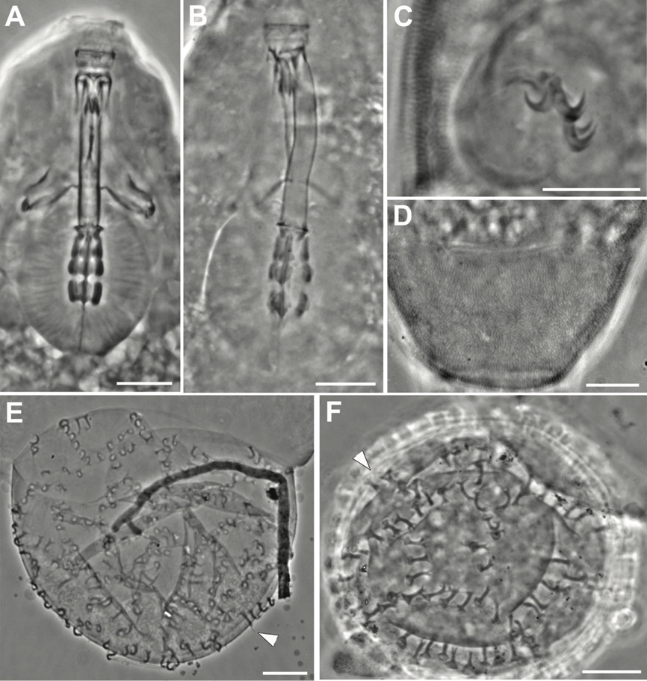
Figure 3. Murrayon nocentiniae (A-F), Murrayon ovoglabellus (G-L). A. Feeding apparatus. B. Feeding apparatus. C. Claws on the hind legs. D. Claw on the second pair of legs. E. Egg processes. F. Egg. G. Feeding apparatus (white arrow = dorsal crests, black arrow = ventral crests of buccal armature). H. Macroplacoids. I. Claws on the hind legs. J. Claw on the second pair of legs. K. Egg processes (arrowheads). F. Eggs (arrowheads = egg processes). A-F, J, L: PhC. G-I, K: DIC. Slide: A, C-D (CT6084); B, E-F (Tipo115); G-J (CT14699); K-l (Tipo968-12). Scale bars: A-L = 10 µm.
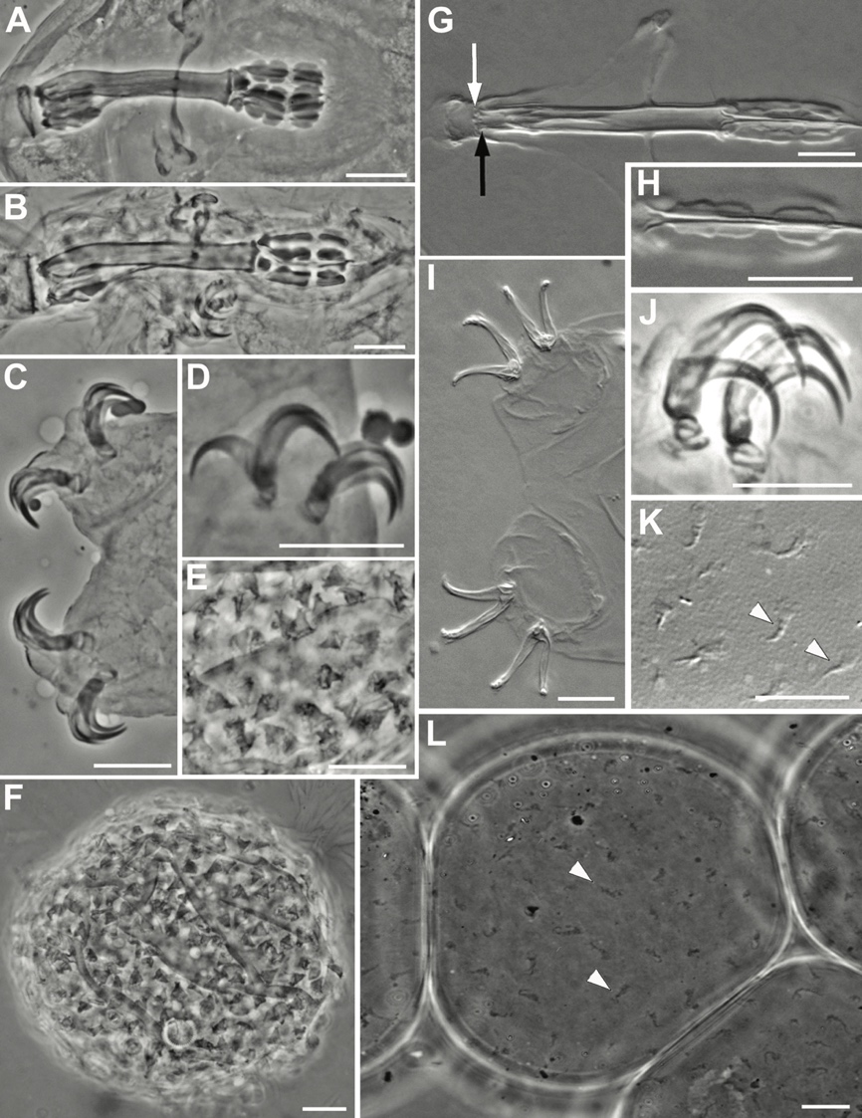
Figure 4. Paramurrayon meieri sp. nov. A. Animal (lateral view). B. Animal (ventral view). C. Head region (dorsal view). D. Feeding apparatus. E. Macroplacoids. F. Buccal armature (dorsal view) (arrowhead = transverse crests). G. Buccal armature (ventral view) (arrowhead = transverse crest). H. Head region (lateral view) (white arrowhead = epicuticular pillars; black arrowhead = hook in the ventral lamina). I. Claws on the second and third pair of legs. J. Claws on the second and third pair of legs (arrowheads = longitudinal thickenings). K. Claw on the second pair of legs (arrowhead = lunula). A-C, H, K-J: PhC. D-G, I: DIC. Slide: B, D-G, I (holotype); A, C, H, K-J (paratypes). Scale bars: A-C, I-J = 20 µm, D, H = 10 µm, E-G, K = 5 µm.
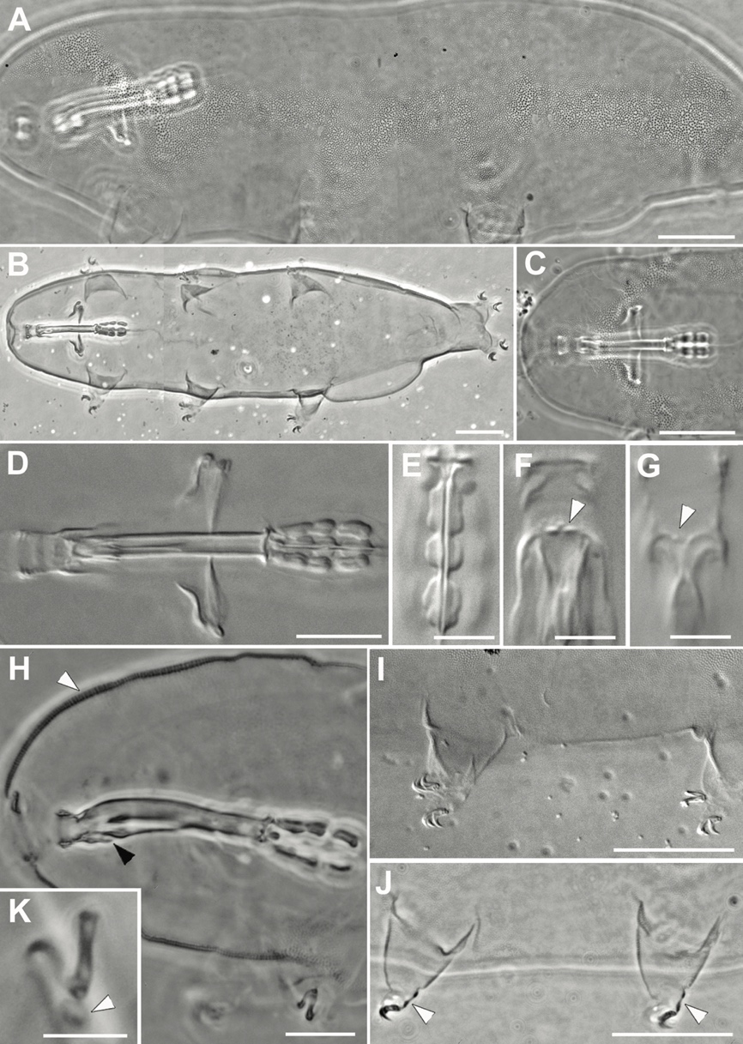
Figure 5. Paramurrayon meieri sp. nov. A. Egg. B Egg processes in lateral view. C. Surface of the egg. D. Egg processes. E. Egg. F. Surface of the egg. G. Egg. H. Egg processes. White arrowheads = threadlike filaments. Black arrowhead = base of the cuticular lamina covering the processes. Arrows = cuticular lamina covering the processes. A-E, G-H: PhC. F: DIC. Slide: A-E (sample 282 from Geitaknottane Natural Reserve, Norway: type locality); F-H (sample 274 from Førland, Sletthei, Norway). Scale bars: A-H = 10 µm.
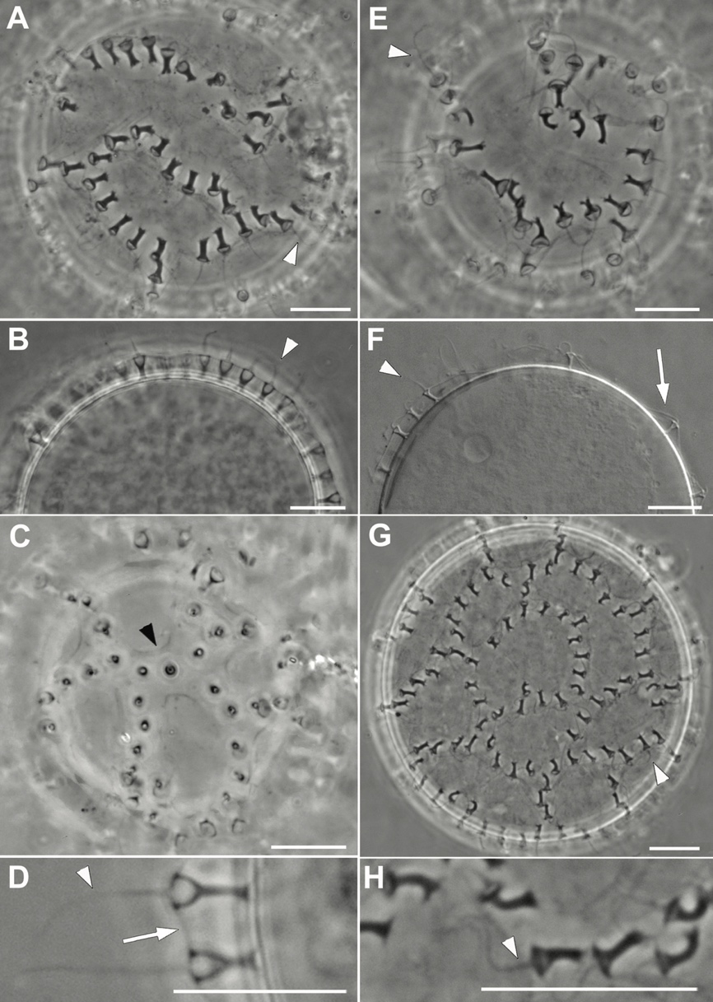
Figure 6. Murrayon pullari (A-D), Murrayon hastatus (E-G). A. Feeding apparatus. B. Egg. C. Eggs within crustacean exoskeleton (probably ostracods). D. Claws on the third pair of legs. E. Feeding apparatus. F. Egg. G. Claws on the hind legs. A-G: PhC. Slide: A, D (C199s3); B-C (Tipo143); E-G (C1178s4). Scale bars: A-B, D-G = 10 µm; C = 100 µm.
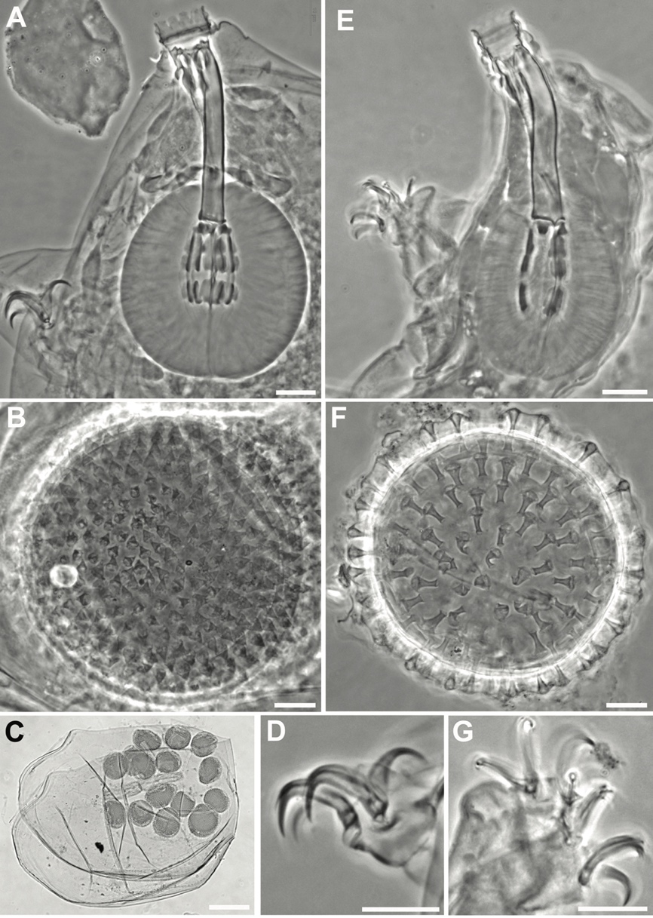
Figure 7. Evolutionary scenarios for the genera of Murrayidae (A, B), Macroversum mirum (C-G; holotype). A, B. Synapomorphies (with [notes]) are represented by numbers. * = Murrayon hastatus is not considered due to its uncertain phylogenetic position. Scenarios A and B differ by the plesiomorphic status of the egg morphology and claw size. 1 = feeding apparatus characterized (in lateral view) by a hook on the margin of the ventral lamina [unknown for Macroversum], and two macroplacoids in the pharynx. 2 = pillar-like structures in the inner epicuticle layer [unknown for Macroversum]. 3 = symmetrical claws with: the two claw branches diverging immediately after the basal portion (i.e. very short common tract) [with lunules]. 4 = claw V-shaped (i.e. main branch similar in length to secondary branch). 5 = egg of the Murrayon type (i.e. conical egg processes) [for Macroversum the eggs are unknown]. 6 = egg of the Paramurrayon type (i.e. chalice-shaped processes covered by a thin cuticular lamina) [for Macroversum the eggs are unknown]. 7 = colonization of freshwater habitats with proportionally larger and longer claws with respect to the ancestor (freshwater tardigrades have longer claws, probably for better adherence to the substrate; Nelson et al. 2015). 8 = reduction of the claws with respect to the ancestor. 9 = claw L-shaped (i.e. main branch longer than the secondary; E-G). 10 = cuticular connection between the lunules. 11 = loss of lunules [presence of cuticular connection between the claws; E-G]. 12 = two, posterior, dorso-lateral papillae. C. Animal in toto. D. Anterior portion of animal with feeding apparatus. E. Second pair of legs. F. Third pair of legs. G. Hind legs. Arrowheads = cuticular bars. Slide: C-G (slide 4084). Scale bars: A = 20 µm, B-E = 10 µm.
