The Impact of English Premier League broadcasts on Danish spectator demand: A Small League Perspective

Christian Gjersing Nielsenª, Rasmus K. Storm*^{a, b} and Tor Georg Jakobsen^{b}

ª Danish Institute for Sports Studies
^{b}NTNU Business School, Norwegian University of Science and Technology

*Corresponding Author:
Rasmus K. Storm
Danish Institute for Sports Studies
Kanonbådsvej 4a
DK-1437 København K, Denmark
rasmus.storm@idan.dk

The Impact of English Premier League Broadcasts on Danish Spectator Demand: A Small League Perspective

Abstract
The effect of live transmissions of football matches on spectator demand in European football has been extensively studied over the years, although with little focus on the smaller leagues. By deploying robust panel data regression models on Danish first tier (Superligaen) data from 2010/11–2015/16, this paper contribute to filling this gap. We find that matches clashing with English Premier League (EPL) broadcasts do not suffer in attendance and that weather is an important driver of demand.

Introduction
There is an ongoing debate about whether broadcasting of international matches is a threat to national league interest (e.g. Forrest & Simmons, 2006; Kringstad, Solberg, & Jakobsen, 2018; Solberg & Mehus, 2014). The Big Five leagues gain increasing amounts of revenue from television rights deals at the expense of smaller leagues, thereby broadening the quality gap between the top leagues and the rest. For instance, in Malaysia spending on media rights for the Big Five leagues equates to 900% of what is spent on the domestic league, whereas in the Scandinavian countries it is 77%, in France it is 16% and in Italy, Spain, Germany and the UK it is under 3% (Storm & Solberg, 2018).
While it is uncertain whether the Big Five leagues will attract an even larger share of the financial resources available to broadcasters for media rights in the future, these tendencies are worrying from a smaller league perspective. The quality of top league football matches can be seen as a potential threat to smaller leagues’ popularity, media rights revenue and – additionally – spectator demand. Subsequent increases in media attention can direct financial resources, television viewers’ and spectators’ interest from the domestic leagues to foreign leagues and reduce demand for domestic football in smaller nations.
Even though Danish professional football clubs, as in other European leagues, earn an increasing share of their revenue from television rights and sponsorship deals, high spectator demand is still crucial to the clubs due to its relationship to other sources of income (Késenne, 2007). Through the sale of merchandise and the lively atmosphere they create at the stadiums, spectators can be considered a ‘part of the product’ of the match (Borland & Macdonald, 2003). A full – or highly utilized – stadium presents a positive image of the product, possibly resulting in queue- and crowding-in-effects (Feehan, 2006). This can further increase the attractiveness for (potential) sponsors and (future) television broadcasters alike (Budzinski & Satzer, 2011).
Even though the effect of live transmissions on football spectator demand has been extensively studied, there has been relatively little focus on smaller football nations (Kringstad et al., 2018). More insights from minor leagues could shed light on how demand for domestic club football is affected by competition from international football leagues.
In 1969, the first international league club match was screened on Danish television, when Danish Broadcasting Association (Danmarks Radio, ‘DR’) – at that time a state radio and television monopoly – together with the Norwegian and Swedish state broadcasters, purchased the rights to air matches from the English first tier in football (Bech, 2009). Today, media rights holders for the English Premier League (EPL) in Denmark are commercially owned platforms which broadcast a significant number of EPL matches from each round live on Danish television.
Based on this background, we intend to examine whether high quality football broadcasts have an impact on live attendance in the Danish first tier, ‘Superligaen’. We focus on the impact of the biggest of the Big Five, EPL, and aim to answer the following research questions:
- Do Superliga matches clashing with EPL broadcasts suffer in attendance?
Furthermore, we hypothesize that (2) the (negative) effects are stronger if the EPL broadcast is a contest between two high quality clubs, as higher quality increases the opportunity cost of attending a live game in the Danish first tier. Additionally, (3) we expect the attractiveness of EPL broadcasts to increase when it is raining or snowing due to the convenience of staying at home and watching a match on television during bad weather.
To answer questions 1–3, we deploy robust panel data regression models on a unique set of Danish data covering the period 2010/11 to 2015/16 and interpret the results. The structure of the paper is as follows: First, we review existing literature on the effect of broadcasting on match day attendance (Section II) to gain information on how to form our regressions. Second, we present the data and discuss our applied methods and specific estimation techniques (Section III). Third, we present and discuss our results (Section IV) and conclude with reflections on the findings and future research pathways (Section V).

The Effects of Televised Football: Reviewing the Literature
As indicated above, it is often argued that the increase in supply of televised sports is detrimental to attendance demand, which in some leagues has resulted in the use of blackouts, for example, in the EPL (Forrest, Simmons, & Szymanski, 2004). This, however, has not been the case in Denmark where all Superliga matches, according to the website superstats.dk, have been televised since 2005.
Activities that compete with live attendance are the same match being shown on free-to-air, pay TV or online streaming, or watching or taking part in other sporting events or leisure activities (Borland & Macdonald, 2003). When the subscription package is paid for, or if the match is shown on a free-to-air channel, the monetary cost of watching a match is reduced or zero. Further, the time cost is lower than when travelling to the venue to watch it in-person (Solberg & Mehus, 2014). Theoretically, it is possible that broadcasts work in two directions. On the one hand, it seems plausible that broadcasts serve as substitutes and deter some fans from going to the stadium due to the lower cost of watching the match live on television (G. Allan & Roy, 2008). On the other hand, a complementary effect may exist since promotion on television also serves as an advertisement for the match at the stadium (Price & Sen, 2003). Most evidence, however, suggests that the direct broadcast of a match either reduces or has no impact on demand for the live match, and any complementary effects seem to be offset by the substitution effect.
Matches clashing with broadcasts of higher quality pan-European matches may also suffer in attendance (for a brief review of the literature see Table 1). Further, recent studies suggest that ‘foreign league imports’ comprise a substitute for smaller leagues (Kringstad et al., 2018; Solberg & Mehus, 2014).

--- Please insert Table 1 here ---

The effect of broadcasts can depend on the day of the week (Baimbridge, Cameron, & Dawson, 1996; Buraimo & Simmons, 2008, 2009; Forrest et al., 2004) and the specific season (Forrest et al., 2004), and is typically more pronounced if the broadcast is on free-to-air television (Buraimo, 2008; Buraimo, Forrest, & Simmons, 2009; Buraimo & Simmons, 2009; García & Rodríguez, 2002; Solberg & Mehus, 2014).
Controversially, Kringstad et al. (2018) find a positive effect if a match is broadcast on a channel that is included in most television subscription packages. They nevertheless argue that this could be due to an inefficiency in capturing all factors driving demand (in their models), and that televised matches may also be an indicator of quality as broadcasters select high quality matches.
Football fans obviously have different preferences, and it is plausible that some would rather watch a high-quality match on television than go to the stadium to see their local club. If this is the case, the availability of top league football may have a negative impact on attendance. This is the case in Norway, where broadcasts of foreign elite leagues do appear to reduce attendance in the domestic leagues. Solberg and Mehus (2014) report that Norwegian football fans with preferences for foreign football attend domestic league matches less frequently. Kringstad et al. (2018) also find that the monthly aggregated number of televised matches from the Big Five leagues on Norwegian channels commonly subscribed to have a negative effect on attendance.
Additionally, studies of English football report negative effects when domestic non-first tier matches clash with broadcasts from pan-European tournaments involving English clubs (Buraimo, 2008; Buraimo et al., 2009; Forrest & Simmons, 2006; Forrest et al., 2004). This evidence from other leagues emphasizes the potential of a substitution effect from high quality transmissions on spectator demand. Denmark, as a relatively small league, provides sufficient conditions to test the potential presence of a substitution effect from high quality leagues.

Data, Methods and Empirical models

Variables
In accordance with existing studies, we use match day attendance in log form as our dependent variable (García & Rodríguez, 2009). We also include predictors that enable us to test the hypothesized substitution effect. As the EPL is the most prominent foreign league televised in Denmark, and hence is expected to have a stronger substitution effect than other top leagues, we adopt the approach of Forrest et al. (2004) and deploy a dummy variable indicating whether the match clashes with one or more EPL broadcasts (EPL clash). Of the 1,149 matches in the sample – covering the season from 2010/11 to 2015/16 – 528 (46.0%) clashed with a Premier League broadcast.
We run further models with clashes among the large English clubs – Liverpool, Manchester United, Manchester City, Chelsea and Arsenal – for the whole period, and Tottenham in 2015/16 under the assumption that these matches, in accordance with our second research question, represent a higher opportunity cost than other EPL broadcasts (Big 5–6 clash). In 95 cases (8.3%) a match clashed with a broadcast between these clubs.
Weather conditions are expected to influence stadium demand, and both good and bad weather can discourage people from going to the match (García & Rodríguez, 2002). This is especially the case in Denmark, where matches are rarely sold out, so consumers can decide on match day whether to buy a ticket. We therefore include a measure reflecting the average Temperature at the nearest weather station/airport during the match, as well as its squared form to capture non-linear effects. Further, we adopt a dummy variable indicating whether rain and/or snow is detected during the game (Precipitation). Weather data has been collected from Wunderground.com.
Moreover, as we in accordance with our third research question hypothesize that the attractiveness of EPL broadcasts is expected to increase with bad weather, we run specific models incorporating interaction terms: EPL clash*Precipitation (Model 2). Further, it is possible that the effect of precipitation is dependent on the temperature in the sense that negative effects should decrease as the temperature rises. To test this, we run an additional model with the interaction terms: Temperature*Precipitation (Model 3).
To control for other relevant factors expected to be significant drivers of attendance demand, we add variables which are commonly utilized in demand studies. These are described in the following and benefits the study by making the results more comparable in terms of generalization.
The characteristics of the data do not allow us to test the direct substitution effect of the same match being broadcast. This is because all matches during the period were televised, and only nine matches were broadcast on free-to-air television. We further expect the variation in channels broadcasting Superligaen to be a proxy for sporting quality. For example, with few exceptions, the Danish match of the week (main event) has systematically been broadcast on TV3+ in the period covered by our data. Therefore, we include a control indicating whether a match has been broadcast on this channel.
Scheduling of the match can affect demand as the opportunity cost is higher on weekdays (Feehan, 2006). In Denmark, Sunday has historically been ‘football day’ and we therefore expect demand to be highest on Sundays (reference group) and enter dummy variables for Weekdays and Saturdays.
Clubs with large payrolls can buy more talent, and studies have demonstrated the existence of a clear relationship between payrolls and sporting performance (e.g. Hall, Szymanski, & Zimbalist, 2002; Szymanski & Kuypers, 2000). Hence, we expect the annual staffing costs – including the club’s payroll for players – to reflect the level of talent in each team (Buraimo et al., 2009), and we also expect clubs with a high level of talent to draw larger crowds. Thus, we enter the home (Home budget) and away (Away budget) clubs’ total staffing costs obtained from their annual financial reports, relative to the average league budget to control for talent effects.
Further, it is a common finding that a positive relationship exists between attendance and team success (Buraimo & Simmons, 2008; Hogan, Massey, & Massey, 2017; Pawlowski & Nalbantis, 2015), so we include two variables indicating the league position of the home (Position home) and away team (Position away).
Rottenberg (1956) stated that fans of sport teams are also concerned with uncertainty of outcome, and hence the relative difference in playing strength among teams. Knowing that this has been debated (Forrest, Simmons, & Buraimo, 2005; Jespersen & Pedersen, 2018), we assume that bookmaker odds reflect all relevant information regarding the clubs current sporting strength and include a measure derived from betting odds reflecting the probability of a home win (Probability home win). We also include the squared form to control for non-linear effects (Peel & Thomas, 1988, 1992). To further control for the travelling cost among away fans, we include a measure of distance (e.g. Baimbridge et al., 1996) between the home and away clubs’ arenas by car obtained from the website krak.dk, which is a Danish equivalent of Google Maps.
The age of the stadium may also affect demand. Feddersen, Maennig and Borcherding (2006) demonstrate that the ‘novelty effect’ of a new arena in the German Bundesliga had a positive effect lasting for five years. This is why we include a dummy variable taking the value of 1 if the match takes place at a stadium that has been constructed or rebuilt within the past five years (New or reconstructed arena).
As matches between teams located within the same geographical area generally attract more spectators than other matches (regardless of match characteristics) due to local rivalry (Forrest & Simmons, 2006), we construct a dummy variable taking the value of 1 if the home and away team are located no more than 60 kilometres (km) apart (approximately 40 miles) (Derby). This is a subjective-based distance but seems to fit Danish league football well. In comparison, Kringstad et al. (2018) define local derbies as matches involving two teams located within a maximum distance of 120 km. However, as Denmark is a country with a comparatively small geographical area, its clubs are typically located close to each other, making each club’s catchment area smaller.
In addition, we include two dummy variables taking the value of 1 if the away team is Brøndby IF and FC København respectively, which have been the most dominant clubs in Danish football. Kringstad et al. (2018) reported positive effects when the away team was Rosenborg, the most dominant club in Norwegian football, while Buraimo and Simmons (2009) found similar effects for Real Madrid and Barcelona in Spanish football.
Economic variables such as ticket price, income and market size are not included in our models as was done, for example, in Baimbridge et al. (1996). First, no central registration of ticket prices exists in Denmark. Second, it is difficult to assess market size. For instance, Brøndby IF is located in the least populated municipality in the dataset, but it is still a large market club after Danish standards, with spectators coming from outside the municipality and even across Denmark. Third, due to the controversial nature of the income variable (Noll, 1974), we also exclude income as a variable in our specifications. In any case, we expect rather small variations in market size and income during the period and argue that they are – at least partly – captured by our fixed effect models.

Specifications
Our focus is on explanatory variables that differ over time, and fixed effects modelling is our method of choice. Descriptive statistics for our overall models as well as the expected sign from our estimations are presented in Table 2.

--- Please insert Table 2 here ---

In the models presented in Table 3 (see the Results and Discussion section), we include dummy variables for each home team (minus one). We ran Hausman (1978) tests confirming that fixed effects modelling is preferable over random effects. However, the main rationale for choosing the former is its ability to control for all time-invariant variables described in the former paragraph, and hence we are able to dispose with many of the problems arising from spurious relationships. It may be that a clash with an EPL match affects home teams differently and this is accounted for in our models, where we subsequently get a ‘purer’ relationship between xit and yit in our regression results. As the dummy variables remove the effect of time-invariant characteristics we are better able to assess the predictors’ net effects (Beck, 2008; Mehmetoglu & Jakobsen, 2017). In the models presented in Table 3 and 4, we thus allow the intercept to vary by unit.

Model specification of fixed effects
[1]
Where: i = units, t = time

In the models presented, we apply dummy variables to each home team (however, not reported in the tables).

Model 1
[2]
Where: i = home team, t = time, and W = the within estimator.
As pointed out in the Variables section, we have included an interaction term composed of the two dichotomous variables EPL clash and Precipitation in Model 2 (indices are the same as in equation 2).

Model 2
[3]

In addition, we include a model testing for the interaction between temperature and precipitation for rain or snow (indices are the same as in equation 2).

Model 3
[4]

When calculating the root-mean-square error (RMSE) the data was split randomly. In our five-fold cross-validation the dataset is split into five distinct subset. In turn, each subset is used as test data and the remainder as training data. In our tables, we report the overall RMSE:
[5]
Overall RMSE:
[6] $√\frac{RMSE1+…+RMSEk}{k}$

Where i = home team, T = time, k = number of subsets, and j= groups (in our case H-team)

Results and Discussion
As shown in Model 1 in Table 3, EPL clash and Big 5–6 clash have an unexpected positive sign, but are both non-significant indicating that Superliga matches clashing with EPL broadcast do not suffer in attendance per se, and that there is no difference if it is an ordinary EPL clash or a match between the Big 5–6, disconfirming our two first hypothesis’.

--- Please insert Table 3 here ---
In Model 2 in Table 3 EPL clash*precipitation has a negative sign and is significant at the 5% level, indicating that demand is lower for matches clashing with EPL broadcasts when it is raining or snowing. The interaction effect between precipitation and EPL clash is illustrated in Figure 1 with 95% confidence intervals. From that it appears that it is Precipitation and not whether matches clash with an EPL broadcast, which is the main (negative) driver. Hence, we find no evidence suggesting that attendance is reduced when a match overlap with an EPL broadcast and cannot confirm our third hypothesis that ‘the attractiveness of EPL broadcasts increase when it is raining or snowing…’. We additionally estimated log-log models reaching the same overall conclusions (see appendix, Table 1).

--- Please insert Figure 1 here ---

Our results contradict the findings of Kringstad et al. (2018), who report that attendance has a negative relationship to the aggregated number of matches from the Big Five leagues, as well as Buraimo (2008), Forrest et al. (2004), Forrest and Simmons (2006) and Buraimo et al. (2009), who all find that attendance in the English football league falls when a match clashes with a pan-European broadcast involving English clubs.
TV3+, which typically broadcast the main event of the round in the Danish first tier, is non-significant in all models and thus does not seem to be a driver of sporting quality, indicating that other control variables included in the model capture these quality aspects.
In accordance with the findings of García and Rodríguez (2002) and Iho and Heikkilä (2010), Precipitation has a significant negative effect on attendance irrespective of whether it clashes with an EPL broadcast (see Model 1 and Model 2). Additionally, Temperature (Temperature SQ) has a significantly positive (1% level) relationship to attendance up to approximately 17.3 degrees Celsius (see figure 2) before decreasing, indicating that high temperatures increase the opportunity cost of other outside activities.

--- Please insert Figure 2 here ---

From Model 3 in Table 3, it is apparent that the curvilinear effect of temperature holds for both match days with and without rain/snow, as illustrated in Figure 3 below.

--- Please insert Figure 3 here ---

Matches scheduled on Weekdays unexpectedly do not seem to crowd out attendance, while Saturday matches clearly experience a decline in attendance relative to Sunday matches at the 1% level. This is contrary to most studies which typically distinguish between weekend and weekday matches, and find attendance to be lower on weekdays (Kringstad et al., 2018; Madalozzo & Villar, 2009).
Regarding sporting quality, both the Home budget – at the 5% level – and Away budget – at the 1% level – have a positive relationship to attendance, indicating that clubs with more expensive, and hence higher quality squads, attract more spectators both at home and away. This is (partly) in accordance with the findings of Buraimo, Forrest and Simmons (2009), who include a variable for the home clubs’ relative wage budget (but not the away clubs) and find positive effects. Buraimo (2008), however, considers the effect of both the home and away clubs, but only report significant results for the away club’s budget, arguing that fans grow accustomed to the home club’s level of talent.
Moreover, and in accordance with most literature, the sporting success of both teams on display are both significant at the 1% level, with Position home being more important than Position away (Buraimo & Simmons, 2008; Hogan et al., 2017; Pawlowski & Nalbantis, 2015). Like Kringstad et al. (2018) – although using a different approach – we find no evidence that Danish football fans are concerned with uncertainty of outcome at the match level in our preferred models, as we find both Probability home win and its squared to be non-significant. Yet, in the log-log specifications (appendix, table 1) both the linear and squared term come out as significant with unexpected positive signs, indicating that the relationship to demand is increasing at an increasing rate.
Further, Distance between the home and away arenas only has a negative effect on attendance at the 10% level in Model 1 and 2, indicating that higher travelling costs for away fans result in fewer spectators. The variable is, however, non-significant in Model 3, but with a p-value of 0.112.
Contrary to Kringstad et al. (2018) and Feddersen et al. (2006), we find no evidence that a New or reconstructed arena built or rebuilt within the last five years has a significant effect on attendance demand. This is quite a controversial finding, which suggests that investing in facilities is not a quick-fix solution to increasing spectator demand, and that investments in facilities should be considered carefully and only as a part of a broader strategy.
Matches between teams located within close proximity of each other unsurprisingly enjoy a higher attendance (Derby), with this variable being significant at the 1% level. Further, it appears that demand is significantly higher (1% level) when the away club is Brøndby IF or FC København, which is consistent with existing research (Buraimo & Simmons, 2009; Kringstad et al., 2018), and underscores how rivalries and historically successful clubs attract more spectators.

Conclusion, Implications and future research
In this paper, we have focused on one of Europe’s smaller football leagues, in Denmark, and tested whether broadcasts from foreign elite leagues are a threat to local match attendance. Evidence from other leagues suggests that a substitution effect exists, which indicates potential competition from international football imports.
The findings from the study, however, do not support the existence of such a substitution effect in Danish football when performing relevant modelling and taking all matches and relevant controls into consideration. This is an interesting finding, and a positive message to Danish league managers and stakeholders interested in obtaining a high level of attractiveness and hence a high spectator demand.
As it stands, it can be argued that the Danish league football is a valued product among Danish football fans, and that clashes with EPL broadcasts do not result in reduced attendance. Yet, bad weather – irrespective of a match clashes with an EPL broadcast – has a negative effect on attendance demand, while the negative effect of precipitation seems to wear off with increasing temperature. As high temperatures increase the attractiveness of other leisure activities, spectator demand is maximized at 17.3 degrees Celsius.
Besides these findings, our examination of determinants of spectator demand also point towards new research areas. It is possible that other interaction effects related to broadcasts from top leagues may exist, for example, scheduling of domestic matches on different weekdays. Future studies could explore whether the effect of foreign broadcasts on spectator demand is dependent on the timing of the match in this regard.
Moreover, as this study indicates, results from existing research cannot necessarily be generalized to other leagues. Habits and preferences seem to vary across nations and cultures, so it is imperative to conduct more research on the impact of foreign live transmissions on spectator demand in medium-sized and smaller leagues.
This study focuses only on the impact of EPL broadcasts on stadium attendance, but it is plausible that domestic television viewership could also suffer from international competition. Domestic viewership is therefore also a relevant topic for future research and more evidence from such studies could assist league managers in optimizing demand and benefitting spectators alike.

References
Allan, G., & Roy, G. (2008). Does Television Crowd Out Spectators? New Evidence From the Scottish Premier League. Journal of Sports Economics, 9(6), 592–605. https://doi.org/10.1177/1527002508321458
Allan, S. (2004). Satellite television and football attendance: the not so super effect. Applied Economics Letters, 11(2), 123–125. https://doi.org/10.1080/1350485042000200231
Baimbridge, M., Cameron, S., & Dawson, P. (1996). Satellite Television and the Demand for Football: A Whole New Ball Game? Scottish Journal of Political Economy, 43(3), 317–333. https://doi.org/https://doi.org/10.1111/j.1467-9485.1996.tb00848.x
Bech, M. (2009). Da lørdagen pludselig fik en lyd. Retrieved April 24, 2018, from https://politiken.dk/sport/fodbold/art4828372/Da-lørdagen-pludselig-fik-en-lyd
Beck, N. (2008). Time-Series Cross-Section Methods. In J. M. Box-Steffensmeier, H. E. Brady, & D. Collier (Eds.), The Oxford Handbook of Political Methodology (pp. 475–493). Oxford: Oxford University Press.
Borland, J., & Macdonald, R. (2003). Demand for Sport. Oxford Review of Economic Policy, 19(4), 478–502. https://doi.org/http://oxrep.oxfordjournals.org/content/by/year
Budzinski, O., & Satzer, J. (2011). Sports business and multisided markets: towards a new analytical framework? Sport, Business and Management: An International Journal, 1(2), 124–137. https://doi.org/10.1108/20426781111146736
Buraimo, B. (2008). Stadium Attendance and Television Audience Demand in English League Football. Managerial and Decision Economics, 29, 513–523. https://doi.org/https://doi.org/10.1002/mde.1421
Buraimo, B., Forrest, D., & Simmons, R. (2009). Insights for clubs from modelling attendance in football. Journal of the Operational Research Society, 60, 147–155. https://doi.org/10.1057/palgrave.jors.2602549
Buraimo, B., & Simmons, R. (2008). Do Sports Fans Really Value Uncertainty of Outcome? Evidence from the English Premier League. International Journal of Sport Finance, (3), 146–155.
Buraimo, B., & Simmons, R. (2009). A tale of Two Audiences: Spectators, Television Viewers and Outcome Uncertainty in Spanish football. Journal of Economics and Business, 61, 326–338. https://doi.org/10.1016/j.jeconbus.2008.10.002
Cox, A. (2012). Live Broadcasting, Gate Revenue, and Football Club Performance: Some Evidence. International Journal of the Economics of Business, 19(1), 75–98.
Cox, A. (2015). Spectator Demand, Uncertainty of Results, and Public Interest: Evidence From the English Premier League. Journal of Sports Economics, 1–28. https://doi.org/10.1177/1527002515619655
Feddersen, A., Maennig, W., & Borcherding, M. (2006). The Novelty Effect of New Soccer Stadia: The Case of Germany. International Journal of Sport Finance, (1), 174–188.
Feehan, P. (2006). Attendance at sports events. In W. Andreff & S. Szymanski (Eds.), Handbook on the Economics of Sport (pp. 90–99). Cheltenham, UK: Edward Elgar Publishing Limited.
Forrest, D., & Simmons, R. (2006). New Issues in Attendance Demand. The Case of the English Football League. Journal of Sports Economics, 7(3), 247–266. https://doi.org/10.1177/1527002504273392
Forrest, D., Simmons, R., & Buraimo, B. (2005). Outcome Uncertainty and the Couch Potato Audience. Scottish Journal of Political Economy, 52(4), 641–661.
Forrest, D., Simmons, R., & Szymanski, S. (2004). Broadcasting, Attendance and the Inefficiency of Cartels. Review of Industrial Organization, 24, 243–265. https://doi.org/10.1023/B:REIO.0000038274.05704.99
García, J., & Rodríguez, P. (2002). The Determinants of Football Match Attendance Revisited - Empirical Evidence From the Spanish Football League. Journal of Political Economy, 3(1), 18–38. https://doi.org/10.1177/152700250200300103
García, J., & Rodríguez, P. (2009). Sports attendance: A survey of the Literature 1973-2007. Rivista Di Diritto Ed Economia Dello Sport, V(2), 112–151.
Hall, S., Szymanski, S., & Zimbalist, A. S. (2002). Testing Causality Between Team Performance and Payroll. Journal of Sports Economics, 3(2), 149–168.
Hausman, J. A. (1978). Specification Tests in Econometrics. Econometrica, 46(6), 1251–1271. https://doi.org/10.2307/1913827
Hogan, V., Massey, P., & Massey, S. (2017). Analysing match attendance in the European Rugby Cup: Does uncertainty of outcome matter in a multinational tournament? European Sport Management Quarterly, 17(3), 312–330. https://doi.org/10.1080/16184742.2016.1276207
Iho, A., & Heikkilä, J. (2010). Impact of Advance Ticket Sales on Attendance in the Finnish Football League. Journal of Sports Economics, 11(2), 214–226. https://doi.org/10.1177/1527002509346819
Jespersen, N. D., & Pedersen, L. B. (2018). Rejecting the Uncertainty of Outcome Hypothesis on Attendance Demand in all Four Major European Football Leagues. Forum for Idræt, 33(1), 110–116. https://doi.org/https://doi.org/10.7146/ffi.v33i1.109683
Késenne, S. (2007). The Economic Theory of Professional Team Sports: An Analytical Treatment. Cheltenham: Edward Elgar Publishing.
Kringstad, M., Solberg, H. A., & Jakobsen, T. G. (2018). Does Live Broadcasting Reduce Stadium Attendance? The Case of Norwegian Football. Sport, Business and Management: An International Journal, 8(1), 67–81. https://doi.org/10.1108/SBM-11-2016-0071
Madalozzo, R., & Villar, R. B. (2009). Brazilian Football: What Brings Fans to the Game? Journal of Sports Economics, 10(6), 639–650. https://doi.org/10.1177/1527002509335572
Mehmetoglu, M., & Jakobsen, T. G. (2017). Applied Statistics Using Stata: A Guide for the Social Sciences. Los Angeles: Sage Publications.
Noll, R. G. (1974). Attendance and price setting. In Government and the Sports Business (pp. 115–157). Washington, DC: Brookings Institution.
Pawlowski, T., & Nalbantis, G. (2015). Competition format, championship uncertainty and stadium attendance in European football – a small league perspective. Applied Economics, 47(38), 4128–4139. https://doi.org/10.1080/00036846.2015.1023949
Peel, D., & Thomas, D. (1988). Outcome uncertainty and the demand for football: An analysis of match attendances in the English Football League. Scottish Journal of Political Economy, 35(3), 242–249.
Peel, D., & Thomas, D. (1992). The Demand for Football: Some Evidence on Outcome Uncertainty. Empirical Economics, 17, 323–331. https://doi.org/doi.org/10.1007/BF01206291
Price, D. I., & Sen, K. C. (2003). The Demand for Game Day Attendance in College Football: An Analysis of the 1997 Division 1-A season. Managerial and Decision Economics, 24(1), 35–46. https://doi.org/10.1002/mde.1100
Rottenberg, S. (1956). The Baseball Players’ Labor Market. The Journal of Political Economy, 64(3), 242–258. https://doi.org/10.2307/1061172
Solberg, H. A., & Mehus, I. (2014). The Challenge of Attracting Football Fans to Stadia? International Journal of Sport Finance, 9, 3–19.
Storm, R. K., & Solberg, H. A. (2018). European Club Capitalism and FIFA Redistribution Models: An Analysis of Development Patterns in Globalised Football. Sport in Society, 1–16. https://doi.org/10.1080/17430437.2018.1424136
Szymanski, S., & Kuypers, T. (2000). Winners and Losers: The Business Strategy of Football. London: Penquin Books.
Tipsbladet. (2017). Tipsbladet.dk varmer op til derby-runden i Superligaen med en gennemgang af alle rivalopgørene. Retrieved May 2, 2018, from https://www.tipsbladet.dk/nyhed/superliga/derby-runde-her-er-superligaens-rivaliseringer

Table 1: Findings on the effect of broadcasting in football demand studies
Authors(s) | Title | Method | Findings
G. Allan & Roy (2008) | Does television crowd out spectators? New evidence from the Scottish Premier League | Seemingly unrelated regression estimates with home team fixed effects (cross-sectional data) on log attendance divided into season ticket holders; pay-at- home fans; and pay-at-the gate visitors in the Scottish first tier (2002/03). | Broadcasting of a match reduced the number of pay-at-the-gate home fans, while there is no significant effect for season ticket holders and pay-at-the-gate visitors.
Allan (2004) | Satellite television and football attendance: the not so super effect | Ordinary least squares (OLS) with seasonal fixed effects on Aston Villa’s (time series data) log attendance home matches (1995/96-2000/01) | Broadcasting of a match reduced attendance.
Baimbridge, Cameron & Dawson (1996) | Satellite television and the demand for football: a whole new ball game? | OLS (cross-sectional data) on log attendance in the English first tier (1993/94) | Broadcasting of a match reduced attendance on Mondays, but not Sundays.
Buraimo (2008) | Stadium attendance and television audience demand in English League Football | Paris-Winston OLS with panel-corrected standard errors (panel data) on log attendance in the English second tier (1997/98-2003/04) | Broadcasting of a match reduced attendance with a larger negative effect if the match was broadcast on free-to-air television.  Pan-European (UEFA Champions League and UEFA Cup) matches involving English clubs broadcast on the same day had a negative effect on attendance.
Buraimo, Forrest & Simmons (2009) | Insights for clubs from modelling match attendance in football | Hausman-Taylor estimator (panel data) on log attendance in the English second tier (1997/98-2003/04) | Broadcasting of a match reduced attendance with a larger negative effect if the match was broadcast on free-to-air television.  Pan-European matches involving English clubs broadcast on terrestrial TV the same day had a negative effect on attendance, while no significant effect was found for subscription channels.
Buraimo & Simmons (2008) | Do sports fans really value uncertainty of outcome? Evidence from the English Premier League | Random effects tobit estimator (panel data) on log attendance in the English first tier (2000/01-2005/06). | Broadcasting of a match reduced attendance on Mondays and Sundays, but not on other days.
Buraimo & Simmons (2009) | A tale of two audiences: spectators, television viewers and outcome uncertainty in Spanish football | Paris-Winston OLS with panel-corrected standard errors (panel data) on log attendance in the Spanish first tier (2003/04-2006/07). | Broadcasting of a match on public TV reduced attendance with a greater effect on weekdays. No significant effects were found for subscription TV.
Cox (2012) | Live broadcasting: gate revenue, and football club performance: some evidence | OLS with home team fixed effects (panel data) on log match day revenue in the English first tier (2004/05-2007/08). | Broadcasting of a match had a negative effect on match day revenue with a greater effect on weaker clubs.
Cox (2015) | Spectator demand, uncertainty of results, and public interest: evidence from the English Premier League | Various estimation techniques (panel data) on log attendance (2004/05-2011/12). | Broadcasting of a match had a negative effect on attendance.
Forrest & Simmons (2006) | New issues in attendance demand  the case of the English Football League | Paris-Winston OLS with panel-corrected standard errors (panel data) on log attendance in the English second, third and fourth tier (1999/00-2001/02). | The overall conclusion is that broadcasting of a match did not have an adverse effect on attendance.  Champions League matches involving British clubs broadcast on free-to-air TV had a negative effect on attendances in the English third and fourth tier. Matches on subscription TV had a (smaller than for free-to-air) negative effect on attendance in the fourth tier.
Forrest et al. (2004) | Broadcasting, attendance and the inefficiency of cartels | Tobit estimator with seasonal fixed effects (first tier) and OLS with home team and seasonal fixed effects (second tier) (panel data) on log attendance in the English football (1992/93-1997/98) | The effect of broadcasting of a match is dependent on the specific weekday and season. There is no clear evidence that broadcasting had a general (negative) effect on attendance in the English first tier, however, most evidence suggested a negative effect in the second tier.  Pan-European matches involving English clubs broadcast had a negative effect on attendances in the English second tier (not tested for the first tier).
García & Rodríguez (2002) | The determinants of football match attendance revisited – empirical evidence from the Spanish football league | OLS with home team and seasonal fixed effects on log attendance not including tickets sold to children and season ticket holders (1992/93-1995/96). | Broadcasting of a match reduced attendance with broadcasts on free-to-air having a greater effect than those on private channels.
Kringstad et al. (2018) | Does live broadcasting reduce stadium attendance? The case of Norwegian football | OLS with home team fixed effects as well as mixed effects (2005-2011) | Domestic broadcasts on “free TV” were positively correlated with attendance.  The monthly aggregated number of televised matches from the Big Five leagues on channels commonly subscribed to had a negative effect on attendance.
Solberg & Mehus (2014) | The challenge of attracting football fans to stadia? | Poisson regression on surveyed Norwegian football fans (season 2010) | Consumers with preferences for televised matches attended fewer matches.  Consumers with preferences for foreign football attended fewer matches.  Non-season ticket holders had a higher propensity to watch matches on TV rather than attending.  The number of matches attended had a negative relationship to the number of matches broadcast on free-to-air channels.

Table 2: Descriptive Statistics for Dependent and independent variables (N = 1,149)
Name | Expected sign | Mean | SD | Minimum | Maximum
log(attendance) |  | 8.699 | 0.606 | 6.965 | 10.411
EPL clash | Negative | 0.460 | 0.499 | 0 | 1
Big 5-6 clash | Negative | 0.083 | 0.276 | 0 | 1
Temperature | Positive | 11.57 | 6.187 | -8 | 31
Precipitation | Negative | 0.240 | 0.427 | 0 | 1
TV3+ | Positive | 0.165 | 0.372 | 0 | 1
Weekdays | Negative | 0.321 | 0.467 | 0 | 1
Saturdays | Negative | 0.158 | 0.364 | 0 | 1
Home budget | Positive | 1.009 | 0.606 | 0.219 | 2.459
Away budget | Positive | 0.993 | 0.600 | 0.219 | 2.459
Position home | Negative | 6.498 | 3.463 | 1 | 14
Position away | Negative | 6.486 | 3.446 | 1 | 14
Probability home win | Positive | 0.424 | 0.136 | 0.08 | 0.78
Distance | Negative | 194.6 | 111.4 | 11 | 427
New or reconstructed arena | Positive | 0.130 | 0.336 | 0 | 1
Derby | Positive | 0.143 | 0.350 | 0 | 1
Brøndby IF | Positive | 0.082 | 0.274 | 0 | 1
FC København | Positive | 0.080 | 0.272 | 0 | 1

Table 3: Log-Linear Fixed effects models, home team, interaction between EPL clash and precipitation, and interaction between temperature and precipitation
 | Model 1 |  | Model 2 |  | Model 3
Independent variables | B | SE B | B | SE B |  |  | B |  | SE B
EPL clash | 0.016 | 0.020 | 0.034 | 0.021 |  | 0.016 |  | 0.020
Big 5–6 clash | 0.002 | 0.030 | --- | --- |  | 0.000 |  |  | 0.031
Temperature | 0.054*** | 0.006 | 0.054*** | 0.006 |  |  | 0.051*** |  | 0.007
Temperature SQ | -0.001*** | 0.0001 | -0.001*** | 0.0001 |  |  | -0.001*** |  | 0.000
Precipitation | -0.060*** | 0.018 | -0.023 | 0.024 |  |  | -0.198 |  | 0.155
EPL clash*precipitation | --- | --- | -0.082** | 0.035 |  |  | --- |  | ---
Temperature*precipit. | --- | --- | --- | --- |  |  | 0.013 |  | 0.016
Temp*Temp*precipit. | --- | --- | --- | --- |  |  | -0.0003 |  | 0.000
TV3+ | -0.004 | 0.028 | -0.005 | 0.028 |  |  | -0.003 |  | 0.028
Weekdays | -0.006 | 0.021 | -0.003 | 0.021 |  |  | -0.006 |  | 0.022
Saturdays | -0.087*** | 0.023 | -0.086*** | 0.022 |  |  | -0.087*** |  | 0.023
Home budget | 0.113** | 0.055 | 0.121** | 0.055 |  |  | 0.114** |  | 0.055
Away budget | 0.067*** | 0.020 | 0.066*** | 0.020 |  |  | 0.069*** |  | 0.020
Position home | -0.030*** | 0.003 | -0.030*** | 0.003 |  |  | -0.030*** |  | 0.003
Position away | -0.014*** | 0.003 | -0.014*** | 0.003 |  |  | -0.014*** |  | 0.003
Probability home win | 0.435 | 0.393 | 0.425 | 0.393 |  |  | 0.442 |  | 0.394
Probability home win SQ | 0.023 | 0.416 | -0.020 | 0.415 |  |  | -0.026 |  | 0.417
Distance | -0.0002* | 0.0001 | -0.0002* | 0.0001 |  |  | -0.0002* |  | 0.0001
New or reconstructed arena | -0.023 | 0.042 | -0.016 | 0.042 |  |  | -0.022 |  | 0.042
Derby | 0.123*** | 0.030 | 0.125*** | 0.030 |  |  | 0.123*** |  | 0.030
Brøndby IF | 0.369*** | 0.035 | 0.373*** | 0.035 |  |  | 0.367*** |  | 0.035
FC København | 0.313*** | 0.043 | 0.318*** | 0.043 |  |  | 0.312*** |  | 0.043
Intercept | 7.972*** | 0.133 | 7.952*** | 0.133 |  |  | 8.002*** |  | 0.136
R-squared within | 0.441 |  | 0.444 |  |  |  | 0.442
K-fold mean RMSE | 0.471 |  | 0.469 |  |  |  | 0.471
Groups | 17 |  | 17 |  |  |  | 17
N | 1149 |  | 1149 |  |  |  | 1149
Note: *significant at 10 %, **significant at 5 %, *** significant at 1 %. In model 2. EPL clash and Big 5–6 clash are collapsed in model 2. Groups are home teams

Figure 1: Interaction effect between EPL clash and precipitation
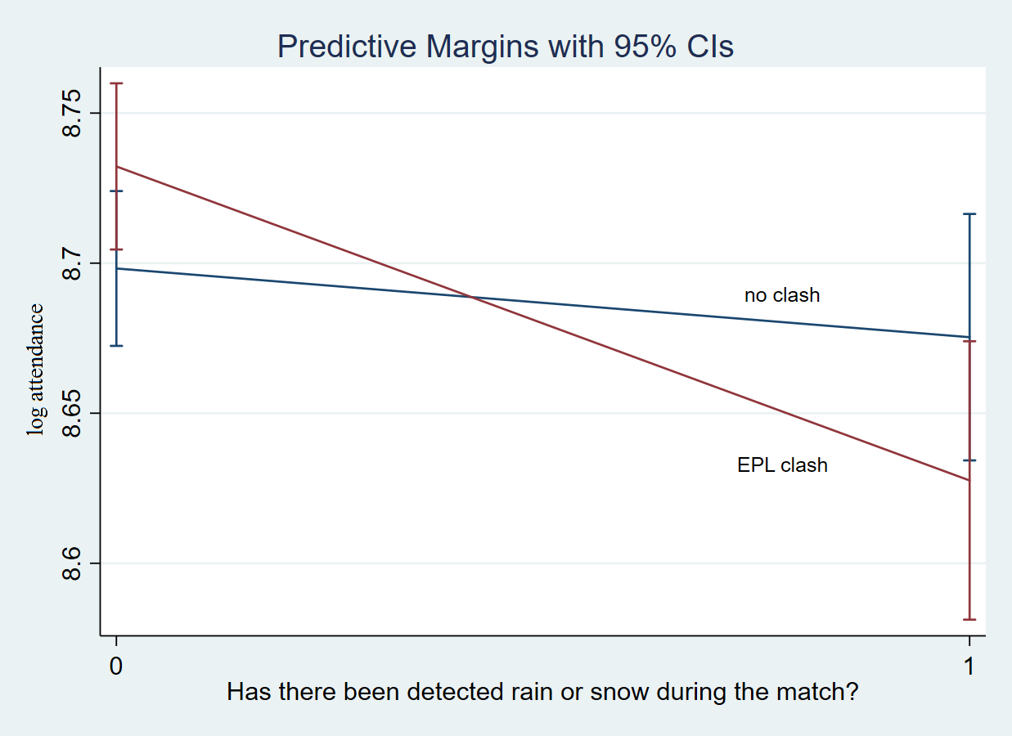

Figure 2: Relationship between temperature and attendance
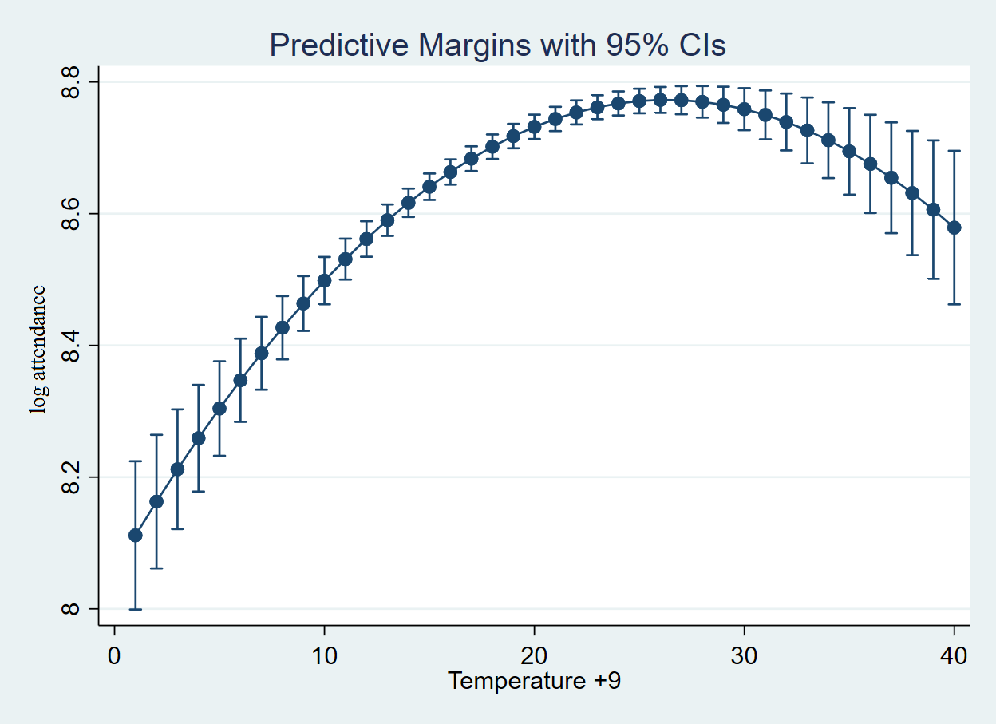

Figure 3: The interaction effect between temperature and precipitation

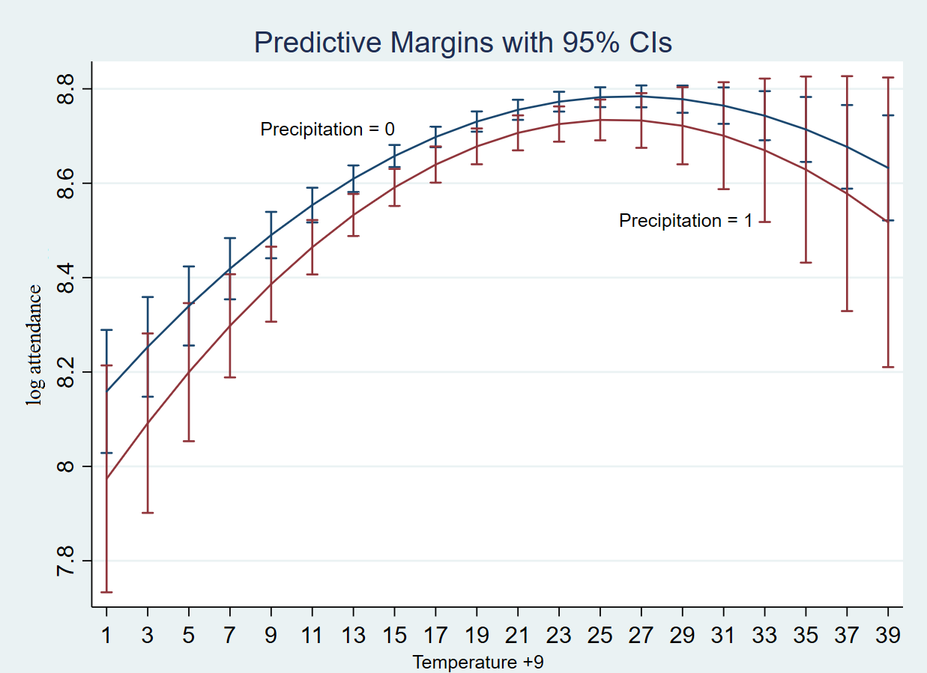

Appendix
Table A1: Fixed effects log-log models, home team and interaction between EPL clash and precipitation
 | Model 1 |  | Model 2 |  |  | Model 3
Independent variables | B | SE B | B | SE B | B |  |  | SE B
EPL clash | 0.024 | 0.020 | 0.042** | 0.021 |  |  | 0.022 |  | 0.020
Big 5–6 clash | 0.009 | 0.031 | --- | --- |  |  | 0.003 |  | 0.031
Temperature | 0.523*** | 0.131 | 0.515*** | 0.130 |  |  | 0.455*** |  | 0.135
Temperature SQ | -0.052** | 0.024 | -0.050** | 0.024 |  |  | -0.044* |  | 0.025
Precipitation | -0.058*** | 0.018 | -0.020 | 0.024 |  |  | -1.423** |  | 0.675
EPL clash*precipitation | --- | --- | -0.083** | 0.035 |  |  | --- |  | ---
Temperature*precipit. | --- | --- | --- | --- |  |  | -0.898* |  | 0.497
Temp*Temp*precipit. | --- | --- | --- | --- |  |  | -0.146 |  | 0.091
TV3+ | -0.004 | 0.028 | -0.005 | 0.028 |  |  | -0.003 |  | 0.028
Weekdays | -0.001 | 0.021 | 0.002 | 0.021 |  |  | -0.002 |  | 0.021
Saturdays | -0.098*** | 0.023 | -0.097*** | 0.022 |  |  | -0.097*** |  | 0.023
Home budget | 0.119* | 0.065 | 0.128* | 0.065 |  |  | 0.118* |  | 0.065
Away budget | 0.076*** | 0.018 | 0.075*** | 0.018 |  |  | 0.080*** |  | 0.018
Position home | -0.148*** | 0.014 | -0.147*** | 0.014 |  |  | -0.147*** |  | 0.014
Position away | -0.069*** | 0.013 | -0.069*** | 0.013 |  |  | -0.068*** |  | 0.013
Probability home win | 0.421*** | 0.114 | 0.417*** | 0.114 |  |  | 0.433*** |  | 0.114
Probability home win SQ | 0.118** | 0.049 | 0.116** | 0.049 |  |  | 0.122** |  | 0.049
Distance | -0.0002 | 0.0001 | -0.0002 | 0.0001 |  |  | -0.0001 |  | 0.0001
New or reconstructed ar. | -0.033 | 0.043 | -0.024 | 0.043 |  |  | -0.029 |  | 0.043
Derby | 0.130*** | 0.030 | 0.133*** | 0.030 |  |  | 0.130*** |  | 0.030
Brøndby IF | 0.377*** | 0.035 | 0.381*** | 0.034 |  |  | 0.374*** |  | 0.035
FC København | 0.303*** | 0.040 | 0.308*** | 0.040 |  |  | 0.303*** |  | 0.040
Intercept | 8.258*** | 0.195 | 8.252*** | 0.194 |  |  | 8.391*** |  | 0.202
R-squared within | 0.440 |  | 0.442 |  |  |  | 0.443
K-fold mean RMSE | 0.459 |  | 0.456 |  |  |  | 0.459
Groups | 17 |  | 17 |  |  |  | 17
N | 1149 |  | 1149 |  |  |  | 1149
Note: *significant at 10 %, **significant at 5 %, *** significant at 1 %. EPL clash and Big 5–6 clash are collapsed in model 2. Groups are home teams

The Big Five leagues include England, Germany, France, Italy and Spain.
The number of studies on match day attendance is significant. While the literature review in this paper focuses on the studies that are most relevant to analyzing the problem presented, the operationalization of our model variables in section III draws on other parts of the body of literature on spectator demand as inspiration for the variables chosen.
Blackouts refer to matches not being broadcast.
We use this period, as very few matches before 2010/11 clashed with Premier League broadcasts.
In 2015/16 Tottenham claimed its first top 3 placing since the 1989/90 season. Furthermore, the Danish footballer Christian Eriksen (who also had a leading role in the national team) had a dominant role in the team. So we classify Tottenham as a high demand team for Danish viewers, but only in this season. We go deeper into our set of models in the Specifications section.
The lowest temperature in the dataset is -8. To prevent negative values when squaring our variable a constant of ‘9’ has been added to its values.
57% of all matches from 2004/05–2015/16 were played on Sundays.
We also include Sønderjyske versus Esbjerg, which are located further apart, in Derby. This is because games between Sønderjyske and Esbjerg are characterised as derbies among fans and in the press (Tipsbladet, 2017).
Noll argues that per capita income also reflects other societal differences between cities leading to different conclusions across studies.
When we have repeated observations on each unit (the home teams), we can elaborate on the regression equation by including unit-specific dummy variables D_{i}. The fixed effects (within) estimator takes into account the measured time-varying independent variables that we have included in our model (x_{it}) but also accounts for both the time-invariant independent variables (x_{i}) that cannot be included in our model and the unmeasured time-invariant variables.
The 95% confidence intervals calculated in Figures 1 and 3 show at which combinations of EPL clash and precipitation the effects are significantly or not significantly different with 95% statistical certainty in Figure 1, and in Figure 3 different combinations of temperature and precipitation.
Note that the graphs shows temperature plus nine degrees.
The sign is negative because the best position is assigned with ‘1’, while the bottom position is assigned with ‘12’.
Distance is also non-significant in the log-log models, however, with p-values close to 0,10.

