Morphology and activity of electrolytic silver catalyst for partial oxidation of methanol to formaldehyde under different exposures and oxidation reactions

S. Lervold¹, K. Arnesen¹, N. Beck², R. Lødeng³, J. Yang¹, K. Bingen⁴, J. Skjelstad⁵ and H.J. Venvik^{1*}
¹Dept. of Chemical Engineering, NTNU - Norwegian University of Science and Technology, NO-7491 Trondheim, Norway
²Karlsruhe Institute of Technology, DE-76021 Karlsruhe, Germany
³SINTEF Industry, NO-7465 Trondheim, Norway
⁴Dynea AS, NO-2004 Lillestrøm, Norway
⁵K.A. Rasmussen AS, NO-2316 Hamar, Norway
*Corresponding author: Hilde.j.Venvik@ntnu.no, +47 73592831
https://orcid.org/0000-0002-8113-032X

Abstract
Electrolytic silver particles were studied in relation to its morphology changes under different reactive and non-reactive atmospheres, and its catalytic activity in oxidation of methanol to formaldehyde (MTF), carbon monoxide to carbon dioxide, and hydrogen to water. Scanning electron microscopy (SEM) and X-ray Diffraction (XRD) were applied to analyze structural changes in the silver catalyst after exposure or interaction with nitrogen, oxygen, methanol/water, carbon monoxide and hydrogen, applied either individually or in selected combinations, at temperatures approaching 700 °C. The as-received Ag catalyst consists of agglomerated, faceted, polycrystalline particles. These undergo massive morphological changes during MTF reaction conditions. It was found that Ag catalysts exposed to oxygen-free atmospheres (N₂, H₂/N₂ and CH₃OH/H₂O/N₂) at 650 °C exhibit minimal changes in surface morphology compared to the fresh catalyst, while severe restructuring occurs on the mesoscopic scale under oxygen containing atmospheres (O₂/N₂, H₂/O₂/N₂ and CO/O₂/N₂ ) at elevated temperature. This restructuring renders a smoothened surface with refacetted areas and many pinholes, while a small primary crystallite size (~40 nm, XRD) is maintained. Such pinholes are commonly described as a result of sub-surface oxygen/hydrogen/hydroxyl interactions. Here, they are present in all samples exposed to oxygen, indicating that presence of hydrogen is not prerequisite. For the CO and H₂ oxidation sub-systems, the initial activity was comparable. But, while the conversion of H₂ is preserved during 70h time on stream, the CO conversion gradually reduces from 70 to 10%. This suggests that the restructuring associated with dissolution of O at high temperature inhibits the CO to CO₂ pathway.

Keywords: Electrolytic silver catalyst, formaldehyde, surface morphology, CO oxidation, H₂ oxidation

Introduction
Formaldehyde is a key building-block in several chemical industries. It is a versatile organic molecule with high reactivity, making it applicable in the synthesis of various polymers, adhesives, glues, resins and chemical intermediates. Some of these products include resins for wood panel industry; polyacetal and other acetylenic chemicals important for the construction, automotive, and pharmaceutical industries [1,2].
Two different process technologies currently dominate industrial formaldehyde synthesis. The silver-catalyzed process, first described in the early twentieth century, is performed over electrolytic silver at air-lean conditions. Continued development resulted in the second route, industrialized since the 1950s, proceeding by partial oxidation in excess air over metal oxides from iron, molybdenum and/or vanadium [1,2]. Industrial formaldehyde manufacture based on the silver catalyst is operated with high selectivity to formaldehyde, i.e. a yield ranging from 82-92% with catalyst lifetime ranging from 4 weeks to 12 months [1]. The large-scale silver-catalyzed partial oxidation of methanol produces around 7 × 10⁶ tons of formaldehyde annually [3], which accounts for approximately 50% of industrial formaldehyde manufacture. Formaldehyde demand has increased by 2–3% per year on average over the past two decades, and the silver catalyst route offers advantages regarding investment and operational cost, as well as reliability [4,5].
Industrially, the overall exothermic process is carried out at adiabatic conditions. Methanol vapor, steam and air are passed through a shallow bed of electrolytic silver at temperatures between 923-953 K and atmospheric pressure. Formaldehyde formation results from two general pathways, dehydrogenation and partial oxidation of methanol (Eq.1 and 2), the latter being the most significant. Near complete methanol conversion is achieved by addition of steam and rapid quenching of the products, with around 90-92% selectivity to formaldehyde. Approximately 8-10% of the methanol feedstock is, however, non-selectively oxidized to carbon dioxide and water or carbon dioxide and hydrogen.
The product distribution from methanol oxidation over silver involves a relatively complex reaction network [1,4,5] that can be represented by Eq. 1-9 below:

$$CH_{3}OH_{(g)}\underset{→}{O_{(a)}} CH_{2}O_{\left(g\right)}+H_{2_{(g)} }$$ | $$∆H=+84 \frac{kJ}{mol}$$ | (1)
$$CH_{3}OH_{(g)}+\frac{1}{2}O_{2}→CH_{2}O_{(g)}+H_{2}O_{(g)}$$ | $$∆H=-159 \frac{kJ}{mol}$$ | (2)
$$CH_{3}OH_{(g)}+{\frac{3}{2}O}_{2}→C{O_{2}}_{(g)}+{{2H}_{2}O}_{\left(g\right)}$$ | $$∆H=-676\frac{kJ}{mol}$$ | (3)
$$CH_{3}OH_{(g)}→CO_{(g)}+{2H}_{2}$$ | $$∆H=91 \frac{kJ}{mol}$$ | (4)
$$CH_{2}O_{(g)}+O_{2}→C{O_{2}}_{(g)}+H_{2}O_{(g)}$$ | $$∆H=-519 \frac{kJ}{mol}$$ | (5)
$$CH_{2}O_{(g)}+\frac{1}{2}O_{2}→C{O_{2}}_{(g)}+{H_{2}}_{(g)}$$ | $$∆H=-271 \frac{kJ}{mol}$$ | (6)
$$CH_{2}O_{(g)}→CO_{(g)}+{H_{2}}_{(g)}$$ | $$∆H=+12 \frac{kJ}{mol}$$ | (7)
$${H_{2}}_{(g)}+\frac{1}{2}O_{2}→H_{2}O_{(g)}$$ | $$∆H=-243 \frac{kJ}{mol}$$ | (8)
$${CO}_{(g)}+\frac{1}{2}O_{2}→{{CO}_{2}}_{(g)}$$ | $$∆H=-283 \frac{kJ}{mol}$$ | (9)

Here, (g) denotes gas phase species and $∆H$ the enthalpy of reaction at 973 K. In Equation 1, O_{(a)} represents some form of chemisorbed atomic oxygen on silver. This is because very little dehydrogenation is found to proceed in absence of oxygen in the feed, while a significant contribution from dehydrogenation can be observed to proceed in parallel with the partial oxidation (Eq. 2) [4,6-9]. There is thus a consensus that the interaction of oxygen with silver is essential to catalytic formation of formaldehyde. The major side product CO₂ directly affects the formaldehyde yield, but the actual mechanism of formation is still disputed (Eq. 3,6,9). Our own MTF experiments have proved that the decomposition of CH₂O is highly favored by temperature and residence time. Hence, at high conversion and high temperature, CO is mainly a product of homogenous gas phase reactions.

The detailed reaction mechanism has been addressed by experimental investigations of reaction performance, characterization of the silver morphology and the interaction between oxygen and silver [4,6-8,10-13]. Three distinct atomic oxygen species have been classified as resulting from the adsorption and dissolution of O₂ at temperatures and pressures relevant for industrial formaldehyde manufacture, namely O_{α}, O_{β} and O_{γ}. These species’ characteristics differ in location, Ag-O bonding and thermal stability. The weakly chemisorbed O_{α} surface species is associated with a thermal desorption temperature around 580 K in absence of gas-phase O₂. It is formed by O₂ dissociation on low index planes ((110) and (111)) [4,6,10,13-16]. Bulk-dissolved, i.e. subsurface, O_{β} is formed from diffusion of O_{α} into the Ag bulk, occupying interstitial sites. Its presence is correlated with the observation of an O₂ desorption signal between 680 and 800 K, and at temperatures above 773 K formation of O_{β} is reported to be accompanied by bulk restructuring into (111) facets [4,6,10,13,15-17]. High surface coverage of oxygen, grain boundaries or other structural defects in the Ag structure are found to facilitate O_{β} formation. O_{γ} is a more strongly chemisorbed surface species compared to O_{α}. Its origin is discussed as either dissociative chemisorption of O₂ at lower temperatures on Ag(111) planes located near grain boundaries or volume diffusion of O_{β} through (111)-terminated facets above 900 K [4,10,13,17,18]. Diffusion of interstitial O along the (110) direction has been shown to distort the fcc lattice and claimed to affect the formation and availability of O_{β} and O_{γ} [8].

A common hypothesis is that O_{α} participates in the non-selective oxidation of CH₃OH and CH₂O, contributing to CO₂ formation [4,6,8,10,18-20]. This is in contrast to the O_{γ} often identified as responsible for the more specific pathway to CH₂O and present at temperatures above 900 K (in presence of gas-phase O₂) [4-8,18-20]. The role of these species and associated pathways at various reaction conditions are still under debate, especially in relation to the surface restructuring and active surface area evolution. Wachs and Madix [14] used isotopic labelling to show that adsorbed atomic oxygen must be present to promote formation of methoxy, formaldehyde and formate species and presented a simplified reaction mechanism. The O_{α} was claimed to be the only active oxygen species in the mechanism and a direct reaction pathway from methanol to carbon dioxide was not included. Andreasen et al. used this model as a basis for developing a microkinetic model for oxidation of methanol to formaldehyde and oxidation of formaldehyde to carbon dioxide [21]. Only one type of atomic oxygen was included in the elementary reaction system, i.e. O_{α}. More recently, Aljama et al. provided a density functional theory (DFT) based microkinetic model for the reaction kinetics relevant for MTF manufacture [22]. They find oxygen to be present at low concentrations and playing a significant part in the catalytic activity. The model was based on reactions over a clean Ag(111) surface and O- or OH-assisted pathways were studied. The results indicated that the dissociation of oxygen was the most critical step, and surface oxygen promoted formaldehyde formation through methoxy intermediates.

Reactions in heterogeneously catalyzed systems are driven by chemical potential gradients at the phase boundaries. If kinetically feasible, the catalyst morphology and composition will take on the configuration exhibiting a minimum Gibbs free energy, which is also a function of the gas phase composition. Massive morphological restructuring of the Ag catalyst during reaction above Tamman temperature (642 K) occurs to attain a thermodynamically favorable structure [6-8]. The morphological changes during MTF reactions are linked to the ability of the Ag lattice to incorporate oxygen and hydrogen at elevated temperature [4,6-8,10,12,13,15-17,19,23]. This can be described as refacetting to enhance low index planes ((110) and (111)), accompanied by pinhole formation. The refacetting and formation of O_{γ} have again been linked to the reaction mechanism in terms of O_{γ} on (111) facilitating the selective formation of formaldehyde. As indicated above, others describe the mechanism based on one surface O species, rendering the pathway to CO₂ especially unclear. E.g., Aljama et al microkinetic model [6] describes CO₂ as a product of CO oxidation.

Exploration of the relationship between different atmospheres and silver morphology, in conjunction with catalytic activity for oxidation reactions, are important aspects in our MTF investigations. In this study we focus on the interrelation between morphology changes and activity of the Ag MTF catalyst in partial reaction systems such as CO and H₂ oxidation. The morphological changes are compared to those occurring under MTF reaction conditions as well as a range of exposures to MTF relevant species (N₂, H₂, O₂, CH₃OH/H₂O) of the same catalyst.

Experimental
The polycrystalline silver catalyst applied in this study was produced by electrolytic refining and supplied by K.A. Rasmussen AS. The silver is characterized by high purity (>99.99%) and low volumetric density upon packing. The purity of the silver was confirmed in independent ICP-MS analyses. Industrial production of formaldehyde is typically performed over layered beds of Ag particles of different size fractions, and a standard size fraction of 0.25-0.5 mm (relevant to the top layer of the industrial bed configuration) was applied in all investigations in this study. Nitrogen, synthetic air, hydrogen and carbon monoxide gases were of instrument grade (99.99%) and methanol of analytical grade.
Analyses by scanning electron microscopy (SEM) were performed with a Hitachi S-3400N instrument. Electron micrographs were collected at accelerating voltage of 12kV with the detection of secondary electrons (SE). The Ag particle samples were mounted on carbon tape before SEM analysis. X-ray diffraction was performed using a Bruker D8 A25 DaVinci X-ray Diffractometer with the software Diffrac.Measurement Centre v6.5.0. The instrument uses a Cu anode with Kα radiation (λ= 1.54Å). To ensure a homogeneous sample with a levelled surface, the silver particles were grounded in advance. A method for crystalline samples measuring at 2θ angles from 35° to 105° degrees with fixed V6 slit was applied. Further data processing was performed in the Diffrac.Eva v4.2.1.10 software for identifying metal phases and crystallite size.
Different sample exposures under elevated temperature and varying length were carried out in two different continuous flow setups, referred to as the calcination- and MTF-setup. Both contain laboratory-scale fixed-bed quartz reactors mounted vertically within a temperature-programmed furnace. All experiments were run at atmospheric pressure. Experiments with N₂ and air (synthetic) were performed in the calcination setup. Fresh Ag catalyst was added (~1 g) to the reactor using a quartz sinter as support for the bed. A total flow of approximately 100 ml/min of N₂ or air was regulated by a rotameter. The catalyst was heated from ambient to set-point temperature at 10 °C/min and cooled with the same rate after given exposure time.
The methanol to formaldehyde (MTF) experimental setup is mainly used to perform catalytic activity investigations. Gas is fed through four high pressure stainless steel pipe lines equipped with mass flow controllers (Bronkhorst) for synthetic air, N₂, CO or H₂. A pressurized (He) stainless steel container is used for CH₃OH/H₂O feed, which is regulated by a liquid flow controller that also contains an integrated evaporator (Bronkhorst). The furnace has a two-zone heating design, preheat and reaction zone, to ensure optimized temperature control. A pocket for the movable thermocouple is installed along the reactor to enable axial reactor temperature measurements. The laboratory reactor design is described in more detail in the appended Supporting information. A gas chromatograph (GC) is used to analyze the product and feed stream (Agilent Technologies 7890A) and pipelines from the evaporator to the GC are heat-traced at a temperature of 120 – 140 °C. The GC contains two columns; a PLOT molsieve column to separate light gases (H₂, O₂, CH₄, CO and N₂) and a WCOT CP-sil column to separate compounds based on boiling point (CH₄, CO₂, CH₃OH, CH₂O, HCOOH and H₂O). Two thermal conductivity detectors (TCD) are applied for detection and quantification.
Experiments performed with 1 mol% H₂ in N₂ and a mix of CH₃OH and H₂O in N₂ (molar composition CH₃OH/H₂O= 8/11) were carried out in the MTF set-up at 250 Nml/min total flow (volume gas at STP; 0 °C, 101.3 kPa). The temperature program is similar as used for N₂/air analyses. The reactor was assembled with a silver bed of ~250 mg Ag particles on top of a quartz sinter and a layer of quartz wool as support, yielding a GHSV (STP) of 6.67 x 10⁵ h⁻¹. A two-day MTF synthesis experiment was performed at atmospheric pressure. The feed has a molar composition of CH₃OH /H₂O/O₂/N₂ = 8/11/3/78 for a total flow = 750 Nml/min, GHSV (STP) = 6.95 x 10⁵ h⁻¹. The reactor configuration was similar as above, with a silver bed of ~675 mg Ag particles on top of a quartz sinter and a layer of quartz wool as support.
Oxidation experiments were also performed in the same set-up feeding N₂ diluted H₂ or CO in excess oxygen. Experiments were conducted as one or more heating and cooling sequences, stabilizing at each furnace set-point temperature for ~45 minutes (every 100 °C). One run was also maintained at high temperature for three days on-stream (72h), followed by stepwise cooling. The catalyst (~250 mg) bed configuration was similar as described above. CO and H₂ oxidation experiments were performed by feeding H₂ or CO (2 mol%) in excess of oxygen (6 mol%), which was supplied through synthetic air and balanced with N₂. Two fresh silver beds were used for each feed to establish the reproducibility, and to see how prolonged exposure (12/12/72h) affected the silver morphology relative to one cycle (12h).
Comparable bed temperatures were established in the different set-ups. The actual bed temperature is assumed equal to the set temperature in the experiments performed in the calcination set-up. In the MTF reactor, a thermocouple is placed axially (see also Supporting information) to be able to measure as representative catalyst temperatures as possible. Nevertheless, and depending on reactant flow and composition, as well as conversion, the local bed temperature may be slightly higher than measured, especially where the reactant mixture meets the Ag particles. Both measured and furnace set-point temperatures will be given in the captions, but the measured bed temperatures will be used during discussions.
The on-line analysis by the calibrated GC provides quantitative analysis of all reactants and products. Conversion and selectivity were calculated using N₂ as an internal standard. Conversion, defined as converted reactant (r), is the molar fraction of reactant (CH₃OH, CO, H₂ or O₂) transformed, expressed as a percentage:
$$Conversion X_{r}[\%]=\frac{{[reactant]}_{in}-{[reactant]}_{out}}{{[reactant]}_{in}}$$
Selectivity [%] is the number of moles formed of a specific product (p) per mole of reactant consumed.
$$Selectivity S_{p}\left[\%\right]=\frac{{[product]}_{out}}{{[reactant]}_{in}-{[reactant]}_{out}}$$
Here, [-] denotes molar flow.

Results and Discussion

3.1 Characterization of as-received silver catalyst before and after MTF synthesis.
Figure 1 presents the structural characteristics obtained from SEM of the silver catalyst before and after MTF synthesis. The as-received catalyst was confirmed by XRD as polycrystalline fcc silver with an average crystallite grain size of ~38nm. SEM micrographs of unused silver at two different magnifications are shown. At low magnification, Fig. 1(a), a rough structure is visible that is characteristic of kinetic control during precipitation from solution [24]. At higher magnification, Fig. 1(b), a particle structure with large facets is shown. The overall growth structure may be described as aggregated polycrystals that yield the desirable low packing density and relatively high surface area for a bulk metal catalyst. In addition, the relatively small primary grains possibly affect the catalyst stability in a positive manner that will be further discussed below.
The performance of the silver catalyst was investigated at constant flow under reactant concentrations and temperature (~650 °C) relevant to industrial formaldehyde manufacture, with conversion and main product distribution as illustrated in Figure 2. The main carbon-containing products were CH₂O and CO₂, as well as minor amounts of CO, resulting in a formaldehyde yield of 88.2%. H₂O and H₂ were also present, while O₂ was completely converted. The results agree well with data from comparable investigations [4-6] and no significant deactivation was present during time on stream.
Massive morphological changes are evident from subjecting the catalyst to MTF reaction conditions for 50h, as can be seen from Figure 1(c) and (d). The overall roughness as revealed at low magnification is to some degree preserved (Fig. 1(c)), but at larger magnification, restructuring and “pinhole” formation are evident (Fig 1(d)). Such restructuring of silver resulting from MTF conditions well above the Tammann temperature is previously described in the literature [3,4,6,7,15,17,25,26], with the underlying phenomena extensively discussed. The general driving force for morphological changes is minimization of the surface free energy and bulk defects, resulting in refacetting, sintering, and annealing of grain boundaries and dislocations if the associated kinetic barriers can be overcome. Over time, such phenomena normally generate larger crystallites and lower surface area. The development of pinholes is in such a context not supposedly favorable. With respect to silver under MTF conditions, there seems to exist an agreement on faceting to render a combination of low-index planes as silver’s minimum energy configuration under reaction conditions. The sintering simultaneously causes smoothening and a reduction in surface area [3,4,11,15,17], that to various extent is compensated by formation of pinholes. The pinholes have been reported to preferentially develop in the vicinity of defects [4,13,15,25]. It is also worth noting, that despite the apparent high mobility of Ag required to induce the observed changes, the XRD crystallite size change is relatively small. Similar particles with an initial crystallite size of ~41 nm that have been used in industrial MTF over months, increased to ~58 nm in the topmost layer of the catalyst bed. This implies that the phenomena that cause the pinholes also preserve or recreate the primary grain structure during reaction. Nagy et al. [6,7] describe this as the thermal rearrangement of silver being constantly disrupted by reaction-induced defects, for which the dissolution of oxygen in the Ag lattice plays a significant role as will be further discussed below.

3.2 Oxygen-free atmospheres’ (N₂, H₂/N₂ and H₂O/MeOH) interactions with silver
Silver catalyst was exposed to nitrogen at 650 °C for 5 and 24 hours. XRD analysis of the N₂ exposed sample revealed no change in crystallite size (~38nm), compared to fresh Ag. From the SEM micrographs in Figure 3(a) and (b), it is clear that the structural changes in the silver are considerably less than after MTF reaction conditions. Restructuring such as that of Fig. 1(d) is not evident. Some features resembling pinholes are noticeable in Fig 3(b), but in lower density and not consistent throughout the sample. The experimental duration has little or no influence on the size and number of holes or on the overall silver morphology. Very small concentrations of pinholes in the silver surface during thermal treatment in N₂ were also reported by Millar et al [25].
SEM micrographs of samples subjected to H₂ (1 mol%) in N₂ atmosphere are presented in Figure 3(c) and (d) (24 h, 650 °C furnace set-point). Due to a heat gradient in the set-up, the actual temperature in the catalyst bed was ~600 °C. It is difficult to conclude on significant changes compared to the as-received catalyst sample. Minor pinhole formation can be seen also here, and prolonged exposure time has no apparent impact on the silver morphology.
Silver catalysts exposed to N₂ without or with H₂ added hence show large similarities and only minor alterations from the as-received electrolytic silver within the scale and level of detailing obtained from SEM. Much of the topographic variation may be within the morphology distribution resulting from the electrolytic precipitation during synthesis. Nitrogen is assumed inert, neither adsorbing nor reacting on the surface, so any changes should be a result of thermal excitation and minimization of energy. Hydrogen, on the other hand, is reported to diffuse into the silver bulk [19,27], but it is not possible to conclude on any such effect. This may change under higher partial pressure than applied here.
Several Raman spectroscopy studies have revealed that for silver catalysts synthesized by electrochemical techniques, a variety of oxygen species become incorporated in the bulk [10,19,25]. Results from analysis of as-received silver catalysts showed presence of subsurface hydroxyl and oxygen species in addition to strongly bound atomic oxygen [28]. Preliminary, ex-situ spectra from our fresh catalyst were obtained using a Horiba HR800 Raman Spectrometer (He-Ne laser 633 nm emission line). The results confirmed the above-stated presence of hydroxyl species at 1000 cm⁻¹ and intense peaks related to υ (COO) vibrations located in 1300 and 1600 cm⁻¹ regions. Bao et al. [19] also indicated that hydrogen atoms adsorbed on the silver surface may diffuse into the bulk and react with oxygen atoms. High temperature and trace amounts of subsurface incorporations from synthesis and storage seem to be the cause of morphology changes in silver treated with N₂ and H₂ in our investigation, minor pinhole formation in particular.
Figure 3(e) and (f) show SEM micrographs of silver catalyst exposed to a CH₃OH/H₂O/N₂ mixture at a bed temperature of ~630 °C. After 24 hours at similar CH₃OH/H₂O levels as in the feed of the MTF synthesis, no obvious structural changes have occurred in the silver as observed by SEM and the XRD crystallite size was unaffected, similar to the fresh silver and N₂ atmosphere results (~38nm). Millar et al [25,27], however, found clear structural changes when exposing silver to H₂O and CH₃OH vapor at elevated temperature in separate experiments. The experiments were performed in situ in an environmental SEM at 5mbar, increasing the temperature (5-10K/min) before dwelling at ~700 °C. The duration is hence determined by the nature of the experiment, and relatively short (<1 day). The steam exposure was found to induce sintering, smoothening the surface texture, as well as pinholes formation. The concentration and size of the observed pinholes increased with exposure temperature until 650 °C. Raising the temperature further, however, resulted in the number of pinholes decreasing but the size increasing slightly. Similar trends were achieved regarding the pinhole formation when exposing silver to methanol vapor, but the number of pinholes remaining after extended methanol interaction was relatively insignificant. The same applies also for the results obtained with both CH₃OH and H₂O present. Still, there appears to be a higher degree of pinhole formation in the previous studies by Millar et al. than in the present observations with the mixture of the two components. The reason for this is not known, but the conditions (partial pressures), the duration and the nature of the experiment (in situ vs pre-/post characterization) may play a role, as well as possible initial incorporations from the electrolysis as discussed above. van Veen et al [18] performed treatments of silver catalyst under methanol and He at elevated temperature subsequent to treatment under oxygen. The SEM data indicate no pinhole formation, but this was not commented. The authors conclude that the surface is smoothened by the exposure, without extensive faceting.
During the methanol/steam experiment, GC analysis was performed and trace amounts of CH₂O and H₂ were detected. This is in agreement with previous work, establishing that in absence of oxygen, the methanol dehydrogenation reaction is selective towards formaldehyde but slow [4-6]. Still, it adds to the evidence that atomic oxygen must be present to activate the silver surface for both structural changes and fast MTF reaction pathways to formaldehyde.

3.3 Oxygen interactions with Ag through exposure to air, H₂ and CO oxidation
A severe restructuring of the surface on mesoscopic scale is found for silver particles exposed to oxygen at elevated temperature (650 °C). This applies to both annealing in O₂/N₂ and under lean oxidation reaction conditions for CO and H₂. Exposure to synthetic air resulted in considerable changes in morphology for all samples, shown in Figure 4, and more extensive with exposure time. Considerable parts of the electrolytic growth structure of the as-received catalyst appear smoothened, sintered and refacetted. Pinholes are observed in significantly larger numbers than for the oxygen-free exposures (N₂, H₂/N₂ and H₂O/CH₃OH/N₂). The micrographs are consistent with results obtained by Waterhouse et al. where polycrystalline silver catalyst was exposed to O₂ for 5 hours at 650 °C [10]. Minor differences were detected by XRD compared to the fresh silver catalyst, but a slight decrease in crystallite size could be estimated for both oxidation experiments. i.e. from ~38 nm to ~33 and ~35 nm for H₂ and CO oxidation, respectively. Based on SEM, Nagy et al. [6] reported a significant decrease in the secondary particle size, i.e. the micrometer sized electrolytic polycrystalline particles made up from primary crystallites in (assumed) the nm size range, upon exposure to O₂ at 750 °C. The corresponding He treatment did not cause a similar defragmentation. Unfortunately, very few primary particle size estimates (Scherrer) from XRD data on electrolytic silver exist in the literature. Herein et al. and Schubert et al. only displayed XRD data from silver foils [29,30]. They reported that the coarse grain structure of the commercial Ag catalyst sample caused complications in the diffracted beam line analysis.
Silver applied as catalyst for CO and H₂ oxidation exhibits similar restructuring, seemingly independent of whether the bed has been used for a single temperature cycle to 660-670 °C or multiple cycles, as shown in Figure 5 and 6. It is also similar to the morphology obtained for the silver catalyst applied in the lab-scale MTF synthesis (Figure 1(c) and (d)). A smoothened surface with refacetted areas and pinholes is visible. Independent contributions have argued that such pinholes are formed by reaction between bulk-dissolved oxygen and hydrogen [3,15]. In their work using environmental SEM with polycrystalline silver under methanol-air atmosphere, Millar et al. [25,27] observed the pinhole formation rate and size to be dependent on temperature. Increasing the temperature to that of industrial MTF conditions leads to pronounced appearance of pinholes, creating an intensely perforated surface. They hypothesized the formation of pinholes being due to recombination of sub-surface hydroxyl species in the silver, especially close to surface defects. Subsurface hydroxyl species were found to exist in silver pretreated in hydrogen at 900 °C and then oxidized in air [15,16]. Stress induced by the hydrostatic pressure created would then be released via surface explosions to create holes, a view also shared by Bao et al. [17].
The morphology of the holes caused by H₂ and CO oxidation experiments appears similar (Figure 5 and 6), but whether they are structurally comparable at nanometer scale is not known. Similar structural changes due to temperature only, or nitrogen being used between runs or as dilutant, are deemed minor or unimportant based on Figure 3, but different exposures could affect the catalyst differently at a scale not accessible by SEM. It is well established that dissociated/atomic hydrogen as well as oxygen may dissolve in the silver lattice [15,16,19,31-34]. Our data demonstrate, however, that the formation of H₂O or hydroxyl in the Ag bulk cannot be prerequisite for pinhole formation. From our investigation, we find that oxygen dissolution, and possible recombination in the bulk or along defects, is likely the main cause of pinhole formation. Additional, but less apparent, contributions from hydrogen dissolution or hydroxyl formation cannot be excluded. Dissolution of CO/CO₂ is not viable and dissolution of C has to our knowledge not been discussed in this context. Minor amounts of dissolved C is known from detailed single crystal investigations to occur in most metals unless subjected to extensive cleaning, including Ag [35,36]. C1s peaks in X-ray photoelectron spectra were also reported for Ag catalyst particles [16] . However, a continuous supply from dissociation of CO in excess O₂ is improbable. Millar et al. analyzed their Ag catalyst by TPD under helium after exposure to methanol-oxygen (no H₂O) mixtures at 500 °C, and H₂, H₂O and CO₂ were detected. The concentration of CO₂ was considerably less than the amount of H₂O produced and was assumed to originate from different intermediates [27]. We thus find a significant contribution from CO/CO₂ formation to produce the surface disruptions unlikely. More detailed investigations in combination with systematic experimental duration variations are required to discriminate potential differences in the restructuring between H₂ and CO oxidation.
Facet formation to yield the terraced structures displayed in the SEM images of Fig. 4(d), 5(d) and 6(d) is in accordance with an increase in the Ag atom mobility in the presence of oxygen above the Tammann temperature. In the literature, oxygen is reported to chemisorb onto the silver surface, lowering the surface free energy, promoting densely packed (111) facet termination, and simultaneously incorporate into the silver bulk causing the silver lattice to expand [3,4,6-8,10,28,37]. As pointed out in the introduction, the faceting has also been connected to the formation of O_{γ} species and selective oxidation to CH₂O [18]. The dissolution of components leading to an expansion that is assumed to cause stress, lattice defects and disruptions from within the bulk [6] may actually also (re)generate surface area and grain boundaries. Lefferts et al. [15] support the abovementioned enhanced formation of pinholes at grain boundaries, and suggested that dislocations and grain boundaries in the Ag matrix give rise to enhanced uptakes of hydrogen and oxygen. Thus, if inherent defects facilitate dissolution (O/H/OH) and disruption, a fine and defective initial grain structure from electrolytic synthesis may promote a favorable restructuring under reaction conditions, which would be in agreement with our XRD particle size observations. If this is the case, the synthesis of the silver catalyst may be a factor in determining the outcome of the silver-oxygen interaction.

3.4 Catalytic activity measurement of H₂ and CO oxidation on Ag
The oxidation of H₂ and CO also represents reaction sub-systems important for optimizing the formaldehyde manufacture process. The H₂ and CO oxidation experiments in excess oxygen can also provide information on relevant reaction pathways associated with the previously discussed restructuring. The concentration of CO was chosen based on results illustrated in Figure 2, where minor amounts of CO was detected. The same H₂ concentration was applied for comparison. Blank experiments confirmed no detectable contributions from gas phase reactions in terms of CO₂ formation, but trace amounts of H₂O without catalyst at the maximum temperature (700 °C furnace set-point/630 °C measured bed). Figure 7 shows the conversion of CO (a) and H₂ (b) plotted against the measured catalyst bed temperature, during initial reactor heating and cooling cycle.
Both oxidation experiments show that high temperature is required for reasonable activity, but the system remains below complete conversion even at a bed temperature in excess of 630 °C. The initial cycle shows different hysteresis behavior (heating/cooling) between CO and H₂, and this can be reproduced with fresh catalyst. Reproduced was also the increase in conversion of CO at ~273 °C, before decreasing again at increased temperature. The same, but less pronounced, is also present for H₂ conversion. This behavior was only present during the first heating cycle of the fresh Ag catalyst and has not been further investigated. Rehren et al [23] report, however, that carbonate readily forms on oxygen pre-covered Ag at ambient temperature, decomposing to CO₂ and chemisorbed O (O_{α}) around 180 °C. Given that the conversion is calculated on basis of CO and N₂ analyses only, this may be interpreted as the O_{α} released from carbonate lending itself to CO conversion at low temperature. The as-received Ag is commonly stored under ambient conditions for long time, and this may well have caused such pre-coverage. The lower conversion for H₂ at similar temperature may be interpreted as different low temperature coverage/activation of H₂ compared to CO.
Results obtained by applying the same catalyst bed for multiple experiments (12/12/72h), two heating/cooling cycles and one experiment at constant temperature over 72h are displayed in Figure 8. Only the analyses obtained at the highest bed temperatures have been included as function of time-on-stream, with the cycle intervals (A and B) indicated in the figure. For H₂ oxidation, conversion increases after two cycles and stabilizes or slightly increases at >90% under the near isothermal conditions. In contrast, the maximum conversion of CO during CO oxidation decreases as the catalyst bed is subjected an additional heating/cooling cycle under reaction conditions. Moreover, the CO conversion is reduced from 41 % to 9 % during three days at 700 °C furnace set-point temperature (interval C). Moreover, the measured bed-temperatures reflect the conversion levels. While remaining almost constant during H₂ oxidation (~667°C), it changed gradually from 666 °C to -631 °C during the CO oxidation as the as the conversion decreased.
Temporal-analysis-of-products (TAP) experiments were performed by van Veen et al. [18] over an oxygen pretreated silver catalyst, comparing the pulse responses of CH₂O, CO, H₂ and H₂O to those of CH₃OH for temperatures in the range 100- 500 °C. The treatment in O₂ at 750 °C was followed by flushing in inert at 450 °C to facilitate incorporation of O_{γ} in the Ag matrix, but removal of chemisorbed oxygen, before the pulse experiments. At a temperature of 400 °C, pulsing small amounts of methanol yielded formaldehyde and water as the only primary products, strengthening the assumption of O_{γ} as being the only remaining O surface species. A negligible CO conversion along with low hold-up was thus interpreted as little interaction between CO and O_{γ}. They concluded that O_{γ} shows a significantly different behavior compared to O_{α}, the latter described to oxidize carbon monoxide in a “clean-off” reaction. Given that temperatures ≥ 600 °C are required for significant dissolution of O in the Ag matrix and formation of O_{γ}, our observed deactivation may be interpreted as an increase in O_{γ}/O_{α} as the restructuring proceeds under CO+O₂. It may be more difficult to explain the hysteresis behavior in this context, as either improved CO activation or more O_{α} forming upon cooling than heating. However, the presence of O_{α} has been claimed higher at decreasing temperature after activation at ≥ 600 °C than on pure Ag during heating [4,6-10,12,13,18,20,28].
The same conclusion as for CO was drawn, however, for pulse experiments with H₂. No hydrogen conversion could be observed with only O_{γ} present. This seems in contradiction to the present results. Assuming that the restructuring is mainly due to oxygen dissolution at high temperature and that it leads to formation of O_{γ} in both reactions, a significant conversion of H₂ by O_{γ} is taking place in this study. The difference in experimental conditions and analysis for the experiments may affect this comparison, as van Veen et al. point out issues with respect to H₂ pumping and residence time assessment in the TAP [18,27]. In our experiment, the reactants are present simultaneously, and H₂ dissolution and hydroxyl formation may play an additional role. A high temperature is also required before reaching substantial activity in our measurements, in excess of that applied in the TAP, but similar for both CO and H₂. Moreover, H₂ was never completely converted. This could imply that the reaction proceeds between hydrogen and the subsurface oxygen species O_{β} [6]. Lefferts et al. reported increased formation of subsurface species after hydrogen treatment [15]. Even though the presence of hydrogen is not prerequisite for pinhole formation, its dissolution alongside oxygen into the Ag subsurface layers may play a role in the MTF reaction mechanism that calls for further investigation.
Overall, Ag is not very active in CO or H₂ oxidation at temperatures < 600 °C. As extensive restructuring proceeds at elevated temperature, the associated sintering, refacetting and pinhole formation seems to facilitate a surface that maintains a high conversion of H₂, but with a gradual decrease in the conversion of CO. As previously discussed, the incorporation of atomic oxygen in the bulk of the silver causes these phenomena while rendering O_{γ} available for reaction. Put in this context, we find that the O_{γ} species is abundant at high temperature under oxygen.

Conclusions
Effects of different reactive and non-reactive atmospheres on electrolytic silver catalyst morphology were related to the catalytic performance during oxidation of methanol to formaldehyde (MTF), carbon monoxide to carbon dioxide, and hydrogen to water. In agreement with previous findings, the Ag catalyst surface displays massive morphological changes after MTF reaction. Our fresh catalyst consisted of agglomerated, faceted, polycrystalline particles that became refacetted and exhibited extensive pinhole formation. The primary crystallite size from XRD was maintained.
Ag catalysts exposed to oxygen-free atmospheres (N₂, H₂/N₂ and CH₃OH/H₂O/N₂) at 650 °C by and large maintained the morphology of the fresh catalyst. The minor hole formation and topographic changes observed are attributed to impurity incorporations from catalyst synthesis (electrolysis) and thermal sintering, respectively.
Samples exposed to oxygen at temperatures in excess of 600 °C undergo severe restructuring of the surface on the mesoscopic scale. This applies to annealing in oxygen as well as CO and H₂ oxidation reaction conditions. A smoothened surface with refacetted areas and pinholes is visible, similar to the changes resulting from methanol oxidation, and a slight decrease in crystallite size is evidenced from XRD. While some attribute the pinhole formation to recombination of lattice-dissolved hydroxyl/O/H, our study implies that presence of H/H₂ is not prerequisite.

The Ag catalyst displays high initial activity for both CO and H₂ oxidation. While the H₂ conversion seems facilitated by the restructuring during time on stream, the opposite is observed with respect to CO conversion. This suggests that the CO to CO₂ route is inhibited by the dynamics occurring between Ag and oxygen at high temperature.
Our results imply that routes other than the consecutive formation of CO from methanol and CO₂ from CO should be considered in the MTF reaction mechanism. Moreover, while dissolution of oxygen seem established as important to pinhole formation and selective oxidation of methanol to formaldehyde, the role of H₂ dissolution and hydroxyl formation in hydrogen and methanol oxidation should be further investigated.

Acknowledgment
We gratefully acknowledge discussions with Terje Pedersen at K.A. Rasmussen AS. This publication forms a part of the iCSI (industrial Catalysis Science and Innovation) Centre for Research-based Innovation, which receives financial support from the Research Council of Norway under contract no. 237922.

References
1. Millar GJ, Collins M (2017) Industrial production of formaldehyde using polycrystalline silver catalyst. Industrial & Engineering Chemistry Research 56 (33):9247-9265
2. Reuss G, Disteldorf W, Gamer AO, Hilt A (2000) Formaldehyde. Ullmann's Encyclopedia of Industrial Chemistry
3. Waterhouse GIN, Bowmaker GA, Metson JB (2004) Influence of catalyst morphology on the performance of electrolytic silver catalysts for the partial oxidation of methanol to formaldehyde. Applied Catalysis A: General 266 (2):257-273
4. Waterhouse GIN, Bowmaker GA, Metson JB (2004) Mechanism and active sites for the partial oxidation of methanol to formaldehyde over an electrolytic silver catalyst. Applied Catalysis A: General 265 (1):85-101
5. Qian M, Liauw M, Emig G (2003) Formaldehyde synthesis from methanol over silver catalysts. 238 (2):211-222
6. Nagy A, Mestl G (1999) High temperature partial oxidation reactions over silver catalysts. Applied Catalysis A: General 188 (1-2):337-353
7. Nagy A, Mestl G, Rühle T, Weinberg G, Schlögl R (1998) The dynamic restructuring of electrolytic silver during the formaldehyde synthesis reaction. Journal of Catalysis 179 (2):548-559
8. Nagy AJ, Mestl G, Herein D, Weinberg G, Kitzelmann E, Schlögl R (1999) The correlation of subsurface oxygen diffusion with variations of silver morphology in the silver–oxygen system. Journal of Catalysis 182 (2):417-429
9. Schubert H, Tegtmeyer U, Schlögl R (1994) On the mechanism of the selective oxidation of methanol over elemental silver. Catalysis letters 28 (2-4):383-395
10. Waterhouse GIN, Bowmaker GA, Metson JB (2003) Oxygen chemisorption on an electrolytic silver catalyst: a combined TPD and Raman spectroscopic study. Applied surface science 214 (1-4):36-51
11. Besenbacher F, Nørskov JK (1993) Oxygen chemisorption on metal surfaces: general trends for Cu, Ni and Ag. Progress in Surface Science 44 (1):5-66
12. Millar GJ, Metson JB, Bowmaker GA, Cooney RP (1995) In situ Raman studies of the selective oxidation of methanol to formaldehyde and ethene to ethylene oxide on a polycrystalline silver catalyst. Journal of the Chemical Society, Faraday Transactions 91 (22):4149-4159
13. Lefferts L, Van Ommen J, Ross J (1987) The silver-oxygen interaction in relation to oxidative dehydrogenation of methanol. Applied catalysis 31 (2):291-308
14. Wachs IE, Madix R, (1978) The oxidation of methanol on a silver (110) catalyst. 76 (2):531-558
15. Lefferts L, Van Ommen J, Ross J (1987) The influence of hydrogen treatment and catalyst morphology on the interaction of oxygen with a silver catalyst. Applied catalysis 34:329-339
16. Lefferts L, Van Ommen JG, Ross JRJJotCS, Faraday Transactions 1: Physical Chemistry in Condensed Phases (1987) An X-ray photoelectron spectroscopy study of the influence of hydrogen on the oxygen–silver interaction. 83 (10):3161-3165
17. Bao X, Barth J, Lehmpfuhl G, Schuster R, Uchida Y, Schlögl R, Ertl G (1993) Oxygen-induced restructuring of Ag (111). Surface science 284 (1-2):14-22
18. van Veen AC, Hinrichsen O, Muhler M (2002) Mechanistic studies on the oxidative dehydrogenation of methanol over polycrystalline silver using the temporal-analysis-of-products approach. Journal of Catalysis 210 (1):53-66
19. Bao X, Muhler M, Pettinger B, Uchida Y, Lehmpfuhl G, Schlögl R, Ertl G (1995) The effect of water on the formation of strongly bound oxygen on silver surfaces. Catalysis letters 32 (1-2):171-183
20. Xinhe B, Jingfa DJJoC (1986) The oxidation of methanol on electrolytic silver catalyst. 99 (2):391-399
21. Andreasen A, Lynggaard H, Stegelmann C, Stoltze P (2005) Simplified kinetic models of methanol oxidation on silver. Applied Catalysis A: General 289 (2):267-273
22. Aljama H, Yoo JS, Nørskov JK, Abild‐Pedersen F, Studt F (2016) Methanol Partial Oxidation on Ag (1 1 1) from First Principles. ChemCatChem 8 (23):3621-3625
23. Rehren C, Muhler M, Bao X, Schlögl R, Ertl G (1991) The interaction of silver with oxygen. Zeitschrift für Physikalische Chemie 174 (1):11-52
24. Mullin JW (2001) Crystallization. Elsevier,
25. Millar GJ, Nelson ML, Uwins PJ (1997) In SituImaging of Catalytic Etching on Silver during Methanol Oxidation Conditions by Environmental Scanning Electron Microscopy. Journal of Catalysis 169 (1):143-156
26. Uwins PJ, Millar GJ, Nelson ML (1997) Dynamic imaging of structural changes in silver catalysts by environmental scanning electron microscopy. Microscopy research technique 36 (5):382-389
27. Millar GJ, Nelson ML, Uwins PJ (1998) In situ observation of structural changes in polycrystalline silver catalysts by environmental scanning electron microscopy. Journal of the Chemical Society, Faraday Transactions 94 (14):2015-2023
28. Bao X, Muhler M, Pettinger B, Schlögl R, Ertl G (1993) On the nature of the active state of silver during catalytic oxidation of methanol. Catalysis letters 22 (3):215-225
29. Herein D, Nagy A, Schubert H, Weinberg G, Kitzelmann E, Schlögl RJZfPC (1996) The reaction of molecular oxygen with silver at technical catalytic conditions: Bulk structural consequences of a gas-solid interface reaction. 197 (1-2):67-96
30. Schubert H, Tegtmeyer U, Herein D, Bao X, Muhler M, Schlögl RJCl (1995) On the relation between catalytic performance and microstructure of polycrystalline silver in the partial oxidation of methanol. 33 (3-4):305-319
31. Eichenauer W, Miller G (1985) Diffusion and solubility of oxygen in silver.
32. Outlaw R, Wu D, Davidson M, Hoflund GB (1992) Study of the oxygen transport through Ag (110), Ag (poly), and Ag 2.0 Zr. Journal of Vacuum Science Technology A: Vacuum, Surfaces, Films 10 (4):1497-1502
33. Hoffman R, Turnbull D (1951) Lattice and grain boundary self‐diffusion in silver. Journal of Applied Physics 22 (5):634-639
34. Bao X, Lehmpfuhl G, Weinberg G, Schlögl R, Ertl G (1992) Variation of the morphology of silver surfaces by thermal and catalytic etching. Journal of the Chemical Society 88 (6):865-872
35. Woodruff DP, Delchar TA (1986) Modern techniques of surface science. Cambridge solid science series. Cambridge University Press, Cambridge
36. Taylor CE, Garvey SD, Pemberton JE (1996) Carbon Contamination at Silver Surfaces: Surface Preparation Procedures Evaluated by Raman Spectroscopy and X-ray Photoelectron Spectroscopy. Analytical Chemistry 68 (14):2401-2408
37. Yanase A, Komiyama H, Tanaka K (1990) Adsorbate-induced lattice relaxation of small supported silver particles observed by an in situ X-ray diffraction technique. Surface science 226 (1-2):L65-L69

Figures

Captions
Figure 1: SEM micrographs at two levels of magnification of: (a) and (b) the as-received electrolytic Ag catalyst; (c) and (d) Ag catalyst after 2 days of methanol oxidation to formaldehyde (MTF). MTF conditions: 690 °C furnace set-point; 642 °C measured bed temperature; molar feed composition CH₃OH/H₂O/O₂/N₂=8/11/3/78; total flow 750 Nml/min. The micrographs on the left were taken at 500× magnification, those on the right at 3K/2.7K× magnification.
Figure 2: Methanol conversion and selectivity to main carbon products (CH₂O, CO₂, CO) as function of time on stream for MTF over ~675 mg electrolytic silver catalyst. Reaction conditions: 690 °C furnace set-point; 642 °C measured bed temperature; molar feed composition CH₃OH/H₂O/O₂/N₂= 8/11/3/78; total flow 750 Nml/min.
Figure 3: SEM micrographs at two levels of magnification of silver catalyst after annealing at 650 °C furnace set-point in: (a) and (b) N₂ for 5h and 24 h; (c) and (d) 1 mol% H₂ in N₂ , 24 h; (e) and (f) 8 mol% CH₃OH, 10 mol% H₂O, in N₂, 24 h. The micrographs on the left were taken at 300/500× magnification, those on the right at 1K/3K× magnification.
Figure 4: SEM micrographs of silver catalyst after annealing at 650 °C furnace set-point in synthetic air for 5, 24 and 72 hours: (a) 5h, 500× magnification; (b) 72h, 1K× magnification; (c) 24h, 500x magnification; (d) 24h, 3Kx magnification.
Figure 5: SEM micrographs of silver catalyst after H₂ oxidation: (a) and (b) one heating/cooling cycle ramping from 165 to 673 °C measured bed temperature and back (12h); (c) and (d) prolonged use (12/12/72h) 666-668 °C. Reaction conditions: molar feed composition CO/O₂/N₂=5/15/230; total flow 250 Nml/min. The micrographs on the left were taken at 500× magnification, those on the right at 650/3K× magnification.
Figure 6: SEM micrographs of silver catalyst after CO oxidation; (a) and (b) one cycle (12h) ramping from 187 to 666 °C set-point temperature and back; (c) and (d) prolonged use (12/12/72h) at 666-631 °C. Reaction conditions: molar feed composition H₂/O₂/N₂=5/15/230; total flow 250 Nml/min. The micrographs on the left were taken at 500/1K× magnification, those on the right at 1K/3K× magnification.
Figure 7: Conversion as function of measured catalyst bed temperature for one cycle (12h) ramping from 200 to 700 °C set-point temperature (heating, filled symbols) and back (cooling, open symbols) over ~250 mg electrolytic silver catalyst: (a) CO oxidation and (b) H₂ oxidation. Reaction conditions: 2 mol% CO or H₂, 6 mol% O₂, in N₂; total flow 250 Nml/min.
Figure 8: CO and H₂ conversion as function of time on stream during oxidation at 700 °C furnace set-point temperature over ~250 mg electrolytic silver catalyst. The intervals labeled A and B contain 12h heating/cooling cycles in between the measurement points, while interval C (72h) was obtained at near isothermal conditions. The reactor was flushed with nitrogen between the cycles. Reaction conditions: 2 mol% CO or H₂, 6 mol% O₂, in N₂; total flow 250 Nml/min. The measured bed temperature changed gradually during the experiment from 666 to 631 °C and from 666 to 668 °C for CO and H₂ oxidation, respectively.

Figure 1

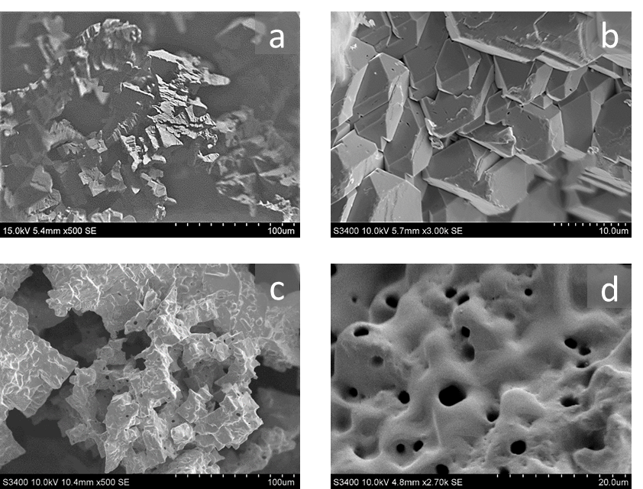

Figure 2

Figure 3
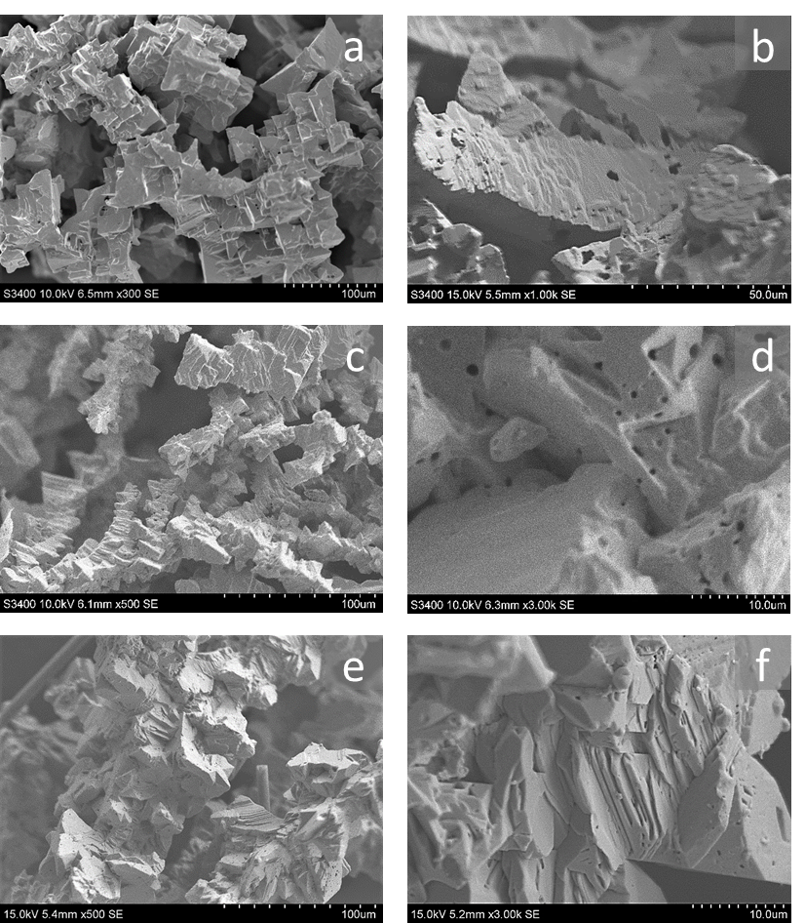

Figure 4
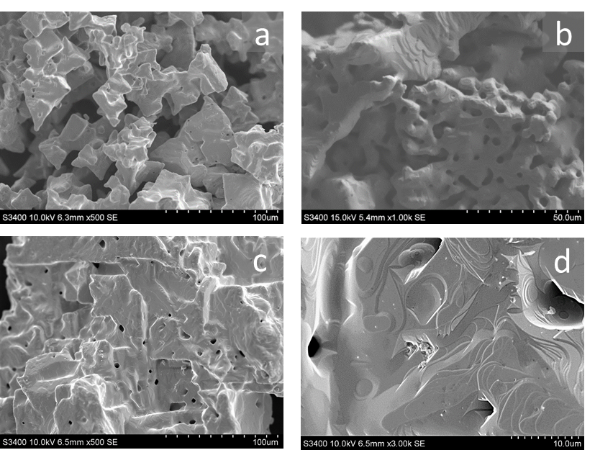

Figure 5
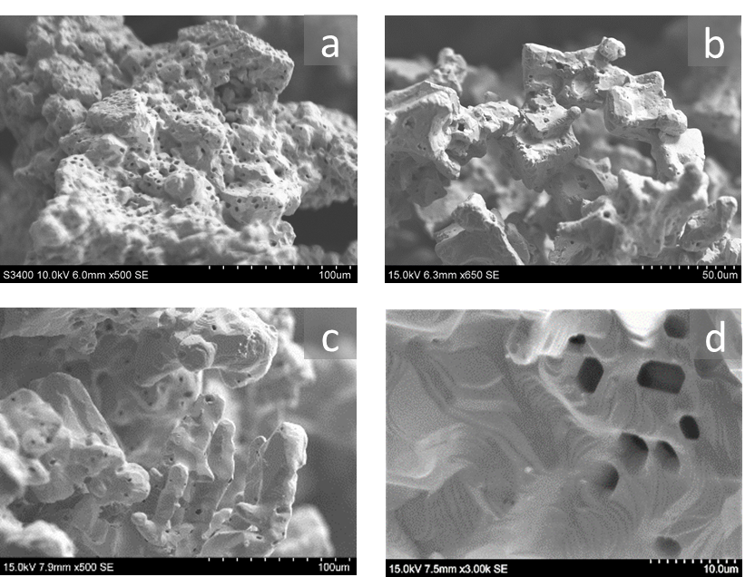

Figure 6
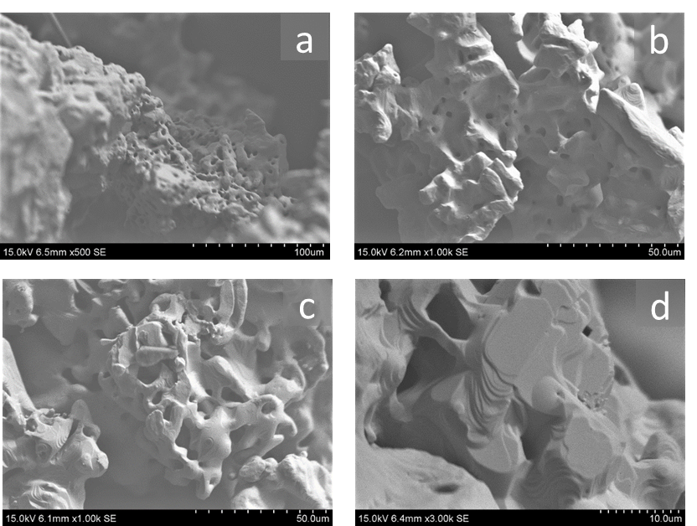

Figure 7

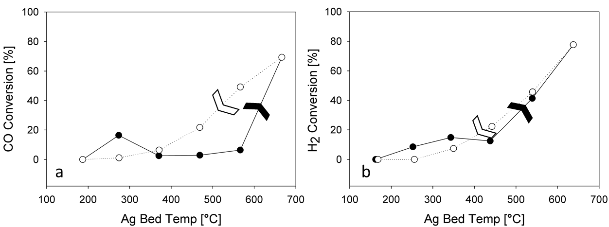

Figure 8

