Airplane braking friction on dry snow, wet snow or slush contaminated runways
Alex Klein-Paste^{a,1}
¹NTNU, dept. of Civil and Transport Engineering, Winter Maintenance Research Group, Høgskoleringen 7A, N-7491 Trondheim, Norway
Abstract. Airplanes need tire-pavement friction during taxiing, take-off and landing. The presence of snow reduces the friction and therefore there is need to understand how much friction can be expected on the different types of snow. This study analyses the braking performance of Boeing 737 airplanes on snow or slush contaminated runways. Airplane braking performance on runways contaminated with dry snow, wet snow and slush as analysed. The main finding is that airplanes experienced wet snow covered runways more often as very slippery, compared to slush covered runways. The fraction of the landings experiencing the conditions as “poor” or “less than poor” was significantly higher on wet snow (21%), compared to landings on slush (11%). This can be caused due to higher precipitation intensity during wet snow precipitation, or possibly because wet snow, in contrast to slush, is a compressible material that gets compacted and fills the underlying pavement texture.

1 Introduction
Airplanes need a certain amount of tire-pavement friction for retardation and directional control during taxiing, take-off and landing. The magnitude of the required friction depend mainly on the aircraft type, gross weight, runway length, cross wind, reversed engine thrust usage and pilot skills. The presence of snow or ice on runways reduces the available friction and therefore it is important that pilots get correct information on the prevailing runway conditions.

In aviation, snow and ice is considered as a type of runway contamination (such as oil, sand and rubber deposits) and are therefore referred to as "winter-contaminants. The available braking friction for airplanes is called the "braking action". Historically, the term originated from the subjective feeling of the pilots how well the aircraft responds (decelerates) when pressing the brake pedals. The braking action was expressed in a scale from 1 to 5, ranging from “poor” to “good” [1]. More recently the scale have been extended from 0 to 6 to indicate “less than poor” and “dry runway” respectively [2]. Nowadays it is possible to measure the braking action during the parts of the landings where the frictional conditions limit the total stopping distance [3].

Before operating on winter-contaminated runways, pilots calculate the required stopping distance based on the landing weight, wind and runway conditions. These calculations are known as performance calculations. To make the performance calculations pilots need accurate information on how much braking action can be expected. Historically, airports have estimated the braking action by conducting measurements with ground friction measurement devices (GFMD's) [4]. Unfortunately, it has proven difficult to establish a reliable correlation between actual aircraft braking performance and the readings of GFMD's on winter contaminated runways [5]. An alternative approach is to estimate the braking action based on descriptive data, such as the type, depth and spatial coverage of the contamination. This data is collected by means of a visual inspection, conducted by the ground personnel of the airport. The Talpa-Arc matrix [2] uses type, depth and temperature to estimate the braking action. Another model, known as the IRIS runway model also includes other parameters such as coverage, use of sand and chemicals, runway temperature and dew point [6]. To support further development of these models and provide a correct situation awareness, there is still a need for better understanding how aircraft perform under real-life operational winter conditions.

The Norwegian aerodrome operator Avinor performed a five-year R&D project, called IRIS (Intelligent Runway Information System) where it collected landing data and coupled this with reported runway condition information and weather data. The present paper presents a study using this dataset to investigate the differences in braking performance on dry snow, wet snow or slush.

2 Method
Data was collected during the winters 2008/2009 to 2012/2013 at different airports in Norway The number of airports increased from two in 2008/2009 to 15 in 2012/2013. Data from the Quick Access Recorder (QAR) was obtained from all landings of Boeing 737-600, 700, 800, 900 models that were operated by Scandinavian Air Services (SAS) and Norwegian Air Shuttle AS.

The airplane braking coefficient µ_{B} was determined by a methodology described earlier [3]. In short, the total retardation force during landing is measured and the contribution of wheel braking is determined. This provides an estimate of the used friction during the landing. Only when the airplane's anti-skid system becomes activated it is certain that the airplane utilized all of the available friction and µ_{B} can be determined. In these cases the landing distance is limited by the frictional conditions of the runway, hence denoted a friction limited landing (FL-landing). The obtained µ_{B} of the FL landings were interpreted into the common scale braking action scale, according to Table 1.

Table 1. Conversion of measured airplane braking coefficient into the common braking action scale [3].
airplane braking coefficient | Braking action
μ_{B} >0.2 | 5 – good
0.15 < μ_{B} ≤ 0.2 | 4 – medium / good
0.10 < μ_{B} ≤ 0.15 | 3 – medium
0.075 < μ_{B} ≤ 0.10 | 2 – medium / poor
0.05 < μ_{B} ≤ 0.075 | 1 – poor
μ_{B} ≤ 0.05 | 0 – less than poor

During operation under winter conditions, runway inspectors regularly enter the runway and report the surface conditions for each third of the runway length (called a RWY section). The frequency of these inspections varies with the conditions, but typically range in Norway between 30 minutes and eight hours. The type of the contamination (dry, wet, rime, dry snow, wet snow, slush, compacted snow, or ice), the depth (in mm), the spatial coverage (in %) and other relevant information such as the use of sand or anti-/de-icing chemicals is registered. Weather stations placed near the runway (within 500 meters) measured air temperature, runway temperature, dew point temperature and wind at one-minute intervals.

The GPS data from the QAR was used to identify on which runway section the FL state occurred and the braking friction coefficient µ_{B} was coupled with the observed runway condition of that section. The current size of the database is shown in Table 2. Only data from runways contaminated with dry snow, wet snow or slush with 100 % spatial coverage were used for the present analysis.

Table 2. Size of the landing database.
Number of winter seasons | 5
airports | 15
landings | 117849
FL-landings | 5097
RWY sections* | 353547
RWY sections with FL-landing | 6418
Number of FL-landings on
dry snow, 100% coverage | 135
wet snow, 100% coverage | 382
slush, 100% coverage | 221

3 Results
The measured aircraft braking coefficient on dry snow, wet snow and slush contaminated runways is plotted against runway temperature in Figure 1.

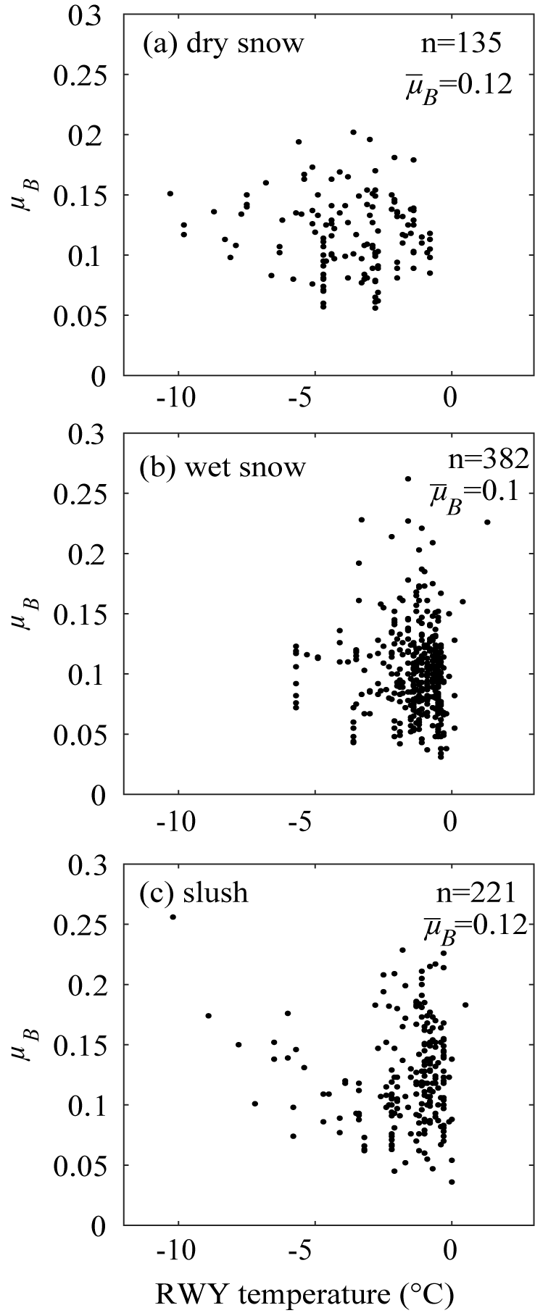
Figure 1. Airplane braking friction coefficient of FL landings on (a) dry snow, (b) wet snow, and (c) slush contaminated runways.

Figure 1 shows that there is a large scatter present for each type of runway contamination. The aircraft braking friction can range from below 0.05 (less than poor) to above 0.2 (good) in all three types of runway contamination. The average braking friction coefficient is very similar (ranging only between 0.1 and 0.12), but due to the large scatter, an average number has little value/meaning.

There is no clear temperature dependency visible for any of the contamination types. Again, the scatter in the data dominates the picture. Naturally, wet snow and slush mostly occur around 0°C. However, also at lower temperatures wet snow and slush can be present due to the usage of anti-/de-icing chemicals on runways.

Figure 2 presents the distribution of the µ_{B,} converted into the braking action scale (0-5) and the percentage of landings experiencing the runway as 0 (less than poor) or 1 (poor) is highlighted by the dashed rectangles.
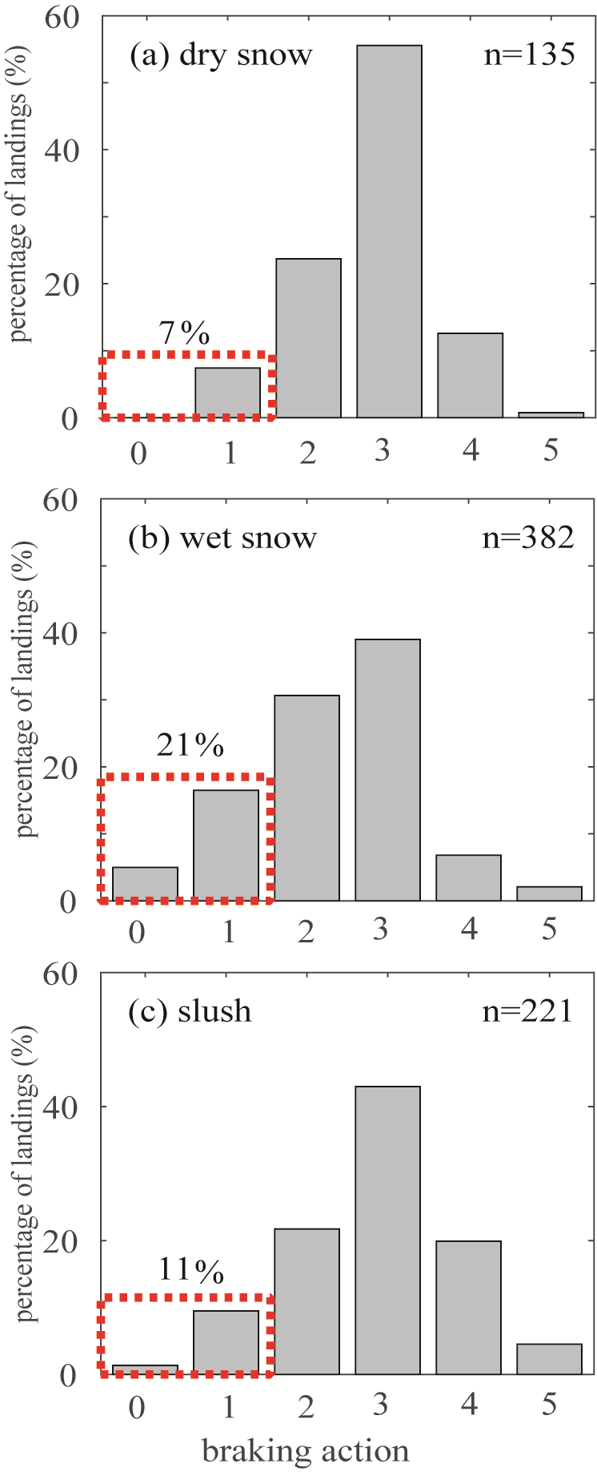
Figure 2. Distribution of braking action for landings on (a) dry
Snow, (b) wet snow, (c) slush. The red rectangles highlight the percentage of landings experiencing the runway as “less than poor” or “poor”.

On wet snow, 21 % of the landings experienced the runway as 0 or 1 (less than poor or poor). This percentage is significantly higher than on dry snow (7%) or slush (11%). Hence, the runways contaminated with wet snow were more often experienced as very slippery, compared to slush.

During operation under snowfall, airports have to close the runway regularly to perform snow clearance operation. In Norway, the runway inspector determines the need for a snow clearance operation. After the snow/slush is removed the runway is inspected before it re-opens for air traffic. The time difference between runway inspection and landing is called the report age and expresses how long snow can have accumulated before the landing took place. The report age distribution of landings on dry snow, wet snow and slush are shown in Figure 3.
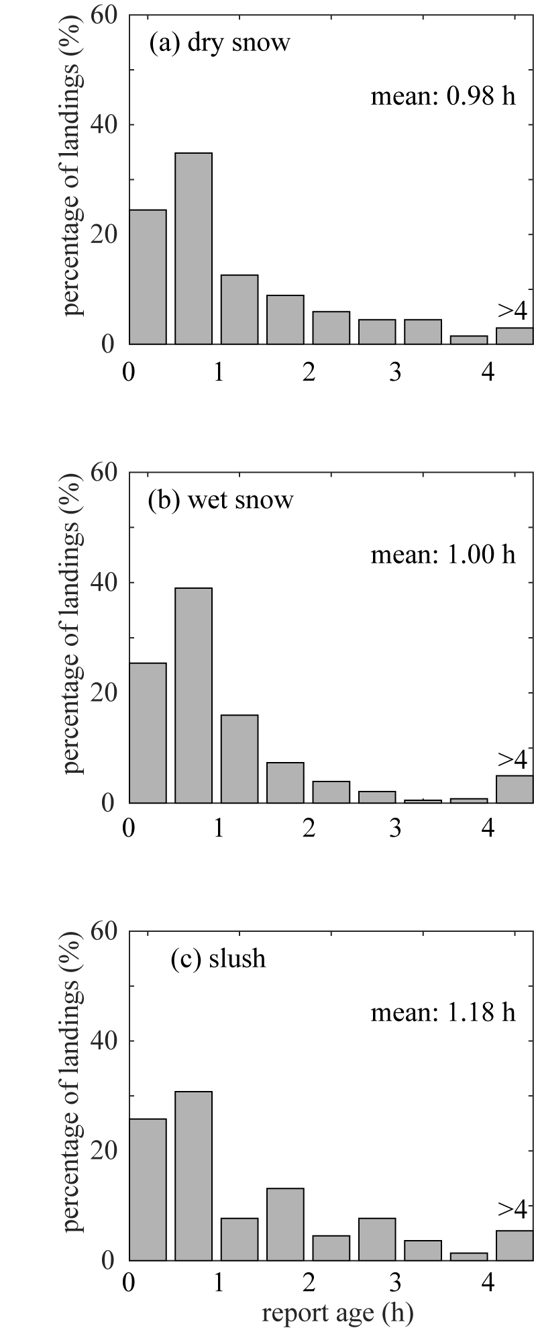
Figure 3. Distribution of the report ages (in hours) for the landings on (a) dry snow, (b) wet snow, and (c) slush.

Figure 3 shows that the distributions of the report ages are very similar. The average report time on slush is slightly higher (1.18 h), compared to dry snow (0.98 h) and wet snow (1.0 h). This means that there are no large differences in how long the airports maintain a runway open during precipitation of dry snow, wet snow or slush.

To calculate the amount of precipitation (in mm snow height) that had fallen between the last snow clearance and landing one needs high-resolution precipitation intensity data and integrate the intensity over the time between snow clearance and landing. One-minute precipitation intensity data (Optic Eye precipitation sensor) was only available for 207 landings on snow/slush. For these landings the accumulated precipitation (in geometrical snow/slush depth) was calculated and presented in Figure 4. One needs to bear in mind that there are uncertainties connected to measuring precipitation rates in geometrical snow depths, particularly on such short time scales of 0-4 hours. Hence, Figure 4 cannot give a definite answer, but should be viewed as an indication based on the available information.

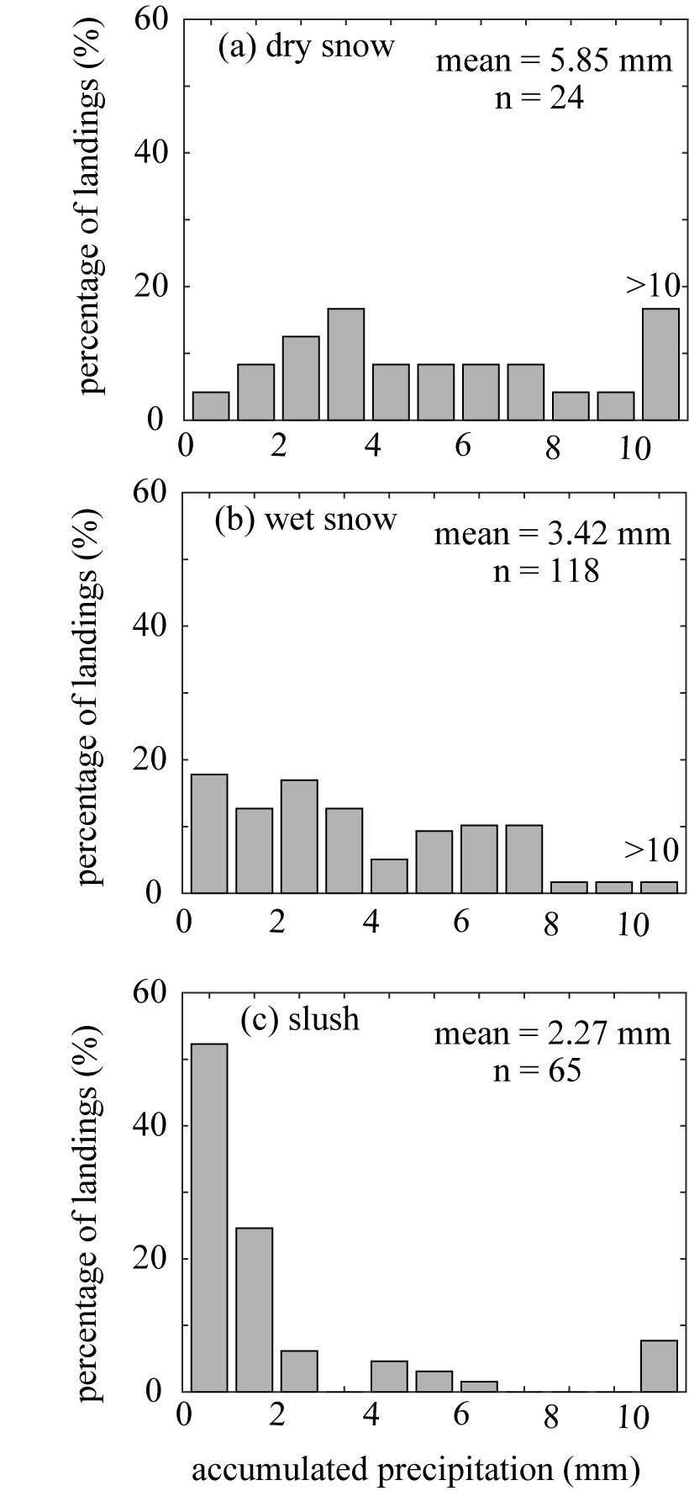
Figure 4. Distribution of the precipitation accumulated after the last runway condition report (in mm snow/slush depth) for the landings on (a) dry snow, (b) wet snow and (c) slush.
Figure 4 suggests that more dry snow was allowed to accumulate (on average about 6 mm), compared to wet snow (on average about 3 mm) and slush (on average about 2 mm).

4 Discussion
The main question that arises from this study is “why did the airplanes experience wet snow more often as “poor” or “less than poor”, compared to slush?” One explanation can be that more wet snow was allowed to accumulate, compared to slush, as suggested by Figure 4. If this is true, it is due to higher precipitation intensities, not because the airports kept the runways longer open when wet snow was present, as shown in Figure 3.
Another explanation can be that given amount wet snow on a pavement is in fact experienced more slippery, compared to the same amount of slush. This may be counter-intuitive within the aviation community, because slush has historically received more attention than wet snow. Slush mainly consists of water and ice particles and behaves like an incompressible fluid. The braking action on slush is mainly reduced because of hydroplaning. When a tire rolls on a pavement covered with an incompressible fluid, it is squeezing the fluid from under the footprint. This squeezing process generates pressures on the surface of the tire footprint [7], delaying or preventing it to get into contact with the underlying pavement. When full hydroplaning occurs it provides almost no braking action as the tire slides over the fluid film without reaching the pavement texture at all. Hydroplaning is largely speed dependent since the speed determines how much time is available for the squeeze out. However, it is also largely dependent on the fluid thickness. As long as the thickness is limited, the tire will be able to get at least partly in contact with the pavement texture and reasonably high amounts of braking action will be experienced. Since runways are regularly cleared and the accumulation of slush is limited, the danger of hydroplaning is effectively reduced.
But for wet snow, on the other hand, the way friction is lost differs from the case of slush. Wet snow is a compressible material, consisting of ice particles, water and considerable amounts of air. Being compressible, wet snow is much more difficult to squeeze out under the footprint. It rather compacts and fills the pavement texture when an external pressure is applied. An example of a thin layer of wet snow that was compacted by an aircraft tire is shown in Figure 5. The picture was made after the runway was cleared using a runway sweeper. All uncompressed wet snow was removed but the snow compacted by the tire was firmly attached to the pavement. Hence on wet snow, runways get slippery not because of hydroplaning, but because friction is created between the compacted wet snow and the tire.
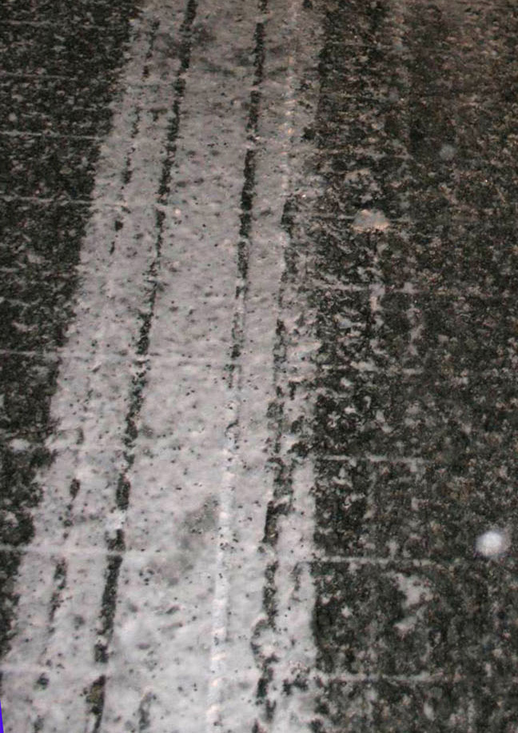
Figure 5. Example of a thin layer of wet snow compressed by a single aircraft tire passage. The runway sweeper was able to remove all loose wet snow, but not the snow compressed by the tire. The longitudinal grooves present in the aircraft tire can be recognized in the track.

This study only used Boeing 737-600,700 and 800 airplanes, hence the question arises to what extend the results are valid for other aircraft types. Airplane braking performance, in terms of required landing distance, is largely dependent on the type of airplane because it depends on many factors, for example the groundspeed over the runway threshold, the aircraft mass, its aerodynamic characteristics and effectiveness of reversed engine trust. This is why each airplane has its own set of equations and figures to calculate landing distances. These equations typically needs a measured or estimated braking friction coefficient as input. It is possible that the braking friction coefficients are to some extend affected by the aircraft type. Parameters like the normal load, tire inflation pressure and algorithms of the Anti-Skid system can influence how much friction can be created between the tire and the contaminated runway. Hence, a measured aircraft braking coefficient of one aircraft may not be exactly similar to the friction experienced by another aircraft on the same runway conditions. Nevertheless, the main result that the airplanes experience wet snow more often as “poor” or “less than poor”, compared to slush is likely to be valid for other aircraft types as well. The reason is that compression and compaction of wet snow occurs on all types of aircraft tires at all speeds (also low speeds). Hence wet snow is likely to be slippery also at the later stages of the landing where wheel braking is most critical. Slush on the other hand, is mainly slippery at high speeds where there it too little time available to assist the squeeze out of the material and hydrodynamic forces starts to carry a part of the normal load.
Historically, the aviation industry have had more focus on slush-contaminated runways, compared to runways contaminated with wet snow. This is partly due to the issue of increased rolling resistance and impingement drag [8], hampering take-off. But slush seems also to be considered more slippery as wet snow. This is for example reflected in the Talpa Arc matrix [2] where slush greater than 1/8 inch (approximately 3 mm) is considered as “medium-poor” whereas wet snow of the same depth is considered as “medium”. This study suggest that that view may need reconsideration.
Dedicated studies under controlled conditions, comparing the reduction of braking action on similar amounts of wet snow and slush would be very helpful to further understand how and how severely braking action can be lost due to the presence of wet snow and slush.

5 Conclusion
Airplane braking performance on runways contaminated with dry snow, wet snow and slush as analysed. The main finding is that airplanes experienced wet snow covered runways more often as very slippery, compared to slush covered runways. The fraction of the landings experiencing the conditions as “poor” or “less than poor” was significantly higher on wet snow (21%), compared to landings on slush (11%).

One reason for this difference can be that more wet snow had accumulated since the last snow clearance operation, as compared to slush. The airports did not keep runways contaminated with slush longer open, but the precipitation rates may have been higher during wet snowfall.

Another explanation for the difference can be that a limited amount wet snow can be experienced more slippery by airplanes, compared to the same amount of slush because the compressible wet snow gets easily compacted in the pavement texture.

Acknowledgements
This work was funded by the Norwegian Aerodrome operator Avinor and the data for this analysis was provided by Avinor’s IRIS project. The author thank Stig Jone Nevland, Avinor, for his support to the project. The author also thank Arne Bang Huseby, University of Oslo for his assistance for the required pre-processing of the data.

References

1. ICAO, International standards and recommended practice, Annex 15 Aeronautical Information Services Chapter 5 NOTAM. Eleventh edition ed. 2003: International Civil Aviation Organization.
2. Subbotin, N. and S. Gardner, Takeoff and Landing Performance Assessment Validation Effort of the Runway Condition Assesment Matrix. 2013.
3. Klein-Paste, A., et al., Braking performance of commercial airplanes during operation on winter contaminated runways. Cold Regions Science and Technology, 2012. 79-80: p. 29-37.
4. Andresen, A. and J.C. Wambold, Friction Fundamentals, Concepts and Methodology. 1999.
5. Boccanfuso, A. History of the Joint Winter Runway Friction Measurement Program. 2004. Transportation Development Centre, Transport Canada.
6. Klein-Paste, A., H.-J. Bugge, and A.B. Huseby, A decision support model to assess the braking performance on snow and ice contaminated runways. Cold Regions Science and Technology, 2015. 117: p. 43-51.
7. Van Es, G.W.H., Hydroplaning of modern aircraft tires. 2001, National Aerospace Laboratory NLR.
8. Giesberts, M.K.H., Test and evaluation of precipitation drag on an aircraft caused by snow and standing water on a runway. 2001.

