Title
Effect of Hydrogen on the Collective Behavior of Dislocations in the Case of Nanoindentation
Authors
Kai Zhao¹, Jianying He¹, A. E. Mayer², Zhiliang Zhang¹
Affiliation Address
1 NTNU Nanomechanical Lab, Department of Structural Engineering, Norwegian University of Science and Technology (NTNU), Richard Birkelandsvei 1a, Trondheim 7491, Norway
2 Department of Physics, Chelyabinsk State University, Br. Kashirinykh str. 129, Chelyabinsk 454001, Russia

Abstract
Most of the studies reported treats the effect of hydrogen on single dislocation line, while models that describe the collective interaction are missing. In this study, hydrogen-induced softening of metallic materials is studied from a perspective of collective behavior of dislocations. Building on the evolution of dislocation density, a hydrogen-informed expanding cavity model is developed for the first time to describe the dynamic evolution of load-displacement curve obtained from nanoindentation tests. Large-scale molecular dynamics simulations on the mechanical behavior of fcc Ni with and without hydrogen (H) charged are performed to calibrate the proposed continuum model. The results show that the H-induced decrease of indentation force is due to that the energy barrier for dislocation nucleation is lowered by the solute drag of the H atmosphere formed around dislocations. It is found that the power-law exponent of the self-organized criticality of dislocations increases due to the insertion of H atoms. Analysis also indicates that H can reduce the probability of dislocation pile-up, thus promote the delivery of dislocations to the surface of specimens during nanoindentation.

1. Introduction
It has been proved that hydrogen interstitials in metallic lattice can induce catastrophic damage of infrastructure materials, such as, pipeline steels. Hydrogen embrittlement (HE) is often referred to as the sudden failure of system with H charged at a stress level much lower than the fracture strength, although in numerous studies it has also been used to stand for H-induced blistering, vacancy formation, etc. One of the most accepted HE mechanisms is the hydrogen enhanced decohesion (HEDE) [1-4], which suggests that an atomically sharp crack-tip is facilitated due to the H induced bond weakening. In HEDE, dislocation activity is allowed, but has to be fairly limited so that the crack tip will not be blunted. However, with the development of advanced in-situ imaging and characterization techniques, it has been revealed that H can actually promote the multiplication of dislocations, which is precluded in HEDE mechanism. Thus, the so-called hydrogen enhanced local plasticity (HELP) mechanism has been proposed to explain the observed localized slip bands [5, 6] and enhanced dislocation motion [7-9] in H-charged specimens. Quote from the original definition by Birnbaum and Sofronis [10], HELP is built on the assumption that the insertion of H atoms can shield the repulsive interaction between neighboring dislocations, thus can be used to address the easier dislocation slip behavior [11, 12], reduction of yield stress [13-15] and some other softening phenomenon [16, 17] under H environment. H-induced increase of flow stress experimentally observed in Fe alloys [18-21], Al [22] and Ni alloys [23, 24] challenges the validity of HELP. In a recent atomistic study, Song and Curtin [25, 26] have illustrated that H atoms form Cottrell atmospheres around moving dislocations, and cause solute drag rather than facilitate the dislocation slip. Thus, the macroscopic softening in H-charged specimens cannot be expected, again challenging the HELP mechanism. This seems contrary to the former study [27], where the calculations show that the Snoek atmosphere accumulated around a [111] screw dislocation becomes asymmetrical under external stress and produces an additional stress which promotes the motion of dislocations.
Furthermore, the MD simulations of H-charged Ni and Pd under nanoindentation [28] indicate that the H-induced change of loading force originates only from the swelling of the metallic lattice, in another word, H atoms do not directly affect the nucleation of dislocations. A multiscale approach [29] proposed to predict the effect of H atoms on the onset of homogeneous dislocation nucleation (HDN) shows that, even low H concentration of ~ 1 at-% in Ni single crystal will lead to a large reduction of HDN energy barriers. The discrepancy can be expected due to the planar character of the core structure of screw dislocations in fcc lattice. Under the theoretical framework proposed by Kirchheim [30], solute induced softening is determined by the decrease of double kink formation energy, while hardening is related to the retarding of kink motion along screw dislocation. Although the multiscale details of HE are still under debate, the studies mentioned above demonstrate that the interaction between hydrogen and small-scale plasticity significantly influences the mechanical response of H-charged metallic materials. While these studies have been dedicated to treat the effect of H atmosphere on the motion of single dislocation line, no related researches have been performed to explore the H influence on the collective behavior of dislocation networks after hydrogen atoms are charged. Envisioned as a complex nonequilibrium process, recent experimental and theoretical studies [31-35] have demonstrated the intermittent and power-law behaviors caused by avalanches of dislocations motion in plastic deformation. The power-law distribution is reminiscent of self-organized criticality (SOC), where events of all magnitudes can occur. The well-known Abelian sandpile model (also known as the Bak-Tang-Wiesenfeld model) [36, 37] has been proposed to provide a phenomenological explanation for a wide range of dynamical systems from stock markets to sand dunes. While extensive studies have been performed for pure metals, no studies have been carried out to illustrate the SOC behavior under H environment. Thus, this work aims to capture the effect of H atoms on the power-law characteristic of small-scale plasticity via nanoindentation.
Due to the characteristic length of the specimen underneath the indenter is in the magnitude of the mean distance between dislocations, nanoindentation experiment can provide us a deep insight about the small-scale plastic behavior after elastic instability. The basic procedure of a nanoindentation process can be described as following: (a) elastic stage, an indenter with given geometry is pushed into the specimen surface, during which the maximum shear stress beneath the contact interface is lower than the critical resolved shear stress at any slip systems; (b) plastic stage, the dislocation emission is activated, and a characteristic phenomenon is the occurrence of sharp drop on the force-depth curve. While the traditional Hertzian model [38] can be used to describe the elastic response as a function of indentation depth, no corresponding model can be applied to predict the plastic response. In the study of nanovoid, Krasnikov and Mayer [39] have proposed a dislocation density based method to evaluate the void growth through the generation and slipping of dislocations. First established from Hill’s solution for the quasi-static expansion of an internally pressurized spherical shell [40], the expanding cavity model (ECM) [38] has been proposed to describe the indentation deformation by considering a hemi-spherical core beneath the indenter. It is assumed that this core is surrounded by a hemi-spherical plastic region outside. Thus, a similar dislocation density based model [41] is developed for nanoindentation with a spherical indenter. Furthermore, it is proved that H atoms can facilitate the homogeneous nucleation of dislocation loops [42]. Unlike a straight dislocation line, the dislocation loops formed beneath the indenter do not have a long-range stress field and can only trap H atoms near plastic deformation zone in the ECM model. Without doubt, the distribution of H atoms around a dislocation will affect its energetics and core structure, and thus the mobility [43-50]. We noticed that in either the HELP theory [10] or the nano-hydride formation mechanism proposed by Song and Curtin [25], only the elastic interaction between single dislocation and H atoms is investigated. Therefore, this work also involves the interaction between H atoms and collective behavior of dislocations by considering the H-induced decrease of nucleation energy [30] in the dislocation density based model [41].
While the results of numerous in-situ nanoindentation experiments have been the strong evidences of the HELP mechanism, the diffusion kinetics of H atoms coupled with the evolution of plasticity has not been reported. Here we have developed a theoretical framework based on the evolution of dislocation density to predict the elastic-plastic response of metallic materials under nanoindentation considering the kinetic diffusion of H interstitials from region far away from the contact surface. The basic assumption is that the diffused H atoms will finally be trapped in the plastic zone in Fig. 1, and contribute to lower the energy required for the formation of the dislocation loop emitted from the contact surface, meanwhile form a cloud of Cottrell atmosphere around dislocations and thus affect their motion. As mentioned above, the main goal of this paper is to understand the effect of H atmosphere on the collective behavior of dislocation networks using the Abelian sandpile model [36, 37] and to establish a newly proposed hydrogen-informed expanding cavity (HEC) model. Large-scale molecular dynamics (MD) simulations are performed to calibrate and verify the proposed continuum model. The manuscript is organized as follows: atomistic simulation details and analytical framework are given in Section 2; numerical results are discussed in Section 3; discussions are made in Section 4.

2. Analytical model and computational methodology
2.1 Theoretical framework
Inspired by the Krasnikov-Mayer plasticity model [39] describing the growth of a nanovoid, here a dislocation-density based analytical hydrogen-informed expanding cavity (HEC) model is developed to explicitly involve the nucleation of dislocations during indentation process. The basic idea is shown in Fig. 2, which is designed to navigate the understanding of this continuum model. According to the strain gradient elasticity solution of the expanding cavity model [51, 52] of nanoindentation, the principal stresses within the interior of specimen underneath the spherical indenter read as,
$σ_{rr}=-\frac{2σ_{Y}}{3}\left(1-\frac{r_{c}^{3}}{r_{o}^{3}}\right)+2\left[\frac{κ}{3n}{\left(\frac{σ_{Y}}{E}\right)}^{n}\left(1-\frac{r_{c}^{3n}}{r^{3n}}\right)-\frac{6Cσ_{Y}}{5E}\frac{1}{a^{2}}\frac{r_{c}^{3}}{a^{3}}\left(\frac{a^{5}}{r_{c}^{5}}-\frac{a^{5}}{r^{5}}\right)\right]$ (2.1-a)
$σ_{θθ}=-\frac{2σ_{Y}}{3}\left(1-\frac{r_{c}^{3}}{r_{o}^{3}}\right)+2\left[\frac{κ}{3n}{\left(\frac{σ_{Y}}{E}\right)}^{n}\left(1+\left(\frac{3n}{2}-1\right)\frac{r_{c}^{3n}}{r^{3n}}\right)-\frac{6Cσ_{Y}}{5E}\frac{1}{a^{2}}\frac{r_{c}^{3}}{a^{3}}\left(\frac{a^{5}}{r_{c}^{5}}+\frac{3}{2}\frac{a^{5}}{r^{5}}\right)\right]$ (2.1-b)
where $σ_{Y}$ is the yield strength, $E$ is the Young’s modulus, $κ,n,C$ are the constitutive parameters of the elastic-plastic material [53], $a$ is the contact radius, i.e. the inner radius of the plastic region, and $r_{c}$ is the outer radius. For the continuity of hardening behavior at yield strain, the strength coefficient $κ$ is defined as [54],
$κ=σ_{Y}{\left(\frac{E}{σ_{Y}}\right)}^{n}$ (2.2)
For the sake of simplicity, here we use a linearly elastic – perfectly plastic material, i.e. n = 0,
$σ_{rr}=-\frac{2σ_{Y}}{3}\left(1-\frac{r_{c}^{3}}{r_{o}^{3}}\right)-\frac{12Cσ_{Y}}{5E}\frac{1}{a^{2}}\frac{r_{c}^{3}}{a^{3}}\left(\frac{a^{5}}{r_{c}^{5}}-\frac{a^{5}}{r^{5}}\right)$ (2.3-a)
$σ_{θθ}=-\frac{2σ_{Y}}{3}\left(1-\frac{r_{c}^{3}}{r_{o}^{3}}\right)-\frac{12Cσ_{Y}}{5E}\frac{1}{a^{2}}\frac{r_{c}^{3}}{a^{3}}\left(\frac{a^{5}}{r_{c}^{5}}+\frac{3}{2}\frac{a^{5}}{r^{5}}\right)$ (2.3-b)
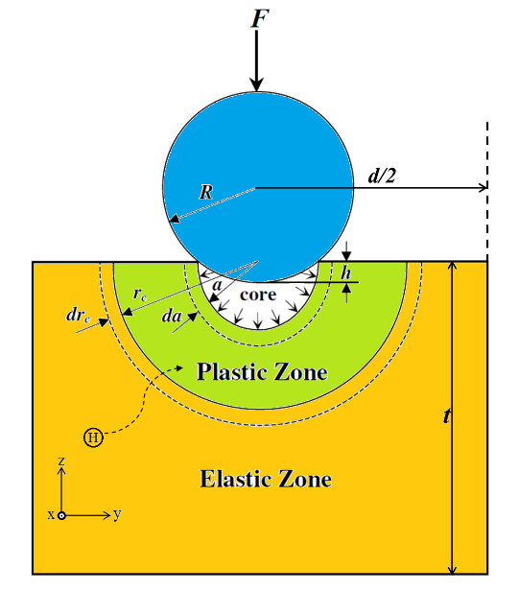
Fig. 1 Schematic showing of a nanoindentation system under H environment.
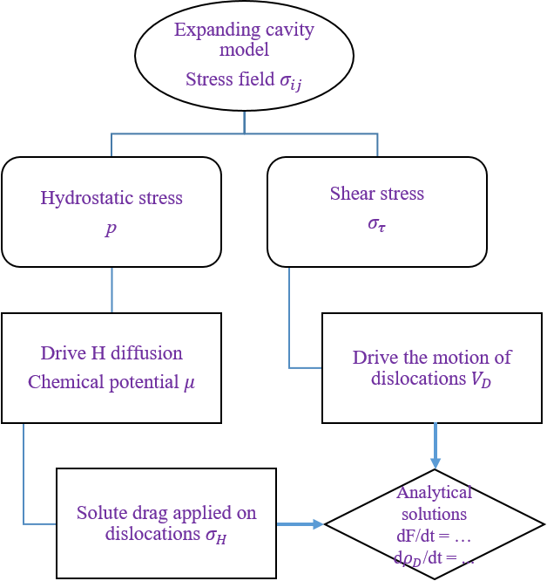
Fig. 2 Flow chart of the computational HEC framework organized in Section 2.1.

Following the kinetic paradigm proposed by Song and Curtin [25, 26, 43], we assume that the H atoms are driven to the plastic zone around the ‘void’ surface by the chemical potential. The hydrostatic stress inside a system under the spherical indenter reads,
$p=\frac{1+v}{3}\left\{-\frac{4σ_{Y}}{3}\left(1-\frac{r_{c}^{3}}{r_{o}^{3}}\right)-\frac{12Cσ_{Y}}{5E}\frac{1}{a^{2}}\frac{r_{c}^{3}}{a^{3}}\left(2\frac{a^{5}}{r_{c}^{5}}+\frac{1}{2}\frac{a^{5}}{r^{5}}\right)\right\}$ (2.4)
where $v$ is the Poisson’s ratio of the material. According to the solution theory, the chemical potential for an H atom can be written as,
$μ=μ_{0}+k_{B}Tln\frac{c_{H}}{1-c_{H}}+pΩ$ (2.5)
where $c_{H}$ is the equilibrium local H concentration at (r, θ), $Ω$ is the partial volume of H, k_{B} is the Boltzmann constant, and $μ_{0}$ is a constant. The driving force for H atom diffusion toward the plastic zone is,
$\overset{⃑}{F}=-∇μ=-k_{B}T\frac{1}{c_{H}\left(1-c_{H}\right)}∇c_{H}+Ω∇p$ (2.6)
Away from the immediate plastic zone, the H concentration $c_{H}≪1$ is small, thus the dominant driving force is manifested by the stress field of the nanoscale contact,
$\overset{⃑}{F}=-\frac{2Ω(1+v)Cσ_{Y}r_{c}^{3}}{E}\frac{1}{r^{6}}{\overset{⃑}{e}}_{r}$ (2.7)
with ${\overset{⃑}{e}}_{r}$ being a unit radial vector pointing towards the central point of the contact surface. Then the radial velocity of H atoms is,
$V_{r}=-\frac{dr}{dt}=-\frac{D}{k_{B}T}{\left(∇μ\right)}_{r}=\frac{2(1+v)DΩCσ_{Y}r_{c}^{3}}{k_{B}TE}\frac{1}{r^{6}}$ (2.8)
where $D$ is the diffusion coefficient of H atoms. According to Song and Curtin [25, 26], after a time t all H atoms within a radius $r=R_{H}$ can arrive at the outer boundary of the plastic zone $r\sim r_{c}$,
$R_{H}={\left(\frac{14(1+v)DΩCσ_{Y}tr_{c}^{3}}{k_{B}TE}+r_{c}^{7}\right)}^{1/7}$ (2.9)
The number $N_{H}/L_{x}$ of H atoms per unit length in the plastic zone at time t is,
$\frac{N_{H}}{L_{x}}(t)=\frac{2c_{0}}{a_{0}^{3}}\int_{-π}^{0}{\frac{R_{H}^{2}}{2}dθ}=\frac{πc_{0}}{a_{0}^{3}}{\left(\frac{14(1+v)DΩCσ_{Y}tr_{c}^{3}}{k_{B}TE}+r_{c}^{7}\right)}^{2/7}$ (2.10)
where $L_{x}$ is the length of specimen along the direction perpendicular to the 2D model shown in Fig. 1, $c_{0}$ is the hydrogen concentration far away from the plastic zone. Assuming $F_{ind}$ is the force applied on the specimen, the contact radius can be determined as [55],
$a={\left[\frac{3}{8}\frac{\left(1-υ^{2}\right)}{E}2RF_{ind}\right]}^{1/3}$ (2.11-a)
${\left(\frac{r_{c}}{a}\right)}^{3}=\frac{1}{4}\frac{E}{σ_{Y}}\frac{a}{R}$ (2.11-b)
where $R$ is the radius of the spherical indenter-tip. Thus, the shear stress is,
$σ_{τ}=\frac{σ_{rr}-σ_{θθ}}{2}=\frac{3Cσ_{Y}}{Er_{c}^{2}}{\left(\frac{r_{c}}{r}\right)}^{5}$ (2.12-a)
If we make $\overline{r}=r/r_{c}$ and ${\overline{σ}}_{Y}=σ_{Y}/E$, the equation above can be rewritten as,
$σ_{τ}=\frac{3C{\overline{σ}}_{Y}}{r_{c}^{2}}{\left(\frac{1}{\overline{r}}\right)}^{5}=σ_{τ}^{max}{\left(\frac{a}{r}\right)}^{5}$ (2.12-b)
with $σ_{τ}^{max}$ is the shear stress at the virtual void surface:
$σ_{τ}^{max}=\frac{3C{\overline{σ}}_{Y}}{r_{c}^{2}}{\left(\frac{a}{4{\overline{σ}}_{Y}R}\right)}^{5/3}$ (2.13)
The total indentation depth can be considered as the sum of the elastic displacement $h_{e}$ and plastic displacement $h_{p}$. Thus, for an increment of penetration depth $dh$, taking the time derivative, we have,
$\frac{dh}{dt}={\dot{h}}_{e}+{\dot{h}}_{p}=v_{i}$ (2.14)
where $v_{i}$ is the indenter velocity. According to the Hertzian theory, the elastic displacement is a function of the applied force,
$h_{e}={\left(\frac{3F_{ind}}{4E^{*}\sqrt{R}}\right)}^{2/3}$ (2.15)
where $E^{*}$ is the reduced modulus. To relate the loading rate with the deformation of plastic zone, the plastic component can be written as,
${\dot{h}}_{p}=\left(r_{c}-a\right)\dot{ω}$ (2.16)
Thus, we can obtain the following ordinary differential equation (ODE) for the force evolution,
$\frac{dF_{ind}}{dt}=\frac{3}{2}F_{ind}^{1/3}\left[v_{i}-\left(r_{c}-a\right)\dot{ω}\right]/{\left(\frac{3}{4E^{*}\sqrt{R}}\right)}^{2/3}$ (2.17)
The characteristic deformation rate $\dot{ω}$ can be described by Orowan equation,
$\dot{ω}=\frac{b}{\sqrt{6}}V_{D}ρ_{D}$ (2.18)
where $b$ is the module of Burgers vector, $V_{D}$ is the dislocation velocity, and $ρ_{D}$ is the scalar density of dislocations. The dislocation velocity can be derived using the following equation of motion [39, 56],
$βV_{D}=b\left[σ_{τ}^{max}-σ_{Y}/2\right]∙{\left[1-{\left(V_{D}/c_{t}\right)}^{2}\right]}^{3/2}$ (2.19)
where $β$ is the phonon frition coefficient increasing with temperature [57]. Eq.(2.19) represents the balance of forces applied on dislocation by considering the quasi-relativistic effect: the phonon drag force is equal to the force caused by external stress field excluding the static yield strength $σ_{Y}$.The dislocation nucleation can be described by a typical thermo-activated process equation for the probability of critical thermal fluctuation from the classical nucleation theory. The dislocation density evolution can be divided into the contributions of homogeneous and heterogeneous multiplication and net annihilation,
$\frac{dρ_{D}}{dt}={\left(\frac{dρ_{D}}{dt}\right)}_{hom}+{\left(\frac{dρ_{D}}{dt}\right)}_{het}-{\left(\frac{dρ_{D}}{dt}\right)}_{ann}$ (2.20)
where the first term can be written as,
${\left(\frac{dρ_{D}}{dt}\right)}_{hom}=ξ∙L∙N∙N_{1}∙Π=\frac{πc_{t}}{d^{3}}\left(\frac{2πb\left(r_{c}^{2}-a^{2}\right)}{a_{cr}^{3}}\right)exp\left(-\frac{ΔE_{c}}{k_{B}T}\right)$ (2.21)
where $ξ=c_{t}/2a_{cr}$ is the (attempt) characteristic frequency for dislocation emission, $L=2πa_{cr}$ is the length of the emitted dislocation loop, $N=1/d^{3}$ ($d$ is the edge length of the cube shown in Fig. 1) is the number of areas close to the contact surface where the dislocation nucleation occurs, and the number of nucleus in the plastic zone can be estimated as $N_{1}=2πb\left(r_{c}^{2}-a^{2}\right)/a_{cr}^{3}$. The probability of thermal fluctuation leading to the dislocation nucleation is estimated as [39],
$Π=exp\left(-\frac{ΔE_{c}}{k_{B}T}\right)=exp⁡\left(-\frac{πϵ_{s}^{2}}{2bτ_{max}k_{B}T}\right)$ (2.22)
As illustrated by Krasnikov and Mayer [39], large amount of studies have been dedicated to consider this Arrhenius process in the case of preexisting void. In order to evaluate the energy change,
$∆E_{c}=E_{se}-E_{σ}$ (2.23)
where $E_{se}$ is the formation energy of a semi-circular dislocation from a void surface, and $E_{σ}$ is the reduction of the elastic energy due to external stress. The energy of dislocation line with curvature radius $r_{d}$ can be taken in simple form $E_{se}=πr_{d}ϵ_{s}$, where $ϵ_{s}$ is the formation energy of dislocation per unit length, which typically ranges from ~ 0.2 to 0.4 eV/b [58]. The elastic energy is,
$E_{σ}=\left(σ_{τ}-σ_{H}\right)b\frac{πr_{d}^{2}}{2}$ (2.24)
where according to the Fleischer-Friedel (FF) theory, the solute drag stress due to H pinning can be written as [59, 60],
$σ_{H}^{FF}=\frac{f_{m}^{3/2}\sqrt{c_{H}}}{b\sqrt{2sΓ_{l}}}$ (2.25)
where $s=b^{2}\sqrt{3}/2$ is the atomic area in the glide plane, $Γ_{l}$ is the dislocation line tension (for the screw $Γ_{s}=E_{Ls}(1+v)/(1-v)$ while for the edge $Γ_{e}=E_{Le}(1-2v)$, with the classical line energy of a straight dislocation is $E_{L}=μb^{2}/2$, and for the screw $E_{Ls}=0.61E_{L}$ and for the edge $E_{Le}=0.95E_{L}$), and with H induced obstacle strength is,
$f_{m}=\overline{α}μb^{2}$ (2.26)
where $\overline{α}$ is the mean pinning coefficient. Unfortunately, $\overline{α}$ is difficult to determine a priori for H interstitials, hence we treat it as an adjustable parameter. To a first approximation, we can assume that for a semi-circular loop, the dislocation line tension is,
$Γ_{l}=\frac{Γ_{s}+Γ_{e}}{2}$ (2.27)
An alternative theory for solute drag is so called Mott-Nabarro-Labusch (MNL) model [59, 60], which considers the collective interaction of random solute atoms, not only the ones in the glide plane,
$σ_{H}^{MNL}={\left(\frac{2wf_{m}^{4}c_{H}^{2}}{b^{3}s^{2}Γ_{l}}\right)}^{1/3}$ (2.28)
where w is the interaction range of an obstacle defined in the solid solution hardening theory. According to Patinet and Proville [60], this characteristic length can be approximated as one half of the core width, ~ 1.3b. The local concentration of H atoms is,
$c_{H}\left(r,ϕ\right)=\frac{N_{H}/L_{x}}{\frac{π}{2}\left(r_{c}^{2}-a^{2}\right)}$ (2.29)
Minimizing $∆E_{c}$ with respect to the loop radius $r_{d}$ yields the critical radius,
$r_{cr}=\frac{ϵ_{s}}{b(σ_{τ}-σ_{H})}$ (2.30)
Thus, the energy required for the nucleation of a semi-circular loop is,
$ΔE_{Dc}=\frac{πϵ_{s}^{2}}{2b(σ_{τ}-σ_{H})}$ (2.31)
The second term in Eq.(2.20) can be described by connecting the energy irreversible spending on the plastic deformation and the energy of dislocation formation in continuum mater,
${\left(\frac{dρ_{D}}{dt}\right)}_{het}=\frac{0.1}{ϵ_{D}}\left(b∙σ_{τ}^{max}∙V_{D}\right)ρ_{D}$ (2.32)
where $ϵ_{D}$ is the line energy of dislocation per unit length [61, 62]. The third term in Eq.(2.20) comes from the dislocation annihilation, which reads as [63, 64],
${\left(\frac{dρ_{D}}{dt}\right)}_{ann}=k_{a}bV_{D}ρ_{D}^{2}$ (2.33)
where $k_{a}$ is the annihilation factor, which is increasing with temperature [64]. Thus, the total rate of dislocation production is,
$\frac{dρ_{D}}{dt}=\frac{πc_{t}}{2d^{3}}\left(\frac{2πR^{2}b}{a_{cr}^{3}}\right)exp\left(-\frac{ΔE_{Dc}}{k_{B}T}\right)+\frac{0.1}{ϵ_{D}}\left(b∙σ_{τ}^{max}∙V_{D}\right)ρ_{D}-k_{a}bV_{D}ρ_{D}^{2}$ (2.34)
By numerically solving the ordinary differential equations Eq.(2.17)&(2.34) with a fourth order Runge-Kutta method, the force-depth relationship can be evaluated under different experimental settings, such as, H concentration, indenter radius, specimen size, loading rate etc. Optimized by comparing with MD results, the default setting of parameters used in numerical implementation is shown in Table 1. We can find that H charging mainly affect the annihilation of dislocation network in present model. This actually indicates that the insertion of H atoms affects the collective behavior of dislocations, and will be verified further by MD simulations.

Table 1. The materials parameters used in the numerical implementation.
Parameters | Value
 | Pure Ni | Ni-H system
Burgers vector $b$ | 0.083 nm
Diffusion coefficient at 0 K | - | 3.84$×$10⁻⁶ m²/s
Diffusion activation barrier | - | 45.72 kJ/mol
Dislocation annihilation factor $k_{a}$ | 16.65 | 7
Dislocation formation energy $ϵ_{s}$ | 0.136 eV
Dislocation line energy $ϵ_{D}$ | 8 eV/$b$
Shear modulus $G$ | 76 GPa
Strain hardening parameter $n$ | 0.06
Strain gradient coefficient $C$ | 1.093 N
Partial volume of H atom in Ni lattice | - | 3.39 Å³
Phonon friction coefficient $β$ | 1.4$×$10⁻¹⁴ GPa$∙$s
Poisson’s ration $ν$ | 0.31
Transverse (Shear) sound velocity $c_{t}$ | 2.97 km/s
Yield strength $σ_{Y}$ | 0.13 GPa
Young’s modulus $E$ | 250 GPa

2.2 Simulation details
In order to verify the theoretical predictions formulated above, LAMMPS code [65] is employed to perform atomistic simulations in this paper. The particle interaction between Ni and H atoms is described by a widely-used embedded atom method (EAM) potential [66]. A Finnis-Sinclair type EAM potential [67] is used to compute the pairwise interactions of pure Ni. Indentation is carried out using a rigid spherical indenter tip [68]. The specimen shown in Fig. 1 is built as a cube with the edge length equals to 400 Å. The periodic boundary condition is applied along the x- and y- axis in Cartesian coordinate. The time step for velocity-Verlet integration is set as 1 fs. Before applying indentation loading, the system is relaxed in a NPT ensemble for 100 ps, carried out at 300 K and 0 bar (only applied along x- and y- directions) with Nosé-Hoover thermostat and barostat. The H atoms are randomly seeded in the specimen, and followed by a conjugate gradient equilibration and another NPT relaxation for 250 ps. Then, the indentation loading is applied along z-axis by penetrating a spherical indenter (with a tip radius of 60 Å) into the specimen upper-surface with a fixed velocity (0.5 Å/ps). The defects detection is conducted by using the dislocation extraction algorithm (DXA) [69]. During the modelling, we calculate the common neighbor analysis (CNA) [70, 71] and centro-symmetry parameters (CSP) [68] for post-processing. The defective structures are visualized in OVITO [72].

3. Results and discussions
3.1 Indentation force-depth curves
The MD results and analytical predictions of nanoindentation force as a function of depth under different H concentrations are compared in Fig. 3, where the obvious decreasing of critical force caused by H insertion in MD simulations is observed. However, it seems that the H amount is not a key factor to control the flow behavior. In present simulations, 1000 H atoms means a H-concentration of 0.0168%, which is much smaller than that used in Ref [28]. The FF and MNL models for hydrogen drag described in Section 2.2 were examined by comparing their predictions of the force v.s. depth relation at a given H concentration. Here, MNL model predicts a lower force after yielding compared with FF model. This difference conforms to the underlying mechanisms of these two models [73], in which the FF model considers the strong-pinning between dislocation induced lattice misfit and the solute distortion, while the MNL model is developed in a perspective of weak-pinning. The analytical prediction of HEC model agrees well with MD results at ‘elastic’ stage, where dislocations have been generated actually. We can observe that the analytical model predicts a larger indentation force after yielding, compared to MD results. This is due to the fact that in MD specimens the H atoms are dispersively distributed in the whole simulation box, while the analytical model assumes that the H atoms tend to diffuse and concentrate locally around the void surface. Only when the penetration depth is large enough, the radius of plastic zone becomes comparable with the specimen size. Thus, we can expect a good agreement between analytical prediction and MD simulations when the penetration depth is larger than ~ 70 Å as shown in Fig. 3. Additionally, in real nanoindentation experiments where the loading rate is much lower than the diffusivity of H atoms, we can expect a better agreement, because with the dynamical movement of indenter, H atoms can always immediately reach the vicinity of void surface under the driving of chemical potential. The discussion here further points out that to achieve an accurate description of the interaction between H diffusion and plastic deformation, a mixed scheme of Monte Carlo relaxation and MD simulation should be applied in future studies. It has to be mentioned that unfortunately due to the lack of the study about H as a solution in Ni system, we can only use the parameters obtained from Ni/Al interaction [60]. Further attentions should be paid in dealing with H-induced drag force, because the state of the art atomistic simulations cannot define the cutoff distance in MNL model due to the 1/r scaling of the solute/dislocation interaction energy [74]. It should be noticed the treatment of H drag force employed in the theoretical framework above is based on the assumption that the insertion of H atoms in octahedral sites does not significantly alter the core structure of dislocations. And this criterion is supported by a recent study of core energy and Peierls potential of both edge and screw dislocation in H-decorated bcc Fe [47], although the research of fcc metal is expected in the future. It should be noted that the jerky behavior after first force drop in MD curve could not be correctly captured by present analytical model, which does not contain a term representing stochastic dislocation avalanche in Eq.(2.33).
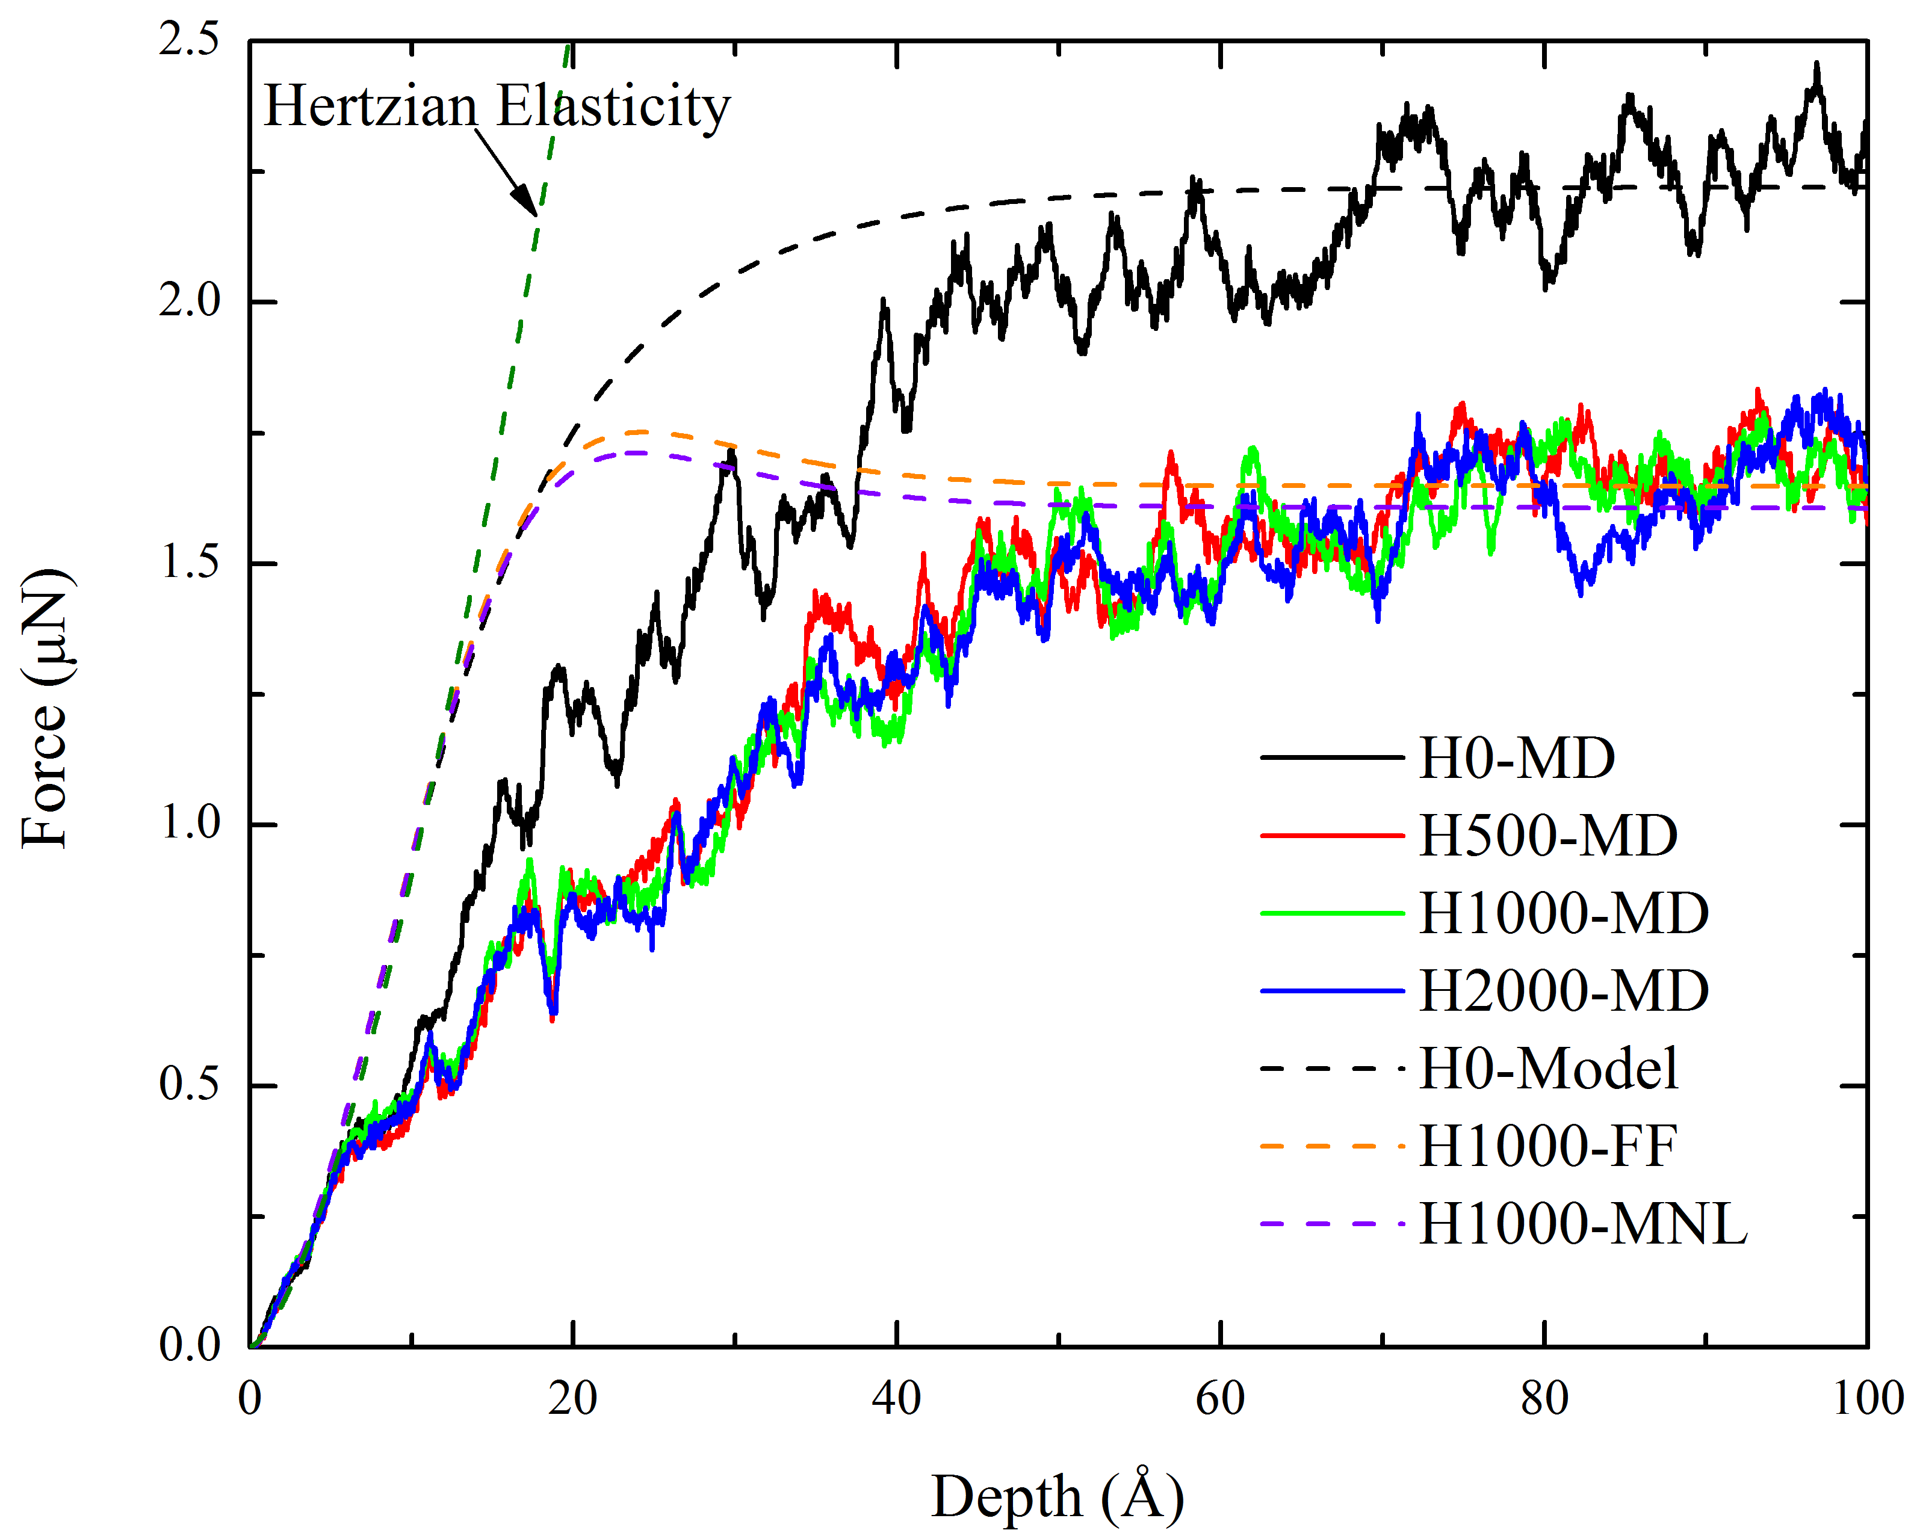
Fig. 3 Indentation force as a function of depth under different H concentrations. All MD specimens (solid lines) have a fixed amount of Ni atoms (5,952,168), and different numbers of H atoms, i.e. 0, 500, 1000 and 2000, respectively. The indenter velocity is 50 m/s, and the indenter tip radius is 6 nm. The analytical model (dash lines) is solved for the pure Ni and the system charged with 1000 H atoms scenarios.
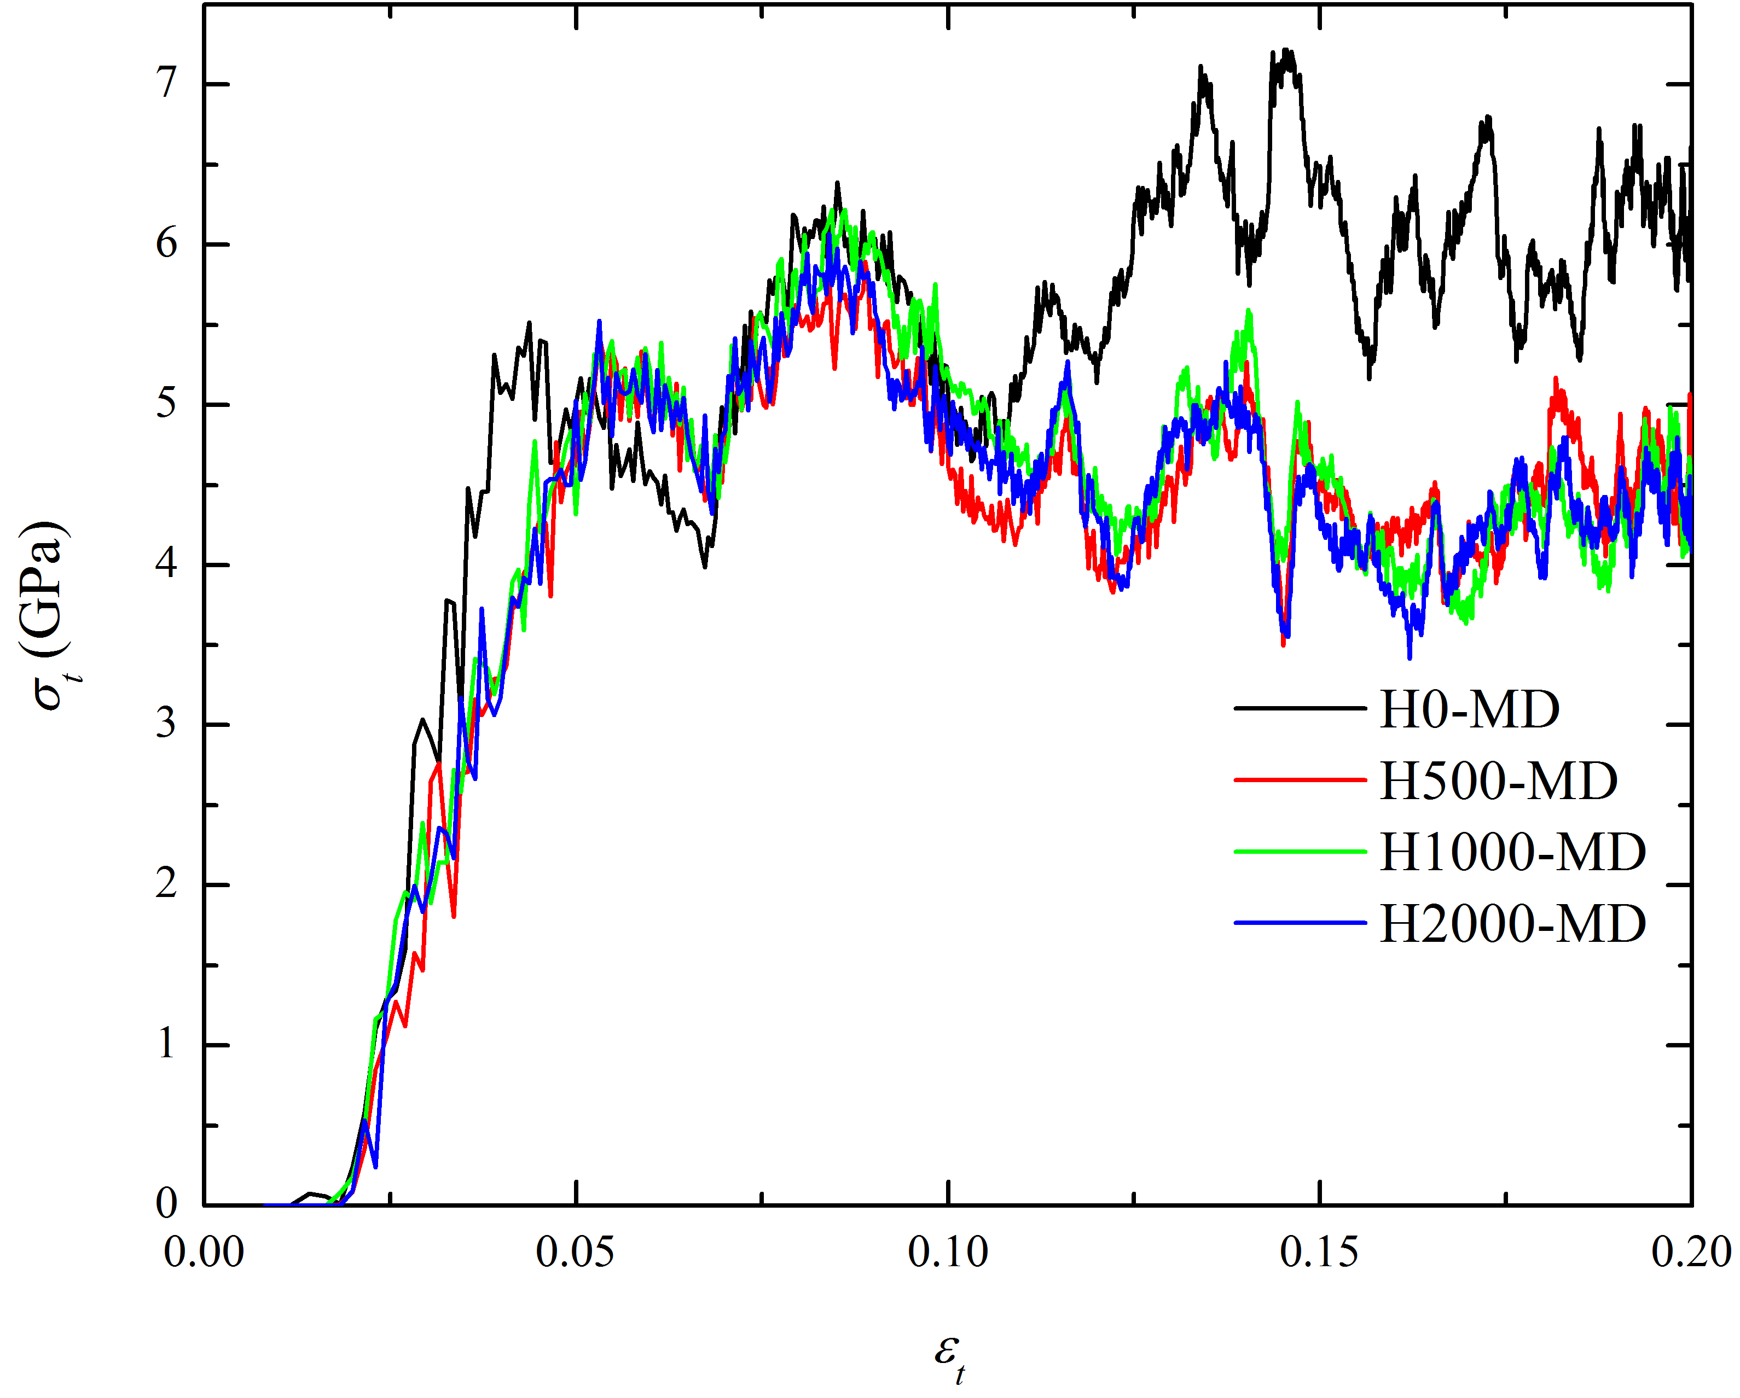
Fig. 4 Equivalent flow stress as a function of strain under uniaxial tension with different numbers of H atoms charged.

Based on experiments of metals, Tabor [75] proposed the following relation between flow stress and strain in uniaxial tension equivalent to the corresponding indentation test.
$σ_{t}=\frac{p_{m}}{ψ}=\frac{F_{ind}/A}{ψ}$ (3.1)
$ε_{t}=0.2\frac{a}{R}$ (3.2)
where $σ_{t}$ and $ε_{t}$ are flow stress and strain in uniaxial tension, $p_{m}$ is mean indentation pressure, $ψ$ is the plastic constraint factor (taken as 3 [54, 75]), $A$ is the cross-sectional contact area of the indenter. Fig. 4 shows that the flow stress decreases after hydrogen charging. During the nanoindentation of a pure single crystal, the hardening mechanisms, such as, grain size reduction and solid-solution hardening, are absent and the flow stress is mainly affected by the dislocation movement, i.e. the classic Taylor relation $σ∝\sqrt{ρ_{D}}$ [76]. Thus, the H induced decrease of flow stress suggests a corresponding decrease of the dislocation density. Once the H atoms are charged into the Ni specimens, it seems that the flow stress is not dependent on the change of H amount. This may indicate that the dislocation density will not be further decreased even more H atoms are charged.
In Fig. 5, we calculated the percent of defective Ni atoms in Ni-H systems under continuous indentation in MD simulations. When the indentation depth is larger than ~ 50 Å, the density of defective atoms in Ni-H systems is lower than that of pure Ni, which demonstrates that H addition will suppress the multiplication of dislocations. The amount of inserted H atoms does not affect the dislocation evolution significantly. In the snapshots shown in Fig. 6 (a)&(d), it is found that stacking fault ribbons are nucleated on the contact surface. Then, as shown in Fig. 6 (b)&(e), in pure Ni we can observe the dislocation loops are emitted along four <011> crystalline directions simultaneously, while in Ni-H2000 system this emission activity is suppressed. Thus, we can expect in pure Ni, the emitted loops will finally approach each other and form stacking fault tetrahedron (SFT) known as a strong obstacle for the motion of dislocations. The dislocations emitted from the contact surface will be impeded by SFTs and pile up in the upper half of the simulation box. However, we do not observe this retardation behavior in H-charged Ni specimens, where it is much easier for the dislocation to move and reach the free surface.

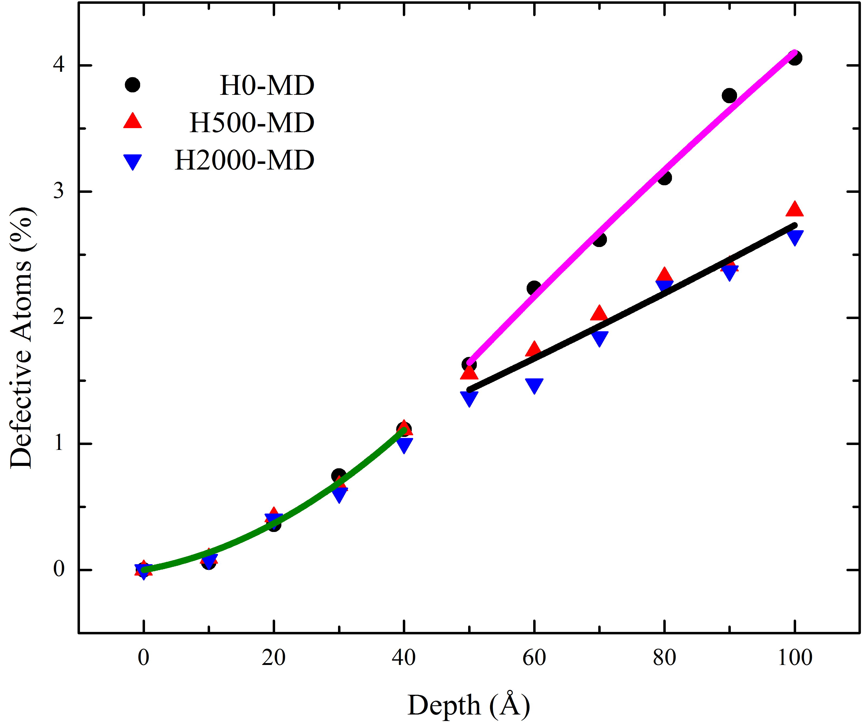
Fig. 5 Defective atoms as a function of indentation process. Black points: no H atoms. Red uptriangles: with 500 H atoms charged. Blue downtriangles: with 2000 H atoms charged. The solid lines are used to mark the trend of MD results.

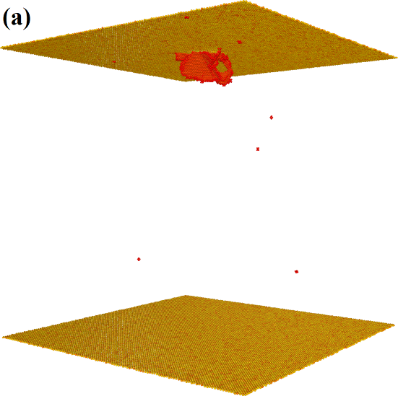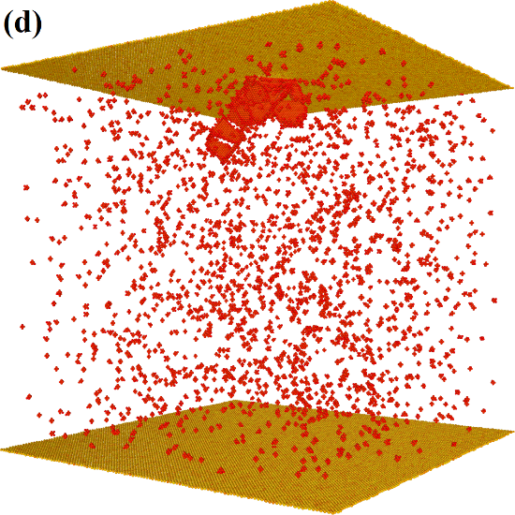
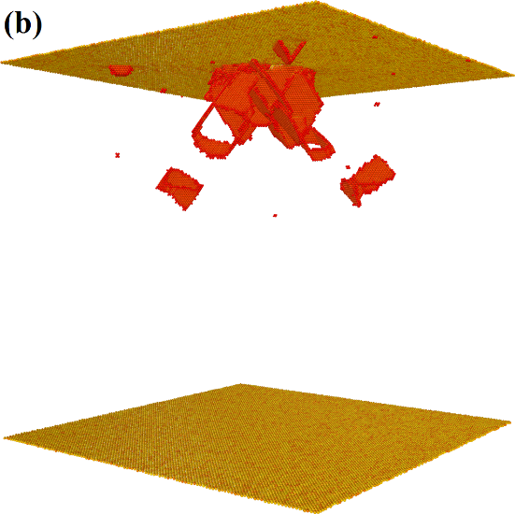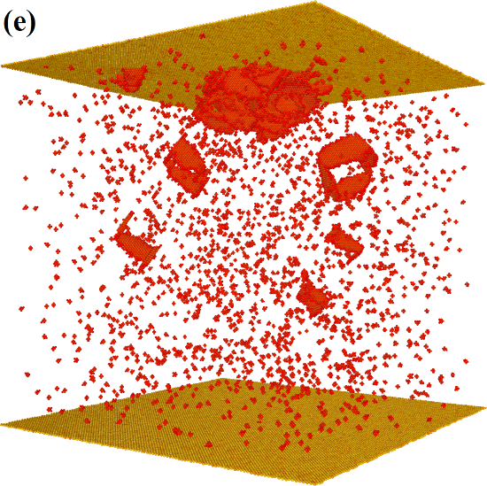
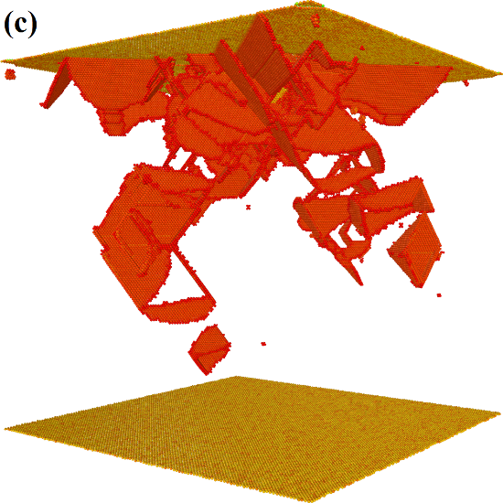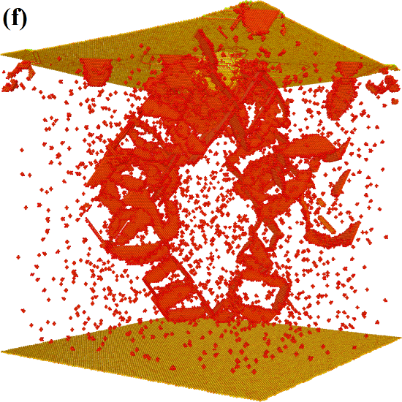
Fig. 6 The snapshots of pure Ni and Ni-H specimens under indentation of a rigid spherical indenter. (a)-(c), pure Ni at indentation depth: 10, 20 and 60 Å; (d)-(f), Ni-H2000 at indentation depth: 10, 20 and 60 Å. The atoms are filtered by CNA computation and colored by centrosymmetry parameter with range from 0 ~ 90. In (d)-(f), the dispersive red points are atomic clusters consisting of one H atom and more than 6 Ni atoms.

3.2 Collective behaviors of dislocations
As we have observed in Fig. 3, the force-depth curves show a feature of intermittency known as the dislocation avalanche behavior. In the perspective of statistical physics, power-law scaling of dislocation avalanche has been widely observed in experiments [77] and simulations [31, 78]. Follow the method proposed by Niiyama and Shimokawa [31], we calculated the self-organized criticality [36, 37] of dislocation motions of the Ni-H systems. In a system that shows SOC phenomenon, the physics of the serrated yielding behaviors can be described by a power-law distribution, $P(x)∝x^{-α}$, where $x$ is the size of plastic events and $α$ is characteristic constant of the system. Here, $x$ is defined as the stochastic drop of indentation force. Thus, to solve $α$, it equals to obtain the slope of the logarithmic function: $lnP∝-αlnx$. In Fig. 7, considering the numerical errors, the calculated value of $α$ for the specimen without H charged agrees well with previous experiments [79], simulations [31] and mean-filed value 1.5 [80, 81]. With increasing H concentration, the SOC exponent increases although some fluctuations exist. We can find that there is a sharp increase of the SOC exponent when the H atoms are charged into the specimen. Specifically, compared with systems showing a larger SOC exponent, we observed that in the pure Ni specimen (with a smaller SOC exponent), that it is much easier to form Lomer-Cottrell lock and SFT. It is well known that these defects can effectively impede the motion of dislocations. This observation is also consistent with the study shown in Ref [31], where the Al single crystal shows a dislocation pinning effect due to the formation of self-organized defect clusters. Here the rising of SOC exponent also suggests that the dislocation motion is promoted by H atmosphere.

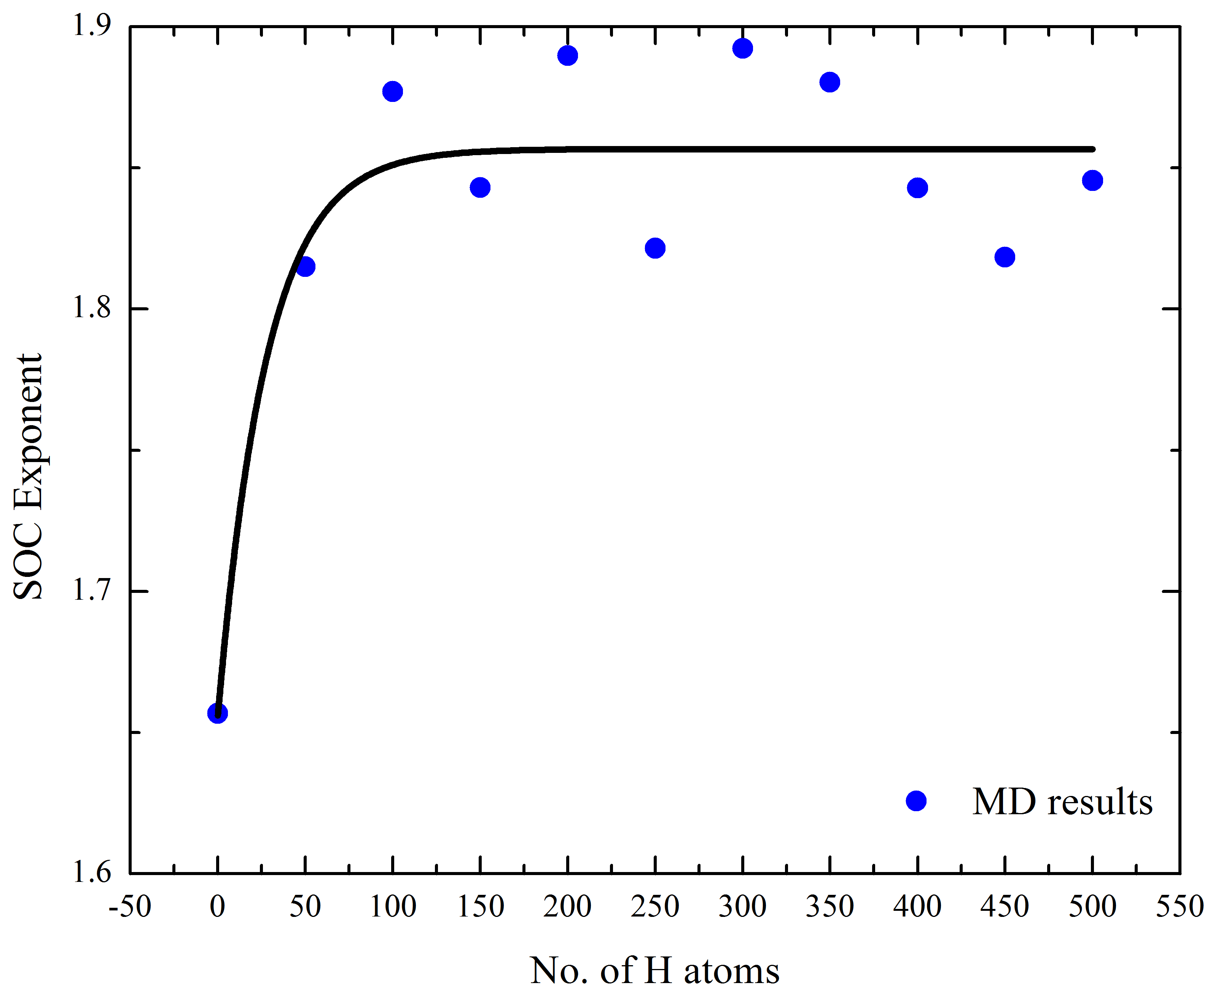
Fig. 7 SOC exponent v.s. H concentration. The black line is used to show the trend of MD results.

4. Discussions
This paper presents how H atoms work as solute to soften the metallic materials. MD simulations are performed to reveal the effect of H on the complex interaction among dislocation networks. A hydrogen-informed expanding cavity model is proposed to capture the mechanical response of H-charged materials under nanoindentation. Here we emphasize that due to the severe plastic deformation caused by the penetration of indenter, a strain localization zone is formed underneath the indenter/specimen contact surface. Thus, driven by the chemical potential, H atoms will concentrate in this zone and interact with dislocations in present theoretical framework. This assumption can be easily satisfied in practical experimental settings where the diffusivity of H atoms is much larger than the loading rate.
The results emerging from present simulations indicate that, the collective behavior of dislocations is affected by H insertion. H can truly influence the SOC exponent, which is thought as a scale-invariant quantity to characterize the non-equilibrium systems. The observation of dislocation behaviors leads to the conclusion that H atoms can decrease the probability of piling up of dislocations, inconsistent with the traditional picture, where the H atoms can decrease the repulsive interactions between two dislocations and thus promote the accumulation of dislocations. Here we propose a new explanation that H-induced force decreasing is due to that H insertion can effectively decrease the probability for the generation of obstacles. That is to say, the movement of dislocations to free surface will be enhanced. Symbolically, in pure metal lattice, dislocations move like scattered strings in viscous fluid and finally will entangle with each other. While in H-charged specimens, the dispersive H atoms will constrain the motion of these dislocation strings and decrease the probability of entanglement. We noticed that in a series of electrochemical nanoindentation experiments, Barnoush and Vehoff [42] have observed that charging H can drastically decrease the applied loading of Ni specimens. They attributed this change to the effect of H on the free energy of dislocation nucleation by using the defectant model of HE [30, 82, 83]. This model only accounts the activation of the dislocation nucleation process, and does not consider the collective behavior after the initiation of plasticity. Moreover, different from the displacement control commonly used in atomistic simulations, force control is widely used in experiments. Between these two loading patterns, there exists a large difference of activation entropy, which can change the nucleation rate by orders of magnitude [84, 85].
To summarize, we have performed MD simulations of H-charged specimens under nanoindentation loading, and proposed the HEC model based on the collective evolution of dislocations. It is found that the power-law exponent of SOC increases with increasing H concentration. This change is attributed to that the H insertion can suppress the pile-up of dislocations, and lead to an easy movement to the free surface, thus decrease the density of dislocations and release local concentration of stress.

Acknowledgement
K.Z. would like to be grateful for the constructive discussion with Prof. Tomoaki Niiyama and Prof. Afrooz Barnoush. Financial support for this work is provided by the Research Council of Norway under HIPP project (No. 234130/E30). All simulations are carried out on the NOTUR (Grant No. NN9110K, NN9391K) high performance computer clusters Vilje at NTNU, Trondheim and Stallo at UiT, Tromsø.

References
[1] I.M. Robertson, P. Sofronis, A. Nagao, M.L. Martin, S. Wang, D.W. Gross, K.E. Nygren, Hydrogen Embrittlement Understood. Metall. Mater. Trans. B 46 (2015) 1085-1103.
[2] R.P. Gangloff, B.P. Somerday, Gaseous Hydrogen Embrittlement of Materials in Energy Technologies: The Problem, Its Characterisation and Effects on Particular Alloy Classes, Woodhead Publishing Limited, Cambridge, U.K., 2012.
[3] R.A. Oriani, Whitney Award Lecture - 1987: Hydrogen - The Versatile Embrittler. Corrosion 43 (1987) 390-397.
[4] A.R. Troiano, The role of hydrogen and other interstitials in the mechanical behavior of metals. Trans. Am. Soc. Met. 52 (1960) 54-80.
[5] Y. Murakami, The effect of hydrogen on fatigue properties of metals used for fuel cell system. Int. J. Fract. 138 (2006) 167-195.
[6] D.P. Abraham, C.J. Altstetter, Hydrogen-enhanced localization of plasticity in an austenitic stainless steel. Metall. Mater. Trans. A 26 (1995) 2859-2871.
[7] P. Sofronis, I.M. Robertson, Transmission electron microscopy observations and micromechanical/continuum models for the effect of hydrogen on the mechanical behaviour of metals. Philos. Mag. A 82 (2002) 3405-3413.
[8] P.J. Ferreira, I.M. Robertson, H.K. Birnbaum, Hydrogen effects on the character of dislocations in high-purity aluminum. Acta Mater. 47 (1999) 2991-2998.
[9] P.J. Ferreira, I.M. Robertson, H.K. Birnbaum, Hydrogen effects on the interaction between dislocations. Acta Mater. 46 (1998) 1749-1757.
[10] H.K. Birnbaum, P. Sofronis, Hydrogen-enhanced localized plasticity - a mechanism for hydrogen-related fracture. Mater. Sci. Eng. A 176 (1994) 191-202.
[11] W.W. Gerberich, D.D. Stauffer, P. Sofronis, A coexistent view of hydrogen effects on mechanical behavior of crystals: HELP and HEDE, Proceedings of the 2008 International Hydrogen Conference - Effects of Hydrogen on Materials, 2009, pp. 38-45.
[12] A. Barnoush, H. Vehoff, In situ Electrochemical Nanoindentation: A Nanomechanical Approach to Rank Hydrogen Embrittlement in Extremely Small Volumes, Proceedings of the 2008 International Hydrogen Conference - Effects of Hydrogen on Materials, 2009, pp. 187-194.
[13] M.Q. Chandler, M.F. Horstemeyer, M.I. Baskes, G.J. Wagner, P.M. Gullett, B. Jelinek, Hydrogen effects on nanovoid nucleation at nickel grain boundaries. Acta Mater. 56 (2008) 619-631.
[14] M.Q. Chandler, M.F. Horstemeyer, M.I. Baskes, P.M. Gullett, G.J. Wagner, B. Jelinek, Hydrogen effects on nanovoid nucleation in face-centered cubic single-crystals. Acta Mater. 56 (2008) 95-104.
[15] D.F. Teter, I.M. Robertson, H.K. Birnbaum, The effects of hydrogen on the deformation and fracture of β-titanium. Acta Mater. 49 (2001) 4313-4323.
[16] H. Matsui, H. Kimura, S. Moriya, The effect of hydrogen on the mechanical properties of high purity iron I. Softening and hardening of high purity iron by hydrogen charging during tensile deformation. Mater. Sci. Eng. 40 (1979) 207-216.
[17] H. Matsui, H. Kimura, A. Kimura, The effect of hydrogen on the mechanical properties of high purity iron III. The dependence of softening in specimen size and charging current density. Mater. Sci. Eng. 40 (1979) 227-234.
[18] C. Borchers, T. Michler, A. Pundt, Effect of hydrogen on the mechanical properties of stainless steels. Adv. Eng. Mater. 10 (2008) 11-23.
[19] D.P. Abraham, C.J. Altstetter, The effect of hydrogen on the yield and flow stress of an austenitic stainless steel. Metall. Mater. Trans. A 26 (1995) 2849-2858.
[20] S. Asano, R. Otsuka, Further discussion on the lattice hardening due to dissolved hydrogen in iron and steel. Scripta Metall. 12 (1978) 287-288.
[21] S. Asano, R. Otsuka, The lattice hardening due to dissolved hydrogen in iron and steel. Scripta Metall. 10 (1976) 1015-1020.
[22] J.W. Watson, M. Meshii, Y.Z. Shen, Effect of cathodic charging on the mechanical properties of aluminum. Metall. Trans. A 19 (1988) 2299-2304.
[23] G. Girardin, D. Delafosse, Measurement of the saturated dislocation pinning force in hydrogenated nickel and nickel base alloys. Scripta Mater. 51 (2004) 1177-1181.
[24] T. Boniszewski, G.C. Smith, The influence of hydrogen on the plastic deformation ductility, and fracture of nickel in tension. Acta Metall. 11 (1963) 165-178.
[25] J. Song, W.A. Curtin, Atomic mechanism and prediction of hydrogen embrittlement in iron. Nat. Mater. 12 (2013) 145-151.
[26] J. Song, W.A. Curtin, A nanoscale mechanism of hydrogen embrittlement in metals. Acta Mater. 59 (2011) 1557-1569.
[27] T.-Y. Zhang, W.-Y. Chu, C.-M. Hsiao, Mechanism of hydrogen induced softening. Scripta Metall. 20 (1986) 225-230.
[28] X. Zhou, B. Ouyang, W.A. Curtin, J. Song, Atomistic investigation of the influence of hydrogen on dislocation nucleation during nanoindentation in Ni and Pd. Acta Mater. 116 (2016) 364-369.
[29] G.P.M. Leyson, B. Grabowski, J. Neugebauer, Multiscale modeling of hydrogen enhanced homogeneous dislocation nucleation. Acta Mater. 107 (2016) 144-151.
[30] R. Kirchheim, Solid solution softening and hardening by mobile solute atoms with special focus on hydrogen. Scripta Mater. 67 (2012) 767-770.
[31] T. Niiyama, T. Shimokawa, Atomistic mechanisms of intermittent plasticity in metals: Dislocation avalanches and defect cluster pinning. Phys. Rev. E 91 (2015) 022401.
[32] F.F. Csikor, C. Motz, D. Weygand, M. Zaiser, S. Zapperi, Dislocation Avalanches, Strain Bursts, and the Problem of Plastic Forming at the Micrometer Scale. Science 318 (2007) 251.
[33] G. Ananthakrishna, Current theoretical approaches to collective behavior of dislocations. Physics Reports 440 (2007) 113-259.
[34] M.C. Miguel, A. Vespignani, S. Zapperi, J. Weiss, J.-R. Grasso, Intermittent dislocation flow in viscoplastic deformation. Nature 410 (2001) 667-671.
[35] G. Ananthakrishna, S.J. Noronha, C. Fressengeas, L.P. Kubin, Crossover from chaotic to self-organized critical dynamics in jerky flow of single crystals. Phys. Rev. E 60 (1999) 5455-5462.
[36] P. Bak, C. Tang, K. Wiesenfeld, Self-organized criticality. Phys. Rev. A 38 (1988) 364-374.
[37] P. Bak, C. Tang, K. Wiesenfeld, Self-organized criticality: An explanation of the 1/f noise. Phys. Rev. Lett. 59 (1987) 381-384.
[38] K.L. Johnson, Contact Mechanics, Cambridge University Press, Cambridge, 1987.
[39] V.S. Krasnikov, A.E. Mayer, Plasticity driven growth of nanovoids and strength of aluminum at high rate tension: Molecular dynamics simulations and continuum modeling. Int. J. Plast. 74 (2015) 75-91.
[40] R. Hill, The Mathematical Theory of Plasticity, Clarendon Press, Oxford, 1950.
[41] K. Zhao, J. He, A.E. Mayer, Z. Zhang, Plasticity initiation and evolution in the nanoindentation of bcc Fe. In preparation.
[42] A. Barnoush, H. Vehoff, Recent developments in the study of hydrogen embrittlement: Hydrogen effect on dislocation nucleation. Acta Mater. 58 (2010) 5274-5285.
[43] J. Song, W.A. Curtin, Mechanisms of hydrogen-enhanced localized plasticity: An atomistic study using alpha-Fe as a model system. Acta Mater. 68 (2014) 61-69.
[44] M.A. Bhatia, S. Groh, K.N. Solanki, Atomic-scale investigation of point defects and hydrogen-solute atmospheres on the edge dislocation mobility in alpha iron. J. Appl. Phys. 116 (2014) 064302.
[45] S. Wang, K. Takahashi, N. Hashimoto, S. Isobe, S. Ohnuki, Strain field of interstitial hydrogen atom in body-centered cubic iron and its effect on hydrogen–dislocation interaction. Scripta Mater. 68 (2013) 249-252.
[46] S. Wang, N. Hashimoto, S. Ohnuki, Effects of hydrogen on activation volume and density of mobile dislocations in iron-based alloy. Mater. Sci. Eng. A 562 (2013) 101-108.
[47] S. Wang, N. Hashimoto, S. Ohnuki, Hydrogen-induced change in core structures of {110}[111] edge and {110}[111] screw dislocations in iron. Sci. Rep. 3 (2013) 2760.
[48] M. Itakura, H. Kaburaki, M. Yamaguchi, T. Okita, The effect of hydrogen atoms on the screw dislocation mobility in bcc iron: A first-principles study. Acta Mater. 61 (2013) 6857-6867.
[49] M. Wen, Z. Li, Thermally activated process of homogeneous dislocation nucleation and hydrogen effects: An atomistic study. Comp. Mater. Sci. 54 (2012) 28-31.
[50] Y.Z. Tang, J.A. El-Awady, Atomistic simulations of the interactions of hydrogen with dislocations in fcc metals. Phys. Rev. B 86 (2012).
[51] X.L. Gao, An expanding cavity model incorporating strain-hardening and indentation size effects. Int. J. Solids Struct. 43 (2006) 6615-6629.
[52] X.L. Gao, Strain gradient plasticity solution for an internally pressurized thick-walled spherical shell of an elastic–plastic material. Mech. Res. Commun. 30 (2003) 411-420.
[53] B.S. Altan, E.C. Aifantis, On Some Aspects in the Special Theory of Gradient Elasticity, Journal of the Mechanical Behavior of Materials, 1997, p. 231.
[54] S.K. Kang, Y.C. Kim, K.H. Kim, J.Y. Kim, D. Kwon, Extended expanding cavity model for measurement of flow properties using instrumented spherical indentation. Int. J. Plast. 49 (2013) 1-15.
[55] T.P. Remington, C.J. Ruestes, E.M. Bringa, B.A. Remington, C.H. Lu, B. Kad, M.A. Meyers, Plastic deformation in nanoindentation of tantalum: A new mechanism for prismatic loop formation. Acta Mater. 78 (2014) 378-393.
[56] V.S. Krasnikov, A.E. Mayer, A.P. Yalovets, Dislocation based high-rate plasticity model and its application to plate-impact and ultra short electron irradiation simulations. Int. J. Plast. 27 (2011) 1294-1308.
[57] A.Y. Kuksin, A.V. Yanilkin, Atomistic simulation of the motion of dislocations in metals under phonon drag conditions. Phys. Solid State 55 (2013) 1010-1019.
[58] G. Ananthakrishna, Current theoretical approaches to collective behavior of dislocations. Phys. Rep. 440 (2007) 113-259.
[59] S. Patinet, L. Proville, Dislocation pinning by substitutional impurities in an atomic-scale model for Al(Mg) solid solutions. Philos. Mag. 91 (2011) 1581-1606.
[60] S. Patinet, L. Proville, Depinning transition for a screw dislocation in a model solid solution. Phys. Rev. B 78 (2008) 104109.
[61] B.D. Wirth, G.R. Odette, D. Maroudas, G.E. Lucas, Dislocation loop structure, energy and mobility of self-interstitial atom clusters in bcc iron. J. Nucl. Mater. 276 (2000) 33-40.
[62] J.O. Schiffgens, K.E. Garrison, Computer simulation studies of the a/2 <111> edge dislocation in a‐iron. J. Appl. Phys. 43 (1972) 3240-3254.
[63] A.V. Yanilkin, V.S. Krasnikov, A.Y. Kuksin, A.E. Mayer, Dynamics and kinetics of dislocations in Al and Al–Cu alloy under dynamic loading. Int. J. Plast. 55 (2014) 94-107.
[64] G.A. Malygin, Structure factors that influence the stability of plastic strain of BCC metals under tensile load. Phys. Solid State 47 (2005) 896-902.
[65] S. Plimpton, Fast parallel algorithms for short-range molecular dynamics. J. Comput. Phys. 117 (1995) 1-19.
[66] J.E. Angelo, N.R. Moody, M.I. Baskes, Trapping of hydrogen to lattice defects in nickel. Modell. Simul. Mater. Sci. Eng. 3 (1995) 289.
[67] G.J. Ackland, G. Tichy, V. Vitek, M.W. Finnis, Simple N-body potentials for the noble metals and nickel. Philos. Mag. A 56 (1987) 735-756.
[68] C.L. Kelchner, S.J. Plimpton, J.C. Hamilton, Dislocation nucleation and defect structure during surface indentation. Phys. Rev. B 58 (1998) 11085-11088.
[69] S. Alexander, V.B. Vasily, A. Athanasios, Automated identification and indexing of dislocations in crystal interfaces. Modell. Simul. Mater. Sci. Eng. 20 (2012) 085007.
[70] H. Tsuzuki, P.S. Branicio, J.P. Rino, Structural characterization of deformed crystals by analysis of common atomic neighborhood. Comput. Phys. Commun. 177 (2007) 518-523.
[71] D. Faken, H. Jónsson, Systematic analysis of local atomic structure combined with 3D computer graphics. Comp. Mater. Sci. 2 (1994) 279-286.
[72] S. Alexander, Visualization and analysis of atomistic simulation data with OVITO–the Open Visualization Tool. Modell. Simul. Mater. Sci. Eng. 18 (2010) 015012.
[73] G.P.M. Leyson, W.A. Curtin, Friedel vs. Labusch: The strong/weak pinning transition in solute strengthened metals. Philos. Mag. 93 (2013) 2428-2444.
[74] C. Varvenne, G.P.M. Leyson, M. Ghazisaeidi, W.A. Curtin, Solute strengthening in random alloys. Acta Mater. 124 (2017) 660-683.
[75] D. Tabor, The Hardness of Metals, Clarendon Press1951.
[76] W.D. Nix, H.J. Gao, Indentation size effects in crystalline materials: A law for strain gradient plasticity. J. Mech. Phys. Solids 46 (1998) 411-425.
[77] S. Papanikolaou, D.M. Dimiduk, W. Choi, J.P. Sethna, M.D. Uchic, C.F. Woodward, S. Zapperi, Quasi-periodic events in crystal plasticity and the self-organized avalanche oscillator. Nature 490 (2012) 517-521.
[78] M. Koslowski, R. LeSar, R. Thomson, Avalanches and Scaling in Plastic Deformation. Phys. Rev. Lett. 93 (2004) 125502.
[79] D.M. Dimiduk, C. Woodward, R. LeSar, M.D. Uchic, Scale-Free Intermittent Flow in Crystal Plasticity. Science 312 (2006) 1188-1190.
[80] M. Zaiser, Scale invariance in plastic flow of crystalline solids. Adv. Phys. 55 (2006) 185-245.
[81] M. Zaiser, P. Moretti, Fluctuation phenomena in crystal plasticity - a continuum model. J. Stat. Mech. Theor. Exp. 2005 (2005) P08004.
[82] R. Kirchheim, Revisiting hydrogen embrittlement models and hydrogen-induced homogeneous nucleation of dislocations. Scripta Mater. 62 (2010) 67-70.
[83] R. Kirchheim, On the solute-defect interaction in the framework of a defactant concept. International Journal of Materials Research 100 (2009) 483-487.
[84] S. Ryu, K. Kang, W. Cai, Predicting the dislocation nucleation rate as a function of temperature and stress. J. Mater. Res. 26 (2011) 2335-2354.
[85] S. Ryu, K. Kang, W. Cai, Entropic effect on the rate of dislocation nucleation. Proc. Natl. Acad. Sci. USA 108 (2011) 5174-5178.

Email address: zhiliang.zhang@ntnu.no

