DECOUPLING BETWEEN HUMAN DEVELOPMENT AND ENERGY CONSUMPTION WITHIN FOOTPRINT ACCOUNTS

Ortzi Akizu-Gardoki^{1,2}, Gorka Bueno³, Thomas Wiedmann⁴,
Jose Manuel Lopez-Guede⁵, Iñaki Arto⁶, Patxi Hernandez⁷, Daniel Moran⁸

¹ University of the Basque Country (UPV/EHU), Department of Graphic Design and Engineering Projects,
Nieves Cano 12, 01006 Vitoria-Gasteiz, Spain
² University of the Basque Country (UPV/EHU), Hegoa Institute for International Cooperation and Development Studies, Avda. Lehendakari Agirre, 81, 48015 Bilbao Spain
³ University of the Basque Country (UPV/EHU), Department of Electronics Technology, Bilbao, Spain
⁴ Sustainability Assessment Program, School of Civil and Environmental Engineering, UNSW Sydney, Australia
⁵ University of the Basque Country (UPV/EHU), Department of Engineering Systems and Automatics, Vitoria-Gasteiz, Spain
⁶ Basque Centre for Climate Change, Bilbao, Spain
⁷ Tecnalia Research & Innovation, Azpeitia, Spain
⁸ Programme for Industrial Ecology, Gamle Fysikk building, NTNU, Trondheim, Norway

Abstract

Historically, the growth of energy consumption has fuelled human development, but this approach is no longer socially and environmentally sustainable. Recent analyses suggest that some individual countries have responded to this issue successfully by decoupling Total Primary Energy Supply from human development increase. However, globalisation and international trade have allowed high-income countries to outsource industrial production to lower income countries, thereby increasingly relying on foreign energy use to satisfy their own consumption of goods and services. Accounting for the import of embodied energy in goods and services, this study proposes an alternative estimation of the Decoupling Index based on the Total Primary Energy Footprint rather than Total Primary Energy Supply. An analysis of 126 countries over the years 2000-2014 demonstrates that previous studies based on energy supply highly overestimated decoupling. Footprint-based results, on the other hand, show an overall decrease of the Decoupling Index for most countries (93 out of 126). There is a reduction of the number of both absolutely decoupled countries (from 40 to 27) and relatively decoupled countries (from 29 to 17), and an increase of coupled countries (from 55 to 80). Furthermore, the study shows that decoupling is not a phenomenon characterising only high-income countries due to improvements in energy efficiency, but is also occurring in countries with low Human Development Index and low energy consumption. Finally, six exemplary countries have been identified, which were able to maintain a continuous decoupling trend. From these exemplary countries, lessons have been identified in order to boost the necessary global decoupling of energy consumption and achieved welfare.

Keywords: decoupling index; energy footprint; energy democracy; energy transitions; consumption based accounts; sustainable development goals

Highlights:
- Energy footprint accounts show an overall decrease of decoupling for most countries.
- Six exemplary countries show a maintained decoupling of HDI from energy requirement.
- Permanent or temporary decoupling has been detected in 89 countries.
- Both high and low-HDI countries can achieve temporary decoupling.

Acronyms
ADP | Absolute Decoupling Point
CBA | Consumption Base Accounts
DF | Driving Forcers
DI | Decoupling Index
EI | Education Index
EP | Environmental Pressure
GDP | Gross Domestic Product
GFC | Great Financial Crisis – Great Recession
GMRIO | Global Multi Regional Input-Output
HDI | Human Development Index
IEA | International Energy Agency
II | Income Index
LEI | Life Expectancy Index
MF | Material Footprint
PB | Planetary Boundaries
PBA | Production Based Accounts
TFC | Total Final Consumption
TPEF | Total Primary Energy Footprint
TPES | Total Primary Energy Supply

Introduction

In order to achieve a global sustainable a use of energy resources, energy consumption needs to respect socially fair and environmentally viable Planetary Boundaries (O’Neill et al., 2018). The introduction reviews the literature to establish the required energy to achieve development and define sustainable energy boundaries. Within this context, the decoupling phenomenon has been observed, in which energy consumption can be reduced while increasing countries development levels.

Energy consumption requirements
The correlation between the energy consumption and welfare of a country has been a well discussed topic. There is general agreement in the literature that a certain amount of energy consumption is fundamental to the economic progress and social development of a country (Wu and Chen, 2017). Nevertheless, there is still no consensus regarding the minimum thresholds of energy consumption needed to achieve acceptable living standards. Krugmann and Goldemberg (1983) found that between 11.5 and 15.7 MWh per capita per year was the cost of satisfying the basic human needs. Subsequently, an economic minimum requirement of 7.25 MWh per capita per year was identified (Grabl et al., 2004). Comparatively, Martínez and Ebenhack (2008) identified that 9.3 MWh per capita per year (MWh·cap⁻¹·yr⁻¹) were necessary to maintain the HDI level above 0.7, and 33.7 MWh in order to uplift the HDI value above 0.9. With 2005 data, it was stated that an average consumption of 16.7 MWh·cap⁻¹·yr⁻¹ was enough to achieve a 0.8 HDI value (Steinberger and Roberts, 2010). Subsequently, using the Life Expectancy parameter, Mazur (2011) detected that all nations consuming above 40 MWh·cap⁻¹·yr⁻¹have life expectancies near 80 years. Similarly, in 2012 it was detected that energy consumption of above 43.8 MWh·cap⁻¹·yr⁻¹ does not necessarily lead to a higher Quality of Life Index (Pasten and Santamarina, 2012). Finally, Steckel et al. (2013) found that 27.8 MWh·cap⁻¹·yr⁻¹ could very likely maintain the HDI higher than 0.9.

Energy consumption boundaries
In order to match human energy needs to available energy, current research attempts to understand how much energy is accessible worldwide as well as which the physical and sustainable Planetary Boundaries (PB) are (Rockström et al., 2009), in order to preserve the Earth System in a resilient and accommodating state (Steffen et al., 2015). The natural limits of global energy resources were recognised by the scientific community for the first time in the 1970s (Meadows et al., 1972). Currently, forecasting the peak-oil is a constant challenge for the scientific community (Pargman et al., 2017). Current fossil-fuel-based global energy consumption threshold needs to be lowered, since is has been defined as: environmentally unsustainable (Inman, 2008), (IPCC, 2015), (Gies, 2017), socially unfair (Sovacool et al., 2016) (Eisenstein, 2017), and further economic losses and crises have been forecasted (Hsiang et al., 2017) (Fouquet, 2017) (Inman, 2013).
In response to the knowledge of energy limitations, as well as an attempt to promote an equal opportunity to the access of energy for all citizens in the world, in 1998 the Swiss Government promoted the “2000 Watt Society” (Stulz et al., 2011). The initiative had the ambitious target of reducing 60% of the Total Primary Energy Supply (TPES) from 41 to 17.52 MWh·cap⁻¹·yr⁻¹ (Heeren et al., 2012). However, 18 years later, in 2015, the TPES of the country was still 34.46 MWh·cap⁻¹·yr⁻¹ (International Energy Agency, 2015). But this figure does not include the energy consumed in other countries embodied in imported products and services, which has been growing in recent decades (Arto et al., 2016).
The shift towards renewable energy sources has been stated to be environmentally indispensable (IPCC, 2015) and even beneficial in economic or social terms globally (Jacobson and Delucchi, 2011) (WWF, 2011) (Jacobson et al., 2015) (Teske et al., 2015) (García-Olivares, 2016) and nationally (Kucukvar et al., 2017), as demonstrated by using the Triple Bottom Line methodology (Slaper and Hall, 2011). According to optimistic studies, a 100% renewable energy supply for 139 countries could be possible within 2050, while actually maintaining the global energy consumption of 2012 (Jacobson et al., 2017). In this respect, even if all the countries in the world could be able to maintain 2012 consumption levels within renewable generation (13,267,620 ktoe, International Energy Agency, IEA), maintaining human population in 2012 levels (7100 millions) each individual would have the equal right of consuming a Total Primary Energy Footprint of 21.9 MWh·cap⁻¹·yr⁻¹ of fully renewable energy. Nevertheless, limits for renewable energies have been discovered. For example, taking into account the land usage in the case for the solar resource, has concluded that a global transition to domestically produced renewable solar energy will be physically unfeasible to maintain current energy consumption levels (Capellán-Pérez et al., 2017). Other research has considered a strong limit in renewable energy penetration; in an optimistic scenario, the total installed capacity of renewables is forecasted to saturate at around 1.8 TW in 2030 (Hansen et al., 2017) and maximum global production capacities of around 145,000 TWh in 2050 (Capellán-Pérez et al., 2014).
Being aware of these limits, Cullen et al. (2011) analysed the capacity of reduction of TPES through savings and efficient management and concluded that a 73% reduction would be feasible. A global energy consumption reduction from 475 EJ·yr⁻¹ to 129 EJ·yr⁻¹ (based on the 2005 data) was identified as feasible, reducing energy use from buildings, transport and industry (Cullen et al., 2011). This baseline would give each citizen the equal right to consume of 4.7 MWh·cap⁻¹·yr⁻¹. Nevertheless this reduction capacity has been contrasted based on the difficulty of reducing current energy consumption levels; especially due to the strong correlation between energy consumption and economic growth (Sorrell, 2015).
Lastly, due to the limitation of the Planetary Boundaries, has been found that generally the current resource consumption level is 2 to 6 times the sustainable level one (O’Neill et al., 2018). Thus, taking into account the present global energy consumption (13,647,367 ktoe in 2015, IEA) and assuming the positive condition that population figures will be maintained (7,355 millions in 2015, World Bank), energy consumption should be reduced to between 3.6 and 10.8 MWh·cap⁻¹·yr⁻¹.

Decoupling
Being aware of the limited availability of energy (renewable or less), the decoupling between energy consumption (and its impacts) and the achieved welfare has been defined as a “key issue” to reach the Sustainable Development Goals (SDGs) (UNEP, 2011), (UNEP, 2014). This issue establishes how humanity should be able to maintain current life standards in developed countries and promote development in low-income countries without affecting the environmental bio-capacity of the Earth. To accomplish the decoupling challenge, technological innovations (eco-efficiency and system innovations) have been seen as the main leverages (UNEP, 2011), (UNEP, 2014). As a secondary aspect, the need to encourage change in consumption patterns, to reduce the consumption of resources while achieving improvements in quality of life, has been identified as an influential factor (UNEP, 2014). These objectives are aligned with “Goal 7” of SDG (UN, 2015) where the sustainable energy availability is recognised as a right for all individuals, “Goal 10” of SDG, where equality between countries is recognised, and finally “Goal 12” where sustainable consumption ways are claimed.
Since 1970, the relation between consumed energy and gained GNP or GDP has been widely studied and has assessed the possibility of decoupling (Bullard and Foster, 1976), (Meadows et al., 1972), (Nilsson, 1993). In 2002, an extensive study was developed by the Organisation for Economic Co-operation and Development (OECD, 2002), where indicators to measure the Environmental Pressure (EP) from specific Driving Forcers (DF) were classified, and the variation ratio between EP and DF during a certain period was defined as the Decoupling Factor (DF). Mielnik and Goldemberg (2002) analysed the decoupling phenomena in 20 developing countries, concluding that technology improvements due to foreign investments could promote a decoupling. Decoupling was also analysed in the transportation sector, between consumed energy and provoked emissions (Tapio, 2005). Diakoulaki and Mandaraka (2007) analysed the decoupling between emissions and industrial growth within the 14 EU countries, finding that a considerable effort has been done for decoupling. Decoupling between environmental impacts (measured in CO₂eq emissions) and GDP has also been analysed in Brazil (de Freitas and Kaneko, 2011), and between consumed energy and GDP in China (Zhang et al., 2015). Both studies concluded that technology played an important role in decoupling in Brazil, reducing the carbon intensity of the generation mix, and in China, increasing the energy efficiency (energy intensified effect). In China was founded that decoupling was also a result of the rapid economic growth of the country (Wang, 2011).
A more recent study, that analysed the decoupling phenomenon in eight countries, concluded that decoupling, is more present and constant in developed countries (Wu et al., 2018). Wu et al. (2018) used a specific Decoupling Index (DI) of Impact-GDP-Technology (IGT) in different countries within GDP and TPES, where this decoupling is clearly observed in developed countries such as the UK, France, and USA. In the study, absolute decoupling and relative decoupling terms were used to clearly distinguish the achievements of different countries.
Nevertheless, relating the decoupling phenomenon to technological advancements of the developed countries, has already been considered for re-evaluation (Moreau and Vuille, 2018). When integrating footprint accounting in resource consumption measurements, it was found that the decoupling between economic achievements and environmental impacts was “smaller than reported or even non-existent” (Wiedmann et al., 2015), due to exporting production chains to other countries. Moreau and Vuille (2018) states that decoupling is still under discussion due to the “virtual decoupling” concept. The “virtual decoupling” occurs when a developed country argues to reduce energy consumption, while in reality has only exported the industrial production chains to other less developed countries (Moreau and Vuille, 2018), thus national energy measurements are not able to detect this consumptions. As a result, even if decoupling has been defined as a necessary factor to achieve sustainable goals, it is not clear which countries and when reach decoupling – or simply have export high energy consumer industry to other countries –, and whether there is an impetus to attain it.

Accounting for total primary energy consumption
In order to determine decoupling, energy consumed by a country may be measured in different ways that affect the results. The Total Primary Energy Supply of a country (TPES) and the Total Final Consumption (TFC) have been the most popular indicators when measuring energy consumption, both defined by the (International Energy Agency, 2015). TPES is the sum of TFC and the losses of the energy transformation and distribution sectors (Goldemberg and Siqueira Prado, 2011). However, TPES and TFC are both Production Based Accounts (PBA), where energy consumption is measured within the boundaries of a country (Peters, 2008). In present day, the massive outsourcing of industrial production chains and services (especially from high-income countries to low-income ones), causes the total energy consumption of high-income countries appears to be smaller, since part of it is outsourced and accounted for in other countries (Arto et al., 2016).
To address this occurrence, scientists have used Consumption Base Accounting (CBA). CBA was initially used for Carbon Footprint measurement (Munksgaard and Pedersen, 2001), (Peters, 2008), (Peters and Hertwich, 2008), (Kanemoto et al., 2012), (Barrett et al., 2013) using the Global Multi Regional Input-Output (GMRIO) methodology (Wiedmann and Lenzen, 2018). Footprint accounting has become a well-established method to trace the total resource needs and environmental impacts of a country’s consumption (Wiedmann et al., 2007), (Galli et al., 2012), (Hoekstra and Wiedmann, 2014), (Wiedmann et al., 2015).
Using the same MRIO methodology, the “Energy Footprint” concept was developed (Arto et al., 2016). This considers the energy embodied in imported goods and services that is consumed in other countries, and is defined as Total Primary Energy Footprint (TPEF). TPEF allows relocating the energy accounts according to the final consumers. Several studies have been developed in this field, taking into account different databases (GTAP, WIOD, OECD, Eora and EXIOBASE) as well as different countries (Chen and Lin, 2008), (Wiedmann, 2009), (Mativenga and Rajemi, 2011), (Chen and Chen, 2013), (Heinonen and Junnila, 2014), (Arto et al., 2016), (Lan et al., 2016). The latest research in the energy field prioritised comparing the accuracy of results when calculating the energy footprint (Owen et al., 2017), (Min and Rao, 2017); forecasted future energy scenarios (Kucukvar et al., 2017), (Kaltenegger et al., 2017); as well as computed energy footprint calculations based in single years (Wu and Chen, 2017), (Chen and Wu, 2017), (Rocco et al., 2018), (Chen et al., 2018), (Wood et al., 2018), (Zhang et al., 2018).
Despite these advancements, the decoupling phenomenon between the TPEF and subsequent achieved welfare has not been addressed in a broad way through –analysing contemporaneously several countries– with the use of a Decoupling Index and Energy Footprint accounts. Given the precedent “virtual decoupling” detected in Switzerland (Moreau and Vuille, 2018), the possibility of studying decoupling in several countries within a footprint account perspective is especially relevant.

Study aims
The objective of this study is to analyse unsolved decoupling phenomena between Total Primary Energy Footprint (TPEF) and achieved welfare (measured with HDI) among 126 countries from 2000 to 2014. The presence of the decoupling effect in developed and non-developed countries has been studied, in an attempt to define any link between the level of development in a country and the achievement of decoupling.
For this purpose, the TPEF of 126 countries has been calculated using CBA during 2000 and 2014. With these data, the Decoupling Index (DI) between consumed energy and achieved HDI (defined in Methodology section) has been calculated, analysing the difference between TPES and TPEF results. Secondly, TPEF based DI versus gained HDI has been analysed and countries have been classified in four decoupling types. At this stage, exemplary countries have been identified dividing the Decoupling Index in four year gaps: 2000-2004, 2004-2008, 2008-2012 and 2012-2014, where maintained decoupling has been achieved. Thirdly, country-based, time series have been developed in order to more accurately observe the decoupling trends of exemplary countries. Lastly, temporary decoupled countries have also been detected in order to understand which countries could achieve future absolute decoupling trends.
Section 2 of this paper illustrates the Global Multi-Region Input-Output method used. Section 3 breaks down results divided in the above defined four parts and in Section 4, the results are discussed. Finally, Section 5 provides recommendations and implications for improved policy making.

Methods and data

GMRIO calculation
Global Multi Regional Input-Output (GMRIO) methodology has been used to calculate the Total Primary Energy Footprint (TPEF) from the initial Total Primary Energy Supply (TPES) obtained from the International Energy Agency (IEA). This has been accomplished using the 26 industry sector based Eora database economic information for 189 countries (Lenzen et al., 2012). A more detailed version of this database, with 15,909 sectors, is available (Lenzen et al., 2013) but, since the original energy data from the IEA matches better with 26-sector version of Eora, the former has been considered more appropriate for the purpose of this research. It must be clarified that the Eora 26 database estimates the economic sectorial data of certain industries in some countries, thus when using these data to calculate the TPEF of a country, the errors already reported in economic matrixes will be reflected in the calculated footprints. According to Moran and Wood (2014), after performing a sensitivity analysis within a harmonised carbon footprint satellite account, differences between Eora, WIOD, EXIOBASE and GTAP databases are smaller than 10% in most major economies. Reducing uncertainty in MRIO analysis has been identified as relevant work for the future standardization of results (Rodrigues et al., 2018), but it is out of the scope of this paper.

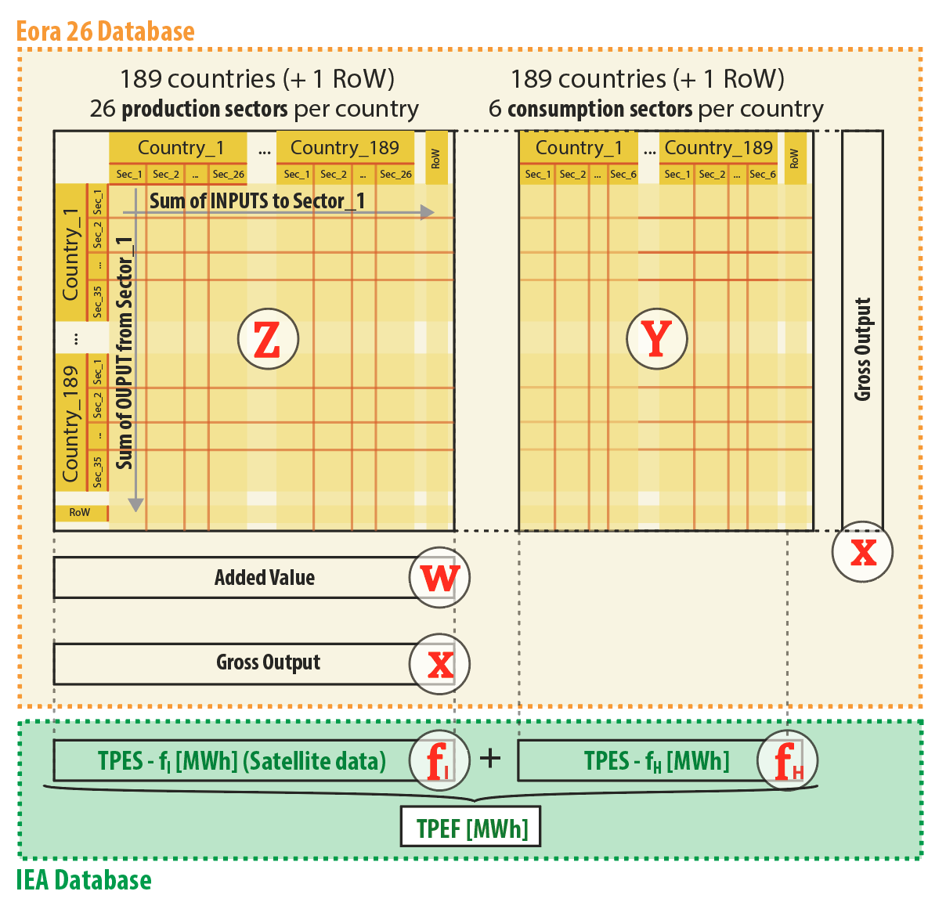
- : Global Multi-Regional Input-Output (GMRIO) structure with the Eora 26-sector database (orange) and TPES data from IEA (green). The final block in the original version of Eora reports 6 categories of final demand for each country. For the sake of simplicity, for each one, we have aggregated the 6 categories by country into one. Adapted from Miller and Blair (2009).

A standard, environmentally extended, demand-driven input-output model has been used to calculate the TPEF of countries (Owen et al., 2017), (Oita et al., 2016), (Lenzen et al., 2004), (Wiedmann et al., 2007). In order to relate IEA TPES energy data with the Eora 26 economic database, a row vector of satellite data of energy consumption for each industrial sector by country was created (f_{I}) following the criteria indicated in Supplementary Table 1. The TPES is the sum of energy consumption by industries (f_{I}, a row vector with information on the energy use of 189 countries and 26 sectors) and the direct use of energy per household (f_{H}, a row vector with information on energy use per household in 189 countries). This method, also known as the Leontief equation, follows the sequence of equations below. Firstly, the energy consumption coefficient per unit of industrial output (c vector) has been calculated, where diag stands for the diagonalization of a vector, as:

$$c$$$$=f_{I}{·(diag(x))}^{-1}$$ | (1)
The technical coefficients matrix (A) has been calculated, and from this in turn we arrive at the Leontief Inverse (L):
$$A= Z{(diag(x))}^{-1}$$ | - (2)
$${L≡\left(I-A\right)}^{-1}$$ | - (3)
Next, the total (i.e. a scalar) industrial energy embodied in the products and services demanded by country r ($g_{I}^{r}$) is obtained using the standard demand-driven IO model:
$$g_{I}^{r} =cLy_{TOT}^{r}$$ | - (4)
Where $y_{TOT}^{r}$ is a column vector (4915 x 1) representing the total final demand of goods and services by country r.
Finally, we obtain the total TPEF of country r as the sum of the industrial energy embodied in the products and services ($g_{I}^{r}$) and the energy consumed directly by final users ($g_{H}^{r}$).

$$g^{r}=g_{I}^{r}+g_{H}^{r}$$ | (5)

In this study, due to the insufficiency of the energy consumption country-based satellite data, and the extant difficulties of cross-referencing the results of MRIO analysis with HDI data, we have however obtained the results for 126 countries out of the total 189 Eora database countries.

Human Development Index
The Human Development Index has been the selected indicator to compare the consumed energy with the achieved welfare of a country; as this accounts for the economic advantages but also improvements in human well-being (Sen, 1992). Data has been derived from UNDP (UNDP, 2015) and has been processed in order to obtain average trends, which have been used to validate the final conclusions of the project. HDI, shown in Equation 6, is the geometric mean of Income Index (II), Life Expectancy Index (LEI) and Education Index (EI), based in the aggregation of economic, health and education level of a country (UNDP, 2017).
$$HDI=\sqrt[3]{LEI×II×EI}$$ | (6)

Decoupling Index
The decoupling phenomena, has been most frequently graphically observed (Wiedmann et al., 2015), (Steinberger and Roberts, 2010). Nevertheless, the Decoupling Index (DI) (Wang, 2011), (Wu et al., 2018), is a crucial parameter that enables to compare the achievements of a single country over time, or to compare different countries with each other. The DI allows understanding how countries are reducing environmental burdens (in this case energy consumption) while increasing their development status. The difference between relative decoupling and absolute decoupling is especially important since the latter implies an energy reduction in absolute terms. The DI has been a development from the well known I=PAT formula (Wu et al., 2018), obtaining the final Equation 7; where g represents the average increase of GDP, and t represents the average decline rate of energy consumption per unit of GDP between the selected years.
$$DI=\frac{t}{g}×\left(1+g\right)=\frac{Δ GDP\left(\%\right)-Δ TPES\left(\%\right)}{ΔGDP\left(\%\right)}$$ | (7)

DI= ARCTAN( Δ HDI%HDI%ΔEnergyEnergy CConsumptionP(%)) | (8)
In this study, Equation 7 has been used as a reference to create Equation 8, where results have been calculated in degrees due to the differences between GDP and HDI, and population variable P has been added in the energy variations. The use of degrees allows having a clearer visual range, since the HDI values have the maximum value of 1.0 whereas GDP does not present a specific maximum. Equation 8 shows how Figure 2 has been created, where angle 45º corresponds to the equivalent of 1 in Equation 7. In Equation 8 the increase of HDI and energy consumption have been included in percentage.
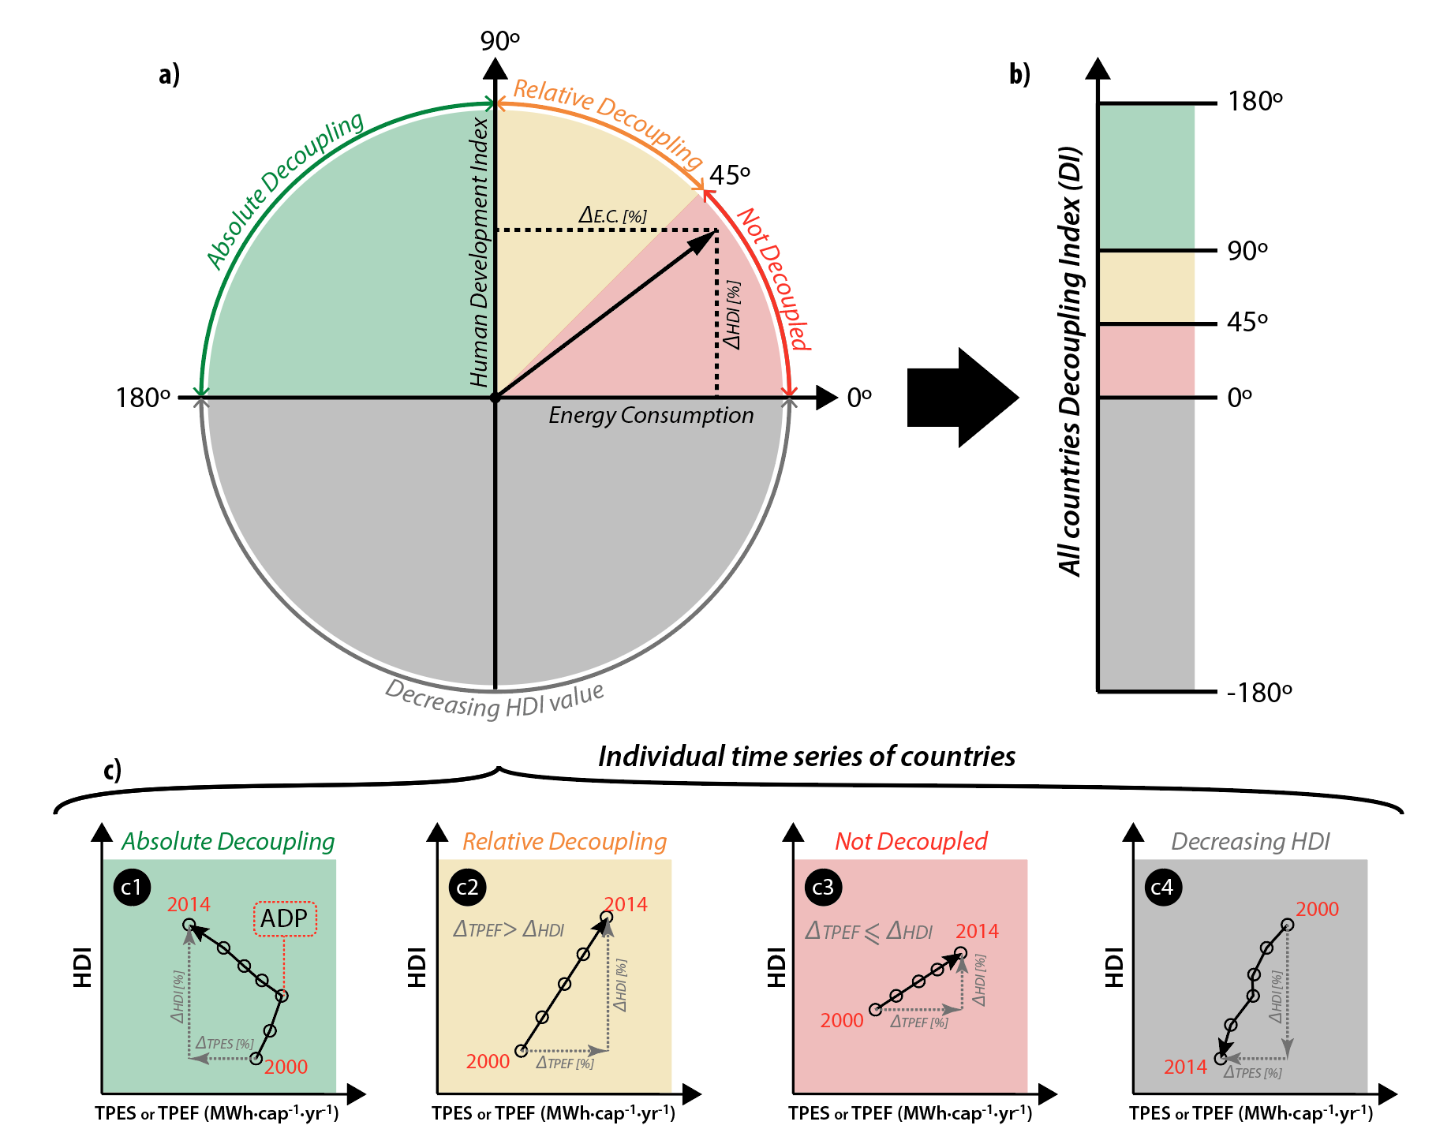
- : Decoupling Index indicator between HDI and energy consumption.

It must be clarified that Equation 8 results range is originally from -90 to 90, but in order to amplify the results range, Matlab has been used to detect when the angles correspond to different quadrants, creating a new results range of -180 to 180 degrees. Figure 2 (a) shows how the results have been identified in quadrants (Zhang et al., 2017), and Figure 2 (b) shows how these quadrants have been converted into a linear visualization mode; this allows the comparison of the results of DI with a single vertical arrow according to TPES and TPEF data as shown later in Figure 3. Four different trends have been identified among countries shown in Figure 2 (c), according to the Decoupling Index methodology:
- Absolutely decoupled countries (90 to 180º). Those who are reducing their TPES (or TPEF) and increasing their HDI. Figure 2(a) shows how the Absolute Decoupling Point (ADP) could be graphically identified in the annual series. ADP corresponds to the point after which energy consumption started reducing while still HDI is still increasing. (e.g. FRA: HDI +5%, TPEF -10%, DI 153º)
- Relatively decoupled countries (45 to 90º). Those countries that need to increase their energy consumption to increase the HDI value, but the percentage of energy consumption increase is lower than the increased HDI percentage. (e.g. MOZ: HDI +39%, TPEF +7%, DI 80º)
- Not decoupled countries (0 to 45º). Countries that need to increase their energy consumption at least in the same or greater percentage that the increase of the achieved HDI value. (e.g. NOR: HDI +3%, TPEF +11%, DI 17º)
- Reduction of HDI (0º to -180º). In this case two different subsections could be distinguished. Firstly, there is a scenario where energy consumption increases, and secondly one where consumption decreases. This last situation might happen in cases such as wars or deep national crisis. Eventually, in high-developed countries, a momentary soft decrease of HDI could be justified in order to achieve planned energy reductions. (e.g. SYR: HDI -6%, TPEF -30%, DI -168º)

Results

Results have been divided into four subsections matching the specific aims of the study (Section 1.5).

Decoupling Index as measured by TPES and TPEF
The index has been calculated according to the methodology introduced in Section 2.3. Figure 3 shows that the Decoupling Index (DI) changes significantly in many countries when considering TPES or TPEF data. There is a general trend of decreasing the DI in most of the countries (93 countries out of 126 decrease their DI while 33 increase it). The number of absolutely decoupled countries have been reduced from 40 to 27, the number of relatively decoupled countries have been reduced from 29 to 17 and instead the amount of coupled countries have increase from 55 to 80 using TPEF account.
This general trend to reduce the DI of countries when using TPEF accounts occurs due to an energy consumption increase in percentage in comparison with TPES accounts, while maintaining the same HDI gain. In high-income countries, even though the imported embodied energy has been generally slightly reduced since the Global Financial Crisis (GFC, or Great Recession) (Mazumder, 2018), is still higher than in 2000; and in low-income countries imported embodied energy has been slowly growing since 2000. Thus, during the analysed time period, low-income countries and high-income countries in general have a worse Decoupling Index with TPEF accounts. Therefore, even if the sum of the TPES and TPEF of all countries is equal, same quantity of energy consumption is extracted from exporter countries to be relocated in importer ones; in the Decoupling Index, a there is not a balance between countries that increased and decreased the DI value when using TPEF accounts (Supplementary Figure 1).
Countries that have an absolute decoupling within TPES, such as AUS, CAN, KWT, NLD, NOR, ROU, SVK, CHE and TJK, are coupled when using TPEF data; meaning that their consumption implies larger levels of energy than their production for the same level of HDI. Similarly, some countries that are shown to have a relative decoupling with TPES values, appear to be coupled under TPEF accounts, such as AZE, BWA, HRV, GHA, KEN, NPL, NZL, PRY, POL, MDA, SRB and YEM. Other countries, which are shown to be in absolute decoupling situation with TPES, are only relatively decoupled according to TPEF data, such as: DOM, FIN, LUX and UKR.
On the other hand, a total of 33 out of 126 countries improved their DI value when using TPEF accounts. The highest variations occurred in 3 countries; BLR, which seems to be coupled according to TPES calculations, is absolutely decoupled; and MEX and MLT, which are relatively decoupled according to TPES measurements, are absolutely decoupled in TPEF terms.
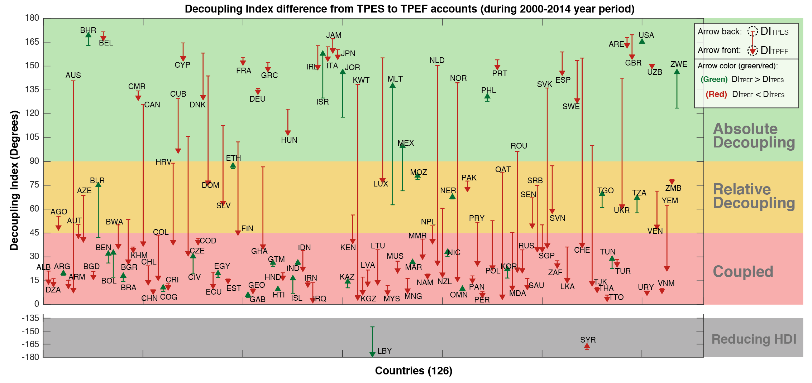

- : The arrows start in the DI_{TPES} and end in the DI_{TPEF},, and both are calculated using consumption based accounts (CBA), during the 2000-2014 period. The red arrows show how in 93 countries (from the analysed 126 ones) TPEF reports a smaller DI than that offered by TPES data, and the green arrows show how in 33 countries the TPEF identifies a greater DI than that detected by TPES data.

TPEF based Decoupling Index versus HDI
Figure 4 shows the relation between the development level (in terms of HDI) and the achieved DI (based on TPEF accounts) in 2000-2014 split into four periods: 2000-2004, 2004-2008, 2008-2012, and 2012-2014. It can be seen that every period follows a very different pattern.
Noticeably, although decoupling is generally less present when TPEF data is used, successive years indicate increasing numbers of countries that are reaching the absolute decoupling (Figure 4 and Figure 5). Nevertheless, some high-HDI countries, that have been absolutely decoupled during the first three periods, are not anymore decoupled during the last period (USA, DEU, DNK) (Figure 5).
Intriguingly, it is remarkable that countries with extremely low HDI, have achieved temporary in periods 2 and 3 (NER, YEM, ZWE, MOZ) (Figure 4). However, there are fewer less-developed countries that are absolutely decoupled during the last period or are able to maintain the decoupled trend long term.

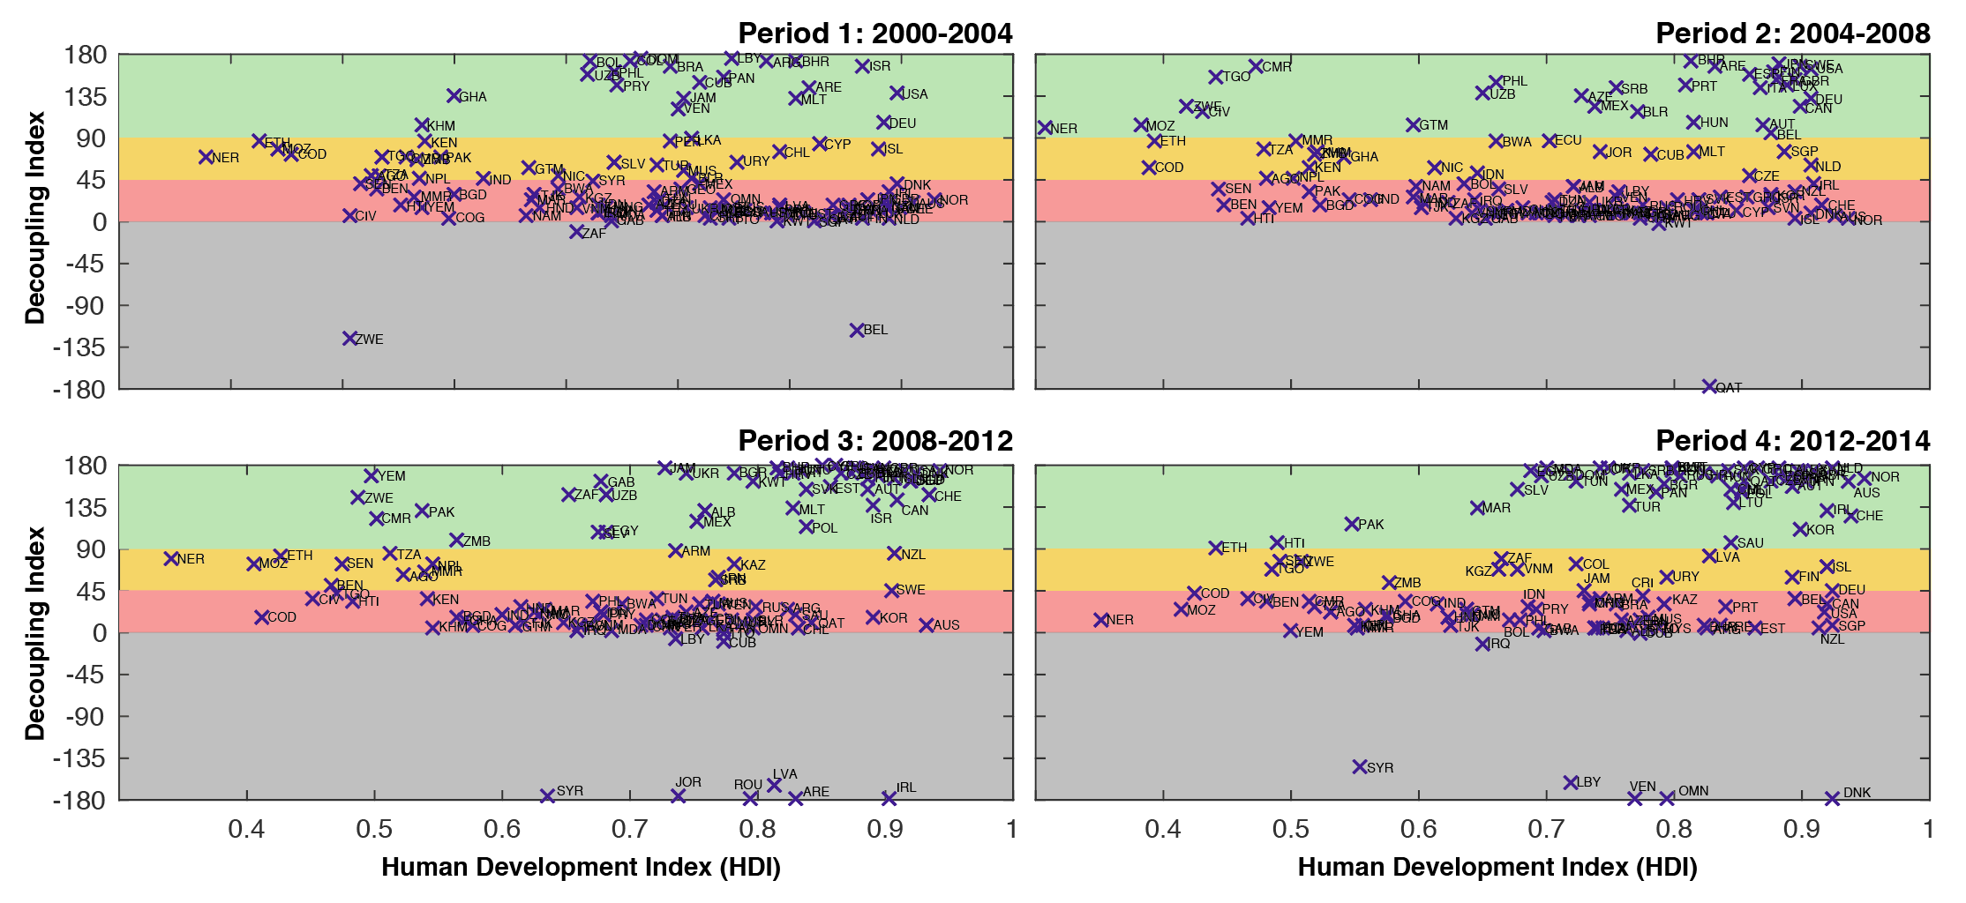
- : In this figure, DI_{TPEF} and its relation with HDI have been analysed. The main goal of this figure is to understand the general trends of countries, shown by the “dark” areas of the charts. As can be seen, in Period 1 the only “dark” area is in the dependent (red) zone, while in Period 3 and Period 4, new “dark” areas appear in the absolutely decoupled (green) zone.

Figure 5 has been created by zooming into Figure 4 in order to better understand the countries that could serve as a reference for “best practice” countries, with an HDI value between 0.8 and 1.0 and a Decoupling Index between 90º and 180º, manifesting an absolute decoupling.

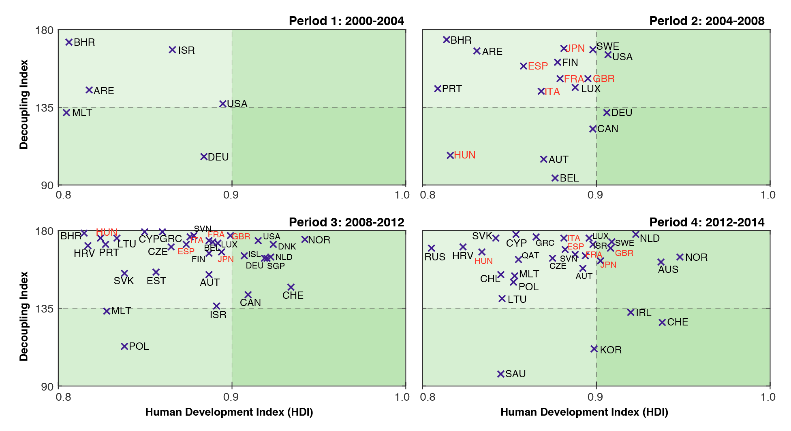
- : DI and HDI relation according TPEF accounts, during the four different periods. Exemplary countries (red) have been identified when at least in 3 periods have been able to maintain an absolute decoupling trend.

Figure 5 shows that there is not a single country with a maintained absolute decoupling since 2000, and only 6 countries from the 126 analysed have an HDI above 0.8 and are manifesting a continuous absolute decoupling since 2004 (and also in average from 2000 to 2014): ESP, ITA, HUN, GBR, JPN and FRA. It could be understood that these countries are exemplary countries, which are achieving a maintained reduction of their energy consumption, while maintaining a gain in HDI.

Time series performances
Time series were developed for each of the 126 countries from year 2000 to 2014, and those for the six exemplary countries detected in the previous subsection have been shown in Figure 6, in order to better understand their dynamics. Has been found that, firstly, exemplary countries present more gradual and stable energy reductions during recent years, which were achieved in two ways: reducing energy consumption inside the country (observed from TPES curve) and reducing embodied energy consumption in goods and services imported from other countries (observed from TPEF curve), while increasing HDI. Hungary, Italy and Spain are the countries that have reached the major reductions in their TPEF values, with 29%, 30% and 33%, respectively.
Secondly, all of the exemplary countries have been affected by the GFC increasing the reduction value of the TPEF from previous years. Nevertheless, all of them have been able to maintain the HDI increase tendency. This means that the crisis phenomena could be seen as an opportunity to reach reduction goals, rather than a risk, if it is properly managed (Schneider et al., 2010).
Additionally, a large difference in consumption is observed when Absolute Decoupling Point (ADP) was reached, meaning that each country could find its own strategy in order to improve their current consumption levels (Figure6). France, Japan and the United Kingdom present the highest ADP value, with 60 to 65 MWh·cap⁻¹·yr⁻¹, and Hungary the lowest, with 36 MWh·cap⁻¹·yr⁻¹. Spain and Italy found the ADP at 48 MWh·cap⁻¹·yr⁻¹.
Finally, a critical observation was made that all of the exemplary countries have a higher TPEF than TPES, meaning that all of them are net importers of energy embodied in goods and services. This means that achieving a decoupling could be harder for net embodied energy exporter countries (such as China or India). It has been observed that generally only 14.2 % of the absolutely decoupled countries are net embodied energy exporters, whereas from the relatively decoupled or coupled countries, net embodied energy exporters make up 41.2% and 41.3% respectively (Supplementary Table 2). This has been measured by comparing the obtained DI_{TPEF} and the corresponding Hidden Energy Flow (HEF, HEF = TPES/TPEF-1, (Akizu et al., 2017) (Akizu et al., 2018)) of each country (Supplementary Table 2).
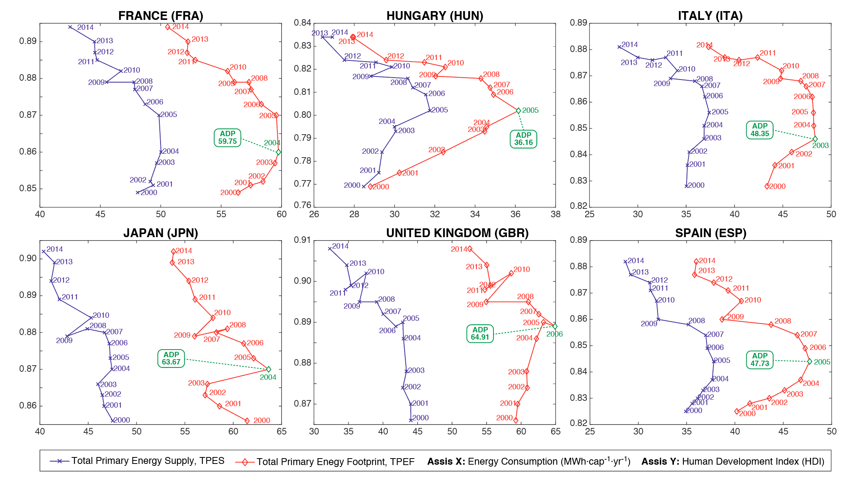
- : The consumed TPES and TPEF and the achieved HDI of the six exemplary countries during the 2000-2014 period. The Absolute Decoupling Point (ADP, green) has been highlighted in the TPEF line of each country.

Figure 7 shows which industrial sectors (defined by the Eora database, Supplementary Table 1) present higher energy reductions in the exemplary countries. Direct electricity consumed at homes been included in the industrial sector 24 (“Private Households”). A sectorial divergence is notorious. While in some countries, such as HUN or GBR, reduction in “Private households” energy consumption has been significant (3-4%), in other countries, such as JPN or ITA, reductions in “Construction” sector have been more relevant (1-4%). “Electricity, Gas and Water” and “Petroleum, Chemical and Non-Metallic” sectors have notorious reductions in almost all the countries. It has been observed that “Transportation” sector has not any significant reduction in any of the exemplary countries. “Electrical and Machinery” sector has variations in reductions; JPN has been able to reduce the energy consumed in this sector, while the rest of the exemplary countries are increasing the energy consumption in it. Trade sectors have generally suffer a slight reduction, while “Financial and Business activities” have experienced a generally slight increase.

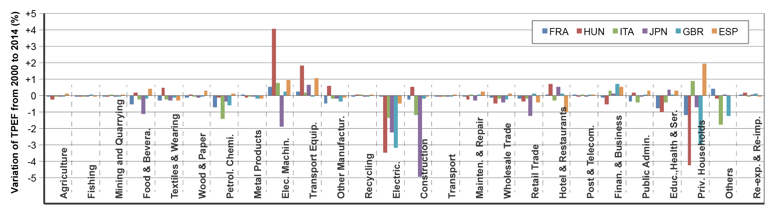
- : Percent increase or decrease of energy consumption by sector (according to TPEF accounts) from 2000 to 2014 for the six exemplary countries.

Temporary or permanent decoupling
In this subsection, countries that have manifested a temporary decoupling in one or more years have been identified. Figure 8 shows that from the 126 countries analysed, taking into account the TPEF values, 89 have reached a permanent or temporary decoupling; from which 27 (as shown in Figure 3) are permanently decoupled and 62 have experienced a temporary decoupling. Temporary decoupling means that at least in one year have been able to reduce TPEF while increasing their HDI value. The TPEF value at which these countries have reach the temporary decoupling, is drastically different among countries. Some countries have been able to decouple with a TPEF inferior than 20 MWh·cap⁻¹·yr⁻¹ (especially in Africa), whereas others have decoupled with a TPEF superior than 180 MWh·cap⁻¹·yr⁻¹. Achieving a temporary decoupling – even if less relevant than achieving an average absolute decoupling –, reveals the possible 62 candidate countries that could be able to reach a maintained decoupling in the incoming years (Supplementary Figure 2 and Supplementary Figure 3).

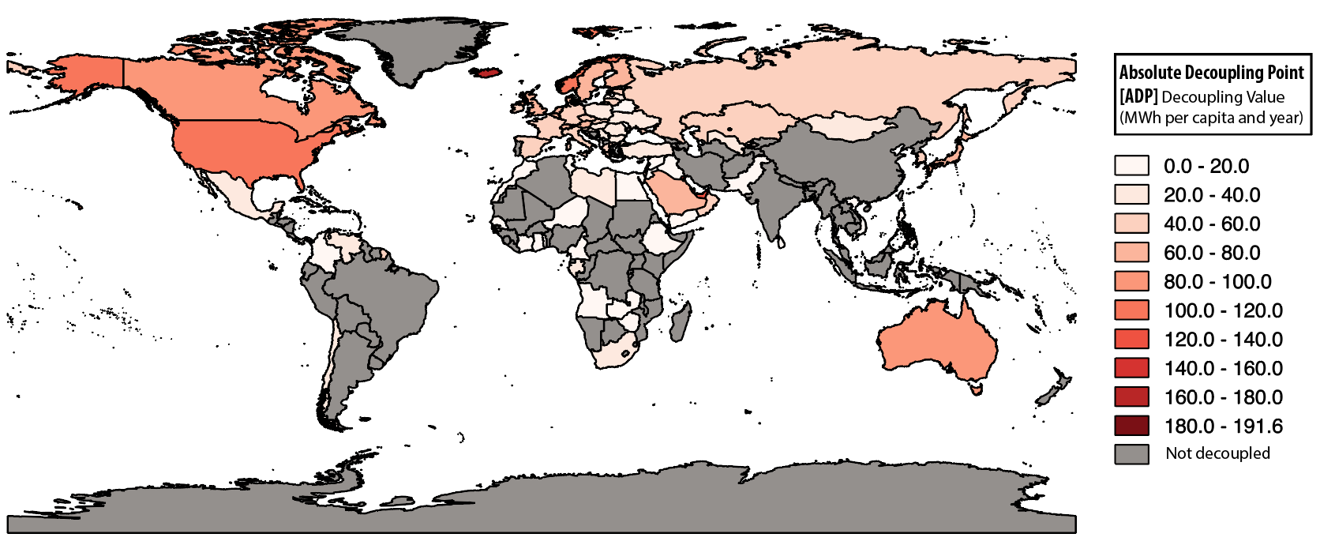
- : 89 countries have been temporarily or permanently decoupled during the 2000-2014 period according TPEF accounts.

Discussion:

General discussion:

In order to achieve global energy justice (Sovacool et al., 2016) and gain a global equal share of energy resources, most developed countries should reduce their current energy consumption (as explained Section 1). Nevertheless this reduction does not imply necessarily a reduction of citizen’s wellbeing. The possibility of meeting a decoupling between energy consumption and HDI allows countries to transit towards a low socio-environmental impact energy system. Furthermore, this could enhance a fair share of global energy resources among countries, boosting international energy justice. In this study, six countries have been identified (FRA, HUN, ITA, JPN, GBR, ESP), which are already experiencing the decoupling phenomenon in a maintained way. Until the present day, mainly the “degrowth movement”, recognised by the scientific community (Weiss and Cattaneo, 2017), has made clear proposals for reducing resources consumption in order to reach better global living standards. The energy degrowth proposal, due to the possibility of increasing development (welfare) while reducing energy consumption, has the potential to become an international energy transition strategy.
In order to analyse DI, this study shows that consumption-based accounts must be used; since results are more complete than traditional TPES-based analyses. Only footprint-based accounts are able to reflect the current reality of the internationally globalised goods and services market. The use of TPEF data, instead of TPES, brings most of the analysed countries towards a more coupled situation between energy consumption and HDI. Calculations that have been carried out with TPES (Wu et al., 2018) are only able to offer an interesting but partial perspective of the energy consumption decoupling, generating a “virtual decoupling” in numerous countries (such as AUS, CAN, LUX, CHE, etc.). This study shows that footprint accounts need to be taken into account to avoid “virtual decoupling”, not only in developed countries, but even in non-developed ones. This is particularly significant when defining worldwide energetically exemplary countries to follow.

As a positive result of the research, it has been noted that absolute decoupling has been permanently or partially achieved within very different energy consumption and HDI values by 89 countries (Figure 8). Absolute decoupling has been achieved from high-energy consumption countries as QAT, ISL and LUX (with a TPEF between 192-169 MWh·cap⁻¹·yr⁻¹and a HDI between 0.83-0.89), to low energy consumption ones as YEM, SEN and NER (with a TPEF between 4-2 MWh·cap⁻¹·yr⁻¹ and a HDI between 0.35-0.49). This gives an optimistic nuance to the incoming necessary energy transition process, meaning that regardless of the energy intensity of a country, there is room of improvement for energy consumption reductions in every national reality and maintain or increase the HDI. Furthermore, it could be observed in Figure 4, shows that more countries are able to reach an absolute decoupling in the last period (2012-2014) than previously, showing a clear international tendency to move towards lower energy consumption realities.
This study shows that according to the analysed 126 countries, there is much left to do to trigger the necessary worldwide decoupling required to reach sufficient energy consumption reduction in developed countries, and boost the increase of HDI in less-developed ones to achieve the sustainable use of global energy resources, with low socio-environmental impacts. Nevertheless, positive performances have been found, observing that more countries have been achieving important decoupling targets in recent years, especially between 2012 and 2014.

Exemplary countries:

Although achieving a temporary absolute decoupling can frequently occur, maintaining this tendency in the long-term, in order to clearly reduce the energy consumption of a country while increasing its HDI, has been found to be challenging. From the 126 countries analysed, only 27 have shown an average absolute decoupling during the total year gap of 2000-2014 (Figure 3), and only 6 of them, within the HDI above 0.8, have shown a maintained absolute decoupling during the last three year gaps, 2004-2008, 2008-2012 and 2012-2014 (Figure 4 and Figure 5). These exemplary countries show three relevant aspects.

Firstly, the gradual energy reduction is a constant trend in most of them, avoiding drastic reductions. Energy reductions have been achieved inside the country boundaries (most probably due to the energy efficiency achievements: eco-efficiency and innovation), but also within the imported energy embodied in goods and services. Reached energy reductions during 14 years have been significant, and three of the exemplary countries (ESP, ITA, HUN) have been able to reduce around 30% of their TPEF. According to the sectorial distribution of reductions, achievements in the electric production sector have been notorious in all countries, as well as in the petrochemical sector. Reductions in the construction and the household sectors are also relevant in some countries. Thus, it is noticed that each country has its own strategy to reduce the TPEF, reducing energy consumption from significantly different economic sectors.

Secondly, the GFC has positively impacted in the exemplary countries regarding this scope, provoking ulterior reductions in their energy consumption while still increasing the HDI value. This allows citizens to understand the crisis as an opportunity (Schneider et al., 2010).

Finally, all of the exemplary countries are net embodied energy importers. This should be taken into account to improve international relations promoting the support to most industrial producer countries, enhancing their increase of HDI while maintaining low levels for their per capita energy consumption. The recognition of the current imports of embodied energy in goods and services is a key factor. Importer countries need to be aware of the privileges that this brings to them (such as to allow an easier decoupling between energy consumption and welfare), and fair economic payments for imported embodied energy should be promoted. Compensation systems, such as the ones developed in carbon footprints in global scale (Pezzey and Jotzo, 2013), (Meng et al., 2018) or in ecosystem services in a more national or regional scale (Reed et al., 2017), could be implemented in the energy field.

Conclusions and Policy Implications

In the current globalised market, with large amount of goods and service exchanges among countries, it is compulsory to take into account the energy embodied in trade if an integral energy consumption diagnosis is desired. Countries can no longer understand their energy consumption accounts using TPES data directly drawn from the International Energy Agency database. Instead, TPES data needs to be complemented with TPEF calculations in order to avoid distortion of energy consumption pattern realities.

Exemplary countries, the ones that have achieved a maintained decoupling among consumed energy and improved HDI, have developed it via gradual energy consumption reductions as opposed to drastic energy consumption reduction performances. These reductions could be achieved by two paths; firstly by enhancing the integration of eco-efficiency and innovation tools within national boundaries (in particular within the electricity, petrochemical, construction and private houses sectors), and secondly via supporting the reduction of imported energy embodied in products and services from other countries which in turn triggers energy sovereignty. Despite the lack of clearly identified environmentally sustainable and socially fair global energy threshold, most developing countries seem to have a margin to increase their energy consumption in order to increase their HDI. However, this increase could be supported and expedited by international collaborations with energy efficient standards across developing countries through Kyoto Protocol-type clean development mechanisms or technology transfers (UNEP, 1998).

The study shows, that economic crises are an opportunity to gain decoupling. In all of the six exemplary countries, the 2009 Global Financial Crisis (GFC) enhanced their energy reduction while increasing their HDI.

Net embodied-energy exporter countries have been found especially weak when trying to achieve a decoupling reality; thus, in order to create a global absolute decoupling trend, solidarity towards and collaboration with net embodied-energy exporter countries should be increased. Building upon the recognition of trade in embodied energy trade and on quantitative information on energy footprints, international cooperation on reducing global energy demand should be designed.
This work contributes to “Goal 7” of SDG (UN, 2015), promoting insights to reach a sustainable energy system for all individuals. The work also contributes towards the achievement of “Goal 10” of the SDG, fostering the reduction of inequality among countries, and “Goal 12”, enhancing sustainable consumption patterns.

Acknowledgment
The authors are grateful to Erasmus Panther Programme coordinated by Warsaw University of Technology, to the Sustainability Assessment Program (SAP) of the University of New South Wales (UNSW Sydney) and to the University of the Basque Country (UPV/EHU) to make the 10-month research stay possible at UNSW Sydney, where this paper has been developed. The authors also thank Hung Pham for his patient and support in Matlab coding at the initial steps of the project. The authors thank James Hayes, Marian Arante and Anthony Coxeter for their valuable contribution as professional English editors within this project.

References
Akizu, O., Bueno, G., Barcena, I., Kurt, E., Topaloğlu, N., Lopez-Guede, J.M., 2018. Contributions of Bottom-Up Energy Transitions in Germany: A Case Study Analysis. Energies 11, 849. https://doi.org/10.3390/en11040849
Akizu, O., Urkidi, L., Bueno, G., Lago, R., Barcena, I., Mantxo, M., Basurko, I., Lopez-Guede, J.M., 2017. Tracing the emerging energy transitions in the Global North and the Global South. Int. J. Hydrog. Energy. https://doi.org/10.1016/j.ijhydene.2017.04.297
Arto, I., Capellán-Pérez, I., Lago, R., Bueno, G., Bermejo, R., 2016. The energy requirements of a developed world. Energy Sustain. Dev. 33, 1–13. https://doi.org/10.1016/j.esd.2016.04.001
Barrett, J., Peters, G., Wiedmann, T., Scott, K., Lenzen, M., Roelich, K., Quéré, C.L., 2013. Consumption-based GHG emission accounting: a UK case study. Clim. Policy 13, 451–470. https://doi.org/10.1080/14693062.2013.788858
Bullard, C.W., Foster, C.Z., 1976. On decoupling energy and GNP growth. Energy 1, 291–300. https://doi.org/10.1016/0360-5442(76)90004-9
Capellán-Pérez, I., de Castro, C., Arto, I., 2017. Assessing vulnerabilities and limits in the transition to renewable energies: Land requirements under 100% solar energy scenarios. Renew. Sustain. Energy Rev. 77, 760–782. https://doi.org/10.1016/j.rser.2017.03.137
Capellán-Pérez, I., Mediavilla, M., de Castro, C., Carpintero, Ó., Miguel, L.J., 2014. Fossil fuel depletion and socio-economic scenarios: An integrated approach. Energy 77, 641–666. https://doi.org/10.1016/j.energy.2014.09.063
Chen, B., Li, J.S., Wu, X.F., Han, M.Y., Zeng, L., Li, Z., Chen, G.Q., 2018. Global energy flows embodied in international trade: A combination of environmentally extended input–output analysis and complex network analysis. Appl. Energy 210, 98–107. https://doi.org/10.1016/j.apenergy.2017.10.113
Chen, C.-Z., Lin, Z.-S., 2008. Multiple timescale analysis and factor analysis of energy ecological footprint growth in China 1953–2006. Energy Policy 36, 1666–1678. https://doi.org/10.1016/j.enpol.2007.11.033
Chen, G.Q., Wu, X.F., 2017. Energy overview for globalized world economy: Source, supply chain and sink. Renew. Sustain. Energy Rev. 69, 735–749. https://doi.org/10.1016/j.rser.2016.11.151
Chen, Z.-M., Chen, G.Q., 2013. Demand-driven energy requirement of world economy 2007: A multi-region input–output network simulation. Commun. Nonlinear Sci. Numer. Simul. 18, 1757–1774. https://doi.org/10.1016/j.cnsns.2012.11.004
Cullen, J.M., Allwood, J.M., Borgstein, E.H., 2011. Reducing Energy Demand: What Are the Practical Limits? Environ. Sci. Technol. 45, 1711–1718. https://doi.org/10.1021/es102641n
de Freitas, L.C., Kaneko, S., 2011. Decomposing the decoupling of CO2 emissions and economic growth in Brazil. Ecol. Econ. 70, 1459–1469. https://doi.org/10.1016/j.ecolecon.2011.02.011
Diakoulaki, D., Mandaraka, M., 2007. Decomposition analysis for assessing the progress in decoupling industrial growth from CO2 emissions in the EU manufacturing sector. Energy Econ., Modeling of Industrial Energy Consumption 29, 636–664. https://doi.org/10.1016/j.eneco.2007.01.005
Eisenstein, M., 2017. How social scientists can help to shape climate policy. Nature 551, 142–144. https://doi.org/10.1038/d41586-017-07418-y
Fouquet, R., 2017. Make low-carbon energy an integral part of the knowledge economy. Nature 551, S141. https://doi.org/10.1038/d41586-017-07509-w
Galli, A., Wiedmann, T., Ercin, E., Knoblauch, D., Ewing, B., Giljum, S., 2012. Integrating Ecological, Carbon and Water footprint into a “Footprint Family” of indicators: Definition and role in tracking human pressure on the planet. Ecol. Indic., The State of the Art in Ecological Footprint: Theory and Applications 16, 100–112. https://doi.org/10.1016/j.ecolind.2011.06.017
García-Olivares, A., 2016. Energy for a sustainable post-carbon society. Sci. Mar. 80, 257–268.
Gies, E., 2017. The real cost of energy. Nature 551, 145–147. https://doi.org/10.1038/d41586-017-07510-3
Goldemberg, J., Siqueira Prado, L.T., 2011. The decline of the world’s energy intensity. Energy Policy 39, 1802–1805. https://doi.org/10.1016/j.enpol.2011.01.013
Grabl, H., Kokott, J., Kulessa, M., Luther, J., Nuscheler, F., Sauerbon, R., Schellnhuber, H.J., Schulze, E.D., 2004. World in Transition: Towards Sustainable Energy Systems. Earthscan.
Hansen, J.P., Narbel, P.A., Aksnes, D.L., 2017. Limits to growth in the renewable energy sector. Renew. Sustain. Energy Rev. 70, 769–774. https://doi.org/10.1016/j.rser.2016.11.257
Heeren, N., Wallbaum, H., Jakob, M., 2012. Towards a 2000 Watt society – assessing building-specific saving potentials of the Swiss residential building stock. Int. J. Sustain. Build. Technol. Urban Dev. 3, 43–49. https://doi.org/10.1080/2093761X.2012.673917
Heinonen, J., Junnila, S., 2014. Residential energy consumption patterns and the overall housing energy requirements of urban and rural households in Finland. Energy Build. 76, 295–303. https://doi.org/10.1016/j.enbuild.2014.02.079
Hoekstra, A.Y., Wiedmann, T.O., 2014. Humanity’s unsustainable environmental footprint. Science 344, 1114–1117. https://doi.org/10.1126/science.1248365
Hsiang, S., Kopp, R., Jina, A., Rising, J., Delgado, M., Mohan, S., Rasmussen, D.J., Muir-Wood, R., Wilson, P., Oppenheimer, M., Larsen, K., Houser, T., 2017. Estimating economic damage from climate change in the United States. Science 356, 1362–1369. https://doi.org/10.1126/science.aal4369
Inman, M., 2013. The True Cost of Fossil Fuels. Sci. Am. 308, 58–61. https://doi.org/10.1038/scientificamerican0413-58
Inman, M., 2008. Carbon is forever. Nat. Rep. Clim. Change 156–158. https://doi.org/10.1038/climate.2008.122
International Energy Agency, 2015. Energy Balances 2015.
IPCC, 2015. Fifth Assessment Report (AR5), Climate Change 2014.
Jacobson, M.Z., Delucchi, M.A., 2011. Providing all global energy with wind, water, and solar power, Part I: Technologies, energy resources, quantities and areas of infrastructure, and materials. Energy Policy 39, 1154–1169. https://doi.org/10.1016/j.enpol.2010.11.040
Jacobson, M.Z., Delucchi, M.A., Bauer, Z.A.F., Goodman, S.C., Chapman, W.E., Cameron, M.A., Bozonnat, C., Chobadi, L., Clonts, H.A., Enevoldsen, P., Erwin, J.R., Fobi, S.N., Goldstrom, O.K., Hennessy, E.M., Liu, J., Lo, J., Meyer, C.B., Morris, S.B., Moy, K.R., O’Neill, P.L., Petkov, I., Redfern, S., Schucker, R., Sontag, M.A., Wang, J., Weiner, E., Yachanin, A.S., 2017. 100% Clean and Renewable Wind, Water, and Sunlight All-Sector Energy Roadmaps for 139 Countries of the World. Joule 1, 108–121. https://doi.org/10.1016/j.joule.2017.07.005
Jacobson, M.Z., Delucchi, M.A., Bazouin, G., Bauer, Z.A.F., Heavey, C.C., Fisher, E., Morris, S.B., Piekutowski, D.J.Y., Vencill, T.A., Yeskoo, T.W., 2015. 100% clean and renewable wind, water, and sunlight (WWS) all-sector energy roadmaps for the 50 United States. Energy Environ. Sci. 8, 2093–2117. https://doi.org/10.1039/C5EE01283J
Kaltenegger, O., Löschel, A., Pothen, F., 2017. The effect of globalisation on energy footprints: Disentangling the links of global value chains. Energy Econ., Seventh Atlantic Workshop in Energy and Environmental Economics 68, 148–168. https://doi.org/10.1016/j.eneco.2018.01.008
Kanemoto, K., Lenzen, M., Peters, G.P., Moran, D.D., Geschke, A., 2012. Frameworks for Comparing Emissions Associated with Production, Consumption, And International Trade. Environ. Sci. Technol. 46, 172–179. https://doi.org/10.1021/es202239t
Kovanda, J., Weinzettel, J., 2013. The importance of raw material equivalents in economy-wide material flow accounting and its policy dimension. Environ. Sci. Policy 29, 71–80. https://doi.org/10.1016/j.envsci.2013.01.005
Krugmann, H., Goldemberg, J., 1983. The energy cost of satisfying basic human needs. Technol. Forecast. Soc. Change 24, 45–60. https://doi.org/10.1016/0040-1625(83)90062-8
Kucukvar, M., Onat, N.C., Haider, M.A., Shaikh, M.A., 2017. A Global Multiregional Life Cycle Sustainability Assessment of National Energy Production Scenarios until 2050. Presented at the International Conference on Industrial Engineering and Operations Management Bogota.
Lan, J., Malik, A., Lenzen, M., McBain, D., Kanemoto, K., 2016. A structural decomposition analysis of global energy footprints. Appl. Energy 163, 436–451. https://doi.org/10.1016/j.apenergy.2015.10.178
Lenzen, M., Kanemoto, K., Moran, D., Geschke, A., 2012. Mapping the Structure of the World Economy. Environ. Sci. Technol. 46, 8374–8381. https://doi.org/10.1021/es300171x
Lenzen, M., Moran, D., Kanemoto, K., Geschke, A., 2013. Building Eora: A Global Multi-Region Input–Output Database at High Country and Sector Resolution. Econ. Syst. Res. 25, 20–49. https://doi.org/10.1080/09535314.2013.769938
Lenzen, M., Pade, L.-L., Munksgaard, J., 2004. CO2 Multipliers in Multi-region Input-Output Models. Econ. Syst. Res. 16, 391–412. https://doi.org/10.1080/0953531042000304272
Martínez, D.M., Ebenhack, B.W., 2008. Understanding the role of energy consumption in human development through the use of saturation phenomena. Energy Policy 36, 1430–1435. https://doi.org/10.1016/j.enpol.2007.12.016
Mativenga, P.T., Rajemi, M.F., 2011. Calculation of optimum cutting parameters based on minimum energy footprint. CIRP Ann. - Manuf. Technol. 60, 149–152. https://doi.org/10.1016/j.cirp.2011.03.088
Mazumder, S., 2018. Inflation in Europe after the Great Recession. Econ. Model. https://doi.org/10.1016/j.econmod.2017.12.014
Mazur, A., 2011. Does increasing energy or electricity consumption improve quality of life in industrial nations? Energy Policy 39, 2568–2572. https://doi.org/10.1016/j.enpol.2011.02.024
Meadows, D.H., Meadows, D.L., Randers, J., Behrens III, W.W., 1972. The Limits to growth: a report for the Club of Rome’s project on the predicament of mankind. Universe Books.
Meng, X., Yao, Z., Nie, J., Zhao, Y., 2018. Make or buy? It is the question: A study in the presence of carbon tax. Int. J. Prod. Econ. 195, 328–337. https://doi.org/10.1016/j.ijpe.2017.10.029
Mielnik, O., Goldemberg, J., 2002. Foreign direct investment and decoupling between energy and gross domestic product in developing countries. Energy Policy 30, 87–89. https://doi.org/10.1016/S0301-4215(01)00080-5
Miller, R.E., Blair, P.D., 2009. Input-Output Analysis: Foundations and Extensions. Cambridge University Press.
Min, J., Rao, N.D., 2017. Estimating Uncertainty in Household Energy Footprints. J. Ind. Ecol. n/a-n/a. https://doi.org/10.1111/jiec.12670
Moran, D., Wood, R., 2014. Convergence Between the Eora, Wiod, Exiobase, and Openeu’s Consumption-Based Carbon Accounts. Econ. Syst. Res. 26, 245–261. https://doi.org/10.1080/09535314.2014.935298
Moreau, V., Vuille, F., 2018. Decoupling energy use and economic growth: Counter evidence from structural effects and embodied energy in trade. Appl. Energy 215, 54–62. https://doi.org/10.1016/j.apenergy.2018.01.044
Munksgaard, J., Pedersen, K.A., 2001. CO2 accounts for open economies: producer or consumer responsibility? Energy Policy 29, 327–334. https://doi.org/10.1016/S0301-4215(00)00120-8
Nilsson, L.J., 1993. Energy intensity trends in 31 industrial and developing countries 1950–1988. Energy 18, 309–322. https://doi.org/10.1016/0360-5442(93)90066-M
OECD, (Organization for Economic Co-operation and Development), 2002. Indicators to measure decoupling of environmental pressure from economic growth. Sustainable Development. SG/SD (2002).
Oita, A., Malik, A., Kanemoto, K., Geschke, A., Nishijima, S., Lenzen, M., 2016. Substantial nitrogen pollution embedded in international trade. Nat. Geosci. 9, 111–115. https://doi.org/10.1038/ngeo2635
O’Neill, D.W., Fanning, A.L., Lamb, W.F., Steinberger, J.K., 2018. A good life for all within planetary boundaries. Nat. Sustain. 1, 88–95. https://doi.org/10.1038/s41893-018-0021-4
Owen, A., Brockway, P., Brand-Correa, L., Bunse, L., Sakai, M., Barrett, J., 2017. Energy consumption-based accounts: A comparison of results using different energy extension vectors. Appl. Energy 190, 464–473. https://doi.org/10.1016/j.apenergy.2016.12.089
Pargman, D., Eriksson, E., Höök, M., Tanenbaum, J., Pufal, M., Wangel, J., 2017. What if there had only been half the oil? Rewriting history to envision the consequences of peak oil. Energy Res. Soc. Sci., Narratives and Storytelling in Energy and Climate Change Research 31, 170–178. https://doi.org/10.1016/j.erss.2017.06.007
Pasten, C., Santamarina, J.C., 2012. Energy and quality of life. Energy Policy, Special Section: Fuel Poverty Comes of Age: Commemorating 21 Years of Research and Policy 49, 468–476. https://doi.org/10.1016/j.enpol.2012.06.051
Peters, G.P., 2008. From production-based to consumption-based national emission inventories. Ecol. Econ. 65, 13–23. https://doi.org/10.1016/j.ecolecon.2007.10.014
Peters, G.P., Hertwich, E.G., 2008. Post-Kyoto greenhouse gas inventories: production versus consumption. Clim. Change 86, 51–66. https://doi.org/10.1007/s10584-007-9280-1
Pezzey, J.C.V., Jotzo, F., 2013. Carbon tax needs thresholds to reach its full potential. Nat. Clim. Change 3, 1008–1011. https://doi.org/10.1038/nclimate2054
Reed, M.S., Allen, K., Attlee, A., Dougill, A.J., Evans, K.L., Kenter, J.O., Hoy, J., McNab, D., Stead, S.M., Twyman, C., Scott, A.S., Smyth, M.A., Stringer, L.C., Whittingham, M.J., 2017. A place-based approach to payments for ecosystem services. Glob. Environ. Change 43, 92–106. https://doi.org/10.1016/j.gloenvcha.2016.12.009
Rocco, M.V., Forcada Ferrer, R.J., Colombo, E., 2018. Understanding the energy metabolism of World economies through the joint use of Production- and Consumption-based energy accountings. Appl. Energy 211, 590–603. https://doi.org/10.1016/j.apenergy.2017.10.090
Rockström, J., Steffen, W., Noone, K., Persson, A., Chapin, F.S., Lambin, E.F., Lenton, T.M., Scheffer, M., Folke, C., Schellnhuber, H.J., Nykvist, B., de Wit, C.A., Hughes, T., van der Leeuw, S., Rodhe, H., Sörlin, S., Snyder, P.K., Costanza, R., Svedin, U., Falkenmark, M., Karlberg, L., Corell, R.W., Fabry, V.J., Hansen, J., Walker, B., Liverman, D., Richardson, K., Crutzen, P., Foley, J.A., 2009. A safe operating space for humanity. Nature 461, 472–475. https://doi.org/10.1038/461472a
Rodrigues, J.F.D., Moran, D., Wood, R., Behrens, P., 2018. Uncertainty of Consumption-Based Carbon Accounts. Environ. Sci. Technol. https://doi.org/10.1021/acs.est.8b00632
Schneider, F., Kallis, G., Martinez-Alier, J., 2010. Crisis or opportunity? Economic degrowth for social equity and ecological sustainability. Introduction to this special issue. J. Clean. Prod., Growth, Recession or Degrowth for Sustainability and Equity? 18, 511–518. https://doi.org/10.1016/j.jclepro.2010.01.014
Sen, A., 1992. Inequality Reexamined. Harvard University Press, New York.
Slaper, T.F., Hall, T.J., 2011. The Triple Bottom Line: What Is It and How Does It Work? Indiana Bus. Rev. Volume 86, No. 1.
Sorrell, S., 2015. Reducing energy demand: A review of issues, challenges and approaches. Renew. Sustain. Energy Rev. 47, 74–82. https://doi.org/10.1016/j.rser.2015.03.002
Sovacool, B.K., Heffron, R.J., McCauley, D., Goldthau, A., 2016. Energy decisions reframed as justice and ethical concerns. Nat. Energy 1, 16024. https://doi.org/10.1038/nenergy.2016.24
Steckel, J.C., Brecha, R.J., Jakob, M., Strefler, J., Luderer, G., 2013. Development without energy? Assessing future scenarios of energy consumption in developing countries. Ecol. Econ. 90, 53–67. https://doi.org/10.1016/j.ecolecon.2013.02.006
Steffen, W., Richardson, K., Rockström, J., Cornell, S.E., Fetzer, I., Bennett, E.M., Biggs, R., Carpenter, S.R., Vries, W. de, Wit, C.A. de, Folke, C., Gerten, D., Heinke, J., Mace, G.M., Persson, L.M., Ramanathan, V., Reyers, B., Sörlin, S., 2015. Planetary boundaries: Guiding human development on a changing planet. Science 347, 1259855. https://doi.org/10.1126/science.1259855
Steinberger, J.K., Roberts, J.T., 2010. From constraint to sufficiency: The decoupling of energy and carbon from human needs, 1975–2005. Ecol. Econ., Special Section: Ecological Distribution Conflicts 70, 425–433. https://doi.org/10.1016/j.ecolecon.2010.09.014
Stulz, R., Tanner, S., Sigg, R., 2011. Chapter 16 - Swiss 2000-Watt Society: A Sustainable Energy Vision for the Future, in: Sioshansi, F.P. (Ed.), Energy, Sustainability and the Environment. Butterworth-Heinemann, Boston, pp. 477–496. https://doi.org/10.1016/B978-0-12-385136-9.10016-6
Tapio, P., 2005. Towards a theory of decoupling: degrees of decoupling in the EU and the case of road traffic in Finland between 1970 and 2001. Transp. Policy 12, 137–151. https://doi.org/10.1016/j.tranpol.2005.01.001
Teske, S., Sawyer, S., Schäfer, O., Pregger, T., Simon, S., Naegler, T., 2015. Energy [R] evolution – a sustainable world energy outlook 2015.
UN, 2015. Transforming our World: the 2030 Agenda for Sustainable Development Annex A/RES/70/1.
UNDP (Ed.), 2017. Human Development Report 2016: Human Development for Everyone. And Technical Notes. United Nations, New York, NY.
UNDP, 2015. Trends in the Human Development Index, 1990-2015 [WWW Document]. URL http://hdr.undp.org/en/composite/trends
UNEP, U.N., 1998. KYOTO PROTOCOL TO THE UNITED NATIONS FRAMEWORK CONVENTION ON CLIMATE CHANGE.
UNEP, U.N.E.P., 2014. Decoupling 2: technologies, opportunities and policy options. UNEP.
UNEP, U.N.E.P., 2011. Decoupling: natural resource use and environmental impacts from economic growth. UNEP.
Wang, H., 2011. Decoupling Measure between Economic Growth and Energy Consumption of China. Energy Procedia, 2010 International Conference on Energy, Environment and Development - ICEED2010 5, 2363–2367. https://doi.org/10.1016/j.egypro.2011.03.406
Weiss, M., Cattaneo, C., 2017. Degrowth – Taking Stock and Reviewing an Emerging Academic Paradigm. Ecol. Econ. 137, 220–230. https://doi.org/10.1016/j.ecolecon.2017.01.014
Wiedmann, T., 2009. A first empirical comparison of energy Footprints embodied in trade — MRIO versus PLUM. Ecol. Econ., Methodological Advancements in the Footprint Analysis 68, 1975–1990. https://doi.org/10.1016/j.ecolecon.2008.06.023
Wiedmann, T., Lenzen, M., 2018. Environmental and social footprints of international trade. Nat. Geosci. 11, 314–321. https://doi.org/10.1038/s41561-018-0113-9
Wiedmann, T., Lenzen, M., Turner, K., Barrett, J., 2007. Examining the global environmental impact of regional consumption activities — Part 2: Review of input–output models for the assessment of environmental impacts embodied in trade. Ecol. Econ. 61, 15–26. https://doi.org/10.1016/j.ecolecon.2006.12.003
Wiedmann, T.O., Schandl, H., Lenzen, M., Moran, D., Suh, S., West, J., Kanemoto, K., 2015. The material footprint of nations. Proc. Natl. Acad. Sci. 112, 6271–6276. https://doi.org/10.1073/pnas.1220362110
Wood, R., Stadler, K., Simas, M., Bulavskaya, T., Giljum, S., Lutter, S., Tukker, A., 2018. Growth in Environmental Footprints and Environmental Impacts Embodied in Trade: Resource Efficiency Indicators from EXIOBASE3. J. Ind. Ecol. n/a-n/a. https://doi.org/10.1111/jiec.12735
Wu, X.F., Chen, G.Q., 2017. Global primary energy use associated with production, consumption and international trade. Energy Policy 111, 85–94. https://doi.org/10.1016/j.enpol.2017.09.024
Wu, Y., Zhu, Q., Zhu, B., 2018. Comparisons of decoupling trends of global economic growth and energy consumption between developed and developing countries. Energy Policy 116, 30–38. https://doi.org/10.1016/j.enpol.2018.01.047
WWF, 2011. The energy report: 100% renewable energy by 2050. WWF, Ecofys, OMA, Switzerland and Netherlands.
Zhang, C., Chen, W.-Q., Liu, G., Zhu, D.-J., 2017. Economic Growth and the Evolution of Material Cycles: An Analytical Framework Integrating Material Flow and Stock Indicators. Ecol. Econ. 140, 265–274. https://doi.org/10.1016/j.ecolecon.2017.04.021
Zhang, D., Caron, J., Winchester, N., 2018. Sectoral Aggregation Error in the Accounting of Energy and Emissions Embodied in Trade and Consumption. J. Ind. Ecol. n/a-n/a. https://doi.org/10.1111/jiec.12734
Zhang, M., Song, Y., Su, B., Sun, X., 2015. Decomposing the decoupling indicator between the economic growth and energy consumption in China. Energy Effic. 8, 1231–1239. https://doi.org/10.1007/s12053-015-9348-0

Supplementary Material

Next supplementary figures and tables have been added to support the better understanding of the study.
Supplementary Table 1: Matching between TPES data obtained form International Energy Agency (IEA) and Eora Database 26 sectors to create the TPES satellite data.
Sector number (Eora) | Sector Description (Eora) | Sector matching (IEA)
 |  | Final Consumption IEA | Losses IEA
1 | Agriculture | L_82: Agriculture/forestry | -
2 | Fishing | L_83: Fishing | -
3 | Mining and Quarrying | L_63: Mining and quarrying | -
4 | Food & Beverages | L_64: Food and tobacco | -
5 | Textiles and Wearing Apparel | L_68: Textile and leather | -
6 | Wood and Paper | L_65: Paper, pulp and print  L_66: Wood and wood products | -
7 | Petroleum, Chemical and Non-Metallic Mineral Products | L_58: Chemical and petrochemical  L_59: Non-ferrous metals  L_60: Non-metallic minerals | L_26: Coke ovens (transf.)  L_27: Patent fuel plants (transf.)  L_29: Oil refineries (transf.)  L_30: Petrochemical plants (transf.)  L31: Coal liquefaction plants (transf.)  L_34: Charcoal production plants (transf.)
8 | Metal Products | L_57: Iron and steel | L_24: Blast furnaces (transf.)
9 | Electrical and Machinery | L_62: Machinery | -
10 | Transport Equipment | L_61: Transport equipment | -
11 | Other Manufacturing | L_69: Non-specified (industry) | -
12 | Recycling | - | -
13 | Electricity, Gas and Water | - | L_15: Main activity producer electricity plants (transf.)  L_16: Autoproducer electricity plants (transf.)  L_17: Main activity producer CHP plants (transf.)  L_18: Autoproducer CHP plants (transf.)  L_19: Main activity producer heat plants (transf.)  L_20: Autoproducer heat plants (transf.)  L_21: Heat pumps (transf.)  L_22: Electric boilers (transf.)  L_23: Chemical heat for electricity production (transf.)  L_36: Energy industry own use  L_54: Losses
14 | Construction | L_67: Construction | L_28: BKB/peat briquette plants (transf.)
19 | Transport | L_70: Transport | -
15 | Maintenance and Repair | L_81: Commercial and public services (Proportionally divided according to the Eora 26 “Z” matrix). | -
16 | Wholesale Trade
17 | Retail Trade
18 | Hotels and Restaurants
20 | Post and Telecommunications
21 | Financial Intermediation and Business Activities
22 | Public Administration
23 | Education, Health and Other Services
24 | Private Households | L_80: Residential | -
25 | Others | L_84: Non-specified (other)  L_85: Non-energy use | L_12: Transfers  L_13: Statistical differences
26 | Re-export & Re-import | - | -
TOTAL | 100 % | 100 %

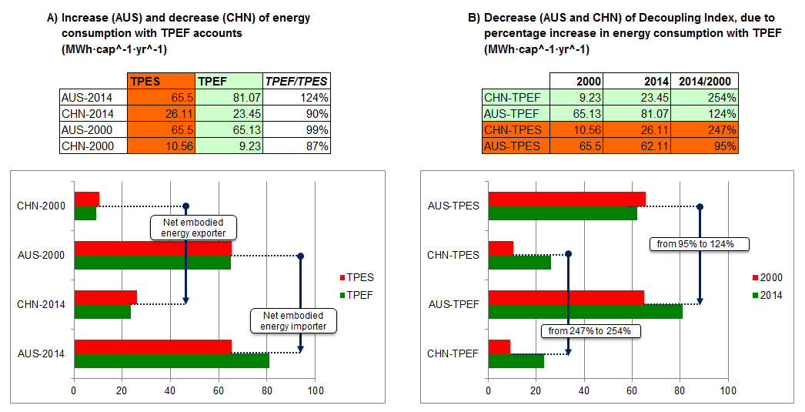
Supplementary Figure 1: Example of how the Decoupling Index (DI) decreases in embodied energy exporter countries (CHN) and embodied energy importer countries (AUS). In both of them, the DI is lower when TPEF accounts are considered instead of TPES ones. This occurs due to a higher percentage increase of energy use within TPEF accounts between 2000 and 2014. The figure shows how countries are net embodied energy importers or exporters (a) and how the percentage difference in energy increase is greater in both countries (b) with footprint accounts.

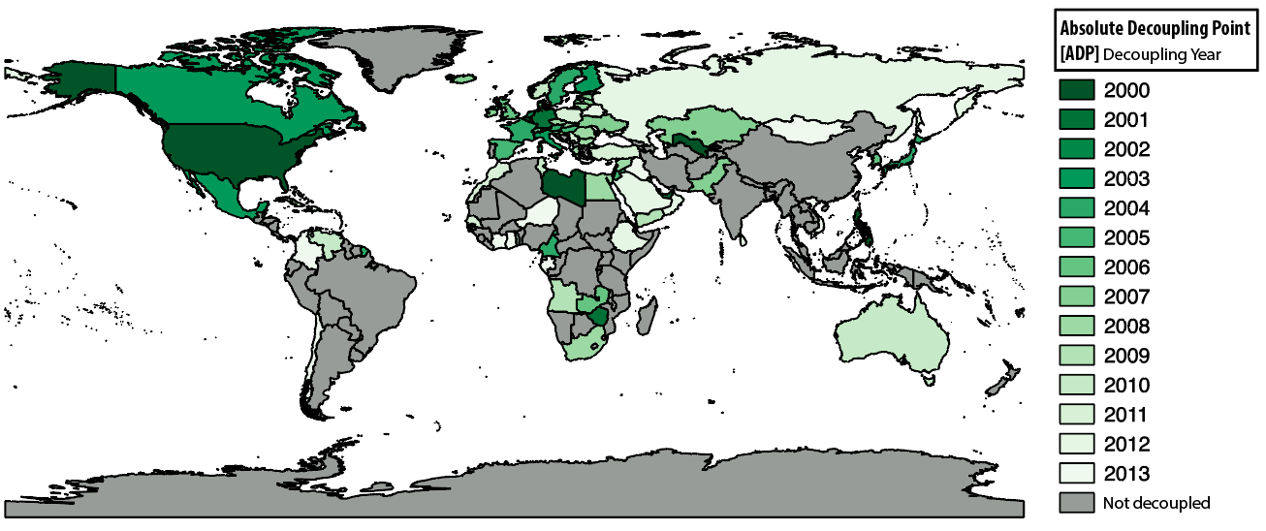
Supplementary Figure 2: 89 countries experienced temporary or permanent decoupling between the year 2000 and 2014. The year that the decoupling was reached is shown in the figure above.

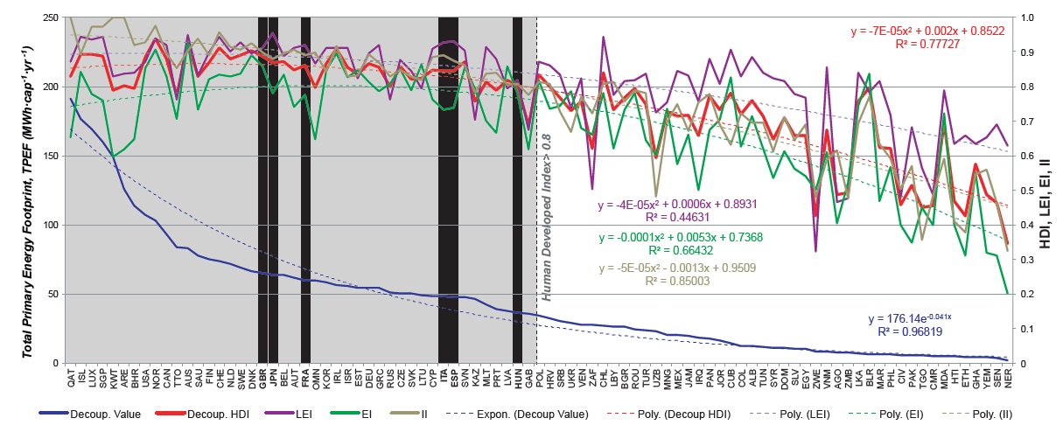
Supplementary Figure 3: The 89 temporarily and permanently decoupled countries (exemplary countries in black lines) ordered from left to right according the higher TPEF where decoupling was achieved (in vertical axis Y1). A line has been traced in the value of 0.8 HDI, which is understood as the bottom limit of high HDI according to UNDP. To the left of the line, countries with a higher decoupling than 35 MWh·cap⁻¹·yr⁻¹ can be found. In order to better understand the characteristics of the 89 decoupling countries, HDI data (in vertical axis Y2) has been disaggregated in Life Expectancy Index (LEI, purple), Education Index (EI, green) and Income Index (II, orange). It is observed that while the high II levels of high-TPEF consumer countries are able to maintain their decoupling trend, the low EI (below 0.7) of some high-TPEF countries might make sustained decoupling difficult. On the contrary, high LEI of some medium-low TPEF countries might support their capacity to achieve sustained decoupling.

Supplementary Table 2: Decoupling Index values (DI_{TPES} and DI_{TPEF} ) during the 2000-2014 year period by country and country codes. Countries have been listed from greatest to lowest according their DI_{TPEF} , from the most absolutely decoupled country to the most coupled ones, and lastly the ones where HDI has been reduced. In the rightmost column, Hidden Energy Flow (HEF) has been added (HEF =TPEF/TPES-1), which shows the percentage increase/reduction of energy that countries display if imported energy embodied in goods and services is taken into account (Akizu et al., 2017).

Country | Code | DI_TPES (2000-2014) | DI_TPEF (2000-2014) | HEF  (Average 2000-2014)
Bahrain | BHR | 162.89 | 168.73 | -23%
Belgium | BEL | 171.55 | 168.30 | -3%
USA | USA | 164.25 | 164.68 | 14%
UAE | ARE | 167.92 | 163.76 | 4%
Jamaica | JAM | 167.17 | 160.55 | 20%
Israel | ISR | 129.90 | 157.16 | 42%
UK | GBR | 169.69 | 156.66 | 50%
Japan | JPN | 160.31 | 156.56 | 30%
Cyprus | CYP | 164.55 | 155.57 | 70%
Italy | ITA | 162.12 | 155.33 | 30%
France | FRA | 155.50 | 152.88 | 19%
Uzbekistan | UZB | 150.93 | 150.73 | -8%
Portugal | PRT | 153.92 | 150.12 | 34%
Ireland | IRL | 162.83 | 150.01 | 36%
Greece | GRC | 152.34 | 148.79 | 62%
Spain | ESP | 158.89 | 146.47 | 23%
Zimbabwe | ZWE | 123.56 | 145.56 | -13%
Jordan | JOR | 117.83 | 145.55 | 23%
Malta | MLT | 62.74 | 136.92 | 75%
Germany | DEU | 135.90 | 134.49 | 12%
Denmark | DNK | 158.18 | 131.12 | 52%
Cameroon | CMR | 134.38 | 130.81 | 7%
Philippines | PHL | 127.84 | 130.25 | 3%
Sweden | SWE | 153.51 | 129.10 | 5%
Hungary | HUN | 122.86 | 108.89 | 9%
Mexico | MEX | 71.57 | 99.02 | 5%
Cuba | CUB | 129.54 | 97.54 | 14%
Ethiopia | ETH | 85.58 | 86.77 | -22%
Mozambique | MOZ | 78.80 | 80.44 | 5%
Luxembourg | LUX | 155.17 | 78.79 | 64%
Zambia | ZMB | 78.74 | 77.99 | 3%
Dominican Republic | DOM | 143.77 | 77.40 | 8%
Belarus | BLR | 42.21 | 74.48 | -81%
Pakistan | PAK | 77.69 | 73.36 | -10%
Togo | TGO | 61.03 | 68.92 | 1%
Niger | NER | 66.41 | 67.22 | 16%
Tanzania | TZA | 57.69 | 66.54 | -2%
El Salvador | SLV | 112.57 | 64.53 | 23%
Ukraine | UKR | 142.38 | 62.35 | -21%
Slovenia | SVN | 87.28 | 59.62 | 5%
Senegal | SEN | 67.17 | 50.36 | 18%
Venezuela | VEN | 71.32 | 49.65 | -4%
Angola | AGO | 55.48 | 49.18 | 5%
Finland | FIN | 102.31 | 45.99 | -8%
Austria | AUT | 50.28 | 43.92 | 31%
Azerbaijan | AZE | 68.62 | 41.63 | -8%
Kenya | KEN | 56.34 | 40.76 | 11%
Nepal | NPL | 49.53 | 40.51 | 7%
Croatia | HRV | 88.91 | 39.91 | 20%
DR Congo | COD | 41.70 | 39.88 | 4%
Canada | CAN | 125.90 | 39.09 | -3%
Switzerland | CHE | 155.02 | 38.06 | 80%
Slovakia | SVK | 136.21 | 37.87 | 22%
Botswana | BWA | 50.11 | 37.35 | 88%
Ghana | GHA | 86.61 | 37.20 | 2%
Serbia | SRB | 74.92 | 35.50 | 7%
Singapore | SGP | 50.11 | 35.44 | 131%
Cambodia | KHM | 36.16 | 35.01 | 10%
Czech Republic | CZE | 105.72 | 32.97 | -1%
Nicaragua | NIC | 30.27 | 32.49 | 15%
Bolivia | BOL | 17.18 | 32.04 | -8%
Benin | BEN | 26.15 | 31.40 | 7%
Myanmar | MMR | 41.17 | 30.82 | -3%
Cote dIvoire | CIV | 19.30 | 29.72 | -14%
Tunisia | TUN | 22.66 | 28.13 | 5%
Bulgaria | BGR | 53.54 | 27.72 | -21%
Netherlands | NLD | 150.31 | 26.95 | 13%
Paraguay | PRY | 51.74 | 26.63 | 29%
Morocco | MAR | 25.84 | 26.13 | -7%
Turkey | TUR | 28.35 | 26.01 | 26%
India | IND | 25.10 | 25.79 | -5%
Guatemala | GTM | 24.04 | 25.68 | 12%
South Africa | ZAF | 27.54 | 25.25 | -16%
Poland | POL | 52.75 | 24.01 | 8%
Yemen | YEM | 62.21 | 23.46 | -1%
Indonesia | IDN | 34.00 | 23.17 | -10%
Romania | ROU | 96.40 | 22.66 | 0%
Russia | RUS | 34.40 | 22.25 | -17%
Mauritius | MUS | 27.26 | 22.16 | 75%
South Korea | KOR | 16.70 | 21.75 | 0%
New Zealand | NZL | 60.55 | 19.53 | 8%
Argentina | ARG | 18.50 | 19.19 | 3%
Egypt | EGY | 17.09 | 19.10 | 1%
Namibia | NAM | 19.19 | 18.48 | 79%
Bangladesh | BGD | 20.82 | 18.03 | 4%
Honduras | HND | 19.98 | 17.58 | 7%
Brazil | BRA | 14.56 | 17.51 | 1%
Colombia | COL | 43.70 | 17.51 | 31%
Norway | NOR | 139.48 | 16.86 | 30%
Sri Lanka | LKA | 36.20 | 15.96 | 0%
Iceland | ISL | 7.05 | 15.88 | -9%
Panama | PAN | 18.01 | 15.71 | 35%
Estonia | EST | 16.08 | 15.52 | 5%
Albania | ALB | 21.04 | 15.12 | 28%
Lithuania | LTU | 34.47 | 14.75 | 36%
Chile | CHL | 24.35 | 14.68 | -4%
Tajikistan | TJK | 100.01 | 14.00 | -1%
Latvia | LVA | 21.70 | 13.84 | 37%
Kazakhstan | KAZ | 10.51 | 13.82 | -14%
Algeria | DZA | 16.29 | 13.61 | -32%
Iran | IRN | 14.54 | 13.23 | 0%
Ecuador | ECU | 20.37 | 12.34 | 13%
Armenia | ARM | 15.28 | 12.33 | 18%
Saudi Arabia | SAU | 16.39 | 11.72 | -8%
Costa Rica | CRI | 13.04 | 11.48 | 22%
Moldova | MDA | 45.37 | 11.25 | -71%
Congo | COG | 8.29 | 10.14 | 12%
Thailand | THA | 10.85 | 9.90 | -14%
Australia | AUS | 140.74 | 9.80 | 13%
Mongolia | MNG | 16.38 | 9.44 | -14%
Oman | OMN | 8.64 | 9.38 | -25%
Viet Nam | VNM | 10.21 | 9.28 | -10%
Georgia | GEO | 9.84 | 9.21 | 35%
Haiti | HTI | 8.99 | 9.14 | 3%
China | CHN | 9.26 | 8.85 | -14%
Kyrgyzstan | KGZ | 17.28 | 8.41 | -2%
Malaysia | MYS | 11.90 | 8.30 | -28%
Uruguay | URY | 8.27 | 8.08 | 45%
Peru | PER | 8.04 | 6.57 | 17%
Qatar | QAT | 83.22 | 5.63 | -23%
Gabon | GAB | 4.36 | 5.40 | 6%
Kuwait | KWT | 138.41 | 5.15 | 13%
Trinidad and Tobago | TTO | 5.93 | 4.28 | -50%
Iraq | IRQ | 13.74 | 3.46 | -7%
Syria | SYR | -171.36 | -168.37 | -13%
Libya | LBY | -145.06 | -175.20 | -42%

