Filtration Properties of Ferric Hydroxide Precipitate in Nickel Production

Ina Beate Jenssen, Mona Aufles Hines, Ole Morten Dotterud, Oluf Bøckman, Jens-Petter Andreassen*

Corresponding author:
*Jens-Petter Andreassen
Department of Chemical Engineering, Norwegian University of Science and Technology (NTNU), N-7491 Trondheim, Norway
E-mail: jens-petter.andreassen@ntnu.no
Phone: +47 92032209

Affiliations, e-mail addresses and phone numbers:
Ina Beate Jenssen: Department of Chemical Engineering, Norwegian University of Science and Technology (NTNU), ina.b.jenssen@ntnu.no, +47 90919548

Mona Aufles Hines: Department of Chemical Engineering, NTNU, mona.aufleshines@gmail.com

Ole Morten Dotterud: Glencore Nikkelverk AS, ole.dotterud@glencore.no

Oluf Bøckman: Glencore Nikkelverk AS, oluf.bockman@glencore.no

Keywords
Iron hydroxide, Precipitation, Filtration

Abstract
Ferric iron removal from the nickel electrolyte at Glencore Nikkelverk AS in Kristiansand, Norway, is achieved by precipitation of iron hydroxide followed by filtration, and it is desirable to improve filtration properties of the precipitated iron hydroxide in order to decrease the filtration time. The effect of increasing the residence time from the current 45 minutes to 75 minutes and temperature from 65 °C to 90 °C on the filtration properties of the precipitated iron hydroxide (akaganéite) was studied by simulating the industrial process conditions in a continuous reactor setup operating at steady state, using ferrous-containing process solution as feed material. It was possible to decrease the filter cake resistance by both increasing residence time and temperature, but temperature gave the most pronounced effect and reduced the filter cake resistance by one order of magnitude.

Introduction
Glencore Nikkelverk AS in Kristiansand, Norway, is one of the largest nickel refineries in the world. It has a unique process that produce metals with very high purity from polymetallic feeds at one site. During the last years the amount of iron in the raw material used for hydrometallurgical nickel production at Glencore Nikkelverk AS has increased. Hence, the equipment such as filter presses have to handle larger amounts of iron precipitated in the process, and it is necessary to improve the filterability of the precipitate [1]. The current study investigated the effect of residence time and temperature on filtration performance for suspensions originating from a continuous reactor setup operating at steady state, simulating the conditions in the plant.
The refinery produces nickel, cobalt, copper, and sulphuric acid as main products, by the chlorine leach process introduced in the 1970’s [1-4]. The main feed material is nickel matte containing typically up to 56 wt% Ni, 22 wt% S, 20 wt% Cu, 2.5 wt% Fe and 2.2 wt% Co [1]. The iron, regarded as the main impurity, is removed by precipitation of ferric hydroxide [1-4]. The overall reaction for the precipitation is shown in equation . The main product of the iron precipitation in nickel production is akaganéite [1], as its structure is stabilised by Cl- ions [5, 6].
In order to achieve better filterability, it is necessary to control the properties of the precipitated akaganéite, such as the particle size which is a result of the nucleation and growth kinetics, influenced by the supersaturation and temperature [7, 8]. The supersaturation of ferric hydroxides in an aqueous solution is dependent on the activity of free ferric ions and hydroxide ions, a_{Fe3+} and a_{OH-}, respectively, and the activity solubility product, K_{a} [5, 8] as expressed by equation , and hence affected by pH [9], concentration of complexing ions and ionic strength. At constant pH the activity of ferric ions in the solution will hence be determining parameter for the supersaturation, and can be controlled by changing the residence time.

During filtration the filter cake functions as filter medium, and by using the Kozeny-Carman model, the dependency of the specific filter cake resistance (filterability), α, on the particle size, x, and the filter cake porosity, ε, can be described by equation [10, 11]. As seen from equation , an increase in particle size will cause a decrease in the specific cake resistance, thus better filtration properties [10, 12-14].

The effects of pH, temperature and reaction time on precipitation of iron hydroxides such as goethite, ferrihydrite, akaganéite, and hematite have been studied previously. Elevated temperatures during precipitation and increased reaction time have previously been reported to give a precipitate with better filtration properties [15-17].

Experimental
At Glencore Nikkelverk AS the nickel matte is chlorine-leached to dissolve the nickel, and the slurry is fed to an autoclave stage, before it is cooled and pumped to cementation tanks. Then the slurry, containing 220 g/L Ni and 7-15 g/L Fe, is purified by precipitation of iron and solvent extraction of cobalt and other minor impurities, and sent to electrowinning where various nickel products are produced [2-4, 18]. The iron precipitation is controlled by pH and redox-potential (ORP), in the range of 1.3 – 1.8 and 480 – 550 mV, respectively, by addition of chlorine gas recycled from the electrowinning, and NiCO₃ [1, 19]. The main precipitation is occurring in a stirred tank reactor at 65 °C with a residence time of 40 – 50 minutes [1].
Precipitation of iron hydroxide was studied onsite in a continuous 2 L reactor system (Figure 1). Experiments were performed in two campaigns during 2017. Due to possible variations in the feed, experiments were repeated 2-5 times to obtain a sufficient estimate of the variance, rather than studying multiple residence times and temperatures within the time limit of the study. The highest possible increase in both residence time and temperature that satisfied the achievement of steady-state in the reactor system, was found by initial experiments to be 75 minutes and 90 °C, as compared to 45 minutes and 65 °C in current production.
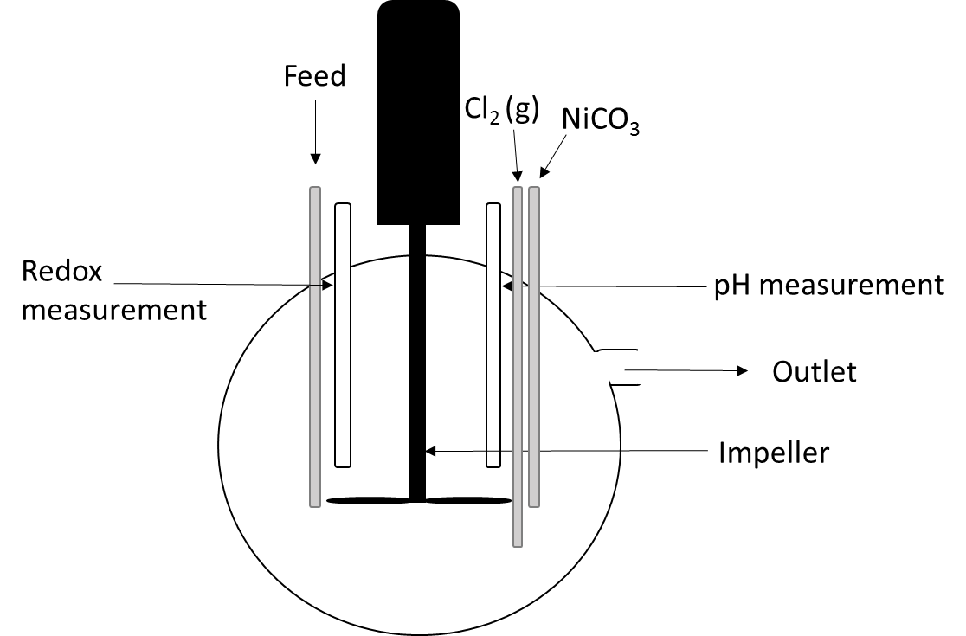
Figure 1: Sketch of the continuous reactor used in the experiments. The experiments were performed using a 2 L round-bottomed glass reactor with temperature control. Proper mixing was facilitated by a propeller stirrer operating at a stirring speed of 505 rpm. Ferrous-containing process solution from the plant was used as feed. The pH was kept constant at 1.8 by feedback control using nickel carbonate slurry, and the redox potential was maintained at 480 mV using Ag/AgCl reference electrode by manually adjusting the chlorine gas supply.
After steady-state was achieved, a sample of the slurry was taken out in order to determine the specific filter cake resistance. The specific filter cake resistance measurements were performed at constant temperature 60 °C. The samples were filtered through a Sartorius filter holder by applying vacuum to obtain constant pressure, and equation was applied to determine the specific cake resistance based on experimentally determined data for filtrate volume and filtration time [10, 12, 20].

Here c is the solid concentration, µ is the viscosity of the filtrate, A is the filter area, R is the resistance of the filter cloth and Δp is the pressure difference [10]. The pressure difference was monitored with a manometer, and the filtrate volume was measured as a function of time. The viscosity of the filtrate was determined by use of a Cannon-Fenske viscometer.
Small samples were taken out for characterisation of the precipitate. The samples were filtrated, washed with distilled water, and dried in air at 80 °C overnight. Powder X-ray diffraction (XRD) was performed with a Bruker D8 A25 DaVinci X-ray Diffractometer with CuKα radiation to confirm consistency of the crystalline product, and scanning electron microscopy (SEM) images were obtained with a Hitachi S-3400N for particle size information. BET specific surface area measurements by nitrogen adsorption were carried out for samples from the second campaign. The samples were degassed at 120 °C overnight, and analysed with a Micromeritics Tri Star 3000 Surface Area and Porosity Analyzer.

Results and discussion
XRD analyses confirmed that the precipitate formed in all experiments were crystalline and composed by akaganéite (Figure 2), as expected due to the chlorine-rich environment in which akaganéite is favoured [5, 6]. It is possible that intermediates such as ferrihydrite can be present during the precipitation, however not to the extent that it is visible from the XRD patterns.

Figure 2: XRD patterns for the precipitated akaganéite for each temperature and residence time. The vertical lines indicates peak positions for akaganéite.
From Figure 2 it can be seen that there is a difference in peak width for the different temperatures, while the residence time does not have the same impact. The larger peak broadening for akaganéite formed at 65 °C compared to 90 °C implies more structural disorder or smaller size of the particles. A crystalline material composed by many small sub-domains may also contribute to peak broadening [5, 6, 21]. In order to obtain more information about the properties of the particles the BET specific surface area was determined, see Figure 3.

Figure 3: BET specific surface area for each residence time and temperature with error bars showing the standard deviations.
The BET specific surface area varies from 141 m²/g to 54 m²/g for akaganéite formed at residence time 45 minutes and 65 °C, and 75 minutes and 90 °C, respectively, decreasing with increasing temperature, but not significantly reduced with increasing residence time.
Figure 4 shows the specific filter cake resistance for the four experimental conditions. Temperature is clearly the most influencing factor, and by increasing the temperature from 65 °C to 90 °C, the filter cake resistance was reduced by one order of magnitude, both for residence time 45 and 75 minutes. For filtration of 30 mL slurry, this corresponds to a significant variation in filtration time from 0.5 to 19 minutes, for residence time 45 minutes and temperature 65 °C, and residence time 75 minutes and temperature 90 °C, respectively.

Figure 4: Specific filter cake resistance, α, for each residence time and temperature with error bars showing the standard deviations.
The filtration resistance (equation ) varies with the square of particle size, in the sense that it varies linearly with the external surface area of the particles in the suspension. However, as demonstrated by Figure 5, the relationship between the cake resistance and the surface area is non-linear, indicating that surfaces other than the external contribute to the measured total surface area.

Figure 5: Specific filter cake resistance as a function of specific surface area of the precipitated akaganéite.
Assuming that the particles are spherical, the “particle sizes” based on the BET-surface area measurements were calculated to be in the range 10 to 30 nm, corresponding to the highest and lowest specific surface area. However, observation of particles formed in the system, shown in Figure 6, shows that this information is probably originating from internal surfaces of particles that are significantly larger (2-5 µm). The particles have a complex morphology, evident of a spherulitic type of growth mechanism, which results in poly-crystalline particles resulting from growth front nucleation [22]. The size of the internal subdomains of such particles increase with higher temperature and lower supersaturation, which is supported by the observed peak width in the XRD-analysis. A similar change towards a lower external surface area is also expected at lower supersaturation and increasing temperature since such conditions favour growth over nucleation and hence allows for larger spherulitic particles. In order to shed more light on this explanation and determine a more accurate particle size distribution of the particles, further analyses are necessary.
10 µm
Figure 6: SEM image of akaganéite precipitated at 90 °C and residence time 75 minutes.

Conclusions
The effect of temperature and residence time on filtration properties of precipitated iron hydroxide has been studied in a continuous reactor setup operating at steady state, simulating the conditions at Glencore Nikkelverk AS. The precipitated iron hydroxide, akaganéite, was shown to have a complex morphology and the particles were in the size range of 2-5 µm. Surface area measurements indicated particles with a high internal surface area, decreasing with increasing residence time and temperature. It was shown that increasing residence time has a minor effect on the filtration properties of the precipitated akaganéite. Increased temperature gave the most pronounced effect, reducing the specific filter cake resistance with one order of magnitude.

Acknowledgements
The authors thank the Norwegian Research Council, Yara, Glencore Nikkelverk AS, and Boliden Odda for financing the project (project number 236674), and Kent Skaiaa and Tore Amdal, Glencore Nikkelverk AS, for practical assistance during the experimental work.

Bibliography
1. Dotterud, O.M., et al., Iron control and tailings disposal in the Xstrata chlorine leach process, in Hydrometallurgy of nickel and cobolt 2009, J.J.B.a.R.F.a.I.M.a.V.G.P.a.D.J. Robinson, Editor. 2009. p. 321-333.
2. Stensholt, E., et al., Development and practice of the Falconbridge chlorine leach process. CIM bulletin, 2001. 94(1051): p. 101-104.
3. Stensholt, E., H. Zachariasen, and J. Lund. The Falconbridge chlorine leach process. in Proceedings of the 25th Annual Conference of Metallurgists, Nickel Metallurgy. 1986.
4. Stensholt, E., et al., Recent improvements in the Falconbridge nickel refinery. Extractive metallurgy of nickel and cobalt, 1988: p. 403-412.
5. Cornell, R.M. and U. Schwertmann, The Iron Oxides: Structure, Properties, Reactions, Occurrences and Uses. 2006: Wiley.
6. Faivre, D. and R.B. Frankel, Iron Oxides: From Nature to Applications. 2016: Wiley.
7. Myerson, A.S. and B.L. Trout, Nucleation from Solution. Science, 2013. 341(6148): p. 855-856.
8. Mullin, J.W., Crystallization. 2001: Elsevier Science.
9. Claassen, J.O. and R.F. Sandenbergh, Influence of temperature and pH on the quality of metastable iron phases produced in zinc-rich solutions. Hydrometallurgy, 2007. 86(3): p. 178-190.
10. Wakeman, R.J. and E.S. Tarleton, Filtration: Equipment Selection, Modelling and Process Simulation. 1999: Elsevier Advanced Technology.
11. Holdich, R.G., Fundamentals of Particle Technology. 2002: Midland Information Technology and Publishing.
12. Bourcier, D., et al., Influence of particle size and shape properties on cake resistance and compressibility during pressure filtration. Chemical Engineering Science, 2016. 144: p. 176-187.
13. Carman, P.C., Fluid flow through granular beds. Chemical Engineering Research and Design, 1997. 75: p. S32-S48.
14. Wakeman, R., The influence of particle properties on filtration. Separation and Purification Technology, 2007. 58(2): p. 234-241.
15. Masambi, S., C. Dorfling, and S. Bradshaw, Comparing iron phosphate and hematite precipitation processes for iron removal from chloride leach solutions. Minerals Engineering, 2016. 98: p. 14-21.
16. Cohen, B., et al., Precipitation of iron from concentrated chloride solutions: Literature observations, challenges and preliminary experimental results. Minerals Engineering, 2005. 18(13): p. 1344-1347.
17. Van Der Woude, J.H.A., P. Verhees, and P.L. De Bruyn, Formation of colloidal dispersions from supersaturated iron(III) nitrate solutions. II. Kinetics of growth at elevated temperatures. Colloids and Surfaces, 1983. 8(1): p. 79-92.
18. Moskalyk, R.R. and A.M. Alfantazi, Nickel laterite processing and electrowinning practice. Minerals Engineering, 2002. 15(8): p. 593-605.
19. Crundwell, F., et al., Extractive Metallurgy of Nickel, Cobalt and Platinum Group Metals. 2011: Elsevier Science.
20. Beck, R., et al., The effect of crystallization conditions, crystal morphology and size on pressure filtration of l-glutamic acid and an aromatic amine. Separation and Purification Technology, 2009. 66(3): p. 549-558.
21. Che, M. and J.C. Vedrine, Characterization of Solid Materials and Heterogeneous Catalysts: From Structure to Surface Reactivity. 2012: Wiley.
22. Andreassen, J.-P. and A. Lewis, Classical and Nonclassical Theories of Crystal Growth, in New Perspectives on Mineral Nucleation and Growth: From Solution Precursors to Solid Materials, A.E. Van Driessche, et al., Editors. 2016, Springer. p. 137-154.

