Developing a Risk-Based Maintenance Model for a Natural Gas Regulating and Metering Station using Bayesian Network

Leonardo Leonia, Ahmad BahooToroodya,b, Filippo De Carloa,b*, Nicola Paltrinieric

  - Department of Industrial Engineering (DIEF), University of Florence, 50125, Florence, Italy

  - IBISLAB, University of Florence, 50125, Florence, Italy

  - Department of Mechanical and Industrial Engineering, Norwegian University of Science and Technology NTNU, S.P. Andersens Veg 5, 7031, Trondheim, Norway

Abstract

During the last decades, the vital role of maintenance activities in industries including natural gas distribution system has cleared up progressively. High costs may induce to reduced maintenance and, in turn, lead to a lower availability and high risk of undesired events. Therefore, a probabilistic model, based on an acceptable level of risk, is required to avoid under and over estimation of maintenance time interval. This paper presents an advanced Risk-based Maintenance (RBM) methodology to optimize maintenance time schedule. Bayesian Network (BN) is applied to model the risk and the associated uncertainty. The developed method can assist the asset managers to work out the exact maintenance time for each component according to the risk level. To demonstrate and discuss the applicability of the methodology, a case study of Natural Gas Reduction and Measuring Station in Italy is considered. Results prove that the most critical components are the calculator and pilots, while the most reliable one is the odorization. Furthermore, the pressure and temperature gauge (PTG), the remote control system (RCS) and the meter are predicted as the components that require less time to transit from minor risk to catastrophic risk.
Keywords: Risk-based maintenance, Bayesian Network, Natural Gas Reduction and Measuring Station

Introduction

Natural gas is one of the most pivotal sources among fossil energy all over the world, particularly for industry and for electric energy production. It covers 20% of energy consumption in the European Union (Montiel et al., 1996) and its export value to the industrialized countries is progressively increasing (Vianello & Maschio, 2014). Accidents related to gas distribution and consumption may bring huge damages to environment and humans. In recent years, a striking portion of catastrophic events were related to the gas distribution networks industry. In 2004 the explosion of a natural gas factory in Belgium was lead to considerable number of fatalities and injuries. During the same year, in Paraguay, a conflagration caused by gas leakage led to more than 250 deaths. In 2009, another

explosion caused by gas leakage induced the greatest conflagration in Moscow ever since the Second World War (Han & Weng, 2011). There could also be some external causes leading to accidents, like the hurricanes that in 2005 and 2008 struck the Gulf of Mexico and damaged gas pipelines (Girgin & Krausmann, 2016). Considering these accidents, it is inevitably necessary to reduce the risk associated with possible breakdowns in natural gas distribution systems.
To provide a reliable service, maintenance must be implemented. The literature on definition of maintenance in different applications is vast (Bhandari et al., 2015; Garg & Deshmukh, 2006; Khan & Haddara, 2003; Okoh & Haugen, 2013; Sharma et al., 2011). Dhillon (2002) defines maintenance as all the appropriate actions for retaining an item or a part or an equipment or restoring it to a given condition. There are four kinds of maintenance: corrective, preventive, proactive and predictive (Iqbal et al., 2017). Corrective maintenance is done after a failure, leading to more risks. On the contrary, preventive maintenance is done before a failure, involving more costs. Another kind of maintenance is Condition-Based Maintenance (CBM), referred as proactive maintenance. In this category, the parameter of interest in the system is monitored and, in case of exceeding the safe operational limits, maintenance is required. Jardine et al. (1999) adopted CBM to study shear pump bearings in a food processing plant, in which vibrations are controlled. A more recent type of maintenance is Risk-Based Maintenance (RBM) (Arunraj & Maiti, 2007), which integrates reliability with safety and environmental issues and minimizes the probability of system failure and its consequences related to safety, economic, and environment (Khan & Haddara, 2003). As the data set using for failure rate calculations through the CBM approaches are mostly limited, RBM have been considered as a complement of CBM through the different operational conditions (BahooToroody, et al., 2018; Abaei et al., 2018). RBM can be adopted to be assured about the level of risk and its associated cost. The base principle of this category is to prioritize the maintenance of the components based on the level of risk (Ambühl & Sørensen, 2017).
There is a great deal of research on RBM and optimization of maintenance plans (Abbassi et al., 2016; Barua et al., 2016; Dawotola et al., 2012; Khan & Haddara, 2004; Krishnasamy et al., 2005).

Dawotola et al. (2012) proposed a maintenance plan considering both economic issues and risk aspects for an oil pipeline system. The optimization process has six steps: probability of failure estimation, determination of consequences of failure, estimation of risk of failure, calculation of risk reduction, calculation of total cost function and determination of cost-optimal inspection frequency of the pipeline in a preventive maintenance policy. The maintenance interval is estimated by minimizing the expected total cost that considers both preventive and corrective maintenance. In another research, a risk-based maintenance strategy is adopted by Krishnasamy et al. (2005) to a power generation plant. The authors have divided the methodology into four stages: scope identification, risk assessment, risk evaluation, and maintenance planning. A Fault Tree Analysis (FTA) is used to estimate the probabilities of failure. This model identifies the critical components and allows reducing the cost related to maintenance.
Meanwhile, Bayesian inference, as a parametric and non-parametric probabilistic method, have attracted a significant attention from researches for increasing both effectiveness and efficiency of RBM applications (Abaei et al., 2017; Arzaghi et al., 2017; Cullum et al., 2018; Nielsen & Sørensen, 2018; Toroody et al., 2016). Bayesian Network (BN) is generally used for causal representation of the phenomena involved in a complex system or process, where data sources are limited and uncertain (Trucco et al., 2008). As most of the traditional risk analysis techniques (such as FTA and Event Tree Analysis (ETA)) are static and non-updatable conventional model, they regularly fail to fully capture the variation of risks during operation (Paltrinieri and Khan, 2016; Khakzad et al., 2011). Besides, conventional techniques use only binary variables and do not represent conditional dependencies (Martins et al., 2014). Accordingly, based on BN, Abbassi et al. (2016) presented a RBM methodology, applied to an offshore process facility. In this method, risk level is calculated via BN considering the failure probabilities and the possible consequences and the maintenance plan is determined after setting the evidence that the system operates at the lowest possible risk. One year later Pui et al. (2017) proposed a similar methodology applied to an offshore manage pressure drilling, focusing on two critical systems: rotating control device and blowout preventer. Very recently,

BahooToroody et al. (2018) addressed the gap of the implementing a decision support tool for integrity management within the process industry based on the observations made from the deteriorating facilities considering the uncertainties and the fluctuation involved in the long term trend of the gas distribution process using BN and Influence Diagram (ID).
Probability of failures estimation is of prominent importance and is widely established in gas pipelines (Wu et al., 2017; Yuhua & Datao, 2005). Yuhua and Datao (2005) presented a method to evaluate the probability of failure for a gas pipeline. Their study is divided in two parts: the first part is a qualitative analysis used to achieve the minimal cut set of a FT in which the pipeline failure is given as top event, while the second part is devoted to a quantitative analysis including the estimation of the failure probability of the top event. To evaluate the probabilities of failure, the authors applied the Delphi method and represented natural linguistic expressions through the fuzzy set theory. In the other more recent research, Wu et al. (2017) developed a probabilistic study about gas pipelines using BN and Dempster-Shafer evidence theory, to deal with expert judgments. Other researchers assessed the reliability of gas pipelines containing corrosion defects (Caleyo et al., 2002; Teixeira et al., 2008). Caleyo et al. (2002) used different methods to estimate the probability of failure: the first-order second-moment iterative reliability method, the crude Monte Carlo integration technique, and the first order Taylor series expansion of the limit state function. On the other side, Teixeira et al. (2008) adopted the first-order reliability method and used Monte Carlo simulation to deal with uncertainty. Despite all these ongoing efforts made on operational process including gas distribution systems, still lack of RBM application for estimating maintenance time is seen (Zarei et al., 2017). As a result, a risk-based methodology for maintenance scheduling is developed in this work and demonstrated through an application of case study. The objective of this approach is to provide the optimum maintenance time by implementing a BN analysis. The advance of the proposed model has been verified on actual examples of stochastic process of a Natural Gas Regulating and Metering Stations
(NGRMS) near Florence, Italy.

  - Bayesian network

A wide summary of BN is provided by Barber (2012) and Neapolitan (2004). A BN is a Directed Acyclic (DAG) used for reasoning under uncertainty, in which each node represents a variable and each arc represents a conditional dependency among the variables. It calculates the joint probability distribution of a set of random variables using Eq. (1):

𝑃(𝑈) = ∏𝑛
𝑖 = 1
𝑃(𝑋_{𝑖}|𝑝𝑎(𝑋_{𝑖}))
(1)

where P(U) is the joint probability distribution and pa(𝑋_{𝑖}) is the parent set of variable.

As an example, the joint probability distribution of the variables 𝑋₁ ‒ 𝑋₄ illustrated in Fig. 1 is given by 𝑃(𝑋₁,𝑋₂,𝑋₃,𝑋₄) = 𝑃(𝑋₁)𝑃(𝑋₂)𝑃(𝑋₃│𝑋₁,𝑋₂)𝑃(𝑋₄|𝑋₃). When new information about the
state/value of any of the node in the network is acquired, BN estimates the updated joint probability distribution based on Bayes’ Theorem. Given the evidence that 𝑋₃ is in a state/value e the joint
probability distribution is updated using Eq. (2):

(𝑋 ,𝑋 ,𝑋 │𝑒) = 𝑃(𝑋1,𝑋2,𝑋4,𝑒)

(2)

1 2 4
∑ , ,𝑋 𝑃(𝑋₁,𝑋₂,𝑋₄,𝑒)

1 2 4

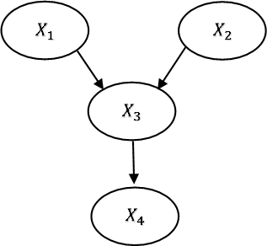

Fig. 1. Example of a Bayesian Network.

Developed methodology

The sequence of the proposed methodology for risk-based maintenance in this study is illustrated in

Fig. 2.

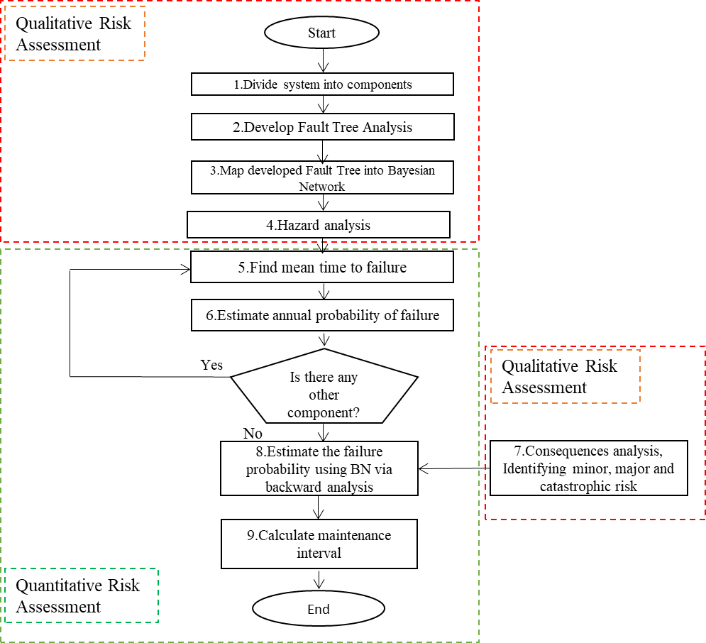

Fig. 2. Proposed dynamic RBM methodology for NGRMS applying Bayesian Network.

In the first stage, (1.) the system is defined and divided into its components. The relationship among the components is also determined in this phase. Next, (2.) the associated FT is built. The top event (system failure) is broken down into sub events until all the primary events (events that could not be expanded further) are found. Then, (3.) the FT is transformed into a BN and later would be (4.), where the hazard analysis identifies failure consequences based on historical data. Consequence analysis is executed to model the risk assessment and subsequently RBM. The possible consequences

should be mapped into the BN as a children of the top event. These steps are accounted for qualitative risk assessment.
In the next step, (5.) Mean Times To Failure (MTTF) of each component are found using available data. Subsequently, (6.) the annual probability of failure is worked out then. The probability table of root nodes in the BN can be filled with their respective failure probabilities. Next, (7.) is to specify the consequences of system failure (top event) and risk of the operation. The level of risk can be defined in different approaches. Herein, it is proposed to be divided into three different categories:
- minor risk that is a low level of risk and it is considered acceptable in order to operate safely;

- major risk that is a higher level of risk that comprehends consequences that may bring damages to environment or to human beings;
- catastrophic risk that is the highest level of risk and it has to be avoided.

Based on present RBM the optimum maintenance time of components is revised through probability updating. (8.) Setting the evidence that minor risk has occurred at 100% probability, a backward analysis is conducted on the BN to point out the updated probabilities of the roots (e.g. the probabilities of failure of the components when the system operates at the lowest risk possible). Finally, (9.), based on the updated probabilities the maintenance interval is calculated.

Application of the methodology to NGRMS

In order to demonstrate the applicability of the developed RBM methodology, it is applied to NGRMS as a case study. The main functions of a NGRMS are measuring the flow of the gas and reducing the gas pressure to adapt it to the subsequent utilities. a NGRMS has four critical groups of different components, that can lead to a failure of the system as shown in Table 1.

Table 1

Groups and components of NGRMS.

Group Component

Reduction Pressure regulator Pilot
Filter
Measuring Pressure and temperature gauge

Calculator Meter
Remote control system
Odorization THT tank
THT pipelines
Preheating Pump
Boiler Water pipe

Pressure regulator keeps the downstream function at a pre-determined value and at the same time it has to guarantee the required flow. The gas flow is regulated by increasing or decreasing the cross- sectional flow area. Pilot is needed to have more precision and a faster change of the gas flow. Filter has to block the impurities, both solid and liquid which are always present in the gas. The filters must be set before the pressure regulator. The measuring group measures both the flow and its characteristics parameters. The gas flow is measured in cubic meters for every hour. Remote control system allows to measure the data from distance. Preheating group is placed after filter and before pressure regulator. As the temperature decreases along with reduction of pressure, also to prevent the formation of ice, the gas is heated by an exchanger in which there is a flow of water. A very precise quantity of odorizer, which is usually tetrahydrothiophene (THT), must be added to warn of any gas leaks. Resulted FT and its corresponding BN are shown in Fig. 3. and Fig. 4., respectively. As it can be seen in Fig. 5., the possible consequences are categorized into efficiency, loss and leakage that are later expanded further into increase of noise, damage third part, environmental impact and explosion.

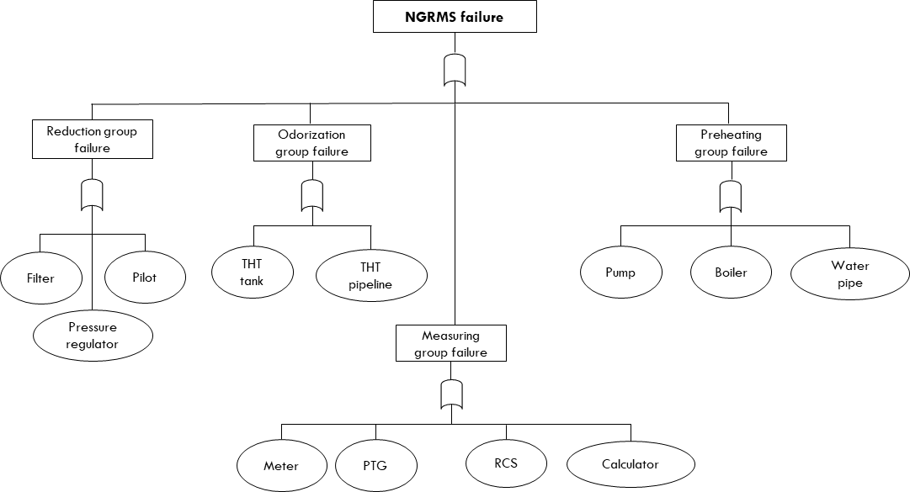

Fig. 3. Developed FT for failure scenario of a NGRMS

Data provided by industry (ESTRA, 2016) refer to 59 different NGRMSs. The data presents maintenance activity, component of interest, time of maintenance and costs of maintenance including trip costs, manpower costs and materials costs. It is worth noting that the MTTF of each component are also provided by industry based on literature and the calculation of their experts. These values and corresponding failure rate are shown in Table 2.

Table 2

MTTF and Failure rate of critical components of NGRMS’.

Component | MTTF (hours) | Failure rate(per hour)
Pressure regulator | 60882 | 1.64E-05
Pilots | 45814.8 | 2.18E-05
Filter | 10336.8 | 9.67E-05
PTG | 19359.6 | 5.17E-05
Calculator | 73233.6 | 1.37E-05
Meter | 44150.4 | 2.26E-05
RCS | 37492.8 | 2.67E-05
THT tank | 92593.2 | 1.08E-05
THT pipelines | 132363.6 | 7.55E-06

Pump | 20848.8 | 4.8E-05
Boiler | 31623.6 | 3.16E-05
Water pipe | 135166.8 | 7.4E-06

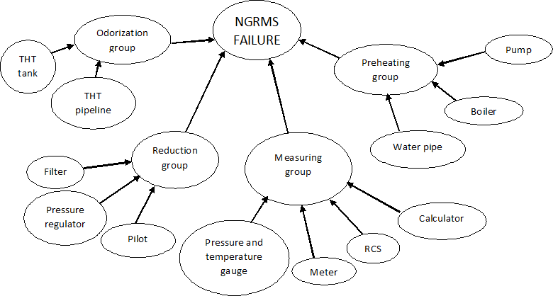

Fig.4. Developed BN for risk analysis of a NGRMS

Based on reported MTTF and failure rate the probability of failure in a year is calculated. According to Krishnasamy et al. (2005) and in order to consider the randomness of failures events, exponential distribution is adopted for the estimation of maintenance intervals. So the annual probabilities of failure would be achieved by Eq. (3):

(𝑡) = 1 ‒ 𝑒 ‒ 𝜆𝑡
(3)

where P(t) is the annual probability of failure when t is set equal to 8760 hours (a year) and 𝜆 is the

failure rate expressed in failure per hour given by Eq. (4):

1
𝜆 = 𝑀𝑇𝑇𝐹
(4)

The developed BN for a NRGMS incorporating the failure of critical components is illustrated in Fig. 5.

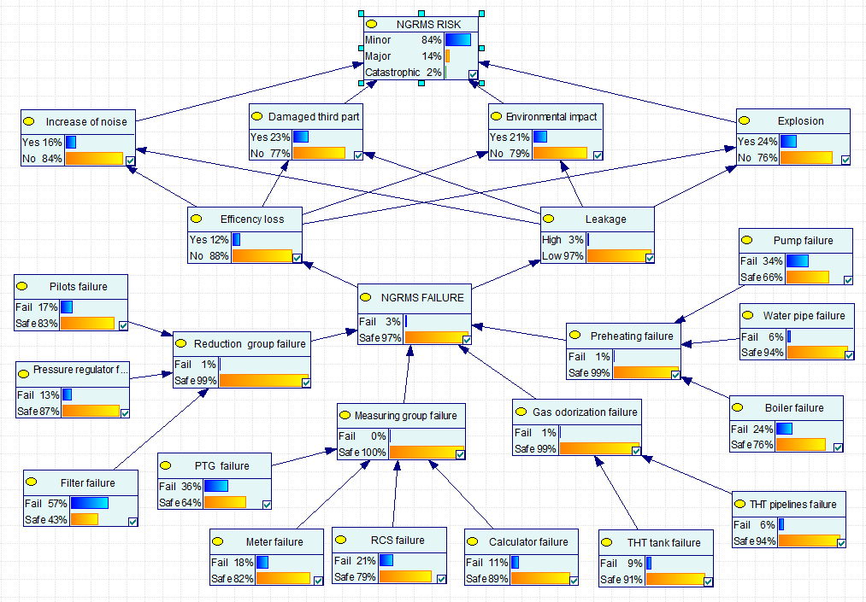

Fig.5. Developed BN to estimate maintenance interval of critical components

The primary events are linked to four major intermediate events (i.e. reduction group failure, measuring group failure, preheating failure and gas odorization failure) which consequently may lead to system failure. The annual failure probabilities of critical components calculated by Eq.3 were assigned to root nodes as prior probability. The CPTs of intermediate and leaf nodes represent the contribution factors of root nodes in the intermediate nodes. The Conditional Probability Table (CPT) of NGRMS risks is then filled using a typical risk matrix illustrated in Table 3. The status on

likelihood and consequences mentioned in Table 3, are developed as reported in Table 4 and Table

5. Based on the succeeding intermediate events, NGRMS is estimated to exhibit a reliability of 97%.

Table 3

Adopted risk matrix for developing RBM.

 |  | Consequences
 |  | Minor | Major | Catastrophic
Likelihood | Almost Certain | M | H | E
 | Likely | M | H | H
 | Possible | L | M | H
 | Unlikely | L | L | M
(L,M,H,E): Low, Medium, High, Extreme

Table 4

Consequence criteria ranking

Consequence Severity of effect
Minor | No effect
 | Very minor effect on production
 | Minor effect on production
 | Small effect on production, repair not required
Major | Moderate effect on production, repair required
 | Component performance is degraded
 | Component is severely affected, NGRMS may not operate
 | Component is inoperable with loss of primary function
Catastrophic | Failure involves hazardous outcomes
 | Failure is hazardous and occurs without warning, NGRMS operation is suspended

Table 5

Likelihood criteria ranking

Likelihood Occurrence probability
Unlikely | <1 in 1,500,000
 | 1 in 150,000
Possible | 1 in 15,000
 | 1 in 2,000
Likely | 1 in 400
 | 1 in 80
 | 1 in 20
Almost Certain | 1 in 8
 | 1 in 3
 | >1 in 2

The risk of operation consisting of three aforementioned levels is integrated into the network. After mapping the possible consequences into the BN, the system results to operate in minor risk with probability of 84%, in major risk with probability of 14% and in catastrophic risk with probability of 4%.
To generate the posterior probability of the components, the risk level of 100% safe level (minor risk) was targeted. In the light of new evidence and based on posterior probability, the maintenance interval is calculated using Eq. (5):

𝑇 =‒
ln (1 ‒ 𝐹(𝑡))

𝜆
(5)

where F(t) is the updated probability of failure and 𝜆 is the previous failure rate estimated by Eq. (4).

The posterior probabilities and the maintenance times of each component are reported in following section.

Results and discussions

Table 6 lists the maintenance intervals of NGRMS’ components in the three different scenarios of minor, major and catastrophic risk.
  - Minor risk level

The calculations depicted that the most critical components are determined as the calculator and pilots with the shortest maintenance interval of 295 and 297 days. On the contrary, the most reliable components are the THT tank and the remote control system which have the longest maintenance interval of 444 and 387 days, respectively. The less critical component of reduction group is filter, for which maintenance is required to be performed every 379 days. Maintenance schedule of meter will be optimized with a repair interval of 328 days, around once every 11 months. The THT pipelines must be maintained every 302 days as the third most critical component while the boiler are to be serviced every 340 days. Following these criteria, the most critical group that has to be controlled in a more accurate way is preheating group including pump, boiler and water pipe (second most critical component) with maintenance interval of 346, 340 and 298 respectively.
  - Major risk level

In case that the policies of the system accept and tolerate more risks (major level), the maintenance time can be extended to wider time interval. The repair action is needed for THT tank before 575 days in order to avoid it from major risk. This time interval (575 days) is the longest time for overpassing from minor to major risk, the second and third longest are pressure regulator and THT pipelines, estimated as 480 and 433 days. 17 days delay, in the process of maintenance activities throughout the measuring group (the calculator) can lead to an unexpected change in the risk level of the system from minor risk to major level.

Table 6

Failure probabilities (P_{f}) and maintenance time (T_{main}) of NGRMS’ critical components.

Component | Prior P_{f} | 100% minor risk level |  | 100% major risk level |  | 100% catastrophic risk level
 |  | Posterior Pf | Tmain (days) | Posterior Pf | Tmain (days) | Posterior Pf | Tmain (days)
Pressure regulator | 0.134013 | 0.122479 | 325 | 0.174786 | 480 | 0.320445 | 966
Pilots | 0.174036 | 0.163036 | 297 | 0.212925 | 399 | 0.351852 | 723
Filter | 0.571497 | 0.56579 | 379 | 0.591672 | 407 | 0.663746 | 495
PTG | 0.363957 | 0.36299 | 376 | 0.367373 | 382 | 0.379576 | 398
Calculator | 0.11274 | 0.111392 | 295 | 0.117505 | 312 | 0.134529 | 361
Meter | 0.179969 | 0.178723 | 328 | 0.184373 | 340 | 0.200107 | 372
RCS | 0.208357 | 0.207154 | 387 | 0.212609 | 398 | 0.227798 | 431

THT tank | 0.09027 | 0.085055 | 444 | 0.108705 | 575 | 0.174564 | 959
THT pipelines | 0.064039 | 0.058674 | 302 | 0.083006 | 433 | 0.150764 | 817
Pump | 0.343064 | 0.339672 | 346 | 0.355052 | 365 | 0.39788 | 423
Boiler | 0.241952 | 0.238039 | 340 | 0.255786 | 369 | 0.305206 | 455
Water pipe | 0.062753 | 0.057915 | 298 | 0.079857 | 416 | 0.14096 | 760

  - Catastrophic risk level

The free maintenance time approaching the system into catastrophic risk level can be predicted based on proposed RBM approach (See table 4). As it can be seen form the results, there are some components needing less time in order to overpass from minor to catastrophic risk level. The measuring group with Pressure and temperature gauge (22 days), Meter and the remote controls (44 days) and calculator (65 days) are the most critical components in this regards. The longest time to suffer from catastrophic risk level, throughout the system, are related to pressure regulator and THT tank with 966 and 959 days, respectively.
Finally, a clustered column chart is applied to compare assigned maintenance interval across the three risk levels. (see Fig. 6.)
1200

1000

800

600

400

200

0
Pressure Pilots Filter PTG Calculator Meter RCS THT tank THT Pump Boiler Water regulator pipelines pipe
MT (minor risk) MT (major risk) MT catastrophic risk

Fig. 6. assigned maintenance time interval for all components across the different risk level Aggregated framework allows engineers and designers to plan an effective maintenance schedule.
The proposed maintenance plan has to be followed to minimize failure consequences. Longer maintenance time may produce major or catastrophic consequences. On the other side adopting

shorter maintenance time will increase maintenance efforts and lead to more costs and loss of productivity. Risk profile and maintenance plan has to be updated as soon as new information is known. The methodology could be applied to systems in which high safety is required.

Conclusions

This paper presents a novel methodology to optimize the maintenance of gas regulating operation to model the associated risks. By modeling the failure risks, the cost of maintenance and non- productive time of operation is minimized significantly. The developed RBM methodology estimates the optimum maintenance interval for each component using a Bayesian Network. NGRMS was chosen as a case study to illustrate the methodology and its advantages. This study divides the possible risks in three different categories. By these categories the maintenance time is determined given that a component is overpassing the minor, major or catastrophic level of risk. The most critical components were determined based on their respective times of maintenance. Further work can also be carried out to study the redundant and stand-by components based on Non-Homogeneous Poisson Process (NHPP) considering correlation modelling between data.

Acknowledgement

Authors gratefully acknowledge the financial support provided by Estra S.p.A. and the University of Florence.

References

Abaei, M. M., Arzaghi, E., Abbassi, R., Garaniya, V., & Penesis, I. (2017). Developing a novel risk- based methodology for multi-criteria decision making in marine renewable energy applications. Renewable Energy, 102, 341-348.
Abaei, M. M., Arzaghi, E., Abbassi, R., Garaniya, V., Chai, S., & Khan, F. (2018). A robust risk assessment methodology for safety analysis of marine structures under storm conditions. Ocean Engineering, 156, 167-178.

Abbassi, R., Bhandari, J., Khan, F., Garaniya, V., & Chai, S. (2016). Developing a quantitative risk- based methodology for maintenance scheduling using Bayesian network. Chemical Engineering Transactions, 48, 235-240.
Ambühl, S., & Sørensen, J. D. (2017). On Different Maintenance Strategies for Casted Components of Offshore Wind Turbines.
Arunraj, N., & Maiti, J. (2007). Risk-based maintenance—Techniques and applications. Journal of hazardous materials, 142(3), 653-661.
Arzaghi, E., Abaei, M. M., Abbassi, R., Garaniya, V., Chin, C., & Khan, F. (2017). Risk-based maintenance planning of subsea pipelines through fatigue crack growth monitoring. Engineering Failure Analysis, 79, 928-939.
BahooToroody, A., Abaei, M. M., Arzaghi, E., BahooToroody, F., De Carlo, F., & Abbassi, R. (2018). Multi-Level Optimization of Maintenance Plan for Natural Gas System Exposed to Deterioration Process. Journal of hazardous materials.
Barber, D. (2012). Bayesian reasoning and machine learning: Cambridge University Press.

Barua, S., Gao, X., Pasman, H., & Mannan, M. S. (2016). Bayesian network based dynamic operational risk assessment. Journal of Loss Prevention in the Process Industries, 41, 399- 410.
Bhandari, J., Abbassi, R., Garaniya, V., & Khan, F. (2015). Risk analysis of deepwater drilling operations using Bayesian network. Journal of Loss Prevention in the Process Industries, 38, 11-23.
Bobbio, A., Portinale, L., Minichino, M., & Ciancamerla, E. (2001). Improving the analysis of dependable systems by mapping fault trees into Bayesian networks. Reliability Engineering & System Safety, 71(3), 249-260.
Caleyo, F., Gonzalez, J., & Hallen, J. (2002). A study on the reliability assessment methodology for pipelines with active corrosion defects. International Journal of Pressure Vessels and Piping, 79(1), 77-86.

Cullum, J., Binns, J., Lonsdale, M., Abbassi, R., & Garaniya, V. (2018). Risk-Based Maintenance Scheduling with application to naval vessels and ships. Ocean Engineering, 148, 476-485.
Dawotola, A. W., Trafalis, T., Mustaffa, Z., Van Gelder, P., & Vrijling, J. (2012). Risk-based maintenance of a cross-country petroleum pipeline system. Journal of pipeline systems engineering and practice, 4(3), 141-148.
Dhillon, B. S. (2002). Engineering maintenance: a modern approach. CRC press. ESTRA. (2016). NGRMS' failure data handbook. ESTRA.
Garg, A., & Deshmukh, S. (2006). Maintenance management: literature review and directions.

Journal of quality in maintenance engineering, 12(3), 205-238.

Girgin, S., & Krausmann, E. (2016). Historical analysis of US onshore hazardous liquid pipeline accidents triggered by natural hazards. Journal of Loss Prevention in the Process Industries, 40, 578-590.
Han, Z., & Weng, W. (2011). Comparison study on qualitative and quantitative risk assessment methods for urban natural gas pipeline network. Journal of hazardous materials, 189(1-2), 509-518.
Iqbal, H., Tesfamariam, S., Haider, H., & Sadiq, R. (2017). Inspection and maintenance of oil & gas pipelines: a review of policies. Structure and Infrastructure Engineering, 13(6), 794-815.
Jardine, A., Joseph, T., & Banjevic, D. (1999). Optimizing condition-based maintenance decisions for equipment subject to vibration monitoring. Journal of Quality in Maintenance Engineering, 5(3), 192-202.
Khakzad, N., Khan, F., & Amyotte, P. (2011). Safety analysis in process facilities: comparison of fault tree and Bayesian network approaches. Reliability Engineering & System Safety, 96(8), 925-932.
Khan, F. I., & Haddara, M. (2004). Risk‐based maintenance (RBM): A new approach for process plant inspection and maintenance. Process safety progress, 23(4), 252-265.

Khan, F. I., & Haddara, M. M. (2003). Risk-based maintenance (RBM): a quantitative approach for maintenance/inspection scheduling and planning. Journal of Loss Prevention in the Process Industries, 16(6), 561-573.
Krishnasamy, L., Khan, F., & Haddara, M. (2005). Development of a risk-based maintenance (RBM) strategy for a power-generating plant. Journal of Loss Prevention in the Process Industries, 18(2), 69-81.
Martins, M. R., Schleder, A. M., & Droguett, E. L. (2014). A methodology for risk analysis based on hybrid bayesian networks: application to the regasification system of liquefied natural gas onboard a floating storage and regasification unit. Risk Analysis, 34(12), 2098-2120.
Montiel, H., Vilchez, J. A., Arnaldos, J., & Casal, J. (1996). Historical analysis of accidents in the transportation of natural gas. Journal of Hazardous Materials, 51(1-3), 77-92.
Neapolitan, R. E. (2004). Learning bayesian networks (Vol. 38): Pearson Prentice Hall Upper Saddle River, NJ.
Nielsen, J. S., & Sørensen, J. D. (2018). Computational framework for risk-based planning of inspections, maintenance and condition monitoring using discrete Bayesian networks. Structure and Infrastructure Engineering, 14(8), 1082-1094.
Okoh, P., & Haugen, S. (2013). Maintenance-related major accidents: classification of causes and case study. Journal of Loss Prevention in the Process Industries, 26(6), 1060-1070.
Pui, G., Bhandari, J., Arzaghi, E., Abbassi, R., & Garaniya, V. (2017). Risk-based maintenance of offshore managed pressure drilling (MPD) operation. Journal of Petroleum Science and Engineering, 159, 513-521.
Sharma, A., Yadava, G., & Deshmukh, S. (2011). A literature review and future perspectives on maintenance optimization. Journal of quality in maintenance engineering, 17(1), 5-25.
Sorenson, H. W. (1970). Least-squares estimation: from Gauss to Kalman. IEEE spectrum, 7(7), 63- 68.

Teixeira, A., Soares, C. G., Netto, T., & Estefen, S. (2008). Reliability of pipelines with corrosion defects. International Journal of Pressure Vessels and Piping, 85(4), 228-237.
Toroody, A. B., Abaiee, M. M., Gholamnia, R., & Ketabdari, M. J. (2016). Epistemic-based investigation of the probability of hazard scenarios using Bayesian network for the lifting operation of floating objects. Journal of Marine Science and Application, 15(3), 250-259.
Trucco, P., Cagno, E., Ruggeri, F., & Grande, O. (2008). A Bayesian Belief Network modelling of organisational factors in risk analysis: A case study in maritime transportation. Reliability Engineering & System Safety, 93(6), 845-856.
Vianello, C., & Maschio, G. (2014). Quantitative risk assessment of the Italian gas distribution network. Journal of Loss Prevention in the Process Industries, 32, 5-17.
Wu, J., Zhou, R., Xu, S., & Wu, Z. (2017). Probabilistic analysis of natural gas pipeline network accident based on Bayesian network. Journal of Loss Prevention in the Process Industries, 46, 126-136.
Yuhua, D., & Datao, Y. (2005). Estimation of failure probability of oil and gas transmission pipelines by fuzzy fault tree analysis. Journal of Loss Prevention in the Process Industries, 18(2), 83-88.
Zarei, E., Azadeh, A., Khakzad, N., Aliabadi, M. M., & Mohammadfam, I. (2017). Dynamic safety assessment of natural gas stations using Bayesian network. Journal of hazardous materials, 321, 830-840.

