Received 00th January 20xx,
- FACET Functional Materials and Materials Chemistry, Department of Materials Science and Engineering, Norwegian University of Science and Technology, 7491 Trondheim, Norway
- . Swiss-Norwegian Beamlines at the European Synchrotron Radiation Facility, 71 Avenue des Martyrs, CS 40220, 38043 Grenoble Cedex 9, France
† Footnotes relating to the title and/or authors should appear here.
Electronic Supplementary Information (ESI) available: [details of any supplementary information available should be included here]. See DOI: 10.1039/x0xx00000x
Accepted 00th January 20xx
DOI: 10.1039/x0xx00000x
www.rsc.org/
Kinetics of the hydrothermal synthesis of nanosized K_{x}Na_{1-x}NbO₃
Susanne Linn Skjærvø,ª Kristin H. Wells,ª Wouter van Beek,^{b} Tor Grandeª and Mari-Ann Einarsrud *ª
Hydrothermal synthesis is an efficient method of making nanosized functional oxide materials, and has also been used to synthesize K_{x}Na_{1-x}NbO₃ solid solution, a promising lead-free piezoelectric material. However the control of the nucleation and growth during the synthesis to tailor the properties of the materials is challenging and this work aimed to solve the challenges reported regarding stoichiometry and size of K_{x}Na_{1-x}NbO₃ formed by hydrothermal synthesis by in situ X-ray diffraction. K_{x}Na_{1-x}NbO₃ crystallites of 18-65 nm with a controlled stoichiometry were produced by varying the Na/K ratio in the precursor solution, the solvent type and the final reaction temperature. The reaction proceeds via rapid formation of a potassium sodium hexaniobate intermediate phase during heating, which converts to K_{x}Na_{1-x}NbO₃ at the reaction temperature. The Na occupancy in K_{x}Na_{1-x}NbO₃ was found to correlate with the Na content in the intermediate phase and decreases with increasing temperature. We show that the in situ technique is powerful method to in general be able to prepare oxide nanoparticles with designed properties.

Introduction
There has been an increasing focus on harvesting the effects of nanosized piezoceramics,¹ and in later years, K_{x}Na_{1-x}NbO₃-based materials have emerged as promising lead-free piezoelectrics.^{2,3} Thus, synthesis routes to nanostructured K_{x}Na_{1-x}NbO₃ with controllable stoichiometry are desired to exploit their potential as sensors and actuators in nanodevices.⁴ Wet chemical methods like hydrothermal synthesis provide low-temperature, water-based routes to a variety of functional oxides,⁵ but to control the stoichiometry and crystallite size of the product is demanding particularly in case of solid solutions such as K_{x}Na_{1-x}NbO₃. Some studies have unveiled the challenges connected with the different solubility of Na and K niobate salts in water^{6,7} motivating the change to less polar solvents,⁸ but the actual effect on the reaction mechanism is still to be understood. Handoko et al. and Zhang et al. experienced challenges with preparing the K_{x}Na_{1-x}NbO₃ solid solution for $1-x>0.2$ with hydrothermal synthesis^{7,9} and while others have obtained solid solutions, the crystallite sizes have been in the micrometer range.^{9,10} Although some studies propose a dissolution-precipitation process for the hydrothermal synthesis of K_{x}Na_{1-x}NbO₃, similar to the mechanism observed for KNbO₃,⁴ the majority of the literature agrees that the reaction from Nb₂O₅ in a solution of NaOH and KOH goes through an intermediate phase, K_{4+x}Na_{4-x}Nb₆O₁₉ · 9 H₂O (0 < x < 4).^{7,11–13} Sun et al. suggested that K_{x}Na_{1-x}NbO₃ forms through a reaction between the K_{4+x}Na_{4-x}Nb₆O₁₉ · 9 H₂O intermediate phase and remnants of the Nb₂O₅ precursor ¹¹ while López-Juãrez et al. suggested that K_{4+x}Na_{4-x}Nb₆O₁₉ · 9 H₂O only expels water and excess alkali to form K_{x}Na_{1-x}NbO₃.¹² These studies show that the hydrothermal synthesis is inherently challenging to study as the reaction takes place inside a closed reaction chamber,¹⁴ and the importance of in situ studies for further advances is evident.
Here we present here the first in situ time-resolved X-ray diffraction study of hydrothermal synthesis of K_{x}Na_{1-x}NbO₃, revealing the effects of temperature, Na/K ratio in the precursor solution and type of solvent on the reaction kinetics, final stoichiometry and crystallite size of the product. We use the in situ data to explain why and how the crystallite size as well as the final stoichiometry can be controlled by tailoring the reaction temperature and the chemistry of the precursor solution.
Results
General reaction scheme
A similar phase evolution was revealed for all the experiments, exemplified by the reaction at 210 °C, 250 bar and R = 0.5 without ethanol, in Figure 1a. Figure 1b-d present single diffraction patterns of the three distinct phases, recorded at different times. The pristine slurry consisted of T-Nb₂O₅ and a broad feature indicating the presence of amorphous Nb-based species (Figure 1b). The broad feature is highlighted by a light blue area. The amorphous species and most of the T-Nb₂O₅ precursor instantaneously dissolved during heating. Simultaneously, the intermediate phase potassium sodium hexaniobate, K_{4+x}Na_{4-x}Nb₆O₁₉ · 9 H₂O (Figure 1c) appeared, a
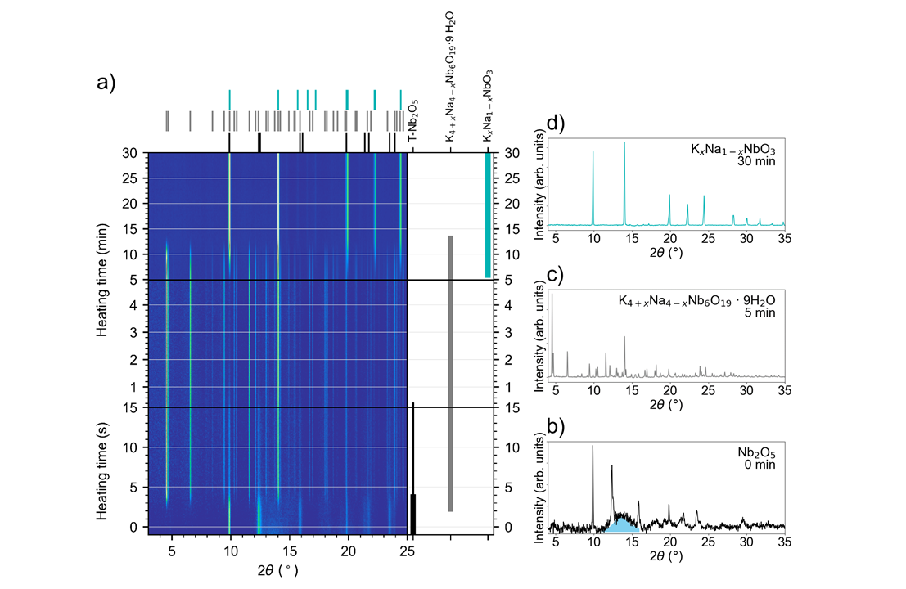
Figure 1 a) Phase evolution during hydrothermal synthesis of K_{x}Na_{1-x}NbO₃ at 210 °C for R = 0.5. Horizontal dividers indicate a change in time-resolution. Figures b-d are single diffractograms of the three distinct phases observed, in addition to a broad feature represented as a light blue area in Figure d. The constant background signal from the capillary and solvent has been subtracted for clarification. The wavelength used was 0.6776 Å.

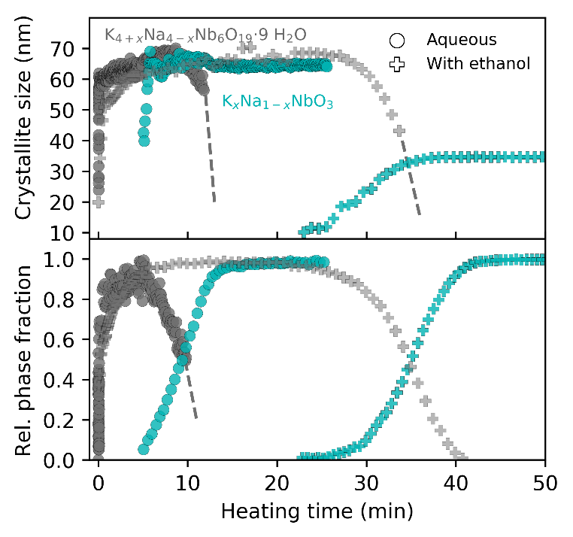
phase first reported by Kennedy.¹⁵ After approximately 0.5 min the T-Nb₂O₅ precursor was completely dissolved. The K_{x}Na_{1-x}NbO₃ perovskite phase started to form after about 5 min. The intermediate phase slowly disappeared as the amount of K_{x}Na_{1- x}NbO₃ evolved, resulting in K_{x}Na_{1-x}NbO₃ as the final phase (Figure 1d). Figure 2 shows the time-resolved crystallite sizes and relative phase fractions during the nucleation and growth of the intermediate phase and K_{x}Na_{1-x}NbO₃ in aqueous solution and in water/ethanol mixture. The crystallite size and relative phase fractions of the intermediate phase increased rapidly during the first seconds before stabilizing for a few minutes. The crystallite size and relative phase fraction of the intermediate phase continued to be constant for a few minutes after the nucleation of K_{x}Na_{1-x}NbO₃ had started. In the aqueous solution, the crystallite size and relative phase fraction of the intermediate phase decreased after ~8 min, and within the next 6 min the phase completely disappeared, at which point the amount of K_{x}Na_{1-x}NbO₃ formed ceased. For the syntheses in water/ethanol mixture, the reaction scheme was similar as in aqueous solution, but the intermediate phase was stable for a longer time delaying the onset of nucleation of K_{x}Na_{1-x}NbO₃ by ~25 min.
Figure 2 Crystallite size and relative phase fraction evolution of the intermediate phase and final product K_{x}Na_{1-x}NbO₃ during hydrothermal synthesis at 210 °C for R = 0.5, in aqueous solution and water/ethanol mixture. Dashed lines are added for clarification where the refinements were unstable.

The indexing of the intermediate phase gave a monoclinic unit cell for all samples with varying R-values and temperatures (see Figure S2 for refinement visualization and the resulting unit cell parameters). Several variations of unit cell parameters gave fits with similar R_{wp}, due to the large flexibility of monoclinic Pawley fits, therefore the refinements were carefully executed so that the refinements were done in exactly the same way for all the experiments. The Rietveld refinements of K_{x}Na_{1-x}NbO₃ resulted in a tetragonal structure (P4mm¹⁶) for R ≤ 0.25 and a mix with NaNbO₃ (Pbma¹⁷) secondary phase for R > 0.25. The refinements of K_{x}Na_{1-x}NbO₃ in this range were challenging due to overlapping reflections with the secondary phase NaNbO₃ (up to 50 wt%) and broad reflections for R = 0.25-0.35. Several crystal structures (Pm¹⁶, Amm2¹⁶, I2mm¹⁸, P2mm¹⁸) were tested, but they either gave a poor fit (Amm2, I2mm, P2mm) or similar output values as when using the P4mm phase (Pm). Thus the tetragonal phase was chosen for consistency.
The effect of temperature and ethanol in the solvent
The effects of temperature and solvent on the reaction kinetics were investigated for R = 0.5. Figure 3 presents the maximum crystallite size of the intermediate phase and the final crystallite size of K_{x}Na_{1-x}NbO₃ for different temperatures, in water and in water/ethanol mixture. For the experiments in water, the maximum size for the intermediate phase and the final size of K_{x}Na_{1-x}NbO₃ were similar (~60-65 nm) and did not change significantly with temperature. In the water/ethanol mixture, the size of the intermediate phase was similar as in water, but the final size of K_{x}Na_{1-x}NbO₃ became significantly smaller (~30-42 nm).
Figure 4 Reaction time for the K_{x}Na_{1-x}NbO₃ synthesis for R = 0.5 in water and water/ethanol mixture and b) intercept and c) slope of the JMA equation for the growth of K_{x}Na_{1-x}NbO₃ and d) the relative difference in unit cell volume of the intermediate phase as a function of reaction temperature. Lines are drawn as guides for the eye.

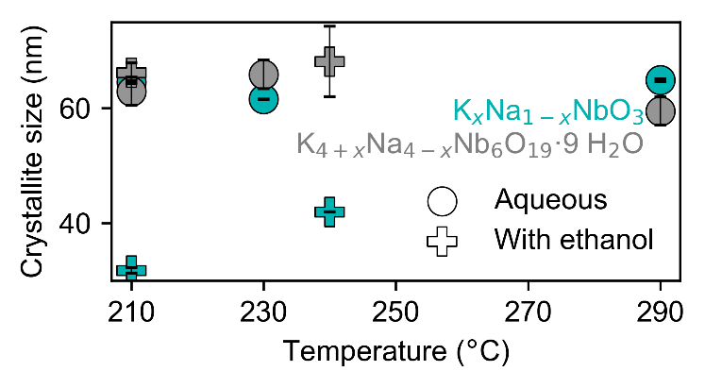
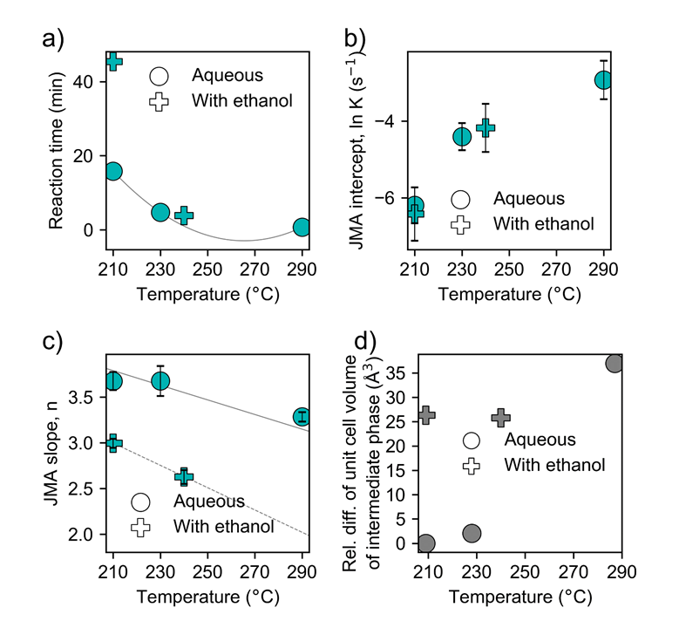
The total reaction time for the syntheses with and without ethanol in the solvent for R = 0.5, defined as the point where a stable crystallite size and relative phase fraction for K_{x}Na_{1-x}NbO₃ were reached, is shown as function of temperature in Figure 4a. The reaction time was less than 1 h for all experiments, and decreased with increasing temperature. The use of water/ethanol mixture prolonged the synthesis time, especially at lower temperatures. Figure 4b and c displays the JMA intercept (K) and slope (n) from fitting the time-resolved phase fraction of K_{x}Na_{1-x}NbO₃ to the JMA equation. All the time-resolved phase fractions could be fitted to linear Sharp-Hancock plots. The JMA intercept K increased with temperature but was not significantly influenced by the water content in the solvent. The JMA slope (n) in Figure 4c was in the range 2.5-3.7 and decreased with increasing temperature and by including ethanol in the solvent. The unit cell volume of the intermediate phase was also observed to change with the reaction conditions reflecting a difference in the alkali content in the precursor phase due to the larger size of the potassium cation relative to the sodium cation. The relative difference in the unit cell volume of the intermediate phase, shown in Figure 4d, depends on the temperature and the solvent type. The relative difference in the volume increased upon increasing the reaction temperature and by using the water/ethanol mixture.
The effect of R-value on the reaction kinetics
The effect of R-value on the kinetics of the formation of K_{x}Na_{1-x}NbO₃ was investigated for R = 0.1-0.5 at 210 and 230 °C and is represented by JMA intercepts and slopes in Figure 5. All the time-resolved phase fractions could be fitted to linear Sharp-Hancock plots. A similar trend in JMA intercept was observed for all R-values at both temperatures, showing a slight decrease around R = 0.25-0.3. The temperature difference between the two datasets was not large enough to see any difference in the JMA slopes in Figure 5b, as expected from the values in Figure 4, but showed a consistent increase with increasing R-value. The values of n were in the range 2-3.7.
Variation in the stoichiometry of K_{x}Na_{1-x}NbO₃ with temperature and R-value
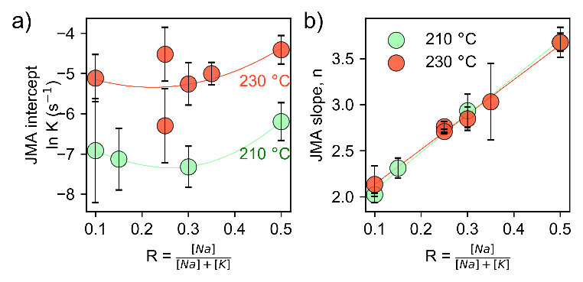
To investigate the effect of the R-value on the stoichiometry of K_{x}Na_{1-x}NbO₃, solutions with R = 0.1-0.5 were investigated at 210 and 230 °C. Figure 6a presents the refined values of the Na occupancy of K_{x}Na_{1-x}NbO₃. Two distinctly different regimes appeared on either side of R ≈ 0.25. For R ≤ 0.25, the structure was purely tetragonal K_{x}Na_{1-x}NbO₃ with a Na occupancy of 1 – x < 0.65. For R > 0.25 the tetragonal K_{x}Na_{1-x}NbO₃ phase was accompanied by a NaNbO₃ secondary phase (up to 50 wt%), also observed ex situ by Handoko et al. at 200 °C.⁷ By comparing the experiments at 210 and 230 °C, complemented with the ex situ work of Handoko et al. at 200 °C, the R-limit for the appearance of the secondary phase increased with increasing temperature. Additionally, one experiment was done at 290 °C for R = 0.5, which resulted in a much lower Na occupancy compared to the experiments at lower temperatures. The Na occupancy for different reaction temperatures is also presented in Figure S3, showing that ethanol in the solvent did not have a significant effect on the final stoichiometry of K_{x}Na_{1-x}NbO₃. Figure 6b shows the relative difference in the unit cell volume of the intermediate phase for R = 0.1-0.5. The volume decreased linearly with increasing amounts of Na, giving a relative difference of ~20 Å between the experiments at R = 0.1 and 0.5.
Figure 3 Maximum crystallite size of the intermediate phase and the final crystallite size of K_{x}Na_{1-x}NbO₃ for hydrothermal synthesis with R = 0.5 in water and water/ethanol mixture.
Figure 7 Morphology of the intermediate phase and K_{x}Na_{1-x}NbO₃ after 60 min coil synthesis of R = 0.23 at 220 °C. K_{x}Na_{1-x}NbO₃ nanorods with average diameter of 100 nm are growing along the surface of large hexagonally shaped crystallites of the intermediate phase.

Figure 5 JMA equation a) intercept and b) slope for the growth of K_{x}Na_{1-x}NbO₃ during hydrothermal synthesis for varying R-values at 210 and 230 °C. Lines are drawn as guides for the eye.

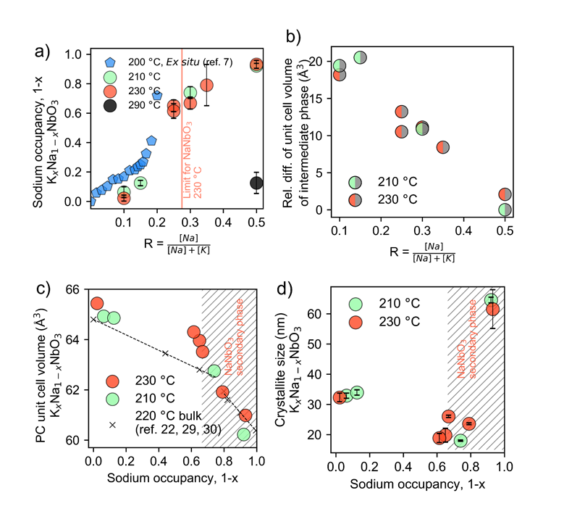
Figure 6 Sodium occupancy (1 - x) of K_{x}Na_{1-x}NbO₃ as a function of the R-value, b) relative difference in unit cell volume for the intermediate phase, c) pseudo-cubic unit cell volume of K_{x}Na_{1-x}NbO₃ as a function of sodium occupancy (1 - x) and d) crystallite size of K_{x}Na_{1-x}NbO₃ made for varying R-values at 210 and 230 °C. Ex situ unit cell volume for bulk at 220 °C are included for comparison.

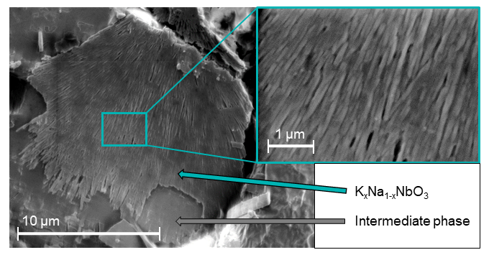
The effect R-value on the unit cell volume and crystallite size of K_{x}Na_{1-x}NbO₃
The pseudo-cubic unit cell volume of K_{x}Na_{1-x}NbO₃ in Figure 6c showed a steady decrease, consistent with reported values for bulk,^{18–20} but were slightly higher, which has been explained in the literature by the incorporation of hydroxyl ions or water in the lattice.²¹ The refined crystallite size is presented in Figure 6d and shows a significant decrease for 1 - x = 0.6 - 0.8. Around the limit between the two observed regimes at 1 - x = 0.65, the relative difference in the unit cell volume relative to bulk were more pronounced, and in relation to the refined crystallite size of K_{x}Na_{1-x}NbO₃ in Figure 6d, this can be ascribed to a finite-size effect, frequently observed in ferroelectric oxides.²² The small crystallite sizes of ~20 nm achieved for 1 - x = 0.6-0.8 is worth noticing as they are, to the best of the author’s knowledge, the smallest yet to be reported in the literature for hydrothermal synthesis of K_{x}Na_{1-x}NbO₃.
Ex situ characterization of the morphology
Figure 7 shows the resulting morphology of the intermediate phase and K_{x}Na_{1-x}NbO₃ after 60 min coil synthesis of a slurry with R = 0.23 at 220 °C. The large crystallites with a distinct hexagonal shape was the dominating morphology. On the surface of some of these hexagons, the growth of nanorods was observed, growing in the direction parallell to the surface and forming what appeared to be a thin layer of nanorods, limited in length by the size of the intermediate phase crystallite.
Discussion
In the following sections, we discuss the connections between the present findings and their implications on the growth mechanism and stoichiometry of K_{x}Na_{1-x}NbO₃ as well as reaction kinetics.
Growth mechanism of K_{x}Na_{1-x}NbO₃
The reaction temperature did not seem to affect the final crystallite size of K_{x}Na_{1-x}NbO₃ (Figure 2), and crystallite size was in the same range as the crystallite size of the intermediate phase. If the growth of K_{x}Na_{1-x}NbO₃ had occurred through a dissolution-precipitation mechanism, one would have expected the crystallite size to be strongly dependent on temperature, but this is not observed. Ex situ imaging of particles made with the coil synthesis in Figure 7, confirms that K_{x}Na_{1-x}NbO₃ grows directly onto the surface of the intermediate phase, which has also been reported before ,¹² and as will be discussed in later sections, the reaction kinetics strongly indicate heterogeneous nucleation of K_{x}Na_{1-x}NbO₃. The crystal structure of the intermediate phase is not known in detail, but if the transformation is occurring mostly through removal of excess alkali and water from the crystal structure, the crystallite size of the intermediate phase limits or control the crystallite size of K_{x}Na_{1-x}NbO₃. This could explain the apparent limitation of the extent of the K_{x}Na_{1-x}NbO₃ nanorods in Figure 7, as the nanorods only grow where they are directly in contact with the surface of the intermediate phase. Heterogeneous nucleation is a prerequisite for such a mechanism as there must be direct contact between the two phases.
Following the above discussion, it is important to understand what determines the crystallite size of the intermediate phase. The relative phase fraction and crystallite size of the intermediate phase, shown in Figure 2, displays a rapid formation of the intermediate phase during the first few seconds (<10 s) of heating. The conditions were transient in this time range, as 90 % of final reaction temperature was reached after ~10 s for all the experiments (see temperature profiles in Figure S1). Such a rapid formation before reaching the final reaction temperature would imply a high nucleation rate, which would result in small crystallite size and thus the kinetics and resulting size of the crystallites would be similar for all the experiments regardless of the final reaction temperature.
The effect of temperature and R-value on the sodium occupancy in K_{x}Na_{1-x}NbO₃
A noticeable decrease in the Na occupancy was observed when increasing the synthesis temperature, see Figure 6a. Three explanations for this are envisaged, one being that the difference in solubility of sodium and potassium niobates phases^{6,7} can change with temperature. Another explanation is that the relatively larger potassium ions can enter the crystal structure more easily at higher temperature due to thermal expansion. The thermally induced phase transition from orthorhombic to tetragonal at ~210 °C for bulk material¹⁶ also gives a volume expansion, adding to this possible effect. The ability to incorporate K into the crystal structure is probably directly correlated with the appearance of the NaNbO₃ secondary phase, explaining why NaNbO₃ was observed already at R = 0.21 for Handoko et al. at 200 °C.⁷ Thermodynamics provide the third explanation, as the driving force for the nucleation of K_{x}Na_{1-x}NbO₃ depends on the Gibbs energy of formation of the phase from the solution, which depends on x. This will also change with the composition of the precursor solution as well as the final product. A higher reaction temperature will favor thermodynamic equilibrium and since KNbO₃ has a larger thermodynamic stability than NaNbO₃,²³ a higher K-content with increasing temperature is anticipated. This underlines the importance of using a high enough synthesis temperature during the hydrothermal synthesis of K_{x}Na_{1-x}NbO₃ as long as the goal is to produce single-phase K_{x}Na_{1-x}NbO₃ with a stoichiometry of 1 - x ≥ 0.5.
As seen in Figure 6a, the Na occupancy in K_{x}Na_{1-x}NbO₃ increases with R. Since the reaction scheme includes an intermediate phase, it is interesting to see whether a similar increase in Na content can also be observed in the intermediate phase with increasing R. The linearly decreasing unit cell volume of the intermediate phase with increasing R-value in Figure 6b implies that more Na is entering the structure, assuming that the unit cell volume is directly connected to the amount of sodium in the structure due to the smaller ionic radius of Na (1.53 Å) compared to K (1.78 Å).²⁴ Additionally, the low Na occupancy observed for K_{x}Na_{1-x}NbO₃ at R = 0.5 and 290 °C (see Figure S3 for details) corresponds well with the large increase in unit cell volume of the intermediate phase for the same temperature (Figure 4d), which can cannot be explained alone by simply an effect of thermal expansion. Therefore, we infer from the data that there is a connection between the amount of Na in the intermediate phase and in the K_{x}Na_{1-x}NbO₃. This also supports the suggested growth mechanism in the previous section, accentuating the importance of controlling the Na content in the intermediate phase.
The effect of R-value and ethanol on the reaction kinetics
The consistent increase of the JMA slopes with increasing temperature in Figure 5b indicates that the amount of possible nucleation sites for K_{x}Na_{1-x}NbO₃ will increase for higher R-values. Generally, homogeneous nucleation with three-dimensional growth gives n = 4, so n < 4 as observed here signifies constraints for either nucleation, growth or both.²⁵ A constant nucleation rate can be assumed since the Sharp-Hancock plots are linear (not shown). As the highest value of n in this paper is approaching 4, the nucleation likely occurs during the entire transformation, as instantaneous nucleation would always give n-values < 3. Therefore, it is suggested that the low values of n are due to constrained growth due to heterogeneous nucleation,²⁶ for instance at grain corners for R = 0.1, while the high n-value for R = 0.5 indicates almost three-dimensional growth, with a gradual dependency between these two points. This observation is challenging to rationalize without more investigations, but if the previously proposed mechanism is assumed, one could expect that the larger ionic radius of K compared to Na limits the diffusion out of the intermediate phase.
A delayed starting point for the nucleation of K_{x}Na_{1-x}NbO₃ was observed when using the water/ethanol mixture compared to water, seen in Figure 2, resulting in a longer total reaction time, as seen in Figure 4a. By looking at the JMA intercepts K for the transformation to K_{x}Na_{1-x}NbO₃ in Figure 4b, ethanol in the solvent did not affect the rate of the transformation. Thus, the observed delay must be linked to a change in the stability of the intermediate phase when using water/ethanol mixture. All the JMA slopes (n) in Figure 4c were < 4 indicating heterogeneous nucleation.²⁶

Outlook
The findings in this work accentuate the importance of understanding the entire reaction scheme for production of K_{x}Na_{1-x}NbO₃ by hydrothermal synthesis. Since the crystallite size of the intermediate phase seems to set an upper limit for the crystallite size of K_{x}Na_{1-x}NbO₃, a rapid heating rate is necessary when nanosized K_{x}Na_{1-x}NbO₃ is desired. A continuous-flow setup can give much higher heating rates than the conventional autoclave setup and thus provide a great advantage for producing nanosized K_{x}Na_{1-x}NbO₃ in industrial quantities.
Experimental
T-Nb₂O₅ powder²⁷ was synthesized by precipitation from (NH₄)NbO(C₂O₄)₂·5H₂O (Sigma-Aldrich, 99.99 %) dissolved in water by adding NH₄OH (25 wt%, Emsure) before drying and then calcining at 600 °C for 12 h, as described by Mokkelbost et al.^{28,29} Highly concentrated slurries were made by mixing T-Nb₂O₅ powder with 9 M NaOH/KOH aqueous solutions of different Na/K ratios, giving an alkali/niobium ratio of 9.5. For some syntheses, 50:50 vol% of water and ethanol was used instead of pure water. The slurries were stored in PET bottles and injected with a plastic syringe into a custom-made in situ cell, making sure to fill the entire volume of the cell. The cell, which has been previously described,²⁹ consisted of a sapphire capillary with an inner and outer diameter of 0.8 and 1.15 mm, respectively, which was fixed to an adjustable aluminium frame by graphite ferrules and Swagelok fittings. An HPLC pump connected to the dead-ended cell provided a stable pressure. The mid ¹/₃ of the capillary’s length was heated by a hot-air blower and the temperature was calibrated by refining the unit cell expansion of boron nitride.³⁰ The blower was ramped up to reaction temperature while being directed away from the capillary and was remotely swung into position only after the desired pressure was achieved and data acquisition had been initiated, providing quasi-instant heating (see temperature profiles in Figure S1). Values of R = [Na] / ([Na]+[K]) in the range 0.1-0.5 at temperatures of 210-290 °C were studied. The pressure was normally set to 250 bar, but for the syntheses with ethanol, the pressure was lowered to 100 bar to avoid supercritical conditions.
To produce powders for ex situ characterization with conditions as similar as possible to the in situ cell, a coil was manufactured from extra corrosion resistant stainless steel (316 L) and used as a reaction vessel. Slurries were made with R = 0.23 and injected into the coil before being rapidly heated to 220 °C in a fluidized sand bath. The autogenous pressure generated by heating was stabilized to 250 bar pressurized with the HPLC pump. After a total heating time of 60 min the coil was immersed in cold water. The resulting particles were washed three times with deionized water, centrifuged and dried by evaporation at room-temperature. The composition of the powders were confirmed with a Bruker D8 A25 DaVinci X-ray Diffractometer with CuK_{α} radiation with a LynxEye™ SuperSpeed Detector before being imaged using a Hitachi SU6600 FE-SEM.
In situ powder X-ray diffraction (PXRD) data were collected at the Swiss-Norwegian Beamlines (BM01) at the European Synchrotron Radiation Facility (ESRF) using a monochromatic beam with wavelengths of 0.6776 and 0.6999 Å (two different beam times). The diffraction signal was detected by a Pilatus 2M detector³¹ with acquisition times of 0.1, 1 or 5 s depending on the experiment. The as-recorded data were treated with the Pilatus@SNBL platform³¹ and the refinements were performed using Topas 5 in launch mode using JEdit with macros for Topas.³² Batch refinements were made possible by launching Topas with Jupyter Lab/Notebook.³³
The instrumental resolution function, wavelength and detector distance were found and calibrated by refining a NIST 660a LaB₆ standard. The diffraction patterns of the product phases were summed (25-60 s total acquisition time) to enhance statistics and the default approach was a full Rietveld refinement, refining the unit cell parameters, the Gaussian and Lorentzian isotropic size parameters, isotropic temperature factors, scale factor, Na/K occupancy and Chebychev background parameters. The K_{x}Na_{1-x}NbO₃ phase in all the experiments was tentatively refined with several structures (Pm,¹⁶ P4mm,¹⁶ I2mm,¹⁸ Amm2¹⁸) but P4mm was chosen for all the experiments. For refinements of the formed NaNbO₃ secondary phase the space group Pbma¹⁷ was used. Atomic positions in all the structures were fixed to literature values.^{16,17} The unit cell used to fit the intermediate phase was found by a grid search using the McMaille software³⁴ on the 20 most intense peaks in summed (100 s) diffraction patterns. The choice of a proper unit cell was based on a high figure of merit, provided that all the reflections were identified. The least symmetric space group was then chosen to avoid extinction of any reflections.
For the time-resolved Rietveld refinements of K_{x}Na_{1-x}NbO₃ the same approach as described above was used, but with additionally fixing the isotropic temperature factors and Na/K occupancy to the final refined values to avoid breakdown of the refinements. The phase fraction evolution of K_{x}Na_{1-x}NbO₃ was assumed to correspond to the normalized time-resolved scale factor. The refinements of the intermediate phase were accomplished with the Pawley method.³⁵ The crystallite size was refined using Gaussian and Lorentzian isotropic size parameters while the unit cell parameters were fixed to the values found for a summed pattern (100 s). The time-evolution of the phase fraction was found by summing the intensity of all the diffraction lines found for each diffraction pattern by the Pawley fit, and then normalized using the minimum and maximum value. As the Pawley method cannot provide information about the absolute amount of a phase relative to another, the time-evolution of the phase fraction of the intermediate phase can only be seen in relation to itself and not relative to the phase fraction of K_{x}Na_{1-x}NbO_{3.}
Information about the growth mechanism of K_{x}Na_{1-x}NbO₃ was extracted by fitting the refined phase fraction over time to the Johnson-Mehl-Avrami (JMA) equation ($α=1-e^{-(K{t)}^{n}}$ , where α is the phase fraction, K is a rate constant and n depends on the transformation mechanism).^{36,37} The JMA slope n and intercept K were found by transforming the phase fraction with the Sharp-Hancock method.³⁸
Conclusions
The kinetics of the formation of K_{x}Na_{1-x}NbO₃ by hydrothermal synthesis were studied by in situ X-ray diffraction. A similar phase evolution was observed for all investigated temperatures and R-values, where the precursor T-Nb₂O₅ dissolved and rapidly formed a potassium hexaniobate intermediate phase which in turn transformed into nanosized K_{x}Na_{1-x}NbO₃ (~18-65 nm) via a proposed mechanism where water and excess alkali is leaving the structure of the intermediate phase. This mechanism is supported by the observation of heterogeneous nucleation (n = 2-3.7) of K_{x}Na_{1-x}NbO₃ and the non-existent temperature dependence on the final crystallite size of K_{x}Na_{1-x}NbO₃. Using water/ethanol mixture instead of an aqueous solution prolonged the reaction time by stabilizing the intermediate phase and gave a smaller final K_{x}Na_{1-x}NbO₃ crystallite size.
The Na occupancy in K_{x}Na_{1-x}NbO₃ is proposed to be linked to the Na content in the intermediate phase which both increased when increasing the R-value. For R < 0.25, purely tetragonal (P4mm) K_{x}Na_{1-x}NbO₃ was observed, while for R > 0.25 a NaNbO₃ secondary phase appeared. The Na occupancy decreased and the R-limit for the presence of NaNbO₃ secondary phase increased when increasing the synthesis temperature, accentuating the importance of using a high enough synthesis temperature when producing K_{x}Na_{1-x}NbO₃ with hydrothermal synthesis.
Conflicts of interest
There are no conflicts to declare.
Acknowledgements
Financial support from NTNU Norwegian University of Science and Technology and The Research Council of Norway under the Toppforsk program to the project (No 250403) "From aqueous solutions to oxide thin films and hierarchical Structures" is gratefully acknowledged.
Notes and references
‡ Supplementary information is available.

1 L.-Q. Cheng and J.-F. Li, J. Mater., 2016, 2, 25–36.
2 J. Rödel, W. Jo, K. T. P. Seifert, E. M. Anton, T. Granzow and D. Damjanovic, J. Am. Ceram. Soc., 2009, 92, 1153–1177.
3 Y. Saito, H. Takao, T. Tani, T. Nonoyama, K. Takatori, T. Homma, T. Nagaya and M. Nakamura, Nature, 2004, 432, 84–87.
4 Z. Wang, H. Gu, Y. Hu, K. Yang, M. Hu, D. Zhou and J. Guan, CrystEngComm, 2010, 12, 3157.
5 M.-A. Einarsrud and T. Grande, Chem. Soc. Rev., 2014, 43, 2187–2199.
6 S. L. Skjærvø, S. Sommer, P. Nørby, E. D. Bøjesen, T. Grande, B. B. Iversen and M.-A. Einarsrud, J. Am. Ceram. Soc., 2017, 100, 3835–3842.
7 A. D. Handoko and G. K. L. Goh, Green Chem., 2010, 12, 680–687.
8 L. Su, K. Zhu, J. Qiu and H. Ji, J. Mater. Sci., 2010, 45, 3311–3317.
9 F. Zhang, L. Han, S. Bai, T. Sun, T. Karaki and M. Adachi, Jpn. J. Appl. Phys., 2008, 47, 7685–7688.
10 L. A. Ramajo, F. Rubio-Marcos, A. Del Campo, J. F. Fernández, M. S. Castro and R. Parra, Ceram. Int., 2014, 40, 14701–14712.
11 C. Sun, X. Xing, J. Chen, J. Deng, L. Li, R. Yu, L. Qiao and G. Liu, Eur. J. Inorg. Chem., 2007, 2007, 1884–1888.
12 R. López-Juárez, R. Castañeda-Guzmán and M. E. Villafuerte-Castrejón, Ceram. Int., 2014, 40, 14757–14764.
13 F. Zhang, S. Bai and T. Karaki, Phys. Status Solidi A, 2011, 208, 1052–1055.
14 K. Byrappa and T. Adschiri, Prog. Cryst. Growth Charact. Mater., 2007, 53, 117–166.
15 J. H. Kennedy, J. Inorg. Nucl. Chem., 1961, 20, 53–57.
16 D. W. Baker, P. A. Thomas, N. Zhang and A. M. Glazer, Appl. Phys. Lett., 2009, 95, 91903-1–3.
17 A. W. Hewat, Ferroelectrics, 1974, 7, 83–85.
18 M. Ahtee and A. M. Glazer, Acta Crystallogr. Sect. A, 1976, 32, 434–446.
19 S. L. Skjærvø, K. Høydalsvik, A. B. Blichfeld, M.-A. Einarsrud and T. Grande, R. Soc. Open Sci., 2018, 5, 1–5.
20 J. Tellier, B. Malic, B. Dkhil, D. Jenko, J. Cilensek and M. Kosec, Solid State Sci., 2009, 11, 320–324.
21 S. Wada, T. Suzuki and T. Noma, Jpn. J. Appl. Phys., 1995, 34, 5368–5379.
22 G. Wang, S. M. Selbach, Y. Yu, X. Zhang, T. Grande and M.-A. Einarsrud, CrystEngComm, 2009, 11, 1958–1963.
23 S. K. Sahu, S. Zlotnik, A. Navrotsky and P. M. Vilarinho, J. Mater. Chem. C, 2015, 3, 7691–7698.
24 R. D. Shannon, Acta Crystallogr. Sect. A, 1976, 32, 751–767.
25 S. F. Hulbert, J. Br. Ceram. Soc., 1969, 6, 11–20.
26 I. Sinha and R. K. Mandal, J. Non. Cryst. Solids, 2011, 357, 919–925.
27 K. Kato and S. Tamura, Acta Crystallogr. Sect. B, 1975, 31, 673–677.
28 T. Mokkelbost, Ø. Andersen, R. A. Strøm, K. Wiik, T. Grande and M.-A. Einarsrud, J. Am. Ceram. Soc., 2007, 90, 3395–3400.
29 S. L. Skjærvø, K. H. Wells, S. Sommer, T.-D. Vu, J. R. Tolchard, W. van Beek, T. Grande, B. B. Iversen and M.-A. Einarsrud, Cryst. Growth Des., 2018, 18, 770–774.
30 R. S. Pease, Acta Crystallogr., 1952, 5, 356–361.
31 V. Dyadkin, P. Pattison, V. Dmitriev and D. Chernyshov, J. Synchrotron Radiat., 2016, 23, 825–829.
32 J. S. O. Evans, Mater. Sci. Forum, 2010, 651, 1–9.
33 T. Kluyver, B. Ragan-Kelley, F. Pérez, B. Granger, M. Bussonnier, J. Frederic, K. Kelley, J. Hamrick, J. Grout, S. Corlay, P. Ivanov, D. Avila, S. Abdalla and C. Willing, Position. Power Acad. Publ. Play. Agents Agendas, 2016, 87–90.
34 A. Le Bail, Powder Diffr., 2004, 19, 249–254.
35 G. S. Pawley, J. Appl. Cryst, 1981, 14, 357–361.
36 M. Avrami, J. Chem. Phys., 1939, 7, 1103–1112.
37 M. Avrami, J. Chem. Phys., 1940, 8, 212–224.
38 J. D. Hancock and J. H. Sharp, J. Am. Ceram. Soc., 1972, 55, 74–77.

