Automatic replenishment of perishables in grocery retailing: The value of utilizing remaining shelf life information

Purpose To investigate the impact of sharing and utilizing remaining shelf life information from grocery stores by use of age-based replenishment policies for perishables
Design/methodology/approach The performance is evaluated through a discrete event simulation model, which mirrors a part of one of Norway’s largest grocery retailer and uses their POS-data to reflect a realistic demand pattern of 232 stores for one year
Findings The findings indicate that a current age-based replenishment policy (EWA policy) provides a significant improvement of 17.7% increase in availability for perishables with a shelf life between 4 to 11 days, but suffers from high inventory levels and only reduces waste with 3.4% compared to a base stock policy. A proposed adjustment to the EWA policy, EWA_{SS}, provides a more balanced performance in the conducted study with a reduction of 10.7% waste and 10.3% increase in availability by keeping the same average inventory level.
Implications Sharing and utilizing remaining shelf life information for replenishment of perishables with a predetermined shelf life between 6 to 11 days can be beneficial, and could enable the replenishment processes to be automated. However, for products with longer shelf life the benefits slowly diminishes.
Originality/Value The study proposes a new age-based replenishment policy which in the conducted study showed a more balanced performance improvement, in both waste and availability, compared with previous replenishment policies.
Keywords. Information sharing, Shelf life, Replenishment, Perishables, Simulation

Introduction
Perishables are of major importance for grocery retailers and accounts for 25% of the total sales and more than 35% of the growth in the European grocery market (Nielsen, 2016). Compared to other food products the main difference is the shorter shelf life (less than 30 days) (Van Donselaar et al., 2006). Food waste is often reported to be higher for these perishables products (Kaipia et al., 2013; Mena et al., 2014) and the short shelf life complicates the inventory management practice (Karaesmen et al., 2011). Non-perishable products are typically managed through an automatic replenishment system, which generates order proposals to the stores based on point-of-sales, safety stock levels, batch sizes, and delivering times (Potter and Disney, 2010). These systems have shown to improve performance of grocery retailer, however, they do not function satisfactorily in its original form for perishable products (Van Donselaar et al., 2006).
Suggestions for how automatic replenishment systems can handle perishable products has been introduced by utilizing remaining shelf life (RSL) information (also known as age distribution) of the products in the stores (Broekmeulen and van Donselaar, 2009; Duan and Liao, 2013; Lowalekar and Ravichandran, 2015). Mena et al. (2014) add that increasing transparency (e.g. by sharing more detailed information about the product’s age) might reduce supply chain wide food waste. This is also supported by the proposed replenishment models, which yields promising results with mean performance improvements (calculated as reduced cost) around 8% and up to 25% in some cases. However, several issues are still not addressed in the current solutions. Currently, the models are only tested with use of artificial generated stationary demand data in a dyadic relation with one warehouse and one store, or small scaled divergent systems. Likewise, the models only handle either a complete first-in-first-out (FIFO) depletion or complete last-in-first-out (LIFO) depletion even though reality lies somewhere in between those two (Janssen et al., 2016).
Even though the models can bring important insights they do not fully reflect a modern retailer configuration with hundreds of stores which each differ in sales, delivery frequency, and required service levels (Aastrup and Kotzab, 2010; Kuhn and Sternbeck, 2013; van Donk et al., 2008). It is further noticed that studies of information sharing in dyadic supply chains are too simplified and more realistic supply chain structures are encouraged (Huang et al., 2003).
The purpose of the paper is to investigate the impact of utilizing the remaining shelf life information from the stores in a setting closer to the reality of today’s grocery retailers. Specifically, we do this by examining the inventory control of perishables in a divergent food supply chain based on one of Norway’s largest retailers with more than 200 stores. Through simulation the study evaluates one of the popular and well performing heuristics for replenishment of perishables, the EWA policy (Broekmeulen and van Donselaar, 2009), and suggests and evaluates a refined version of this policy. The evaluation of the replenishment policies is made for products with a shelf life ranging from 4 to 20 days, mixed FIFO and LIFO depletion, various delivery frequencies, different service level requirements, and evaluated using a range of performance measures.

Background
In perishable inventory management demand is modelled either as deterministic or stochastic, and the shelf life is either considered as fixed or random. A fixed shelf life refers to a known deterministic life time whereas random shelf life refers to a known or unknown probabilistic life time (Janssen et al., 2016). In this study, focus is placed on modelling products with a fixed shelf life under stochastic demand. Within grocery retailing this includes products such as: dairy, meat, cold cuts, or other perishable products with a predetermined expiration date. Findings of how to manage these products with a fixed shelf life may later be extended to include products with a random shelf life.
If the shelf life of the product is fixed to one day the news vendor solution is optimal, and extensions for two days shelf life have also been provided (Nahmias and Pierskalla, 1973). However, as shelf life increases further it becomes significantly complicated to mathematically find the optimal solution and previous contributions has mainly searched for finding good heuristic replenishment policies rather than the true optimum (Broekmeulen and van Donselaar, 2009; Duan and Liao, 2013). Replenishment policies might be further subdivided into either periodic or continuous review policies. Generally, continuous review policies need less safety stock than periodic review policies, but on the other hand require (hereof the name) a continuous review of the inventory level and the ability to place orders at all times (Silver et al., 1998). In grocery retailing periodic review is most common as stores have predefined days where they place and receive order (Kuhn and Sternbeck, 2013). Consequently, the remaining of this section is dedicated to present the most relevant periodic replenishment policies for perishable. For continuous review policies the reader is referred to e.g. Kouki et al., (2015) and Kouki et al., (2016).
A (R,S)-policy with fixed life time is proposed by (Chiu, 1995) where the decision variables are both the length of the review period (R) and the order-up-to level (S). The flexible review period is beneficial from an inventory perspective, however, it might be impractical and challenging from a distribution planning perspective. With only the order quantity as a decision variable Minner and Transchel (2010) proposed and evaluated a dynamic order policy, which showed a nearly 10% reduction in waste for products with a very short shelf life (less than 6 days) compared to constant order policy (i.e. fixed order quantity each time). Minner and Transchel (2010) further observed that, because of its simplicity, a constant order policy should not be neglected especially if demand is stationary, demand is somewhat stable (CoV ≤ 0.5) and the shelf life is short (2-3 days).
The EWA policy introduced by (Broekmeulen and van Donselaar, 2009) is a direct extension of the policy found in traditional automatic replenishment systems, and is intended to be used for automatic replenishment of perishables. Traditional automatic replenishment systems apply a (R,s,nQ) policy with a fixed review period (R), dynamic reorder-point (s), and order multiplier (n) of batches with a given batch size (Q) (Potter and Disney, 2010). In contrast, the EWA policy increases the order quantity based on the expected amount of products outdating. Compared to the dynamic policy by Minner and Transchel (2010) the EWA policy also takes into account the batch size constraint between the warehouse and the stores. Mathematically, the EWA policy can be expressed as follows:

$if: I_{t}-\sum_{i=t+1}^{t+R+L-1}{Ô_{i}}<\sum_{i=t+1}^{t+R+L}{E\left[D\right]}+SS then:$
$Q_{t}= \left\lceil \frac{\sum_{i=t+1}^{t+R+L-1}{Ô_{i}}+\sum_{i=t+1}^{t+R+L}{E\left[D\right]}+SS-I_{t}}{B}\right\rceil$ (1)
Where:
I_{t}: inventory position (inventory on hand plus inventory in transit) at time t.
R: number of days until next review
L: lead time
E[D]: expected demand
SS: safety stock, constant
B: batch size (order multiplier between the store and the warehouse)
Q_{t}: order quantity (number of batches) ordered at time t
Ô_{i}: estimated amount of products outdating
The difference between the base stock policy and the EWA policy is the inclusion of an estimate for the amount of products outdating, Ô. If the inventory position, I, minus the expected amount of products outdating is less than the expected demand plus safety stock an order is placed. The order quantity is equal to the estimated amount outdating plus expected demand plus safety stock minus current inventory position, subjected to the batch size.
Another, but similar, approach is the old inventory ratio policy which determines the order quantity in a two-step procedure (Duan and Liao, 2013). First, the inventory position is raised following a base-stock policy. Second, if the ratio between the old (the assessment of when inventory is old is subjective) and the total inventory on hand exceeds a given threshold, δ, an additional replenishment quantity – equal to the amount of old inventory – is ordered.
A simulation study, which evaluated six different replenishment policies found the EWA policy to be the best performing periodic review policy for perishables (Lowalekar and Ravichandran, 2015). However, as pointed out by Minner and Transchel (2010) the EWA policy applies a constant safety stock which might not by adequate if demand is non-stationary. Determining the right safety stock levels has been shown to be rather complicated and easily ends with an oversupply (Van Donselaar and Broekmeulen, 2012). Based on the above studies the EWA policy is selected for this study, but to account for deficiencies in safety stock calculations a modification to the EWA policy is proposed in the following section.

Development of Modified EWA Policy
As observed by Van Donselaar and Broekmeulen (2012) the order quantity proposed by the EWA policy may be too high in some cases due to how safety stocks are included in the policy. Generally, for products with a short shelf life the EWA policy will place orders earlier than a base stock policy to account for the products that outdate. Consequently, if orders are placed earlier and the same safety stock levels are kept (as if a base stock policy was used) we risk having too many products with a limited RSL on inventory. This will result in a very high service level but also increase the risk of products outdating. As the predetermined shelf life of the product increases (say, above 15 days) the risk that products outdate on the shelf may decrease. And, as the number of products which outdate approaches zero, the EWA policy becomes equal to a normal base stock policy (Broekmeulen and van Donselaar, 2009). Therefore, to make a better balance and not just add to the order if there is a high number a products outdating it is proposed to slightly modify the EWA policy.
The difference between the EWA policy and the modified policy is in regards to the safety stock or total buffer size – hereof the name EWA_{SS.} In the EWA policy the ‘total buffer size’ equals the amount of products outdating (to account for products expiring) plus safety stock to account for demand certainty. In the EWA_{SS} policy this protection is shared. Thus, the ‘total buffer size’ is either equal to the amount of products outdating, or the safety stock size based on uncertainty in demand (the biggest of the two). In other words, if the number of products outdating is e.g. 10 and the safety stock is 5, the EWA_{SS} policy will use a total buffer size of 10, whereas the total buffer size in the EWA policy would be 15. Mathematically it is formulated as:
$if I_{t}-\sum_{i=t+1}^{t+R+L-1}{Ô_{i}}<\sum_{i=t+1}^{t+R+L}{E\left[D\right]}+SS then:$
$if SS<\sum_{i=t+1}^{t+R+L-1}{Ô_{i}} then:$
$Q_{t}= max\left(\left\lceil \frac{\sum_{i=t+1}^{t+R+L}{E\left[D\right]+\sum_{i=t+1}^{t+R+L-1}{Ô_{i}}}-I_{t}}{B}\right\rceil ,0\right)$ (2a)

$if SS≥\sum_{i=t+1}^{t+R+L-1}{Ô_{i}} then:$
$Q_{t}= max\left(\left\lceil \frac{\sum_{i=t+1}^{t+R+L}{E\left[D\right]}+SS-I_{t}}{B }\right\rceil ,0\right)$ (2b)
The safety stock (SS) is calculated as the standard deviation of forecast errors during review interval plus replenishment lead time times a safety factor ($σ_{R+L} ∙k$) (Silver et al., 1998).

Research design
To investigate the performance of the EWA and EWA_{SS} policies in a more realistic setting than current literature the analysis in this study is based on a simulation model of a Norwegian grocery retailer. To estimate the impact of utilizing RSL information through these policies the simulation model mirrors the structure and settings (delivery times, service levels, review periods, etc.) and uses POS-data from 1 year to reflect the sales pattern. Using simulation allows us to test various scenarios and investigate the causality between variables (Croom, 2009).

4.1. Case selection
The Norwegian retailer was selected due to ongoing research activities and a mutual curiosity in the topic. The retailer holds all three major categories of food products (fresh, dry, and frozen) and is currently considering how to automate the ordering process for especially the fresh food products. Thus, they showed a high level of interest on the topic as well a high level of willingness to collaborate. This enabled the research team to get access to rather sensitive data and use snowball sampling to connect with key personnel for interviews (Patton, 2002). Additionally, the Norwegian retailer was selected as they represent a rather typical setup for grocery retailers. The retailer owns several warehouses and is in total supplying more than 1000 stores across Norway across five major concepts (chains). For certain products the retailer uses cross-docking between its warehouses. Thus, to simplify and focus the problem one of the main warehouses and its accompanying 232 stores was selected for this study.

4.2. Data collection
Semi-structured interviews with the warehouse-, purchasing-, and logistics manager as well as the employees responsible for forecasting and the current automated replenishment system was conducted to understand the ordering process at both the stores and the warehouse. The outcome of these interviews were used for determining the assumptions and logic of the simulation model. Additionally, daily POS-data from 232 stores for a one year period was received from the retailer to use for further analysis of the sales pattern.

4.3. Data analysis
The 232 stores belong to five different store concepts and each concept targets different market segments, which among others, is reflected through different requirements of P1 service level (Silver et al., 1998) originating from the retailer itself. To account for the differences in weekly sales volume subgroups within each concept were formed (see Table 1). The number of subgroups were formed by balancing the dispersion in sales within the group (this should not be too high), and the number of stores within each group (the number of stores within each subgroup should be comparable) as well as accounting for the difference in delivery frequency. Hereby, the e.g. 69 stores belonging to concept A was divided into five subgroups (A-xs to A-xl) to reflect the diversity of sales among the stores and also account for differences in the number of weekly ordering days.

Table 1: Characterictic of subgroups (stores) in the simulation model
Concept | P1 Service level | Ordering days | Mean weekly sales (units) | Number of stores | Subgroup
A | 97% | Tu, Sa | 16 | 11 | A-xs
 |  | Tu, Sa | 25 | 11 | A-s
 |  | Tu, Th, Sa | 34 | 22 | A-m
 |  | Tu, Th, Sa | 49 | 17 | A-l
 |  | Tu, Th, Sa | 62 | 8 | A-xl
B | 96% | Tu, Sa | 5 | 12 | B-xs
 |  | Tu, Sa | 8 | 23 | B-s
 |  | Tu, Sa | 13 | 25 | B-m
 |  | Tu, Sa | 18 | 17 | B-l
 |  | Tu, Sa | 26 | 11 | B-xl
 |  | M, W, Sa | 37 | 10 | B-xxl
C | 97,5% | M, W, Sa | 30 | 3 | C-xs
 |  | M, W, Sa | 46 | 9 | C-s
 |  | M, W, Sa | 62 | 12 | C-m
 |  | M, Tu, W, Th, Sa | 86 | 14 | C-l
 |  | M, Tu, W, Th, Sa | 128 | 9 | C-xl
D | 98% | M, Tu, W, Th, Sa | 74 | 4 | D-s
 |  | M, Tu, W, Th, Sa | 108 | 6 | D-m
 |  | M, Tu, W, Th, Sa | 172 | 2 | D-l
E | 97,5% | M, Tu, W, Th, Sa | 222 | 3 | E-m
 |  | M, Tu, W, Th, Sa, Su | 696 | 3 | E-l

It is well-known that the sales pattern in retailing is different throughout the week (non-stationary) with higher sales towards the weekend (Aastrup and Kotzab, 2010; van Donk et al., 2008). Thus, for each subgroup a daily demand distribution was estimated based on the POS-data. I.e. for subgroup A-xs sales from 11 stores for all Mondays were plotted to fit a probability distribution. 11 stores in the simulation model is then using this probability distribution. A total of (7 x 21) 147 probability distributions were fitted to mirror demand each day for each subgroup. The distributions were fitted using fitdistrplus in RStudio.

4.4. Model assumptions
The model is a discrete event simulation model, which includes the warehouse and 232 stores divided into the 21 subgroups from Table 1. The following notation and assumptions were used:

- The simulation model considers one product (this focuses the problem and removes potential halo or cannibalization effects).
- The model uses the fitted probability distributions to imitate demand at each store. A unique distribution for each day for each subgroup.
- The stores can place orders according to the ordering days listed in Table 1 as well as use the listed service level
- Products arrive to the stores with a fixed lead-time of 38 hour (average lead time at the Norwegian retailer). Upon arrival all products are placed on the shelves with the newest products at the back of the shelf.
- Replenishment quantities for the stores are multiples of a batch size B.
- Inventory allocations follows a first come first serve principle
- The safety stock, SS, is recalculated for each replenishment order according to the desired service level (from Table 1) and forecast error ($k∙σ_{RL}$) (Silver et al., 1998).
- The warehouse can place orders at the supplier Sunday, Tuesday, Wednesday, and Friday
- Products arrive to the warehouse with a fixed lead-time of 38 hours, and to reflect the current situation at the Norwegian grocery retailer between 0-15% (uniform distribution) of the products they receive is already one day old (as some suppliers sometimes produce too much, and has to deliver that amount the following day).
- Infinite supply is assumed from the supplier.
- Demand which cannot be satisfied is lost

The simulation model functions by a number of events at the warehouse (W) and at the stores (S). Figure 1 explains each event and how the relate to each other. At event S3 the EWA, EWA_{SS} and a baseline replenishment policies are implemented. The baseline reflects a traditional automatic system for non-perishable products (Potter and Disney, 2010). Besides the three events at the warehouse and the three events at the stores all products are reduced with 1 day of remaining shelf life for every 24 hours.

Figure 1: Events in the simulation model

4.5. Model verification
Verification refers to debugging of the simulation model and ensuring it functions as intended (Kleijnen, 1995). The tactic of ‘verification through intermediate calculations’ has been used, i.e. intermediate results in the simulation model (e.g. inventory level after receiving orders and satisfying demand) has first manually been calculated and then compared with the results from the simulation model (Kleijnen, 1995). If any discrepancies the model was corrected accordingly.

Numerical results
To evaluate the applicability and performance of the EWA and EWA_{SS} policy three main scenarios with different replenishment policies between the stores and the warehouse were established: (1) Baseline scenario, (2) EWA policy, and (3) EWA_{SS} policy. The simulations were run for one year (plus 4 months warm-up period for the forecasting procedure) and for each scenario the shelf life of the product was gradually increased (with 1 day) from 4 days of shelf life to 20 days of shelf life. These limits were made because the total lead time through the supply chain is at least 2 x 38 hours and products with a shelf life less than four days would have expired before they reached the stores. Additionally, no changes was observed with a shelf life above 20 days.
To make the simulations closer to reality a mix between FIFO and LIFO depletion was implemented. A small pilot study with 3 stores revealed that on average 9.5% of the products are picked from the back (LIFO). Thus, as a round number 90% / 10% depletion was selected for this study, meaning 90 % of the demand in the stores was depleted following FIFO and the remaining 10 % following LIFO. Symbolizing that 90 % of the consumer will pick the products in front, while 10 % will search for products at the back of the shelf with a longer remaining shelf life. Additionally, a batch size between the warehouse and the stores of 9 SKUs to one batch was used. A sensitivity analysis of the FIFO depletion percentage and the batch size is include in the end.
To ensure a comprehensive evaluation of the scenarios relevant performance measures are selected. Several comprehensive performance measurement systems have been proposed for food and grocery supply chains encompassing various levels (supply chain, organization, process) and dimensions (e.g. availability, quality, cost) (Manikas and Terry, 2009; Van Der Vorst, 2006). Here, the most frequently used and recommend measures for grocery retailing is selected: availability (fill rate), waste, number of deliveries, and average inventory level (Broekmeulen and van Donselaar, 2009; Hübner et al., 2013; Kaipia et al., 2013; Van Der Vorst, 2006). The “moment of truth” for grocery retailers is when the consumers enter the stores and reach for the products on the shelves (Hübner et al., 2013). A low fill rate indicates a lack of supply to the stores while high waste might indicate an oversupply to the stores – thus, these two performance measures are useful to compare side by side. The number of deliveries are included to represent the transport and handling cost, while the average inventory level represents the tied-up capital.
In Figure 2 the fill rate and the waste is compared and the numbers refers to the shelf life, e.g. for the scenario with a product of eight days shelf life the baseline scenario resulted a fill rate of 88% with 23% waste.
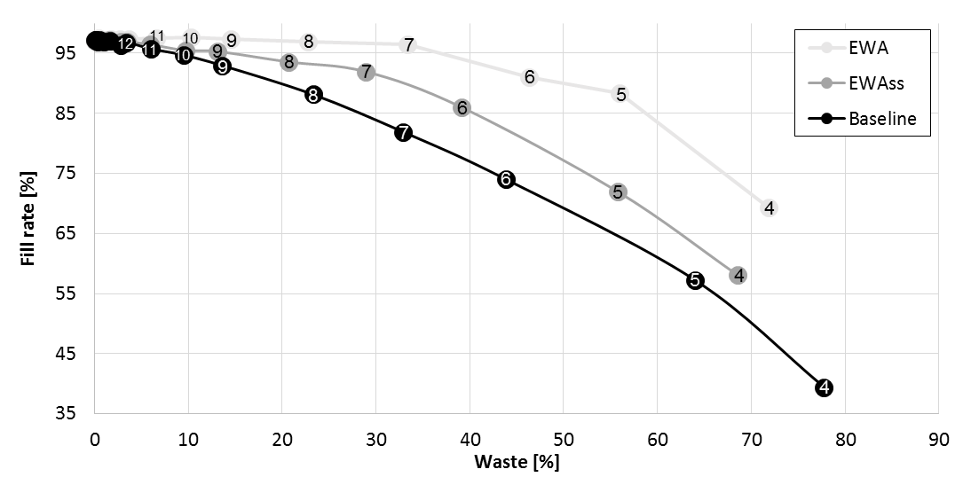
Figure 2: One year average waste across all stores and warehouse and fill rate across stores
From Figure 2 it can be observed that the EWA policy outperforms the two other policies with regards to fill rate when the shelf life is less than 11 days. This is expected as the total buffer size in the EWA policy is bigger than the EWA_{SS}. However, if the corresponding waste levels are considered it is observed that the EWA policy obtains the higher fill rate by wasting more products compared to the EWA_{SS} policy. Compared to the baseline scenario the EWA policy increases fill rate with 17.7% on average, and reduced waste with 3.4% for products with a shelf life between 4 and 11 days. In contrast, compared to the baseline scenario, the EWA_{SS} policy balances the increase in fill rate and decrease waste more evenly. Specifically, the fill rate increases on average with 10.3% and waste reduces with 10.7% for products with a shelf life between 4 and 11 days.

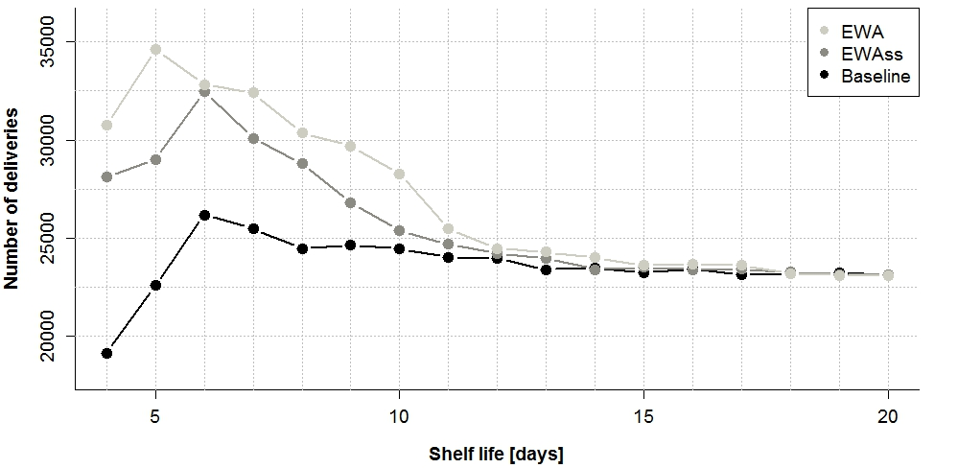

Figure 3: Total number of deliveries for one year for all stores and warehouse
Figure 3 depicts the number of deliveries to all 232 stores and the warehouse during the 1 year of simulation with the three different replenishment policies and with the products shelf life ranging from 4 to 20 days. The EWA_{SS} policy uses less deliveries than the EWA policy, and they both use more than the baseline scenario. This is coherent with the findings from Figure 2. If the fill rate has to improve the stores need to make use of more frequent deliveries, as they can not build inventory for e.g. a whole weeks sales as the will expire before the week is over. Thus, it is expected that the EWA and EWA_{SS} policy will have more deliveries than the baseline. On the other hand, the EWA_{SS} policy is able to align supply and demand more evenly than the EWA policy (higher fill rate and lower waste), which results in a lower number of deliveries. It could be argued that the EWA policy “oversupplies” the stores by constantly pushing new products out to the stores (due to the bigger buffer), which will require more deliveries and result in more waste compared to the EWA_{SS} policy.
For products with a shelf life between 4 and 11 days the EWA policies uses 28% more deliveries compared to the baseline scenario, whereas the EWA_{SS} policy uses 18% more deliveries. It should be noticed that in all scenarios the allowed number of ordering days follows the specifications from Table 1. Thus, the differences are there simply because the stores (i.e. the replenishment policy) did not make use of all allowed ordering days in the baseline scenario. Also, in a practical context the stores in e.g. subgroup a-x would place orders both Tuesday and Saturday for their entire product range, but not necessarily place an order for this particular product. Therefore, a high number of deliveries does not necessarily require more physical transportation, merely, an increased amount of activities at the warehouse for picking and packing products and the stores for restocking the shelves (Kotzab and Teller, 2005).
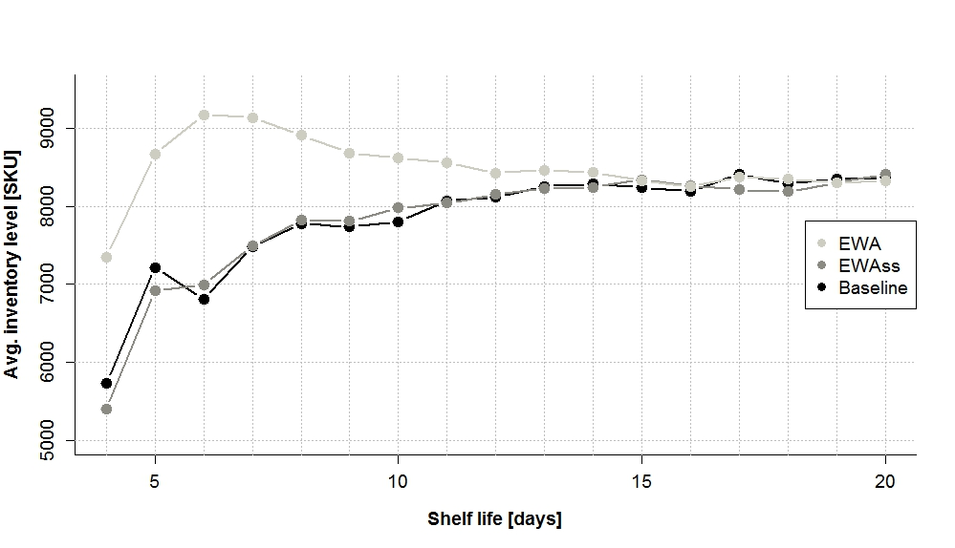
Figure 4: Average inventory level for one year across all stores and warehouse
Compared to the EWA policy, an improved alignment of supply and demand with the EWA_{SS} policy is also reflected by a lower average inventory level as shown in Figure 4. The EWA policy pushes more products to the stores and creates a higher inventory level compared to the EWA_{SS} policy and baseline scenario. For products with a shelf life between 4 to 11 days the average inventory level is 17.8% (1307 units) higher for the EWA policy compared to the baseline scenario. This obviously requires more capital to be tied up in inventory. For comparison, the EWA_{SS} policy has an average inventory level which is -0.3% lower than the baseline scenario.
To evaluate the robustness of the results two sensitivity analyses were made. First, all three scenarios were run with an 80% and 100% FIFO depletion in the stores. The results showed that all performance measures were similar, and only a 0.3% point reduction in waste was observed as the depletion decreased to 80%. In the second sensitivity analysis all three scenarios were run with a batch size of 6 and 12. Not surprisingly the results indicates that lower batch sizes results in lower inventory levels and increased deliveries. A smaller batch size also slightly reduces waste, with approximately 0.7% point for both the EWA_{SS} policy and 0.8% EWA policy, which is coherent with previous findings (Eriksson et al., 2014).

Discussion and conclusion
The purpose of this paper is to investigate the impact of utilizing remaining shelf life information from grocery retail stores for the replenishment of perishables. A discrete event simulation model has been developed involving one warehouse, one product, 232 stores, mixed FIFO and LIFO depletion, differentiated service levels, batch size constraints and ordering frequencies. Two age-based replenishment policies were evaluated based on one year POS-data from one of Norway’s largest grocery retailers.
The findings indicate a potential improvement in availability and waste for products with a shelf of 11 days or below if remaining shelf life information is utilized in the replenishment decision. Both the EWA and EWAss policy pushes more products to the stores compared to the basic RsnQ logic as it tries to add ”the number of products outdating” to the order. However, it could be argued that the RsnQ logic pushes too few products and the EWA model pushes too many (because of the total buffer size), while the EWAss model represents a balance between those two. The remaining discussion and conclusion is centered around three subsections: theoretical contributions, practical implications, and limitation and future research.

6.1. Contributions to theory
This study makes two primary contributions to theory. Firstly, the EWA policy by Broekmeulen and van Donselaar (2009) has been evaluated in a divergent supply chain. The results indicate an average increase of 17.7% in fill rate, for products with a shelf life between 4 to 11 days across all 232 stores. Even though the fill rate is not reported separately this increase is similar to the cost improvement reported by Broekmeulen and van Donselaar (2009). However, the findings indicate that the EWA policy only reduces waste levels slightly but leads to higher inventory levels , which could be explained by high buffers for demand uncertainty and the risk of expiration (Van Donselaar and Broekmeulen, 2012). To reduce the waste and inventory levels a modification to the EWA policy, EWA_{SS}, is proposed and evaluated. The EWA_{SS} policy demonstrates a more balanced performance of fill rate (+10.3%) and waste level (-10.7%) by improving both parameters without increasing the average inventory level.

6.2. Implications for practitioners
The findings clearly demonstrates that the value of sharing and utilizing information is dependent of the shelf life of the product as illustrated in Figure 2 to Figure 4. Thus, for practitioners the findings indicate that differentiated information sharing and replenishment policies are useful for managing a broad range of products. The shelf life is an important characteristic for establishing this differentiation, and for perishables the remaining shelf life information from the store can be beneficial to utilize – especially for products with a shelf life around 6 to 11 days based on Figure 2. On the other hand, as the shelf life increases, using only POS and waste data (how many products that are wasted each day) provide a satisfactory performance.
Even though the findings show an improvement in performance the grocery retailers need to evaluate if they can accept the (still high) waste levels. If so, the findings indicate that it will be possible to automate the replenishment process for perishable products by utilizing remaining shelf life information. Additional initiatives could also be combined with sophisticated replenishment policies and information sharing such as using cross-docking to reduce the time spent in the warehouse and reducing the batch size to reduce waste stores with a low turnover.
The fact that some stores (group B) on average might only sell up 36 units a week indicates that e.g. 1% lower waste would bring a more savings than 1% increased sales brings in profit. In this consideration it would also be necessary to consider the chance of selling a substitute product as discussed in the coming section.

6.3. Limitations and future research
The study is based on actual POS data from one product. By studying a whole product group the effects of product substitution could be included and incorporated into the replenishment decision as well (Van Donselaar et al., 2006). To evaluate age-based replenishment polices with substitution. Access to real performance data is encouraged to account for the various uncertainties and particularities that are not included in a simulation model. The performance of the EWAss policy may be even further improved if a Qmin is introduced. Estimating the actual value of Qmin is therefore highly relevant for future research.
Both the EWA and the EWA_{SS} policy assumes that remaining shelf life information is collected and shared from the grocery stores. Future research could investigate if it would be possible to estimate this type of information based on (1) the remaining shelf life when the products leave the warehouse, (2) the amount of products wasted and sold each day in the stores, and (3) estimates of the FIFO depletion rate in the stores. If reasonable estimates are possible the EWA and EWA_{SS} policy could be implemented without the relatively high investments needed in the supply chain to trace remaining shelf life of products.

References
Aastrup, J., & Kotzab, H. (2010). Forty years of out-of-stock research–and shelves are still empty. The International Review of Retail, Distribution and Consumer Research, 20(1), 147-164.
Broekmeulen, R. A., & van Donselaar, K. H. (2009). A heuristic to manage perishable inventory with batch ordering, positive lead-times, and time-varying demand. Computers & Operations Research, 36(11), 3013-3018.
Chiu, H. N. (1995). A heuristic (R, T) periodic review perishable inventory model with lead times. International Journal of Production Economics, 42(1), 1-15.
Croom, S. (2009). Introduction to research methodology in operations management. In C. Karlsson (Ed.), Researching operations management (pp. 43-83): Routledge.
Duan, Q., & Liao, T. W. (2013). A new age-based replenishment policy for supply chain inventory optimization of highly perishable products. International Journal of Production Economics, 145(2), 658-671.
Eriksson, M., Strid, I., & Hansson, P.-A. (2014). Waste of organic and conventional meat and dairy products—A case study from Swedish retail. Resources, Conservation and Recycling, 83, 44-52.
Huang, G. Q., Lau, J. S., & Mak, K. (2003). The impacts of sharing production information on supply chain dynamics: a review of the literature. International Journal of Production Research, 41(7), 1483-1517.
Hübner, A. H., Kuhn, H., & Sternbeck, M. G. (2013). Demand and supply chain planning in grocery retail: an operations planning framework. International Journal of Retail & Distribution Management, 41(7), 512-530.
Janssen, L., Claus, T., & Sauer, J. (2016). Literature review of deteriorating inventory models by key topics from 2012 to 2015. International Journal of Production Economics, 182, 86-112.
Kaipia, R., Dukovska-Popovska, I., & Loikkanen, L. (2013). Creating sustainable fresh food supply chains through waste reduction. International Journal of Physical Distribution & Logistics Management, 43(3), 262-276.
Karaesmen, I. Z., Scheller–Wolf, A., & Deniz, B. (2011). Managing perishable and aging inventories: review and future research directions Planning production and inventories in the extended enterprise (pp. 393-436): Springer.
Kleijnen, J. P. (1995). Verification and validation of simulation models. European Journal of Operational Research, 82(1), 145-162.
Kotzab, H., & Teller, C. (2005). Development and empirical test of a grocery retail instore logistics model. British Food Journal, 107(8), 594-605.
Kouki, C., Babai, M. Z., Jemai, Z., & Minner, S. (2016). A coordinated multi-item inventory system for perishables with random lifetime. International Journal of Production Economics, 181(A), 226-237.
Kouki, C., Jemaï, Z., & Minner, S. (2015). A lost sales (r, Q) inventory control model for perishables with fixed lifetime and lead time. International Journal of Production Economics, 168, 143-157.
Kuhn, H., & Sternbeck, M. G. (2013). Integrative retail logistics: an exploratory study. Operations Management Research, 6(1-2), 2-18.
Lowalekar, H., & Ravichandran, N. (2015). A combined age‐and‐stock‐based policy for ordering blood units in hospital blood banks. International Transactions in Operational Research.
Manikas, I., & Terry, L. A. (2009). A case study assessment of the operational performance of a multiple fresh produce distribution centre in the UK. British Food Journal, 111(5), 421-435.
Mena, C., Terry, L. A., Williams, A., & Ellram, L. (2014). Causes of waste across multi-tier supply networks: Cases in the UK food sector. International Journal of Production Economics, 152, 144-158.
Minner, S., & Transchel, S. (2010). Periodic review inventory-control for perishable products under service-level constraints. Or Spectrum, 32(4), 979-996.
Nahmias, S., & Pierskalla, W. P. (1973). Optimal ordering policies for a product that perishes in two periods subject to stochastic demand. Naval Research Logistics (NRL), 20(2), 207-229.
Nielsen, A. C. (2016). Western Eurpean FMCG Report Q4 2016. Retrieved from http://www.nielsen.com/content/dam/nielsenglobal/eu/docs/reports/nielsen-european-trends-report-Q4-2016.pdf
Patton, M. Q. (2002). Qualitative Research & Evaluation Methods (Vol. 3rd Edition): SAGE Publications, Inc.
Potter, A., & Disney, S. M. (2010). Removing bullwhip from the Tesco supply chain. Paper presented at the Production and Operations Management Society Annual Conference.
Silver, E. A., Pyke, D. F., & Peterson, R. (1998). Inventory management and production planning and scheduling (Vol. 3): Wiley New York.
Van Der Vorst, J. G. (2006). Performance measurement in agri-food supply-chain networks. In C. J. Ondersteijn, J. H. Wijnands, R. B. Huirne, & O. van Kooten (Eds.), Quantifying the agri-food supply chain (pp. 15-26): Springer.
van Donk, D. P., Akkerman, R., & Van der Vaart, T. (2008). Opportunities and realities of supply chain integration: the case of food manufacturers. British Food Journal, 110(2), 218-235.
Van Donselaar, K., van Woensel, T., Broekmeulen, R., & Fransoo, J. (2006). Inventory control of perishables in supermarkets. International Journal of Production Economics, 104(2), 462-472.
Van Donselaar, K. H., & Broekmeulen, R. A. (2012). Approximations for the relative outdating of perishable products by combining stochastic modeling, simulation and regression modeling. International Journal of Production Economics, 140(2), 660-669.

If the current inventory level is very high compared to the amount needed, Eq. 2a and 2b can produce a negative order quantity. In that case it should be raised to 0 to avoid transshipment, which is why the max() function is used.

