Critical assessment of non-linear hydrodynamic load models for a fully flexible monopile offshore wind turbine

|  |  |  |
| --- | --- | --- |
| Loup Suja-Thauvin  NTNU, Department of Marine Technology  Trondheim, Norway  *loups@stud.ntnu.no* | Jørgen R. Krokstad  NTNU, Department of Marine Technology  Trondheim, Norway | Erin E. Bachynski  NTNU, Department of Marine Technology  Trondheim, Norway |

**Abstract:**

**This paper presents a comparison between experimental data of a model-scale 4 MW monopile offshore wind turbine subjected to extreme irregular sea states in finite water and the numerical models suggested in offshore wind energy standards to assess ULS conditions. The model is fully flexible with its 1st and 2nd eigenfrequencies and 1st mode shape tuned to fit those of the full-scale turbine. The measured and simulated bending moments at the sea bottom are decomposed around the eigenfrequencies of the structure, and the Morison equation with stream function wave kinematics is found to trigger transient 1st mode response (so-called ringing response). The amplitude of the simulated 1st mode response is proportional to the incoming wave steepness; such a relationship is not observed experimentally. Similarly, 2nd mode response is triggered by Wienke’s slamming model, but generally does not match the experimental data. Although the numerical models from the design standards (Morison’s equation with stream function kinematics, plus a slamming model) can give conservative estimates of the extreme responses, the models miss the balance between 1st and 2nd mode responses. The simplification of the physics in the numerical models can thus lead to inaccuracies in response prediction, such as the stress distribution along the monopile.**

1. Introduction

Offshore wind turbines mounted on monopiles are currently being built or planned in the North Sea in water depths between 20 and 50m (Ho et al., 2016). In order to safely design the monopiles, the maximum load effect that the structure will experience over its lifetime has to be assessed (so-called Ultimate Limit State (ULS) analysis). A number of standards suggest hydrodynamic load models for such a study for different situations (for example DNV-OS-J101, 2014b; DNV-RP-C205, 2014a; IEC 61400-3, 2009). These standards are mostly adapted from experience from the oil and gas industry, whose structures differ from offshore wind turbines in two important aspects:

* The depths considered for oil and gas platforms are much larger than those of offshore wind turbines, enabling the simplification of ‘infinite water depth’.
* For offshore wind turbines, the displacement of the 2nd mode shape near the mean sea level is large compared to oil and gas platforms. This means that the 2nd mode of the structure will be excited by breaking wave events (which induce loads around the mean sea level), as shown for instance by Peeringa and Hermans (2017). For bottom-fixed oil and gas platforms, breaking wave loads act close to the maximum of the 1st mode shape, but are unlikely to excite global 1st mode response due to the short load duration.

Figure 1 illustrates the concepts explained above. The largest contribution from hydrodynamic loads is around the mean sea level, which means that for a wind turbine it will be low (in relative heights) compared to an offshore oil and gas platform.

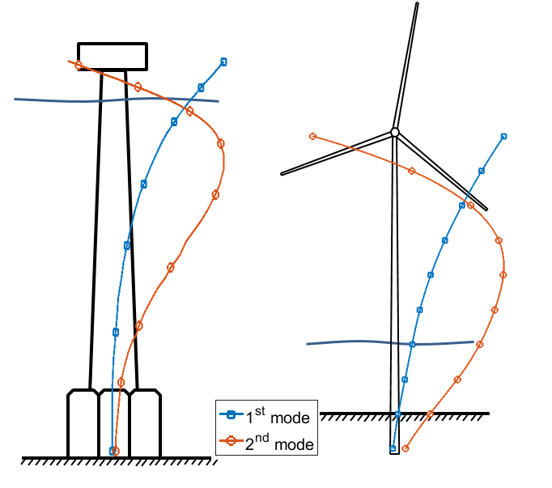

Figure . Schematic representation of the Draugen platform (Natvig and Teigen, 1993) and the offshore wind turbine used in the present paper (not to scale). The lines represent the 1st and 2nd mode shapes normalized against their maximum value (the mode shapes of the Draugen platform are taken from Faltinsen and Timokha, 2016)

The main aim of this paper is to assess how well the standards used by the offshore wind industry predict the response of the support structure in ULS conditions. Experimental data produced by the Maritime Research Institute Netherlands (MARIN) is compared to the numerical models proposed in the standards. In these experiments, a fully flexible model of an idling 4 MW bottom-fixed offshore wind turbine mounted on a monopile was subjected to extreme weather conditions. Suja-Thauvin et al. (2017) analysed these experiments and showed that the largest responses for an offshore wind turbine in the above-mentioned conditions were provoked by steep and breaking waves. 2nd and 3rd order hydrodynamic loads from the wave trigger the 1st mode of the structure and produce the response phenomenon known as ‘ringing’, characterized by a build-up of the resonant vibration over about one wave period which then slowly decays (Natvig, 1994) and illustrated in Figure 2. The bending moment in Figure 2 has been filtered to show only the response of the 1st mode of the structure, this procedure is explained in section 5.2. The loads due to the impact of the breaking wave on the structure (so-called slamming loads) excite the 2nd mode of the structure, which can account for up to 20% of the maximum response (Suja-Thauvin et al., 2017). Slamming loads excite all modes of the structure, but only higher modes will significantly be excited due to (i) the fact that the slam duration is very short compared to the 1st eigenperiod and (ii) the shape of the 2nd mode compared to the 1st mode. A conclusion of Suja-Thauvin et al. (2017) is thus that in order to correctly depict the maximum responses experienced by the support structure of offshore wind turbines, one has to account for both ringing responses and responses to breaking waves.

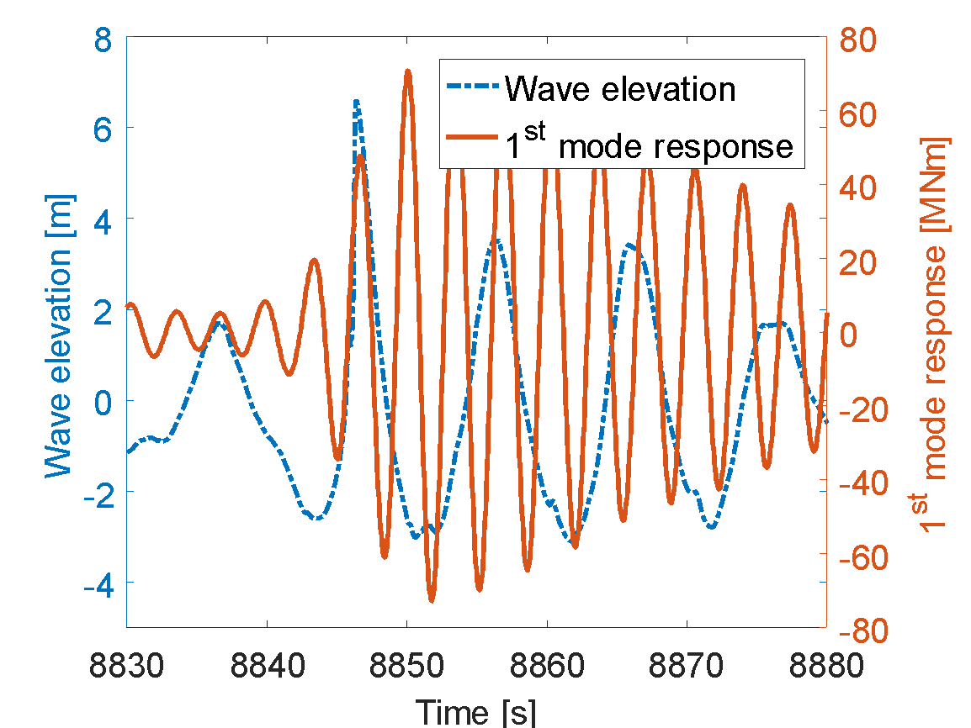

Figure . Illustration of a ringing event. A surface-piercing vertical cylinder is exposed to a steep wave, and the bending moment is measured at the sea bottom.

Numerical models for predicting ringing gained attention in the 1990s, when ringing was first observed during model tests of the Hutton and Heidrun TLP offshore oil and gas platforms and of the deep water concrete towers of the Draugen and Troll A platforms (Natvig and Teigen, 1993). For offshore wind turbines, the necessity of using non-linear wave kinematics when calculating hydrodynamic loads for capturing this phenomenon was shown for example by (Marino et al., 2013a). This agrees well with Paulsen et al. (2013), who showed by using a CFD solver that the excitation force based on linear wave kinematics does not have the frequency content necessary to excite the 1st mode of the structure. Bredmose et al. (2012) used a simple cantilever beam numerical model to assess the importance of wave height and water depth with respect to ringing responses and to show how this phenomenon can dominate the total response due to dynamic amplification.

In addition to ringing responses, breaking wave events have also been studied for offshore wind turbines. Both de Ridder et al. (2011) and Bredmose et al. (2013) carried out experiments on a bottom-fixed responding structure whose characteristics were similar to those of an idling extra-large wind turbine and found out that breaking waves could lead to extreme accelerations of the nacelle. Bredmose and Jacobsen (2010) carried out a CFD analysis where focused waves were forced to break at different locations in the vicinity of the turbine in order to assess the hydrodynamic loads at different stages of the breaking process. (Marino et al., 2013a) applied a fully nonlinear high-order boundary-element solver to a series of realistic sea states and showed that the bending moment at the tower base could be six times larger compared to a linear model.

The numerical models presented in the aforementioned works provide accurate predictions of the response of a bottom-fixed offshore wind turbine to steep breaking waves but are too computationally expensive to be used by the industry for design, where typically thousands of load cases need to be assessed. The standards commonly used by the industry to calculate hydrodynamic loading under steep breaking waves (DNV-OS-J101, 2014b; DNV-RP-C205, 2014a; IEC 61400-3, 2009) suggest simpler models, such as the stream function theory (Rienecker and Fenton, 1981) and Wienke’s slamming model (Wienke and Oumeraci, 2005). To assess the validity of these models for calculating the turbine’s response under steep/breaking wave loads, the above-mentioned models have been implemented in Matlab® and used to try to match the experiments carried out by MARIN.

Other theories that attempt to reproduce ringing responses have been developed by Faltinsen et al. (1995, so-called FNV model) and Malenica and Molin (1995, so-called MM). Both these theories were developed based on a perturbation approach and estimate the excitation load up to third order in terms of wave steepness. Krokstad et al. (1998) presented a validation of the response predicted by the FNV model in deep water, and Kristiansen and Faltinsen (2017) further developed the model for finite water. Paulsen et al. (2014) showed that the excitation loads from both the FNV and the MM models, within their range of validity, match those predicted by CFD. Both models account for hydrodynamic-structural interaction by considering the diffracted wave from the cylinder. On the contrary, the models presented in this paper – and commonly used in design – do not account for the presence of the structure, and only estimate the kinematics of the undisturbed wave.

The paper is organized as follows: section 2 briefly presents the experiments carried out by MARIN, and in section 3 we introduce the structural model used in the paper. In section 4 we use the models proposed by the standards to carry out the ULS analysis under the environmental conditions of the MARIN experiments, and section 5 compares the same models on a single event basis to assess how the models perform. Conclusions are drawn in section 6.

1. Presentation of the model test

A more detailed description of the experiments is given by Suja-Thauvin et al. (2017); only the most relevant points are given here. The dimensions of the experimental set-up and the flexible model are given in Figure 3 and Figure 4. The values given in the paper are full-scale, unless specified otherwise. The fully flexible model was held by a 6-component force frame and placed in a pit dug into the shallow water basin of MARIN, a rigid model was also constructed and placed in the basin but is not analysed in this study. The force frame was calibrated by pulling on it with known weights which showed an accuracy in measured moments of 2-3%. The fore-aft bending moment was measured at the sea bed and is simply referred to as ‘response’ in the rest of the paper.

4 wave gauges were placed in the basin. The accuracy of the wave gauges was not reported, but a typical value is approximately 1 mm in model scale (Steen, 2014), or 5 cm in full scale. Only one wave gauge (marked in Figure 3) was used in this study. This wave gauge was placed about 13 diameters from both models, so it is expected that the diffracted and reflected waves can be neglected. The elevation measured by this wave gauge is used as an input for the numerical models after linearization (see appendix A). The waves were generated by a piston-type wave-maker, consisting of a flat plate forced into horizontal motion by an electrical actuator.

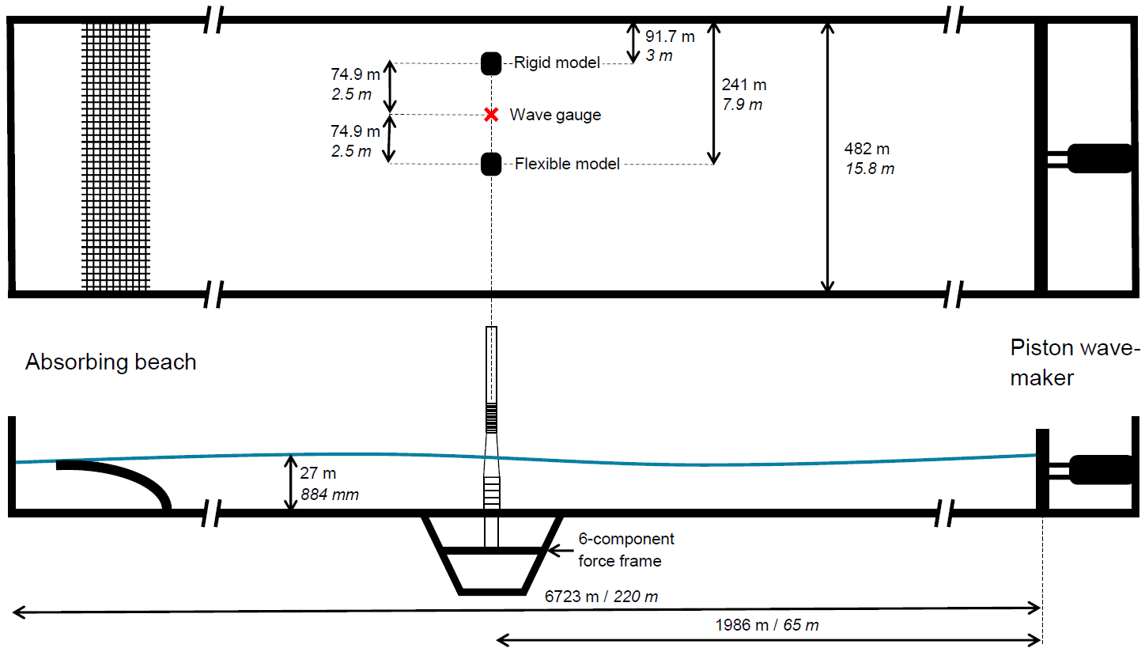

Figure . Top and side view of the experimental set-up (values are given both in full and model scale)

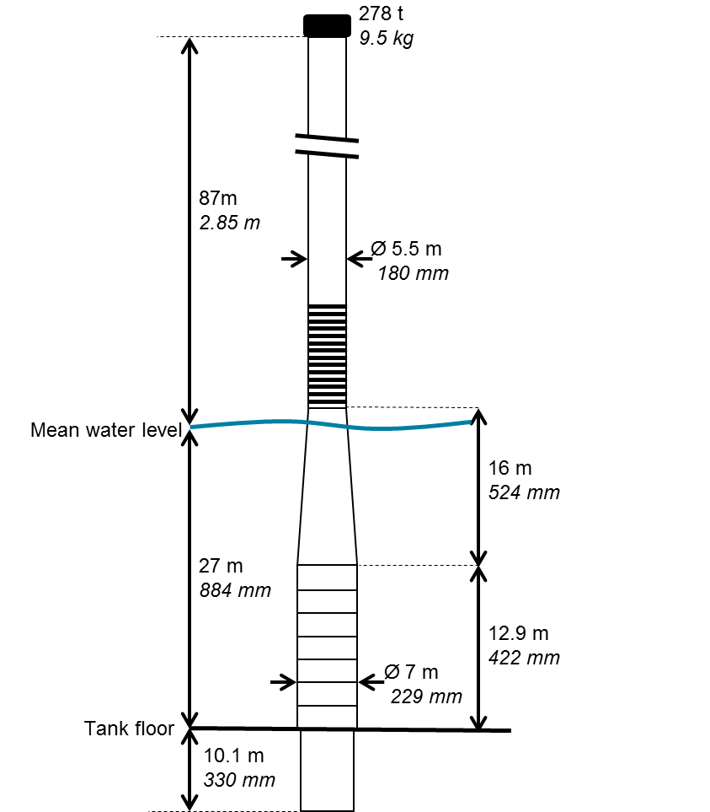

Figure . Flexible model (values are given both in full and model scale)

The prototype is a 1:30.6 Froude scaled model of a 4 MW wind turbine. The diameter at the mean sea level is 5.78 m and the water depth is 27 m. Special effort was put into achieving the correct 1st and 2nd eigenfrequencies and correct 1st mode shape. Table 1 shows the eigenfrequencies and damping ratios of the model (derived from hammer tests in water, see Bunnik et al., 2015), and Figure 5 shows the mode shapes of the 1st and 2nd mode.

Table . Frequencies and damping ratios of the model (full-scale values).

|  |  |  |  |  |
| --- | --- | --- | --- | --- |
|  | 1st mode | 2nd mode | 3rd mode | 4th mode |
| Eigenfrequency [Hz] | 0.29 | 1.21 | 3.11 | 7.24 |
| Damping (% of critical) | 1.1 | 1.1 | 2 | 2 |

It should be noted that the damping values are low compared to idling full-scale wind turbine (Damgaard et al., 2013; Damgaard and Andersen, 2012; Shirzadeh et al., 2015 report 1.7-2.8% of critical damping for the first mode, depending on the wind speed). Considerations regarding very lightly damped systems are briefly discussed in section 5.4.

The 3rd and 4th modes measured on the experimental model have not been tuned to fit those of the full-scale model, which implies that conclusions based on the analysis of these two modes (and even higher) could not be applied to a full-scale wind turbine. Therefore these higher modes have been left out of the study. All the measured data presented in this work has been low-pass filtered to remove the response of the structure at these higher modes. More details are given in Suja-Thauvin et al. (2017).

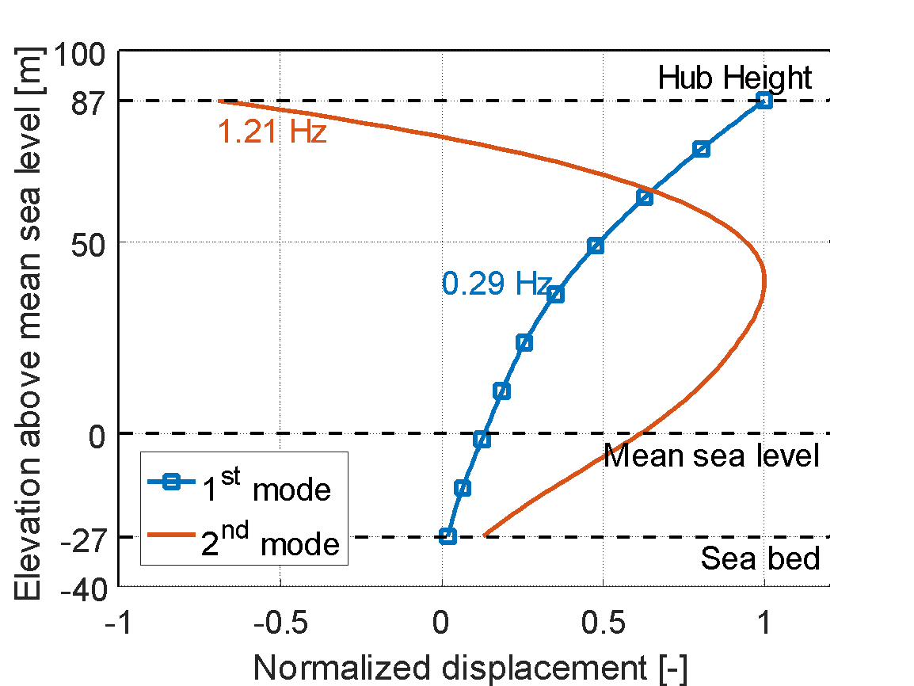

Figure . Normalized mode shapes of the model. These mode shapes are also used in the structural model (see section 3).

In this paper, we analyse selected sea states from the experiments, summarized in Table 2 and plotted in Figure 6. The experimental campaign was divided into Part A and Part B as they were different stages of the same project, but the experimental set-up remained unchanged between these two parts. Figure 6 shows the graph of the Dogger-Bank Creyke Beck B site (see Frimann-Dahl, 2015) and gives an indication of the return periods of the analysed sea states. It should be noted that the wind conditions for the selected sea states have not been determined. Under all sea states analysed in the paper, the turbine is assumed idling and no aerodynamics are modelled (except estimated damping from an idling turbine). In reality, the mildest sea states are probably associated with an operational turbine.

Table . Selected sea states

|  |  |  |  |
| --- | --- | --- | --- |
|  |  |  | Number of realizations |
| Part A | | | |
| 3.5 | 8.5 | 3.3 | 1 |
| 5.81 | 10.93 | 3.3 | 1 |
| 5.89 | 10 | 3.3 | 1 |
| 6.18 | 10 | 3.3 | 1 |
| Part B | | | |
| 5 | 8.5 | 3.3 | 1 |
| 6.5 | 10 | 3.3 | 1 |
| 9 | 13 | 3.3 | 3 |
| 9 | 11 | 3.3 | 3 |



Figure . Hs-Tp plot for the DoggerBank Creyke Beck B location. Contour lines for 1, 10 and 50-year return period.

1. Structural model

The numerical tool developed for modelling the response of the structure is a simple mode shape solver (see for example Gans, 2015). The mode shapes and damping levels were provided by Bunnik et al. (2015). The response bending moment of the structure is calculated with the Euler-Bernoulli beam equation assuming a slender structure in the vertical direction :

(1)

where is the response bending moment, is the Young’s modulus, is the area moment of inertia of the cross-section and is the deflection of the system. The deflection is assumed to be the sum of the deflections of each individual mode:

(2)

where is the mode shape of the mode and is the modal displacement of the mode. The modal displacement for each mode is determined solving the simple one degree of freedom equation with Matlab®:

(3)

where is the modal excitation for the mode and , and are respectively the modal mass (including added mass), the modal damping and the modal stiffness of mode . The modal excitation for each mode is obtained by integrating the product of the excitation force times the mode shape over the instantaneous wetted surface.

(4)

where is the hydrodynamic load, calculated with one of the models described in section 4.1.4, is the instantaneous wave elevation and is the water depth.

1. Standards – statistical analysis
   1. Procedure to estimate ULS response

In this section we evaluate the characteristic response for ULS design (shortened to “ULS response”) of the structure using three standards commonly used in the offshore wind industry, namely DNV-OS-J101 (2014b); DNV-RP-C205 (2014a); IEC 61400-3 (2009). We investigate load case 6.1 from these standards, which was established by de Ridder et al. (2017) as the design driver for the present experimental campaign. The standards prescribe 20 realizations of the 50-year return sea state corresponding to the desired location, each including a wave with the characteristics of a 50-year return wave embedded at a random time. If the wave is breaking at the structure, a slamming load model has to be added to account for the impact-like load on the structure (more details are given in section 4.1.4).

Each realization has a 10-minute duration and corresponds to a linear superposition of regular wave components according to a JONSWAP spectrum (see Hasselmann et al., 1973) as suggested in all three standards. The average of the 20 maxima obtained from the simulated response time-series is interpreted as the ULS response. This response is commonly referred to as the ‘50-year response’ even though it is rather the response to 50-year return environmental conditions. In this paper, in order to align with the common terminology, we denote the response estimated following the aforementioned procedure the ‘50-year response’. Figure 7 illustrates this procedure.

In this paper, we assume that each of the analysed sea states (given in Table 2) corresponds to a 50-year return sea state at a fictitious location. Once the 50-year return sea state has been determined, one must define the characteristics of the 50-year return wave and the wave kinematics used to model this wave. The next four subsections deal respectively with

Figure . Procedure for estimating the 50-year response

Selection of 50-year sea state and 50-year wave characteristics (wave height and wave period)

Realization of a random 10-min linear irregular wave elevation of the 50-year sea state

Embedding of the 50-year wave at a random time with appropriate wave kinematics + slamming model

Simulation of the response of the structure, estimation of the maximum response

Average of the 20 maximum simulated responses

20 x

* determining the characteristics of the 50-year wave
* choosing the kinematics model used to simulate the 50-year wave
* the embedding procedure
* the hydrodynamic load models
  + 1. 50-year return wave characteristics

To define the height of the 50-year return wave based on the 50-year return sea state, IEC 61400-3 (2009) assumes that the sea state has a 3-hour stationarity during which the wave elevation follows a Gaussian distribution and the wave heights follow a given distribution (in this paper either a Rayleigh or a Battjes and Groenendijk distribution, see Battjes and Groenendijk, 2000). We denote hereafter the height of the 50-year return wave and the significant wave height of the 50-year return sea state. IEC 61400-3 (2009) shows in detail how to estimate assuming a Rayleigh distribution of the wave elevation. This assumption yields the classical result . The same derivation can be carried out assuming a Battjes and Groenendijk distribution (hereafter noted BG). The details of the derivation can be found in Battjes and Groenendijk (2000).

Figure 8 shows the calculated assuming the two different wave height distributions for each sea state. In addition, we show the significant wave height for each sea state and the maximum measured wave height. In order to find the maximum wave height, two maxima are measured per sea state, corresponding to trough-to-crest and crest-to-trough wave heights, and then the maximum of the two is taken. The error bars for the measured values correspond to two standard deviations of the 3-hour maximum, as estimated for a Rayleigh distribution of the peaks, above and below the measured value (see for example Naess and Moan, 2012). The measured maximum wave height is only given as an indication, since the maximum wave of a 3-hour realization of the 50-year return sea state is in general not the same as the 50-year return wave.



Figure . Estimated 50-year wave heights (open symbols) and measured 3-hour maximum wave height (red circle)

The Rayleigh distribution is known to be a good approximation for wave height distribution in deep water. The BG distribution takes depth into consideration and converges towards the Rayleigh distribution in deep waters. This is confirmed by Figure 8, where for lower sea states both models give similar results. The method presented by Battjes and Groenendijk (2000) uses a look-up table and does not provide an estimate for the lowest sea state (HS = 3.5 m, TP = 8.5 m). For such conditions, it is reasonable to assume that the wave height distribution is well represented by a Rayleigh distribution.

In addition to determining the , it is necessary to determine the period of the 50-year return wave, hereafter noted . can be taken within the range given by the following formula, according to IEC 61400-3 (2009)

(5)

For each sea state, different values of varying within the range given by equation (5) were tested and the most conservative results were always obtained with the shortest (corresponding to the steepest 50-year return wave). Only results for the steepest 50-year return wave are shown in this paper. It should be noted that this equation provides depending only on . In this paper, the 2 highest sea states have the same and will therefore have the same .

* + 1. Determination of the wave kinematics

In order to accurately model the kinematics of a single wave, different theories suggest different approaches. Figure 9 is common to all three standards and suggests which theory can be used to describe a given regular wave depending on the wave height, wave period, and water depth. All these theories provide a solution for the Laplace equation and boundary conditions that can be found in most text books (e.g. Faltinsen, 1990). The main difference between these theories is the order to which they satisfy the dynamic and kinematic boundary condition at the free surface, higher order meaning more accuracy but also higher computational time.

In Figure 9, the ‘x’ and the ‘+’ represent the 50-year return waves shown in Figure 8. It can be seen in Figure 9 that a stream function of order between 3 and 9 is required to accurately model the 50-year return waves analysed in this study. For the following simulations, a 9th order stream function was used to model the 50-year return waves. The kinematics of the stream function waves were computed following Rienecker and Fenton (1981).

Figure 9 also shows dots which correspond to the individual events studied in section 5.

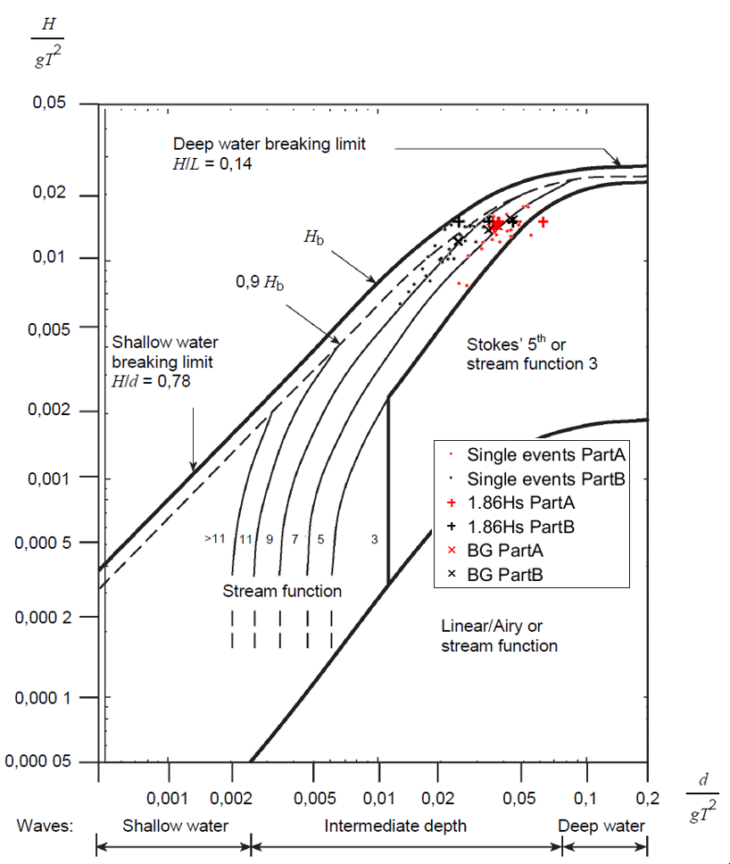

Figure . Wave kinematic models depending on wave characteristics (taken from IEC 61400-3, 2009)

* + 1. Embedding procedure

For the present paper, the embedding of the stream function is done following Rainey and Camp (2007), as shown in Figure 10. This figure shows how the stream function wave is smoothly embedded into the linear irregular sea by defining two blending areas (marked in grey) where the linear and the stream function wave are multiplied by weighting functions. These weighting functions ensure a transition without discontinuities between the stream function and the linear kinematics. The weighting functions are applied to the wave elevation, the particle velocity and the particle acceleration.

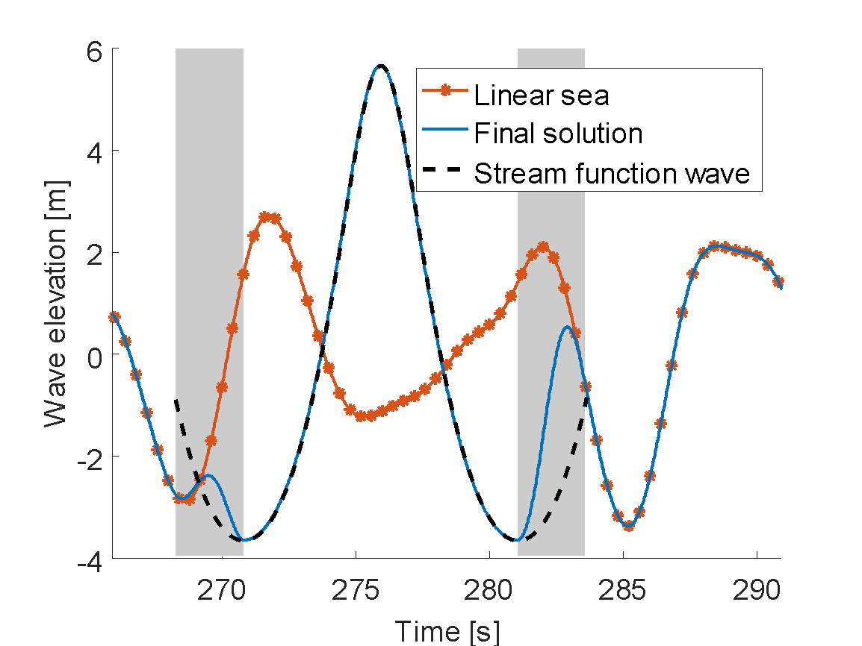

Figure . Embedding process (following the description in Rainey and Camp, 2007).

According to IEC 61400-3 (2009), the instant when the 50-year wave is embedded into the linear irregular sea is randomly selected for each realization of the 50-year sea state. The effect of the time of embedding on the estimation of the ULS load can be seen by comparing the responses of the structure to the same realization of a 10-minute sea state with a stream function randomly embedded with 2 seconds of difference (no slamming model is applied in this simulation). Figure 11.a shows the wave elevation of the linear realization and with the two different embeddings, while Figure 11.b shows the response of the structure.

|  |  |
| --- | --- |
| a) Embedded wave | b) Response to the different embeddings |

Figure . Illustration of the embedding procedure at two slightly different instants.

As shown in Figure 11.b the difference of maximum bending moments between the two embeddings is about 13%. 10 realizations of 2 time series with 2-second separated embedding have been carried out, and the average difference between the 2 embeddings was about 9%. This is caused by the response history of the structure, i.e. its position, velocity and acceleration when the wave passes through it, as well as the wave kinematics induced by sewing together the time histories. Since the time of embedding is random, the kinematics of the structure at the time of embedding vary from one realization to the next. Furthermore, the process of embedding introduces different wave kinematics in the overlap region. By averaging the maxima over 20 realizations, the result accounts for some of these uncertainties.

* + 1. Hydrodynamic load models

The considered 50-year return waves all have a wavelength longer than 10 times the radius of the cylinder, which implies that near-field first-order diffraction effects from the structure can be neglected (Faltinsen, 1990). Therefore, as suggested by all three standards, the numerical model of the structure was vertically divided into strips of length and the well-known Morison equation (Morison et al., 1950) was used to calculate the hydrodynamic loads on each strip:

(6)

with the water density, the cylinder radius, and the particle acceleration and velocity in the horizontal direction respectively, and and the inertia and drag coefficients. The particle acceleration and velocity are obtained from the kinematic model as explained above. The inertia and drag coefficients are determined empirically. For the Reynolds and Keulegan-Carpenter numbers relevant to this study, Sarpkaya (2010) recommends and .

A slamming load is added to the Morison equation to account for the impact of the breaking wave on the structure. This load is calculated according to “Wienke’s model” developed in Wienke and Oumeraci (2005) and given by the following equation:

(7)

with the slamming coefficient, the wave celerity, the curling factor and the maximum wave elevation for the given slamming event. The slamming coefficient is time dependent and is given by (assuming corresponds to the time of impact)

for

and

for and (8)

with the angle between the water surface and the axis of the cylinder

In the present paper, the slamming load is applied when the slope of the wave elevation is maximum (as this was found to fit the experimental data by comparing the excitation loads measured on some of the small sea states to the numerical models) and at the free surface elevation. Both the duration and the amplitude of the slamming load are dependent on the celerity of the wave, which the present study is calculated with the stream function theory. In another study using the same experimental data as this paper, Burmester et al. (2017) report a curling factor of 0.28. This value is used in the present study.

* 1. Analysis of the statistical results

In the data provided by MARIN, we interpret each wave elevation time series as a 3-hour realization of a 50-year sea state and look at the maximum response over this realization. We then compare this maximum to the estimation of the 50-year response obtained following the procedure explained above and summarized in Figure 7. This comparison is plotted in Figure 12. The calculated 50-year responses correspond to estimations of considering the two mentioned wave height distributions (Rayleigh and BG). As in Figure 8, the error bars for the measured values correspond to two standard deviations of the 3-hour maximum, as estimated for a Rayleigh distribution of the peaks, above and below the measured value.

For the sea states with a large significant wave height, the models suggested by the standards overpredict the responses compared to the experimental measurements. The overprediction is reduced by using the BG distribution since this distribution leads to lower estimates of (as seen in Figure 8). For lower sea states, the predicted response is closer to the measurements. The overprediction is mainly related to the 2nd mode response, which depends strongly on the celerity of the stream function wave. In order to understand the difference of prediction between low and high sea states, individual events where a large response of the structure was measured are analysed in section 5.

It should be noted that the maximum response of the structure during a 50-year sea state does not generally correspond to the response of the structure to a 50-year return wave: it is therefore not strictly correct to compare the measurements and the estimations. However, such a comparison provides an indication of whether the numerical simulations are conservative.



Figure . 50-year responses obtained for the different wave height distributions (open symbols) and 3-hour maximum measured response (red circles).

1. Single event simulation

In this section, we analyse how the models suggested by the industry perform when assessing extreme responses by considering individual events. We focus on the events that produced the largest measured responses of part A and part B. For Part A, that event occurred during sea state and for Part B, it occurred during sea state . These events are named events A1 and B1 respectively, and are simulated using the following three models:

* **M_Lin**: Morison with linear kinematics. The wave kinematics are obtained from a linearization of the wave elevation measured during the experiments (see appendix A). Wheeler stretching (Wheeler, 1969), non-linear wave models and slamming models are not applied.
* **M_SF**: Morison with stream function wave kinematics. The wave immediately preceding the measured large response is replaced with a 9th order stream function wave. The wave height and wave period of the embedded stream function wave are taken as the measured wave height and trough-to-trough period, as shown in Figure 13.
* **M_SF_W**: Morison with stream function wave kinematics and Wienke’s slamming model. As in M_SF, with the addition of Wienke’s slamming model at the instant where the slope of the wave elevation is maximum. For the slamming model, the wave celerity is obtained from the stream function theory.

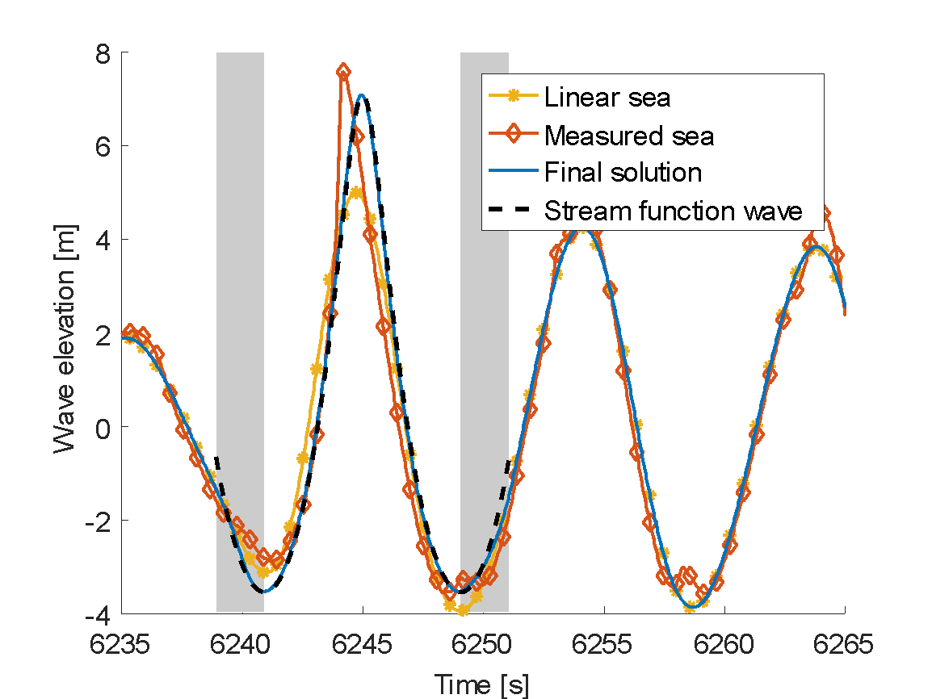

Figure . Embedding of a stream function wave onto the linearization of the measured wave elevation.

* 1. Largest responses

Figure 14 shows the simulated and measured responses of events A1 and B1. The upper plot shows the time series of the response, and the following plots are the continuous wavelet transforms (cwt, see Daubechies, 1992) of the measured and simulated responses. The colour scale is kept the same over all events, with warm colours corresponding to high energy content.

Figure 14a,b and Figure 14c,d show that during the experiments the structure oscillates in its 1st and 2nd mode (with eigenperiods of 3.44 and 0.82 s, respectively). This confirms what was found by Suja-Thauvin et al. (2017), i.e. that the passage of a steep and breaking wave triggers both 1st and 2nd mode response.

|  |  |
| --- | --- |
| a) Time series of the response, measured and simulated with different models for event A1 | b) Time series of the response, measured and simulated with different models for event B1 |
| c) Cwt of the measured response for event A1 | d) Cwt of the measured response for event B1 |
| e) Cwt of the response simulated with linear wave kinematics for event A1 | f) Cwt of the response simulated with linear wave kinematics for event B1 |
| g) Cwt of the response simulated with the embedded stream function for event A1 | h) Cwt of the response simulated with the embedded stream function for event B1 |
| i) Cwt of the response simulated with the embedded stream function and Wienke’s model for event A1 | j) Cwt of the response simulated with the embedded stream function and Wienke’s model for event B1 |

Figure . Analysis of individual events: the plots on the left and on the right correspond events A1 and B1 respectively.

The time series in Figure 14a,b and the cwt plots in Figure 14e,f show that for both events, using the M_Lin model does not match the measured response. Neither the 1st nor the 2nd mode are triggered. The limitations of using linear wave kinematics to simulate extreme waves are well known (Marino et al., 2013a; Paulsen et al., 2013; Suja-Thauvin et al., 2014).

For event A1, it can be seen from Figure 14a and the cwt plots in Figure 14g that the 1st mode response is not triggered correctly using the M_SF model. As seen in Figure 15 (zoom of Figure 14i), adding Wienke’s slamming model triggers 2nd mode response but does not change the 1st mode response. Indeed, the duration of the slamming load estimated by Wienke’s model is too short to significantly trigger 1st mode response (see Suja-Thauvin and Krokstad, 2016).



Figure . Zoom of Figure 14i (cwt of the response simulated with the embedded stream function and Wienke’s model for event A1)

For event B1, the time series in Figure 14b and the cwt plot in Figure 14h show that the 1st mode response is triggered by the M_SF model. As for event A1, Figure 14j shows that the M_SF_W model triggers 2nd mode response.

Figure 16 shows the modal excitation force for the first mode simulated with M_SF and M_L for event B1. The cwt plots show that the excitation force of the M_SF model contains higher frequencies than that of the M_L, which explain its ability to trigger 1st mode response in the structure. The trough-to-trough period of the wave provoking event B1 is 11.25 s, which for the 9th order stream function wave gives a 9th harmonic at 0.8 Hz. The ability of the stream function to trigger 1st mode response is analysed in more detail in section 5.3.1.

|  |  |
| --- | --- |
| 1. Time series of the modal excitation forces for event B1, for M_SF and M_L |  |
| 1. Cwt of the modal excitation force with the M_SF model | 1. Cwt of the modal excitation force with the M_L model |

Figure . Modal excitation load for mode 1 of event B1. The red dot in the cwt plot corresponds to the maximum energy content at the 1st eigenfrequency of the structure (Section 5.3.1)

These results suggest that the studied non-linear wave kinematic model can qualitatively produce 1st mode response, and that Wienke’s model can trigger the 2nd mode of the structure. A combination of the two models therefore has the potential to match the experimental data. To assess the models in more detail, the next section examines a larger number of events.

* 1. Response decomposition by modes

For the 21 largest events of part A and the 30 largest events of part B (in terms of measured response), the responses were decomposed into quasi-static, 1st mode and 2nd mode response. Two Butterworth band pass filters were applied around the 1st and 2nd eigenfrequencies of the structure to extract the 1st and 2nd mode responses, and the remaining signal was taken as the quasi-static response. Figure 17 shows the decomposition of the response for event A1. The vertical dotted line corresponds to the time where the total response is maximum. By evaluating the amplitude of the responses of different modes at it is possible to determine the contribution of the different modes to the maximum response.

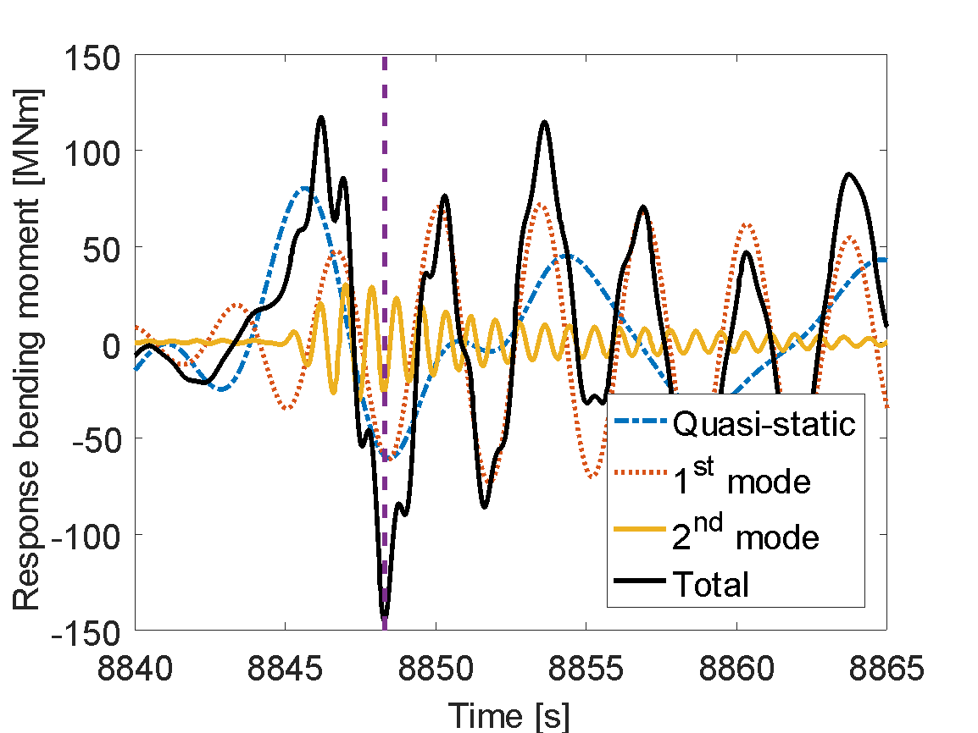

Figure . Decomposition of the response around the eigenfrequencies of the structure for event A1.

Figure 18 shows the contribution of the different modes for the simulated responses and how they compare to the measured responses for part A. Figure 18a shows that all models reproduce the quasi-static response reasonably well, with M_Lin slightly underestimating it. The differences in quasi-static response between M_Lin and the models including stream function kinematics are due to the vertical length of integration of the loads on the structure: M_Lin assumes loads up to the mean water level whereas M_SF and M_SF_W assumes loads up to the measured wave elevation. As noted in section 5.1 and illustrated in Figure 18b,c, M_Lin does not trigger 1st or 2nd mode response and therefore underestimates the total response, as shown in Figure 18d,e. Figure 18b also shows that both models using stream function wave kinematics do trigger 1st mode response to a larger extent than M_Lin but still underestimate it. As explained previously, only the slamming model has the capability to 2nd mode response, but the response from the simulations is significantly larger than the experiments.

It appears from Figure 18 that 1st mode and quasi-static response are affected by the presence of the slamming model. The time of occurrence of the maxima when the slamming model is applied is slightly different than without slamming model, and therefore the contributions of the different modes vary slightly. There was no indication that the slamming model significantly affected the 1st mode and the quasi-static response.

Figure 18 indicates that stream function wave kinematics with Wienke’s slamming model have the potential to correctly predict the total response of the structure, but generally do not capture the balance between 1st and 2nd mode response. This leads to an inaccurate distribution of the stresses along the monopile.

|  |  |
| --- | --- |
| a) Comparison between quasi-static measured and simulated responses for Part A | b) Comparison between 1st mode measured and simulated responses for Part A |
| c) Comparison between 2nd mode measured and simulated responses for Part A | d) Comparison between total measured and simulated responses for Part A |
| e) Summary of the measured and simulated responses for Part A | |

Figure . Comparison of the simulated responses with the measured response for the largest events in Part A. The response has been decomposed into contributions of the different modes of the structure.

Figure 19 shows the same results as Figure 18 for the largest 30 events of part B. The conclusions regarding the M_Lin model and the quasi-static and 2nd mode response drawn for part A also apply for part B. When it comes to 1st mode response however, there is no clear trend of how well the models using the stream function (models M_SF and M_SF_W) capture it: for some events, they produce conservative results while for others they are non-conservative.

Figure 19e shows that the stream function with Wienke’s model does not give a conservative estimate of the total response of the structure when the 1st mode response is underestimated. This underestimation can in some cases be compensated by an overestimation of the 2nd mode response using the slamming model, but the physics of the process of maximum response are not correctly captured.

|  |  |
| --- | --- |
| a) Comparison between quasi-static measured and simulated responses for Part B | b) Comparison between 1st mode measured and simulated responses for Part B |
| c) Comparison between 2nd mode measured and simulated responses for Part B | d) Comparison between total measured and simulated responses for Part B |
| e) Summary of the measured and simulated responses for Part B | |

Figure . Comparison of the simulated responses with the measured response for the largest events in Part B. The response has been decomposed into contributions of the different modes of the structure.

* 1. Analysis of the models

In this part we try to explain the discrepancies observed between the models and the experimental data. In the following, we define the wave steepness as the steepness of the highest third of the wave, equal to , where and are defined in Figure 20 and is the wave celerity, taken equal to the stream function wave celerity for simulated waves and estimated with the nonlinear dispersion relationship for measured waves.

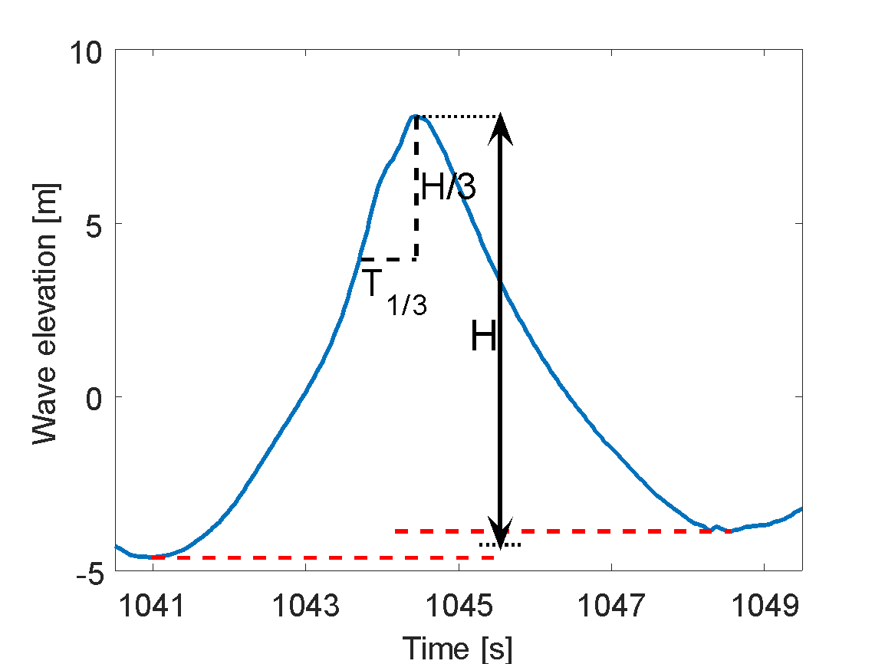

Figure . Definition of the wave steepness at the highest third of the wave.

* + 1. Stream function – ringing response

Here we assess how the frequency content of the excitation affects the 1st mode response. We evaluate the energy content of the modal excitation force for mode 1 (obtained from equation 4) at the 1st eigenfrequency by calculating the cwt and taking its maximum along the 1st eigenfrequency of the structure, indicated by a red dot in Figure 16.

From Figure 21 to Figure 26, the data points correspond to the events analysed in section 5.1. Figure 21 shows the correlation between the energy content of the modal excitation force at the 1st eigenfrequency (which has been normalized against its maximum value) and the maximum value of the simulated 1st mode response (this is different from previous figures, where the contribution of the 1st mode response at the instant where the total maximum was reached was shown). As expected, there is a strong correlation between these parameters.

Figure 22 shows the correlation of the stream function wave steepness and the energy content of the excitation force at the 1st eigenfrequency. Waves get steeper as the influence of higher harmonics gets larger, therefore steeper waves have a higher energy content at high frequencies. The eigenfrequency of the structure (0.29 Hz) corresponds to harmonics between 3 and 5 for the considered waves. This explains why steeper waves produce excitation forces with larger energy content at 0.29 Hz, as can be seen in Figure 22.

In Figure 21 and Figure 22 the black line is obtained from a linear regression of the data. The R2 coefficient is given in the caption.

|  |  |
| --- | --- |
| Figure . Energy content of the excitation force at the 1st eigenfrequency against maximum 1st mode simulated response (R2 = 0.91). | Figure . Stream function wave steepness against energy content of the excitation force at the 1st eigenfrequency (R2 = 0.76). |

Figure 23 shows that there is no clear correlation between the measured wave steepness and 1st mode response. Figure 24 shows the same for a different definition of the wave steepness (wave height over wavelength). This suggests that the reason why the stream function model does not consistently capture 1st mode response is because it produces a response proportional to the wave steepness, which does not correspond to what is observed in the experiments.

|  |  |
| --- | --- |
| Figure . Measured wave steepness against maximum 1st mode measured response | Figure . Measured wave steepness (wave height over wavelength) against maximum 1st mode measured response. |

* + 1. Slamming model – 2nd mode response

By definition, the amplitude of the slamming load is proportional to the wave elevation times the wave celerity squared (see Wienke and Oumeraci, 2005). The impulse of the slamming load is proportional to its amplitude, and classical structure dynamics (see for example Biggs, 1964) shows that increasing impulse produces an increased response of the structure. This explains the linear trend in the correlation between the simulated 2nd mode response and the wave elevation times the wave celerity squared seen in Figure 25. As in the analysis of 1st mode response in section 5.3.1, the trend in the simulations does not correspond to what can be observed from the experiments. Figure 26 shows no apparent trend between the measured 2nd mode response and the wave elevation times the celerity squared. This can be due to (i) physical phenomena not considered in the theory (such as air entrapment, asymmetry of the load, imperfections on the surface), (ii) an inaccurate estimation of the wave celerity and (iii) an inaccurate representation of the shape of the impact load by the slamming model (given by equation (8)). A detailed analysis of the effect of the shape of the slamming load is beyond the scope of this paper, but classical structure dynamics (Biggs, 1964) shows that the response of a structure to a transient load depends on the shape of the load. It should be noted that the impulse could not be obtained from measurements with the given experimental setup.

|  |  |
| --- | --- |
| Figure . Maximum 2nd mode simulated response against wave elevation * celerity squared (R2 = 0.78). | Figure . Maximum 2nd mode measured response against wave elevation * celerity squared. |

* 1. Discussion on damping

The damping of the 1st and 2nd mode was 1.1% of the critical damping. Research done by Bachynski and Moan (2014) and Schløer et al. (2016) suggests that damping is not critical for the maximum response but more relevant for fatigue damage. This agrees with the numerical simulations reported in Marino et al. (2013b) where it can be seen at an event level that the maximum bending moments at the tower bottom are not generally smaller in power production mode (which implies larger damping) compared to idling conditions. However, Suja-Thauvin et al. (2016) pointed out that for very lightly damped systems the 1st mode response produced by a ringing event will not decay quickly, so a new event may produce 1st mode response on top of these free decay oscillations, potentially increasing the maximum if the oscillations from the two events occur in phase. Bachynski et al. (2017) explored this issue further and showed that at a statistical level, increased damping would decrease the extreme bending moment at the tower bottom.

The present experimental set-up did not enable variation of the system damping. It was thus impossible to assess whether – for a very lightly damped structure – the response to non-linear loading might be somewhat hidden by the large responses at the 1st eigenmode. Indeed, if an event A induces a 1st mode response in the structure and that response has not dampened out by the time a later event B occurs, it will be challenging to assess the contribution of each event to the 1st mode response. The question of whether low damping decreases the sensitivity of the system to non-linearities is left for further studies.

1. Conclusion

Experimental data of a monopile offshore wind turbine subjected to severe irregular waves has been compared to the numerical models suggested by typical standards used in the offshore wind industry (namely DNV-OS-J101, 2014b; DNV-RP-C205, 2014a; IEC 61400-3, 2009). The experimental campaign at MARIN consisted of a fully flexible monopile offshore wind turbine in finite water depth and subjected to extreme irregular sea states. The model was built so that its dimensions, its 1st and 2nd eigenfrequencies and 1st mode shape fit those of a full scale 4 MW wind turbine. During the experimental campaign, ULS conditions were found to be the design driver for the given structure (de Ridder et al., 2017), so this paper attempts to reproduce the characteristic response for ULS design, commonly referred to as the 50-year response. Both statistical and event-based comparisons were considered.

Several limitations to the present work should be noted. This analysis is based on experimental data from a limited number of sea state realizations at 1:30.6 scale, with the inherent limitations and uncertainties associated with wave generation and small-scale testing. In addition, due to the experimental set-up, only one combination of 1st and 2nd eigenfrequencies was analysed. As rotor size increases (Ho et al., 2016), the mass and moment of inertia on top of the tower may increase at different rates, thus changing the ratio of 1st to 2nd eigenfrequency. This could potentially change the relative contributions of the 1st and 2nd mode responses to the total response and therefore modify Figure 18e and Figure 19e. Furthermore, the wave elevation measured during the experiments is inherently nonlinear and had to be linearized to be a valid input to the hydrodynamic load models (see Appendix A). The 3rd and 4th modes of the structure were also disregarded in this study and might be relevant when assessing maximum responses. Finally, we did not consider memory effects (i.e. the fact that the response to previous events influences the response to a given wave). Peng et al. (2013) showed that it is possible to get larger responses from wave groups than from individual regular waves with the same characteristics as the largest wave of the group.

In order to determine the 50-year response, the standards suggest simulating the response of the structure over 20 realizations of the 50-year sea state with the 50-year wave randomly embedded. The 50-year wave kinematics are determined using the stream function and the hydrodynamic loads are computed with the Morison equation. During the experiments, large responses were provoked by steep and breaking waves, so Wienke’s slamming model (see Wienke and Oumeraci, 2005) was added on top of the Morison loads. The numerical model gave a conservative estimate of the 50-year response for the largest sea states studied in this paper, but underpredicted the 50-year response for the milder sea states.

The events which produced a large response in the experiments were analysed individually, and the measured and simulated responses were decomposed into contributions around the 1st and 2nd eigenfrequencies of the structure. The results suggest that the numerical model does not correctly predict the relative contributions of the 1st and 2nd mode response to the total response. In particular, it was found that

* The quasi-static response was in general accurately estimated by linear as well as non-linear wave kinematic models.
* The Morison equation with stream function wave kinematics inconsistently predicted ringing response (transient 1st mode response). The amplitude of the simulated response was roughly proportional to the wave steepness, but this correlation was not found in the experimentally measured response.
* The 2nd mode of the structure was only excited by the slamming model. This is consistent with the findings of Suja-Thauvin et al. (2017), who show that during the experiments, 2nd mode response was triggered by waves breaking at the structure. However, according to the theory, the amplitude of the 2nd mode response is proportional to the wave elevation times the celerity squared, which was not observed in the experimental data.

Overall, the numerical model – with Morison’s equation, stream function wave kinematics, and a slamming model – conservatively estimated the total maximum response on 3 out of 21 events for part A and 14 out of 30 events for part B. For all events where the total response was overestimated, the 2nd mode response was also overestimated, but there was no clear trend for the 1st mode response. These findings imply that even in a situation where the models give a conservative estimate of the 50-year response, the balance between 1st and 2nd mode response might not be realistic, and the stress distribution along the monopile can be inaccurate.

It should be noted that in this paper, the models were implemented to reproduce experimental data in order to allow an event-based comparison. In the estimation of 50-year response of offshore wind turbines, rather than using experimental data, the industry typically has access to metocean data to estimate the relevant extreme conditions. In order to select a relevant 50-year return wave in section 4.1.1, based on IEC 61400-3 (2009), we assumed both Rayleigh and Battjes and Groenendijk distributions for the wave heights for a 3-hour sea state. In addition, several parameters required careful selection in order to provide trustworthy results. The assumptions made here are summarized in Table 3.

Table . Input to the numerical models

|  |  |  |
| --- | --- | --- |
| Required input | Selected value | Reference |
| Load model | Morison with strip theory | (DNV-RP-C205, 2014; IEC 61400-3, 2009) |
| Hydrodynamic coefficients | and . | (Sarpkaya, 2010) |
| Wave kinematic model | Stream function wave theory | (DNV-RP-C205, 2014; IEC 61400-3, 2009) |
| Wave embedding procedure | Method described by Rainey and Camp | (Rainey and Camp, 2007) |
| Slamming model | Wienke’s model | (DNV-RP-C205, 2014) |
| Curling factor |  | (Burmester et al., 2017) |

Acknowledgments

This study has been financed by Statkraft and the Norwegian Research Council, project number 237192. The authors are grateful to the WiFi project for providing the experimental data used for this paper as well as for support and relevant input to the presented discussion. The authors also want to thank Tim Bunnik for sharing information about the mode shape solver. The participants of the WiFi project, in alphabetical order, are Ballast Nedam, Deltares, DNV, Dong, ECN, EON, GL, MARIN, Ramboll, Royal HaskoningDHV, RWE, Savannah River National Laboratory, Siemens, Sirris/OWI-lab, Statkraft, Statoil, STX, Van Oord, Vattenfall and Volker InfraDesign bv.

Bachynski, E.E., Kristiansen, T., Thys, M., 2017. Experimental and numerical investigations of monopile ringing in irregular finite-depth water waves. Appl. Ocean Res. 68, 154–170. https://doi.org/10.1016/j.apor.2017.08.011

Bachynski, E.E., Moan, T., 2014. Ringing loads on tension leg platform wind turbines. Ocean Eng. 84, 237–248. https://doi.org/10.1016/j.oceaneng.2014.04.007

Battjes, J.A., Groenendijk, H.W., 2000. Wave height distributions on shallow foreshores. Coast. Eng. 40, 161–182. https://doi.org/10.1016/S0378-3839(00)00007-7

Biggs, J.M., 1964. Introduction to structural dynamics. McGraw-Hill College.

Bredmose, H., Jacobsen, N.G., 2010. Breaking Wave Impacts on Offshore Wind Turbine Foundations: Focused Wave Groups and CFD 397–404. https://doi.org/10.1115/OMAE2010-20368

Bredmose, H., Schløer, S., Paulsen, B.T., 2012. Higher-Harmonic Response of a Slender Cantilever Beam to Fully Nonlinear Regular Wave Forcing 469–478. https://doi.org/10.1115/OMAE2012-83475

Bredmose, H., Slabiak, P., Sahlberg-Nielsen, L., Schlütter, F., 2013. Dynamic Excitation of Monopiles by Steep and Breaking Waves: Experimental and Numerical Study V008T09A062. https://doi.org/10.1115/OMAE2013-10948

Bunnik, T., Helder, J., de Ridder, E.J., 2015. Simulation of the Flexible Response of a Fixed Offshore Wind Turbine subject to Breaking Waves. Presented at the 7th International Conference on HYDROELASTICITY IN MARINE TECHNOLOGY.

Burmester, S., de Ridder, E.-J., Wehmeyer, C., Asp, E., Gujer, P., 2017. Comparing Different Approaches for Calculating Wave Impacts on a Monopile Turbine Foundation V010T09A063. https://doi.org/10.1115/OMAE2017-61182

Damgaard, M., Andersen, J.K.F., 2012. Natural Frequency And Damping Estimation of an Offshore Wind Turbine Structure. Presented at the The Twenty-second International Offshore and Polar Engineering Conference, International Society of Offshore and Polar Engineers.

Damgaard, M., Ibsen, L.B., Andersen, L.V., Andersen, J.K.F., 2013. Cross-wind modal properties of offshore wind turbines identified by full scale testing. J. Wind Eng. Ind. Aerodyn. 116, 94–108. https://doi.org/10.1016/j.jweia.2013.03.003

Daubechies, I., 1992. Ten lectures on wavelets. SIAM.

de Ridder, E.J., Aalberts, P., van den Berg, J., Buchner, B., Peeringa, J., 2011. The Dynamic Response of an Offshore Wind Turbine With Realistic Flexibility to Breaking Wave Impact 543–552. https://doi.org/10.1115/OMAE2011-49563

de Ridder, E.J., Bunnik, T., Peeringa, J.M., Paulsen, B.T., Wehmeyer, C., Gujer, P., Asp, E., 2017. Summary of the Joint Industry Project Wave Impact on Fixed Foundations (WiFi JIP) V010T09A081. https://doi.org/10.1115/OMAE2017-62040

DNV-OS-J101, 2014. DNV-OS-J101 Design of offshore wind turbine structures. DNV.

DNV-RP-C205, 2014. DNV-RP-C205 Environmental Conditions and Environmental Loads. DNV.

Faltinsen, O.M., 1990. Sea loads on ships and offshore structures, Ocean Techmology. Cambridge.

Faltinsen, O.M., Newman, J.N., Vinje, T., 1995. Nonlinear wave loads on a slender vertical cylinder. J. Fluid Mech. 289, 179–198. https://doi.org/10.1017/S0022112095001297

Faltinsen, O.M., Timokha, A.N., 2016. Undamped eigenperiods of a sea-based gravity monotower. Appl. Math. Model. 40, 8217–8243. https://doi.org/10.1016/j.apm.2016.04.003

Frimann-Dahl, J., 2015. Experimental Validation and Design Review of Wave Loads on Large-Diameter Monopiles. NTNU, Marine Technology.

Gans, R.F., 2015. Mechanical Systems. Springer.

Hasselmann, K., Barnett, T.P., Bouws, E., Carlson, H., Cartwright, D.E., Enke, K., Ewing, J.A., Gienapp, H., Hasselmann, D.E., Kruseman, P., Meerburg, A., Müller, P., Olbers, D.J., Richter, K., Sell, W., Walden, H., 1973. Measurements of wind-wave growth and swell decay during the Joint North Sea Wave Project (JONSWAP).

Ho, A., Mbistrova, A., Corbetta, G., 2016. The European offshore wind industry - key trends and statistics 2015 [WWW Document]. WindEurope. URL https://windeurope.org/about-wind/statistics/offshore/key-trends-2015/ (accessed 10.10.16).

IEC 61400-3, 2009. IEC 61400-3: Wind Turbines–Part 3: Design Requirements for Offshore Wind Turbines. Int. Electrotech. Comm. Geneva.

Johannessen, T.B., 2011. Nonlinear Superposition Methods Applied to Continuous Ocean Wave Spectra. J. Offshore Mech. Arct. Eng. 134, 011302–011302. https://doi.org/10.1115/1.4003518

Johannessen, T.B., 2008. On the Use of Linear and Weakly Nonlinear Wave Theory in Continuous Ocean Wave Spectra: Convergence With Respect to Frequency 211–217. https://doi.org/10.1115/OMAE2008-57355

Kristiansen, T., Faltinsen, O.M., 2017. Higher harmonic wave loads on a vertical cylinder in finite water depth. J. Fluid Mech. 833, 773–805. https://doi.org/10.1017/jfm.2017.702

Krokstad, J.R., Stansberg, C.T., Nestegård, A., Marthinsen, T., 1998. A New Nonslender Ringing Load Approach Verified Against Experiments. J. Offshore Mech. Arct. Eng. 120, 20–29. https://doi.org/10.1115/1.2829515

Malenica, Š., Molin, B., 1995. Third-harmonic wave diffraction by a vertical cylinder. J. Fluid Mech. 302, 203–229. https://doi.org/10.1017/S0022112095004071

Marino, E., Lugni, C., Borri, C., 2013a. A novel numerical strategy for the simulation of irregular nonlinear waves and their effects on the dynamic response of offshore wind turbines. Comput. Methods Appl. Mech. Eng. 255, 275–288. https://doi.org/10.1016/j.cma.2012.12.005

Marino, E., Lugni, C., Borri, C., 2013b. The role of the nonlinear wave kinematics on the global responses of an OWT in parked and operating conditions. J. Wind Eng. Ind. Aerodyn., The Twelfth Italian National Conference on Wind Engineering, IN-VENTO-2012, Venezia, Italy, October 7th–10th 2012 123, Part B, 363–376. https://doi.org/10.1016/j.jweia.2013.09.003

Morison, J.R., Johnson, J.W., Schaaf, S.A., 1950. The Force Exerted by Surface Waves on Piles. J. Pet. Technol. 2, 149–154. https://doi.org/10.2118/950149-G

Naess, A., Moan, T., 2012. Stochastic Dynamics of Marine Structures. Cambridge University Press.

Natvig, B.J., 1994. A Proposed Ringing Analysis Model For Higher Order Tether Response. Fourth Int. Offshore Polar Eng. Conf.

Natvig, B.J., Teigen, P., 1993. Review Of Hydrodynamic Challenges In Tlp Design. Int. J. Offshore Polar Eng. 3.

Newman, J.N., 1996. Nonlinear Scattering of Long Waves by a Vertical Cylinder, in: Grue, J., Gjevik, B., Weber, J.E. (Eds.), Waves and Nonlinear Processes in Hydrodynamics, Fluid Mechanics and Its Applications. Springer Netherlands, pp. 91–102.

Paulsen, B.T., Bredmose, H., Bingham, H.B., Jacobsen, N.G., 2014. Forcing of a bottom-mounted circular cylinder by steep regular water waves at finite depth. J. Fluid Mech. 755, 1–34. https://doi.org/10.1017/jfm.2014.386

Paulsen, B.T., Bredmose, H., Bingham, H.B., Schløer, S., 2013. Steep Wave Loads From Irregular Waves on an Offshore Wind Turbine Foundation: Computation and Experiment V009T12A028. https://doi.org/10.1115/OMAE2013-10727

Peeringa, J.M., Hermans, K.W., 2017. Impact of New Slamming Wave Design Method on the Structural Dynamics of a Classic, Modern and Future Offshore Wind Turbine V010T09A071. https://doi.org/10.1115/OMAE2017-61654

Peng, Z., Raaijmakers, T., Wellens, P., 2013. Nonlinear Wave Group Impact on a Cylindrical Monopile V001T01A044. https://doi.org/10.1115/OMAE2013-10838

Rainey, P.J., Camp, T.R., 2007. Constrained non-linear waves for offshore wind turbine design. J. Phys. Conf. Ser. 75, 012067. https://doi.org/10.1088/1742-6596/75/1/012067

Rienecker, M.M., Fenton, J.D., 1981. A Fourier approximation method for steady water waves. J. Fluid Mech. 104, 119–137. https://doi.org/10.1017/S0022112081002851

Sarpkaya, T., 2010. Wave forces on offshore structures. Cambridge University Press.

Schløer, S., Bredmose, H., Bingham, H.B., 2016. The influence of fully nonlinear wave forces on aero-hydro-elastic calculations of monopile wind turbines. Mar. Struct. 50, 162–188. https://doi.org/10.1016/j.marstruc.2016.06.004

Shirzadeh, R., Weijtjens, W., Guillaume, P., Devriendt, C., 2015. The dynamics of an offshore wind turbine in parked conditions: a comparison between simulations and measurements. Wind Energy 18, 1685–1702. https://doi.org/10.1002/we.1781

Steen, S., 2014. Experimental Methods in Marine Hydrodynamics - Lecture notes.

Suja-Thauvin, L., Eliassen, L., Krokstad, J., 2014. The scalability of loads on large diameter monopile offshore wind support structures. Presented at the International Wind Engineering Conference, Hannover.

Suja-Thauvin, L., Krokstad, J.R., 2016. Simplified Bottom Fixed Offshore Wind Turbine in Extreme Sea States. Presented at the The 26th International Ocean and Polar Engineering Conference, International Society of Offshore and Polar Engineers, Rhodos (Greece).

Suja-Thauvin, L., Krokstad, J.R., Bachynski, E.E., de Ridder, E.-J., 2017. Experimental results of a multimode monopile offshore wind turbine support structure subjected to steep and breaking irregular waves. Ocean Eng. 146, 339–351. https://doi.org/10.1016/j.oceaneng.2017.09.024

Suja-Thauvin, L., Krokstad, J.R., Frimann-Dahl, J., 2016. Maximum loads on a one degree of freedom model-scale offshore wind turbine. Energy Procedia, EERA DeepWind’ 2016, 13th Deep Sea Offshore Wind R&D Conference.

Wheeler, J.D., 1969. Methods for Calculating Forces Produced by Irregular Waves. Presented at the Offshore Technology Conference, Offshore Technology Conference. https://doi.org/10.4043/1006-MS

Wienke, J., Oumeraci, H., 2005. Breaking wave impact force on a vertical and inclined slender pile—theoretical and large-scale model investigations. Coast. Eng. 52, 435–462. https://doi.org/10.1016/j.coastaleng.2004.12.008

Appendix A: wave linearization

A1 Filtering

Difference-frequency waves are first removed from the measured signal using a simple high-pass filter. The difference-frequency waves are far from the linear waves (in the red circle in Figure 27a), making the filtering process straightforward.

Next, some of the higher order waves are removed by using a low-pass filter. We assume that 3rd and higher order waves have energy at frequencies that are higher than the linear wave, and will therefore simply be removed by the low-pass filter. However, removing second order sum-frequency waves is more complicated because some of these waves have frequencies that lie within the range of linear waves. If the cut-off frequency is too low, one might lose information from the linear waves. On the other hand, if the cut-off frequency is too high, part of the higher order waves will remain. The explanation of how this cut-off frequency is selected is given in appendix A2.

Once the high-pass and low-pass filters have been applied, we obtain the initial approximation for the linear wave (red curve in Figure 27b). In this initial approximation, difference-frequency waves have been removed, but the sum-frequency waves whose frequencies lie within the linear waves remain. This unwanted energy is removed as follows: a second order wave (yellow curve in Figure 27c) is estimated from the initial approximation of the linear wave (Newman, 1996):

(9)

with the gravitational acceleration, and the horizontal and vertical water particle velocities, respectively and with subscript indicating differentiation.

We then want to remove this second order wave from . However, part of is higher than the cut-off frequency (the region to the right of the black dotted line in Figure 27c) and will introduce higher frequencies into the linear wave if simply substracted. Therefore, is first filtered in the same way as the measured wave elevation (the result of this filtering is the yellow curve in Figure 27d) and then substracted from . We then obtain the second approximation of the linear wave

(10)

Equation (9) used to calculate requires a linear wave elevation as input. However, contains second order wave energy that was not removed by the initial filtering process, as explained above. This introduces an error in the second order wave and therefore in the linear wave . In order to reduce this error, we use to calculate a new estimation of the second order wave, using equation (9) with instead of . We then obtain .

We iterate this process and compare and at each step. When the maximum of the difference is below a certain threshold (set to for the present study), we consider that the process has converged and we use the obtained linear wave as input for the numerical models.

The flow chart in Figure 28 describes the iterative process explained above. In this flow chart, the numbers of the figures illustrating the concepts are also given.

|  |  |
| --- | --- |
| **a** | **b** |
| **c** | **d** |

Figure . Spectra of the wave elevation during filtering process.

A2 Selection of the cut-off frequency

As stated above, the selection of the cut-off frequency for the low-pass filter is not straight forward. It is specified in the standard DNV-RP-C205 (2014a) that if second order loads are to be calculated from a linear wave time series, a low-pass filter should be applied with the following cut-off frequency.

(11)

This cut-off frequency, developed for deep water, has to be applied because some kinematic terms used in non-linear hydrodynamic models can brcome unphysically large at the tail of the commonly used wave spectra (see Johannessen, 2008). For intermediate water conditions, the inherent non-linear behaviour of the waves implies that a lower cut-off frequency than the one presented in equation (11) has to be used.

The unwanted high-frequency energy is filtered out by use of a Butterworth filter. This filter is defined by two parameters: the cut-off frequency and the order of the filter, higher order meaning a sharper cut at the cut-off frequency. Suja-Thauvin and Krokstad (2016) varied these two parameters and a reconstructed linear wave was calculated for sea states of different severity. It was found that a 4th order Butterworth filter with a cut-off frequency gives the most accurate results. However, as pointed out by Johannessen (2011), the results are sensitive to the cut-off frequency selected. A careful assessment of the filter has to be carried out in order to get accurate results.

The linearization of the measured wave elevation introduces uncertainties into the estimation of the input to the hydrodynamic models, but these do not affect the computation of the loads that determine the 50-year response in the present study:

* For the stream function theory, the wave height is taken from the unfiltered measured wave elevation and the period from the linear wave is practically the same as for the measured wave. The kinematics of the stream function are only dependent on those two parameters and the water depth and therefore independent of the linearization process.
* Wienke’s slamming model is only dependent on the wave elevation and the celerity of the wave (which depends on the stream function). Its ability to trigger 1st or 2nd mode motion is therefore not dependent on the linearization process

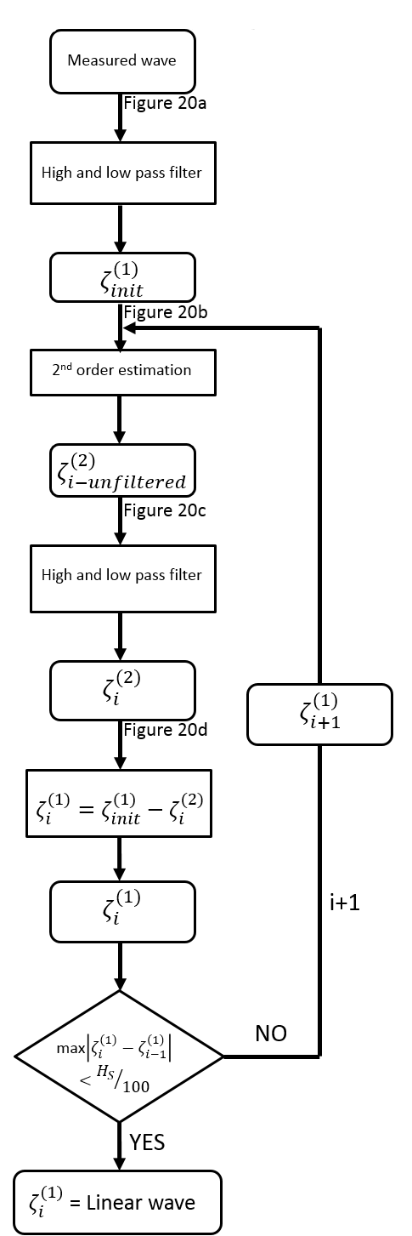

Figure . Flow chart for the linearization process.