The effect of dissolved gas on coalescence of oil drops studied with microfluidics
Marcin Dudek¹, Kelly Muijlwijk², Karin Schroën³ and Gisle Øye¹
¹ Ugelstad Laboratory, Department of Chemical Engineering, Norwegian University of Science and Technology (NTNU), Trondheim, Norway
² FrieslandCampina, Wageningen, The Netherlands
³ Food Process Engineering Group, Wageningen University and Research Centre (WUR), Wageningen, The Netherlands
Abstract
Hypothesis
In literature it is stated that the stability of oil-in-water emulsions could be enhanced by decreasing the so-called “hydrophobic interactions” between surfaces through removal of dissolved atmospheric gases. Since the effect of the dissolved gases depends on the hydrophobicity of the oil phase, as well as the system pressure, we vary this effect systematically and monitor droplet coalescence in a tailor-made microfluidic device.
Experiments
The coalescence of oil drops in standard and degassed conditions was studied by direct observation using a microfluidic setup. Two model oils (heptane and xylene) were used to represent different hydrophobicity of the dispersed phases, together with an oil with dynamic interfacial behaviour (diluted crude oil). In addition, the effect of the volume fraction, droplet size and degassing method was studied.
Findings
At ambient pressure, the degassing of the continuous phase reduced the extent of coalescence for the model oils, which is in agreement with other reports. No effect of the dissolved gases was found on the drop formation process. At elevated pressures, the dissolved gases influenced only the most hydrophobic oil (heptane), while causing no effect in the other systems. The coalescence frequencies decreased upon the reduction of the drop sizes, which was justified with the theory for two interacting spheres.
Introduction
Emulsions are kinetically stabilized systems of dispersed drops that, given sufficient time, will phase-separate. Coalescence is one of the main processes that governs emulsion stability, and is important in various applications, including petroleum, pharmaceutical and food industry. Liao and Lucas¹ presented a literature review of coalescence theories, and most widely used is probably the film drainage model proposed by Shinnar and Church². In this model, the coalescence process is divided into three steps: (1) approach of droplets leading to thin film formation, (2) film drainage and (3) film rupture, leading to coalescence. The film thickness and drainage process are governed by droplet features, fluid characteristics, interfacial properties and flow aspects³. These factors will give rise to interaction forces acting across the thin film between droplets, of which the attractive interactions are generally considered to be the result of van der Waals forces, whereas the repulsive interactions originate from overlapping electrical double layers or steric (often polymer-induced) repulsion.
However, additional attractive interactions that cannot be explained by van der Waals interactions, have long been observed between hydrophobic surfaces in aqueous solutions⁴⁻⁵. In an early review, Christenson and Claesson⁶ put these ‘hydrophobic interactions’ into the following categories:
- Strong, short-range attractive interactions between stable surfaces. These interactions were found between very hydrophobic surfaces and occur in a similar range as the van der Waal attraction (i.e. up to 20 nm), but are stronger.
- Attractive interactions of variable strength and range in the presence of bubbles. These ranged from 25 to 250 nm and originated from the presence of nanobubbles near the vicinity of hydrophobic surfaces.
- Very long-ranged attractive interactions that decay exponentially. These interactions are most elusive and difficult to explain, in regard to both the origin and magnitude of the attraction, but are commonly observed in systems with mobile hydrophobic groups.
More recently, it has been suggested that the ‘hydrophobic interactions’ may be a combination of long-ranged attraction (likely originating from bridging bubbles) that are not directly related to the hydrophobicity of the surfaces, and truly hydrophobic interactions at short range (separation distances <10-20 nm)⁷⁻⁸.
It is clear that the origin of these interactions is not well understood, although interesting results were reported. The presence of dissolved atmospheric gases (typically 1 mM at standard conditions) affects the hydrophobic interactions considerably^{7, 9-10}, and numerous papers have demonstrated the importance of dissolved gas for particle aggregation¹¹⁻¹², emulsion stability^{9, 13-14} and surface tension¹⁵. Conversely, degassing improved removal of hydrophobic contaminants from water¹⁶. The effect of dissolved gases was also studied in reverse osmosis desalination process at laboratory¹⁷ and pilot scale¹⁸, and in both cases degassing improved process performance. The influence of dissolved gas on formation and stability of emulsion droplets has only been studied at ambient pressure.
Recently, microfluidics have become popular tools to investigate emulsions¹⁹⁻²¹, including coalescence of drops in both oil-in-water²²⁻²³ and water-in-oil systems²⁴⁻²⁵. Krebs et al. used it to quantify coalescence of oil droplets, leading to coalescence time distributions as function of the droplet velocity and size²⁶, and surfactant concentration²⁷. Microfluidic tools are well fitted to study emulsion stability in more extreme conditions, i.e. high temperature²⁸⁻³⁰, g-force³¹, but also elevated pressure. Still, emulsion behaviour in microfluidics at pressurized conditions has scarcely been reported³², while, to the best of our knowledge, no one has studied the effect of dissolved gas on emulsion stability at elevated pressures.
The objective of this work was to study the effect of dissolved gas on the droplet coalescence at elevated pressure. Microfluidic methods were developed to provide insight into the stability of oil-in-water emulsions through direct observations at high frame rates. The influence of droplet size and dispersed phase volume fraction were investigated using two pure model oils, heptane and xylene. Furthermore, diluted crude oil with dynamic interfacial behaviour was used. The results of triplicate measurements (> 1000 droplets each) were reported as coalescence frequency values, in combination with drop size distributions.

Experimental
Materials. Heptane (Chromasolv for HPLC, Sigma-Aldrich, USA) and xylene (isomeric mixture for analysis, Merck, Germany) were used as received. The crude oil was produced at the Norwegian Continental Shelf, and diluted to 25% wt. in a mixture of heptane and xylene (later referred to as HX) with mass ratio 71.5:28.5, which corresponded to a saturated to aromatic ratio in the crude oil (characteristics were reported elsewhere: crude oil D in ³³). The basic physical parameters of the oil phases used here are listed in Table 1.
Table 1. Physical properties of the dispersed phases
Dispersed phase |  | Heptane | Xylene | Heptane/xylene 71.5:28.5 v/v (HX) | Crude oil in HX 25% m/m
Density @20°C [g/ml] |  | 0.684 | 0.867 | 0.736 | 0.761
Viscosity @20°C [mPa s] |  | 0.550 | 0.541 | 0.548 | 0.597
Interfacial tension [mN/m] | Standard brine (Std-Brine) | 47.4±0.1 | 38.2±0.1 | 42.2±0.5 | 13.7±0.2
 | Degassed brine (Deg-Brine) | 47.3±0.3 | 38.0±0.1 | 41.1±0.9 | 13.5±0.7
Densities of oil phases were measured with a DMA 5000 laboratory density meter (Anton Paar, Austria). Viscosity was obtained by using a MCR 301 laboratory rheometer (Anton Paar, Austria) with cylindrical geometry (CC-27). The interfacial tension (IFT) between model oil and water phases were measured with Du Noüy ring tensiometer (Sigma 70, KSV, Finland), while the IFT of brine and diluted crude oil was measured with a pendant drop tensiometer (PAT-1M, Sinterface Technologies, Germany).
3.5% wt. sodium chloride (for analysis, Merck Millipore, USA) was dissolved in deionized water (resistivity >18.2 MΩ·cm, Millipore Simplicity Systems, Germany) to make standard brine solutions, referred to as Std-Brine. For degassing of brine, an ultrasonic bath (Bransonic CPXH2800-E, Emerson, USA) was used for 15 min (further referred to as Deg-Brine). To compare the efficiency of degassing by ultrasonication, a series of experiments was also performed with conventionally degassed brines (vacuum < 25mmHg).
The dissolved gas from the brine and one of the model oils (xylene) was also removed through repeated freezing and thawing procedure. The samples were put in Schlenk tubes and sealed in nitrogen atmosphere to avoid condensation of oxygen. Next, they were frozen by immersing the tubes into liquid nitrogen. Once frozen, the samples were put under vacuum (ca. 10⁻⁴ bar) for 15 minutes. Afterwards, the sealed tubes were warmed under tepid water in order to thaw the liquid inside. The procedure was repeated until the bubbles stopped appearing in the solution (min. 3 times).
Methods
Microfluidic chips. Custom-designed glass microfluidic chips, Figure 1, were provided by Micronit Microtechnologies B.V. (The Netherlands) and their design was similar to those used by Krebs et al.²⁷. The inlet channels, leading to a T-junction where the droplets were created, were 100 µm wide. After passing a meandering channel, the droplets entered a coalescence chamber with a width of 500 µm, where they could undergo coalescence. The length of the coalescence chamber was approximately 33 mm and led to the outlet of the chip. The chips had an additional inlet for the continuous phase, located at the beginning of the coalescence channel. This allowed for variation in the volume fraction of the dispersed phase. Unless otherwise stated, the additional inlet was blocked during the experiments. All channels had the same depth (45 µm). The microfluidic chips were placed in a chip holder (Fluidic Connect PRO, Micronit Microtechnologies B.V., The Netherlands) and connected to the flow setup with PEEK tubing (inner diameter 250 µm, Sigma-Aldrich, USA) and FFKM ferrules (Fluidic PRO Ferrules, Micronit Microtechnologies B.V., The Netherlands). After the experiments, the chips were first sonicated in deionized (DI) water, then isopropanol, followed by sonication in DI water again. Each step lasted 15 min. For the chips used in the diluted crude oil experiments, a mixture of toluene and acetone (3:1 v/v) was used instead of DI water in the first sonication step. Afterwards, the chips were dried with compressed air and baked in an ashing furnace for 6 hours at 475°C. Shortly before the experiments, the chips were treated with low-pressure oxygen plasma for 10 minutes (Zepto, Diener electronic GmbH, Germany).
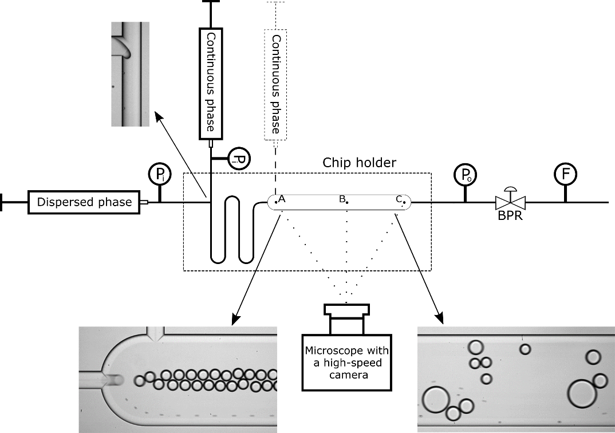
Figure 1. The microfluidic setup with the design of the chip. The pressure was controlled by a backpressure regulator (BPR) and was measured at the inlet (P_{i}) and outlet (P_{o}) by the pressure sensors. The total flow was measured by a Coriolis force flowmeter. A, B and C illustrate the recording points during the experiments.
Microfluidic setup. The flow rate and the pressure were controlled with the flow setup depicted in Figure 1. The liquids were pumped with syringe pumps (neMESYS mid-pressure module V3, Cetoni GmbH, Germany), fitted with stainless steel syringes. Generally, the droplet diameter exceeded the height of the channel slightly leading to a somewhat flattened shape that always deviated less than 10% of the hydraulic diameter. Therefore, the measured diameters are directly reported. Generally, the droplet size was controlled by the flow rate of the continuous phase, with a small dependency on the dispersed phase as also reported by other authors²². The flow rate of the dispersed phase governed the number of droplets. The ratio between the continuous and dispersed phase flow rates was kept constant at 1:8, except when the additional inlet for the continuous phase was used. All experimental conditions are presented in Table 2 and experiments at each condition were repeated 3 times.
Table 2. Overview of the experimental conditions in different report sections.
Results subsection | Flow rate [µl min⁻¹] |  |  | Pressure [barg] | Dispersed phase | Approx. droplet size [µm]
 | Continuous phase | Dispersed phase | Continuous phase – additional inlet
Heptane vs xylene | 160 | 20 | - | 0; 6; 11 | Heptane  Xylene | 56  56
Dispersed phase volume fraction effect (SI) | 160 | 20 | 0  50 | 0; 6 | Xylene | 56  56
Droplet size effect | 120  160  200  240 | 15  20  25  30 | -  -  -  - | 0; 6  0; 6  1; 6  1; 6 | Xylene | 66  56  48  41
Model oil vs crude oil | 160 | 20 | - | 0; 6 | HX  Crude oil in HX | 56  52
The pressure of each liquid before the inlet (P_{i}) and combined liquids at the outlet (P_{o}) was monitored with pressure sensors (Qmix P, Cetoni GmbH, Germany), and controlled by a backpressure regulator – BPR (15-300 psi, VICI AG International, Switzerland). The total outlet flow was measured with a microfluidic Coriolis flow sensor – F (mini CORI-FLOW, Elveflow, France). By adjusting the back-pressure regulator, the system pressure was adjusted to 0, 6, or 11 bar(g), the latter being the upper pressure limit of the chip holder pressure resistance. The flowmeter readings indicated temporary decline of the flow rate, which came back to the original level and stabilized within 20 seconds, and the reverse happened when decreasing the pressure. All reported pressures refer to the outlet pressure after flow rate stabilisation. The temperature was not controlled, but was constant throughout the experiment (ca. 22°C).
The interactions between the droplets were observed with a high-speed camera (AX100, Photron, Japan), connected to an inverted microscope (Ti-U Eclipse, Nikon, Japan) with an external LED light source (HDF7010, Hayashi, Japan).
Data acquisition and image analysis. Two sets of images were recorded for each experiment at 8 500 fps. The inlet of the coalescence chamber (A in Figure 1) was recorded in order to retrieve the initial size and number of the droplets. Afterwards, 10 000 frames were recorded further down the chamber for the analysis of coalescence events. The distance between the first and the second recording point was either 15.6 or 26 mm (B and C in Figure 1, respectively). The shorter distance was used for the model fluids that coalesced more readily than the crude oil systems.
The images were processed with ImageJ software: first, the frames were converted from greyscale images into binary, after which the areas and centre of mass coordinates (X,Y) of the droplets were obtained using the Analyse Particle feature. The height and width of the detection box was set to 500 µm and 301.2 µm, respectively; the lower size limit for droplets was set at 200 µm² to prevent detection of small satellite droplets, sometimes created at the T-junction³⁴. The circularity parameter was in the range 0.8-1 to disregard polygonal shapes occurring in the voids formed between droplets; and to detect only complete droplets, the exclusion on edges feature was used. As the majority of drops were smaller than the detection box, a single drop was detected in tens of frames (frames 2, 3, 7 and 12 in Figure S1 in SI). In total, tens of thousands of objects were detected.
The data were copied to Microsoft Excel to calculate the average drop velocity. It is worth pointing out that the velocity of the drops was 20-40% lower than the velocity of the continuous phase, due to drag forces that reduced the droplet velocity, also confirmed by previous findings of Krebs et al.²⁷. The drop velocity and the length of the channel were used to obtain the residence time (t_{res}).
The areas of the droplets increased proportionally with the number of coalescence events and, based on this, they were sorted into several size classes. The calculated average velocity, the width of the detection box and the average droplet diameter of each of the size classes were used to convert the dataset of tens of thousands of objects to the estimated number of observed droplets of different sizes (N_{f}). Figure 2 displays a typical outcome as the number distribution of droplets of different size classes at the second recording point.
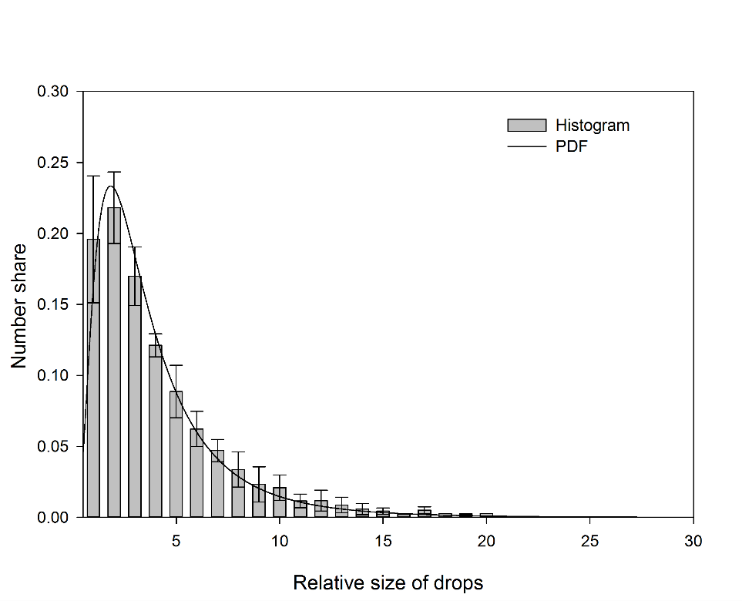
Figure 2. Droplet size distribution at the second recording point (based on ca. 600 droplets) and a calculated probability density function. Data for heptane droplets in Std-Brine at lowest pressure. Data are for three repeated experiments.
The size distribution was transferred to Matlab, with which the probability density functions were calculated with the distribution-fitting tool. The probability density functions (PDF) generally showed a good fit, as the typical deviations from the average values in the histogram were lower than 5%. Therefore, all subsequent size distributions were presented as PDFs. The number of droplets at the inlet (N_{in}) was estimated by Equation 1:
$$N_{in}=\sum_{i=1}^{i}{n_{i}*\frac{A_{f_{i}}}{A_{in}}}$$ | (1)
where n_{i} was number of droplets in class i, A_{fi} the area of class i droplets at the second recording point and A_{in} the area of a drop formed at the T-junction. N_{in} was usually above 2000. The percentage of non-coalesced droplets at the end of the channel was given by $\left(\frac{n_{1}}{N_{in}}\right)*100\%$, with n₁ the number of the droplets of initial size. The number of droplets retrieved from the inlet image series was used as a control to compare with the estimated N_{in}.
Similarly to the method presented by Krebs et al.²⁷, the ratio between N_{in} and N_{f} gave the mean relative size of a droplet and number of coalescence events ((N_{in}/N_{f}) -1); a droplet of size 3 undergoes 2 coalescence events. The coalescence frequency follows from Equation 2:
$f=\frac{\frac{N_{in}}{N_{f}}-1}{t_{res}}$. | (2)
Statistical analysis (t-Student, α=0.05) was performed for all results to determine whether the differences between data sets were statistically significant or not.

Results & Discussion
Heptane vs Xylene
Figure 3 shows the average coalescence frequency at different system pressures for heptane and xylene drops in standard and degassed brines.
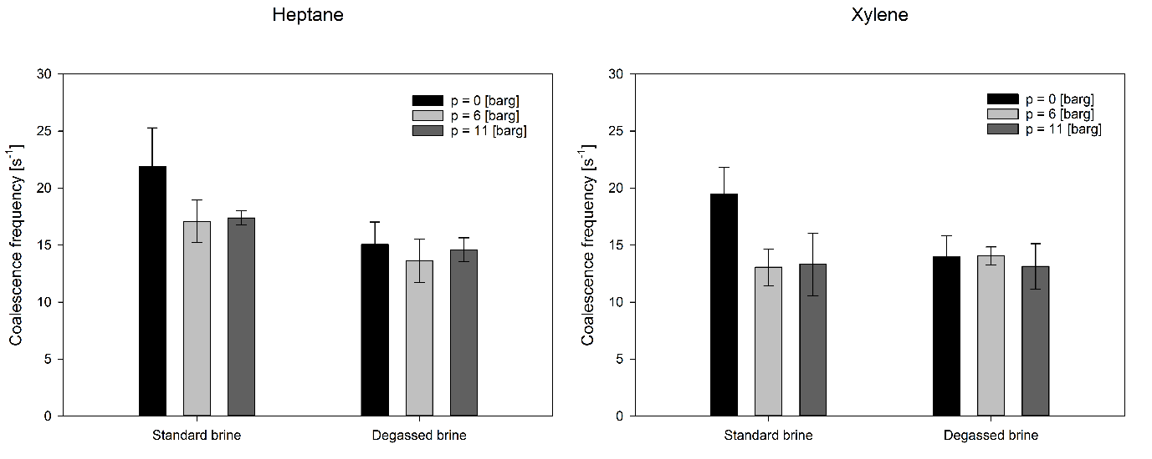Figure 3. Coalescence frequencies of heptane and xylene at various pressures in Std-Brine and Deg-Brine.
Most coalescence was observed in the standard brine at ambient system pressure, with slightly higher coalescence frequency for heptane than for xylene. The coalescence frequency in standard brine decreased with the increase of system pressure, and the reduction was somewhat larger for xylene than for heptane. In the degassed brine, the coalescence frequency was practically independent of the system pressure. The coalescence frequencies that were found seem similar to those found for standard brine at elevated pressure for xylene, while they are slightly lower for heptane. Notably, we found no effect of the dissolved gas on the droplet size during formation of the droplets.
The probability density functions for the experimental conditions used above (Figure S2 in the Supporting Information) were wider, and more positively skewed at standard conditions, and ambient pressure, which implies more polydisperse systems, whereas the samples without dissolved gas and at elevated pressure in standard brine had the smallest drop sizes and narrowest size distributions. In order to investigate the effect of dissolved gas further, additional experiments were performed to test the degassing method (Figure 4).
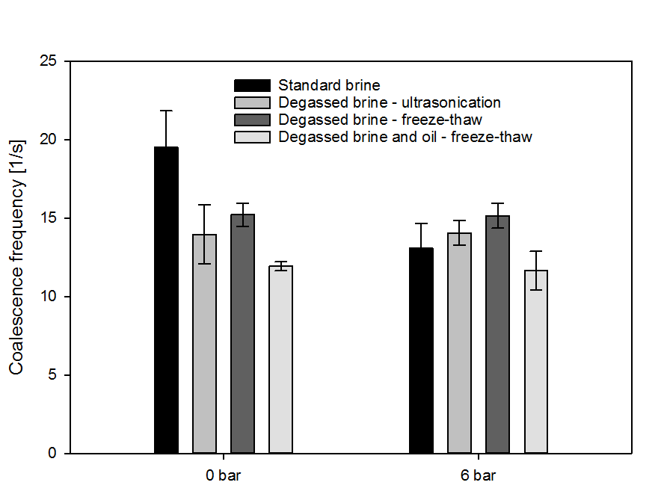
Figure 4. Coalescence frequencies of xylene in brines degassed by using different methods.
No statistically significant differences were observed for brines degassed by ultrasonication and the freeze-thaw method. Removing the dissolved gas from xylene further increased the stability of the oil droplets against coalescence, although the reduction of the coalescence frequency was not as marked as found for degassed brine.
When reducing the volume fraction of the dispersed phase (from ca. 0.17 to 0.13) by the additional flow of the continuous phase, the coalescence frequency became lower, which may also be caused by the higher velocity of drops as discussed later. The trends observed for degassing and increasing pressure were similar as mentioned before (see Figure S3 in the Supporting Information).
For further discussion of our findings, we used various sources available in the literature as the starting point. Experimental observations show that dissolved gas molecules accumulate close to hydrophobic surfaces and thereby affect the orientation of the surrounding water molecules³⁵. This imposed ordering of dipole moments can extend into the gap between two surfaces by percolation from gas molecule to gas molecule, resulting in density fluctuations and formation of gaseous bridges that pull the surfaces together and facilitate coalescence. Simultaneously, dissolved gases has been reported to act as nucleation sites for cavitation and thus enhance coalescence³⁶. The effect of dissolved gas on surfactant-free emulsions has been investigated by Pashley et al. ^{12-13, 36}, who revealed that the removal of dissolved gas improved dispersion by reduction of the hydrophobic interactions. This was attributed to the formation of smaller droplets in the absence of dissolved gas¹², while re-gassing of already formed emulsions did not influence their stability. Furthermore, it was suggested that freshly created oil-water interfaces quickly acquired a negative charge by adsorption of OH⁻ ions, which provided some stability towards coalescence through electrical double layer repulsion, which was confirmed by reducing the pH decrease, which led to rapid growth of droplet size³⁷. In our experiments, the high salt concentration compressed the double layer thickness considerably and effectively removed electrostatic repulsion. Additionally, the drop sizes in our study were 2-3 orders of magnitude larger than in the investigations referred to. This may have increased the extent of hydrophobic interactions, resulting in less stable droplets in our case (see section below).
The difference in coalescence frequency between heptane and xylene in standard brine can be assigned to the lower interfacial tension between xylene and brine (Table 1). This corresponds to stronger adhesive interactions between the aromatic π-electrons in xylene and the brine, rather than between the saturated hydrocarbons in heptane and the brine, which could affect the drainage time and consequently coalescence frequency. Indeed, the coalescence time²⁶ of xylene drops was longer, compared to heptane (Figure S6 in the Supporting Information) when measured in a different microfluidic chip (details in the Supporting Information), which was also in line with the findings of Kourio et al.³⁸.
The variation in interfacial tension shows that heptane is more hydrophobic than xylene. Furthermore, partitioning of compounds between octanol and water, and the logarithm of the resulting value (log K_{OW}) is a common way of assigning hydrophobicity values to organic compounds³⁹. Log K_{OW} values of 4.66 and 3.15 for heptane and xylene, respectively, further demonstrate higher degree of hydrophobicity of heptane. This also implies that more dissolved gas molecules are expected to accumulate close to the heptane-water interface and promote coalescence as outlined above. When the system pressure is increased in standard brine, the increased gas solubility results in less nucleation of the dissolved gas, and therefore less cavitation and vapour bridge formation, leading to a reduction in coalescence upon increasing the system pressure. Higher dissolved gas concentration at water-heptane interface could also be the reason for the somewhat higher coalescence frequency in this case. The independence of coalescence frequency on system pressure in the degassed systems confirms the importance of the dissolved gas on additional “hydrophobic” attraction in standard brines, whereas that fact that coalescence frequency is very similar for heptane and xylene in degassed brine, suggests that truly hydrophobic, short-ranged interactions were not observed in our experiments.
When zooming in on the three methods used for degassing: ultrasonication, vacuum and freeze-thaw procedure it should be mentioned that the removal efficiency of the first method was probably not as high as the other two⁴⁰; vacuum degassing should remove up to 95-97%, and freeze-thawing was reported to remove virtually all dissolved gas molecules¹². Since there was hardly any difference in coalescence frequency in our dynamic interface system, it seems that the level of degassing did not play a major role in the stability of oil droplets. It should also be noted that even with partial deaeration, the effects of the decreased attractive forces should still be observable^{7-8, 11}. Degassing of the oil phase led to a small decrease in coalescence frequency, but was not as significant as the effect of degassing the water phase.
In summary, when comparing coalescence in standard and degassed brines, it is evident that the removal of dissolved gas results reduced the additional “hydrophobic” attraction that, probably combined with a slight change in density of water, increased the drainage time and reduced coalescence for both heptane and xylene at ambient pressure.

Droplet size
We next investigated the coalescence frequency of xylene droplet of various sizes (Figure 5).
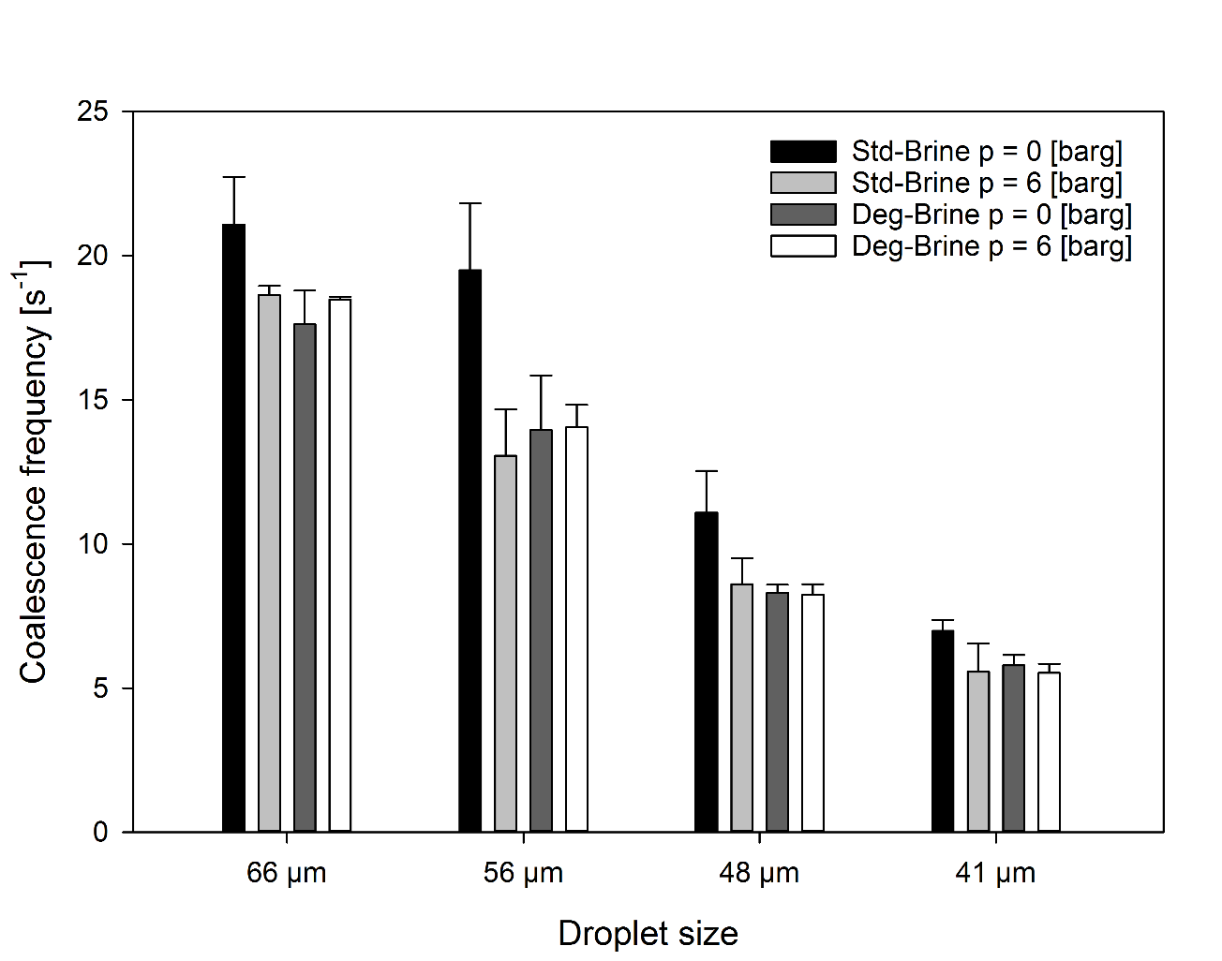
Figure 5. Coalescence frequencies of drops with different initial sizes in Std- and Deg-Brine at different pressure levels.
The coalescence frequencies decreased as the droplets became smaller, and this trend prevailed independent of the system pressure or the absence of dissolved gases. For all drop sizes, coalescence frequency decreased upon degassing at ambient pressure, whereas the coalescence frequency at higher system pressures resembled that of the degassed brine.
The models for drainage time t_{dr} have the general form of⁴¹:
$$t_{dr}=k\frac{μ*R^{a}}{γ^{c}*B^{d}}{(∆ρg)}^{b}$$ | (3)
where µ is the viscosity of the continuous phase, R is the radius of the coalescing droplet, γ is the interfacial tension, B is the modified Hamaker constant, Δρ is the density difference, g is the gravitational acceleration and a, b, c, d, k are positive constants. According to Equation 3, drainage times are expected to increase with droplet size, although literature is not unanimous on that account⁴²⁻⁴⁴. In our experiments the opposite was found, and an explanation could be that the modified Hamaker constant is an oversimplified approximation of the surface forces, acting on the droplets, as suggested by Grimes with regards to the coalescence in complex crude oil systems⁴⁵.
In our case, however, it is entirely possible that the hydrophobic interactions could have been incorrectly neglected in Equation 3 and when taking them into account, the total interaction energy between two drops can be expressed with the following equation³⁶:
$$V_{S}\left(kT\right)=\frac{R}{kT}\left[2πϵ_{0}ϵψ_{0}^{2}exp\left(-κH\right)-\frac{A_{121}}{12H}-A_{1}exp\left(-\frac{H}{λ_{1}}\right)-A_{2}exp\left(-\frac{H}{λ_{2}}\right)\right]$$ | (4)
where V_{S} is the total interaction energy between spheres in kT units, R is the spherical droplet radius, ϵ₀ϵ is the permittivity of water, ψ₀ is the particle’s electrostatic potential,
κ⁻¹ is the Debye length, H is the distance between the droplet surfaces and A₁₂₁ is the Hamaker constant. The values of constants A₁, A₂ and λ₁, λ₂ (decay lengths) are experimentally determined. The first term within the parentheses accounts for the repulsive double layer interactions and can be neglected in our case, due to the high salt concentration. The second term represents the attractive van der Waals interactions, included in the Equation 3 as the modified Hamaker constant, while the last two terms account for attractive hydrophobic interactions, which we showed to have an effect on the coalescence times between drops. It can be then concluded from Equation (4) that the interaction strength increases with droplet size and compensates for the larger volume of drained liquid, which is in agreement with the higher coalescence frequency found for the larger droplets.
In addition, we also have to consider the increased total flow rate, necessary for achieving the smaller sized droplets (see Table 2). This had a marked effect on the drop velocity and the initial amount of droplets, possibly leading to changes in the hydrodynamic forces, although Krebs mentioned that their effect on droplet coalescence was at most in the order of 25% where we find larger effects. Also other have stated that the coalescence frequency could be affected with substantiating to which extent^{26-27, 46-47}.
Model oil vs diluted crude oil.
In crude oil systems, surface-active components will be present, and that is discussed next. The coalescence frequencies of a model oil, consisting of a heptane-xylene mixture, and a crude oil diluted with similar heptane-xylene mixture are compared in Figure 6.
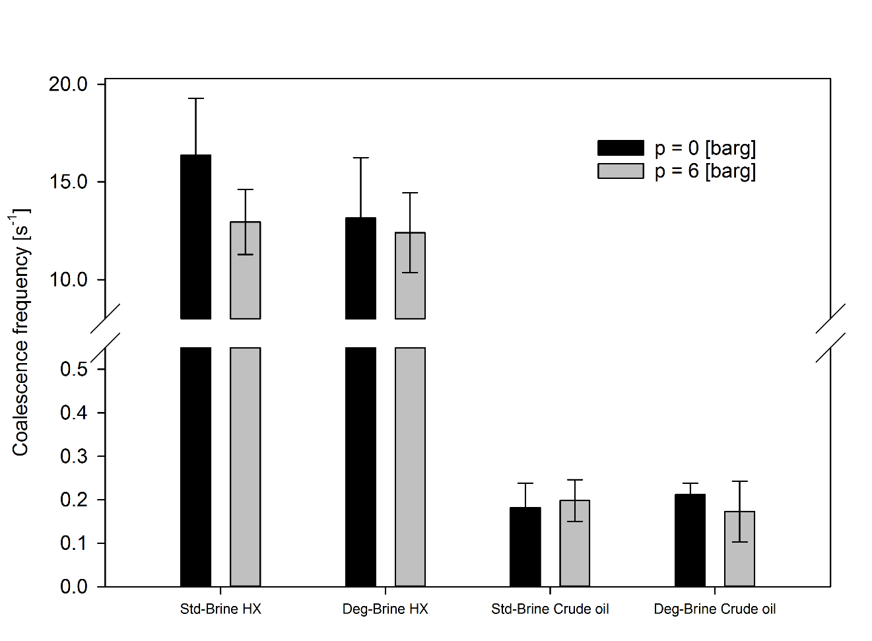Figure 6. Comparison of coalescence frequencies between the model oil and diluted crude oil in Std- and Deg-Brine at different pressure levels.
The behaviour of the model oil was similar as observed for other model oils used before: removal of dissolved gas resulted in slightly lower coalescence frequency at ambient pressure, while it had no effect at higher pressure. The diluted crude oil showed a reduction in coalescence frequency by a factor of 100, compared to the model oils. The number of non-coalesced drops was 5-20% for the model oils, while this was more than 90% for the diluted crude oil. If coalescence took place, a droplet coalesced only once or twice for the explored conditions. Furthermore, gas removal had no effect on the coalescence frequency irrespective of the applied pressure.
The different behaviour of the diluted crude oil systems can be attributed to the presence of resins and asphaltenes, which are responsible for the time-dependent alteration of the interfacial properties of crude oils⁴⁸. Although, the crude oil used in this study was light and contained relatively low amounts of resins and asphaltenes (5.1% and 0.3%, respectively), these amounts are more than sufficient to cover the oil water interface. In previous research we have shown that the asphaltenes can build up elastic layers at oil-water interfaces and increase the coalescence time⁴⁹, which may lead to a reduced coalescence frequency between crude oil drops. The lack of response to the removal of dissolved gas can also be explained by the presence of the interfacially active components. When these components (which contain heteroatoms such as oxygen, nitrogen and sulphur) adsorb at the oil-water interface, they will reduce the hydrophobicity of the drops. In accordance with the mechanism outlined above, this would result in less accumulation of dissolved gas close to the surface of the drops, which would lower the possibility of cavitation or vapour bridge formation between the droplets.

Conclusions
The effect of the dissolved gas on oil droplet coalescence in water (3.5% brine) was studied with microfluidic tools at ambient and elevated pressures. At ambient pressure, our results were in agreement with previous reports⁹⁻¹¹, where removal of dissolved gas resulted in enhanced emulsion stability. We observed no influence of the dissolved gas on emulsion droplet formation ^{12, 36}; however, coalescence between oil drops was affected, most probably through reduced cavitation, or vapour bridge formation. At elevated pressures, the removal of dissolved gas caused minor reduction in the coalescence for heptane, the most hydrophobic oil in our study, and no effects were noted in other emulsions.
Furthermore, the coalescence frequency of smaller droplets was lower than for large droplets, which could be explained by the theory for two interacting spheres. Therefore, it is likely that the increased interaction force for larger particles, together with the lack of electrostatic repulsion, have played a crucial role for the coalescence behaviour in our systems. We have also shown the drastic decrease of coalescence frequency for the diluted crude oil and its insensitivity to the presence of dissolved gases. Both the formation of viscoelastic films by resins and asphaltenes, as well as absence of hydrophobic nucleation sites may have contributed to the overall effect.
By utilizing microfluidic methods, it was possible to evaluate the oil droplet coalescence in standard and degassed conditions, at elevated pressure and by direct measurement. Since in the microfluidic devices process conditions can be varied systematically, we think that this type of study will greatly help in expanding the current knowledge base on droplet behaviour in general and on coalescence more specifically. Further work will include developing new methods for the measurements of coalescence frequency and time at higher system temperature and pressure, as a next step toward industrial applications.
Acknowledgments
This work was carried out as a part of SUBPRO, a Research-based Innovation Centre within Subsea Production and Processing. The authors gratefully acknowledge the financial support from SUBPRO, which is financed by the Research Council of Norway, major industry partners and NTNU. We additionally thank Maurice Strubel from Wageningen University for his technical advice and help during development of the setup.

References
1. Liao, Y.; Lucas, D., A literature review on mechanisms and models for the coalescence process of fluid particles. Chemical Engineering Science 2010, 65 (10), 2851-2864.
2. Shinnar, R.; Church, J. M., Statistical Theories of Turbulence in Predicting Particle Size in Agitated Dispersions. Industrial & Engineering Chemistry 1960, 52 (3), 253-256.
3. Chesters, A. K., The modelling of coalescence processes in fluid-liquid dispersions: a review of current understanding. Chemical Engineering Research and Design 1991, 69 (A4), 259-270.
4. Tanford, C., The Hydrophobic Effect: Formation of Micelles and Biological Membranes. 2 ed.; Wiley: New York, 1980.
5. Israelachvili, J.; Pashley, R., The hydrophobic interaction is long range, decaying exponentially with distance. Nature 1982, 300 (5890), 341-342.
6. Christenson, H. K.; Claesson, P. M., Direct measurements of the force between hydrophobic surfaces in water. Advances in Colloid and Interface Science 2001, 91 (3), 391-436.
7. Meyer, E. E.; Lin, Q.; Israelachvili, J. N., Effects of Dissolved Gas on the Hydrophobic Attraction between Surfactant-Coated Surfaces. Langmuir 2005, 21 (1), 256-259.
8. Faghihnejad, A.; Zeng, H., Hydrophobic interactions between polymer surfaces: using polystyrene as a model system. Soft Matter 2012, 8 (9), 2746-2759.
9. Karaman, M. E.; Ninham, B. W.; Pashley, R. M., Effects of Dissolved Gas on Emulsions, Emulsion Polymerization, and Surfactant Aggregation. The Journal of Physical Chemistry 1996, 100 (38), 15503-15507.
10. Ishida, N.; Sakamoto, M.; Miyahara, M.; Higashitani, K., Attraction between Hydrophobic Surfaces with and without Gas Phase. Langmuir 2000, 16 (13), 5681-5687.
11. Alfridsson, M.; Ninham, B.; Wall, S., Role of Co-Ion Specificity and Dissolved Atmospheric Gas in Colloid Interaction. Langmuir 2000, 16 (26), 10087-10091.
12. Pashley, R. M., Effect of Degassing on the Formation and Stability of Surfactant-Free Emulsions and Fine Teflon Dispersions. The Journal of Physical Chemistry B 2003, 107 (7), 1714-1720.
13. Francis, M. J.; Gulati, N.; Pashley, R. M., The dispersion of natural oils in de-gassed water. Journal of Colloid and Interface Science 2006, 299 (2), 673-677.
14. Sowa, B.; Zhang, X. H.; Kozielski, K.; Hartley, P. G.; Maeda, N., Influence of Dissolved Atmospheric Gases on the Spontaneous Emulsification of Alkane−Ethanol−Water Systems. The Journal of Physical Chemistry C 2011, 115 (17), 8768-8774.
15. Karagianni, M.; Avranas, A., The effect of deaeration on the surface tension of water and some other liquids. Colloids and Surfaces A: Physicochemical and Engineering Aspects 2009, 335 (1–3), 168-173.
16. Pashley, R. M.; Rzechowicz, M.; Pashley, L. R.; Francis, M. J., De-Gassed Water Is a Better Cleaning Agent. The Journal of Physical Chemistry B 2005, 109 (3), 1231-1238.
17. Rzechowicz, M.; Pashley, R. M., The effect of de-gassing on the efficiency of reverse osmosis filtration. Journal of Membrane Science 2007, 295 (1–2), 102-107.
18. Francis, M. J.; Pashley, R. M., The effects of feed water temperature and dissolved gases on permeate flow rate and permeate conductivity in a pilot scale reverse osmosis desalination unit. Desalination and Water Treatment 2011, 36 (1-3), 363-373.
19. Zhao, C.-X.; Middelberg, A. P. J., Two-phase microfluidic flows. Chemical Engineering Science 2011, 66 (7), 1394-1411.
20. Gu, H.; Duits, M. H. G.; Mugele, F., Droplets Formation and Merging in Two-Phase Flow Microfluidics. International Journal of Molecular Sciences 2011, 12 (4), 2572.
21. Bremond, N.; Bibette, J., Exploring emulsion science with microfluidics. Soft Matter 2012, 8 (41), 10549-10559.
22. Krebs, T.; Schroën, C. G. P. H.; Boom, R. M., Coalescence kinetics of oil-in-water emulsions studied with microfluidics. Fuel 2013, 106, 327-334.
23. Mazutis, L.; Griffiths, A. D., Selective droplet coalescence using microfluidic systems. Lab Chip 2012, 12 (10), 1800-6.
24. Mazutis, L.; Baret, J.-C.; Griffiths, A. D., A fast and efficient microfluidic system for highly selective one-to-one droplet fusion. Lab on a Chip 2009, 9 (18), 2665-2672.
25. Lee, M.; Collins, J. W.; Aubrecht, D. M.; Sperling, R. A.; Solomon, L.; Ha, J. W.; Yi, G. R.; Weitz, D. A.; Manoharan, V. N., Synchronized reinjection and coalescence of droplets in microfluidics. Lab Chip 2014, 14 (3), 509-13.
26. Krebs, T.; Schroen, K.; Boom, R., A microfluidic method to study demulsification kinetics. Lab on a Chip 2012, 12 (6), 1060-1070.
27. Krebs, T.; Schroën, K.; Boom, R., Coalescence dynamics of surfactant-stabilized emulsions studied with microfluidics. Soft Matter 2012, 8 (41), 10650-10657.
28. Köhler, J. M.; Henkel, T.; Grodrian, A.; Kirner, T.; Roth, M.; Martin, K.; Metze, J., Digital reaction technology by micro segmented flow—components, concepts and applications. Chemical Engineering Journal 2004, 101 (1), 201-216.
29. Ting, T. H.; Yap, Y. F.; Nguyen, N.-T.; Wong, T. N.; Chai, J. C. K.; Yobas, L., Thermally mediated breakup of drops in microchannels. Applied Physics Letters 2006, 89 (23), 234101.
30. Feng, H.; Ershov, D.; Krebs, T.; Schroen, K.; Stuart, M. A.; van der Gucht, J.; Sprakel, J., Manipulating and quantifying temperature-triggered coalescence with microcentrifugation. Lab Chip 2015, 15 (1), 188-94.
31. Krebs, T.; Ershov, D.; Schroen, C. G. P. H.; Boom, R. M., Coalescence and compression in centrifuged emulsions studied with in situ optical microscopy. Soft Matter 2013, 9 (15), 4026.
32. Timko, M. T.; Marre, S.; Maag, A. R., Formation and characterization of emulsions consisting of dense carbon dioxide and water: Ultrasound. Journal of Supercritical Fluids 2016, 109, 51-60.
33. Dudek, M.; Kancir, E.; Øye, G., Influence of the Crude Oil and Water Compositions on the Quality of Synthetic Produced Water. Energy & Fuels 2017, 31 (4), 3708-3716.
34. Carrier, O.; Funfschilling, D.; Li, H. Z., Effect of the fluid injection configuration on droplet size in a microfluidic T junction. Physical review. E, Statistical, nonlinear, and soft matter physics 2014, 89 (1), 013003.
35. Ninham, B. W.; Lo Nostro, P., Molecular Forces and Self Assembly in Colloid, Nano Sciences and Biology. 1 ed.; Cambridge University Press: Cambridge, 2010.
36. Maeda, N.; Rosenberg, K. J.; Israelachvili, J. N.; Pashley, R. M., Further Studies on the Effect of Degassing on the Dispersion and Stability of Surfactant-Free Emulsions. Langmuir 2004, 20 (8), 3129-3137.
37. Francis, M. J.; Pashley, R. M., Further studies into oil droplet size manipulation. Colloids and Surfaces A: Physicochemical and Engineering Aspects 2009, 334 (1), 100-106.
38. Kourio, M. J.; Gourdon, C.; Casamatta, G., Study of drop-interface coalescence: Drainage time measurement. Chemical Engineering & Technology 1994, 17 (4), 249-254.
39. Holmberg, K.; Jönsson, B.; Kronberg, B.; Lindman, B., Surfactants and Polymers in Aqueous Solution. Wiley: 2002.
40. Butler, I. B.; Schoonen, M. A. A.; Rickard, D. T., Removal of dissolved oxygen from water: A comparison of four common techniques. Talanta 1994, 41 (2), 211-215.
41. Slattery, J. C.; Sagis, L.; Oh, E. S., Interfacial Transport Phenomena. Springer US: 2007.
42. Ghosh, P., A Comparative Study of the Film-Drainage Models for Coalescence of Drops and Bubbles at Flat Interface. Chemical Engineering & Technology 2004, 27 (11), 1200-1205.
43. Ghosh, P.; Juvekar, V. A., Analysis of the Drop Rest Phenomenon. Chemical Engineering Research and Design 2002, 80 (7), 715-728.
44. Lang, S. B.; Wilke, C. R., A Hydrodynamic Mechanism for the Coalescence of Liquid Drops. II. Experimental Studies. Industrial & Engineering Chemistry Fundamentals 1971, 10 (3), 341-352.
45. Grimes, B. A., Population Balance Model for Batch Gravity Separation of Crude Oil and Water Emulsions. Part I: Model Formulation. Journal of Dispersion Science and Technology 2012, 33 (4), 578-590.
46. Zhou, Q.; Sun, Y.; Yi, S.; Wang, K.; Luo, G., Investigation of droplet coalescence in nanoparticle suspensions by a microfluidic collision experiment. Soft Matter 2016, 12 (6), 1674-1682.
47. Muijlwijk, K.; Colijn, I.; Harsono, H.; Krebs, T.; Berton-Carabin, C.; Schroën, K., Coalescence of protein-stabilised emulsions studied with microfluidics. Food Hydrocolloids 2017, 70, 96-104.
48. Sjöblom, J.; Aske, N.; Harald Auflem, I.; Brandal, Ø.; Erik Havre, T.; Sæther, Ø.; Westvik, A.; Eng Johnsen, E.; Kallevik, H., Our current understanding of water-in-crude oil emulsions.: Recent characterization techniques and high pressure performance. Advances in Colloid and Interface Science 2003, 100–102, 399-473.
49. Gaweł, B.; Lesaint, C.; Bandyopadhyay, S.; Øye, G., Role of Physicochemical and Interfacial Properties on the Binary Coalescence of Crude Oil Drops in Synthetic Produced Water. Energy & Fuels 2015, 29 (2), 512-519.

