* * * Submitted to the Journal of Cleaner Production * * *

Exploring the Pursuit of Sustainability in Reverse Supply Chains for Electronics

Bente Flygansvær
BI Norwegian Business School
Department of Accounting Auditing and Business Analytics
N-0442 Oslo, Norway
Phone +4746410467
E-mail bente.flygansvaer@bi.no

Robert Dahlstrom*
Joseph C. Seibert Professor of Marketing
Miami University Farmer School of Business - Department of Marketing
3017A Farmer School of Business, Oxford, Ohio U.S.A.
Phone 1 513 529-2097
&
BI Norwegian Business School - Department of Marketing
E-mail dahlstrf@miamioh.edu

Arne Nygaard
Kristiania University College
Postboks 1155 Sentrum
Kirkegaten 24-26, 0107 Oslo, Norway
Phone 952 43 656
E-mail arne.nygaard@kristiania.no
&
Norwegian University of Science and Technology (NTNU),
Department of Industrial Economics and Technology Management
Teknologivegen 22, 2815 Gjøvik, Norway

* Corresponding author

ACKNOWLEDGEMENTS: The authors thanks Lisa Ellram and Henry Yao for their insightful reviews of a previous version of this manuscript. We acknowledge Olga Masliak, Marius Glorvigen, Renas, and Per Halvard Øveren for technical support, advice and assistance.

Exploring the Pursuit of Sustainability in Reverse Supply Chains for Electronics

Abstract: This study examines reverse supply chains in the electronics industry. The analysis characterizes the flow of resources among firms in a reverse supply chain in the Norwegian electronics industry. The study subsequently examines influences of governance mechanisms and culture on the social, ecological, and economic performance in the supply chain. Based on principal-agency theory, the authors implicate collaboration, monitoring, and specific assets as determinants of the interfirm culture operating in the reverse supply chain. The interfirm culture and collaboration serve as antecedents to triple bottom line performance. Data collected with Norwegian electronics collectors indicate that collaboration and interfirm culture influence ecological, economic, and relational components of sustainable performance.

Keywords: reverse supply chains, agency theory, waste of electrical and electronic equipment, reversed logistics, circular economy, product life cycle management

1. Introduction

Sustainable supply chains enable firms to manage the flow of resources throughout production, consumption, and post-consumption (Carter and Rodgers, 2008). When properly designed and implemented, these supply chains enable firms to realize triple bottom line performance manifest in marked financial returns, reduced carbon footprints, and enhanced customer satisfaction (Elkington, 1998). The reverse supply chains employed to reclaim and reprocess products are important parts of sustainable supply chains (Linton, Klassen, and Jayaraman, 2007). Reverse supply chains in consumer electronics, for instance, enable firms to re-purpose integrated circuitry and recycle precious metals (Kasper et al. 2015).
Continuing innovation in the electronics results in an increasing supply of electronic waste and increasing demand to innovate the recycling of new products. The global electronics industry produces forty million tons of waste annually (Electronic-Waste-Facts 2017), yet only fifteen percent of this waste is recycled (Baldé, Wang, and Kuehr 2015). The annual sale of remanufactured products in the US alone, however, annually exceeds $50 million (Guide and Van Wassenhove 2007). The percent of reclaimed materials is low, yet the potential to re-purpose materials is significant. Proper management of WEEE (waste of electrical and electronic equipment) provides the opportunity to redirect products away from landfills while simultaneously yielding efficient sourcing of products and components (Babu, Parande, Basha 2007). Few studies, however, have examined how the structure and control of reverse supply chains influence triple bottom line performance.
The goal of this study is to gain an understanding of the productive management of reverse supply chains. As the amount of waste escalates, management increasingly incorporates recycling strategies into their operations. Informed decision making about the vitality of this practice must consider its ecological, social, and economic ramifications (Chabowski, Mena, and Gonzalez-Padron, 2011). Careful management of WEEE provides the opportunity to promote health, enhance environmental conditions, and raise financial performance. Analysis of a supply chain that has been successful in directing tons of materials away from disposal offers insight into the productivity of the reverse supply chain. Thus, we characterize a Norwegian reverse supply chain in which non-profit companies provide managerial direction in the recycling of electronics products and components.
We treat these non-profit firms as principals that direct the action of the agents engaged in the collection of used electronics. We augment this principal-agency approach (Eisenhardt, 1989) with logic from Bradach and Eccles (1989) that describe control mechanisms employed to regulate agent performance. We implicate monitoring, collaboration, and specific investments as determinants of the sustainable culture operating within a reverse supply chain. We further suggest that the interfirm culture plays a critical role in driving triple bottom line performance (Baumgartner and Zielowski, 2007). Florida’s (1996) groundbreaking analysis of product returns recognizes that the importance of relationship quality and social performance. Subsequent research by Guide et al. (2000), Östlin, Sundin, and Björkman, (2008), and Simpson (2010) similarly examines social interaction and its relationship with recycling. By contrast, research by Guide, Harrison, and van Wassenhove (2003) and Quariguasi et al. (2010) offer evidence of environmental and economic benefits of reverse supply chain. These analyses capture discrete facets of performance, yet they do not simultaneously examine the triple bottom line. We characterize the interfirm culture and implicate it as a mediator between control structures and triple bottom line performance.
We organized the paper to address these objectives. We begin by describing the empirical context. Drawing from agency theory, we subsequently describe control mechanisms that contribute to the ecologically oriented culture operating within a supply chain. We frame this culture as a determinant of economic, social, and ecological outcomes in the supply chain. We then describe and empirically assess our model. We conclude by highlighting implications of the research.
2. Norwegian Reverse Supply Chains for Electronics
Due to the potential to enhance value creation and secure sustainable development, reverse supply chains are important to industry practice and theory (Carter and Ellram, 1998). The context for this paper is the reverse supply chains for WEEE (Waste from Electrical and Electronic Equipment) in Norway. In 1998, the Norwegian Ministry of the Environment enacted legislation designed to protect against pollution and related waste. These regulations were further developed and harmonized with EU Directive 2002/96/EC in the Waste Regulations of 2006 for Norwegian WEEE practices (Li et al. 2013). Figure 1 depicts the flow of resources and information throughout the supply chain. The downstream movement of components reflects a typical stream of resources from raw materials procurement through consumption.
Figure 1 Norwegian Reverse Supply Chain for Electronic Waste, about here

Upon enactment of WEEE laws, producers of electronic materials were obligated to take part in industry-wide national reverse supply chains to uphold their producer responsibility. Domestic manufacturers and importers established recycling firms to facilitate reverse flows of electronics and established these industry-wide reverse supply chains. The entities charged with managing the reverse supply chains are the “recyclers” in figure 1. Because these recyclers oversee the operations of the collectors (i.e., agents), we treat them as principals in a principal-agency model (Eisenhardt 1989). The focus of our data collection is the relationship between the recycler (i.e., principal) and the collectors (i.e., agents) who act on behalf of the recyclers.
The recycler acts on behalf of the EE (electronic equipment) industry, and in particular EE-companies that are members of their reverse supply chain. A membership means that the EE-company delegates its producer responsibility to the recycling company. The producer responsibility is established as a part of Norwegian law, and implies many obligations. The main obligation is to ensure that producers (or importers) take responsibility for their products at end-of-life, and make sure that EE-equipment is recycled without the release of hazardous materials into the environment. The Norwegian government has set a fixed 80% collection level goal for WEEE at end-of-life (Kjellsdotter et al, 2015). It is essential to collect and recycle hazardous substances and flammable-, corrosive-, explosive- or toxic material that can be harmful to humans and the environment. When the recycler takes on this responsibility for their members, they charge a membership fee, and use this funding to buy services from the recycling industry. The services include a number of reclamation activities like collection, accumulation, sorting, handling, transportation, dismantling, and recycling. In these industry wide reverse supply chains, recycling and disposal are the only waste handling alternatives. For competitive reasons, producers and importers preclude recyclers and collectors from reselling their products.
The principal is a non-profit company, and the company’s main goal and vision is “no toxins on the loose.” They report on the triple bottom line performance to their stakeholders, which include the government, the EE-industry and supply chain members. Government is concerned with safeguarding the producer responsibility, which includes collection levels of WEEE-volumes and recovery and treatment of hazardous materials. The EE-industry and members of the reverse supply chain are concerned with effectiveness and efficiency, including satisfaction with the principal and low cost of operations.
The collectors perform a selection of these activities, including collection, accumulation, sorting, handling and transportation. The collectors’ task is to identify users of EE-equipment, and ensure that these products enter the reverse supply chain when defined as waste (at end-of-life). The recycling company has issued contracts to collectors (i.e., agents) that represent the recycler throughout the country. The contracts are standard across agents. In addition to outlining compensation prices (fixed price per ton of collected WEEE), the contracts address material handling, equipment accumulation, collection and transportation. The contracts further specify standards for the collection site locations, and they provide information to the final user of EE-equipment. The agents are able to compete against each other for EE volume and the effectiveness and efficiency of their operations determines their earnings.
3. Theoretical Model
Principal-agency theory focuses on situations under which one entity, the principal, delegates authority to another entity, the agent, to act on its behalf (Eisenhardt, 1989; Dubey et al., 2017). Supply chains offer many occasions under which a firm delegates authority to an agent (Ketchen and Hult, 2007). For example, managers of reverse supply chain for electronic waste engage agents to handle product collection, consolidation, and processing (Gregory and Kirchain, 2008).
Principals design supply chains to increase the likelihood that agent activity will lead to desired outcomes (Ciliberti et al., 2018). Manatsa and McLaren (2008), for instance, illustrate how incentive structures encourage information sharing in a supply chain. After relationships have been established, principals employ multiple divergent mechanisms to yield desired performance (Bergen, Dutta, and Walker, 1992). Bradach and Eccles (1989) offer a framework in which authority, trust, and price-based mechanisms regulate relationships within a supply chain (Homburg et al., 2009). Authority-based mechanisms rely on unilateral regulation wielded by the principal to guide agent behavior (Heide, 1994). Behavioral monitoring is an authority-based mechanism that focuses on principal regulation of the routines and procedures employed by agents in their efforts to produce desired outcomes (Vachon and Klassen, 2006). For example, companies operating reverse supply chains for electronic products supervise the amount of computer printers and televisions recovered by collectors. The efforts undertaken by the principal to monitor the agent activity are designed to align the goals of the principal and agent (Zsidisin and Ellram, 2003).
Trust-based mechanisms emphasize the development of social norms to regulate interaction. Simatupang and Sridharan (2002), for instance, illustrate how firms leverage collaboration to enhance supply chain performance. Supply chain collaboration involves two or more organizations working together to achieve greater success than could be achieved in isolation (Daugherty, 2011). Collaboration facilitates information sharing and incentive alignment that enhance interfirm interaction and performance (Simatupang and Sridharan, 2002 Airike, Rotter, and Mark-Herbert, 2016).
Price-based mechanisms refer to economic incentives that regulate supply chain performance. In many supply chain relationships, firms make specific investments associated with a trading partner (Williamson, 2008). In reverse supply chains, agents responsible for collecting electronics make specific investments in the operating procedures of the principal. These investments enable firms to contribute to the supply chain’s performance (Ghosh and John, 1999). Nevertheless, the potential to lose much of the value of this asset serves as an economic incentive to comply with the principal (Klein, 1980). For example, Jap and Ganesan (2000) offer evidence that a supplier’s specific investments are associated with the supplier’s commitment to a relationship.
We suggest that these trust, authority, and price-based mechanisms are crucial to establishing and maintaining an interorganizational culture that drives performance. We initially implicate these factors as antecedent to interfirm culture and subsequently identify antecedents to triple bottom line performance (See Fig. 1). Consider first the relationship between control structures and the interorganizational culture.
Figure 2 Proposed antecedents and consequences of interfirm
sustainability-oriented culture, about here

3.1 Antecedents to Interfirm Culture

Corporate culture is manifest in the shared values and beliefs that help individuals understand organizational functioning and that provide norms for behavior (Schein, 1984; Dubey et al., 2017). We focus on the degree to which the interfirm culture adopts an ecological focus.
Two elements central to interfirm culture include the shared vision and patterns of behavior (McAfee, Glassman, and Honeycutt, 2002). The shared vision refers to the extent to which expectations are shared among members of the supply chain. Shared vision is essential to long-term exchange relationships because productive combination of strategic resources is only realized if the firms have systems compatible enough to facilitate coordinated action (Matinheikki, Rajala, and Peltokorpi, 2017; Dyer and Singh, 1998). The ecological orientation of the agency is one facet of the norms of behavior essential to the supply chain’s culture (Vachon and Klassen, 2006). This orientation examines the degree to which the culture is sensitive to environmental concerns. Firms that educate employees regarding ecology, for instance, have strong ecologically-oriented cultures.
The control mechanisms employed by the principal are likely to influence the shared vision within the reverse supply chain. Monitoring addresses effort undertaken by one party to measure the performance of another. Supply chain principals monitor agents concerning their compliance to procedures and system requirements. Prior research indicates that monitoring can weaken or strengthen relationships. Heide, Wathne, and Rokkan (2007) indicate that behavioral monitoring enhances the likelihood of agents to produce defensive attitudes that lead to weaker relationships with principals. By contrast, Ciliberti, Pontrandolfo, and Scozzi (2008) characterize the level of monitoring operating in five multinational supply chains. Principal monitoring provides a context in which supply chain partners can discuss problems and collectively find solutions. IKEA, for instance, closely monitors supplier activity, and this action leads to better appreciation of the sustainable goals of the firm (Andersen and Skjoett-Larsen, 2009). Monitoring by the principal raises the awareness of supply chain contingencies leading to a shared vision within the reverse supply chain.
Principal monitoring of agency behavior should also accentuate environmental sensitivity. Klassen and Vachon (2003) illustrate positive benefits of behavioral monitoring. When principals implement audits and formalize evaluation processes, they signal to their agents concerning the importance placed on environmental issues. Agents respond to this heightened monitoring by enhancing their sensitivity to ecological matters. Therefore, we propose the following:
H1: Principal monitoring enhances the interfirm culture operating in the supply chain.

Collaboration should also influence the interfirm culture in the supply chain. Some level of collaboration is essential to developing interfirm culture, yet principals and agents vary in the degree of their collaboration (Boddy, Macbeth, and Wagner, 2000). In their analysis of the beverage industry, for example, Nidumolu et al. (2014) describe collaboration between Coca-Cola and Latin American Water Funds. Collaborative initiatives led to a common understanding about the supply chain factors that influence water quality and supply. Working together provided the opportunity to voice concerns and incorporate priorities into a common understanding of supply chain objectives (Krishna, 2011).
Collaboration between principal and agent promotes understanding of how the supply chain affects the environment and leads trading partners to heightened sensitivity to ecological matters (Herczeg, Akkerman, Hauschild, 2018). Klassen and Vachon (2003) report an association between supply chain collaboration and the ecological orientation of firms in the supply network. Klassen and Whybark (1999) likewise recognize that collaboration on pollution controls leads to managerial systems oriented toward conservation. In each case, as collaboration increased, firms increasingly became more attuned to ecological concerns. Therefore, we propose the following:
H2: Principal-agency collaboration enhances the interfirm culture operating in the supply chain.

The specific investments in the principal also influence the interfirm culture. A key aspect of firm-specific assets is the experiential knowledge gained about the firm’s resources and capabilities (Penrose, 1959). As agents acquire this knowledge, they become more aware of the shared knowledge residing with the principal (Mahoney and Kor, 2015). Agency investments in the unique operating procedures prompt them to take action to ensure their productive use (Rindfleisch and Heide, 1997). Agents ensure the productive use of these investments by embracing the ecological objectives of principals (Coggan, Whitten, Bennett, 2010). Since these investments lose much of their value if they are re-deployed, agents stand to lose considerably if they do not act to ensure the productive use of these assets (Rokkan, Heide, Wathne, 2003). Xie, Suh, and Kwon (2010) similarly find that idiosyncratic assets yield greater commitment to supply chain relationships. Therefore, we propose the following:
H3: Agent specific investments in the principal enhance the interfirm culture operating in the supply chain.

3.2 Antecedents to Triple Bottom Line Performance

Triple bottom line performance examines the firm’s efforts to secure ecological, social, and economic performance (Elkington, 1997). We examine ecological performance as the level of agency product reclamation and resource (e.g., energy) conservation. The agency’s satisfaction with the principal serves as a measure of social performance (Cambra-Fierro and Polo-Redondo, 2008). Satisfaction with principal addresses the extent to which an agent evaluates interactions with the principal as gratifying and fulfilling (Geyskens and Steenkamp, 2000). Economic performance refers to the perceived financial return from the relationship with the principal. This construct addresses the agent’s economic outcomes derived from the principal (Geyskens, Steenkamp, and Kumar, 1999).
The level of collaboration and the interfirm culture should influence the ecological performance of the agency (Franco, 2017). Vachon and Klassen (2008) indicate that environmental collaboration with customers yielded higher scrap rates in the North American package printing industry. Similarly, Hond (1998) indicates that cooperation in auto recycling channels facilitated the implementation of cooperative recycling strategies. Benjaafar, Li, and Daskin (2013) identify conditions under which interfirm collaboration yields lower levels of ecological influence. Their models recognize that collaboration enables firms to take into account how their decisions influence the carbon footprint of the firm. Lee (2011) also illustrates how collaboration between Hyundai and its suppliers reduced the carbon footprint associated with automobile raw materials, manufacturing, and distribution.
The shared vision and ecological orientation of the interfirm culture call attention to environmental impact of the supply chain. Shared vision in the chemical industry, for instance, enables Raytheon to communicate their sustainability objectives to suppliers. As a result, firms are able to implement strategies that lower their output of VOC’s and solid waste (Reiskins et al., 1999). When principal and agent have a common understanding of objectives, agents are inclined to work toward achieving these goals. Griffiths and Myers (2005), for instance, illustrate a relationship between information sharing and performance. As trading parties become aware of the goals of trading partners, they are in a better position to act to achieve these goals.
The ecological orientation within the reverse supply chain similarly draws attention to the principal’s priorities (Handfield, Sroufe, and Walton, 2005). To the extent that these priorities reflect environmental factors, agents respond by lowering their environmental influence (Toffel, 2004). Agency awareness of the ecological orientation of the trading partners enables them to engage in activities that benefit the reverse supply chain. Therefore, we propose the following:
H4: The ecological performance of agents is enhanced via:
- Collaboration between the agent and principal and
- The interfirm culture operating in the supply chain.

Triple bottom line considerations necessarily involve economic performance. Prior research indicates that suppliers and customers seek collaborative relationships as a way of improving performance (Ittner and Larcker, 1997). For example, Duffy and Fearne (2004) illustrate conditions under which food retailers and their suppliers benefit from partnerships. Mohr and Spekman (1994) similarly indicate that coordination of interfirm activities enhances performance. Throughout the process of collaborating, firms share information that enables them to work together to address potential inefficiencies in reverse supply chains (Sheu, Yen, and Chae, 2006). Relationships characterized by collaboration yield higher levels of profitability and sales growth (Hoegl and Wagner, 2005). In addition, collaboration leads to lower service-related costs and enhanced supply chain cash flows (Stank, Keller, and Daugherty, 2001).
The culture operating within the supply chain should also influence economic performance. Nestlé built a cluster of firms that supply coffee. The company established a shared vision about logistical, agricultural, and technical capabilities leading to higher productivity for the principal and agents (Kramer and Porter, 2011). The 3M Corporation similarly designed cooperative, ecologically-oriented systems that yielded lower costs and enhanced revenues (Shrivastava, 1995). In both cases, awareness of the ecological orientation enabled agents to address these constraints while enhancing productivity.
H5: The level of economic performance is positively related to:

- Collaboration between the agent and principal and
- The interfirm culture operating in the supply chain.

Collaboration and interfirm culture should also influence social performance (Sheu, Yen, and Chae, 2006). Elkington (1998) emphasizes that the assessment of social performance should examine the impact of a company on people. We therefore examine the level of agency satisfaction with the principal as a component of social performance. Firms that work together toward shared goals foster an environment of open communication in which partners develop high levels of satisfaction and commitment (Rota, Reynolds, and Zanasi, 2013). Nidumolu et al. (2014) also offer evidence that external collaboration enhances the commitment to trading partners within a supply chain. Similarly, shared vision provides trading partners with a level of comfort concerning how the organization will achieve objectives (Kantabutra and Avery, 2007). The ecological orientation of the principal serves as a bond that engenders higher levels of satisfaction with the relationship (Jonsson and Zineldin, 2003). Therefore, we propose the following:
H6: Agency satisfaction with the principal is positively related to:

- Collaboration between the agent and principal and
- The interfirm culture operating in the supply chain.

4. Method

4.1 Research design, measures and sample identification
We collected data through a cross-sectional design, using a survey instrument. With the exception of the interfirm culture and the ecological performance measures, the survey instrument was based on existing scales, adopted for this study. We operationalized the key study variables using multi-item reflective scales. The survey items and response formats appear in Table 1. We define three sets of measures below associated with control mechanisms, interfirm culture, and triple bottom line performance.
Table 1 Measurement indicators, about here

Control mechanisms. The control mechanisms include collaboration, monitoring, and specific investments (Bradach and Eccles, 1989). The collaboration scale examines the extent to which the agents perceive that the principal works together with them on their activities. The scale is adapted from Gavronski et al. (2011). The monitoring scale describes the extent to which the agents perceive that the principal oversees their behavior and activities in a formal manner (Heide 2003). The specific investment scale focuses on firm-specific knowledge obtained by the agent. In these recovery relationships, it is germane to understand the procedures associated with product handling, sorting, and processing. Therefore, we have adapted a scale measuring agent investments in the reverse supply chain (John and Weitz, 1989).
Interfirm culture. Interfirm culture addresses the shared vision and ecological orientation within principal-agent relationships (McAfee et al., 2002). Shared vision represents agent perceptions of their common understanding with the principal regarding environmental matters (Dyer and Singh, 1998). Eco-oriented culture reflects the agent evaluation of the supply chain’s standing on environmental matters (Vachon and Klassen, 2006). The measures are developed for this research.
Triple bottom line performance. Triple bottom line performance addresses the economic, social, and ecological outcomes (Elkington, 2007). Economic performance is adapted from Bello and Gilliland (1997), whereas satisfaction is developed based on Johnson, Krapfel, and Grimm (2001) and Ruekert and Churchill (1984). The ecological performance variables refer to interaction with the physical environment.
We developed the measures of interfirm culture and environmental performance following recommended guidelines for psychometric scales (Anderson, 1987). Based on a literature review, we generated five-point, Likert-based scale items addressing shared vision, ecological orientation, and ecological performance. Supply chain management and marketing faculty subsequently classified measures into respective groups. Inter-rater reliability (Perreault and Leigh, 1989) among five faculty asked to distinguish between shared vision and ecological orientation was (.92), whereas inter-rater reliability among five separate faculty assessing ecological orientation and ecological performance was (.89).
Prior to distributing the survey, we asked members of the supply chain to assess the face validity of the measures. Face validity is a minimum first step in validation that involves asking people with expertise in a field to assess the survey measures (Bryman and Bell, 2015). We adapted the measures to the industry terminology, and asked a pilot sample to evaluate them. The pilot sample testing the questionnaire consisted of five key informants. We identified the pilot sample from a mix of collector locations distributed across the country. In this manner, we ensure that geographical variance in terminology use and interpretation did not affect the results. We also included the key informant at the recycling company to get the views from both sides of the agency relationship. The pilot sample was asked whether the measures reflected their business and operations, and to comment on the specific industry language. We received some corrections and adjusted the questionnaire accordingly.
We initially developed all measures for the survey in English. After translating into Norwegian, we used collaborative, iterative process to back-translate the measures into English (Douglas and Craig, 2007). There were no meaningful differences between the surveys suggesting that translation does not significantly alter assessment of constructs.
We distributed the survey to all collectors (agents) in the reverse supply chain. We identify the agents from those collectors that have a contract with the principal at the time of the survey. The recycling company has issued a contract to every individual collector location, irrespective of ownership structure (i.e. two or more locations may be part of the same company). In total, at the time of the survey, there were 190 collector locations within the network. We used a key informant approach (John and Reve, 1982) in our survey. The identified key informant is the local agent responsible for each collector location. The recycling company provided us with a list of all key informants, but some agents represent more than one location. Elimination of duplicates yielded a sampling frame of 159 agents.
The survey was distributed online using the Qualtrics platform. An introductory email explained the purpose of the study and provided a contact for questions. The advantage of online survey solutions is the convenience of distribution. It is cost-efficient and easy for the respondents to answer in their own time, and it avoids potential interviewer bias. The Data Protection Official for research in Norway (nsd.uib.no) reviewed the survey. The survey was distributed non-anonymously. Therefore, it was easy to track each respondent and run dedicated follow-ups to those that had not answered, and those that provided missing data. We ran a series of follow-ups by email and telephone. We received completed responses from 102 agents, representing 64 % (102/159) of the population. Comparison of data from early and late responses evinced no statistically significant differences which suggests that non-response bias has a minimal effect on the pattern of results (Armstrong and Overton 1977)
Since some of the measures were developed for this study, we initially analyzed the data using the guidelines established by Churchill (1979). Coefficient alpha and exploratory factor analysis provided the basis for assessing convergent validity. Based on this process, we dropped one item (We have developed a mutual understanding of responsibilities) from the collaboration scale and two items (Our interactions are based on prescribed rules and procedures; Our interactions are subject to a lot on prescribed rules and procedures stating responsibilities) from the monitoring scale. We similarly removed two items (We have made significant effort to educate our employees about the importance of the environment; We recognize the importance we place on the environment) from the ecological orientation scale. No items were removed from the shared vision, economic performance, and satisfaction scales.
After the removal of two items (Our action leads to limited climate change; Our action leads to reduced volumes of waste), exploratory factor analysis of the ecological performance measure evinced two constructs. The environmental footprint consisted of four items assessing the agency’s influence on broad environmental factors such as energy conservation and water quality. The recycling measure consisted of three items assessing the level of sorting and recycling of electronic waste.
5. Results

We employed partial least squares structural equation modeling (PLS-SEM) to assess the proposed model. PLS-SEM is a causal modeling technique focused on maximizing the explained variance of dependent latent constructs (Hair, Ringle, Sarstedt, 2011). It is a recommended technique in early stages of research when validating exploratory models (Mondéjar-Jiménez et al., 2016). PLS modeling consists of two sections, the measurement and structural models.
Figure 3 The specified factor loadings, about here

The measurement model examines the relationships between constructs and their indicators. For example, the economic performance construct consists of four reflective measures. Figure 2 provides a synopsis of the factor model and enumerates all relationships between constructs and their indicators. Item reliability was assessed by examining factor loadings that were lower than (.50). Since the deletion of the fourth satisfaction measure led to increased average variance extracted (AVE) for the satisfaction measure, we deleted this item (Hair et al., 2014). No other variables or constructs were deleted on this basis.
Table 1 provides summary statistics for the measurement model. Although the coefficient alpha for monitoring is low at .69, it evinces acceptable composite reliability and AVE. Summary indicators of all other constructs support the validity of the measurement model.
We subsequently employed the Fornell Larcker (1981) criterion comparing the AVE of each construct with other latent variables correlates (see Table 2). The Fornell–Larcker (1981) criterion proposes that a latent construct shares more variance with its assigned indicators than with other latent variable in the structural model. The discriminant validity of a set of measures is supported when the square root of the AVE for each construct is higher than the correlation with other construct (Das, 2017). All scales in our study meet this criterion for discriminant validity.
Table 2 Fornell-Larcker criterion, about here

5. 1Descriptive Statistics
Table 3 provides a summary of the mean and distribution of all constructs in the model. All scales were assessed using five-point Likert-type questions ranging from 1 (low) to 5 (high). The standardized means for the governance mechanisms indicate relatively higher levels of principal monitoring (mean = 3.9) than collaboration (mean = 3.5) and specific investments (mean = 3.2). The reported levels of shared vision (mean = 4.4) and ecologically-oriented culture (mean = 4.1) are substantial and suggest a strong ecological focus in the interfirm culture. Among triple bottom line performance measures, agents report relatively highest levels of recycling (mean = 4.5) followed by environmental footprint (mean = 4.0), satisfaction (mean = 4.0), and lastly, economic performance (mean = 3.3). Analysis of the histogram distribution indicates unimodal distribution of the data about the mean for the monitoring construct. All other variables evince a bi-modal distribution where 85-90% of the data are distributed about the mean, yet the remaining reports are distributed at the low end of the metric.
Table 3 Descriptive Statistics, about here

5.2 Tests of Hypotheses

The structural model specifies the relationships among constructs (See figure 4). We employed a second-order model in which the shared vision and ecological orientation constructs are treated as components of the interfirm culture (Becker, Klein, Wetzels, 2012). The series of equations for endogenous constructs is:
Interfirm Culture = β₁₁ Monitoring + β₂₁Collaboration + β₃₁ Specific assets + Z₁
Ecological Footprint = β₁₂ Collaboration + β₂₂ Interfirm Culture + Z₂

Recycling = β₁₃ Collaboration + β₂₃ Interfirm Culture + Z₃
Economic performance = β₁₄ Collaboration + β₂₄ Interfirm Culture + Z₄
Satisfaction = β₁₅ Collaboration + β₂₅ Interfirm Culture + Z₅

Figure 4 The specified structural model, about here

Prior to examining the structural model, we examined the variance inflation factors. Since none of these indicators exceeded 1.6, the results do not seem to be substantially compromised by collinearity. We subsequently used a blindfolding technique (Hair et al., 2014) to assess the predictive relevance of the model. The Q² statistics all exceed zero and suggest that the accuracy of the path model is acceptable (Mondéjar-Jiménez et al., 2016). In addition, the range of adjusted R² (.09 - .48) suggests that exogenous variables explain some portion of the variance in the endogenous constructs.
Table 4 and Figure 5 summarize the specified structural model implicating governance mechanisms as determinants of culture and performance. H1-2 examining antecedents to interfirm culture are supported as principal monitoring (β₁₁ = .199, p > .05) and collaboration with the principal (β₂₁ = .428, p<.05) enhance the interfirm culture. In contrast to H3, specific assets (β₃₁ = .158, p >.05) are unrelated to interfirm culture.
Table 4 The specified structural model: antecedents to
triple bottom line performance about here

The second series of equations examined antecedents to triple bottom line performance. Since factor analysis identified two facets of ecological performance, we examined discriminant influences on environmental footprint and recycling. In contrast to H4a, collaboration (β₁₃ = .135 p >.05) does not reduce a firm’s environmental footprint. Interfirm culture (β₂₂ = .405, p < .05), however, is associated with lower environmental footprints. Collaboration (β₁₃ = -.063, p >.05) does not foster recycling efforts, yet interfirm culture (β₂₃ = .428, p>.05) enhances recycling. Although the direct effects of collaboration are non-significant, the indirect effect of collaboration on environmental footprint (β =.174, p < .05) and recycling (β = .183, p < .05) is significant. These results support H4b for both facets of environmental performance, but not H4a.
H5 and H6 examined antecedents to economic performance and satisfaction, respectively. Collaboration (β₁₄ = .107, p > .05) is not significantly associated with economic performance, but interfirm culture (β₂₄ = .253, p < .05) raises economic performance. The indirect effect of collaboration is significant (β = .109, p < .05). Collaboration (β₁₅ = .19, p < .05) and interfirm culture (β₂₅ = .13, p > .05) raise the level of satisfaction. These results support H5a, H6a-b, but not H5b.
Figure 5 provides a summary of all statistically significant relationships examined in the proposed model. The data suggest that principal monitoring of agents and collaboration between principal and agent enhances the interfirm culture in the supply chain. The culture subsequently enhances the agent’s environmental footprint, recycling efforts, economic performance, and satisfaction. In addition, interfirm collaboration enhances satisfaction.
Figure 5 Summary of findings about here

6. Discussion

The goal of this study has been to gain an understanding of the productive management of reverse supply chains. The study adopted a principal-agency approach that framed control structures as antecedent to the shared culture between the recycler and its collectors (i.e., agents). Principal monitoring and interfirm collaboration enhance the interfirm culture within reverse supply chain. The study also illustrates the role that an interfirm culture plays in reverse supply chain. The data indicate that the agent’s interfirm culture enhances all measured facets of triple bottom line performance. Prior to examining the implications of these results, consider the limitations in this study.
6.1 Limitations
The nature of the industry should be considered when interpreting these results. As agents who make their livelihood from recycling electronic waste, it is not surprising that they evince strong ecological orientations. Future studies should examine the ecological orientation of other members of the supply chain (e.g., retailers, consumers). Similarly, research examining the ecological orientation in other contexts may yield contrasting results.
A second limitation of the study is the source of data. When all data are collected via a single source (i.e., agent surveys), there is potential for common method bias (Podsakoff et al., 2003). Although the response rate was relatively robust, the Norwegian population is relatively low and the number of recycling agents is modest. The authors tested a series of models that compared free estimates of the covariance of two constructs with models that constrained the covariance at 1. All analyses indicated enhanced fit for the free estimates suggesting discriminant validity among the constructs. Nevertheless, the data do not afford the opportunity provide more comprehensive assessments of method bias. Recent research underscores the need (Ralston, Richey, and Grawe 2017) to consider the influences of collaboration on perceived and objective performance criteria. A larger sampling frame that employs data collected from multiple vantage points would offer greater insight into the role of collaboration.
6.2 Theoretical Implications

Our study is consistent with Bradach and Eccles (1989) framework advocating the use of authority, price, and trust-based mechanisms to regulate relationships within a supply chain.
Monitoring of agents represents an authority-based control mechanism. Prior research offers two perspectives concerning the influences of monitoring on interfirm culture. Heide et al. (2007) employ data from the construction industry to support their contention that behavioral monitoring produces defensive attitudes and weaker relationships. By contrast, Ciliberti et al. (2008), examine manufacturers that have adopted a corporate social responsibility system within the supply chain. Consistent with Ciliberti et al. (2008), we find principal monitoring fosters shared vision and heightened sensitivity to ecological concerns among agents. The reverse supply chains in our study and the supply chains analyzed by Ciliberti et al. (2008) consist of firms that have made substantial efforts to establish sustainability-oriented cultures that emphasize interfirm relationships as well as ecological and economic performance. In Heide et al.’s (2007) research, however, firms did not have a triple bottom line sustainability agenda. To the extent that principals actively develop strong social relationships within the supply chain, agents may be more likely to view monitoring as a mechanism for enhanced dialogue (Saffold, 1988). Future research should consider how the decision to move forward with a sustainability-oriented culture influences the utility of monitoring as a governance mechanism.
Specific assets lose much of their value should an agent elect to leave the supply chain. Consequently, these investments provide a price-based mechanism for regulating agency relationships. Our study stands in contrast to Coggan et al., (2010) who recognize that agents ensure the productive use of idiosyncratic assets by adopting the ecological practices of the principal. Rørtstad, Vatn, and Kvakkestad (2007) underscore the importance of transaction costs associated with an agent’s specific investments. To the extent that transaction costs are low, agents have limited need to foster collective vision consistent with the principal. Future studies should augment the current research via analysis of the transaction costs generated by each agent. In addition, research would benefit from analyzing a broader set of specific assets that include site, physical, and knowledge-based investments.
Collaboration between the principal and agent serves as a form of trust-based control regulating the relationship. Consistent with Krishna (2011), we offer evidence that collaboration enhances the shared vision between firms. Our results also corroborate prior research (Vachon and Klassen, 2006) illustrating conditions under which collaboration enhances the ecologically oriented culture in the reverse supply chain. Three of the four hypotheses implicating collaboration as a determinant of triple bottom line performance are not supported. Although variance inflation factors were low, the effects of collaboration are reduced due to the collinearity with the interfirm culture. The observed indirect effect of collaboration on the environmental footprint is consistent with prior studies implicating collaboration as antecedent to scrap sales (Vachon and Klassen, 2008) and recycling (Hond 1998). Similarly, the indirect effect of collaboration on economic performance is consistent with Kramer and Porter (2011). The results suggest a more parsimonious model that frames interfirm culture as a mediator of collaboration on performance. When the interfirm culture is rich, collaboration enhances the culture yielding triple bottom line performance.
Our results suggest that interfirm culture is a determinant of triple bottom line performance. Based on Griffiths and Myers (2005) report that information sharing yields better performance, we implicated shared vision as a driver of ecological, relational, and economic performance. The data suggest that the shared vision and ecological orientation in the culture enhance all facets of performance. Reich and Benbasat (2000) indicate that shared vision is most effective when it is accompanied by short-term business objectives. Planning processes that prioritize goals and specify short and long-term objectives can raise the level of shared vision and its efficacy as a driver of triple bottom line performance. Thus, future research should enhance the current study via analysis of the short-term business objectives.
The data indicate that an agent’s ecological orientation is related to multiple facets of triple bottom line performance. As described by Handfield et al. (2005), the agent’s ecological orientation draws attention to the principal’s priorities leading to better ecological performance (including recycling efforts and environmental footprint) and heightened perceived economic performance. Additional research could augment these findings by examining conditions under which the firm’s ecological orientation leads to trade-offs between facets of the triple bottom line. Thus, a heightened ecological orientation may yield ecological benefits but at appreciably higher costs to the firm.
6.3 Managerial Implications

Despite the limits endemic to the research design and data, the results provide some insight to managers of reverse supply chain. Managers of recycling systems that seek to enhance triple bottom line performance should foster an ecologically oriented culture. When agents recognize the environmental focus of the network, recycling efforts, overall environmental footprints, perceived economic performance, and satisfaction with the principal flourish. The ecological orientation can be enhanced by principal’s efforts to collaborate and via efforts to monitor agent behavior. In some supply chains, the pursuit of shared vision is a goal unto itself. Bowersox, Closs, and Stank (2000), for instance, underscore the need for supply chain partners to have a common vision of the value creation process. Firms interested in enhancing shared vision in a reverse supply chain should recognize the merits of principal monitoring of agency action and interfirm collaboration.
The role of collaboration as a governance mechanism should be examined by the principal. Collaboration not only enhanced the interfirm culture, it also enhanced the level of satisfaction within the reverse supply chain. While these results emphasize the role of collaboration, managers of these relationships should recognize that interfirm interaction involves the interface of two or more firms with separate organizational designs, corporate cultures, and incentive systems (Benavides, Eskinazis, and Swan 2012). Firms that foster collaboration should consider how it can be used in conjunction with organizational design and incentives to achieve desired reverse supply chain outcomes.
7. Conclusion

The goal of this study has been to gain an understanding of the productive management of reverse supply chains. We characterized the flow of resources among firms engaged in the recycling of used electronics. Our empirical model subsequently used principal-agency logic to implicate governance structures as antecedent to interfirm culture. Principal monitoring and interfirm collaboration serve as governance mechanisms that enhance the interfirm culture leading to heightened triple bottom line performance.
The utility of our model and results can be extended by examining the interfirm culture operating in other industries that have adopted circular economy strategies (Manninen et al. 2018). The efficacy of governance structures and interfirm culture in industries such as the automobile and construction industries would provide insight into theory and practice. The recyclers that serving these industries and the electronics are often interconnected due to the common materials provided by each of these industries (Toffel 2004). The degree to which these interfirm networks augment other governance mechanism is a next step in this stream of research. Inter-industry standards for reverse supply chains may use develop governance standards that augment the efficacy of the interfirm culture as a determinant of triple bottom line performance. Our theoretical model and findings be insightful to this research.
References

Airike, P., Rotter, J., Mark-Herbert, C. 2016. Corporate motives for multi-stakeholder collaboration– corporate social responsibility in the electronics supply chains. J. Clean. Prod. 131, 639-648.
Andersen, M., Skjoett-Larsen, T., 2009. Corporate social responsibility in global supply chains, Supply Chain Manag.: An Int. J. 14, 75–86.
Anderson, J. C. 1987. An approach for confirmatory measurement and structural equation modeling of organizational properties, Manage. Sci. 33, 525-541.
Armstrong, J. S., Overton, T. S., 1977. Estimating nonresponse bias in mail surveys J. Mark. Res. 14, 396-402.
Babu B. R., Parande A. K., Basha C. A., 2007. Electrical and electronic waste: a global environmental problem. Waste Manag Res. 25, 307–18.
Baumgartner, R., Zielowski, C. 2007. Analyzing zero emission strategies regarding impact on organizational culture and contribution to sustainable development. J. Clean. Prod. 15, 13/14, 1321-1327.
Baldé, C. P., Wang, F., Kuehr, R., Huisman, J., 2014. The global e-waste monitor: quantities, flows and resources. United Nations University, Bonn, Germany
Becker, J. M., Klein, K., Wetzels, M. 2012. Hierarchical latent variable models in PLS-SEM: guidelines for using reflective-formative type models. Long Range Plann. 45, 359-394.
Bello, D. C., Gilliland, D. I., 1997. The effect of output controls, process controls and flexibility on export channel performance, J. Mark. 61, 22-38.
Benavides, L., Eskinazis, V. D., Swan, D., 2012. Six steps to successful supply chain collaboration. SCMP’s Supply Chain Q. Q2, 23.
Benjaafar, S., Li, Y., Daskin, M., 2013. Carbon footprint and the management of supply chains: Insights from simple models, Autom. Sc. Eng. IEEE Trans. 10, 99-116.
Bergen, M., Dutta, S., Walker Jr., O.C., 1992. Agency relationships in marketing: a review of the implications and applications of agency and related theories, J. Mark. 56, 1-24.
Boddy, D., Macbeth, D., Wagner, B. 2000. Implementing collaboration between organizations: an empirical study of supply chain partnering. J Manag. Stud. 37, 1003-1018.
Bowersox, D, Closs, D, Stank, T., 2000. Ten mega-trends that will revolutionize supply chain logistics, J. Bus. Logist. 21, 1-15.
Bradach, J., & Eccles, R. (1989). Price, authority, and trust: from ideal types to plural forms. Ann. Rev. Soc. 15, 97-118.
Bryman, A., Bell, E., 2015. Business Research Methods. Oxford University Press, USA.
Cambra-Fierro, J. J., Polo-Redondo, Y., 2008. Creating satisfaction in the demand-supply chain: the buyers' perspective, Supply Chain Manag.: An Int. J. 13, 211-224.
Carter, C.R. and Ellram, L.M., 1998. Reverse logistics: a review of the literature and framework for future investigation. J. Bus. Logist. 19, 85-102.
Carter, C.R. Rogers, D.S. 2008. A framework of sustainable supply chain management: moving toward new theory, Int. J. Phys. Distrib. Logist. 38, 360-387.
Chabowski, B.R., Mena, J.A. Gonzalez-Padron, T.L., 2011. The structure of sustainability research in marketing, 1958–2008: a basis for future research opportunities, J. Acad. Mark. Sc. 39, 55-70.
Churchill Jr., G. A. 1979. A paradigm for developing better measures of marketing constructs. J. Mark. Res. 16, 64-73.
Ciliberti, F., de Haan, J., de Groot, G., Pontrandolfo, P. 2011. CSR codes and the principal-agent problem in supply chains: four case studies. J. Clean. Prod. 19, 885-894.
Ciliberti, F., Pontrandolfo, P., Scozzi, B., 2008. Investigating corporate social responsibility in supply chains: a SME perspective, J. Clean. Prod. 16, 1579-1588.
Coggan, A., Whitten, S. M., Bennett, J., 2010. Influences of transaction costs in environmental policy, Ecol. Econ. 69, 1777-1784.
Das, D., 2017. Development and validation of a scale for measuring sustainable supply chain management practices and performance. J. Clean. Prod. 164, 1344-1362,
Daugherty, P. J., 2011. Review of logistics and supply chain relationship literature and suggested research agenda, Int. J. Phys. Distrib. Log. 41, 16-31.
Douglas, S, P., Craig, C. S., 2007. Collaborative and iterative translation: an alternative approach to back translation, J. Int. Mark. 15, 30-43.
Dubey, R., Gunasekaran, A., Helo, P., Papadopoulos, T., Childe, S., Sahay, B. 2017. 'Explaining the impact of reconfigurable manufacturing systems on environmental performance: the role of top management and organizational culture', J. Clean. Prod. 141, 56-66.
Duffy, R., Fearne, A., 2004. The impact of supply chain partnerships on supplier performance. Int. J. Logist. Manag. 15, 57-72.
Dyer, J. H., Singh, H., 1998. The relational view: cooperative strategy and sources of interorganizational competitive advantage, Acad. Manag. Rev. 23, 660-679.
Eisenhardt, K. M., 1989. Agency theory: an assessment and review. Acad. Manag. Rev. 14, 57-74.
Electronic-Waste-Facts, 2017. http://www.theworldcounts.com/stories/electronic-waste-facts, accessed August 14, 2017.
Elkington, J., 1997. Cannibals with Forks: The Triple Bottom Line of Twenty First Century Business, Capstone, Mankato, MN.
Florida, R., 1996. Lean and green: the move to environmentally conscious manufacturing. Calif. Manag. Rev. 39, 80–102.
Fornell, C., Larcker, D. F., 1981. Evaluating structural equation models with unobservable variables and measurement error. J. Mark. Res., 39-50.
Franco, M.A. 2017. Circular economy at the micro level: A dynamic view of incumbents’ struggles and challenges in the textile industry. J. Clean. Prod. 168, 833-845
Gavronski, I., Klassen, R. D., Vachon, S., Nascimento, M. D., 2011. A resource-based view of green supply management, Transport. Res. 47, 872-885.
Geyskens, I., Steenkamp, J. B. E. M., 2000. Economic and social satisfaction: measurement and relevance to marketing channel relationships, J. Retail. 76, 11-32.
Geyskens, I., Steenkamp, J. B. E. M, Kumar, N., 1999. A meta-analysis of satisfaction in marketing channel relationships, J. Mark. Res. 36, 223–238.
Ghosh, M., John, G., 1999. Governance value analysis and marketing strategy. J. Mark. 131-145.
Gregory, J. R., Kirchain, R. E., 2008. A comparison of North American electronics recycling systems, In electronics and the environment, Proceedings of the 2007 IEEE International Symposium, 227-232.
Griffiths, D. A., Myers, M. B., 2005. The performance implications of strategic fit of relational norm governance strategies in global supply chain relationships, J. Int. Bus. Studies. 36, 254-269.
Guide Jr, V.D.R., Jayaraman, V., Srivastava, R. and Benton, W.C., 2000. Supply-chain management for recoverable manufacturing systems. Interfaces, 30, 125-142.
Guide, V. D. R., Harrison, T. P., Van Wassenhove, L. N., 2003. The challenge of closed-loop supply chains. Interfaces, 33, 3-6.
Hair Jr, J. F., Hult, G. T. M., Ringle, C., Sarstedt, M., 2014. A Primer on Partial Least Squares Structural Equation Modeling (PLS-SEM). Sage Publications.
Hair, J. F., Ringle, C. M., Sarstedt, M., 2011. PLS-SEM: indeed a silver bullet. J. Mark. Theor. Prac., 19, 139-152.
Handfield, R., Sroufe, R., Walton, S., 2005. Integrating environmental management and supply chain strategies, Bus. Strateg. Environ, 14, 1-19.
Heide, J. B., 1994. Interorganizational governance in marketing channels, J. Mark. 58, 71-85.
Heide, J. B., 2003. Plural governance in industrial purchasing, J. Mark. 67, 18-29.
Heide, J. B., Wathne, K. H. Rokkan, A. I., 2007. Interfirm monitoring, social contracts, and relationship outcomes, J. Mark. Res. 44, 425-433.
Herczeg, G., Akkerman, R., Hauschild, M. 2018. Supply chain collaboration in industrial symbiosis networks. J. Clean. Prod. 171, 1058-1067.
Hoegl, M., Wagner, S. M., 2005. Buyer-supplier collaboration in product development projects, J. Manag. 31, 530-548.
Homburg, C., Cannon, J. P., Krohmer, H., Kiedaisch. I., 2009. Governance of international business relationships: a cross-cultural study on alternative governance modes, J. Int. Mark. 17, 1-20.
Hond, F., 1998. Inertia and the strategic use of politics and power: a case study in the automotive industry, Int. J. Technol. Manag. 16, 641-654.
Ittner, C. D., Larcker, D. F., 1997. The performance effects of process management techniques. Manag. Sc. 43, 522-534.
Jap, S. D., Ganesan, S., 2000. Control mechanisms and the relationship life cycle: implications for safeguarding specific investments and developing commitment. J. Mark. Res. 37, 227-245.
John, G., Reve, T., 1982. The reliability and validity of key informant data from dyadic relationships in marketing channels. J. Mark. Res. 19, 517-524.
John, G., Weitz, B., 1989. Salesforce compensation: an empirical investigation of factors related to use of salary versus incentive compensation, J. Mark. Res. 26, 1-14.
Johnson, C. J., Krapfel, R. E., Grimm, C. M., 2001. A contingency model of supplier-reseller satisfaction perceptions in distribution channels, J. Mark. Channels. 8, 65-90.
Jonsson, P., Zineldin, M., 2003. Achieving high satisfaction in supplier-dealer working relationships, Supply Chain Manag.: An Int. J. 8, 224-240.
Kantabutra, S., Avery, G. C., 2007. Vision effects in customer and staff satisfaction: An empirical investigation, Leadership Org. Dev. J. 28, 209-229.
Kasper, A. C., Gabriel, A. P., de Oliveira, E. L. B., de Freitas Juchneski, N. C., Veit, H. M., 2015. Electronic waste recycling. In Electronic Waste, Springer International Publishing.
Ketchen, D. Hult, G. T. M., 2007. Bridging organization theory and supply chain management: the case of best value supply chains, J. Oper. Manag. 25, 573-580.
Kjellsdotter, I.L.,Raadal, H. L., Fråne, A., Ljungkvist, H., 2015. The role of the WEEE collection and recycling system setup on environmental, economic and socio-economic performance, Stockholm, Sweden: Swedish Environmental Research Institute Number B 2243.
Klassen, R. D., Vachon, S., 2003. Collaboration and evaluation in the supply chain: the impact on plant‐level environmental investment, Prod. Oper. Manag. 12, 336-352.
Klassen, R. D., Whybark, D. C., 1999. Environmental management in operations: the selection of environmental technologies, Decision Sci. 30, 601-631.
Klein, B. 1980. Transaction cost determinants of ‘unfair’ contractual arrangements, Am. Econ. Rev. 70, 356-362.
Kramer, M. R., Porter, M., 2011. Creating shared value. Harvard Bus. Rev. 89, 62-77.
Krishna, S. J., 2011. Supply chain collaboration: evolution management framework, Int. J. Global Bus. 4, 23-43.
Lee, K., 2011. Integrating carbon footprint into supply chain management: the case of Hyundai Motor Company (HMC) in the automobile industry, J. Clean. Prod. 19, 1216-1223.
Li, J., Lopez, B. N., Liu, L, Zhao, N, Yu, K, Zheng, L. (2013), Regional or global WEEE recycling. Where to go? Waste Manag. 3, 923-934.
Linton, J. D., Klassen, R., Jayaraman, V., 2007. Sustainable supply chains: an introduction J. Oper. Manag. 25, 1075-1082.
Mahoney, J. T., Kor, Y. Y., 2015. Advancing the human capital perspective on value creation by joining capabilities and governance approaches, Acad. Manag. Perspectives. 29, 296-308.
Manatsa, P. R., McLaren, T. S., 2008. Information sharing in a supply chain: using agency theory to guide the design of incentives, Supply Chain Forum: Int. J. 9, 18-26.
Manninen, K., Koskela, S., Antikainen, R., Bocken, N., Dahlbo, H, Aminoff, A. 2018. 'Do circular economy business models capture intended environmental value propositions?' J. Clean. Prod. 171, 413-422.
Matinheikki, J., Rajala, R., Peltokorpi, A. 2017. From the profit of one toward benefitting many – crafting a vision of shared value creation. J. Clean. Prod. 162, S83-S93.
McAfee, R. B., Glassman, M., Honeycutt, E. D., 2002. The effects of culture and human resource management policies on supply chain management strategy, J. Bus. Logist. 23, 1-18.
Mohr, J., Spekman, R., 1994. Characteristics of partnership success: partnership attributes, communication behavior, and conflict resolution techniques. Strateg. Manag. J. 15, 135-152.
Mondéjar-Jiménez, J. A., Ferrari, G., Secondi, L., Principato, L., 2016. From the table to waste: an exploratory study on behaviour towards food waste of Spanish and Italian youths. J. Clean. Prod. 138, 8-18.
Nidumolu, R., Ellison, J., Whalen, J. Billman, E., 2014 The collaboration imperative, Harvard Bus. Rev. 92, 76-84.
Östlin, J., Sundin, E., Björkman, M., 2008. Importance of closed-loop supply chain relationships for product remanufacturing. Int. J. Prod. Econ. 115, 336-348.
Penrose, E. T., 1959. The Theory of the Growth of the Firm. New York: Oxford University Press.
Perreault, W. D., Leigh, L. E., 1989. Reliability of nominal data based on qualitative judgments, J. Mark. Res. 26, 135-148.
Podsakoff, P .M., MacKenzie, S. B., Lee, J-Y., Podsakoff, 2003. Common method biases in behavioral research: a critical review of the literature and recommended remedies, J. Appl. Psych. 88, 879-903.
Quariguasi Frota Neto, J., Walther, G., Bloemhof, J. A. E. E., Van Nunen, J. A. E. E., Spengler, T., 2010. From closed-loop to sustainable supply chains: the WEEE case, Int. J. Prod. Res. 48, 4463-4481.
Ralston, P., Richey, R.G., Grawe, S., 2017. The past and future of supply chain collaboration: a literature synthesis and call for research. Int. J. Logist. Manag. 28, 508-530.
Reich, B.H., Benbasat, I., 2000. Factors that influence the social dimension of alignment between business and information technology objectives, MIS Q. 24, 81-113.
Reiskin, E. D., White, A. L., Johnson, J. K., Votta, T. J., 1999. Servicizing the chemical supply chain, J. Ind. Eco. 3, 19-31.
Rindfleisch, A., Heide, J. B., 1997. Transaction cost analysis: past, present, and future applications. J. Mark. 61, 30-54.
Rokkan, A. I., Heide, J. B., Wathne, K. H. 2003. Specific investments in marketing relationships: expropriation and bonding effects. J. Mark. Res. 40, 210-224.
Rørstad, P.K., Vatn, A., Kvakkestad, V., 2007. Why do transaction costs of agricultural policies vary? Agr. Eco. 36, 1-11.
Rota, C., Reynolds, N., Zanasi, C., 2013. Sustainable food supply chains: the role of collaboration and sustainable relationships, Int. J. Bus. Soc. Sci. 4, 45-53.
Ruekert, R. W., Churchill Jr., G. A., 1984. Reliability and validity of alternative measures of channel member satisfaction, J. Mark. Res. 21, 226-233.
Saffold, G. S., 1988. Culture traits, strength, and organizational performance: moving beyond strong culture. Acad. Manag. Rev. 13, 546-558.
Schein, E. H., 1984. Coming to a new awareness of organizational culture, Sloan Manag. Rev. 25, 3-16.
Sheu, C., Rebecca Yen, H., Chae, B. 2006. Determinants of supplier-retailer collaboration: evidence from an international study. Int. J. Oper. Prod. Manag. 26, 24-49.
Shrivastava, P., 1995. Environmental technologies and competitive advantage, Strategic Manag. J. 16, 183-200.
Simatupang, T. M., Sridharan, R., 2002. The collaborative supply chain, Int. J. Logist. Manag. 13, 15-30.
Simpson, D., 2010. Use of supply relationships to recycle secondary materials. Int. J. Prod. Res. 48, 227-249.
Stank, T. P., Keller, S. B., Daugherty, P. J., 2001. Supply chain collaboration and logistical service performance, J. Bus. Logist. 22, 29-48.
Toffel, M. W., 2004. Strategic management of product recovery, Calif. Manag. Rev. 46, 120-141.
Vachon, S., Klassen, R. D., 2006. Extending green practices across the supply chain: the impact of upstream and downstream integration, Int. J. Oper. Prod. Manag. 26, 795–821.
Vachon, S., Klassen, R. D., 2008. Environmental management and manufacturing performance: the role of collaboration in the supply chain, Int. J. Prod. Econ. 111, 299-315.
Williamson, O. E., 2008. Outsourcing: transaction cost economics and supply chain management, J. Supply Chain Manag. 44, 5-16.
Xie, Y. H., Suh, T., Kwon, I. W. G., 2010. Do the magnitude and asymmetry of specific asset investments matter in the supplier-buyer relationship? J. Mark. Manag. 26, 858-877.
Zsidisin, G. A., Ellram, L. M., 2003. An agency theory investigation of supply risk management. J. Supply Chain Manag. 39, 15-27.

Table 1
Measurement indicators
Principal Monitoring (Heide 2003) | Factor Loadings | Cronbach’s Alpha | Composite Reliability | AVE
To what extent would you agree with that interactions with the principal are: |  | .68 | .82 | .60
Regulated by a formalized routine. | 0.73
Governed by a formal, preplanned basis. | 0.79
Must conform to conform to written rules and formal guidelines. | 0.81
Collaboration (Gavronski et al. 2011) |  | .89 | .93 | .82
To what extent would you agree that the you and the principal have:
Worked together to reduce environmental impact of our activities. | 0.86
Conducted joint planning to anticipate and resolve environmental-related problems. | 0.92
Made joint decisions about ways to reduce our overall environmental impact | 0.93
Investment in training (John and Weitz 1989; Anderson 1982) |  | .75 | .86 | .82
To what extent would you agree with the following:
Their recycling operations take considerable time to learn | 0.69
Their operations are complicated. | 0.86
A new employee must invest heavily to learn about their operations | 0.89
Shared Vision |  | .75 | .86 | .67
To what extent would you agree with the following:
We have a shared vision with our employees concerning interaction with the environment. | 0.80
We have a common understanding of the importance of our relationship with the environment. | 0.86
We are familiar with the principal’s vision "No environmental toxins on the loose". | 0.87
Ecologically-oriented Culture |  | .80 | .88 | .71
To what extent would you agree with the following:
We have a corporate culture that is sensitive to the environment. | 0.63
We have well understood policies concerning interaction with the environment. | 0.80
We made significant effort to educate our employees about our relationship with the physical environment. | 0.82
We have recognized the importance that we place on our relationship with the environment. | 0.84
Ecological Performance - Environmental Footprint |  | .77 | .86 | .66
To what extent would you agree that your action leads to:
Enhanced energy conservation | 0.75
Improved air quality | 0.84
Enhanced water quality | 0.87
Reduced land degradation | 0.87
Ecological Performance - Recycling |  | .85 | .90 | .69
To what extent would you agree that your action leads to:
Increased level of sorting | 0.88
Increased recycling | 0.92
Reduced volumes of EE (electrical and electronic) waste | 0.95
Economic Performance (Bello and Gilliland 1997) |  | .90 | .94 | .84
Relative to other collectors, how well would you compare your performance in terms of meeting:
Economic goals | 0.77
Collection levels | 0.78
Growth goals | 0.85
Volume goals of the principal. | 0.88
Satisfaction (Johnson, Krapfel Jr., and Grimm 2001; Ruekert and Churchill 1984) |  | .83 | .90 | .74
To what extent would you agree with the following:
Overall, we are satisfied with our relationship with the principal. | 0.83
The principal is a good partner with which to do business. | 0.85
We expect to continue to do business with the principal. | 0.91

Table 2
Fornell-Larcker criterion
 | 1 | 2 | 3 | 4 | 5 | 6 | 7 | 8 | 9
1. Principal Monitoring | 0.78
2. Collaboration with Principal | 0.20 | 0.9
3. Specific Investments in Principal | 0.09 | 0.13 | 0.82
4. Shared Vision | 0.18 | 0.41 | 0.08 | 0.84
5. Eco-oriented Culture | 0.33 | 0.47 | 0.31 | 0.59 | 0.78
6. Environmental footprint | 0.16 | 0.33 | 0.19 | 0.36 | 0.47 | 0.83
7. Recycling Efforts | 0.08 | 0.15 | 0.1 | 0.23 | 0.44 | 0.43 | 0.91
8. Economic performance | 0.14 | 0.23 | 0.04 | 0.22 | 0.32 | 0.29 | 0.28 | 0.82
9. Satisfaction with Principal | 0.22 | 0.3 | 0.05 | 0.28 | 0.29 | 0.12 | 0.28 | 0.36 | 0.86

Table 3
Descriptive statistics
 | Mean | Standard deviation | Range
1. Principal Monitoring | 3.9 | 0.48 | 2.3
2. Collaboration with Principal | 3.5 | 0.78 | 4
3. Specific Investments in Principal | 3.2 | 0.63 | 3
4. Shared Vision | 4.4 | 0.49 | 1.5
5. Eco-oriented Culture | 4.1 | 0.6 | 2.7
6. Environmental footprint | 4.0 | 0.57 | 2.8
7. Recycling Efforts | 4.5 | 0.49 | 1.7
8. Economic performance | 3.3 | 0.61 | 3.8
9. Satisfaction with Principal | 4.0 | 0.54 | 2.3

Table 4
The specified structural model: antecedents to triple bottom line performance

 | Interfirm Culture |  | Triple Bottom  Line Performance
 |  |  | Environmental | Recycling | Economic | Satisfaction
Direct Effects |  |  | Footprint | Efforts | Performance | with principal
Antecedent Constructs
Principal Monitoring | .199 **
Collaboration with Principal | .428 ** |  | .135 | - .063 | .107 | .193 **
Specific Investments | .158
Interfirm Culture |  |  | .405 ** | .428 ** | .253 ** | .218 **
Adjusted R² | .290 |  | .223 | .147 | .087 | .112

Indirect Effects
 |  |  | Environmental | Recycling | Economic | Satisfaction
 |  |  | Footprint | Efforts | Performance | with principal
Collaboration with Principal |  |  | .174 ** | .183 ** | .109 ** | .094
** p<.05.

Figure 1 Norwegian reverse supply chain for electronic waste

Raw Materials
 |  | Manufacturer |  |  |  |  |  |  |  |  | Recycler
 |  |  |  | Distributor
 |  |  |  |  |  | Retailer
 |  |  |  |  |  |  |  | Consumer
 |  |  |  |  |  |  |  |  |  | Collector
 |  |  |  |  |  |  |  |  |  |  |  |  | Re-processor
Recycle |  |  |  |  |  |  |  |  |  |  |  |  | Disposal

Downstream supply chain
Reverse Supply chain to waste hierarchy functions
Reverse Supply chain recipients
Regulation and oversight of reverse supply chain

Figure 2 Proposed antecedents and consequences of interfirm sustainability-oriented culture

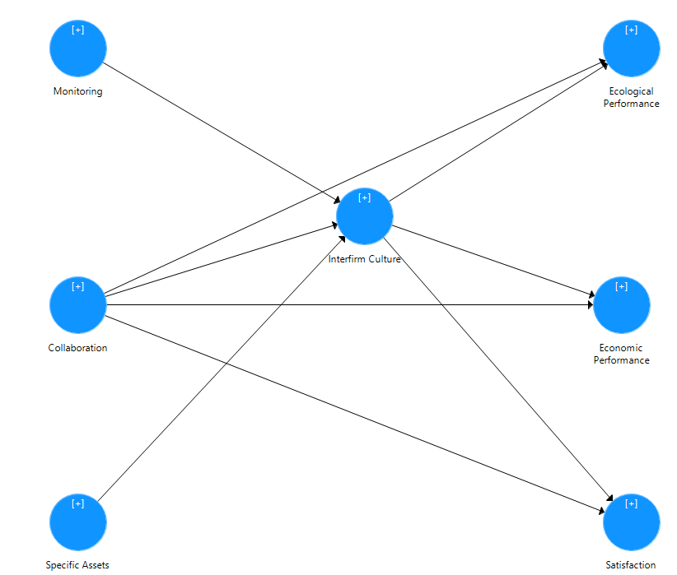
Control  Mechanisms |  | Interfirm Culture |  | Triple Bottom  Line Performance

Figure 3 The specified factor loadings
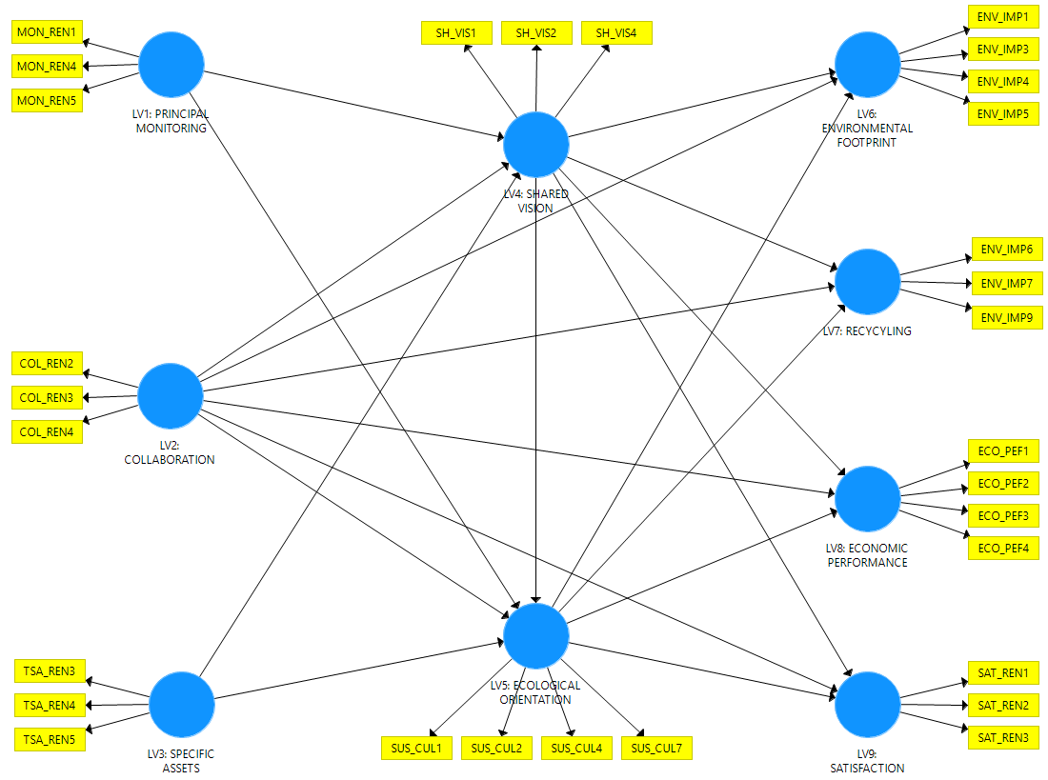

Figure 4 The specified structural model

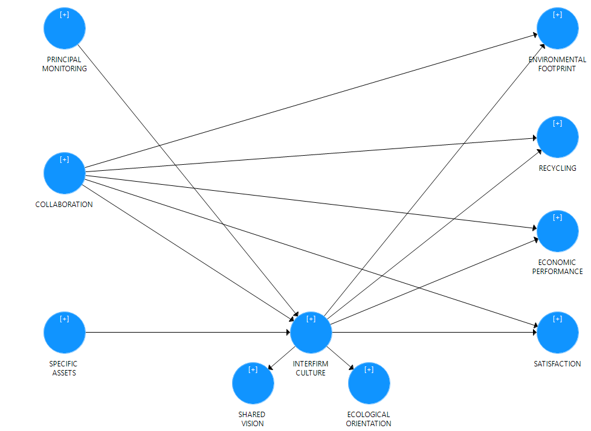
Control  Mechanisms |  | Interfirm Culture |  | Triple Bottom  Line Performance

Figure 5 Summary of findings

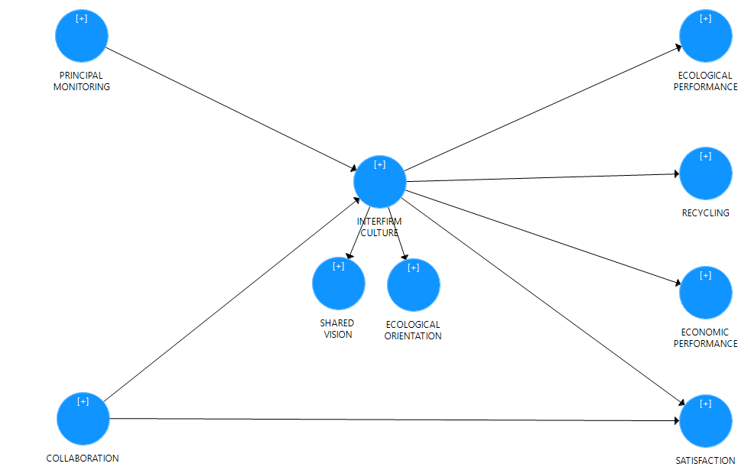
Control  Mechanisms |  | Interfirm Culture |  | Triple Bottom  Line Performance

