Introduction
There is considerable research going on aimed at understanding how project duration can be compressed, based on the assumption that this will allow earlier benefits realisation. However, this paper is concerned with the compressing of the schedule based on imposed settings; where the settings are related to unexpected and urgent project. The paper is based on a detailed, case study of a large-scale telecommunications project involving a number of actors in both the private and the public sector. The case project – to expand an existing telecommunications network in Algeria (we call the network ‘Operator B’) – was a project financed through the state budget and estimated to cost approximately USD 100 million for the first phase and with a total budget estimated at approximately USD 1.2 billion. The project’s legitimacy, and urgency, lay largely in the return on investment (ROI) for the upgraded and implemented network, where ROI related to two factors, savings and investment, and is equal to savings over investment (Muller et al., 2005; Rong Chang et al., 2014). In this paper, ROI is simply the cost to benefit ratio. The existing 2G network was to be upgraded to 3G/4G before the Algerian state, currently the sole owner, would sell a 49 per cent share of ‘Operator B’ at an expected four times return on the investment.
The project was a complex endeavour in terms of organisation and technology: the project involved several influential public bodies and authorities, where the lead was the Ministry of ICT and external suppliers (the main contractor was chosen after swift bidding for the project). Moreover, the project was global through the involvement of suppliers from other countries, requiring virtual cooperation between the organisations involved. This posed challenges in terms of time difference combined with cultural differences, exacerbated by the strict timeline.
The case project would normally take two years to be delivered, but was compressed to three months. Similar case projects, owned by ‘Operator A’ but using the same contractor and in the same country, have been used for comparison. This reveals big differences in schedule, and taking these schedule differences as our starting point, the paper investigates how the project management team (mainly from the contractor side) identified opportunities and how these were implemented to fit the project duration within that time window.
The main focus in this study is on time and on reduction of project duration. Reduction of project duration can be achieved in two principally different ways: (1) shortening the project duration based on continuous improvements in a ‘normal’ situation where the project is planned and delivered under the assumption of normal progress; and (2) compressing the project duration as much as possible – i.e., ‘crashing’ or ‘fast-tracking’ – motivated by improving the business case through fast delivery to the market. The case project investigated in this paper is of the second type. The case is unexpected and urgent projects; where unexpected and urgent projects can arise because of new business opportunity, or for protection against sudden threat, or, most obviously, to restore a severely damaged asset (Wearne, 2006)
We approached this study by creating a chronological narrative of the case project and subjecting the underlying project data to various analyses. What emerges, we believe, is a novel understanding of the role and practice of project management in fast-paced projects and a theory of project management that acknowledges the importance of taking a holistic view – i.e., balancing short- and long-term considerations – of projects with urgency. The case project offers a view into how the idea of embracing uncertainty can be linked with project speed management and time-to-market assessments, and allows us to understand how these concepts are implemented at the project level.
The paper is structured in the following way. In the next section, we present the theoretical background and framing of the study. In the succeeding section, we present the context for our empirical research and the research methodology. In the empirical section, we first offer a detailed background to the project case, its context and process, and then turn to the question of how the project management team, from the contractor’s standpoint, could manage to squeeze a schedule of two years into a period of three months. We then analyse the consequences of the fast project delivery, during and after the project, and the short- to medium-term impacts. We also evaluate the project from different stakeholders’ perspectives to see the degree of success or failure.

Theoretical framework
The definition of a ‘project’ embeds the notion of time; where the key metrics for measuring project management success is temporally-bound as projects must be on-time, on-budget and according to specifications (PMBOK, 2013). Bubshait and Almohawis (1994) deﬁned time as the degree to which the general conditions promote the completion of a project within the allocated duration. Naoum (1994) and Chan (1996) measured this criterion by time overrun and execution time, respectively. Songer and Molenaar (1997), Lam et al. (2007) and Bassioni et al. (2004) also considered ‘on schedule’ as one success criterion. Project delays can be managed, as well as project speed, which has been shown in much research done on concurrent engineering (Mahmound-Jouini et al., 2004; Midler, 1993): hence the necessity of developing a framework based on generic performance indicators to measure and monitor the project speed performance to be on schedule (Zidane et al., 2016a).
Projects behind schedule are an indicator of poor productivity and bad project performance (Ramanathan et al., 2012). Any delay in a project can lead to cost and time overruns, and these two are connected (Sambasivan and Soon, 2007). When projects are delayed, they are either extended or accelerated, and therefore incur additional cost. For the project owner, delay may lead to loss of revenue through lack of production facilities and rentable space, or a dependence on present facilities. For the contractor, delay may result in cost overrun due to longer work period or penalties, and higher material and labour costs (Assaf and Al-Hejji, 2006; Khoshgoftar et al., 2010).
In production, new product development, and sales and distribution, time represents a powerful source of competitive advantage (Stalk and Hout, 1990, 2003; Zidane et al., 2015; Zidane et al., 2016b). This is particularly true in markets where the first mover has a strong advantage (Brown and Eisenhardt, 1998; Cordero, 1991; Mahmound-Jouini et al., 2004; Stalk and Hout, 1990, 2003). Several companies have employed time-based strategies, such as the telecommunication and ICT industry, the automotive industry and many other types of industry where production starts by developing new products. Delivering faster new product development projects in these markets reduces costs, increases profits and creates value (Schmelzer, 1992).
Most innovative companies in this new era of globalisation are more concerned with time reduction as their first and major priority than with cost reduction (Ansoff, 1965; Porter, 2008; Rich and Hines, 1997; Demartini and Mella, 2011). Hutchinson (2007), based on an adaptation of Blackburn (1991), made an illustration concerning long-term trends in manufacturing. His illustration indicates roughly how industry norms have changed from decade to decade. Changes in the period present a revealing picture of the evolution towards time-based competition that is almost universal across all industries.
The freedom to apply flexible processes requires skilful and strong project managers to decide what and what not to do to attain quality products in a short time. Many previous studies (e.g. Anderson, 1992; Jiang et al., 2001; Dainty et al., 2003; Krahn, 2005) lacked a holistic view that provides an abstract and compact representation of project manager skills (Kosaroglu and Hunt, 2009). Some others either mentioned or implied skills sets, but fell short of clear descriptions (Hosking, 1988; Wateridge, 1997; Song and Parry, 1997; Kosaroglu and Hunt, 2009). Kosaroglu and Hunt (2009) summarised and discussed the set of skills that project managers need to lead their telecommunications projects to success, which are technical, leadership, managerial and administrative.
Telecommunications infrastructure is increasingly becoming the backbone for several activities such as mobile commerce and internet-based inter-organisational information systems (e.g. e-commerce and e-government). Certainly, collaboration activities that straddle several departments and organisations rely on the telecommunications infrastructure for effective collaborative support. In addition, the telecommunications companies, which sometimes provide services to a diverse set of organisations, have to rely on virtual tools to enable project collaboration (Muganda and Pillay, 2013). This kind of collaboration increases the difficulties in the missions of the project managers in regular settings; however, things become harder in unexpected and urgent sceneries (Mojtahedi and Oo, 2017).
Projects are increasingly expected to cope with urgent and unexpected scenarios (Dalcher, 2016; Wearne and White-Hunt, 2014). Wearne and White-Hunt (2014) studied twelve cases to answer the differences between managing urgent and unexpected project with managing normal project. Where according to them, urgent unexpected project can fall into four types: (1) urgent project in response to unexpected opportunities; (2) Urgent unexpected project to save assets under threat; (3) Urgent unexpected project to restore failed or very damaged assets; (4) Urgent unexpected project to find survivors and recover evidence of victims.
When the project delivery date is priority, the project team may use schedule compression techniques. PMBOK (2013) has addressed two techniques, which are crashing and fast tracking; where the schedule compression techniques are used to shorten the schedule duration without reducing the project scope, in order to meet schedule constraints, imposed dates, or other schedule objectives. PMBOK (2013) gives two techniques for schedule compression, but according to the PMBOOK, this is not only limited to these two techniques. The first is the crashing technique, as defined by PMBOK (2013), “a technique used to shorten the schedule duration for at least incremental cost by adding resources. […]. Crashing works only for activity on critical path where additional resources will shorten the activity’s duration. Crashing does not always produce a viable alternative and may result in increased risk and/ or cost”. The second is the fast tracking, “it is a schedule compression technique in which activities or phases normally done in sequence are performed in parallel for at least a portion of their duration. […]. Fast tracking may result in rework and increased risk. Fast tracking only works if activities can be overlapped to shorten the project duration”.
Where unexpected is defined as “things that happen unexpectedly, not expected, unforeseen, an event not regarded as about to happen” (Merriam-Webster, 1984). According to Wearne and White-Hunt (2014), unexpected can mean that an event was never thought of previously, or it was thought of but the possibility of it to happen was not allowed for; where the associated risk can be ‘unknown unknown’ or ‘known unknown’. Geraldi et al. (2010) classified the unexpected events according to their probability, impact, pertinence and timing.
Urgent is defined as “requiring immediate action or attention. Of an action or event done or arranged in response to an urgent situation” (Merriam-Webster, 1984). However, based on different perceptions, urgent definition may differ some a person to another, or organization to another. What is seen urgent at a certain level of an organisation may not be seen urgent at another level within the same organisation (McDonough and Pearson, 1993; Wearne and White-Hunt, 2014). Project stakeholders could vary in their understanding and response to work stated as urgent, working faster than normal may or may not mean priority in the use of resources; however, all agree that urgent means working faster than normal and that this usually incurs increased cost (Wearne and White-Hunt, 2014).

Paper objective and research methodology
Building on a case project where project duration was dramatically compressed compared with a similar case – i.e., compared to the scopes. We conducted case study research to document the positive and negative effects of accelerated project execution. The project was changed to deliver two years of workload in a tight time window of three months, from the date of signing the contract until use of the final product. We will discuss how project was executed, the effects on project management performance, and the project as a business case. An emergency is defined as a serious, sudden, unexpected, and often dangerous situation/ event requiring immediate action (Merriam-Webster, 1984). The case presented in this paper is not an emergency in that sense; however, it was unexpected and very urgent project in response to unforeseen opportunities.
We have also investigated the period after the project was completed to understand the long-term consequences, looking at the project from the perspectives of the owner, the client, the main contractor and subcontractors, to see to what extent the project may be considered a success or failure. The research questions are:
RQ1. Why the case is considered superfast project?
RQ2. How the project management team succeed in meeting the deadline, and what means were used to compress the project duration?
RQ3. What are the consequences, positive and negative impacts from the schedule compressing?
To answer these research questions, our research design is based on case study research. We have based our empirical study on archival material and semi-structured interviews. A typical case study focuses on matters that exemplify a stable, cross-case relationship (Seawright and Gerring, 2013). To put the observations in our primary case project into perspective, we have chosen a similar case project with comparable scope. The primary purpose of this comparison was to examine the assumption that the project qualifies as ‘superfast’. The primary case project does not represent a typical case: it is a very special case. We think this unique case has a lot to offer as an illustration of the effects investigated in this paper. In line with Flyvbjerg (2006), we hold that thorough investigation of a single case is very useful for learning purposes. Although we cannot generalise the findings, a single case study does contribute to scientific development.
Data collection is critical in a case study (Yin, 2009). A prerequisite for attaining robust results from a case study is to have multiple data sources that can be triangulated to ensure the validity of the results. For our study, data were gathered from documents in archives and through semi-structured interviews. Interviews are one of the most important sources of information in case study research (Yin, 2009). By combining data from documents and interviews, a clear picture of the project emerged. We also had the benefit of inside knowledge of the case project, as one of the co-authors was an active participant in the project before becoming a researcher. This has allowed us to locate relevant archival material and select suitable interviewees, but we have been careful to analyse the collected data as a group of researchers to prevent pre-knowledge of the case introducing bias into the research.
In our study, ten semi-structured interviews were organised to investigate the issues regarding 1) the reason for the urgency of the project; 2) the fast execution; and 3) the consequences of schedule compression at the post-project level. For issue 1, the data collected were publically available material from the Ministry of ICT and information obtained through telephone interviews with two persons from the top management of the client (heads of departments in ‘Operator B’). The two interviews lasted about thirty minutes each and specifically addressed the urgency of the project. For issue 2, about project execution, we interviewed key individuals from the contractor side: the product line manager, the account manager, the core network technical expert and the project director. The interviews were virtual, using digital means of communication, and the duration of the interviews varied from half an hour to an hour and half. From ‘Operator B’, we interviewed the project director and deputy project director in the form of open discussions by digital means. The total discussion time was an hour and half to two hours. To collect data for issue 3, in addition to those interviewed listed above, we also interviewed for half an hour the after sales manager in charge of the maintenance of the network and the new project director.
Access to archives was limited due to confidentiality and privacy matters. The archives used were the case project director’s notes, a similar case project director’s notes from the same contractor, archival documents from website of ‘Operator B’, archival documents from the Algerian Ministry of ICT’s website and archival documents from the local telecommunications regulation agency, ARPT.
The data obtained from archives and interviews were analysed using qualitative data analysis (Miles et al., 1994, pp.8–9). The qualitative data analysis consisted of three approaches: data reduction, data display, and conclusion drawing and verification (Miles et al., 1994). Data reduction refers to the process of selecting, focusing, simplifying, abstracting and transforming the data that appear in written-up field notes or transcriptions. Data reduction is a form of analysis that sharpens, sorts, focuses, discards and organises data in a way such that conclusions can be drawn (Miles et al., 1994). Tesch (1990) calls this process data condensation. Data display is an organised, compressed assembly of information that permits conclusion drawing and action (Miles et al., 1994).
Beside the limitation for accessing the archives due to confidentiality; there are some other limitations regarding how urgent and unexpected the case was managed in comparing to normal case. Since unexpected case is not made in advance, where the data and information regarding it is limited to some interviews and reports. A second limitation is there is no clear definition of what is normal practices such that we can say what is a normal case and an urgent case.

Empirical study
For many years, the telecommunications industry around the world was highly regulated. This changed dramatically during the last decades of the twentieth century with the commercial introduction of mobile data, the de-regularisation of the telecommunications industry, the emergence of new global competitors and the development of the IT industry (Bergman et al., 2013). Many telecommunications projects are international projects involving collaboration between participants from multiple countries. They face unique challenges that do not appear in intra-national projects, these being challenges related to differences in work practices, legal regulations and cultural values (Mahalingam and Levitt, 2007; Aarseth et al., 2013). The telecommunications industry relies on time-to-market and fast delivery to gain competitive advantages and increase profit margins: thus the need for speed is a major priority. Rapid and short-lived technology advances, deregulation and greater competition have transformed the telecommunications industry to bring new products into the market faster; nevertheless, the literature covers little about this hypercompetitive industry in the present day (Kosaroglu and Hunt, 2009).
The case project was conducted within the Algerian telecommunications industry. The Algerian telecommunications industry relies on three operators (MPTIC, 2016): Operators A, B and C. Operator A is state-owned with some stock owned by Algerian citizens, and it was the first telecommunications operator in Algeria, created in 1962 after the independence of Algeria. Operator A provides all telecommunications services, from 2G/3G/4G networks to internet via fibre (FTTH), landline phones through wire or wireless (CDMA, WiMAX) and many other services. Operator B started investing in the Algerian market in 2001, the network starting operations in early 2002. This operator is 51 per cent state-owned, the remaining 49 per cent of the stocks owned by a multinational telecommunications corporation. Operator B provides only a 2G service. This operator was 100 per cent nationalised in mid-2013 and the government decided to upgrade the network to 3G/4G technologies before reselling the 49 per cent share. Operator C came to the Algerian market in late 2003 and started operating its network in late 2004. It is 20 per cent owned by the state and 80 per cent owned by another multinational telecommunications corporation. Operator C provided 2G service at its opening, a 3G service since 2015, and a 4G service since 2016.
A main supplier was chosen for the project after a compressed bidding process. This main contractor started as a small enterprise producing telecommunications equipment. Having grown into an international manufacturing organisation with numerous production facilities in various countries, it has now become one of the leading and largest global network suppliers in telecommunications industry.
During the bidding competition, all other potential contractors involved in the bidding declined to accept the three-month project time: most asked for at least a year and half to deliver the planned scope. However, the chosen contractor accepted the fixed time-to-delivery. The choice of contractor was made in late 2013 and the main contractor was given the task to deliver the scope – i.e. network upgrade to 3G/4G services before the end of the first quarter of 2014.
The main contractor had already delivered a similar project scope for Operator A within a time schedule of two years and three months. This second case project is used for comparison purposes and some details of both case projects are presented in Table 1.
Table 1. Comparison between two projects delivered from the same main contractor for different clients
Item | Contract with Operator B | Contract with Operator A
Total contract monetary value | Approx. 100 million USD | Approx. 109 million USD
Scope | Network design, core network with seven MSC, two ngHLR/VLR (1+1), six SR (1+1), one SMSC and one billing system upgrade. In addition, radio access network with seven RNC and 1320 Node-B, network optimisation and end-to-end delivery. | Network design, core network with nine MSC, three ngHLR/VLR, nine SR (1+1), one SMSC and one backup, and two billing systems (1+1). In addition, radio access network with 12 RNC and 1850 Node-B, network optimisation and end-to-end delivery.
Delivery time | 3 months | 27 months
Penalty for late delivery | Yes | No
Projects started urgently in order to meet a date set by a several reasons. Figure 1 depict simplified project schedules for the two project cases, the primary case and the comparison case, based on calendar time. We can see from the schedule of the comparison case that most of the time was spent before starting implementation – i.e. from contract negotiation to equipment delivery. The fast case spent half of the project period on preparations but, compared to the comparison case, this was done in three months instead of 14 months, thus saving almost a year. Implementation took 13 months in the comparison case and three months in the fast project. For both case projects, the split between preparations and delivery is about 50–50. In the fast case, there was no waiting time for equipment production to start; instead, equipment was redirected from suitable supplies already produced for other clients. These units would have to be replaced in the other projects, which meant there would be delays in those projects.
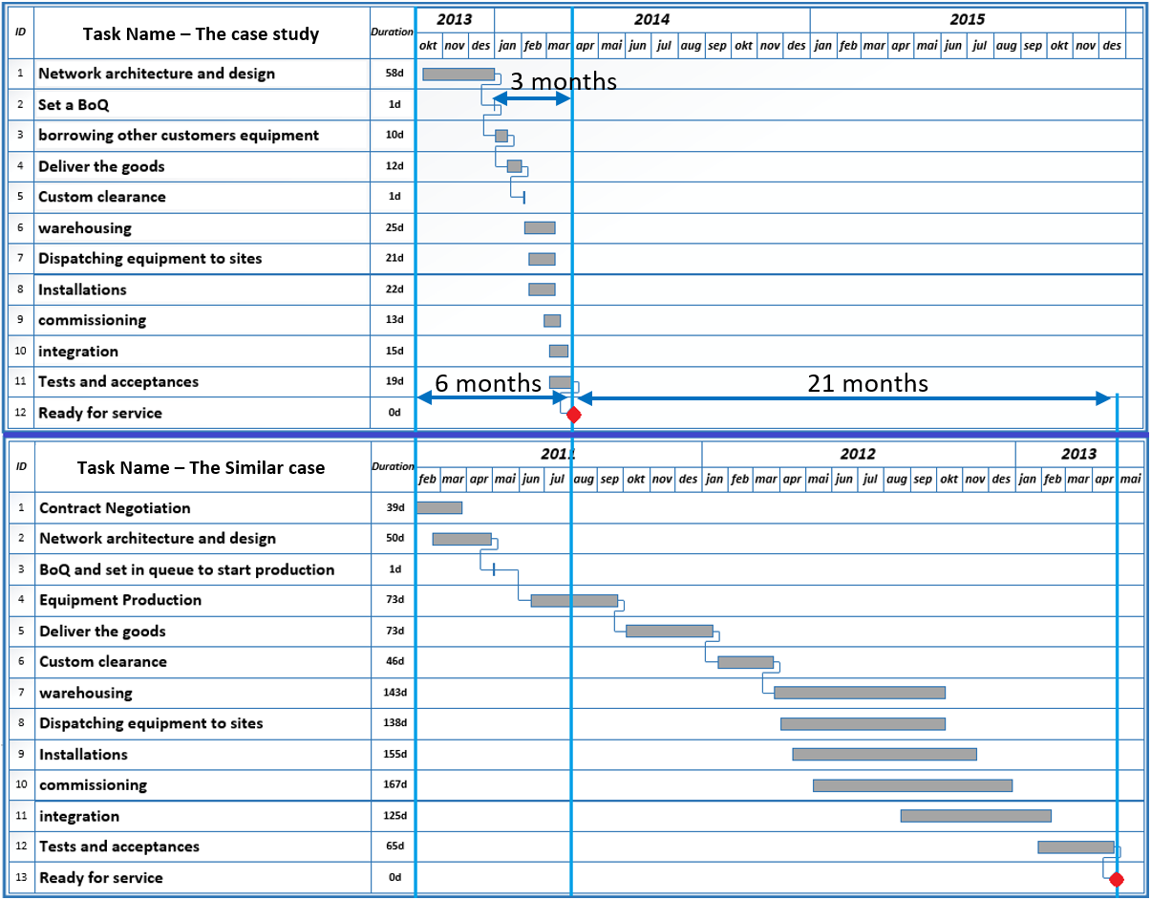
The comparison case (lower time schedule in Figure 1) was executed under normal circumstances: there was no extreme urgency for project delivery, so all the activities followed a routine sequence. This project was delivered with all its scope, respecting the requirements and testing them, within budget and a few weeks behind schedule. The compressed case project was delivered a week ahead of schedule, within budget (at the customer acceptance moment, and including forecasted costs for the remaining activities) and adhering to the technical specifications by testing the main ones. However, the full scope was not delivered as the main contractor delivered the parts that would strongly contribute to the project efficacy – i.e. enabling 3G/4G services, including its billing. The scope of delivery was 95 per cent of the core network, including the billing system, and 50 per cent of the radio access network, which gives an overall scope delivery of about 70 per cent. In this kind of project, the scope of the project lies in a workload of 40 per cent core network and 60 per cent radio access network (see Figure 2). However, the technological complexity always lies in the core network, which requires more expertise and extremely highly qualified engineers to deliver a working system.
Figure 1. Schedule of the case compared to the similar case
This project was awarded to the main contractor on rather short notice – i.e. three months from issue of the invitation for bidding to signing of the contract – so there was an urgent need to establish sub-contractors for the dispatching and logistics, equipment hardware installations and some materials. The core network was divided into seven main sites requiring seven hardware installation teams with at least nine team members experienced in this kind of hardware installation. The radio access network gets its complexity from the number and the location of sites: 1,320 Node-b located in different sites and widely dispersed geographically. According to Wearne and White-Hunt (2014), the urgent and unexpected projects have three different ways to bring resources, which are: (1) Diverted resources – teams formed by diversion of resources already employed by the sponsors for related planned work. (2) Augmented resources – teams formed partly as the first one and partly by temporary employees. (3) Bespoke resources – teams formed entirely for the urgent unexpected project. The case in this study used the third type of resources, where the teams were created specially to implement this project. Resources were diverted from the established resources of the running projects to the implementation of this urgent and unexpected project.
The core network (right side of figure 2) is the brain and the heart of the whole network: without the core network in place (having been commissioned, integrated and tested), there would be no service available, even if the complete access network was installed.
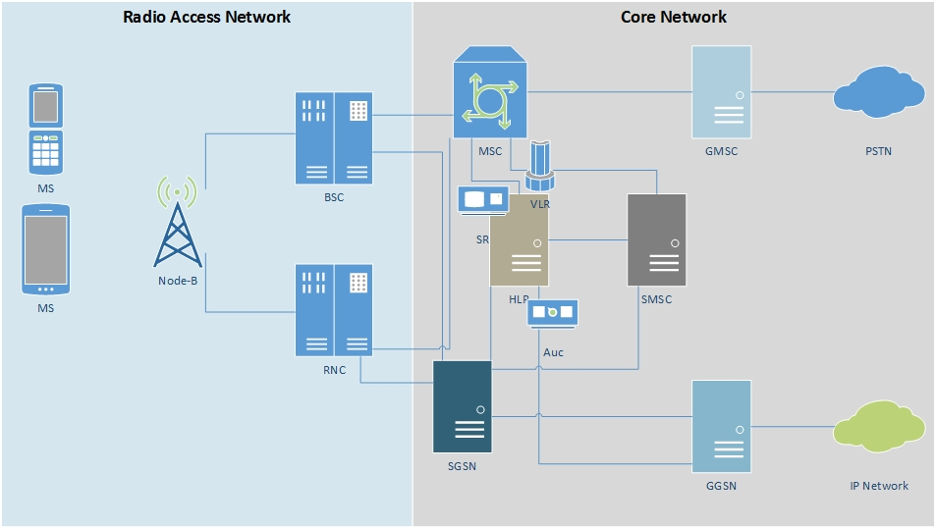
Figure 2. Simplified network architecture
The difficult task regarding the access network sites (left side of figure 2) is dispatching the equipment and the logistics, especially when it comes to urban areas (due to traffic, regulations regarding truck traffic, etc.). Another difficulty is related to replacing the existing antennae, which support only 2G frequency, with new antennae which support 2G/3G/4G frequencies. The replacement should be done late at night and very quickly to avoid long interruptions to the service. The subcontractors’ selection was done without any bidding, but rather based on inviting suppliers (for services and materials) and trying to negotiate acceptable terms.

Findings and analysis
In this section, we will provide our findings and analysis of the compressed case project, viewed from different angles, to provide answers to the research questions.

The reasons for considering the case as superfast project
The project scope and the workload would in a normal project need at least two years to be delivered. The comparison case project, with a similar main contractor, within the same country, was delivered in 27 months (see Figure 1). The difference is that the project was with another client, ‘Operator A’. There are many organisations involved in this project, each organisation having its own motivation for compressing the project schedule. The project’s main driver, however, was the government, which had delegated the project to the Ministry of ICT. Since the government already owned ‘Operator A’, which provides a full range of services to the users, including 3G/4G, there was no need to rush getting a second operator in place to provide the same services. However, since the project’s legitimacy and urgency lay in the financial profitability of the upgraded existing network, it was important to upgrade as soon as possible the existing 2G network to 3G/4G before selling 49 per cent of the stocks.
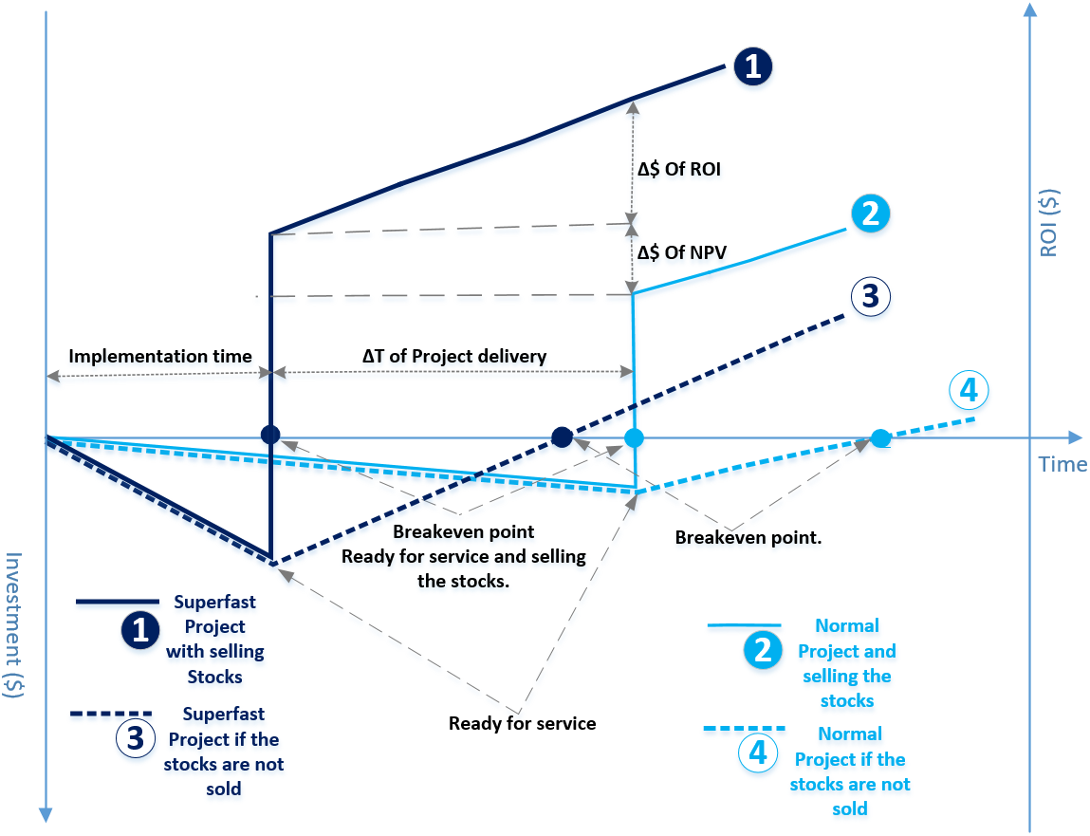
One of the interviewees in the top management of ‘Operator B’ explained the urgency in upgrading the network. The sooner the network was upgraded, the higher the value of the stocks, as shown in Figure 3 by the solid dark blue curve 1, representing the superfast project with selling of the stocks.

Figure 3. The cash flow curves for the superfast project and normal project for the Ministry of ICT, compiled by the authors based on data from the case projects
Furthermore, based on interviewee information, the ∆$ of NPV in Figure 3 represents a decrease in the monetary value of the network after a certain time, believed to be caused by the rapid and short-lived technology advances, inflation, deregulation and greater competition (Kosaroglu and Hunt, 2009). The authors question this assumption and rather believe the monetary value of the network would increase during the two years following completion. There are two reasons for this. Firstly, the number of subscribers (users) in the network will increase, and secondly, the next generation (5G) is expected to be introduced in the market only in 2020. For these two reasons, we think that the ∆$ of NPV would be a positive value. However, regarding the return on investment (ROI), the sooner the service is introduced to the market, the sooner it will generate income. The four assumptions of the government regarding the project (curves 1, 2, 3 and 4 in Figure 3) show in all cases that the sooner the project is delivered, the earlier ROI is realised. As ROI was defined earlier in this paper as cost to benefit ratio, the ROI in Figure 3 starts to appear and accumulate from the break-even point.
The motivation of the main contractor to accept the tight time window and commit to the delivery date was being awarded the whole contract value – i.e., USD 1.2 billion, expected net profit of approximately 13 per cent, which means approximately USD 156 million. However, for this first phase (the project case), there was no any additions of incentives for speed of completion in the contract. The main contractor was also motivated by establishing a strong position within the local and international market, gaining reputation and improving the partnership with the project owner.
For the subcontractors the stimulus is more to gain respect of the contractor since the relationship is not only a limited contract but also long-term cooperation. The same can be applied to suppliers, who are looking for stable long-term clients to supply them with the necessary materials, tools and machinery.
According to Wearne and White-Hunt (2014), urgent and unexpected projects have to be rare in business and government to be tolerable. They added that uniqueness is partial, and the cases support many of the established lessons of managing normal projects. Example of the lessons learned are presented in the next subsection related to RQ2. This case is unexpected and urgent as mentioned above and based on all the presented data. Still according to Wearne and White-Hunt (2014), if the project was unexpected and not urgent, it could be defined and budgeted in the normal way before starting implementing it. And if it was urgent but expected, the project could be fast tracked easily, since most of things are known known. And when the project is unexpected and urgent as the case in this paper, the need for more than fast tracking and/or crashing techniques is necessary.

How the project management team succeed in meeting the deadline
This kind of telecommunications infrastructure project is not about new product development: 3G/4G technologies are already available in the market. However, there is still a need to develop some customised solutions for different specific issues – e.g., software applications, integration solutions, licences, etc. The main contractor is part of a global company with many projects, both similar and different to this one, all over the world, meaning it is practically impossible for the central headquarters to directly support the projects. Because of this, the company has developed a categorisation system where projects are classified from A to F. The categorisation reflects the priority of each project: a project with high-level strategic objectives or high financial benefits will be highly ranked (A or B). When a project is classified as level A, it will be subject to a high level of attention from the central organisation and be under daily monitoring from headquarters. Undoubtedly, a high ranking may have negative effects on the project manager as a result of high pressure, more time spent on detailed reporting, intensive and long meetings with senior management, and interference with the tactical and operational decisions of the project manager. On the other hand, classifying a project as ‘level A’ means giving full authority to the project manager regarding the management of the project. Thus, it is the full responsibility of the project manager to cope with the pressure and the interferences regarding the tactical and operational decisions and plans.
To fully understand how the main contractor was able to compress the project duration to the extreme extent seen in this case project, we need to review the many tactical decisions made both at the front-end and at the operational level of the project. In chronological order, they were as follows.
- When Operator B initiated discussions with the supplier market to obtain a contractor willing to take on such an accelerated project, almost all of the contractors were concerned about the delivery time target. Instead of trying to understand the operator requirements and analyse their needs, the potential contractors were trying to extend the project delivery date. The chosen contractor was the only exception, and intensively mobilised its product line managers from marketing and sales to understand the technical requirements and specifications, understand the existing network, design a potential network architecture and determine the required equipment.
- This was a risky decision on the part of the chosen main contractor. In reality, all available local marketing resources were assigned to a project with high risk and before having signed any agreement. Also, appointing a project director before signing any contract was risky, but this early assignment allowed the project director to oversee the work done by the marketing department and early on translate the technical requirements into actions that later formed much of the project plan.
- The choice of project director was also important: he was a senior project manager with long experience in managing telecommunications infrastructure projects, with good knowledge of the company and its internal regulations, and with strong administrative skills. These skills helped him to forecast possible scenarios and make plans that allowed for satisfying the client.
- At a certain point in time, when all the competitors pulled out, the operator made an unofficial agreement with the chosen contractor, even though a formal contract had still not been awarded. In a normal project, the BoQ (Bill of Quantity) would not have been issued this early and, when issued, it would have been sent to headquarters to initiate production of the equipment. This would have taken at least six months, followed by shipping of the goods by sea, meaning at least another two months. But being a ‘level A’ project, the radical decision was made to assemble the equipment from batches already produced for other projects, as well as to undertake the shipping by air. This saved more than eight months in the project schedule.
- Another significant time saving was made at customs clearance, which normally would take at least two months. Managing to have the Ministry of ICT, as project sponsor, intervene saved another two months by avoiding inspection and checking.
- The equipment sourced from other projects had to be physically reconfigured, and this was done utilising all available resources in the local office, prioritising this project over other tasks.
- For transportation and hardware installation of the equipment, a large number of suppliers were engaged to speed up the process.
- Even employing a large number of subcontractors, the project team understood that delivering the whole scope within the deadline would be impossible. The solution was to split the project into two sub-projects: the project director managed the core network project and a sub-project manager took charge of the access network project (see a diagram of the simplified network architecture in Figure 2). Thus the project director negotiated with the client to set a new target of delivering the full core network within the deadline. The access network would be delivered prioritised based on population density and with priority given to the capital of the country. Under this agreement, completion of the access network after the original deadline would not be considered a delay and the client would not apply penalty clauses towards the main contractor.
- There are seven core networks within the whole network: among the seven, three are principals, the other four auxiliaries. The three principal and three auxiliary core networks were completed a week ahead of schedule; the last auxiliary was delivered a week behind the schedule. The radio access networks in place at the deadline were mostly located in the capital and in four other big cities with high population density. Service testing and acceptances were done a week ahead of schedule, and the announcement of the 3G/4G network was pronounced officially by the Ministry of ICT at the fixed date, the end of the first quarter of 2014.
The list above of the reasons to succeed the delivery of the project within the deadline may sound customised to this specific case. However, there are other decisions leading the project to success, which may contribute for the body of knowledge, we list most of the lessons learned:
Other things helped to speed up the project execution is the communication between the client and the contractor. The client changed their communications and procedures to respond to the project urgency. The same happened within the contractor organisations as discussed previously. This reported also by Wearne and White-Hunt (2014), where they mentioned that the sponsor may achieve that by achieving rapid vertical teams, using oral instructions, rapid selection of resources and simplification of procedures.
The client trust the contractor, since the previous cooperation witnessed this fact. Moreover, the main contractor working with the competitors as a partners during the integration of the new equipment within the existing network. This was encouraged from the client, and even the project manager from the client helped in better cooperation between all the parties, where all of them are competitors.
Early establishment of project management and communication system for the project and all involved stakeholders. In addition, appointing a fulltime experienced project manager with necessary skills, as discussed in the theoretical section, the skills which are technical, leadership, managerial and administrative. Where the project manager is able to coordinate team members from different companies and different cultures. The task was easier since the appointed project teams already familiar with all parties and the type of project parameters. Another reported criterion regarding the teams’ members is that most of them were innovative and committed, with lot of ideas to share and a full involvement. This reported also by Loosemore (1988), where he observed that people under emergency and crises are more committed and with lot of ideas to share. Solnit (2009) observed that people are more motivated and energetic under emergencies, with an effective performance on their tasks.
The contractor’s strategy with suppliers (both, services and materials), save enormous time. Once prequalified subcontractors are available, and contractor and subcontractors are used to work together, this save time and encourage start work even based on oral engagements, this also supported by findings from Walker and Lloyd-Walker (2016).

The consequences from the schedule compressing
Before listing the consequences and impacts of the superfast speed of this project, let us examine to what extent it was a success or failure from the perspectives of different stakeholders. Project efficiency is a question of ‘doing things right’ and producing project outputs in terms of the agreed scope, cost, time and quality. Effectiveness is ‘doing the right things’ – i.e., setting the right targets to achieve an overall goal. Samset (2003) defines effectiveness as a measure of the extent to which the objectives have been achieved – that is, the first-order effect of the project for the users, in the market, in terms of production, etc. Therefore, the measure of effectiveness is more related to the project stakeholders.
The project was considered highly successful from the owner and client perspectives. The owner reached the target by selling the planned 49 per cent stocks of the operator company at the desired price and the operator established operation of the 3G/4G services. The operator had zero 3G/4G subscribers (3G/4G users) at the end of the first quarter of 2014, while in January 2015, the registered number of 3G/4G subscribers was approximately 4.1 million out of a total market of 16 million, a market share of 25.39 per cent (ARPT, 2015). This illustrates how the project started to show its effectiveness and that the objectives had been achieved. Efficiency is more the concern of the main contractor and subcontractors. The project met the expectations of the client, even if the efficiency was less good. The scope was not fully delivered by the deadline: the reality was that some months were still needed to complete the scope (the radio access network part) and, although the cost at deadline was under budget, there was the remaining work to deliver.
From the human resources perspective, there were several issues. Firstly, the team members involved in the project were exhausted: working 18 hours a day, seven days a week during the three-month period was devastating for the people. Secondly, there were safety issues, which might be traced back to cost cutting and lack of incentives. The local technical director, under whom the project director was organisationally located, was only concerned about costs and cancelled all rewards for the project team and subcontractors. This caused dissatisfaction and lack of trust and, combined with cost cutting, led to the resignation of many employees and subcontractors. Consequently, there was a lack of resources for the second phase of the megaproject, which was expanding the cover area of the radio access network. In addition, the technical director cut costs related to safety – e.g. safety equipment like helmets and climbing belts for subcontractors involved in hardware installations and truck backup drivers for long distances. This cost-cutting created two main incidents: 1) a subcontractor tower climber fell from a tower because of using a bad quality climbing belt; and 2) a traffic accident occurred, where one driver travelled a distance of more than 800 km to deliver equipment. We should emphasise that these incidents were not mainly due to the high project speed, but mostly to the cost-cutting measures.
Based on the Barnes’ (1971) ‘iron triangle’, which consist of the three constraints time, cost and performance; where performance is the quality and safety. The reduction and cutting in costs may cause the reduction of quality or losing safety of the work (accidents). In this case the project lost safety at first, second the quality of the work, since the staff and suppliers lost motivation due to cancelation of incentives. It should also be noted that decisions made in this project to source equipment from other projects caused the dissatisfaction of clients in other countries because of the delays in delivering their equipment as planned. One of the clients applied the penalty clause, which made the mother company lose approximately USD 2 million.

Discussion and conclusions
This paper discusses a case project situated in a special context and which was implemented in a very tight time window. The aim of this case study is to learn how managing urgent projects is different from a normal similar project.
In terms of RQ1, and before discussing the reasons made the case to be considered as superfast project, a summary of the motivation behind speeding are mentioned. The impetus for accelerating this project so dramatically, this was financially motivated. Generally, in markets where there are impending new entrants, new product development projects can reduce costs, increase profits and create values (Schmelzer, 1992). In the case project, the need for its urgency was triggered by the value that could be achieved by selling half of the operator company after the 3G/4G service was in place. This was also related to the rapid and short-lived technological advances seen in the telecommunications market and market deregulation (Kosaroglu and Hunt, 2009). The case is superfast, urgent and unexpected because of the sudden unexpected business opportunity that led to speed up in selecting a contracting and fix a target date that sounds impossible comparing to similar case.
RQ2 is about how, and how well, the project management team succeeded in meeting this tight deadline. The project manager on the main contractor side did indeed succeed in delivering most of the project scope within that tight time window. The main means to achieving this are discussed in the following.
At the heart of this project, including both its birth and execution, lies a willingness to embrace uncertainty. This meant not shying away from the obvious risk posed in the front-end phase of the project when being faced with the request from the client to compress the project dramatically, but instead investing the resources required to undertake appropriate investigations to determine whether the request could be met. When the tough request caused all other competitors to pull out of the competition, this paid off in the form of a large contract that, if successfully delivered, could help the company build a reputation that could contribute to its winning future contracts for similar projects. Hillson (1998) argues that there is a need to develop strategic risk-based thinking within organisational cultures in order to deal with project uncertainty and complexity. To assess an organisation’s uncertainty management practices, Hillson (1997) introduced an uncertainty management maturity model. The highest maturity level is called ‘natural’: at this level, the organisation has an uncertainty-awareness culture with a proactive approach to uncertainty management in all aspects of the business and with an emphasis on opportunity management. A deliberate focus on opportunities is a characteristic of a mature uncertainty culture (Hillson, 1997; Karlsen, 2011). The main contractor in this case project was indeed proactive before even signing the contract by being fully involved in the bidding and mobilising its resources to identify the potential business opportunity. This intensive early involvement, embracing uncertainty, saved the contractor enormous time before even signing any agreement with the client.
There are many types and sources of uncertainties. Uncertainties related to estimates arise because of changing requirements, lack of knowledge about the scope of work due to ambiguity, numerous and diverse expectations, and newness of the product. It has been suggested that the use of adaptive methods with incremental deliveries may make a project less vulnerable to uncertainty (Siddique and Hussein, 2016). This adaptive approach allows for more flexibility which enables decisions to be continually adapted during both the planning and execution of the project. Flexibility has been also achieved by providing the project team with a degree of autonomy to expand and prioritize as they see fit. The ability to handle emerging issues is another dimension of flexibility, especially when the project management does not have the opportunity to predict all possible challenges in advance. In this situation, decision-making requires critical and analytical judgment, and is based on facts and experiences. This applies even when leaders are presented with incomplete and ambiguous information. Müller and Turner (2007) show that to be successful, project managers have a strong need for this competence.
By applying project portfolio management principles and having a system for classifying projects based on their importance and urgency, the main contractor was able to rightly categorise the case project as level A. This meant giving it top priority in terms of resources and personnel, and freedom to operate under less stringent administrative procedures that could otherwise slow down progress by imposing reporting and consultation burdens.
Assigning key personnel, including the project director, to the project before even knowing whether the efforts in the front-end phase would translate into an awarded contract was another important decision. The technical skills and insight into this type of project held by the project director permitted him to understand which part of the project scope must be given priority in order to deliver the project faster – i.e. the core network.
The single decision that saved most time was redirecting equipment that had already been produced for other projects to eliminate the long manufacturing time which would otherwise had prolonged the project by eight months. This approach might be questioned: partly, one could claim that a fair amount luck allowed this, due to other projects having been scheduled such that suitable equipment had been produced, and partly this decision had detrimental effects on the projects that had to surrender their equipment, causing client dissatisfaction that might make up for some or all the positive effects on market reputation achieved by delivering the case project in such a short time. But the principle of saving time by removing manufacturing of equipment from the critical path of the project could not be achieved by other means and still produce the same effect of massive time saving. If the company could be fairly sure that there would be a series of projects using the same or similar equipment, the equipment could be produced to stock rather than to order. If the equipment must be tailored to each project (which was the case in this project, as the equipment had to be reworked), it might still be possible to produce parts, sub-systems and intermediate assemblies that allow fast final assembly of the equipment when specific project requirements are known.
Having secured the necessary equipment, the company deviated from normal practices of sea transport of large volumes of bulky and heavy equipment and instead accepted the much higher cost of air freight. This saved an additional two months and was absolutely necessary to deliver on time. Had a too strong cost focus instead been allowed to prevail, the decision might have been to stick to sea freight, thus almost certainly incurring penalty payments. Furthermore, the company decided to allocate massive manpower resources to repurpose the equipment, transport it to the various locations and install the hardware. This was another decision made that carried high additional cost compared with the planned approach, but which saved much time and thus helped the project meet its deadline. As we see, many of the decisions made throughout this project are of this nature—being proactive in accepting higher cost to cut the duration of project tasks, and thus being willing to invest in order to be able to deliver on time and thereby meet project objectives.
The simultaneous involvement of all levels of management in once decisions, reliance on oral commitments, acceptance of cost uncertainty. This actions helped in co-axial integration of all project teams within all the levels and all the involved organisations.
The communication between the client and the contractor is at a high effective level, by achieving rapid vertical teams, using oral instructions, rapid selection of resources and simplification of procedures. The trust between the client and the contractor, and the collaboration between the main contractor and its competitors as a partners
Appointing a fulltime experienced project manager with necessary skills, early establishment of project management and communication system for the project and all involved stakeholders increased the success of the project case. The contractor’s strategy with subcontractors based on prequalified saved time and encourage start work even based on oral engagements. An important key success factor was the involvement of all the stakeholders from the beginning; this allowed a concurrency in dealing with tasks.
In terms of RQ3, the obvious positive outcome achieved was the very large financial upside to the owner, who could sell the 49 per cent share of ‘Operator B’, and to the main contractor, whose profit margin in this project was large. Furthermore, the reputation of the main contractor as a supplier willing to take on risky projects and able to deliver more or less on time could be an important competitive advantage when bidding for future projects. On a societal level, such fast delivery of the project meant that shortly after project completion about four million users had access to much faster mobile data services. However, the project also saw some outcomes that were not desired. The highly compressed project duration, combined with internal pressure to cut costs, created a work environment that made the project susceptible to stress, both at the employee and team levels, as well as safety breaches. For the main contractor, the bold decision to redirect equipment from several other projects caused client dissatisfaction in these projects, which could have future repercussions.
From this case project, we see that the urgency of a project may lead to some negative consequences and impacts, and short- and mid-term interests are not always sufficient to make decisions about accelerating a project. Holistic thinking and a sustainable approach to managing uncertainty at the business and project level are needed to ensure a long-term perspective and overall profits. In this case project, the organisation decided to embrace uncertainty, developing strong strategic and tactical plans combined with a long-term vision of the future. This helped avoid many undesired consequences, but could not avert all of them. Our hope is that other organisations and projects can learn from the way this case project could be executed at such breath-taking speed, thus helping to accelerate projects that can benefit from higher speed while avoiding some of the negative effects of time compression. It is important to consider losing short-term benefits from the urgent unexpected projects; the case in here is accepting losing the cost for the determinant of time and performances (quality and safety of work).
The case study shows the management of superfast case in a specific settings. The urgency came from the unexpected urgent business opportunities. This case shows that the sponsors/clients, and contractors should be aware of the existing of this kind of scenarios and they should be ready to manage them successfully.
This case study is not aimed to provide a generic model for managing superfast project in telecommunications industry. However, the case reports a successful case when it comes to its effectiveness – i.e., satisfying the client and meet the project objectives. On the other hand, the case was a failure when it comes to medium-terms with respect to the contractor strategy, and the safety constraints.
For future research, it will be interesting to check the effect of the methodology used within the contractor on the urgent projects – e.g. concurrent engineering. Another interesting part to investigate within the same scope is to check the possibility to plan for the surprises; however, we should persist that the type of projects are the urgent and unexpected to respond to unexpected business opportunities. Linking early warning signs to this topic can address the question regarding planning the surprises.

References
Aarseth, W., Rolstadås, A. and Andersen, B. (2013), “Managing organizational challenges in global projects”, International Journal of Managing Projects in Business, Vol. 7 No. 1, pp. 103–132.
Anderson, S.D. (1992), “Project quality and project managers”, International Journal of Project Management, Vol. 10 No. 3, pp. 138–144.
Ansoff, H.I. (1965), Corporate strategy: An analytic approach to business policy for growth and expansion, McGraw-Hill, New York, NY.
ARPT (2015), “Rapport Annuel 2015”, available at: https://www.arpt.dz/fr/pub/raa/ (accessed 11 November 2017).
Assaf, S.A. and Al-Hejji, S. (2006), “Causes of delay in large construction projects”, International Journal of Project Management, Vol. 24 No. 4, pp. 349–357.
Barnes, N.M.L. (1971), “Civil Engineering Bills of Quantities”, CIRIA Research Report, No. 98.
Bassioni, H., Price, A. and Hassan, T. (2004), “Performance measurement in construction”, Journal of Management Engineering, Vol. 20 No. 2, pp. 42–50.
Bergman, I., Gunnarson, S. and Räisänen, C. (2013), “Decoupling and standardization in the projectification of a company”, International Journal of Managing Projects in Business, Vol. 6 No. 1, pp. 106–128.
Blackburn, J.D. (1991), Time-based competition: The next battleground in American manufacturing, Business One Irwin, Homewood, IL.
Brown, S.L. and Eisenhardt, K.M. (1998), Competing on the edge: Strategy as structured chaos, Harvard Business School Press, Boston, MA.
Bubshait, A.A. and Almohawis, S.A. (1994), “Evaluating the general conditions of a construction contract”, International Journal of Project Management, Vol. 12 No. 3, pp. 133–135.
Chan, A.P.C. (1996), “Determinants of project success in the construction industry of Hong Kong”, PhD thesis, University of South Australia, Adelaide.
Cordero, R. (1991), “Managing for speed to avoid product obsolescence”, Journal of Product Innovation Management, Vol. 8 No. 4, pp. 283–294.
Dainty, A.R.J., Cheng, M. and Moore, D.R. (2003), “Redefining performance measures for construction project managers: An empirical evaluation”, Construction Management and Economics, Vol. 21 No. 2, pp. 209–218.
Dalcher, D. (2016), “Rethinking project practice: emerging insights from a series of books for practitioners”, International Journal of Managing Projects in Business, Vol. 9 No. 4, pp. 798–821.
Demartini, C. and Mella, P. (2011), “Time competition. The new strategic frontier”, iBusiness, Vol. 3, pp. 136–145.
Flyvbjerg, B. (2006), “Five misunderstandings about case-study research”, Qualitative Inquiry, Vol. 12 No. 2, pp. 219–245.
Hillson, D. (1997), “Towards a risk maturity model”, International Journal of Project & Business Risk Management, Vol. 1 No. 1, pp. 35–45.
Hillson, D. (1998), “Project risk management: future developments”, International Journal of Project & Business Risk Management, Vol. 2 No. 2, pp. 181–95.
Hosking, D.M. (1988), “Organising, leadership and skilful process”, Journal of Management Studies, Vol. 25 No. 2, pp. 147–166.
Hutchinson, R. (2007), “The impact of time-based accounting on manufacturing performance”, PhD thesis, University of Toledo.
Jiang, J.J., Klein, G. and Chen, H.G. (2001), “The relative influence of IS project implementation policies and project leadership on eventual outcomes”, Project Management Journal, Vol. 32 No. 3, pp. 49–55.
Karlsen, J. (2011), “Supportive culture for efficient project uncertainty management”, International Journal of Managing Projects in Business, Vol. 4 No. 2, pp. 240–256.
Khoshgoftar, M., Bakar, A.H.A. and Osman, O. (2010), “Causes of delays in Iranian construction projects”, International Journal of Construction Management, Vol. 10 No. 2, pp. 53–69.
Kosaroglu, M. and Hunt, R.A. (2009), “New product development projects and project manager skill sets in the telecommunications industry”, International Journal of Managing Projects in Business, Vol. 2 No. 2, pp. 308–317.
Krahn, J.L. (2005), “Project leadership: an empirical investigation”, PhD dissertation, University of Calgary, Calgary.
Lam, E.W., Chan, A.P. and Chan, D.W. (2007), “Benchmarking the performance of design-build projects: Development of project success index”, Benchmarking: An International Journal, Vol. 14 No. 5, pp. 624–638.
Leung, M.-Y., Chong, A., Ng, T. and Cheung, M.C.K. (2004), “Demystifying stakeholders commitment and its impact on construction projects”, Construction Management and Economics, Vol. 22, September, pp. 701–715.
Loosemore, M. (1998), “Organisational behaviour during a construction crisis”, International Journal of Project Management, Vol. 16 No. 2, pp. 115–121.
Mahalingam, A. and Levitt, R. (2007), “Institutional theory as a framework for analyzing conflicts on global projects”, Journal of Construction Engineering and Management, Vol. 133 No. 7, pp 517–528.
Mahmound-Jouini, S.B., Midler, C. and Garel, G. (2004), “Time-to-market vs. time-to-delivery managing speed in engineering, procurement, and construction projects”, International Journal of Project Management, Vol. 22 No. 5, pp. 359–367.
Merriam-Webster (1984), Merriam-Webster's Dictionary of Synonyms: A Dictionary of Discriminated Synonyms with Antonyms and Analogous and Contrasted Words, Merriam-Webster Inc., Springfield, Massachusetts.
Midler, C. (1993), L'auto qui n'existait pas: Management des projets et transformation de l’entreprise, Intereditions, Paris.
Miles, M.B.H., Miles, A.M.M.B. and Huberman, A.M. (1994), An expanded sourcebook qualitative data analysis, SAGE Publications Inc., London.
Mojtahedi, M. and Oo, B. L. (2017), “The impact of stakeholder attributes on performance of disaster recovery projects: The case of transport infrastructure”, International Journal of Project Management, Vol. 35 No. 5, pp. 841-852.
MPTIC (2016), “Evolution du secteur de la poste et des TIC depuis 1962”, available at: https://www.mptic.dz/fr/content/ (accessed 10 November 2016).
Muganda, N. and Pillay, K. (2013), “Forms of power, politics and leadership in asynchronous virtual project environment: An exploratory analysis in South Africa”, International Journal of Managing Projects in Business, Vol. 6 No. 3, pp. 457–484.
Muller, A., Happe, D. and Wilson, S. (2005), Virtualization with VMware ESX server, Oreilly & Associates, Sebastopol, CA.
Müller, R. and Turner, R. (2007), “The influence of project managers on project success criteria and project success by type of project”, European management journal, Vol. 25 No. 4, pp. 298 –309.
Naoum, S.G. (1994), “Critical analysis of time and cost of management and traditional contracts”, Journal of Construction Engineering and Management, Vol. 120 No. 4, pp. 687–705.
PMBOK Guide (2013), A Guide to the Project Management Body of Knowledge, 5th ed., Project Management Institute, Newtown Square, PA.
Porter, M.E. (2008), On competition: Updated and expanded edition, Harvard Business School Press, Boston, MA.
Ramanathan, C., Narayanan, S. P. and Idrus, A. B. (2012), “Construction delays causing risks on time and cost - A critical review”, Australasian Journal of Construction Economics and Building, Vol 12, pp. 37-57.
Rich, N. and Hines, P. (1997), “Supply-chain management and time-based competition: The role of the supplier association”, International Journal of Physical Distribution & Logistics Management, Vol. 27, Nos. 3–4, pp. 210–225.
Rong Chang, B., Tsai, H.F., Chen, C.M. and Huang, C.F. (2014), “Analysis of virtualized cloud server together with shared storage and estimation of consolidation ratio and TCO/ROI”, Engineering Computations, Vol. 31 No. 8, pp. 1746–1760.
Sambasivan, M. and Soon, Y.W. (2007), “Causes and effects of delays in Malaysian construction industry”, International Journal of Project Management, Vol. 25 No. 5, pp. 517–526.
Samset, K. (2003), Project evaluation: Making investment succeed, Fagbokforlaget, Trondheim.
Schmelzer, H.J. (1992), Organisation und Controlling von Produktentwicklungen: Praxis des wettbewerbsorientierten Entwicklungsmanagement, Schäffer-Poeschel, Stuttgart.
Seawright, J. and Gerring, J. (2013), “Case selection techniques in case study research: A menu of qualitative and quantitative options”, Political Research Quarterly, Vol. 61 No. 2, pp. 294–308.
Siddique, L. and Hussein, B. A. (2016), “A qualitative study of success criteria in Norwegian agile software projects from suppliers’ perspective”, International journal of information systems and project management, vol. 4 No. 2, pp. 63–79.
Solnit, R. (2009), A paradise built in hell. The Extraordinary Communities that Arise in Disaster, Viking, New York, NY.
Song, X.M. and Parry, M.E. (1997), “The determinants of Japanese new product success”, Journal of Marketing Research, Vol. 14 No. 1, pp. 64–76.
Songer, A.D. and Molenaar, K.R. (1997), “Project characteristics for successful public-sector design-build”, Journal of Construction Engineering and Management, Vol. 123 No. 1, pp. 34–40.
Stalk, G. Jr. and Hout, T.M. (1990, 2003), Competing against time: How time-based competition is reshaping global markets, Free Press, New York, NY.
Tesch, R. (1990), Qualitative research: Analysis types and software tools, Falmer, Bristol, PA.
Walker, D. H. and Lloyd-Walker, B. M. (2016), “Understanding the motivation and context for alliancing in the Australian construction industry”, International Journal of Managing Projects in Business, Vol. 9 No. 1, pp. 74–93.
Wateridge, J. (1997), “Training for IS/IT project manager: A way forward”, International Journal of Project Management, Vol. 15 No. 5, pp. 283–289.
Wearne, S. (2006), “Managing unexpected urgent projects”, Project Management Quarterly, Vol. 37 No. 5, pp. 97-102.
Wearne, S. and White-Hunt, K. (2014), Managing the Urgent and Unexpected: Twelve Project Cases and a Commentary, Routledge, New York, NY.
Yin, R. (2009), Case study research: Design and methods, SAGE Publications Inc., London.
Zidane, Y.J-T., Andersen, B.S., Johansen, A. and Ahmad, S.B.S. (2016a), “Need for speed: Framework for measuring construction project pace—case of road project”, Procedia—Social and Behavioral Sciences, Vol. 226, pp. 12–19.
Zidane, Y.J-T., Johansen, A., Hussein, B.A. and Andersen, B. (2016b), “PESTOL: Framework for «project evaluation on strategic, tactical and operational levels»”, International Journal of Information System and Project Management, Vol. 4 No. 3, pp. 25–41.
Zidane, Y.J-T., Rolstadås, A., Johansen, A., Ekambaram, A. and Sriram, P.K. (2015), “«The fast and the fantastic»: Time-cost trade-offs in new product development vs. construction projects”, in Advances in production management systems (Vol. 459), IFIP Advances in Information and Communication Technology, Springer International Publishing, Tokyo, Japan, pp. 589–597.

MSC: mobile switching centre.
ngHLR/VLR: new generation home location register/ visitor location register.
SR: switch register.
SMSC: short message service centre.
RNC: radio network controller.
Node-B: used instead of BTS (base transceiver station), for data service the term Node-B is used.

