A parametric toolkit for advanced timber structures

John Haddal Mork
Norwegian University of Science and Technology (NTNU)
Department of Architecture and Technology
Trondheim, Norway

Marcin Luczkowski
Norwegian University of Science and Technology (NTNU)
Department of Structural Engineering
Trondheim, Norway

Steinar Hillersøy Dyvik
Norwegian University of Science and Technology (NTNU)
Department of Architecture and Technology
Trondheim, Norway

Bendik Manum
Norwegian University of Science and Technology (NTNU)
Department of Architecture and Technology
Trondheim, Norway

Anders Rønnquist
Norwegian University of Science and Technology (NTNU)
Department of Structural Engineering
Trondheim, Norway

A parametric toolkit for advanced timber structures

Abstract
The building industry is about to embrace mass customization. In recent years, iconic buildings have demanded a new way of approaching design and manufacturing. We, among others, believe that parametrization is key to fully exploiting mass customization in building industry. This study presents an early beta-version of an interdisciplinary parametric timber construction toolkit. In order to better understand all the real and industrial challenges, two timber bridges have been designed, structurally analyzed and are now being manufactured. The paper describes the aim of the toolkit, how it works, the case studies and necessary future requirements of the toolkit. Finally, the paper emphasizes the importance of parametrization to achieve a mass customized building industry.

Introduction
Mass customization has been a discussed topic since the early 90s (Joseph). It is mass production, but of components that are individually customized. Potential outcomes are increased profits, bespoke architecture and not least more efficient material usage. The latter consequently influences the environmental impact of architecture. Other industries, such as shipping and even the footwear industry have applied mass customization for years. The building industry has also, to some extent, adopted the principles of mass customization. Computer Numerical Control (CNC)machines of different kinds enable manufacturers to produce unique components at the same speed as copies (Rapp and Johnson).

However, to make mass customization economically sustainable, not only the manufacturing part, but also the complete process of design and development must allow for efficient and individual customization. Computer Aided Design (CAD) has existed since the 80s, but in reality this is more or less a digital, augmented variant of manual drawing. However, digital parametric workflows represent a dramatically new way of applying digital power while designing our built environment. As we see it, parametrization is key to achieving a mass customized building industry. Instead of drawing geometry, parametric workflows let the user define the design as a series of decisions, systems and relationships. Hence the digital design process has the potential of becoming more streamlined.
Parametricism (P. Schumacher, 2008) is a buzzword that has been around for some years, and is often associated with organic, prestige buildings made by architects like Zaha Hadid or Frank Gehry. However, parametric workflows have a much greater potential than creating signature architecture, and is thoroughly described in Architectural Design’s special edition “Parametricism 2.0”. Patrik Schumacher claims following: “In order to reverse the current marginalisation of Parametricism, it is necessary to relaunch it in a self-critical redirection as Parametricism 2.0. Parametricism is architecture’s answer to contemporary, computationally empowered civilisation, and is the only architectural style that can take full advantage of the computational revolution that now drives all domains of society.” (Patrik Schumacher, 2016)

Great examples of such methodology can be seen in the work of Shigeru Ban and Achim Menges. Shigeru Ban’s famous Nine Bridges Country Club (Ban) gridshell is realized with the help of DesignToProcution’s use of parameterization and automation of manufacturing processes. Achim Menges applies parametric tools throughout the entire process while making his pavilions and structures (Li and Knippers). He is one the pioneers of a design approach that uses physical properties as input for its computational design.

However, there are few good parametric tools specifically tailored for designing timber structures. There are some, for example, Woodpecker (Stehling) and Beaver (Petzold), but these are developed to tackle the transition from design to manufacturing. Designing parametrically expands the limits of which forms are possible to achieve in design. These designs are trivial to make digitally, but not necessarily designs that are possible, nor rational to build. As we see it, the gap is too large from digital parametric design environments to physical reality. Our long-term research goal is to develop an interdisciplinary parametric toolkit for designing advanced timber structures. Tools that assists architects, structural engineers and manufacturers to create sophisticated, yet rational and tectonic structures.

The main objective of the study presented in the paper is to reveal the challenges and requirements of a timber-specific parametric toolkit through a pilot project. In order to have a basis for comparison and exposing realistic and industrial challenges, a well-established structural solution has been tested with such parametric tools. Two conventional timber truss bridges, with dowels and slotted in metal plates as connectors, have been designed, structurally analysed and are now being manufactured with the exclusive use of a parametric workflow. The architectural expression is similar in both bridges, but has different boundary conditions and scenery, and hence they have different appearances. The following is a description of the toolkits aim, the developed beta-tools, the case studies and the further challenges and requirements of the toolkit.

The aim of the toolkit
Parametric modelling enables a 100% dynamic pipeline, meaning that any change of the design automatically influences and updates every other part of the design - at least in theory. In reality, most projects have broken links somewhere in the process. Such broken links can be caused by everything from the need to export a file, working on two separate project files or not least by an algorithm that doesn’t handle flexibility. The vision of the pipeline made possible by the timber toolkit is to enable fully automatic update from sketch to manufacturing. Or said differently; if a user changes fundamental parameters like the span of a bridge, new CNC-instructions of every component in the structure are automatically regenerated. In between, the wireframe geometry, structural analysis/results and budget constraints are also updated and hence provide the basis for the CNC-instructions. It’s important to emphasize is that the tool does not necessarily produce valid results, but a results that are more easily evaluated.

What is important for the toolkit is to make it flexible. The tool should not only work for timber bridges, but any type of timber structure. It currently works for most types of timber structures built up by nodes and members, but will be scalable to also apply for solids, namely cross laminated timber (CLT).
The toolkit is designed for Grasshopper 3D (McNeel, Grasshopper 3D), a visual programming plugin for McNeel’s Rhinoceros 3D (McNeel, “Rhinoceros 3D”). Brilliant and relevant plugins for parts of the described process already exist. Therefore, the toolkit is designed to interface as best as possible with plugins such as Karamba, Kangaroo and FabTools. Collaboration is key, and therefore the tool is built up by, and for, architects, engineers and manufacturers. This should guarantee that the established pipeline is suitable for all three disciplines.

The toolkit is built around the simple fact that processing timber is exclusively subtractive. Drilling, cutting, sanding and milling are all subtractive operations. Of course gluing components is somehow additive, but is geometrically just a composition of individual timber stocks. Obvious facts in physical reality are easy to forget while working virtually. The toolkit aims to better mimic the physical principles of processing timber. Not only when translating a design to production, but also while developing the design. In other words, this is a shift from ‘design to production’ to ‘design and production’.

How the toolkit works
Can a parametric toolkit be valid and useful for all type of member-based timber structures? If so, how? A kinematic timber gridshell is fundamentally different from a timber truss bridge or a light-frame wall. Or is it? If you, step by step, evaluate these structures, you will see they are actually quite similar. They share a similar logic of hierarchy, although they are not similar in expression or structural principle.
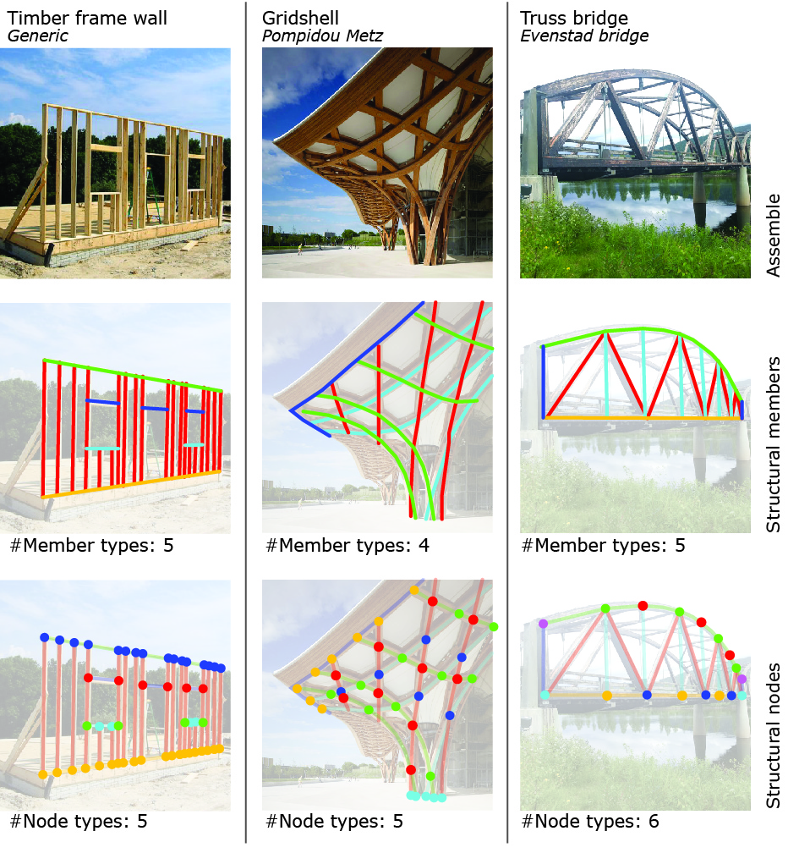
Figure 1: Geometric analysis of 3 different timber structures.

The first row (figure 1) shows three rather different structures. They have different function, different complexity, but what is shared is that all three structures are built up with the help of structural members and nodes. In the second row the members are categorized based on the logics of how the members are being materialized and detailed. The third row categorizes the different nodes, also based on how the node and related members are being materialized and detailed (not how they structurally work as a beam, column, cable etc.). Despite the simplification of the analysis, one can see that even complex structures like that of Pompidou Metz, have a limited amount of detailing types. It all melts down to a hierarchy of nodes and members that have a relation to each other. A member has specific nodes and a node has specific members. To the trained eye, it is rather easy to intuitively identify different geometric categories. However, creating a parametric logic that identifies the categories automatically is more cumbersome - especially when rebuilding the pipeline for each individual project.

Further, each of these members and nodes have physical properties and metadata. This data can be referred to as parameters when designing parametrically. Building information modelling (BIM) (Kymmell) is specialized to handle all these meta-data. However, when applying visual programming language and designing advanced structures, this data is more challenging to handle and sort. Even one single member can have dozens of different parameters, including everything from width, length, price, species, local XY-plane, grain-direction and further.

The parametric timber toolkit is built up to automate and streamline the process of identifying structural members and nodes, and generate and apply relevant meta-data. The following is a brief description of the kit’s prototype tools. A typical workflow using the toolkit may look like this:

- Generating wireframe
- Materialization and categorizing
- Categorization and node-finding
- Structural analysis based on EuroCode 5
- Detailing (automatic Computer Aided Machine (CAM)-instructions are embedded)
- Results, budget and statistics
- Build!
(Step 1-6 are repeated multiple times while iterating a design)

Materialization tool
As described in figure 1, beams, bars, columns and any structural or non-structural timber member can be described from a guide curve. Curves and lines as structural skeleton/wireframe are simple and efficient to either draw manually or generate using Grasshopper native components. They make the basis for the materialization of a structure. Further, the wireframe represents the theoretical positions of member’s axis and is needed for structural analysis. By materialization we refer to the cross section, grain-direction, timber species, group name, structural properties, price, identification number and other metadata. The materialization component automatically generates and stores geometric data expected to be needed later, during a detailing phase.

Crucial for both aesthetic expression and structural performance is the rotational alignment of the member. Thus members can be auto-oriented to the world’s Z-axis, the normal of a mesh or a custom vector.

Per now, only rectangular cross sections are supported, but crucial is the possibility to define sub-elements. For instance, a large glulam member is often composed of multiple smaller glulam elements that are processed individually before being glued together. By treating the member as sub-elements, it is convenient to, for instance, drill a tilted hole through all elements. Visually it appears as one part, but the CAM-software reads it as individual elements.

When the skeleton is materialized, the designer gets a better visual impression of the current design. Furthermore, even though cross-sections might be wrong, data from the materialization process makes a well-informed basis for generating budgets and other results.

Node-maker tool
More effort is often put into designing the nodes than designing the members. To both simplify the design, and not least to create an architectural expression, the principles of detailing are repeated throughout a project. This is evident in figure 1. Advanced timber structures may contain hundreds or thousands of individual nodes. Finding nodes are only based on an intersection search of curves, but categorizing nodes demands custom logics. A closer look at figure 1 shows that simple rules may be used to identify node-categories. Such rules can be defined by using the node maker tool:

- Gridshell: If node consist of members in U(red)-direction and V(green)-direction, then it is a red node
- If node consist of a vertical cable (turquoise) and a bottom chord (yellow), then it is a yellow node
- Frame wall: If the node consists of a stud (red) and a top-plate (green), then it is defined as a blue node

Further, parameters, such as the orientation plane of the node, are automatically generated. Similarly, rules from the user is applied:

- If it is identified as a red node in the gridshell, the normal-direction of the plane is parallel to the normal-direction of the theoretical shell.
- If it is identified as a bottom-chord node, the normal direction of the plane is parallel to the axis of the secondary beam and the alignment of the plane is parallel to the direction of the bottom chord.

These logics may seem very obvious, but become very powerful in a conceptual phase when the wireframe geometry is changing a lot. These logics make the algorithm easy to understand how to detail it, solely based on its properties, and are crucial if, for instance, changing the resolution of a gridshell.

Structural analysis tool
The structural analysis is realized through the finite element analysis (FEA). For achieving forces and bending moments in the structural elements, the Karamba FEA plugin is introduced in the proposed computational workflow. Material properties and cross-sections have to be defined before running the FEA solver. What is characteristic for the conceptual phase of design is that information about element behaviour (labelling elements as beam, column or cable) is unknown, or belong to the set of frequently adjusted variables. This is particularly true if the design is based on a parametric model, in which one input parameter change (e.g. the position of surface controlling point) means the whole structure has to be rebuilt (redefined). To make this process as adaptable to our methodology as possible, we integrate detailing components within FEA.

Figure 2: Structural analysis and detailing methodology.

The dimensioning of the cross-sections comes after FEA analysis and is based on the authors’ code for Eurocode 5 (EC5) and 3 (EC3) requirements. The dimensioning of the node is also scripted in the component and could influence the cross-sections or the topological solution (see figure 2).

Currently, the results from structural analysis tool can be used as a draft, but future development will make it more accurate and reliable. That said, efficient structural feedback is key when developing an architectural concept for a design.

Sorting tool
When detailing the geometry, whether it is a node or a member, various data is needed. If a node is being detailed, data from both the node and the connected bars are relevant. Opposite is data from the attached nodes relevant when detailing a member. The sorting tool sorts data based on which node or member the designer chooses to detail. For instance, if choosing to detail a yellow node in the truss in figure one, the tool outputs unified data lists of the nodes, the lower chords, the cables and the bars.

Detailing tools
As described in the introduction, the authors have identified too big a gap between physical processing of timber and the method of digital designing timber. Inspired by the Woodpecker plugin by DesignToProduction, the detailing components also generate BTL-files. The BTL-format is read by most CAM-software and is a free standard providing a parametric description of wooden building components. What distinguishes the developed tools in Woodpecker is the parallel generation of geometry. The expected benefit is to let users design more intuitively and let the technical CAM-preparation generate in the background.
An example clearly explains the need for such an approach. If you want to design a beam with a big hole in the middle, various options are possible. Firstly, drawing a rectangle and a circle that are together being extruded. Or secondly, modelling a box and then performing a subtractive boolean using a cylinder. However, both solutions are fundamentally different from the physical operation, and distance the designer from reality. Since the applied tools highly influence a design process, the chances are that impossible designs are being generated with the described methods. Further, the geometry does not contain information directly readable by CAM-software. If the mentioned example were to be designed using the toolkit, the beam is materialized and positioned using a guide curve. Depending on the size, the hole can be made using either a virtual mill or a drill. In addition to a visual preview of the design, CAM-instructions are generated in the background. In other words: Digital craft.
Per now, due to the chosen design of the case project, only pocketing, cutting, drilling and contour are developed. However, the BTL-library is much more comprehensive and supports more advanced operations such as tenon, ruled contours and dovetail joints.

The case project
The case project is a collaboration between NTNU, SINTEF, the Municipality of Orkdal and Moelven Glulam. A park along the river Orkla is being refurbished and the path will be upgraded to a road for pedestrians and cyclists. Two side rivers create the need for the bridges. Furthermore, the municipality is planning to conduct snow removal using a 13 ton (+5 ton gravel), 2,5 meters wide wheel-loader, making the load conditions particularly demanding compared to ordinary pedestrian bridges.

As mentioned in the introduction, both bridges apply the connection principle developed in conjunction with the Lillehammer 1994 Winter Olympics and the Gardermoen Airport (Aasheim). An 8mm metal-plate is slotted into to the members and connected using 12mm dowels. Since developing the pioneering projects, many glulam truss bridges for traffic purposes have been built in Scandinavia. What distinguishes the bridges in the case project from existing ones, is the secondary steel structure. Conventionally the metal-plates in the lower chord are connected with the secondary beam using a bolt placed below the bottom chord. However, with the scale of a pedestrian bridge, this would have been demanded undesirably large and dominating details. Thus, the connecting bolt is lifted and integrated into the bottom chord.

Both for aesthetic arguments and to clarify the case-project, the bridges have the same architectural expression. Horizontal laths with mounted LED-strips make the railing, while the path is composed of ribbed timber boards and the secondary structure is a hanging steel-cylinder. However, different boundary conditions, such as surrounding trees and a cottage, different spans and directions of the connecting path, makes the appearance of the bridges different. Both bridges will be finalized during spring 2017.

Parametrization and workflow
With the help of the working beta-tools, described timber truss bridges have been completely parametrized. The parametric model will then be adaptable for any type of project needing a timber truss bridge. This will allow for more complexity, larger dimensions and different detailing. The following is a step-by-step explanation of the parametric pipeline used in the case-bridges:

- Upper and lower centre-curves are manually drawn as either freeform splines, arches or lines. See figure 3a.
- Based on parameters, such as width, truss-type and amount of bars, wireframe-geometry is generated. See figure 3a
- The wireframe geometry is materialized. Here the geometry is determined to be glulam. For instance, the final version of the bottom chord is subdivided into 55+115+55 x 315mm, but can be changed at any time. See figure 3b.
- Nodes are divided into different detailing categories: Upper chord node, bottom chord node, foundation node and upper node.
- The bridge is structurally analysed. The analysis reports if the chosen cross-section fulfils Eurocode criteria and determines the joints capacity by adjusting positions and the number of dowels.
- All node categories are individually detailed.
- The BTL-file is automatically generated while the metal-geometry can be baked to 2d-files used in a CNC-cutter. Figure 4d shows a CNC-test based on the algorithm.

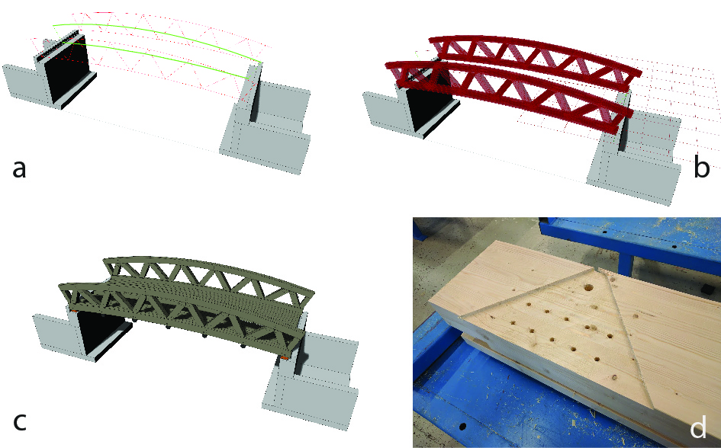

Figure 3: 3a) Wireframe (red) and centre-curve (green), 3b) Materialized wireframe, 3c) Detailed wireframe, 3d) CNC-test of the bottom chord.

Parametric detailing of the bridge (step 6)
While developing the design, the detailing of the nodes was the most time-consuming. However, using the sort tool, only five main, design specific, algorithm modules had to be developed. The most comprehensive detail is the bottom chord node and is determined by a series of parameters. The main parameters are the cross-sections and the amount of dowels needed. Other parameters, such as thickness of the metal-plate and distance from the centre of dowels to the edge of the metal are fixed parameters due to standardization. The timber is pocketed and drilled to integrate the metal-plates in the timer. The geometry of the bottom chord can be seen in figure 4.

Follo Bridge
The Follo bridge is the shortest, spanning only 10 meters and is the first bridge to be built. During the winter, the river accumulates ice and hence has a risk of damaging the bridge. For this reason, the bridge is arched and raised 40 cm relative to the old bridge.

Evjen Bridge
The Evjen river and bridge are located beside a local fireplace and timber shelter. The height difference of the riverbanks is approximately 1.5 meters and due to universal design requirements of maximum 1:20 inclination, the length of the bridge is almost double length of the span. Furthermore, due to the directions of the connecting paths, the bridge makes two turns. One turn is towards the local fireplace, where small amphitheatre is built into the bridge.

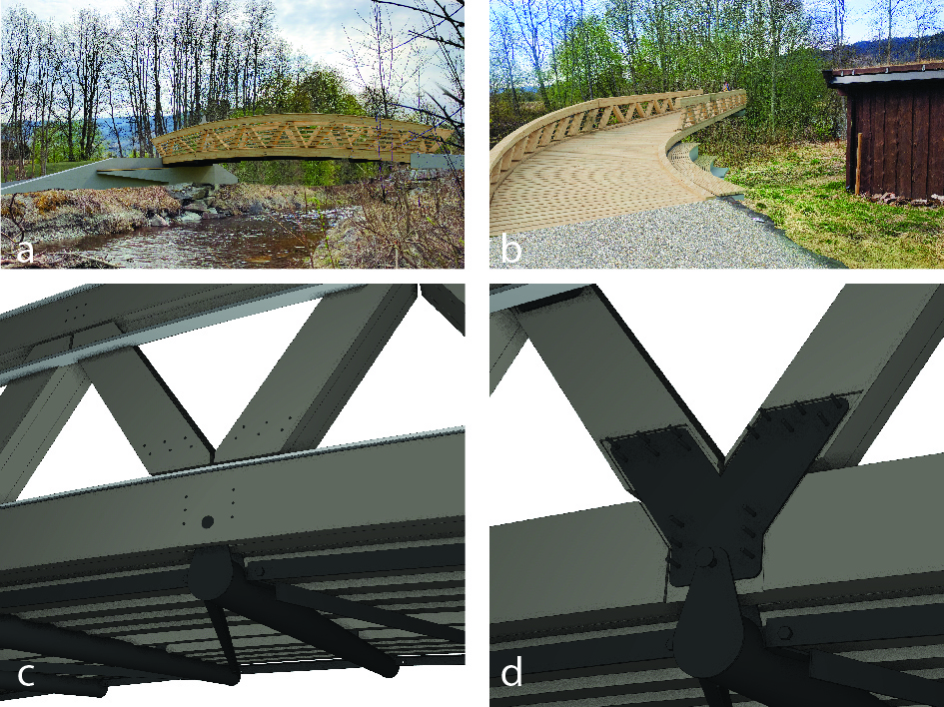
Figure 4: 4a) Follo bridge, 4b) Evjen bridge, 4c) Lower chord node, 4d) How the node looks like at the inside

Discussion
It is still early in the development of the toolkit. Yes, the toolkit is working. It has been a great help when designing the bridges. However, it still has many bugs and is rather slow and needs a better interface to be applicable for other designers. That said, the potential and need of further development is obvious.

Efficiency
Has the efficiency of designing a bridge increased? In many ways it is too early to answer this question. The development up until now has been a mix between tool development and designing the bridge. Development of the tools has been clearly the most time consuming work. Depending on what parameter is modified, the algorithm uses between 30 and 120 seconds to recalculate a complete structure with all metal components and BTL-file. Compared to a manual workflow, which would demand days of redrawing, one can, with certainty, say that the efficiency has increased.
Manufacturing tests have shown that the pipeline is still efficient when leaving the parametric environment. In theory there is no need for the manufacturer to rework of the 3d-model. The test shown in figure 4d, were sent directly to the CNC-machine.
With the parametric model of the bridge complete, designing a new project with similar principles will also have increased efficiency. Sketching a detailed 3D-model of a one span bridge with all components included will perhaps require no more than a day’s work. It would of course, only be an early draft, but still a remarkably well-informed draft with volume-prices, visual impact and identified structural challenges. The model would be a good basis for new iterations in collaboration between disciplines.
Despite these gains, 30-120 seconds still feels very slow. Creative drafting with multiple iterations is dependent on almost real-time feedback to be productive. In this case, waiting 30 seconds is killing the creative process.

Is the industry ready?
Designing a project parametrically demands new skills and mindsets. Not only from a geeky architect, but from all the influenced stakeholders. As mentioned in the introduction, parametric workflows have the potential of being 100% deterministic. However, broken links, manually performed parts of the process, slows down the pipeline drastically. Per now, industry is not ready, but we strongly believe and hope it is getting there quite soon. The key is to lower the threshold and complexity of using such tools. The described toolkit might contribute to this. The toolkit simplifies data handling, materialization, vector operations, sorting and transfer to manufacturing.

Further research
The tool is not ready to be shared, and is per now only a working prototype usable for those who knows well how the tool works. Some key challenges have been identified:

- The code is not running fast enough, and currently limits the tool as a conceptual, creative tool. The working prototypes have been useful for understanding how such a timber toolkit should work, but will in the near future be completely re-coded.
- Until now, the focus has been on the pipeline and has not exploited the potential of properly timber materialize timber geometry. Further implementation may be a timber-library, visualization of grain-direction and including manufacturing traces like the need of filleted corners when milling.
- The designing tools is now limited to a small set of operations, but is rather trivial to expand to other operations that the BTL-format supports. Further, also other manufacturing approaches might be exploited.
- The pipeline generates data intended for budget and other results real time, but is currently not visualized. Development/integration of a visual dashboard that gives real-time feedback may make a creative process more informed.

Conclusion
This study set out to make a pilot project that revealed challenges and requirements of a timber-specific parametric toolkit. The development has been pushed forward by a case-project. From this study, following conclusions can be presented:

- A timber, or any material, specific parametric toolkit proved to demand a comprehensive set of tools just to handle the data-flow that are increased once geometry is being materialized.
- The tool is still not fully operational and many challenges must be solved to make it usable for third parties.
- From an architect’s perspective, it is important to find areas of the process that can more streamlined without compromising architectural quality. The described tool automates tasks that does not improve architectural quality itself, but are still needed in the process from sketch to fabrication. Merging design development and manufacturing preparation is especially seen as a big potential.
- The introduction claimed that parametrization is key to achieve a mass customized building industry, but we also need customize tools to streamline the process of designing. Designing the bridges using described toolkit supports this assertion.
- If parametrization is key, the building industry must parametrize its pipeline to stay competitive in the future.

Acknowledgements
The authors have been dependent on technical support from Nathalie Labonnote (SINTEF) and Daniel Barosso/Åge Holmestad (Moelven Glulam) and financial support from Innovation Norway. Such comprehensive case project would not have been possible to realize without funding, patience and innovative attitude of Johannes Lippardt and Orkdal Kommune.

References

Aasheim, Erik. “Glulam Trusses for Olympic Arenas, Norway.” Structural Engineering International 3.2 (1993): 86–87. Web.
Ban, Shigeru. “Nine Bridges Country Club.” ArchDaily. N.p., 3 Apr. 2014. Web. 18 Jan. 2017.
Joseph, Pine B. “Mass Customization: The New Frontier in Business Competition.” Harvard Business School Press, Boston (1993): n. pag. Print.
Kymmell, Willem. Building Information Modeling: Planning and Managing Construction Projects with 4D CAD and Simulations (McGraw-Hill Construction Series): Planning and Managing Construction Projects with 4D CAD and Simulations. McGraw Hill Professional, 2007. Print.
Li, Jian-Min, and Jan Knippers. “Segmental Timber Plate Shell for the Landesgartenschau Exhibition Hall in Schwäbisch Gmünd—the Application of Finger Joints in Plate Structures.” International Journal of Space Structures 30.2 (2015): 123–139. Print.
McNeel, Robert. Grasshopper 3D. N.p., 2015. Print.
“Rhinoceros 3D.” Retrieved Jan 15 (2009): n. pag. Print.
Petzold, Frank. Beaver. N.p. Web.
Rapp, Edward J., and Glen A. Johnson. Computer Numerical Control Machine Tool. Google Patents, 1980. Google Scholar. Web. 18 Jan. 2017.
Schumacher, P. Parametricism as Style-Parametricist Manifesto, 2008. N.p. Print.
Schumacher, Patrik. “Parametricism 2.0: Gearing Up to Impact the Global Built Environment.” Architectural Design 86.2 (2016): 10. Wiley Online Library. Web.
Stehling, Hanno. Woodpecker. N.p. Web.

