Table 1. Descriptive statistics for the 112 children in the study
Variable | Mean/% | SD | Min. | Max. | n | % missing
Child and family characteristics
Gender  Female  Male | 42.0%  58.0% |  |  |  | 47  65
Child temperament | 21.85 | 4.55 | 12.0 | 37.0 | 104 | 14.8
Mothers’ educational level |  |  |  |  |  | 8.2
High school or less | 13.4% |  |  |  | 15
Bachelor’s degree /<4 years | 39.3% |  |  |  | 44
University degree ≥ 4 years | 47.3% |  |  |  | 53
Covariates
Child age | 23.17 | 3.8 | 16.0 | 32.0 | 112
Maternal prenatal depression | 4.2 | 3.5 | 0.0 | 16.0 | 112

Table 2. Descriptive information about the childcare centres
Variable | Mean/% | SD | Min. | Max. | n | % missing
Childcare factors
Quality (emotional support) | 5.32 | 0.68 | 3.1 | 6.8 | 112
Hours in childcare | 7.67 | 0.78 | 5.0 | 9.0 | 100 | 18.0
Hours in care, categorical
< 8 | 33.0% |  | 5.0 | 7.0 | 37
≥ 8 | 67.0% |  | 8.0 | 9.0 | 75
Organization of childcare
Traditional CC units | 67.9% |  |  |  | 76
Open/flexible CC units | 24.1% |  |  |  | 27
Family day care | 8.0% |  |  |  | 9
Group size | 14.4 | 5.89 | 4.0 | 31.0 | 111 | 0.9
Group size, categorical
4–9 children | 24.3% |  |  |  | 27
10–15 children | 54.1% |  |  |  | 60
16–32 children | 21.6% |  |  |  | 24
Child:caregiver ratio |  |  |  |  |  | 8.2
≤ 3 | 62.2% |  |  |  | 69
> 3 | 37.8% |  |  |  | 42
Note: CC = childcare centre

Table 3. Morning and mid-afternoon cortisol levels (log10-transformed nmol/L) at home and in childcare
Time | Home | Childcare
 | Untransformed log10 values  M (SD) n M (SD) | Untransformed log10 values  M (SD) n M (SD)
10 am | 6.77 (3.46) 94 .79 (.19) | 7.05 (3.96) 91 .80 (.20)
3 pm | 5.91 (2.85) 83 .73 (.20) | 7.83 (3.88) 87 .85 (.19)

Table 4. Interactions between time and family-, child-, and childcare-related factors
(mixed models with log-transformed cortisol levels as the dependent variable)

Variables | Estimate | p-value | 95% CI
Mother’s educational level | .005 | .865 | –.049 to .058
Female gender | .027 | .516 | –.054 to .108
Child temperament | .003 | .079 | –.000 to .006
Eight hours or more in childcare | .083 | .046 | .001 to .164
Organization of childcare  (traditional units versus other) | .005 | .909 | –.086 to .096
Number of children in the group | .003 | .357 | –.003 to .011
Child:adult ratio | –.039 | .357 | –.122 to .045
Quality of caregiver–child  interactions | .021 | .503 | –.040 to .086

Figure 1. Enrolment of participants

Figure 2. Change in cortisol levels (log-transformed nmol/L) from morning to mid- afternoon at home and in childcare (mixed model analysis)

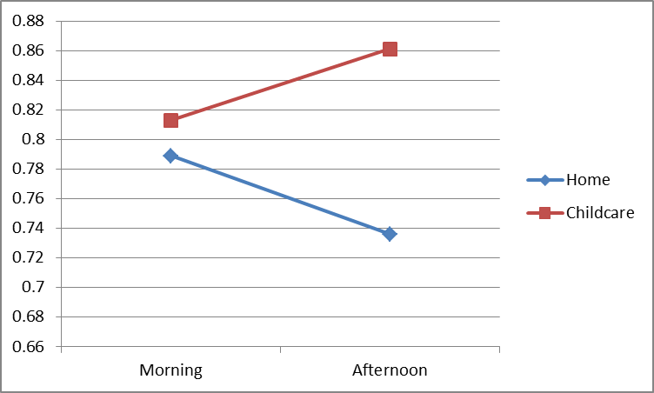

Figure 3. Morning to mid-afternoon change in cortisol levels (log10-transformed) in childcare for children attending childcare for less than 8 hours per day compared with children attending childcare 8–9 hours per day (mixed-model analysis)

