Mathematical modeling of the oxygen uptake kinetics during whole-body endurance exercise and recovery

John F. Moxnes

Land Systems Division

Norwegian Defence Research Establishment
P.O. Box 25
N-2027 Kjeller, Norway

E-mail: john-f.moxnes@ffi.no

Øyvind Sandbakk
Center for Elite Sports Research,
Department of Neuromedicine and movement science
Norwegian University of Science and Technology,
7026 Trondheim, Norway
E-mail: oyvind.sandbakk@ntnu.no
Phone: +4791187691

August 24rd, 2016

Abstract

In this study, we elucidate four different mathematical models of the kinetics of oxygen uptake during whole-body endurance exercise at different intensities and throughout the subsequent recovery periods. We employ the hypothetical inductive-deductive method and forecast four different models for the oxygen kinetic. The VO₂ development using these models compared with experimental results where an elite cross-country skier performed laboratory tests while running with poles on a treadmill, in which the rate of oxygen uptake and blood lactate concentration as a function of time were measured. The most developed model accounted for the delayed superimposed slow component of oxygen uptake and the influence of lactic power production on the oxygen kinetics. The rate of change in oxygen with this model is consistent with the accumulated oxygen deficit model and matched the data well, even for intensities above the lactate threshold and during recovery.

Keywords: VO₂ kinetics, aerobic power, anaerobic power, lactate concentration.

Introduction
Cross-country skiing is a demanding endurance sport where the rate of work and metabolic intensity are changing continuously across the varying terrain . In such sports, the oxygen uptake (VO₂) kinetics, that describes the rate of change in VO₂ following the onset of exercise or a change in work rate, is of significant importance.

The pulmonary oxygen uptake is used as a proxy for VO₂ and rise in a nearly exponential fashion following the onset of exercise. This has been described by three distinct phases: Phase I is the first 15-25 sec, named the cardio-dynamic phase representing the circulatory transit delay of VO₂ from muscles to lungs ; Phase II is the increase in VO₂ reflecting the adjustment of VO₂ in the active skeletal muscles; Phase III is the steady-state phase of VO₂ during moderate intensity exercise .

At high intensities above the lactate threshold (LT) a delayed slow component of VO₂ is normally initiated 100-200 sec following commencement of exercise . This slow component generates a steady-state situation of VO₂ that is either right below or equal to the maximal VO₂ (VO₂max). Although the mechanism underlying the slow component is not well understood, the amplitude and rate of change of the slow component are both correlated with changes in blood lactate concentration during heavy exercise . In addition, a slow increase in VO₂ during prolonged submaximal intensity, referred to as VO₂ drift, is also observed at intensities well below the LT .

To model VO₂ kinetics in response to exercise differential equations with a smooth function of time and intensity has been shown to provide more accurate estimations over a continuum of exercise intensities than the abovementioned three-phase model where the phases turn on and off at discrete time intervals . In the current study we outline four different models for describing the VO₂ kinetics during and after endurance exercise. Model 1 is Stirling et al.’s differential equation. Model 2 is a first order differential equation model where the time development of VO₂ at a given work rate is used as input . Here, VO₂ kinetics is assessed using the difference between requirements of aerobic power and the available aerobic power to fully accommodate the work rate . Model 3 is an extension of Model 2 where we additionally account for reduced chemical- and contraction-coupling efficiencies associated with production of lactic power. Thus, this model induces a superimposed delayed slow component of VO₂. Model 4 is a theoretically derived model that accounts for the superimposed slow component and that the production of lactic power may directly influence the aerobic kinetics.

The purpose of this study was to elucidate these four models for the kinetics of VO₂ during whole-body endurance exercise at different exercise intensities and the subsequent recovery periods. These models were fitted to the characteristics of an elite cross-country skier performing laboratory tests while running with poles on a treadmill, in which the rate of VO₂ and blood lactate concentration were measured as a function of time.

In our model development, we have aimed to increase the level of sophistication by including different components and compare how they capture the main physiological behavior. Specifically, Model 1 and 2 differ in the way the handle intensities above the maximal rate of oxygen uptake. Model 3 additionally handles the superimposed delay component, while model 4 differs from 3 since the oxygen kinetic is dependent of the lactate kinetic.

Methods

Overall design
Initially, the four models described above where outlined. The mathematical computation program Mathematica 9 (Wolfram Research Incorporation, Champaign, IL, USA) was used to simulate the kinetics of VO₂ during whole body exercises and recovery. The outputs of the simulation models were compared with experimental data where the skier ran with poles on a treadmill at various exercise intensities. Here, the VO₂ and blood lactate concentration were measured as a function of time.

Model development

Intracellular production of ATP either occurs aerobically (in the mitochondria by oxidative phosphorylation) or anaerobically due to glycolysis/glycogenolysis (generating lactic anaerobic power) as well as breakdown of Phosphocreatine (PCr) into Creatine (Cr) (i.e., ADP + PCr gives ATP + Cr in the Creatine Kinease (CK) reaction). The symbol represents contraction-coupling efficiency while denotes the chemical-coupling efficiency during aerobic production of ATP. The symbol represents chemical coupling efficiencies during production of ATP through glycolysis/glycogenolysis (G), and the chemical coupling efficiencies during ATP production by CK reaction. The work power (i.e. the time derivate of the sum of external work and internal work) where ATP is produced aerobically is , whereas work power where ATP is produced by G is equal to . The work power where ATP is produced by CK is equal to . Here , , and represents the aerobic power, the power due to the G, and the power due to the CK reaction (alactic power) respectively. These powers are different than the corresponding work powers due to heat production. Note that the aerobic power does not account for resting aerobic power (in our case estimated to be = 85 J/s). The total aerobic power is . The two chemical coupling efficiencies and are similar, whereas is larger . Total work power is given by
(1)
We propose that the associated with a specified work rate (P) is generally given as
(2)
and denote constants for our incline of 0.105, and “mod” means model assumption. During steady-state exercise below the LT, == 0,= , where the bars means the steady-state values in time of the efficiencies. We achieve from equation (1) and (2) that
(3)
For low exercise intensities may be assumed as constant for different intensities. Then and c denote constants for our chosen incline of 0.105. and c are simply established by applying a linear regression analysis on the measured aerobic power vs the work rate P at low steady-state intensity. and are then given by . In this article we set to zero as an approximation, while c = 6.25 [13]

Model 1
At a sustained steady-state work rate, aerobic power reaches a steady-state within 2-3 minutes . To account for this delay mathematically Stirling et al. used a first order differential equation. Our Model 1 is analogous to this differential equation model. The aerobic power due to the work rate ( = -) is found by solving the following equation
(4)
The “dot” means time derivative, and denotes the maximum aerobic power. Here we define the virtual aerobic power for all intensities, also for use during non-steady-state situations .
(5)

Model 2
Our Model 2 is also a first order differential equation model with the work rate as input as earlier forecasted .
(6)
where is the time parameter characterizing the time at which aerobic power attains a steady-state asymptotically during constant work rate. The Min function ensures that the aerobic power is below . Reaching steady-state means less than 1% change in aerobic power per second. Model 1 and Model 2 differ in the way they handle intensities above. When B = 0, C = 0, and E = 1, Model 1 and Model 2 are alike given that, and intensities are also below . In this article we propose that B = 0, C = 1, and E = 1 for Model 1 and A is fitted to the measurements.

Model 3
The contraction coupling efficiency (), or the aerobic chemical coupling efficiency () may vary with time due to high exercise intensity. Reduced efficiency leads to a higher aerobic power for the same work rate and this may explain the delayed superimposed slow aerobic component on the steady-state aerobic power. In order to account for this phenomenon, we set as our third and new model
(7)
This equation describes the need for aerobic work power to fully accommodate the work rate.
For example, given that is a constant through time we derive from equation (7) that
(8)
Thus, Model 3 equals Model 2 only if is constant for a specified timeframe. If decreases slowly with time, equation (7) is the same, while increases slowly due to the . This gives a delayed superimposed aerobic power.

Model 4
As a forth model, we forecast the new model
(9)
Although the model so far seems ad hoc, some interesting consequences can be deduced to support the model. Considering first constant efficiencies, we derive from equation (9) after multiplying with
(10)

In order to further elucidate on equation (10), we have from equation (3) that , which may be seen as a generalized accumulated oxygen deficit model . Thus we have
(11)
Assuming that the exercise intensity is significantly below the lactate threshold we set that . Equation (11) can be reorganized algebraically and expressed as
(12)
Below the LT we also have that . Applying equations (10) and (12), we derive
(13)
Thus, we find that the alactic power is proportional to the rate of change of the aerobic power . Model 4 is thus consistent with the generalized oxygen accumulated oxygen deficit model and we deduce that if the intensity is below the lactate threshold, the alactic power is proportional to the rate of change of the aerobic power.

The cardio dynamic phase, which represents the circulatory transit delay from muscles to lungs, was not considered because the focus of the study was on actual aerobic power. Typical values of for moderate intensity exercise range between 23-36 s . Di Prampero and Ferreti (1999) suggests 10-24 s. Some studies have established that increases linearly with concentration of lactate whereas others observed that = 23 s for all work rates . The 2.83 m/s run (see our protocol described below) gives least scatter in the aerobic data for the transient period during increasing aerobic power. We therefore chose = 23 s and 1/A= 16380 J based on the least root mean square (RMS) error between experimental data and the different models during the first 100 sec at 2.83 m/s.

Contraction-coupling efficiency
The contraction-coupling efficiency is assumed to be and chemical efficiency related to aerobic is . We use . With regards to alactic power, we forecast that is close to 1. We set = 0.95. With regards to lactic power, we set that . Amount of heat generated per used ATP is found to be about two times larger in oxidative phosphorylation and anaerobic glycolysis compared to ATP from CK . The number of ATP generated per used oxygen is theoretically estimated to be about 6. However, studies reveal that when exercise intensity is equal to or above LT, ATP utilization increase and contraction coupling efficiency decrease for a constant work rate. This may in part be explained by a change in fiber type recruitment, an elevated temperature, lowered pH, or increased Pi levels . Thus a lower contraction coupling efficiency of muscle contractions and a lower P/O ratio could simply explain lack of steady-state ATP consumption for a given work rate. We forecast that efficiencies during production and use of ATP may dependent mainly on the pH and thereby strongly correlate to the lactate concentration. To account for a model with time varying parameters, we set that and depend on the lactate concentration. As a model we set that andwhere . The function describes reduction in efficiencies due to lactate concentration C (Figure 1). We apply the hypothetical inductive-deductive method. Thus, the simulated consequences (deductions) of this assumption (Figure 1) are what we compare with the experiments. The data are not extensive enough to uniquely construct how efficiencies reduce with increasing lactate concentration. Thus as a simplified model we let the efficiencies decrease linearly with increasing lactate concentration. The decline we establish by inverse modeling.

Figure 1: A postulated scaled efficiency as a function of the lactate concentration C in mmol/L.

Lactic power
The model in equation (9) requires lactic power as input. In this study we used changes in blood lactate concentration measured in mmol/L to indicate changes in lactic power. Here, the change in lactate was converted into lactic power following the relationship indicated by di Prampero and Ferretti (1999). Using that formula, 1 mmol/L blood lactate corresponds to 2.7-3.3 mL/kg O₂. We set that 1 mL of O₂ is 20 J. Lactic power in J/s is set to 2.7 x 20 m , where is the rate of change in blood lactate concentration in mmol/L blood, and m is the mass of the skier. It is worth noticing that there are several shortcomings of using this formula, for example that blood lactate concentration can differ significantly from muscle lactate concentration in dynamic situations, that lactate produced is oxidized in several body tissues and that the concentration in the blood is additionally influenced by blood volume and the type of exercise. This gives an error margin in the analysis. However, the formula has repeatedly showed valid results, so we regard it as our best tool in our case.

Experimental test
The characteristics of the skier were as following; body mass of m = 78 kg, body height of 181 cm, VO₂max () = 1870 J/s, lactate threshold power = 1650 J/s.

All treadmill tests were performed on a 6 × 3 m motor-driven treadmill (Bonte Technology, Zwolle, The Netherlands). Inclination and speed were calibrated using the Qualisys Pro Reflex system and the Qualisys Track Manager software (Qualisys AB, Gothenburg, Sweden). The treadmill belt consisted of a non-slip rubber surface that allowed the skier to use his own poles (pole length: 80% of body height) with special carbide tips.

An open-circuit indirect calorimetry (Oxycon Pro apparatus with a mixing chamber) was used to measure gas exchange values (Jaeger GmbH, Hoechberg, Germany). Before each measurement, the VO₂ and VCO₂ gas analyzers were calibrated using high-precision gases (16.00 ± 0.04% O2 and 5.00 ± 0.1% CO₂, Riessner-Gase GmbH & co, Lichtenfels, Germany). The inspiratory flow meter was calibrated with a 3 L volume syringe (Hans Rudolph Inc., Kansas City, MO). Blood lactate concentration (BLa) was measured on 5 μL samples taken from the fingertip by a Lactate Pro LT-1710 t (ArkRay Inc, Kyoto, Japan).

The experimental protocols followed the order described below. Training on the days before testing was standardized, and the subject drank a standard fluid with sugar and electrolytes during all breaks while testing. Before each testing session, a standardized 20-min warm-up was performed. All tests were performed at constant work rates with 0.105 radians inclinations. On four separate days, the skier ran at 2.33 m/s, 2.83 m/s, 3.08 m/s and 3.19 m/s respectively. The first three speeds were below lactate threshold, whereas the highest was slightly above (but below ). On a fifth day to the skier ran for at 3.88 m/s, which is about 9% above . Following all tests a subsequent recovery period followed the exercise. VO₂ was continuously measured and blood lactate concentration taken at different time points throughout all exercise and recovery. See Figures in the results for more details about the various protocols.

VO₂max was tested at an inclination of 0.105 radians, with an initial speed of 3 m/s followed by 0.3 m/s increase in speed every minute until exhaustion. VO₂ was measured continuously and the average of the three highest 10-s consecutive measurements determined VO₂max and used for calculations of maximal aerobic metabolic power. The test was considered to be at maximal effort based on three criteria: 1) a plateau in VO₂ is obtained with increasing exercise intensity, 2) respiratory exchange ratio is above 1.10, and 3) blood lactate concentration exceeds 8 mmol/L.

We summarize the parameters that are used in Table 1.

Table 1: The parameters used in the models

 |  | c | m |  |  |  |  | 1/A
1870 J/s | 85 J/s | 6.25 | 78 kg | 0.3 | 0.15 | Figure 1 | 23 s | 16380 Js

Results

Figure 2 shows the simulated and experimental results for the lowest exercise intensity (0.66 ). A visual inspection shows that all models fit reasonably well with the experimental data, although the simulated steady-state value is too high. For some reason, the measured VO₂ scatters more during the recovery period.

Figure 3 shows VO₂ at an intensity below the lactate threshold (0.80 ). Here, Model 1 and 2 fit reasonably well to the data but they do not account for the delayed superimposed aerobic power. Models 3 and 4 fits this better and give higher aerobic power due to the delayed superimposed aerobic power, which is caused by the lower efficiencies utilized (see Figure 1). An indication of delayed VO₂ kinetic (after accounting for lactic power) is observed for Model 4, which consequently provides better fit better than Model 3 during the recovery period.

Figure 4 illustrates that an intensity close to the lactate threshold (0.87 ) reveals a non-steady delayed superimposed aerobic power which Models 1 and 2 fail to account for. The delayed slow superimposed component of aerobic power in Model 3 appears to be too large, whereas Model 4 provides the best fit to the data.

In Figure 5 the intensity is above lactate threshold (0.90 ) in which Models 3 and 4 show a superimposed delayed slow component while Models 1 and 2 did not fit well. Model 4 seems to provide the best fit to the data although it is notable that Model 3 fits somewhat better than Model 4 during the recovery period.

Figure 6 shows an intensity above VO₂max (1.09 ). Here, Model 1 shows too slow VO₂ kinetics while Models 2 and 3 show too fast VO₂ kinetics. Models 3 and 4 reach maximal aerobic power after 50 and 60 s respectively and the delayed superimposed slow component of aerobic power is better predicted. However, discrepancies are seen during the recovery period for all models. Table 2 shows a root mean square error between model and data.

Table 2: The root mean square error between the models and the data.

 | Model 1 | Model 2 | Model 3 | Model 4
V = 8.4 km/h | 53.45 | 54.72 | 58.43 | 57.89
V = 10.2 km/h | 75.75 | 78.13 | 62.37 | 69.13
V = 11.1 km/h | 84.59 | 82.04 | 46.85 | 45.08
V = 11.5 km/h | 64.97 | 73.38 | 80.60 | 57.16
V = 14.0 km/h | 96.72 | 102.74 | 92.24 | 109.53

Figure 2a: The powers Q in J/s as a function of time (t) for an elite skier while running with poles on a treadmill at an incline of 0.105 and speed of 8.4 km/h= 2.33 m/s.
_ _ _ _ _ :Black: Simulated aerobic power using Model 1
______ : Blue: Simulated aerobic power using Model 2
__ _ __ _ : Red: Simulated aerobic power using Model 3
___ ___ : Green: Simulated aerobic power using Model 4
………… : Black: Simulated anaerobic lactic power
●: Aerobic power measured in the experiment

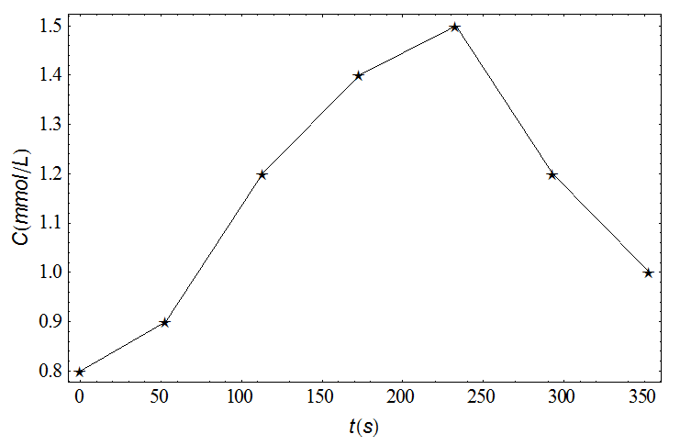
Figure 2b: The lactate concentration as a function of time for an elite skier while running with poles on a treadmill at an incline of 0.105 and speed of 8.4 km/h= 2.33 m/s.

Figure 3a: The powers Q in J/s as a function of time (t) for an elite skier while running with poles on a treadmill at an incline of 0.105 and speed of 10.2 km/h = 2.83 m/s.
_ _ _ _ _ :Black: Simulated aerobic power using Model 1
______ : Blue: Simulated aerobic power using Model 2
__ _ __ _ : Red: Simulated aerobic power using Model 3
___ ___ : Green: Simulated aerobic power using Model 4
………… : Black: Simulated anaerobic lactic power
●: Aerobic power measured in the experiment

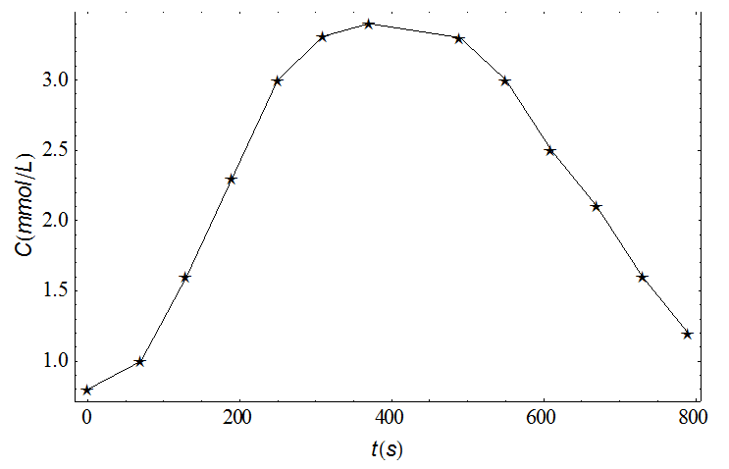
Figure 3b: The lactate concentration as a function of time for an elite skier while running with poles on a treadmill at an incline of 0.105 and speed of 10.2 km/h = 2.83 m/s.

Figure 4a: The powers Q in J/s as a function of time (t) for an elite skier while running with poles on a treadmill at an incline of 0.105 and speed of 11.1 km/h = 3.08 m/s.
_ _ _ _ _ :Black: Simulated aerobic power using Model 1
______ : Blue: Simulated aerobic power using Model 2
__ _ __ _ : Red: Simulated aerobic power using Model 3
___ ___ : Green: Simulated aerobic power using Model 4
………… : Black: Simulated anaerobic lactic power
●: Aerobic power using from experimental data
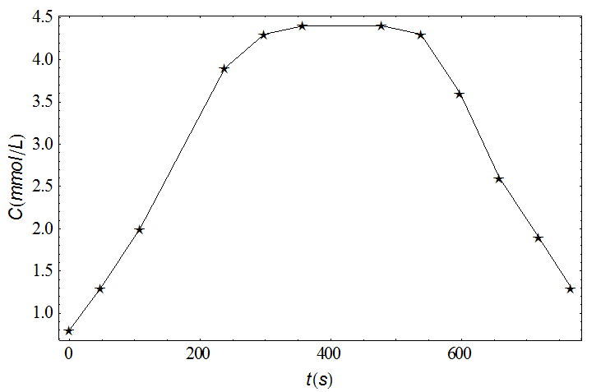
Figure 4b: The lactate concentration as a function of time for an elite skier while running with poles on a treadmill at an incline of 0.105 and speed of 11.1 km/h = 3.08 m/s.

Figure 5a: The powers Q in J/s as a function of time (t) for an elite skier while running with poles on a treadmill at an incline of 0.105 and speed of 11.5 km/h = 3.19 m/s.
_ _ _ _ _ :Black: Simulated aerobic power using Model 1
______ : Blue: Simulated aerobic power using Model 2
__ _ __ _ : Red: Simulated aerobic power using Model 3
___ ___ : Green: Simulated aerobic power using Model 4
………… : Black: Simulated anaerobic lactic power
●: Aerobic power measured in the experiment
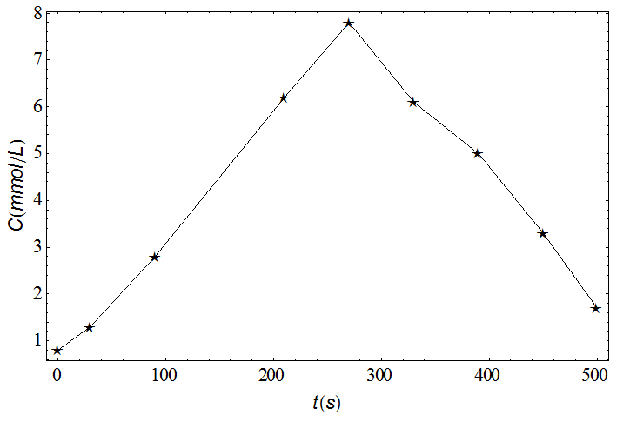
Figure 5b: The lactate concentration as a function of time for an elite skier while running with poles on a treadmill at an incline of 0.105 and speed of 11.5 km/h = 3.19 m/s.

Figure 6a: The powers Q in J/s as a function of time (t) for an elite skier running while running with poles on a treadmill at an incline of 0.105 and speed of 14.0 km/h = 3.88 m/s.
_ _ _ _ _ :Black: Simulated aerobic power using Model 1
_______ : Blue: Simulated aerobic power using Model 2
__ _ __ _ : Red: Simulated aerobic power using Model 3
___ ___ : Green: Simulated aerobic power using Model 4
………… : Black: Simulated anaerobic lactic power
●: Aerobic power measured in the experiment

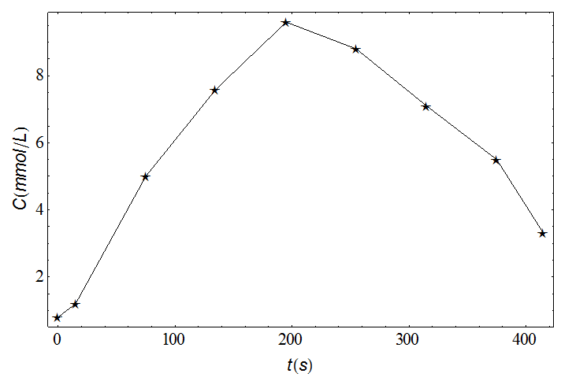
Figure 6b: The lactate concentration as a function of time for an elite skier while running with poles on a treadmill at an incline of 0.105 and speed of 14.0 km/h = 3.88 m/s.

At intensities below 70% of LT, the lactate concentration is lower than 1.5 mmol/L and the slow component of the VO₂ is negligible. Between 70% of LT and LT the lactate concentration is between 1.5 and 4.5 mmol/L. The slow component of VO₂ is significant and VO₂ drifts starts from 100 to 200 s and reaches a steady state of VO₂ that is lower than VO₂max. At intensities between LT and VO₂max the slow component interferes directly with the VO₂ kinetics and generates a VO2 that approaches VO₂max. Finally, at intensities above VO₂max the VO₂ reaches VO₂max relatively early and the slow component is of less importance. The exercise is terminated by the athlete after some time (approximately 150 seconds). We have also made a table related to this (Table 3).

Table 3: Aspects related to oxygen uptake kinetics during exercise at different intensities.

Intensity < 70% | 70% < Intensity <LT | LT < Intensity < VO₂max | VO₂max <Intensity
Lactate level is steady and less than 1.5  No significant slow component of VO₂ | Lactate level is steady-state between 1.5 and 4.5  Significant slow component of VO₂  Steady state VO₂ is somewhat lower than VO₂max | No steady state level of lactate  Slow component of VO₂ interferes with VO₂ kinetics and generates a VO₂ that approaches VO₂max | VO₂ reaches VO₂max relatively early and the slow component is of less importance  Exercise is terminated by the athlete after some time

Conclusions

In this study, we elucidated four different mathematical models for the kinetics of oxygen uptake during whole-body exercise at different intensities and throughout the subsequent recovery periods. We employ the hypothetical inductive-deductive method and study four different models for the VO₂ kinetics, in which two of them have not previously been presented in the literature. The VO₂ development using these models compared with experimental results where an elite cross-country skier performed laboratory tests while running with poles on a treadmill. The most developed model accounted for the delayed superimposed slow component of VO₂ and the influence of lactic power production on VO₂ kinetics. The rate of change of VO₂ of this model is consistent with the accumulated oxygen deficit model and matched the data well, even for intensities above the lactate threshold and during recovery.

The three other models were also able to predict VO₂ kinetics fairly well. Our Model 1, that is a modified version of Stirling et al.’s [4] differential equation, shows good agreement at low intensity and during the recovery periods, but fails to account for the superimposed slow component when exercising at high intensities. The same applies to Model 2 where the time development of VO₂ associated with a given work rate does not account for the superimposed slow component.

This was improved in Model 3 where the chemical- and contraction-coupling efficiencies associated with production of high lactic power during high exercise intensity was accounted for. This model induces a superimposed delayed slow component of VO₂ that fits the data better than Model 1 and 2 at high intensities and indicate that reduced chemical- and contraction-coupling efficiencies are present at high intensities where high lactic power is produced. Specifically, we modelled that efficiencies decrease as a function of lactate concentration to account for the delayed superimposed slow component of aerobic power. We do not propose that the increased blood lactate concentrations directly influence these efficiencies. However, it is likely that the coinciding reduction in muscle pH does. Although, this seems to have improved Model 3 at high intensity, it gives somewhat too high aerobic power during steady-state. Model 3 shows 40% higher RMS than model 4 at 11.5 km/h (3.19 m/s), while model 4 only shows 19% higher RMS than model 3 at 14.0 km/h (3.88 m/s). Therefore, in Model 4 we further assume that also the aerobic kinetics is influenced by lactic power production, which altogether may capture the data best.

Cross-country skiing is performed at varying exercise intensities, with the uphill parts performed at high intensity well above what can be done aerobically, whereas downhill terrain allows for recovery. This shows an importance of understanding the factors influencing oxygen kinetics above aerobic steady state exercise and during recovery. Uniquely for this study, our most developed model could account for the delayed superimposed slow component of oxygen uptake and the influence of lactic power production on the oxygen kinetics.

Although we consider the elite skier to be a representative subject, other skiers would have different characteristics and generate slightly different aggregated data and behavior. In this study we did not perform any repeated measures of performance of our skier, which might be regarded a weakness of the current design. However, results from national and international competitions, as well as performance tests in our laboratory, indicate that elite skiers are able to reproduce performance by a standard deviation of less than 2%.

Competing interests

The authors declare that they have no competing interests.

Authors’ contributions

JFM performed the mathematical simulations while ØS performed the laboratory testing. Both authors contributed with important intellectual content in all parts of the manuscript. Both authors read and approved the final manuscript.

Funding

No sources of funding to report.

References

[1] O. Sandbakk, G. Ettema, S. Leirdal, V. Jakobsen, and H.C. Holmberg, Analysis of a sprint ski race and associated laboratory determinants of world-class performance, Eur J Appl Physiol 111 (2011), pp. 947-57.
[2] O. Sandbakk, and H.C. Holmberg, A reappraisal of success factors for Olympic cross-country skiing, Int J Sports Physiol Perform 9 (2014), pp. 117-21.
[3] T.J. Barstow, N. Lamarra, and B.J. Whipp, Modulation of muscle and pulmonary O2 uptakes by circulatory dynamics during exercise, Journal of Applied Physiology 68 (1990), pp. 979-989.
[4] J. Stirling, M. Zakynthinaki, and B. Saltin, A model of oxygen uptake kinetics in response to exercise: Including a means of calculating oxygen demand/deficit/debt, Bulletin of mathematical biology 67 (2005), pp. 989-1015.
[5] J.M. Murias, M.D. Spencer, J.M. Kowalchuk, and D.H. Paterson, Influence of phase I duration on phase II VO2 kinetics parameter estimates in older and young adults, American Journal of Physiology-Regulatory, Integrative and Comparative Physiology 301 (2011), pp. R218-R224.
[6] V. Billat, B. Bocquet, J. Slawinski, and L. Laffite, Effects of a prior intermittent run at vVO2MAX on oxygen kinetics during an all-out severe run in humans, Journal of sports medicine and physical fitness 40 (2000), p. 185.
[7] B. Grassi, H.B. Rossiter, and J.A. Zoladz, Skeletal muscle fatigue and decreased efficiency: two sides of the same coin?, Exerc Sport Sci Rev 43 (2015), pp. 75-83.
[8] A.M. Jones, B. Grassi, P.M. Christensen, P. Krustrup, J. Bangsbo, and D.C. Poole, Slow component of VO2 kinetics: mechanistic bases and practical applications, Med Sci Sports Exerc 43 (2011), pp. 2046-62.
[9] H.B. Rossiter, Exercise: Kinetic considerations for gas exchange, Compr Physiol 1 (2011), pp. 203-44.
[10] T.J. Barstow, Characterization of VO2 kinetics during heavy exercise, Medicine and Science in Sports and Exercise 26 (1994), pp. 1327-1334.
[11] G.A. Gaesser, and D.C. Poole, The slow component of oxygen uptake kinetics in humans, Exercise and sport sciences reviews 24 (1996), pp. 35-70.
[12] J.F. Moxnes, and Ø. Sandbakk, The kinetics of lactate production and removal during whole-body exercise, Theor Biol Med Model 9 (2012).
[13] J.F. Moxnes, K. Hausken, and Ø. Sandbakk, On the kinetics of anaerobic power, Theoretical Biology and Medical Modelling 9 (2012), p. 29.
[14] P.E. di Prampero, and G. Ferretti, The energetics of anaerobic muscle metabolism: a reappraisal of older and recent concepts, Respiration physiology 118 (1999), pp. 103-115.
[15] J. González‐Alonso, B. Quistorff, P. Krustrup, J. Bangsbo, and B. Saltin, Heat production in human skeletal muscle at the onset of intense dynamic exercise, The Journal of physiology 524 (2000), pp. 603-615.
[16] J.I. Medbo, A.-C. Mohn, I. Tabata, R. Bahr, O. Vaage, and O.M. Sejersted, Anaerobic capacity determined by maximal accumulated O2 deficit, Journal of Applied Physiology 64 (1988), pp. 50-60.
[17] P.E. Di Prampero, Factors limiting maximal performance in humans, European journal of applied physiology 90 (2003), pp. 420-429.
[18] T. Losnegard, H. Myklebust, and J. Hallén, Energy system contribution as a determinant of performance in elite skiers, (2011).
[19] J. Bangsbo, P. Krustrup, J. González-Alonso, and B. Saltin, ATP production and efficiency of human skeletal muscle during intense exercise: effect of previous exercise, American Journal of Physiology-Endocrinology And Metabolism 280 (2001), pp. E956-E964.
[20] P. Cerretelli, D. Pendergast, W. Paganelli, and D. Rennie, Effects of specific muscle training on VO2 on-response and early blood lactate, Journal of Applied Physiology 47 (1979), pp. 761-769.
[21] T. Binzoni, G. Ferretti, K. Schenker, and P. Cerretelli, Phosphocreatine hydrolysis by 31P-NMR at the onset of constant-load exercise in humans, Journal of Applied Physiology 73 (1992), pp. 1644-1649.

