Depicting and describing meanings with iconic signs in Norwegian Sign Language
Lindsay Ferrara
NTNU, Norwegian University of Science and Technology
lindsay.n.ferrara@ntnu.no

c/o Department of Language and Literature
Norwegian University of Science and Technology
NO-7491, Trondheim, Norway

Rolf Piene Halvorsen
Norwegian National Unit for Hearing Impairment and Mental Health
Oslo University Hospital
rolhal@ous-hf.no

c/o Norwegian National Unit for Hearing Impairment and Mental Health
Oslo University Hospital- Aker
Postboks 4959, Nydalen
0424 Oslo

Abstract
There is growing momentum towards a theory of languaging that acknowledges the diverse semiotic repertoire people use with each other. This paper contributes to this goal by providing further evidence from signed language discourse. In particular, we examine iconic signs from Norwegian Sign Language, which can be interpreted as both “regular” lexical signs and as token depictions. This dual potential is manipulated by signers in context. We analyze these signs as descriptions and depictions, two different modes of representation. Then we compare these signs to some of the description and depiction that occurs in spoken language discourse. In this way we aim to present some of the advantages of using description and depiction in analyses of communication and interaction. By doing this, we also forge links between the languaging of speakers and the languaging of signers.

Keywords: Norwegian Sign Language, languaging, gesture, iconicity, semiotic

Author Biographies:

Lindsay Ferrara is a signed language linguist with interests in cognitive grammar, cognitive semiotics, and multi-modal interaction and communication. Her research often focuses on the multimodal and semiotically diverse nature of signed language discourse. She recently moved to Norway to join the Norwegian University of Science and Technology (NTNU) as an associate professor in the program for Signed Language and Interpreting, where she now also focuses on language description and adult signed language acquisition and teaching.

Rolf Piene Halvorsen is a Norwegian Sign Language interpreter and linguist who works at the Norwegian National Unit for Hearing Impairment and Mental Health, Oslo University Hospital. His research focuses on discourse analysis from a cognitive linguistics perspective and topics related to deafness, signed language, and mental health. He also has experience teaching Norwegian Sign Language to professionals, such as interpreters, teachers, clerics, and therapists.

Introduction
There is now a large body of work demonstrating the complex and semiotically diverse ways people interact and communicate. Researchers have shown how people coordinate different types of actions, such as hand movements, eye gaze, and speech into utterances to effectively prompt meaning construction. Such work has led to the view that language is better conceived as a repertoire of semiotically diverse practices situated in context, rather than as a static and structural mental entity (e.g., McNeill, 1992; Goodwin, 2000; Enfield, 2009; Calbris, 2011; Kendon, 2014, 2015).

Kendon (2004, 2012, 2014) has extensively reported on the linguistic and historical developments that have led to this reconsideration of language and the various influences these have had on studies of gesture, spoken and signed languages. He explains that, in more recent times, linguists, philosophers, and psychologists have been more concerned with the fully conventionalized lexis and grammar people use with each other. The result has been the promotion of spoken linguistic actions above all other semiotic actions. For example, within structural and formal language models, the visible actions people do with their bodies while speaking are often not considered for analysis. The view that speech is “language” and that any other semiotic, bodily action is “not language,” has had ramifications for deaf communities, because their natural signed languages are visual languages produced on the hands, face, and body. Thus, early on, signed language researchers were tasked with proving that signed languages were full human languages, on par with spoken languages.

To do this, researchers focused on describing the actions signers did with their hands and bodies within a structural linguistic model, based on spoken languages, popular at the time. For example, Klima & Bellugi (1979), in their seminal work on American Sign Language, acknowledge that signers communicate using “a range of forms from lexical signs to mimetic depiction to pantomime…” (p. 34). However, they immediately follow this observation with the assertion that the iconic, representational properties of these behaviors are obscured in many cases, and that over time they transform into formal, componential, and arbitrary structures, in line with the structure of spoken languages. Over the last fifty or so years, much theoretical and applied work has been given to describe what is and is not part of a signed language grammar, according to various linguistic theories.

However, evaluating the status of the different actions that make up signed language discourse is often difficult to undertake in practice and is debated in the literature. In the following sections of this paper, we will discuss recent work that promotes a semiotically diverse model of language and use, and we will draw on both spoken and signed language research to underscore the three ways people express themselves—through indicating (pointing), through description (telling), and through depiction (showing) (e.g., Clark & Gerrig, 1990; Holt 2000; Heath, 2002; Liddell 2003; Sidnell, 2006; Dudis, 2011; L. Ferrara, 2012; Cormier, Smith, & Zwets, 2013: Johnston, 2013; L. Ferrara & Johnston, 2014; Clark, 2016). These fundamentally different modes of representation can be used alone or together in the construction of utterances. Indicating involves pointing in order locate and thereby designate referents. Descriptions tell about meanings, whereas demonstrations partially show meanings. In this paper, we focus on acts of description and demonstration. Thus indicating as a mode of representation will not be taken up further here, although we recognize that it too is essential to understanding how languaging happens. In addition, as a way to align with current work in this area, the term depiction will be used instead of demonstration.

We will also promote the characterization of language not as a static state, but rather as a dynamic interplay between conceptual structure and immediate context (Langacker, 2001; Kendon, 2014). As Kendon (2014) argues, language should be seen “as a mode of action, rather than treating it as an abstract, quasi-static social institution” (p. 12). We will promote this view of languaging by profiling the contributions of both description and depiction to language structure with examples from spoken and signed languages. Our focus will be on a group of iconic signs from Norwegian Sign Language. We will show that description and depiction can be manipulated and realized together during instances of languaging, and that they cannot always be distinguished from each other. We use this as evidence that both description and depiction should be included in theories of language, thereby aligning with previous work (e.g., Taub, 2001; Johnston, 2013; Fuks, 2014; Kendon, 2014; Dingemanse 2015).

Meaning construction through describing and depicting
In the above section, we introduced description as one way people communicate with each other. Descriptions tell about things and events. Dingemanse (2015) characterizes them as such:

Descriptions are typically arbitrary, without a motivated link between form and meaning. They encode meaning using strings of symbols with conventional significations, as the letters in the word “pipe” or the words in a sentence like “the ball flew over the goal”. These symbols are discrete rather than gradient: small differences in form do not correspond to analogical differences in meaning. To interpret descriptions, we decode such strings of symbols according to a system of conventions. (p. 950-951)

As we can see from this definition, descriptions align with the most conventionalized lexis and grammar (of spoken languages), which has been the primary focus of linguists working within structural and formal approaches.

Depictions, on the other hand, are generally considered to be demonstrations of a thing or event. They refer to the thing or event while also allowing others to ”experience what it is like to perceive the things depicted” (Clark & Gerrig, 1990, p. 765). Furthermore, depictions are:

typically iconic, representing what they stand for in terms of structural resemblances between form and meaning. They use material gradiently so that certain changes in form imply analogical differences in meaning. Consider the varying intensity of the strokes of paint that represent the shimmer and shadows on Magritte’s pipe, or the continuous movement of a hand gesture mimicking the trajectory of a ball. To interpret depictions, we imagine what it is like to see the thing depicted. (Dingemanse, 2015, p. 950)

In this way, depictions are understood as a varied set of multimodal, symbolic practices. For example, iconic hand movements, quotations, and sculptures are all considered types of depictions. In many research traditions, depictions have been largely considered paralinguistic, if linguistic at all. However, as indicated above, we will be considering how depiction is essential to language as a mode of action.

We summarize the characteristics of depiction and description in Table 1, taken from Dingemanse (2015, p. 951) and based on Goodman (1968), Kosslyn (1980), and Clark and Gerrig (1990).

Table 1. Characteristics of description and depiction (Dingemanse, 2015, p. 951).
 | Depiction | Description
Form-meaning mapping | Iconic | Arbitrary
Building blocks | Gradient markings | Discrete symbols
Interpretation | Imagine to interpret | Decode to interpret

We also bring in characteristics of depiction highlighted by Dudis’ (2011) work on signed language discourse. First, depiction is not only iconic, but it also invokes imagery. Second, a consideration of depiction does not involve judgements about linguistic status. We will apply this notion of depiction to both the following review of research from spoken language discourse as well as to the iconic Norwegian Sign Language signs examined specifically in this paper.

Describing and depicting in spoken language discourse
We have mentioned above the growing body of research focused on the diverse ways people communicate during an emerging interaction, which includes description, depiction, and indication. Kendon (2008) reminds us that such an inclusive consideration is not without precedent, but it has only recently passed back into favor after a period in linguistics primarily focused on the most conventionalized aspects of communication, i.e., the lexis and grammar of a language community, especially as represented by writing (i.e., description, see Table 1). Even so, research from different fields shows that people employ multiple bodily articulators working in concert to achieve situated meaning construction and that these complex multimodal ensembles are not “in addition to” or “on the side of” language, but rather are essential to it. In the following sections, we review work on three types of behaviors observed in spoken language discourse—utterance visible action, enactment, and ideophones—and present them as examples of everyday activities that people do to describe and depict meanings.

Utterance visible action

From some of the earliest work, researchers have shown that co-speech gestures, defined generally as symbolic movements visibly produced by the hands, face, and body, contribute meaningfully to interaction. Inspired by Kendon (1972, 1980), McNeill (1992), in his seminal work, describes a myriad of co-speech gestures and argues that they are tightly integrated with spoken language in timing, meaning, and function. So much so, that he proposes that language and gesture form one system. Others echo and expand on this position. Kendon (2004, 2013, 2014, 2015) describes in detail the various visible actions people may engage in when producing an utterance, whether this utterance is a combination of speech and manual and facial actions or whether it is produced by deaf signers who only have visible action at their disposal as a means of expression. Noting the several ambiguities in the uses of the word “gesture,” Kendon (2013) proposed to use the term “utterance visible action” to refer to all those different ways humans, whether speakers or signers, employ visible bodily action in utterance production, whether this be done in conjunction with speech or as a sole mode of discourse, as in the case of users of signed languages. Since we are sympathetic to this point of view, we shall also use this term throughout this paper.

Others have undertaken investigations of how, in utterances, different modalities interact with each other during meaning construction (e.g., Goodwin, 2000; Sidnell, 2006: Enfield, 2009; Calbris, 2011). In many of these investigations, the utterance visible actions in focus are representational and iconic. Such actions are recognized for their depictive qualities (Dingemanse, 2013). McNeill (1992) describes, what he calls, iconic gestures as “[bearing] a close formal relationship to the semantic content of speech” (p. 12). Later he adds that, “speech and gesture refer to the same event and are partially overlapping, but the pictures they represent are different” (ibid., p. 13). Within the terminological framework adopted here, we can say that iconic utterance visible actions add an element of depiction to otherwise descriptive utterances. Traditionally, these functions have been canonically divided according to modality—with speech providing description and utterance visible action providing depiction. However, this neat division of labor is not always the case. We will be highlighting such cases throughout this paper, discussing previous research on signed and spoken languages which takes a more unified approach (e.g., Johnston, 2013; Fuks, 2014; Dingemanse, 2015). We also present our own exploration of a group of iconic signs in Norwegian Sign Language that provide more evidence of this view.

Enactment
Another type of iconic, semiotic action available to speakers (and as we shall see, signers) in their multi-modal communicative repertoire is the practice of demonstrating the thoughts, words, or actions of (real or imagined) referents. These enactments occur when a person recruits any number of articulators, e.g., each of the hands, arms, head, face, shoulders, torso, vocal tract, etc., to produce iconic demonstrations. In this way, enactments may be comprised of speech, seen in (1), and/or utterance visible actions, seen in (2).

- “And they were like, ‘Well that’s too bad’” (K. Ferrara & Bell, 1995, p. 267)
- “And I was just like, ‘[making a face]’” (Blyth, Recktenwald, & Wang, 1990, p. 217)

In addition, enactments are often described as “life-sized” and show meaning from what McNeill (1992) describes as a character viewpoint, as opposed to an observer viewpoint.

Enactments as parts of spoken language interaction have received some attention by researchers. For example, studies have explored the use of framing devices in relation to both constructed action and constructed dialogue, two types of enactment (e.g., Blyth, Recktenwald, & Wang, 1990; Mathis & Yule, 1994; K. Ferrara & Bell, 1995; Cameron, 1998, also seen in (1) and (2)). Other studies have considered how constructed dialogue and constructed action are more than the mere reproduction of a previous event (e.g., K. Ferrara & Bell, 1995; Mathis & Yule, 1994; Fox & Robles, 2010; Sams, 2010). There has also been some investigation into the functional contrast between enactments and spoken language, and these studies implicitly and explicitly address the depictive functions of enactments, which interplay with description, during different types of usage events (e.g., Clark & Gerrig, 1990; Holt, 2000; Heath, 2002). For example, in a study investigating enactments produced by patients during general health consultations, Heath (2002) observes that, “… enactment and demonstrations display the unique and particular qualities of pain and suffering…they provide particular characteristics to conventional ways of describing (and diagnosing) illness” (p. 613). Enactments as displays of the specific and particular, which also interact with conventional ways of describing, are also present in the enactments produced during signed language discourse. However, before moving on to these actions, we introduce one last example of description and depiction in spoken languages, ideophones.

Ideophones
Ideophones, which exist in a number of spoken languages, are defined as, “marked words that depict sensory imagery” (Dingemanse, 2011, p. 78). Ideophones function primarily as depictions, although they are also conventionalized, iconic words. They have also been described as performances (Kunene, 2001; McGregor, 2011 cited in Dingemanse, 2015, p. 952) and as enactments (Dingemanse, 2015). An early study investigating tense-aspect systems cross-linguistically found similarities between ideophones and some types of reduplicated signs in signed languages (Bergman & Östen, 1994). Later in this paper, we will extend a comparison of ideophones to other types of signed language signs.

Two examples of ideophones are presented in (3) and (4), from the languages Baka from SeSotho respectively.

(3) ‘É dòto tɛ̀ɛ.
3.sg.h stay.pres tɛ̀ɛ
‘He keeps tɛ̀ɛ (i.e., completely calm)’
(Kilian-Hatz, 2001, p. 159)

(4) a mo re nyemo
‘he to-him did nyemo’
i.e. ‘he did to him nyemo’
i.e. ‘he did to him give dirty look’)
i.e. ‘he gave him a dirty look’
(Kunene, 2001, p. 184)

In (4), the expression is accompanied by a dirty look by the speaker—thus the non-manual visible action and the ideophone support each other and depict the speaker’s meaning through facial expression and speech. The combination of ideophones with utterance visible actions, such as the facial expression in (4), has been observed in many languages, especially during storytelling (Dingemanse, 2013). Thus, we can see that ideophones may instantiate unimodal depictions (through speech), seen in (3), or multimodal depictions (as speech accompanied by utterance visible action), seen in (4).

Describing and depicting in signed language discourse
Now that we have introduced some of the depictions used in concert with description in spoken language discourse, we now turn to signed language discourse. Since researchers began investigating signed language structure, there has been a lot of focus on distinguishing the conventional and linguistic (i.e., descriptive) from the gradient and the gestural (i.e., depictive) (see Kendon, 2008 and Fuks, 2014 for a discussion of this trend). Two types of signs that have been at the center of these attempts are, what we call here, depicting signs and enactment. In the following sections, we will introduce these signs as examples of depiction, some of which may also be used as descriptions. These types of signs are the main focus of the current paper, and we will use them as evidence that depiction and description often go hand-in-hand. We will also show how such signs are dynamically manipulated in context to suit a signer’s aims to depict and describe.

Depicting signs
Depicting signs go by many names in the signed language literature, with classifier predicate being a frequent alternative (e.g., Supalla, 2003; Sandler & Lillo-Martin, 2006). Here, the term depicting sign is used as it nicely promotes our conception of these signs as depictions, rather than descriptions. Furthermore, we describe depicting signs as complex, iconic signs that are only partly-lexicalized (Liddell, 2003; Schembri, Jones & Burnham, 2005; Johnston & Schembri, 2010), and which are most often produced in the signing space in front of the signer (e.g., Emmorey & Falgier, 1999; Liddell 2003, Perniss, 2007; to be contrasted with enactments which unfold around the signer, see the next section below). They are used to depict the movement of entities, the size, shape, or distribution of entities, or the location of entities, and they display topographic relationships (e.g., Emmorey, 2002; Liddell, 2003; Johnston & Schembri, 2007). An example of a sign depicting the shape and extent of an entity in Norwegian Sign Language is shown in Figure 1.

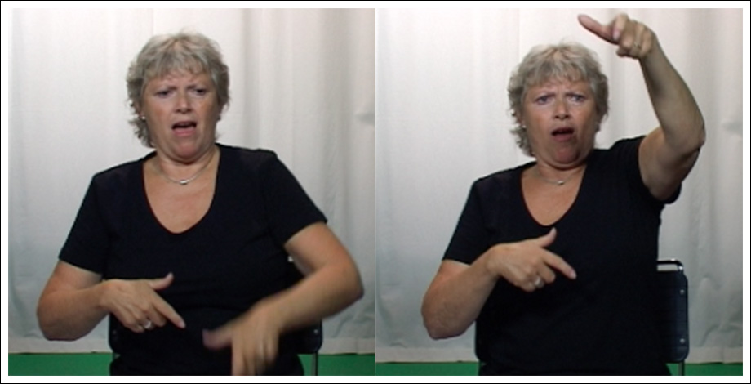
<Figure 1. An example of a depicting sign in Norwegian Sign Language. This particular instance depicts the World Trade Tower in New York City. > about here

Here, the signer depicts the World Trade Tower as part of her retelling about the September 11th attacks in New York City. This iconic sign shows the interlocutor that a building extends upwards, very high into the sky—i.e., it is a skyscraper. The building is scaled down so that it fits into the space in front of the signer, but its location also interacts and relates to other depictive elements—for example, this sign and its location are used in the following sequences when the signer depicts how a plane flew into the upper floors of the building during the attacks.

Enactment
In contrast to depicting signs, which depict events often scaled down to the space in front of the signer, enactments are often described as life-sized depictions that involve the signer and the space around the signer (e.g., Metzger, 1995; Liddell 2003). In many ways, enactments in signed language discourse are similar to those in spoken language discourse. Signers also produce enactments with their hands, arms, and bodies, to demonstrate actions and referents. An example of an enactment is illustrated in Figure 2. Here a signer is retelling the picture story "Frog, Where Are You?" (Mayer, 1969) in Norwegian Sign Language and recruits her whole upper body, arms, head, and face to show how a little boy holds onto some branches (which later turn out to be deer antlers).
<Figure 2. An example of an enactment produced by a signer of Norwegian Sign Language. about here>

The use of enactment is pervasive in signed language interaction, especially during storytelling, to show what referents do and show how referents feel (e.g., Liddell & Metzger, 1998; Mather & Winston, 1998). It also functions to engage and entertain an audience and “bring a story to life” (e.g., Quinto-Pozos, 2007; Hodge & Ferrara, 2014). In this way, enactments contribute to what Washabaugh (1981), in his discussion of signed language communities, calls presence manipulation, in addition to their contributions to meaning exchange. Johnston (1992) also suggests that presence manipulation in signed languages may be quite important given social, historical, and language factors. The importance of presence manipulation has also been commented on in relation to users of spoken languages in some communities and contexts, e.g., the Neapolitans in Kendon, 2004).

Enactments occur sequentially and/or simultaneously with other signs during signed language discourse. They may also involve more or less of a signer's body and have different degrees of perceptual salience (Metzger, 1995; Quinto-Pozos & Mehta, 2010). This theme has been recently taken up again by Cormier and colleagues who propose a scale of constructed action, i.e., enactment, in British Sign Language (BSL) discourse, which they cluster into three broad types: overt, reduced, subtle. These three types are based on the number and level of activation (i.e., intensity) of articulators recruited for the enactment, which include the hands, arms, face, mouth, head, eye gaze, and torso (Cormier, Smith, & Sevcikova-Sehyr, 2015). The enactment presented in Figure 1 is considered an example of an overt enactment. Later in this paper, additional examples of enactments varying in their fullfledgedness will be discussed, along with depicting signs. We will be linking these observations to the dynamic languaging that people engage in, as they recruit their bodies (and speech) in varying degrees to serve descriptive and depictive aims.

Signs with two faces
While co-speech utterance visible actions that depict and enact are not generally considered words in spoken languages, actions which are very similar to them may well be recognized as signs in signed languages, in many cases. That is, conventionalized signs may resemble depictions and some appear to be formed from abstracted demonstrations of actions and referents. For example, let us compare the enactment that was presented in Figure 2 with the conventionalized sign that means “to take a hold of,” illustrated in the top left of Figure 3. The forms and meanings of these two signs appear similar—as both iconically show the hand closing, an action required to physically hold something in the hand. They also both prompt a meaning related to grabbing something by the hand. However, the enactment in Figure 1 is interpreted as a depiction of “holding onto,” whereas the sign in Figure 3 is interpreted primarily as a description of such an action.
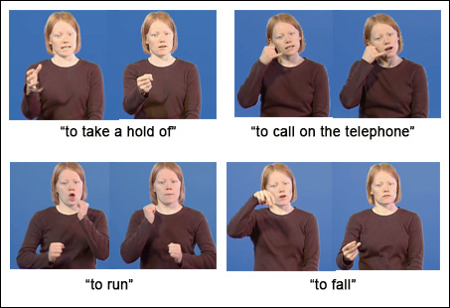
<Figure 3. Norwegian Sign Language signs that resemble depictions (used with kind permission from Statped, www.tegnordbok.no). about here>

The other signs presented in Figure 3 are conventionalized forms that prompt the default, and arguably idiomatic, meanings “to call,” “to run,” and “to fall.” For example, there is no objective reason as to why the sign “to run” could not have been conventionalized to mean “a tantrum” or “to cross country ski.” In this way their meanings, while iconic and motivated, are considered descriptions prompting a default, idiomatic meaning (see Johnston & Ferrara, 2012 for further discussion on this point). However, we also know that signers may produce formationally similar actions not to describe an event or referent but rather to present a depiction to be watched (the differences observed between the signer’s actions in Figure 2 and the sign, “to take a hold of,” presented in Figure 3).

Some researchers have interpreted these resemblances between lexical signs and depictions as evidence that depictions are a source for the development of new signs (e.g., Klima & Bellugi, 1979; Aronoff, Meir, Padden, & Sandler, 2003; Zeshan, 2003; Janzen, 2012; Johnston & Ferrara, 2012). From within this lexicalization perspective, researchers have also described signs de-lexicalizing during an instance of use (e.g., Tervoort, 1973; Cuxac, 1999; Johnston & Schembri, 1999; Aronoff et al., 2003; Wilcox, 2004a; Sandler & Lillo-Martin, 2006; Janzen, 2012; Fuks 2014; albeit sometimes using alternate terminology). One result of delexicalization is that the sign is to be interpreted as a token enactment, or depiction, rather than as a description with its default idiomatic reading, as mentioned above (Johnston & Ferrara, 2012; see also Klima & Bellugi, 1979 and Dudis, 2011, for two further perspectives on this).

In response to these discussions of lexicalization and de-lexicalization, Cormier, Quinto-Pozos, Svecikova, & Schembri (2012) have suggested an alternative explanation. They state that there is little evidence for a path of lexicalization, because most signed languages lack diachronic data (although see Wilcox, 2004b, 2007, for an account of several American Sign Language signs). Instead, lexical signs may develop and exist concurrently with their enacting counterparts (Cormier et al., 2012). They place such "lexical signs incorporating embodiment" and "character viewpoint gestures (non-lexicalised)” on a continuum of lexicalization of embodiment. They make a similar decision regarding depicting signs and their lexical counterparts by placing “lexical signs incorporating entity handshapes” and “observer viewpoint gestures (non-lexicalised)” on a continuum of lexicalization of entity constructions (Cormier et al., 2012, p. 342). In our discussion to follow, we will be less concerned with the lexical status of these signs (aligning with Dudis, 2011). Instead we will focus on how signs function as descriptions and depictions and how signers are able to manipulate this structure during the performance of a sign.

Describing and depicting swimming in NTS
A first example will introduce our discussion and demonstrate the dual function of some signs in Norwegian Sign Language. The example comes from another re-telling of the “Frog, Where Are You?” (Mayer, 1969) picture book. The signer has just explained how the boy and the dog have fallen over a ledge into a pond below. In Figure 4, the signer first shows the boy getting his bearings as he floats in the water (an instance of an overt enactment, the first image on the left on the top row) before signing that the boy then swims to shore. Of interest here are the three iterations of the signs glossed as swim in Figure 4, outline in black.
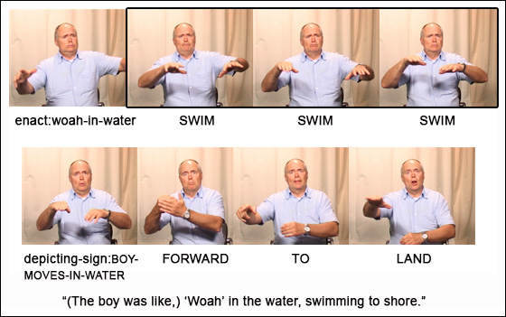
<Figure 4. “Swimming” as a depiction and a description in a Norwegian Sign Language narrative. about here>

Under our analysis, these signs exhibit descriptive and depictive qualities, which are manipulated in context by the signer. On the one hand, we interpret these signs as tokens of the sign swim (compare their forms with the citation form of the sign swim, which involves two iterations, shown in Figure 5) and are largely interpreted in context as describing that the boy swims (to shore). This description is complemented by the signer also mouthing the Norwegian word svømme, "swims," with each iteration of the sign. This action, in effect, also provides a description of what the boy does.

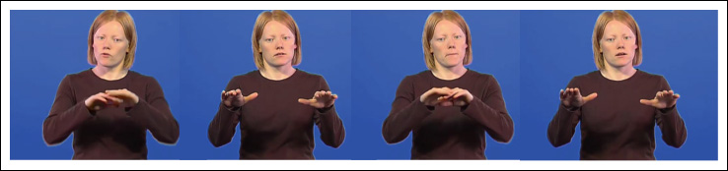
<Figure 5. Citation form of swim, “to swim,” in Norwegian Sign Language (reproduced with kind permission from Statped, www.tegnordbok.no). about here>

On the other hand, these signs are accompanied by additional utterance visible actions, produced on the signer's face and head, and perhaps a portion of his upper torso. The signer uses these subtle depictive elements to demonstrate what the boy in the story does. These non-manual actions may also prompt an interlocuter to interpret the hands (i.e., the sign) as part of the ongoing enactment, a continuation from the boy getting his bearings after falling in the water. That is, instead of simply perceiving a description that tells us what happens in the story, we also interpret an instance of swimming taking place, i.e., a depictive enactment.

The signer can describe and depict with these signs, because the form of the sign swim, “to swim,” resembles a schematic demonstration of swimming (at least for this signing community). As such, an instance of the lexical Norwegian Sign Language sign will always provide the potential to be elaborated into a depiction. Thus, if a signer produces the sign swim and also recruits the active participation of other articulators, a depictive meaning is profiled more strongly than a descriptive meaning. However, if only a few articulators are active along with the hands, a default, lexical reading of the manual sign may be preferred, which mostly functions to describe what happened. This dual potential of a sign accounts for the de-lexicalization of signs observed by various signed language researchers mentioned in the previous section as well as the continuum of signs proposed by Cormier et. al (2012).

Depicting (and describing) sleeping in Norwegian Sign Language
Another example further illustrates the dual-function of some iconic signs and how they are manipulated during usage events. In this example, a signer narrates that the boy and dog from the story she is retelling are going to sleep for the night. The full utterance is shown in Figure 6. At one moment during this utterance, the signer moves her hands and body in a way that is very similar to the iconic, conventionalized sign sleep, "to sleep" (compare the sign glossed as sleep in the top row of Figure 6 with the citation form of a lexical Norwegian Sign Language sign meaning “to sleep” illustrated in Figure 7).
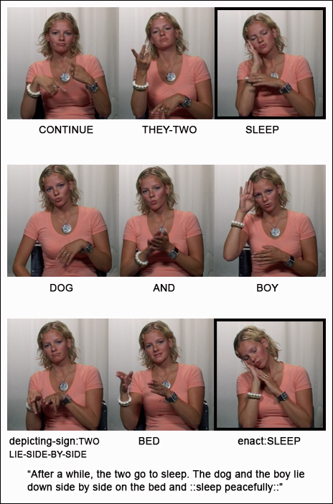
<Figure 6. An example of a formationally similar lexical sign (glossed sleep), which occurs with the mouthed Norwegian word sove, “sleep,” and an enactment (glossed enact:sleep). about here>
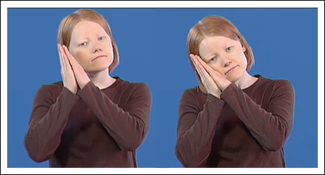
<Figure 7. Citation form of one Norwegian Sign language lexical sign meaning, “to sleep" (used with kind permission from Statped, www.tegnordbok.no). about here>

The signer simultaneously mouthes the Norwegian word sove, "sleep," which also describes the event with a Norwegian word. Altogether, this sign takes three-quarters of a second to produce. The sign participates in a larger construction that means, "After a while, the two go to sleep." This description is accompanied by a subtle depiction realized through the sign’s iconic form, which resembles an act of “laying one’s head on the pillow,” and the brief co-occurring eye closure.

This instance contrasts with another instance of a similar sign that occurs only seconds later (see the sign glossed as enact:sleep in the bottom row in Figure 6). During this moment, the signer uses both of her hands and tilts her head, similar to the lexical sign (Figure 7). However, the head tilt here is much more pronounced than in the previous instance (compare with the sign glossed as sleep in the first row of Figure 6). In addition, the signer produces a mouth movement and a facial expression that appears to enact "sleeping peacefully." In this way, the signer demonstrates that the boy and dog were oblivious to their pet frog's immanent escape. This sign takes 1.2 seconds to produce, which is comparably longer than its descriptive predecessor. Taking all of these elements into consideration suggests that we interpret this sign primarily as a depiction, rather than as a description. The signer recruits manual and non-manual articulators to depict an act of “sleeping.”

Describing and depicting falling in Norwegian Sign Language
We will use a third, final example to further demonstrate the dynamic interplay of depiction and description in Norwegian Sign Language. Here, a signer explains that the boy in the story he is retelling falls down from a tree after an owl surprises him. The sign in focus is the sign glossed as fall on the bottom row of Figure 8, which shows three frames of the sign’s production (outlined in black).

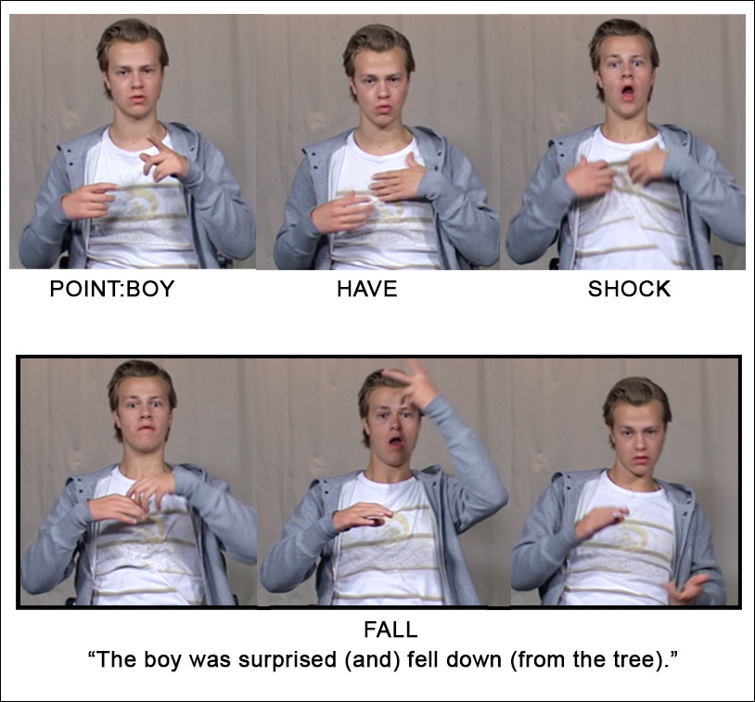
<Figure 8. An example of the sign FALL, “to fall down” interpreted as both a description and a depiction. about here>

We analyze the sign as a depicting sign and as an embellished lexical sign. With both interpretations, the right hand shows the legs of a person as they move along an arc downwards to the end point of the fall. We can see that this end point is lower than starting point, which, in this instance, is a tree branch depicted on the left hand. In this way the sign iconically depicts a person falling. Parallel to these depictive qualities, the sign also resembles the fully conventionalized sign meaning “to fall” in Norwegian Sign Language (see the citation form of this sign in Figure 3). We see here again that a signer can choose to express themselves through complementary depictive and descriptive means, with depictive elements understood through the imagination and descriptive elements understood through a decoding process (refer back to Table 1).

Accommodating depiction and description in a theory of languaging
Now, we move on to explore how convention and iconicity sanction the use of the signs exemplified above and contribute to their dual potential as descriptions and depictions. These signs provide further evidence that languaging involves the manipulation of multiple, sometimes multimodal articulators, that effectively describe and depict meanings over the course of emerging interaction. We will follow up this discussion with a comparison of these signs to the examples of description and depiction presented earlier from spoken language discourse. In this way, we hope to highlight some commonalities and differences across language communities.

The dual potential of iconic, depictive signed language signs
The signs examined in this paper are lexicalized, iconic signs. We suggest here that such signs take advantage of convention and embodied experience to sanction their use. Let us go back to the example of swimming presented above. The sign swim resembles an abstracted demonstration of swimming, and so a signer can employ this sign as a depiction and/or description during a particular usage event by manipulating its level of expressiveness. In doing so, the signer has at their disposal both their conventionalized experience of this sign as well as the embodied understanding of this concept. Put slightly differently, the lexical sign swim is produced and understood via convention but also via the iconic structure-preserving mappings between the sign and our mental model of swimming, which is developed through our encounters with swimming.

We compare this analysis to an analysis of handshapes in Israeli Sign Language, where Fuks (2014) observes that categorical handshapes can be modified gradiently to reflect gradient changes to the relevant referent’s size and shape in Israeli Sign Language. Signers can modify particular features of a conventional handshape to allow for a “change in ‘subtle’ meanings to be represented in a gradient manner” (Fuks, 2014, p. 222). She also highlights the role iconicity plays in this potential. In an additional study, Fuks (2016) shows how signers can manipulate any number of a sign’s formational characteristics to express intensity.

In the current study, we also examine the manipulation of whole signs, not just handshapes. Iconic, gradient changes to a sign’s location, movement, orientation, handshape, as well as various non-manual actions can be used to express gradient changes in meaning. In our analysis, we framed these modifications as serving descriptive and depictive functions. In the view of language as a mode of action, we can reformulate the above observations to say that these signs have both depictive and descriptive potential, and only when deployed in a usage event will these functions be made manifest in varying, complementary degrees.

Similarities in describing and depicting in signed and spoken language discourse
We have shown that many conventionalized, iconic signs are able to function as both descriptions and depictions. We will now compare these signs to the examples of description and depiction in spoken language discourse introduced earlier in this paper: utterance visible action, enactments, and ideophones. We want to emphasize that signers and speakers are able to manipulate their multimodal semiotic repertoire to describe and depict meanings over the course of an emerging interaction and that both should be profiled in a theory of languaging, reiterating themes from recent research (e.g., Johnston, 2013; Kendon, 2014; Dingemanse, 2015; Clark, 2016; Fuks 2014, 2016).

First, in relation to utterance visible action, speakers may use their hands or other non-manual actions to depict imagery, often in conjunction with description (and additional depiction) that manifests through speech. Such acts may resemble the depicting signs and enactments produced by signers. In fact, there has been some evidence that hearing speakers and deaf signers depict imagery with their hands in sometimes very similar ways (Schembri, Jones, & Burnham, 2005). However, this practice seems more conventionalized among signers. In any case, both speakers and signers integrate these depictive actions with other types of symbolic actions (e.g., pointing, lexical signs and words, grammar) into utterances that effectively prompt composite meanings.

Enactments, in the forms of constructed actions and dialogue, were also discussed as examples of depiction in spoken language discourse. Such enactments can be multimodal, recruiting both speech and utterance visible action, or they can be performed by solely manipulating the speech stream. Thus, enactments may align with more traditional observations that speakers describe with speech and depict with their visible body or they can also be used to exemplify the dual function of one modality—with speech effecting both a description and depiction in the same moment. An example from Clark and Gerrig (1990) illustrates this practice and is presented in (5).

(5) And then Mrs. Dewlap said that he [raising voice] could just wait for this turn with the rest of them [lowering voice] and so he did (Clark & Gerrig, 1990, p. 791).

Here, manipulation of the speech stream results in a degree of depiction while the speaker simultaneously describes what happened. We find this similar to the signs discussed in this paper, for example the signs swim in Figure 4, because they simultaneously describe and depict through their realization within a usage event.

Our final comparison acknowledges how the signs examined in this paper and ideophones take advantage of convention and iconicity to depict and describe. While ideophones are described primarily as depictions, they are also acknowledged as iconic words (Dingemanse, 2013). In a similar way, the signs examined in this paper are conventional, iconic signs that can also be performed as depictions. Furthermore, there is evidence that ideophones exhibit complementary degrees of depiction and description, depending on how the speaker elaborates upon the word in context. With increased expressiveness and decreased morphosyntactic integration, an ideophone is interpreted as a depiction, whereas a decrease in expressiveness and an increase in morphosyntactic integration lead to an interpretation of an ideophone as a description (Dingemanse & Akita, 2016; Dingemanse 2017). We find this type of continuum (which is visualized in Figure 9) useful in describing the conventionalized, iconic signs explored here.

Figure 9. A continuum of description and depiction (based on the continuum of deideophonization and ideophonization presented in Dingemanse, 2017, p. 135).

If a signer produces an iconic, sign without additional manipulation or embellishment, and it is understood with its conventionalized, default reading, we can say the sign falls more towards the descriptive end of the continuum (e.g., the instance of the signs swim above). However, if a signer manipulates the formational properties of an iconic sign to highlight gradient changes to the sign’s default meaning, it may be considered to fall more towards the depictive end of the continuum (the example with the sign sleep above). This continuum is in some ways very similar to the scales of lexical signs and either character viewpoint gestures or observer viewpoint gestures proposed by Cormier et. al (2012), as they also attempt to capture the varied expressiveness of iconic signs. Here however, we focus on the dual, complementary potential of these signs as descriptions and depictions. This potential underlies our experience with these signs—they are both descriptive and depictive, and we manipulate these functions to fit the needs of particular instances of use.

Conclusion
Throughout this paper we have presented and discussed examples of description and depiction, further evidencing the ordinary and pervasive nature of these modes of representation. In this way, we align with those before us who challenge a focus on the descriptiveness of language, at the expense of its depictive nature (e.g., Clark & Gerrig, 1990, Johnston, 1992, 2013; Kendon, 2008, Dingemanse, 2013; Fuks, 2014). This paper explored conventionalized signed language signs that resemble different types of iconic demonstrations in Norwegian Sign Language. We illustrated how signers manipulate both the descriptive and depictive potential of these signs during instances of use. Our goal with these examples was to shift the discussion away from distinctions between the conventional and the non-conventional, or the linguistic from the gestural. Instead, we hoped to promote languaging as a dynamic mode of interaction that recruits from a semiotically diverse repertoire that is manipulated creatively in context to describe and depict meanings.

To do this, we also brought in a discussion of description and depiction in spoken language discourse by reviewing work on utterance visible action, enactment, and ideophones. We saw that these symbolic actions may be deployed together or separately, often comprising multimodal ensembles of description and depiction. While utterance visible action may be easy to distinguish from the speech stream, we saw that enactment and ideophones can manipulate both speech and other manual and nonmanual visible actions to achieve meaning construction. In this way, we underscored that a line between description through speech and depiction through utterance visible action is unwarranted. Ideophones and other types of speech enactments exemplify the dual-function of words—they can describe and depict meanings. It is also not necessarily the case that these functions can be assigned to one part of a word or another. We highlighted the similarities between these types of semiotic actions and depictions and iconic signs in signed languages. In this way have forged further links between the languaging of speakers and the languaging of signers.

Acknowledgements
We would like to thank Anna-Lena Nilsson for her comments on an early draft of this paper. We are also grateful to Adam Kendon for his thorough and constructive comments on previous versions of this paper. An anonymous reviewer also provided extensive feedback, which greatly strengthened our paper. Finally, we are indebted to the Norwegian signers who participated in the data collection and allowed us to share their language with you. All remaining errors are our own.

References

Aronoff, Mark, Meir, Irit, Padden, Carol, & Sandler, Wendy. (2003). Classifier complexes and morphology in two sign languages. In Karen Emmorey (Ed.), Perspectives on classifier constructions in sign languages (pp. 53-84). Mahwah, NJ: Lawrence Erlbaum Associates.

Bergman, Brita, & Dahl, Östen. (1994). Ideophones in sign language? The place of reduplication in the tense-aspect system of Swedish Sign Language. In Carl Bache, Hans Basbøll, & Carl-Erik Lindberg (Eds.), Tense, aspect and action: Empirical and theoretical contributions to language typology (pp. 397-422). Berlin, Germany: Walter de Gruyter.

Blyth, Carl, Recktenwald, Sigrid, & Wang, Jenny. (1990). I'm like, "Say what?!": A new quotative in American oral narrative. American Speech, 65(3), 215-227.

Calbris, Geneviève. (2011). Elements of meaning in gesture. Amsterdam/Philadelphia: John Benjamins.

Cameron, Richard. (1998). A variable syntax of speech, gesture, and sound effect: Direct quotations in Spanish. Language Variation and Change, 10(1), 43-83. doi:10.1017/S0954394500001216

Clark, Herbert H. (2016). Depicting as a method of communication. Psychological Review, 123(3), 324-347. doi:http://dx.doi.org/10.1037/rev0000026

Clark, Herbert H, & Gerrig, Richard J. (1990). Quotations as demonstrations. Language, 66(4), 764-805.

Cormier, Kearsy, Quinto-Pozos, David, Sevcikova, Zed, & Schembri, Adam. (2012). Lexicalisation and de-lexicalisation processes in sign languages: Comparing depicting constructions and viewpoint gestures. Language and Communication, 32(4), 329-348. doi:http://dx.doi.org/10.1016/j.langcom.2012.09.004

Cormier, Kearsy, Smith, Sandra, & Zwets, Martine. (2013). Framing constructed action in British Sign Language narratives. Journal of Pragmatics, 55, 119-139. doi:http://dx.doi.org/10.1016/j.pragma.2013.06.002

Cormier, Kearsy, Smith, Sandra, & Sevcikova-Sehyr, Zed. (2015). Rethinking constructed action. Sign Language and Linguistics, 18(2), 167-204.

Cuxac, C. (1999). The expression of spatial relations and the spatialization of semantic representations in French Sign Language. In C Fuchs & S Robert (Eds.), Language diversity and cognitive representations (pp. 123-142). Amsterdam/ Philadelphia: John Benjamins.

Dingemanse, Mark. (2011). Ideophones and the Aesthetics of everyday language in a west-African society. Senses & Society, 6(1), 77-85. doi:10.2752/174589311X12893982233830

Dingemanse, Mark. (2013). Ideophones and gesture in everyday speech. Gesture, 13(2), 143-165. doi:10.1075/gest.13.2.02din

Dingemanse, Mark. (2015). Ideophones and reduplication: Depiction, description, and the interpretation of repeated talk in discourse. Studies in Language, 39(4), 946-970. doi:10.1075/sl.39.4.05din

Dingemanse, Mark. (2017). Expressiveness and system integration: On the typology of ideophones, with special reference to Siwu. STUF - Language Typology and Universals, 70(2), 119-141.

Dingemanse, Mark, & Akita, Kimi. (2016). An inverse relation between expressiveness and grammatical integration: on the morphosyntactic typology of ideophones, with special reference to Japanese. Journal of Linguistics, First view, 1-32. doi:doi:10.1017/S002222671600030X

Dudis, Paul. (2011). The body in scene depictions. In Cynthia Roy (Ed.), Discourse in signed languages (pp. 3-45). Washington, D.C.: Gallaudet University Press.

Emmorey, Karen. (2002). Language, cognition, and the brain: Insights from sign language research. Mahwah, NJ: Lawrence Earlbaum Associates.

Emmorey, Karen, & Falgier, Brenda. (1999). Talking about space with space: Describing environments in ASL. In Elizabeth Winston (Ed.), Storytelling and conversation: Discourse in deaf communities (pp. 3-26). Washington, D.C.: Gallaudet University Press.

Enfield, Nick J. (2009). The anatomy of meaning: Speech, gesture, and composite utterances. Cambridge: Cambridge University Press.

Ferrara, Lindsay. (2012). The grammar of depiction: Exploring gesture and language in Australian Sign Language (Auslan). (Ph.D. Dissertation), Macquarie University, Sydney.

Ferrara, Lindsay, & Johnston, Trevor. (2014). Elaborating who's what: A study of constructed action and clause structure in Auslan (Australian Sign Language). Australian Journal of Linguistics, 34(2), 193-215. doi:10.1080/07268602.2014.887405

Ferrara, Kathleen, & Bell, Barbara. (1995). Sociolinguistic variation and discourse function of constructed dialogue introducers: The case of BE+LIKE. American Speech, 70(3), 265-290.

Fox, Barbara A, & Robles, Jessica. (2010). It's like mmm: Enactments with it's like. Discourse Studies, 12(6), 715-738. doi:10.1177/1461445610381862

Fuks, Orit. (2014). Gradient and categorically: Handshape's two semiotic dimensions in Israeli Sign Language discourse. Journal of Pragmatics, 60, 207-225. doi:http://dx.doi.org/10.1016/j.pragma.2013.08.023

Fuks, Orit. (2016). Intensifier actions in Israeli Sign Language. Gesture, 15(2), 192-223. doi:10.1075/gest.15.2.03fuk

Goodman, Nelson. (1968). Languages of art: An approach to the theory of symbols. Indianapolis: Bobbs-Merrill.

Goodwin, Charles. (2000). Action and embodiment within situated human interaction. Journal of Pragmatics, 32, 1489-1522.

Halvorsen, Rolf. (2012). Tre diskursmarkører i norsk tegnspråk: en studie av blunk, blikkendring og nikk i åtte fortellinger [Three discourse markers in Norwegian Sign Language: A study of blinking, eyegaze, and nodding in eight narratives]. (Ph.D. dissertation), University of Oslo, Oslo, Norway.

Heath, Christian. (2002). Demonstrative suffering: The gestural (re)embodiment of symptoms. Journal of Communication, 52, 597-616.

Hodge, Gabrielle, & Ferrara, Lindsay. (2014). Showing the story: Enactment as performance in Auslan narratives. In Lauren Gawne & Jill Vaughan (Eds.), Selected Papers from the 44th Conference of the Australian Linguistic Society, 2013 (pp. 372-397). Melbourne, Australia: University of Melbourne. Retrieved from http://hdl.handle.net/11343/40973.

Holt, Elizabeth. (2000). Reporting and reacting: Concurrent responses to reported speech. Research on Language & Social Interaction, 33(4), 425-454.

Janzen, Terry. (2012). Lexicalization and grammaticalization. In Roland Pfau, M Steinbach, & Bencie Woll (Eds.), Sign Languages: An international handbook (pp. 816-481). Berlin/Boston: Mouton de Gruyter.

Johnston, Trevor. (1992). The realization of the linguistic metafunctions in a sign language. Language Sciences, 14(4), 317-353.

Johnston, Trevor. (2013). Towards a comparative semiotics of pointing actions in signed and spoken languages. Gesture, 13(2), 109-142. doi:10.1075/gest.13.2.01joh

Johnston, Trevor, & Ferrara, Lindsay. (2012). Lexicalization in signed languages: When an idiom is not an idiom. Selected Papers from UK-CLA Meetings, 1, 229-248. http://www.uk-cla.org.uk/proceedings/volume_1/21-17

Johnston, Trevor, & Schembri, Adam. (1999). On defining Lexeme in a Signed Language. Sign Language and Linguistics, 2(2), 115-185. doi: 10.1075/sll.2.2.03joh

Johnston, Trevor, & Schembri, Adam. (2007). Australian Sign Language: An introduction to sign language linguistics. Cambridge: Cambridge University Press.

Johnston, Trevor, & Schembri, Adam. (2010). Variation, lexicalization and grammaticalization in signed languages. Langage et societe, 131(March), 19-35.

Kendon, Adam. (1972). Some relationships between body motion and speech: An analysis of an example. In Aron Wolfe Siegman & Benjamin Pope (Eds.), Studies in dyadic communication (pp. 177-210). New York: Pergamon Press.

Kendon, Adam. (1980). Gesticulation and speech: Two aspects of the process of utterance. In Mary Ritchie Key (Ed.), The relationship of verbal and nonverbal communication (Vol. Contributions to sociology of language, pp. 207-227). The Hague, The Netherlands: Mouton Publishers.

Kendon, Adam. (2004). Gesture: Visible action as utterance. Cambridge: Cambridge University Press.

Kendon, Adam. (2008). Some reflections on the relationship between 'gesture' and 'sign'. Gesture, 8(3), 348-366. doi:10.1075/gest.8.3.05ken

Kendon, Adam. (2012). Language and kinesic complexity: Reflections on "Dedicated gestures and the emergence of sign language" by Wendy Sandler. Gesture, 12(3), 308-326. doi:10.1075/gest.12.3.02ken

Kendon, Adam. (2013). Exploring the utterance roles of visible bodily action: A personal account. In Cornelia Müller, Alan Cienki, Ellen Fricke, Silva H Ladewig, David McNeill, & Sedinha Tessendorf (Eds.), Body – Language - Communication (pp. 7-28). Berlin and Boston: De Gruyter Mouton.

Kendon, Adam. (2014). Semiotic diversity in utterance production and the concept of ‘language’. Phil. Trans. R. Soc. B, 369, 20130293. doi:http://dx.doi.org/10.1098/rstb.2013.0293

Kendon, Adam. (2015). Gesture and sign: Utterance uses of visible bodily action. In Keith Allan (Ed.), The Routledge handbook of linguistics (pp. 33-46). Oxon, UK: Routledge.

Kilian-Hatz, Christa. (2001). Universality and diversity: Ideophones from Baka and Kxoe. In F K Erhard Voeltz & Christa Kilian-Hatz (Eds.), Ideophones (pp. 155-164). Amsterdam: John Benjamins.

Klima, Edward, & Bellugi, Ursula. (1979). The signs of language. Cambridge, MA: Harvard University Press.

Kosslyn, Stephen M. (1980). Image and mind. Cambridge, MA: Harvard University Press.

Kunene, Daniel P. (2001). Speaking the act: The ideophone as a linguistic rebel. In F. K. Erhard Voeltz & Christa Kilian-Hatz (Eds.), Ideophones (pp. 183-191). Amsterdam: John Benjamins.

Langacker, Ronald W. (2001). Discourse in cognitive grammar. Cognitive Linguistics, 12(2), 143-188.

Liddell, Scott K. (2003). Grammar, gesture, and meaning in American Sign Language. New York: Cambridge University Press.

Liddell, Scott K, & Metzger, Melanie. (1998). Gesture in sign language discourse. Journal of Pragmatics, 30, 657-697.

Mather, Sue, & Winston, Elizabeth. (1998). Spatial mapping and involvement in ASL storytelling. In Ceil Lucas (Ed.), Pinky extension and eye gaze: Language use in deaf communities (pp. 183-210). Washington, DC: Gallaudet University Press.

Mathis, Terrie, & Yule, George. (1994). Zero quotatives. Discourse Processes, 18(1), 63-76. doi:10.1080/01638539409544884

Mayer, Mercer. (1969). Frog, where are you? New York: Dial Press.

McNeill, David. (1992). Hand and mind: What gestures reveal about thought. Chicago: University of Chicago Press.

Metzger, Melanie. (1995). Constructed dialogue and constructed action in American Sign Language. In Ceil Lucas (Ed.), Sociolinguistics in deaf communities (pp. 255-271). Washington, DC: Gallaudet University Press.

Perniss, Pamela. (2007). Achieving spatial coherence in German Sign Language narratives: The use of classifiers and perspective. Lingua, 117(7), 1315-1338.

Quinto-Pozos, David. (2007). Can constructed action be considered obligatory. Lingua, 117(7), 1285-1314.

Quinto-Pozos, David, & Mehta, Sarika. (2010). Register variation in mimetic gestural complements to signed language. Journal of Pragmatics, 42(3), 557-584.

Sams, Jessie. (2010). Quoting the unspoken: An analysis of quotations in spoken discourse. Journal of Pragmatics, 42, 3147-3160. doi:10.1016/j.pragma.2010.04.024

Sandler, Wendy, & Lillo-Martin, Diane. (2006). Sign language and linguistic universals. Cambridge: Cambridge University Press.

Schembri, Adam, Jones, Caroline, & Burnham, Denis. (2005). Comparing action gestures and classifier verbs of motion: Evidence from Australian Sign Language, Taiwan Sign Language, and nonsigners' gestures without speech. Journal of Deaf Studies and Deaf Education, 10(3), 272-290. doi:10.1093/deafed/eni029

Sidnell, Jack. (2006). Coordinating gesture, talk, and gaze in reenactments. Research on Language & Social Interaction, 39(4), 377-409. doi:10.1207/s15327973rlsi3904_2

Supalla, Ted. (2003). Revisiting visual analogy in ASL classifier predicates. In Karen Emmorey (Ed.), Perspectives on classifier constructions in sign languages (pp. 249-257). Mahwah, NJ: Lawrence Earlbaum Associates.

Taub, Sarah. (2001). Language from the body: Iconicity and metaphor in American Sign Language. New York: Cambridge University Press.

Tervoort, Bernard Th. (1973). Could there be a human sign language? Semiotica, 9, 347-382.

Washabaugh, William. (1981). Sign language in its social context. Annual Review of Anthropology, 10, 237-252. doi:10.1146/annurev.an.10.100181.001321

Wilcox, Sherman. (2004a). Cognitive iconicity: Conceptual spaces, meaning, and gesture in signed languages. Cognitive Linguistics, 15(2), 119-147.

Wilcox, Sherman. (2004b). Gesture and language: cross-linguistic and historical data from signed languages. Gesture, 4(1), 43-73.

Wilcox, Sherman. (2007). Routes from gesture to language. In ELena Pizzuto, Paola Pietrandrea, & Raffaele Simone (Eds.), Verbal and signed languages: Comparing structures, constructs and methodologies (pp. 107-131). Berlin/New York: Mouton de Gruyter.

Zeshan, Ulrike. (2003). 'Classificatory' constructions in Indo-Pakistani Sign Language: Grammaticalization and lexicalization processes. In Karen Emmorey (Ed.), Perspectives on classifier constructions in sign languages (pp. 113-141). Mahwah, NJ: Lawrence Earlbaum Associates.

The examples in this paper were collected during one of the author's doctoral research, see Halvorsen (2012).

