Nanorubber-Modified Cement System for Oil and Gas Well Cementing Application
Narjes Jafariesfad^{1, *}, Mahmoud Khalifeh², Pål Skalle¹, Mette Rica Geiker³
- Department of Geoscience and Petroleum, Norwegian University of Science and Technology (NTNU), Trondheim 7491, Norway
- Department of Petroleum Engineering, University of Stavanger, Stavanger 4036, Norway
- Department of Structural Engineering, Norwegian University of Science and Technology (NTNU), Trondheim 7491, Norway
* narjes.jafariesfad@ntnu.no
Abstract
Flexible cement systems with low shrinkage are more capable than the conventional cement systems to withstand the tensile stresses generated by fluctuation of temperature and pressure in oil and gas wells. In this work nanorubber particles (NR), stable at high temperature and in alkaline environment, were incorporated into a cement system. The impact of NR on the heat of hydration, autogenous shrinkage and tensile properties were measured at 40 $℃$, whereas the sonic compressive strength development and 3 days tensile strength were measured at 20.7 MPa and 142 $℃$. Addition of NR to the cement system resulted in reduced autogenous shrinkage, but also retarded setting time and compressive strength development. Incorporation of NR into the cement system improved the capacity to withstand tensile stresses at laboratory conditions. The results indicate promising performance at well conditions, which is supported by a measured positive impact on tensile strength at high temperature and pressure.
Keywords: Oil Well Cement; Shrinkage; Tensile Properties; Flexibility; Nanorubber
- Introduction
The process of placing cement in the annular space between the casing and the formations exposed to the wellbore is called primary cementing. The key objective of primary cementing is to achieve long-term zonal isolation, excluding fluids in one zone from another in oil and gas wells. (Nelson and Guillot, 2006) Over the well’s life-cycle, the wellbore experiences a variety of stressful scenarios depending on the operations in the well (Reddy et al., 2005; Saint-Marc et al., 2008; Williams et al., 2011). In addition to fluctuation of temperature and pressure and mechanical loads, shrinkage stresses can be detrimental to the cement sheath integrity (Bois et al., 2011; Bois et al., 2012; McCulloch et al., 2003). From the imposed stresses perspective, cement sheath typically fails in tension, and failure occurs when the tensile stress is greater than tensile strength of the cement sheath (Nelson and Guillot, 2006; Williams et al., 2011). In summary, the roots of long-term zonal isolation failure of the cement sheath are addressed as: low tensile properties and volumetric instability (Jafariesfad et al., 2017a).
The tensile strength requirement of a cement system is affected by its Young’s modulus. By reducing Young’s modulus, the tensile strength requirement is reduced (Thiercelin et al., 1998; Williams et al., 2011). Additionally, it has been claimed that by 10 % reduction in Young’s modulus, the threshold pressure before break-through of cross flow (the flow of fluids from one zone to another) is doubled, resulting in improved resistance to cross flow (Yao and Hua, 2007). Therefore, flexible cement systems are performing much better compared to conventional cement systems under stresses developed in the cement sheath during its life (Thiercelin et al., 1998; Williams et al., 2011; Yuan et al., 2012). Addition of flexible particles to the cement system is the common method to improve its flexibility (Jansen et al., 2013; Roy-Delage and Thiercelin, 2004). Incorporation of flexible particles into the cement paste decreases the Young’s modulus; however, also the tensile strength is reduced, which is not favorable. It should be noted that in contradiction to cement paste, addition of flexible particles to mortars and concretes might result in either reduction or increase in tensile strength (Thomas et al., 2014; Ukrainczyk and Rogina, 2013; Wang et al., 2005).
The result of some recent studies on flexible particles addition to oil well cement systems is presented in Table 1. The results are difficult to compare, as the systems’ compositions and the curing conditions are different. In general, by addition of flexible particles to a cement paste, the tensile strength was reduced. Addition of potential particles resulting in Young’s modulus reduction while preserving the tensile strength would be of significant interest for oil-well cementing applications. Such a promising system would be capable of withstanding extreme loading conditions in oil and gas wells.
Table 1: Impact of flexible particles addition on tensile strength σ_{t}, and Young’s modulus E, of oil well cement systems. (Agapiou et al., 2016; Brothers, 2005; Le Roy-Delage et al., 2000; Pavlock et al., 2012; Sun et al., 2006; Williams et al., 2011; Yao and Hua, 2007)
Additive | Content (% BWOC) | Curing conditions | σ_{t} (MPa) | E (GPa) | σ_{t}/E$×$10³ | % change in σ_{t} | % change in E | % change in σ_{t}/E | Ref
Latex | 0 | 7 d  In water at 60 $℃$ | 5.0 | 14.7 | 0.34 | - | - | - | (Pavlock et al., 2012)
 | 9-22 |  | 4.4 | 11.6 | 0.38 | -12 | -21 | 12
Rubber | 0 | 7 d at 27$℃$ | 3.7 | 13.8 | 0.27 | - | - | - | (Agapiou et al., 2016)
 | 10 |  | 3.1 | 10.5 | 0.30 | -16 | -24 | 11
Rubber* | 0 | 14 d at 315 $℃$ | 3.3 | - | - | - | - | - | (Brothers, 2005)
 | 20 |  | 0.4 | - | - | -88 | - | -
Flexible and expanding particles | 0 | U** | 3.0 | 9.7 | 0.31 | - | - | - | (Williams et al., 2011)
 | U** |  | 1.4 | 3.1 | 0.45 | -53 | -68 | 45
Flexible particles | 0 | 3 d at 20.7 MPa, 114$℃$ | 9.1*** | 9.0 | 1.01 | - | - | - | (Le Roy-Delage et al., 2000)
 | U** |  | 8.2*** | 6.2 | 1.32 | -10 | -31 | 31
Flexible particles | 0 | 3 d at 20.7 MPa, 77$℃$ | 6.7*** | 3.8 | 1.76 | - | - | -
 | U** |  | 4.5*** | 2.9 | 1.55 | -33 | -24 | -12
Carboxylated nitrille rubber | 0 | 2 d at 80 $℃$ | 8.3*** | 12.6 | 0.66 | - | - | - | (Yao and Hua, 2007)
 | 4 |  | 6.7*** | 8.4 | 0.80 | -19 | -33 | 21
 | 10 |  | 5.5*** | 6.0 | 0.92 | -34 | -52 | 39
Latex | 0 | 52 $℃$ | - | 11.2 | - | - | - | - | (Sun et al., 2006)
 | 5 |  | - | 9.8 | - | - | -13 | -
 | 10 |  | - | 8.6 | - | - | -23 | -
*In calcium phosphate cement
**U: Unknown
***Flexural strength
In the polymer industry, epoxy resins are widely used. However, due to the inherent brittle nature and poor crack resistance of epoxy, addition of microrubber particles (MR) is a frequently used method to improve their performance. This results in toughness enhancement, it also causes a significant loss of tensile properties (Tripathi and Srivastava, 2007). Recent studies on developing high-performance epoxy resins, proposed application of nanorubber particles (NR), which lead to an impressive toughening effect, increased thermal resistance, and preserved tensile properties (Huang et al., 2005; Tang et al., 2013; Zhang et al., 2014). Moreover, application of NR in friction materials can substantially improve their toughness and thermal resistance compared to pure systems and systems with conventional rubber particles (Liu et al., 2006). According to the reported results for NR-epoxy systems, Jafariesfad et al. (2017a) suggested that a promising method which simultaneously improves flexibility and maintains tensile strength of a cement system might be the application of nanosized flexible particles. Potential flexible particles for oil well cementing applications are required to have high thermal stability and be stable at high pH conditions as occur in cement slurry.
This study investigates the feasibility of the use of NR in oil well cement systems. The NR selected for the study is stable at high temperature and in alkaline environment. The impact of NR addition on a cement system’s autogenous shrinkage and tensile properties were investigated. In addition, the sonic compressive strength development under high pressure and temperature conditions, the setting time and the heat of hydration under laboratory conditions were determined. The performance of the NR-cement systems was assessed in order to evaluate their applicability under well conditions.
- Experimental procedure
2.1. Nanorubber
The NR used in this study was carboxylic acrylonitrile butadiene rubber, Narpow VP-501, with acrylonitrile content of 26 wt. % and diameter of 50-100 nm supplied by SINOPEC Beijing Research Institute. The thermal stability of the NR was measured using thermogravimetric analysis (TGA) by means of Mettler Toledo model TGA/SDTA 851e. Weight loss versus temperature was measured for a sample of 10 mg with a heating rate of 2.5 $℃$/min from ambient temperature to 500 $℃$ in nitrogen atmosphere (Fig. 1). The onset of thermal decomposition, T_{Onset} (weight loss of 5 %), took place at 335 $℃$. As shown in Fig. 1, the NR experienced very little weight loss at temperatures below 300 $℃$, indicating that it is stable under these temperature conditions.
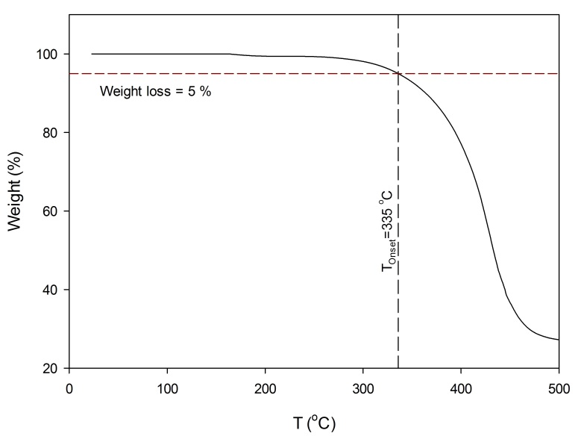
Fig. 1: Thermogravimetric analysis of the NR; the onset of thermal decomposition of the NR, weight loss of 5 %, obtained at 335 $℃$.
Upon exposure to water the COOH-NR surface uptakes a large amount of water. This could be due to the dissociation of the COOH groups into COO─ and H⁺, which can separately be solvated by the adsorbed water molecules (Tu et al., 2012). Additionally, investigations on the impact of particle size on water absorption capacity (WAC) revealed that the smaller the particle size, the higher the WAC is, especially during the first hours of water exposure (Abbasy et al., 2008), thus the WAC should be determined for the NR used. WAC of the NR was determined using the test method used by Abbasy et al. (2008). WAC was measured in deionized water and synthetic pore solution (2.07 g/l CaSO₄.2H₂O, 12.50 g/l Na₂SO₄, and 2.92 g/l NaOH in deionized water). 50 g of the carrier fluid was mixed with 2 g of the NR and stirred for 30 min at the highest rate of stirrer. Then, the suspension was subjected to vacuum filtration for approximately 1 h. The percentage of absorbed water by the NR was determined from Eq. 1:
$$WAC=\frac{W_{NR-t_{f}}-W_{NR-t_{i}}}{W_{NR-t_{i}}}×100 (1)$$
where WAC expressed as a percent; $W_{NR-t_{i}}$ is the initial weight of the NR in g; and $W_{NR-t_{f}}$ is the final weight of the NR in g after vacuum filtration.
WAC of the NR in deionized water and synthetic pore solution after 30 min was measured to be 65 % and 35 %, respectively.
  - NR-cement system preparation
The cement systems used in this study were prepared from API Class G oil well cement, silica flour SSA-1 (sf) and selected additives (supplied by Halliburton) as well as deionized water. sf was in the form of minus 200-mesh (<74 µm) powder and used to maintain low permeability and high compressive strength of the cement systems under high temperature conditions. Addition of silica flour to cement system is recommended where static temperature exceeds 110 $℃$ (Nelson and Guillot, 2006). The chemical composition of cement and the cement systems’ compositions are tabulated in Tables 2 and 3.
Table 2: The chemical composition of API Class G oil well cement (provided by Halliburton)
Compositions  (wt. %) | SiO₂ | Al₂O₃ | Fe₂O₃ | CaO | MgO | SO₃ | P₂O₅ | K₂O | Na₂O | LOI* | Density (g/cm³)
Cement | 21.67 | 4.11 | 5.24 | 64.32 | 0.65 | 2.77 | 0.08 | 0.65 | 0.13 | 1.48 | 3.15
*Loss on ignition
Table 3: The cement systems’ composition and test conditions
Sample | Test conditions | w/(c+sf)* | Mix content for 100 g of cement
 |  |  | sf | Mix water | Free water** | Bentonite | Defoamer | Dispersant | Retarder | NR
NR-0 | 40$℃$, atmospheric pressure | 0.441 | - | 44.2 | 44.1 | 0.5 | 0.1 | 3.0 | - | -
NR-2 |  | 0.443 | - | 45.1 | 44.3 | 0.5 | 0.1 | 3.0 | - | 2.0
NR-4 |  | 0.445 | - | 46.0 | 44.5 | 0.5 | 0.1 | 3.0 | - | 4.0
NR-8 |  | 0.448 | - | 47.7 | 44.8 | 0.5 | 0.1 | 3.0 | - | 8.0
NR-0-HT | 142 $℃$, 20.7 MPa (API Schedule 9 Sg) | 0.443 | 35 | 59.6 | 59.8 | 0.5 | 0.1 | 1.5 | 2.0 | -
NR-2-HT |  | 0.444 | 35 | 60.5 | 60.0 | 0.5 | 0.1 | 1.5 | 2.0 | 2.0
NR-4-HT |  | 0.446 | 35 | 61.4 | 60.2 | 0.5 | 0.1 | 1.5 | 2.0 | 4.0
NR-8-HT |  | 0.448 | 35 | 63.1 | 60.5 | 0.5 | 0.1 | 1.5 | 2.0 | 8.0
*w: water, c: cement, sf: silica flour
**Free water=Mix water-(absorbed water by NR and bentonite)+(water available in dispersant and retarder solution)
All cement slurries, batch size of 600 ml, were prepared according to API RP 10-B (API-RP-10B-2, 2012) using OFITE constant speed blender, especially designed for oil well cement paste preparation. For the systems containing NR, cold water was used to diminish the temperature rising due to the NR dispersion process in water. Bentonite was mixed with water and left to prehydrate for 30 min before adding the cement (Nelson and Guillot, 2006). In fresh water, bentonite swells to approximately 10 times its original volume. First, bentonite, 0.5 % by weight of cement (BWOC), was mixed with water at 4000 rpm for 15 s, followed by 15 s at 12000 rpm, then left 20 min for prehydration. Afterwards, the NR was added and mixed for 15 s at 4000 rpm, followed by 5 min mixing at 12000 rpm. As the suspension contained lots of air bubbles, defoamer (NF 6), 0.1 % BWOC, was added to the suspension. Then, the suspension was again mixed for 1 min at 12000 rpm. Subsequently, retarder (HR 25) and dispersant (CFR 8L) were added to the suspension, which was mixed for 15 s. Subsequently, preblended cement and silica flour was added to the suspension during 15 s while mixing at 4000 rpm, followed by 35 s mixing at 12000 rpm. The prepared cement slurry was preconditioned at a stirring rate of 150 rpm for 20 min before any testing. The same procedure, excluding preconditioning, was used for preparing samples in isothermal calorimetry test using a 700-watt Philips blender, HR1372 model. The batch size was 100 ml.
The dispersion of NR in the cement paste was inspected in samples collected after the flattened Brazilian test (see section 2.6). A scanning electron microscope (SEM, Hitachi S5500) with an accelerating voltage of 30 kV was used to observe the dispersion of NR in samples. No agglomeration of NR was detected in the samples based on the SEM images (magnification range: 20-50k).
  - Free-fluid (bleeding) measurement
For determination of the free-fluid content (bleeding), 250 ml of preconditioned paste was placed in a conical flask, sealed and left in a place without any vibration for 2 h to measure the free-fluid content (bleeding). After 2 h, the volume of developed supernatant fluid was measured by an accuracy of ±0.2 ml and it was recorded as milliliters free-fluid (ISO10426-1, 2009). The measured free-fluid was converted to a percentage of the initial paste volume.
  - Isothermal calorimetry
The impact of NR addition on heat of hydration of the cement systems during the first 60 h of hydration was studied using a TAM Air isothermal calorimeter at 40$℃$. After preparing each cement system, a sample of about 6 g was placed in a glass ampoule sealed and immediately inserted into the equipment (approximately 10 min after adding water). The normalization of the heat flow was done based on the mass of the sample.
  - Autogenous (bulk) shrinkage measurement
In order to measure the autogenous strain, the standard ASTM C 1698-09 (ASTM-C1698-09, 2014) was followed. This is a modified version of the technique proposed by Jensen and Hansen (1995). The preconditioned slurry was poured in watertight corrugated polyethylene molds with a diameter of 30 mm and a length of approximately 420 mm. The specimen was sealed and placed in a dilatometer kept in an oven at 40 $℃$. The dilatometer was equipped with electronic linear displacement transducers and automatic data-logging; the measuring accuracy was ±5 μm/m (Sant et al., 2006). The measurements were performed at intervals of 15 min and started at about 50±10 min after adding water. The autogenous shrinkage strains were zeroed at time-zero t₀, defined as the time when stresses develop inside the cement system (Meddah and Tagnit-Hamou, 2011). t₀ representative of setting time, was obtained from the curve of rate of autogenous shrinkage strain versus time, for more details see (Jafariesfad et al., 2017b; Meddah and Tagnit-Hamou, 2011).
  - Tensile properties measurement
The flattened Brazilian test (Fig. 2a) was used for determination of Young’s modulus E, and tensile strength $σ_{t}$σ_{t}, by information gained from different sections of a complete load-displacement test record (Wang et al., 2004; Wang and Xing, 1999). $σ_{t}$σ_{t} was determined from Eq. 2 (Wang et al., 2004):
$σ_{t}$σ_{t} = 2P_{max} K(α)/πdh (2)
where$P_{max}$ P_{max} is the maximum load during testing, d the diameter, h the thickness, and K is the coefficient which is a function of loading angle. The loading angle was selected: $2α=30°$2α=30°, and K(15°)=$k=0.9205$0.9205 (Wang et al., 2004). Initially, when the specimen is loaded, it has a non-linear behavior caused by compression of available porosity and micro-cracking of the specimen. Then follows a period of linear ascending, the load reaches its maximum when a crack initiates. For a valid test, the crack should initiate from the central region and propagate essentially in the vertical direction. This subsequent fracture process is characterized by fluctuation of the load; the ascending load does not surpass the previous maximum load (Wang and Wu, 2004). The crack shape and the load-displacement curve of a valid test are shown in Figs. 2b and 2c, respectively.
Young’s modulus was determined from the slope of the linear section before the maximum load from Eq. 3 (Wang et al., 2004):
$$E=\frac{P/{∆w}}{πh}∙\frac{2α}{\sin{α}}\left\{\left(1-ν\right)-ln⁡(1+\right. \frac{4}{{(sin{α})}^{2}})\} (3)$$
where P is the resultant of the distributed load, $∆w$ the compression displacement, h the thickness, α is the half loading angel, and $ν$ the Poisson’s ratio is taken as 0.2 in the calculations (Teodoriu et al., 2012).
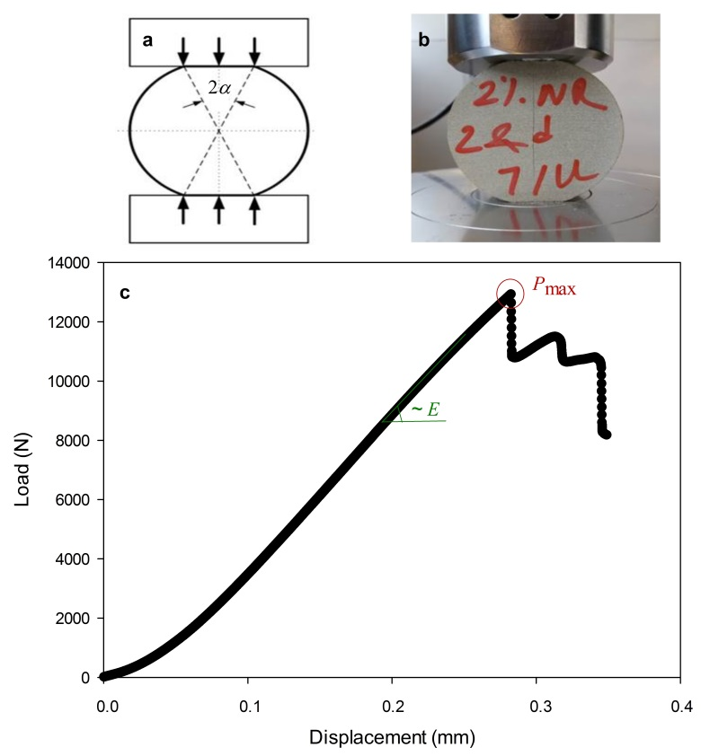
Fig. 2: (a) loading method, flattened Brazilian disc specimen (Chen et al., 2014); (b) valid crack style, crack initiation at the center; (c) valid load-displacement record for testing flattened Brazilian disc specimen.
For each of the cement systems the prepared cement slurry was transferred to 8 cylindrical molds, with 50 mm in diameter and 35 mm in thickness, sealed and cured for the desired time in an oven at a constant temperature of 40 $℃$. After curing, the samples were taken out of the oven and machined to flattened disc specimen (thickness of 25 mm, diameter of 50 mm and loading angle of $2α=30°$2α=30°) and tested within the same day. According to the specimen dimensions, the loading rate was 1×10⁻³ mm/s $1×{10}^{-3}mm/sec$for all samples (Keles and Tutluoglu, 2011). The valid tests were selected according to load-displacement curve and the crack style to fulfill the validity criteria (see earlier description). The presented values for $σ_{t}$σ_{t} and E are the mean value of the valid test results, minimum 4.
The original Brazilian test method was used to measure the tensile strength of the NR-cement systems cured according to API Schedule 9 Sg with a temperature gradient of 2.4 $℃$/100 m. The cement slurry was poured into cylindrical molds with a diameter of 50 mm and thickness of 120 mm, sealed and cured under pressure of 20.7 MPa and temperature of 142 $℃$. After curing, each sample was cut into 3 specimens with a thickness of 25 mm. The maximum applied load was converted to tensile strength by applying the specimen dimensions and Eq. 2 with K(0°)=$k=0.9205$1 (Wang et al., 2004).
  - Sonic compressive strength and setting time determination
A Chandler ultrasonic cement analyzer (UCA), providing high pressure/high temperature conditions, was used to measure the sonic compressive strength development of the slurries. UCA identifies the onset of strength buildup in the cement system, initial setting time at compressive strength of 0.34 MPa (50 psi) and final setting at 3.4 MPa (500 psi). The UCA generates a continuous profile of compressive strength as a function of time by measuring the transit time of an acoustic signal. Transit times are converted to compressive strength by means of correlations chosen from a library of available correlations based on the specific gravity of the cement system. In order to measure the sonic compressive strength, Chandler 5270 Data Acquisition and Control System version 2.0.152 was used. The NR-cement systems were cured according to API Schedule 9 Sg with a temperature gradient of 2.4 $℃$/100 m. The experiment was conducted at 20.7 MPa and 142 $℃$.
- Result and discussion
3.1. Free-fluid
The amount of free-fluid (bleeding) was measured to characterize the stability of the cement slurry. Addition of the NR decreased the free-fluid content, see Table 4.
Table 4: Free-fluid content, initial w/c, and actual w/c corrected for free-fluid of NR-cement systems
Sample | NR-0 | NR-2 | NR-4 | NR-8
Free-fluid (vol. %) | 2.2 | 1.3 | 1.2 | 0.8
Free-fluid (g/100 g c) | 1.7 | 1.1 | 1.0 | 0.7
Initial w/c (Table 3) | 0.441 | 0.443 | 0.445 | 0.448
Actual w/c (corrected for free-fluid) | 0.424 | 0.432 | 0.435 | 0.441

The reduced free fluid resulted in a slightly higher w/c (maximum 0.01) in the NR-cement systems compared to the reference system. In addition, the initial w/c differed (maximum 0.007). The initial and actual w/c (corrected for free-fluid) are presented in Table 4; the maximum difference in actual w/c is 0.017.
3.2. Setting time and hydration development
The setting time for the NR-cement systems cured at 40 $℃$ were determined from the rate of autogenous shrinkage strain curves. According to Meddah and Tagnit-Hamou (2011) the peak time (“time-zero”, t₀) as indicated in Fig 3 is comparable to the setting time (Meddah and Tagnit-Hamou, 2011). Addition of NR to the cement system caused retardation of setting time (Fig. 4) and hydration development (Fig 5). The higher the NR content was, the higher the degree of retardation. Similar trends were observed for samples tested at 20.7 MPa and 142 $℃$ (see Section 3.4). The initial and final setting times at well conditions are listed in Table 6.
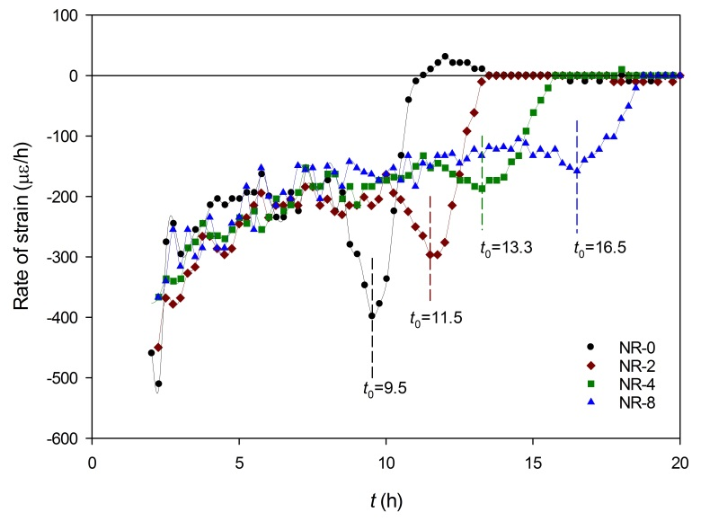
Fig. 3: Evolution of rate of autogenous shrinkage strain for NR-cement systems cured at 40 $℃$ and atmospheric pressure. Time-zero t₀, is indicated for all systems.
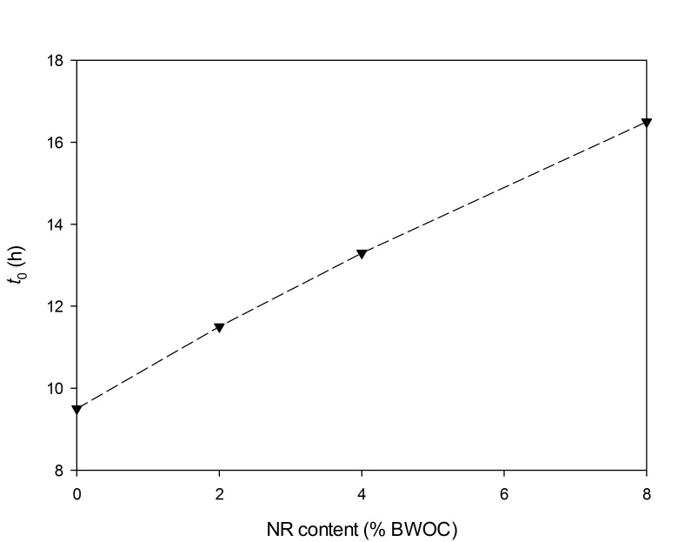
Fig. 4: The time-zero t₀, as a function of NR content for NR-cement systems cured at 40 $℃$ and atmospheric pressure.
It has been reported that incorporation of MR into cement system also resulted in setting time retardation. For oil well cement system containing 5.5 % MR the initial setting time increased approximately 45 % (Yao and Hua, 2007). From Fig. 4, the increase in the setting time for a system containing 5.5 % NR is estimated to approximately 50 %, which is in the same range reported for MR-cement system.
The following two mechanisms have been suggested as explanations for the observed retardation of cement hydration:
- Physical retardation due to NR hindering the water access (Kong et al., 2015b; Kong et al., 2016; Su et al., 1991; Van Gemert et al., 2005);
- Chemical retardation due to complexation of Ca²⁺ ions with carboxyl groups (Baueregger et al., 2015; Kong et al., 2015b; Kong et al., 2016);
Due to COOH groups on the NR surface, NR has strong complexation interaction with Ca²⁺ ions in the pore solution of the hydrating cement system. COOH groups are chemically bound onto the NR surface. These groups ionize in the high pH environment of the fresh cement paste and this results in adhesion of cement paste to existing substrates. Ca²⁺ ions which are released in the pore solution of cement paste develop an electrostatic interaction with COO─, see Fig. 6. (Short, 2007)
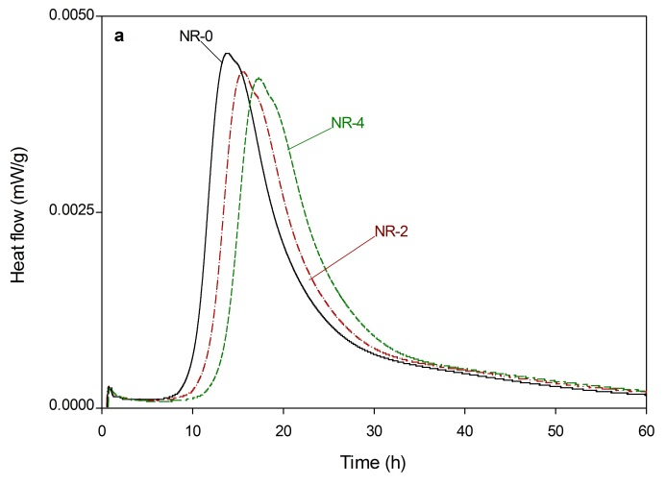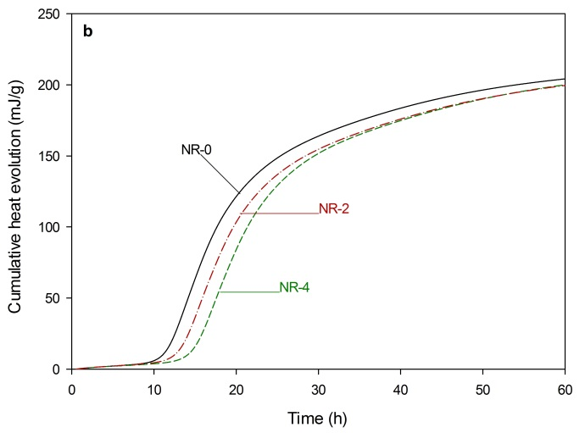
Fig. 5: Impact of NR addition on the heat of hydration of NR-cement systems at 40 $℃$ and atmospheric pressure.
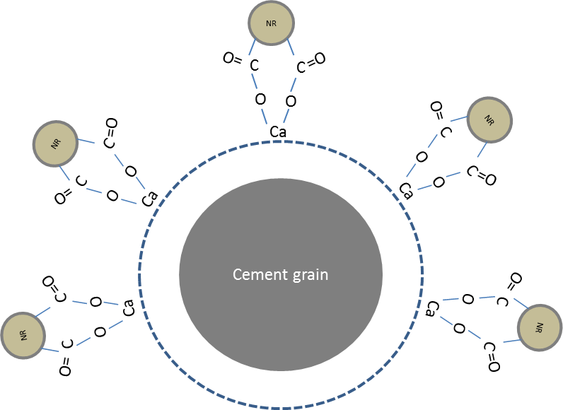
Fig. 6: Ionized carboxyl groups interacted with calcium ions in solution and bonding to a cement grain, based on (Short, 2007).
3.3. Autogenous (bulk) shrinkage
Fig. 7 illustrates the impact of NR addition on the development of autogenous shrinkage at 40 $℃$. Fig. 7a presents the autogenous shrinkage versus time from the point cement was added to the water (t), and Fig. 7b presents the autogenous shrinkage versus time referenced to the system’s time-zero (t-t₀). Addition of 2 % NR did not affect the shrinkage strain. At 3 days of curing, NR-4 and NR-8 resulted in approximately 30 % and 50 % reduction in autogenous shrinkage strain compared to NR-0, respectively. At 12 days of curing, NR-4 and NR-8 displayed approximately 30-35 % reduction in autogenous shrinkage.
The observed reduction in shrinkage might partly be due to release of water initially adsorbed by the NR. The water adsorbed in NR is a source of internal curing water, proportional to NR content. This homogenously distributed internal curing water might reduce shrinkage stresses (Geiker et al., 2004). In Table 5, the amounts of internal curing water in NR-2, NR-4 and NR-8 relative to the reference system are listed. It can be seen that the internal curing water from the NR compares to compensation of approximately 10-40 % of the chemical shrinkage of the NR-cement systems, considering a total chemical shrinkage of 6.5 ml/100 g cement (Lura et al., 2003). Addition of NR to the cement system decreased the free-fluid content (bleeding), leading to slightly higher w/c in the NR-cement systems compared to the reference system (listed in Table 4, maximum 0.44 vs. 0.42). Only a limited part of the reduction in shrinkage can be explained due to slightly higher w/c in NR-4 and NR-8 compared to NR-0 (Kong et al., 2015a; Zhang et al., 2003).
Table 5: Internal curing water from NR, and percent compensated chemical shrinkage in NR-cement systems relative to the reference system.
Sample | Internal curing water from NR (g /100 g c) | Compensated chemical shrinkage*(%)
NR-0 | - | -
NR-2 | 0.7 | 10
NR-4 | 1.4 | 20
NR-8 | 2.8 | 40
*Considering a total chemical shrinkage of 6.5 ml/100 g c (Lura et al., 2003).
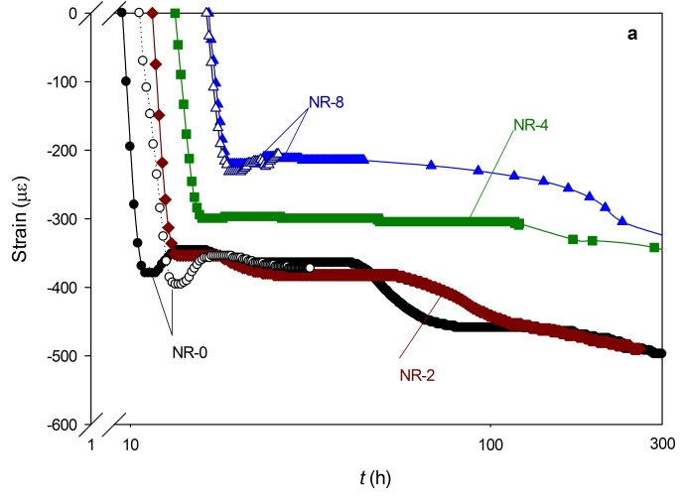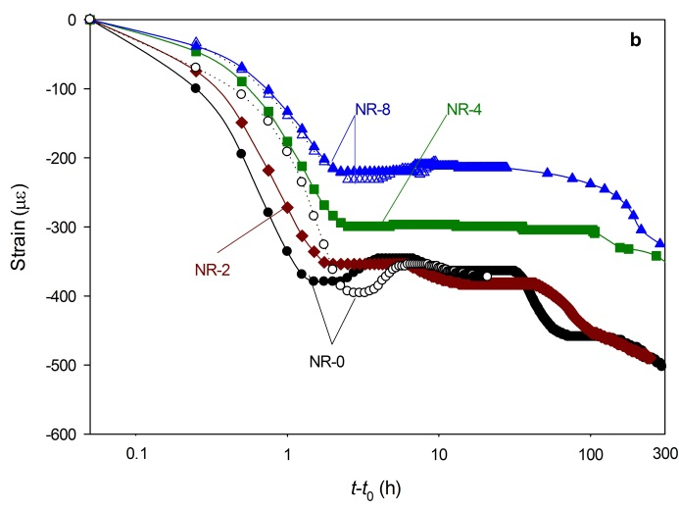
Fig. 7: Autogenous shrinkage strain of NR-cement systems cured at 40 $℃$ and atmospheric pressure, (a) versus time (t) and, (b) versus time referenced to time-zero (t-t₀). Repeated test result is presented for NR-0 and NR-8 (open symbols).
3.4. Mechanical properties development
Fig. 8 shows the sonic strength development of the samples cured at 20.7 MPa and 142 $℃$. Addition of NR to the cement system caused retardation in both the setting time and sonic strength development; higher the NR content caused higher increase in the setting time and reduced the rate of strength development, see Table 6. The systems containing NR presented slower strength development. Initially, the strength development of NR-2-HT was below reference system, but after about 3 days of curing it surpassed the reference system.
Table 6: Initial setting, final setting, sonic compressive strength, and tensile strength of NR-cement systems cured under pressure of 20.7 MPa and temperature of 142 $℃$.
Sample | Initial setting (h) | Final setting (h) | Sonic strength (MPa) |  |  | Tensile strength (MPa)
 |  |  | 1 d | 3 d | 5 d | 3 d
NR-0-HT | 4.4 | 5.2 | 14.2 | 17.7 | 16.6 | 6.8±1.6
NR-2-HT | 5.2 | 6.8 | 12.0 | 17.8 | 17.6 | -
NR-4-HT | 5.3 | 6.9 | 9.7 | 14.7 | - | 7.2±1.7
NR-8-HT | 6.2 | 8.5 | 8.4 | 13.3 | 13.8 | 5.8±0.6

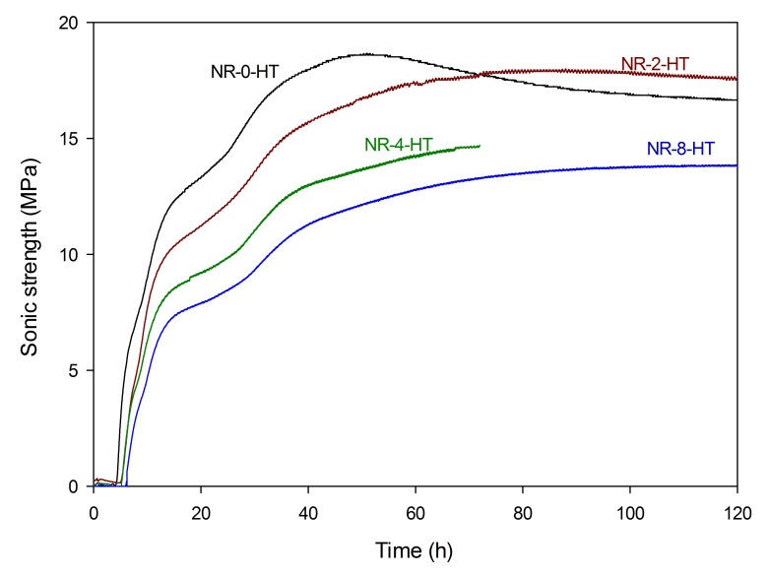
Fig. 8: Sonic compressive strength development of the NR-cement systems estimated by UCA, cured at 20.7 MPa and 142 $℃$.
The results of 3-day and 28-day Brazilian test for the specimens cured at 40 $℃$ are shown in Fig. 9. An increase of NR content in the cement system caused increased displacement at P_{max} and decreased P_{max} (Fig. 9a). Fig. 9b illustrates the influence of NR content on 3-day and 28-day tensile strength. In the presence of NR, the tensile strength reduction is more significant at 3 days of curing, which might be due to retardation of cement system hydration. From 3 to 28 days the systems containing NR presented more noticeable increase in tensile strength compared to the reference system. The increase in tensile strength of NR-0, NR-2, NR-4 and NR-8 systems from 3 days to 28 days was approximately 5, 25, 60 and 50 %, respectively. At 28 days of curing at 40 $℃$, addition of 2, 4 and 8 % NR resulted in about 10, 5 and 15 % reduction in tensile strength compared to the reference system.
As expected, at higher NR content, the Young’s modulus reduced more compared to the reference system, see Fig. 9c. At 3 days of curing, incorporation of 2, 4 and 8 % NR into the cement system resulted in approximately 25, 30 and 45 % reduction in Young’s modulus, respectively. Addition of 2, 4 and 8 % NR to the cement system cured for 28 days resulted in approximately 25, 25 and 45 % reduction in Young’s modulus, respectively. The tensile strength requirement of cement system to withstand stresses is a function of its Young’s modulus. Reduction in cement Young’s modulus results in decreased tensile strength requirement (Thiercelin et al., 1998; Williams et al., 2011).
The ratio of tensile strength to Young’s modulus σ_{t}/E, of the cement system has been proposed for comparison between different systems to determine which system performs better under tensile stresses (Nelson and Guillot, 2006; Williams et al., 2011). A higher ratio achieved in a system with lower E and/or higher σ_{t}, is beneficial for elevated stress environments. For samples cured for 3 days, the reduction in E was not enough to compensate the noticeable reduction in σ_{t}. NR-2 and NR-8 had almost the same value of σ_{t}/E as NR-0, but σ_{t}/E was reduced for NR-4 compared to NR-0. At 28 days of curing NR caused improved σ_{t}/E, indicating better performance under tension.
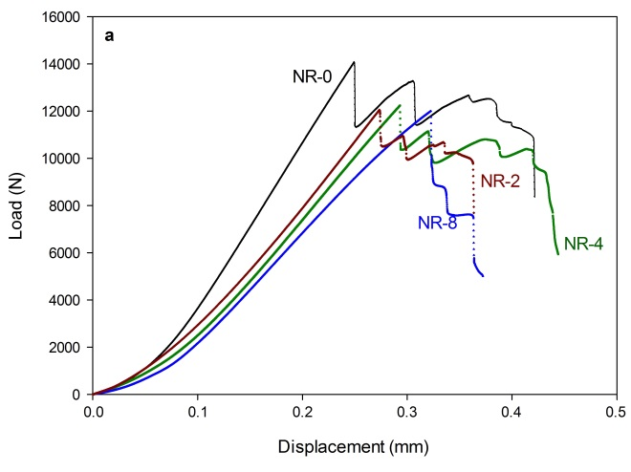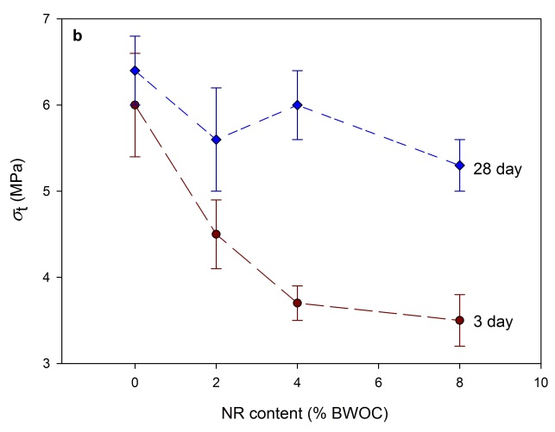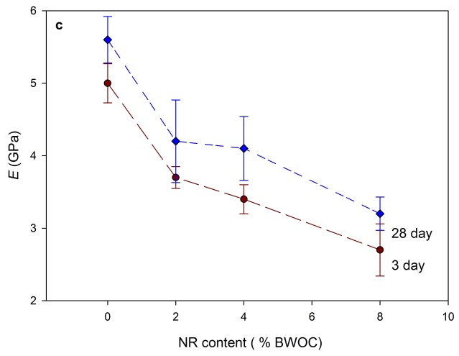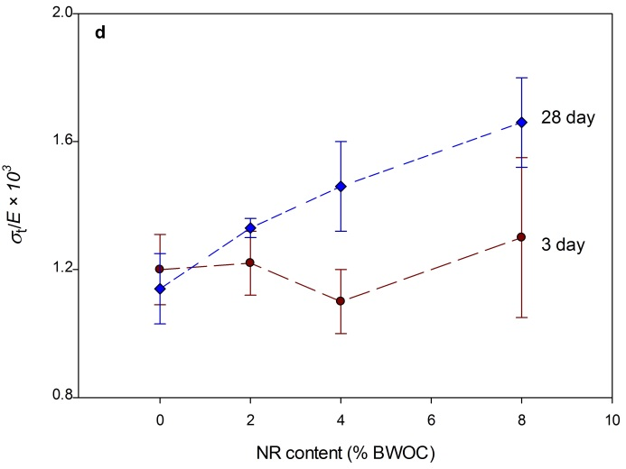
Fig. 9: (a) Load-displacement curves for NR-cement systems cured for 28 days from Brazilian test of flattened specimens, (b) the tensile strength $σ_{t}$σ_{t}, (c) Young’s modulus E, and (d) $σ_{t}$σ_{t}/E of cement systems as a function of NR content for samples cured for 3 and 28 days at 40 $°C$ and atmospheric pressure.
Tensile strength of NR-cement systems cured for 3 days at 20.7 MPa and 142 $℃$ are listed in Table 6. NR-4-HT presented a slight increase in tensile strength compared to NR-0-HT. However, addition of 8 % NR to the cement system resulted in approximately 15 % reduction in tensile strength.
4. Assessment of the applicability of NR for improvement of cement system performance
The cement sheath requirement in terms of cement properties depends strongly on the loading that is expected during the life of the well and on the formation’s mechanical properties (Shenold and Teodoriu, 2016; Thiercelin et al., 1998). Thiercelin et al. (1998) carried out a finite element analysis to predict the tensile strength requirement of cement system placed next to soft to hard formations and under different loadings. Jafariesfad et al. (2017a) illustrated the normalized tensile strength requirement vs. normalized Young’s modulus for the extreme loading conditions analyzed in (Thiercelin et al., 1998). The curve of tensile strength requirement versus its Young’s modulus of cement system is according to data from (Thiercelin et al., 1998) based on the below loading conditions:
- Temperature increase of 93 $℃$ (200 $℉$) and formation’s Young’s modulus of 2 GPa,
- Pressure increase of 34 MPa (4900 psi) and formation’s Young’s modulus of 17 GPa,
- Pressure decrease of 28 MPa (4000 psi) and formation’s Young’s modulus of 17 GPa.
In Fig. 10, tensile strength requirement for these three loading types are plotted. In order to evaluate the impact of NR on cement system performance under extreme loadings, the results for the investigated NR-cement systems cured at 40 $℃$ are shown in Fig. 10. The reference system is below the tensile strength requirement to survive under temperature increase of 93 $℃$. The systems containing NR are above the requirement curves due to a combination of reduced Young’s modulus and negligible impact on tensile strength. It needs to be addressed that NR-0, NR-2, NR-4 and NR-8 are cured for 28 days at 40 $℃$ and atmospheric pressure. For a more realistic evaluation, the NR-cement systems should be cured at well conditions. The tensile strength of the cement systems cured at 20.7 MPa and 142 $℃$ are presented in Table 6 and indicated in Fig. 10. Based on the requirement curves, the Young’s modulus for NR-4-HT and NR-8-HT should be below 5.7 and 4.6 MPa to lie in the green area.
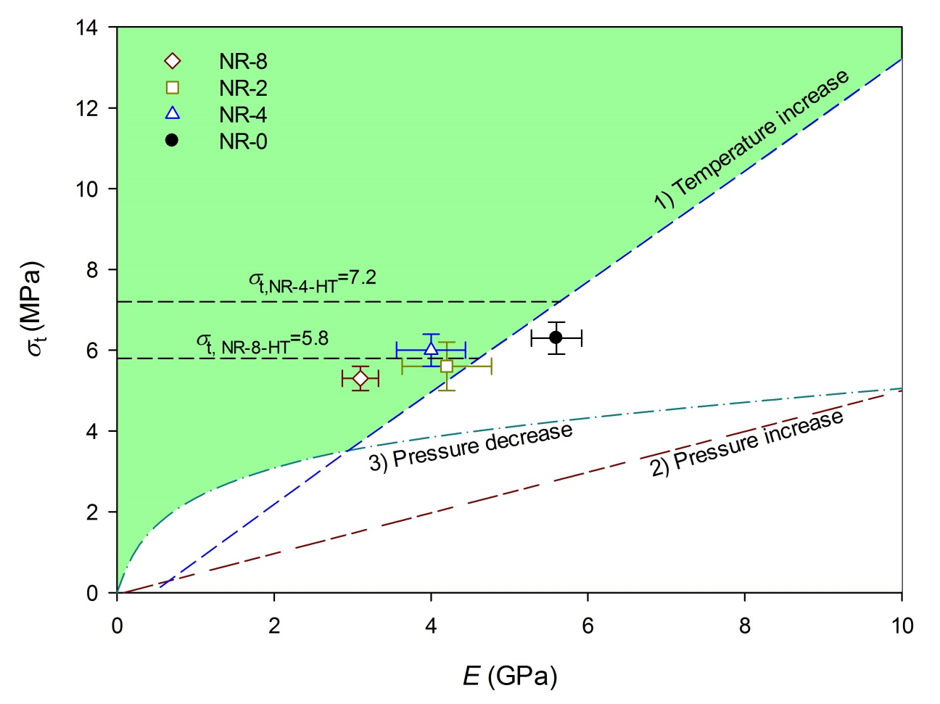
Fig. 10: Tensile strength requirement vs. Young’s modulus of cement systems for different loading types. The requirement curves are for: 1) Temperature increase: 93$℃$ (200$℉$), E_{Formation}=2 GPa; 2) Pressure increase: 34 MPa (4900 psi), E_{Formation}=17 GPa; 3) Pressure decrease: 28 MPa (4000 psi), E_{Formation}=17 GPa. After (Jafariesfad et al., 2017a; Thiercelin et al., 1998). The data points present NR-cement systems cured at 40 $℃$ and atmospheric pressure for 28 days; the black dash lines show the tensile strength of NR-cement systems cured at 20.7 MPa and 142 $℃$.
Thiercelin et al. (1998) assumed volume stability in their model for prediction of tensile strength requirement of cement system. However, bulk shrinkage can result in significant damage to the cement sheath even before the well experiences additional stress from temperature and/or pressure fluctuation (McCulloch et al., 2003). Therefore, reduction in shrinkage of cement system can result in improved resistance to stresses, and thus reduced risk of cement system failure (Jafariesfad et al., 2017a). As discussed, in the NR-cement systems in addition to improved flexibility, the autogenous shrinkage (at 40 $℃$) was reduced 30-35 %, indicating improved performance under imposed stresses during well’s life.
From the systems available in Table 1, the system containing carboxylated nitrile rubber particles (Yao and Hua, 2007) is the most comparable system with the NR/cement system. Addition of 4 % NR to the cement system cured for 28 d at 40 $℃$ and 3 d at 142$℃$ and 20.7 MPa, resulted in approximately 5 % reduction and 5 % increase in tensile strength, respectively. For system containing 4 % microsized carboxylated nitrile rubber (Yao and Hua, 2007), the tensile strength reduced approximately 20 %. This comparison shows improved performance of the investigated NR-cement system compared to the MR-cement systems reported in (Yao and Hua, 2007). However, in order to ensure that NR-cement system performs better than MR-cement system, these systems, with similar composition, should be cured at the same conditions and tested with the same methods.
Based on the impact of NR addition on the tensile strength, Young’s modulus, cement hydration and sonic compressive strength, application of 2-4 % NR in oil well cement systems seems promising.
5. Conclusion
The impact of temperature stable nanorubber particles (NR, up to 8 % by mass of cement) on tensile properties, sonic compressive strength development, bulk shrinkage and hydration development of Class G oil well cement systems was investigated.
- At 28 days of curing at 40 $℃$, σ_{t}/E improved with increasing NR content. At 3 days the flexibility was improved, but no impact on σ_{t}/E was observed. This might be explained by the observed retardation of cement hydration. Comparison of the results to requirements under extreme loading conditions indicates promising performance of the NR-cement systems.
- At well conditions (20.7 MPa and 142 $℃$), measurement of tensile strength showed limited impact of NR. Assuming increased flexibility, this indicates a positive impact of NR on the performance of the cement system under tension.
- Incorporation of NR into the cement system resulted in reduced autogenous shrinkage at 40$℃$. The mitigation of autogenous shrinkage might partly be explained by internal curing water released from the NR during hydration.
Acknowledgment
The authors would like to thank Professor Helge Hodne for his assistance at Well Cementing Laboratory at University of Stavanger, Halliburton and Sinopec Beijing Research Institute of Chemical Industry for providing materials, and the financial support by The Research Council of Norway (project number 10412401) and Weber Saint-Gobain Construction AS (Norway).
References
Abbasy, I., Vasquez, J.E., Eoff, L.S. and Dalrymple, E.D. 2008. Laboratory Evaluation of Water-Swellable Materials for Fracture Shutoff. Proc., SPE/DOE Improved Oil Recovery Symposium, Tulsa, Oklahoma, USA. http://dx.doi.org/10.2118/113193-MS.
Agapiou, K., Gamwell, C.R. and Sodhi, T.S. 2016. Influence of Recycled Rubber Tire Morphology on the Mechanical Properties of Well Cements. Proc., 50th US Rock Mechanics / Geomechanics Symposium, Houston, Texas, USA.
API-RP-10B-2, 2012. Recommended Practice for Testing Well Cements. API, Washington, DC.
ASTM-C1698-09, 2014. Standard Test Method for Autogenous Strain of Cement Paste and Mortar. ASTM International, West Conshohocken, USA.
Baueregger, S., Perello, M. and Plank, J., 2015. Influence of carboxylated styrene–butadiene latex copolymer on Portland cement hydration. Cem. Concr. Compos., 63: 42-50. http://dx.doi.org/10.1016/j.cemconcomp.2015.06.004.
Bois, A.P., Gamier, A., Rodot, F., Saint-Marc, J. and Aimard, N., 2011. How to prevent loss of zonal isolation through a comprehensive analysis of microannulus formation. SPE Drill. Completion, 26(1): 13-31. http://dx.doi.org/10.2118/124719-PA.
Bois, A.P., Garnier, A., Galdiolo, G. and Laudet, J.B., 2012. Use of a Mechanistic Model To Forecast Cement-Sheath Integrity. SPE Drill. Completion, 27(2): 303-314. http://dx.doi.org/10.2118/139668-PA.
Brothers, L.E., 2005. Cement compositions with improved mechanical properties and methods of cementing in subterranean formations. Google Patents.
Chen, X., Wu, S. and Zhou, J., 2014. Quantification of dynamic tensile behavior of cement-based materials. Constr. Build. Mater., 51: 15-23. http://dx.doi.org/10.1016/j.conbuildmat.2013.10.039.
Geiker, M.R., Bentz, D.P. and Jensen, O.M., 2004. Mitigating autogenous shrinkage by internal curing. ACI Spec. Publ., 218: 143-154.
Huang, F., Liu, Y.Q., Zhang, X.H., Gao, J.M., Song, Z.H., Tang, B.H., Wei, G.S. and Qiao, J.L., 2005. Interface and properties of epoxy resin modified by elastomeric nano-particles. Sci. China Ser. B-Chem., 48(2): 148-155. http://dx.doi.org/10.1360/04yb0022.
ISO10426-1, 2009. Petroleum and natural gas industries-Cements and materials for well cementing-Part1: Specification. ISO, Geneva, Switzerland.
Jafariesfad, N., Geiker, M.R., Gong, Y., Skalle, P., Zhang, Z. and He, J., 2017a. Cement Sheath Modification Using Nanomaterials for Long-term Zonal Isolation of Oil Wells: Review. Manuscript submitted for publication.
Jafariesfad, N., Geiker, M.R. and Skalle, P., 2017b. Nano-Sized MgO with Engineered Expansive Property for Enhanced Cement System Performance. SPE J., In Press.
Jansen, D., Goetz-Neunhoeffer, F., Neubauer, J., Haerzschel, R. and Hergeth, W.D., 2013. Effect of polymers on cement hydration: A case study using substituted PDADMA. Cem. Concr. Compos., 35: 71-77. http://dx.doi.org/10.1016/j.cemconcomp.2012.08.022.
Keles, C. and Tutluoglu, L., 2011. Investigation of proper specimen geometry for mode I fracture toughness testing with flattened Brazilian disc method. Int. J. Fract., 169(1): 61-75. http://dx.doi.org/10.1007/s10704-011-9584-z.
Kong, X.-m., Zhang, Z.-l. and Lu, Z.-c., 2015a. Effect of pre-soaked superabsorbent polymer on shrinkage of high-strength concrete. Mater. Struct., 48(9): 2741-2758. https://doi.org/10.1617/s11527-014-0351-2.
Kong, X., Emmerling, S., Pakusch, J., Rueckel, M. and Nieberle, J., 2015b. Retardation effect of styrene-acrylate copolymer latexes on cement hydration. Cem. Concr. Res., 75: 23-41. http://dx.doi.org/10.1016/j.cemconres.2015.04.014.
Kong, X., Pakusch, J., Jansen, D., Emmerling, S., Neubauer, J. and Goetz-Neuhoeffer, F., 2016. Effect of polymer latexes with cleaned serum on the phase development of hydrating cement pastes. Cem. Concr. Res., 84: 30-40. http://dx.doi.org/10.1016/j.cemconres.2016.02.013.
Le Roy-Delage, S., Baumgarte, C., Thiercelin, M. and Vidick, B. 2000. New Cement Systems for Durable Zonal Isolation. Proc., IADC/SPE Drilling Conference, New Orleans, Louisiana, 2000/1/1/. https://doi.org/10.2118/59132-MS.
Liu, Y.Q., Fan, Z., Ma, H., Tan, Y. and Qiao, J.L., 2006. Application of nano powdered rubber in friction materials. Wear, 261(2): 225-229. http://dx.doi.org/10.1016/j.wear.2005.10.011.
Lura, P., Jensen, O.M. and van Breugel, K., 2003. Autogenous shrinkage in high-performance cement paste: An evaluation of basic mechanisms. Cem. Concr. Res., 33(2): 223-232. http://dx.doi.org/10.1016/S0008-8846(02)00890-6.
McCulloch, J., Gastineau, J., Bour, D. and Ravi, K., 2003. Life Cycle Modeling of Wellbore Cement Systems Used for Enhanced Geothermal System Development. Geotherm. Resour. Counc. Trans., 27: 147-154.
Meddah, M.S. and Tagnit-Hamou, A., 2011. Evaluation of rate of deformation for early-age concrete shrinkage analysis and time zero determination. J. Mater. Civ. Eng., 23(7): 1076-1086. http://dx.doi.org/10.1061/(ASCE)MT.1943-5533.0000261.
Nelson, E.B. and Guillot, D., 2006. Well Cementing. Schlumberger.
Pavlock, C., Tennison, B., Thompson, J.G. and Darbe, R.P. 2012. Latex-based cement design: Meeting the challenges of the Haynesville shale. Proc., SPE Americas Unconventional Resources Conference, Pittsbuurgh, Pennsylvania, USA, 5-7 June. https://doi.org/10.2118/152730-MS.
Reddy, B.R., Santra, A.K., McMechan, D.E., Gray, D.W., Brenneis, C. and Dunn, R. 2005. Cement Mechanical Property Measurements Under Wellbore Conditions. Proc., SPE Annual Technical Conference and Exhibition, Dallas, Texas, 9 – 12 October. http://dx.doi.org/10.2118/95921-MS.
Roy-Delage, S.L. and Thiercelin, M., 2004. Cementing compositions and applications of such compositions for cementing oil wells or the like. Google Patents.
Saint-Marc, J., Garnier, A. and Bois, A.P. 2008. Initial State of Stress: The Key to Achieving Long-Term Cement-Sheath Integrity. Proc., SPE Annual Technical Conference and Exhibition, Denver, Colorado, USA, 21–24 September. http://dx.doi.org/10.2118/116651-MS.
Sant, G., Lura, P. and Weiss, J., 2006. Measurement of volume change in cementitious materials at early ages: review of testing protocols and interpretation of results. Transp. Res. Rec.: J. Transp. Res. Board, 1979: 21-29. http://dx.doi.org/10.3141/1979-05.
Shenold, C. and Teodoriu, C., 2016. Development of a structured workflow for enhanced well cement integrity: Lessons learned and the way ahead. J. Nat. Gas Sci. Eng., 36, Part A: 824-836. https://doi.org/10.1016/j.jngse.2016.10.042.
Short, N.R., 2007. Degradation of polymer-cement composites. In: C.L. Page and M.M. Page (Editors), Durability of concrete and cement composites. Elsevier pp. 364-390. http://dx.doi.org/10.1533/9781845693398.364.
Su, Z., Bijen, J.M.J.M. and Larbi, J.A., 1991. Influence of polymer modification on the hydration of portland cement. Cem. Concr. Res., 21(4): 535-544. http://dx.doi.org/10.1016/0008-8846(91)90103-O.
Sun, F., Lv, G. and Jin, J. 2006. Application and Research of Latex Tenacity Cement Slurry System. Proc., International Oil & Gas Conference and Exhibition in China, Beijing, China, 5-7 December. https://doi.org/10.2118/104434-MS.
Tang, L.C., Wang, X., Wan, Y.J., Wu, L.B., Jiang, J.X. and Lai, G.Q., 2013. Mechanical properties and fracture behaviors of epoxy composites with multi-scale rubber particles. Mater. Chem. Phys., 141(1): 333-342. http://dx.doi.org/10.1016/j.matchemphys.2013.05.018.
Teodoriu, C., Yuan, Z., Schubert, J. and Amani, M. 2012. Experimental Measurements of mechanical parameters of Class G cement. Proc., SPE/EAGE European Unconventional Resources Conference and Exhibition, Vienna, Austria, 20-22 March. http://dx.doi.org/10.2118/153007-MS.
Thiercelin, M.J., Dargaud, B., Baret, J.F. and Rodriquez, W.J., 1998. Cement Design Based on Cement Mechanical Response. SPE Drill. Completion, 13(4): 266-273. http://dx.doi.org/10.2118/52890-PA.
Thomas, B.S., Gupta, R.C., Kalla, P. and Cseteneyi, L., 2014. Strength, abrasion and permeation characteristics of cement concrete containing discarded rubber fine aggregates. 59: 204-212. http://dx.doi.org/10.1016/j.conbuildmat.2014.01.074.
Tripathi, G. and Srivastava, D., 2007. Effect of carboxyl-terminated poly(butadiene-co-acrylonitrile) (CTBN) concentration on thermal and mechanical properties of binary blends of diglycidyl ether of bisphenol-A (DGEBA) epoxy resin. Mater. Sci. Eng.: A, 443(1–2): 262-269. http://dx.doi.org/10.1016/j.msea.2006.09.031.
Tu, A., Kwag, H.R., Barnette, A.L. and Kim, S.H., 2012. Water adsorption isotherms on CH3-, OH-, and COOH-terminated organic surfaces at ambient conditions measured with PM-RAIRS. Langmuir, 28(43): 15263-15269. http://dx.doi.org/10.1021/la302848k.
Ukrainczyk, N. and Rogina, A., 2013. Styrene–butadiene latex modified calcium aluminate cement mortar. Cem. Concr. Compos., 41: 16-23. https://doi.org/10.1016/j.cemconcomp.2013.04.012.
Van Gemert, D., Czarnecki, L., Maultzsch, M., Schorn, H., Beeldens, A., Łukowski, P. and Knapen, E., 2005. Cement concrete and concrete–polymer composites: Two merging worlds: A report from 11th ICPIC Congress in Berlin, 2004. Cem. Concr. Compos., 27(9–10): 926-933. http://dx.doi.org/10.1016/j.cemconcomp.2005.05.004.
Wang, J., Zhang, S., Yu, H., Kong, X., Wang, X. and Gu, Z., 2005. Study of cement mortars modified by emulsifier-free latexes. Cem. Concr. Compos., 27(9–10): 920-925. https://doi.org/10.1016/j.cemconcomp.2005.05.005.
Wang, Q.Z., Jia, X.M., Kou, S.Q., Zhang, Z.X. and Lindqvist, P.A., 2004. The flattened Brazilian disc specimen used for testing elastic modulus, tensile strength and fracture toughness of brittle rocks: analytical and numerical results. Int. J. Rock Mech. Min. Sci., 41(2): 245-253. http://dx.doi.org/10.1016/S1365-1609(03)00093-5.
Wang, Q.Z. and Wu, L.Z., 2004. The flattened Brazilian disc specimen used for determining elastic modulus, tensile strength and fracture toughness of brittle rocks: experimental results. Int. J. Rock Mech. Min. Sci., 41, Supplement 1(3): 26-30. http://dx.doi.org/10.1016/j.ijrmms.2004.03.015.
Wang, Q.Z. and Xing, L., 1999. Determination of fracture toughness KIC by using the flattened Brazilian disk specimen for rocks. Eng. Fract. Mech., 64(2): 193-201. http://dx.doi.org/10.1016/S0013-7944(99)00065-X.
Williams, R.H., Khatri, D.K., Keese, R.F., Roy-Delage, S.L., Roye, J.M., Leach, D.L.R., Porcherie, O., Rottler, P. and Rodriguez, J. 2011. Flexible, Expanding Cement System (FECS) Successfully Provides Zonal Isolation Across Marcellus Shale Gas Trends. Proc., Canadian Unconventional Resources Conference, Calgary, Alberta, Canada, 15–17 November. http://dx.doi.org/10.2118/149440-MS.
Yao, X. and Hua, S. 2007. Design of Novel Composite Agent for Improving the Toughness of Oil-Well Cement Sheath. Proc., SPE International Symposium on Oilfield Chemistry, 28 February–2 March. http://dx.doi.org/10.2118/106010-MS.
Yuan, Z., Schubert, J., Teodoriu, C. and Gardoni, P. 2012. HPHT Gas Well Cementing Complications and its Effect on Casing Collapse Resistance. Proc., SPE Oil and Gas India Conference and Exhibition, Mumbai, India, 28–30 March. http://dx.doi.org/10.2118/153986-MS.
Zhang, M.H., Tam, C.T. and Leow, M.P., 2003. Effect of water-to-cementitious materials ratio and silica fume on the autogenous shrinkage of concrete. Cem. Concr. Res., 33(10): 1687-1694. http://dx.doi.org/10.1016/S0008-8846(03)00149-2.
Zhang, Z., Tan, Y., Wang, X., Tan, H. and Li, J., 2014. Mechanical behavior and fracture toughness of epoxy composites reinforced with combination of fibrous and spherical nanofillers. Polym. Compos. http://dx.doi.org/10.1002/pc.23125.

