Ontogenetic timing of density dependence: location-specific patterns reflect distribution of a limiting resource

Maxim A. K. Teichert¹
Sigurd Einum²
Anders G. Finstad¹
Ola Ugedal¹
Torbjørn Forseth¹

¹Norwegian Institute for Nature Research, Tungasletta 2
N-7485 Trondheim
Norway

²Centre for Biodiversity Dynamics
Department of Biology
Norwegian University of Science and Technology
Realfagbygget,
NO-7491 Trondheim
Norway

*Correspondence Author:
Maxim A.K. Teichert
Tel: +47 7380 1463
e-mail: maxim.teichert@hotmail.com

No of text pages: 25
No of tables: 1
No of figures: 4
Abstract
Theoretical considerations suggest that the relative abundance of age-specific limiting resources determines the ontogenetic timing of density dependence. Structural shelters may represent one such resource which can become increasingly scarce with increasing body size. Here we use a time series of juvenile Atlantic salmon (Salmo salar) densities and ask whether ontogenetic patterns of density-dependent losses in two separate reaches of a river can be predicted by considering their shelter abundances. The analyses were conducted using sampling site data (N = 30) as well as stream-reach averages. Loss rates from the egg to the young-of-the-year stage were density-dependent in both reaches. For the transition from the young-of-the-year to the yearling stage, when shelters are more likely to become limiting, the results were sensitive to the spatial scale of analysis. On the reach scale, among-year variation in loss rates was positively correlated with density in the reach with the lowest shelter abundance, whereas no such effect was found in the other reach. This demonstrates that the ontogenetic timing of density dependence can vary among areas within populations, and hence among populations, and that this variation can be explained by quantification of age-specific limiting factors. For analyses at the sample site scale this pattern was reversed, with stronger density dependence in the reach with highest shelter abundance. However, this result was clearly driven by immigration into low density sites, which masked the true reach-level effect. Thus, our study also exemplifies how population level regulation inferred from patch- or trap-based data that fails to account for animal movements can be biased.

Keywords: Age-structure, intraspecific competition, niche shift, stage-structure
Introduction
Although there is now a general consensus that animal populations are regulated by density dependence (Sinclair 1989; Krebs 1994; Turchin 1999), the patterns are often complex (Benton et al. 2006). In particular, it often remains uncertain when during ontogeny density dependence occurs (Armstrong 1997; Vandenbos et al. 2006). It is becoming increasingly clear that populations may be regulated to different extents during different life history stages (e.g. Hellriegel 2000; Ratikainen et al. 2008; Bonenfant et al. 2009), and that the timing affects population dynamics by shifting the mean and by changing the amplitude and/or regularity of population size fluctuations (Hellriegel 2000). For some species, density dependence can be particularly strong during the early juvenile stage (Sinclair 1989; Harper and Semlitsch 2007; Kennedy et al. 2008), whereas later stages are more heavily influenced by density in others (Forrester and Steele 2000; Harper and Semlitsch 2007; Bonenfant et al. 2009; Loman and Lardner 2009; McMahon et al. 2009). Such divergent patterns in the ontogenetic timing of density dependence may also exist among different populations within the same species (Elliott 1989, Elliott and Hurley 1998). This seems to be particularly likely in organisms which undergo ontogenetic habitat shifts, and where the potentially limiting resources are age-specific (i.e. different life stages limited by different types of resources, Beckstead and Augspurger 2004). The relative abundance of age-specific limiting resources, which may vary among populations, may then cause different populations to experience competition for limiting resources during different life stages.

Here we consider structural refuge as one such potentially limiting resource, and ask whether differences in timing of density dependence can be predicted by considering its abundance in different environments. The availability of structural refuge has been widely identified as a limiting factor (Harwood et al. 2002; Griffiths et al. 2004; Davey et al. 2009) which may be critical to the persistence of many populations (Schwarzkopf and Alford 1996). Due to the protection such shelters provide from predators (Begon et al. 1996; Hossie and Murray 2010) and adverse environmental conditions (Schwarzkopf and Alford 1996; Millidine et al. 2006), lack of sufficient shelter opportunities may result in strong competition (Davey et al. 2009; Lammers et al. 2009). In freshwater prawns (Macrobrachium australiense H.) for example, dominant individuals expel subdominant individuals from vegetation cover and thus expose them to increased risk of predation (Lammers et al. 2009). For crayfish (Orconectes virilis H.), such shelters may be more limiting than food in regulating population abundance (Miller et al. 1992). Because the importance of shelters as a limiting factor is often known, and their abundance can be easily measured, organisms relying on such resources constitute promising model systems for revealing the mechanistic causes of the complexity in population dynamics.

Both shelter use (e.g. Valdimarsson and Metcalfe 1998; Orpwood et al. 2003; Finstad et al. 2007; Teichert et al. 2010) and density-dependent regulation (e.g. Elliott 1994; Jonsson et al. 1998; Einum et al. 2006; Finstad et al. 2009) have been well studied in stream dwelling salmonids. However, few studies address density-dependent mortality at different ages (see Lobón-Cerviá et al. 2012 for a recent example), thus limiting the ability to make effective management decisions concerning stocking regimes and habitat restoration (Einum and Nislow 2011). We therefore use Atlantic salmon (Salmo salar, L.) as a model organism to test for differences in density-dependent mortality between age-groups in a river which is highly uniform in terms of temperature, discharge and land use, but differs notably in shelter availability between the upper and lower reaches. Atlantic salmon experience high mortality rates during the first few weeks following emergence from nests (Einum and Fleming 2000a; Einum and Fleming 2000b; Nislow et al. 2004). This mortality is density-dependent (Einum et al. 2006), and the limiting resource appears to primarily be habitats with low water velocities that allow successful feeding (Nislow et al. 1998; Nislow et al. 1999; Kennedy et al. 2008). For older stages, a broader range of water velocities can be utilised (Nislow et al. 1999), and the availability of interstitial shelters may become limiting (Finstad et al. 2007), as has been demonstrated in the same study river by Finstad et al. (2009). Thus, we predict density dependence for older life stages to be most prominent within the reach of the river which has a lower abundance of shelters.

Materials and methods
Study area
Data were gathered in the River Nausta, on the west coast of Norway (61º30’N, 5º43’E). The river has a natural flow regime with a median discharge of 13.5 m³s⁻¹ between 2001 and 2010. Average July minimum and maximum discharges for the same period were 9.1 and 32.8 m³s⁻¹, respectively. At a discharge of 12.1 m³s⁻¹, average width measures 44.3 m, as determined by aerial photography and measured every 50 m. The river is dominated by Atlantic salmon, but smaller numbers of brown trout (Salmo trutta L.), three-spined stickleback (Gasterosteus aculeatus L.) and European eel (Anguilla anguilla L.) are also present. Adult anadromous salmonids may ascend this river up to a distance of 9.9 km for breeding, facilitated by a fish ladder which allows them to bypass a waterfall at 2.9 km upstream from the sea. However, for juvenile fish, upstream movement is prevented and downstream movement is likely minimized by the waterfall. Based on scale samples of returning adults taken between 1997 and 2009 (n = 1292) , the majority (68.7 %) of juvenile salmon in the River Nausta migrate to sea as smolts at age 3+, the remaining fish at age 2+ (26 %) and 4+ (5.3 %) (Ugedal, unpublished data). To avoid bias in estimates of population loss rates among reaches and years caused by variation in smolt age we only consider loss rates up to age 1+. Shelter availability differs markedly between the two reaches upstream and downstream of the fish ladder. This was quantified by dividing the river into 81 sections (size range 1054 to 48 023 m², mean 7785 m²) of homogenous substrate composition based on a visual categorization of dominating and sub-dominating (by area) substrate classes (sand < 2 cm, gravel 2-12 cm, cobble 12-30 cm, boulders > 30 cm and bedrock). Shelter provided by overhanging vegetation and woody debris was not considered, due to small amounts of riparian vegetation (the river is largely flanked by open farmland) and lack of resulting input of debris. In each section, three randomly distributed replicate measurements of shelter were taken, in which the available shelter was quantified, using a 13 mm rubber tube, according to Finstad et al. (2007). An estimate of weighted mean shelter abundance per m² for each of the two river reaches was then calculated as:
(1)
where NS_{j} and A_{j} are the measured total number of shelters and the area for each section j, respectively (Fig. 1). Finally, river gradient was estimated from digital elevation models by slope raster point every 25 m. Shelter availability was approximately four times higher in the upper than in the lower reach of the river (WS_{upper} = 1.77; WS_{lower} = 0.43, Fig. 1). River gradient, also tended to differ between the river reaches (t = 1.95, df = 323.89, P = 0.052), with mean gradient being lower for the lower reach (1.73 %) than for the upper reach (2.13 %). For ease of understanding, upper and lower reaches will henceforth be referred to as high- and low-shelter reaches, respectively.

Electrofishing survey
Independent of the assessment of shelter availability, a total of 30 electrofishing stations (size range 39 to 184 m², mean 94 m²) were placed along the river (18 in the high-, 12 in the low-shelter reach), representing the river’s range of physical habitat (Borsanyi et al. 2004). Due to the size of the river, the electrofishing stations usually covered an area along the river bank, rather than crossing the entire width. These stations were electrofished in autumn during 2003 - 2010 (no. of stations fished per year: min 19, max 30, mean 27). The location of each station was marked on a map and referenced by GPS and at least one of the members of the electrofishing team participated each year, to ensure consistency. At each site, the densities of young-of-the-year (YOY) and yearling (1+) salmon were estimated using 3-, 2- or 1-pass electrofishing (Bohlin et al. 1989; Mitro and Zale 2000). Age classes were determined by length-frequency distributions and verified by scale samples. Older juveniles were also sampled, but not included in the present study. For those sites where sufficient numbers of caught fish (n > 20) permitted calculating reliable estimates, 3- and 2-pass electrofishing was used to estimate catch efficiency (P) separately for YOY and 1+ salmon. Based on these results, a mean catch probability (P_{mean}) was calculated for YOY (P_{mean} = 0.47 ± 0.09 SD; n = 37) and 1+ salmon (P_{mean} = 0.62 ± 0.12 SD; n = 25). Abundance of each cohort j at each site i was then estimated as:
(2)
where T and k is the total catch and the number of electrofishing passes, respectively (Bohlin et al. 1989). Finally, fish abundances were expressed as densities of individuals per 100 m². For each site, we calculated the loss rate from YOY to 1+ as ln(D_{t}/D_{t+1}), where D_{t} and D_{t+1} are the number of individuals per 100 m² for a cohort in years t and t+1, respectively. Due to the occurrence of stations with zero density, one was added to the densities of both year classes to enable the calculation of the loss rates.

In addition to the electrofishing survey, the number of eggs deposited per m² was estimated separately for each of the two reaches, using a combination of catch statistics and migration counts from the fish ladder. Catch statistics from the high-shelter reach of the river, where counts from the fish trap gave the pre-fishing abundance, were used to calculate harvest rates and number of female spawners in that area. Body size distributions and sex-ratios in the catches were then used to calculate female spawner biomass. For the low-shelter reach we assumed harvest rates to be equal to those observed in the high-shelter reach, and used catch statistics in a similar way to calculate female spawner biomass. Total egg densities for the two reaches were then calculated as total female spawner biomass (kg) multiplied by fecundity (1450 eggs kg⁻¹) divided by their respective areas. Using these data, loss rates from the egg to the YOY stage could be calculated.

Statistical analysis
Linear mixed effects models (LMM) were used to compare the density of the different age groups among river reaches and years, with electrofishing station added as a random variable.

Variation in loss rates over the different stages was analysed at two spatial scales. In the first, we analysed the variation in loss rates on a reach level. We calculated the geometric mean density for the two age classes of all stations within each of the two reaches for each year. Again, one was added to the densities of both age classes to enable the calculation of the geometric mean. These means were used to obtain annual loss rates over the stages egg to YOY and YOY to 1+ at the reach level. Differences among years in water discharge during sampling may influence numbers caught, either because it influences catchability, or because discharge influences wetted area (i.e. river width) and hence the area over which the fish can be distributed. Thus, the estimated fish densities were standardized to a common discharge prior to taking the geometric mean. This was done by first obtaining a linear relation between observed discharge (m³s⁻¹) during sampling for each year i, Q_{i}, and observed densities within stations j, D_{ij}. For this, a LMM was used, with electrofishing station being added as a random factor. The estimated slope b for this relationship was -4.13 ± 1.02 SE (t = -4.03, P < 0.001). Then, standardized densities, DS_{i,j} for each year i and each cohort j were calculated as:
DS_{i,j} = D_{i,j} + (Q_{µ} - Q _{i}) b (3)
where Q_{µ} is the mean discharge observed during sampling over all years. Loss rates based on the mean standardised densities were analysed using a generalized least squares model (GLS), testing for effects of density and river reach, and an interaction between these. Models with different fixed effects structures were compared using a backwards selection procedure where effects were removed sequentially until no further model simplification could be made without causing a significant (p < 0.05) decrease in log-likelihoods (calculated based on maximum likelihood (ML), Zuur et al. 2009).

In our second set of analyses we modelled variation in station-specific loss rates of YOY to 1+ across years (i.e. including station as a random effect) as a function of station-specific density and river reach, using LMMs. In these, year was included as a fixed effect to control for overall variation in loss rates (i.e. due to environmental variation) or capture efficiency (i.e. water discharge during sampling) among years. Thus, for these analyses, there was no need to standardize densities according to discharge during sampling. Model selection was performed as described above.

To test whether measurement errors may have produced spurious density-dependent relationships in our data (Freckleton et al. 2006), we generated data sets with random measurement error, but without density dependence. The observed initial distribution of YOY abundances combined with randomly drawn (i.e. density independent) loss rates from the observed normal distribution were used to generate new 1+ abundances. Using sampling efficiencies (P_{mean}) observed from the original data set (YOY: 0.47 ± 0.09 SD, 1+: 0.62 ± 0.12 SD), an artificial sampling process was simulated. The likelihood that the observed relationship between fish densities and loss rates was generated by sampling error was then assessed as the proportion of the simulated data sets (1000 simulations) having an equal or more negative relationship than the original observed data.
All statistical analyses were performed in R 2.12.0 (R development Core Team 2010) using the functions lme and gls in the nlme package (Pinheiro et al. 2009) for linear mixed effects and generalized least squares models, respectively.

Results
During the seven year study period a total number of 14540 YOY and 1+ salmon were caught, with individual sizes ranging between 33 and 70 mm (mean ± SD = 51.02 ± 5.37) for the 9832 YOY and, 60 and 130 (mean ± SD = 85.04 ± 9.71) for the 4708 1+.

Densities of YOY (mean ± SD: 81.41 fish·100 m⁻² ± 69.26 and 90.81 fish·100 m⁻² ± 76.78, for low and high-shelter river reaches respectively) differed significantly among years (LMM: F_{6,151} = 2.38, P = 0.032), but not between river reaches (comparison of log-likelihoods: P = 0.390, Table 1, Fig. 2). The densities of 1+ (mean ± SD: 18.92 fish·100 m⁻² ± 21.78 & 41.66 fish·100 m⁻² ± 33.06, for low and high-shelter river reaches respectively) did however differ significantly both among years (LMM: F_{6,151} = 16.41, P < 0.001) and between river reaches (Table 1, Fig. 2, LME: F_{1,27} = 10.31, P < 0.003), being higher in the high- than in the low-shelter reach.

Reach level loss rates
In the analysis of loss rates from the egg to the YOY stage, both the main effect of reach and the interaction between reach and egg density was removed during model selection (comparison of log-likelihoods: P > 0.329 for both). The main effect of egg density could not be removed (comparison of log-likelihoods: P < 0.001). The estimated slope suggests a strong positive effect of egg density on loss rates in both reaches (Fig. 3a, estimated slope: 0.96 ± 0.04 SE).

For the loss rates from the YOY to the 1+ stage, the interaction term could not be removed from the model (comparisons of log-likelihoods: P = 0.030). Within the observed range of YOY densities, loss rates were higher in the low-shelter reach than in the high-shelter one (Fig. 3b). Furthermore, whilst the estimated slope in the best model was positive in the low-shelter reach (estimated slope: 1.39 ± 0.67 SE) it was close to zero in the high-shelter reach (estimated slope: -0.17 ± 0.79 SE, Fig. 3b). Thus, it appears that density-dependent mortality was strong in the low-shelter reach of the river and absent in the high-shelter reach.

Station level loss rates
For station specific loss rates from the YOY to the 1+ stage, all interactions could be sequentially removed from the full model (comparison of log-likelihoods: P > 0.096 for all), except for the interaction between river reach and YOY density (comparison of log-likelihoods: P < 0.006, Fig. 4). Within the observed range of YOY densities, loss rates were larger in the downstream reach than in the high-shelter one (Fig. 4). Furthermore, and in contrast to the analyses on the reach level, the effect of YOY density on loss rates was stronger in the high-shelter reach of the river (Fig. 4, estimated slopes: 0.59 ± 0.09 SE and 0.97 ± 0.54 for the low and high-shelter river reaches, respectively).

Positive relationships between loss rates and density for both reach- and station level analyses are unlikely the result of sampling error. Simulated results only produced slopes that were equal to or more positive than the observed results in less than 5 % of the simulations.

Discussion
Our analyses show the presence of density-dependent mortality occurring during both age transitions (egg to YOY and YOY to 1+) within this population of Atlantic salmon. Density dependence during the first transition was of a similar strength between the two river reaches, as were overall mortality rates (i.e. common intercept in the model). This is in accordance with previous studies showing intense density dependence during the first period following emergence (e.g. reviewed in Einum and Nislow 2011), which is likely due to limited availability of low water current habitats providing positive growth (Nislow et al. 1998, Nislow et al. 1999, Kennedy et al. 2008). The observed patterns of density dependence during the second transition were more complex, depending on both the spatial scale of analysis and river reach. Thus, to evaluate the fit of these results with our initial prediction, i.e. that density dependence for older life stages should be most prominent within the reach of the river which has a lower abundance of shelters, a more detailed discussion is required.

For the loss rates from YOY to 1+ there appear to be conflicting results from the analyses at reach and station levels regarding the relative strength of density dependence in the two river reaches. Whilst the reach level analysis shows the relationship between YOY density and loss rates to be strongest in the low-shelter reach and absent in the high-shelter reach (Fig. 3b), the station level analysis shows the relationship to be stronger in the high-shelter reach and weaker in the low-shelter reach (Fig. 4). For the latter analysis, a group of observations shows negative loss rates, which must be caused by immigration (Fig. 4). Immigration rates which more than compensate for losses (emigration or mortality) appear to be particularly common at low initial density for stations in the high-shelter reach. In the low-shelter reach of the river much fewer negative loss rate observations are present, indicating little immigration even when initial local density of YOY was low. Mapping of shelters (Fig. 1) suggests that shelter availability in the low-shelter reach was generally low and patchily distributed. This reduced shelter availability may be the result of smaller substrate and higher sedimentation rates generally associated with lower water velocities, as indicated by the lower gradient of the low-shelter reach. Therefore, individuals dispersing in search of areas with unoccupied shelter may have had to cover large distances in the low-shelter reach, reducing the likelihood of survival (Hendry et al. 2004). In comparison, shelter availability in the high-shelter reach is much higher and more continuous, likely minimising dispersal distances. The pronounced discrepancy in the results from the two levels of analyses is striking, and the station-based analysis fails to capture the dynamics of the whole population. This is interesting given the common approach of studying density dependence based on data from selected sampling stations or traps (Ray and Hastings 1996; Johansen et al. 2005; Lobon-Cervia 2007). Our results suggest that caution should be taken when trying to estimate population level regulation from patch- or trap-based data that fails to account for movement of animals between sampling stations over time-steps.

Compared on the current literature, our finding that population loss rates were also density-dependent for the YOY to 1+ stages is somewhat unusual. Although density-dependent processes have been documented in older salmonid age classes as well, this is usually limited to density-dependent growth (e.g. Jenkins et al. 1999; Gibson et al. 2008; Kaspersson and Hojesjo 2009) and only a comparatively small number of studies state the occurrence of other density dependent mechanisms in older life history stages (Elliott and Hurley 1998; Lobón-Cerviá et al. 2012). Otherwise, regulation of newly emerged YOY is believed to be sufficient for later stages to be unaffected by variations in density (Milner et al. 2003; Armstrong and Nislow 2006 and references therein). Density-dependent mortality could however affect older cohorts if the amount of limiting resources changes little (or decreases) throughout ontogeny, because the per capita resource requirements increase with increasing body size. Due to the ontogenetic niche shifts involved in juvenile salmonid life history, this is predicted to depend on the relative amount of different types of habitats (Einum and Nislow 2011). For the River Nausta it seems clear that the amount of limiting resources during the transition from YOY to 1+ (likely shelter availability) relative to the amount during the transition from egg to YOY (likely availability of areas with low water current) translates into density-dependent loss rates for the older stage for the low-, but not the high-shelter reach.

There are at least two situations, commonly encountered in management, where knowledge about the ontogenetic timing of density dependence is highly important: 1) during exploitation of animal populations and 2) during habitat management in species with ontogenetic habitat shifts. In exploited populations, the effects of removing individuals will be highly dependent on the life-stage or seasonal timing of that removal relative to the corresponding timing of density-dependent natural losses (Ratikainen et al. 2008). As an example, hunting on grouse during the fall will have small effects on the size of the breeding population in the following spring if hunting mortality is compensated by reduced natural mortality during a density-dependent winter period (Ellison 1991). Effective habitat management also needs to consider which stages are affected by density-dependence and what the limiting resources are. Habitat manipulations will only be successful if they increase carrying capacity for a stage which is actually limited. For a North American butterfly (Icaricia icarioides fenderi M.) for example, it has been suggested that habitat improvements should involve augmenting larval host plants as well as adult nectar sources (Schultz and Dlugosch 1999).

These current results support a small group of literature in demonstrating that ontogenetic timing of density dependence not only can be expected to differ among species, but also among populations within single species. More importantly though, we show that the timing of density dependence may also vary among locations within the same population. Given knowledge about what resources may become limiting for different age-classes within a population, adequate habitat surveys may therefore provide a means to identify which stages may be vulnerable to experiencing density dependence. Finally, rather than expecting general rules about timing of density dependence that are globally applicable for populations of a given species, we should expect such processes to be highly system specific, being dependent on the relative abundances of resources required by the different life stages.

Acknowledgements
The authors would like to thank Jan Gunnar Jensås and other members of the NINA staff, as well as several local volunteers from Naustdal for assistance during field work. Financial support was provided by the Norwegian Research Council through the Wild Salmon Programme, the private foundation ‘Nausta – a future for wild salmon’, the Norwegian Directorate for Nature Management and the Norwegian Institute for Nature Research. Additional funding was provided by the Research Council of Norway via the Environmentally Designed Operation of Regulated Rivers project (EnviDORR, p.no.: 201779/560) under the Clean Energy for the Future program (RENERGI) and the Centre for Environmental Design of Renewable Energy (CEDREN, p.no.: 193818/56) under the Centers for Environmentally Friendly Energy Research (FME) and the industry and management partners of CEDREN.

References
Armstrong JD (1997) Self-thinning in juvenile sea trout and other salmonid fishes revisited. J Anim Ecol 66:519-526
Armstrong JD, Nislow KH (2006) Critical habitat during the transition from maternal provisioning in freshwater fish, with emphasis on Atlantic salmon (Salmo salar) and brown trout (Salmo trutta). J Zool 269:403-413
Beckstead J, Augspurger CK (2004) An experimental test of resistance to cheatgrass invasion: limiting resources at different life stages. Biol Inv 6:417-432
Begon M, Harper JL, Townsend CR (1996) Ecology, 3rd edn. Blackwell Science, Oxford
Benton TG, Plaistow SJ, Coulson TN (2006) Complex population dynamics and complex causation: devils, details and demography. Proc Roy Soc Ser B 273:1173-1181
Bohlin T, Hamrin S, Heggberget TG, Rasmussen G, Saltveit SJ (1989) Electrofishing – Theory and practice with special emphasis on salmonids. Hydrobiologia 173:9-43
Bonenfant C, Gaillard JM, Coulson T, Festa-Bianchet M, Loison A, Garel M, Loe LE, Blanchard P, Pettorelli N, Owen-Smith N, Du Toit J, Duncan P (2009) Empirical evidence of density dependence in populations of large herbivores. Adv Ecol Res 41:313-357
Borsanyi P, Alfredsen K, Harby A, Ugedal O, Kraxner C (2004) A meso-scale habitat classification method for production modelling of Atlantic salmon in Norway. Hydroec Appl 1:119-138
Davey AJH, Doncaster CP, Jones OD (2009) Distinguishing between interference and exploitation competition for shelter in a mobile fish population. Environ Model Assess 14:555-562
Einum S, Fleming IA (2000a) Highly fecund mothers sacrifice offspring survival to maximize fitness. Nature 405:565-567
Einum S, Fleming IA (2000b) Selection against late emergence and small offspring in Atlantic salmon (Salmo salar). Evolution 54:628-639.
Einum S, Nislow KH (2011) Variation in population size through time and space: theory and recent empirical advances from Atlantic salmon. In: Aas Ø, Einum S, Klemetsen A, Skurdal J (eds) Atlantic Salmon Ecology. Wiley-Blackwell, Oxford, pp 277-298
Einum S, Sundt-Hansen L, Nislow KH (2006) The partitioning of density-dependent dispersal, growth and survival throughout ontogeny in a highly fecund organism. Oikos 113:489-496
Elliott JM (1989) The critical period concept for juvenile survival and its relevance for population regulation in young sea trout, Salmo trutta. J Fish Biol 35:91-98
Elliott JM (1994) Quantitative Ecology and the Brown Trout. Oxford University Press, Oxford
Elliott JM, Hurley MA (1998) Population regulation in adult, but not juvenile, resident trout (Salmo trutta) in a lake district stream. J Anim Ecol 67:280-286
Ellison LN (1991) Shooting and compensatory mortality in tetraonids. Ornis Scand 22:229-240
Finstad AG, Einum S, Forseth T, Ugedal O (2007) Shelter availability affects behaviour, size-dependent and mean growth of juvenile Atlantic salmon. Freshwat Biol 52:1710-1718
Finstad AG, Einum S, Ugedal O, Forseth T (2009) Spatial distribution of limited resources and local density regulation in juvenile Atlantic salmon. J Anim Ecol 78, 226-235
Forrester GE, Steele MA (2000) Variation in the presence and cause of density-dependent mortality in three species of reef fishes. Ecology 81:2416-2427
Freckleton RP, Watkinson AR, Green RE, Sutherland WJ (2006) Census error and the detection of density dependence. J Anim Ecol 75:837-851
Gibson AJF, Bowlby HD, Amiro PG (2008) Are wild populations ideally distributed? Variations in density-dependent habitat use by age class in juvenile Atlantic salmon (Salmo salar). Can J Fish Aquat Sci 65:1667–1680
Griffiths SW, Collen P, Armstrong JD (2004) Competition for shelter among over-wintering signal crayfish and juvenile Atlantic salmon. J Fish Biol 65:436-447
Harper EB, Semlitsch RD (2007) Density dependence in the terrestrial life history stage of two anurans. Oecologia 153:879-889
Harwood AJ, Metcalfe NB, Griffiths SW, Armstrong JD (2002) Intra- and inter-specific competition for winter concealment habitat in juvenile salmonids. Can J Fish Aquat Sci 59:1515-1523
Hellriegel B (2000) Single- or multistage regulation in complex life cycles: does it make a difference? Oikos 88:239-249
Hendry AP, Bohlin T, Jonsson B, Berg OK (2004) To sea or not to sea? Anadromy versus non-anadromy in salmonids. In: Hendry AP, Stearns SC (eds) Evolution illuminated: salmon and their relatives. Oxford University Press, Oxford, pp 92-125
Hossie TJ, Murray DL (2010) You can't run but you can hide: refuge use in frog tadpoles elicits density-dependent predation by dragonfly larvae. Oecologia 163:395-404
Huntingford FA, Metcalfe NB, Thorpe JE, Graham WD, Adams CE (1990) Social dominance and body size in Atlantic salmon parr, Salmo salar L. J Fish Biol 36:877-881
Jenkins TM, Diehl S, Kratz KW, Cooper SD (1999) Effects of population density on individual growth of brown trout in streams. Ecology 80:941-956
Johansen M, Elliott JM, Klemetsen A (2005) A comparative study of juvenile salmon density in 20 streams throughout a very large river system in northern Norway. Ecol Freshw Fish 14:96-110
Jonsson N, Jonsson B, Hansen LP (1998) The relative role of density-dependent and density-independent survival in the life cycle of Atlantic salmon Salmo salar. J Anim Ecol 67:751-762.
Kaspersson R, Höjesjö J (2009) Density-dependent growth rate in an age-structured population: a field study on stream-dwelling brown trout Salmo trutta. J Fish Biol 74:2196-2215
Kennedy BP, Nislow KH, Folt CL (2008) Habitat-mediated foraging limitations drive survival bottlenecks for juvenile salmon. Ecology 89:2529-2541
Krebs CJ (1994) Ecology. Harper-Collins, New York
Lammers JH, Warburton K, Cribb BW (2009) Diurnal refuge competition in the freshwater prawn, Macrobrachium australiense. J Crustacean Biol 29:476-483
Lobon-Cervia J (2007) Density-dependent growth in stream-living brown trout Salmo trutta L. Funct Ecol 21:117-124
Lobon-Cervia J, Budy P, Mortensen E (2012) Patterns of natural mortality in stream-living brown trout (Salmo trutta). Freshwat Biol 57: 575-588
Loman J, Lardner B (2009) Density dependent growth in adult brown frogs Rana arvalis and Rana temporaria - A field experiment. Acta Oecol 35:824-830
McMahon CR, Bester MN, Hindell MA, Brook BW, Bradshaw CJA (2009) Shifting trends: detecting environmentally mediated regulation in long-lived marine vertebrates using time-series data. Oecologia 159:69-82
Miller JE, Savino JF, Neely RK (1992) Competition for food between crayfish (Orconectes virilis) and the slimy sculpin (Cottus cognatus). J Freshw Ecol 7:127-136
Millidine KJ, Armstrong JD, Metcalfe NB (2006) Presence of shelter reduces maintenance metabolism of juvenile salmon. Funct Ecol 20:839-845
Milner NJ, Elliott JM, Armstrong JD, Gardiner R, Welton JS, Ladle M (2003) The natural control of salmon and trout populations in streams. Fish Res 62:111-125
Mitro MG, Zale AV (2000) Predicting fish abundance using single-pass removal sampling. Can J Fish Aquat Sci 57:951-961
Nislow KH, Einum S, Folt CL (2004) Testing predictions of the critical period for survival concept using experiments with stocked Atlantic salmon. J Fish Biol 65:188-200
Nislow KH, Folt C, Seandel M (1998) Food and foraging behavior in relation to microhabitat use and survival of age-0 Atlantic salmon. Can J Fish Aquat Sci 55:116-127
Nislow KH, Folt CL, Parrish DL (1999) Favorable foraging locations for young Atlantic salmon: Application to habitat and population restoration. Ecol Appl 9:1085-1099
Orpwood JE, Griffiths SW, Armstrong JD (2003) Effects of body size on sympatric shelter use in over-wintering juvenile salmonids. J Fish Biol 63:166-173
Pinheiro J, Bates D, DebRoy S, Sarkar D, R Development Core Team (2009) nlme: Linear and nonlinear mixed effects models. R package version 3.1-96
R Development Core Team (2011) R: A language and environment for statistical computing. R Foundation for Statistical Computing, Vienna, Austria. ISBN 3-900051-07-0, URL http://www.R-project.org
Ratikainen I, Gill JA, Gunnarsson TG, Sutherland WJ, Kokko H (2008) When density dependence is not instantaneous: theoretical developments and management implications. Ecol Lett 11:184-198
Ray C, Hastings A (1996) Density dependence: Are we searching at the wrong spatial scale? J Anim Ecol 65:556-566
Schultz CB, Dlugosch KM (1999) Nectar and hostplant scarcity limit populations of an endangered Oregon butterfly. Oecologia 119:231-238
Schwarzkopf L, Alford RA (1996) Desiccation and shelter-site use in a tropical amphibian: Comparing toads with physical models. Funct Ecol 10:193-200
Sinclair ARE (1989) Population regulation in animals. In: Cherrett JM (ed) Ecological concepts. Blackwell, Oxford, pp 197-241
Teichert MAK, Kvingedal E, Forseth T, Ugedal O, Finstad AG (2010) Effects of discharge and local density on the growth of juvenile Atlantic salmon Salmo salar. J Fish Biol 76:1751-1769
Turchin P (1999) Population regulation: a synthetic view. Oikos 84:153-159
Valdimarsson SK, Metcalfe NB (1998) Shelter selection in juvenile Atlantic salmon or why do salmon seek shelter in winter? J Fish Biol 52:42-49
Vandenbos RE, Tonn WM, Boss SM (2006) Cascading life-history interactions: alternative density-dependent pathways drive recruitment dynamics in a freshwater fish. Oecologia 148:573-582
Zuur AF, Ieno EN, Walker N, Saveliev AA, Smith GM (2009) Mixed effects models and extensions in ecology with R. Springer, New York.

Table 1. Mean (geometric) standardized (i.e. corrected for discharge at sampling) densities (per 100 m²), standard deviation and range, of YOY and 1+ Atlantic salmon and mean estimated (geometric) egg density of Atlantic salmon (per 100 m²) for high- and low-shelter reaches in the River Nausta, averaged over all stations for each individual year.
Reach | Year | Discharge | YOY density | SD | min | max | 1+ density | SD | min | max | Egg density
Low-shelter | 2002 | - | - | - | - | - | - | - | - | - | 1059
 | 2003 | 9.8 | 57.0 | 21.7 | 31.2 | 78.7 | 3.4 | 6.5 | 0 | 12.8 | 176
 | 2004 | 11.2 | 43.2 | 51.3 | 4.7 | 184 | 8.6 | 11.6 | 0 | 35 | 169
 | 2005 | 14.2 | 45.5 | 87.9 | 0 | 250 | 7.3 | 14.0 | 0 | 34 | 148
 | 2006 | 8.6 | 65.7 | 68.7 | 1.2 | 262 | 18.9 | 36.6 | 0 | 133 | 160
 | 2007 | 9.4 | 58.0 | 81.2 | 1.2 | 285 | 10.8 | 13.3 | 0 | 47.9 | 192
 | 2008 | 10.4 | 45.9 | 65.7 | 0 | 193 | 16.1 | 18.2 | 0 | 55.6 | 892
 | 2009 | 12.1 | 43.5 | 62.2 | 0 | 195 | 9.9 | 14.0 | 0 | 41.7 | 800
 | 2010 | 5.6 | 77.6 | 109.8 | 5.3 | 303 | 20.4 | 33.7 | 0 | 98.8 | -
High-shelter | 2002 | - | - | - | - | - | - | - | - | - | 871
 | 2003 | 9.8 | 58.5 | 68.5 | 15 | 242 | 54.8 | 32.6 | 16 | 127 | 609
 | 2004 | 11.2 | 80.3 | 98.8 | 9.7 | 376 | 20.8 | 18.0 | 4.5 | 64.4 | 343
 | 2005 | 14.2 | 79.5 | 95.3 | 11 | 385 | 25.3 | 22.4 | 6 | 85 | 221
 | 2006 | 8.6 | 76.7 | 92.0 | 6.8 | 339 | 65.2 | 45.6 | 17.4 | 186 | 357
 | 2007 | 9.4 | 70.1 | 58.6 | 14.9 | 210 | 30.9 | 17.5 | 7.1 | 79.4 | 152
 | 2008 | 10.4 | 57.6 | 60.0 | 13.5 | 206 | 38.9 | 29.5 | 9.3 | 126 | 580
 | 2009 | 12.1 | 45.5 | 28.8 | 15.4 | 106 | 15.0 | 11.7 | 0 | 40.2 | 181
 | 2010 | 5.6 | 53.1 | 57.9 | 5.8 | 225 | 58.4 | 28.7 | 6.4 | 118 | -

Figure captions
Figure 1. Shelter availability for the 81 sections of homogenous substrate composition in the River Nausta. The dashed line marks the position of the fish ladder and thus the division between high- and low-shelter river reaches.
Figure 2. Mean (geometric) densities of juvenile Atlantic salmon in the River Nausta averaged over all years for a) YOY and b) 1+ for each individual station. Open circles designate outliers. The low-shelter reach includes stations 1-12 and the high-shelter reach includes stations 13-30. Vertical dotted lines indicate the border between high- and low-shelter reaches.
Figure 3. Relationships between population loss rates of juvenile Atlantic salmon in the River Nausta from a) egg to YOY and egg densities and b) YOY to 1+ and YOY densities. Filled circles show observations from the high-shelter reach, whilst open circles show those from the low-shelter reach. Corresponding lines are estimated relationships from the best statistical model.
Figure 4. Relationships between population loss rates of juvenile Atlantic salmon in the River Nausta from YOY to 1+ and YOY densities, using station level data. Filled circles show observations from the high-shelter reach, whilst open circles show those from the low-shelter reach. Corresponding lines are estimated relationships from the best statistical model.
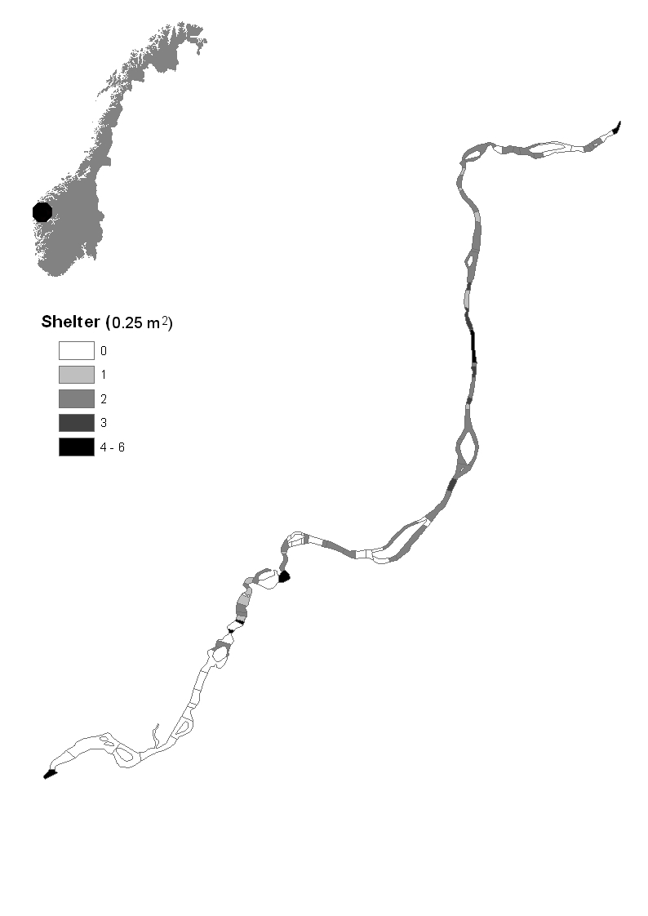
Figure 1.
Lower reach
Upper reach
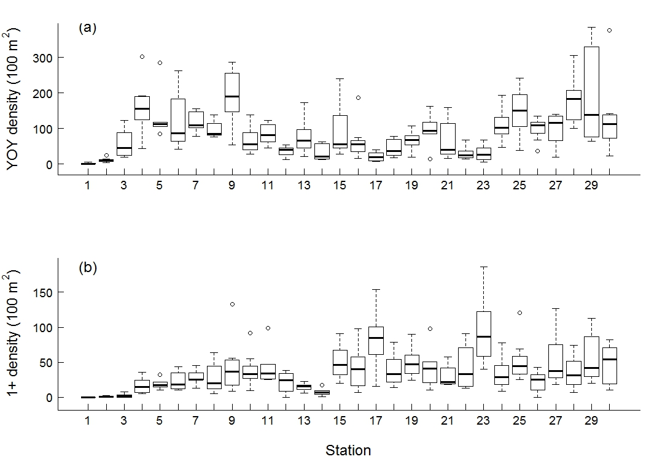
Figure 2.
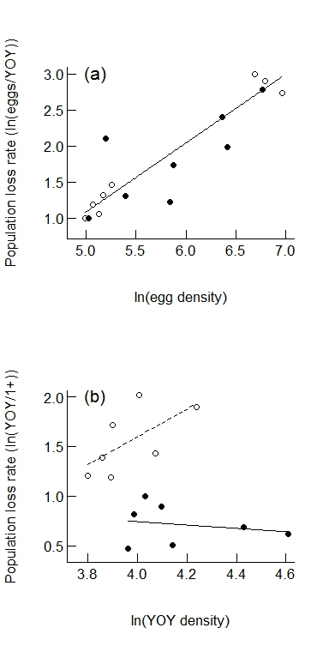
Figure 3.
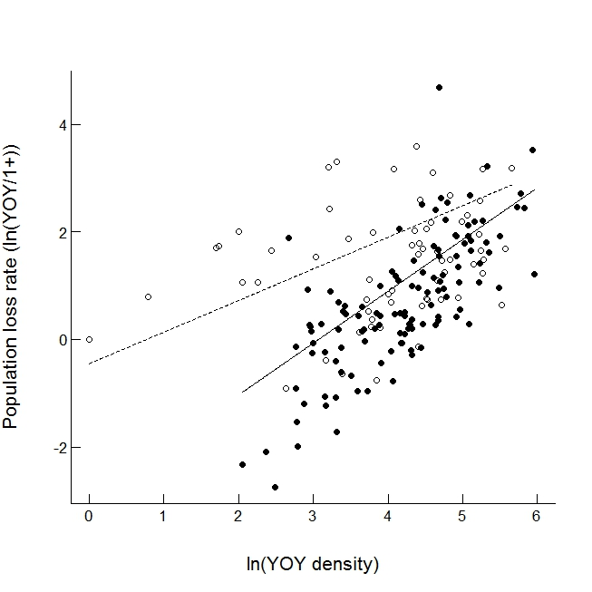
Figure 4.

