## Bounds of Elastic Parameters characterizing Transversely Isotropic Media: Application to Shales

Running Title: Bounds of TI Elastic Parameters for Shales

# Rune M. Holt

NTNU (Norwegian University of Science and Technology), Trondheim, Norway

Email: [rune.holt@ntnu.no](mailto:rune.holt@ntnu.no)

# ABSTRACT

Several rocks, and in particular shales are often described as TI (Transversely Isotropic) materials. Geophysical data coverage does not always permit reliable determination of all 5 elastic parameters, neither in seismic and sonic data from the field nor in laboratory measurements. Data may however be constrained by the existence of bounds on elastic moduli, derived from the fundamental requirement of positive elastic energy. Conditioned bounds are described for engineering parameters like Poisson’s ratios, as well as anisotropy coefficients like the moveout parameter ** and the anellipticity parameter **. By conditioned bounds is meant bounds that in general depend on some of the other elastic moduli: The bounds as described here are controlled primarily by P- and S-wave moduli obtained from wave propagation along a symmetry axis, and to some extent by P- and S-wave anisotropies. Such data may be acquired more easily from geophysical measurements. Laboratory data obtained with various types of shales under different testing conditions are inspected, and none of them fail to adapt to the bounds. The data show for instance clear distinctions between how the proximity to bounds is driven by stress changes for saturated *vs*. non-saturated shales.

# KEYWORDS

Anisotropy, Elasticity, Rock physics, Seismic, Shale

# INTRODUCTION

The anisotropic nature of subsurface rocks is commonly recognized in geophysical interpretation, and has been so for several decades (see e.g. Crampin, 1985; Thomsen, 2002). The growing economic interest in shale as a reservoir rock (e.g. Hows et al., 2013) has cleared the way for anisotropy to be considered to a larger extent also in rock mechanics and rock engineering practices. An example is initiation and growth of hydraulic fractures, which is influenced by rock stiffness in the direction normal to crack opening. This stiffness is the so-called plane strain modulus, which is a combination of Young's modulus and Poisson's ratio that is influenced by anisotropy. Within limits of linear elasticity, stress evolution within and outside depleting reservoirs as well as in the surrounding rock is controlled by Poisson's ratio, so the anisotropic nature of this parameter has to be accounted for in a proper way. It is well established that strength anisotropy and probably also stiffness anisotropy contribute to borehole instabilities when drilling deviated wells through shale layers (Søreide et al., 2009). In addition, anisotropy of shale cap rock above hydrocarbon reservoirs and CO2 storage sites requires influences interpretation of AVO and 4D seismic.

Shale in its non-fractured state is often assumed to be transversely isotropic (TI). For clay rich shales, anisotropy caused by alignment of flaky clay minerals and micro-laminations are visible in scanning electron images. For gas or oil shales, which are not necessarily shales according to geological definitions and not necessarily by clay content, anisotropy may be caused by laminations at larger scales. Although heterogeneities exist on many length scales, anisotropy appears to give a better description than conventional isotropic formulations.

In the isotropic world, geophysicists and engineers are used to limits on elastic moduli of solids, like Poisson's ratio () has to be between -1 and ½, and the ratio between P- and S-wave velocities (vP/vS) should always be > 1. These bounds are based on the requirement that the elastic energy should always be positive. The upper bound to Poisson's ratio corresponds to vanishing shear modulus in the limit of a fluid. The lower bound () corresponds to a material with zero bulk modulus, but finite shear modulus, a situation which is approached by certain honeycomb structures and foams (Prall and Lakes, 1997).

A similar kind of analysis can be done for anisotropic elastic media, but does in general not produce rigid bounds (Ting and Chen, 2005). The motivation behind the work presented here is to find theoretical bounds that apply to rocks, given that some information is available from seismic or laboratory measurements. Such bounds may be useful in order to constrain other parameters that are less easy to obtain from experiments. Indeed, a main challenge to the implementation of anisotropy in geomechanics is the difficulty in obtaining sufficient and sufficiently reliable data characterizing the anisotropy. The aims of this paper are to increase the awareness of these fundamental bounds on elastic properties among users of geophysical or engineering data, and to see to what extent these bounds may be used as guidelines for estimation of required anisotropy parameters in field data analysis.

This work is limited to the special case of transverse isotropy. In the next section the relationships between stiffnesses and compliancies that can be derived from elastic wave velocities and engineering parameters are shown, such as anisotropic Poisson's ratios and the anisotropy of Young's modulus. Then we proceed to describe bounds on these parameters, as well as on anisotropy parameters, such as Thomsen's moveout parameter  (Thomsen, 1986) and the anellipticity parameter ** (Alkhalifah and Tsvankin, 1995). The bounds may be used to constrain parameter values if we for example know the P- and S-wave moduli from wave propagation in one direction. Finally, we will look at how experimental observations fit within the prescribed bounds, and discuss how the bounds may be utilized in practical data analysis.

# THEORETICAL BACKGROUND

## Formal description of elasticity in TI symmetry

The formal description of transversely isotropic solids is well-known from several textbooks (Nye, 1985; Thomsen, 2002). We consider a TI medium with the vertical axis as symmetry axis, so that the elasticity matrix (in Voigt notation) can be written



There are 5 independent elastic coefficients, having in mind the relationship between *C*11, *C*12 and *C*66;. Elastic wave velocities are directly linked to the coefficients of the elasticity matrix. In the following, indices V and H will respectively denote the symmetry axis direction and any direction within the symmetry plane while ** is the bulk density:



Thomsen (1986) defined 3 anisotropy parameters that have become widely used in industrial applications as well as in academia:



These parameters were introduced to simplify the equations for angular dependence of velocities in the case of weak anisotropy (||, || & || <<1). The Thomsen parameters themselves are however useful descriptors of anisotropy, even without restricting to weak anisotropy. An additional parameter, that can be linked to the Thomsen parameters above, was introduced by Alkhalifah and Tsvankin (1995):



This parameter describes the anellipticity of the slowness surfaces in the wave vector space, and reduces to zero when ** = **, for elliptical anisotropy or isotropy.

Common rock mechanics parameters, Young's moduli and Poisson's ratios[1], in addition to the shear moduli *G*HV and *G*HH, are given by the inverse of the stiffness matrix (the compliance matrix):



*EV* and *EH* are Young’s moduli for loading along and perpendicular to the symmetry axis, respectively. The Poisson ratio *VH* is determined by applying uniaxial stress along the symmetry axis and measuring the resulting strain in the symmetry plane. For *HV* it is vice versa, while *HH* refers to stresses and strains that are orthogonal to each other within the symmetry plane. The out-of- plane shear modulus[2] *G*VH= 1/*C*44. The in-plane shear modulus is related to the corresponding *EH* and *HH* (in the same way as *C*11, *C*12 and *C*66 are related):



Further, since the compliance matrix also needs to obey TI symmetry, it follows that



For a sample loaded normal to the symmetry plane, Young's modulus and Poisson ratio can be expressed through the stiffness matrix elements:





For a sample loaded along any direction within the symmetry plane, the corresponding expressions for Young's modulus and Poisson ratios are:







Thus, the anisotropy of Young's modulus can be expressed as



The equations above demonstrate how dynamic moduli, determined from seismic or sonic borehole measurements, in principle can be converted into static moduli that are more convenient in engineering applications. One needs however to be aware that static and dynamic moduli of porous rocks in general are different (Fjær *et al*., 2008). One part of the difference is caused by plasticity, since static measurements enforce finite strain while dynamic moduli are obtained with infinitesimal strains. From laboratory experiments it appears that both non-elastic effects and frequency dependence (dispersion) contribute significantly to the static – dynamic discrepancy in shales (Holt *et al*., 2015).

# BOUNDS ON ANISOTROPIC MODULI

## Bounds on elastic parameters: General concept

As mentioned in the introduction, rigid bounds on elastic parameters are determined on basis of the fundamental principle that the total elastic energy needs to be positive. In isotropic solids, this means that the elastic moduli (*E*, *K*, *G*) (*K* is bulk modulus) have to be positive. In addition, Poisson's ratio has to obey the following inequality:



The upper limit corresponds to the case of a fluid, for which *E*=*G*=0, but *K*≠0. The lower bound corresponds to *K* =0, but *E* and *G* ≠0.

In a TI solid, the requirement of positive elastic energy (the elasticity matrix is positive definite) implies the following inequalities (Nye, 1985):



As can be seen[3], these expressions state that *C*11> *C*66.

In terms of compliances, the bounds can be expressed similarly to above:



This means that by combining Eqs. (5) and (16), the bounds on Poisson’s ratios and Young’s moduli can be expressed as follows (Pickering, 1970; Amadei, 1983; Jaeger *et al*., 2007):



**Bounds on Poisson's ratios and on *E*-modulus anisotropy**

The motivation behind this work is to find theoretical bounds for key parameters of transversely isotropic rocks. As pointed out in the Introduction, general bounds of anisotropic elastic moduli cannot be found (Ting and Chen, 2005). However, in reality, some information will be available, for instance from laboratory, borehole or seismic measurements. Our task is to see how this information, together with the bounds, can be used to limit the values for less directly measurable elastic parameters, such as Poisson's ratios and E-modulus anisotropy (below), as well as Thomsen's ** and the anellipticity parameter ** (in the next paragraph). In both cases, the upper and lower (negative) bounds of *C*13, with constraints on *C*11, *C*33 and *C*66, following from Eq., play a vital role:



Bounds are hence in general functions of these stiffness parameters. Considering Poisson's ratios, **VH (Eq. ) converges to the familiar bounds (Eq. ) in the isotropic limit. Thenand for the upper bound (fluid), whileand  for the lower bound.

We will specify bounds that apply to cases of specified values of the ratio between *C*66 and *C*11. These are then constrained bounds that have practical meaning, in the sense that if we know the values of *C*66 and *C*11from wave velocity measurements, and we know the P-wave anisotropy ** so that we can compute *C*33, we find the bounds on Poisson's ratios, Young's moduli and the anisotropy parameters ** and ** (see below).

The upper and lower bounds for **VH are then directly given by inserting the maximum and minimum values of *C*13 given by Eq. into Eq.:





In the fluid limit (*C*66 → 0), the bounds on this Poisson ratio become, i.e. a function of P-wave anisotropy (obviously, a layered fluid may be anisotropic):



The approximate values represent the weak anisotropy approximation. So; for a normal isotropic fluid, the bounds are. The bounds, along with the bounds of the other Poisson’s ratios given below, are shown in Figure 1 as a function of *C*66/*C*11. Notice that the bounds diverge in the hypothetical limit *C*66 → *C*11.

The maximum and minimum values of **HV in Eq. within the bounds given in Eq. correspond to the limit; i.e.





In the limit of a TI anisotropic fluid, the bounds for this Poisson ratio are:



which for an isotropic fluid becomes.

The 3rd Poisson ratio **HH has a maximum when *C*13=0, and reaches its lowest possible value when:





So, in the limit of a fluid, the upper bound for **HH is 1 which is consistent with Eq. (17).

Figure 1 shows how all the bounds depend on *C*66/*C*11 in the case of no P-wave anisotropy (** = 0). Since the bounds are associated with different values of *C*13, the anisotropy is also governed by the value of *C*13, i.e. Thomsen’s ** (and **) are not necessarily zero. Eqs. and show how P-wave anisotropy will directly influence the bounds on Poisson’s ratios. In the Appendix, the three Poisson's ratios are displayed as a function of *C*13/*C*33, illustrating under what conditions the different bounds are encountered.

Eq. expresses the anisotropy of Young's moduli. From Eq. , this is equal to the ratio between the Poisson's ratios, i.e. . For finite shear stiffness, the upper bound of the ratio between Young’s moduli is reached when *C*13=0:



The minimum value corresponds to:



which in the limit of an isotropic fluid approaches . The variation of between the bounds is shown in the Appendix.

**Bounds on anisotropy parameters ** and** ******

Thomsen's ** - parameter (Eq.) is bounded upwards by the maximum (positive) value of *C*13. Its lower bound is when *C*13=-*C*44. Thus:



Notice that the lower bound (also pointed out by Grechka and Mateeva, 2007) is very likely to be negative, although is not a rigid bound. In the fluid limit, when *C*44=*C*66=0,



The bounds of  are shown as a function of *C*66/*C*11 in Bounds on Thomsen's ** for a TI material as a function of C66/C11 for positive and negative P- and S-wave anisotropy (** = ** = ±0.1)**Error! Reference source not found.**, for a case of positive P- and S-wave anisotropy (like in lithologically anisotropic rocks like shale), and for a case of negative ** and ** (like for purely stress-induced anisotropy). Increasing shear stiffness (*C*66) is seen to increase both the upper and the lower bounds for **.

The maximum value of ** (Alkhalifah and Tsvankin, 1995) is dictated by the lower bound of **, and diverges in the fluid limit:



The lower bound of ** corresponds to the upper bound of * *It is zero in the fluid limit, but as can be seen from the Appendix, along with the variation of * *and* * between the bounds, it may be negative for rocks with finite shear stiffness.

In summary (Table 1) it is seen that the positive maximum value of *C*13 from Eq. controls the upper bounds of **VH, **HV and **, in addition to the lower bounds of **HH, the *E*-modulus ratio,and **. Physically this is associated with the fluid limit in isotropic materials; i.e. low shear stiffness brings a rock closer to those bounds. The negative minimum value of *C*13 controls the lower bounds of **VH, **HV as well as **HH; the latter is also linked to the absolute maximum of *C*13. The minimum value of ** (and maximum value of **) occurs when *C*13=- *C*44. Negative values of *C*13 are not commonly observed, but would be associated with materials that have high shear stiffness and low bulk stiffness. The maximum value of **HH and the maximum *E*-modulus ratio occurs when *C*13=0, which is approached in laminated materials when one of the layers is much softer than the others, or in cracked solids with large crack density.

# EXPERIMENTAL OBSERVATIONS

Laboratory data have been gathered from the literature as well as by experiments performed in-house. The aim is to see to what extent experimental data on presumably transversely isotropic shales fall between the theoretical bounds outlined above. Trends are sought~~,~~ that may be useful in practical assessments of parameters that are otherwise difficult to measure in a reliable way. For instance, ultrasonic measurements of *C*13 are often attached with significant uncertainty. In some laboratories a single core is used~~,~~ and waves are propagated in several directions. Wave pulses are transmitted at oblique angles to the symmetry axis. The detected travel times correspond more to group velocities than phase velocities and need to be corrected before *C*13 can be determined reliably. In many laboratories, several differently oriented core plugs are used, introducing uncertainty linked to rock heterogeneity. These experimental challenges represent main causes for uncertainty in calculated values of Thomsen's ** as well as dynamic Poisson ratios.

Experimental data are taken from the sources referenced in Table 2. These comprise a number of shales from different depths as well as different geographical and geological origins. Porosities, clay contents, and organic contents also vary, as indicated in the Table. Different test procedures in terms of applied stress and different measurement techniques (ultrasonic, seismic frequencies) have been applied.

Figure 3- Figure 5 show the measured values of the three Poisson ratios, along with the corresponding upper and lower bounds, plotted against the ratio *C*66/*C*11. Since the bounds depend on the values of *C*33 as well (except for **HH) they are not unique, and are plotted with open symbols with the same marker colour as the data points. Notice that all measured values of all three Poisson ratios fall well within the prescribed bounds. **VH and **HH never exceed ½, whereas **HV is larger than ½for several shales, and even > 1 at high stress for Muderong Shale (after Dewhurst and Siggins, 2008). The same shale is the only one that exhibits negative values of Poisson’s ratios as seen for **HH in Figure 5 The cause of this is that *C*13 increases strongly with increasing stress.

Figure 6 shows the measurements and bounds of Thomsen’s **. Most values are positive, but a few data points display negative values; however; all values are well within the prescribed bounds. Notice that the bounds for ** depend on both *C*33 and *C*44 and therefore are more scattered as a result of the variation in properties of the individual shales.

# DISCUSSION

As can be seen from Table 1, most of the bounds are related to the maximum and minimum values of *C*13. Figure 7 shows the ratio between measured *C*13 and its theoretical maximum, as given by Eq. (17). This plot displays a relatively clear decreasing trend, with *C*13 values approaching the upper bound when the shear stiffness *C*66 approaches zero. This is expected, since fluids obviously – as for isotropic media – represent a limiting class of materials.The Figure further shows no negative values of *C*13, i.e. shales do not get close to the bound corresponding to the honeycomb-like textures exhibiting negligible bulk and finite shear stiffness. From Table 1 it is noticed that *C*13 = 0 corresponds to the upper bound of **HH (and *E*V*/E*H). The data points in the lower right part of Figure 7 do indeed have values of **HH that are close to the upper bound, as can be seen in Figure 5. It is interesting to notice that these are all shales that are considered as “dry” or have low water saturations.

Within Figure 7 there are several hidden trends. For instance, some of the shales were tested by changing the stress. Although the stress paths were different due to some being undrained with pore pressure measurements, some drained to atmosphere, some with isotropic stress and some with anisotropic stress, a couple of trends are visible by plotting *C*13/*C*13max *vs.* net mean stress, as seen in Figure 8. First; water saturated shales and “dry” / “gas” shales are clearly separated. With increasing stress, the dry shales tend to move upwards in the plot, whereas the saturated shales (except for Muderong shale) move away from the upper bound. In order to see if the observed behaviour is what might be expected, simple modelling was performed combining Hudson’s anisotropic crack theory (Hudson, 1981) with the anisotropic Gassmann equation (1951) (Figure 9). The figure shows that reducing the crack density (e.g. by applying stress), the Hudson model for dry cracked material predicts an increase in *C*13/*C*13max.When fluid is added to the cracked material through the anisotropic Gassmann model, however, the *C*13/*C*13max ratio reduces slightly. Both features are in agreement with the observations made above.

Amongst the data in Figure 7 there are a few measurements made at seismic as well as ultrasonic frequencies (Hofmann, 2005; Bauer *et al*., 2015). These measurement all show significant dispersion, i.e. increase in Young’s modulus and hence also in P- and S-wave moduli, from the seismic to the ultrasonic band. The dispersion was very prominent, except for the dried Mancos Shale. The trend is that *C*13/*C*13max increases with frequency. At this moment there is no firm explanation of the observed dispersion in shale, so this remains at this stage an observation.

Temperature was changed from room conditions to *in situ* values (typically 70 – 90°C) for some of the SINTEF shales tested. For water saturated shales this did not lead to a noticeable shift in *C*13/*C*13max, whereas a significant increase was found for the gas shale. This requires further studies before any conclusion can be made.

A last but not least side comment: Neglecting anisotropy, and just calculating a “Poisson’s ratio” from measured velocities in one direction, may lead to significant errors. To demonstrate that, an “isotropic” Poisson’s ratio was calculated from the data used in the analysis above, using P- and S-wave velocities along the symmetry axis as if they were isotropic velocities. Figure 10 shows that all the anisotropic Poisson ratios are off from the isotropic line. **VH is closest, but would still be erroneous for the majority of the data points if the isotropic assumption was made.

# CONCLUSIONS

Elastic parameters of transversely isotropic materials have bounds emerging from the fundamental requirement of positive elastic energy. The bounds are given by the bounds on the elastic parameter *C*13 (=),constrained by given values of elastic stiffnesses *C*11, *C*33, *C*44 and *C*66. This may often be a practical situation, since *C*13 is not always determined reliably from wave velocity measurements, neither in seismic, sonic nor laboratory ultrasonics. Above, constrained upper and lower bounds for the 3 Poisson ratios and for the ratio between the 2 Young’s moduli of a TI medium were given, along with bounds on the anisotropy parameters ** and **.

It is important to underline that the three Poisson ratios in general will be quite different from each other, so that representing a TI medium with one Poisson’s ratio becomes meaningless. Also, the familiar bounds on the isotropic Poisson’s ratio do not apply in the anisotropic case: Poisson’s ratios may exceed ½, and under certain conditions individual Poisson’s ratios span a range of values that may exceed ± 1 and beyond. Thomsen’s ** always has a negative lower bound. Both the lower and in particular the upper bound on ** increase with increasing ratio *C*66/*C*11. The anellipticity parameter ** may theoretically be large (> 4) for soft (low *C*66/*C*11) TI media, while it may become negative, in particular in case of high *C*66/*C*11 values.

Experimental data on shales tested under different loading conditions in different laboratories, and measured at seismic as well as ultrasonic frequencies, all fall within the prescribed bounds. These shales originate from a variety of geological and geographical locations, and they span over a wide range of petrophysical and petrographical characteristics.

The data do not reveal any negative values of *C*13. Closer inspection of trends within the bounds indicates that non-saturated and fully saturated shales are well separated. It also appears that increasing stress moves these two kinds of shales in opposite directions between the bounds, by affecting the ratio differently.

**ACKNOWLEDGEMENTS**

The author acknowledges the financial support through the Joint Industry Project “Shale Rock Physics” at SINTEF Petroleum Research, funded by The Research Council of Norway and the participating companies BP, DONG Energy, GDF Suez, Maersk and Total. The Research Council of Norway is also acknowledged for its support through the ROSE program at NTNU. Several discussions with colleagues at SINTEF and NTNU have contributed to the contents of this Paper, particularly mentioned are Alexey Stovas at NTNU, and Andreas Bauer and Erling Fjær with SINTEF.

**REFERENCES**

Alkhalifah, T. and Tsvankin, I., 1995, Velocity analysis for transversely isotropic media: Geophysics, **60**, 1550-1566.

Amadei, B. (1983) Rock anisotropy and the theory of stress measurements. New York: Springer-Verlag.

Bauer, A., Szewczyk, D., Hedegaard, J., Holt, R.M., 2015, Seismic dispersion in Mancos Shale: In Abstr. 3rd Int. Workshop on Rock Physics, Perth, Australia, April 2015; 4 pp.

Crampin, S., 1985, Evaluation of anisotropy by shear-wave splitting: Geophysics, **50**, 142-152.

Domnesteanu, P., McCann, C., Sothcott, J., 2002, Velocity anisotropy and attenuation of shale in under- and overpressured conditions: Geophys. Prospecting, **50**, 487-503.

Dewhurst, D.N. and Siggins, A.F., 2006, Impact of fabric, microcracks and stress field on shale anisotropy: Geophys. J. Int., **165**, 135–148.

Fjær, E., Holt, R.M., Horsrud, P., Raaen, A.M., Risnes, R., 2008, Petroleum Related Rock mechanics: Elsevier; 491 pp.

Gassmann, F., 1951, Über die Elastizität poröser Medien: Vierteljahrsschrift der Naturforschenden Gesellshaft in Zürich, **96**, 1–23.

Grechka, V., Mateeva, A., 2007, Inversion of P-wave VSP data for local anisotropy: Theory and case study: Geophysics 72, D69-D79; doi: 10.1190/1.2742970

Helbig, K., 1983, Elliptical anisotropy – Its significance and meaning: Geophysics 48, 825-832, doi: 10.1190/1.1441514

Hofmann, R., 2005, Frequency dependent elastic and anelastic properties of clastic rocks. Ph. D. Thesis, Colorado School of Mines. 170 pp.

Holt, R.M., Bauer, A., Fjær, E., Stenebråten, J.F., Szewczyk, D., Horsrud, P., 2015, Relating static and dynamic mechanical anisotropies of shale: ARMA 15-484; 7 pp.

Hornby, B.E., 1998, Experimental laboratory determination of the dynamic elastic properties of wet, drained shales: J. Geophys. Res., **103**, B12, 29945-29964.

Hossain, Z., Ellis, M., 2014, Rock physics inequalities (RPI) to validate anisotropic rock physics predictions and measurements: SEG Expanded Abstracts, pp. 2871-2875; doi:/10.1190/segam2014-1177.1

Hows, A.M., Hofmann, R., Gonzales, E.F., 2013, Characterization of anisotropic dynamic mechanical rock properties in shale gas plays: ARMA 13-604; 14 pp.

Hudson, J.A,, 1981, Wave speeds and attenuation of elastic waves in material containing cracks: Geophys. J. Roy. Astr. Soc., **64**, 133-150.

Jaeger, J., Cook, N.G., Zimmerman, R., 2007, Fundamentals of rock mechanics, 4th ed. Malden, MA: Blackwell Ltd.

Johnston, J.E., Christensen, N.I., 1995, Seismic anisotropy of shales: J. Geophys. Res. **100**, 5991-6003.

Nye, J.F., 1985, Physical Properties of Crystals. Oxford Sci. Publ.; 329 pp.

Pickering, D.J., 1970, Anisotropic elastic parameters for soil, Géotechnique **20**, 271-276.

Prall, D., Lakes, R.S., 1997, Properties of a chiral honeycomb with a Poisson's ratio of -1: Int. J. Mech. Sci. **39**, 305-314.

Rudzki, M.P., 2003, Parametric representation of the elastic wave in anisotropic media: J. Appl. Geophys. **54**, 165-183 (translation of original article from 1911 by K. Elbig)

Søreide, O.K., Bostrøm, B., Horsrud, P., 2009, Borehole stability simulations of an HPHT field using anisotropic shale modeling. ARMA 09-185;

Thomsen, L., 1986, Weak elastic anisotropy: Geophysics **51**, 1954-1966, doi:10.1190/1.1442051

Thomsen, L., 1990, Poisson was not a geophysicist! The Leading Edge **9**, 27-29

Thomsen, L., 1996, Poisson was not a rock physicist, either!: The Leading Edge **15**, 852-855

Thomsen, L., 2002, Understanding Seismic Anisotropy in Exploration and Exploitation: SEG & EAGE Distinguished Instructor Short Course, ISBN 978-1-56080-112-2

Ting, T.C.T., Chen, T., 2005, Poisson's ratio for anisotropic materials can have no bounds. Quart. J. Mech. Appl. Math. **58**, 73-82

# FIGURE CAPTIONS

Figure 1: Bounds on Poisson’s ratios for a TI material as a function of C66/C11 (for zero P-wave anisotropy; ** = 0).

**Figure 2:** Bounds on Thomsen's ** for a TI material as a function of C66/C11 for positive and negative P- and S-wave anisotropy (** = ** = ±0.1)

Figure 3: Poisson’s ratio **VH from dynamic measurements, i.e. calculated from multidirectional ultrasonic velocities (using Eq. (9)) or directly measured in low frequency set-ups, plotted agaiunst *C*66/*C*11. Filled symbols are data points, whereas open symbols represent the upper and lower bounds calculated separately for each shale. Notice that data points include measurements of the given shales at different stress levels , different frequencies, or different temperatures, as indicated in Table 2.

Figure 4: Poisson’s ratio **HV from dynamic measurements, i.e. calculated from multidirectional ultrasonic velocities (using Eq. (12)) or directly measured in low frequency set-ups, plotted agaiunst *C*66/*C*11. See caption of Figure 3 for further information.

Figure 5: Poisson’s ratio **HH from dynamic measurements, i.e. calculated from multidirectional ultrasonic velocities (using Eq. (11)) or directly measured in low frequency set-ups, plotted agaiunst *C*66/*C*11. See caption of Figure 3 for further information.

Figure 6: Thomsen’s **from dynamic measurements, i.e. calculated (using Eq. (3)) from multidirectional ultrasonic velocities or low frequency data, plotted agaiunst *C*66/*C*11. See caption of Figure 3 for further information.

Figure 7: The ratio between *C*13 and the upper bound *C*13max(see Eq. (17)) from dynamic measurements, i.e. calculated from multidirectional ultrasonic velocities or directly measured in low frequency set-ups, plotted agaiunst *C*66/*C*11. See caption of Figure 3 for further information.

Figure 8: The ratio between *C*13 and the upper bound *C*13max *vs*. mean net stress for water-saturated (filled symbols) and non-saturated shales (room dry; open symbols) (see Table 2 and references therein for more details on the shales and the test procedures).

Figure 9: The ratio between *C*13 and the upper bound *C*13max *vs*. crack density, calculated for a dry cracked solid according to Hudson’s theory (1981), and for a water-saturated case by applying the anisotropic Gassmann model (1951) to the dry material.

Figure 10: The anisotropic Poisson ratios described in the text for the shale data used in the analysis, plotted against an “isotropic” Poisson’s ratio calculated as **"ISO"=½(vPV2-2vSV2)/( vPV2-vSV2).

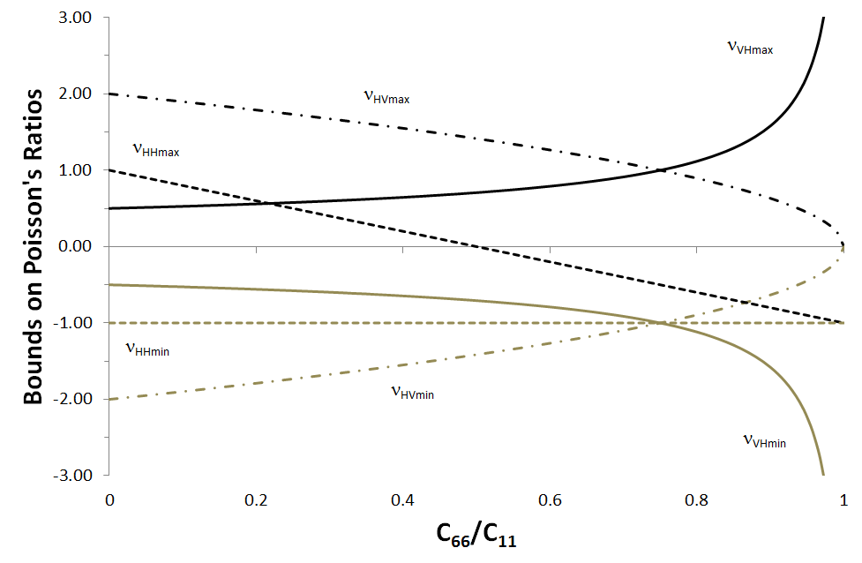

Figure 1: Bounds on Poisson’s ratios for a TI material as a function of C66/C11 (for zero P-wave anisotropy; ** = 0).

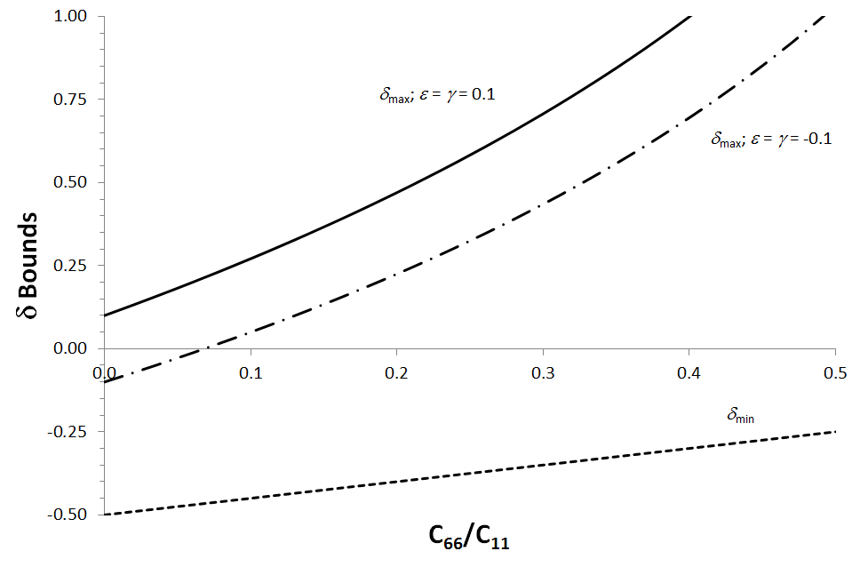

Figure 2: Bounds on Thomsen's ** for a TI material as a function of C66/C11 for positive and negative P- and S-wave anisotropy (** = ** = ±0.1)

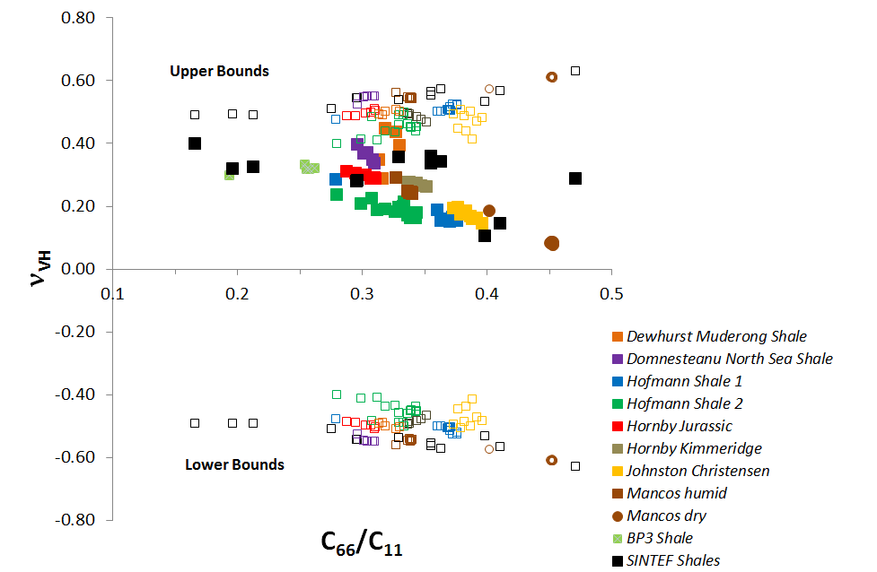

Figure 3: Poisson’s ratio **VH from dynamic measurements, i.e. calculated from multidirectional ultrasonic velocities (using Eq. (9)) or directly measured in low frequency set-ups, plotted agaiunst *C*66/*C*11. Filled symbols are data points, whereas open symbols represent the upper and lower bounds calculated separately for each shale. Notice that data points include measurements of the given shales at different stress levels , different frequencies, or different temperatures, as indicated in Table 2.

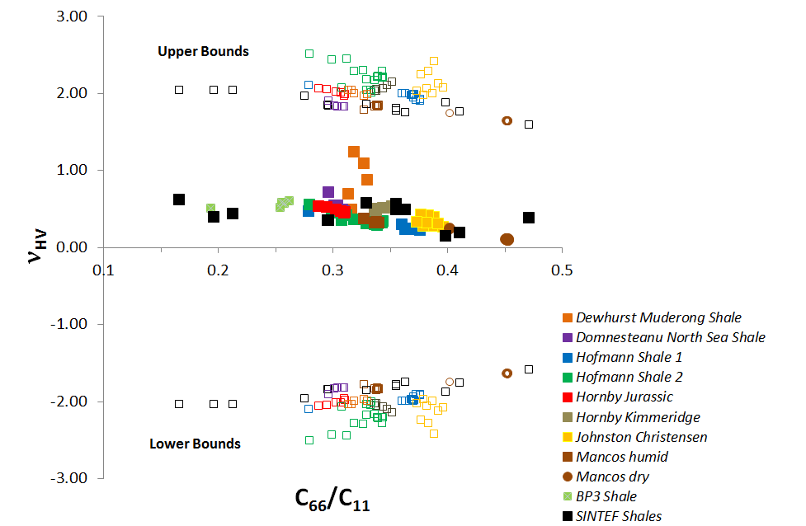

Figure 4: Poisson’s ratio **HV from dynamic measurements, i.e. calculated from multidirectional ultrasonic velocities (using Eq. (12)) or directly measured in low frequency set-ups, plotted agaiunst *C*66/*C*11. See caption of Figure 3 for further information.

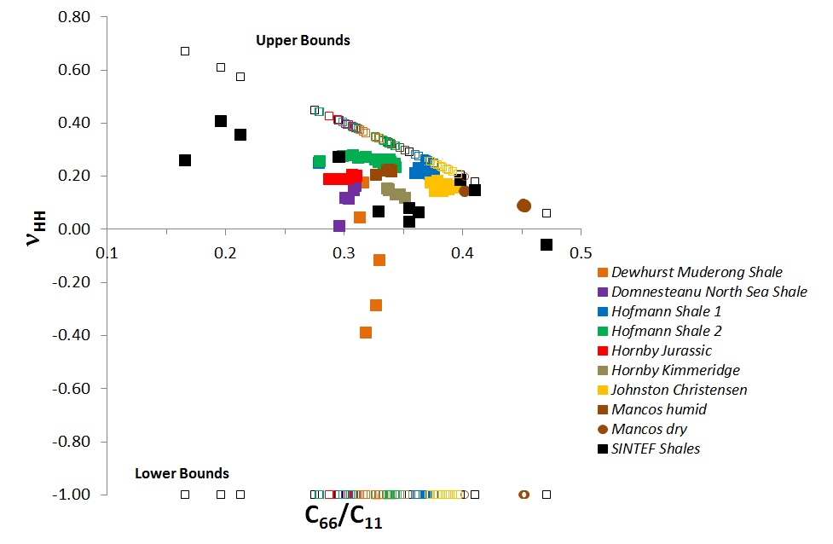

Figure 5: Poisson’s ratio **HH from dynamic measurements, i.e. calculated from multidirectional ultrasonic velocities (using Eq. (11)) or directly measured in low frequency set-ups, plotted agaiunst *C*66/*C*11. See caption of Figure 3 for further information.

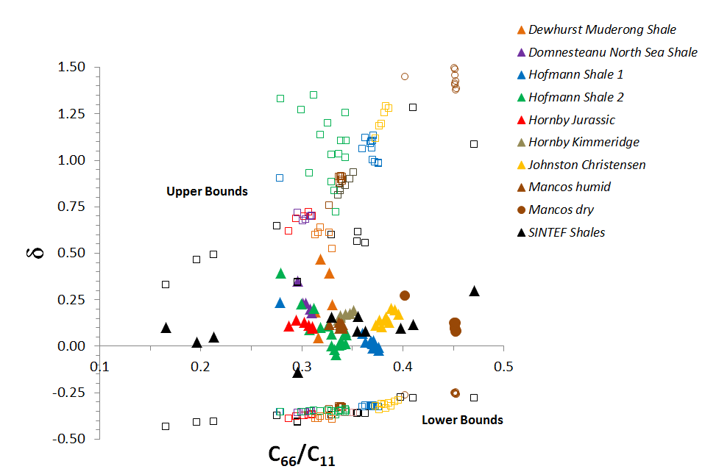

Figure 6: Thomsen’s **from dynamic measurements, i.e. calculated (using Eq. (3)) from multidirectional ultrasonic velocities or low frequency data, plotted agaiunst *C*66/*C*11. See caption of Figure 3 for further information.

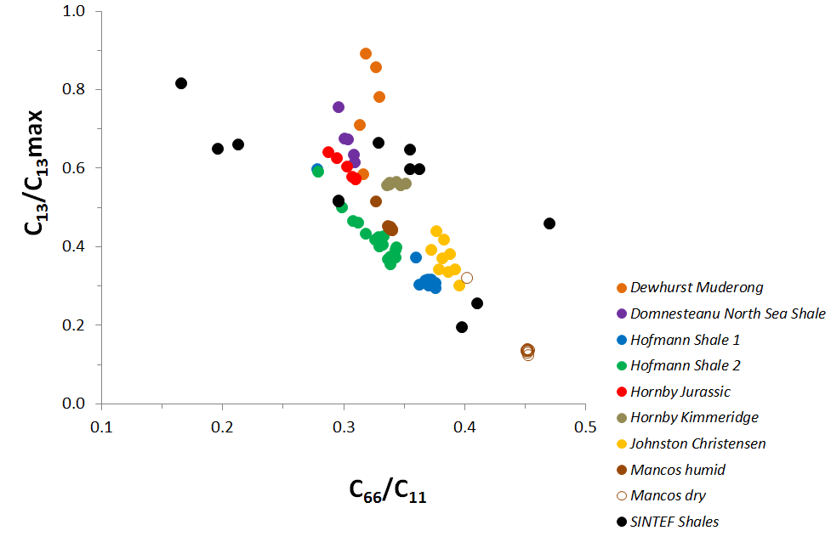

Figure 7: The ratio between *C*13 and the upper bound *C*13max(see Eq. (17)) from dynamic measurements, i.e. calculated from multidirectional ultrasonic velocities or directly measured in low frequency set-ups, plotted agaiunst *C*66/*C*11. See caption of Figure 3 for further information.

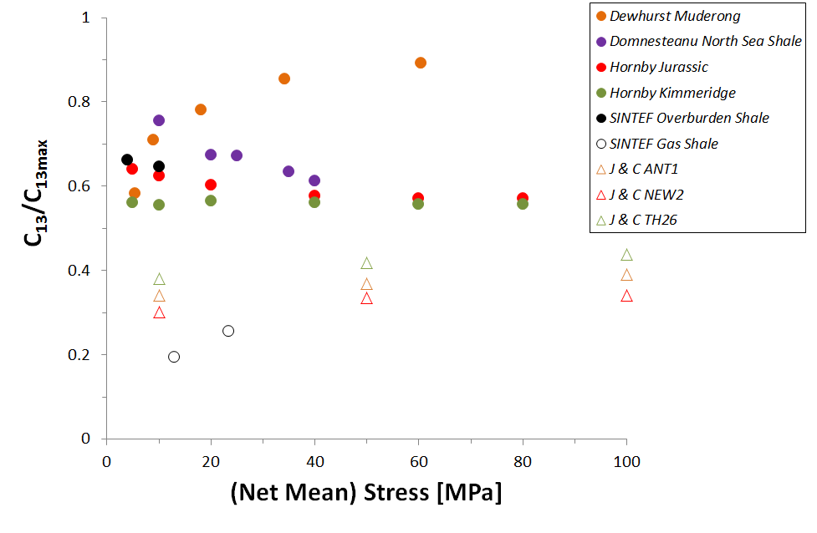

Figure 8: The ratio between *C*13 and the upper bound *C*13max *vs*. mean net stress for water-saturated (filled symbols) and non-saturated shales (room dry; open symbols) (see Table 2 and references therein for more detail on the shales and the test procedures).

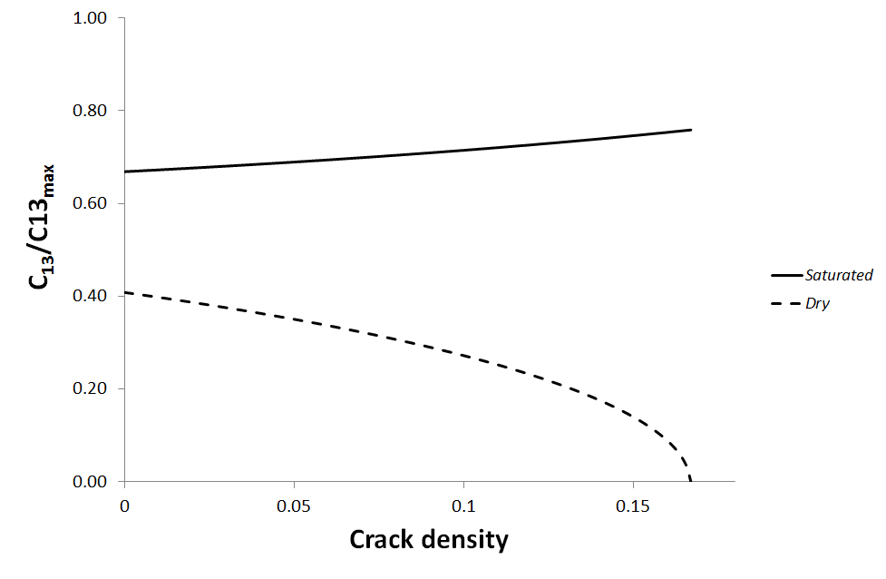

Figure 9: The ratio between *C*13 and the upper bound *C*13max *vs*. crack density, calculated for a dry cracked solid according to Hudson’s theory (1981), and for a water-saturated case by applying the anisotropic Gassmann model (1951) to the dry material.

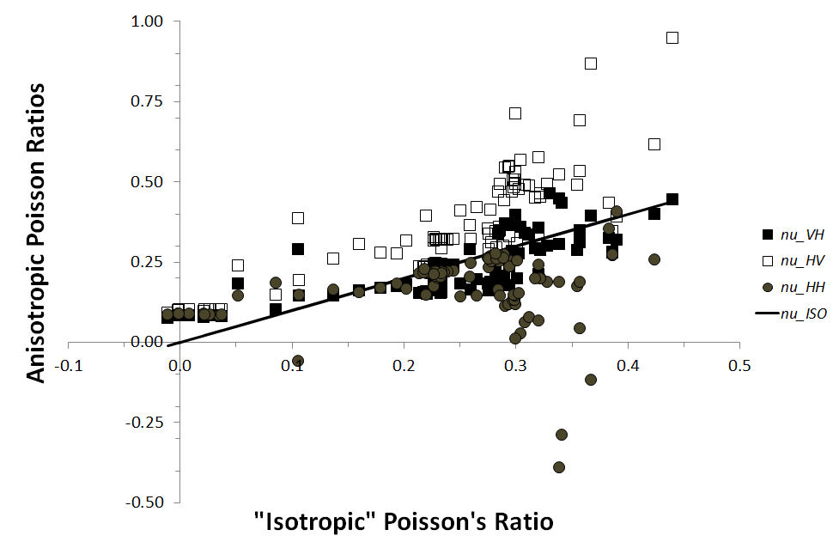

Figure 10: The anisotropic Poisson ratios described in the text for the shale data used in the analysis, plotted against an “isotropic” Poisson’s ratio calculated as **"ISO"=½(vPV2-2vSV2)/( vPV2-vSV2).

**TABLE CAPTIONS**

**Table 1:** A summary of how bounds on Poisson's ratios, the ratio between Young's moduli, Thomsen's *δ* and the anellipticity parameter *η* are expressed in terms of *C*11, *C*33 and *C*66 and how they relate to the value of *C*13.

Table 2: List of sources of shale data used to compare with the expected bounds (Figures 12 – 17). Key information given (in addition to the reference) include porosity, clay content and depth (when available), in addition to brief descriptions of the test procedures and wave velocity measurement techniques.

|  |  |  |  |  |
| --- | --- | --- | --- | --- |
| Parameter | Minimum value | Controlled by | Maximum value | Controlled by |
| Poisson’s ratio **VH |  |  |  |  |
| Poisson’s ratio **HV | - |  |  |  |
| Poisson’s ratio **HH | -1 | , |  |  |
| Young’s modulus ratio *E*V/*E*H |  | , |  |  |
| Thomsen’s * *parameter |  |  |  | , |
| Anellipticity parameter ** | * | , |  |  |

*The full expression for **min is:



**Table 1**

|  |  |  |  |  |  |
| --- | --- | --- | --- | --- | --- |
| Shale | Reference | Sample characteristics | Sample conditions | Test procedure | Velocity measurements |
| Muderong | Dewhurst & Siggins (2006) | φ=0.17; Clay content = 0.65; Depth: 1120 m | Preserved shale, fully brine-saturated | Undrained triaxial segments w/ pore pressure | Multidirectional ultrasonic on single core |
| North Sea | Domnesteanu et al. (2002) | φ=0.146; Clay content = 0.49; Depth: 3-4000m (overpressured) | Preserved shale, fully brine-saturated by loading | Isotropic loading w/ pore pressure cycling | Ultrasonic on 3 differently oriented cores |
| Hofmann Shale 1 | Hofmann (2005) | φ=0.26; Clay content ~ 0.45; Depth: Not available | Saturated with injected 19 % KCl brine | Isotropic net stress: 17 MPa (3000 psi confining, 500 psi pore pressure) | Low frequency 3 Hz – 3 kHz + Ultrasonic on 3 differently oriented cores |
| Hofmann Shale 2 | Hofmann (2005) | φ=0.08; Clay content ~ 0.41; Depth: Not available | Saturated with injected 19 % KCl brine | Isotropic net stress: 17 MPa (3000 psi confining, 500 psi pore pressure) | Low frequency 3 Hz – 3 kHz + Ultrasonic on 3 differently oriented cores |
| Jurassic | Hornby (1998) | φ=0.105; Clay content ~ 0.58; Depth: Outcrop under sea | Stored and tested in native fluid; water saturated | Isotropic loading to 80 MPa, pore pressure drained to atmosphere | Ultrasonic on 3 differently oriented cores |
| Kimmeridge | Hornby (1998) | φ=0.025; Clay content ~ 0.57; Depth: 3750 m | Preserved shale, friable, water saturated | Isotropic loading to 80 MPa, pore pressure drained to atmosphere | Ultrasonic on 3 differently oriented cores |
| Johnston -Christensen (Devonian-Mississippian black shales) | Johnston & Christensen (1995) | φ<0.01; Organic rich | Room dry shales | Isotropic loading 10 – 100 MPa | Ultrasonic on differently oriented cores |
| Mancos | Bauer et al. (2015) | φ~0.07; Clay content ~ 0.25; Outcrop | Humid: As received; preserved in oil (relative humidity: 86%)  Dry: Relative humidity 11% | 26 MPa axial stress; 17 MPa confining pressure | Low frequency 1 - 150 Hz + Ultrasonic on 3 differently oriented cores |
| SINTEF | In-house data base | 5 different field shales; varying porosity, clay content and depth | Preserved shales, 4 fully brine-saturated, 1 as received (gas shale) | In situ stresses & pore pressures; room and in situ temperatures | Multidirectional ultrasonic on single cores |

**Table 2**

**APPENDIX**

Figure A1 shows how the three Poisson's ratios depend on the ratio *C*13/*C*33 for the case of *C*66/*C*11=0.5. This is a fairly high value, corresponding to a velocity ratio of. This is rarely expected in shale~~,~~ but may be observed in e.g. dry sands or sandstone. The figure shows the idealized case of zero P-wave anisotropy and also the more realistic case of *ε* = 0.2. The bounds of **VH and **HV are seen to occur for the maximum and minimum values of *C*13, as pointed out in the main text and in Table 1. According to Eqs. and the absolute values of the bounds for VH decrease and those for HV increase with increasing **. Furthermore, **HH is never positive, and reaches a broad maximum at *C*13=0.

Figure A2 shows how the three Poisson's ratios depend on the ratio *C*13/*C*33 for the case of *C*66/*C*11=0.1. This corresponds to a velocity ratio, which is a realistic value for soft shale. Again the idealized case of zero P-wave anisotropy and a case with ε = 0.2 are displayed. The behaviour is similar to that seen for *C*66/*C*11=0.5, except that **HH now is positive (and > 0.5) for most values of *C*13, except very close to the bounds.

The variation of between the bounds in Eq. and are shown for *C*66/*C*11=0.1 and 0.5 in Figure A3, for both ε =  = 0 and ε =  = 0.2. Similarly the variation of ** is shown in Figure A4, while that of ** is shown in Figure A5.

**FIGURE CAPTIONS IN APPENDIX**

Figure A1: The three Poisson ratios of a TI material vs. the ratio *C*13/*C*33 for *C*66/*C*11 = 0.5 and for the P-wave anisotropy parameter ** = 0 and for ** = 0.2. The upper and lower bounds for C13/C33 are ± 0.707 for ** = 0, and ± 0.837 in the case ** = 0.2.

Figure A2: The three Poisson ratios of a TI material vs. the ratio *C*13/*C*33 for *C*66/*C*11 = 0.1 and for the P-wave anisotropy parameter ** = 0 and for ** = 0.2. The upper and lower bounds for C13/C33 are ± 0.949 for ** = 0, and ± 1.122 in the case ** = 0.2.

Figure A3: The ratio between vertical and horizontal Young's modulus (*E*V/*E*H) as a function of *C*13/*C*33 for *C*66/*C*11 = 0.1 and 0.5, with Thomsen parameters ** =** = 0 and ** = ** = 0.2.

Figure A4: Thomsen's ** plotted within the attainable range of *C*13/*C*33 values for *C*66/*C*11 = 0.1 and C66/C11 = 0.5, with P- and S-wave anisotropy parameters ** =** = 0 and ** =** = 0.2.

Figure A5: The Tsvankin-Alkalifah anellipticity parameter * *plotted within the attainable range of *C*13/*C*33 values for C66/C11 = 0.1 and C66/C11 = 0.5, with P- and S-wave anisotropy parameters ** =** = 0 and ** =** = 0.2.

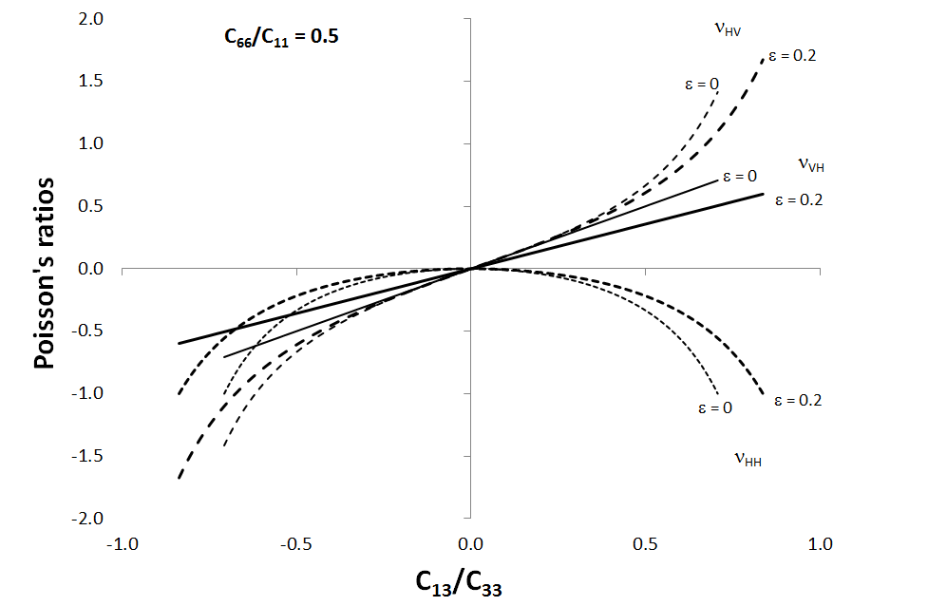

Figure A1: The three Poisson ratios of a TI material vs. the ratio *C*13/*C*33 for *C*66/*C*11 = 0.5 and for the P-wave anisotropy parameter ** = 0 and for ** = 0.2. The upper and lower bounds for C13/C33 are ± 0.707 for ** = 0, and ± 0.837 in the case ** = 0.2.

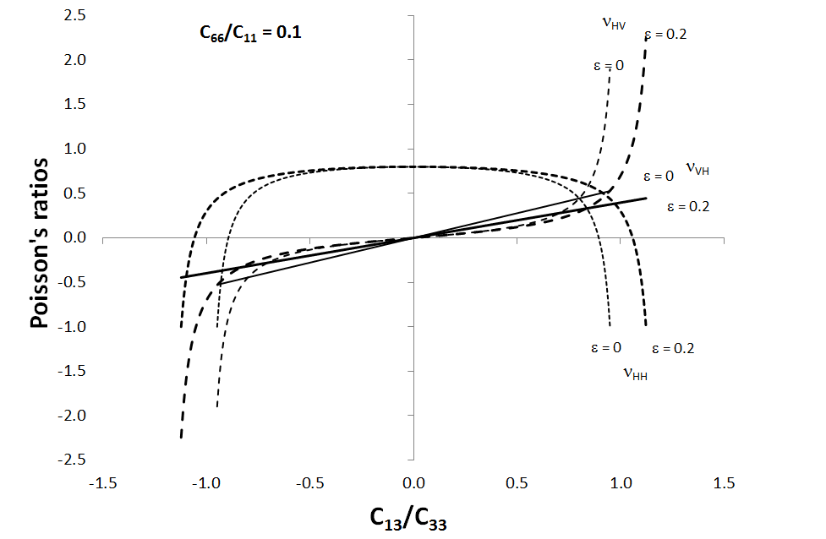

Figure A2: The three Poisson ratios of a TI material vs. the ratio *C*13/*C*33 for *C*66/*C*11 = 0.1 and for the P-wave anisotropy parameter ** = 0 and for ** = 0.2. The upper and lower bounds for C13/C33 are ± 0.949 for ** = 0, and ± 1.122 in the case ** = 0.2.

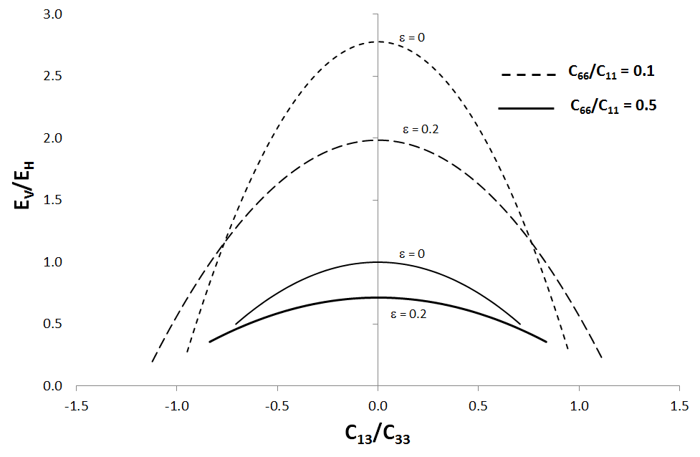

Figure A3: The ratio between vertical and horizontal Young's modulus (*E*V/*E*H) as a function of *C*13/*C*33 for *C*66/*C*11 = 0.1 and 0.5, with Thomsen parameters ** =** = 0 and ** = ** = 0.2.

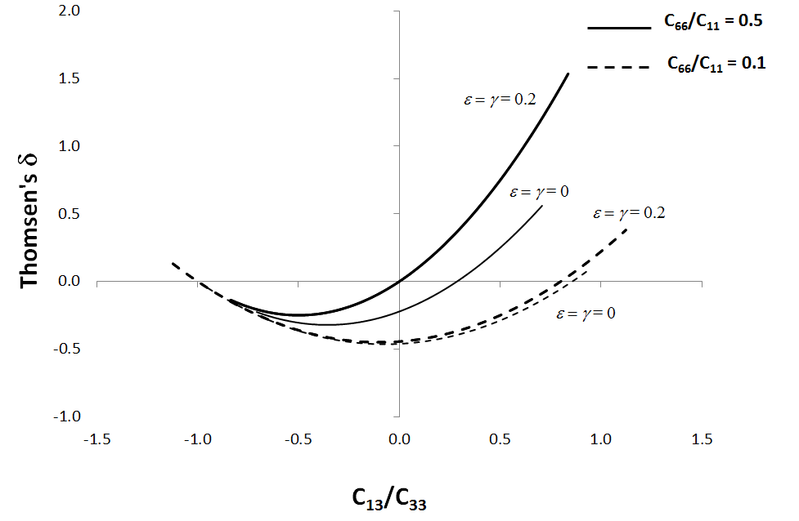

Figure A4: Thomsen's ** plotted within the attainable range of *C*13/*C*33 values for *C*66/*C*11 = 0.1 and C66/C11 = 0.5, with P- and S-wave anisotropy parameters ** =** = 0 and ** =** = 0.2.

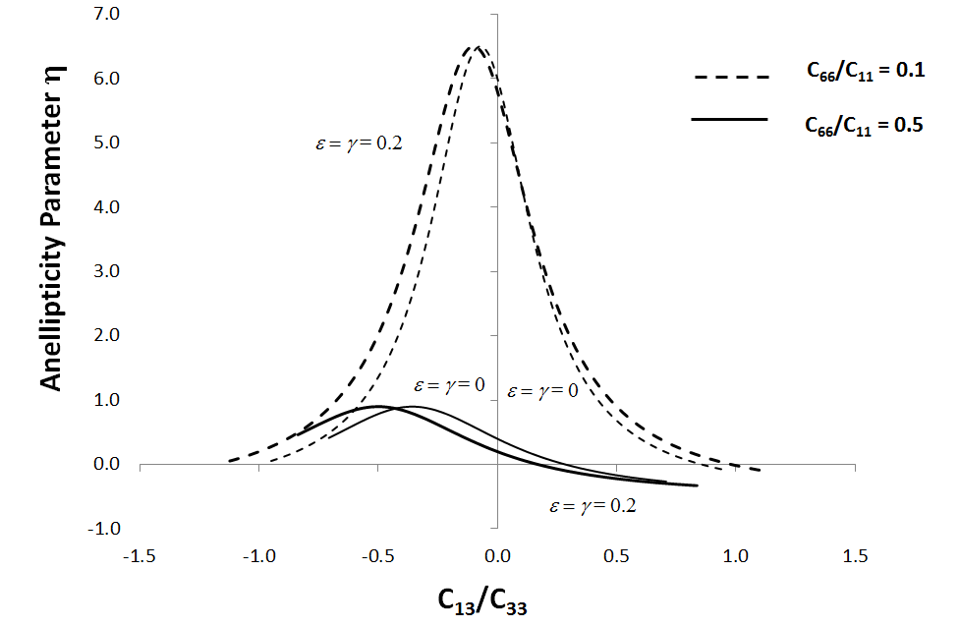

Figure A5: The Tsvankin-Alkalifah anellipticity parameter * *plotted within the attainable range of *C*13/*C*33 values for C66/C11 = 0.1 and C66/C11 = 0.5, with P- and S-wave anisotropy parameters ** =** = 0 and ** =** = 0.2.

1. Poisson was neither a geophysicist nor a rock physicist (Thomsen, 1990 and 1996). Poisson's ratio should indeed be used with care in geophysics, where it is never measure directly. In rock mechanics, however, it is of fundamental importance, and it is directly measurable in static mechanical tests. Its anisotropic nature is however most often not considered.
2. The factor of 2 in the shear compliance terms in the matrix of Eq. (5) is due to the use of the tensor definition of shear strain  , rather than the engineering definition  (*u*i are displacements).
3. Notice that there is no basic restriction that *C*33> *C*66. Such a bound was anticipated by Hossain and Ellis (2014), with reference to an old paper by Rudzki (published in German in 1911, but translated and commented by Helbig and Slawinski, 2003). It appears as this is argued by Rudzki as being a result of experience rather than a basic limit. In fact, considering a layered medium of solid and fluid where the fluid compressibility is large, *C*33< *C*66 is easily achieved.