Conformation of Carboxylated Schizophyllan in Aqueous Solution

Kazuto Yoshiba^{a,*}, Takahiro Sato^{b}, Takaaki Osumiª, Ann-Sissel T. Ulset^{c} and Bjørn E. Christensen^{c}

a. Division of Molecular Science, Faculty of Science and Technology, Gunma University, 1-5-1 Tenjin-cho, Kiryu, Gunma, 376-8515, Japan
b. Department of Macromolecular Science, Osaka University, 1-1 Machikaneyama-cho, Toyonaka, Osaka 560-0043, Japan
c. NOBIPOL, Department of Biotechnology, Norwegian University of Science and Technology (NTNU), Trondheim NO-7491, Norway

Corresponding Author
* Kazuto Yoshiba
Division of Molecular Science, Faculty of Science and Technology, Gunma University
1-5-1 Tenjin-cho, Kiryu, Gunma, 376-8515, JAPAN
Tel: +81 277 30 1486 Fax: +81 277 30 1409
e-mail: yoshiba@gunma-u.ac.jp

ABSTRACT
Carboxylated schizophyllan (sclerox) samples of different degrees of oxidation were molecularly characterized by size exclusion chromatography equipped with a multi-angle light scattering detector (SEC-MALS) in 0.10 M aqueous NaCl solution. The molar mass distribution obtained by SEC-MALS shows that sclerox of low degree of oxidation is dissolved mainly as the trimer, whereas the trimer and single chain coexist in solution of sclerox of high degree of oxidation. The trimer of sclerox is much more flexible than the fully ordered triple helix of the parent schizophyllan and easily dissociates into single chains upon heating.

Keywords: schizophyllan; triple helix; periodate oxidation; size exclusion chromatography; light scattering

1. Introduction
Schizophyllan, an extracellular polysaccharide produced by the fungus Schizophyllum commune (Kikumoto, Miyajima, Yoshizumi, Fujimoto & Kimura, 1970; Kikumoto, Miyajima, Kimura, Okubo, & Komatsu, 1971), is a linear β-1,3-glucan, consisting of the repeating unit of three β-1,3-glucose with one side chain of β-1,6-glucose as illustrated in Figure 1A. It is known that schizophyllan stimulates the immune system and has an antitumor activity. Norisuye et al. discovered that schizophyllan exists as a rigid triple helix in water (Norisuye, Yanaki, & Fujita, 1980; Yanaki, Norisuye, & Fujita, 1980; Kashiwagi, Norisuye, & Fujita, 1981; Sato, Norisuye, & Fujita, 1981) and its triple helical conformation is related to the antitumor activity (Norisuye, 1985; Okamura et al., 1986). In the triple helix, three schizophyllan chains assemble by intermolecular hydrogen bonds, and the side chain glucoses are located outward to the helical core (Takahashi, Kobatake, Kojima, 1984).
The schizophyllan triple helix is stable in water, whereas it dissociates to single chains in dimethylsulfoxide (DMSO) and water-DMSO mixtures (Norisuye et al, 1980; Sato, Norisuye, & Fujita, 1983), as well as in water at high pH and/or high temperature (Kashiwagi, et al., 1981). Such a denaturation process is irreversible and the dilution of the DMSO solution with water does not produce the original triple helix but more or less random aggregations at finite concentrations (Sato, Sakurai, Norisuye, & Fujita, 1983). Stokke et al. have shown that the change of the solvent conditions produces trimer, circular and more complex aggregated species as a result of the renaturation from schizophyllan single chains in very dilute solutions (Stokke, Elgsaeter, Brant, Kuge, & Kitamura, 1993; Falch & Stokke, 2001).
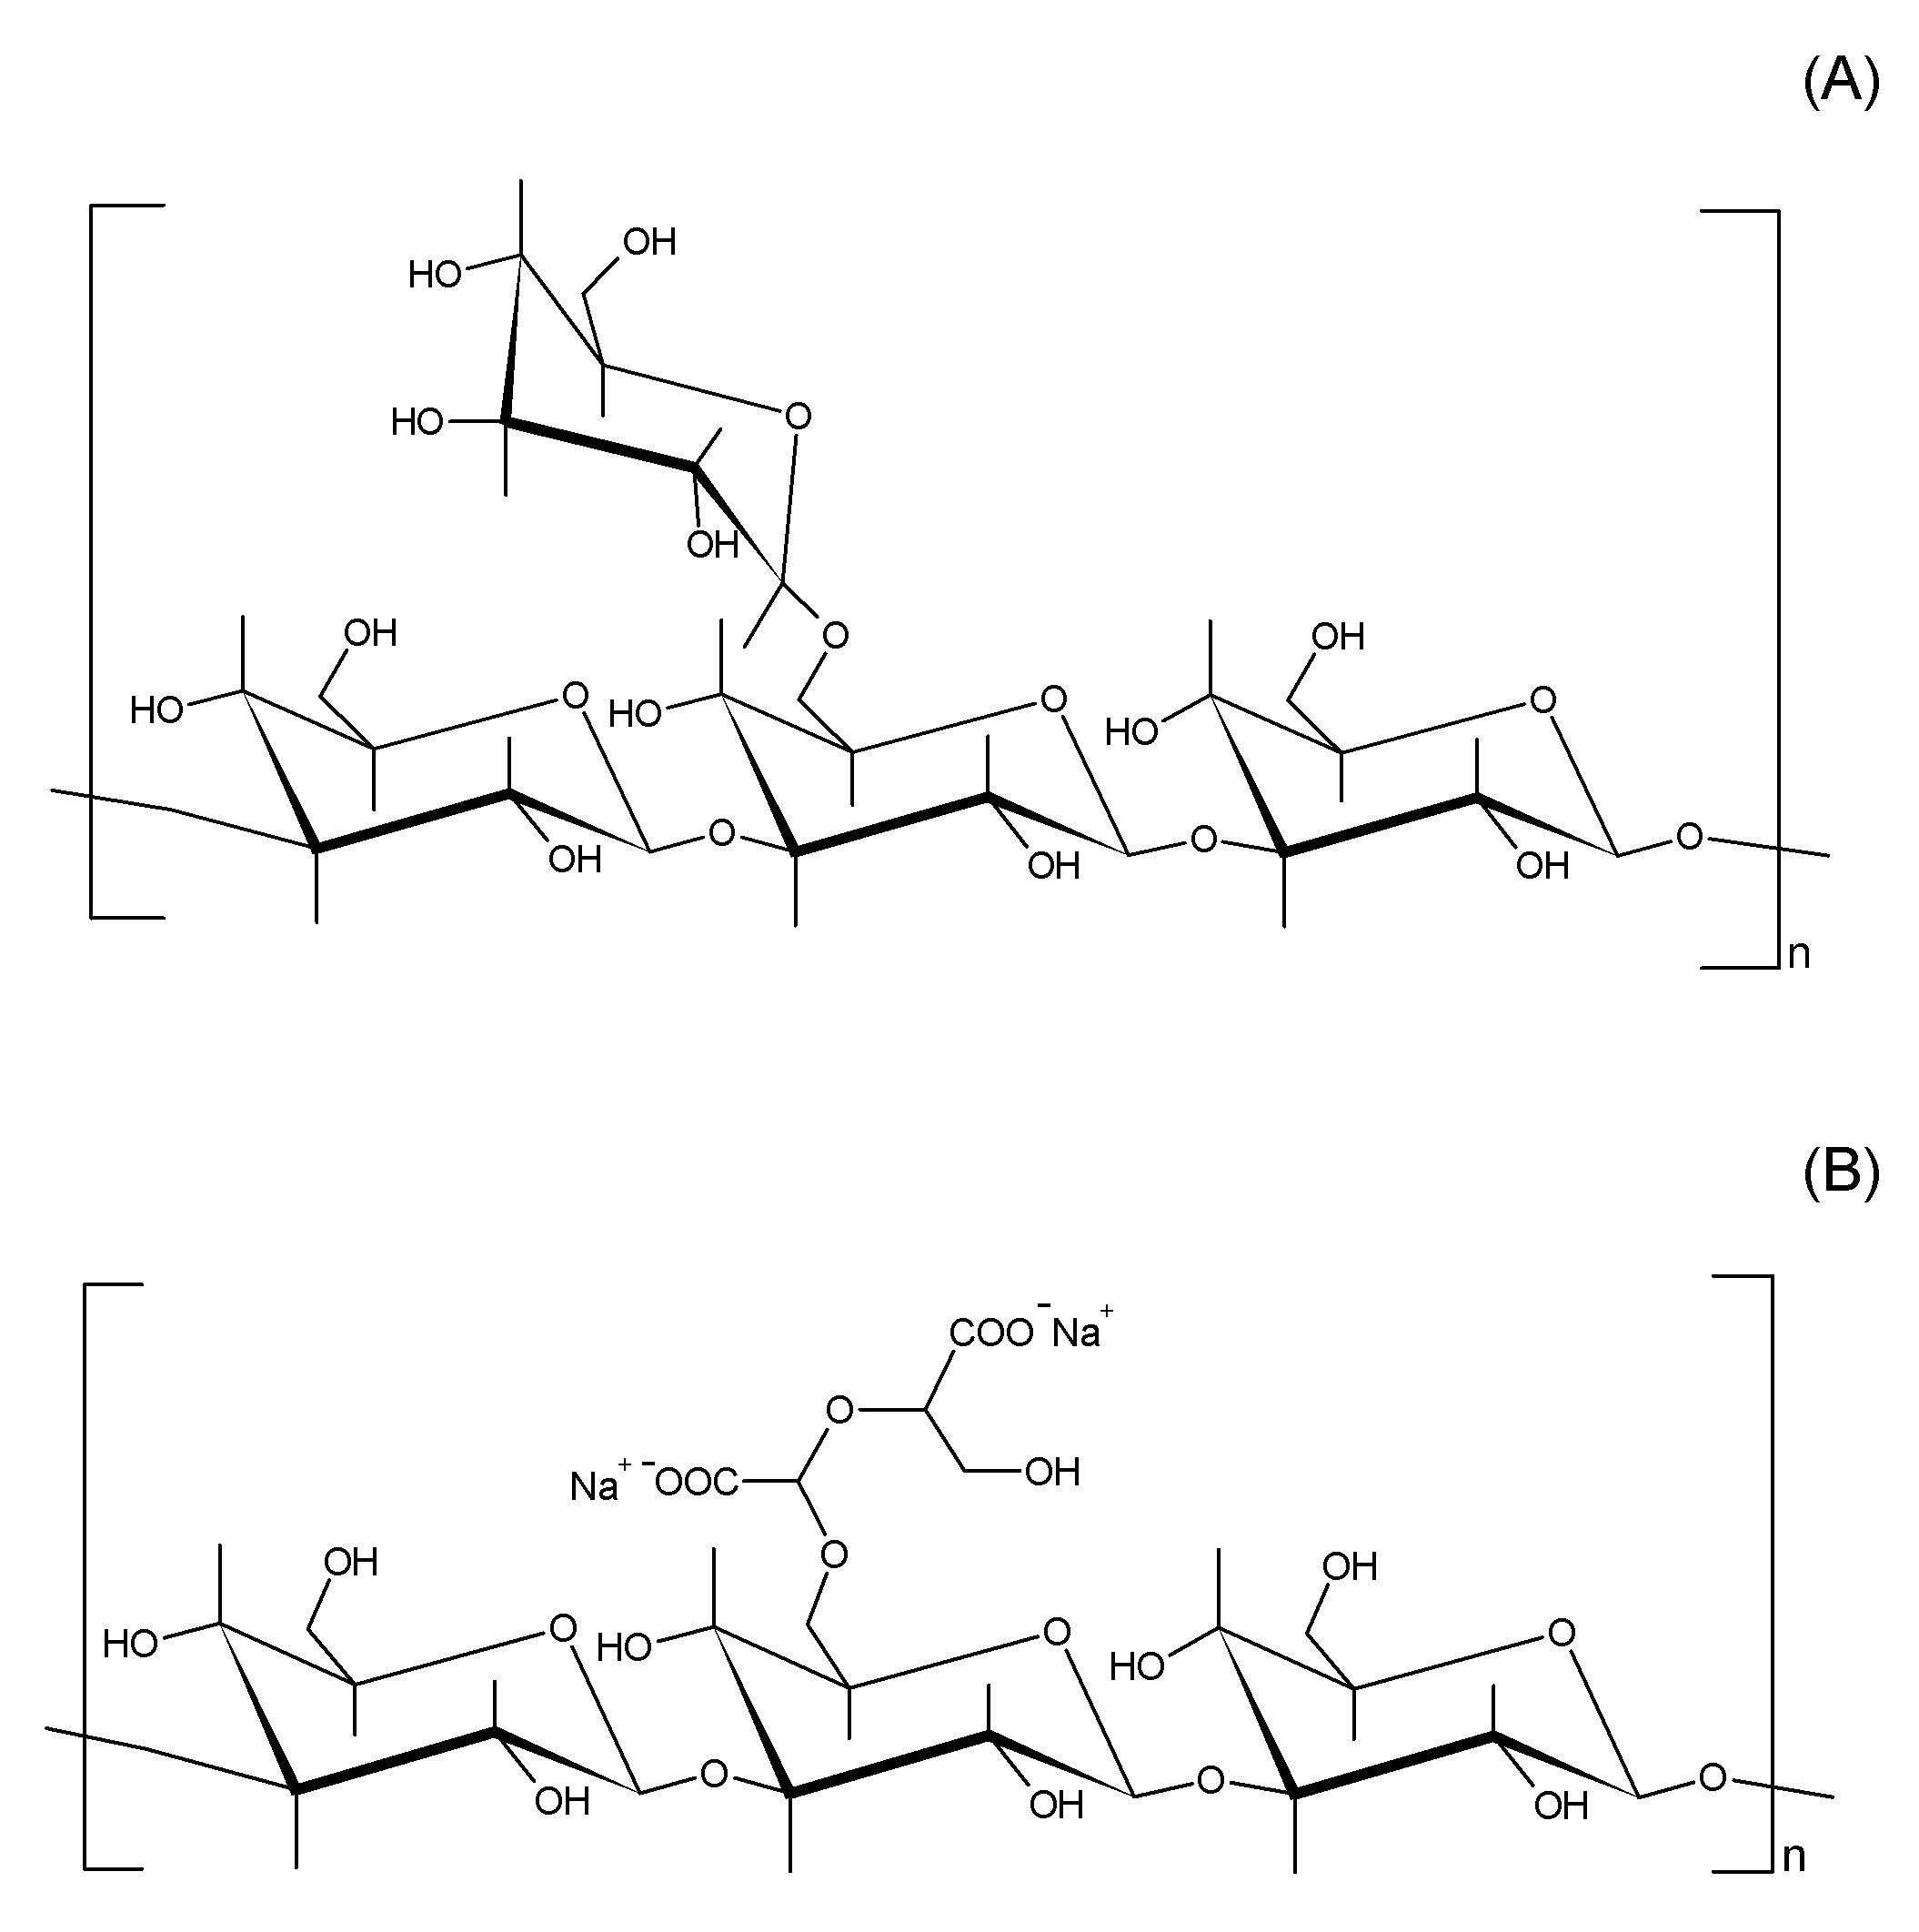
Figure 1 Chemical structure of the repeating unit of schizophyllan (A) and carboxylated schizophyllan (B).

Since carboxylation of polysaccharides modifies their physicochemical properties and biological functions, various neutral polysaccharides have been oxidized to introduce carboxylate groups (Hofreiter, Wolff, & Mehltretter, 1957; Casu et al., 1984). Crescenzi et al. synthesized a new ionic polysaccharide (‘sclerox’) from scleroglucan by two successive oxidations with sodium periodate and sodium chlorite, respectively (Crescenzi, Gamini, Paradossi, & Torri, 1983). Here, scleroglucan is a polysaccharide produced by a fungus different from Schizophyllum commune, having the same chemical structure and triple helical conformation as schizophyllan. Periodate oxidation and subsequent chlorite oxidation are specific reactions including the ring-opening of the side chain, so that the degree of substitution of polysaccharide can be controlled by the amounts of periodate in the reaction (Stokke, Elgsaeter, Smidrød, & Christensen, 1995; Christensen, Aasprong, & Stokke, 2001). Carboxylated scleroglucan (Figure 1B) shows polyelectrolyte character unlike the parent scleroglucan, such as pH and salt dependences of solution properties (Coviello, Dentini, & Crescenzi, 1995; Covielo, Dentini, Crescenzi, & Vincenti, 1995). Coviello et al. performed small angle X-ray scattering measurements on sclerox in aqueous solution, and concluded that sclerox exists as a mixture of the triple helix and single chains (Coviello et al., 1998). However, because scleroglucan is produced as a gel-like component adhered with mycelium, its isolation from the fungus is made under a severe condition, so that partial irreversible denaturation and aggregation of the triple helices may take place (see above) in isolated scleroglucan samples, which makes the parent scleroglucan sample be poorly soluble in water (Yanaki, & Norisuye, 1983). These partial denaturation and aggregation make difficult to study the detailed molecular conformation for both scleroglucan and sclerox prepared from scleroglucan.
This paper reports the molecular conformation of carboxylated schizophyllan (also named sclerox) in solution. It is important for expanding the applicative fields of the polysaccharide to understand the physical properties in solution on the basis of the molecular conformation. The carboxylation, which occurs only in the side chains, largely alters physical properties of sclerox from parent schizophyllan by first introducing the carbonyl groups with periodate oxidation, and subsequent chlorite oxidation. We characterized the molecular conformation of sclerox with different degrees of carboxylation examined mainly by size-exclusion chromatography equipped with a multi-angle light scattering detector (SEC-MALS) to investigate the carboxylation effects on the triple helical conformation of schizophyllan. Since native schizophyllan is well soluble in both water and aqueous salt solutions, we can compare the molecular conformations after the carboxylation on their molar mass dependence. Furthermore, SEC-MALS can analyze both triple helix and single chain existing in the solution of sclerox separately, so that we can characterize more precise molecular conformation of sclerox with different degrees of carboxylation.

2. Experimental
2.1. Chemical modification of schizophyllan
According to Norisuye et al. (Norisuye, Yanaki, & Fujita, 1980), a stock schizophyllan sample (SPG) supplied from Taito Co., Ltd. (now Mitsui Sugar Co., Ltd., Tokyo, Japan) was dissolved in water and separated into three fractions by fractional precipitation with deionized water as the solvent and acetone (Wako Pure Chemical Industries Ltd., Osaka, Japan) as the precipitant. The sample was freeze-dried from aqueous solution after the filtration with a DISMIC-25AS filter (pore size 0.45 μm, Toyo Roshi Co., Ltd., Tokyo, Japan). The fractional precipitation was repeated twice on the middle fraction. The fractionated samples were reprecipitated again in ethanol and freeze-dried from aqueous solution. The sample was dried in vacuo before use. The experimental details have been described in previous papers on schizophyllan for the sample preparation (Kikumoto et al., 1970) and degradation (Norisuye, Yanaki, & Fujita, 1980; Yanaki, Nishi, Tabata, Kojima, 1983).
A middle fraction prepared above was oxidized by the following two-step oxidation using NaIO₄ and NaClO₂. In the first oxidation with NaIO₄ (Wako Pure Chemical Industries Ltd., Osaka, Japan), 120 mg of the fractionated schizophyllan sample was dissolved in 120 cm³ of deionized water containing 13.3 cm³ of 1-propanol (Wako Pure Chemical Industries Ltd., Osaka, Japan). An appropriate amount of aqueous 30 mM NaIO₄ solution was added to adjust the concentration equivalent to the repeating unit of schizophyllan. The reaction was performed by stirring the solution at room temperature in the dark for 24 hours to obtain the corresponding dialdehydes. The second oxidation reaction was carried out in 0.5 M aqueous solution of NaClO₂ (Kanto Chemical Co. Inc., Tokyo, Japan) in the presence of 0.5 M acetic acid (Wako Pure Chemical Industries Ltd., Osaka, Japan). Nitrogen gas was bubbled through the solution in the oxidation and the reaction was performed for 24 hours in the dark at room temperature, and the pH condition was below pH 4 until the reaction was finished. The solution after the oxidations was dialyzed repeatedly with deionized water. The sodium salt of carboxylated sample was obtained by freeze-drying after neutralization with 0.01 M NaOH (Wako Pure Chemical Industries, Osaka, Japan).
Infrared spectra of the samples before and after carboxylation were obtained at room temperature on a JASCO FT/IR-4200 spectrometer (JASCO Co., Ltd., Tokyo, Japan). The KBr disk was prepared by mixing with each freeze-dried sample.
The degree of substitution (DS) was determined by potentiometric titration with 0.01 M NaOH in aqueous 0.10 M NaCl (Wako Chemical Industries Ltd., Osaka, Japan) at room temperature. The sample was transformed to the acid form before the measurement by mixing 20 cm³ of the aqueous solution of 40 mg of the sample with 1g of Amberlite IR-120B (Organo Co., Ltd., Tokyo, Japan) at room temperature for one day. The neutralization point was determined from the titration curve to calculate the DS of sclerox according to Figure 1(B). In what follows, sclerox samples are coded as SC-X, where X represents the molar ratio of NaIO₄ to the side-chain glucose residue of schizophyllan in the solution at performing the oxidation reaction.
2.2. Size-exclusion chromatography equipped with a multi angle light scattering detector (SEC-MALS)
SEC-MALS measurements were made on a Shodex GPC-101 size exclusion chromatography apparatus (Showa Denko K.K., Kanagawa, Japan) connected with a DAWN HELEOS II MALS detector (Wyatt Technology Co., Santa Barbara, USA). A guard column, OHpak SB-G (Showa Denko K.K., Kanagawa, Japan) and two SEC columns, OHpak SB-806M-HQ (Showa Denko K.K., Kanagawa, Japan) were serially connected and warmed at 40 °C in a thermostated oven. The MALS detector and differential refractometer were connected to the columns in series to detect the scattering intensity and the concentration profiles. The flow rate was fixed to 1.0 cm³ min⁻¹. The MALS detector was calibrated by a standard poly(ethyleneoxide) sample of 2.7×10⁴ g mol⁻¹ (Tosoh Co. Ltd., Tokyo, Japan) and toluene. The refractive index increment for schizophyllan and sclerox solutions at the constant solvent chemical potential, (∂n/∂c)_{μ} = 0.141 cm⁻³g⁻¹, was used in the calculations for the molar mass and concentration profiles from elution curves obtained. MALS data were analyzed by the Zimm plot to estimate the molar mass and radius of gyration at each elution time.
In preliminary viscosity measurements, the Huggins plot of the aqueous solutions of sclerox without salt showed strong electro-viscous effects even at low DS. Therefore, we employed aqueous 0.10 M NaCl as an eluent for SEC-MALS measurements. Sclerox and the parent schizophyllan samples were dissolved in 0.10 M NaCl containing 0.01 M NaOH to make solutions with c = 2.0×10⁻³ g cm⁻³ and diluted with the eluent of aqueous 0.10 M NaCl to suitable concentrations. Sample solutions were injected to SEC (injection volume, 0.1 cm³) after the filtration with DISMIC-25AS (pore size 0.45 μm, Toyo Roshi Co., Ltd., Tokyo, Japan) and the SEC data were recorded with ASTRA® ver.5.3 software (Wyatt technology Co., Santa Barbara, USA).

3. Results and discussion
3.1. Molecular characteristics of sclerox samples
Figure 2 shows IR spectra of schizophyllan (SPG) and carboxylated schizophyllan (SC-Xs) with different degrees of carboxylation in bulk at room temperature. As reported by Coviello et al. (Coviello, Grassi, Rambone, & Alhaique, 2001), SC-Xs samples exhibit a characteristic band of carboxyl salt at the wavenumber υ ~1600 cm⁻¹, and the peak height increases with X. Since excess amounts of NaClO₂ were used in the second oxidation step, there is no significant peak at υ ~1700 cm⁻¹, assigned to carbonyl band in the spectra.
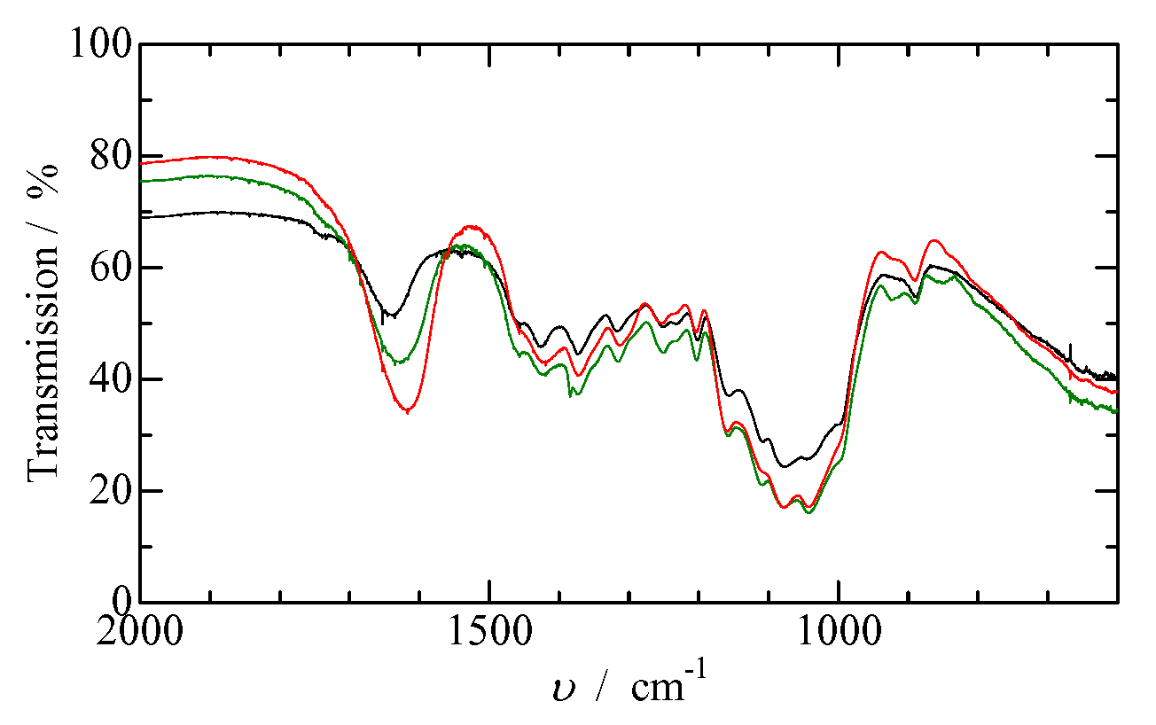
Figure 2 Infrared spectra for SPG (black) and SC-0.4 (green) SC-1.0 (red) in bulk at room temperature.

Crescenzi et al. reported ¹³C-NMR spectra for scleroglucan and sclerox, and demonstrated the spectra to be consistent with the chemical structure shown in Figure 1B (Crescenzi et al., 1983). Because of lower degrees of carboxylation, our SC-X samples did not show appreciable difference in ¹³C-NMR spectrum from that of SPG. However, our SC-X samples were prepared in the same method as that of the previous work, so that we can expect the same chemical structure depicted in Figure 1B for our SC-X samples.
Table 1 lists degrees of substitution (DS) of three sclerox samples obtained by potentiometric titration. Here, DS is the fraction of side-chain glucose residues oxidized in total side-chain glucose residues. DS increases with increasing extents of oxidation, but is consistently lower than the molar ratio (X) of added NaIO₄ relative to the repeating units of schizophyllan. This is ascribed to the consumption of periodate following the initial dialdehyde formation between C2 and C3 or between C3 and C4 of the side chains, leading to the release of formic acid (from C3) but no net increase in the aldehyde content (Christensen et al., 2001).

Table 1 The weight average molar mass, molar mass dispersity and degree of substitution (DS) for carboxylated schizophyllan samples after the oxidation.
Sample code | X ª | DS | M_{w} ×10⁻⁴/ g mol⁻¹ | M_{w}/M_{n}
SPG | 0 | 0 | 40.7 | 1.20
SC-0.2 | 0.2 | 0.16 | 36.6 | 1.48
SC-0.4 | 0.4 | 0.19 | 30.5 | 1.54
SC-1.0 | 1.0 | 0.38 | 33.8 | 2.42
a, X represents the molar ratio of NaIO₄ to the side-chain glucose residue of schizophyllan in the solution at performing the oxidation reaction

Figure 3 shows chromatograms (concentration profiles) and molar masses (M), plotted against the elution volume V_{e} for schizophyllan (SPG) and three sclerox samples (SC-0.2, SC-0.4, and SC-1.0) obtained by SEC-MALS. The elution (concentration) curves become broader and shifts to larger elution volumes (V_{e}) with increasing X. The M-V_{e} curves for different X do not overlap, but cross each other around V_{e} ~ 16 cm³ (or M ~ 3 × 10⁵ g mol⁻¹). It is known that the M-V_{e} curve is related with the dimension of each fraction at same V_{e}, such as the universal calibration curve for SEC (Gu et al., 1999). These changes of M-V_{e} curves suggest that the chain conformation of SC-Xs is changed by oxidation even at low DS, which is different from the SPG triple helix (see below).
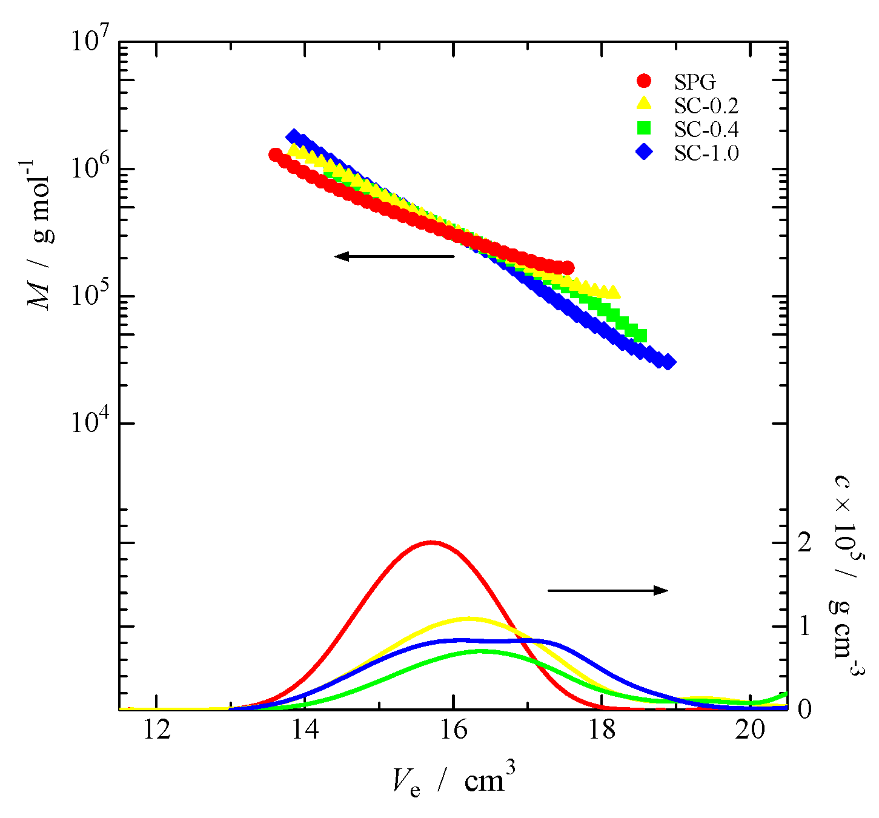
Figure 3 SEC chromatograms for carboxylated schizophyllan and schizophyllan samples at 40 °C in aqueous 0.10 M NaCl obtained from refractive index and MALS detectors: Symbols; red circles and curve for SPG (4.9×10⁻⁴ g cm⁻³), yellow triangles and curve for SC-0.2 (3.8×10⁻⁴ g cm⁻³), green squares and curve for SC-0.4 (3.2 ×10⁻⁴ g cm⁻³), blue diamonds and curve for SC-1.0 (6.9 ×10⁻⁴ g cm⁻³).

Table 1 lists the weight average molar mass (M_{w}) and the molar mass dispersity M_{w}/M_{n} for SPG and SC-X samples calculated from the results shown in Figure 3. With increasing X, M_{w} decreases and M_{w}/M_{n} increases monotonously, which indicate that the oxidation reaction may be accompanied by partial dissociation, and possibly some depolymerization, of the SPG triple helix.
Figure 4 shows chain length distributions of SPG and SC-X samples, obtained from the results given in Figure 3. Results are presented in terms of the weight fraction w as a function of the number N₀ of main-chain glucose residues (not repeating units) per molecule, calculated from the molar mass M divided by the average molar mass, , per main-chain glucose residue. Strictly speaking, N₀ is the weight average number of main-chain glucose residues of all species eluted at each elution slice (V_{e}). The distribution curves for SC-0.2 and SC-0.4 are broader, and their w(N₀) at both smaller and larger N₀ tails are higher than that of the original SPG. The increase of w(N₀) at the small N₀ tail may be ascribed to depolymerization together with dissociation of the triple helix, while the increase of w(N₀) at larger N₀ tail may indicate re-aggregation of single-strand chains dissociated in 0.10 M aqueous NaCl (Sato et al., 1983). In the chemical modification used here, namely partial periodate oxidation, the side chain glucose residues of schizophyllan react with periodate to produce dialdehyde, for a periodate-resistant β-1,3-linked backbone (Stokke et al., 1995; Christensen et al., 2001). The oxidation of the main chain occurs only at the chain termini, so that the contribution to w(N₀) is negligible. The distribution curve for SC-1.0 has two peaks around N₀ ~ 1500 and 600. Comparing this distribution curve with those for the original SPG triple helix (unfilled circles) and the corresponding single chains (the dashed curve in Figure 4), which was obtained by shifting N₀ values with a factor 1/3, we may conclude that trimers and single chains of SC-1.0 coexist in 0.10 M aqueous NaCl. It is noted that the distribution curve for SC-1.0 has a tail in the high N₀ region, which indicates the existence of aggregates of sclerox chains higher than the trimer.
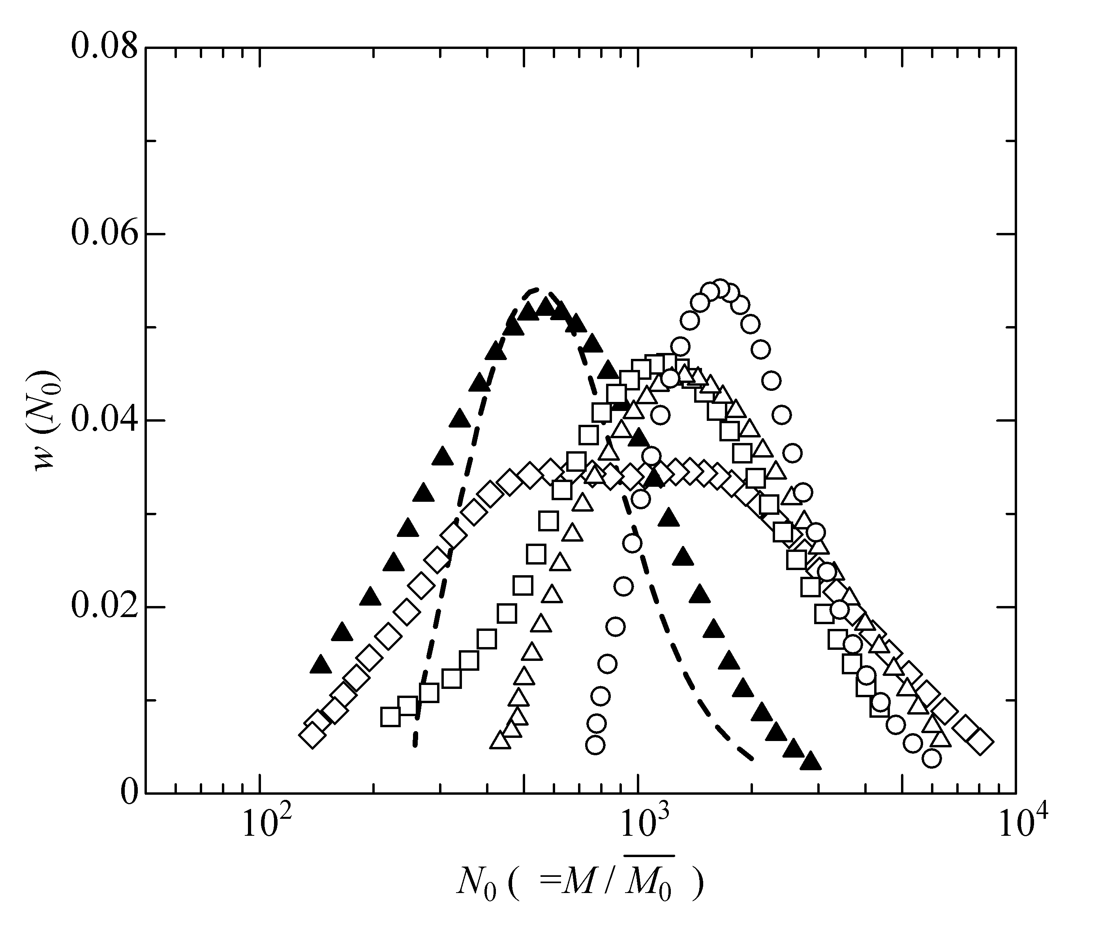
Figure 4 The molar mass distribution for schizophyllan and carboxylated schizophyllan samples against the number N₀ of main-chain glucose residues of species: Symbols; unfilled circles, SPG; unfilled triangles, SC-0.2; unfilled squares, SC-0.4; unfilled diamonds, SC-1.0; filled triangles, SC-0.2 sample thermally treated at 80 °C. Dashed curve represents calculated curve from SEC-MALS data of schizophyllan shifted by M/3.

Figure 4 also includes the distribution function for SC-0.2 heated at 80 °C for 2 hours before the SEC-MALS measurement. This distribution curve is slightly broader but close to the distribution curve for the single chain of the original SPG (dashed curve). The broadness may be due to the scission (during oxidation and heating) and aggregation (upon cooling) of the SC-0.2 chains. The trimer of SC-0.2 is thermally less stable than the SPG triple helix, which is stable in water up to 100 °C (Yanaki, Tabata, & Kojima, 1985; Kitamura & Kuge, 1989).
3.2. Global conformation of the trimer and single chain of sclerox in solution
Figure 5A shows N₀ dependences of the radius of gyration <S²>^{1/2} for samples of SPG and SC-0.2 in 0.10 M NaCl determined from SEC-MALS measurements at 40 °C. The N₀ dependences of both heated and unheated SC-0.2 (filled and unfilled triangles) are weaker than that of the SPG triple helix (unfilled circles); the slope in the large N₀ region decreases from 0.97 to 0.76. In Figure 5A, filled circles represent Kashiwagi et al.’s data for SPG in 0.01 M aqueous NaOH (Kashiwagi et al., 1981). In this solvent, SPG exists as the triple helix, and our results for SPG in 0.10 M aqueous NaCl almost agree with the N₀ dependence in 0.01 M aqueous NaOH. Slight upward deviations of the filled circles may come from wider molar mass distributions of Kashiwagi et al.’s SPG samples. The solid curve in the figure indicates the fitting result of our SPG data by the Kratcky-Porod wormlike chain model (Benoit & Doty, 1953; Yamakawa, 1997). The best fit was obtained with the persistence length (q) and the pitch (h) per main-chain glucose residue of 120 nm and 0.28 nm, respectively. The q value is slightly smaller than that obtained by Kashiwagi et al., while h is close to the triple helix pitch (= 0.30 nm) for SPG in crystalline state (Takahashi, Kobatake, & Suzuki, 1984). Figure 5A also contains Kashiwagi et al.’s data for SPG in dimethylsulfoxide (DMSO, dashed line). It is known that SPG dissolves in DMSO as a single coiled chain, and the data of the thermally treated SC-0.2 in 0.10 M aqueous NaCl are close to those of SPG in DMSO.
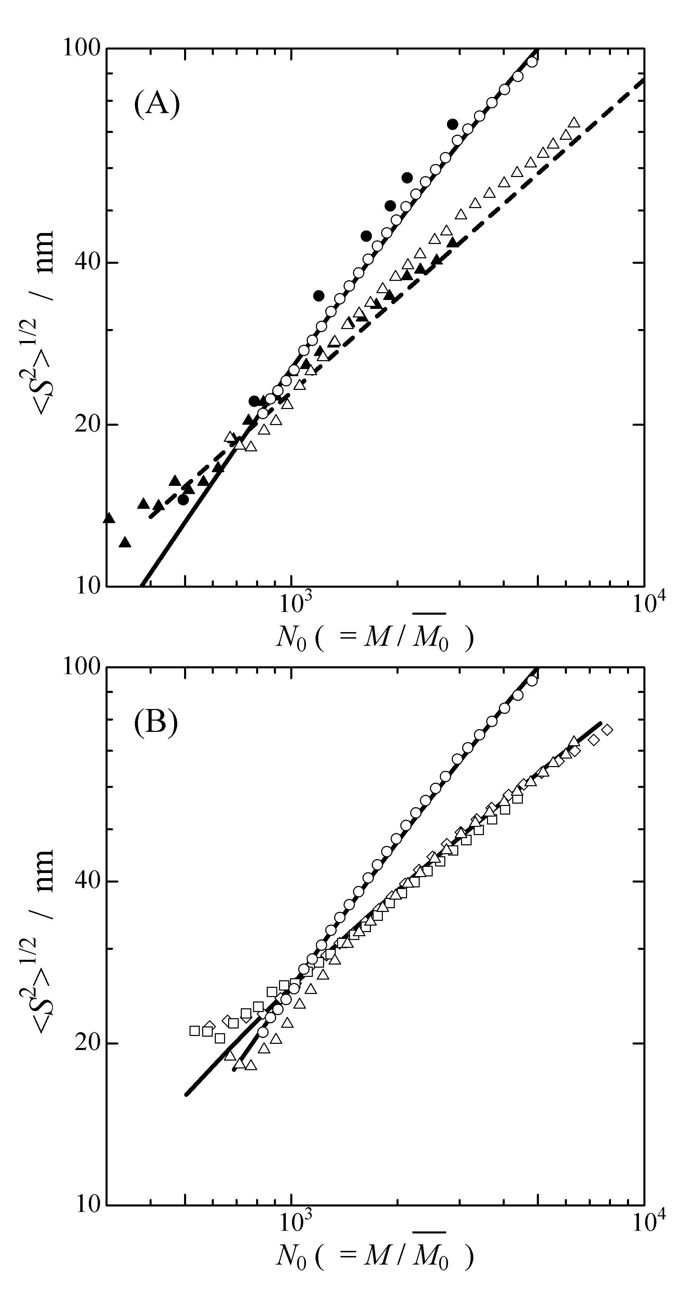
Figure 5 N₀ dependence of <S²>^{1/2} for SPG and carboxylated schizophyllan samples in aqueous 0.10 M NaCl: (A) SPG (unfilled circles) and SC-0.2 for unheated (unfilled triangles) and heated samples (filled triangles); (B) SPG (unfilled circles), SC-0.2 (unfilled triangles), SC-0.4 (unfilled squares) and SC-1.0 (unfilled diamonds) from SEC-MALS results. Filled circles and dashed line in Figure 5A are literature values for schizophyllan in 0.01 M NaOH and in DMSO, respectively (Kashiwagi et al., 1981). Solid curves represent the theoretical curves analyzed by Benoit-Doty equation for schizophyllan (q = 120 nm, h = 0.28 nm); carboxylated schizophyllan (q = 16 nm, h = 0.51 nm) in aqueous 0.10 M NaCl.

Figure 5B shows N₀ dependences of <S²>^{1/2} for thermally untreated SC-0.2, SC-0.4 and SC-1.0 (SC-Xs) compared with the SPG triple helix in 0.10 M aqueous NaCl. As shown in Figure 4, thermally untreated SC-Xs exist mostly as trimers at N₀ > 1000, but the data points for SC-Xs at N₀ > 1000 deviate downward from those for the SPG triple helix. This clearly indicates that the trimers of SC-Xs are not identical with the SPG triple helix. To fit the results of the SC-Xs data at 1500 < N₀ < 3000 by the Kratcky-Porod wormlike chain model, we have to choose h = 0.51 nm and q = 16 nm (the solid curve in Figure 5B). The h value is larger and the q value is smaller than those for the SPG triple helix. Therefore, the trimer of the SC-Xs is more extended and more flexible than the SPG triple helix. The value of h is identical with that for curdlan tris(phenylcarbamate) in 4-methyl-2-pentanone (Ochiai, Terao, Nakamura, Yoshikawa, & Sato, 2012). The inter-strand hydrogen bond among SC-Xs chains in the trimer may be weakened or broken by the oxidization reaction, and this may induce the thermal destabilization of the trimer of SC-0.2 as demonstrated in Figure 4. Data points for SC-Xs at N₀ > 3000 deviate from the solid curve, which may be due to the contamination of SC-Xs chain aggregates.

4. Conclusion
We have characterized a molecular conformation of carboxylated schizophyllan (sclerox) in aqueous 0.10 M NaCl with size-exclusion chromatography equipped with a light scattering detector. At low degree of oxidation, sclerox maintained the trimer, but the original triple helical structure was broken. The molar mass dependence of radius of gyration showed that the sclerox trimer takes a semiflexible conformation more flexible and more extended than the original triple helix. Moreover, the sclerox trimer is thermally less stable than the original triple helix. At high degree of oxidation, the sclerox trimer was partly dissociated into single chains, of which conformation was similar to the random coil of the single chain of the original SPG in DMSO.

Acknowledgements
K. Y. thanks Mr. Kazuki Watanabe, Shoko Scientific Co. Ltd., for a part of SEC-MALS measurements.

References
Benoit, H., & Doty, P. (1953). Light scattering from non-gaussian chains. The Journal of Physical Chemistry, 57, 958-963.
Bram, E. B., & Grasselli, J. G. ed. (1977), Infrared and Raman spectroscopy Part B. N. Y.: Marcel Dekker Inc.
Casu, B., Gennaro, U., Meille, S. V., Morrone, M., Naggi, A., Occhipinti, M. S., & Torri, G. (1984). Dicarboxyamylose and dicarboxycellulose, stereoregular polyelectrolytes: physicochemical characterization and interaction with divalent cations. International Journal of Biological Macromolecules, 6, 89-92.
Christensen, B. E., Aasprong, E., & Stokke, B. T. (2001). Gelation of periodate oxidized scleroglucan (scleroaldehyde) Carbohydrate Polymers, 46, 241-248.
Coviello, T., Dentini, M., & Crescenzi, V. (1995). Conformation and thermal stability of oxidized scleroglucan chains in aqueous NaOH. Polymer Bulletin, 34, 337-343.
Coviello, T., Dentini, M., Crescenzi, V., & Vincenti, A. (1995). Ionic strength and temperature dependence of oxidized scleroglucan solution properties: optical activity and viscosity data. Carbohydrate Polymers, 26,5-10.
Coviello, T., Grassi, M., Rambone, G., & Alhaique, F. (2001). A crosslinked system from scleroglucan derivative: preparation and characterization. Biomaterials, 22, 1899-1909.
Coviello, T., Maeda, H., Yuguchi, Y., Urakawa, H., Kajiwara, K., Dentini, M., & Crescenzi, V. (1998). Conformational characteristics of oxidized scleroglucan Macromolecules, 31, 1602-1607.
Crescenzi, V., Gamini, A., Paradossi, G., & Torri, G (1983). Solution properties of a new polyelectrolyte derived from the polysaccharide scleroglucan. Carbohydrate Polymers, 3, 273-286.
Falch, B. H., & Stokke, B. T. (2001). Structual stability of (1→3)-β-D-glucan macrocycles. Carbohydrate Polymers, 44, 113-121.
Gu, H., Nakamura, Y., Sato, T., Teramoto, A., Green, M. M., & Andreola, C. (1999). Global conformations of chiral polyisocyanates in dilute solution. Polymer, 40, 849-856.
Hofreiter, B. T., Wolff, I. A., & Mehltretter, C. L. (1957). Chlorous acid oxidation of periodate oxidized cornstarch. Journal of the American Chemical Society, 79, 6457-6460.
Kashiwagi, Y., Norisuye, T., & Fujita, H. (1981). Triple helix of Schizophyllum commune polysaccharide in dilute solution. 4. Light scattering and viscosity in dilute aqueous sodium hydroxide. Macromolecules, 14, 1220-1225.
Kikumoto, Miyajima, Yoshizumi, Fujimoto & Kimura, (1970). Polysaccharide produced by Schizophyllum commune Part I. Formation and some properties of an extracellular polysaccharide. Journal of the Agricultural Chemical Society of Japan, 44, 337-342.
Kikumoto, Miyajima, Kimura, Okubo, & Komatsu, (1971). Polysaccharide produced by Schizophyllum commune Part II. Chemical structure of an extracellular polysaccharide. Journal of the Agricultural Chemical Society of Japan., 45, 162-168.
Kitamura, S., & Kuge, T. (1989). A differential scanning calorimetric study of the conformational transitions of schizophyllan in mixtures of water and dimethylsulfoxide Biopolymers, 28, 639-654.
Norisuye, T. (1985). Triple-stranded helical structure of schizophyllan and its antitumor activity in aqueous solution. Die Makromolekulare Chemie Supplement, 14, 105-118.
Norisuye, T., Yanaki, T., & Fujita, H. (1980). Triple helix of a Schizophyllum commune polysaccharide in aqueous solution. Journal of Polymer Science: Polymer Physics Edition, 18, 547-558.
Ochiai, T., Terao, K., Nakamura, Y., Yoshikawa, C., & Sato, T. (2012). Rigid helical conformation of curdlan tris(phenylcarbamate) in solution. Polymer, 53, 3946-3950.
Okamura, K., Suzuki, M., Chihara, T., Fujiwara, A., Fukuda, T., Goto, S., Ichinohe, K., Jimi, S., Kasamatsu, T., Kawai, N., Mizuguchi, K., Mori, S., Nakano, H., Noda, K., Sekiba, K., Suzuki, K., Suzuki, T., Takahashi, K., Takeuchi, K., Takeuchi, S., Yajima, A., & Ogawa, N. (1986). Clinical evaluation of schizophyllan combined with irradiation in patients with cervical cancer. Cancer, 58, 865-872.
Sato, T., Norisuye, T., & Fujita, H. (1981). Melting behavior of Schizophyllum commune polysaccharides in mixtures of water and dimethyl sulfoxide. Carbohydrate Research, 95, 195-204.
Sato, T., Norisuye, T., & Fujita, H. (1983) Triple helix of Schizophyllun commune polysaccharide in dilute solution. 5. Light scattering and refractmetry in mixtures of water and dimethyl sulfoxide. Macromolecules, 16, 185-189.
Sato, T., Sakurai, K., Norisuye, T., & Fujita, H. (1983). Collapse of randomly coiled schizophyllan in mixtures of water and dimethylsulfoxide. Polymer Journal, 15, 87-96.
Stokke, B. T., Elgsaeter, A., Smidrød, O., & Christensen, B. E. (1995). Carboxylation of scleroglucan for controlled crosslinking by heavy metal ions. Carbohydrate Polymers, 27, 5-11.
Stokke, B. T., Elgsaeter, A., Brant, D. A., Kuge, T., & Kitamura, S. (1993). Macromolecular cyclization of (1→6)-branched-(1→3)-β-D-glucans observed after denaturation-renaturation of the triple-helical structure. Biopolymers, 33, 193-198.
Takahashi, Y., Kobatake, T., & Suzuki, H. (1984). Triple helical structure of schizophyllan. Reports on Progress in Polymer Physics in Japan, 27, 767-768.
Yamakawa, H. (1997). Helical Wormlike Chains in Polymer Solutions. Berlin: Springer.
Yanaki, T., Nishi, K., Tabata, K., & Kojima, T. (1983). Ultrasonic degradation of Schizophyllum commune polysaccharide in dilute aqueous solution. Journal of Applied Polymer Science, 28, 873-878.
Yanaki, T., & Norisuye, T. (1983). Triple helix and random coil of scleroglucan in dilute solution. Polymer Journal, 15, 389-396.
Yanaki, T., Norisuye, T., & Fujita, H. (1980). Triple helix of Schizophyllum commune polysaccharide in dilute solution. 3. Hydrodynamic properties in water. Macromolecules, 13, 1462-1466.
Yanaki T., Tabata, K., & Kojima, T. (1985). Melting behaviour of a triple helical polysaccharide schizophyllan in aqueous solution. Carbohydrate Polymers, 5, 275-283.

