The influence of amino acids, buffers and pH on the γ-irradiation induced degradation of alginates

Ann-Sissel T. Ulset1, Hideki Mori2, Marianne Ø. Dalheim1, Masayuki Hara2, Bjørn E. Christensen1*

1 NOBIPOL, Department of Biotechnology, Norwegian University of Science and Technology (NTNU), N-7491 Trondheim, Norway

2Department of Biological Science, Graduate School of Science, Osaka Prefecture University, 1-2 Gakuen-cho, Naka-ku, Sakai, Osaka 599-8570, Japan

ABSTRACT:

Alginate-based biomaterials and medical devices are commonly subjected to γ-irradiation as a means of sterilization, either in the dry state or the gel (hydrated) state. In this process the alginate chains degrade randomly in a dose-dependent manner, altering alginates’ material properties. The addition of free radical scavenging amino acids such as histidine and phenylalanine protects the alginate significantly against degradation as shown by monitoring changes in the molecular weight distributions using SEC-MALLS and determining the *pseudo* first order rate constants of degradation. Tris buffer (0.5 M), but not acetate, citrate or phosphate buffers had a similar effect on the degradation rate. Changes in pH itself had only marginal effects on the rate of alginate degradation, and on the protective effect of amino acids. Contrary to previous reports the chemical composition (M/G profile) of the alginates, including homopolymeric mannuronan, was unaltered following irradiation up to 10 kGy.

KEYWORDS:

Alginate, mannuronan, γ-irradiation, SEC-MALLS, radical scavenger, amino acids, NMR

INTRODUCTION

Alginates are a family of polysaccharides produced by several brown seaweeds and some bacteria1, 2. Because of their ability to form porous hydrogels in the presence of calcium salts they are much used as biomaterials in the form of hydrogels, fibers, foams and microparticles, mainly for encapsulation and proliferation of cells. The pore sizes of alginate hydrogels are usually large enough to allow the permeation of oxygen and nutrients in the culture media while for example cells are well trapped3, 4. Calcium-alginate gels and poly(L-lysine)-alginate gels have been used as immune-insulating membranes of transplantable pancreatic β-islets for diabetic therapy5 and scaffolds in tissue engineering of tissues such as cartilages, nerves, and dermis. A new trend was recently evoked in technology where alginates are applied in the biochemical engineering field, for example, alginates have been used in cell-immobilized microfluidic devices6, 7, long tube-like cell-entrapped hydrogels8, and in a glue-like material for ink-jet printing of living cells to construct artificial tissues and organs in 3D structure9, 10. Possibilities for medical applications of alginates in those devices seem to be increasing.

Alginates are considered being nontoxic, biocompatible, weakly absorbable (degradable *in vivo* without emitting harmful compounds), and bio-inert (less actively affecting viable cells) materials. Alginate gels are generally non-adhesive for most types of cultured (mammalian) cells. However, the adhesive properties of the gels can be freely modified or designed by co-immobilization or grafting of extracellular matrix (ECM) proteins and their mimicking peptides (-RGD-, -IKVAV-, -GFOGER-, etc.) onto the alginate chains. Various types of integrin in cell membranes can recognize the various ECM proteins or their mimicking peptides. A variety of the amino acid sequences for the recognition have been reviewed in the literature11.

The chemical structure and biosynthesis of alginates are schematically outlined in Figure 1. All alginates seem to be based on homopolymeric mannuronan, an unbranched polysaccharide containing only β-1,4-linked D-mannuronic acid (M), as an intermediate polymer. The action of processive C5-epimerases, which convert M-residues to the corresponding C5-epimer (α-L-guluronic acid (G)) on the polymer level, further leads to a diverse range of polymers differing not only in the M/G ratio, or equivalently the fractions of G (FG) and M (FM) residues, but also in the sequence of monosaccharides. For most purposes the structural characterisation of alginates12 therefore includes diad and triad frequencies, as well as the average length of G-blocks, which are consecutive ..GGG.. sequences. The latter is particularly important since gelation with calcium salts occurs through Ca2+-dependent dimerization of G-blocks, whereas other sequences except alternating (..MGMGMG..) sequences, which tend to associate weakly with calcium ions13, are non-gelling, elastic segments.

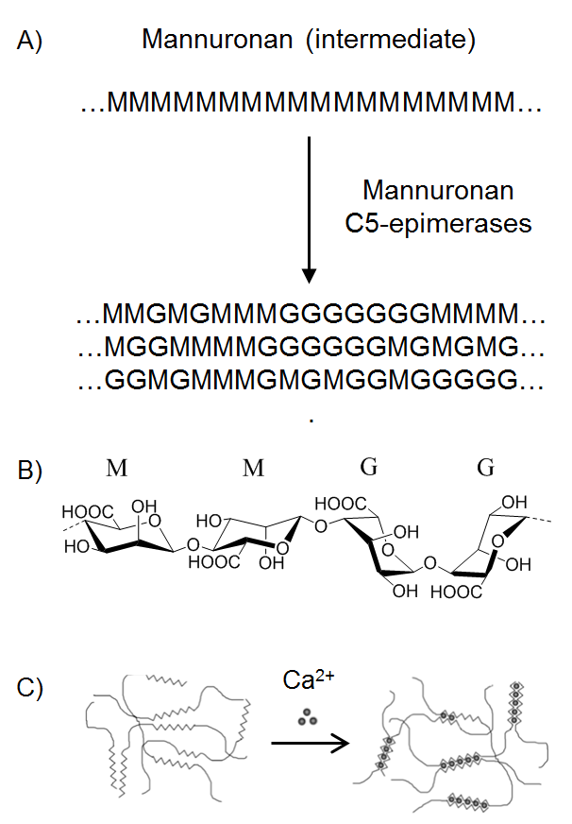

**Figure 1.** Biosynthesis, structure, and Ca2+-induced gelation of alginates. Homopolymeric mannuronan is converted to functional alginates by several mannuronan-C5-epimerases, which convert residues of β-D-mannuronic acid (M) to α-L-guluronic acid (G) (A). The corresponding transition from 4C1 to 1C4 conformation provides the calcium-binding GG cavity as illustrated in the MMGG fragment (B). The G-blocks are primarily responsible for Ca2+-induced chain dimerization and gelation (“egg-box model”) (C)

The physical properties of alginate gels also depend strongly on alginate concentration, the amount and type of gelling ions, the mode of adding such ions (homogenously or heterogeneously), the presence of salts and co-solutes, and the molecular weight distribution12.

γ-Irradiation is widely used for sterilization of medical devices, including alginate foams14 and gels. γ-Rays can penetrate deep into the materials for sterilization without generating residual chemicals. However, the radiation can induce both crosslinking and degradation via radical reactions. Like many other polysaccharides, alginates can be degraded dose-dependently by gamma-irradiation14-17 in the dry state, in solution, and in the gel state. Gamma-irradiation has also been used as a tool to decrease the molecular weight of alginate samples3, as an alternative to chemical or enzymatic degradation. Interestingly, but apparently not confirmed by others, an increase in the M/G ratio upon strong γ–irradiation of alginates has been reported15. The mechanism remains unclear.

Alginate biomaterials or devices may contain added peptides and proteins, e.g. Type I collagen, or peptide ligands for cell attachment18, 19. These proteins can be directly affected by γ-irradiation. For example, Type I collagen and gelatin were shown to be cross-linked and also degraded simultaneously, resulting in broadening of their molecular weight distributions 20. Their influence on the behaviour of the alginate when subjected to γ-irradiation has to our knowledge not been studied. However, an effect may be expected since amino acids react with (scavenge) the hydroxyl radicals formed upon γ-irradiation.

Here we present data on the influence of amino acids (glycine, phenylalanine, and histidine) on the rate of alginate degradation, as well as the influence of buffer type and pH upon γ-irradiation. Changes in the molecular weight distribution are monitored by SEC-MALLS, thereby avoiding the systematic errors occurring in SEC using standards such as pullulan, dextran or poly(ethylene) oxide. Possible changes in the M/G profile are addressed using state-of-the-art 1H-NMR methods. The study includes homopolymeric mannuronan to specifically study the possibility for γ-ray induced M-to-G conversion (epimerization). This study can accumulate basic knowledge about the action of gamma-irradiation on the alginate molecules with and without amino acids. It can contribute to the safe application of alginate as a scaffold in tissue engineering and medical devices.

EXPERIMENTAL

*Samples*

Characterization information for the alginates used in this work is given in Table 1. Sodium alginate (80-120 cps) was obtained from Wako, Osaka. Sodium alginates (330 cps, 510 cps, 960 cps) were obtained from Nacalai tesque, Kyoto. Mannuronan was a laboratory sample and its preparation and characteristics have been described previously21. The amino acids (L-histidine (His), L(-)-phenylalanine (Phe), and L-glycine (Gly), were obtained from Wako, Osaka. The experiments were conducted using the 330 cps sample unless otherwise specified.

*γ-irradiation*

Buffered sodium alginate solutions 1% (w/v) were prepared in screw-capped vials (New PP sample tube (No. 2), Maruemu Corp., Osaka), and then irradiated with γ-rays at ca. 30oC in the 60Co gamma-ray facility of the Radiation Research Center in Osaka Prefecture University. The doses were 0.5, 1.0 or 2.0 kGy, with a dose rate of 4-5 kGy/h. Three different amino acids (His, Phe, Gly) were added to the alginate solutions for gamma-irradiation at a concentration of 0, 0.5 mM, 5.0 mM, or 50 mM in order to estimate their effect as additives on the degradation of alginate. The buffers were either 0.1M Tris-HCl (pH 8.0) or 0.1 M Na-Citrate buffer (pH 5.0). Other buffers such as 5 mM Tris-HCl buffer (pH 8.0), 5 mM K-phosphate buffer (pH 8.0), 5 mM Na-Citrate buffer (pH 5.0) and 5 mM Na-Acetate buffer (pH 5.0) were used for irradiation of alginate in some experiments. The irradiated samples were transferred to dialysis tubes (MWCO: 3500, BioDesign Dialysis Tubing TM, Biodesign Inc. #D306-50, New York), and dialyzed against a 25-fold volume of distilled water for 3 days at 4 oC, with replacement of the dialyzing solution every 12 h. The samples were subsequently frozen for 24h at -80oC and then lyophilized using a Freeze-Dryer (Eyela FD-1, Tokyo). Powder of sodium alginate was also irradiated for comparison using the same irradiation conditions and then analysed directly, without dialysis.

*SEC-MALLS*

SEC-MALLS was carried out as previously described22, 23. In brief, the measurements were carried out at ambient temperature on an HPLC system consisting of a solvent reservoir, an on-line degasser, a HPLA isocratic pump, an autoinjector, a precolumn, and serially connected columns (TSK G-6000PWXL, 5000 PWXL, and 4000 PWXL). The 4000 PWXL column was omitted in some cases. The column outlet was connected to a Dawn DSP multiangle laser light scattering photometer (Wyatt,USA) (λ0 = 0**.**633 nm) followed by an Optilab DSP differential refractometer (P-10 cell). The flow rate was 0.5 ml min-1. The injection volume was 100–250 μL, and the sample concentration was adjusted to obtain the best possible light scattering signal without influencing the RI profile (overloading). Samples were filtered (pore size 0.22 or 0.45 μm) prior to injection. Data from the light scattering and the differential refractometer were collected and processed using Astra software (Wyatt, USA), using a refractive index increment (dn/dc)μof 0.150 mL g-1. The reproducibility (repeated injections of the same sample) resulted in standard deviations of 3.5% for Mw and 6.2% for Mn (n =4).

*NMR*

1H-NMR experiments were carried out as described previously21.

RESULTS AND DISCUSSION

*SEC-MALLS and data analysis*

Un-irradiated and γ-irradiated samples were analysed by SEC-MALLS using established methods14, 24, providing molar mass distributions, as well as the weight average (Mw) and number average (Mn) molecular weights without relying on SEC standards. Some examples (chromatograms and slice molecular weights) are shown in Figure 2.

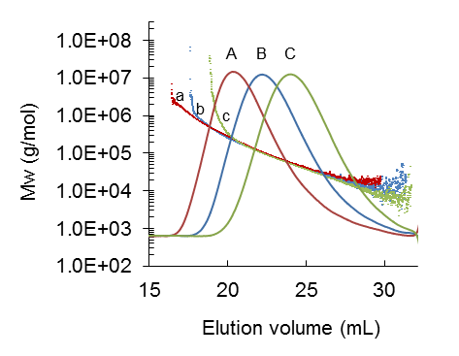

**Figure 2.** SEC-MALLS (selected data) obtained for alginate irradiated at pH 8.0 in 5 mM Tris-HCl buffer. Solid lines: Concentration profiles (RI detector) at 0 (A), 0.5 (B) and 1.0 kGy (C). Symbols: Slice molecular weights at 0 (a), 0.5 (b) and 1.0 kGy (c).

Earlier studies on the subject15, 16, 25, 26 have used SEC combined with calibration using either pullulan, poly(ethylene oxide) or poly(ethylene glycol) standards to determine molar masses of alginates. However, it is well known that such standards may overestimate the molar masses of alginates because of the much larger hydrodynamic volume of the latter. We have earlier estimated the extent of overestimation to a factor 4-6 based on a SEC-MALLS comparison of alginate and pullulan27. It follows that systematically overestimating the molar masses of γ-irradiated alginates might not accurately estimate the rate constant (k´).

Although SEC-MALLS also provides M­n the results sometimes tend to be somewhat less robust than Mw for well-known reasons28. More specifically, the weak scattering at the low molecular weight tail (typically above elution volumes of 27 ml) necessitates a relatively uncertain extrapolation procedure. We therefore compared two approaches for processing SEC-MALLS data such as those given in Figure 2. In method A ‘slice’ molecular weights were used directly. In method B we fitted the data (molecular weight versus elution volume) to a straight line for the elution interval 14-20 ml. This was done in the Astra software by splitting each chromatogram in two parts (peak 1 and peak 2), which were processed separately. For peak 1 (10.5 – 14 ml) unfitted data were used, whereas for peak 2 (above 14 ml) data were fitted to a first order exponential, using a pure alginate standard as guide. Mw and Mn for the combined peaks were then obtained through the standard relations:

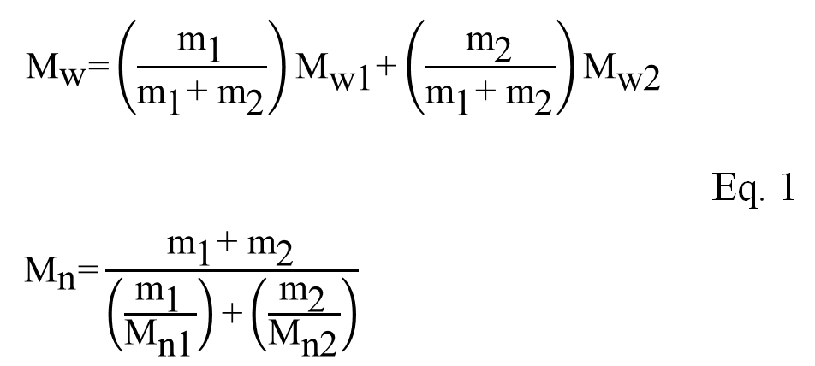

Here, m1 and m2 refer to themass eluting in each of the peaks. Comparing the data (Figure 3) showed that the fitting in Method B had an almost negligible influence on the molecular weight dispersity (Mw/Mn). The figure further demonstrates that the dispersity decreased rapidly and levelled out at 2.0 as the sample was degraded. Such behaviour is typical for random degradation of polymers29

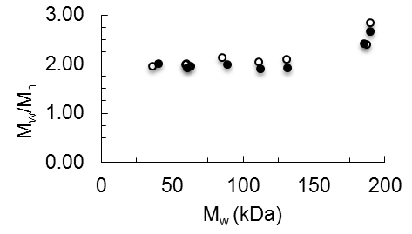

**Figure 3.** Molecular weight dispersity data (Mw/Mn) as a function of Mw for alginate irradiated at pH 8 in 5 mM Tris-HCl buffer. Filled symbols: Method A (unfitted SEC-MALLS data). Open symbols: Method B (see text)

*Degradation kinetics*

Figure 4 shows plots of Mw versus γ-irradiation dose for alginate irradiated in the absence and presence of 50 mM histidine in 0.1 M citrate pH 5.0 and 0.1 M Tris pH 8.0, illustrating the range of data obtained in this study. A complete set of figures for 0-50 mM histidine, phenylalanine and glycine is given in the Supplementary information (Figures S1-S3).

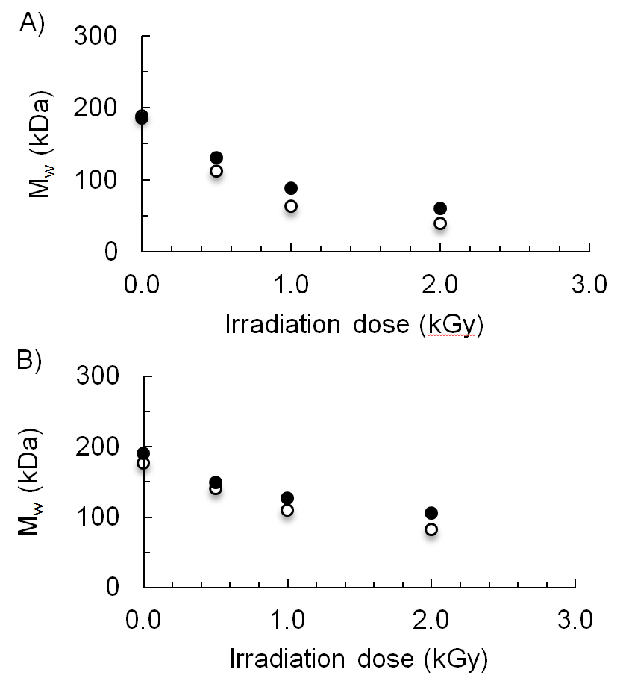

**Figure 4.** γ-Irradiation of alginate: Dose dependency of Mw in the absence (A) and presence (B) of 50 mM histidine. Filled symbols: 0.1 M Tris pH 8.0. Open symbols: 0.1 M citrate pH 5.0.

To further analyse the molecular weight data (Figure 4, Figures S1-S3), apparent pseudo first order rate constants (k’) were determined from plots of 1/Mn versus dose (D) (Figure 5) based on the expression:

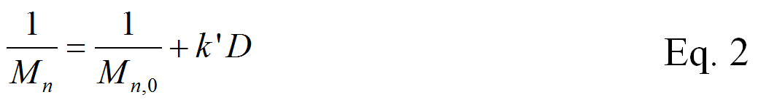

The equation corresponds to random fragmentation of polymers in general29, where k’ equals k/M0 (M0 being the monomer mass, 198 Da for sodium alginate) and the reaction time (t) is substituted by the irradiation dose (D). The equation is identical to that used by Sen et al.26

An alternative to rate constants in the present context is the ‘yield of chain scission’ (Gs)25, which normalizes the degradation rate in terms of polymer concentration (c), solution density (d) and degradation dose (D) defined as

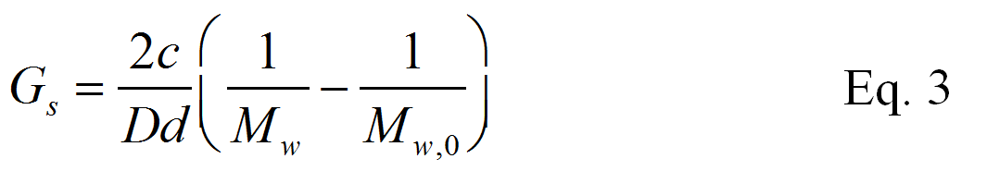

Comparing Eqs. 2 and 3 yields

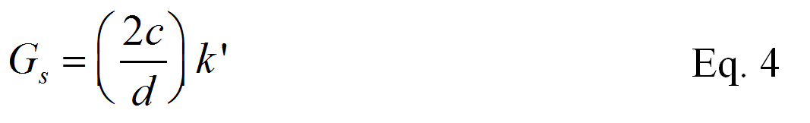

Hence, Gs and k’ are proportional, and the relative comparisons carried out here will be unaffected by substituting Gs for k’.

Another parameter used to quantify the extent of degradation is Nx, which for a certain extent of degradation (x) is defined as26:

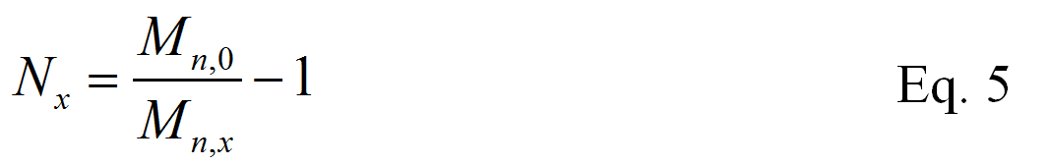

The relationship between Nx and the constant k’ is obtained by rearranging the relationship also given by Sen et al.26:

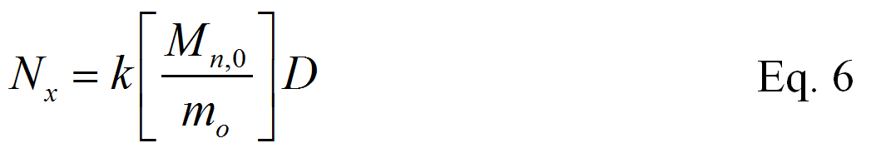

A disadvantage of using Nx is its dependence on the molecular weight of the undegraded sample (Mn,0). Hence, comparing alginates with different molecular weights would introduce an additional variable in the analysis, and Nx was therefore not adopted here.

As all experiments in solution were carried out at the same concentration of alginate (1% w/v), k’ is used as the primary parameter in this study. Plots of 1/Mn versus irradiation dose at different concentrations of phenylalanine and histidine are given in Figure 5.



**Figure 5.** 1/Mn vs. γ-irradiation dose for irradiation of alginate in the presence of 0, 0.5, 5 and 50 mM phenylalanine (A-D) and 0, 0.5, 5 and 50 mM histidine (A, E-G). Filled symbols: 0.1 M Tris pH 8.0. Open symbols: 0.1 M citrate pH 5.0.

In all cases, the plots in Figure 5 are linear, in agreement with Eq. 2 and the assumption that the chains degrade randomly. Rate constants were subsequently determined and plotted as a function of the amino acid concentration (Figure 6).

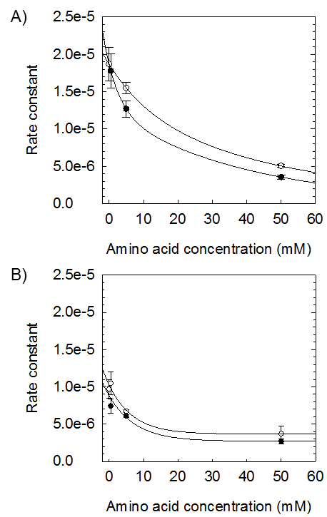

**Figure 6.** The influence of histidine and phenylalanine on the rate of degradation (k’) of alginate (1% w/v) by γ-irradiation in 0.1 M citrate buffer, pH 5 (A) and 0.1 M Tris buffer, pH 8 (B). Lines are drawn as guides-to-the eye. Filled circles: Histidine. Open circles: Phenylalanine.

In contrast to glycine, which had no detectable influence on the degradation rate (data not shown), both histidine and phenylalanine showed a concentration-dependent reduction of the rate of alginate degradation. The greatest changes occurred at relatively low concentrations (0 – 10 mM), whereas a tendency for levelling off was observed around 50 mM. We ascribe the difference between glycine on one hand, and histidine and phenylalanine on the other, to the high ability of the latter to effectively scavenge hydroxyl radicals. Rate constants for the reaction of phenylalanine and histidine with hydroxyl radicals are 480 and 12 times larger, respectively, than that of glycine30.

Apparently, low concentrations of these amino acids are sufficient to scavenge most of the hydroxyl radicals generated during γ-irradiation. Although the amount of radicals and the kinetics of radical scavenging may not be accurately known in the present case, it may still be possible to make a rough estimate of the amount of hydroxyl radicals based on data from pulse radiolysis of alginate. Scott et al.31 estimated that an irradiation dose corresponding to 1 kGy results in the formation of 0.5 mM of hydroxyl radicals. If the efficiency to form hydroxyl radicals (per dose unit) is somewhat similar with our conditions in gamma-radiolysis, the explanation as described above is possible.

Figure 6 also shows that the degradation of alginate, both in the absence and presence of amino acids, is about two times faster at pH 5 (0.1 M citrate buffer) than at pH 8 (0.1 M Tris buffer). To investigate any possible effects caused by pH alone, an additional series of γ-irradiation experiments (0 and 1 kGy) were conducted with four different buffers with low ionic strength: a) 5 mM citrate pH 5 b) 5 mM acetate pH 5 c) 5 mM Tris-HCl pH 8 and d) 5 mM phosphate pH 8. Rate constants determined in 5 mM buffers may in practise also be taken as values in the absence of salt. The ionic strength of 1% (10 g/l) sodium alginate is 50.5 mM, and the additional 5 mM should have a marginal influence. This is supported by the fact that the rate constant was not significantly changed by adding glycine up to 50 mM.

Figure 7 shows the cumulative molar mass distributions obtained before and after irradiation. The data suggests that the distributions obtained at pH 8 are only marginally shifted to lower molar masses compared to pH 5, whereas no significant differences can be observed between the buffers at the same pH. The finding that pH in the range 5-8 has a negligible influence on the rate of γ-irradiation induced degradation of alginate seems reasonable as alginate, with a pKa in the range 3.5, has the same state of ionization in this pH interval. However, compared to the influence of other components described below, the pH effect alone is very small and can be ignored in the present context. Hence, the differences between the buffers observed in Figure 6 are not due to pH differences, but to the nature and concentration of the buffers: Tris buffers lead to lower rates of alginate degradation. Tris-HCl in high concentrations (0.1 M) most probably acts as a free radical scavenger, as also observed by others32.

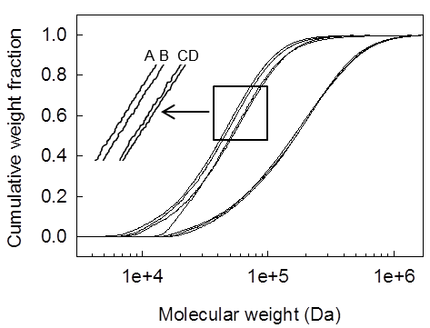

**Figure 7.** Cumulative molar mass distributions for undegraded alginate (black) and alginate irradiated with 1.0 kGy in 5 mM buffers. Insert: Expanded view. A: Tris pH 8, B: Phosphate pH 8, C: Citrate pH 5, D: Acetate pH 5

Despite the dependence of the buffer type on the rate constants (kHis and kPhe) observed in Figure 6, the ratio between them (kHis/kPhe) remains the same. The average values of the ratios in the interval 5 – 50 mM are 1.30 ± 0.10 and 1.30 ± 0.17 for pH 5 and pH 8, respectively. The imidazole side chain of histidine has a pKa of about 6.0. At pH 5 it becomes more charged (about 90% protonated) compared to pH 8 (less than 1% charged), whereas the state of ionization of phenylalanine is identical at pH 5 and pH 8. Hence, the protonation state of histidine seems to have a marginal or no effect on its protective effect against γ-irradiation induced degradation of alginate.

The dose range used here to determine rate constants (0 – 2 kGy) may be too low for many practical applications. However, the linear relationship between Mn-1 and dose, which according to Sen et al.26 persists up to doses of 25 kGy, renders our rate constants valid also in this range.

*Degradation of different alginates in solution and in the solid state*

Alginates differing in solution viscosities (between 80 and 960 cps), corresponding to different initial molar masses, were irradiated at 2 kGy in aqueous solutions (unbuffered). One sample (330 cps) was additionally irradiated at 2 kGy using 0.1 M Tris-HCl buffer pH 8.0. SEC-MALLS data obtained before and after γ-irradiation, including Mw and Mn values, are given in Supplementary Information (Sections 4.1-4.2)

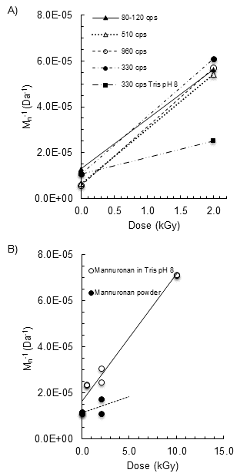

**Figure 8.** (A) Plots of 1/Mn versus γ-irradiation dose for four alginates differing in solution viscosity (80-120, 330, 560 and 910 cps) irradiated in the absence of buffer, and for the 330 cps alginate irradiated in 0.1 M TrisHCl buffer pH 8.0. (B) Corresponding plot for mannuronan irradiated in 0.1 M TrisHCl buffer pH 8.0, and for mannuronan irradiated in the dry state.

The results in Figure 8A suggest that the slopes of the plots of 1/Mn versus dose were largely independent of the initial molecular weight and dispersity, in accordance with a random depolymerisation mechanism and Eq. 2. The 80-120 cps sample did not behave much differently than the other samples although it had a significantly broader molecular weight distribution compared to the others. Using Mw instead of Mn would on the other hand provide clear differences, not clearly revealing the random nature of the degradation.

Results for homopolymeric mannuronan are given in Figure 8B. In 0.1 M Tris-HCl buffer pH 8 the mannuronan degrades essentially at the same rate as the other alginates (up to 2.0 kGy). Therefore, the chemical composition (‘M/G-profile’) has no major influence on the rate of degradation in solution. In contrast, Sen et al.26 reported a much larger effect of the chemical composition for irradiation of different alginates in the solid state. An analysis of their data suggests (by extrapolation to FG = 0) that mannuronan in that case would degrade 1.6 times faster than an alginate with FG = 0.45.

The figure further includes data for mannuronan irradiated for 0 and 2 kGy in the solid state. In this case the rate of degradation is about one order of magnitude lower than in aqueous solution.

*Effects of γ-irradiation upon chemical composition of alginates*

Possible structural effects of γ-irradiation of polysaccharides have not been much described in the literature. Lee et al.15, however, reported large changes in the M/G profile upon irradiation of alginate in solution. For example, irradiation at 10 kGy led to an apparent change in the M/G ratio from 1.88 to 1.42, corresponding to an increase in FG from 0.35 to 0.41. The authors suggested this was due to a selective destruction of M residues, amounting to 24% according to their M/G data. Concomitantly, Mw decreased from about 200,000 Da to 100,000 Da (Fig. 2 in the article15). The number of chain breaks corresponding to this change is much too small to be solely responsible for an apparent loss of 24% of the M residues The selective loss of M residues without inducing chain breaks would necessarily lead to novel residues in the chain, and therefore novel peaks in the NMR spectrum. The quality of the 13C-NMR spectra presented by Lee et al. is probably not sufficient to identify such components, except if C5-epimerization (conversion of M to G) was the major event.

We addressed this problem by performing γ-irradiation at 10 kGy on homopolymeric mannuronan (1% solution), and then studying the degraded mannuronan by high-resolution 1H-NMR following standard protocols33, 34 (Figure 9). One notes the complete absence of peaks corresponding to L-guluronic acid, notably the anomeric proton signal normally appearing at 5.05 ppm. Apart for signals corresponding to the reducing ends (M1redα at 5.21 ppm and M1redβ at 4.89 ppm) only a minor peak at 4.83 ppm was found. We may therefore conclude that no detectable conversion from M to G occurs in our case. Notably, peaks corresponding to unsaturated (double bond between C4 and C5) derivatives35 that could possibly form by radical reactions16 could not be detected. The NMR data does therefore not provide data on the mechanism of degradation, for instance in support of the radical mechanisms proposed for alginate by Nagasawa et al.16 or for pectin by Zegota et al.36. It should be noted that γ-irradiation at 10 kGy in 1% mannuronan solution resulted in a decrease in Mw from 210 to 22 kDa, and a decrease in Mn from 85 to 14 kDa (Figure 8b). The latter corresponds to a number average chain length (DPn = Mn/M0) of 71, meaning 2 out of 70 residues are terminal (non-reducing and reducing end positions) and may in principle carry chemical modifications resulting from reaction with radicals followed by chain scission.

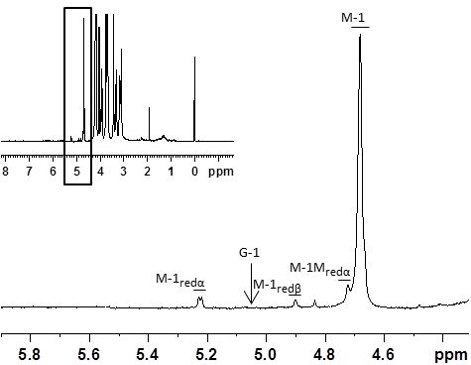

**Figure 9.** The 1H-NMR spectrum (300 MHz, D2O at 90°C) of mannuronan (anomeric region) after γ-irradiation (10 kGy, 1% solution). A peak corresponding to H-1 of G residues (expected at 5.05 ppm, indicated by an arrow) cannot be seen in the spectrum. The inserted figure shows the complete spectrum where the anomeric region is indicated.

To further explore possible structural effects of γ-irradiation on alginates in general, we conducted γ-irradiation experiments with a series of alginates in addition to homopolymeric mannuronan, both in the dry state and in 1% solution, and analysed the degraded alginates with high-resolution 1H-NMR. The different monad-, diad- and triad frequencies were calculated according to Grasdalen et al.33, 37 and the results are summarized in Table 1. As a general observation, no significant changes in the M/G ratio and in the diad and triad frequencies were observed for γ-irradiation at 2.0 kGy. We may therefore conclude that structural effects are negligible in the dose range used here.

Another possibility of structural changes occurring concomitantly with depolymerisation could be secondary reactions between the amino acid radicals formed by γ-irradiation, and the alginate leading to, for example, amino acid substituted alginate. Such by-products cannot be excluded. However, no signals suggesting reactions with amino acids were identified in the 1H-NMR spectra. The extent of such reactions therefore seems negligible.

**Table 1.** Composition (monad- diad- and triad frequencies) and M/G-ratio of untreated and γ-irradiated mannuronan and alginates at different conditions. The samples were analysed by 1H-NMR (300MHz) in D2O at 90°C. Monad-, diad- and triad frequencies are calculated according to Grasdalen et al.33, 37

|  |  |  |  |  |  |  |  |  |  |  |  |  |
| --- | --- | --- | --- | --- | --- | --- | --- | --- | --- | --- | --- | --- |
| **Sample** | **Mw**  **(kDa)** | **Irr. dose**  **(kGy)** | **Irradiation**  **Conditions** | **FG** | **FM** | **FGG** | **FGM** | **FMM** | **FGGM** | **FMGM** | **FGGG** | **M/G** |
| Mannuronan | 210 | 0.0 |  | - | 1.00 | - | - | 1.00 | - | - | - | - |
|  | n.d. | 2.0 | Solid state | - | 1.00 | - | - | 1.00 | - | - | - | - |
|  | 61 | 2.0 | 100 mM Tris pH 8 | - | 1.00 | - | - | 1.00 | - | - | - | - |
|  | 22 | 10.0 | 100 mM Tris pH 8 | - | 1.00 | - | - | 1.00 | - | - | - | - |
| Alginate 330 cps | 230 | 0.0 |  | 0.44 | 0.56 | 0.26 | 0.18 | 0.38 | 0.04 | 0.14 | 0.08 | 1.27 |
|  | n.d. | 2.0 | 100 mM Tris pH 8 | 0.44 | 0.56 | 0.27 | 0.17 | 0.39 | 0.04 | 0.13 | 0.10 | 1.27 |
|  | n.d. | 2.0 | Powder | 0.44 | 0.56 | 0.27 | 0.17 | 0.38 | 0.04 | 0.13 | 0.09 | 1.26 |
|  | 30 | 2.0 | Unbuffered water | 0.45 | 0.55 | 0.27 | 0.18 | 0.38 | 0.04 | 0.13 | 0.10 | 1.23 |
| Alginate 80 - 120 cps | 220 | 0.0 |  | 0.44 | 0.56 | 0.26 | 0.18 | 0.38 | 0.04 | 0.14 | 0.08 | 1.29 |
|  | 28 | 2.0 | Unbuffered water | 0.45 | 0.55 | 0.28 | 0.17 | 0.38 | 0.04 | 0.13 | 0.11 | 1.21 |
| Alginate 510 cps | 360 | 0.0 |  | 0.44 | 0.56 | 0.25 | 0.18 | 0.38 | 0.05 | 0.14 | 0.07 | 1.29 |
|  | 30 | 2.0 | Unbuffered water | 0.44 | 0.56 | 0.26 | 0.18 | 0.39 | 0.04 | 0.14 | 0.09 | 1.28 |
| Alginate 960 cps | 430 | 0.0 |  | 0.46 | 0.54 | 0.28 | 0.18 | 0.36 | 0.05 | 0.13 | 0.10 | 1.18 |
|  | 33 | 2.0 | Unbuffered water | 0.47 | 0.53 | 0.30 | 0.18 | 0.35 | 0.04 | 0.13 | 0.12 | 1.11 |

CONCLUSIONS

Alginate-based hydrogels are increasingly being applied as scaffolds in tissue engineering and as materials for 3D printing and cell-array technologies. In many cases peptides or proteins may be present, for example as ligands for cell attachment. γ-irradiation is a commonly used method for sterilization of such biomaterials and it is therefore of great interest to clarify the role of amino acids in the γ-irradiation induced degradation of alginate. Of particular relevance is the possible protective effect of amino acids such as histidine and phenylalanine, which have the ability to effectively scavenge free radicals.

Our data confirm several earlier studies showing that alginates degrade according to pseudo first order kinetics when exposed to γ-irradiation. The rate of degradation can be significantly decreased by adding amino acids known to scavenge free radicals, in particular histidine or phenylalanine, but not by adding glycine. pH itself and the type of buffer (5 mM range) has a negligible influence on the rate of degradation. However, 0.1 M Tris buffer at pH 8 does have a detectable stabilizing effect, which is attributed to the radical scavenging effect of Tris itself. No changes in the chemical composition (M/G profile) were detected for a series of alginates, including homopolymeric mannuronan.

SUPPORTING INFORMATION AVAILABLE

Mw values plotted as a function of γ-irradiation doses. This material is available free of charge via the Internet at <http://pubs.acs.org>

AUTHOR INFORMATION

**Corresponding Author**

*Bjørn E. Christensen. E-mail: bjorn.christensen@ntnu.no

Author Contributions

The manuscript was written through contributions of all authors. All authors have given approval to the final version of the manuscript.

Funding Sources

This work was supported by grants from NTNU (Project 81726300, PhD grant M.Ø. Dalheim) and the Research Council of Norway (Grants no. 211935)

ACKNOWLEDGMENT

Mr. Takaya Yamamoto (Osaka Prefecture University) is thanked for technical help in preparing samples for γ-irradiation

REFERENCES

(1) Andersen, T.; Strand, B. L.; Formo, K.; Alsberg, E.; Christensen, B. E., Alginates as biomaterials in tissue engineering. In *Carbohydrate Chemistry - Chemical and Biological Approaches*, Rauter, A. P.; Lindhorst, T. K., Eds. The Royal Society of Chemistry: Cambridge, UK, 2012; Vol. 37, pp 227-258.

(2) Donati, I.; Paoletti, S., Material Properties of Alginates. In *Alginates: Biology and Applications*, Rehm, B. H. A., Ed. Springer Berlin / Heidelberg: 2009; Vol. 13, pp 1-53.

(3) Kong, H. J.; Smith, M. K.; Mooney, D. J., Designing alginate hydrogels to maintain viability of immobilized cells. *Biomaterials* **2003,** 24, (22), 4023-4029.

(4) Goh, C. H.; Heng, P. W. S.; Chan, L. W., Alginates as a useful natural polymer for microencapsulation and therapeutic applications. *Carbohyd Polym* **2012,** 88, (1), 1-12.

(5) Mørch, Y. A.; Strand, B. L.; Skjåk-Bræk, G., Alginate structure function relationships relevant to their use for cell encapsulation. In *The Bioartificial Pancreas and Other Biohybrid Therapies*, Hallé, J.-P.; de Vos, P.; Rosenberg, L., Eds. Research Science Post: Kerala, India, 2009; pp 51-66.

(6) Wu, M. H.; Huang, S. B.; Lee, G. B., Microfluidic cell culture systems for drug research. *Lab on a chip* **2010,** 10, (8), 939-56.

(7) Tasoglu, S.; Gurkan, U. A.; Wang, S.; Demirci, U., Manipulating biological agents and cells in micro-scale volumes for applications in medicine. *Chemical Society reviews* **2013,** 42, (13), 5788-5808.

(8) Onoe, H.; Okitsu, T.; Itou, A.; Kato-Negishi, M.; Gojo, R.; Kiriya, D.; Sato, K.; Miura, S.; Iwanaga, S.; Kuribayashi-Shigetomi, K.; Matsunaga, Y. T.; Shimoyama, Y.; Takeuchi, S., Metre-long cell-laden microfibres exhibit tissue morphologies and functions. *Nat Mater* **2013,** 12, (6), 584-590.

(9) Nishiyama, Y.; Nakamura, M.; Henmi, C.; Yamaguchi, K.; Mochizuki, S.; Nakagawa, H.; Takiura, K., Development of a three-dimensional bioprinter: construction of cell supporting structures using hydrogel and state-of-the-art inkjet technology. *J Biomechan Eng* **2009,** 131, (3), 035001.

(10) Khalil, S.; Sun, W., Bioprinting endothelial cells with alginate for 3D tissue constructs. *J Biomechan Eng* **2009,** 131, (11), 111002.

(11) Higuchi, A.; Ling, Q. D.; Hsu, S. T.; Umezawa, A., Biomimetic Cell Culture Proteins as Extracellular Matrices for Stem Cell Differentiation. *Chem Rev* **2012,** 112, (8), 4507-4540.

(12) Draget, K. I.; Moe, S. T.; Skjåk-Bræk, G.; Smidsrød, O., Alginates. In *Food Polysaccharides and Their Applications*, second ed.; Stephen, A. M.; Phillips, G. O.; Williams, P. A., Eds. CRC Press: Boca Raton, 2006; pp 289-334.

(13) Donati, I.; Mørch, Y. A.; Strand, B. L.; Skjåk-Bræk, G.; Paoletti, S., Effect of elongation of alternating sequences on swelling behavior and large deformation properties of natural alginate gels. *The journal of physical chemistry. B* **2009,** 113, 12916–12922.

(14) Andersen, T.; Melvik, J. E.; Gåserød, O.; Alsberg, E.; Christensen, B. E., Ionically gelled alginate foams: Physical properties controlled by operational and macromolecular parameters. *Biomacromolecules* **2012,** 13, 3703–3710.

(15) Lee, D. W.; Choi, W. S.; Byun, M. W.; Park, H. J.; Yu, Y. M.; Lee, C. M., Effect of g-irradiation on degradation of alginate. *J Agric Food Chem* **2003,** 51, (16), 4819-4823.

(16) Nagasawa, N.; Mitomo, H.; Yoshii, F.; Kume, T., Radiation-induced degradation of sodium alginate. *Polym Degrad Stabil* **2000,** 69, (3), 279-285.

(17) Cardoso, D. A.; Ulset, A. S.; Bender, J.; Jansen, J. A.; Christensen, B. E.; Leeuwenburgh, S. C., Effects of physical and chemical treatments on the molecular weight and degradation of alginate-hydroxyapatite composites. *Macromolecular bioscience* **2014,** 14, 872-880.

(18) Hsiong, S. X.; Huebsch, N.; Fischbach, C.; Kong, H. J.; Mooney, D. J., Integrin-adhesion ligand bond formation of preosteoblasts and stem cells in three-dimensional RGD presenting matrices. *Biomacromolecules* **2008,** 9, (7), 1843-1851.

(19) Vacharathit, V.; Silva, E. A.; Mooney, D. J., Viability and functionality of cells delivered from peptide conjugated scaffolds. *Biomaterials* **2011,** 32, (15), 3721-3728.

(20) Hara, M.; Koshimizu, N.; Yoshida, M.; Haug, I. J.; Ulset, A. S. T.; Christensen, B. E., Cross-linking and depolymerisation of g-irradiated fish gelatin and porcine gelatin studied by SEC-MALLS and SDS-PAGE: A comparative Study. *J Biomat Sci Polym Edn* **2010,** 21, (6-7), 877-892.

(21) Kristiansen, K. A.; Schirmer, B. C.; Aachmann, F. L.; Skjåk-Bræk, G.; Draget, K. I.; Christensen, B. E., Novel alginates prepared by independent control of chain stiffness and distribution of G-residues: Structure and gelling properties. *Carbohyd Polym* **2009,** 77, (4), 725-735.

(22) Kristiansen, K. A.; Dalheim, M. Ø.; Christensen, B. E., Periodate oxidation and macromolecular compaction of hyaluronan. *Pure Appl Chem* **2013,** 85, (9), 1893-1900.

(23) Kristiansen, K. A.; Tomren, H. B.; Christensen, B. E., Periodate oxidized alginates: Depolymerization kinetics. *Carbohyd Polym* **2011,** 86, 1595-1601.

(24) Vold, I. M. N.; Kristiansen, K. A.; Christensen, B. E., A study of the chain stiffness and extension of alginates, in vitro epimerized alginates, and periodate-oxidized alginates using size-exclusion chromatography combined with light scattering and viscosity detectors. *Biomacromolecules* **2006,** 7, 2136-2146.

(25) Wasikiewicz, J. M.; Yoshii, F.; Nagasawa, N.; Wach, R. A.; Mitomo, H., Degradation of chitosan and sodium alginate by gamma radiation, sonochemical and ultraviolet methods. *Radiat Phys Chem* **2005,** 73, (5), 287-295.

(26) Sen, M.; Rendevski, S.; Kavakli, P. A.; Sepehrianazar, A., Effect of G/M ratio on the radiation-induced degradation of sodium alginate. *Radiat Phys Chem* **2010,** 79, (3), 279-282.

(27) Christensen, B. E.; Skjåk-Bræk, G.; Smidsrød, O., Comment on "conformational changes and aggregation of alginic acid as determined by, fluorescence correlation spectroscopy". *Biomacromolecules* **2007,** 8, (10), 3279-3279.

(28) Ioan, C. E.; Aberle, T.; Burchard, W., Structure properties of dextran. 2. Dilute solution. *Macromolecules* **2000,** 33, (15), 5730-5739.

(29) Tanford, C., *Physical Chemistry of Macromolecules*. John Wiley & Sons: New York, 1961.

(30) Inoue, N.; Bessho, M.; Furuta, M.; Kojima, T.; Okuda, S.; Hara, M., A novel collagen hydrogel cross-linked by gamma-ray irradiation in acidic pH conditions. *J Biomat Sci Polym Edn* **2006,** 17, (8), 837-858.

(31) Scott, J. E.; Tigwell, M. J.; Phelps, C. F.; Nieduszynski, I. A., On the mechanism of scission of alginate chains by periodate. *Carbohyd Res* **1976,** 47, (1), 105-117.

(32) Hicks, M.; Gebicki, J. M., Rate constants for reaction of hydroxyl radicals with tris, tricine and hepes buffers. *Febs Lett* **1986,** 199, (1), 92-94.

(33) Grasdalen, H., High-field 1H-n.m.r. spectroscopy of alginate: Sequential structure and linkage conformations. *Carbohyd Res* **1983,** 118, 255-260.

(34) Campa, C.; Oust, A.; Skjåk-Bræk, G.; Paulsen, B. S.; Paoletti, S.; Christensen, B. E.; Ballance, S., Determination of average degree of polymerisation and distribution of oligosaccharides in a partially acid-hydrolysed homopolysaccharide: A comparison of four experimental methods applied to mannuronan. *J Chromatogr A* **2004,** 1026, (1-2), 271-281.

(35) Campa, C.; Holtan, S.; Nilsen, N.; Bjerkan, T. M.; Stokke, B. T.; Skjåk-Bræk, G., Biochemical analysis of the processive mechanism for epimerisation of alginate by mannuronan C-5 epimerase AlgE4. *Biochem J* **2004,** 381, (1), 155-164.

(36) Zegota, H., The effect of g-irradiation on citrus pectin in N2O and N2O/O2 saturated aqueous solutions. *Food Hydrocol* **1999,** 13, (1), 51-58.

(37) Grasdalen, H.; Larsen, B.; Smidsrød, O., A P.M.R. study of the composition and sequence of uronate residues in alginates. *Carbohyd Res* **1979,** 68, 23-31.