Effect of Water Wash on Mist and Aerosol Formation in Absorption Column
Hammad Majeedª Hallvard F. Svendsenª*
ª Norwegian University of Science and Technology, Trondheim 7491, Norway
First Author:

Hammad Majeed
Norwegian University of Science and Technology
E-mail address: hammad.majeed@ntnu.no

Second and Corresponding Author:

*Hallvard F. Svendsen
Norwegian University of Science and Technology
E-mail address: hallvard.svendsen@chemeng.ntnu.no
Corresponding author. Tel.: +47-95141784
Effect of Water Wash on Mist and Aerosol Formation in Absorption Column
Hammad Majeedª Hallvard F. Svendsenª*
ªNorwegian University of Science and Technology, Trondheim 7491, Norway
Abstract:
Environmental issues regarding solvent emissions can hamper the realization of state of the art post combustion CO₂ capture (PCCC). These emissions stem from the emitted flue gas from which CO₂ has been recovered and are due to volatile solvent in gas form and solvent carrying aerosols, either formed in the absorption column or carried over from an up-stream unit and contaminated by solvent in the absorber. The issue of aerosol-based emissions has only recently been reported for a PCCC process and very little information is available in this area. It is therefore important to understand and characterize the mechanisms of aerosol formation and growth so that appropriate actions can be taken in reducing the total amine emissions. From the literature and common practice, it is known that the use of a water wash section in a CO₂ capture column can reduce the total amine emissions from these plants. This is mainly a reduction in gaseous solvent content whereas emissions caused by aerosols may not be removed. Moreover, typical demisting equipment has low efficiency when the droplets or particles are in the range 0.1 - 3µ. It is thus very important to be able to predict the behavior of these aerosols passing through a water wash section.
In this study, we focus on the effect of water wash on aerosol composition and growth. It is found that water wash systems help in reducing both gaseous and aerosol-born amine emission. Aerosol droplets grow extensively in the water wash section because of water condensation and this may simplify subsequent removal in a demister. Droplet growth is found to be highly sensitive to gas phase amine depletion or content increase caused by high droplet number concentrations. Variations in operating parameters of the absorber and water wash columns were found to have effect on droplet growth and emission levels.
Keywords: Post combustion CO₂ capture, Absorption columns, Aerosol formation, Amine emissions, Water wash, Simulation
- Introduction:
Global climate change and increase in temperature are major issues of the current era [1,2]. Carbon capture and storage (CCS) is globally under extensive research and development as a method to reduce CO₂ emissions to the atmosphere, thereby mitigating emissions and climate problems and possibly provide a method for reducing the atmospheric CO₂ content [3]. Amine scrubbing is an advanced and robust process for post combustion carbon capture and 30 wt.% aqueous Monoethanolamine (MEA) solution is often considered as a base case solvent for PCCC plants [4,5].
When used for CO₂ removal from power plant exhaust, the need for solvent regeneration energy, reducing the overall plant efficiency, and environmental effects of amine emissions are still of great concern [4,6,7]. Emission of aerosols from an absorption column can in many cases lead to dramatically increased amine losses and is presently one of the main concerns in the realization of state of the art PCCC plants [7,8]. A comprehensive survey on aerosol formation in absorption and wet scrubbing processes is given by [9].
One mechanism for aerosol droplet formation is homogenous nucleation. Supersaturation of the gas phase is the important factor in the formation of an aerosol droplet and its growth. The degree of supersaturation (S), can be calculated using the following equation;
$$S=\frac{P(T, y_{1}^{G},…,y_{K}^{G})}{P_{s}(T, y_{1}^{G},…,y_{K}^{G})}$$
Where P is the actual total partial pressure of all vapour components i (i = 1,….., K + 1, component K+1 being the inert gas) and P_{s} is the total equilibrium pressure at the dew point of the vapour mixture.
The total pressure p or p_{s} can be calculated as the sum of the individual partial pressures of all condensable components. The saturation has to exceed the critical barrier before nucleation and consequently aerosol formation can take place [10,11]. Homogeneous nucleation is often difficult to distinguish from heterogeneous nucleation where extremely small particles in the gas, which are always there, serve as nucleation points, thereby lowering the critical barrier for condensation. In addition, and probably the most common source of aerosol emissions, is the presence of particles or droplets in the sub-micron range in the entering gas. In this work, the latter case is the focus.
In typical absorption columns for post combustion or industrial CO₂ capture the water-wash system is intended to control gas-phase emissions and it has been shown to be effective for this purpose. However, mist and aerosols pass through the water wash unaffected and conventional demisting systems also have a limited effect on controlling these emissions [12].
Pilot plant studies with MEA as solvent have shown that in the presence of sulphuric acid aerosols entering the absorber, the MEA emissions are in the range 600-1100 mg/Nm³ [13,14]. In the presence of soot, the MEA emissions were lower and in the range around 200 mg/Nm³. Without water wash and demisting equipment around 3500 mg/Nm³ MEA emissions have been reported [15].
Emission levels as mentioned are prohibitive with regard to industrial operation. In order to avoid or drastically reduce the aerosol levels, it is proposed to adjust amine absorber parameters in such a way that the aerosol droplets either evaporate or grow to a size at which they can easily be removed in conventional demisting equipment. The absorber and water wash section configuration and operating conditions have a significant effect on aerosol growth. Linde-BASF tested an advanced two stage water wash emission control system above the absorber bed. This helped to reduce the emissions but did not completely solve the problem [16]. Aker Solutions developed a novel emission control system involving the combination of an anti-mist design and an acid wash setup and used this on flue gas from a Residual Catalytic Cracker (RCC) containing external nuclei like H₂SO₄ which lead to high amine emission. With this new concept, the emissions were reduced significantly but still amine emissions in the range of a few ppm were confirmed [17].
Fulk reported in his work that aerosol growth in water wash columns is expected to occur because of rapid condensation of water on aerosols and modelling results presented in that work also indicate rapid growth of aerosol in wash sections[18]. In another modelling work the effect of water wash on aerosol growth is modelled and results exhibit the same characteristics as reported by Fulk [19].
All these investigations show that it is of vital significance to understand the behaviour of aerosols in both the absorber and water wash sections. In this work a 2D model is used to predict development in droplet internal temperature and concentration profiles, droplet growth and the effect of aerosol droplets on the gas phase in water wash sections used in PCCC plants.
2. Modelling
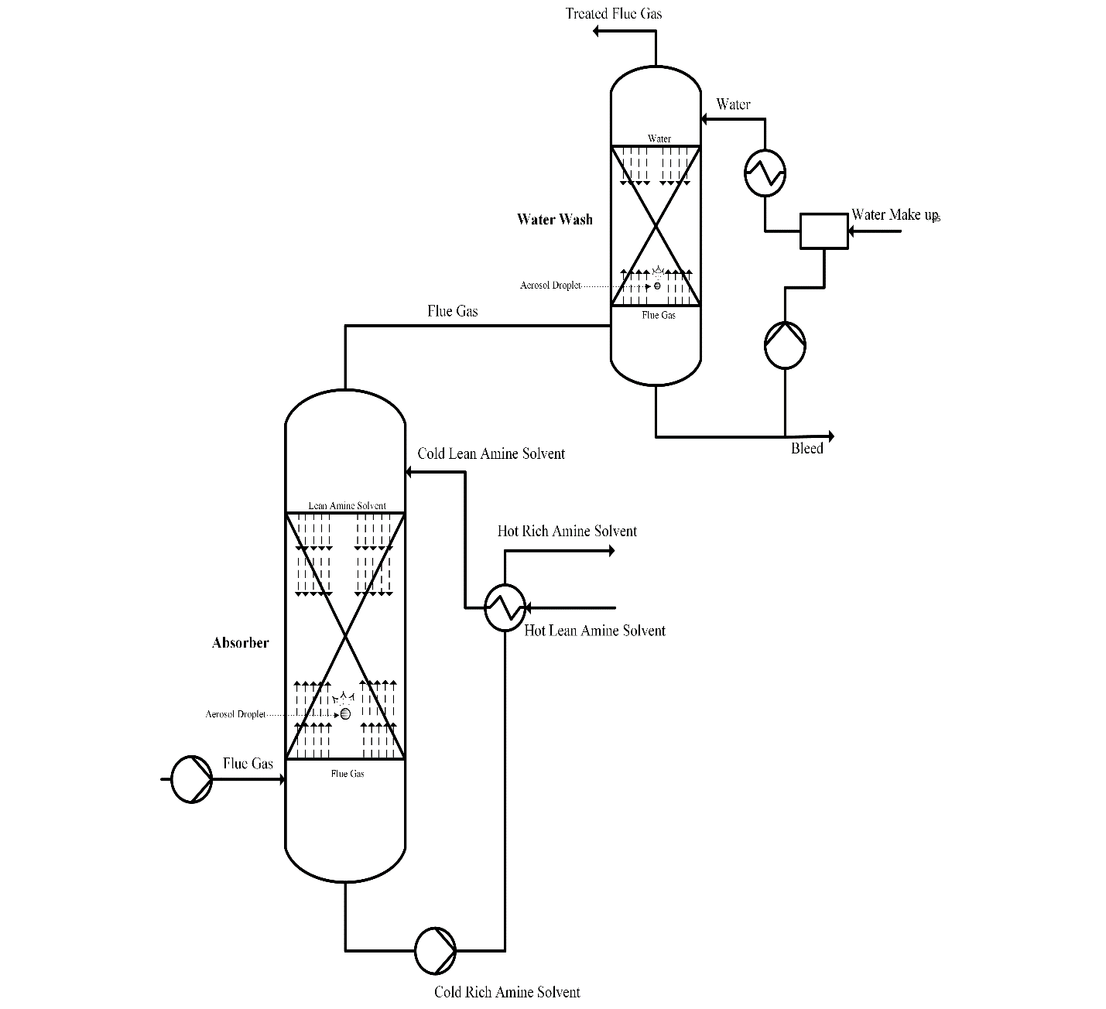
A detailed model covering the mass and heat transfer processes between gas and aerosol phase and between gas and bulk liquid phase, including the droplet internal concentration and temperature profiles, is developed and already well explained in [20,21]. These papers describe the model equations for the three phases, the data input, the solution methodology and also give examples how droplets shrink or grow as they pass through an absorber, along with the droplet internal variable profiles and also the gas phase profiles to see possible depletion effects. These papers focus on aerosol behaviour only in the absorber section and the water wash section is not included. The current work is an extension of the already developed model where the aerosol droplets travel with the gas phase from the absorber and into the water wash sections where wash water is recycled around each section. The water wash model comprises a set of transferring components along with heat transfer similar to that in the absorption section. A schematic illustration of the whole process is presented in figure 1. The illustration contains only one water wash but in fact two separate water washes of 2 m height were used to model results. Flue gas from the first water wash passes into water wash 2 and the liquid from water wash 2 is fed into water wash 1. The various cases were simulated in CO2SIM which then gave the liquid phase concentration and temperature profiles. These were used as basis for modelling the gas phase and droplet phase profiles.
Figure 1: Simplified process diagram of absorber and water wash in typical PCCC plants

3. Kinetics
The reaction kinetics of CO₂ and MEA is based on the termolecular mechanism [22,23] and a concentration based reaction rate with reversibility is used. The kinetic constants are given with Arrhenius type temperature dependency and adopted from [24,25]. The heat and mass transfer model is adopted from [26–28] while transport are taken from [29,30]. The equations and related information about the implementation used in the current work is well documented in [20,21].
Transport equations of the rigorous model were extended to the water wash sections. These equations were implemented in Matlab and solved with an orthogonal collocation method.
4.Results and discussions
In earlier papers [20,21] Aspen was used to model the gas and liquid phase absorber profiles as a basis for the aerosol droplet modelling. An absorber of 15m height was used with no water wash attached. In this work, another simulator, CO2SIM [31–34], is used to model the liquid and gas side profiles. A column of 15m together with two water washes of 2 m each were simulated in CO2SIM, and the profiles used as basis for the current work. The equilibrium model is an e-NRTL model adopted from [25] and was used as basis both for the aerosol modelling and the CO2SIM simulation of the absorber profiles. In the e-NRTL model the parameter fitting is based on binary MEA-water VLE data from [35,36], while the excess enthalpy data are taken from [37,38], freezing point depression data from [39], VLE data for the MEA-H₂O-CO₂ from [40] and CO₂ Solubility from [41]. Mass and heat balances between the gas and aerosol phase and between the gas and liquid phase are taken into account implying that only the bulk liquid phase profiles from the simulations are used and that gas phase composition and temperature are derived from mass and heat balances as described in [21].
The aerosol droplets are assumed to enter with the gas phase and travel up the column with a velocity relative to the gas phase given by the droplet terminal velocity. This velocity is very small for typical aerosol droplets. The aerosol droplets will undergo changes in terms of internal component and temperature profiles and in size. After the absorber section the droplets move directly into water wash 1 where they meet wash-water at a specific rate. Subsequently they enter water wash 2 and then exit with the treated flue gas. The droplet internal variable profiles and growth in both absorber and water wash will be presented and discussed in the modelled cases as given in Table 1. The focus, however, is the water wash section.

Table 1: Modelled Cases
Case 1 | Droplet, initial radius 1.5μ, containing 5M MEA travelling from bottom to top of column (0-19 m), c_{N}= 1-10⁷ drops/cm³
Case 2 | Droplet, initial radius 1.5μ, containing 0.0001M MEA travelling from bottom to top of column (0-19 m) , c_{N}= 1-10⁷ drops/cm³
Case 3 | Droplet, initial radius 0.15μ, containing 5M MEA travelling from bottom to top of column (0-19 m) c_{N}= 1-10⁷ drops/cm³
Case 4 | Droplet, initial radius 0.15μ, containing 0.0001M MEA travelling from bottom to top of column (0-19 m) c_{N}= 1-10⁷ drops/cm³

In Figure 2 the liquid phase composition and temperature profiles obtained from CO2SIM are shown. These are used as basis for the modelled cases 1-4 given in Table 1.
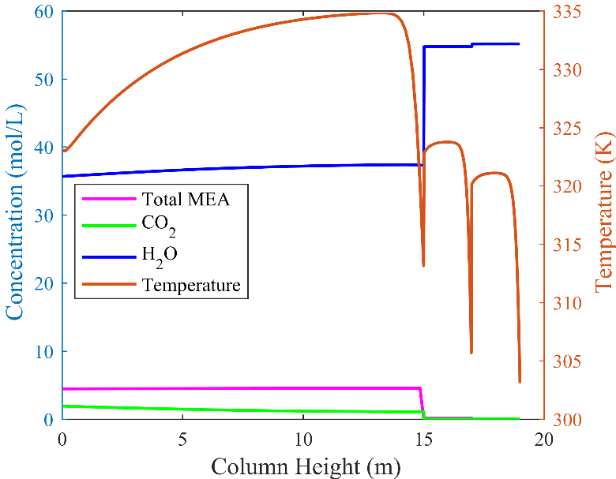

Figure 2: Liquid phase composition and temperature profiles in absorber and water wash
In the following sections, the results presentation and discussions are focused around the aerosol droplet behaviour in the water wash sections. For Case 1, also the absorber part is shown in order to show the whole picture for one case.
After presenting the results for cases 1-4, we have studied the impact of changing some operating and design parameters in order to investigate if such alterations could facilitate a reduction in amine emissions, either by a direct emission reduction, or by increasing the droplet size, making removal in an impingement type demister easier. Case 4 is selected as base case and alterations are made by varying a single parameter at a time. The cases studied are given in Table 2.
Table 2: Modelled cases by varying parameters
Case 5 | Case 4: Varying Parameter: Lean solution temperature increased from 40 ⁰C to 60 ⁰C
Case 6 | Case 4: Varying Parameter: Temperature of first water wash increased from 30 ⁰C to 40 ⁰C
Case 7 | Case 4: Varying Parameter: Temperature of second water wash increased from 30 ⁰C to 40 ⁰C
Case 8 | Case 4: Varying Parameter: Water wash height increased from 2m to 2.5m each
Case 9 | Case 4: Varying Parameter: Water wash flow rate of both, doubled from base case

4.1.Droplet internal and gas phase profiles
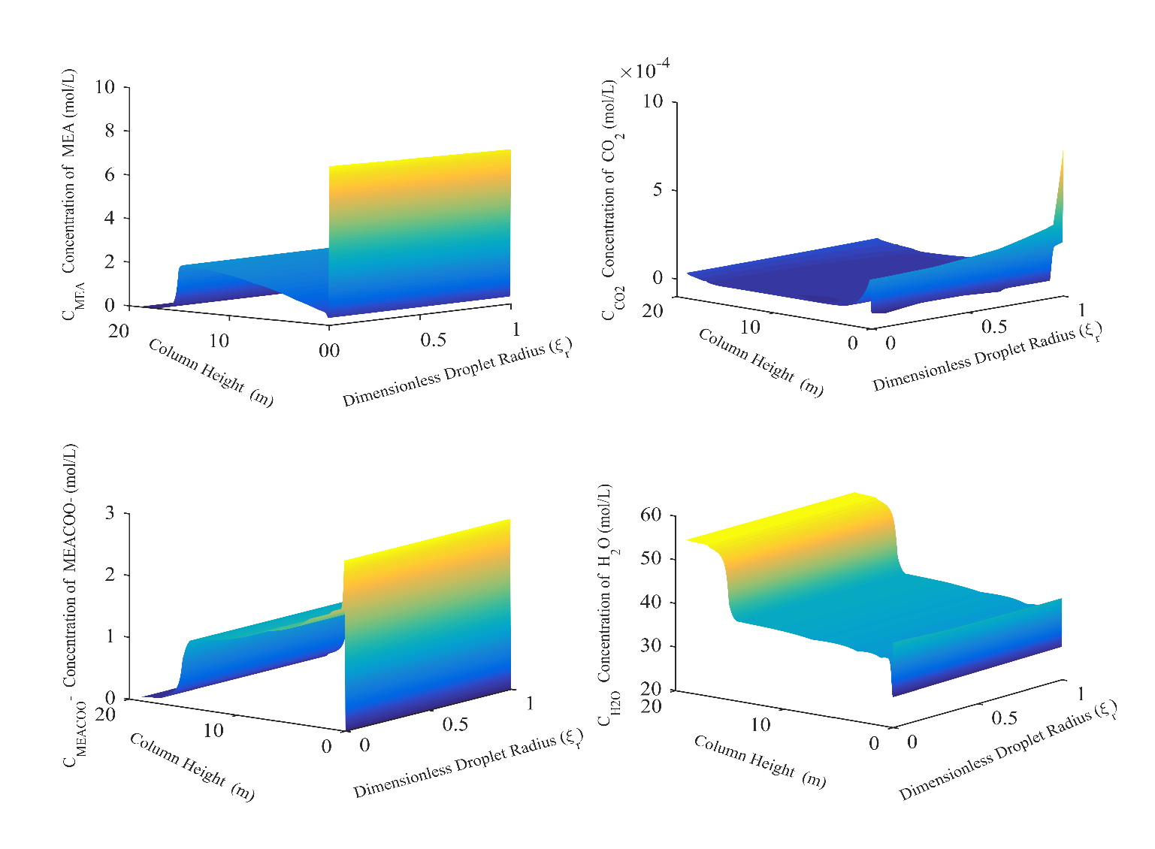
In Case 1, droplets with radius 1.5µ containing 5M MEA pass with the gas phase through the absorber and water washes, interacting continuously with the bulk liquid phase. The properties of the bulk liquid phase are given in Figure 2 and are assumed not to be affected by the aerosol droplets, regardless of number concentration. In Figure 3 are plotted respectively the free MEA, the free CO₂, the carbamate and the water concentrations as function of position in the absorber and water washes and as function of the droplet internal position. The free MEA profiles are given in Figure 3a and show that water evaporates fast, thereby increasing the MEA concentration initially. Figure 3d shows the respective drop in water concentration. This gives a rapid drop in droplet temperature, water starts condensing on the droplet surface, and the water concentration goes up. At the same time, CO₂ diffuses into the droplet, see Figure 3b, reacts with MEA, increases the droplet temperature and reduces the free MEA concentration. Relatively fast, a more stable situation is reached where CO₂ diffuses out of the aerosol droplet because of falling gas phase CO₂ partial pressure as it moves upwards in the absorber. At the same time, the carbamate concentration goes down accordingly. This is in full agreement with the results reported in [21].
Figure 3: Case 1: Concentration profiles whole column (a) MEA, (b) CO₂, (c) Carbamate, (d) Water
In Figure 4 are shown the droplet internal free MEA, carbamate and water profiles for the last meter of the absorber and the two water wash sections as function of initial droplet number concentration. As expected, the varying droplet compositions leaving the absorber also penetrate into the water washes and result in quite different concentration profiles in this section. With low droplet number concentration, the gas phase composition is unaffected by the aerosol, both in the absorber and the water washes. In this case the aerosol droplet composition is close to the bulk liquid composition at the end of the absorber. This is fully in line with the findings in [21]. Upon entering the water wash section the droplets meet a very dilute liquid phase. This gives low MEA partial pressures in the gas phase and MEA will start desorbing.
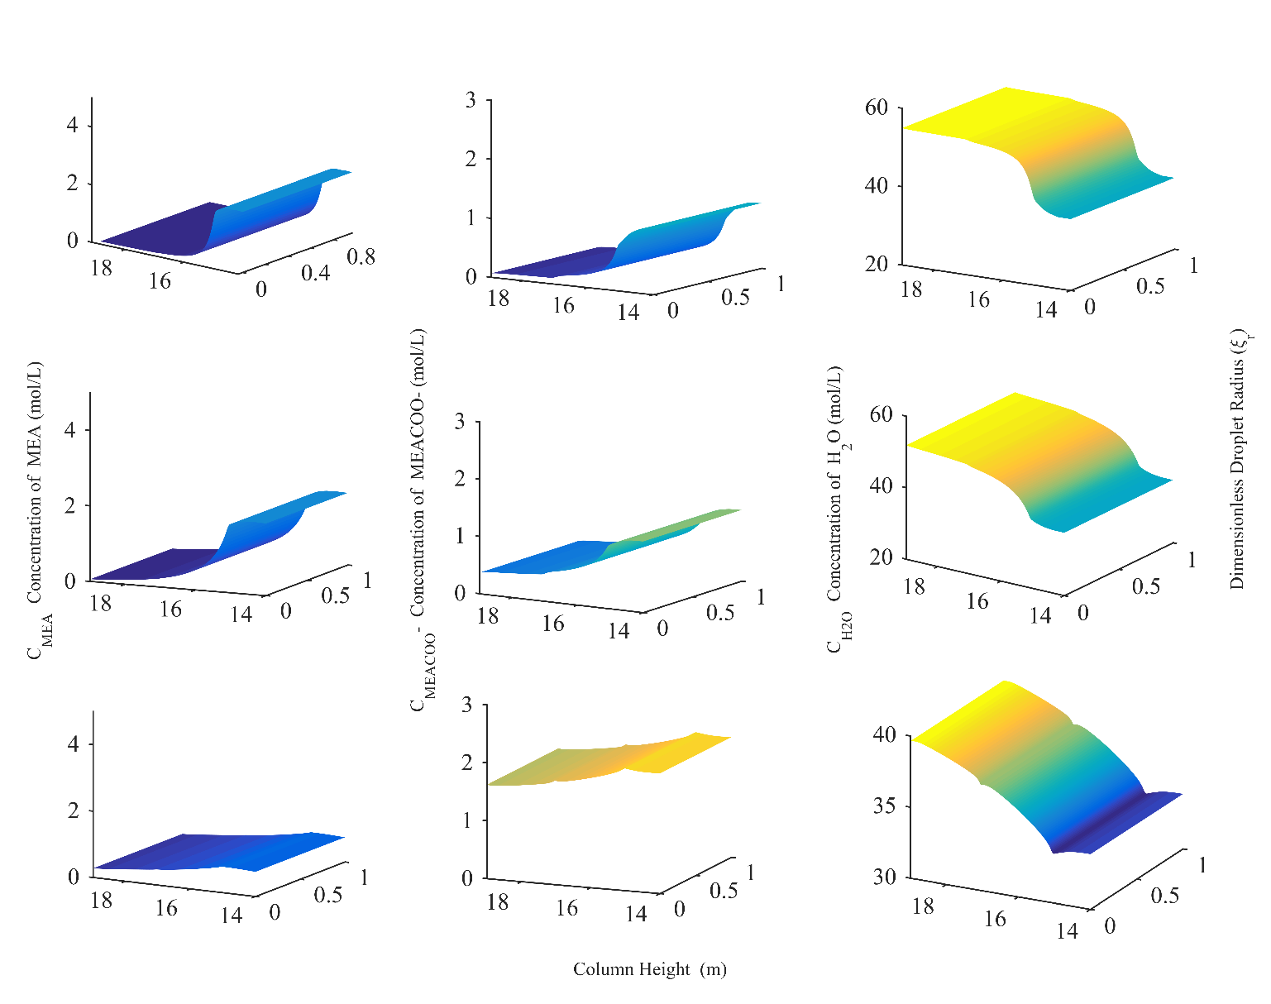
Figure 4: Case 1: Concentration profiles in water wash (a) MEA c_{N}=10³, (b) Carbamate c_{N}=10³, (c) Water c_{N}=10³, (d) MEA c_{N}=10⁵, (e) Carbamate c_{N}=10⁵, (f) Water c_{N}=10⁵, (g) MEA c_{N}=10⁷, (h) Carbamate c_{N}=10⁷, (i) Water c_{N}=10⁷

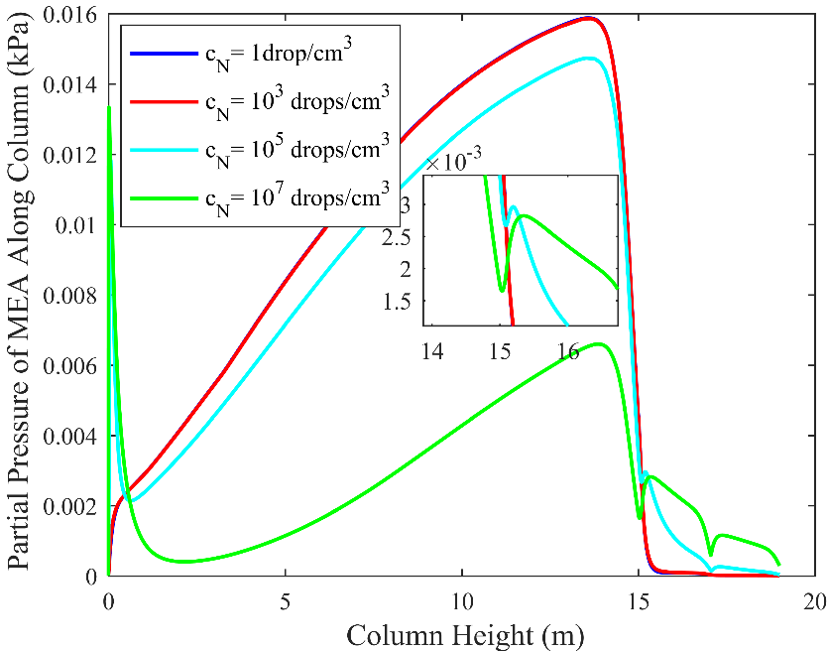

Figure 5: Pressure profiles along column (Case 1)
For the two lowest droplet number concentrations, the desorption of MEA is seen not to influence the gas phase in the absorber or water washes. However, already at a droplet number concentration of 10⁵ droplets/cm³, the gas phase composition profile for MEA is seen to be affected, see Figure 5, and MEA is slightly depleted from after about 1 m into the absorber and throughout the absorber. However, for the water wash part the effect is opposite. The large number of droplets now carry a significant amount of MEA into the wash section. This MEA strips out of the droplets and increases the gas phase MEA partial pressure. This MEA is mostly removed by the wash water, but also in the second water wash the MEA partial pressure is above what is seen for the low droplet number cases (c_{N} = 1-10³ droplets /cm³). Because of this, the droplets exiting the second water wash will have an MEA content higher than for the low droplet number cases. Increasing the droplet number to 10⁷ droplets /cm³ is seen to further aggravate the situation. A strong MEA depletion in the absorber is seen, and a subsequent strong carryover of MEA into the water wash section, manifesting itself in the MEA partial pressures seen in the water washes for this case in Figure 5 and the high remaining MEA and carbamate content in the leaving droplets, see Figure 4.
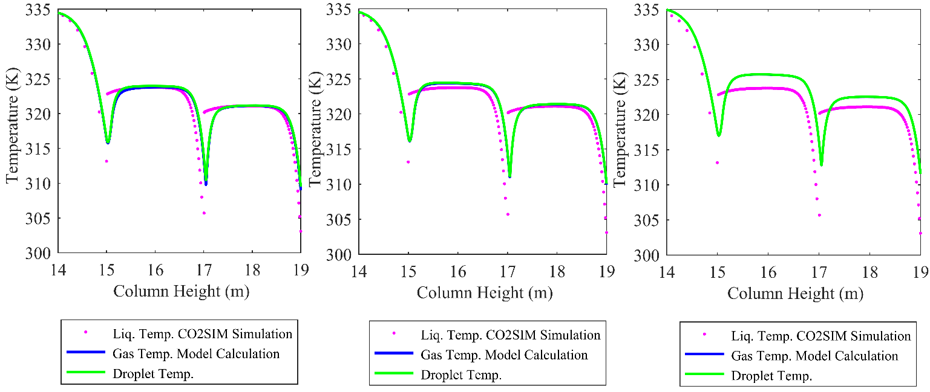
Figure 6: Case 1: Droplet temperature profiles in water wash; (a) c_{N}=10³ (b) c_{N}=10⁵ (c) c_{N}=10⁷

Figure 6 shows the temperature profiles for Case 1 and the three droplet number concentrations. For all cases the gas phase and droplet temperatures are practically equal and the curves are on top of each other. The temperature bulges seen in the water washes are caused mainly by condensation of water. We see that for the lowest droplet concentration, the gas and droplet temperatures follow the bulk liquid temperature apart from at the wash section inlets where gas and aerosol are lagging a little behind. Because of the limited heat capacity of the droplets, and also limited interfacial area, they do not significantly affect the gas temperature. Already at 10⁵ droplets /cm³, the gas and droplet phases are seen to reach higher temperatures than the bulk liquid. The droplets enter the water wash at low temperature and condensation takes place. With a large interfacial area, more water condenses on the droplets than on the bulk liquid, relative to the liquid mass, and thus, more heating up is seen. This effect is seen to be even stronger at 10⁷ droplets /cm³.
Case 2 is similar to case 1 except that the initial composition of the droplets is changed from 5M MEA to 0.0001M MEA, or close to pure water. As described earlier, only the water wash section results will be presented from case 2 and onwards. The obtained MEA, carbamate and water concentrations profiles for 1m from the absorber top and through the water washes are presented in the Supplementary information as Figure S1. Similarly, the gas phase MEA profiles are found in Figure S2. The temperature profiles in Figure S3 are also included in Supplementary information.
The profiles for 1 and 1000 droplets /cm³ overlap each other so only results from the latter case are presented. This is done for the following cases as well. At the lower droplet number concentrations, the droplet composition leaving the absorber is close to the bulk liquid, consistent with results in [20], and therefore very close to the composition in Case 1. Thus, as in Case 1, no influence on the gas phase MEA pressure profile is seen. At 10⁵ droplets /cm³, Figure S2 shows that the gas phase MEA depletion in the absorber is smaller than for Case 1. This is even more accentuated for 10⁷ droplets /cm³. At the same time the Case 1 droplets have a higher carbamate content and lower free MEA content than for Case 2. The total amine content out from the absorber is somewhat higher in Case 1 compared to Case 2. This gives a lower total carryover of amine into the water wash section in Case 2. However, as there is more free amine in Case 2 compared to carbamate, the MEA is released more rapidly in the water wash in case 2, leading to a higher MEA partial pressure in the gas phase initially in the first water wash.
As seen from Figures S1 and S2, the differences are small between Case 1 and 2 indicating that the inlet droplet amine content is not crucial for the final amine emissions after the water wash.
As MEA is desorbed from the droplets and as water condenses, the water concentration starts to build-up and increases from the first to the second water wash. At low droplet number concentrations, we end up with almost pure water. On the other hand, when the droplet number concentration is increased, the build-up of water is reduced as the larger droplet volume contains much more MEA. The removal of MEA to the gas phase reaches a pseudo equilibrium where the rate of removal from the droplets is governed by the rate of absorption into the bulk liquid phase. At high droplet number concentrations the bulk liquid absorption rate is relatively low and the amount of MEA present inside the droplets as they leave the second water wash is seen to be high, see Figure S1(g, h, i). The same effect is seen in Case 1 in Figure 4.
Figure S3 in supplementary results shows the temperature profiles in the water wash sections for all number concentrations. The initial decreases in temperature from 14 to15m at the top of absorber column is caused by cold incoming lean solution. The droplets then enter into the first water wash and an increase in temperature is observed as seen in the previous case; also mainly because of condensation of water.
Changing the initial composition of the droplets is seen to have very little to no impact on the temperature profiles as they are behaving the same as seen in Case 1.
Cases 3 and 4 are similar to cases 1 and 2 in the way that the compositions of the droplets are the same but the initial radii are reduced to 0.15µ. This is the droplet size range mostly reported in the literature regarding aerosol-based emissions. However, no specific size distribution is available in reported campaigns.
In Case 3 the droplets have an initial radius of 0.15µ containing 5M MEA. MEA, carbamate and water profiles for all number concentrations in this case are shown in Figure 7. It is seen that the profiles exhibit the same general behaviour as for the larger droplets. However, the changes in concentration are faster and the impact on the gas phase is smaller. The build-up of MEA inside the droplets at the absorber top at 15m is also the same as seen in case 1. This is reasonable, as the droplet diameter in case 3 is 10 times smaller than for Case 1. In the water wash, water starts to condense and MEA is desorbed. Increasing the droplet number concentration produces qualitatively similar results as seen in Figure 4 but the effects are weaker. Only at 10⁷ droplets /cm³ do we see significant concentrations of free MEA and carbamate in the droplets leaving the water washes, see Figure 7g and 7h.
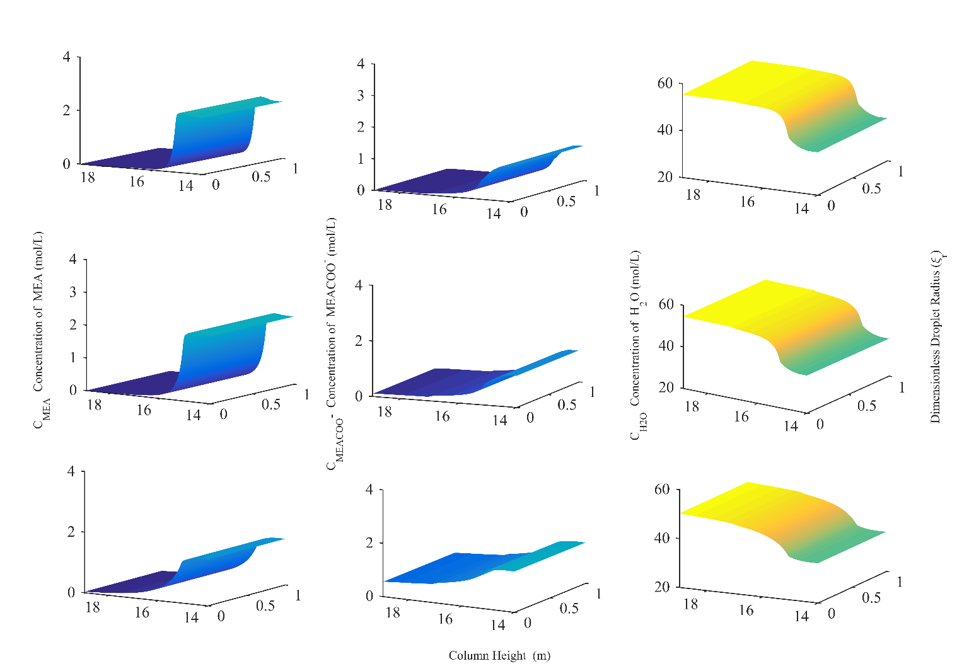
Figure 7: Case 3: Concentration profiles in water wash (a) MEA c_{N}=10³, (b) Carbamate c_{N}=10³, (c) Water c_{N}=10³, (d) MEA c_{N}=10⁵, (e) Carbamate c_{N}=10⁵, (f) Water c_{N}=10⁵, (g) MEA c_{N}=10⁷, (h) Carbamate c_{N}=10⁷, (i) Water c_{N}=10⁷
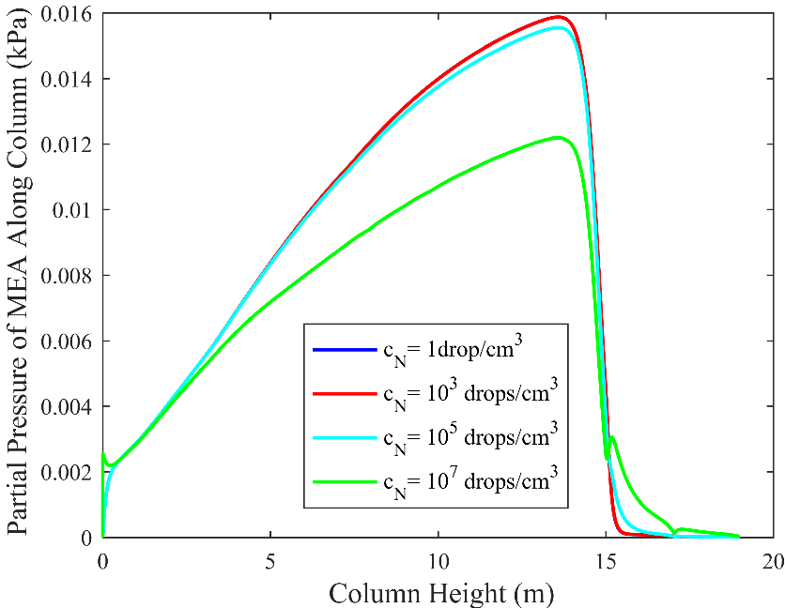

Figure 8: Pressure profiles along column (Case 3)

This is also reflected in Figure 8 where droplet number concentrations up to 10⁵ droplets /cm³ have a negligible impact on the gas phase profiles also in the water washes; although a small effect is visible for 10⁵ droplets /cm³. At 10⁷ droplets /cm³ we see a significant effect similar to Case 1.
Figure 9 presents temperature profiles for case 3. Droplet and gas phase temperature profiles follow the same pattern as the liquid bulk for the lower number concentrations and even up to 10⁵ droplets/cm³ no significant difference is seen. This is in line with the concentration profiles as discussed earlier. At 10⁷ droplets/cm³ the temperature of the gas and droplets is raised because of the increased volume and increased water condensation.
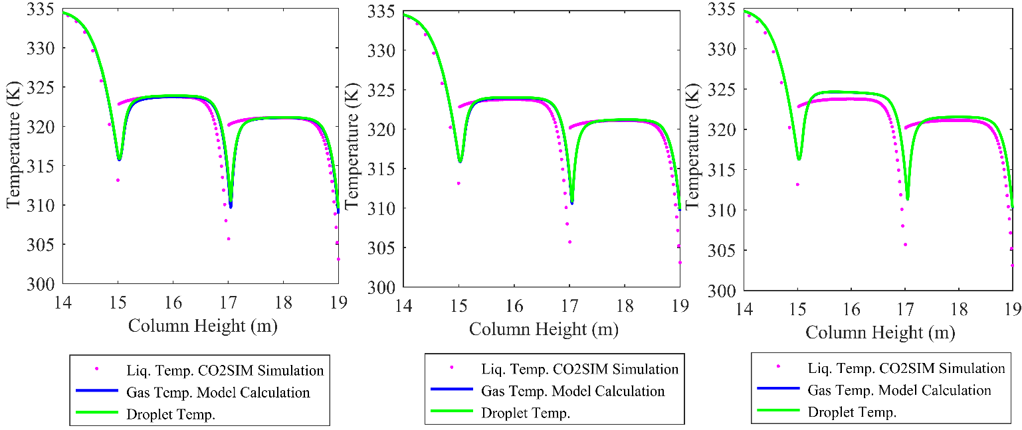
Figure 9: Case 3: Droplet temperature profiles in water wash; (a) c_{N}=10³ (b) c_{N}=10⁵ (c) c_{N}=10⁷

In Case 4 the initial radius is the same as in case 3 but the initial composition is changed to 0.0001M MEA. This is similar to case 2 in terms of initial composition. MEA, carbamate and water profiles for all number concentrations are presented in Figure 10. Starting with a close to pure water droplet the concentration of MEA inside the droplets increases as it moves up in absorber column because of positive driving forces of MEA towards the droplets. This increment is maintained toward the column top and a peak in concentration is seen. This peak in MEA concentration at the absorber top nearly vanishes when the number concentration is increased as some gas phase depletion of MEA at the top occurs, see Figure 11. When droplets enter into the first water wash, desorption of MEA starts rapidly and water condenses on the droplet surface increasing volume and temperature.
Comparing Figures 7 and 10, we see, as when comparing Case 1 and 2, that the total droplet MEA concentrations out from the absorber are very similar for the two lower droplet number cases. However, there is more free MEA and less carbamate in Case 4. The difference in this respect between case 3 and 4 compared to case 1 and 2, is larger. Thus, in case 4, because of this, the desorption rate in the first water wash is high and very small amounts of MEA remain in the droplet out from the water wash sections. At the highest number concentration a small amount of carbamate remains as seen in Figure 10h.
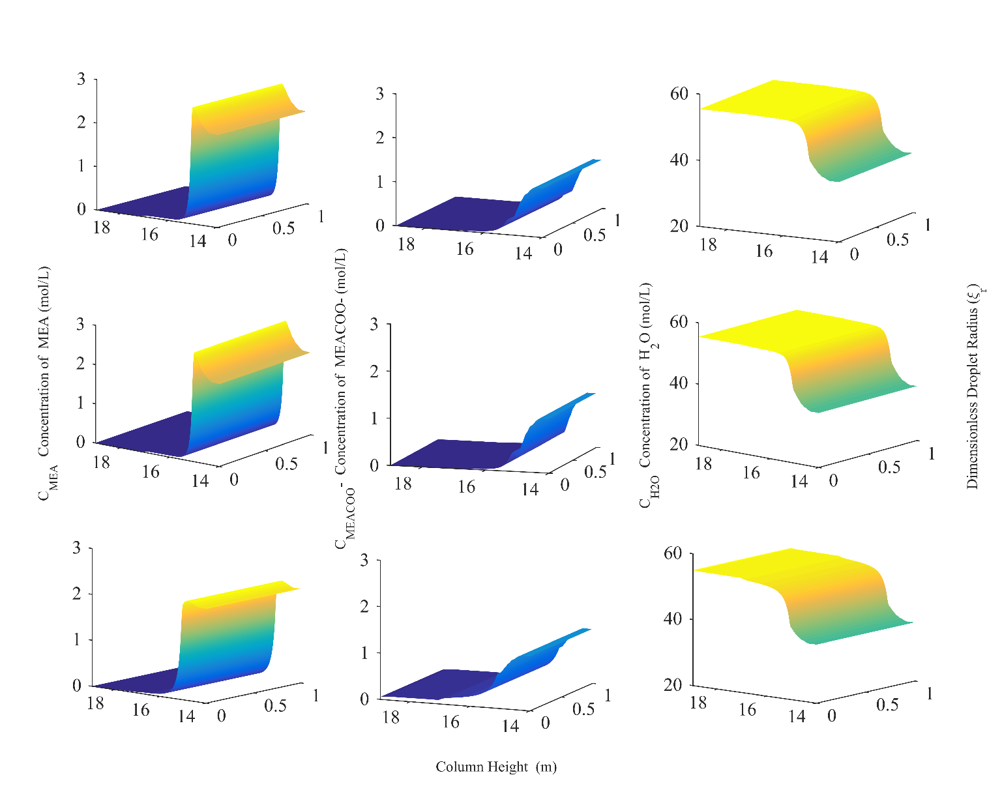
Figure 10: Case 4: Concentration profiles in water wash (a) MEA c_{N}=10³, (b) Carbamate c_{N}=10³, (c) Water c_{N}=10³, (d) MEA c_{N}=10⁵, (e) Carbamate c_{N}=10⁵, (f) Water c_{N}=10⁵, (g) MEA c_{N}=10⁷, (h) Carbamate c_{N}=10⁷, (i) Water c_{N}=10⁷
The amount of MEA desorbing into the gas phase in the water washes is small and hardly any peak in MEA partial pressure can be seen even up to 10⁷droplets/cm³. A small increase at the inlet of the first wash can be seen. In this case, the bulk liquid phase manages to absorb whatever comes into the gas phase from the droplets. This finding is in complete agreement with what was reported in [21], where it was found that in order to see any depletion effect of MEA in the gas phase, 10⁸droplets/cm³ were required for this initial composition and size of droplet.
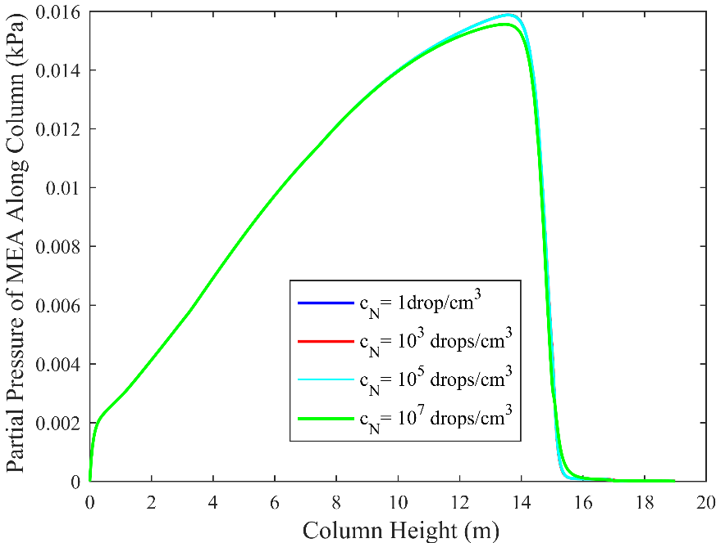

Figure 11: Pressure profiles along column (Case 4)

The temperature profiles for case 4 are very similar to those in case 3 in Figure 9. Thus, they are only included as figure S4 in supplementary results. This indicates that initial composition of the droplet may not have a significant effect on the temperature profiles for these droplet number concentrations and initial size of droplets.

4.2.Droplet Growth
The growth of droplets is another important factor in understanding the phenomena of mist and aerosol development. In this section droplet growth for varying droplet number concentrations will be discussed, particularly in the water wash section.
Droplet development for Case 1 is presented in Figure 12. A droplet having an initial radius of 1.5µ containing 5M MEA will grow in size to about 3.2µ in the absorber section and further grow rapidly in the wash section to about 6.7µ. Most of the droplet growth takes place in the first water wash section. There is little change in droplet growth when increasing the number concentration to c_{N}=10³ apart from in the second water wash. Figure 5 show the gas phase MEA partial pressure profiles and no visible difference between c_{N}=1 and 10³ can be seen in the second water wash. Still, the small difference existing in the partial pressures results in a visible difference in droplet growth. This illustrates the sensitivity in droplet growth to small variations in gas phase MEA partial pressure, the main reason being variations in water condensation. At c_{N}=10⁵ a large change in growth is seen, in particular in the water washes. The reason is the depletion of MEA in the gas phase as seen in Figure 5. Both the capacity for MEA in the droplet swarm and the total droplet surface area are large. This results in rapid absorption of MEA, which the mass transfer between bulk liquid and gas phase is not able to maintain. Therefore MEA depletion results. This again results in less MEA being transported into the droplets and the rate of water mass transfer to the droplets is also reduced. The main reason for the reduction in droplet growth is the reduced water uptake. When the number concentration reaches 10⁷ droplets/cm³, hardly any droplet size change is seen as the gas phase MEA depletion is large, see Figure 5, and prevents droplet growth even in the water wash section. This is in line with the findings of [21].

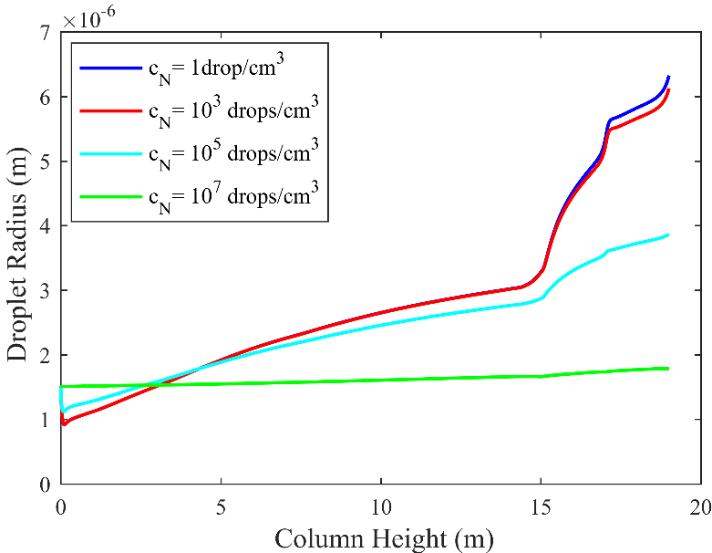

Figure 12: Growth of aerosol droplets with varying c_{N} (Case 1)

The growth of droplets with the same initial size but with 5M MEA is replaced with 0.0001M, is presented in Figure 13 for case 2.
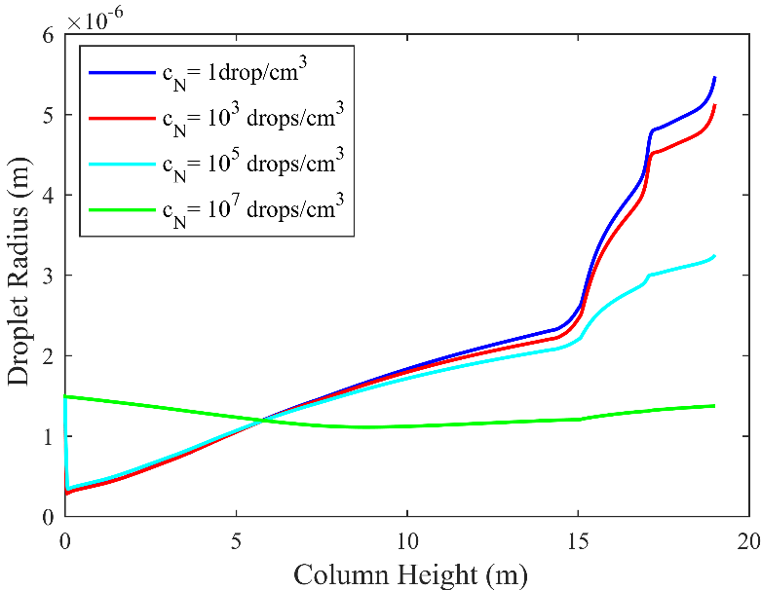

Figure 13: Growth of single aerosol droplet varying c_{N} (Case 2)

Modelling results show very similar behaviour as seen in case 1. Droplet number concentrations in the range 1-10³ droplets/cm³ have no significant effect on growth. Both concentrations follow somehow the same behaviour until the second water wash where a single droplet grows more than 10³ droplets. Similarly, increasing the number concentration further reduces the growth because of MEA gas phase depletion and in the case of 10⁷ droplets/cm³ the droplet size is actually reduced slightly from the initial size. Again, this illustrates the profound effect of MEA depletion in the gas phase.
The overall growth of droplets in Case 2 at all number concentrations is less than what was seen in Figure 12 for Case 1, showing an effect of changed initial composition. The initially 5M MEA droplets grow about 9% more in size than droplets with initially 0.0001 M MEA. Again, this shows the importance of the droplet MEA concentration in promoting water transfer to the droplets.
In cases, 3 and 4 the initial radius is reduced while the initial droplet concentrations are the same. In case 3, the droplets have an initial radius of 0.15µ with composition of 5M MEA. The growth profiles are shown in Figure 14.
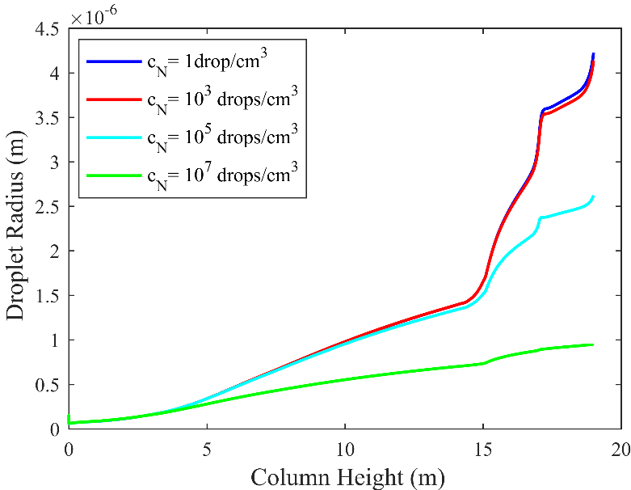

Figure 14: Growth of single aerosol droplet varying c_{N} (Case 3)

Plotted results exhibit similar behaviour as seen for Case 1. Droplet concentrations up to 10³ droplets/cm³ have no effect on the size change until the second water wash. A difference is seen when the droplet number concentration reaches 10⁵ droplets/cm³, but only in the water wash sections. This is consistent with the MEA partial pressure profiles shown in Figure 8 where a change is seen mainly for the first water wash. This change also affects the second water wash. It is interesting to note that even if the initial size is reduced by a factor of 10, the final droplet size exiting the water washes is only reduced by a factor of approximately 1.5. It is particularly the water wash sections that even out the droplet sizes. For droplet number concentration less than 10³ droplets/cm³, the size increases by a factor of more than 3 in Case 3, whereas as in Case 1 it only increased by a factor of about 2. A similar effect is seen for the higher droplet concentrations.
Profiles for case 4 in which the initial composition is changed to 0.0001M MEA with initial radius of 0.15µ are shown in Figure 15.

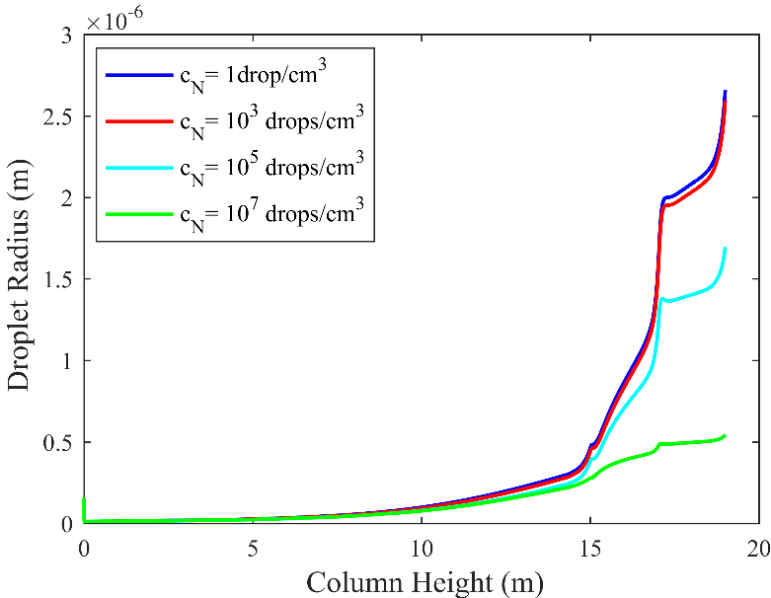

Figure 15: Growth of single aerosol droplet varying c_{N} (Case 4)
Starting with nearly pure water droplets, i.e. with 0.0001 M MEA, the profiles for overall growth for all number concentrations are similar to Case 2. The final sizes are reduced by about 25% compared to Case 3 in the lower droplet number concentration range. There is no difference between 1 drop or 1000 droplets as the profiles almost overlap each other until they leave with the treated flue gas from the second water wash. When c_{N} is extended to 10⁵ droplets/cm³ a reduction in growth is seen which, as in the other cases, is more pronounced with 10⁷ droplets/cm³. The results are in line with the previous cases. We see that droplets grow for all number concentrations in this case. The reason for this is the reduced MEA depletion effect as seen in Figure 11 where only a small increase in MEA partial pressure is seen at the entrance of the first water wash. Still, even with this almost invisible effect on the MEA partial pressure profiles, the growth rates are significantly decreased for the higher droplet number concentrations.

4.3.Changes in inlet parameters:
As described in the introduction section, experimental studies have shown that emission levels can be reduced by altering operating parameters in the absorber and water wash section, for details see [16,17]. In order to test this in our model, we have performed individual simulations of the whole flow sheet where the different factors have been varied. As a base case, the most realistic former case was used, i.e. Case 4. The new cases are listed in Table 2.
In Case 5 the temperature of the lean solution is increased from the base case 40 ⁰C to 60 ⁰C while the remaining parameters are the same. In Case 6 the temperature of the first water wash is increased from 30 ⁰C to 40 ⁰C and in Case 7 the temperature of the second water wash is increased from 30⁰C to 40⁰C. In Case 8 the height of the water wash sections is increased from 2m to 2.5m each and in Case 9 the flow rate of liquid in both water washes is doubled compared to the base case. In every case, one parameter is altered while remaining parameters are the same as in the base case. Number concentrations between 10³ and 10⁷ droplets/cm³ are reported as a typical range of aerosol droplets with 0.15µ size so only results for the two extreme number concentrations are reported in this section.
The MEA partial pressure profiles and droplet growth for cases 4 to 9 and the two number concentrations are presented in Figures 16 and 17.
The results in Figure 16 show that the changes made in operating conditions, apart from the lean amine inlet temperature, have very little influence on the MEA gas phase partial pressure profiles. The two number concentrations are shown individually in Figure 16 a) and b) because they almost overlap, indicating little effect of number concentration. This in line with the earlier findings for Case 4. When the lean amine inlet temperature is raised to 60ºC the MEA partial pressure in the absorber top is increased. This is reasonable because higher lean amine inlet temperature will raise the absorber and water wash temperatures as well. It should be noted that in all these cases, a CO₂ capture rate of 90% is targeted and other parameters were adjusted slightly to achieve this in the simulations.
In Figure 17 the results show the general trend that droplets grow in size regardless of operating conditions and number concentration caused by an uptake of amine and water. The lower droplet number concentration shows a much larger increase in final size than the high number concentration, as has also been observed in the previous section. Again, this shows the high sensitivity for droplet growth toward nearly invisible depletion of MEA in the gas phase.
For 10³ droplets/cm³ a variation in the inlet parameters does affect the final sizes and composition of droplets, but profiles are somewhat similar to the base case. Increasing the temperature in the first water wash, Case 6, does not affect the final droplet size significantly although it is reduced a bit. Increasing the temperature in the second water wash, Case 7, reduces the droplet size from the base case. In Case 5 where the lean solution enters at 60ºC, the droplet growth inside the absorber part is seen to be lower than in the other cases. This is because of increased volatility of both water and MEA caused by higher temperature. However, as the warmer gas and droplets move into the water wash section, more condensation takes place and the final droplet size is higher than for the other cases. When the height of both wash columns is increased from a total of 4 to 5m, Case 8, the droplets grow more because of the increased residence time. This shows that the water wash section size may play an important role. In the final case, Case 9, the liquid flowrate in both water washes is doubled. This gives an increased droplet size because the higher thermal capacity of the liquid flow maintains a lower temperature in the water washes resulting in increased condensation of water on the droplets.
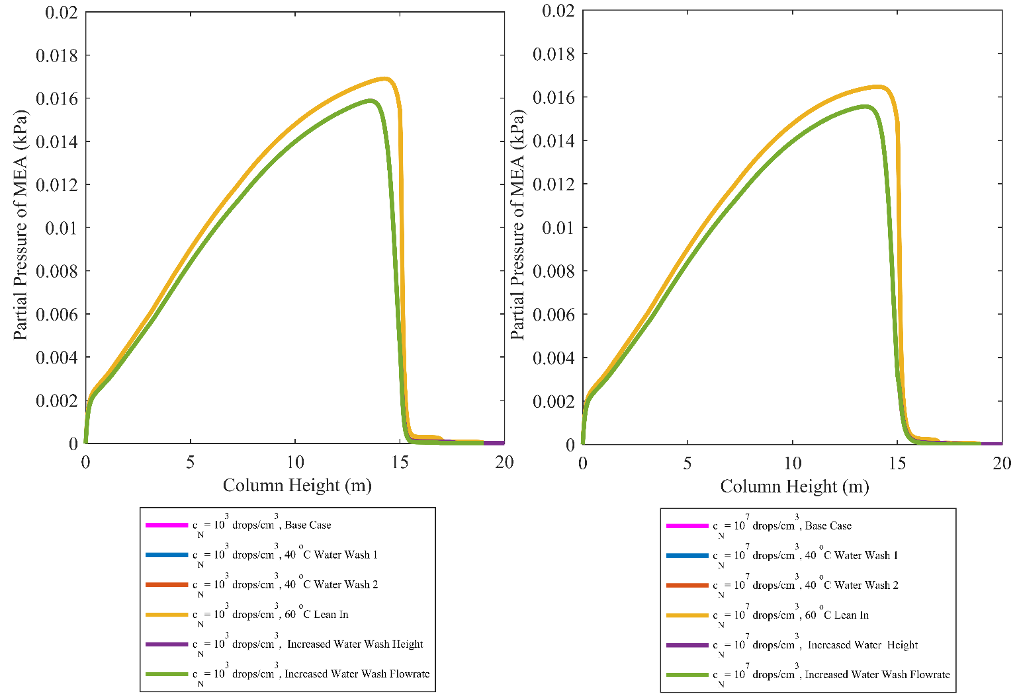
When the number concentrations are increased from 10³ to 10⁷ droplet/cm³ the effect of changes in operating conditions is very small. For Case 5, with increased lean amine temperature, a small increase in droplet size is seen.
Figure 16: MEA pressure profiles along column for varying operating parameters:
(a) 10³ droplets/cm³ (b) 10⁷ droplets/cm³
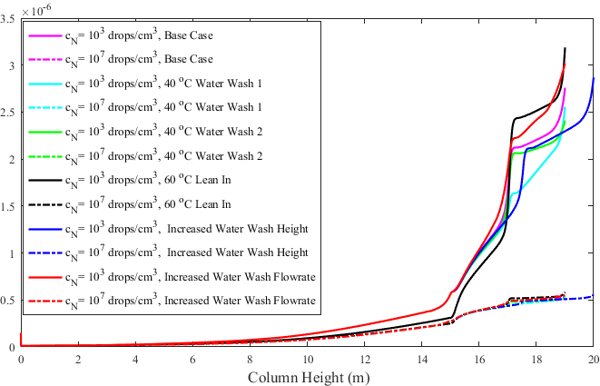

Figure 17: Droplet growth by varying inlet operating conditions

4.4. Results Assessment
Only few investigations based on emissions reduction and measurement of aerosols in terms of number concentration and losses in PCCC plants are available in the literature and can be used as comparison with the results of the modelling work.
Morken et al., [42], reported results of emissions of MEA from an absorber equipped with water wash and running on exhaust from a gas fired power plant. Unfortunately, these data are not useful for comparing with our results as the exhaust gas contained little or no particulates.
Amine emissions reported in [6,13,15] are all based on different sorts of foreign nuclei. Ranges of number concentrations are 10³-10⁷ droplets/cm³ with emissions of MEA ranging from 600-1100 mg/Nm³ in the presence of sulphuric acid and 200 mg/Nm³ when soot particles are introduced. In the current work cases 3 and 4 can be considered to be the most relevant for comparison because of their smaller initial droplet size. In Case 3, 5M MEA droplets having an initial size of 0.15µ enters with droplet number concentrations of 10³-10⁷droplets/cm³, the estimated total amine in the droplet swarm leaving the absorber column range from 5-5000 mg/Nm³. Out from the water wash section the emissions end up at 1-3400 mg/Nm³. The high values are attributed to the significant content of carbamate and protonated MEA (0.55mol/L) still being present in the droplets at c_{N}=10⁷droplets/cm³. The free MEA present in the droplets is low. When 5M is replaced with nearly pure water droplets with the same initial radius and number concentrations, the total amine release from the absorber section can range from 0.8-225 mg/Nm³ while exiting the second wash these emissions are 0.05-62 mg/Nm³.
In order to sum up the results for the varying operating parameters and the base case, the estimated amounts of MEA carried by the droplets are plotted as function of position for the three number concentration modelled as shown in Figure 18.
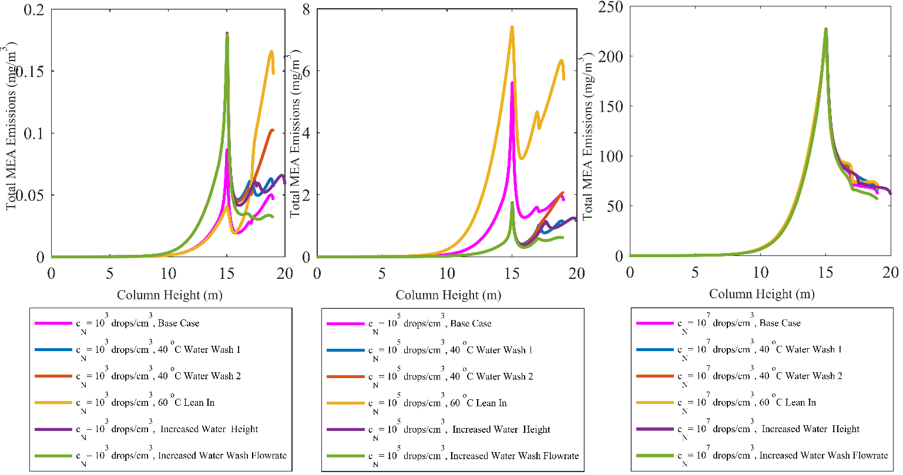
Figure 18: Estimated amine emissions from modelled absorber and water wash column (Base Case and Varying parameters)
For the lowest droplet number concentration, we see from Figure 18 that the aerosol-carried emission contribution is low for all changes in operating parameters, less than 0.2 mg/Nm³. However, the various operating conditions are seen to influence the emissions significantly. Increasing the lean amine inlet temperature to 60ºC is seen to give by far the largest emissions, if the gas leaves untreated. On the other hand, also the droplet size is the highest, and possibly a demisting devise may change the picture as discussed later. Increasing the temperature in water wash 1 is seen also to have a negative effect. The only change that reduces the emissions is to increase the liquid flow rate through the water washes. This change reduces the emissions and at the same time increases the droplet size.
At the highest droplet number concentration, c_{N}=10⁷droplets/cm³, the emissions predicted are very high, in the range 55-70 mg/Nm³. The effect of the water wash sections is large and is caused by the desorption of MEA from the droplets. In this case, it seems that changing operating parameters has very little effect. Even doubling the wash water flow rate has only a small effect.
With c_{N}=10⁵droplets/cm³, which may be the most relevant droplet concentration, the emissions are in a range well above what can be tolerated. However, the effect of operating variable changes is seen to have the largest impact. All changes, apart from lean amine and water wash 2 temperature rise, are seen to reduce the emissions. Again, increasing the wash water flow rate has the best effect.
Thus, altering the operating parameters is seen to affect droplet size as well as total MEA emissions before demisting. It is seen that increasing the wash water flow rate reduces the total amine emissions more than altering any other parameter compared to the base case, i.e. Case 4.
All absorption plants operating with amine solutions will have a form of demisting devise at the water wash outlet. Normally these devises are based on the principle of impingement separation and increased average droplet size will increase their efficiency. Oral discussions with operators of several pilot plants has revealed that one may see large and relatively rapid variations in emissions, often unexplained. When looking at the strong interaction between initial particle size, droplet number density, small variations in amine gas phase depletion and final droplet size one may speculate that this may be one reason, or part reason, for these variations. Impingement separators are designed with a certain efficiency, a “cut size” D₅₀, at which 50% of the droplets are removed. This can typically be in the range 3-8µ. If the droplets grow to large sizes, they may be removed by the separator with good efficiency. If the growth is hampered by for instance amine depletion, suddenly most of the droplets may pass the demister and result in large emissions
5.Conclusions
Aerosol formation in industrial gas cleaning processes causes severe complications and to understand the mechanism a model is required to explain the processes going on. This work is dedicated to characterizing aerosols in absorption columns as well as in water wash columns, but the focus of this paper is the water wash section.
Water wash systems are mainly intended to control gaseous emissions from absorption columns. However, modelling results show that water wash systems can be a very effective method also for reducing mist-born emissions through desorption of amine from aerosol droplets.
The water wash sections are also very effective in increasing droplet size. Typically, droplet sizes are increased by a factor of 2-8 from the absorber section outlet to the wash section outlet.
Initial droplet number concentration plays a crucial role in droplet growth through gas phase amine depletion or partial pressure increase. In the absorber section, large number concentrations result in amine depletion whereas in the wash section an increase in amine partial pressure is seen. Droplet growth is very sensitive to changes in gas phase amine content and for large initial droplet size and number concentrations, hardly any growth takes place. This sensitivity may partly explain observed large variations in pilot plant emissions.
Growth of droplets to sizes rendering them removable in a demister may be a method for emissions reduction in cases with high inlet gas particulate content.
Operational parameters as lean amine temperature, water wash temperature, water wash height and wash water flow rate were varied in order to study their effect on droplet size and emissions. It was found that increasing lean amine temperature increased both droplet size and emissions before demisting. Increasing temperature in the last water wash section had a similar, but weaker effect. Increased wash water flow rate reduced emissions and increased the droplet size. The other parameters had little effect. At the high droplet number concentrations, i.e. 10⁷ droplet/cm³, all parameters had little or no effect.
Droplet size distributions as well as specific properties of particles entering with the flue gas stream, e.g. sulphuric acid drops, fly ash, soot are important factors that affect the growth and internal profiles. These external nuclei may lead to different emissions based on their particular properties. Characterization of these properties and their effect on emissions will be part of future work.

Acknowledgement
Financial support from the Faculty of Natural Sciences at the Norwegian University of Science and Technology, Trondheim and the CLIMIT Demo project Aerosolve (616125) with partners SINTEF Materials and Chemistry, NTNU, Technology Center Mongstad, Maasvlakte CCS project (ROAD), Uniper, Energie Laborelec and TNO. Technical support from Andrew Tobiesen, SINTEF Material and Chemistry, is greatly appreciated

Notations
P | Partial pressure (kPa) | Greek letters
t | Time (sec)
T | Temperature (K) | µ | micron
 |  | Indices
 |  | MEA | Monoethanol amine
 |  | MEACOO⁻ | Carbamate
 |  | CO₂ | Carbon dioxide
 |  | d | Droplet/Aerosol
 |  | g | Gas
 |  | l | Liquid

References
[1] M. Abunowara, M. Elgarni, Carbon Dioxide Capture from Flue Gases by Solid Sorbents, Energy Procedia. 37 (2013) 16–24. doi:10.1016/j.egypro.2013.05.080.
[2] S. Mori, K. Miyaji, K. Kamegai, CCS, Nuclear Power and Biomass An Assessment of Option Triangle under Global Warming Mitigation Policy by an Integrated Assessment Model MARIA-23, Energy Procedia. 37 (2013) 7474–7483. doi:10.1016/j.egypro.2013.06.691.
[3] T.F. Wall, Combustion processes for carbon capture, Proc. Combust. Inst. 31 (2007) 31–47. doi:10.1016/j.proci.2006.08.123.
[4] Abu-Zahra, Carbon dioxide capture from flue gas: development and evaluation of existing and novel process concepts, PhD Thesis, Technical University of Delft, 2009.
[5] G.T. Rochelle, Amine Scrubbing for CO2 Capture, Science. 325 (2009) 1652–1654. doi:10.1126/science.1176731.
[6] P. Khakharia, J. Mertens, T.J.H. Vlugt, E. Goetheer, Predicting Aerosol Based Emissions in a Post Combustion CO2 Capture Process Using an Aspen Plus Model, Energy Procedia. 63 (2014) 911–925. doi:10.1016/j.egypro.2014.11.101.
[7] J. Mertens, J. Knudsen, M.-L. Thielens, J. Andersen, On-line monitoring and controlling emissions in amine post combustion carbon capture: A field test, Int. J. Greenh. Gas Control. 6 (2012) 2–11. doi:10.1016/j.ijggc.2011.11.015.
[8] IEAGHG, Environmental Impacts of Amine Emissions During Post Combustion Capture Workshop, 2010.
[9] K. Schaber, Aerosol formation in absorption processes, Chem. Eng. Sci. 50 (1995) 1347–1360. doi:10.1016/0009-2509(95)98846-7.
[10] M. Imle, E. von Harbou, L. Brachert, K. Schaber, H. Hasse, Predicting supersaturation by rate-based simulations of reactive absorption, Chem. Eng. Sci. 118 (2014) 41–49. doi:10.1016/j.ces.2014.07.031.
[11] K. Schaber, J. Körber, O. Ofenloch, R. Ehrig, P. Deuflhard, Aerosol formation in gas–liquid contact devices—nucleation, growth and particle dynamics, Chem. Eng. Sci. 57 (2002) 4345–4356.
[12] E.F. da Silva, H. Kolderup, E. Goetheer, K.W. Hjarbo, A. Huizinga, P. Khakharia, I. Tuinman, T. Mejdell, K. Zahlsen, K. Vernstad, A. Hyldbakk, T. Holten, H.M. Kvamsdal, P. van Os, A. Einbu, Emission studies from a CO2 capture pilot plant, Energy Procedia. 37 (2013) 778–783. doi:10.1016/j.egypro.2013.05.167.
[13] P. Khakharia, L. Brachert, J. Mertens, A. Huizinga, B. Schallert, K. Schaber, T.J.H. Vlugt, E. Goetheer, Investigation of aerosol based emission of MEA due to sulphuric acid aerosol and soot in a Post Combustion CO2 Capture process, Int. J. Greenh. Gas Control. 19 (2013) 138–144. doi:10.1016/j.ijggc.2013.08.014.
[14] P. Khakharia, L. Brachert, J. Mertens, C. Anderlohr, A. Huizinga, E.S. Fernandez, B. Schallert, K. Schaber, T.J.H. Vlugt, E. Goetheer, Understanding aerosol based emissions in a Post Combustion CO2 Capture process: Parameter testing and mechanisms, Int. J. Greenh. Gas Control. 34 (2015) 63–74. doi:10.1016/j.ijggc.2015.01.001.
[15] J. Mertens, L. Brachert, D. Desagher, M.L. Thielens, P. Khakharia, E. Goetheer, K. Schaber, ELPI+ measurements of aerosol growth in an amine absorption column, Int. J. Greenh. Gas Control. 23 (2014) 44–50. doi:10.1016/j.ijggc.2014.02.002.
[16] T. Stoffregen, S. Rigby, S. Jovanovic, K.R. Krishnamurthy, Pilot-scale Demonstration of an Advanced Aqueous Amine-based Post-combustion Capture Technology for CO2 Capture from Power Plant Flue Gases, Energy Procedia. 63 (2014) 1456–1469. doi:10.1016/j.egypro.2014.11.155.
[17] O.M. Bade, J.N. Knudsen, O. Gorset, I. Askestad, Controlling Amine Mist Formation in CO2 Capture from Residual Catalytic Cracker (RCC) Flue Gas, Energy Procedia. 63 (2014) 884–892. doi:10.1016/j.egypro.2014.11.098.
[18] S.M. Fulk, Measuring and modeling aerosols in carbon dioxide capture by aqueous amines, Thesis, 2016. https://repositories.lib.utexas.edu/handle/2152/41723 (accessed January 10, 2017).
[19] Y. Zhang, J.-L. Kang, S.M. Fulk, G. Rochelle, Modeling Amine Aerosol Growth at Realistic Pilot Plant Conditions, Energy Procedia. (2017).
[20] H. Majeed, H.K. Knuutila, M. Hillestad, H.F. Svendsen, Characterization and modelling of aerosol droplet in absorption columns, Int. J. Greenh. Gas Control. 58 (2017) 114–126. doi:10.1016/j.ijggc.2017.01.006.
[21] H. Majeed, H. Knuutila, M. Hillestad, H.F. Svendsen, Gas Phase Amine Depletion Created By Aerosol Formation and Growth, Int. J. Greenh. Gas Control. (2017). doi:http://dx.doi.org/10.1016/j.ijggc.2017.07.001.
[22] J.E. Crooks, J.P. Donnellan, Kinetics and mechanism of the reaction between carbon dioxide and amines in aqueous solution, J. Chem. Soc. Perkin Trans. 2. (1989) 331–333.
[23] E.F. da Silva, H.F. Svendsen, Computational chemistry study of reactions, equilibrium and kinetics of chemical CO2 absorption, Int. J. Greenh. Gas Control. 1 (2007) 151–157. doi:10.1016/S1750-5836(07)00022-9.
[24] X. Luo, A. Hartono, S. Hussain, H. F. Svendsen, Mass transfer and kinetics of carbon dioxide absorption into loaded aqueous monoethanolamine solutions, Chem. Eng. Sci. 123 (2015) 57–69. doi:10.1016/j.ces.2014.10.013.
[25] K.R. Putta, D.D.D. Pinto, H.F. Svendsen, H.K. Knuutila, CO2 absorption into loaded aqueous MEA solutions: Kinetics assessment using penetration theory, Int. J. Greenh. Gas Control. 53 (2016) 338–353. doi:10.1016/j.ijggc.2016.08.009.
[26] R. Billet, M. Schultes, Prediction of Mass Transfer Columns with Dumped and Arranged Packings, Chem. Eng. Res. Des. 77 (1999) 498–504. doi:10.1205/026387699526520.
[27] C.J. Geankoplis, Transport Processes and Separation Process Principles, 4 edition, Prentice Hall, Upper Saddle River, NJ, 2003.
[28] T. Yuge, Experiments on Heat Transfer From Spheres Including Combined Natural and Forced Convection, J. Heat Transf. 82(3) (1960) 214–220. doi:10.1115/1.3679912.
[29] E.D. Snijder, M.J. te Riele, G.F. Versteeg, W.P.M. Van Swaaij, Diffusion coefficients of several aqueous alkanolamine solutions, J. Chem. Eng. Data. 38 (1993) 475–480.
[30] G.F. Versteeg, W. Van Swaaij, Solubility and diffusivity of acid gases (carbon dioxide, nitrous oxide) in aqueous alkanolamine solutions, J. Chem. Eng. Data. 33 (1988) 29–34.
[31] F.A. Tobiesen, H.F. Svendsen, O. Juliussen, Experimental validation of a rigorous absorber model for CO2 postcombustion capture, AIChE J. 53 (2007) 846–865. doi:10.1002/aic.11133.
[32] F.A. Tobiesen, O. Juliussen, H.F. Svendsen, Experimental validation of a rigorous desorber model for CO2 post-combustion capture, Chem. Eng. Sci. 63 (2008) 2641–2656. doi:10.1016/j.ces.2008.02.011.
[33] X. Luo, J.N. Knudsen, D. de Montigny, T. Sanpasertparnich, R. Idem, D. Gelowitz, R. Notz, S. Hoch, H. Hasse, E. Lemaire, P. Alix, F.A. Tobiesen, O. Juliussen, M. Köpcke, H.F. Svendsen, Comparison and validation of simulation codes against sixteen sets of data from four different pilot plants, Energy Procedia. 1 (2009) 1249–1256. doi:10.1016/j.egypro.2009.01.164.
[34] T. Mejdell, T. Vassbotn, O. Juliussen, A. Tobiesen, A. Einbu, H. Knuutila, K.A. Hoff, V. Andersson, H.F. Svendsen, Novel full height pilot plant for solvent development and model validation, Energy Procedia. 4 (2011) 1753–1760. doi:10.1016/j.egypro.2011.02.050.
[35] K. Tochigi, K. Akimoto, K. Ochi, F. Liu, Y. Kawase, Isothermal Vapor−Liquid Equilibria for Water + 2-Aminoethanol + Dimethyl Sulfoxide and Its Constituent Three Binary Systems, J. Chem. Eng. Data. 44 (1999) 588–590. doi:10.1021/je980068i.
[36] I. Kim, H.F. Svendsen, E. Børresen, Ebulliometric Determination of Vapor−Liquid Equilibria for Pure Water, Monoethanolamine, N -Methyldiethanolamine, 3-(Methylamino)-propylamine, and Their Binary and Ternary Solutions, J. Chem. Eng. Data. 53 (2008) 2521–2531. doi:10.1021/je800290k.
[37] H. Touhara, S. Okazaki, F. Okino, H. Tanaka, K. Ikari, K. Nakanishi, Thermodynamic properties of aqueous mixtures of hydrophilic compounds 2. Aminoethanol and its methyl derivatives, J. Chem. Thermodyn. 14 (1982) 145–156. doi:10.1016/0021-9614(82)90026-X.
[38] M. Leon Posey, Thermodynamic Model for Acid Gas Loaded Aqueous Alkanolamine Solutions, (1996).
[39] H.T. Chang, M. Posey, G.T. Rochelle, Thermodynamics of alkanolamine-water solutions from freezing point measurements, Ind. Eng. Chem. Res. 32 (1993) 2324–2335. doi:10.1021/ie00022a016.
[40] U.E. Aronu, S. Gondal, E.T. Hessen, T. Haug-Warberg, A. Hartono, K.A. Hoff, H.F. Svendsen, Solubility of CO2 in 15, 30, 45 and 60 mass% MEA from 40 to 120 °C and model representation using the extended UNIQUAC framework, Chem. Eng. Sci. 66 (2011) 6393–6406. doi:10.1016/j.ces.2011.08.042.
[41] A. Hartono, Characterization of diethylenetriamine (DETA) as absorbent for CO2, Norges teknisk-naturvitenskapelige universitet, Fakultet for naturvitenskap og teknologi, Institutt for kjemisk prosessteknologi, 2009. https://brage.bibsys.no/xmlui/handle/11250/248157 (accessed September 20, 2017).
[42] A.K. Morken, B. Nenseter, S. Pedersen, M. Chhaganlal, J.K. Feste, R.B. Tyborgnes, Ø. Ullestad, H. Ulvatn, L. Zhu, T. Mikoviny, A. Wisthaler, T. Cents, O.M. Bade, J. Knudsen, G. de Koeijer, O. Falk-Pedersen, E.S. Hamborg, Emission Results of Amine Plant Operations from MEA Testing at the CO2 Technology Centre Mongstad, Energy Procedia. 63 (2014) 6023–6038. doi:10.1016/j.egypro.2014.11.636.

