Hawk models, hawk mimics and anti-predator behavior of prey

Anders Pape Møller,ª, Bård G. Stokke,^{b} and Diogo S. M. Samia^{c}

ª Laboratoire d'Ecologie, Systématique et Evolution, CNRS UMR 8079,
Université Paris-Sud, Bâtiment 362, F-91405 Orsay Cedex, France,
^{b} Department of Biology, Norwegian University of Science and Technology (NTNU), Realfagbygget, NO-7491 Trondheim, Norway, and
^{c} Laboratory of Theoretical Ecology and Synthesis,
Federal University of Goiás, Caixa Postal 131, 74001-970, Goiânia, Brazil

Word count: 5159

Correspondence to APM:

Tel: (+33) 1 69 15 56 88
Fax: (+33) 1 69 15 56 96
E-mail: anders.moller@u-psud.fr, bard.g.stokke@ntnu.no, diogosamia@gmail.com

Running headline:
Møller et al.: Models, mimics and FID
Prey typically respond to potential predators by taking flight. This results in an optimal flight initiation distance (FID) at which the risk of remaining and the cost of flight are equal. Thus FID is strongly negatively correlated with susceptibility to predation by the sparrowhawk Accipiter nisus across species of small European birds. However, not everything that looks like a hawk is in fact a hawk. Aggressive mimicry arises from the resemblance between a dangerous model such as a predatory hawk and an innocuous mimic such as a cuckoo that makes errors made by individuals that encounter models and mimics potentially dangerous and life threatening. A prime example of such aggressive mimicry is the hawk-like appearance of common cuckoos Cuculus canorus and other cuckoos. If mimicry is efficient, we should expect that species of small birds that are prey of hawks and hosts of cuckoos react just as strongly to a cuckoo as to the presence of a dangerous model like a sparrowhawk. We used FID of small birds as a measure of the reaction of prey to models and mimics, predicting that FID would be negatively related to susceptibility to predation and positively to risk of cuckoo parasitism. Both susceptibility to sparrowhawk predation and rate of brood parasitism by the common cuckoo independently explained variation in FID, consistent with the expectation that both hawks and cuckoos have imposed significant selection pressures on FID, and that species of small birds perceive cuckoos as true mimics of hawks.

Key words: Accipiter nisus, aggressive mimicry; cuckoo; Cuculus canorus; flight initiation distance; sparrowhawk.

Introduction
Mimicry occurs when individuals of a species resembles another which protects the individuals of one or both of the interacting species (Wickler 1968; Ruxton et al. 2004). Such resemblance may be in terms of any sensory modality. Batesian mimicry consists of both mimic and model sharing the signal, but only the model possesses the attribute that makes it unprofitable for predators (Bates 1863). In contrast Müllerian mimicry occurs when at least two species share both warning signals and unpalatable properties (Müller 1878). Such mimicry is widespread across all animal taxa (Wickler 1968; Ruxton et al. 2004). Aggressive mimicry occurs when mimicry includes risk of attack rather than defense as in classical Batesian and Müllerian mimicry. Examples of such aggressive mimicry include hawk-cuckoo mimicry (Davies and Welbergen 2008), other brood parasites (Spottiswoode 2013) and even other taxa (Vane-Wright 1976; Endler 1981; Kikuchi and Pfennig 2013).
A striking example of mimicry occurs in brood parasitic cuckoos that have evolved patterns and color that resemble those of sympatric hawks that are potential predators of the same species that are exploited by the cuckoos as hosts of their offspring. Many parasitic cuckoos have converged in plumage and coloration to the phenotype of Accipiter hawks prompting the suggestion that mimicry would facilitate parasitism by causing hosts to remain at a safe distance from an approaching cuckoo that resembled a hawk (Wallace 1889). Indeed, cuckoos and hawks were perceived to be so similar in phenotype to each other that cuckoos in the Middle Ages were considered to turn into hawks during winter, thereby explaining the absence of cuckoos in winter (Gesner 1669). Indeed the barred plumage color of cuckoos is more similar in appearance to that of hawks in areas of sympatry than to that of allopatric hawks, as expected if it is the benefits of similarity between model and mimic that is responsible for such convergence in coloration (Gluckman and Mundy 2013). Hawk mimicry is efficient for cuckoos because small birds behave towards cuckoos as if they are hawks (Honza et al. 2006; Davies and Welbergen 2008; Trnka and Prokop 2012). However, hawk mimicry does not prevent hosts from attacking cuckoos violently (Røskaft et al. 2002; Grim 2005; Trnka et al. 2012), although it remains to be tested if the level of aggression directed towards cuckoos is reduced in the presence compared to the absence of hawks. Reed warblers Acrocephalus scirpaceus and barn swallows Hirundo rustica can discriminate between cuckoos and hawks (Welbergen and Davies 2008; Liang and Møller 2014), and even adjust the level of mobbing to the local risk of parasitism (Welbergen and Davies 2009, 2011). Blackcaps Sylvia atricapilla attract both conspecifics and heterospecifics in response to the presence of a cuckoo model (Grim 2008). Two types of plumage mimicry have been proposed to have evolved in the in the common cuckoo; a grey striped morph that mimics a hawk and a rufous morph that mimics a kestrel Falco tinnunculus (Thorogood and Davies 2012, 2013b; Trnka and Grim 2013). Thorogood and Davies (2013a) showed that selection for plumage polymorphism in cuckoos arises from social learning from other conspecifics. These findings are consistent with expectations for Batesian mimicry, in which an innocuous mimic (the cuckoo) resembles a dangerous model (the hawk). Furthermore, while great reed warblers A. arundinaceus are able to discriminate between grey cuckoo dummies and hawks, they are unable to discriminate between rufous cuckoo and similarly colored kestrel dummies (Trnka and Grim 2013). Finally, the ratio of level of aggression to grey versus rufous cuckoo dummies is similar to the local ratio of frequencies of grey to rufous morphs among study sites (Trnka and Grim 2013). This suggests a considerable level of sophistication in the adaptation of mimics to models.
Prey respond to predators by means of a large diversity of anti-predator behavior (Caro 2005). A first line of defense is flight from an approaching predator. Such flight can be quantified as the flight initiation distance (FID), being defined as the distance at which a potential prey item takes flight when approached (Hediger 1934; Cooper and Blumstein 2015). Escape behavior is optimized with respect to costs and benefits, and individuals that fall prey to a predator on average have shorter FID than survivors (Møller 2014). As a consequence, bird species with short FID have low survival rates (Møller and Garamszegi 2012), because they are susceptible to predation (Møller er al. 2006). While prey should react to the approach of a predator, they should also be duped by an approaching mimic resembling a potential predator by taking flight at a similar distance as that used when faced with a real predator. The extent to which the effect of a real predator and a mimic should affect anti-predator behavior of potential prey species should depend on the frequency of mimics and models. Similarity in FID in response to hawks and hawk mimics such as the cuckoo should decrease with increasing frequency of innocuous models. This simple prediction has so far not been tested.
The objectives of this study were to test whether common cuckoo hosts have longer flight initiation distances when parasitism is common, and whether FID decreases with susceptibility to sparrowhawk predation. If we accept that cuckoos are known to hosts, but use their aggressive mimicry of hawks as a means of getting access to host nests, then the success of this disguise (i.e. avoiding attack from potential hosts and gaining access to host nests) can vary among populations and even among species with higher frequency of parasitism being associated with longer FID. Because cuckoos use visual information obtained when perched to locate nests of potential hosts, this effect should make common hosts flush early to avoid parasitism. This is because whether a host attacks a mimic or not depends on the relative benefit of correctly detecting the mimic vs. the cost of incorrectly detecting the model (Thorogood and Davies 2013b). In other words, the relative importance of brood parasitism and predation risk as predictors of FID would reflect the efficiency of mimicry; something that has so far not been studied previously.

Materials and methods
Estimates of flight initiation distance
One of us (APM) estimated flight initiation distances for birds during February-September 2006-2014, adopting a technique developed by Blumstein (2006). All estimates were collected blindly with respect to the hypothesis on mimicry being tested here thus preventing any conscious or unconscious bias, because the data were collected before the hypotheses were formulated. The recordings were made in an area of 100 km² in Orsay, Ile-de-France, France and 800 km² in Northern Jutland, Denmark.
Flight initiation distance was recorded following an individual bird having been located with binoculars. Subsequently, APM moved at a normal walking speed towards this individual, while recording the number of steps (which approximately equals the number of meters (Møller et al. 2008a)). The distance at which the individual took flight was recorded as the flight initiation distance, while the starting distance was the distance from where the observer started walking up to the bird to the position of the bird. If the individual bird was located in the vegetation, the height above ground was also recorded to the nearest meter using the observer as a yardstick. Information on date and time of day was also recorded. Individuals were sexed and aged with binoculars, if possible, based on plumage characteristics or behavior during copulation or reproduction (Mullarney et al. 2000). Flight initiation distance was estimated as the Euclidian distance, which equals the square-root of the sum of the squared horizontal distance and the squared height above ground (Blumstein 2006).
Previous studies have shown that starting distance is positively correlated with flight initiation distance (Blumstein 2003; Samia et al. 2013; Samia and Blumstein 2014). APM eliminated this potential problem by standardizing all starting distances to ca. 30 m. Analyses that included starting distance as an additional predictor provided similar conclusions.
All records of flight initiation distance were made during the breeding season, when most individuals are sedentary, since this prevents the same individual from being recorded in different sites. APM avoided any effects of pseudo-replication by recording a single individual of a given sex, age and species at any given site.
Estimates of flight initiation distance showed statistically significant consistency across studies (Møller 2008a, b, c; Blumstein, 2006), observers (Møller 2008a, b, c), countries (Møller 2008c) and seasons (Møller 2008c).

Parasitism rate
We used a comprehensive database of more than 56,000 cases of cuckoo parasitism in Europe (West of the Ural Mountains) based on an extensive survey of museum collections, nest record schemes, bird ringing databases, publications, and web sites (Møller et al. 2011). For host populations we found records of both the number of host nests checked for parasitism and the number of host nests being parasitized, allowing estimates of parasitism rate (the proportion of nests containing a cuckoo egg). If there were estimates for more than one population, estimates were pooled by weighting by sample size.

Susceptibility to sparrowhawk predation
We used the difference in the relative frequency of observed and expected avian prey to estimate susceptibility to predation (Møller and Nielsen 2006). The susceptibility reflects the frequency at which a species is preyed upon relative to its abundance. We calculated the expected number of prey from the abundance of prey relative to the breeding density of available prey (Grell 1998). Specifically we estimated a logarithmic index of prey susceptibility as the observed log₁₀-transformed relative frequency of prey items found at nests minus the log₁₀-transformed expected number of prey based on density estimates in the same area, adding a constant of 0.01 to avoid values of zero:

Prey susceptibility index = log₁₀(proportion of prey + 0.01) – log₁₀(proportion of potential prey in the breeding bird community + 0.01).

The expected number of prey according to abundance was estimated as the proportion of prey individuals of each species from the abundance according to censuses multiplied by the total number of prey individuals. Therefore, an index value of zero implies a prey species that is consumed as expected based on its abundance, while an index value of +1 implies that a given prey species is consumed ten times more frequently than expected from its abundance, and an index value of -1 in a given species as a consumption that is ten times less frequent than expected from its abundance (Møller and Nielsen 2006).
We could not analyze the effects of predation by kestrels because there is no available information on susceptibility to kestrel predation. However, we would expect this effect to be weaker because kestrels only rarely prey upon birds, and because passerine non-hosts do not mistake kestrels and rufous morphs of cuckoos (T. Grim pers. comm.).

Body mass
Information on body mass was extracted from Dunning (1993). All data are reported in Table S1 in the Electronic Supplementary Material.

Comparative analyses
All analyses were made with JMP (SAS 2012). We log₁₀-transformed FID, body mass and parasitism rate to achieve normally distributed variables. Parasitism rate and susceptibility to predation were not significantly related (χ²₁ = 0.03, P = 0.86), so thee was no problem of multi-collinearity in the following analyses. Closely related species are more likely to have similar phenotypes because of their shared ancestry, which may result in data points being statistically dependent by producing more similar residuals than expected by chance from a least squares regression (Felsenstein 2004). A commonly used technique to account for such phylogenetic structure in residuals is the Phylogenetic Generalised Least Squares (PGLS) regression (Grafen 1989). However, the use of PGLS in the absence of a phylogenetic signal in residuals is to be avoided because it among other reasons can substantially increase the Type I error rate in statistical tests (Revell 2010; Garamszegi 2014). We tested if there was phylogenetic signal in the residuals of our comparative model by using Pagel’s λ (Pagel 1997, 1999) as implemented in the R package “phytools” (Revell 2012). λ = 0 indicates an absence of a phylogenetic signal in the residuals (justifying the use of non-phylogenetic statistical models), while λ = 1 indicates the maximum phylogenetic signal in residuals (demanding application of phylogenetically informed models such as PGLS) (Symonds and Blomberg 2014). We used a recent phylogenetic avian hypothesis for our analyses (Jetz et al. 2012; Fig. S1 in the Electronic Supplementary Material), but since there was no phylogenetic signal in the residuals (see Results), this should be independent of the actual phylogenetic hypothesis. We used GLMs with normal error distributions and an identity link function to analyze the relationship between FID and susceptibility to predation and rate of brood parasitism, respectively (SAS 2012).
We assessed relationships based on effect sizes according to the criteria listed by Cohen (1988) for small (Pearson r = 0.10, explaining 1% of the variance), intermediate (9% of the variance) or large effects (25% of the variance).

Results
FID across the 61 species was on average 9.68 m (SE = 0.63), range 3.91-27.49 m (Table S1). Parasitism rate was on average 0.99% (SE = 0.29), range 0 to 12.35%. Susceptibility to sparrowhawk predation was -0.004 (SE = 0.10), range -2.42 to 2.24 (Table S1). There was no significant phylogenetic signal in the residuals since λ = 4.37 x 10⁻⁵ P = 1.00). This implies that a PGLS would converge to the same result as a GLM.
A GLM with log FID as the response variable and square-root transformed parasitism rate and susceptibility to sparrowhawk predation as predictors provided a statistical model that fitted the data (χ²₅₇ = 1.35, P = 1.00; Fig. 1). There was a strongly significant effect of body mass as is commonly the case for studies of FID (Cooper and Blumstein, 2015). In addition, there was a significant effect of intermediate magnitude of cuckoo parasitism with the effect increasing with increasing parasitism rate. Furthermore, there was a significant negative effect in response to susceptibility to sparrowhawk predation with the effect of cuckoo parasitism being larger than that of sparrowhawk predation (Table 1). There was no additional significant effect of body mass squared (χ²₁ = 1.06, P = 0.30). Likewise, there was no significant interaction effect between parasitism and susceptibility to predation (χ²₁ = 2.66, P = 0.10). Variance inflation factors were all less than 1.25, implying no problem of collinearity (McClave and Sincich 2003).

Discussion
The novel main finding of this study is that flight initiation distance is related to both susceptibility to predation and risk of brood parasitism by the common cuckoo. In fact, the effect of brood parasitism was stronger and in the opposite direction to the effect of sparrowhawk predation. A previous study has shown a negative relationship between FID and susceptibility to predation, implying that species with short FID for their body size run higher risks of predation by sparrowhawks (Møller et al. 2006). Cuckoos use visual information to locate the nests of potential hosts (Øien et al. 1996; Moskát and Honza 2000). Hence if certain species are commonly parasitized, this should be due to the presence of cuckoos more frequently or of more cuckoos, which in turn should make potential hosts flush early. These findings imply that mimicry has played a central role in the evolution of anti-predator behavior in birds. We discuss these findings briefly.
The findings reported here are consistent with the plumage pattern and color of the common cuckoo constituting an example of Batesian mimicry. Previous studies have shown that the common cuckoo is a Batesian mimic of the sparrowhawk (Welbergen and Davies 2008), affecting the interaction between the reed warbler and the common cuckoo (Welbergen and Davies 2008, 2009, 2011) and the great reed warbler and the common cuckoo (Trnka and Prokop 2012; Trnka and Grim 2013). The latter finding is important because the great reed warbler is a dangerous host of the common cuckoo that is able to even kill an adult cuckoo (Molnár 1944; Janisch 1948; Trnka and Grim 2013). Hence there is a strong fitness advantage for the common cuckoo if this host species is kept at bay when the common cuckoo approaches its nest.
We have described novel information on the determinants of flight initiation distance by birds by showing that both susceptibility to predation and risk of brood parasitism by the common cuckoo are significant predictors of FID. This result is particularly surprising because the common cuckoo is only present in Europe during a period of four months every spring and summer while the sparrowhawk is commonly a resident in the southern and central parts of the continent. The absence of the cuckoo from Europe during September-April and the influx of migrating and wintering sparrowhawks from northern Europe during September-April imply that there is seasonal variation in the relative frequency of mimics and models. Thus while it is relatively cheap to attack an apparent hawk during summer because many of the encountered birds with a barred breast plumage turn out to be innocuous cuckoo mimics, suddenly all encounters represent dangerous hawk models from September until April. It also implies that suddenly from May onwards there is a reduction in the risk of approaching and attacking a bird with a barred breast plumage. The situation for migratory hosts of the common cuckoo that winter in Africa in areas with many species of sympatric hawks and cuckoos makes this exercise in escape behavior even more challenging during the winter months. If hosts respond to such seasonal changes in the relative abundance of models and mimics, we should expect relatively stronger attacks on common cuckoos and hawks during summer than on hawks outside the breeding season. Davies and Welbergen (2008) studied responses of great Parus major and blue tits Cyanistes caeruleus to presentations of cuckoo and hawk models in winter and found significant responses to both compared to a control. However, the crucial test is an experiment conducted on resident birds in summer and in winter in the same site where cuckoos are present in summer, with the expectation that the response should differ, especially in response to a cuckoo model. Future studies should explore theses hypotheses.
We included body mass of birds responding to models and mimics as a potentially confounding variable in our analyses. The reason is that an intermediate body mass is a significant predictor of susceptibility to predation (Møller and Nielsen 2006). Likewise, smaller species are more frequent hosts of the common cuckoo than larger species. While FID is known to covary with life history, range and habitat choice (Møller and Garamszegi 2012; Møller 2015), we see no reason why these variables should affect the FID of small birds in response to Batesian models and mimics documented here. In fact, none of the tests for effects of additional variables that we reported reached a level of statistical significance.
Predators are the selective agents in the defensive mimicry system investigated here. Superficially hawks have no reason to flee prey that they do not intend to attack. However, such a conclusion is erroneous because prey may damage and even kill predators (Møller and Nielsen 2010) as may secondary predators that approach in response to alarm calls or fear screams (Møller and Nielsen 2010). For example, fieldfares Turdus pilaris are known to incapacitate predators by directed defecation that prevents raptors from taking flight again eventually resulting in starvation and death (Bezzel 1975; Furrer 1975). The present study has implications beyond the reactions of birds to hawk models and hawk mimics. In other systems of mimicry such as venomous snakes, frogs and fish, stinging wasps and bees and many others (Wickler 1968; Ruxton et al. 2004) we should expect that receivers of the mimicry signals would converge between models and mimics because receivers of a given signal should be equally duped by the two categories of individuals. This would act through frequency-dependent selection for mimicry (Harper and Pfennig 2007; Iserbyt et al. 2011; Penney et al. 2012). Hence we expect effects of mimicry on anti-predator behavior beyond the examples of FID reported here.
In conclusion, we have shown that a common measure of anti-predator behavior has evolved in response to risk of predation, but also in response to the rate of parasitism by the brood parasitic common cuckoo that is a Batesian mimic of sparrowhawks. These findings imply that flight initiation distance is a more complex measure of risk-taking than previously thought.

Acknowledgments
We acknowledge the assistance of numerous persons in collecting the data on parasitism by the common cuckoo. Møller et al. (2011) provides an extensive list of contributors. BGS was funded by the Research Council of Norway (218144). DSMS is grateful for support from CAPES. T. Grim, J. Mappes and two reviewers kindly provided constructive criticism.

References
Bates HW. 1863. The naturalist on the river Amazonas. London: Murray.
Bezzel E (1975) Die Wirksamkeit der Kotattacken von Wacholderdrosseln (Turdus pilaris) auf Greifvögel. J Ornithol. 116:488-489.
Blumstein DT. 2003. Flight initiation distance in birds is dependent on intruder starting distance. J Wildl Manage. 67:852–857.
Blumstein DT. 2006. Developing an evolutionary ecology of fear: how life history and natural history traits affect disturbance tolerance in birds. Anim Behav. 71:389–399.
Caro T. 2005. Antipredator Defenses in Birds and Mammals. Chicago and London: University of Chicago Press.
Cohen J. 1988. Statistical power analysis for the behavioral sciences. Second edition. Lawrence Erlbaum, Hillsdale, NJ.
Cooper Jr WE., Blumstein DT. (eds) 2015. Escaping from predators: An integrative view of escape decisions and refuge use. Cambridge: Cambridge University Press.
Davies NB, Welbergen JA. 2008. Cuckoo-hawk mimicry? An experimental test. Proc R Soc Lond B. 275:1817-1822.
Dunning Jr JB. 1993. CRC handbook of avian body masses. Boca Raton: CRC Press.
Endler JA. 1981. An overview of the relationships between mimicry and crypsis. Biol J Linn Soc. 16:25–31.
Felsenstein J. 2004. Inferring phylogenies. 1st ed. Sunderland: Sinauer Associates, Inc.
Furrer RK (1975) Häfigkeit und Wirksamkeit des Angriffsverhaltens bei der Wacholderdrossel Turdus pilaris. Ornithol Beob. 72:1-8.
Garamszegi LZ (ed) 2014. Modern phylogenetic comparative methods and their application in evolutionary biology: Concepts and practice. New York: Springer.
Gesner C. 1669. Vollkommenes Vogelbuch. Hannover: Schlütersche (reprint 1981).
Gluckman T-L, Mundy NI. 2013. Cuckoos in raptors' clothing: barred plumage illuminates a fundamental principle of Batesian mimicry. Anim Behav. 86:1165-1181.
Grafen A. 1989. The phylogenetic regression. Phil Trans R Soc Lond B. 326:119–157.
Grell MB. 1998. Fuglenes Danmark. Copenhagen: Gad.
Grim T. 2005. Grim T (2005a) Host recognition of brood parasites: Implications for methodology in studies of enemy recognition. Auk. 122:530–543.
Grim T. 2008. Are blackcaps (Sylvia atricapilla) defending their nests also calling for help from their neighbours. J Ornithol. 149:169-180.
Harper GR, Pfennig GW. 2007, Mimicry on the edge: Why do mimics vary in resemblance to their model in different parts of thei geographic range: Proc R Soc B. 282:1955-1961
Hediger H. 1934. Zur Biologie und Psychologie der Flucht bei Tieren. Biol Zentralbl. 54:21–40.
Iserbyt A, Bots J, Van Dongen S, Ting JJ, Van Gossum H, Sherratt TN. 2011. Frequency-dependent variation in mimetic fidelity in an intraspecific mimicry system. Proc R Soc B. 278:3116-3122.
Janisch M. 1948. Fight between Cuculus c. canorus L. – cuckoo and Acrocephalus a. arundinaceus L. – great reed warbler. Aquila. 55: 291.
Jetz W, Thomas GH, Joy JB, Hartmann K, Mooers AO. 2012. The global diversity of birds in space and time. Nature. 491:444–448.
Kikuchi DW, Pfennig DW. 2013. Imperfect mimicry and the limits of natural selection Q Rev Biol. 88:297-315.
Liang W, Møller AP. 2014. Hawk mimicry in cuckoos and anti-parasitic aggressive behavior of barn swallows in Denmark and China. J Avian Biol. (in press).
McClave JT, Sincich T. 2003. Statistics. 9th edition. Englewood Cliffs: Prentice-Hall.
Møller AP. 2008a. Flight distance of urban birds, predation and selection for urban life. Behav Ecol Sociobiol. 63:63–75.
Møller AP. 2008b. Flight distance and population trends in European breeding birds. Behav Ecol. 19:1095–1102.
Møller AP. 2008c. Flight distance and blood parasites in birds. Behav Ecol 19:1305–1313.
Møller AP. 2014. Life history, predation and flight initiation distance in a migratory bird. J Evol Biol. 27:1105-1113.
Møller AP. 2015. Birds. In: WE Cooper Jr, DT Blumstein (eds) Escaping from predators: An integrative view of escape decisions and refuge use. Cambridge: Cambridge University Press, pp. 000-000.
Møller AP, Garamszegi LZ. 2012. Between individual variation in risk taking behavior and its life history consequences. Behav Ecol. 23:843-853.
Møller AP, Nielsen JT. 2006. Prey vulnerability in relation to sexual coloration of prey. Behav Ecol Sociobiol. 60:227-233.
Møller AP, Nielsen JT. 2010. Fear screams and adaptation to avoid imminent death: Effects of genetic variation and predation. Ethol Ecol Evol. 22:1-20.
Møller AP, Nielsen JT, Garamszegi LZ. 2006. Risk taking by singing males. Behav Ecol. 19:41-53.
Møller AP, Saino N, Adamík P, Ambrosini R, Antonov A, Campobello D, Stokke BG, Fossøy F, Lehikoinen E, Martin-Vivaldi M, Moksnes A, Moskát C, Røskaft E, Rubolini D, Schulze-Hagen K, Soler M, Shykoff JA. 2011. Rapid change in host use of the common cuckoo Cuculus canorus linked to climate change. Proc. R. Soc. Lond B. 278:733-738.
Molnár B. 1944. The cuckoo in the Hungarian Plain. Aquila. 51:100–112.
Moskát C, Honza M. 2000. Effect of nest site characteristics on the risk of cuckoo Cuculus canorus parasitism in the great reed warbler Acrocephalus arundinaceus. Ecography. 23:335-341.
Mullarney T, Svensson L, Zetterström D, Grant PJ. 2000. The complete guide to the birds of Europe. London: Harper Collins.
Müller F. 1878. Über die Vortheile der Mimicry bei Schmetterlinge. Zool Anz. 1:54-55.
Øien IJ, Honza M, Moksnes A, Røskaft E. 1996. The risk of parasitism in relation to the distance from reed warbler nests to cuckoo perches. J Anim Ecol. 65:147-153.
Pagel M. 1997. Inferring evolutionary processes from phylogenies. Zool Scripta. 26:331–348.
Pagel M. 1999. Inferring the historical patterns of biological evolution. Nature 401:877–884.
Penney HD, Hassall C, Skevington JH, Abbott KR, Sherrat TN. 2012. A comparative analysis of the evolution of imperfect mimicry. Nature. 483:461-464.
Revell LJ. 2010. Phylogenetic signal and linear regression on species data. Methods Ecol Evol. 1:319–329.
Revell J. 2012. phytools: An R package for phylogenetic comparative biology (and other things). Methods Ecol Evol. 3:217–223.
Røskaft E, Moksnes A, Stokke BG, Bicik V, Moskat C. 2002. Aggression to dummy cuckoos by potential European cuckoo hosts. Behaviour. 139:613–628
Ruxton GD, Sherratt TN, Speed MP. 2004. Avoiding attack: The evolutionary ecology of crypsis, warning signals, and mimicry. Oxford: Oxford University Press.
Samia DMS, Nomura F, Blumstein DT. 2013. Do animals generally flush early and avoid the rush? A meta-analysis. Biol Lett. 9:20130016.
Samia DMS, Blumstein DT. 2014. Phi index: a new metric to test the flush early and avoid the rush hypothesis. PLoS One. 9:e113134.
SAS Institute Inc. 2012. JMP version 10.0. Cary: SAS Institute Inc.
Spottiswoode CN. 2013. A brood parasite selects for its own egg traits. Biol Lett. 11:20130573.
Symonds MRE, Blomberg SP. 2014. A primer on phylogenetic generalised least squares. In: LZ Garamszegi (ed) Modern phylogenetic comparative methods and their application in evolutionary biology. New York: Springer, pp. 105–130.
Thorogood R, Davies NB. 2012. Cuckoos combat socially transmitted defenses of reed warbler hosts with a plumage polymorphism. Science. 337:578–580.
Thorogood R, Davies NB. 2013a. Reed warbler hosts fine-tune their defenses to track three decades of cuckoo decline. Evolution. 67:3545-3555.
Thorogood R, Davies NB. 2013b. Hawk mimicry and the evolution of polymorphic cuckoos. Chinese Birds. 4:39-50.
Trnka A, Grim T. 2013. Color plumage polymorphism and predator mimicry in brood parasites. Frontiers Zool. 10:25.
Trnka A, Prokop P. 2012. The effectiveness of hawk mimicry in protecting the cuckoos from aggressive hosts. Anim Behav. 83:263–268.
Trnka A, Prokop P, Grim T. 2012. Uncovering dangerous cheats: How do avian hosts recognize adult brood parasites? PLoS One. 7(5):e37445. .
Vane-Wright RI. 1976. A unified classification of mimetic resemblances. Biol J Linn Soc. 8:25–56.
Wallace AR. 1889. Darwinism. London: Macmillan.
Welbergen JA, Davies NB. 2008. Reed warblers discriminate cuckoos from sparrowhawks with graded alarm signals that attract mates and neighbours. Anim Behav. 76:811–822.
Welbergen JA, Davies NB. 2009. Strategic variation in mobbing as a front line of defense against brood parasitism. Curr Biol. 19:235-240.
Welbergen JA, Davies NB. 2011. A parasite in wolf’s clothing: Hawk mimicry reduces mobbing of cuckoos by hosts. Behav Ecol. 22:574–579.
Wickler W. 1968. Mimicry in animals and plants. New York: McGraw-Hill.

Legend to figure

Figure 1
Residual flight initiation distance adjusted for the effects of body mass in relation to (A) residual susceptibility to sparrowhawk predation adjusted for the effects of body mass and (B) parasitism rate by the common cuckoo.

Fig. 1
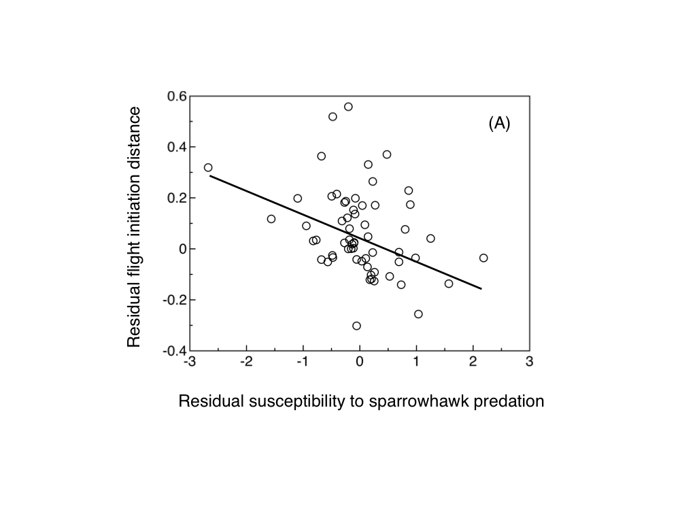

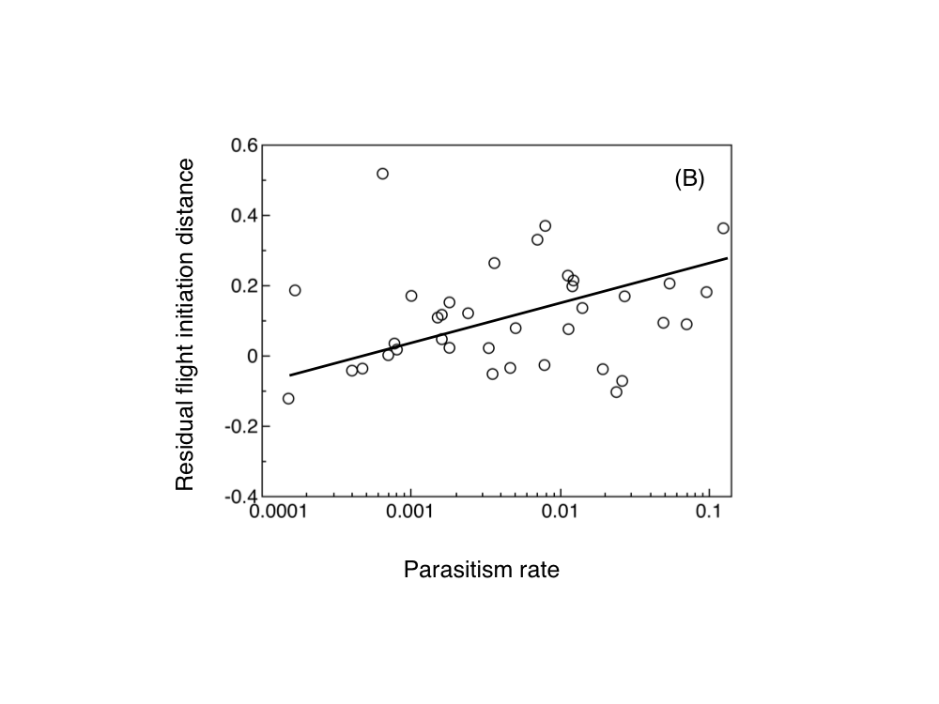
Table 1
Flight initiation distance in relation to parasitism, predation and body mass in a GLM. The model had the statistics ²₃ = 30.516, P < 0.0001. Effect size is Pearson’s product-moment correlation coefficient
Term | Likelihood χ² | df | P | Estimate | SE | Effect size
Intercept | 36.511 | 1 | < 0.0001 | 0.748 | 0.106
Parasitism | 7.601 | 1 | 0.0058 | 0.090 | 0.032 | 0.36
Sparrowhawk predation | 5.041 | 1 | 0.025 | -0.056 | 0.024 | 0.29
Body mass | 24.133 | 1 | < 0.0001 | 0.304 | 0.056 | 0.63

