Nitrogen-doped Carbon Nanofibers for the Oxygen Reduction Reaction: Importance of Iron Growth Catalyst Phase

Marthe E. M. Buan,ª Navaneethan Muthuswamy,ª John C. Walmsley,^{b} De Chenª and Magnus Rønning^{*a}

ª Department of Chemical Engineering, Norwegian University of Science and Technology, 7491 Trondheim, Norway

^{b} SINTEF Materials and Chemistry, Høgskoleringen 5, 7465 Trondheim, Norway

Abstract
A systematic evaluation of the oxygen reduction on nitrogen-doped carbon nanofibers (N-CNFs) has been performed by tuning the properties of the N-CNFs using chemical vapor deposition. Analysis of the as-synthesized N-CNFs show that the iron used as growth catalyst consists of iron carbides including Fe₇C_{3,} χ-Fe₅C₂ and θ-Fe₃C depending on the carbon activity of the synthesis feed. Furthermore, a relation between the growth catalyst phase, the N-CNF properties and the electrocatalytic activity for the oxygen reduction in acidic electrolyte is revealed. The best catalytic activity and selectivity was achieved when the N-CNFs were grown from Hägg carbide, χ-Fe₅C₂, suggesting that this carbide phase favors the incorporation of active sites into the N-CNFs. Controlling the phase of the iron particles used as growth catalysts is therefore essential for obtaining N-CNFs with a high active site density for the oxygen reduction reaction.

Introduction
Nitrogen-doped carbon nanomaterials prepared in the presence of Fe have shown promising activity for the oxygen reduction reaction (ORR), the cathode reaction in fuel cells ^{1–9}. However, in acidic electrolyte the ORR-activities reported so far have not been as high as for the traditional Pt/C catalysts. Understanding the origin of the oxygen reduction activity of N-doped carbon nanomaterials would therefore be of great importance for further improvement of these precious metal free catalysts ^{10–12}. Even though several recent studies have attempted to reveal the active sites for the ORR using sophisticated characterization techniques there is still a lot of controversy on the topic ^{6,10,13}. Another approach for understanding the oxygen reduction on N-doped carbon catalysts is by tuning the material properties and then correlating them with the catalytic activity for the ORR ^{14–17}.
The choice of synthesis method is important in order to carry out fundamental studies. It is essential that the synthesis procedure enables tuning of the catalyst properties systematically. Catalytic chemical vapor deposition (CVD) is a method that allows for altering physico-chemical properties such as morphology, surface structure and composition of carbon nanomaterials by simply adjusting the synthesis parameters such as temperature and partial pressure of the precursors ^{18,19}. In addition, doping of carbon nanostructures using a CVD method induces homogeneous modifications throughout the entire catalyst material.
Carbon nanomaterials such as graphite, graphene, carbon nanotubes and carbon nanofibers can all be produced by CVD. They possess properties such as high electronic conductivity and corrosion resistance, and have therefore been used in a range of energy conversion and storage devices. Heteroatom doping of these materials allows further alteration of their physical and chemical properties and most remarkably improves the catalytic activity. Nitrogen-doped carbon nanofibers (N-CNFs) and nanotubes (N-CNTs) have both shown promising activity for the oxygen reduction in acidic medium ^{20–22}. Moreover, ORR-catalysts based on N-CNFs have recently been prepared by a one-step CVD method using carbon monoxide and ammonia as growth precursors ²³. By utilizing gaseous nitrogen and carbon sources the reaction precursors will be homogeneously mixed before reaching the growth catalyst. Thus, the nitrogen content and even the type of nitrogen groups present in the N-CNFs can be controlled by varying the carbon to nitrogen precursor ratio.
In the present work the properties of N-CNFs have been altered by varying the synthesis temperature and NH₃ partial pressure using a CVD method. Furthermore, the N-CNF properties have been related to the catalytic activity for the ORR in acidic electrolyte. The study revealed that the synthesis conditions strongly influence the solubility of carbon in the Fe growth particles and stabilizes different iron carbides. In turn, the phase of the iron growth catalyst affects the nanofiber structure, surface area and the incorporation of nitrogen in the N-CNFs. The presence of Hägg carbide, χ-Fe₅C₂, facilitates the incorporation of nitrogen into the N-CNFs resulting in higher ORR activities and better selectivity. The results highlight how synthesis conditions and hence the phase of the growth catalyst can be used to improve the catalytic activity of N-CNFs.

Experimental

Synthesis
Expanded graphite (EG) was produced by heating oxidized graphite (Expandable Graphite GHL PX 95/350 N, Georg H. LUH GmbH, Germany) in a microwave oven at 700W for 60s. Incipient wetness impregnation of the support with iron nitrate (Iron(III)-nitrate nonahydrate, Fluka) dissolved in 96% ethanol was used to prepare 20wt% Fe nanoparticles supported on EG. The growth catalyst was then dried at room temperature for several days.
Nitrogen-doped carbon nanofibers were synthesized using a catalytic CVD-method. The growth catalyst (20wt% Fe/EG) was reduced in an H₂:Ar flow (40:160 ml/min, purity 5.0:5.0, AGA) by increasing the temperature of the furnace 3°C/min up to the desired temperature (550°C - 750°C). Subsequently, N-CNFs were grown using a synthesis gas mixture of CO:NH₃:H₂ (150:2.5-10.5:20 ml/min, purity 3.7:3.6:5.0, AGA). Two sets of experiments were performed; one where the NH₃ partial pressure was kept constant at 3.7 % while the N-CNF growth temperature was altered (NCNF-T), and one where the synthesis temperature was kept at 650°C while the partial pressure of NH₃ was altered (NCNF-P_{NH3}). After synthesis the reactor was cooled down to room temperature under an argon flow. The synthesis time was varied between 24-38 hours in order to achieve good N-CNF yields for all samples. The N-CNF yield was defined as the ratio of the mass of N-CNF grown to the mass of iron initially loaded in the reactor (g_{NCNF}/g_{Fe}) and used to calculate the growth rate of the N-CNFs (yield∙100/t_{synthesis}).
Characterization of reference samples including undoped CNFs (CNF/EG), reduced Fe nanoparticles on expanded graphite (Fe/EG-red) and NH₃-treated Fe-nanoparticles (Fe/EG-NH₃) have been published elsewhere ²³.

Physicochemical characterization
The surface area of the N-CNFs was characterized by N₂-adsorption measurements in a Micromeritics TriStar II 3020. The specific surface area was calculated by the Brunauer-Emmet-Teller (BET) method, the specific pore volume (2-300 nm) by Barret-Joyner-Halenda analysis of the desorption isotherm and the specific micropore volume from the t-plot model.
To identify the crystalline phases, X-ray diffraction (XRD) was performed using a Bruker D8 Focus X-ray diffractometer with Cu Kα radiation (λ = 1.54 Å). The samples were prepared by using high vacuum grease to fix the carbon material to the sample holders. Measurements were done in the 2θ angular range 20º - 80º using a fixed slit of 0.6 mm. The diffractograms were analyzed using the software DIFFRAC.EVA and the PDF-4+ database from ICDD. Phase identification was based on the following powder diffraction files; graphite: 00-056-0159, α-Fe: 04-007-9753, Fe₇C₃: 04-003-2411, χ-Fe₅C₂: 04-014-4562, θ-Fe₃C: 00-035-0772.
The microstructure and morphology of the N-CNFs was observed using a Hitachi S-5500 scanning transmission electron microscope (S(T)EM). Transmission electron microscopy (TEM) using a Jeol JEM-ARM200F was employed to characterize the N-CNF nanostructure. The samples were prepared by dispersing the N-CNFs in isopropanol by ultra-sonication. A drop of the dispersion was then deposited on a holey carbon film supported by a copper grid and dried at room temperature.
X-ray photoelectron spectroscopy (XPS) measurements were carried out in a Kratos Axis Ultra DLD spectrometer using monochromatic Al Kα radiation (hν = 1486.58 eV). The samples were prepared by covering carbon tape with an even layer of catalyst. Survey spectra were collected using fixed analyzer pass energies of 160 eV while the high resolution spectra were collected at pass energies of 20 eV (O 1s, N 1s) and 40 eV (Fe 2p). Data analysis was performed using the CasaXPS software. The elemental composition was calculated after the subtraction of Shirley-type backgrounds for the high resolution spectra. The N 1s region was deconvoluted using Gaussian-Lorentzian line shapes with 30% Lorentzian weighting.
Temperature-programmed oxidation (TPO) was performed in a Netzsch STA 449C thermo-microbalance. Around 5-10mg of sample was loaded in the thermogravimetric (TG) instrument and heated from 40ºC to 900ºC at a rate of 10ºC/min under a flow of synthetic air (80mL/min, 5.0, AGA).

Electrochemical characterization
The electrochemical measurements were conducted in a conventional three-electrode setup using a reversible hydrogen electrode (RHE) as reference electrode and a platinum wire as counter electrode. All potentials reported in this paper are given versus the RHE. A rotating ring disk electrode (RRDE, disk: 5 mm ϕ, ring: Pt with 20 % collection efficiency) was used as working electrode. The N-CNF catalysts were deposited on the glassy carbon disk electrode using the method described by Schmidt et al. ²⁴. A catalyst suspension was prepared by sonicating 3.0 mg of N-CNFs in a mixture of 500 µL Millipore H₂O, 200 µL ethanol (100%), 200 µL isopropanol and 100 µL of 0.5 wt% Nafion® (DuPont™ DE521, Ion Power,Inc) for one hour. About 16 µL of the suspension was placed on the glassy carbon disk and dried under a N₂-flow giving approximately 245 μg/cm² of N-CNF catalyst on the electrode surface.
Before performing the ORR the electrolyte was saturated with Ar and the electrodes were cleaned by performing cyclic voltammetry between 1.2 V and 0 V at different scanning rates. The background current was then measured by linear sweep voltammetry (LSV) from 1.10 V to 0.01 V at 5 mVs⁻¹ in the Ar-saturated electrolyte. Oxygen reduction experiments were carried out in O₂-saturated 0.5M H₂SO₄ (95-97% H₂SO₄, Sigma Aldrich) at room temperature. The potential range of the ORR was 1.10 V - 0.01 V, the scanning rate 5 mVs⁻¹ and the rotational speed 1600 rpm. The third cathodic scan for the N-CNF catalysts after background subtraction are reported. Onset potentials for the oxygen reduction (E_{ORR}) were determined by comparing the LSV curve obtained in Ar with the ORR measurement.
In order to detect the amount of H₂O₂ produced on the working electrode during the ORR, a constant potential of 1.2 V vs. RHE was applied to the Pt ring electrode. The H₂O₂ yield was calculated from the ring current (I_{R}), the disk current (I_{D}) and the collection efficiency of the Pt ring (N) using the following equation ²⁵:
( 1 )

Results and discussion

N-CNF growth
(a) (b)
Figure 1 Schematic illustration of the CVD-setup (a) and the synthesis procedure (b) with red atoms representing Fe and green atoms representing N.
Nitrogen-doped carbon nanofibers were grown from Fe nanoparticles supported on expanded graphite by chemical vapor deposition as illustrated in Fig. 1. By varying the synthesis conditions the growth of the N-CNFs and their corresponding properties could be tuned. Two sets of experiments were performed; one where the N-CNF growth temperature was altered (NCNF-T), and one where the amount of nitrogen precursor in the feed was altered (NCNF-P_{NH3}). An overview of the experiments performed is shown in Table 1 along with the N-CNF yield, growth rate and the results from the nitrogen adsorption measurements. It should be noted that since the N-CNFs grown at 650ºC and 3.7% NH₃ is part of both experimental sets, the data from its characterization will be displayed twice to enable direct comparison of all samples within each set.
For the N-CNFs grown at 550ºC there was no observable weight increase after synthesis, and no N-CNF growth was therefore assumed. However, BET measurements revealed an increase in surface area compared to the growth catalyst (reduced 20wt% Fe/EG: 35 m²/g), suggesting that minute amounts of N-CNFs were actually obtained. Analysis in S(T)EM confirmed the presence of small amounts of carbon formed on the Fe nanoparticles. Nevertheless, the yield was considered too low to be comparable with the rest of the samples and no further analysis was performed on NCNF-550.

Table 1 Synthesis parameters, yield, growth rate and results from the N₂-adsorption measurements of the N-CNF catalysts.
Sample | Synthesis T  (⁰C) | P_{NH3}  (%) | Yield  (g/g_{Fe}) | Growth  (%/h) | S_{BET}  (m²/g) | V_{pores}  (cm³/g) | V_{micro}  (cm³/g)
NCNF-550 | 550 | 3.7 | 0 | 0 | 124 | 0.226 | 0.011
NCNF-600 | 600 | 3.7 | 6.1 | 16.0 | 254 | 0.394 | 0.025
NCNF-650 | 650 | 3.7 | 9.6 | 37.7 | 220 | 0.388 | 0.013
NCNF-700 | 700 | 3.7 | 22.7 | 94.7 | 176 | 0.318 | 0.008
NCNF-750 | 750 | 3.7 | 12.0 | 49.9 | 157 | 0.267 | 0.011
NCNF-1.4 | 650 | 1.4 | 19.5 | 81.3 | 298 | 0.413 | 0.028
NCNF-3.7 | 650 | 3.7 | 9.6 | 37.7 | 220 | 0.388 | 0.013
NCNF-5.8 | 650 | 5.8 | 10.8 | 38.7 | 149 | 0.263 | 0.005

The shape of the N₂-adsorption isotherms was similar for all the N-CNF samples and showed a type 4 behavior which is common for mesoporous and macroporous materials (figure not shown). However, the surface area and pore volume of the N-CNFs was altered when varying the synthesis conditions as shown in Table 1. Both the BET surface area and the pore volume decreased as the synthesis temperature increased, even though the N-CNF yields obtained were considerably different. The same was observed for the N-CNFs grown at different NH₃ partial pressures; the surface area and pore volume decreased with increasing P_{NH3}, although the yield for the N-CNFs grown at 3.7% and 5.8% NH₃ was similar. This suggests that the surface area and pore volume of the N-CNFs depend more on the structure of the N-CNFs and to a lesser extent on the N-CNF yield obtained. The highest surface area (298 m²/g) and pore volume (0.413 cm³/g) was achieved for the N-CNFs grown at 650ºC and 1.4% NH₃.
Table 1 indicates that the N-CNF growth rate varied strongly with temperature and showed a maximum at 700 ºC. Both Chiraz et al. ²⁶ and Xie et al. ²⁷ reported an increase in N-CNT yield when increasing the synthesis temperature from 550ºC to 750ºC, but none of the studies performed the N-CNT synthesis at 700 ºC. Their observations are therefore similar to ours since the N-CNF growth in this report also shows an increase in growth rate with synthesis temperature when disregarding the 700 ºC sample.
The high growth rate at 700ºC could be explained by considering the N-CNF growth mechanism. Growth of carbon nanofibers consists of three steps; decomposition of the precursors on the growth catalyst surface, diffusion of carbon through the metal particle and finally nucleation of graphite on the particle surface with subsequent fiber growth. Diffusion of carbon in the growth catalyst particles is generally considered the rate-determining step for CNF and N-CNF growth. At the synthesis temperatures used in this study the Fe nanoparticles are expected to be in a solid state during N-CNF growth. This is in agreement with recent in-situ studies of N-CNTs grown from Fe nanoparticles in the same temperature range ^{28,29}. The carbon diffusion in solid-state pure iron increases with temperature up to 727 ºC due to the temperature dependency of the carbon diffusion coefficient ³⁰. At 727 ºC a phase transition from α-Fe to γ-Fe occurs according to the Fe-Fe₃C phase diagram ³¹. Since the activation energy for carbon diffusion is higher in γ-Fe (142 kJ/mol) compared to α-Fe (67 kJ/mol) a decrease in N-CNF growth rate would therefore be expected when increasing the temperature from 700ºC to 750ºC ³².
XRD analysis (discussed in section 3.2) revealed that the iron particles predominantly consist of different iron carbides after N-CNF growth. Iron carbides have much higher activation energies for carbon diffusion than pure iron. This is because the solid state diffusion of carbon in iron carbides is mediated by thermal vacancies in the metal and carbon sub-lattices, while the carbon diffusion in metallic iron occurs via interstitial diffusion ³⁰. If the iron was present as iron carbides during N-CNF growth it would explain the slow growth rate of the N-CNFs in this study. However, the activation energies for carbon diffusion in various iron carbide mixtures is not known and can therefore not be used to explain the high growth rate at 700ºC. Additional factors such as stability and decomposition rate of the gaseous precursors can also influence the N-CNF growth rate. Increasing the synthesis temperature might increase the decomposition rate of the gaseous precursors on the iron surface and hence increase the N-CNF yield. The decomposition rate of the gaseous precursors may also vary on different iron carbides.
The growth rate was also affected by the NH₃ partial pressure and decreased when increasing the P_{NH3} from 1.4% to 3.7%. In general the growth of N-doped CNFs/CNTs is slower than the growth of pure CNFs/CNTs ^{27,29,33}. Pattinson et al. observed a decrease in the growth rate of their CNT arrays when introducing nitrogen sources to the CVD reactor ²⁹. Since their growth catalyst was Fe₃C they proposed that the decrease in growth rate was due to a buildup of nitrogen at the catalyst surface exposed to the reactants rather than a saturation of the CNT edge with nitrogen. Maldonado and Stevenson also observed a decrease in N-CNF growth with increasing NH₃ fractions in the feed, and attributed this to the increased gasification of graphitic carbon by NH₃ ³⁴. In our study the N-CNFs are grown from CO and NH₃ and it is likely that there will be a competition between the decomposition of NH₃ and CO on the iron growth catalyst surface ³⁵. More NH₃ in the precursor feed will lead to more nitrogen adsorbed on the catalyst particles. Hence, less carbon will be available on the iron surface for N-CNF growth and the yield will decrease. In addition, molecular dynamics simulations have shown that nitrogen atoms slow down the carbon ring-formation on the surface of iron nanoparticles which might decrease the nucleation rate of N-CNFs ³⁶.

Growth catalyst phase
X-ray diffraction provided insight into the crystalline phases present in the N-CNFs and showed reflections corresponding to graphite in the full spectra (not shown). All the N-CNFs displayed a strong graphite reflection at 26.5º (002), and two minor graphite reflections at 54.7º (004) and 77.5º (110). The intensity and width of the (002) reflection varied slightly between the samples which could be attribute to the different N-CNF/graphite ratios or the difference in N-CNF structure for the samples.
In addition, XRD can give information about the state of the iron particles used for N-CNF growth. Hofmann’s research group has shown that there is no difference between XRD diffractograms measured in-situ during CNT growth and ex-situ after growth ^{28,37}. Most likely the natural cooling process kinetically limits the structural changes in the growth catalyst after synthesis ³⁸. Thus, XRD can give an indication of which iron phase the N-CNFs were grown from. The main reflections corresponding to different iron species including metallic iron, iron carbides and iron nitrides all lay in the 2θ range from 40-50º which is shown in Fig. 2. Clear changes were observed in this region for the N-CNFs grown at different synthesis temperature and NH₃ partial pressure signifying differences in the iron particles during N-CNF growth. The N-CNFs grown at 600ºC and 650ºC (Fig. 2a) both exhibit XRD patterns mostly corresponding to the XRD pattern of Hägg carbide, χ-Fe₅C₂. Increasing the synthesis temperature to 700ºC lead to a considerable change in the diffractogram where only one broad peak was observed, making it difficult to distinguish any particular reflections. However, at 750ºC the reflections were strong and corresponded to cementite, θ-Fe₃C. This implies that the iron particles in NCNF-700 were a mixture of χ-Fe₅C₂ and θ-Fe₃C, and that the broad peak actually consisted of reflections from both carbides. The small emerging reflection at 37.7º in NCNF-700 also supports this theory as it is found in the XRD pattern of θ-Fe₃C, but not in χ-Fe₅C₂.

(a)
(b)
Figure 2 X-ray diffraction patterns of the N-CNFs synthesized by varying the synthesis temperature (a), and the NH₃ partial pressure (b).
When increasing the P_{NH3} the reflections at 42.6º and 44.9º decreased significantly as observed in Fig. 2b. In addition, a peak at 40º disappeared completely when going from 1.4% to 5.8% NH₃. These three peaks can be associated with the presence of Eckström-Adcock iron carbide, Fe₇C₃. It was therefore concluded that at low NH₃ partial pressures the iron particles are a mix of χ-Fe₅C₂ and Fe₇C₃, while at 5.8% mostly χ-Fe₅C₂ is present. The reflection at 40º corresponding to Fe₇C₃ was also present in the N-CNFs grown at 600ºC and 650ºC suggesting that Fe₇C₃ also is formed at low temperatures.
The relative stability of iron carbide phases depends on the imposed chemical potential of carbon, μ_{C}, which in turn depends on the synthesis conditions ³⁹. The XRD results show that the synthesis conditions used for N-CNF growth impose a carbon chemical potential favoring the formation of different iron carbides at the expense of metallic iron. In general, high temperatures and low CO partial pressures yield lower μ_{C}. The stability of the trigonal prismatic carbides with decreasing μ_{C} is Fe₇C₃ χ-Fe₅C₂ θ-Fe₃C with respect to free C and α-Fe ³⁹. Under Fischer-Tropsch (F-T) synthesis conditions Fe₇C₃ formation is favored at high μ_{C}, high F-T temperatures (300-350ºC) and long reaction times ⁴⁰. These reaction conditions are similar to the reaction conditions for N-CNF growth at low NH₃ partial pressures (1.4 - 3.7%) and low temperatures (600-650ºC) in this study. Combining these conditions with long reaction times can favor the kinetics of formation of Fe₇C₃ and explain why Fe₇C₃ is observed in the N-CNFs prepared at low NH₃ partial pressures and low temperatures. Increasing the P_{NH3} to 5.8% lowers the μ_{C} of the synthesis feed and favors the formation of χ-Fe₅C₂, while increasing the temperature to 700ºC and 750ºC further lowers the μ_{C} and favors the formation of θ-Fe₃C.

Morphology
TEM was used to study the nanostructure of the N-CNFs and representative images are shown in Fig. 3. Changing the CVD synthesis temperature drastically altered the structure of the N-CNFs (Fig. 3a). At 600ºC and 650ºC the N-CNFs showed a random structure with irregular surface and no hollow core. As the synthesis temperature increased to 700ºC the N-CNFs obtained were a lot more ordered displaying a herringbone structure and a hollow core. At 750ºC both the nature of the iron nanoparticles and the structure of the carbon nanofibers changed significantly. Up to 700ºC the iron particles were mostly located at the tip of the N-CNFs. However, at 750ºC parts of the iron nanoparticles were also found enclosed in the middle of the N-CNFs. In addition the N-CNFs structure appeared to be more similar to multiwalled CNTs with the graphene sheets almost oriented in the growth direction of the fibers. A bamboo-like structure was also observed at 750ºC, and the diameter of the N-CNFs changed around each compartment which was not observed at any of the other synthesis temperatures.
Figure 3 TEM images of N-CNFs grown by altering the synthesis temperature (a) and the NH₃ partial pressure (b).
Considerable changes in the structure of the N-CNFs were also observed when altering the P_{NH3} as indicated by Fig. 3b. The N-CNFs grown under 1.4% NH₃ exhibited similar structures to the N-CNFs grown under 3.7% NH₃ at 600ºC and 650ºC. There was no hollow core and the surface of the nanofibers was irregular even though the graphene sheets in the middle seemed to be more platelet oriented. Occasional holes in the edge of the fibers were also observed. TEM images of carbon nanofibers (CNFs) grown without nitrogen doping at 650ºC is also included for reference. Holes in the middle of the fibers were observed to an even higher extent in the structure of these CNFs. When increasing the NH₃ partial pressure to 5.8% the structure of the N-CNFs became much more organized and displayed herringbone carbon nanofiber structures with bamboo-like compartments.
The structure of CNFs and N-CNFs will be affected by the phase of the growth catalyst through the solubility and rate of carbon diffusion in the particle. For example, at low temperatures the carbon atoms can reach the entire metal-support interface via diffusion before nucleation of the nanofibers start. Nucleation will therefore take place over the entire back of the metal particles and produce nanofibers without a hollow structure as observed at 600ºC and 650ºC ⁴¹. At more elevated temperature the carbon nucleation will occur before the entire metal particle has been saturated with carbon. The nucleation will therefore be restricted to the vicinity of the gas-metal-support interface resulting in hollow nanofibers as seen for the N-CNFs grown at 700ºC and 750ºC. In this study the structure of the N-CNFs could also be related to the iron carbides observed in XRD analysis. Fe₇C₃ is the carbide containing most carbon and the corresponding N-CNFs showed no hollow core. Furthermore, N-CNFs with more χ-Fe₅C₂ present had a hollow core and herringbone structures, while θ-Fe₃C contains less carbon and the corresponding N-CNFs displayed thinner walls and more CNT-type structures.

Nitrogen incorporation

Table 2 Surface composition of the N-CNFs and deconvolution of the N1s region from XPS analysis.
Sample | N  (at%) | O  (at%) | Fe  (at%) | N1  (%) | N2  (%) | N3  (%) | N4  (%) | N5  (%) | N6  (%)
NCNF-600 | 3.4 | 2.1 | 0.36 | 39 | 11 | 34 | 8 | 5 | 4
NCNF-650 | 4.8 | 1.7 | 0.30 | 38 | 13 | 33 | 9 | 5 | 3
NCNF-700 | 4.5 | 1.2 | 0.26 | 36 | 12 | 35 | 10 | 4 | 3
NCNF-750 | 1.4 | 0.9 | 0.12 | 26 | 10 | 38 | 14 | 7 | 4
NCNF-1.4 | 3.3 | 1.8 | 0.23 | 35 | 12 | 38 | 11 | 4 | 0
NCNF-3.7 | 4.8 | 1.7 | 0.30 | 38 | 13 | 33 | 9 | 5 | 3
NCNF-5.8 | 5.8 | 1.6 | 0.45 | 43 | 11 | 31 | 8 | 4 | 3

X-ray photoelectron spectroscopy was used to analyze the surface composition of the N-CNFs. The only elements present in the N-CNFs were Fe, N, O and C, and the content of each element is shown in Table 2. In addition the high resolution measurements for Fe, N and O are included and shown in Fig. 4 and Fig. 5 for varying synthesis temperatures and varying NH₃ partial pressures respectively. The high resolution measurements for carbon were similar for all the N-CNFs and are not included.

a) c)
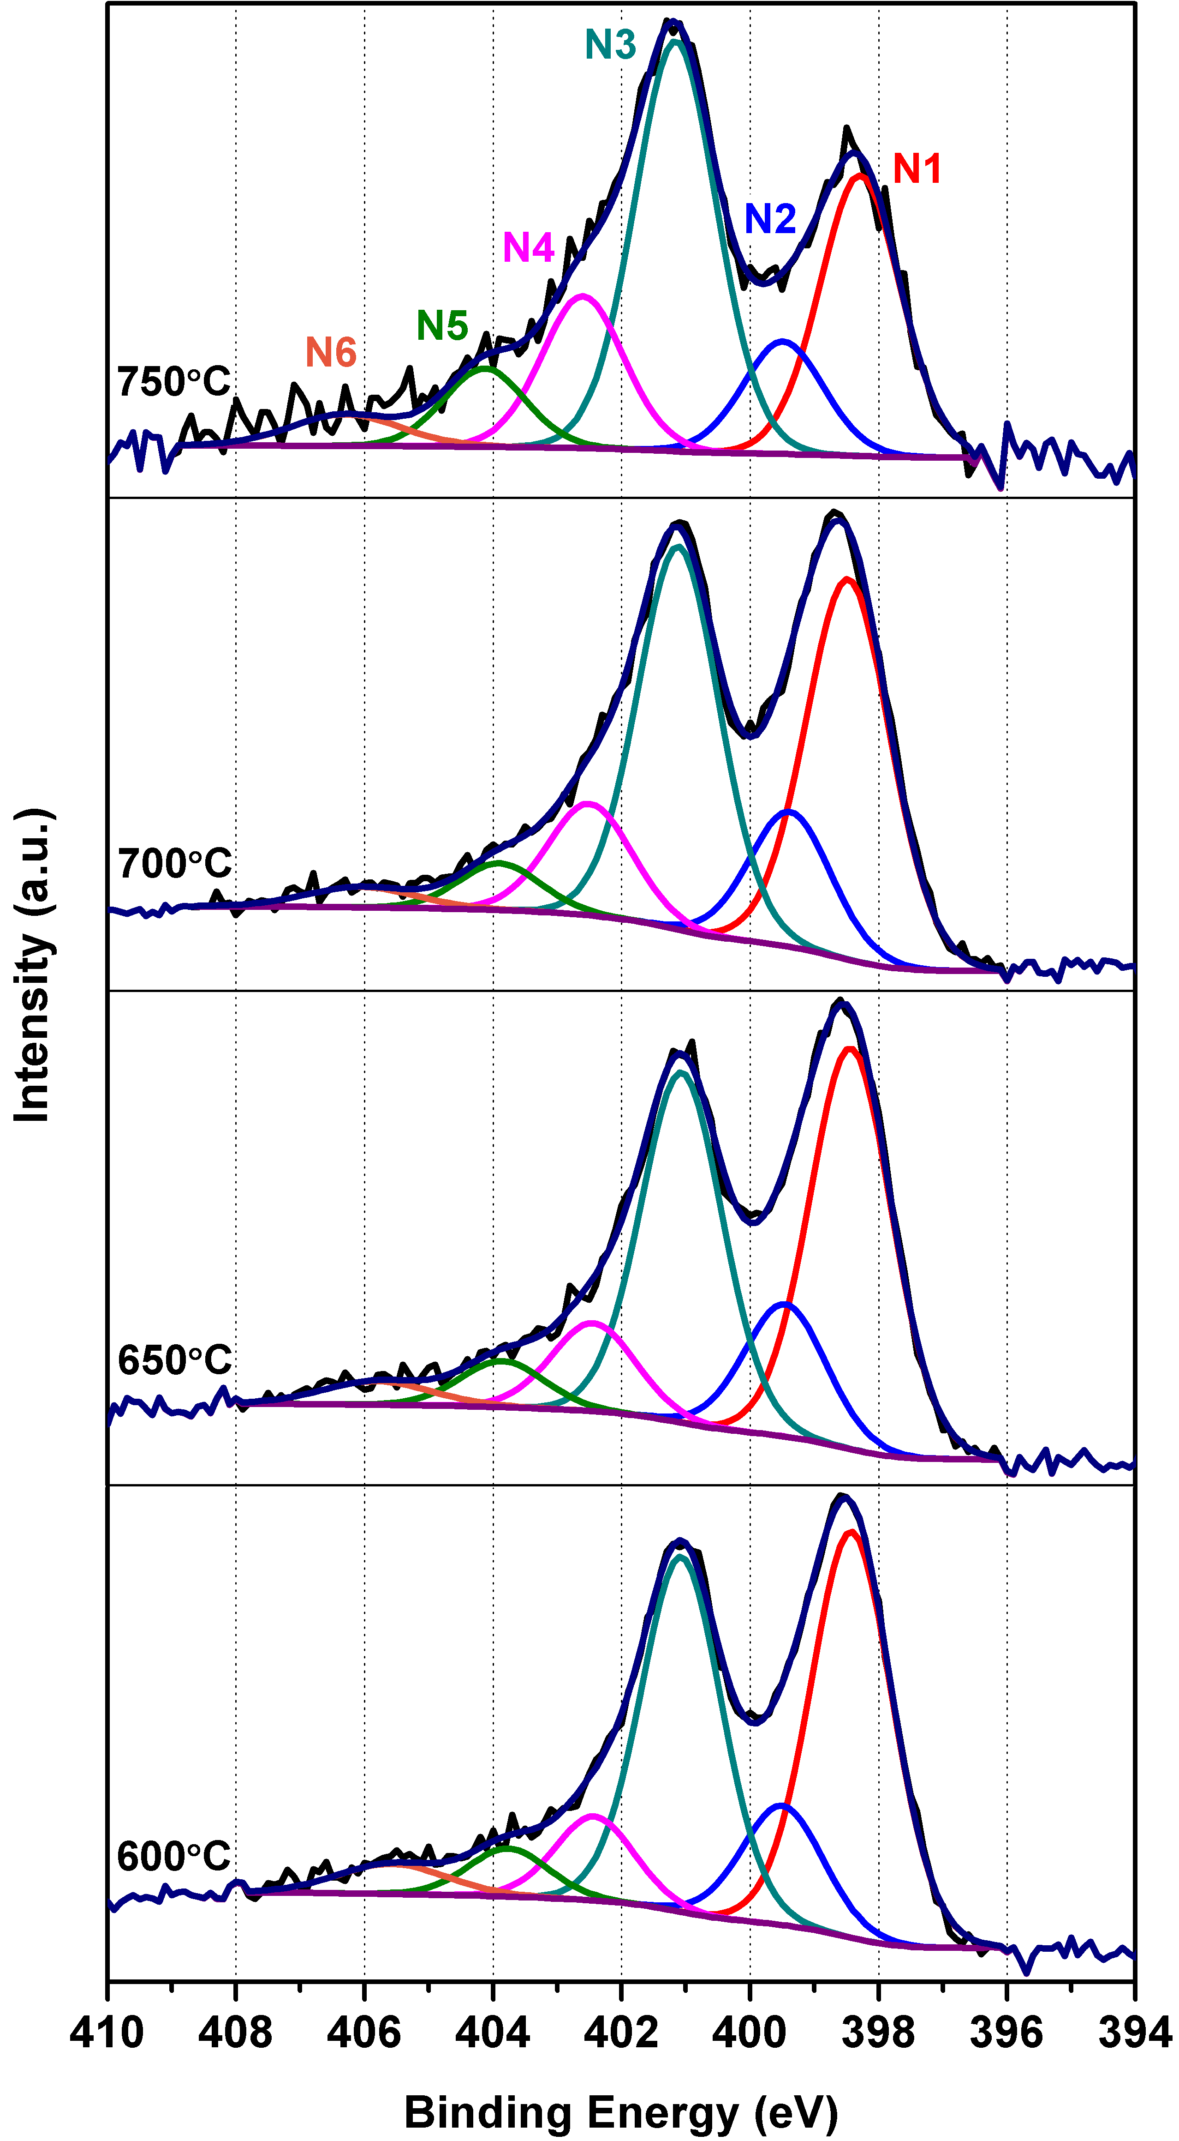
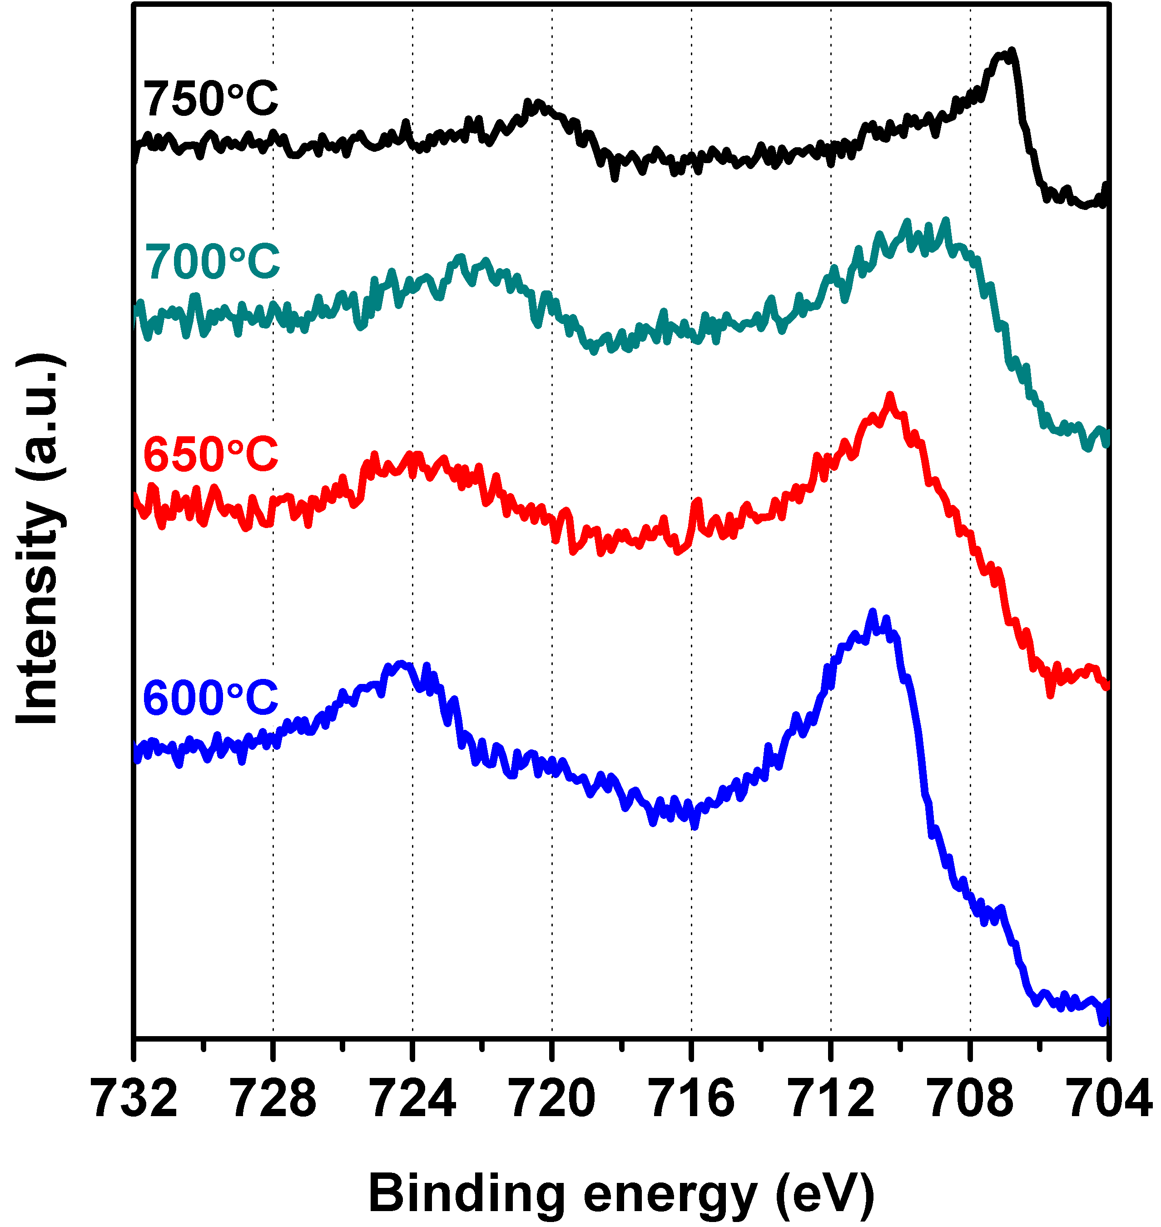
b)
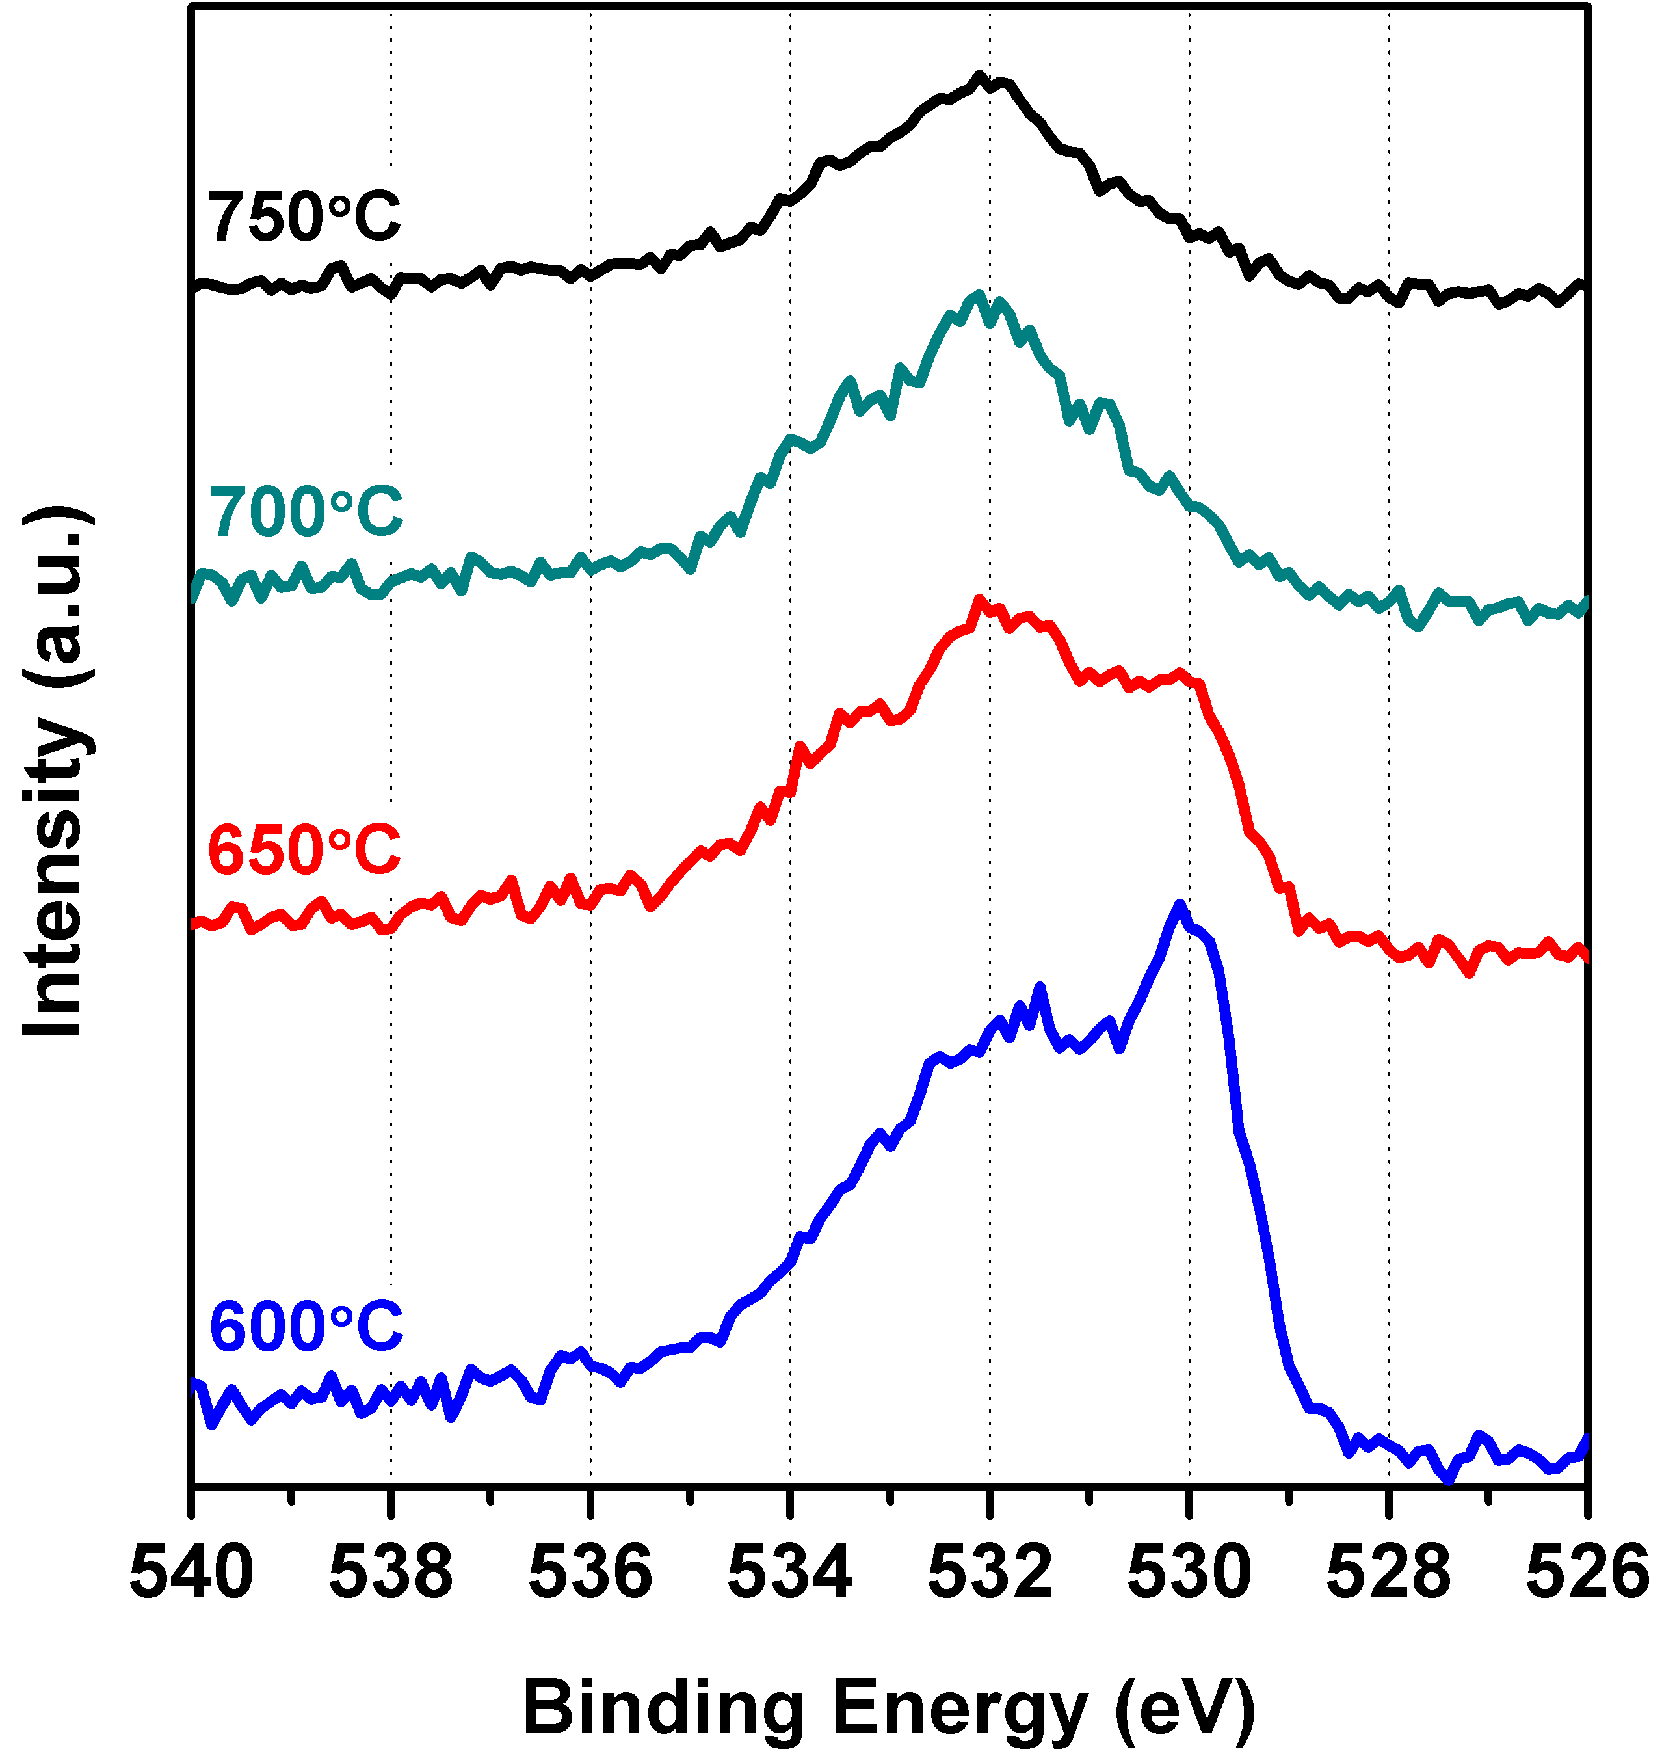
Figure 4 High resolution XPS spectra for the N-CNFs grown by adjusting the synthesis temperature showing the Fe 2p region (a), the O 1s region (b) and deconvolution of the N 1s region (c).
The surface composition of the N-CNFs varied strongly with synthesis conditions. More oxygen and iron was present in the surface of the N-CNFs prepared at low synthesis temperatures compared to elevated temperatures. Fig. 4a-b indicates that the chemical state of oxygen and iron also changed. For oxygen the peak around 530eV decreased with increasing temperature and can be related to oxygen bonded to Fe indicating the presence of iron oxide ⁴². Simultaneously a peak at 707eV appeared in the Fe 2p spectra corresponding to the 2p_{3/2} peak of zero-valent iron (Fe⁰) ^{43,44}. Increasing the synthesis temperature therefore results in a change in the surface iron from iron oxide to iron carbide or metallic iron.

a) c)
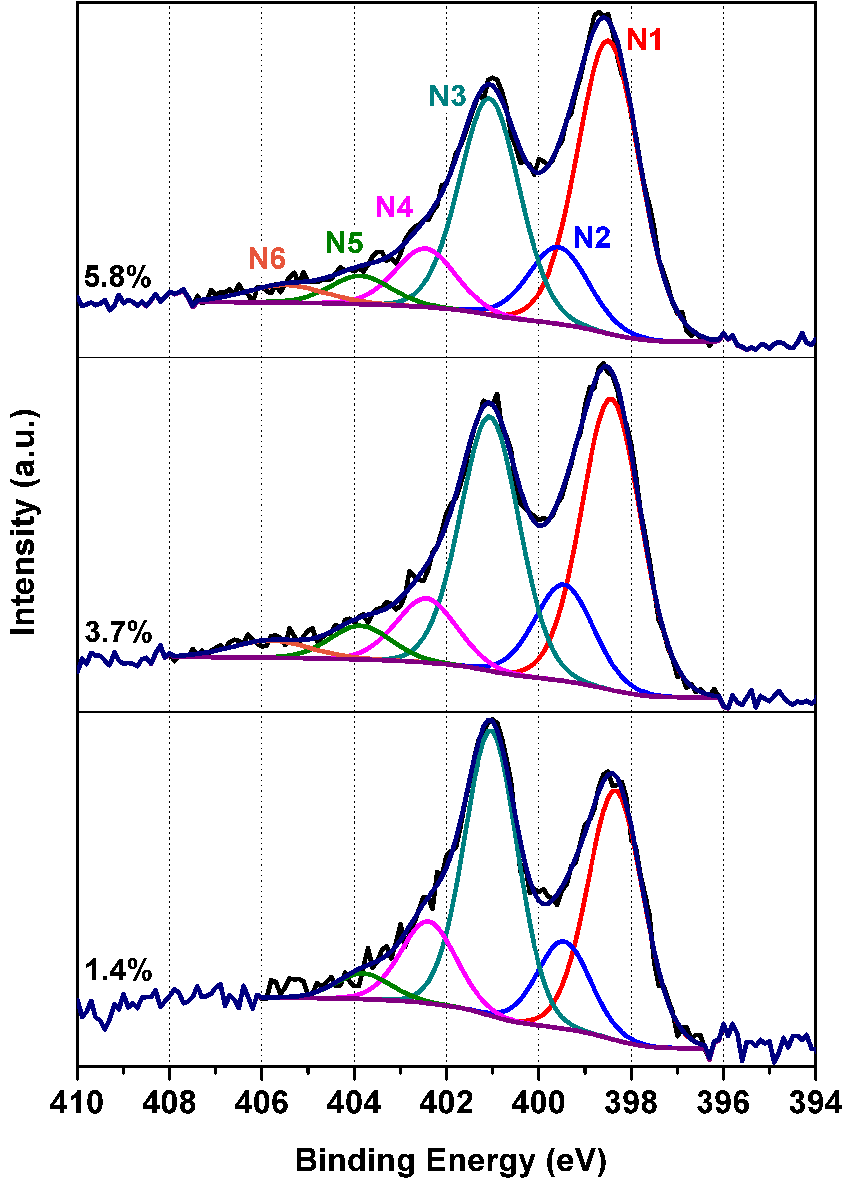
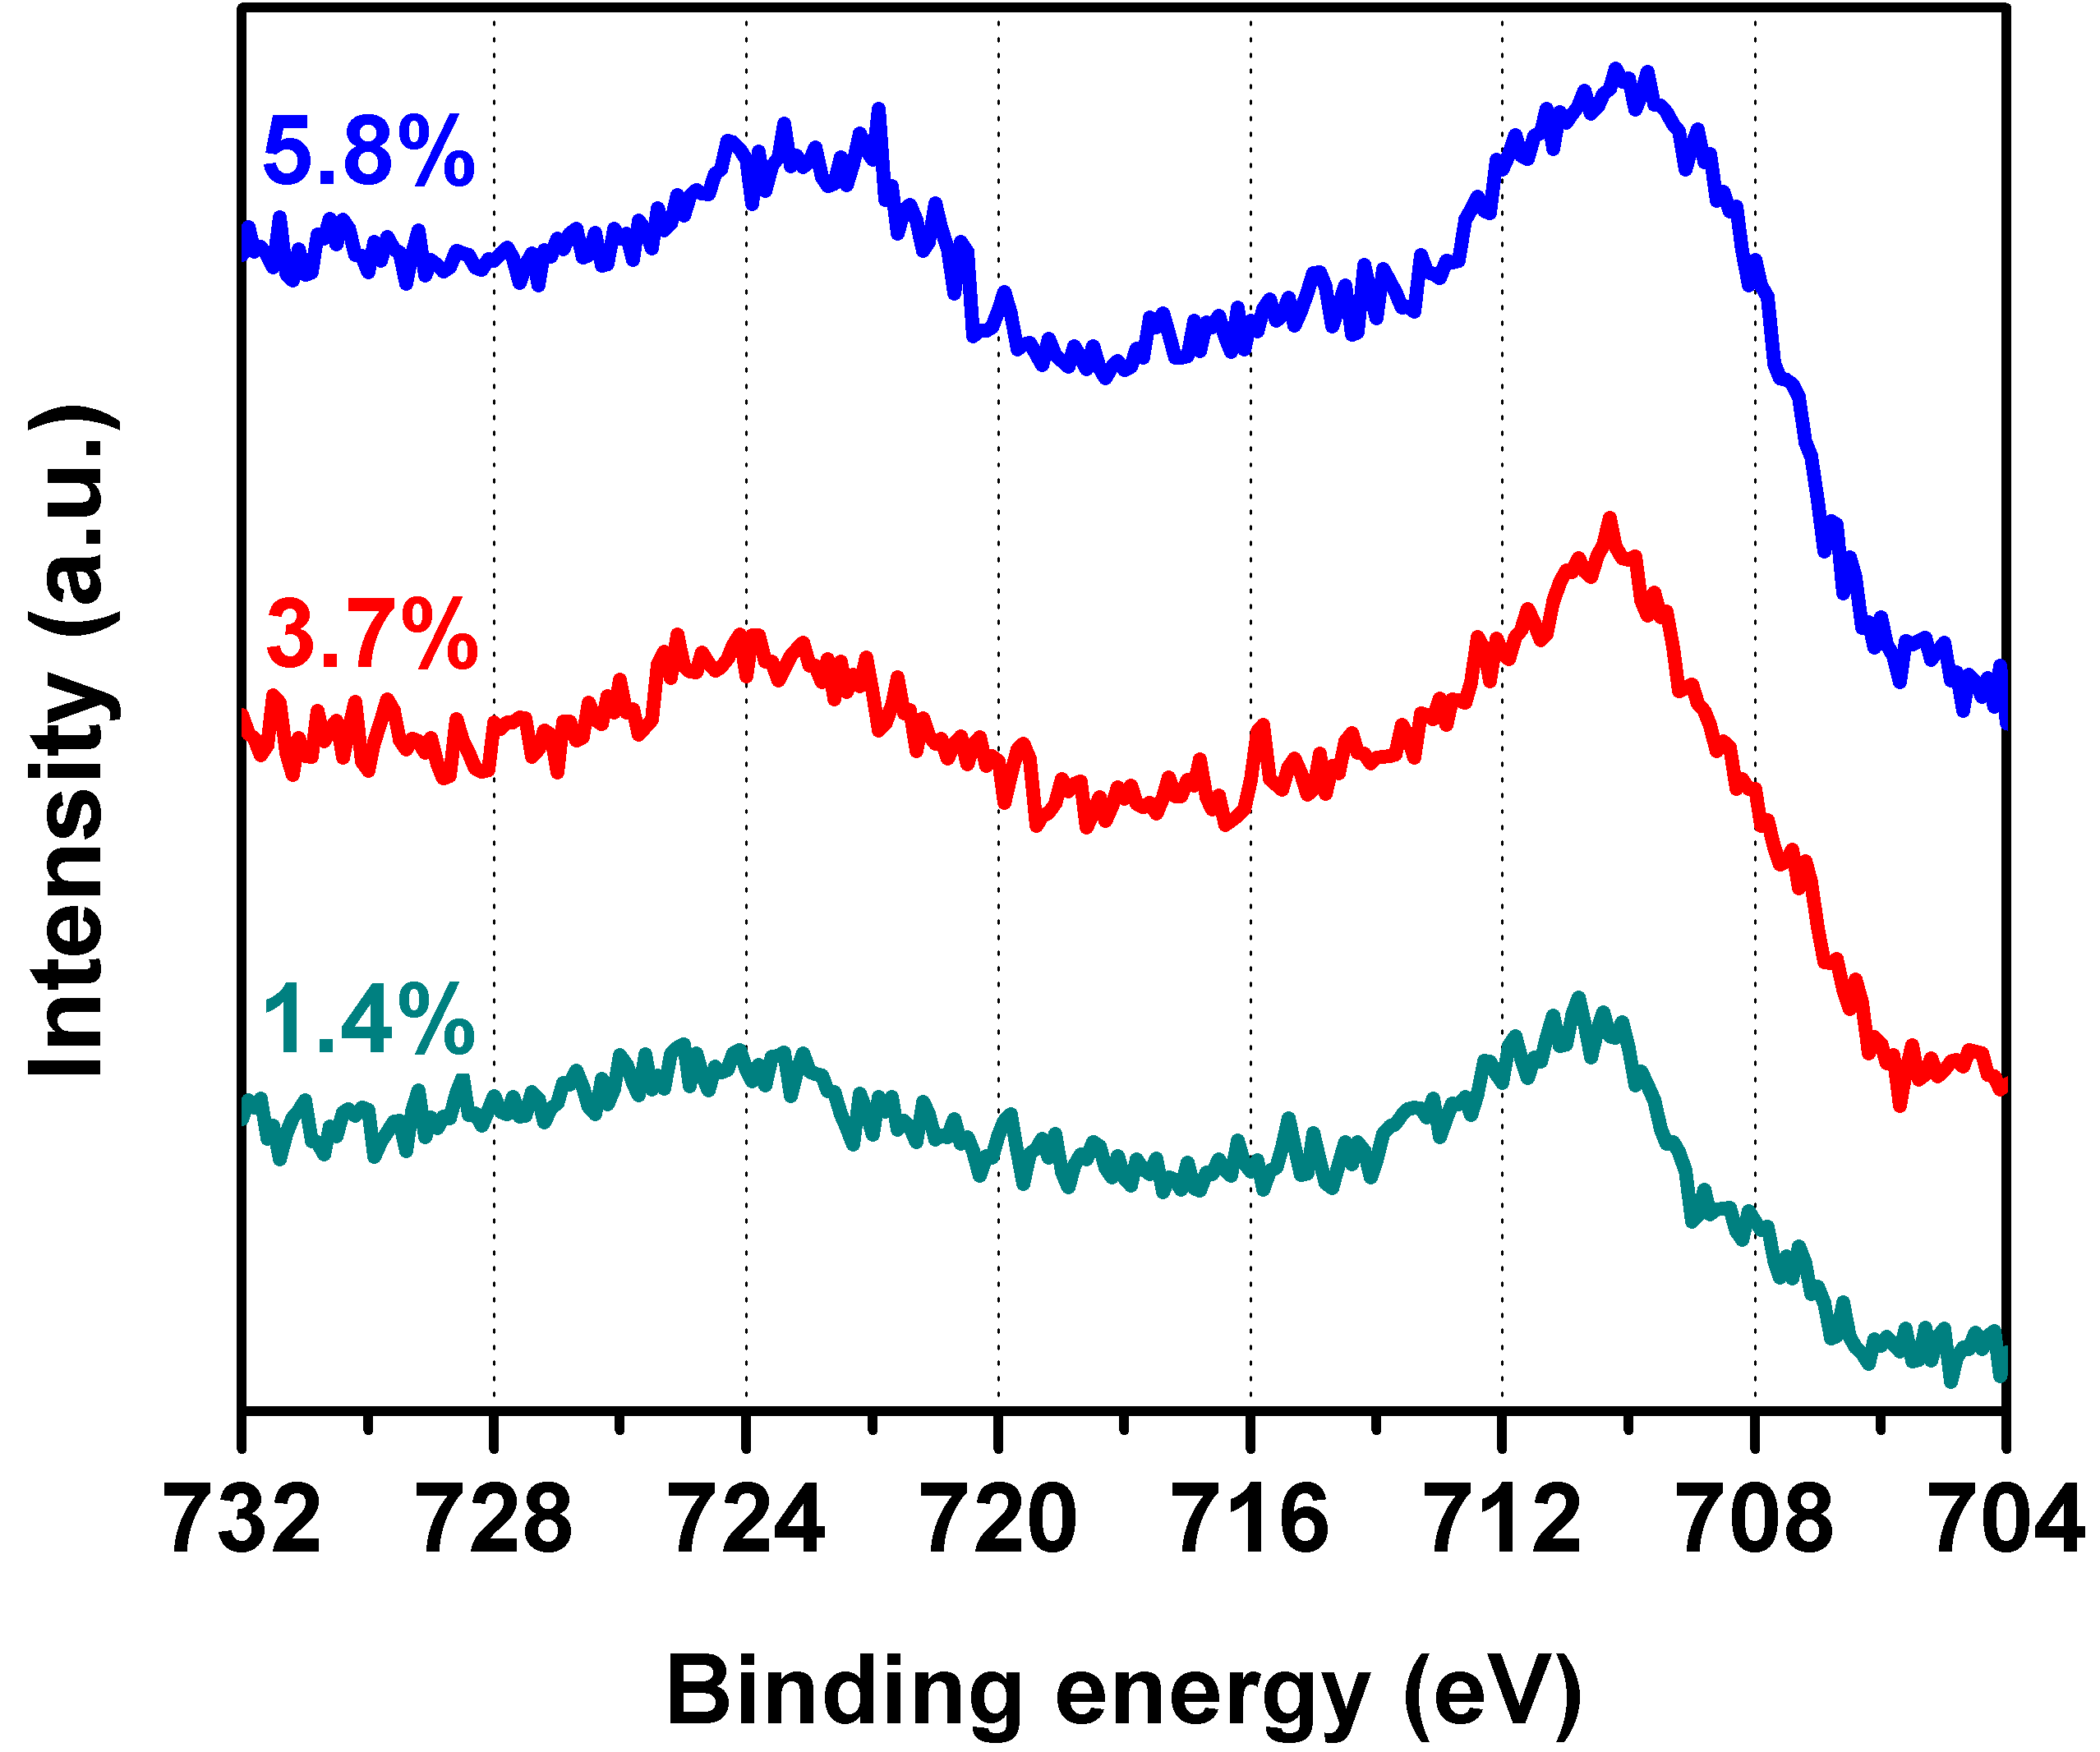
b)
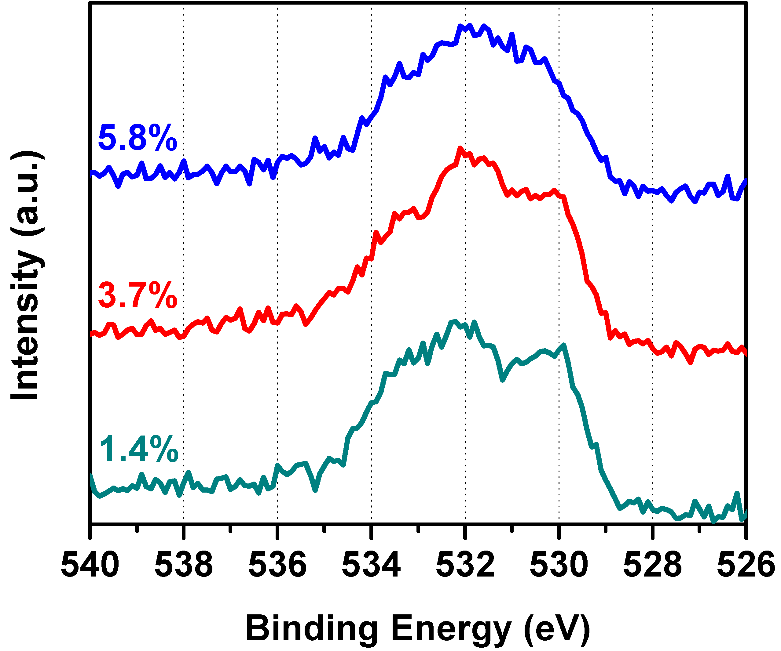
Figure 5 High resolution XPS spectra for the N-CNFs grown by adjusting the NH₃ fraction showing Fe 2p (a), O 1s (b) and deconvolution of N 1s (c).
When increasing the amount of NH₃ in the N-CNF synthesis the surface oxygen content was constant, but the iron content increased. The Fe-O peak in the O 1s appeared to decrease while the iron peak broadened, see Fig. 5. Thus, it seems like the amount of zero-valent iron increased with NH₃ fraction. It is however important to realize that XPS only gives information about the surface composition of the N-CNFs and for both iron carbides and metallic iron the surface is usually oxidized and will appear as iron oxide in XPS.
Deconvolution of the N 1s spectra showed the presence of 6 peaks for all samples except NCNF-1.4% where peak N6 was not present (Fig. 4c & 5c). Fitting of the N 1s region was done by setting the FWHM equal for the N1-N5 peaks within each sample and then allowing it to vary with ±0.025eV. In order to obtain a reasonable fit for all the N-CNFs some variation in the FWHM for the same nitrogen component in different samples was necessary. However, the positions of the peaks were the same for all the N-CNF samples. Only the peak assigned to NO₂ (N6) showed a noticeable shift to higher binding energies with increasing synthesis temperature (405.6 eV405.8 eV406.0 eV406.3 eV).

Table 3 Identification of N-components by deconvolution of the N1s region.
N 1s peak | Assignment | Position (eV) | Reference
N1 | Pyridinic | 398.3 - 398.5 | ^{45–47}
N2 | Amine / Fe-N_{x} / Nitrile | 399.4 - 399.6 | ^{48–50}/⁵¹/⁵²
N3 | Quaternary | 401.0 - 401.2 | ^{45–47}
N4 | Pyridine N-oxide | 402.4 – 402.6 | ^{45,53}
N5 | π-π* shake-up/ N₂ | 403.8 – 404.1 | ⁵⁴/^{55–58}
N6 | NO₂ | 405.5 – 406.3 | ^{45,49}

The identification of the nitrogen components and their corresponding binding energy position is shown in Table 3. The two strongest peaks, N1and N3, were identified as pyridinic nitrogen and quaternary nitrogen respectively. Furthermore, peak N4 was identified as pyridine N-oxide and N6 as -NO₂ groups. Assignment of the N2 peak observed at 399.5eV and the N5 peak lying between 403.8-404.1 eV was more ambiguous. Peaks around 399.5eV have been attributed to amines/amides, nitrile or Fe coordinated to nitrogen. Since the N-CNFs are grown by decomposition of NH₃ it could seem most likely that N2 was due to -NH or -NH₂ groups present in the N-CNFs. However, formation of cyanide-groups (-C≡N) has been reported when CO and NH₃ decompose on iron nanoparticles and could not be excluded ^{35,36}. In literature the position of the N5 peak has been identified as a π-π* shake-up satellite or trapped N₂ gas. Shake-up satellites are typically much broader than the peak in this report and was excluded ⁵⁴. N₂ physisorbed on graphite (HOPG) appears at 403.9eV in the N 1s spectrum ⁵⁵ and corresponds well with the values observed for the N5 peak in the N-CNFs. Studies have suggested that for N-CNTs the N₂ is not physisorbed on the surface, but rather trapped between the graphene layers or inside the core of the N-CNTs ^{56–58}. The contribution from N₂ in the N 1s spectrum is therefore expected to increase with increased probing of the N-CNT core. For the N-CNFs the sample with the thinnest walls (NCNF-750) showed the highest contribution from the N5 peak (7%), which may be due to the increased probing of the N-CNF core where higher amounts of N₂ could be trapped.
As the synthesis temperature increased the nitrogen content in the N-CNFs rose, reaching a maximum at 650ºC, before tailing off at higher temperatures. This is in agreement with the trend for N-CNTs grown from C₂H₆ and NH₃ where the N-content reached a maximum around 650-700ºC ³³. In the present study the N-content was only 1.2 at% for the N-CNFs grown at 750ºC and the proportion of pyridine-like nitrogen (N1) significantly lower than the N-CNFs grown at lower synthesis temperatures. This could be linked to the more tubular structure obtained at 750 ºC resulting in less edge-plane exposure and defects, and hence less possibilities for incorporation of pyridinic nitrogen. Carroll et al. reported that rougher tube walls and less crystalline perfection was achieved for N-CNTs with higher nitrogen content and attributed this to a higher number of pyridine-like nitrogen sites ¹⁸. Thus, there seems to be a relation between the observed N-CNT/N-CNF structure and both the amount of nitrogen and the presence of different nitrogen components.
The highest amount of nitrogen doping (5.8 at%) was achieved at 650ºC with 5.8% NH₃ in the synthesis feed. Increasing the NH₃ fraction of the precursor feed resulted in an increase in nitrogen content for the N-CNFs. Additionally it resulted in an increase in the pyridinic to quaternary nitrogen ratio as depicted in Fig. 5c. This tendency has previously been reported by Maldonado et al. for N-CNFs grown from pyridine and NH₃ ³⁴. Employing NH₃ as nitrogen precursor during CVD synthesis leads to selective incorporation of nitrogen as pyridinic functionalities in the carbon nanofiber structure.

Thermal stability
The thermal stability of the N-CNFs was assessed by performing temperature programmed oxidation as shown in Fig. 6a. Clearly, an increase in synthesis temperature leads to increased oxidation resistance of the N-CNFs. The bulk temperature for N-CNF oxidation was determined from the vertex of the derivative of the TG-curves (DTG), Fig. 6b, and was 435ºC, 440ºC, 455ºC and 510ºC for NCNF-600, NCNF-650, NCNF-700 and NCNF-750 respectively. In addition, the differential scanning calorimetry (DSC) curves (not shown) had the same shape as the DTG curves. Two contributions could be seen in the DSC and DTG curves for the N-CNFs grown at higher temperatures showing that the oxidation proceeded through two steps which again implied the presence of two different types of carbon in the samples. Finally, the residual mass after the oxidation process shows the amount of remaining iron and reflects the yield of N-CNF growth for each sample.
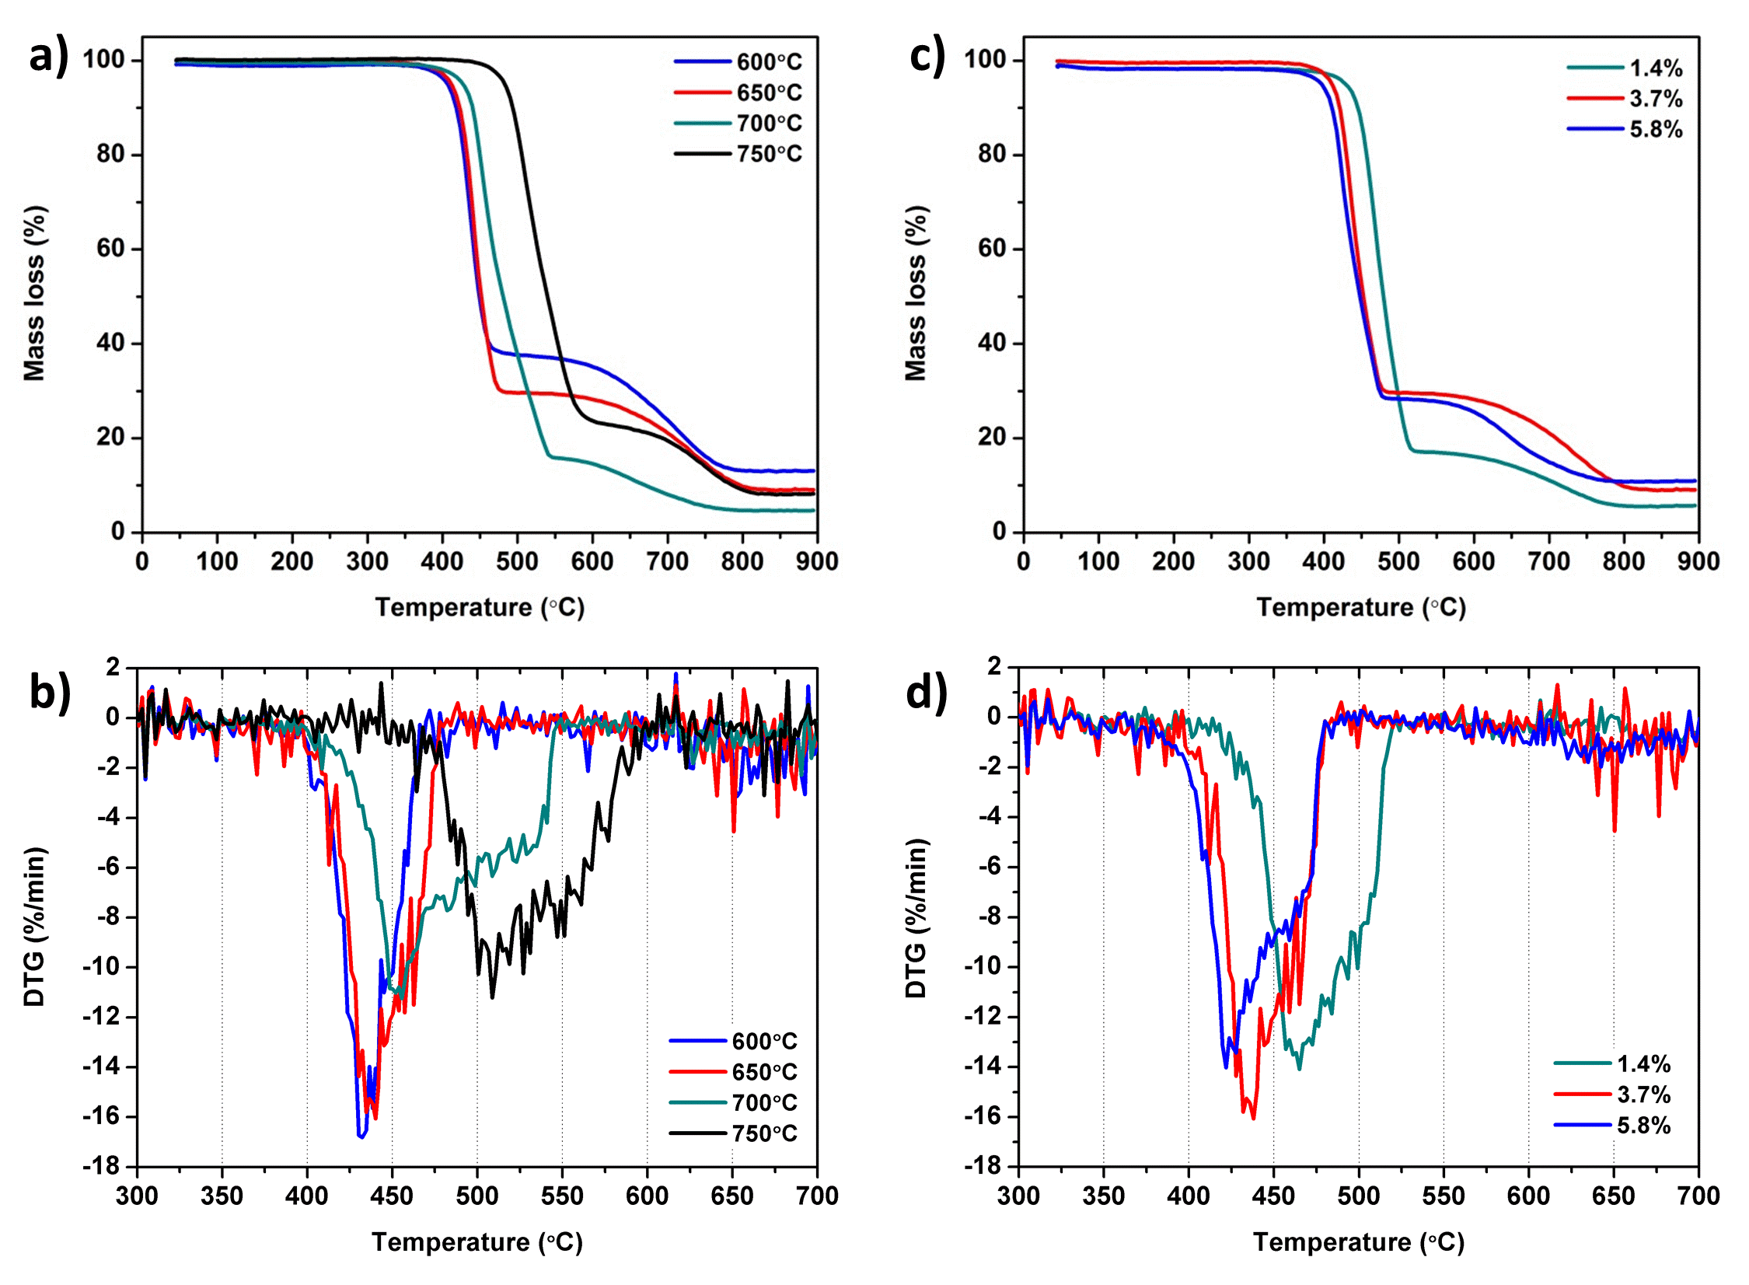
Figure 6 Temperature-programmed oxidation of the N-CNFs grown by altering the synthesis temperatures (a-b) and the P_{NH3} (c-d) showing the thermogravimetric (TG) analysis (a & c) and the derivative of the TG-curve (b & d).
An increase in NH₃ partial pressure resulted in a decrease in the oxidation resistance of the N-CNFs, Fig. 6c-d. The bulk oxidation temperature decreased from 460ºC to 440ºC and finally 425ºC for 1.4%, 3.7% and 5.8% NH₃ respectively. Unlike the N-CNFs grown at different temperatures, the shape of the DTG curves (Fig. 6d) was similar for the N-CNFs grown at different P_{NH3}. This indicates that the oxidation followed a similar path or contained the same kind of carbon for all samples. Low oxidation temperatures of N-doped CNFs compared to pristine CNFs can been ascribed to the presence of nitrogen in the structure leading to more disorder and thus lower oxidation temperatures. For the N-CNFs grown at different NH₃ partial pressures the nitrogen content increased considerably with P_{NH3} and may explain the decrease in oxidation temperature.
Several studies have reported that the thermal stability of N-CNTs grown by CVD increase with synthesis temperature ^{26,27}. Chizari et al. related this to an increased crystallinity of the N-CNTs with temperature due to less defects and lower nitrogen content ²⁶. For the N-CNFs in this study this would also be the case when only considering the N-CNFs grown at 650ºC and 750ºC. However, N-CNFs have also been grown at 600ºC and 700ºC and there is thus no apparent relation between nitrogen content and oxidation temperature of the N-CNFs grown at different synthesis temperatures. An alternative factor that could influence the oxidation resistance of the N-CNFs is the degree of edge plane exposure. TEM characterization indicated that the N-CNFs grown at 750ºC possessed a structure more similar to CNTs. They will thus contain fewer edges than the N-CNFs with a herringbone-type structure obtained at 700ºC which can explain the superior oxidation resistance of NCNF-750. Furthermore, the N-CNFs grown at 600ºC and 650ºC showed more random structures which could result in even more edge plane exposure lowering the oxidation temperatures further.

Electrocatalytic Activity
All the N-CNF catalysts were tested for the oxygen reduction reaction in 0.5M H₂SO₄ and the results are presented in Fig. 7. The synthesis temperature and NH₃ partial pressure utilized during the CVD synthesis clearly affected the ORR-activity of the N-CNFs. As displayed in Fig. 7a-b a synthesis temperature of 650ºC was beneficial for both the catalytic activity and the selectivity towards the 4-electron oxygen reduction to water. In contrast, the N-CNFs grown at 750ºC exhibited both low ORR-activity and poor selectivity, especially at high overpotentials where the amount of H₂O₂ increased up to 55%. Interestingly, the shape of the H₂O₂ curve for NCNF-750 was very different from the lower synthesis temperature N-CNFs suggesting that the oxygen reduction occurred through a different mechanism on this sample.
Higher NH₃ partial pressures during synthesis considerably improved the electrocatalytic activity of the N-CNFs as shown in Fig. 7c and the N-CNFs grown at 5.8% NH₃ possessed high enough ORR-activity to start indicating a diffusion limited current at high overpotentials. In fact, the ORR onset potential for NCNF-5.8% was as high as 0.96 V, and the ORR-current was 5 mA/mg∙cm² at 0.7V when taking into account the low catalyst loading used. Furthermore, the amount of H₂O₂ produced during the oxygen reduction was only 12 % at 0.7 V (Fig. 7d), and the fraction of H₂O₂ remained low over the entire potential range. This was far superior to the selectivity of the N-CNFs grown at 3.7% and 1.4% NH₃ where the amount of H₂O₂ at 0.7 V was 26% and 33% respectively (Fig. 7d). The high catalytic activity and good selectivity of the N-CNF catalyst grown in 5.8% NH₃ makes it a promising electrocatalyst for PEM fuel cell applications. The ORR activity is however lower than what we observe for commercial Pt/C catalysts with high Pt loading as shown in our previous publication ²³.

Figure 7 Oxygen reduction on the N-CNF catalysts grown at different synthesis temperatures (a) and different P_{NH3} (c). Corresponding amount of H₂O₂ detected on the Pt-ring during the ORR (b & d). The polarization curves were obtained in 0.5M H₂SO₄ at 5 mV/s and 1600 rpm with a catalyst loading of 245 μg/cm².
The ORR results highlight how the synthesis conditions and hence the phase of the growth catalyst can be used to improve the ORR activity and selectivity of N-CNF catalysts. While the catalytic activity goes through a maximum for a synthesis temperature of 650ºC, it increases steadily with NH₃ partial pressure. This suggests that keeping the synthesis temperature at 650ºC while increasing the amount of NH₃ further could enhance the ORR activity of the N-CNFs even more. Furthermore, the selectivity of the oxygen reduction was found to depend on the ORR current of the N-CNF catalysts; as the current increases the selectivity towards H₂O increases. This could be related to the density of active sites present in the N-CNFs. Several studies indicate that the ORR on N-CNFs and N-CNTs proceeds through two steps: first a 2-electron reduction of O₂ to H₂O₂ followed by either a 2-electron reduction of H₂O₂ to water or a disproportionation of H₂O₂ to O₂ and H₂O ^{59–61}. Thus, when more active sites are present in the N-CNFs the full reaction mechanism will occur, while the N-CNF catalysts containing fewer active sites will only partly reduce the oxygen resulting in more H₂O₂ detected. Increasing the active site density can therefore be of great importance for improving the selectivity of the ORR on N-CNFs.
The variation in oxygen reduction activity of the N-CNF catalysts prepared at different synthesis conditions may be related to properties such as surface area, pore volume, microstructure, nitrogen content and surface functional group. In this study, no relation could be identified when comparing the ORR activity with structural properties obtained from N₂-adsorption measurements. The best N-CNF catalyst (NCNF-5.8%) possessed the lowest specific surface area (149m²/g) and pore volume (0.263cm³/g) of all the samples, while the worst performing catalyst (NCNF-750ºC) showed almost similar features (157m²/g and 0.267cm³/g). The surface area and pore volume was therefore of minor importance for the ORR activity of the N-CNF catalysts.

Figure 8 Plot of the ORR current at 0.7V vs. total N-content (a) and content of the different N groups (b) as obtained from deconvolution of the N 1s peak in XPS.
Relating the electrocatalytic performance of the N-CNFs with the TEM studies suggests that a nanofiber structure exposing more edge planes can lead to higher ORR-activities. The most active N-CNF catalyst displays a herringbone structure which possesses large amounts of edge planes, while the least active N-CNF catalyst has a tubular nanofiber structure which exposes more basal planes. Since oxygen chemisorption is favored at carbon edge atoms the presence of edge planes may therefore be beneficial for the catalytic activity of the N-CNFs ^{62,63}. Furthermore, the N-CNF structure can be interconnected with the presence of nitrogen functional groups. Matter et al. have related the catalytic activity of N-doped CNFs to the amount of pyridinic nitrogen present ^{20,63}. As pyridinic nitrogen only occur at edges and defects an increase in edge plane exposure can result in a higher pyridinic/quaternary nitrogen ratio and an improved oxygen reduction activity. This was observed for the herringbone NCNF-5.8 where the N_{pyr}/N_{quat} ratio was as high as 1.39, while the more tubular NCNF-750 had the lowest N_{pyr}/N_{quat} ratio of 0.68.
To investigate more closely whether a particular N-group was responsible for the ORR-activity of the N-CNFs, the amount of the different N-groups in at% was plotted versus the ORR current obtained at 0.7V, see Figure 8b. Pyridinic nitrogen, N1, was the only N-group showing a linear relation with the ORR-activity of the N-CNFs. However, an apparent correlation was also found for all the other N-groups (quaternary-N, amine/nitrile and nitric oxides). This was probably due to the total amount of nitrogen in the N-CNFs influencing the at% of each nitrogen functional group more than the small changes in ratio between each group. Larger variations between the different N-groups are therefore required to surely attribute the catalytic activity of the N-CNFs to pyridinic-N.
However, the oxygen reduction activity of N-CNFs might not be related to any specific nitrogen group, but rather to the total amount of nitrogen doped into the carbon structure. In this study the N-CNFs with the highest pyridinic-N content were also the samples with highest total nitrogen content in the surface. A plot of N-content from XPS vs. the ORR-current at 0.7 V is shown in Figure 8a and suggests that higher levels of nitrogen doping results in higher oxygen reduction activity for the N-CNFs. Studies have shown that both quaternary and pyridinic nitrogen can be involved in the oxygen reduction on N-doped carbon catalysts ^{64,65}. Thus, the ORR-activity of the N-CNFs could simply be related to the amount of both pyridinic and quaternary nitrogen groups present in the surface of the N-CNFs.
From XRD measurements of the as-synthesized N-CNFs it was discovered that the phase of the iron particles used as growth catalysts changed with synthesis conditions (Fig. 2). The highest ORR activities were achieved for the N-CNFs that contained more Hägg carbide, χ-Fe₅C₂, such as the N-CNFs grown at 650ºC and 3.7% or 5.8% NH₃. In comparison, N-CNFs containing more Fe₇C₃ (NCNF-1.4%) and θ-Fe₃C (NCNF-750) showed very low catalytic activity. Direct contribution to the oxygen reduction activity from the χ-Fe₅C₂ particles can however be excluded as our recent study showed that the catalytic activity of CNFs grown from χ-Fe₅C₂ is negligible in comparison to N-CNFs ²³. Instead, the presence of different iron carbides is linked to the structure and the level of nitrogen doping of the N-CNFs where growth of N-CNFs from χ-Fe₅C₂ resulted in the highest N-doping levels. Thus, the improved activity for N-CNFs grown from χ-Fe₅C₂ particles is attributed to χ-Fe₅C₂ facilitating the incorporation of active sites for the ORR in the N-CNFs. Controlling the phase of the growth catalyst particles is therefore essential for achieving N-CNF catalysts with high activity for the oxygen reduction reaction.

Conclusion
Nitrogen-doped carbon nanofibers with different physicochemical properties were grown on expanded graphite by varying the CVD synthesis conditions. An increase in synthesis temperature from 700ºC to 750ºC drastically lowered the N-content and the fraction of pyridinic nitrogen in the N-CNFs. This is attributed to the amount of edge planes present since the nanofiber structure changed from herringbone to tubular. By increasing the NH₃ partial pressure, the level of N-doping in the N-CNFs increased and the incorporation of pyridinic nitrogen was favored. XRD analysis showed that iron is present as bulk iron carbide nanoparticles after N-CNF growth. A relation between the iron carbide phase and the structure and level of nitrogen doping of the N-CNFs was revealed.
The as-synthesized N-CNFs were used as catalysts for the oxygen reduction in acidic electrolyte and high amounts of nitrogen improved both the catalytic activity and selectivity of the N-CNFs. In addition, growing N-CNFs from χ-Fe₅C₂ was found to be beneficial for the incorporation of ORR active sites into the N-CNFs. The most active N-CNF catalyst was obtained at 650ºC with 5.8% NH₃ in the feed and showed promising activity for the ORR in acidic electrolyte. The study highlights how synthesis conditions and hence the phase of the growth catalyst can be used to improve the ORR activity and selectivity of N-CNF catalysts.

Acknowledgements
Financial support for this work was provided by the Norwegian University of Science and Technology (NTNU) and by the European Commission 7th Framework Programme (FP7) through the FREECATS project (grant no. 280658). The TEM work was carried out at the NORTEM Gemini Centre at NTNU and supported by the NORTEM project (grant no. 197405) within the INFRASTRUCTURE program of the Research Council of Norway (RCN). NORTEM was co-funded by the RCN and the project partners NTNU, University of Oslo and SINTEF.

References
1 Y. Shao, J. Sui, G. Yin and Y. Gao, Appl. Catal. B Environ., 2008, 79, 89–99.
2 Z. Chen, D. Higgins, A. Yu, L. Zhang and J. Zhang, Energy Environ. Sci., 2011, 4, 3167.
3 H. Peng, Z. Mo, S. Liao, H. Liang, L. Yang, F. Luo, H. Song, Y. Zhong and B. Zhang, Sci. Rep., 2013, 3.
4 Y. Yao, H. Xiao, P. Wang, P. Su and Q. Yang, J. Mater. Chem. A, 2014, 2, 11768–11775.
5 K. N. Wood, R. O’Hayre and S. Pylypenko, Energy Environ. Sci., 2014, 7, 1212.
6 D. Singh, J. Tian, K. Mamtani, J. King, J. T. Miller and U. S. Ozkan, J. Catal., 2014, 317, 30–43.
7 B. Jeong, D. Shin, H. Jeon, J. D. Ocon, B. S. Mun, J. Baik, H. J. Shin and J. Lee, ChemSusChem, 2014, 7, 1289–1294.
8 L. Truong-Phuoc, C. Duong-Viet, W.-H. Doh, A. Bonnefont, I. Janowska, D. Begin, E. R. Savinova, P. Granger and C. Pham-Huu, Catal. Today, 2015, 249, 236–243.
9 D. Banham, S. Ye, K. Pei, J. Ozaki, T. Kishimoto and Y. Imashiro, J. Power Sources, 2015, 285, 334–348.
10 U. Tylus, Q. Jia, K. Strickland, N. Ramaswamy, A. Serov, P. Atanassov and S. Mukerjee, J. Phys. Chem. C, 2014, 118, 8999–9008.
11 E. F. Holby, G. Wu, P. Zelenay and C. D. Taylor, J. Phys. Chem. C, 2014, 118, 14388–14393.
12 S. Ganesan, N. Leonard and S. C. Barton, Phys. Chem. Chem. Phys., 2014, 16, 4576.
13 U. I. Kramm, J. Herranz, N. Larouche, T. M. Arruda, M. Lefèvre, F. Jaouen, P. Bogdanoff, S. Fiechter, I. Abs-Wurmbach, S. Mukerjee and J.-P. Dodelet, Phys. Chem. Chem. Phys., 2012, 14, 11673–88.
14 R. Kothandaraman, V. Nallathambi, K. Artyushkova and S. C. Barton, Appl. Catal. B Environ., 2009, 92, 209–216.
15 G. Wu, C. M. Johnston, N. H. Mack, K. Artyushkova, M. Ferrandon, M. Nelson, J. S. Lezama-Pacheco, S. D. Conradson, K. L. More, D. J. Myers and P. Zelenay, J. Mater. Chem., 2011, 21, 11392.
16 S. Chao, Q. Cui, Z. Bai, H. Yan, K. Wang and L. Yang, Int. J. Hydrogen Energy, 2014, 39, 14768–14776.
17 C. Domínguez, F. J. Pérez-Alonso, M. Abdel Salam, S. A. Al-Thabaiti, A. Y. Obaid, A. A. Alshehri, J. L. Gómez de la Fuente, J. L. G. Fierro and S. Rojas, Appl. Catal. B Environ., 2015, 162, 420–429.
18 J. Liu, S. Webster and D. L. Carroll, J. Phys. Chem. B, 2005, 109, 15769–74.
19 S. Boncel, S. W. Pattinson, V. Geiser, M. S. P. Shaffer and K. K. K. Koziol, Beilstein J. Nanotechnol., 2014, 5, 219–33.
20 P. H. Matter, E. Wang, M. Arias, E. J. Biddinger and U. S. Ozkan, J. Mol. Catal. A Chem., 2007, 264, 73–81.
21 Z. Mo, S. Liao, Y. Zheng and Z. Fu, Carbon, 2012, 50, 2620–2627.
22 C. H. Choi, M. W. Chung, H. C. Kwon, J. H. Chung and S. I. Woo, Appl. Catal. B Environ., 2014, 144, 760–766.
23 M. E. M. Buan, N. Muthuswamy, J. C. Walmsley, D. Chen and M. Rønning, Carbon, 2016, 101, 191–202.
24 T. J. Schmidt, H. A. Gasteiger, G. D. Stäb, P. M. Urban, D. M. Kolb and R. J. Behm, J. Electrochem. Soc., 1998, 145, 2354–2358.
25 U. A. Paulus, T. J. Schmidt, H. A. Gasteiger and R. J. Behm, J. Electroanal. Chem., 2001, 495, 134–145.
26 K. Chizari, A. Vena, L. Laurentius and U. Sundararaj, Carbon, 2014, 68, 369–379.
27 K. Xie, F. Yang, P. Ebbinghaus, A. Erbe, M. Muhler and W. Xia, J. Energy Chem., 2015, 24, 407–415.
28 B. C. Bayer, C. Baehtz, P. R. Kidambi, R. S. Weatherup, C. Mangler, J. Kotakoski, C. J. L. Goddard, S. Caneva, A. Cabrero-Vilatela, J. C. Meyer and S. Hofmann, Appl. Phys. Lett., 2014, 105, 143111.
29 S. W. Pattinson, R. E. Diaz, N. A. Stelmashenko, A. H. Windle, C. Ducati, E. A. Stach and K. K. K. Koziol, Chem. Mater., 2013, 25, 2921–2923.
30 V. Jourdain and C. Bichara, Carbon, 2013, 58, 2–39.
31 H. Baker and H. Okamoto, Eds., ASM Handbook, Volume 3 - Alloy Phase Diagrams, ASM International, 1992.
32 P. Serp, in Carbon Materials for Catalysis, eds. P. Serp and J. L. Figueiredo, John Wiley & Sons, Inc., Hoboken, NJ, USA, 2008, pp. 309–372.
33 K. Chizari, I. Janowska, M. Houllé, I. Florea, O. Ersen, T. Romero, P. Bernhardt, M. J. Ledoux and C. Pham-Huu, Appl. Catal. A Gen., 2010, 380, 72–80.
34 S. Maldonado, S. Morin and K. J. Stevenson, Carbon, 2006, 44, 1429–1437.
35 T. Susi, G. Lanzani, A. G. Nasibulin, P. Ayala, T. Jiang, T. Bligaard, K. Laasonen and E. I. Kauppinen, Phys. Chem. Chem. Phys., 2011, 13, 11303–7.
36 S. Taubert and K. Laasonen, J. Phys. Chem. C, 2012, 116, 18538–18549.
37 C. T. Wirth, B. C. Bayer, A. D. Gamalski, S. Esconjauregui, R. S. Weatherup, C. Ducati, C. Baehtz, J. Robertson and S. Hofmann, Chem. Mater., 2012, 24, 4633–4640.
38 B. C. Bayer, D. A. Bosworth, F. B. Michaelis, R. Blume, G. Habler, R. Abart, R. S. Weatherup, P. R. Kidambi, J. J. Baumberg, A. Knop-Gericke, R. Schloegl, C. Baehtz, Z. H. Barber, J. C. Meyer and S. Hofmann, J. Phys. Chem. C, 2016, 120, 22571–22584.
39 E. de Smit, F. Cinquini, A. M. Beale, O. V. Safonova, W. van Beek, P. Sautet and B. M. Weckhuysen, J. Am. Chem. Soc., 2010, 132, 14928–14941.
40 A. K. Datye, Y. Jin, L. Mansker, R. T. Motjope, T. H. Dlamini and N. J. Coville, Stud. Surf. Sci. Catal., 2000, 130, 1139–1144.
41 K. P. de Jong and J. W. Geus, Catal. Rev., 2000, 42, 481–510.
42 S. Poulin, R. França, L. Moreau-Bélanger and E. Sacher, J. Phys. Chem. C, 2010, 114, 10711–10718.
43 P. B. Amama, D. Zemlyanov, B. Sundarakannan, R. S. Katiyar and T. S. Fisher, J. Phys. D. Appl. Phys., 2008, 41, 165306.
44 C. S. Kuivila, J. B. Butt and P. C. Stair, Appl. Surf. Sci., 1988, 32, 99–121.
45 J. R. Pels, F. Kapteijn, J. A. Moulijn, Q. Zhu and K. M. Thomas, Carbon, 1995, 33, 1641–1653.
46 J. Casanovas, J. M. Ricart, J. Rubio, F. Illas and J. M. Jiménez-Mateos, J. Am. Chem. Soc., 1996, 118, 8071–8076.
47 R. Arrigo, M. Hävecker, S. Wrabetz, R. Blume, M. Lerch, J. McGregor, E. P. J. Parrott, J. A. Zeitler, L. F. Gladden, A. Knop-Gericke, R. Schlögl and D. S. Su, J. Am. Chem. Soc., 2010, 132, 9616–30.
48 E. Raymundo-Piñero, D. Cazorla-Amorós, A. Linares-Solano, J. Find, U. Wild and R. Schlögl, Carbon, 2002, 40, 597–608.
49 K. Roodenko, M. Gensch, J. Rappich, K. Hinrichs, N. Esser and R. Hunger, J. Phys. Chem. B, 2007, 111, 7541–7549.
50 G. Gabriel, G. Sauthier, J. Fraxedas, M. Moreno-Mañas, M. T. Martínez, C. Miravitlles and J. Casabó, Carbon, 2006, 44, 1891–1897.
51 K. Artyushkova, B. Kiefer, B. Halevi, A. Knop-Gericke, R. Schlogl and P. Atanassov, Chem. Commun., 2013, 49, 2539.
52 G. L. Chen, Y. Li, J. Lin, C. H. A. Huan and Y. P. Guo, Surf. Interface Anal., 1999, 28, 245–249.
53 S. Biniak, G. Szymański, J. Siedlewski and A. Świa̧tkowski, Carbon, 1997, 35, 1799–1810.
54 G. Soto, Mater. Lett., 2001, 49, 352–356.
55 O. Björneholm, A. Nilsson, A. Sandell, B. Hernnäs and N. Mårtensson, Phys. Rev. Lett., 1992, 68, 1892–1895.
56 M. Reyes-Reyes, N. Grobert, R. Kamalakaran, T. Seeger, D. Golberg, M. Rühle, Y. Bando, H. Terrones and M. Terrones, Chem. Phys. Lett., 2004, 396, 167–173.
57 H. C. Choi, S. Y. Bae, J. Park, K. Seo, C. Kim, B. Kim, H. J. Song and H.-J. Shin, Appl. Phys. Lett., 2004, 85, 5742.
58 J. Zhou, J. Wang, H. Liu, M. N. Banis, X. Sun and T.-K. Sham, J. Phys. Chem. Lett., 2010, 1, 1709–1713.
59 E. J. Biddinger, D. von Deak, D. Singh, H. Marsh, B. Tan, D. S. Knapke and U. S. Ozkan, J. Electrochem. Soc., 2011, 158, B402.
60 J. D. Wiggins-Camacho and K. J. Stevenson, J. Phys. Chem. C, 2011, 115, 20002–20010.
61 S. Kundu, T. C. Nagaiah, W. Xia, Y. Wang, S. Van Dommele, J. H. Bitter, M. Santa, G. Grundmeier, M. Bron, W. Schuhmann and M. Muhler, J. Phys. Chem. C, 2009, 113, 14302–14310.
62 X. Chu and K. Kinoshita, Mater. Sci. Eng. B, 1997, 49, 53–60.
63 P. Matter, L. Zhang and U. S. Ozkan, J. Catal., 2006, 239, 83–96.
64 G. Liu, X. Li, P. Ganesan and B. N. Popov, Electrochim. Acta, 2010, 55, 2853–2858.
65 P. Zhang, J. S. Lian and Q. Jiang, Phys. Chem. Chem. Phys., 2012, 14, 11715.

