Maritime fleet deployment in ro-ro shipping under inventory constraints
Saurabh Chandra
Indian Institute of Management Indore, Indore, M.P., India; E: saurabh@iimidr.ac.in
Kjetil Fagerholt and Marielle Christiansen
Norwegian University of Science and Technology (NTNU), Trondheim, Norway.

We present a tactical maritime fleet deployment problem in roll-on roll-off (ro-ro) liner shipping scenario, which deals with optimally assigning planned voyages to the available vessels in a fleet to determine the routing and scheduling of vessels across the given trade routes, in order to maximize profit or minimize cost. This paper presents a new model for a fleet deployment problem in liner shipping that considers inventory constraints at ports for vendor managed cargo in each route and determines optimal shipment sizes for those cargoes, between corresponding origin and destination ports. We present an MILP formulation for the problem described above, a scheme to generate appropriate datasets, and computational results for the problem.
Key words: ro-ro liner shipping, fleet deployment problem, inventory management, MILP

Introduction
Maritime transportation acts as the engine fuelling global economic development. About 80% of the global merchandize trade, in terms of volume, is carried through seaways and handled at ports worldwide (UNCTAD 2013). Merchant ships operate in three modes of transportation; liner, tramp and industrial. In the liner mode of operation, vessels sail though given trade routes, as per published itineraries and schedules. Container and ro-ro (roll-on/roll-off) vessels usually operate in liner mode. Tramp ships follow cargo availability and do not necessarily stick to a particular trade route. Industrial ships cater to the cargo transportation requirements of their own operators. A shipping company may not operate its vessels, exclusively, in a particular mode. Owing to the importance of maritime transportation in global trade, research on operations planning in this sector has gained popularity in last couple of decades. Ronen (1983, 1993) and Christiansen et al. (2004, 2013) present a review of ship routing and scheduling and related literature for respective decades.
The fleet deployment problem deals with optimally assigning planned voyages to the available vessels in a fleet to determine the routing and scheduling of vessels across the given trade routes, in order to maximize profit or minimize cost (Fagerholt et al. 2009). A sequential approach is followed by liner companies, when planning assignment of vessels to planned voyages across different trade routes served by the company. First cargo shipment sizes are estimated for different legs of each voyage across a trade route. Then, vessels from company’s fleet or spot ships are assigned to each voyage of a trade route in the given planning horizon. Container shipping companies are giving stiff competition to ro-ro carriers in automobile transportation business. To improve profitability, many ro-ro companies have vertically integrated as third-party maritime logistics providers to offer integrated logistics services to automobile distributors across the world. Under one such contract between a ro-ro shipping line and an automobile distributor, inland transportation, the inventory management of cargo the ports, and ocean transportation falls at the responsibility of shipping line (Chandra et al. 2013).
In this paper we propose a new modelling approach for integrating shipment planning and inventory management of expected cargo along with fleet deployment planning for a ro-ro liner shipping company. There is a substantial body of literature on integrated ship routing and inventory management, although in industrial and tramp shipping scenario. These problems are classified as maritime inventory routing problems in literature (Christiansen et al. 2013). Christiansen et al. (1999) present a single cargo maritime inventory routing problem in industrial shipping. Al-Khayal and Hwang (2007) extend the model to include the planning of multiple cargoes in maritime inventory routing in industrial shipping. Gronhaug and Christiansen (2009) present a LNG- inventory routing problem. Several other versions and extensions to the maritime inventory routing problem are discussed in the literature.
Fleet deployment problem in liner shipping originates from container shipping. Powell and Perakis (1997), Gelareh and Meng (2010), Meng and Wang (2010), Wang et al. (2011), and Zacharioudakis et al. (2011) present models in container liner fleet deployment problem. Fleet deployment problem specific to ro-ro liner shipping cannot be modelled in the same way, owing to some limiting assumptions in container fleet deployment literature. Fagerholt et al. (2009) present a mathematical model for fleet deployment problem in ro-ro liner shipping. Andersson et al. (2014) present a mathematical model for integrated planning of ship speed optimization and fleet deployment problem in ro-ro liner shipping.
The remainder of the paper is organized as follows: In the next section we give a complete description of the integrated fleet deployment and inventory management problem faced by a ro-ro shipping company. Section-3 presents the mathematical formulation for the integrated model. In the section-4 we generate some test data for the problem and test the working of the model using a commercial solver. Results are presented for the test instances. We conclude the paper in the final section.

Problem description
This paper presents a maritime fleet deployment problem in roll-on roll-off (ro-ro) liner shipping scenario. This problem has a planning horizon of typically few months to one year and can be considered as a tactical planning problem. This paper presents a new model for a fleet deployment problem in liner shipping that considers inventory constraints at ports for vendor managed cargo in each route and determines optimal shipment sizes for those cargoes, between corresponding origin and destination ports. As per our investigation, this is the first instance of literature when inventory routing of cargo is being incorporated in a fleet deployment model addressing a liner shipping company. The various entities, their characteristics and assumptions taken in this problem are described below.
A ro-ro shipping company owns and operates a heterogeneous fleet of ships having different cargo capacities, sailing speed ranges, and bunker consumption profiles. It offers regular liner shipping services across different predefined trade routes. A ro-ro shipping company serves various clients across the world as a third party logistics provider along with the regular liner services across its predefined trade routes. The company in collaboration with other logistics services providers offers end-to-end integrated maritime logistics solutions to various automobile manufacturers. In these contracts the responsibility of inventory management at the port stockyards, on both production and consumption ends, along with overseas maritime transportation lies with the shipping company. In actual practice many of these shipping companies operate a separate division for logistics management or may collaborate with a partner LSP (Logistics Services Providers) to integrate planning of associated services along with maritime transportation. The auto manufacturers under these contracts share the production and demand information with the shipping lines on a regular basis. In turn the shipping lines share the ship arrival information with these clients to ensure smooth production plans for vehicles meant for export.
The shipping line has several predefined routes on which it serves. A certain number of mandatory voyages are pre-decided for each trade route. In any voyage along a trade route the ports are assumed to be sequenced in space and time. We assume that any vessel that serves a voyage in a particular route follows the sequence of the ports. When serving a particular trade route a vessel starts its voyage at the first port of the route, loads cargo, travels to successive ports for loading/discharging cargo and finishes the voyage at its last port. Now the vessel may serve another voyage in the same route or another route or end its service in the planning horizon. To serve another voyage it needs to sail under ballast conditions to the first port of the next voyage.
In this paper we consider average deterministic sailing times for each ship between the origin and destination of two successive routes and along the successive ports in a route. The sailing time of a ship between two successive ports in a route includes loading/discharging time at the starting port and waiting time at the ending port. We assume that the loading/discharging time in case of ro-ro ships are negligible as compared to the sailing times. The model presented in this paper allows for variable waiting times for starting voyages, but not between successive ports while serving a voyage in a route.
The shipping line offers the integrated inventory management and maritime transportation services to a set of cargoes traded within the trade routes. Each cargo has an origin port and a destination port within a single trade route, since we are not considering the case of transhipment in this paper. Although the storage spaces in the ports as well as on-board the ships are common and continuous for all cargoes, this scenario represents a multiple cargo transportation planning problem. This is because each cargo needs to be considered as a separate shipment with paired origin-destination. We do not consider spot pickups by company’s own fleet for revenue generation in this model. This model focusses on the shipments and transportation planning of only the internally managed cargoes. At each port the company has to manage a set of cargoes, some of which may be produced cargoes meant for export and other may be meant for consumption. Each product has a given demand/supply at the associated ports which varies by the day. This information is assumed to be known in advance of the starting of the planning horizon.
The overall objective of this study is to develop a model to address the optimal deployment of a shipping liner’s fleet to a given set of predefined trade routes along with inventory routing of internal products along production and consumption ports in their respective routes, so that the combined stock limit at any port is not violated during the planning horizon and also there is no backlogging of demand for any commodity in any of the ports. To describe in further details the objective of this model is to determine the ship routes (i.e. which ships should perform which voyages and in which sequence), the start time of each voyage, which voyages should be serviced by spot ships, the quantity of each internally managed cargo to be loaded/discharged at an associated port during a voyage in order to minimize costs in transportation, spot chartering, and inventory levels at the ports. The above objective has to be achieved keeping in mind that all mandatory voyages are serviced within their given time windows, either by a ship from the shipping company’s fleet or by a spot ship, the inventory of all products in a particular port should not exceed the maximum stock limit and there is no backlogging of demand for any commodity in any of the ports.

Problem Formulation
We have used a time-discrete network for this model as explained in this section. The entire time horizon is divided into periods of equal length. We assume one period of length one day. This assumption seems appropriate for the operations involved, although periods of smaller length can be easily taken. Here we assume a given service speed for each vessel in the planning horizon between a pair of ports and thus the sailing times and costs are taken as fixed parameters.
Notations and Symbols:
Indices:
v a single ship, operated by the shipping company
r,q a single trade route served by the company
p a port
p₀ the first port of a route
c a cargo
t,w a time period in the planning horizon
t₀ the first time period in the planning horizon, here t₀ = 0
i,j a voyage associated with a trade route
pº_{c} origin port of cargo c
p^{d}_{c} destination port of cargo c
a a travel arc connecting two voyages across two time periods, ((r,i,t),(q,j,w))
n a single node representing a voyage served at a particular time period, (r,i,t)
o_{v} origin location of vessel v
d_{v} artificial destination of ship v
Sets:
T set of discrete time periods in the planning horizon, {0,1,2,3…, |T|}
V set of all vessels operated by the shipping company
R Set of geographical trade routes served by the shipping company
R_{v} set of trade routes feasible to ship v
N_{r} set of voyages planned for route r in the given time horizon
M set of all ports across all the trade routes served by the company
M_{r} set of all ports belonging to a trade route r
Mº_{r} set of ports handling production cargo in route r
M^{d}_{r} set of ports handling consumption cargo in route r
K_{r} set of cargoes associated with trade route r
K_{rp} set of all cargoes associated with port p in route r
Kº_{rp} set of cargoes produced at port p of route r
K^{d}_{rp} set of cargoes consumed at port p of route r
S set of all feasible nodes, defined as, $S=\left\{\left(r,i,t\right)\right|r∈R,i∈N_{r,}t∈T\}$
S_{v} set of all nodes feasible to ship v
A_{v} set of all feasible travel arcs for ship v, defined as,
A_{v} $=\left\{\left(\left(r,i,t\right), \left(q,j,w\right)\right)\right|r,q∈R_{v};i∈N_{r},j{∈N}_{q};t,w∈T\}$
A_{vri} set of all arcs a belonging to route r Є R_{v} and voyage number i Є N_{r}, where t Є T
$$A_{vri}=\{(\left(r,i,t\right),(q,j,w))|t∈T,(q,j,w)∈S∪\{d_{v}\}\}$$
A_{vrt} set of all arcs a belonging to route r Є R_{v} and time t Є T, where i Є N_{r}
$$A_{vrt}=\{(\left(r,i,t\right),(q,j,w))|r∈R,i∈M_{r},(q,j,w)∈S∪\{d_{v}\}\}$$

Parameters:
$\overline{Q_{v}}$ maximum cargo carrying capacity of a ship v measured in terms of number of units of a standard cargo it can carry.
P_{rpct} number of units of cargo c forecasted to be produced/demanded in port p of route r in time period t
$\overline{I_{p}}$ maximum storage capacity of port p in terms of number of units of a standard cargo size
$T_{vrp_{0}p}$ expected time taken by ship v to travel from the first port of a route r, denoted as p₀, to a port p in the same route.
$T_{o_{v}r}^{B}$ expected time taken by a ship v to travel from its origin to the first port of a route r
T_{vr} expected time taken by a ship v to complete a route r
$T_{vrq}^{B}$ expected time taken by a ship v to complete a ballast sail between a route r and route q
E_{ri} starting time window for voyage i of route r
L_{ri} ending time window for voyage i of route r
C_{vrq} cost of travelling an arc a between routes r and q by ship v; includes cost of serving a voyage in route r and cost of ballast sailing between routes r and q
$C_{o_{v}r}$ cost of a ship v sailing under ballast from its initial position to the first port of route r
$C_{rd_{v}}$ cost of finishing route of a ship v after route r. This includes only the cost of serving route r
C^{S}_{ri} cost of assigning spot ship to voyage i of route r
IS_{rpc} initial inventory of cargo c at port p of route r
M a very large constant
Decision variables:
x_{va} 1, if ship v traverses an arc a, 0 otherwise
s_{ri} 1, if voyage i of route r is assigned to a spot vessel, 0 otherwise
q_{vrpct} quantity of cargo c loaded/discharged by ship v at port p in route r during time period t
i_{rpt} inventory held at port p for route r at the end of time period t
l_{vt} total load of all cargo on-board ship v at the end of time period t
iº_{rpt} extra inventory of production cargo at port p of route r assigned for spot pickup at time period t
i^{d}_{rpt} shortfall inventory of cargo at port p of route r assigned for spot delivery at time period t
We present a discrete time-space network formulation for the fleet deployment problem as described above. A network, as presented in figure-1, can be defined for each ship v ϵ V. The origin node o_{v} defines the initial position of the ship at the start of planning horizon. This can be a port as well as a point at sea. The destination node d_{v} is an artificial node which represents the end of sailing for ship v in the planning horizon. A regular node in the network is defined as the starting time of a prescheduled voyage in a particular trade route. The starting time of a voyage is discretely divided into equal periods of length one day each. (E_{ri}, L_{ri}) represent the time windows for the start of service at a particular voyage (r,i). We assume that these parameters are given as whole numbers in days. The nodes for the voyage (r,i) will be defined as n = (r,i,t), where the starting time period t ϵ { E_{ri} , E_{ri+1} , .... , L_{ri} }. There will be primarily four types of arcs, represented by a, for any ship v. The first type of arcs will join origin o_{v} to a regular node (r,i,t). This type of arc will be defined as a = (o_{v}, (r,i,t)). These arcs will be feasible only when t is greater than or equal to $T_{o_{v}r}^{B}$. The second types of arcs are regular arcs connecting two voyages. This arc is defined as a = ((r, i, t), (q, j,w) ). Such an arc is feasible only when the time period w is greater than or equal to (t+T_{vr}+T^{B}_{vrq}) and lies in the range [E_{qj} , L_{qj}]. The third type of arcs will join a node from a regular voyage to the artificial destination node d_{v}. This type of arc is defined as a = ((r,i,t), d_{v}). This arc is defined only in those cases in which (t+T_{vr}) is less than or equal to |T|. It can be seen that defining arcs in this way removes many of the infeasible connections a-priori. We denote the origin node of an arc a as a⁻ and the destination node as a⁺. The network defined above is common to all the ships, although each vessel will have its own set of arcs as their respective initial positions and sailing speeds are different.
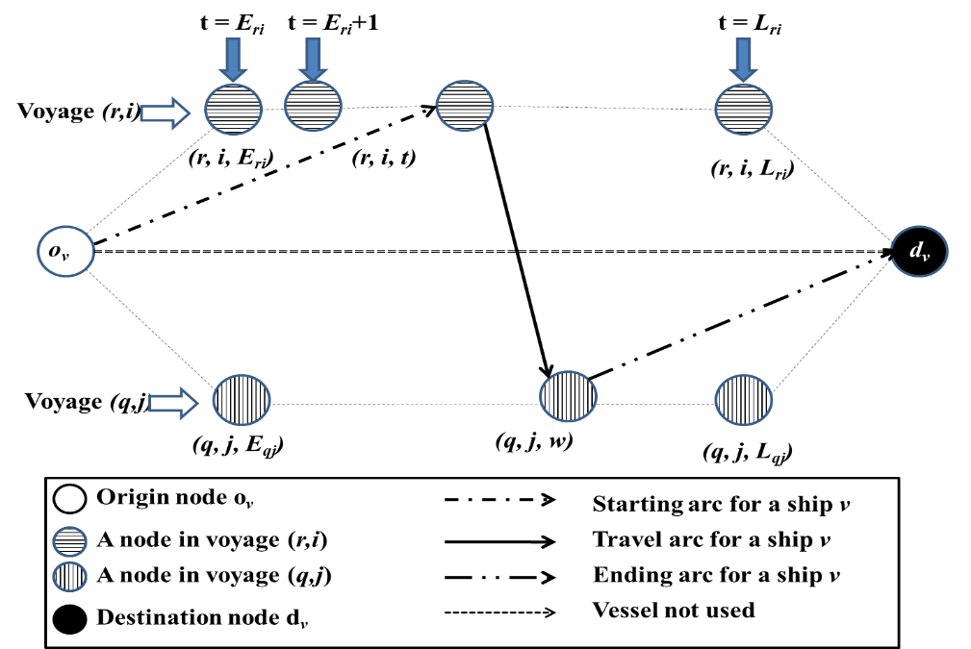
Figure 1: Illustration of the discrete time-space network

Mathematical model:
The objective function tries to minimize the cost of travelling of the company’s vessels along with the cost of assigning voyages to spot ships in its first four terms.
Minimize
$$\sum_{v∈V}{\sum_{\left(r,i,t\right)∈S∪\{d_{v}\}}{C_{o_{v}r}x_{v(o_{v},\left(r,i,t\right))}}}+\sum_{v∈V}{\sum_{\left(r,i,t\right)∈S∪\left\{o_{v}\right\}}{C_{rd_{v}}x_{v\left(\left(r,i,t\right),d_{v}\right)}}}+\sum_{v∈V}{\sum_{\left(\left(r,i,t\right),\left(q,j,t\right)\right)∈A_{v}}{C_{v\left(\left(r,i,t\right)\left(q,j,t\right)\right)}x_{v\left(r,i,t\right)\left(q,j,t\right)}+\sum_{r∈R}{\sum_{i∈N_{r}}{C_{ri}^{S}}}}s_{ri}}+∆\sum_{r∈R}{\sum_{p∈M_{r}}{\sum_{t∈T}{\left(i_{rpt}^{o}+i_{rpt}^{d}\right)}}}$$ | (1)
Subject to:
Routing constraints:
The first set of constraints-(3) make sure that a ship leaves its origin to go to another node, i.e. to serve another voyage or ends its route by going to the artificial destination node d_{v}.
$$\sum_{(o_{v},\left(r,i,t\right))∈A_{v}}{x_{v(o_{v},(r,i,t))}}=1, ∀v∈V$$ | (2)
Similarly constraints-(4) make sure that a ship ends its route at the artificial destination node d_{v}.
$$\sum_{(\left(r,i,t\right),d_{v})∈A_{v}}{x_{v(\left(r,i,t\right),d_{v})}}=1, ∀v∈V$$ | (3)
Constraints-(5) ensure that when a ship arrives at a particular node to serve a voyage in a trade route, it must leave that node to go to another node.
$$\sum_{(\left(q,j,w\right),(r,i,t))∈A_{v}}{x_{v(\left(q,j,w\right),(r,i,t))}}-\sum_{\left(\left(r,i,t\right),\left(q,j,w\right)\right)∈A_{v}}{x_{v\left(\left(r,i,t\right),\left(q,j,w\right)\right)}}=0, ∀v∈V,(r,i,t)∈S_{v}$$ | (4)
Constraints-(6) ensure that each planned voyage in a trade route is compulsorily served by a ship in company’s fleet or by a spot ship.
$$\sum_{v∈V}{\sum_{(\left(r,i,t\right),(q,j,w))∈A_{v}}{x_{v\left(\left(r,i,t\right),\left(q,j,w\right)\right)}}}+s_{ri}=1, ∀r∈R,i∈N_{r}$$ | (5)
Port loading/discharging constraints:
A vessel v can load/discharge cargo at the first port p₀ of a route r at the starting time of voyage only when the ship serves that route. We assume the start of voyage in a route as the starting of cargo work at the first port of the route.
$$q_{vrp_{o}ct}≤{\overline{Q}}_{v}\sum_{(\left(r,i,t\right)\left(q,j,w\right))∈A_{vrt}}{x_{v(\left(r,i,t\right)\left(q,j,w\right))}}, ∀v∈V, r∈R_{v}, t∈T$$ | (6)
Constraints-(7) ensure that once a voyage is being served, then only the cargo loading/discharge at any other port of the route is possible at the corresponding travel time from the origin port till that port if at all the voyage is being served by a vessel. The deterministic travel times also include the service times and expected waiting times at previous ports.
$$q_{vrpct}≤\sum_{\left(\left(r,i,t\right)\left(q,j,w\right)\right)∈A_{vrt}}{x_{v\left(\left(r,i,t^{'}\right)\left(q,j,w\right)\right)}}{\overline{Q}}_{v}, ∀v∈V, r∈R_{v}, p∈M_{r}-\left\{p_{0}\right\}, t∈T:t'=max⁡\left(\left(t- \underline{T_{vrp_{0}p}}\right),0\right)$$ | (7)
A particular cargo c to be served in a voyage is always associated with a pair of an origin p^{c}_{o} and a destination p^{d}_{c}. Constraints-(8) equalize the amount of cargo c loaded at the origin port to that discharged at the destination port, as per the corresponding travel time along a route.
$$q_{vrp_{c}^{0}ct}=q_{vrp_{c}^{d}ct^{'}} ∀v∈V, r∈R_{v}, c∈K_{r}, t∈T:t'=t+ \underline{(T_{rp_{0}p_{c}^{d}v}-T_{rp_{0}p_{c}^{o}v})}$$ | (8)
The inventory balances at the individual ports, for each route, are represented by constraints (9) and (10). Constraints-(9) calculate the total inventory of all products traded along route r at the port p at the end of the initial time period t₀. The ending inventory at time period t₀ at a port p of all products corresponding to route r is equal to the sum of initial inventories of all cargoes in the route, along with the number of units of all the cargoes being discharged during the time period from the ships and all cargoes being produced during this time period, less the number of units loaded onto various ships during this time period and total units of cargoes consumed in t_{o}.
In this model we are not explicitly calculating the shipments and timings related to spot assignments of some voyages. Also it might not always be feasible to fulfil all the internal transportation demands even during the company served voyages. In reality it is not very rare to use spot services of other shipping companies to transport a small load of cargo between a pair of ports along a route. We are implicitly modelling this by adding a variable iº_{rpt} and deducting a variable i^{d}_{rpt} to the actual inventory variable i_{rpt} in the constraints. iº_{rpt} represents the surplus inventory meant to be served by spot shipping and i^{d}_{rpt} represents the cargo discharges meant to be served by spot shipping. In the optimal solution of the mathematical model a maximum of one of these turns out to be greater than zero for a particular port and a time period. Here we penalize these variables with high coefficients in the objective function- (1) to minimize the requirements of spot shipping to serve the internal cargo.
$$i_{rpt_{0}}+\sum_{v∈V}{\sum_{c∈K_{rp}^{o}}{q_{vrpct_{0}}}}-\sum_{c∈K_{rp}^{o}}{P_{rpct_{0}}}-\sum_{v∈V}{\sum_{c∈K_{rp}^{d}}{q_{vrpct_{0}}}}+\sum_{c∈K_{rp}^{d}}{P_{rpct_{0}}+i_{rpt}^{o}-i_{rpt}^{d}}=\sum_{c∈K_{rp}}{{IS}_{rpc}}, ∀r∈R, p∈M_{r}$$ | (9)
Similarly in any other time period the ending inventory of all the cargo, corresponding to a route, at a particular port is determined by the constraints-(10).
$$i_{rp\left(t-1\right)}-\sum_{v∈V}{\sum_{c∈K_{rp}^{o}}{q_{vrpct}}}+\sum_{c∈K_{rp}^{o}}{P_{rpct}}+\sum_{v∈V}{\sum_{c∈K_{rp}^{d}}{q_{vrpct}}}-\sum_{c∈K_{rp}^{d}}{P_{rpct}}-i_{rpt}-i_{rpt}^{o}+i_{rpt}^{d}=0, ∀ r∈R, p∈M_{r}, t∈T-\{0\}$$ | (10)
Ship loading/discharging constraints:
We assume that a ship starts a voyage empty, or conversely completes all the cargo transportation meant for a route during a voyage and finished a voyage empty. Thus the ship load on-board a vessel v at time period t0 is equal to the total cargo loadings made during this time period less the total discharges made during this time period.
$$l_{vt_{0}}-\sum_{r∈R_{v}}{\sum_{p∈M_{r}}{\sum_{c∈K_{rp}^{o}}{q_{vrpct_{o}}}}}+\sum_{r∈R_{v}}{\sum_{p∈M_{r}}{\sum_{c∈K_{rp}^{d}}{q_{vrpct_{o}}}}}=0, ∀v∈V$$ | (11)
Total ship load at the end of any other time period t is given by the total load at the end of last time period plus the total loadings made, less the total discharges made during this time period.
$$l_{v\left(t-1\right)}+\sum_{r∈R_{v}}{\sum_{p∈M_{r}}{\sum_{c∈K_{rp}^{o}}{q_{vrpct}}}}-\sum_{r∈R_{v}}{\sum_{p∈M_{r}}{\sum_{c∈K_{rp}^{d}}{q_{vrpct}}}}-l_{vt}=0, ∀v∈V, t∈T-\left\{0\right\}$$ | (12)
Capacity constraints:
The total stock of all cargoes in a port at a time period must be always less than the total storage capacity of the port. Constraints-(13) consider the fact that a port can be a part of several trade routes.
$$\sum_{r∈R:p∈M_{r}}{i_{rpt}}≤\overline{I_{p}}, ∀ p∈M, t∈T$$ | (13)
Similarly constraints-(14) make sure that the total load on-board a vessel at any time period should not exceed the maximum available capacity of the vessel.
$$l_{vt}≤\overline{Q_{v}}, ∀v∈V, t∈T$$ | (14)
Conditions on variables:
$$s_{ri}∈\left\{0,1\right\}, ∀r∈R,i∈N_{r}$$ | (15)
$$x_{v(\left(r,i,t\right),(q,j,w))} ∈\left\{0,1\right\}, ∀v∈V,(\left(r,i,t\right),(q,j,w))∈A_{v}$$ | (16)
$$q_{vrpct }≥0, ∀v∈V,r∈R_{v},p∈M_{r},c∈K_{rp},t∈T$$ | (17)
$$i_{rpt},i_{rpt}^{o},i_{rpt}^{d}≥0, ∀r∈R,p∈M_{r},t∈T$$ | (18)
$$l_{vt}≥0, ∀v∈V,t∈T$$ | (19)

Testing and results
Test problem – I; A simple test problem instance
We have created and tested this small toy-like problem instance to check the efficacy of the proposed mathematical model.

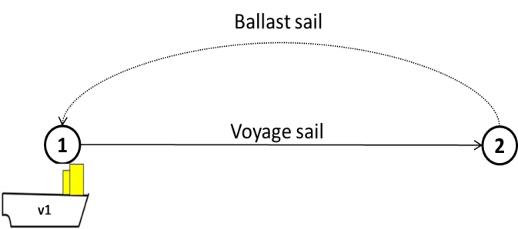

Basic data:
|V| | 1
|R| | 1
|T| | 120
|M| | 2
Ports and cargo in a route:
R | V_{r} | N_{r} | M_{r} | K_{rp} | P^{Avg}_{rpc}
1 | 1 | 4 | 1 | 1 | 1
 |  |  | 2 | (-)1 | 1

Daily prod/dem data:
For this instance we assume it to be constant at 1 unit per day at both ports.
Ship capacity:
v | Qv
1 | 2000+U(0,1)*4500

In the above configuration we assume that the time taken by the ship to sail from port 1 to port 2 is 1 day and same to return in ballast to start new voyage. The ship-1 is at the port-1 at the start of planning horizon, thus the initial ballast sailing time is 0. Cost of sailing the route once is 3 units and that of the ballast sailing is also 3 units. Initial inventory is taken as 30 units at port-1 and 2 units at port-2. The time window for each voyage is +/-2 days from the end of every 30 days.

Optimal solution:
Voyage | Start time | Port-1 loading | Port-2 discharging
1 | 1 | 31 | 31
2 | 32 | 28 | 28
3 | 60 | 31 | 31
4 | 91 | 29 | 29

Test problem -II
Here we present a problem instance, which is an abstraction of the real data. We develop our bigger instances as well on this base. The ro-ro shipping companies share their exact geographical trade routes on their respective websites. We have selected a subset of those trade routes with their exact sea distances obtained from the website http://www.ports.com/sea-routes. Apart from this information all the rest data are fictionally generated to represent the reality. We present here first of these instances, which consists of 2 routes and 2 ships. There are a total of 15 ports in the two routes with route-1 having 8 ports and route-2 the rest 7. Route-1 trades 16 cargoes and route-2 trades 11. The company offers 1 voyage per month in both the routes.
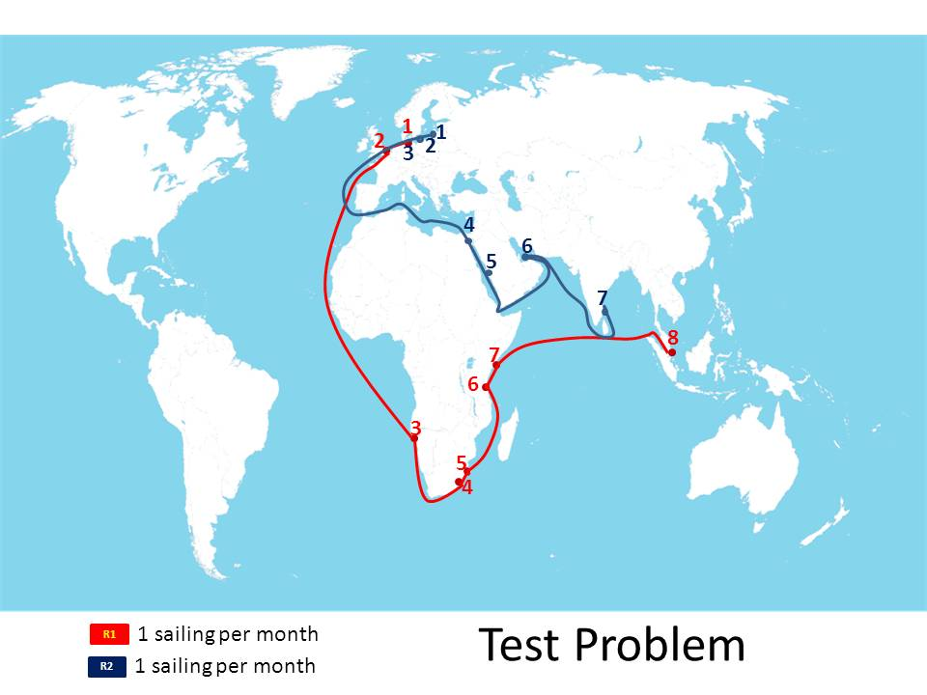
We start with a planning horizon of 90 days for this configuration. A data-set with 2 routes, 2 ships and a planning horizon of 90 days is represented as r2-v2-t90.
R | V_{r} | |Nr|=  (|T|/30*  voy/month) | M_{r} | D_{r_p0_p} | K_{rp} | P^{Avg}_{rpc}
1 | 1,2 | 4 | 1 | 0 | 1, 2, 3, 4, 5, 6 | 10,10,7,7,7,7
 |  |  | 2 | 138 | 7, 8, 9, 10, 11, 12 | 10,10,7,7,7,7
 |  |  | 3 | 6447 | (-)1, (-)7 | 10,10
 |  |  | 4 | 1608 | (-)2, (-)8, 13, 14, 15, 16 | 10,10,6,6,6,6
 |  |  | 5 | 288 | (-)3, (-)9, (-)13 | 7,7,6
 |  |  | 6 | 1516 | (-)4, (-)10, (-)14 | 7,7,6
 |  |  | 7 | 223 | (-)5, (-)11, (-)15 | 7,7,6
 |  |  | 8 | 4325 | (-)6, (-)12, (-)16 | 7,7,6
2 | 1,2 | 4 | 1 | 0 | 1, 2, 3, 4 | 10,20,10,10
 |  |  | 2 | 243 | 5, 6, 7 | 10,10,10
 |  |  | 3 | 183 | 8, 9, 10, 11, (-)1 | 10,10,15,15,10
 |  |  | 4 | 4141 | (-)5, (-)8 | 10,10
 |  |  | 5 | 571 | (-)2, (-)6, (-)9 | 20,10,15
 |  |  | 6 | 2371 | (-)3, (-)7, (-)10 | 10,10,15
 |  |  | 7 | 2540 | (-)4, (-)11 | 10,10

P^{Avg}_{rpc} gives the average production/consumption rate of a cargo c at port p of route r in time period t. D_{r_p0_p} gives the sea-distance in nautical miles from the first port of a route to an intermediate port.
The following distance matrix gives the sea-distances between two routes for ballast voyage. This distance gives the distance between last port of a route and first port of successive route.
Route (Dist - Nm) | R1 | R2
R1 | 9252 | 9621
R2 | 7858 | 8227

The following table gives the sea-distances of each route from the starting position of each ship.
Ship/Route (Dist-Nm) | r1 | r2
v1 | 1000 | 6000
v2 | 7000 | 500

Ship capacities:
Calculated randomly for each vessel as follows:
$$Q_{v}=2000+U\left(0,1\right)*4500$$
Cost factor for each vessel:
We multiply this factor to account for ship size while computing sailing cost.
$$c_{v}=\frac{Q_{v}}{min⁡(Q_{v}|v∈V)}*0.8$$
Ship speed estimation:
We randomly estimate the speed of each vessel as follows:
$$s_{v}=15+U\left(0,1\right)*25$$
Production or Demand rate at a port p in route r during time period t:
Computed randomly as follows:
- For production data:
$$P_{rpct}=N^{-1}[U\left(0,1\right),μ=P_{rpc}^{Avg},σ=0.1*P_{rpc}^{Avg}]$$
- For consumption data:
$$P_{rpct}=N^{-1}[U\left(0,1\right),μ=P_{rpc}^{Avg},σ=0.2*P_{rpc}^{Avg}]$$

Maximum storage capacity in each port:
$$I_{p}=\sum_{r∈R}{\sum_{c∈K_{rp}}{P_{rpc}^{Avg}}}$$
Time windows:
Computed as +/- 5 days from the end of each month for each voyage.
Cost parameters:
We take cost per nautical mile as a fixed value of 139 for a standard vessel doing a ballast sailing. The term c_{v} is the cost factor to take care of ship size. We multiply a factor of 1.2 to take care of the higher cost during a laden voyage in comparison to a ballast voyage.

$$C_{o_{v}r}^{B}=\frac{D_{o_{v}r}*139*c_{v}}{1.0*{10}^{6}}$$
$$C_{vrq}^{B}=\frac{D_{rq}*c_{v}*139}{1.0*{10}^{6}}$$
$$C_{vr}=\frac{D_{r}*139*1.2}{1.0*{10}^{6}}$$
$$C_{ri}^{S}=9999, ∀r∈R,i∈N_{r}$$

Solving the above model gives the following results:
System details: Intel (R) Core ™ 2 Duo CPU; T6750 @ 2.10 GHz; 2.09 GHz, 2.93 GB of RAM
CPLEX called from Python-2.78 took 98.42 seconds to solve this instance to optimality.
Optimal solution:
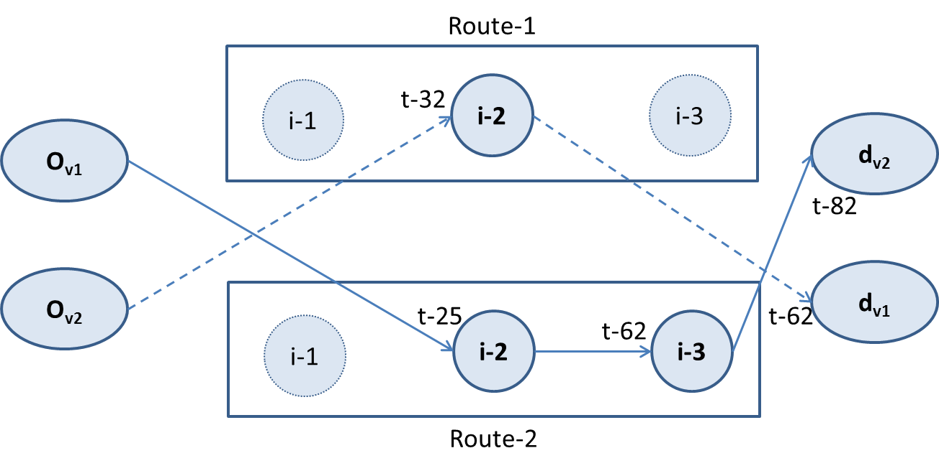
Further testing:
We have generated the 2-route and 2-ship data using 120 days planning horizon and also using 3 ships. We extended the above problem generation scheme to create data-set with 3 routes and tested it for 90 days and 120 days planning horizon with 3 ships.

The overall computational study on MILP solution is presented below:
Test Instance | No. of binaries | No. of columns | No. of Rows | Time taken to optimality (sec)
v1-r1-t120 | 158 | 304 | 924 | 0.2
v2-r2-t90 | 397 | 5635 | 2618 | 98
v2-r2-t120 | 1703 | 3864 | 8921 | 2,409
v3-r2-t90 | 476 | 3159 | 6231 | 565
v3-r2-t120 | 2335 | 4802 | 10385 | 19,991
v3-r3-t90 | 1774 | 4495 | 9759 | 9,636
v3-r3-t120 | 6574 | 6622 | 17184 | 180,000 (5% optimal)

Notes:
- The number of binaries, rows and columns are as per the reduced MILP through CPLEX pre-solve.

- The system used is the one described above:
Intel (R) Core ™ 2 Duo CPU; T6750 @ 2.10 GHz; 2.09 GHz, 2.93 GB of RAM

Conclusions
Ro-ro shipping lines are emerging as mega-carriers offering integrated maritime logistics services to clients. In this scenario, integrated planning of inventory, cargo shipments and ship routing is expected to improve operational efficiency in the part of maritime supply chain managed by a ro-ro shipping company. In this paper we propose a new modelling approach to combine inventory management at origin and destination ports of vendor managed cargo served by a ro-ro shipping carrier. We present a new MILP formulation for the integrated model. Test instances are generated for experimentation and computational results are presented for the same. We aim to develop efficient solution techniques for the proposed model.

References:

- Al-Khayyal, F., Hwang, S.-J., 2007. Inventory constrained maritime routing and scheduling for multi-commodity liquid bulk, Part I: Applications and model. European Journal of Operational Research 176, 106–130.
- Andersson, H., Fagerholt, K., & Hobbesland, K. (2014). Integrated maritime fleet deployment and speed optimization: Case study from RoRo shipping. Computers & Operations Research.
- Chandra, S., Srivastava, R. K., & Agarwal, Y. (2013). Multi-product maritime inventory routing with optional cargoes: An application to outbound automotive logistics. Journal of Advances in Management Research, 10(2), 206-229
- Christiansen M, Fagerholt K, Nygreen B, Ronen D, 2013. Ship routing and scheduling in the new millennium. Eur J Oper Res;228(3):467–83.
- Christiansen, M. 1999. Decomposition of a combined inventory and time constrained ship routing problem. Transportation Sci. 33(1) 3–16.
- Christiansen, M., Fagerholt, K., Ronen, D., 2004. Ship routing and scheduling: status and perspectives. Transportation Science 38 (1), 1–18.
- Fagerholt K. , Trond A. V. Johnsen & Lindstad H. (2009) Fleet deployment in liner shipping: a case study, Maritime Policy & Management, 36(5), 397-409
- Gelareh, S., Meng, Q., 2010. A novel modeling approach for the fleet deployment problem within a short-term planning horizon. Transportation Research Part E 46 (1), 76–89.
- Grønhaug, R., Christiansen, M., 2009. Supply chain optimization for the liquefied natural gas business. Innovations in Distribution Logistics, Lecture Notes in Economics & Mathematical Systems 619, 195–218.
- Meng, Q., Wang, T., 2010. A chance constrained programming model for short-term liner ship planning problems. Maritime Policy & Management 37 (4), 329–346.
- Powell, B. J., A. N. Perakis. 1997. Fleet deployment optimization for liner shipping: An integer programming model. Maritime Policy and Management 24(2) 183–192.
- Ronen, D., 1983. Cargo ships routing and scheduling: survey of models and problems. European Journal of Operational Research 12, 119–126.
- Ronen, D., 1993. Ships scheduling: the last decade. European Journal of Operational Research 71 (3), 325–333.
- UNCTAD, 2011. Review of Maritime Transport 2011. New York & Geneva.
- Wang, S., Wang, T., Meng, Q., 2011. A note on liner ship fleet deployment. Flexible Services and Manufacturing Journal 23 (4), 422–430.
- Zacharioudakis, P.G., Iordanis, P.G., Lyridis, D.V., Psaraftis, H.N., 2011. Liner shipping cycle cost modeling, fleet deployment optimization and what–if analysis. Maritime Economics & Logistics 13 (3), 278–297.

(-) sign in front of a cargo number indicates it is consumed in that port

