Punctuation and extrapolation: Representing a subsurface oil reservoir
Petter G. Almklov*, Thomas Østerlie, Torgeir K. Haavik
NTNU Social Research

Abstract
This paper discusses how data are made to represent subsurface phenomena in petroleum production. Drawing on studies of the subsurface disciplines in an oil company, and the multitude of sensor data employed there, we suggest that sensor data as representational artifacts are punctuated along three axes. We refer to this as spatial, temporal and aspectual punctuation. Whereas the two first refer to the positioning of data in space and time, the latter refers to the sensors’ response to single aspects of the interaction with the subsurface phenomenon. We show how extrapolation of punctuated data is a crucial element of the work of understanding the subsurface. It is when the punctuated data points are creatively extrapolated along the three axes of punctuation that ideas and models of the subsurface phenomena take shape. Consequently we argue that the processes of punctuation and extrapolation are the keys to understand how knowledge about the subsurface is created at the onshore office. Punctuation gives mobility whereas extrapolation is necessary to establish reference between the punctuated data and the inaccessible oil reservoir. We specifically discuss the implications of this has for reservoir models as representational artifacts.

Introduction
Offshore production of oil and gas is—in economic terms—by far the most important industry in Norway today. The offshore reservoirs off the coast of Norway are located beneath thousands of meters of rock under the seabed. Consequently, they are highly inaccessible and it is hard to gain knowledge of them. The petroleum industry depends on advanced technologies for locating, mapping, accessing and producing hydrocarbons. This paper is the result of a rather generous stance taken by the Norwegian petroleum industry in giving access to ethnographically oriented workplace studies. This has allowed all three authors to undertake separate, detailed investigations of the interactions between humans and technology in petroleum production. We have studied the work practices whereby engineers and geologists seek to understand what is going on in the abyss and the technologies they use to do this. In this sense, our object of study is the “knowledge machinery” (Knorr-Cetina 1999, p. 3) of petroleum production.
This paper reports on our shared reflections on the episteme of subsurface characterization, where we explore the relationship between mobility and meaning making when working with subsurface phenomena based on digital data generated by material arrangements of sensor technologies. We explore this relationship through the twin processes of punctuation and extrapolation. Material arrangements of sensor technologies are used to gain knowledge about physically inaccessible subsurface phenomena. In the process of making these phenomena mobile, sensor technologies punctuate them spatially, temporally, and aspectually. Engineers then extrapolate the punctuated data along the same three axes to make them meaningful. We use the term extrapolation rather loosely to discuss how data points are stretched to refer to something more than a single point. Interpolation is thus a subset of extrapolation, as it is a stretching between points. Spatial extrapolation, then, is the stretching of a data point outward from a single point to represent a spatial volume. Similarly, we speak of temporal extrapolation as the stretching of a data point to represent a time period, often used to make inferences about future developments based on a trend. Aspectual extrapolation, however, requires more explanation. We use it to refer to the stretching of a data point to make inferences beyond the aspect, or characteristic, which the data point immediately stands. A simple analogy for this is how measuring a person's body temperature with a doctor’s thermometer may be used to indicate an infection. As we will see, the combination of different data sources is an especially important way of making aspectual extrapolations. Extrapolation, in this paper, is largely a creative venture informed by pressing pragmatic necessity, something that is made particularly evident when we look at the role of extrapolation in modeling, where punctuated data are stretched to make coherent and connected representations of the reservoir as a whole.
This paper builds upon and extends existing research on mobility within science and technology studies. Mobility and its consequences is much explored within this literature through topics such as scientific representation (Latour 1987, 1995), technological artifacts (de Laet and Mol 2000), spatiality (Law and Mol 2001), and standardization (Bowker and Star 1999). To the discussion in this paper, Latour (1995) offers a central observation on the trade-off between mobility and representation: that necessary mobility is produced at the cost of the richness of an unstructured, undifferentiated reality. Our analysis of punctuation elaborates on this by showing how the process of constructing a certain representation through punctuation and extrapolation involves sacrificing alternative representations. We extend the literature on mobility by discussing how the processes that give mobility (punctuation) and the work done to establish reference based on punctuated data (extrapolation), are inextricably entwined.
We use the twin concepts of punctuation and extrapolation to empirically explore how underground phenomena come to be represented through four distinct cases from the domain of petroleum production. Through these four cases we seek a robust empirical foundation to argue that punctuation and extrapolation are general mechanisms involved in representing phenomena within techno-science. Then, we discuss the implications of the analysis for reservoir modeling, a major effort within the petroleum industry to build a coherent representation of the reservoir, a central subsurface phenomenon. We do so, because the reservoir model is regarded as the central point of reference for ongoing efforts within the industry to make better use of existing sensor data for computer-assisted or even completely automated real-time decision-making processes based on simulations. The specific pragmatic concerns influencing extrapolation in model construction have implications for further use of the model. We argue that subsurface personnel are faced with an inherent multiplicity of meanings that is possible to extract from the available data. Modeling, therefore, tends to enforce singular instantiations of this multiplicity. They fill a particular pragmatic role as consistent, uniform and stable representations, and this limits their use in other applications.
Before progressing with our analysis and discussion, we will give an outline of the work of the subsurface departments involved in petroleum production and some of the data used there. Thereafter, we will provide a quick review of relevant theory and literature, as well an overview of the methodological background for this paper.

The subsurface department and its data
Petroleum production is dominated by the sheer inaccessibility of the phenomena of interest on the one hand, and the advanced technologies required in understanding them on the other. We will here give a rough outline of the subsurface departments, who are involved, their main tasks, and the data they have to work with.
The hydrocarbon reservoirs on the Norwegian continental shelf are mainly sedimentary rock of Cretaceous and Jurassic origin. They are buried beneath subsequent sedimentation and are currently found off the coast of Norway, typically around 2000–3000 meters beneath the ocean floor. Oil is produced from concrete or steel platforms or, as has become more common recently, using submerged templates connected to pipelines and floating production facilities. Drilling technology has been subject to vast improvements in the recent decades, particularly in terms of steering and well placement. Wells are now often placed laterally through oil-bearing layers, with accuracy down to a magnitude of meters. Data acquisition from down-hole sensors and remote sensing arrangements have also resulted in improved data quality and increased amounts of data. However, as we will discuss later, even though there are enormous amounts of data available, the petroleum production domain is characterized by a lack of information and great uncertainty.
This paper is based on studies of professionals in dedicated subsurface departments following up production on offshore fields. While they may occasionally go offshore to support operations, their primary workplace is in onshore offices. The personnel on the platforms have mainly executing functions. It is the onshore engineers that have the task of building more coherent ideas and models of the underground, on which plans and strategies are built. Highly simplified, the distribution of work is as follows. The geophysicists and geologists try to understand the solid rock in the reservoir, meaning that they map the major structures of the geological formations, such as the extent and direction of different faults and sedimentary layers, and they describe details in rock properties down to pore level. The reservoir engineers combine this framework of solid structures with production data from existing wells to understand the flow of fluids through the reservoir. Based on this understanding, they plan a strategy for how to extract as much oil as possible from the reservoir, where to drill wells and how to manage the pressure and so on. Drilling engineers manage the process of drilling new wells. Based on the input from the reservoir engineers and geoscientists they try to plan a well path hitting the designated target in a safe and optimal way, and they monitor the drilling project until completion. Production engineers are primarily concerned with managing the production from existing wells. They plan and follow up different valve settings and pressure regimes to optimize the flow rates, as well as ensuring the long and short time viability of individual wells.
No matter the ontological stance one subscribes to in general, the position of whether the world is there for real or whether it is constructed, petroleum production is a domain where what you know and how you know it is indistinguishable in practice. The underground is inaccessible for inspection, except through highly complex representational artifacts. The information on which the subsurface department bases its understanding can be divided into some broad categories. First, there is a generic background knowledge base of petroleum production and supporting disciplines. This consists of both the theory in the petroleum disciplines and the laws of physics and chemistry, but also of more experiential types of knowledge from operations on other fields. Measured data from the reservoir is interpreted and contextualized against the backdrop of this knowledge base. The most important data can be divided into three types. 1) Seismic data are digital three-dimensional “images” of the rock structures, made up of the recorded acoustic reflections of sound waves sent down from ships during seismic surveys. These have low resolution, and only “see” variance in the acoustic properties of the rock. 2) Well logs are detailed, short range observations along the paths of existing wells. These consist of arrays of physical and chemical measurement devices, and are normally plotted along an axis along the well path. 3) Production data made up of different types of measurements of pressures and fluid flow in and out of existing production and injection wells.
The work in a subsurface department rests, to a great extent, on the ability to combine these data into a useful understanding of what is going on in the underground. One key attempt to do so is the construction of reservoir models, large numerical constructs representing the whole reservoir in a unified manner. There are different types of reservoir models, most notably the geological model and the reservoir simulation model. The simulation model is typically a less detailed model than the geological model (geomodel), where the geology is transformed into grid-blocks in order to simulate fluid flow in the reservoir. We will return to these models in the discussion.

STS, a relational ontology and pragmatics
While approaching work within subsurface departments from different academic traditions with distinctly different focuses and theoretical perspectives, all three authors draw upon literature sharing two common traits: a relational ontology and an intrinsic pragmatism (Bateson 1972; Giere 2002, 2004; Hutchins 1995; Bowker and Star 1999; Latour 1995, 1999; Ihde 1991, 2009). A relational ontology favors explanations of a system by stressing qualities of the interactions between components, rather than explanations that are based on ascribing properties to the individual components of the system. With basis in a relational ontology, Hutchins (1995, p.353ff), for instance, offers a well-formulated insistence that culture and cognition must be understood by its interrelations and not as independent components studied by the separate fields of anthropology and cognitive science.
In this paper, we draw particularly upon a relational perspective of technology. This perspective has predominantly been developed within science and technology studies (Bijker et al, 1987; Latour 1987), but also, among other places, in research within social informatics, where a relational perspective, inspired by Actor-Network-Theory (ANT), has been taken by Hanseth and Monteiro (1997) and recently gained much momentum after Orlikowski and Scott’s (2008) discussions of sociomateriality as a development of structuration theory. Approaching technology with a relational ontology leaves room for explanations of the relationship (per se) between technology and humans that are not reducible to the individual relata. Rather, as stressed by Orlikowski and Scott (2008, quoting Barad 2007), the social and material are mutually constitutive.
The pragmatist orientation of this relational approach of technology is found in the way researchers study signs and material representations in terms of what they do and what is done to them rather than looking for some inherent representational content. Specifically addressing modeling, Giere (2004, p. 743) presents a pragmatic discussion of how models are used to represent reality. We should not, he argues, focus on representation, but rather the activity of representing. To this end, he introduces a simple formula: “S uses X to represent W for purpose P” where S in our case would be the subsurface community [in Giere’s case the scientist], X is the model, W is an aspect of the real world and P is the purpose”. In the following, we will discuss the activities by which data and models are made to represent the reservoir for the purpose of producing petroleum.

Sensor data
All subsurface data are generated in complex sociotechnical ventures where both humans and advanced technologies are involved. When we discuss sensors here, we draw on Bateson’s (1972, 1979) epistemology. He employs logical type theory to argue that there is a fundamental logical step between the infinite variability of the external world and the differentiations that are information about it. The map is of a different logical type than the land it represents, and it only contains selected differentiations (boundaries) drawn based on an infinite variability. Though Bateson makes this as a general epistemological point, we draw on this when we regard sensors as devices constructed to let variation in the external world trigger the generation of differentiations in the sensor. As such, the sensor is set to let a selected “difference that makes a difference” generate information (Bateson 1972, p. 459).
The triggered information is of a different logical type than the triggering surroundings, as they are symbolic representations of them. However, when a sensor creates a sign, a code or a number that stands for its surroundings, it does so only for one aspect of it. The definition of this aspect is inscribed in the sensor, and as such, the reading is the result of the interaction between a sensor and its surroundings (Ihde, 1991). Seen in isolation, a sensor is self-referential, as it produces as pre-defined set of responses and is semantically closed. It is set to produce a limited set of responses along a specific axis. Returning to the analogy of a doctor's thermometer, when the mercury of a thermometer moves up and down along its scale, the surroundings are punctuated along the axis of measurement, notwithstanding what heats or cools it or whatever is going on around it.
In principle, a sensor can be local and does not necessarily refer to any standardized aspect, like the canary in the coal mine that stops to sing or dies to indicate that the air is deteriorating. However, such “data” are not easy to mobilize or use in combination with other data, or to see in relation to the existing theoretical knowledge base. The sensors employed in petroleum production (and basically all modern science) are designed to generate data that are mobile across contexts. When we discuss sensor data in the following, we thus refer to sensor arrangements that are built to generate standardized data able to move through digital information infrastructures (Bowker and Star 1999; Latour 1995; Almklov 2008).
In the office the punctuated sensor data are stretched spatially to speak of volumes, temporally to speak of time periods and aspectually to grasp the triggering subsurface phenomenon lurching behind the representations. Each data value does not carry much meaning in itself, but combined with other measurements of the same or other single aspects, and with theory and experience, the subsurface professionals infer more about the referent behind the data (Almklov and Hepsø, 2011). Though almost all information from the reservoir is in the form of “immutable mobiles”, the subsurface department is not primarily a “center of calculation” (Latour 1987, p. 215ff). Rather than mere calculation, the reservoir is mastered by creative combinations, interpolations and extrapolations of the scant data at hand. Keep in mind that when we, in the following, write of extrapolation we include also interpolation, that is, extrapolation between points.

Methodological background
In this paper we build on three separate, yet related research ventures. The authors have all conducted detailed ethnographically oriented studies (participant observation and interviews) in subsurface departments. While the first author has primarily been concerned with geologists and reservoir engineers, the second author has worked primarily with production engineers, while the third author has worked with drilling engineers. As such, this paper reports on the combined generic insights from three related paths of research, not explicitly designed to support the current argument. Even though both the work we studied and the individual disciplines have their differences, they all share great epistemic uncertainty since it is really hard to have exact information of what is really going on due to the inaccessible nature of the reservoir, a high reliance on sensor data, and an increasing reliance on modeling for data aggregation and decision support.
Below is a rough outline of the empirical background we draw upon:
The first author has conducted prolonged ethnographic field work in a subsurface department, and has undertaken subsequent ethnographic and interview-based follow-up studies. His main focus was the epistemology of geology and reservoir management, as well as interdisciplinary communication in a subsurface department. Currently, he is cooperating with reservoir modeling researchers, studying work processes related to new model based tools. The second author has conducted ethnographic fieldwork among a group of production engineers. A key topic of this study has been how human knowledge and sensor data are mutually constitutive. The third author has recently concluded a PhD based on participant observation of and interviews with personnel involved in the drilling process, with the aim of understanding how new model based technologies may affect the safety of the operations. He has also worked for three years as a logging geologist (“mudlogger”) for a service company.
Our studies have predominantly, but not exclusively, been conducted within the same major Norwegian oil company. The topics discussed here concern the epistemic foundations of the work in a subsurface department, and have been touched upon in earlier publications (Almklov and Hepsø, 2011; Haavik, 2011; Østerlie et al, 2012). Thus, this paper presents a synthesis of previous observations, and some underlying conditions that we believe can help explain more superficial and specific findings in the individual projects. Moreover, though as the paper is not the outcome of a deliberate design, there is an element of validation in the comparison of our studies.
We have studied work, and described and analyzed it in other publications, but here we put more weight on the tools with which work is performed. The narration will, in the following, be centered on the properties of sensors, artifacts, and representations. Though we have intimate knowledge of the field and have relevant technical backgrounds, we approach it as social scientists and are not specialists on the discussed technologies as such. The following analysis is based on our observations and what we have learned when studying the work of people who use them to understand the subsurface formations. The account we give here is simplified, both because we do not have the full overview and insight into all aspects of the technologies, and because we want to be able to convey our understanding to a broader audience outside petroleum production. We have, however, not chosen the simplifications that would be most convenient for our argument, but rather confronted data types that may not fit easily with our theoretical discussion. For example, the sampling of cuttings doesn’t have a very prominent role in petroleum production, and the example makes our discussion here somewhat more complex. We have still included a discussion of mudlogging, which is based on physical samples, since it triggers some fundamental considerations with regard to aspectual punctuation and mobility (see section 3.4).

Findings: punctuation and extrapolation
In this section we explore a selection of the most important data types in the subsurface domain through the lenses of punctuation and extrapolation. We illustrate how they are punctuated, spatially, temporally and aspectually, and how they are extrapolated to become meaningful. The data types are chosen to demonstrate different trajectories of punctuation and extrapolation and how these processes are connected. By discussing these data types we also provide an understanding of some of the most crucial extrapolation processes in reservoir characterization.

Resistivity log
While drilling and during subsequent well operations, an assembly of logging sensors is attached to the drill string and lowered down into the well. The drilled hole is a rare opportunity to obtain close-up access to the reservoir, and hence a myriad of different sensors based on different physical principles are lowered into the well. As will be discussed later, physical samples may also be collected from an open well, but the down-hole sensors are usually of utmost importance. The resistivity meter is a workhorse of the well logging assembly, measuring the rock’s resistance to electric conduction. Rock formations filled with oil or gas are less conductive to electricity and hence have a higher resistivity than those containing water. Resistivity, therefore, gives an indication of the type of fluid filling the pores of the formation.
In terms of spatial punctuation, the resistivity log is a series of points along a downward axis representing the well trajectory. The response, from the rock formation in the proximity of the well, to an electric pulse is condensed into a line of point readings along the well trajectory. How much of the volume is actually represented by these points is not all that clear. When these readings are employed to provide indications about the formations around the well, they are extrapolated based on combinations with other data types. One common combination is with seismic data that give a coarse outline of the layering and main faults in the area. Thus, a punctuated reading of the resistivity in a well at a certain point can be extrapolated outward based on a coarse outline of the general structural trends in the area.
The fluid content of the reservoir changes only slowly, so in terms of temporal punctuation, it is mostly relevant to know the date of the logging later on. If different wells penetrate the same body of porous rock, a group of resistivity logs from the same zone can be studied later on to evaluate fluid movement in an area over periods of months and years. In some fields, where there is relatively easy access to the wells, it is not uncommon to do repeated resistivity logs to monitor changes in fluid content over time. This is illustrated in Figure 1. This is a section of a standard well log, where the readings from different sensors are plotted on a downward axis along the well trajectory. Item c) is the original resistivity log. It is red, representing oil, for most of the upper half of the section. When the measurement is repeated for the top half, we can see that water has replaced much of the oil, quite vividly illustrated by the blue color replacing the red.

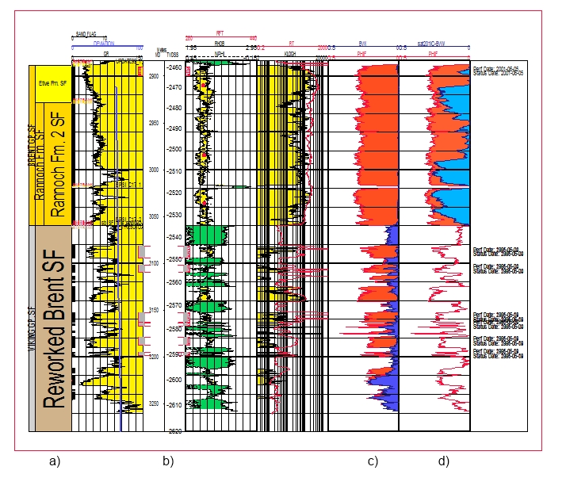
Figure 1 Section of well log. a) is the name of the interpreted geological formation. The downward axes b) are well length and depth. c) and d) are two resistivity measurements with three years between them. Notice how the water (blue) has replaced oil (red) in the upper half of the well.
No one is really interested in the resistivity itself. It is its indirect indication of fluid content that is interesting. Resistivity readings can be the results both of the fluid content of the rock as well as the properties of the rock itself. Moreover, it is critically important for production and safety purposes to know whether an observed interval in a well with high resistivity indicates oil or gas. The visual design of a well log is ideally suited to combining readings from different sensors at the same depth in the well. The resistivity is plotted on a downward axis representing the well depth. Along the same axis are several other measurements. The reading can thus be combined with other readings to infer something about the phenomenon “behind” the data. This we refer to as aspectual extrapolation. It is a movement from measured data toward the phenomenon of interest. To sort out whether high resistivity in a zone represents oil or whether it is only highly resistive shale, it is common to check other readings at the same depth. Shales are slightly radioactive so, if high resistivity occurs at the same depth as readings of high gamma radiation, the probability of oil is lower. Thus, the combination of two rather uninteresting aspects can be used to make inferences about what they are really really interested in, which is oil. When the whole array of sensor readings from the same depth is combined in such ways, the subsurface specialists can usually obtain a pretty good idea of the type of rock and fluid content around the well, even during drilling. As such, the combined log gives relatively robust observations of the conditions in the well. However, the extent to which these observations are valid outward from the well is a matter of spatial extrapolation, commonly in combination with the seismic data or interpolation between wells.

Seismic data
The seismic data (commonly referred to as seismics) are recorded reflections of acoustic pulses. An explosion or a sound generating device emits a powerful pulse that is recorded by an array of hydrophones towed behind ships or attached to the ocean floor. The sedimentary rock on the Norwegian continental shelf consists of relatively horizontal layers of mainly sandstone (lithified sand), shale (lithified clay) and limestone. Boundaries between light and dense layers generate reflections (echoes) that are registered by the hydrophones. After heavy processing, the recorded sound waves can be converted to a three dimensional “image” of the reservoir displaying the reflections as shown in Figure 2 below.
The hydrophones are set to record sound. In order to isolate reflections from the rock structures in the reservoir, the hydrophones are arranged in specific physical patterns and the recordings are subject to heavy computer processing before the seismic data set is ready to be used. In this processing, the time it takes for a reflection to reach a hydrophone is converted to depth of the structure.
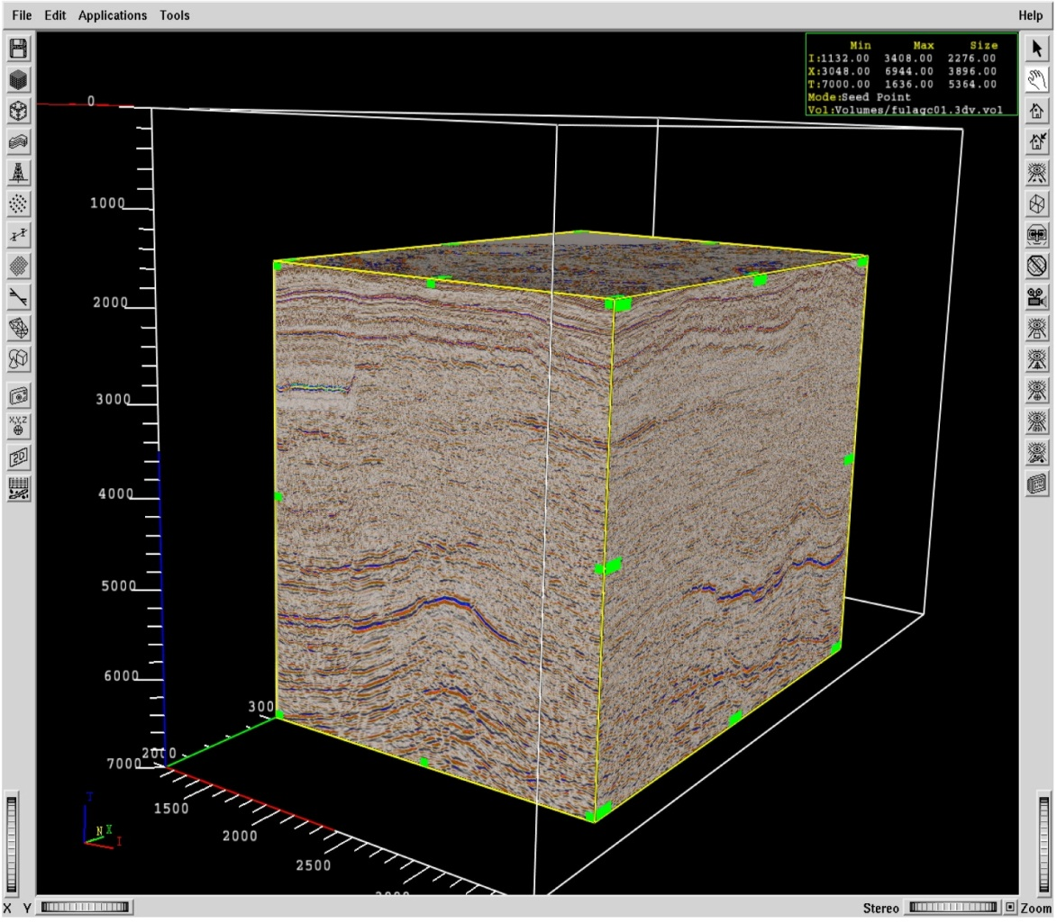
Figure 2 Screen dump of seismic cube.
Seismics are quite different from the other types of data due to the sheer size of the data set. It consists of millions of data points covering the whole extent of the reservoir. However, it does so rather imprecisely, as even a well calibrated data set has a resolution in the range of tens of meters. Thus, it does not discriminate between thin layers. In terms of spatial punctuation, the seismics are a vast number of “pixels” that, when combined, reveal coarse patterns of the reservoir structures. Spatial extrapolation is a matter of going down in scale, and using it to understand fine structural variations. As much geological variety with importance for oil and gas production is too small to produce visible reflections, the patterns seen in the seismics are also extrapolated to make inferences about the shape of structures below seismic resolution.
The seismic sensor arrangements are designed to filter out noise from other sound sources and reflections from geologically less interesting phenomena. The mathematical processing of the seismic data set is also designed to isolate the reflections between layers. When the sound wave hits the boundary between two sedimentary layers, it will be reflected if there is a density difference between the rock types. Aspectually, then, the seismics display variations in acoustic properties of the formations. They are only able to pick up differences that give a sufficient acoustic contrast to produce a reflection. On the Norwegian continental shelf, the visible boundaries on the seismic display are typically ascribed to transitions between tight shale and porous (and possibly hydrocarbon containing) sandstone. The sound reflections are regarded to represent such a layer boundary when they are “tied in” with wells and well observations explain the reflection. When combined with more detailed observations from wells, the acoustic responses can be aspectually extrapolated to represent geology.
The rock structures do not change much during production and seismic surveys are very expensive. Traditionally, they have, therefore, been conducted only once or very few times for each field. In recent decades, however, improvements in sensor arrangements and processing power have allowed for the utilization of repeated seismic surveys to study the differences in acoustic properties that result from changes in the fluid content of the rock. By conducting identical seismic surveys, and studying the differences over time intervals, typically a few years, it is possible to pick up the changes in fluid composition. Contrasts are strongest where gas has replaced water or oil in the pores of reservoir rock and thus reduced the density and altered the acoustic properties of the rock. Thus, we see that a combination of seismic surveys, taken at two points in time, makes it possible to wrestle out another aspectual distinction as the acoustics of the bulk rock and the influence of the fluids in the pores can be separated.

Production data
The fluids streaming out of the many wells drilled into an oil field's subsurface reservoir flows through kilometers of pipelines towards the topside platform. This large, continuously unfolding flow is referred to as the well flow, and is the central object to be monitored and controlled during daily petroleum production. In the preceding two sections we have discussed how engineers can know about underground rock formations by spatially extrapolating log data and seismic data. Unlike rock formations that are stable over time, the well flow is a constantly evolving flow of liquids and particles. To have knowledge about this continuously unfolding phenomenon, sensors generating real-time data about the well flow are mounted at standardized positions within wells and along the pipelines leading towards the platform. Each sensor measures a single characteristic of the well flow – such as temperature, pressure or sand content – punctuating the well flow aspectually. Production data is a general term used about this kind of sensor data.
Engineers need to see how the measured characteristics evolve over time when monitoring and controlling the well flow. The sensors cannot measure change. Rather they make measurements at set time intervals, using these data points as basis for calculating change. The sampling rate of such measurements ranges from once every second to once every ten minutes. Some, more advanced technologies referred to as smart sensors, make frequent measurements, but only report data when there is an actual difference between two measuring points. This kind of sensor data, therefore, has varying sampling intervals. Summarized, by sampling data at time intervals, sensors punctuate the well flow in temporal space.
For the engineers monitoring and controlling daily production, single data points yield only limited information about how the well flow evolves over time. The value of single data points is often inaccurate because of sensor drift. Rather, it is the overall shape of how the data evolves over time that engineers use in monitoring and controlling production. Production data is, therefore, most commonly visualized as a two-dimensional graph, with data value along the y-axis and time along the x-axis. Visualizing production data by sequential interpolation between individual measuring points this way helps engineers to see how a particular characteristic of the well flow evolves over time. Engineers use such graphs in two ways. First, they make inferences about future developments based on the shape of the graph by extrapolating the graph in temporal space beyond the final measuring point to. Because of its high temporal resolution, there is often a lot of noise in production data, which results in jagged graphs. Engineers tend to extrapolate manually at a lower resolution to create more smooth trends to better see how a characteristic evolves over time.
Data from on a single aspect is often not sufficient for the engineers to understand the underlying phenomena. We will explain this by going in some detail on one sensor: the acoustic sand sensor. The acoustic sand sensor is designed to measure the content of sand particles in the well flow. This is measured in terms of grains of sand passing across the sensor position every second. Like practically all sensors, the acoustic sand sensor makes indirect measurements of the characteristic it is designed to isolate and measure. Mounted on the outside of pipeline bends where the well flow hits the piping at high velocities, the acoustic sand probe is designed to punctuate the well flow aspectually by counting the frequency of a particular sound generated when sand hits the piping. Aspectually, what is measured is an acoustic signal, resulted by the interaction between the well flow, the piping and the sensor. The measured sand content as such depends on the sand content itself, as well as on the condition of the piping and a sensor in a harsh environment. Moreover it depends on the velocity of the well flow at that particular position in the well. This is in itself hard to obtain any accurate measurement of. Consequently, an assessment of what sand content the acoustic response represents depends on calibration. In the case of acoustic sand probes, this is a rather complex and costly venture, potentially involving interventions by remotely controlled submarines. Understanding sand data as representations of sand content consequently depends on assessing how much has changed since the last point of calibration.

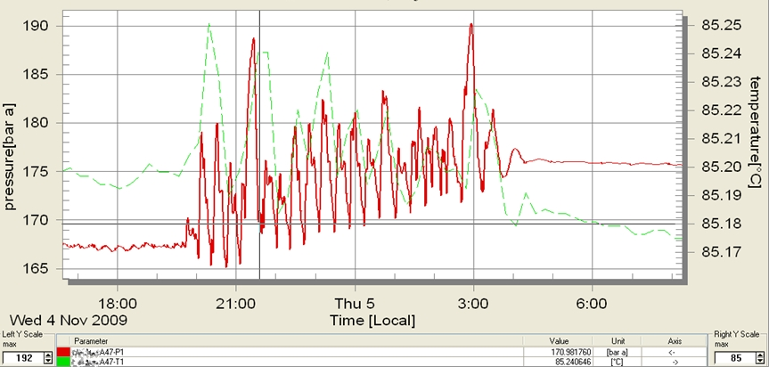
Figure 3 Pressure and temperature development during "slugging". Slugging is often associated with changes in sand content measurements.
Production data are also crucial to monitor the reservoir and possible problems in the production system. Here, too, it is not single data points that represent the developing underlying phenomenon, but extrapolations between different data, and importantly in this context, how the data develop over time. For example: If the visualized data show that sand content suddenly increases, engineers may interpret this pattern to signify a down-hole sand avalanche, where parts of the surrounding rock formation has collapsed around the well. However, it may also be caused by a phenomenon called slugging, where rapid increase and decrease of down-hole pressure tears sand particles off the surrounding rock formation and into the well flow. No matter the reason, sand in the well flow can have serious consequences and must be handled. However, the procedures for handling a sand avalanche are significantly different from those for handling slugging. Engineers, therefore, manually interpolate sand data with pressure data to determine the underlying cause of the increasing sand measurement. A jagged pattern with rapid and violent fluctuations of pressure will tell them that the sand have been caused by slugging (illustrated in Figure 3). Understanding production data is both a matter of looking at data types in combination, but also of understanding their temporal patterns, and often how they develop in concert.

Logging of cuttings during drilling
During drilling, fragments of the drilled formations are brought to the surface by the circulating drilling fluids, referred to within the petroleum industry as mud. These are normally sampled and analyzed by the “mudlogger”. Typical sampling intervals may be each 10 meters above the reservoir and each 3 meters in the reservoir. During drilling these analyses are, in combination with other sources, used to create detailed lithology logs of the subsurface formations that may be compared to the expected sequence of layers to keep track of the progress and positioning of the drilling process with respect to the geological structures.
We have suggested here that punctuation gives mobility (and combinability) of aspects of the phenomenon that is measured. One thing that distinguishes mudlogging from other measurements described in this paper is that the sample is transported, before it has been subject to analysis. It is physically mobilized when rock is cut loose by the drill bit. As it is physically moved, it retains much of its aspectual multipotentiality. The transport of the sample from the subsea formations to the laboratory for analysis is an interesting journey in itself—a journey we will come back to shortly. But for now, when the sample is collected at the shale shaker (a sieve filtering the drilling mud), it is brought to a laboratory on the rig for further analysis.
When the sample arrives at the laboratory, it has been accurately temporally punctuated, coarsely spatially punctuated, and aspectually not punctuated at all. Further punctuation results from the subsequent analysis. A common sample consists of approximately ½–1 kg of cuttings and drilling mud. A smaller sample of 10–30 g is separated from the main sample. The main sample is then packed in a sealed plastic bag which again is packed in a cloth bag that is marked with the name of the well and the depth from which the sample originates. This bag is later shipped to shore, where it is stored. The smaller sample is washed with soapy water in order to remove the drilling mud. In the analysis, the instruments are simple: a sample tray, a needle, a microscope and hydrochloric acid-solution are among the main accessories. The sample is categorized with respect to, among other things, rock type, color, grain size, texture, and oil content. As the categorization is the result of an interactive interrogation of the material including several kinds of instruments, this is a kind of aspectual punctuation, quite similar but not identical to the isolation of single aspects by sensors. Based on this analysis the physical sample is transformed into a plot representing the rock type composition of the sample. In Figure 5 below the column to the left shows the rock type composition of the samples plotted against the depth from which each sample originates. However, this lithology log shows the composition of the rock sample that is retrieved at the shale shaker, not the composition of the formation rock at one single point in the underground formations. At this stage, the spatial positioning is rather coarse and requires corrective action for the sample analysis to be further mobile beyond the lab.
The chips of rock that are drilled out of the well are continuously being carried to the surface by the drilling mud that circulates down through the inner annulus of the drill string and up along the annulus between the drill string and the walls of the well. By reference to the speed of circulation, the depth of the drill bit and the corresponding point in time—the temporal punctuation—it is possible to calculate when cuttings that are drilled at a certain point in time will arrive at the surface. However, this is a crude approximation for two reasons. First, the drilled cuttings have a tendency to sink relatively to the drilling mud, and different rock types may sink with different velocities. Second, the velocity calculations of the drilling mud are based on a laminar flow, but some degree of turbulence in the drilling mud will inevitably occur. As a consequence, the sample retrieved on the shale shaker will consist of drilled cuttings not from one single point in the well, but from a drilled interval of perhaps several meters—a coarse spatial punctuation.
The mixing of the transported sample is not irreversible, however. To plot the analysis against depth, the analysis is evaluated alongside other sensor measurements whose depth origins are highly accurate, such as differential rate of penetration, torque, gamma ray and resistivity. Due to the different characteristics of shale, limestones and sandstones, transitions from one of these rock types to another will be accompanied by a marked change in the values of these parameters. When entering a new formation type it results in a gradual change in the mix of the rock types in the samples. The drilling parameters, however, will often show more distinct signals at the actual depth of the formation boundary. Thus, the observation of a change in geology may be tied to a specific depth. By bringing together these different measurements from different sensors and analyses, one may end up with a representation of the stratified lithology – a formation evaluation log – as in the example in Figure 4. At last the sample has been spatially punctuated, this time through combination with other sensor data.
This plot is now highly mobile and combinable, and, by comparing it with similar plots from other wells in the same area, it is possible to obtain a functional and trustworthy idea of the subsurface formations through extrapolation.
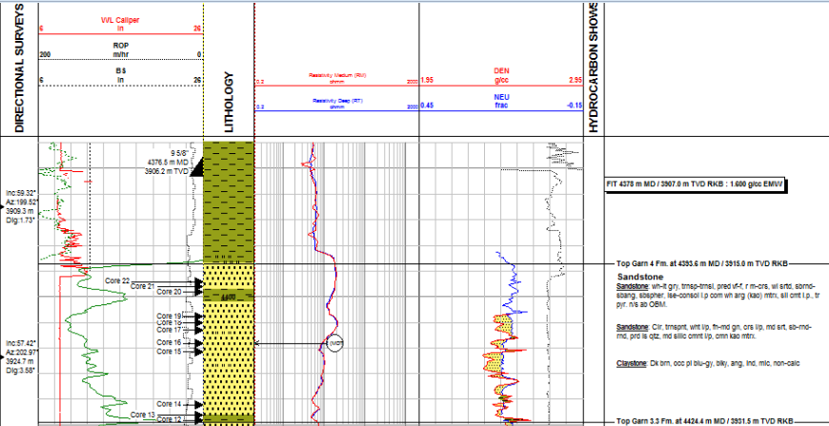
Figure 4. Formation evaluation log. The lithology log is the vertical section consisting of yellow and greenish blocks of color (in this case representing sandstone and claystone).
Figure 4 represent the final formation evaluation log. What it does not show is the content of the cuttings samples. In Figure 5 below the content of the mixed samples and the resulting lithological log is placed side by side to visualize the spatial punctuation that takes place:
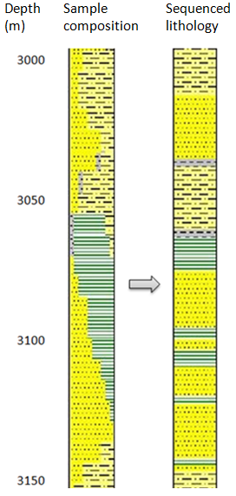
Figure 5. The column to the left shows the relative composition of the sample, whereas in the column to the right layers are drawn as they are interpreted to appear in the subsurface formations.
This example illustrates how knowledge of the geological formations results from combining different types of data that cannot alone account for the structure of the formations. The different data are collected by different sensors/instruments. The process of punctuation and transportation is less linear than the case in the other examples in the paper. As with the other geological data, temporal punctuation of the data from logging is rather trivial, due to the stability of the rock. However, the time of sampling is used to calculate the probable depth of the sample. Spatially, the sample is punctuated indirectly, both by calculating the expected time of arrival based on knowledge of the drilling process, and also by tying in the sample analysis with a model of expected geology, as well as with sensors with more robust spatial positioning. We have primarily discussed sensor data in this paper, and the sampling of cuttings is hardly a sensor. The main difference is that a sample retains much of its aspectual potentiality when transported to the surface. This potentiality is maybe most clearly illustrated by the fact that cuttings are stored in great storage houses onshore, hardly ever revisited. But the potential is always there, to single out one more aspect of it later on, maybe use an electron microscope, maybe undertake chemical analysis.
During drilling, the mudlogger’s analysis in the laboratory draws interactively on several aspects of the rock that she can study with dedicated lab tools. She does so with the support of data from other sensors and a model “predicting” how the sequence of formations may be. She can choose the level of detail she needs to go to, employ new instruments if in doubt and make inferences based on the combinations of analyses that best fit her situation. She can adjust her effort both depending on the quality of the sample and what detail of information is needed. When drilling through long familiar sections, for example, the sample is only superficially analyzed.
With the other data types, most of the interactivity lies in how they are extrapolated, but there is also some room to influence the sensor setup and the software by which it is processed. A resistivity log can, for example, be adjusted to cover more of the surrounding volumes of the well, at the cost of reduced resolution. Sand sensors can be calibrated, and the seismics filtered to highlight specific types of phenomena depending on one’s interests. As such, the experiment conducted by the mudlogger can be seen as a miniature of the whole “analysis” of the reservoir
The sample has had physical mobility up to the laboratory, without aspectual punctuation. This also limits its mobility and combinability as information. It is situated in the laboratory. When the analysis is used further on, however, it is as codes formulated in a standardized manner, as in the names of geological formations in item a) in Figure 1.

Discussion

Mobility, pragmatics and representational applicability
Through the analysis above we have shown how representation of subsurface phenomena is not a passive reading of sensors. Rather, it is the result of a set of sociomaterial representational practices, even down to the individual data point. The analysis shows that the mobility of sensor data in itself is unlimited, but the mobility of the information it may convey is not. The usefulness of sensor data as representations of the reservoir depends on well-informed extrapolation. Since the referent of the punctuated sensor data is an intangible undifferentiated phenomenon, their representational value is highly limited without extrapolation. We will now discuss some implications of these observations for modeling and models in the petroleum industry.
Our basic observation is that sensors punctuate physical phenomena to gain mobility and that the generated sensor data are extrapolated to become meaningful. Extrapolation is closely related to the pragmatic concerns of what the sensor data is to be used for. Reservoir management relies heavily on data from remote sensors and sensor arrangements lowered into the well bore or mounted within producing wells. Punctuation is both a strategy of gaining mobility of information from the inaccessible reservoir to the onshore offices, and also of making the data combinable with other data. In the analysis above, we identified spatial, temporal and aspectual punctuation as the axes along which this is undertaken.
The creative extrapolations of data along these axes are that which create representations of the reservoir. Only a few examples of extrapolation have been discussed, but they should suffice to illustrate that the stretching of data is all important in constructing ideas about the reservoir. Also, it seems, at least from a layman’s perspective, that there is an inexhaustible reservoir of possible combinations and ways to stretch the data.
Log data along a well path, such as resistivity, are typically accurate and trustworthy. However, their usefulness depends on spatial extrapolation toward data from other wells or data that cover greater volumes (typically seismics). They also reflect geologically interesting properties only indirectly and must be combined with other data to make inferences about the phenomenon they are suspected to represent. The seismics, for its part, cover the whole reservoir quite inaccurately and with low resolution, and is aspectually tied to geological structures when paired with well observations, and used in combinations with these to understand the structures that are below the seismic resolution. For the sand data, aspectual extrapolation is necessary to understand the sand readings themselves, but it is also an important element in the work that is done in sorting out errors in sensors. As the well flow is a dynamic phenomenon, extrapolation along the temporal axis is particularly important in production. The mudlogging example illustrates how mobility is achieved without aspectual punctuation. The sample is punctuated temporally and spatially (aided by other sensors and calculations) but not aspectually as it is physically transported to the platform, where it is subject to an interactive analysis. After analysis, the results are coded in ways that are easily combinable with sensor readings.
In all these cases, ideas about the subsurface phenomena are conjured out of the data by extrapolation. The data themselves are resources for pragmatic extrapolation. They represent the subsurface only by such inferences. Hence, while sensor data are highly mobile, the meaning that they can be used to produce is not. In this sense, sensor data are different from data referring to already differentiated phenomena. The data on a bank transcript, for example, refers to established symbolic entities (money), and are normally not tools to explore an undifferentiated phenomenon. I can quite easily combine my transcripts and add up the money from my different accounts and report the sum to the tax authorities. We were hesitant to label the subsurface department as a center of calculation in the introduction of this article. The phrase would suggest the “bank transcript” type of combination, and not the interactive investigation of what the data might reveal that we have described in this paper.
- Although subsurface specialists understand their data pragmatically, and use them as tools rather than representations, we also observe that data are viewed as representational in the organizational discourse. The tension between the pragmatic use of data and such a representational understanding of it has practical consequences for the management of data in the petroleum industry. The last decades of digitalization have led to a wider distribution of data and tasks across sites and contexts. New organizational concepts and ideas are in many cases based on a “representational” understanding of data, envisioning a mobility of subsurface data as representations of the reservoir similar to that of a bank transcript. Stressing the importance of extrapolation, also when data is moved into new contexts, is thus a key contribution of our research to innovation and research in the petroleum sector.

Reservoir modeling and extrapolation
As the discussion of the different data types in Section 3 suggests, ideas about the reservoir are products of the sociomaterial activity of representing. In the interactive extrapolation, the punctuated data are powerful tools that may speak of the reservoir beyond what they immediately represent.
Extrapolation draws on an inherent multiplicity of possible combinations. There are no definite rules as to how far one can stretch a well observation, or what data types to interpret in concert in order to identify a layer boundary or a fault, for example. If there were, they would certainly be broken, due to the pragmatic attitude of the subsurface workers (Almklov, 2008). When building a model, this multiplicity of possible interpretations is reduced to one realization. If we revisit Giere’s (2004) discussion of how scientists use models to represent reality, we understand that the model is informed by a purpose. When building a model of the whole reservoir, extrapolations are undertaken explicitly to form a unified whole, connected and stable, a common reference point on which other work can build. This purpose constrains and informs the extrapolations that are made. The reservoir models are potent tools for communication and cooperation, and in the case of the simulation model, assessment of the fluid movements in the reservoir.
Figure 6 is a seismic and geomodel cross section along the same plane (the path of a new well). Notice how the model (lower pane) consists of an ordered sequence of layers, with defined boundaries and faults. It projects a much less messy image than the actual data upon which it builds. With its simplified boundaries and objects, it is much easier to communicate about and organize around. Also, variants of the model can be employed to simulate fluid flow in the reservoir, based on production volumes.
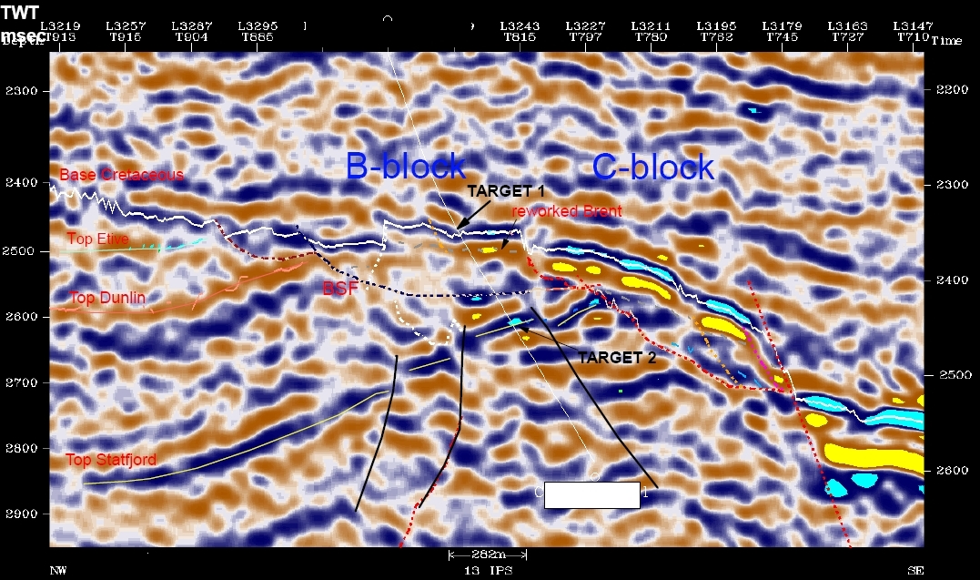
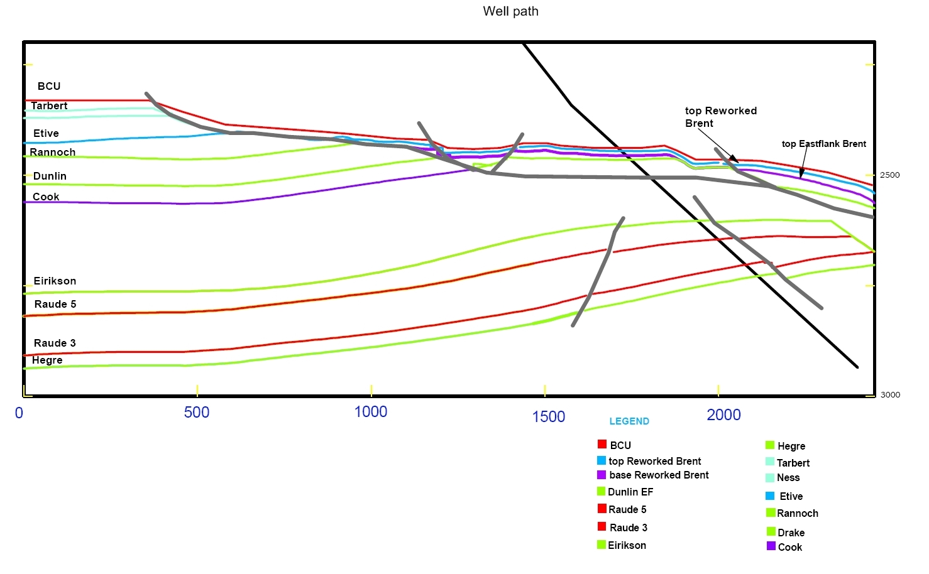
Figure 6 Seismic cross section (top) and geomodel cross section (bottom) of the same area. Dimensions are slightly different.
However, this tidy impression comes at the sacrifice of alternative interpretations. The reservoir model is one realization of a multitude of possible constructs that could be drawn out of the available data. Most of the volume in the model represents subsurface volumes that are not directly inspected. No down-hole sensor has been there, and no remote source has picked up information from it. Still, the model consists of fully drawn boundaries and in between, nicely stacked objects, like the layers named in the left column of Figure 1. The smooth lines are extrapolations, drawn as educated guesses, influenced by the purpose of building a coherent model. The tidiness of the model also suppresses the fact that there is much more available information in some areas than others, and gives a uniform image of the reservoir. The solid lines are speculative far away from the wells (where there is little information) and coarse and simplified near to the wells where robust data could suggest much more fine grained divisions. There are many potential lines to connect the dots, and the model is a construct where one chooses consistency and completeness over local accuracy. Some types of inference also fit poorly into the model. For example, the production behavior of a well can give quite strong indications about the structures in an area. A rapid pressure drop can, for instance, indicate that there is a tight fault between a production well and the wells injecting water to maintain the reservoir pressure. But these data cannot place this barrier spatially. Even though one “knows” that there is an important barrier there, one cannot include it in the geological model, since it is not possible to locate it spatially based on production data.
Still, the model is often regarded as the representation of the reservoir, and its pragmatic history is often forgotten as work progresses and the model is black boxed and institutionalized. For the knowledgeable subsurface personnel, the model is a tool for working with and communicating about the reservoir. For outsiders, it is a representation, a picture. Thus, a reoccurring topic for us, as researchers studying work and supporting innovation in the petroleum industry, is to stress the pragmatics of the model, and that other uses may require other extrapolations. One example we have looked at is model support during drilling. The extrapolations in the model are presented as uniform lines and objects with highly variable support from actual data. During drilling operations, for example, the reservoir model would need to be aligned with real-time data on the fly. To support operational decisions it is important to know how robust or uncertain the extrapolations are, as one has other data sources available that may be more accurate. Thus, the extrapolations made to make the model uniform and useful for communication and simulation, makes the model less useful for supporting drilling operations.
When we are involved in research and development efforts, we often have to confront the view that the model is the best representation of the reservoir, and stress that it is so for specific purposes, and that other combinations of data may be more useful in the cases that we look at. We do not suggest that we know something that the geoscientists do not know themselves on these topics. Rather we try to contribute with a language of representation and modeling that counters the dominating representation-view.

Conclusion
In this paper we have discussed the processes of punctuation and extrapolation in the context of petroleum production. By discussing a selection of data types, we have shown how sensor data are punctuated in space and time. We have also demonstrated how they are punctuated, in a less literal sense, aspectually. A sensor is set up to isolate specific aspects of reality. It is an arrangement crafted to let the surroundings trigger an internal signal. This makes it, in one sense, self-referential as it produces an already internally defined set of responses to aspects that are defined by the sensor. (See Peschl and Riegler 1999, p. 10) On the other hand, it does so as a result of interaction with the surroundings. Reference to the oil reservoir that induces these interaction effects is established as the punctuated data are extrapolated. Points in time are stretched to speak of time intervals, points in space to speak of volumes and the isolated responses of sensors, when interpreted in concert, to speak of the subsurface phenomenon that triggered their responses.
Reservoir models are primarily empirically driven. Their purpose is to aggregate data to a unified useful representation. We have shown that these models, even in their very foundations, are pragmatic, sociomaterial constructs, informed by the creative judgment of the subsurface workers and constrained by the intended purpose of the models. The models are cornerstones of reservoir management today, contributing with input to decisions of production strategies and where to drill new wells. Moreover, many of the developments towards digitalization within the industry rests on increased utilization of these models in for a wider specter of applications and more automated decision support. The present discussion of the epistemological foundations of these models consequently has relevance for the future development of model based methods and technologies in the subsurface domain of petroleum production.
We noted in the introduction that petroleum reservoir characterization is associated with great uncertainties. As such, since robust data are sparse and extrapolations are highly speculative, our case is a vivid illustration of how punctuated data are extrapolated to convey meaning. Though the importance may be less pressing, the processes of punctuation and extrapolation are common in other contexts, and our discussion should have relevance beyond petroleum extraction.
If the data represents the subsurface (and not only the sensor itself), they do so only when extrapolated, and then they refer to a reconstructed idea of the reservoir beyond the data. Extrapolations are made for specific purposes, and are as such pragmatically informed constructs. Consequently, extrapolation is a key to understanding the episteme of a subsurface department and the models by which the reservoir is represented.

References
Almklov, P. (2008), ‘Standardized Data and Singular Situations’, Social Studies of Science, 38(6), 873–897.
Almklov, P. and Hepsø, V. (2011) ‘Between and Beyond Data. How Analogue Field Experience Informs the Interpretation of Remote Data Sources in Petroleum Reservoir Geology’, Social Studies of Science 41(4), 539–561.
Barad, K. (2007) Meeting the Universe Halfway: Quantum physics and the Entanglement of Matter and Meaning. Durham, MA: Duke University Press.
Bateson, G. (1972) Steps to an Ecology of Mind: Collected Essays in Anthropology, Psychiatry, Evolution, and Epistemology, London: Intertext Books.
Bateson, G. (1979) Mind and Nature: A Necessary Unity, London: Wildwood House.
Bijker, W.E., Hughes, T.P. and Pinch, T.J. (1987) The Social Construction of Technological Systems: New Directions in the Sociology and History of Technology. MA: MIT Press.
Bowker, G.C. (1994) Science on the Run: Information Management and Industrial Geophysics at Schlumberger, 1920–1940, Cambridge, Mass.: MIT Press.
Bowker, G.C. and Star, S.L. (1999) Sorting Things Out: Classification and its Consequences, Cambridge, Mass.: MIT Press.
de Laet, M. and Mol, A. (2000) ‘The Zimbabwe Bush Pump’, Social Studies of Science, 30, 225–263.
Giere, R.N. (2002) ‘Models as Parts of Distributed Cognitive Systems’, in Model Based Reasoning: Science, Technology, Values (eds) L. Magnani and N. Nersessian . NY: Kluwer, 227–241.
Giere, R.N. (2004) ‘How Models are Used to Represent Reality’, Philosophy of Science, 71, 742–752.
Hanseth, O. and Monteiro, E. (1997) ‘Inscribing Behaviour in Information Infrastructure Standards’, Accounting, Management and Information Technologies, 7, 183–211.
Haavik, T.K. (2011), 'Chasing Shared Understanding in Drilling Operations', Cognition, Technology & Work, 13(4), 281-294.
Hutchins, E. (1995) Cognition in the wild, Cambridge, Mass.: MIT Press.
Idhe, D. (1991) Instrumental realism, New York, NY: John Wiley & Sons.
Ihde, D. (2009) Postphenomenology and Technoscience: The Peking University Lectures. New York: State University of New York Press.
Knorr-Cetina, K. (1999) Epistemic Cultures: How the Sciences Make Knowledge, Cambridge, Mass.: Harvard University Press.
Korzybski ,A. (1994[1933]) Science and Sanity: An Introduction to Non-Aristotelian Systems and General Semantics, NY: Institute of General Semantics. (First published in 1933)
Latour, B. (1987) Science in Action: How to Follow Scientists and Engineers Through Society, Milton Keynes: Open University Press.
Latour, B. (1995) ‘The ‘Pedofil’ of Boa Vista: A Photo-philosophical Montage’, Common Knowledge, 4, 144–187.
Latour, B. (1999) Pandora's Hope: Essays on the Reality of Science Studies, Cambridge, Mass.: Harvard University Press.
Law, J. and Mol, A. (2001) ‘Situating Technoscience: An Inquiry into Spatialities’, Society and Space 19: 609–621.
Maturana, H. R. and Varela, F. J. (1979) Autopoiesis and Cognition: The Realization of the Living. Boston: Reidel
Orlikowski, W. J., and Scott, S. V. (2008) ‘Sociomateriality: Challenging the Separation of Technology, Work, and Organization’, Academy of Management Annals, 2(1), 433–474.
Peschl, M. and Riegler, A. (1999) ‘Does Representation Need Reality?’, in Understanding Representation in the Cognitive Sciences: Does Representation Need Reality? eds M. Peschl, Av. Stein and A. Riegler, London: Kluwer Academic / Plenum Publishers, 9–17.
Bijker WE, Hughes TP and Pinch TJ. (1987) The Social Construction of Technological Systems: New Directions in the Sociology and History of Technology. The MIT Press.
Whitehead, A.N. and Russell, B. (1925) Principia Mathematica, Cambridge: University Press.

The importance of practical and theoretical knowledge from field trips to analogical fields on dry land when interpreting subsurface data is discussed in Almklov and Hepsø (2011).
We have also contributed to the discourse on sociomateriality in the IS field. (Østerlie et al, 2012).
A relational ontology is somewhat contradictory to the idea of representationalism, since relationality would see the representation and its referent as mutually constitutive (Barad, 2007). Instead of dismissing the concept of representations here, we approach it more pragmatically with the aim of elaborating it within a relational ontology.
Bateson (1972, 1979) draws on Whitehead and Russell’s (1925) mathematical theory of logical types as well as Korzybski’s (1994 [1933]) discussion of the map-territory relation.
See Peschl and Riegler’s (1999, referring to Maturana and Varela, 1979) discussion of self-referential representation in cognitive systems.
See Bowker (1994) for an interesting historical account of well logging, in which resistivity plays an important part.
This spatial extrapolation has been a subject of discussion in much of our earlier work, e.g. Almklov and Hepsø (2011) ])
Particularly when combined with the analyses of cuttings, described below.
Interestingly, these conversions are informed by geological observations in existing wells and general geological knowledge of the speed of sound waves in the expected rock types. Consequently, the data is somewhat shaped by existing knowledge and expectations with regard to the geology of the reservoir and overlying formations.
There is a theoretical limitation (around 15 meters) of its resolution due to the wavelength of the sound waves. The actual resolution is lower. It varies in different fields (due to the geology of the overburden) and with technologies, so a fair summary is that the actual resolution is in the scale of “tens of meters” at best.
Since the seismic “depth” is based on travel time for the sound waves, such tie-in observations will also be used to adjust the depth of the seismic reflection.
The collection of samples stored onshore amounts to a unique representation of the subsurface formation that theoretically may be re-analyzed for purposes unknown today. This storing practice is a requirement of the authorities.
As such, the interactive analyses of a single sample may be regarded as a miniature version of the analyses of the whole reservoir based on different sensor data.
This formation evaluation log is developed in parallel with the log of the down-hole sensors (like resistivity) shown in Figure 1, and has some overlap in information. The log in Figure 1 is most typically used in further reservoir evaluation, while the formation evaluation log (Figure 4) is mostly used in the operational phase.
Here, we are more skeptical of the phrase itself than of Latour’s (1987) application of it that is more in line with our observations.
Here, for simplicity, we discuss the geomodel and reservoir simulation model colloquially. They are both reservoir models. The geomodel is more fine-grained and detailed, while the simulation model is a coarser, simplified model designed for flow simulation.
Different temporal resolution production data, different combinations of well log parameters, different ways of tuning the processing of the seismics, combinations of time lapse seismics and production data to understand fluid movement etc etc.

