**LAYER CONTINUITY IN ACCUMULATIVE ROLL BONDING OF DISSIMILAR MATERIAL COMBINATIONS**

Nagaraj Vinayagam Govindaraj, Jan Gaute Frydendahl, Bjørn Holmedal

Department of Materials Science and Engineering

Norwegian University of Science and Technology

7491, Trondheim

Norway

Corresponding author:

Nagaraj Vinayagam Govindaraj

Department of Materials Science and Engineering

Norwegian University of Science and Technology

7491, Trondheim

Norway

Phone: +47 735 96785

Fax: +47 735 50203

e-mail: [nagaraj.vinayagam@material.ntnu.no](mailto:nagaraj.vinayagam@material.ntnu.no)

**Abstract**

Strips were made by accumulative roll bonding of up to 64 alternating layers of an AA3103 alloy and either commercial purity copper or CuZn20 brass as the second type of layer. With increasing number of accumulative roll bonding cycles the layered structure became unstable. Instability in the strongest layer observed by secondary electron micrographs and orientation imaging micrographs revealed shear bands through the strong layers. The influence of the layer instability on the mechanical properties was investigated by tensile tests and three point bending tests. Numerical simulations using the commercial finite element software DEFORM 2D were used for investigating the instability mechanism in deformation of the multilayers. It is argued that the earlier proposed explanations and analytical estimates of the necking in the hard layers due to internal stresses do not apply. Instead the onset of the instability is in the form of a zigzag-shear instability, where the layers experience periodic increased thinning and bending.

Keywords: Accumulative roll bonding, layer continuity, deformation simulation

**1. Introduction**

Metallic multilayers belong to a new class of materials where thin layers of the metal are combined together by some bonding process into a single structural unit to yield better properties. Multilayer metallic materials produced from dissimilar metal combinations combine the unique advantages of the different metals involved to make composites that have better properties than the individual metals. In addition, these multilayers are reported to exhibit unique mechanical, electrical and magnetic properties when the layer thickness reaches the nanometer regime [1].

Originally, most of these multilayer materials were produced by expensive and time-consuming bottom-up processes like vapour deposition or epitaxial growth [2, 3]. Unfortunately, these methods could not produce products on a very large scale or in significant quantities. With the development of new forming techniques like repeated folding and rolling or accumulative roll bonding (ARB), it has been possible to produce multilayer materials on a bulk scale in sizes suitable for structural or industrial use [1, 4, 5].

It has been reported that in metallic multilayers made from dissimilar metals the harder material necks and ruptures resulting in a dispersion of lamellae in the soft matrix [6, 7]. This type of behavior can produce composites that are suitable for certain dispersion strengthening applications, where layer continuity is not important, while most other applications benefits from layer continuity giving a good load re-distribution between the constituent layers. Layer continuity is important for conductivity applications too. Moreover, the improved fatigue strength and toughness of a multi-layer roll bonded material can be exploited only when the layers are continuous [8]. If necking in the hard layer can be overcome, there is a potential for refining the thickness down to nano-scale [7].

Deformation of sandwich materials has been widely investigated and a number of deformation models have been developed to predict the flow behaviour of the different materials in plane strain compression and rolling [9-13]. The main focus has been on clad and sandwich rolling, but the models can be applied to understand the deformation behaviour of the hard layer in ARB of dissimilar materials also. Atkins and Weinstein [9] argued that in-plane stresses, that are compressive in the softer component and tensile in the harder component, develop to satisfy the yield conditions. Semiatin and Piehler [13] proposed that such tensile stresses in the harder component may cause unstable flow and failure.

When a neck forms in the hard layer in a multilayer composite made up of dissimilar materials, localized deformation and preferential strain hardening of the soft matrix occurs in the vicinity of this neck. In a tensile test the necking occurs as a competition between local work hardening in the neck and locally reduced sheet thickness. In plane strain compression the total sheet thickness follows the tool movement and multiple necking occurs periodically along the rolling direction with exchange of material flow between the necks. Formability of the hard phase is reported to be the determining factor that controls multiple necking and layer continuity in this case [10]. The continuity of the hard layer in the roll bonded multi-layer metallic material thus depends to a great extent on the strength and work hardenability of the hard layer. In addition to the flow properties, the initial thickness ratio i.e. the ratio of thickness of the hard phase to the total thickness of the stack before roll bonding also has a strong influence on the necking and rupture of the hard phase [7].

Bordeaux and Yavari [10] assumed that the Considere criterion for necking applies in deformation of multilayer composites for the hard layer, based on the logarithmic thickness strain in compression, which is obviously wrong. Plastic instability criteria for diffuse necking and local necking during sandwich sheet rolling have also been developed by Hwang et al. [11] to predict the occurrence of plastic instability during rolling of sandwich strips bonded initially. In this work, the occurrence of plastic instability for local necking is concluded to be dependent on the strain hardening exponent of the hard layer, whereas, that for diffuse necking is dependent on initial thickness ratio, strength coefficients and strain hardening exponents of both the hard and soft layer. Nowicke Jr. et al. [12] pointed out that the diffuse necking criterion suggested by Hwang et al. [11] is wrong. They found experimental evidence for that the instability can be delayed by increased amount of hard phase in the clad sheet or by the use of small radius rolls and concluded from hardness measurements and from finite elements simulations that increasing redundant shearing in the soft phase was causing this. However, their experimental results could not be predicted by the simple analyses by Semiatin and Piehler [13].

In this work, the problem of instability during accumulative roll bonding (ARB) of multilayers of AA3103 layers alternated with either Cu or alpha-Brass (CuZn20) layers is analysed. The ARB processing at room temperature and at a higher temperature and the experimental testing is described in Section 2. Results from these experiments are presented in Section 3 and a simplified analytical stability analysis of the layers during ARB along with an introduction to the models used in finite element simulations are presented in Section 4. A short discussion comparing the experimental results with simulations and analytical solutions constitutes Section 5 before the conclusions in Section 6.

**2. Experimental methods**

Approximately 30 mm wide AA3103 strips were cold rolled to a thickness of 1 mm or 0.5 mm from a 20 mm thick billet cut from DC cast homogenized AA3103 material. These strips will henceforth be referred to as aluminium strips. 30 mm wide strips of commercial purity Cu or CuZn20 brass (Br) were cut from 1 mm thick sheets, which were in a soft, slightly cold rolled condition. With 50% rolling reduction proper metallic bonding between the aluminium and Cu or Br strips could not easily be achieved at room temperature, hence the first pass of rolling was always made in the hot condition. However, good bonding can be achieved between two aluminium surfaces even at room temperature. Hence a sandwich with two outermost layers of aluminium strips of half the thickness as either Cu or Br in the middle, were made by hot ARB in the first pass. This enabled subsequent ARB passes to be made in a cold condition with a one to one thickness ratio between the strong and the soft layers. No surface preparation was made on the outer surfaces of the strip, and the rolls were kept moderately lubricated by oil. For cases where the subsequent passes were done by hot rolling, the bonding was good and a simpler stack of only two dissimilar strips could be made at the first pass.

The stacks were pre-heated to 350 °C and held at that temperature for 10 minutes in an air convection furnace and then subjected to warm roll bonding in a 2 high rolling mill with roll diameter 205 mm. The thickness reduction was maintained to be a constant value of 50 % in each rolling pass and the roll bonding process was repeated up-to 6 cycles, either by subsequent warm or cold rolling passes. Precaution was adopted to complete the cold roll bonding cycles within 2 minutes of surface preparation. All the roll bonded samples were 200 mm in length and about 20 mm in width in the last pass due to the need of trimming the edges between the passes. The composites made by subsequent cold ARB will be denoted CARB.

Tensile samples parallel to the rolling direction (RD) were machined out of the roll bonded material according to the dimensions in Fig.1. The tensile tests were carried out with a 10 mm extensometer on a MTS 810 tensile testing set-up at a constant crosshead speed of 2 mm/min.



Fig.1. Specimen used for tensile testing (all dimensions are in mm)

Rectangular samples (40 mm long and 10 mm wide) were machined from the ARB strips for three point flexural testing. The samples were subjected to bending at a constant stroke rate of 2.4 mm/min up to a displacement of 8 mm, and the force and displacement were recorded.

The rolling direction – normal direction (RD-ND) and transverse direction- normal direction (TD-ND) cross sections of the ARB specimens were observed in a Hitachi SU6600 scanning electron microscope (SEM) in the secondary electron imaging (SE) mode. The details of the microstructure were also evaluated by electron backscatter diffraction (EBSD) analysis on Cu layer at the center of the sample thickness in the RD – ND plane. The samples were subjected to ion milling after conventional mechanical surface preparation in a Hitachi IM 3000 flat milling system. A voltage of 3 kV was used for 45 minutes to mill off the surface layers of the deformed material. EBSD was carried out on a Hitachi SU 6600 FEGSEM equipped with a NORDIF UF1000 detector and the data analysis was carried out using TSL OIM 6.0 software. Scans were performed on the samples in the rolling direction (RD) – normal direction (ND) plane at the center of the thickness. Structural refinement and shear bands in the hard phase have been captured through the EBSD analysis.

**3. Experimental results**

Laminated metal strips were processed by ARB in cold and warm (about 350°C) conditions. The material flow and layer integrity was investigated by microscopy and are presented in Section 3.1. The mechanical properties of the ARB samples were tested by tensile tests and by three point bending tests, the results of which are shown in Section 3.2.

**3.1 ARB of alternating layers**

Secondary electron images from RD-ND and TD-ND sections of the maximum deformed specimens prepared are presented in Fig.2. For all the cold ARB specimens, a general observation in the microstructures is a wavy instability leading to fracturing and departing of the hard phase. The instability in the hard phase is however almost absent in the TD-ND section when compared with the RD-ND section, indicating that the instability is two-dimensional.

|  |
| --- |
| a     RD-ND TD-ND |
| b    RD-ND TD-ND |
| c    RD-ND TD-ND |
| d  RD-ND TD-ND |

Fig.2.Secondary electron images of RD ND and TD ND sections of the maximum deformed ARB composite specimens: a) Cold ARB of Al and Br after 4 passes, b) cold ARB of Al and Cu after 5 passes, c) warm ARB of Al and Cu after 6 passes, and d) warm ARB of Al and Cu based on the sandwich with two Al layers and one Cu layer, all of equal thickness, after 6 passes.

It can be observed in Fig.2a that after one warm and three cold ARB passes the hard Br phase is broken up and fragmented by 45° shear bands running through the layers and efficiently preventing further thickness reduction of the hard layers. The string-like structure must be a result of inhomogeneous deformation with multiple fractures in the transverse direction in the hard layers after 4 passes of ARB. Since the TD-ND sections show fracture to a small extent it is a two-dimensional instability mode. It is to be noted that necking, fracturing and departing of the brass layers occurred simultaneously during the fourth pass of ARB and most of the necking sites are aligned at roughly 45° to the loading direction. Similar behaviour has been reported to occur already at the first pass of ARB of Al/Ni [5]. In both cases necking, fracture and departing occurred during the same cycle of ARB.

Cold ARB of Al and Cu on the other hand exhibits considerable thickness reduction in the Cu layer after five passes of ARB, as can be seen in Fig.2b. A two-dimensional layer instability with a wavelength comparable to the layer thickness can be observed in the RD-ND section, with only a weak variation with a considerable longer wavelength in the TD-ND section. Here again, the necking sites are roughly 45° to the loading direction but the elongation has been even more extensive than in the Al and Br samples.

Warm ARB of Al and Cu exhibits instabilities in the layers first after 6 passes with a corresponding higher thickness reduction of the hard layer before instability occurs, as shown in Fig.2c-d. The extent of instabilities is less severe than for the cold ARB cases. Note also that the instability mode is more three-dimensional with less difference between the extent of instabilities in the TD-ND and the RD-ND sections. However, ARB beyond 6 passes and investigation of the further layer refinement was not possible due to the edge cracks evolving during rolling.

It has been reported earlier by Lee et al.[7] that a higher initial thickness ratio between the soft and the hard layer gives earlier instability, and this was the case for the sandwich case with relatively thinner Cu layers, which shows a more developed instability in Fig. 2d. It is interesting to note that the mode of instability in this case is more three-dimensional.

EBSD maps of the Cu layer after 4 passes of warm ARB of Al and Cu is presented in Fig.3. The ARB of the sandwich of three layers of unequal thicknesses was chosen, because instability in the hard layer occurred at the lowest deformation with the relatively thinner hard layer, and the warm deformed material allowed good diffraction conditions for EBSD. Shear bands can be observed as a prominent feature in the sample.

|  |
| --- |
|  |

Fig.3.EBSD map from a Cu layer near the centre of the RD-ND section in a sample processed by four passes of warm ARB with welded Al layers being twice as thick as the Cu layers.

**3.2 Mechanical testing**

Tensile properties of metal composites processed by various number of ARB passes are presented in Fig. 4. A general observation for all the cold ARB specimens is that the strength increases with increasing number of ARB passes. A significant scatter in tensile values can be seen for multi-layer specimens when delamination occurs in some of the samples. It can be observed from Fig. 4a that cold ARB of Al and Br gives a high strength but a poor elongation already after one pass. The samples processed by several passes fail before the yield point is reached. Fig. 4b reveals that cold ARB of Al and Cu exhibits lower levels of strength but significant improved ductility as compared to the cold ARB of Al and Br. However, with three passes or more some samples fracture earlier. In the warm ARB condition shown in Fig.4c, the Al and Cu combination exhibits an increase in strength with increased number of ARB passes.

a

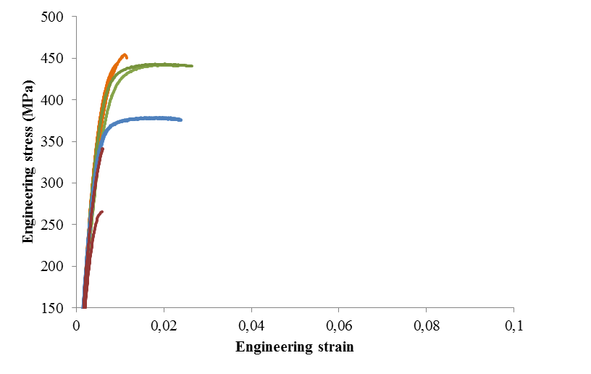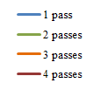

b

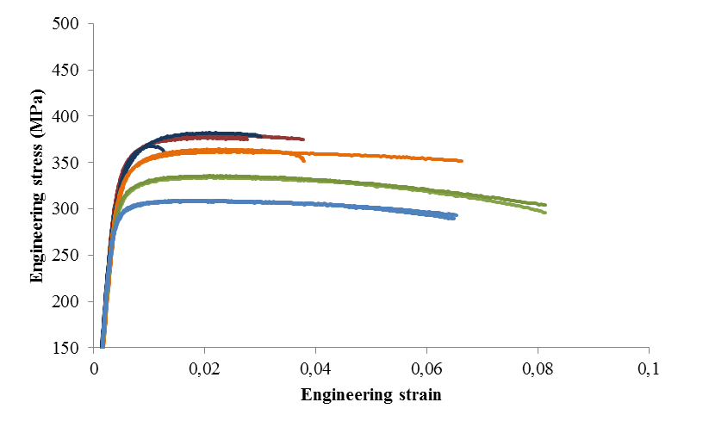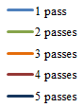

c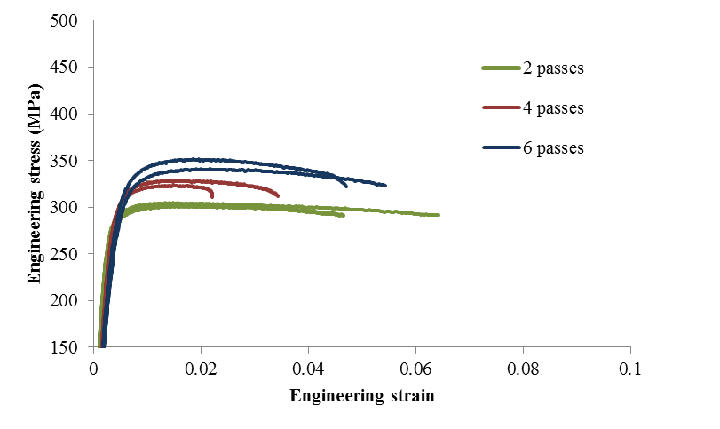

Fig.4. Tensile tests of composites with equal ratios of hard and soft phases: a) made by cold ARB of Al and Br layers after a warm first pass, b) made by cold ARB of Al and Cu layers after a warm first pass, and c) made by warm ARB of Al and Cu layers after 2, 4 and 6 passes.

Results from the three-point flexural tests are presented in Fig.5 for cold ARB specimens. Both the force and displacement are normalized with respect to the sample thickness accounting for thickness variations, according to the formula:



Here  is the flexural tensile stress at the outer surface. The displacement is *l*, the measured force is *P*, *L=????mm* is the span between supporting rolls, *b* *=????mm* is the width of the specimen, *d* is the thickness of the specimen.

For both material combinations the flexural strength increases and the ductility decreases with increasing number of ARB passes. For the combination of Al and Br presented in Fig.5a, the sample subjected to 1 pass ARB shows a continuous strain hardening, whereas the sample after 2 passes shows a drop and rise in the load, characteristic of delamination, crack formation in the harder layer, crack arrest followed by plastic deformation and crack re-nucleation. The third pass sample exhibits a higher flexural strength and a very low ductility, and the fourth pass sample shows neither strength nor ductility.

Delamination and cracking of layers is evident already from the 1 pass with Al and Cu in Fig.5b, for which a slow and stepped curve lowering of the flexural strength followed by plateau after the load drop is interpreted as plastic deformation of the remaining material and crack re-nucleation. Such a slow and stepped drop after crack propagation can however not be observed in the samples subjected to larger number of ARB passes.

|  |
| --- |
| a |
| b |

Fig.5. Flexural strength vs. normalised punch travel, *l/d*, of cold ARB samples from 3 point bending tests of composites of: a) Al and Br, and b) Al and Cu.

**4. Stability analysis**

At some point during ARB, the approximately uniform plane strain compression deformation mode of the layers becomes unstable. A simplified analytical solution can be found for the case of uniform plane strain compression of the layers, for which a simplified stability analysis can be performed. The validity of the simplifications is discussed and next the analytical results are contrasted to FEM simulations of this idealized case in Section 4.1, where the gradual onset of instability could be studied. The commercial finite element analysis package DEFORM 2D was used to analyse deformation and material flow. The cold deformation of aluminium and copper was chosen, for which a basically two-dimensional instability can be expected from the experimental ARB results. However, once the instability occurs, the simplified plane strain compression mode is no longer a good approximation for ARB. Hence a simulation of the rolling gap is performed in Section 4.3.

**4.1 Analytical stability analysis**

The geometry of the rolling of several layers is schematically shown in Fig.6. Alternating layers of soft (thickness *tS*) and hard (thickness *tH*) materials are rolled. Before the rolling pass the total thickness of the sandwich is *t* and fraction of the thickness occupied by the hard layers is *f*. Analytical solutions for the simplified case of plane strain compression of a sandwich material has been given by Atkins and Weinstein [9], explaining how a hard layer can be deformed between two softer layers.

Fig.6. Multilayer rolling geometry of a sandwich strip of thickness *t*, with alternating soft and hard layers of thickness *tS* and *tH* , respectively.

tS

t

tH

The simplest approximation is plane-strain compression in the strip-normal direction with no friction between the tool and the outermost layer. A shear stress is required to transfer the internal stresses across the interfaces between the layers, but its contribution to the yield stress and also the shear components are neglected in the simplified analytical solution. For this simplified case a number of stability analyses have been proposed for clad materials [11-14]. These analyses can be extended to multilayers. While Steif [14] performed a bifurcation analyses, the approach of other analyses by Siematin and Pieler, Hwang et al. and Nowicke Jr. [11-13] was to assume a simplifying analogy to the stability of unconstrained strips in biaxial load. In their analyses only the major stresses are involved, where the major stress of each layer acts in the rolling direction. Since no force is applied in the rolling direction, the force balance becomes.



Here  and  denotes the major stress in the hard layer and soft layers, respectively. The basic assumption is that the materials are approximated by a rigid plastic isotropic von Mises material assuming an associated flow rule and no transverse elongation. The strip normal pressure is equal through the layers, i.e. . A simple analytical solution can be derived [11-13], where for each layer this setup is similar to the assumptions for stability analyses of necking of a strip in plane stress biaxial loading, provided that the constraint from the deformation of the soft layer can be neglected. Assuming that the induced shear flow and deformation in the soft layer requires a relatively low energy, Hills criterion for local necking and Swifts criterion for diffuse necking coincide. The criterion for instability is then



This criterion is the same as obtained by Hwang et al. [11] for the case of local necking. However, their criterion for diffuse necking is wrong, as pointed out by Nowicke Jr. et al. [12]. Also, the criteria for local necking given by Siematin and Pieler and Nowicke Jr. [12, 13] can be incomprehensive. The instability occurs earlier than the maximum force in the rolling direction in the hard layer. The instability estimate in Eq. (8) must be considered as a lowermost limit for instability to occur in the hard layers assuming the other layers are much softer. Given a hard material obeying a power law, the instability will occur at.

Fig.7. Engineering stress strain curves of the harder materials used in ARB.

|  |  |  |  |  |
| --- | --- | --- | --- | --- |
| **Material** | **σu** | **εu** | **K** | **n** |
| **Br** | 452 | 0.31 | 649.85 | 0.31 |
| **Cu** | 312 | 0.33 | 449.83 | 0.33 |
| **AA3103** | 253 | 0.02 | 273.58 | 0.02 |

Table 1. Tensile properties of the starting materials.

Tensile properties of the starting materials are presented in Table 1. The corresponding tensile curves in Fig.7 show considerable work hardening of these slightly pre-rolled Br and Cu strips. The work hardening is decreasing, and according to the simplified analytical stability analysis, estimates that instability in the hard layer would occur at strains still within the first pass of ARB with any of these two materials. However, observation by micrographs reveals that instabilities started occurring during the 4th pass both for the combination Al and Br and for Al and Cu., i.e. after a total Von Mises strain larger than 2.4.

The simplifying assumptions made in most of the analytical stability analyses are not very realistic. The strip surface is constrained by that the layers above and below have to be deformed and by the horizontal tools at the outer layers and the volume of the stack being conserved in between. Local thinning of a groove in the transverse direction in the hard layer would require a corresponding thickening of the soft layers above and below. However, such a thickening would decrease the lengths of the two soft layers and a horizontal material flow would be required in the rolling direction, i.e. shear flow as observed in Fig 2.

**4.2 FEM simulation of plane strain compression**

A specimen corresponding to uniform plane strain deformation after three passes of ARB was modelled with 17 alternating layers of copper in aluminium, starting with a uniform von Mises strain equal to 2.4. Symmetry across the middle of the specimen was assumed. Due to symmetries only a quarter of the specimen was modelled, as illustrated in Fig. 8. Sticking condition was defined between the alternating layers. Both types of layers were assumed to behave as isotropic von Mises materials. The layers in the model were meshed with two dimensional linear quadrilateral elements with four nodes each. It was assumed that after three passes of ARB the materials would have no further work hardening, because saturation of the stress-strain curves occurs around these strains for both these materials. The yield stresses were assumed to be 450MPa for Cu and 300MPa for Al. An attempt was made to run the simulation with a 50MPa stage IV slope of the stress strain curve. However, instability did only occur for the case without work hardening, and this is the case that will be discussed below.

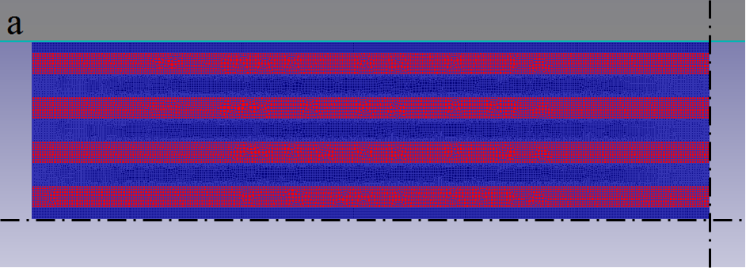

Fig.8. Multi-layer Al-Cu model for FEM simulation of plane strain compression. The boundaries on the lower and right edges are symmetry boundaries indicating that only a quarter of the sample was modelled.

At first the layers deform uniformly, then after a von Mises strain of about 2.5 instability evolved gradually. Strain rate plots from DEFORM 2D simulations are shown in Fig.9 and reveal an alternating pattern of strain rates during deformation subsequent to the onset of instability. These patterns are similar to the crossed shear bands observed in the micrographs in Fig. 2, appearing mostly at 45° to the deformation direction. Instabilities could be arising in these regions of deformation triggered by the difference in flow properties of the hard and the soft layer. A manifestation of such instabilities extending into the hard layer can be the shear bands observed in Fig. 3. Instabilities in the copper layer started showing up in this simulation when the total strain reached a value of around 2.7 and became more pronounced with increasing strain as illustrated by Fig.10b, showing the layers at a strain of 3.1.

|  |  |  |
| --- | --- | --- |
|  | a |  |
|  | b |
|  | c |
|  | d |

Fig.9. Effective strain rate plots on Al/Cu stack showing alternating patterns in a compression simulation of Al and Cu multilayers at strains of a) 2.5 b) 2.7 c) 2.9 d) 3.1. The Cu layers start to become wavy at a strain of around 2.7.

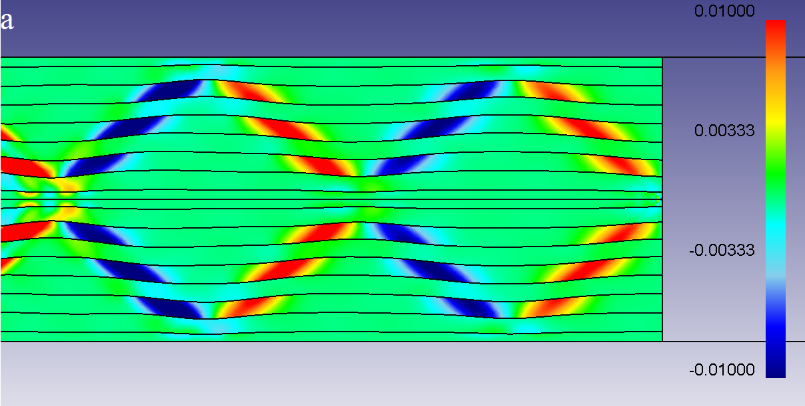

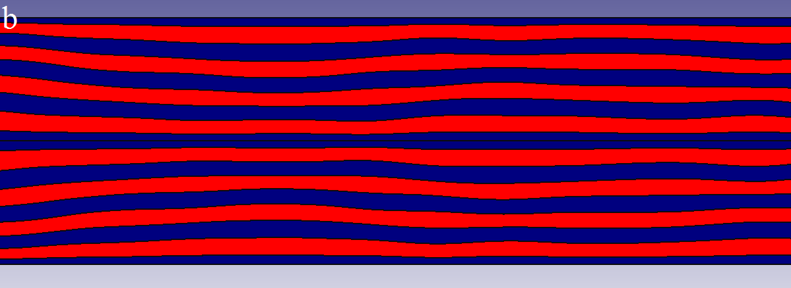

Fig.10.a) Shear strain rate plots showing alternating shear patterns in the soft layers in a compression simulation of Al and Cu multilayers at a strain of about 2.6. b) Wavy pattern in Al and Cu multilayers compressed to a strain of 3.1 indicating zigzag type of instability, Al layers are shown in blue and Cu layers are shown in red

Fig.11. Variation of effective strain rate at two points located near the roll bonded interface in the AA3103 layer. The nominal strain rate based on uniform plane strain compression is shown in green.

In Fig. 11 the variation of the effective strain rate in the plane strain compression simulation shown in Figs. 9-10 is obtained by following two selected material points located in the first AA3103 layer outside the mid-layer. Before the onset of instability the strain rate of both the points coincide with the average strain rate based on the compression of the stack. Next the shear band starts to evolve and the points experience a high strain rate while being inside a shear band and a low strain rate while being outside indicating that the shear bands are moving relatively to the Lagrangian movement of the points.

In the laminate containing many layers, the layers seem to get thinner by a collective zigzag instability. Such zigzag instabilities are extensively studied in pattern forming systems like in hydrodynamic stability theory for formation of two-dimensional roll patterns, see for example [15]. In the early onset of zigzag instability the hard layer becomes longer, and hence thinner, by increasing its length by a sinusoidal bending, as can be observed in Fig.10b. When the deformation proceeds further, this kind of instability in the layer develops and eventually causes fracture of the hard phase. The shear band observed in the Cu layer in Fig.3 indicates the stage before fracture of the hard layer. As can be seen from Fig. 10a the crossing shear bands have opposite sign corresponding to bending in opposite directions. Hence a material point in the hard layer is bent the one way or the other, depending on which shear band it is passing by.

**4.2 FEM simulation of the 4th ARB pass of Al and Cu**

The specimen with 17-layers with a continuous reinforcement of copper in aluminium was also modelled for the case of ARB to examine the instability observed during the 4th ARB pass. Symmetry across the middle of the specimen was applied, as shown in Fig. 12. Since elasticity of the rolls was not included, an artificially high Coulomb friction coefficient of 0.8 was defined between the rolls and the layer stack to compensate for the flattening of the rolls. Sticking condition was defined internally between the layers, and the same isotropic von Mises materials as for the plane strain compression were assumed.

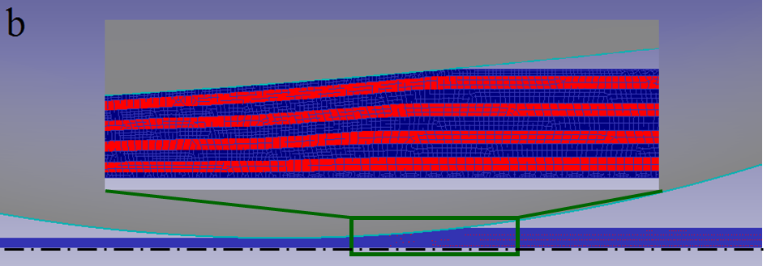

Fig.12. Multi-layer Al-Cu model used for 4th pass ARB simulations. The Al layers are shown in blue and Cu layers in red. The inset shows the layers entering the roll gap. Boundaries on the lower edge are symmetry boundaries indicating that only a half of the sample was calculated.

Figure 13 illustrates strain rate variations as the material goes through the rolling gap. The crossed shear bands are somehow similar to those of the plane strain compression simulations, but of a higher magnitude. The shear bands make a zigzag pattern cross the multilayer stack at fixed locations relative to the rolls. A material volume element passing through the gap between the rolls seems to experience bending and unbending in addition to the shear as it passes the two opposite shear zones respectively. This causes the instability in the form of a sinusoidal two-dimensional bending of the hard layers with more pronounced shear in the soft layers. The distance between the shear bands scales with the total thickness. This scale decreases as the material passes through the gap.

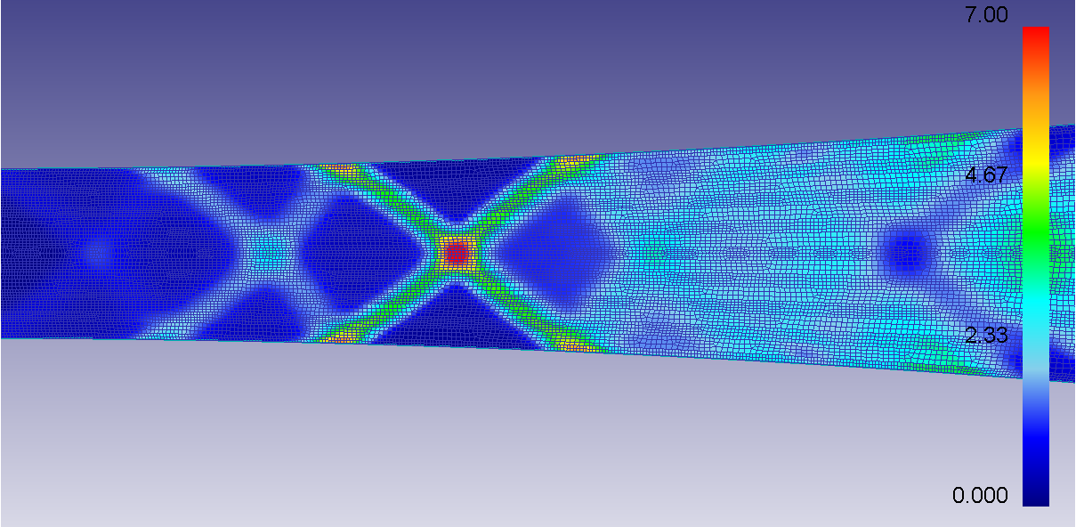

Fig.13.Strain rate plots showing alternating patterns in ARB simulation of Al and Cu multilayers deformed to a strain of around 3.

Figure 14 shows the layers after the simulation of the 4th rolling pass. The instability is little developed, but an early onset is clearly identified as a bending of the layers with a wavenumber scaling with the strip thickness.

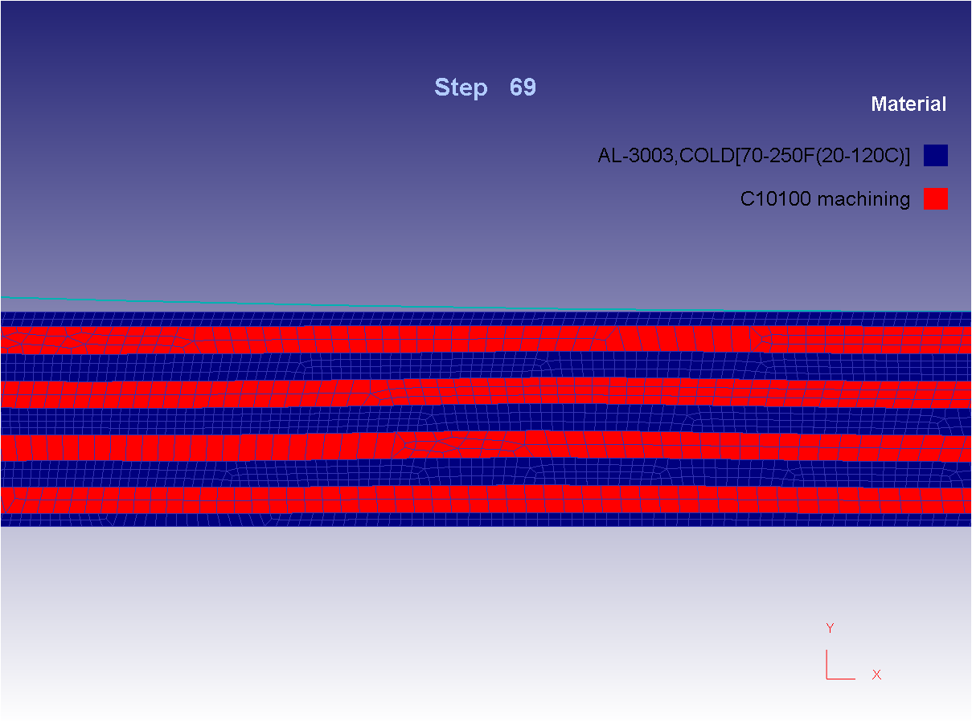

Fig.14. Simulation results showing early onset of instability in a sheet of Al and Cu multilayers at the roll gap exit subsequent to the 4th pass of ARB.

**5. Discussion**

The general increase in strength of the ARB specimens with increasing number of ARB cycles can be attributed to work hardening. As long as the layers do not fracture the rule of mixtures should be applicable to predict the strength of the composites. The temperature of 350°C used for pre heating the samples before warm ARB passes is sufficient to cause significant softening in both AA3103 and Cu. Commercial pure Cu has been reported to undergo significant softening due to partly recrystallization even at room temperature [16], so the strength added by work hardening is partly recovered during a subsequent warm ARB pass. However, it can be observed from Fig.4c that some hardening has also accumulated in the case of warm ARB’ed Al- Cu. The temperature acts as the controlling factor for dislocation motion and dynamic recovery with a corresponding higher strain rate sensitivity that can prevent localisation and explain the improved layer refinement during warm ARB.

In the cases of cold ARB samples, especially of Br and Al represented in Fig.4a, the strength increase is significant up to 2 passes, beyond which the samples exhibit pre-mature failure. This is most likely due to discontinuity in the hard phase due to failure. For the samples without failure, but with a discontinuous hard layer, strength levels of around 400 – 450 MPa are reached by cold ARB of Al and Br samples and 375 MPa for Al and Cu samples. These are significantly higher strengths compared to about 250 – 300 MPa obtainable by cold ARB of AA3103 without the Cu layers [17].

Although the tensile test gives a fair indication of the strength of multilayer materials, further information of the influence of layer continuity on the load bearing capacity, ductility and toughness can be obtained by the three point bend test. The general trend of the increase in the flexural strength with increasing number of ARB passes continues till the hard layers stop being continuous. When the hard layers have disintegrated in the matrix, a drastic drop in both the flexural strength and the ductility was observed in 4 pass cold ARB of Al and Br in Fig.5a. However, the hard layer in the 5 pass cold ARB of Al and Cu does not reveal much disintegration and rupture and hence has a good flexural strength and ductility as shown in Fig.5b. This indicates that continuity of layers is the important factor determining load bearing capacity.

A distinct sequence of several load drops was observed in 2 pass cold ARB of Al and Br and 1 pass Al and Cu in Fig.5. Load drops in similar cases have been reported to correspond to the fracture and delamination of the different layers and the plateaus indicate plastic deformation of the successive layer for crack re-nucleation [18, 19]. Thus delamination in a particular layer inhibits crack propagation into the successive layer and a new crack can be nucleated only after considerable plastic deformation in the successive layer. This mechanism of interface delamination acts as an effective means of arresting cracks and delaying failure of the material as reported by Cepeda and Liu [8, 18]. However, this mechanism cannot be observed in any of the samples where the hard phase is discontinuous. Thus layer continuity seems inevitable for realizing the benefits of the multilayer material through this mechanism of interface delamination induced retardation of cracking [8]. A flexural strength as high as 750- 800 MPa is exhibited by samples of cold ARB of Al and Br as long as the layers are more or less continuous, but the moment continuity is lost, the flexural strength drops to 500- 600 MPa. The low flexural strength and lacking ductility of 4 pass cold ARB of Al and Br samples can be explained similarly based on lack of layer continuity leading to early failure in the bending test.

The 45 degree shear bands cutting through the layers suggest that subsequent to the onset of instability, the thinning of the hard layers is by intersecting shear bands rather than by plane strain compression. The FEM simulations of plane strain compression showed that the onset of instability was in the form of a bifurcation from uniform plane strain compression to the formation of well-defined 45° zigzag shear bands occurring through all the layers of the strip thickness at a certain rolling reduction. The local flow conditions in the alternating shear bands are somehow involved in the bending and unbending of the layers. The zigzag instability initially makes the strong layer more elongated and hence uniformly thinner as compared to the earlier assumptions of localized necking. The distance between bending and unbending is defined by the spacing between the shear bands, which scales with the strip thickness. Since the total thickness is decreasing during compression, the bending wavelength for the layers is decreasing. In the plane strain compression case, this convectively brings new material into the shear zone and the sheared material out of it. When tracing points on the Al layer near the roll bonded interface, it was seen that before the onset of instability the strain rate corresponded to the uniform compression of the stack of layers. Subsequent to onset of instability the points experienced higher strain rates while being inside the shear band and lower strain rates while being outside, clearly defining the onset of instability in Fig. 11.

Yazar et al. [20] reported simulations of cases with a strong layer sandwiched between two thick softer layers as a prototype for investigating instability of metal laminates. They reported a similar instability as reported here, where the hard layer was intersected by shear fronts during deformation. They concluded that homogeneous refinement of continuous structures is still possible if the reinforcement strength is not more than two times the strength of the matrix for the rigid plastic case without work hardening. In their simulation setup a sinusoidal thickness variation in the reinforcement with a wavelength equal to the thickness was necessary to destabilize the homogeneity of the deformation and generate instabilities. The simulations in Fig 9.a-d were repeated with a similar thickness variation, but showed little difference in the onset of instability, thus revealing that such thickness variation is not necessary to generate instabilities in this more realistic simulation of multilayers.

The Cu reinforcement in our case was assumed to be 50% stronger than the cold rolled AA3103 at the considered strain levels where instabilities were inevitably observed. Irrespective of the presence of thickness variations in the hard layer, deformation instabilities occur in roll bonding of dissimilar material combinations thus leading to multiple necking in the hard layer. The strain levels at which instabilities occurred in the DEFORM simulations, are comparable to the strain levels where the Cu layers exhibit significant necking in the actual ARB experiments. Also the absence of instability for the case with work hardening is consistent with the findings of Yazar et al. [20] .

The instability predicted by the 4th pass ARB simulation in Fig 14 is less developed than the experimental one shown in Fig. 15. The difference can be due to the model simplifications regarding isotropic material, two-dimensionality, stiffness of the rolls and friction conditions. The ratio of the yield stresses of the two materials after three passes might have been estimated slightly too low, which will delay the onset of instability according to [20].

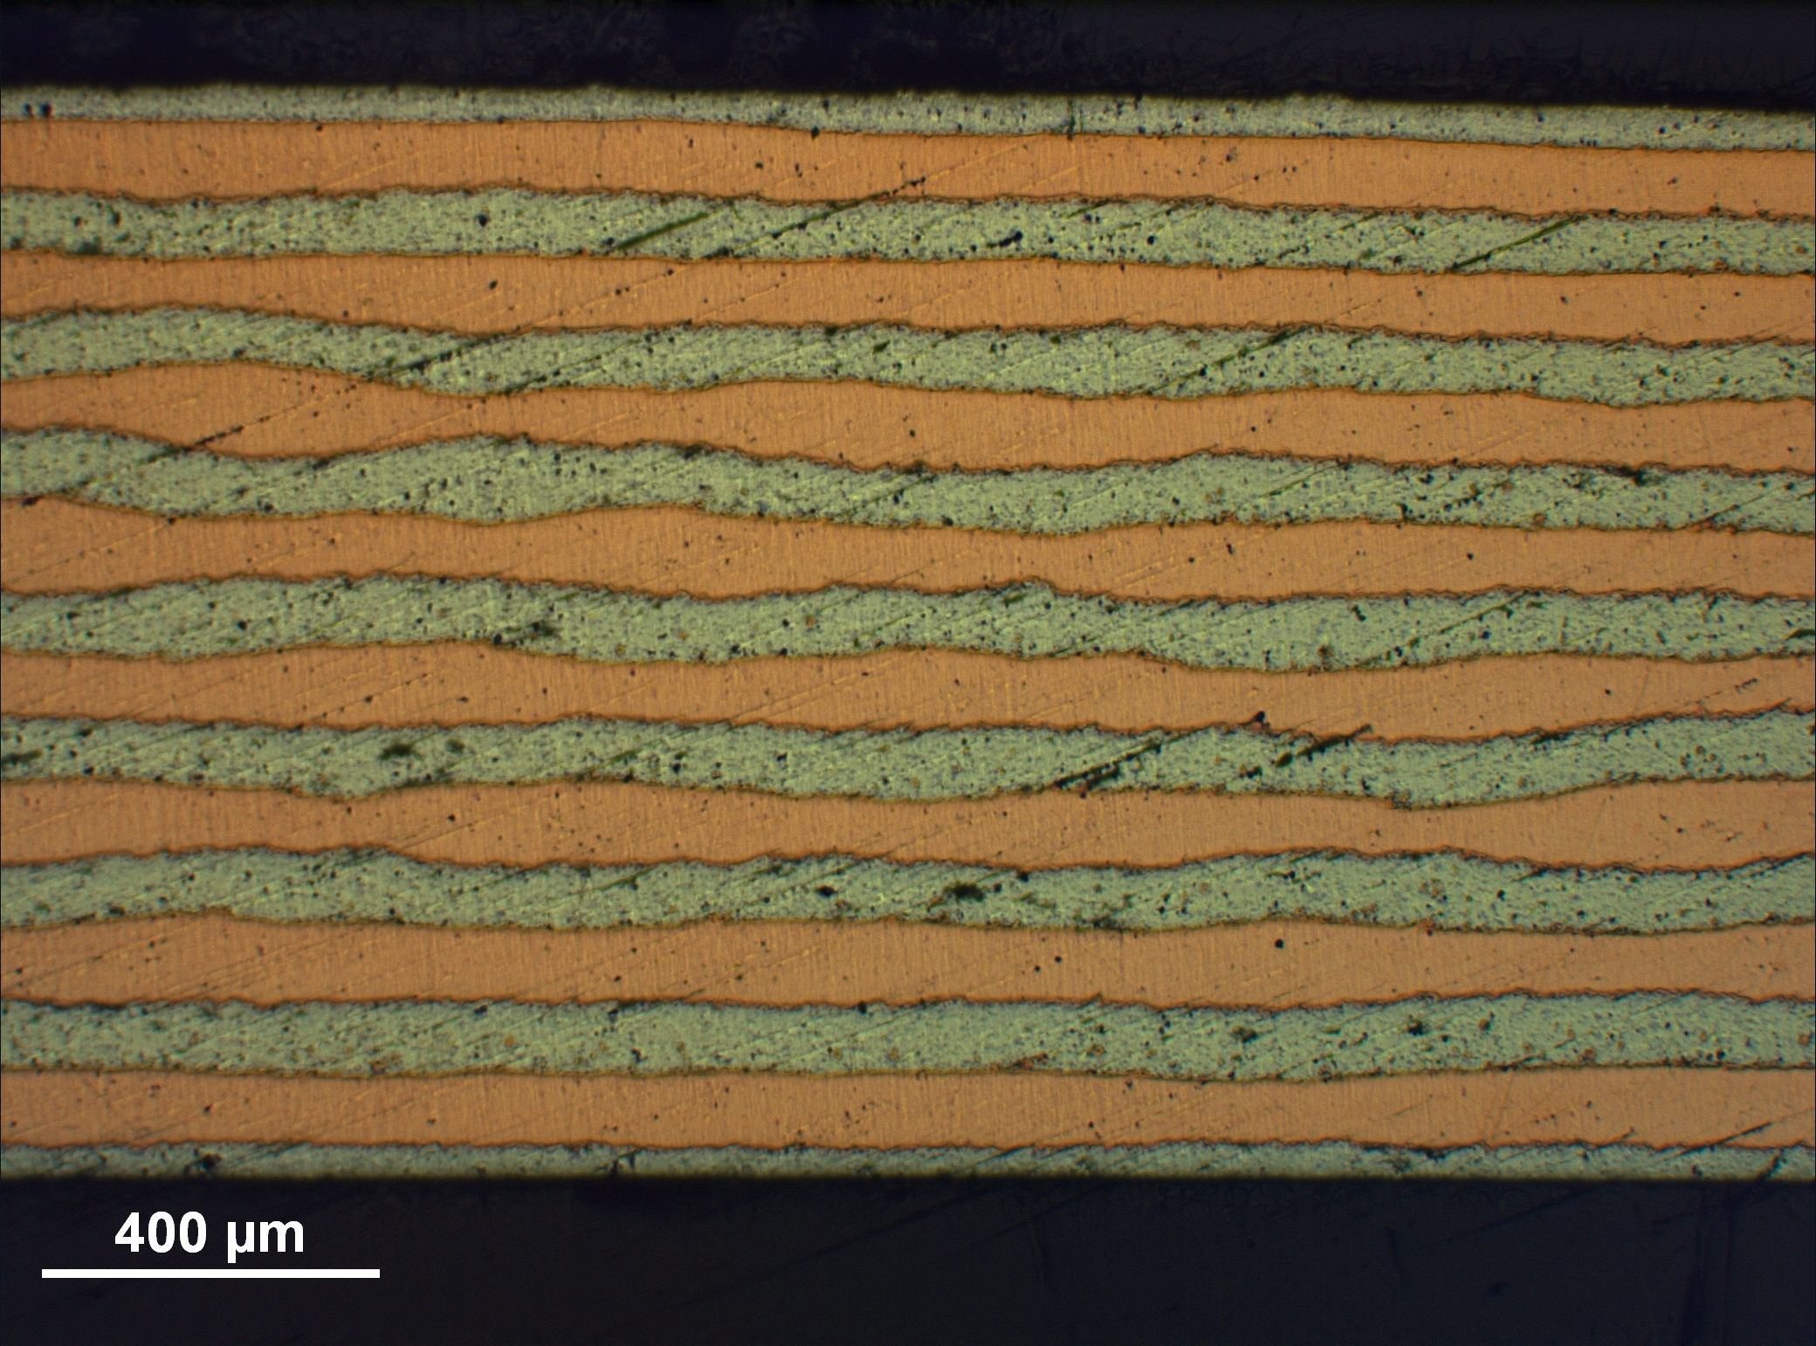

Fig.15.Optical micrograph showing early onset of instability in a sheet of Al and Cu multilayers subsequent to the 4th pass of ARB.

Layer continuity is very important to realize the beneficial effects of multi-layer composites. Experiments and simulations however indicate that the hard layer is bound to disintegrate owing to the zigzag instability caused by the difference in flow properties with the soft layer. This effect, although difficult to eliminate, can be delayed by careful selection and control of the strength ratio between the layers. This can be altered by heat treatments and by warm roll bonding instead of cold roll bonding. However, warm conditions may cause formation of intermetallic phases at the interfaces between the metals. Higher temperature is indeed found to give a better control of the layer thickness in the considered experimental work and work hardening of the hard layer was sufficient to avoid instability in the simulations. Ductility and toughness also get affected and annealing steps are unavoidable at some stage.

**6. Conclusions**

Cold ARB of multilayer metal composites were successfully performed up to 17 layers by 4 passes of Al and Br and up to 33 layers with 5 passes of Al and Cu in alternating layers. Further passes of cold ARB were prevented by severe flow instabilities with disintegration of the hard layers and cracking of the composite. ARB of Al and Cu layers at 350°C up to 6 passes resulted in multilayer metal composites with 64 Al and Cu layers. Only a weak onset of instability of the strong layer could be observed in this case, but further ARB was not possible due to severe edge cracking. Estimates about the onset of instability from simplified analytical solutions were found not to apply as the simplifying assumptions are considered not to be realistic. The observed instability mode was two-dimensional and two-dimensional FEM simulations were performed. The predicted onset and mode of instability were in good agreement with what was found for the cold ARB of Al and Cu. The simulations showed that the instability mode is a zigzag-shear instability, where crossing 45° shear bands form and the result is a sinusoidal type of bending of the strongest layer by the opposite crossing shear bands. The earlier assumption of localization due to periodic localized necking is not confirmed. Instead a zigzag pattern of shear bands forms as a bifurcation of the uniform plane strain compression mode at onset of instability. Initially these shear bands makes the layers more elongated and hence uniformly thinner. The onset of instability seems to correlate with the end of stage IV work hardening, a stage where there is lack of further work hardening of the strong layer. Layer control to avoid or extend this type of instability, might be possible by careful selection and control of the strength ratio and work hardening of the involved metal layers. FEM simulations are a valuable tool for predicting this type of instability.

**REFERENCES**

[1] Eizadjou M, Kazemi Talachi A, Danesh Manesh H, Shakur Shahabi H, Janghorban K. Investigation of structure and mechanical properties of multi-layered Al/Cu composite produced by accumulative roll bonding (ARB) process. Composites Science and Technology. 2008;68:2003-9.

[2] McKeown J, Misra A, Kung H, Hoagland RG, Nastasi M. Microstructures and strength of nanoscale Cu-Ag multilayers. Scripta Materialia. 2002;46:593-8.

[3] Srivastava A, Yu-Zhang K, Kilian L, Frig, rio J, Rivory J. Interfacial diffusion effect on phase transitions in Al/Mn multilayered thin films. Journal of Materials Science. 2007;42:185-90.

[4] Chen MC, Hsieh HC, Wu W. The evolution of microstructures and mechanical properties during accumulative roll bonding of Al/Mg composite. Journal of Alloys and Compounds. 2006;416:169-72.

[5] Min G, Lee J-M, Kang S-B, Kim H-W. Evolution of microstructure for multilayered Al/Ni composites by accumulative roll bonding process. Materials Letters. 2006;60:3255-9.

[6] Hebert RJ, Perepezko JH. Deformation-induced synthesis and structural transformations of metallic multilayers. Scripta Materialia. 2004;50:807-12.

[7] Lee J-M, Lee B-R, Kang S-B. Control of layer continuity in metallic multilayers produced by deformation synthesis method. Materials Science and Engineering: A. 2005;406:95-101.

[8] Liu HS, Zhang B, Zhang GP. Enhanced toughness and fatigue strength of cold roll bonded Cu/Cu laminated composites with mechanical contrast. Scripta Materialia. 2011;65:891-4.

[9] Atkins AG, Weinstein AS. The deformation of sandwich materials. International Journal of Mechanical Sciences. 1970;12:641-57.

[10] Bourdeaux F, Yavari R. Multiple necking and deformation behaviour of multilayer composites prepared by cold rolling. Z Metallkde. 1990;81:130.

[11] Hwang Y-M, Hsu H-H, Lee H-J. Analysis of plastic instability during sandwich sheet rolling. International Journal of Machine Tools and Manufacture. 1996;36:47-62.

[12] Nowicke Jr F, Zavaliangos A, Rogers HC. The effect of roll and clad sheet geometry on the necking instability during rolling of clad sheet metals. International Journal of Mechanical Sciences. 2006;48:868-77.

[13] Semiatin SL, Piehler HR. Formability of sandwich sheet materials in plane strain compression and rolling. Metallurgical Transactions A. 1979;10:97-107.

[14] Steif PS. On deformation instabilities in clad metals subjected to rolling. Journal of Applied Metalworking. 1987;4:317-26.

[15] Holmedal B, Tveitereid M, Palm E. Planform selection in Rayleigh–Bénard convection between finite slabs. Journal of Fluid Mechanics. 2005;537:255-70.

[16] Kuo C-M, Lin C-S. Static recovery activation energy of pure copper at room temperature. Scripta Materialia. 2007;57:667-70.

[17] Haaland BØ, Westermann I, Holmedal B, Nes EA. Microstructure and properties of as-deformed and annealed accumulated roll-bonded aluminium alloys. In: Hirsch J, Gottstein G, Skrotzki B, editors. 11'th International conference on aluminium alloys. Aachen, Germany: Wiley-VCH; 2008. p. 1468-73.

[18] Cepeda-Jiménez CM, Pozuelo M, García-Infanta JM, Ruano OA, Carreño F. Interface Effects on the Fracture Mechanism of a High-Toughness Aluminum-Composite Laminate. Metallurgical and Materials Transactions A. 2009;40:69-79.

[19] Cepeda-Jiménez CM, Alderliesten RC, Ruano OA, Carreño F. Damage tolerance assessment by bend and shear tests of two multilayer composites: Glass fibre reinforced metal laminate and aluminium roll-bonded laminate. Composites Science and Technology. 2009;69:343-8.

[20] Yazar Ö, Ediz T, Öztürk T. Control of macrostructure in deformation processing of metal/metal laminates. Acta Materialia. 2005;53:375-81.

**ACKNOWLEDGEMENTS**

The present study was financed by the Norwegian Research Council under the Improvement project of the Strategic University Program (192450/I30).