Fluid-structure interactions in Francis turbines: a perspective review
Chirag Trivedi
Postdoctoral researcher, Waterpower Laboratory, Norwegian University of Science and Technology, NO-7491 Trondheim, Norway. E-mail: chirag.trivedi@ntnu.no
Michel J. Cervantes
Professor, Luleå University of Technology Sweden;
Norwegian University of Science and Technology, Norway. E-mail: Michel.Cervantes@ltu.se
Abstract
Competitive electricity prices and reduced profit margins have forced hydraulic turbines to operate under critical conditions. The demand for extended operating ranges and the high efficiency of the turbine runners have forced manufacturers to produce lightweight runners. A turbine runner sometimes experiences resonance when a forced (flow-induced) excitation frequency approaches the runner’s natural frequency, resulting in failure. The cost of structural failure after commissioning is prohibitive. To attain a reliable and safe runner design, understanding of the structural response to flow-induced excitations is important. High amplitude pressure pulsations cause fatigue loading of the blades, which develop cracks over time. The amplitudes are dependent on the flow conditions, type of turbine and stator/rotor vane combinations. The structural response is dependent on the material properties, flow-induced damping and natural frequencies. Moreover, in a hydraulic turbine, changes in flow velocity from less than 1 m s⁻¹ to over 40 m s⁻¹ create challenges in predicting the response.
The main objective of this article is to review the studies conducted on fluid-structure interactions within hydraulic turbines. Several aspects are reviewed, such as flow-induced excitation, added mass effect, hydrodynamic damping, and blade flutter. Both experimental and numerical studies are discussed in this article. This review also discusses the consequences of an increased number of transient cycles, such as load variation, start-stop and total load rejection, on the turbines and the fatigue loading. Finally, an attempt is made to highlight the important requirements for prospective fluid-structure analysis to fill current gaps in the literature.
Keywords: design; fatigue; flow; fluid-structure interaction; Francis turbine; numerical modeling; pressure; vibration

Introduction
Hydropower is an important source of renewable energy, contributing approximately 20% of global electricity generation [1]. Hydraulic turbines are generally operated at the design point at which the flow mainly follows the geometry, minimizing losses and thus optimizing hydraulic efficiency [2, 3]. A flexible electricity market and competitive prices force the turbines to operate under off-design steady and transient conditions, under which the flow parameters cannot cope with the geometrical parameters [4, 5]. Power generation at off-design conditions significantly affects the dynamic stability of the turbine [6, 7]. A hydraulic turbine comprises both rotating (runner) and stationary (guide vanes) components, and the interaction between these components can induce high-amplitude dynamic pressure on the blades [8, 9]. The blades are susceptible to fatigue-induced crack(s) when the number of fatigue cycles exceeds the threshold limit [10-12].
Fluid-structure interaction has played an important role in the design and development of hydraulic turbines over the last three decades [13, 14]. Parameters such as added mass, damping, blade flutter, stress concentration, and fatigue loading have been investigated [15, 16]. However, one of the main challenges is the estimation of runner natural frequency under a prototype operating condition. A Francis runner is an assembly of band, crown and highly skewed blades. Deformation in one of the components thus affects the other components and alters the vibration characteristics. The natural frequency reduction may be higher than 50% compared to that observed in air [17]. A large reduction in natural frequency becomes a concern as it approaches the frequency of forced excitation, i.e., rotor-stator interaction. When the reduced natural frequency coincides with the forced excitation frequency, resonance and sometimes failure can follow [18]. Moreover, in the competitive electricity market, turbine runners are manufactured using lightweight materials to achieve high efficiency at a reduced cost and accelerated start-stop conditions. The thin blades are prone to flutter at the resonant frequency, leading to fatigue cracks, sometimes early in their lives [5, 19, 20]. Several incidents of fatigue damage have been reported over the past decade [21-24].
The objective of this paper is to review the studies conducted on fluid-structure interaction in Francis turbines and to highlight opportunities for potential design improvements. Key challenges in obtaining reliable information of the critical parameters, flow induced excitation, added mass effect, hydrodynamic damping, blade flutter, and fatigue loading are discussed. Considering the recent trend of turbine operation and electricity generation, consequences for the turbine blades under transient operating conditions are discussed [4, 25]. In the summary, the need for further studies on fluid-structure interactions in the turbines is discussed.

Forced excitation
In a hydraulic turbine, flow-induced vibrations are mainly associated with the draft tube vortex rope, Von Karman vortices, turbulence, cavitation and rotor-stator interaction (see Figure 1). Vortex rope is a phenomenon observed in single regulated turbines, in which the blades are fixed. At part load, the small guide vane angle creates eddies that pass through the blade passages and interact with blade trailing edge vortices of high tangential velocity and swirling strength [26]. The developed helical vortex core creates a recirculation zone termed a rotating vortex rope (RVR). The observed RVR frequency varies from 0.2 to 0.4 times the runner rotational speed. The high amplitude pressure pulsations induced by RVRs can be decomposed into two components, namely, rotating and plugging (axial direction) [27]. Despite being a low-frequency phenomenon, vortex ropes lead to fatigue and cracks in the runner. Muntean et al. [24] found the maximum displacement at the trailing edge toward the crown after performing computational fluid dynamics (CFD) analysis and finite element analysis (FEA) at part load. Usually, the pressure pulsations induced by the vortex rope are mitigated by air injection. Experiments have shown that such injections may sometimes enhance the pressure pulsations [28]. At higher flow rates, the vortex rope becomes elliptical, and the frequency can be up to 5 times the runner speed [29, 30]. The pressure pulsations have been found to be strongly related to the cavitation number. The pressure amplitudes may be large in model turbines but usually non-existent in prototypes [30]. The reason is the lack of Froude number similarity between model and prototype.
Von Karman vortices develop behind the trailing edge of a structure; their shedding frequency is related to the flow velocity and characteristic length. They may be present at the trailing edge of stay vanes, guide vanes and runner blades and are categorized as a high-frequency phenomenon. It is well known and documented that some turbines have experienced premature fatigue and cracks because of a lock-in between the frequencies of Von Karman vortex shedding and the blade natural frequency [31]. An oblique trailing edge type profile helps to reduce the vibration associated with the Von Karman vortices [32]. The oblique trailing edge allows simultaneous detachment of the alternate vortices, leading to their collision, which weakens the core of the vortices and decreases the vibration amplitude.
The frequencies of rotor-stator interaction and flow turbulence are generally near the runner natural frequencies. For mid-head to high-head Francis turbines, frequencies related to the rotor-stator interaction and their amplitudes are important [30]. High-amplitude pressure pulsations at the rotor-stator interaction frequency induce high cycle fatigue to the blades and sometimes catastrophic damage [10]. Figure 2 shows the ratio of the stress amplitudes from rotor-stator interaction to the total dynamic stress expressed as one-half the peak-to-peak amplitude for different runner types. The values are based on strain gauge measurements conducted on Francis turbines at the rated operating condition [8]. Approximately 80% of the total stresses are related to rotor-stator interaction in high-head turbines. Sufficient distance between blades and guide vanes reduces the stress amplitudes, as observed in low-head turbines. [33]. In this paper, forced excitation frequency refers to the frequency of flow-induced pressure pulsation due to rotor-stator interaction in the turbines. Resonance is one of the main challenges in high-head turbines because the frequency of forced excitation is close to the runner natural frequencies. The first natural frequency is generally observed between 70 and 300 Hz.
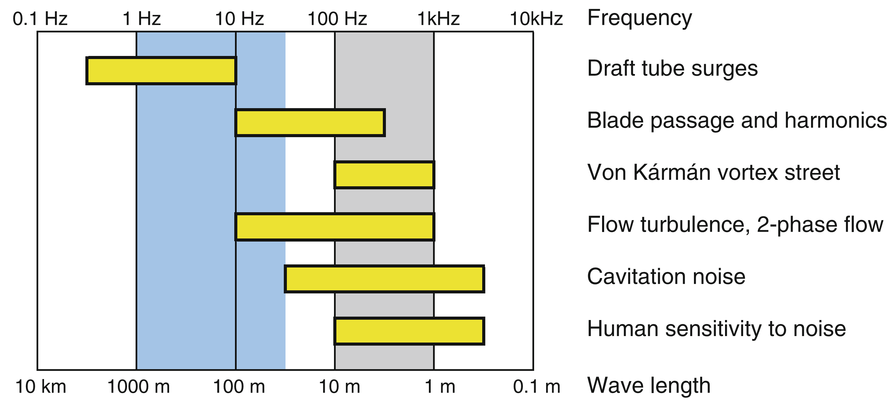
Figure 1 Overview of the frequencies observed in a hydraulic turbine [30].
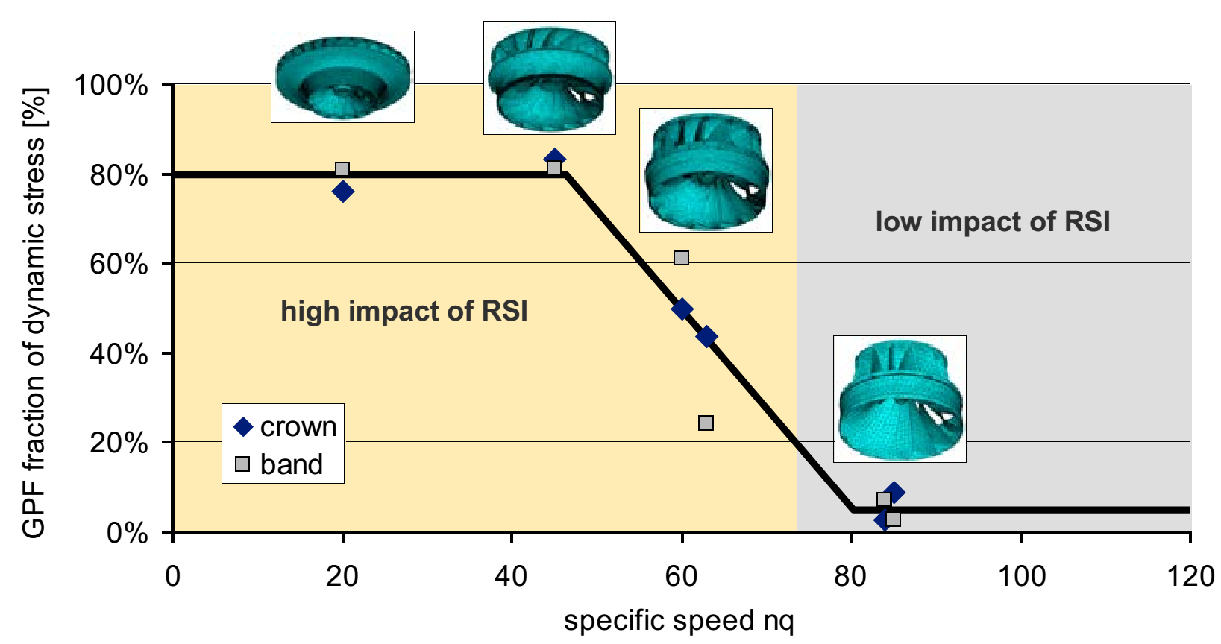
Figure 2 Level of dynamic stresses caused by rotor-stator interaction in hydraulic turbine [8]. RSI=rotor-stator interaction frequency, nq=N∙Q^{0.5}/H^{0.75}; where N is the runner speed in revolutions per minute, Q is the flow rate in m³ s⁻¹, and H is the head in m.
The rotor-stator interaction frequency and its amplitude can be estimated using CFD techniques [34-36]. Figure 3 shows the dynamic pressure loading on a high-head Francis runner blade. The oscillations correspond to the frequency of forced excitation, 156 Hz, observed in the runner. The amplitudes are approximately 15% of the head. The frequency in the stationary and rotating domains is computed using Equations and , respectively.
where n is the runner speed in revolutions per second, and Z_{gv} and Z_{b} are the numbers of guide vanes and rotating blades, respectively. The developed pressure field due to rotor-stator interaction is computed using the following equations [35, 37-39]:
Pressure field related to the runner:
.
Pressure field related to the guide vane:
.
Combined pressure field:
,
.
Equation is used to determine the pressure field as a function of space and time during rotor-stator interaction. The diametrical mode (k) due to rotor-stator interaction is estimated using Equation :
;
where θ=θ_{r}+Ωt, m and n are integers, θ is the angle coordinate, ϕ is the phase angle, A is the amplitude, Ω is the runner angular speed, and t is time. The subscripts “r” and “s” correspond to the rotating and stationary domains, respectively.
Figure 3 Dynamic pressure loading on a Francis runner blade [34]. Exp=experimental, Num=numerical; P42 is the location of a pressure sensor on the blade pressure side.
The frequencies of forced excitation remain constant during steady-state operating conditions. However, the frequencies during a transient condition such as start-stop and total load rejection vary with runner speed. The frequencies are sometimes higher than the runner natural frequency (first mode shape). The runner will experience resonance when the forced excitation frequency matches a natural frequency during each transient cycle. This lock-in may significantly affect the runner operating life. Variation in the strain amplitudes during a complete start-stop cycle is shown in Figure 4. The maximum stress amplitudes are observed during the spin-no-load (SNL) condition, in which the turbine is operated under a no-load condition. The stress amplitudes induce both low and high cycle fatigue in the blades [40].
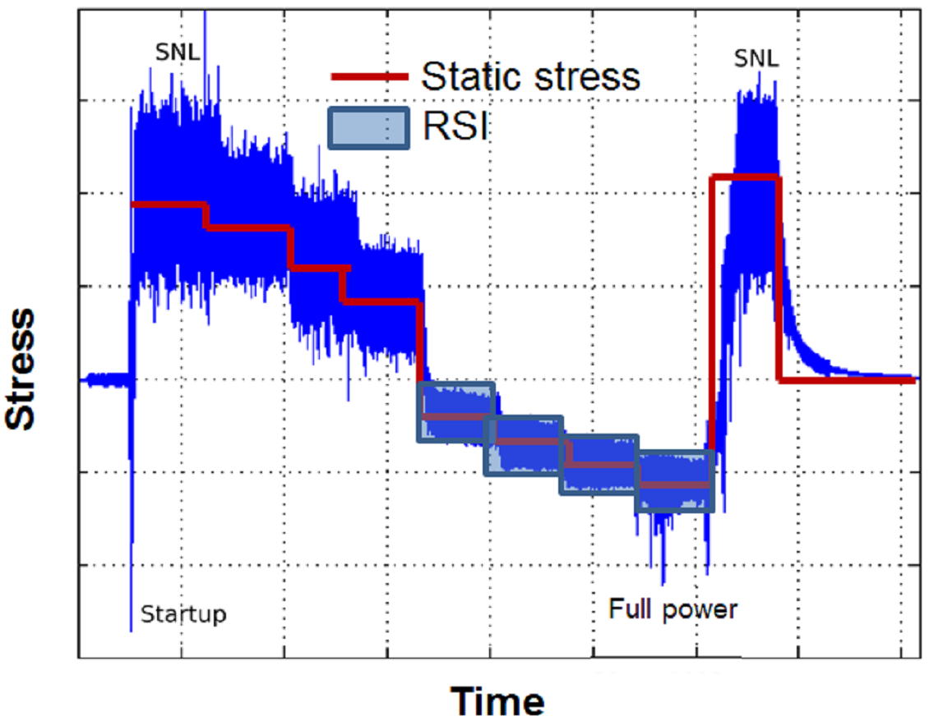
Figure 4 Strain amplitudes during a complete start-stop cycle of a turbine [40].
Overall, forced excitation related to rotor-stator interaction causes significant damage to the runner blades, particularly in mid-head to high-head turbines due to the high dynamic stress related to the total stress. The corresponding frequencies and nodal diameters can be predicted using well-established equations. The frequencies and their harmonics are therefore known before the runner is designed. The main challenge is the numerical estimation of the pressure amplitudes. The reported error in the amplitudes varies from 10% to over 40% [41]. Proper flow modelling through verification and validation may reduce the errors [42-45].

Added mass

Natural frequency
The apparent or added mass of an accelerating body is equal to the reactive force exerted by the body on the fluid divided by the acceleration [46, 47]. The added mass effect can be determined by computing the hydrodynamic forces acting on the runner and its deformation at the corresponding mode shape. [48]. When a runner-like structure is subjected to flow-induced forces, its vibration characteristics change. The natural frequency is an important parameter used to estimate the added mass in the runner. Table 1 summarizes the experimental and numerical studies conducted to investigate the added mass effect on model and prototype runners. The runner was submerged in still water to estimate the added mass effect, and the measured natural frequencies were compared with those in air/vacuum. The reduction in the runner natural frequencies was between 13% and 64% for the corresponding mode shape. A similar added mass effect was obtained from the numerical studies. The difference between the experimental and corresponding numerical values of the natural frequencies was 1.5% to 15%. The difference was mainly dependent on the type of mesh selected and its density for the fluid-structure analysis. A hexahedral type mesh displayed faster convergence and a lower difference than the tetrahedral type.
Table 1 Experimental and numerical studies conducted to investigate the added mass effect in the turbine runners.
Reference | D (m)* | Z_{b} | ν (-)⁺ | ρ (kg m⁻³) | E (GPa) | Mesh nodes | ∆# | δ**
[49] | 0.4 | 17 | 0.56 | 8300 | 110 | 8529/passage | 3.6% | 39%
[17] | 2.9 | 7 | 0.27 | 7700 | 205 | 7681/passage | 1.5% | 58%
[50] | 1.3 | 15 | 0.34 | 7700 | 206 | -- | 12% | 48%
 | 0.7 | 15 | 0.39 | 8600 | 90 | -- | 15% | 64%
[51] | -- | 9 | -- | 8300 | 110 | 165000 | 12% | 13%
[52] | -- | 13 | -- | 7700 | 206 | 20894 | 3.5% | 32%
⁺specific speed of the runner,
*runner outlet diameter
#deviation of numerical value (natural frequency) from the experimental value,
**frequency reduction ratio,
Experimental studies have been performed under static conditions where the runners were submerged in a water-filled tank [53, 54]. The runners were excited by either an impact hammer or piezoelectric patches [55-57] at a specific frequency, and the response was measured using accelerometers. The accelerometer location during the measurements is important and may lead to misleading results if not adequately selected; one of the studies highlighted this importance. Figure 5 shows the natural frequencies observed at the locations P₁, P₂, P₃, and P₄ of a runner. A natural frequency of 415 Hz can be observed at all locations except P₁ because this accelerometer was situated near the nodal points of the runner. The effect of sensor locations, therefore, needs to be determined prior to performing the measurements.
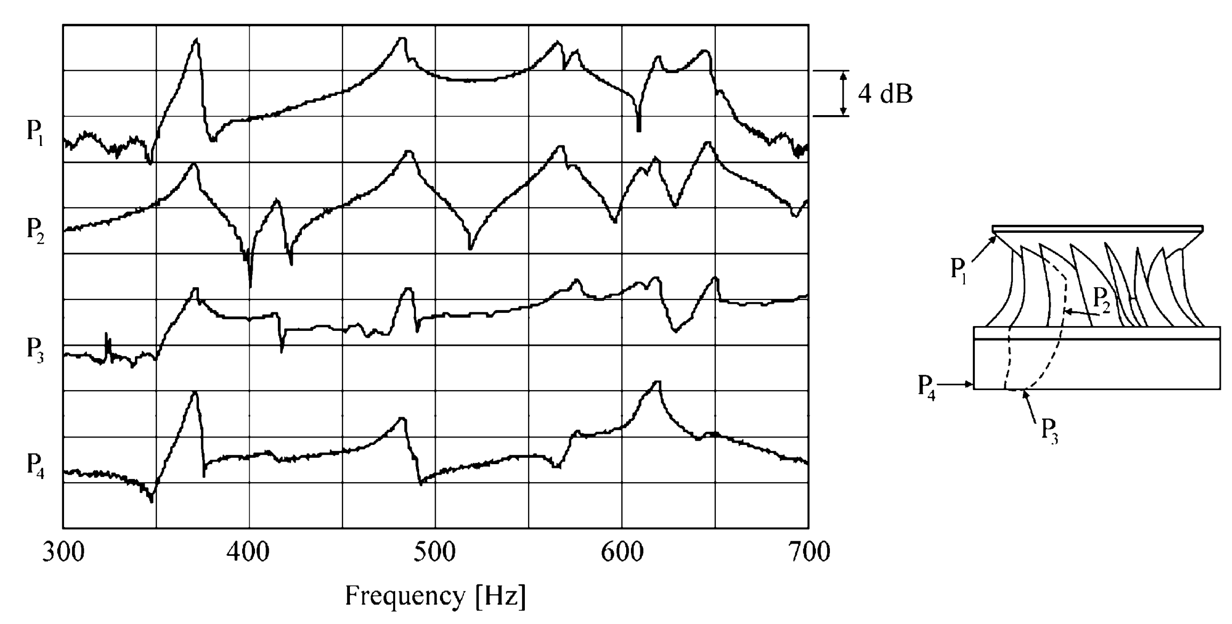
Figure 5 Frequency response from different locations on the runner. P₁–P₄ are the locations of the accelerometers on the runner.
Numerical simulations were performed with a computational domain similar to the experimental configuration [17, 23, 49, 50, 52, 58] for comparison with the experimental results. The mesh was divided into two separate domains, structure and fluid, as shown in Figure 6. Both meshes were connected using a fluid-structure interface. The forces obtained due to water pressure were applied to the structure for the frequency and modal analysis.
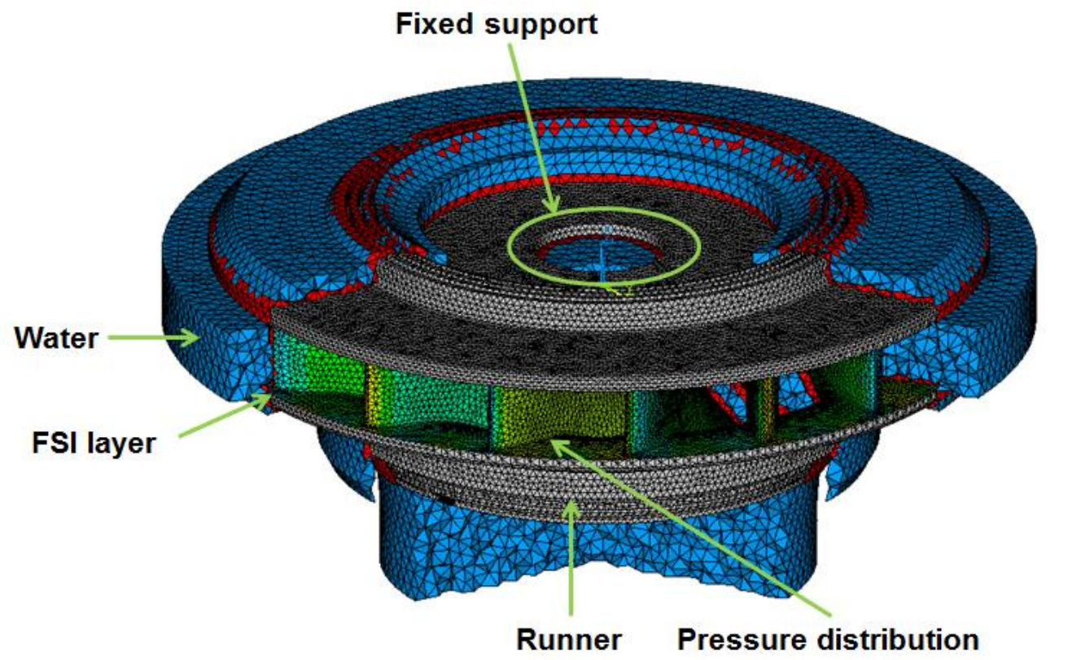
Figure 6 Fluid structure mesh of a Francis turbine runner [59].
Two different methods are used to solve fluid-structure interaction problems [60]. One is the fully coupled method, in which the meshes of the fluid and structure domains are linked. Information about the fluid-added forces acting on the structure is coupled to the structure, and information about the structure deformation is coupled to the fluid domain; thus, the solutions for the fluid and structure are inter-dependent. This coupling implies that the meshes may be subjected to deformation, altering the space discretization quality. Figure 7 shows an example of the linked mesh used to perform a coupled simulation [17]. A conformal mesh was created at the fluid-structure interface to avoid interpolation between the node points. The numerical results are shown in Figure 8. Good agreement was obtained, and the maximum difference of the natural frequencies was 15% in air and 12% in water. This method requires an extremely small time-step size to ensure the stability of the solution [61]. This computation is expensive and not widely adopted in the hydropower industry; a sequential coupled method is generally used instead. The sequential coupled method assumes that the influence of the runner deformation on the flow field is negligible. There is no feedback regarding runner blade deformation in the flow field [9]. This method works faster and allows a mesh of a more consistent quality than in the coupled method but does not guarantee energy conservation at the interface [62]. The sequential coupled method is a popular option when blade deformation is low and does not affect the flow field significantly. Blades are usually thin in the high-head runners. The effect of forced excitation is strong, and the excitation frequency is close to the runner natural frequency. In such cases, the blade deformation is large, and a coupled simulation offers more accurate results [50, 60, 63, 64].
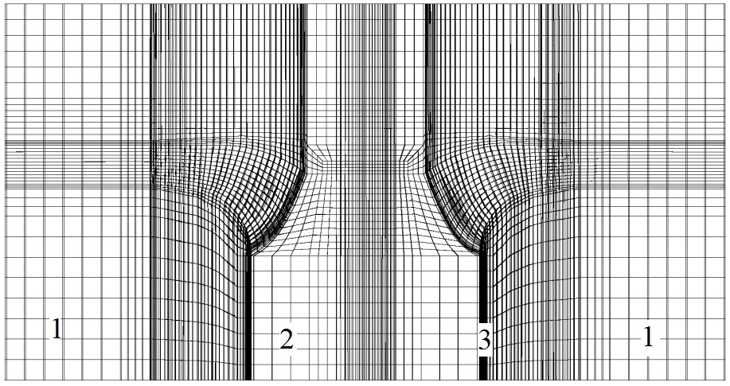
Figure 7 Fluid-structure coupled mesh [17]. Mesh 1 in the fluid domain, mesh 2 in the structure (runner), and mesh 3 at the fluid-structure interface.
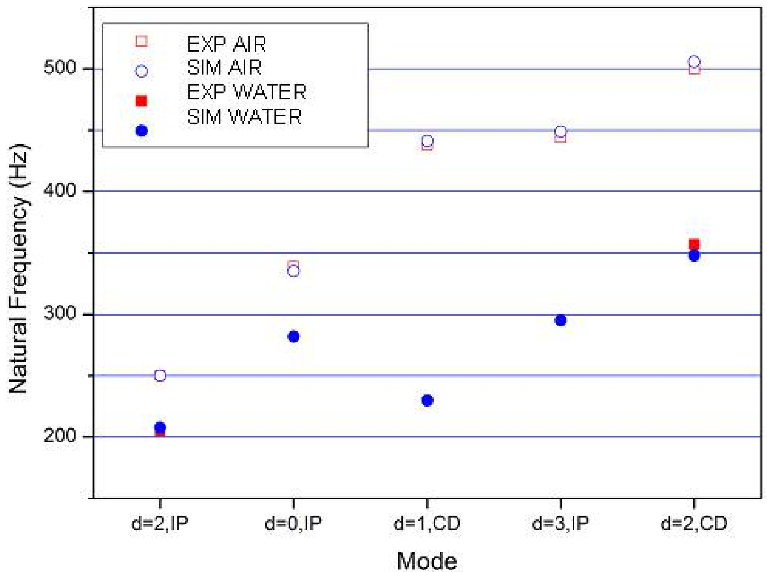
Figure 8 Comparison of the experimental and numerical values of natural frequencies in the air and water of a model Francis turbine runner [17]. The parameter d is the diametrical mode of the runner, IP is the in-phase motion, and CD is the crown-dominating motion.
The mode shape is an important parameter for the analysis of vibration characteristics due to the added mass. In the runner, four mode shapes, namely, bending, torsion, flexion and axial, were observed, and the maximum change in natural frequency corresponded to the bending mode shape. The mode shapes in air and water were similar, but the order was different. Figure 9 shows the observed mode shapes in a model Francis runner during the measurements in air and water. The maximum added mass effect was for the five-nodal diameter of the bending mode. The relative amount of added mass (modal added mass/modal mass) for this nodal diameter was 1.64, and the runner natural frequency was reduced by 38% [53]. Overall, in the runner, the natural frequency reduction was 5-11%for the first nodal diameter, 8-15% for the next two or three nodal diameters, and 10-64% for the higher nodal diameters [17, 53, 58, 65, 66]. During cavitation, the natural frequency reduction may be as high as 80% for the high nodal diameters [67].
The added mass effect for different sigma values of cavitation is shown in Figure 10. The experiments were performed on a hydrofoil (NACA 0009) under cavitating conditions. The angles of attack were 1° and 2° during the tests. Three mode shapes were observed in the hydrofoil: two bending and one torsion. The natural frequency reduction values for the first bending, torsion, and the second bending modes were 48%, 61%, 55%, respectively, in still water compared to those observed in air. For the first bending mode, the natural frequency reduction was 48.3% at a water velocity of 7 m s⁻¹ (σ = 3.05). At 14 m s⁻¹ (σ = 2.48), the natural frequency reduction was 48.8%. The figure shows that the added mass effect increases by σ/2α, which affects the size of the attached cavities on the hydrofoil [67]. It was suggested that the average density of the cavity and its location relative to the hydrofoil deformations play a role in the added mass effects. The deformation is dependent on the mode shape and the corresponding added mass effect. Measurements suggested that at high nodal diameters, the deformation is high, and the flow field during the vibrations is strongly affected [68-70]. The measurements on the hydrofoil may be considered a simple test case for future studies on the actual runner, including cavitation.
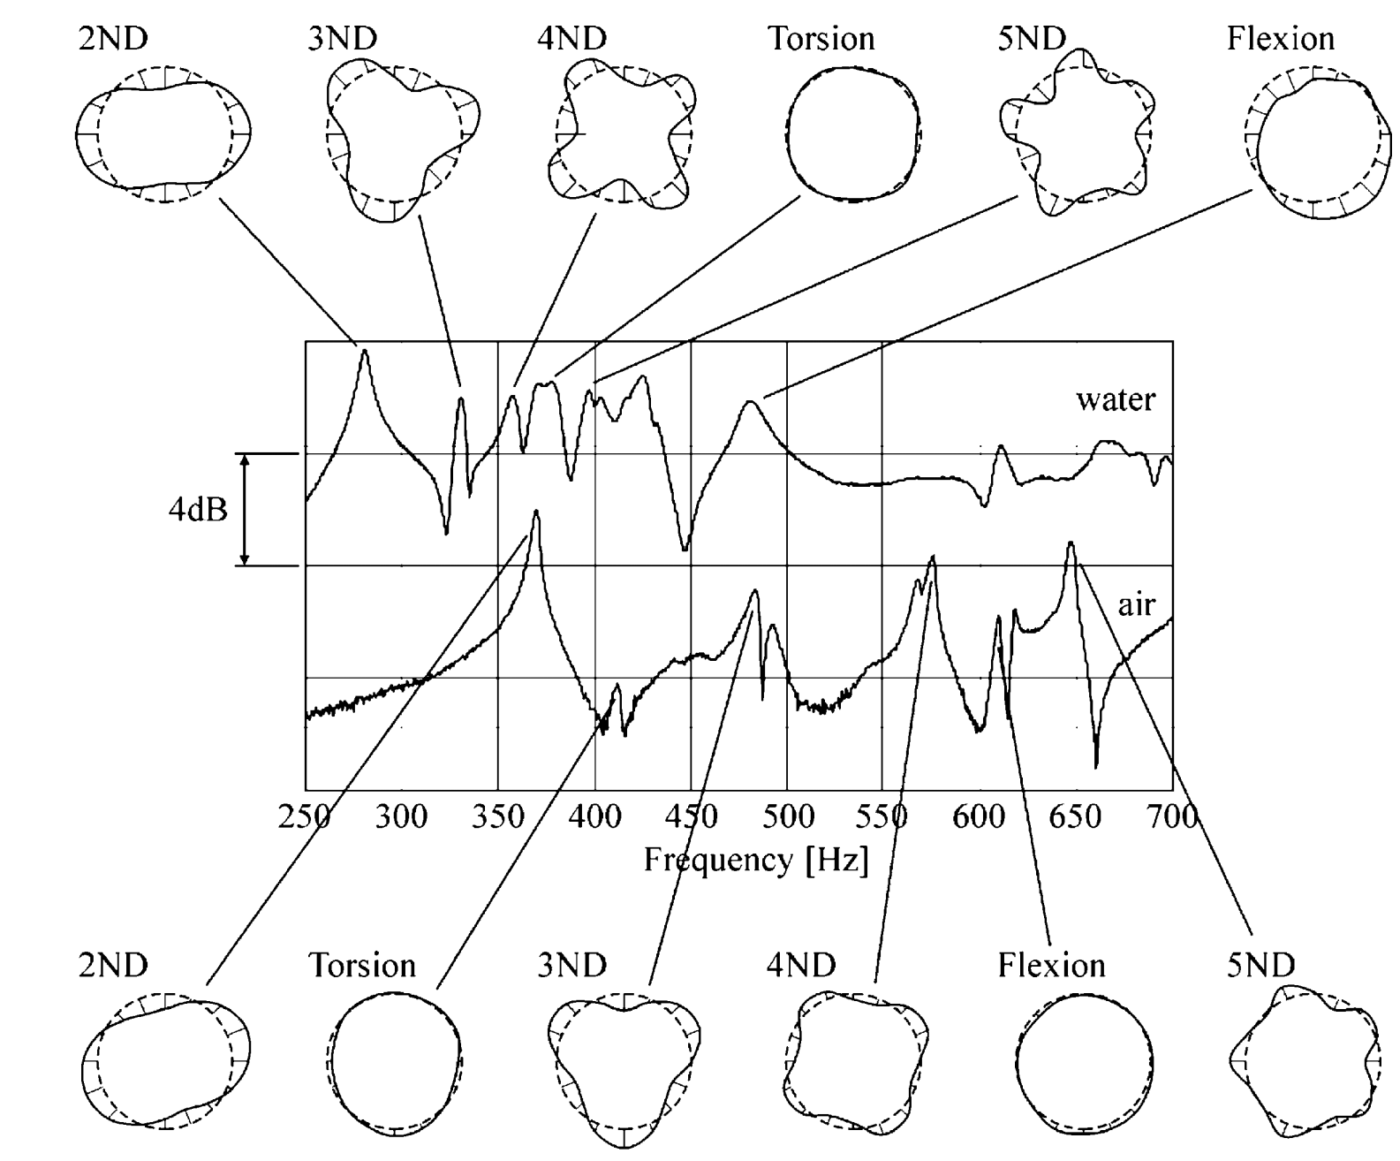
Figure 9 Mode shapes and natural frequencies of a model Francis runner in air and water [53]. The runner properties are as follows: specific speed (ν)=0.56, material density=8300 kg m⁻³, runner mass=55 kg, Young’s modulus=110 GPa, Poisson’s ratio=0.34, reference diameter=0.4 m, and number of blades=17. ND: nodal diameter.
Figure 10 Added mass effect as a function of cavitation on hydrofoil [67]. F2 is the frequency at the torsion mode shape, f3 is the frequency at the second bending mode shape, C_{M} is the added mass coefficient, σ is the cavitation number (sigma), and α is the void fraction.
The precise estimation of mode shapes and their transition is important. A mode-shape analysis provides detailed information about the blades, band, and crown deformation at the resonant frequency [50]. The deformations may be either parallel or relative to each other depending on the nodal diameters/circles [71]. The added mass effect is small in the case of parallel deformation and increases as the deformation shifts in relative position (see Figure 11). The figure shows both parallel (left) and relative (right) deformations in a pump-turbine runner. At three nodal diameters, parallel deformation was observed where the crown and band were deformed parallel to each other; the added mass effect was 9%. At two nodal diameters, relative deformation was observed where the crown was deformed against the band; the added mass effect was 37% [58]. As deformation continues, fatigue begins to develop at the areas of maximum stress concentrations, i.e., the blade’s leading and trailing edges join to the crown and band [24, 72]. A detailed review of the fatigue development is discussed in section 4 on fatigue loading.
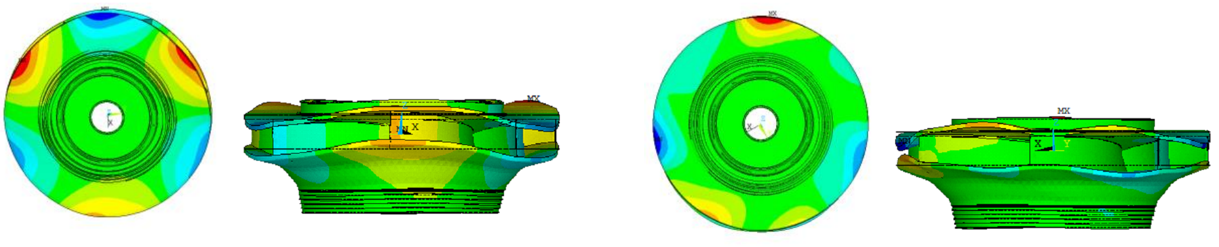
Figure 11 Pump-turbine runner deformation at three (left) and two (right) nodal diameters [58].
During turbine operation, the runner interacts with the nearby structures such as labyrinth seals, guide vanes, distributor rings, and upper and lower cover. The response of the nearby structures is important. Investigations suggest that the relative deformation of the band and/or crown seals may significantly reduce the natural frequencies [53, 73-75]. The proximity of a solid boundary increases the added mass as pressure builds up in its vicinity and pressure waves reflect towards the vibrating structure [74, 76]. Figure 12 shows the disc natural frequencies as a function of its immersion depth in a tank. The location H₁ = 0 m corresponds to the disc on the free surface and H₁ = 0.16 m to the disc in contact with the bottom surface of the tank. When the plate sinks towards the bottom of the rigid tank, the natural frequencies decrease rapidly. The added mass effect is dependent on the surface area in front of the reflecting structure [71].
In a hydraulic turbine, the runner is a rotating component, and the added mass effect is different from the steady conditions. To investigate the additional effects, experiments were recently conducted on a submerged rotating disc [77, 78]. The disc was mounted on a shaft that was rotating at 8 Hz. Four accelerometers were attached to the disc at angular positions of 0, 90, 180, and 210°. Figure 13 shows the natural frequencies of the disc under steady (left) and rotating (right) condition in the water. The natural frequencies observed at the two nodal diameters were 127 Hz and 132 Hz under steady and rotating conditions, respectively. However, during rotation, another peak appeared at 117 Hz. The similar study conducted by Hübner et al. [79] have found similar behavior of a disc, where natural frequency was split under rotating condition. The analysis suggests that the peak might be related to the standing waves developed by the rotation of the disc. The study reveals three important facts: (1) added mass on a rotating structure is different from the same action under still conditions (it might be higher or lower); (2) an additional effect appears: standing waves develop due to the rotation; and (3) nearby surfaces exert a strong influence on the disc natural frequency. One of the main concerns is the proximity of standing wave frequency to the forced excitation frequency. It is difficult to determine the standing wave frequency due to runner rotation at the design stage. Information from the model testing is vital to estimate the possible frequencies related to hydro acoustic effects as the runner angular speed changes.
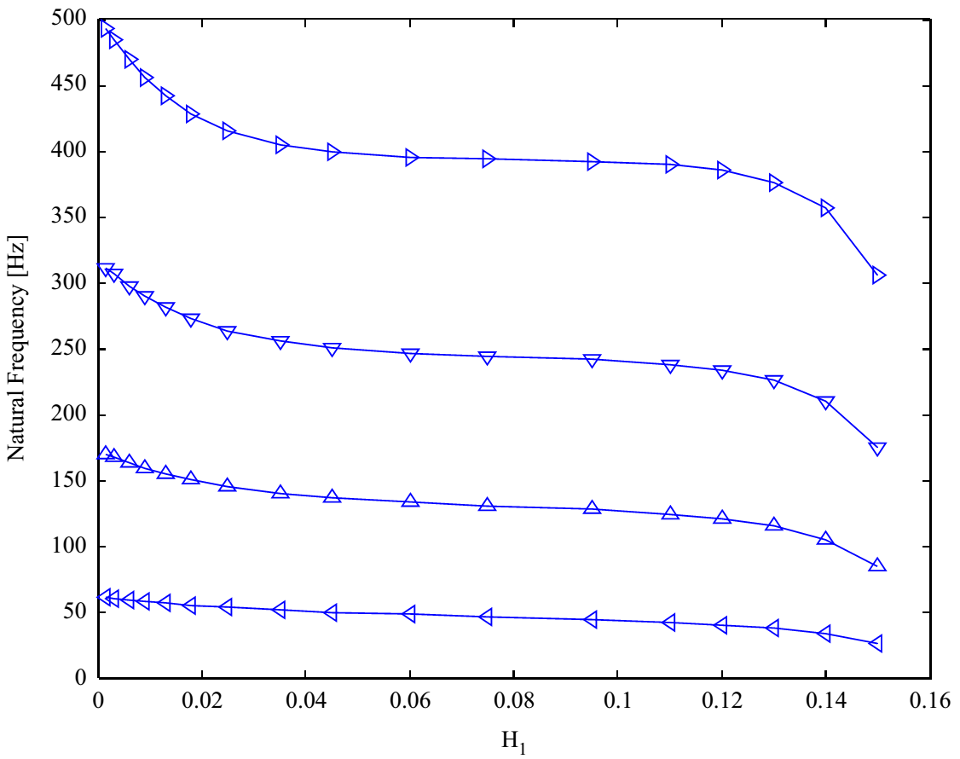
Figure 12 Effect of immersion level (H₁) on the disc natural frequency. The natural frequencies close to 50, 150, 250, and 450 Hz correspond to nodal diameters 0, 1, 2, and 3, respectively [73].
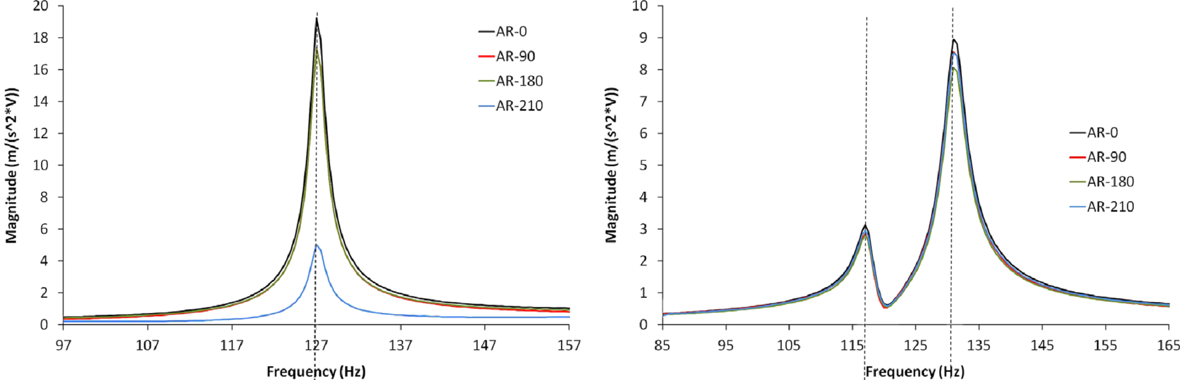
Figure 13 Added mass effect on a circular disc under still (left) and rotating (right) conditions in water [77]. AR-0, 90, 180, 210 correspond to the accelerometers’ radial locations at 0, 90, 180, and 210°, respectively.
Overall, the main parameters affecting the runner natural frequencies are mode shapes, relative deformation of the runner band and crown, proximity of nearby surfaces (particularly the gap in the labyrinth seals), blade profiles, number of blades, and vibrations (flutter) at the blade trailing edge. In a hydraulic turbine, a range of runner natural frequency can be predicted during the design phase for stable operating conditions using available numerical techniques. The added mass effect during a transient operating condition such as a start-stop, however, is completely unknown. The natural frequencies are generally assumed to be higher under transient conditions than under steady-state operating conditions. In fact, the added mass might be significant in the case of a rapid change in the flow field due to an accelerating/decelerating runner structure. The change in runner speed also changes the frequency of forced excitation. If the runner natural frequency is lower than the forced excitation frequency, the runner will experience resonance during each transient cycle. Investigations of the added mass effect should, therefore, consider these aspects during the design phase.

Blade flutter
Blade flutter has been one of the critical problems affecting turbo machines over the past decades, under both compressible and incompressible flow, as it causes significant damage to the blades under resonance conditions [80]. Flutter refers to unstable self-excited blade vibration resulting from unsteady hydrodynamic forces. The blade displacement amplitude grows exponentially or reaches limit cycle oscillation, which can lead to high cycle fatigue and eventual failure. This is an important type of dynamic instability and deserves careful attention [80, 81]. The runner includes several blades, and the influence of the neighboring blades significantly changes the blade flutter mechanism. In fact, the contribution from adjacent blade pairs varies primarily due to changes in mode shape, although reduced frequency has a secondary influence [82]. To obtain the maximum possible efficiency, modern blades are thin and highly skewed, and their cross-sections vary from band to crown and from leading edge to trailing edge. Four important factors affect blade flutter: mode shape, reduced natural frequency, water velocity, and acoustic resonance [83].
Within hydro turbine research, blade flutter is one of the least studied research topics, despite being critical for blade design. It is still not certain whether a runner can experience blade flutter during resonance. Seeley et al. [84] conducted an experimental study on a hydrofoil section to investigate flutter under different flow conditions and cavitation. The hydrofoil was submerged in flowing water with a velocity of up to 22 m s⁻¹. Piezoelectric patches [56] were integrated onto the hydrofoil surface for excitation at specific frequencies. The results showed that vibration amplitudes increase with flow velocity and that the flow condition was significantly affected by the hydrofoil flutter. Figure 14 shows the deflection of the hydrofoil under the influence of different frequency values at a flow velocity of 7 m s⁻¹. The maximum deflection of 0.05 mm at the trailing edge can be observed at 70 Hz. Fluid damping on the hydrofoil increased almost linearly with the flow velocity. However, the hydrodynamic forces were strong enough for the hydrofoil to flutter and suppress the damping effect. The studies under the cavitating condition suggest a large amplitude of the vibrating structure, specifically where sheet cavitation is high [84]. In hydro turbines, laboratory investigations of blade flutter are challenging and expensive because they require high velocity flows (up to 40 m s⁻¹) to match prototype conditions.
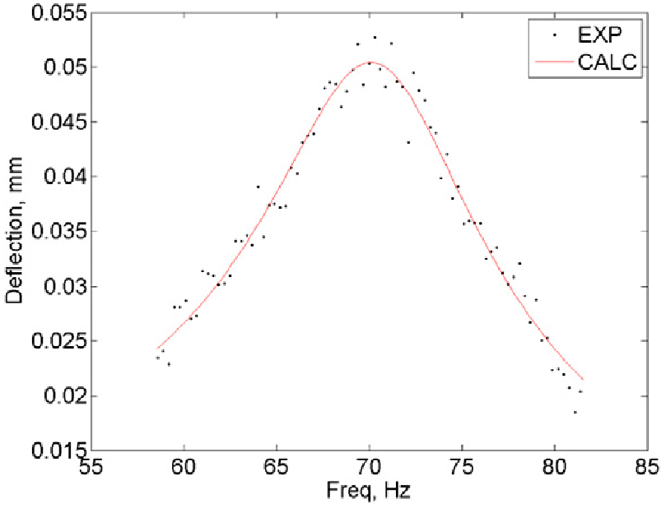
Figure 14 Deflection of a hydrofoil under the influence of different excitation at a velocity of 7 m s⁻¹ [84].
Recently developed numerical techniques can be used to perform numerical studies that consider the blade flutter mechanism [85]. There are two techniques for numerical prediction of aerodynamic damping: nonlinear time marching and time-linearized analysis [86]. These techniques are well documented in the literature [87-94] and have been used extensively to determine blade flutter in compressible turbo machines. However, they have yet to be applied to blade flutter analysis in hydraulic turbines. One may consider this an opportunity to estimate blade flutter by simulating the prototype condition. The main challenge with numerical studies is to obtain solution convergence. Careful evaluation of the numerical model and optimization of the time-step size may provide reliable results for fluid-structure interaction in the turbine runners.

Hydrodynamic damping
Added mass and damping are both important properties of fluid-structure interaction in a turbine. Vibration amplitudes change the added mass effect when they are sufficiently large to separate the fluid from the structure. The motion-induced force will change from an inertial added mass to damping [16], i.e., fluid of high inertia with a high velocity will effectively reduce the vibration amplitudes of the structure and act as a damper. The hydrodynamic damping is important, particularly when the vibration amplitudes are large. Damping is considered the main parameter in avoiding damage during resonance [95]. Over the last two years, industrial research has been more inclined towards investigating the hydrodynamic damping in high-head Francis turbines, specifically in the resonance condition [96].
An experimental study conducted on a hydrofoil revealed useful characteristics of hydraulic damping with respect to flow velocity [55, 84, 97]. Three hydrofoils of different geometrical dimensions were investigated close to the resonance condition. Figure 15 shows an arrangement of one of the hydrofoils on the mounting block (left) and damping ratio (right) during the measurements on the three hydrofoils, H0, H1 and H3. The piezoelectric patches were mounted on the trailing edge of the hydrofoil, two on each side. The observed natural frequencies of the H0, H1, and H3 hydrofoils in still water were 74.9, 71 and 74.1 Hz, respectively. The natural frequencies were 33.1, 32.7, and 37.1% lower, respectively, than the natural frequencies observed in air and decreased with increasing flow velocity. An approximately 10% reduction was observed at a flow velocity of 22 m s⁻¹ compared to the still water condition. However, the variation is within the estimated uncertainty band. It is, therefore, difficult to confirm that the change in natural frequency is a function of the flow velocity. The right side of the figure shows variations in the damping ratio with the flow velocity; it increases almost linearly with the flow velocity. The maximum damping was observed at a flow velocity of 22 m s⁻¹. The small variation in the slope may be related to the different geometrical dimensions of the hydrofoils. Overall, hydrodynamic damping might be the key parameter for reducing the vibration amplitudes when forced excitation (i.e., rotor-stator interaction) occurs close to the runner natural frequency in flowing water.
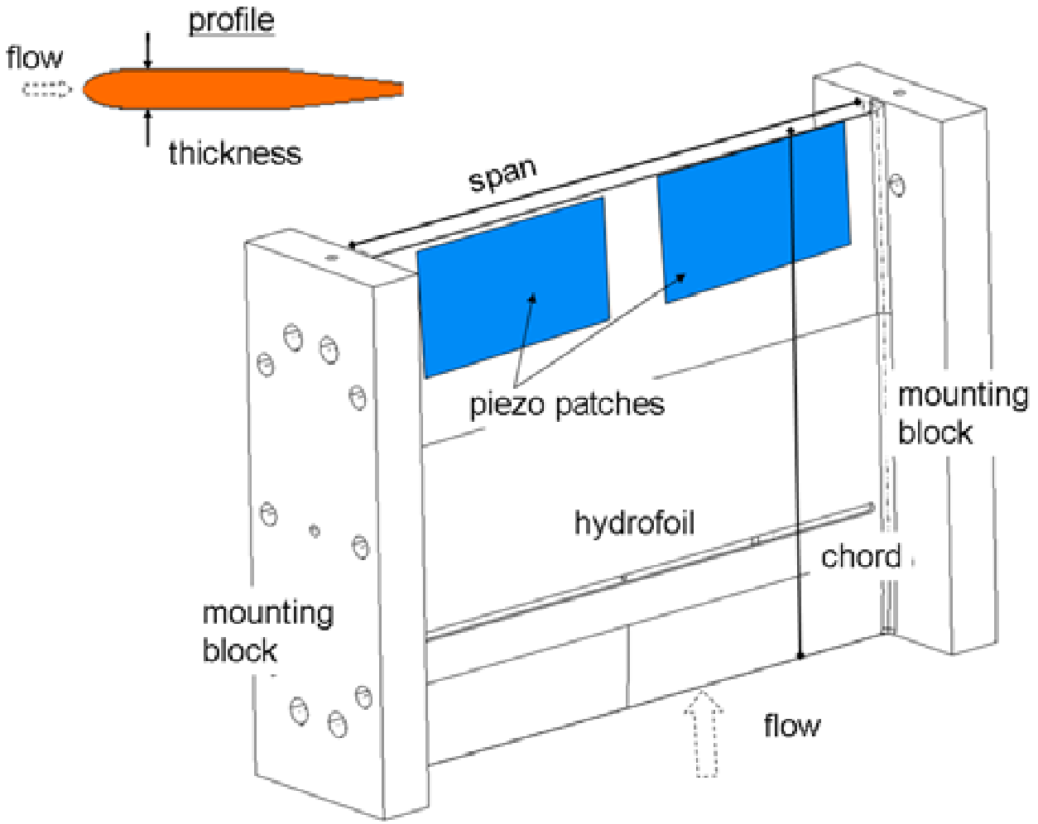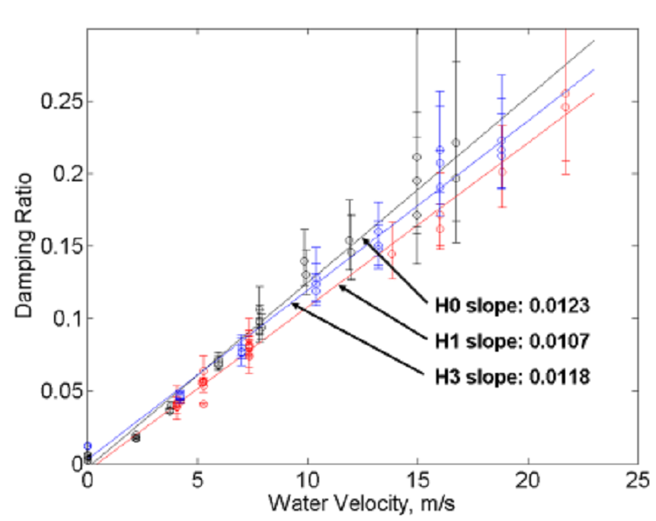
Figure 15 Mounting block arrangement for the hydrofoils and locations of the piezoelectric patches for exciting the hydrofoil at the natural frequency (Coutu et al., 2012).
The damping effect at different natural frequencies is shown in Figure 16. The measurements were performed on a reduced scale model of a pump-turbine runner. The damping ratio decreases with increasing natural frequency. The maximum damping is 3.1% in air and 4.1% in water [54]. At low natural frequencies, approximately 700 Hz, the damping ratio is high but not high enough to reduce the amplitudes of blade flutter. The tested frequency range is too high for a hydraulic turbine because the frequency of forced excitation varies from 100 to 300 Hz.
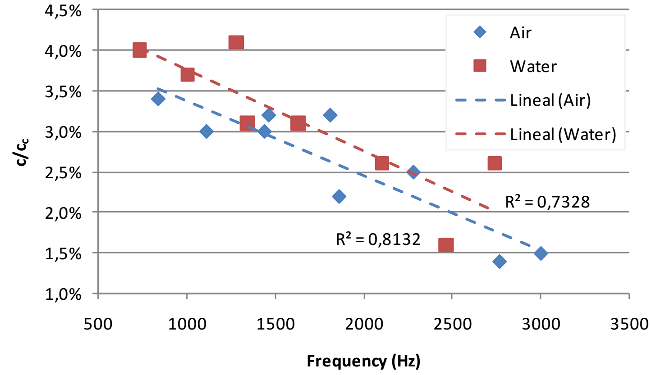
Figure 16 Damping effect in air and water with respect to natural frequencies [54]; c is the damping, and c_{c} is the critical damping.
The investigation of hydrodynamic damping within the context of hydropower presents several challenges because prototype conditions are completely different from conditions during laboratory testing. Unless all of the damping characteristics are well understood, it is difficult to make predictions for the prototype runner. Most importantly, fluid damping in the runner may be different at each location; e.g., at the leading edge, the band and crown junction to the blade trailing edge, and the runner cone. Furthermore, the damping may be dependent on the local flow condition, as observed for the blades of compressible turbomachines [86]. Erroneous predictions/estimations of damping effects based on isolated laboratory tests may result in failures. The damping effects may have a decisive influence depending on the difference between force excitation frequency and resonant frequency.

Fatigue loading
In section 2 on forced excitation, we described how hydraulic turbines experience high amplitude dynamic pressure, which induces both static and dynamic stresses on the blades. The static stresses are associated with the steady-state mean pressure loading, and the dynamic stresses are associated with the cyclic change in pressure loading due to forced excitation. Experimental and numerical studies suggest that the induced stresses are concentrated at the leading and trailing edge T-junctions [98, 99]. Figure 17 shows the dynamic stresses on a Francis runner under a high-load operating condition. The maximum stresses are observed at the T-junctions to the band and crown. In practice, it is difficult to measure the stresses at the positions of maximum stress. The limitation is caused by the strain gauge size and the protection layer for water. Steel templates are used to position strain gauges precisely; a similar technique is adopted in industry [8]. The use of templates is not restricted to one blade; the positions of the other blades can also be defined easily, accurately, and quickly.
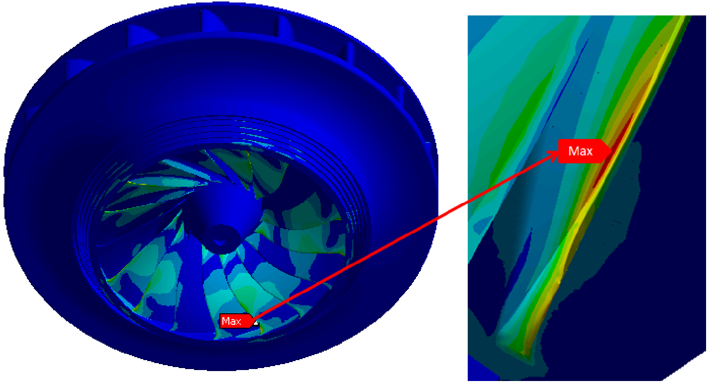
Figure 17 Von Mises dynamic stresses on a high-head Francis runner under off-design conditions [59].
In a high-head turbine, the static and dynamic stresses are much higher than in a mid-head or a low-head turbine. The stress level is dependent on the operating load of the turbine. Figure 18 shows the variation of principal and equivalent stresses at a blade trailing edge close to the crown. At the BEP and stable operating region, the stresses are almost identical. At high load, the stresses are significant, and the Von Mises equivalent stresses are much higher than the principal stresses. At part load (PL3 and PL4), both stresses are almost identical. In the runner, the maximum principal stresses (static) are approximately 25% of the yield strength, which is probably insufficient to cause fatigue. Fatigue could be induced by the combination of residual, static, and dynamic stresses. The dynamic stresses play a significant role in the development of cracks [9, 98, 100].
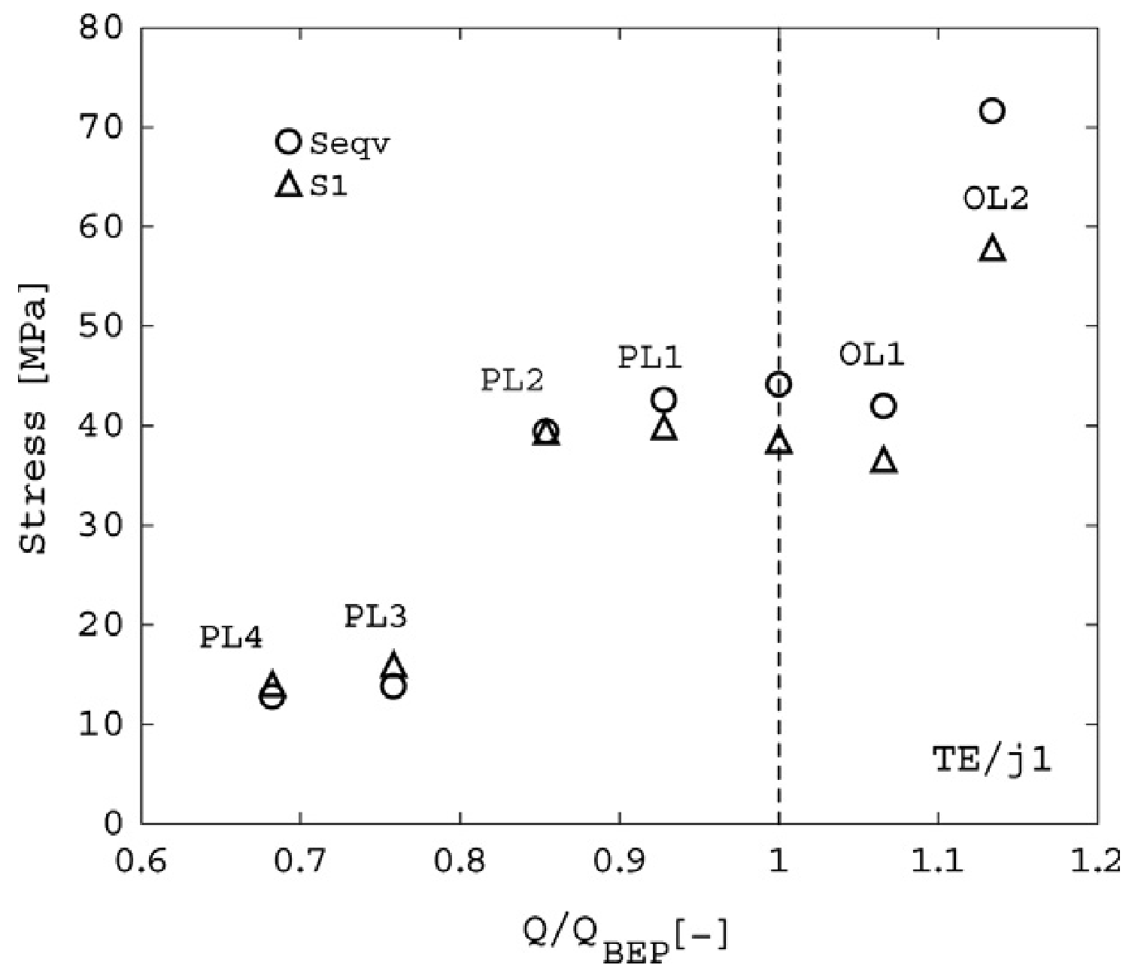
Figure 18 Stress variation at the blade trailing edge of a Francis turbine runner (specific speed=0.44) under different operating conditions [101]. Junction j₁ corresponds to the blade trailing edge joined to the crown; BEP-best efficiency point, S₁-principal stress, and s_{eqv}-Von Mises equivalent stress, PL-part load, OL-over load, and TE-trailing edge.
Hydraulic turbines experience low cycle fatigue during transient operation (cycles < 10⁴) and high cycle fatigue under steady-state operating conditions (≥ 10⁵). An increase in the transient operation of the turbines and long-time power generation at off-design conditions results in rapid growth of fatigue in early life. One of the main parameters for the runner design is the fillet radius at the T-junctions of the blades to the band/crown. Studies on shape optimization reveal an increase in fatigue life by a factor of 2–2.5 compared to the quarter-circular shapes of the fillet [10]. Figure 19 shows a photograph of the broken section (crown) of a pump-turbine runner. A detailed examination of the runner suggested that the failure was associated with the high stress concentration at the T-junction of the blade leading edge. An increase of the fillet radius at this location relieved the stress concentration. The analysis of the added mass effect showed significant reduction of the runner natural frequency at two nodal diameters; the frequency was close to the frequency of forced excitation. Such failures are commonly observed in hydraulic turbines, mainly high-head; the crack initiated from the leading edge T-junction. Similar failures are analyzed in the literature [10-12, 18, 20, 102].
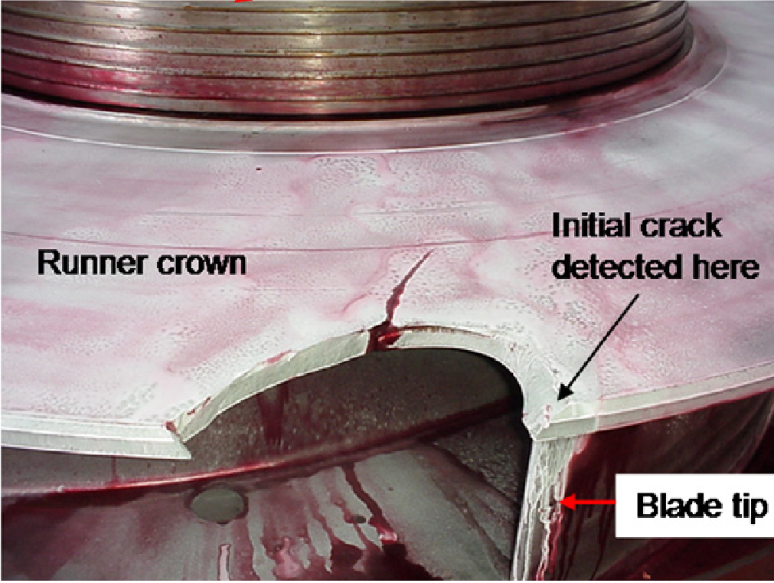
Figure 19 Damaged section of a prototype pump-turbine runner [23].
One of the main causes of fatigue damage and failures is high amplitude dynamic stresses induced by rotor-stator interaction [25, 103]. The stresses and related amplitudes are accurately predicted by available numerical techniques for steady-state operating conditions. However, the main challenge is the consequences during transient operating conditions such as load variation, start-stop, and total load rejection. In fact, the transient conditions cause significant damage to the runner blades. Recently conducted studies suggest that transient conditions cause far more serious damage than during steady-state operating conditions [4, 104]. In a high-head turbine, the blade loading varies at a rate of between 10 to 50 MW per second during the transient cycle, and the blades experience both compressive and tensile stresses. A strain gauge measurement on a Francis turbine (power = 600 MW) suggests that the compressive stress is more prominent than the tensile stress at the suction side trailing edge T-junctions. The stresses change from compressive to tensile or vice versa with the load change. The maximum tensile and compressive stresses are 100 MPa at full load and 230 MPa under total load rejection conditions [105].
A reasonable prediction of the pressure loading and corresponding amplitudes is necessary before fatigue damage leads to cracking. Due to the stochastic nature of the loads, an appropriate and efficient conversion of the dynamic pressure into deformations is very important. The SNL operating condition is typically highly dynamic, and a proper assessment must be made at the design stage [106-108]. Figure 20 shows the variation of unsteady pressure and corresponding strain values during a complete start-stop cycle in a high-head Francis runner. The maximum pressure amplitude is observed during the SNL condition. High amplitude pressure pulsations during SNL and rapid strain variations may cause significant damage to the blades, specifically to the load-peaking turbines [25, 40, 59, 103, 109].
The relative damage under different operating conditions in the Francis turbine runners is shown in Figure 21, in which relative damage in five different runners is compared. The characteristics of the runners are shown in Table 2. The maximum damage occurs during start-stop and SNL in all runners. Compared with other load cases, the start-stops contribute significantly to damage of the runner. The damage caused by one start-stop is greater than several days of turbine operation under steady-state conditions [40]. The start-stop cycles reduce runner lifetime by as much as several years of operation at full load [110]. The comparison of the relative damage factors between start-stop and SNL for the examined runners indicates that it is better to keep them running as a spinning reserve for a few hours than to start many times per day. However, turbine operation at SNL results in a cost in the form of water losses and wear to components. The first natural frequency of the runner is sometimes less than the frequency of the forced excitation [99]. Under that condition, spinning the runner could be catastrophic after crossing the threshold limit of the structure. Proper understanding and analysis of the fluid-structure interaction is, therefore, essential before implementing possible options in the power plant. Gagnon et al. [111] have conducted extensive studies for transient operating conditions that includes start-stop, SNL and load rejection with full/partial air admission. It was highlighted that the periodic assessment of the guide vane operating scheme and the corresponding fatigue loading is vital. The cost for optimizing the scheme is much less than the total damage occurred on the runner blades. Another concern is that negligence of air admission systems during assessment of life expectancy. The air admission system is generally used to reduce the amplitudes of unsteady pressure fluctuations in the runner and draft tube. Gagnon et al. [111] have suggested that this system should not be considered only as a safety measure but also as a mean to maximize runner life and ensure reliable power plant operation through efficient use during transient cycles.
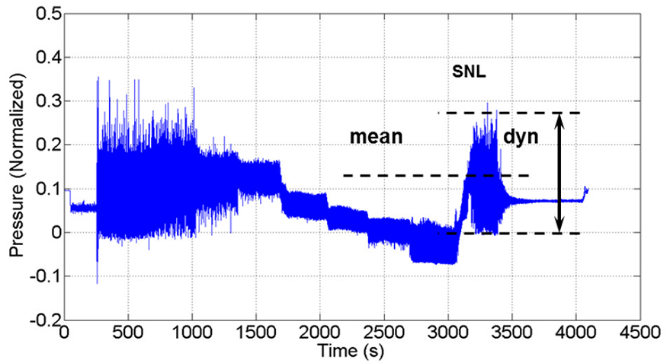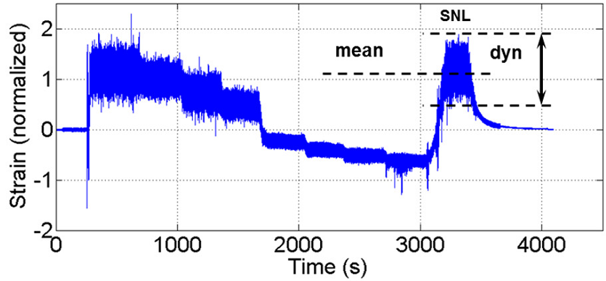
Figure 20 Dynamic pressure loading on the blades (left) and corresponding strain values (right) during a complete start-stop cycle of a Francis turbine [25]. Times from 250 s to 1,000 s and from 3,050 s to 3,500 s correspond to SNL. Times from 2,300 s to 2,700 s correspond to the best efficiency operating point.
Table 2 Types of Francis runner and their operating range used for stress analyses as presented in Figure 21 [40].
Runner type | n_{ED} | Rated power category (MW) | Design type
A | 0.4 | 200-400 | Standard
B | 0.4 | >400 | Wide operating range
C | 0.3 | 200-400 | Heavy duty
D | 0.2 | 0-200 | Standard
E | 0.3 | 0-200 | Standard

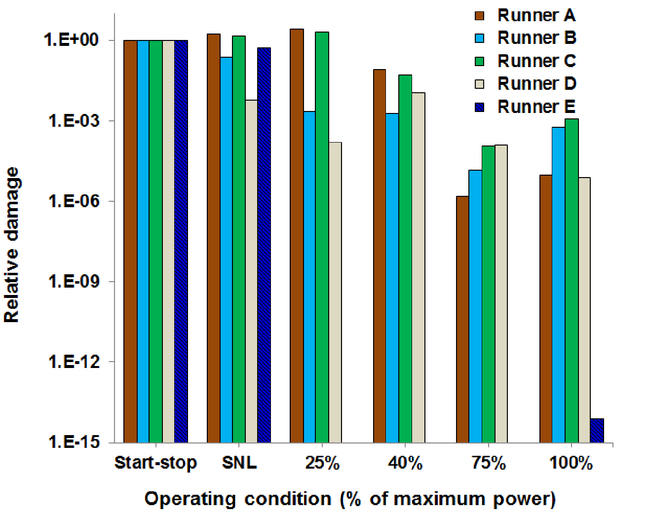
Figure 21 Relative damage factor in Francis turbine runners of different categories [40]. Runner characteristics are presented in Table 2.
Overall, in hydraulic turbines, interactions between water and structure are important, and the surrounding water has a strong impact on the dynamic behavior of the structure. The added mass can reduce the natural frequencies by up to 50% of the corresponding frequencies in air. Further, Von Karman vortex shedding at the leading or trailing edge of the blades may lead to lock-in phenomena if the vortex shedding frequency is near the blades’ natural frequency, resulting in large amplitude vibrations and fatigue problems. The runner is operating in a close environment, and the gap between rotating and stationary parts very small. The hydro elastic instabilities that develop in small gaps (labyrinth seals, close guide vanes) cause significant amplification of the vibration amplitudes that sometimes leads to structural failure {Hübner, 2010 #176;Hubner, 2008 #363;Paidoussis, 1998 #404}.

Quality and trust in numerical studies
Numerical techniques have played an important role in the development of hydraulic turbines over the last three decades [13]. Currently, nearly all experimental studies of fluid-structure interaction are numerically studied. However, the majority of the simulations lack proper verification and validation [48, 58, 110, 112, 113]. To obtain useful results, the proper assessment of the selected numerical model is necessary [45, 114-116]. This paper is limited to fluid-structure analysis within hydraulic turbines; therefore, the discussion in this section is confined to those studies.
Numerical studies of the added mass effect generally focus on the investigation of natural frequencies and corresponding mode shapes. The computational domain is discretized using mesh elements. It is important to investigate the discretization errors associated with the generated mesh. The Richardson extrapolation technique [117] is often applied to estimate the numerical error and variations in the runner natural frequencies with mesh density. The required boundary conditions and data are taken from available experimental data. An example of mesh verification is shown in Figure 22. The performance of both hexahedral and tetrahedral meshes is shown [49]. The study was conducted on a model Francis runner. Below 4,000 nodes, a tetrahedral mesh produces a larger difference than the hexahedral mesh. The mesh-independent solution was obtained with 8,529 nodes for both mesh types. The solution with a hexahedral mesh converged faster. After verification, validation of the numerical model was carried out with the available experimental data of natural frequencies in air and water. The difference between the experimental and numerical values of the natural frequencies was 1-3.6% for all mode shapes.
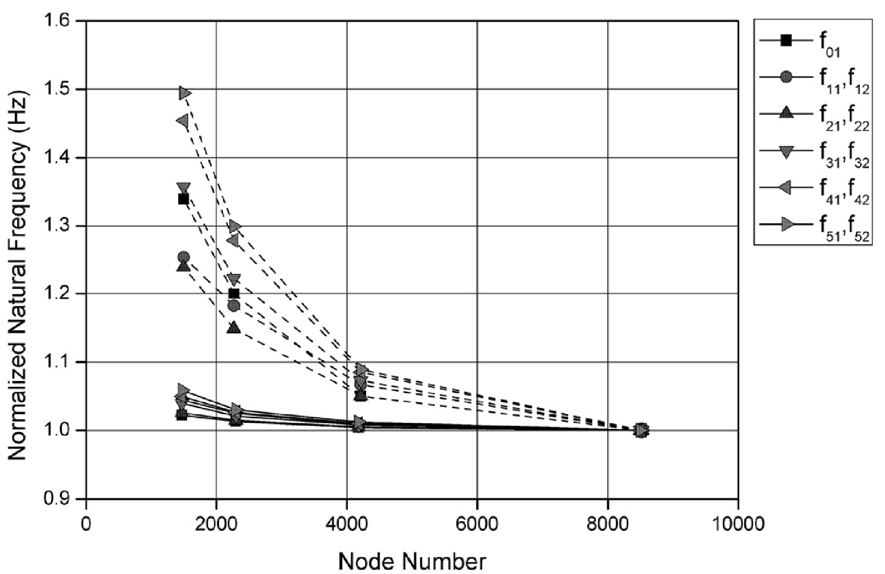
Figure 22 Mesh sensitivity analysis of a model Francis runner [49]. Dashed lines represent results obtained with tetrahedral mesh; continuous lines represent results obtained with hexahedral mesh.
The majority of the studies have been performed with a tetrahedral mesh, but, as it is well known, a tetrahedral mesh requires more computational power and simulation time than a hexahedral mesh [85]. However, no significant discrepancy was reported between the results using a tetrahedral and hexahedral mesh after the mesh sensitivity analysis [118, 119]. Numerical simulations of the added mass effect were verified with the natural frequency value. The mesh sensitivity to other parameters such as mode shape, Young’s modulus, nodal diameter/circle, nodal point, and structure deflection at the critical areas, and the effect of mesh density on fillet radius at the T-junction, should be tested. Detailed verification of the selected mesh density and type would enhance trust in the numerical results [51]. The most sensitive parameter should be considered for the verification. For example, proper resolution of the radial profile at the fillet radius is necessary to obtain better results concerning stress concentrations [10, 101]. This validation can be achieved by increasing the number of mesh points along the radial length. Another important parameter is the quality of the selected mesh elements and node spacing in the direction normal to the fluid-structure interface. Low-quality meshes often underestimate the stress value and can lead to poor design. So far, simulations have been conducted under steady conditions, but the effects might be different under unsteady conditions [120]. The time step size significantly affects the results [39, 121]. A large time step size can produce erroneous results, but a very small time step size is computationally expensive.
Numerical analysis is ideally performed using boundary conditions obtained from experiments [122]. The experimental results, however, include uncertainties, both systematic and random, that arise from the measuring instruments and experimental conditions. The final numerical results include uncertainties involved in experiments [123, 124], errors related to mesh convergence in flow field analysis, numerical errors in structural mesh convergence, uncertainty in the measurements of vibrations and strain, and errors in structural analysis. For example, to perform a stress analysis on the runner, the required pressure forces are obtained from a CFD analysis. Pressure loading on the runner blades under different operating conditions is extracted and applied to perform the structural analysis [125]. Errors in the pressure amplitude range between 5% and 40% [34, 41, 126, 127], and this adds to the complexity of the structural analysis. Detailed analysis and explanation of the errors would, therefore, provide relevant information about the studies conducted. An appropriate safety factor should also be considered in the final design and/or transition to prototype [99].
One of the main challenges in numerical investigations is the requirement of computational power [128]. To obtain better spatial and temporal discretization, a fine mesh and small time step size are necessary, which increases the cost. As discussed in section 3.1 on natural frequency, two-way coupled simulations require substantial computational resources and time [129]. One may not be able to afford such resources. Figure 23 shows the computational power and effort required to conduct a numerical study using available techniques. Moving away from the origin, the computational cost and model preparation time increase by orders of magnitude [48]. Hydropower industries are tending increasingly towards virtual testing, including comprehensive multi-disciplinary optimization of the turbine components [110]. This effort requires a thorough understanding of the underlying coupled physics to choose the appropriate modeling and solution technique. The goal of future simulation-based engineering is to develop well-suited solution procedures for all essential combinations of turbine modeling approaches [61]. Experiments may be conducted for model validation. This inter-dependence of simulation and experiment enhances the need for carefully performed measurements at the laboratory and prototype scales with detailed error analysis. Further, in order to optimize the numerical modeling approach, it is important to parametrize: (1) when one-way or two-way coupling is needed, (2) when steady/quasi-steady/unsteady simulation is needed, (3) when dynamic mesh simulation with entire turbine is needed and (4) which operating conditions should be investigated first so those can be considered as representative for the other stable conditions.
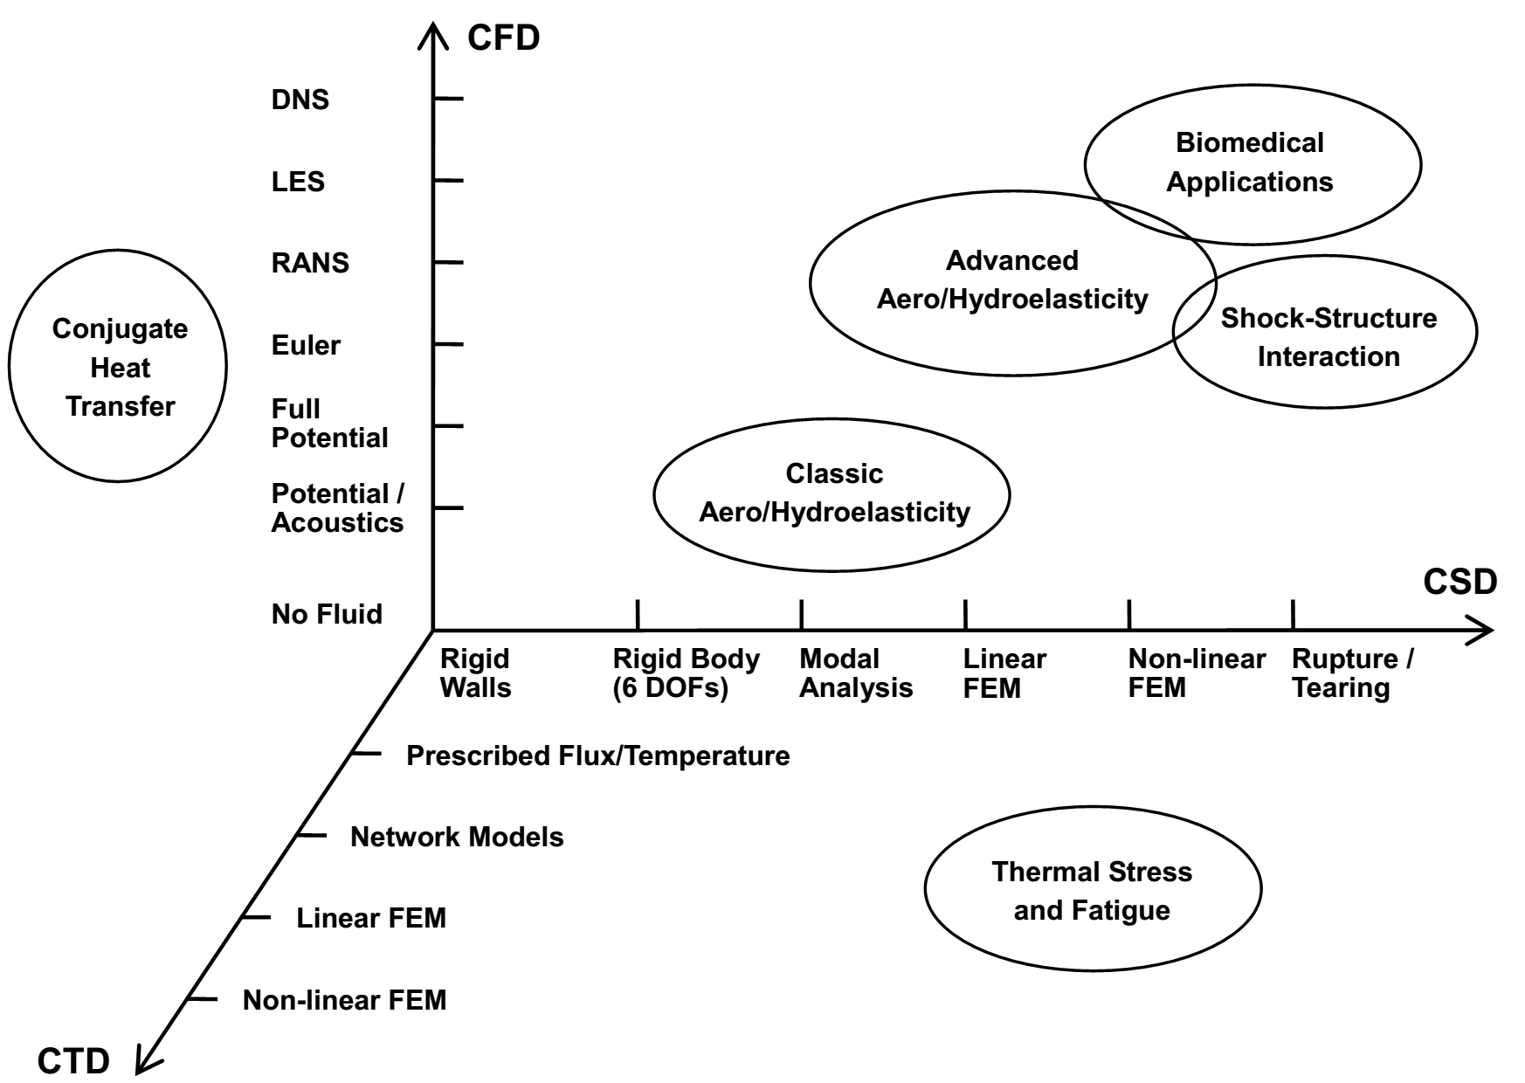
Figure 23 Space of coupled field approximations [48]. CFD = computational fluid dynamics, CSD = computational structural dynamics, FEM = finite element method, DOF = degree of freedom, and CTD = computational thermal dynamics.

Transposition to prototype
Although the model-test is suitable to understand the machine behavior at every loading condition from a hydraulic point of view, fluid structure interaction is not fully understood and its structural response is not scalable to the prototype. It is difficult to estimate the accurate values of sound speed, added mass for different operating conditions and hydro acoustic properties. Such parameters can only be checked on the prototype turbines. There are few parameters such as flow velocity at different location of the runner, coupled response of the runner, resonant frequency of the complete runner assembly including thrust bearing and generator rotor, which can be estimated for the prototype conditions [105]. Furthermore, the structural mechanical response can hardly be evaluated on the model scale because the model runners are manufactured using bronze, while the prototype runners are typically manufactured using stainless steel in 12–17% Cr martensitic-austenitic or martensitic-ferritic-austenitic grades. Stainless steel 16Cr-5Ni is frequently used for both blade plates and ring/crown castings in welded constructions [10]. The response of the components under water, such as the stay vanes and runner, is particularly important because the flow will induce vibrations in those components, which can be critical if adequate measures are not applied.
Studies conducted on the model and prototype runner suggest that some of the parameters could be used to understand the prototype behavior under different conditions. For example, the number of nodal diameters and mode shapes in a prototype runner were similar to those observed with the model runner. Another important parameter is the hydrodynamic damping. Studies have shown a high damping effect at the best efficiency point compared to the off-design conditions. The relationship between hydrodynamic damping and flow velocity in the prototype and the model runners should be established for better scaling.

Prospective fluid-structure analysis within hydropower
Significant growth in the application of fluid-structure analysis has occurred over the last five years. Numerical techniques have played an important role in the improvement of the turbine runner design. Efforts are currently being made towards the safe and reliable design of the turbines that will accommodate the present need for flexible electricity without affecting runner life.
Most of the studies have focused on the investigation of frequency reduction ratio based on modal analysis. However, analysis of the mode shapes, the transition between them, and the nodal points would provide precise information about runner deformation. Further, the actual runner is surrounded by surfaces of different materials, necessitating studies of the simple structures. The measurements have shown that the added mass effect changes with the proximity of the reflecting surfaces to the runner. Analysis of labyrinth seals, pressure wave propagation and reflection are important to simulate prototype conditions correctly.
A study of the hydrofoil has shown that the damping effect increases with flow velocity in a hydraulic turbine, specifically mid-head to high-head turbines; the flow velocity in the runner is as high as 40 m s⁻¹. Damping can play a crucial role in reducing vibration amplitudes under resonance conditions. No detailed study on hydrodynamic damping under resonance condition has been reported. Hübner et al. [79] have suggested that the flow induced damping effects at a Francis runner exhibit a strong dependency on operating condition and mode shape. Practical efforts to characterize hydrodynamic damping raise many open questions: (1) How effective is the damping when a turbine operates at BEP, off-design, runaway and SNL conditions? (2) What is the difference between damping estimated on an isolated one-blade structure to the complete runner? (3) Runner blades mainly experience bending and torsional mode shapes; can damping be improved for these two mode shapes, if not for all mode shapes?
Studies on the added mass effect suggest that the larger deformation of the runner crown is associated with high-amplitude vibration at the blade trailing edge. The vibrations are associated with the blade flutter mechanism. No investigation of blade flutter has been reported, particularly in the hydraulic turbines. In essence, recently developed numerical techniques are now able to estimate blade flutter in incompressible turbomachines. The literature suggests a new approach to decrease flutter effects in the turbine, viz. by controlling mode shape rather than reducing the frequency by exciting a certain mode shape. This new design approach can be implemented by the use of the stability parameter and application of the superposition techniques as suggested for compressible turbomachines [130]. The blade flutter is dependent on the mode shape, frequency, and flow conditions. Among those, the mode shape is the most important parameter influencing blade flutter. Detailed investigation on mode shapes and their transition may provide information to characterize blade flutter in the runner.
Extensive studies on the fatigue analysis have been conducted, but the studies have mainly focused on steady-state operating conditions. Recently, strain gauge measurements and pressure measurements on hydraulic turbines [59] revealed that transient conditions cause significant damage to the runner blades. Prospective analysis should also be focused on the transient conditions such as SNL, start-stop, and total load rejection. Such analysis is extremely difficult and expensive numerically, as mesh deformation is involved. A critical challenge is to maintain good mesh quality during the entire simulation.
There are some important efforts underway to explore the possibility of prototype transpositions. Useful results were presented by Huang et al. [40] and Coutu et al. [109], who have compared the performance of different types of runner for different operating conditions [50]. Rodriguez et al. have investigated the added mass effect along with the frequency reduction ratio that may be used as an initial guess for the other prototypes operating at a similar specific speed [38, 53].

Summary
The objective of this paper is to review the studies conducted on fluid-structure interaction in the Francis turbines and to highlight the gaps for potential design improvements. Key challenges in obtaining reliable information of the critical parameters, flow induced excitation, added mass effect, hydrodynamic damping, blade flutter, and fatigue loading are discussed. The review began with the fundamental challenge, resonance frequency, because the forced excitation and the runner natural frequencies are of the same order. In the case of mid- to high-head turbines, the effect of forced excitation is significant compared to those for low-head turbines [131]. Amplitudes pertaining to the forced excitation were studied for different runner types and operating conditions. The main concern was the reliable prediction of the amplitudes. Available numerical techniques can estimate the amplitudes accurately, but the amplitudes are very sensitive to the selected numerical model, mesh nodes within boundary layer and turbulence modeling. The reported difference between the experimental and numerical values is up to 40%. Under such conditions, certain assumptions are made during the design phase, but these may sometimes result in the inaccurate design of the blades. It is still not known how safe the assumptions are to estimate the rotor-stator interaction in prototypes.
Investigations of the added mass have shown that the natural frequency reduction in the runner may be up to 60% in water. However, these studies did not take into account the effect of flowing water, cavitation, and reflection of the pressure waves from the nearby surfaces. Experimental studies on a hydrofoil indicated that the added mass effect is approximately 10-15% higher in still water than in flowing water. The added mass effect is dependent on the mode shape, and it is at a maximum when the runner band and/or crown undergo relative deformation. Currently, turbines are designed by considering the added mass effect in still water with a certain safety factor. However, the validity of such computation is unknown regarding the prototype implementation and the combined response of the runner assembly. There is still a need for fundamental research to understand the importance of the different parameters affecting the runner natural frequency.
Within hydro turbine research, blade flutter is a rarely studied topic despite being critical for blade design. Experiments conducted on a hydrofoil section suggest that fluttering could significantly alter the flow conditions when amplitudes are critical, specifically during cavitation. Newly developed techniques may provide improved results in some cases [48, 132]. The techniques can model blade flutter [83] and instantaneous blade deformation with respect to changes in dynamic pressure on the blades [129], and they facilitate simplified modeling (blade passage) of the runner without losing the amplitude of forced excitation [132].
Similar to blade flutter, hydrodynamic damping is a rarely studied research topic. A preliminary study on a hydrofoil, with material properties identical to the prototype runner, suggested that hydrodynamic damping can play an important role in reducing vibration amplitudes under resonance conditions if the flow velocity is sufficiently high. A nearly linear relation between flow velocity and the damping ratio was observed from the measurements. However, damping under cavitation and other prototype conditions was not investigated in detail. The dependence of hydrodynamic damping on the mode shape is another subject to be investigated. Depending on the difference between the forming frequency and the resonance frequency, a significant influence of damping effects may be decisive. What would be an acceptable level of vibration amplitudes during the resonance [84, 133]? What is a reliable and affordable numerical technique to estimate the hydrodynamic damping at resonant frequency [97]?
A review of fatigue analysis has shown that the principal stresses are concentrated at T-junctions on the blade leading and trailing edges. Dynamic stresses are the main cause for the development of fatigue crack in the runner. There are several techniques for fatigue analysis, but these are insufficient, as they do not provide reliable predictions. The best example is the catastrophic failure of a high-head Francis runner (SM-3, unit-1, Hydro-Quebec) within a few days of commissioning. Such incidents pose technical challenges to engineers who provide the basic design tools, forcing them back to drawing board. These setbacks, in turn, should alert those at the forefront of research and development to be thorough in the quest to understand the physical aspects of turbine technology. Such incidents also suggest a lack of adequate design tools, but they also point to another fact: in the quest for improved efficiency and higher thrust-to-weight ratio, higher blade loading, higher power, wider operating range, and reduced vaneless gaps, the boundaries of the engineering structures are being extended.
What are the ways for optimum numerical modeling in a hydraulic turbine, and what is the validity of the results regarding prototype transposition? The application of numerical techniques increases dramatically to investigate the problems related to fluid-structure interaction. The techniques are becoming increasingly expensive in terms of both cost and time. The least expensive numerical techniques predict results with the almost same order of accuracy as the expensive techniques. One might ask what the advantage is of using expensive techniques to investigate hydraulic turbines.
Overall, numerous studies have been conducted by many researchers to bring the fundamentals into practical design. The clear indication is that there is a tremendous need for the detailed study of fluid-structure interactions. It would be inaccurate to state that the aforementioned research efforts have all matured to the point that they have been successfully adopted into design systems. Even at the current point, caution is exercised before decisions are made based on new findings. Although there are a variety of reasons for this situation, the principal one, in the authors’ opinion, is that there has been a lack of sustained research and development funding in this area. For example, we have yet to propose a set of reliable design guidelines to improve the fatigue life of blades.
References
[1] Sawin JL, Sverrisson F, Rickerson W. Renewables 2015 global status report. In: Mastny L, editor. REN21 Secretariat, Paris, France: Renewable Energy Policy Network for 21st Century; 2015. p. 251.
[2] Daugherty RL. Hydraulic turbines: With a chapter on centrifugal pumps. First ed. New York: McGraw-Hill book Company, Incorporated; 1920.
[3] Deschênes C, Fraser R, Fau J-P. New trends in turbine modelling and new ways of partnership. IGHEM Toronto, Canada, 2002: 1-12.
[4] Trivedi C, Gandhi B, Cervantes M. Effect of transients on Francis turbine runner life: A review. J Hydraul Res. 2013;51:121-32. doi:10.1080/00221686.2012.732971.
[5] Dorji U, Ghomashchi R. Hydro turbine failure mechanisms: An overview. Eng Fail Anal. 2014;44:136-47. doi:10.1016/j.engfailanal.2014.04.013.
[6] Keck H, Weiss T, Michler W, Sick M. Recent developments in the dynamic analysis of water turbines. Proceedings of the Institution of Mechanical Engineers, Part A: Journal of Power and Energy. 2009;223:415-27. doi:10.1243/09576509JPE578.
[7] Magnoli MV. Numerical simulation of pressure oscillations in large Francis turbines at partial and full load operating conditions and their effects on the runner structural behaviour and fatigue life [Ph. D.]: Technische Universitat Munchen; 2014.
[8] Seidel U, Hübner B, Löfflad J, Faigle P. Evaluation of RSI-induced stresses in Francis runners. IOP Conference Series: Earth and Environmental Science, 26th IAHR Symposiumon Hydraulic Machineryand Systems, IOP Publishing, 2012: 052010.doi:10.1088/1755-1315/15/5/052010.
[9] Xiao R, Wang Z, Luo Y. Dynamic stresses in a Francis turbine runner based on fluid-structure interaction analysis. Tsinghua Science & Technology. 2008;13:587-92.
[10] Huth H-J. Fatigue design of hydraulic turbine runners [Ph. D.]. Trondheim: Norwegian University of Science and Technology (NTNU); 2005.
[11] Seidel U, Mende C, Hübner B, Weber W, Otto A. Dynamic loads in Francis runners and their impact on fatigue life. IOP Conference Series: Earth and Environmental Science, Montreal, Canada, 2014: 9.doi:10.1088/1755-1315/22/3/032054.
[12] Thibault D, Gagnon M, Godin S. Bridging the gap between metallurgy and fatigue reliability of hydraulic turbine runners. IOP Conference Series: Earth and Environmental Science, 2014: 012019.doi:10.1088/1755-1315/22/1/012019.
[13] Keck H, Sick M. Thirty years of numerical flow simulation in hydraulic turbomachines. Acta Mech. 2008;201:211-29. doi:10.1007/s00707-008-0060-4.
[14] Bergmann-Paulsen J. FSI-analysis of a Francis turbine. Trondheim: Norwegian University of Science and Technology; 2012.
[15] Roth S, Hasmatuchi V, Botero F, Farhat M, Avellan F. Fluid-structure coupling in the guide vanes cascade of a pump-turbine scale model. IOP Conference Series: Earth and Environmental Science, IOP Publishing, 2010: 012074.doi:10.1088/1755-1315/12/1/012074.
[16] Sarpkaya T. A critical review of the intrinsic nature of vortex-induced vibrations. J Fluid Struct. 2004;19:389-447. doi:10.1016/j.jfluidstructs.2004.02.005.
[17] Egusquiza E, Valero C, Liang Q, Coussirat M, Seidel U. Fluid added mass effect in the modal response of a pump-turbine impeller. Proceedings of the ASME 2009 International Design Engineering Technical Conference & Computers and Information in Enginneering Conference IDETC/CIE 2009, San Diego, California, USA, 2009: 715-24.doi:10.1115/DETC2009-86830.
[18] Trudel A, Sabourin M. Metallurgical and fatigue assessments of welds in cast welded hydraulic turbine runners. IOP Conference Series: Earth and Environmental Science, 2014: 012015.doi:10.1088/1755-1315/22/1/012015.
[19] Zhou LJ, Wang ZW, Xiao RF, Luo YY. Analysis of dynamic stresses in Kaplan turbine blades. Engineering Computations. 2007;24:753-62. doi:10.1108/02644400710833288.
[20] Gagnon M, Tahan SA, Bocher P, Thibault D. The role of high cycle fatigue (HCF) onset in Francis runner reliability. IOP Conference Series: Earth and Environmental Science, 2012: 022005.doi:10.1088/1755-1315/15/2/022005.
[21] Coutu A, Proulx D, Coulson S, Demers A. Dynamic assesment of hydraulic turbines-high head Francis. Hydrovision 2004, Montreal, Canada, 2004: 13.
[22] Coutu A, Roy MD, Monette C, Nennemann B. Experience with rotor-stator interactions in high head Francis runner. Proceedings of 24th IAHR symposium on hydraulic machinery and systems, Foz do Iguassu, Brazil, 2008: 10.
[23] Egusquiza E, Valero C, Huang XX, Jou E, Guardo A, Rodriguez C. Failure investigation of a large pump-turbine runner. Eng Fail Anal. 2012;23:27-34. doi:10.1016/j.engfailanal.2012.01.012.
[24] Frunzǎverde D, Muntean S, Mǎrginean G, Campian V, Marşavina L, Terzi R, et al. Failure analysis of a Francis turbine runner. IOP Conference Series: Earth and Environmental Science, 25th IAHR Symposium on Hydraulic Machinery and Systems, IOP Publishing, 2010: 012115.doi:10.1088/1755-1315/12/1/012115.
[25] Nennemann B, Morissette JF, Chamberland-Lauzon J, Monette C, Braun O, Melot M, et al. Challenges in dynamic pressure and stress predictions at no-load operation in hydraulic turbines. 27th IAHR Symposium Hydraulic Machinery and systems, Montreal, Canada, 2014: 10.doi:10.1088/1755-1315/22/3/032055.
[26] Jonsson PP, Mulu BG, Cervantes MJ. Experimental investigation of a Kaplan draft tube – Part II: Off-design conditions. Applied Energy. 2012;94:71-83. doi:10.1016/j.apenergy.2012.01.032.
[27] Doerfler P, Ruchonnet N. A statistical method for draft tube pressure pulsation analysis. IOP Conference Series: Earth and Environmental Science, 26th IAHR Symposium on Hydraulic Machinery and Systems, IOP Publishing, 2012: 062002.doi:10.1088/1755-1315/15/6/062002.
[28] Susan-Resiga R, Câmpian V, Dumbravă C, Muntean ACS. In situ unsteady pressure measurements on the draft tube cone of the Francis turbine with air injection over an extended operating range. Calcutta Institute of Engineering and Management, Calcutta. 2013;25.
[29] Nicolet C, Zobeiri A, Maruzewski P, Avellan F. On the upper part load vortex rope in Francis turbine: Experimental investigation. IOP Conference Series: Earth and Environmental Science, 25th IAHR Symposium on Hydraulic Machinery and Systems, IOP Publishing, 2010: 012053.doi:10.1088/1755-1315/12/1/012053.
[30] Dörfler P, Sick M, Coutu A. Flow-induced pulsation and vibration in hydroelectric machinery. First ed. London: Springer-Verlag; 2013.
[31] Ausoni P, Farhat M, Escaler X, Egusquiza E, Avellan F. Cavitation influence on von kármán vortex shedding and induced hydrofoil vibrations. J Fluid Eng-T Asme. 2007;129:966-73. doi:10.1115/1.2746907.
[32] Zobeiri A, Ausoni P, Avellan F, Farhat M. How oblique trailing edge of a hydrofoil reduces the vortex-induced vibration. J Fluid Struct. 2012;32:78-89. doi:10.1016/j.jfluidstructs.2011.12.003.
[33] Ohashi H. Case Study of Pump Failure Due to Rotor-Stator Interaction. International Journal of Rotating Machinery. 1994;1:53-60. doi:10.1155/S1023621X94000059.
[34] Trivedi C, Cervantes M, Gandhi B, Dahlhaug OG. Experimental and numerical studies for a high head Francis turbine at several operating points. J Fluid Eng-T Asme. 2013;135:1111021-17. doi:10.1115/1.4024805.
[35] Zobeiri A. Investigations of time dependent flow phenomena in a turbine and a pump-turbine of Francis type: Rotor-stator interactions and precessing vortex rope [Ph. D.]. Lausanne: École Polytechnique Fédérale de Lausanne; 2009.
[36] Nicolet C, Ruchonnet N, Alligné S, Koutnik J, Avellan F. Hydroacoustic simulation of rotor-stator interaction in resonance conditions in Francis pump-turbine. IOP Conference Series: Earth and Environmental Science, 25th IAHR Symposium on Hydraulic Machinery and Systems, IOP Publishing, 2010: 012005.doi:10.1088/1755-1315/12/1/012005.
[37] Zobeiri A, Kueny J-L, Farhat M, Avellan F. Pump-turbine rotor-stator interactions in generating mode: Pressure fluctuation in distributor channel. 23rd IAHR Symp, Yokohama, Japan, 2006: 10.
[38] Rodriguez CG, Egusquiza E, Santos IF. Frequencies in the vibration induced by the rotor stator interaction in a centrifugal pump turbine. J Fluid Eng-T Asme. 2007;129:1428-35. doi:10.1115/1.2786489.
[39] Hasmatuchi V. Hydrodynamics of a pump-turbine operating at off-design conditions in generating mode [Ph. D.]. Lausanne: École polytechnique fédérale de Lausanne; 2012.
[40] Huang X, Chamberland-Lauzon J, Oram C, Klopfer A, Ruchonnet N. Fatigue analyses of the prototype Francis runners based on site measurements and simulations. 27th IAHR Symposium Hydraulic Machinery and systems, Montreal, Canada, 2014: 8.doi:10.1088/1755-1315/22/1/012014.
[41] Jošt D, Škerlavaj A, Morgut M, Mežnar P, Nobile E. Numerical simulation of flow in a high head Francis turbine with prediction of efficiency, rotor stator interaction and vortex structures in the draft tube. Journal of Physics: Conference Series. 2015;579:012006. doi:10.1088/1742-6596/579/1/012006.
[42] Roache PJ. Quantification of uncertainty in computational fluid dynamics. Annu Rev Fluid Mech. 1997;29:123-60. doi:10.1146/annurev.fluid.29.1.123.
[43] Roache PJ. Perspective: Validation—what does it mean? J Fluid Eng-T Asme. 2009;131:034503. doi:10.1115/1.3077134.
[44] Celik IB, Ghia U, Roache PJ, Freitas CJ. Procedure for estimation and reporting of uncertainty due to discretization in CFD applications. J Fluid Eng-T Asme. 2008;130:4. doi:10.1115/1.2960953.
[45] Stern F, Wilson R, Shao J. Quantitative V&V of CFD simulations and certification of CFD codes. International journal for numerical methods in fluids. 2006;50:1335-55. doi:10.1002/fld.1090.
[46] Leonard A, Roshko A. Aspects of flow-induced vibration. J Fluid Struct. 2001;15:415-25. doi:10.1006/jfls.2000.0360.
[47] Williamson CHK, Govardhan R. A brief review of recent results in vortex-induced vibrations. Journal of Wind Engineering and Industrial Aerodynamics. 2008;96:713-35. doi:10.1016/j.jweia.2007.06.019.
[48] Hübner B, Seidel U, Roth S. Application of fluid-structure coupling to predict the dynamic behavior of turbine components. IOP Conference Series: Earth and Environmental Science, 25th IAHR Symposium on Hydraulic Machinery and Systems, IOP Publishing, 2010: 012009.doi:10.1088/1755-1315/12/1/012009.
[49] Liang QW, Rodriguez CG, Egusquiza E, Escaler X, Farhat M, Avellan F. Numerical simulation of fluid added mass effect on a Francis turbine runner. Comput Fluids. 2007;36:1106-18. doi:10.1016/j.compfluid.2006.08.007.
[50] Lais S, Liang Q, Henggeler U, Weiss T, Escaler X, Egusquiza E. Dynamic analysis of Francis runners- experiment and numerical simulation. International Journal of Fluid Machinery and Systems. 2009;2:303-14. doi:10.5293/IJFMS.2009.2.4.303.
[51] Valero C, Huang X, Egusquiza E, Farhat M, Avellan F. Modal behavior of a reduced scale pump turbine impeller. Part 2: Numerical simulation. IOP Conference Series: Earth and Environmental Science, 2010: 012117.doi:10.1088/1755-1315/12/1/012117.
[52] Flores M, Urquiza G, Rodríguez JM. A fatigue analysis of a hydraulic Francis turbine runner. World Journal of Mechanics. 2012;02:28-34. doi:10.4236/wjm.2012.21004.
[53] Rodriguez CG, Egusquiza E, Escaler X, Liang QW, Avellan F. Experimental investigation of added mass effects on a Francis turbine runner in still water. J Fluid Struct. 2006;22:699-712. doi:10.1016/j.jfluidstructs.2006.04.001.
[54] Escaler X, Hütter JK, Egusquiza E, Farhat M, Avellan F. Modal behavior of a reduced scale pump-turbine impeller. Part 1: Experiments. IOP Conference Series: Earth and Environmental Science, 2010: 012116.doi:10.1088/1755-1315/12/1/012116.
[55] Coutu A, Seeley C, Monette C, Nennemann B, Marmont H. Damping measurements in flowing water. IOP Conference Series: Earth and Environmental Science, 2012: 062060.doi:10.1088/1755-1315/15/6/062060.
[56] Jeffers TR, Kielb JJ, Abhari RS. A novel technique for the measurement of blade damping using piezoelectric actuators. ASME Turbo Expo 2000: Power for Land, Sea, and Air, Munich, Germany, 2000: 11.doi:10.1115/2000-GT-0359.
[57] Wilkie WK, Inman DJ, Lloyd JM, High JW. Anisotropic laminar piezocomposite actuator incorporating machined pmn–pt single-crystal fibers. Journal of Intelligent Material Systems and Structures. 2006;17:15-28. doi:10.1177/1045389X06055891.
[58] He LY, He Y, Luo YY, Wang ZW. Investigation on fluid added mass effect in the modal response of a pump-turbine runner. Iop Conf Ser-Mat Sci, 2013: 022038.doi:10.1088/1757-899x/52/2/022038.
[59] Huang X, Oram C, Sick M. Static and dynamic stress analyses of the prototype high head Francis runner based on site measurement. 27th IAHR Symposium Hydraulic Machinery and systems, Montreal, Canada, 2014: 10.doi:10.1088/1755-1315/22/3/032052.
[60] Schmucker H, Flemming F, Coulson S. Two-way coupled fluid structure interaction simulation of a propeller turbine. IOP Conference Series: Earth and Environmental Science, IOP Publishing, 2010: 012011.doi:10.5293/IJFMS.2010.3.4.342.
[61] Dompierre F, Sabourin M. Determination of turbine runner dynamic behaviour under operating condition by a two-way staggered fluid-structureinteraction method. IOP Conference Series: Earth and Environmental Science, 25th IAHR Symposium on Hydraulic Machinery and Systems, IOP Publishing, 2010: 012085.doi:10.1088/1755-1315/12/1/012085.
[62] Benra F-K, Dohmen HJ, Pei J, Schuster S, Wan B. A comparison of one-way and two-way coupling methods for numerical analysis of fluid-structure interactions. Journal of applied mathematics. 2011;2011. doi:10.1155/2011/853560.
[63] Chitrakar S, Cervantes M, Thapa BS. Fully coupled FSI analysis of Francis turbines exposed to sediment erosion. International Journal of Fluid Machinery and Systems. 2014;7:101-9. doi:10.5293/IJFMS.2014.7.3.101.
[64] Liaghat T. Two-way fluid-structure coupling in vibration and damping analysis of an oscillating hydrofoil [Master]. Canada: École Polytechnique de Montréal; 2014.
[65] Presas A, Valentín D, Egusquiza E, Valero C, Seidel U. Experimental analysis of the dynamic behavior of a rotating disk submerged in water. IOP Conference Series: Earth and Environmental Science, Montreal, Canada, 2014: 8.doi:10.1088/1755-1315/22/3/032043.
[66] Presas A, Valentin D, Egusquiza E, Valero C, Seidel U. Influence of the rotation on the natural frequencies of a submerged-confined disk in water. J Sound Vib. 2015;337:161-80. doi:10.1016/j.jsv.2014.10.032.
[67] Torre ODL, Escaler X, Egusquiza E, Farhat M. Experimental investigation of added mass effects on a hydrofoil under cavitation conditions. J Fluid Struct. 2013;39:173-87. doi:10.1016/j.jfluidstructs.2013.01.008.
[68] Jeong K-H. Free vibration of two identical circular plates coupled with bounded fluid. J Sound Vib. 2003;260:653-70. doi:10.1016/S0022-460X(02)01012-X.
[69] Jeong K-H, Yoo G-H, Lee S-C. Hydroelastic vibration of two identical rectangular plates. J Sound Vib. 2004;272:539-55. doi:10.1016/S0022-460X(03)00383-3.
[70] Jeong K-H, Kim K-J. Hydroelastic vibration of a circular plate submerged in a bounded compressible fluid. J Sound Vib. 2005;283:153-72. doi:10.1016/j.jsv.2004.04.029.
[71] Huang XX, Egusquiza E, Valero C, Presas A. Dynamic behaviour of pump-turbine runner: From disk to prototype runner. Iop Conf Ser-Mat Sci, 2013: 022036.doi:10.1088/1757-899x/52/2/022036.
[72] Guillaume R, Deniau J, Scolaro D, Colombet C. Influence of the rotor-stator interaction on the dynamic stresses of Francis runners. IOP Conference Series: Earth and Environmental Science, 26th IAHR Symposiumon Hydraulic Machinery and Systems, IOP Publishing, 2012: 052011.doi:10.1088/1755-1315/15/5/052011.
[73] Askari E, Jeong K-H, Amabili M. Hydroelastic vibration of circular plates immersed in a liquid-filled container with free surface. J Sound Vib. 2013;332:3064-85. doi:10.1016/j.jsv.2013.01.007.
[74] Rodriguez CG, Flores P, Pierart FG, Contzen LR, Egusquiza E. Capability of structural–acoustical FSI numerical model to predict natural frequencies of submerged structures with nearby rigid surfaces. Comput Fluids. 2012;64:117-26. doi:10.1016/j.compfluid.2012.05.011.
[75] Valentín D, Presas A, Egusquiza E, Valero C. Influence of the added mass effect and boundary conditions on the dynamic response of submerged and confined structures. 27th IAHR Symposium Hydraulic Machinery and systems, Montreal, Canada, 2014: 10.doi:10.1088/1755-1315/22/3/03204.
[76] Chen SS, Wambsganss MW, Jendrzejczyk JA. Added Mass and Damping of a Vibrating Rod in Confined Viscous Fluids. Journal of Applied Mechanics. 1976;43:325-9. doi:10.1115/1.3423833.
[77] Presas A, Valentin D, Egusquiza E, Valero C, Seidel U. On the detection of natural frequencies and mode shapes of submerged rotating disk-like structures from the casing. Mechanical Systems and Signal Processing. 2015;60-61:547-70. doi:10.1016/j.ymssp.2015.01.013.
[78] Presas A, Valentin D, Egusquiza E, Valero C, Seidel U, Weber W. Natural frequencies of rotating disk-like structures submerged viewed from the stationary frame. 28th IAHR Symposium on Hydraulic Machinery and Systems, Grenoble, France, IAHR, 2016.
[79] Hübner B, Weber W, Seidel U. The role of fluid-structure interaction for safety and life time prediction in hydraulic machinery. 28th IAHR Symposium on Hydraulic Machinery and System, Grenoble, France, IAHR, 2016.
[80] Waite JJ, Kielb RE. Physical understanding and sensitivities of low pressure turbine flutter. Journal of Engineering for Gas Turbines and Power. 2014;137:012502-. doi:10.1115/1.4028207.
[81] Srinivasan AV. Flutter and resonant vibration characteristics of engine blades. Journal of Engineering for Gas Turbines and Power. 1997;119:742-75. doi:10.1115/1.2817053.
[82] Nowinski M, Panovsky J. Flutter mechanisms in low pressure turbine blades. ASME 1998 International Gas Turbine and Aeroengine Congress and Exhibition, Stockholm, Sweden, American Society of Mechanical Engineers, 1998: 8.doi:10.1115/98-GT-573.
[83] Mare L, Imregun M, Green JS, Sayma AI. A numerical study of labyrinth seal flutter. Journal of Tribology. 2010;132:022201-. doi:10.1115/1.3204774.
[84] Seeley C, Coutu A, Monette C, Nennemann B, Marmont H. Characterization of hydrofoil damping due to fluid–structure interaction using piezocomposite actuators. Smart Materials and Structures. 2012;21:035027. doi:10.1088/0964-1726/21/3/035027.
[85] ANSYS. Ansys 17.0 release documentation, theory and modelling guide. ANSYS Inc.,Southpointe, 2600 ANSYS Drive, Canonsburg, PA 15317, USA; 2016. p. 2500.
[86] Vasanthakumar P. Computation of aerodynamic damping for flutter analysis of a transonic fan. ASME 2011 Turbo Expo: Turbine Technical Conference and Exposition, American Society of Mechanical Engineers, 2011: 1429-37.doi:10.1115/GT2011-46597.
[87] Erdos JI, Alzner E, Mcnally W. Numerical-solution of periodic transonic flow through a fan stage. Aiaa J. 1977;15:1559-68. doi:10.2514/3.60823.
[88] He L. Method of simulating unsteady turbomachinery flows with multiple perturbations. Aiaa J. 1992;30:2730-5. doi:10.2514/3.11291.
[89] Biesinger T, Cornelius C, Rube C, Braune A, Campregher R, Godin PG, et al. Unsteady CFD methods in a commercial solver for turbomachinery applications. ASME Turbo Expo 2010: Power for Land, Sea, and Air, Glasgow, UK, American Society of Mechanical Engineers, 2010: 2441-52.
[90] He L. Fourier methods for turbomachinery applications. Prog Aerosp Sci. 2010;46:329-41. doi:10.1016/j.paerosci.2010.04.001.
[91] Blumenthal R, Hutchinson B, Zori L. Investigation of transient CFD methods applied to a transonic compressor stage. ASME Turbo Expo 2011: Turbine Technical Conference and Exposition, Vancouver, British Columbia, Canada, American Society of Mechanical Engineers, 2011: 1423-30.
[92] Connell S, Braaten M, Zori L, Steed R, Hutchinson B, Cox G. A comparison of advanced numerical techniques to model transient flow in turbomachinery blade rows. ASME Turbo Expo 2011: Turbine Technical Conference and Exposition, Vancouver, British Columbia, Canada, American Society of Mechanical Engineers, 2011: 1241-50.
[93] Connel S, Hutchinson B, Galpin P, Campregher R, Godin P. The efficient computation of transient flow in turbine blade rows using transformation methods. Proceedings of ASME Turbo Expo 2012 GT 2012, Copenhagen, Denmark, ASME, 2012: 1-10.doi:10.1115/GT2012-69019.
[94] Qizar MA, Mansour ML, Goswami S. Study of steady state and transient blade row CFD methods in a moderately loaded nasa transonic high-speed axial compressor stage. ASME Turbo Expo 2013: Turbine Technical Conference and Exposition, San Antonio, Texas, USA, American Society of Mechanical Engineers, 2013: 9.
[95] Vandiver JK. Damping parameters for flow-induced vibration. J Fluid Struct. 2012;35:105-19. doi:10.1016/j.jfluidstructs.2012.07.002.
[96] Gauthier J, Giroux A, Etienne S, Gosselin F. CFD evaluation of added damping due to fluid flow over a hydroelectric turbine blade. 28th IAHR Symposium on Hydraulic Machinery and Systems, Grenoble, France, IAHR, 2016.
[97] Monette C, Nennemann B, Seeley C, Coutu A, Marmont H. Hydro-dynamic damping theory in flowing water. IOP Conf Series: Earth and Environmental Science, IOP Publishing, 2014: 32044-53.doi:10.1088/1755-1315/22/3/032044.
[98] Saeed RA, Galybin AN, Popov V. Modelling of flow-induced stresses in a Francis turbine runner. Advances in Engineering Software. 2010;41:1245-55. doi:10.1016/j.advengsoft.2010.09.001.
[99] Wang XF, Li HL, Zhu FW. The calculation of fluid-structure interaction and fatigue analysis for Francis turbine runner. IOP Conference Series: Earth and Environmental Science, 2012: 052014.doi:10.1088/1755-1315/15/5/052014.
[100] Saeed RA, Galybin AN, Popov V. 3D fluid–structure modelling and vibration analysis for fault diagnosis of Francis turbine using multiple ann and multiple anfis. Mechanical Systems and Signal Processing. 2013;34:259-76. doi:10.1016/j.ymssp.2012.08.004.
[101] Negru R, Muntean S, Marsavina L, Susan-Resiga R, Pasca N. Computation of stress distribution in a Francis turbine runner induced by fluid flow. Comp Mater Sci. 2012;64:253-9. doi:10.1016/j.commatsci.2012.05.073.
[102] Carpinteri A, Ronchei C, Scorza D, Vantadori S. Fracture mechanics based approach to fatigue analysis of welded joints. Eng Fail Anal. 2015;49:67-78. doi:10.1016/j.engfailanal.2014.12.021.
[103] Melot M, Monette C, Coutu A, Nenneman B. Speed-no-load operating condition: A new standard Francis runner design procedure to predict static stresses. Hydro 2013, Innsbruck, Austria, 2013: 8.
[104] Yang W, Norrlund P, Yang J. Analysis on regulation strategies for extending service life of hydropower turbines. 28th IAHR Symposium on Hydraulic Machinery and Systems, Grenoble, France, IAHR, 2016.
[105] Poll HG, Zanutto JC, Ponge-Ferreira W. Hydraulic power plant machine dynamic diagnosis. Shock and Vibration. 2006;13:409-27. doi:10.1155/2006/203834.
[106] Trivedi C, Cervantes M, Dahlhaug O, Gandhi B. Experimental investigation of a high head Francis turbine during spin-no-load operation. J Fluid Eng-T Asme. 2015;137:061106. doi:10.1115/1.4029729.
[107] Trivedi C, Gandhi B, Cervantes M, Dahlhaug O. Experimental investigations of a model Francis turbine during shutdown at synchronous speed. Renewable Energy. 2015;83:828-36. doi:10.1016/j.renene.2015.05.026.
[108] Trivedi C, Cervantes M, Gandhi B, Dahlhaug O. Experimental investigations of transient pressure variations in a high head model Francis turbine during start-up and shutdown. J Hydrodyn. 2014;26:277-90. doi:10.1016/S1001-6058(14)60031-7.
[109] Coutu A, Lauzon J, Monette C, Nennemann B, Huang X. Francis runner : Cost of operation, presentation. 5th IAHR International Workshop on Cavitation and Dynamic Problems in Hydraulic Machinery, Lausanne, Switzerland, 2013: 12.
[110] Lyutov A, Kryukov A, Cherny S, Chirkov D, Salienko A, Skorospelov V, et al. Modelling of a Francis Turbine Runner Fatigue Failure Process Caused by Fluid-Structure Interaction. 28th IAHR Symposium on Hydraulic Machinery and Systems, Grenoble, France, IAHR, 2016.
[111] Gagnon M, Nicolle J, Morissette J-F, Lawrence M. A look at Francis runner blades response during transients. 28th IAHR Symposium on Hydraulic Machinery and Systems, Grenoble, France, IAHR, 2016.
[112] Salajka V, Kanicky V, Kala J. Dynamic analysis of the Francis turbine runner for hydroelectric power plant burrendong. 3rd IAHR International Meeting of the Workgroup on Cavitation and Dynamic Problems in Hydraulic Machinery and Systems, Brno, Czech Republic, 2009: 271-80.
[113] Cervantes MJ, Trivedi C, Dahlhaug OG, Nielsen T. Francis-99 Workshop 1: steady operation of Francis turbines. Francis-99, Norwegian University of Science and Technology, Trondheim, Norway, Journal of Physics: Conference Series IOP Publishing, 2015: 011001.doi:10.1088/1742-6596/579/1/011001.
[114] Rebba R, Mahadevan S, Huang S. Validation and error estimation of computational models. Reliab Eng Syst Safe. 2006;91:1390-7. doi:10.1016/j.ress.2005.11.035.
[115] Trucano TG, Swiler LP, Igusa T, Oberkampf WL, Pilch M. Calibration, validation, and sensitivity analysis: What's what. Reliab Eng Syst Safe. 2006;91:1331-57. doi:10.1016/j.ress.2005.11.031.
[116] Trivedi C, Cervantes M. State of the art in numerical simulation of high head Francis turbines. Renew Energy Environ Sustain. 2016;1:5. doi:10.1051/rees/2016032.
[117] Ferziger JH, Perić M. Computational methods for fluid dynamics. Third ed. Berlin, Germany: Springer-Verlag Berlin Heidelberg; 2002.
[118] Trivedi C, Cervantes M, Dahlhaug OG. Experimental and Numerical Studies of a High-Head Francis Turbine: A Review of the Francis-99 Test Case. Energies. 2016;9:24. doi:10.3390/en9020074.
[119] Trivedi C, Cervantes MJ, Dahlhaug OG. Numerical techniques applied to hydraulic turbines: A perspective review. Applied Mechanics Reviews. 2016;68:29. doi:10.1115/1.4032681.
[120] Zouhar J, Obrovsky J, Feilhauer M, Skotak A. Case Study and Numerical Analysis of Vibration and Runner Cracks for the Lipno I Hydroelectric Project. 28th IAHR Symposium on Hydraulic Machinery and Systems, Grenoble, France, IAHR, 2016.
[121] Trivedi C, Cervantes MJ, Gandhi BK. Numerical investigation and validation of a Francis turbine at runaway operating conditions. Energies. 2016;9:22. doi:10.3390/en9030149.
[122] Valentín D, Ramos D, Bossio M, Presas A, Egusquiza E, Valero C. Influence of the boundary conditions on the natural frequencies of a Francis turbine. 28th IAHR Symposium on Hydraulic Machinery and Systems, Grenoble, France, IAHR, 2016.
[123] Lloyd G, Espanoles A. Best practice guidelines for marine applications of computational fluid dynamics2002.
[124] Casey M, Wintergerste T. Best practice guidelines-interest group on quality and trust in industrial CFD. First ed: ERCOFTAC; 2000.
[125] Nennemann B, Monette C, Chamberland-Lauzon J. Hydrodynamic damping and stiffness prediction in Francis turbine runners using CFD. 28th IAHR Symposium on Hydraulic Machinery and Systems, Grenoble, France, IAHR, 2016.
[126] Aakti B, Amstutz O, Casartelli E, Romanelli G, Mangani L. On the performance of a high head Francis turbine at design and off-design conditions. Journal of Physics: Conference Series. 2015;579:012010. doi:10.1088/1742-6596/579/1/012010.
[127] Stefan D, Rudolf P. Proper orthogonal decomposition of pressure fields in a draft tube cone of the Francis (tokke) turbine model. Journal of Physics: Conference Series. 2015;579:012002. doi:10.1088/1742-6596/579/1/012002.
[128] Morissette J, Chamberland-Lauzon J, Nennemann B, Monette C, Giroux A, Coutu A, et al. Stress predictions in a Francis turbine at no-load operating regime. 28th IAHR Symposium on Hydraulic Machinery and Systems, Grenoble, France, IAHR, 2016.
[129] Wang WQ, He XQ, Zhang LX, Liew KM, Guo Y. Strongly coupled simulation of fluid-structure interaction in a Francis hydroturbine. International Journal for Numerical Methods in Fluids. 2009;60:515-38. doi:10.1002/fld.1898.
[130] Panovsky J, Kielb RE. A design method to prevent low pressure turbine blade flutter. Journal of Engineering for Gas Turbines and Power. 1999;122:89-98. doi:10.1115/1.483180.
[131] Franke G, Fisher R, Powell C, Seidel U, Koutnik J. On pressure mode shapes arising from rotor/stator interactions. Sound Vib. 2005;39:14-8.
[132] Nicolle J, Giroux AM, Morissette JF. CFD configurations for hydraulic turbine startup. 27th IAHR Symposium Hydraulic Machinery and systems, Montreal, Canada, 2014: 10.doi:10.1088/1755-1315/22/3/032021.
[133] Arpin-Pont J, Gagnon M, Tahan SA, Coutu A, Thibault D. Strain gauge measurement uncertainties on hydraulic turbine runner blade. IOP Conference Series: Earth and Environmental Science, 2012: 062042.doi:10.1088/1755-1315/15/6/062042.

