A review on fluid structure interaction in hydraulic turbines: a focus on hydrodynamic damping
Chirag Trivedi
Postdoctoral Researcher, Hydropower Laboratory, Norwegian University of Science and Technology Norway. E-mail: chirag.trivedi@ntnu.no
Abstract
Hydraulic turbines include stationary and rotating components. The interaction of the components, mainly between the runner blades and distributor vanes, is critical when the frequency of the rotor-stator interaction (RSI) approaches the runner natural frequency. This causes resonance in the turbine runner and the premature failure of the blades. Several turbines have experienced such problems in the last few years. The studies indicated that the added mass effect causes change in natural frequency of the runner. In the critical conditions, when the runner natural frequency is close to the RSI frequency, hydrodynamic damping is an important parameter in controlling turbomachinery blade-forced response. A reliable technique that can predict/estimate the change in the runner natural frequency due to added mass has yet to be developed. This paper reviews the investigations conducted on fluid structure interaction (FSI) focusing on the role of hydrodynamic damping during resonance, RSI and added mass effect. In specific, the review includes: (1) role of boundary layer to improve the damping effect, (2) how nearby structure and submergence level changes the damping effect, (3) dependency on mode-shape, (4) how freestream velocity and vortex shedding helps to increase damping, (5) damping during cavitation, (6) damping variation with respect to a dimensionless β parameter and (7) damping effect during rotation. In the summary, need for the future study of FSI within the field of hydropower and how damping is important in avoiding the catastrophic failures in the early life of hydraulic turbines is discussed.
Table of contents
1. Introduction 2
2. Rotor-stator interaction and fatigue loading 3
3. Effect of added mass on runner natural frequency 8
4. Hydrodynamic damping 11
4.1 Effect of mode-shape 12
4.2 Role of boundary layer 14
4.3 Effect of freestream velocity 18
4.4 Damping effect during cavitation 22
4.5 Effect of submergence level and proximity of nearby structure 24
4.6 Damping dependency on a frequency parameter (β) and KC number 27
4.7 Effect of rotational speed 31
5. Challenges and concerns in damping measurement 31
6. Summary 34
7. References 36

Introduction
Hydropower is an important and stable source of renewable energy. Hydropower contributes over 21% of global electricity generation (Sawin et al., 2015). Hydraulic turbines are the important component of a hydro power plant and convert available waterpower into electricity. Variations in either power generation from wind, solar or other power generators or demand directly affects the hydraulic turbines (Trivedi et al., 2013b). Such turbines must constantly adjust their power output to accommodate these variations irrespective of the design point, the best efficiency point (BEP).
Electricity generation under off-design conditions, except BEP, has raised important concerns about flow stability (Zuo et al., 2015). Unstable flow conditions greatly affect the dynamic behavior of turbines (Magnoli, 2014; Nicolet, 2007). In the competitive electricity market, turbines are designed to obtain the maximum efficiency at minimum manufacturing cost. The lightweight mechanical structure under the influence of unstable flow conditions often results in catastrophic failure (Coutu et al., 2008; Dörfler et al., 2013). Such failures are attributed to the consequences of fluid structure interaction (FSI) caused by high-amplitude rotor-stator interaction (RSI). Sometimes, the runner natural frequency is very much close to the frequency of RSI and/or its harmonic. This amplifies the amplitudes of runner vibrations. The marginal gap between the runner and distributor vanes and the high velocity in the flow passages induce high-amplitude pressure pulsations via RSI (Zobeiri, 2009). For high-head runners, the RSI phenomenon is carefully considered and conservative tests are conducted during the design phase (Seeley et al., 2012). The high-amplitude vibrations developed by RSI can produce up to 10⁷ fatigue cycles per day (Coutu et al., 2008). This can damage the blades when the dynamic stresses are sufficiently high (Seidel et al., 2014).
The flow condition in the turbines is dependent on the operating point and is roughly predictable through computational fluid dynamics (CFD) techniques. This allows the RSI frequencies and their amplitudes to be estimated. The main challenge is the estimation of the added mass when a runner subjects to water pressure. In recent years, progress in the estimation of the natural frequency has seen using coupled/uncoupled finite element analysis (FEA), although this approach is time consuming and expensive (Egusquiza et al., 2012; Presas et al., 2015a, b).
The studies suggested that the hydrodynamic damping can help to reduce the amplitude of natural frequency during resonance. Flow velocity relative to the runner blades is as high as 40 m s⁻¹ in a high-head Francis turbine (Saeed et al., 2010; Seidel et al., 2014). The test-case studies showed that the flow induced damping can be improved by increasing the flow velocity. The damping is an essential quantity and should be determined at the design stage.
Very few studies have investigated the effects of added mass and damping in hydraulic turbines. No clear understanding of damping has been developed; one of the reasons for this is the complex structure of the turbine. The damping can be a useful parameter in reducing the structural vibrations induced by RSI in high-head turbines. This review focuses on three parameters of FSI: RSI, the effects of added mass on the turbine runner and hydrodynamic damping. The main objective of the current review is to fill the gaps and identify how damping can be useful in reducing the amplitudes during resonance condition.

Rotor-stator interaction and fatigue loading
To improve hydraulic efficiency and reduce the losses, gap (i.e., vaneless space) between the runner and distributor is often maintained as minimum as possible. This induces high amplitude pressure pulsations when blades interact with the guide vanes. The high amplitude pressure pulsations induce cyclic pressure loading and cause fatigue to the blades. When the fatigue cycles exceed the threshold limit, crack develops and eventually damage the runner within few years of turbine operation. In the recent years, such problems have increased rapidly mainly in the high-head Francis turbines and pump turbines (Guillaume et al., 2012; Huth, 2005; Keck and Sick, 2008; Rodriguez et al., 2007; Trivedi et al., 2013b; Yan et al., 2010; Yexiang et al., 2011; Zobeiri, 2009; Zuo et al., 2015). The frequencies of pressure pulsations are dependent on the combination of guide vanes (Z_{gv}) and blades (Z_{b}) in a turbine, which are computed using Equations and in the stationary and rotating domains, respectively;
,
,
where, n is the runner speed in revolutions per second. Two mechanisms of pressure wave propagation are generally observed: the first mechanism is the propagation of hydro-acoustic waves at the speed of sound (Arpe et al., 2009; Chen et al., 2008) and the second mechanism is the potential flow advection based on the pressure/velocity gradient (Zobeiri, 2009). In first mechanism, the RSI effect sometimes amplifies when the wave propagation speed matches the time of neighboring blade/guide vanes interaction, consequently, strong amplification of pressure amplitudes and huge vibration of the entire structure.
The amplitudes depend on several parameters, e.g., operating point, vaneless space, runner speed, profile of the guide vanes and blades, strength of vortex shedding from the guide vanes/stay vanes, clearance gap between the guide vane and upper/lower cover and flow-induced vibration (Hasmatuchi et al., 2011; Hasmatuchi et al., 2010; Yang et al., 2012; Yin et al., 2012). The high amplitudes are developed at the full load operating point where the vaneless space is minimized (Hasmatuchi, 2012). Figure 1 shows the amplitudes of the blade passing frequency (f_{r}) and its harmonics as functions of the operating point (discharge) and the vaneless space. The measurements were conducted on a low specific speed, ν = 0.19, pump-turbine model that included 9 blades and 20 guide vanes. The amplitudes, Cp=2(p-p_{ref})/(ρ∙U²), of the blade passing frequency (f=9f_{n}) increase with the discharge and the maximum amplitudes can be observed at high load, Q/Q_{BEP}=1.3. The right side figure indicates that the amplitudes are increasing with a dimensionless parameter, ζ. The dimensionless parameter, ζ, is calculated using Eq. (Zobeiri, 2009). The amplitude increases with the decrease in vaneless space. After ζ/ζ_{BEP}=1.2, minimal changes in the amplitude of the blade passing frequency can be observed.
where R is the radius at the runner outlet in m, r is the radial gap between the guide vane trailing edge and the runner inlet in m, Q is the discharge in m³ s⁻¹, ω is the runner angular speed in radians and E is the specific hydraulic energy in J kg⁻¹.
The maximum effect of the RSI is observed in the vaneless space (Poll et al., 2006; Trivedi et al., 2013a; Zobeiri, 2009) at a location of the blade and guide vane interaction. The amplitude decreases as moving away from the vaneless space. An experimental study on a pump-turbine suggested that the RSI amplitudes dampen faster at the upstream (in the guide vane and stay vane passages) compared to the downstream (in the blade passages). However, the study did not explain the causes for the low amplitudes in the guide vane passages. This might be related to structural rigidity, the flow direction, strength of sound wave propagation and importantly vibration characteristics of the guide vanes. Because guide vane vibratory properties have strong effect on the RSI amplitudes (Hasmatuchi et al., 2010; Roth et al., 2010a; Roth et al., 2010b). Amplitude dampening in the guide vane and stay vane passages may be associated with damping effect. It was suggested that high-amplitude pressure fluctuations may not always be directly related to high-amplitude vibrations from the guide vanes. Sometimes the guide vane vibrations act as an active control system for reducing the RSI amplitudes in the turbine (Roth et al., 2011).
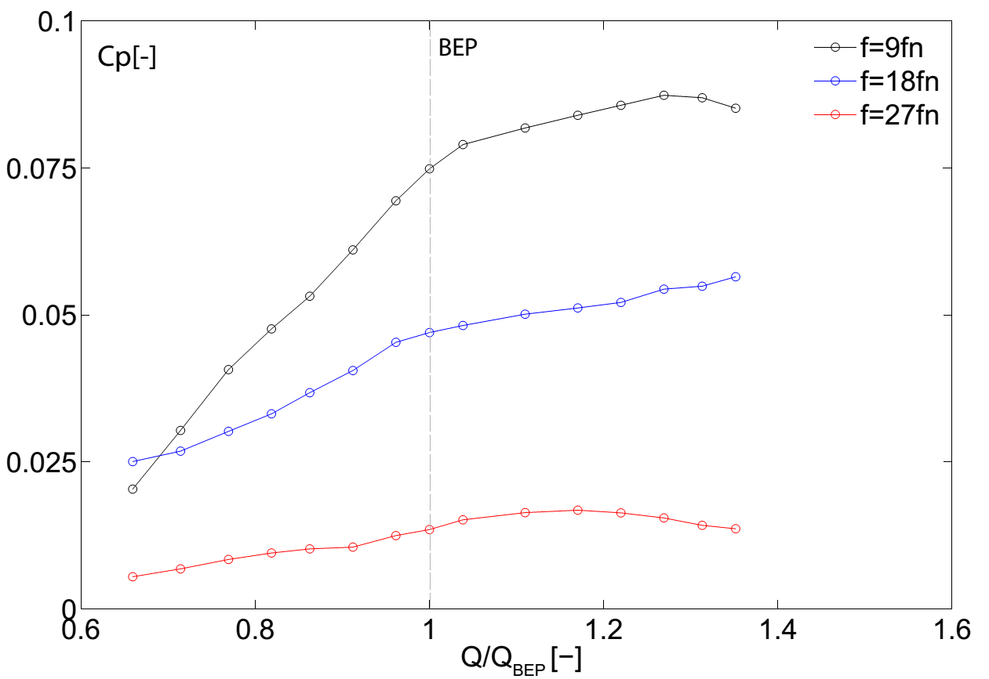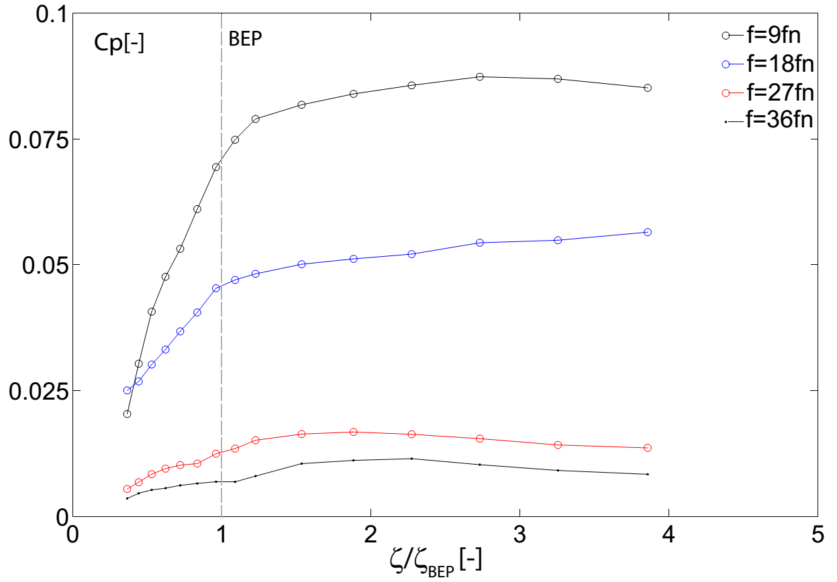
Figure 1 RSI amplitudes with different discharges (left) and as a function of a dimensionless parameter related to the vaneless space (right) (Zobeiri, 2009). The results are obtained from a pump-turbine model, with ν=0.19, that includes 9 blades and 20 guide vanes.
The unsteady flow field developed by RSI is normally assumed to induce the predominant high-cycle fatigue (HCF). The fatigue life is defined by the number of cycles that are necessary to initiate and propagate a crack to a critical dimension. Fatigue cracks tend to occur either early when it is related to design fault in a runner, otherwise the crack is observed after the decades of operation. Areas of high stress concentration due to RSI correspond to blades joined to the crown and band at the leading and trailing edges. The crack generally imitates from these locations when the number of fatigue cycles exceeds the threshold (Huth, 2005). An example of developed crack in a Francis runner is shown in Figure 2. The runner was design for Head=330 m and Power=447 MW (Coutu et al., 2004; Coutu et al., 2008). Length of the crack is 14 inch and that was developed within 200 hours of turbine operation. A detailed analysis revealed that the runner experienced dynamic stresses induced from RSI. Moreover, the runner natural frequency (f*) at the time of actual operation was very close to the guide vane passing frequency, f_{r}/f*=0.96. This resulted in a substantial increase in structural vibrations and resonance, depending on the fluid and structure interaction. During refurbishment, the old runner was replaced by new runner of high natural frequency and the improvement was clear: the strain amplitudes were decreased by a factor of two and the dynamic torque was decreased by a factor of more than three without compromising the runner’s performance (Coutu et al., 2008). The miscalculated parameter for failed runner was the dynamic torque value, which was much higher than the normal acceptable.
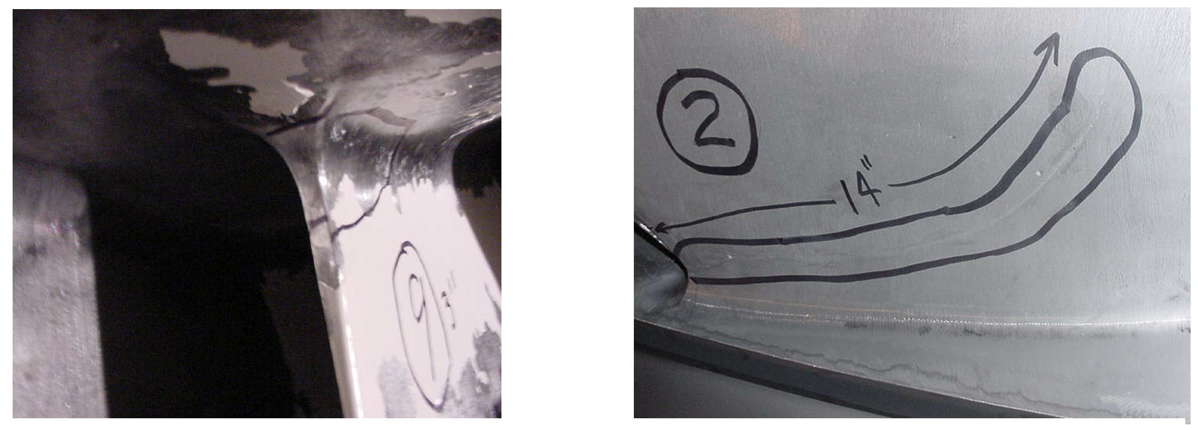
Figure 2 Cracks at the blade trailing edge welded to the crown (left) and band (right) junctions (Coutu et al., 2008).
Figure 3 shows another example of failure in a low head Francis runner, where a crack was observed at the leading-edge-crown junction in one of the blades (Frunzǎverde et al., 2010). The analysis indicated that both RSI and vortex rope induced dynamic stresses in the blade. This failure occurred largely due to welding defects originating from the first phase of repair. After the complete separation of the two fractured surfaces, namely, the weld and blade, near the trailing edge, the maximum principal stress, which was approximately one order of magnitude lower than the yield stress, was found near the leading-edge-crown junction. Due to the stress concentration and dynamic loadings produced by pressure fluctuations associated with the vortex rope, this area is sensitive to fatigue crack initiation. Several other cases of fatigue damage in the runner have been reported over the last two decades (Carpinteri et al., 2015; Flores et al., 2012; Gagnon et al., 2012; Huang et al., 2014; Huth, 2005; Luo et al., 2013; Magnoli, 2014; Seidel et al., 2014; Thibault et al., 2014; Trudel and Sabourin, 2014; Wang et al., 2012). A majority of these failures are related to dynamic stresses induced by RSI and, recently, increased transients such as load variations, start-stop, spin-no-load and total load rejection (Trivedi et al., 2013b; Zuo et al., 2015).
Figure 3 Damaged blade of a low head Francis runner (Frunzǎverde et al., 2010).

Effect of added mass on runner natural frequency
The structure of hydraulic turbines reacts differently when it subjects to dynamic pressure loading under flowing water. Traditional techniques that have been used for decades for the estimation of natural frequencies and mode-shapes in air and water are no longer reliable. Following the catastrophic failure of a newly designed Francis runner (Coutu et al., 2004), research on added mass effect is being carefully considered. The main challenge is the reliable estimation of the runner natural frequency due to added mass. Because, the added mass effect is dependent on several parameters, including the geometrical shape of the structure (runner diameter, blade profile and joining of the blades to the band and crown junction), its relative position from the boundaries, nearby structures, amplitude, direction of vibrations and the local flow condition (Blevins, 2001; Conca et al., 1997; Wu et al., 2013; Yadykin et al., 2003).
In the last decade, extensive study has been conducted on different structures starting from a simple airfoil to a full-scale prototype runner. De La Torre et al. (Torre et al., 2013) conducted a study on a hydrofoil, NACA0009. They studied four configurations: (1) a hydrofoil in air, (2) a suction side surface in contact with air and the pressure side surface in contact with water, (3) submerged in sill water and (4) submerged in flowing water at 7 and 14 m s⁻¹. The maximum added mass effect was observed in still water condition, where the natural frequency was reduced by 50%. During cavitation at 14 m s⁻¹ flow velocity, the natural frequency reduction was approximately 20%. For simplified structure and environmental condition, estimations and prediction of added mass effect is quite straight forward. However, it is challenging when complexities are included such as rotating structure and it is surrounded by several solid walls in flowing water.
Further study on a simplified structure such as circular disc, which has identical geometry as runner crown and band, showed that the added mass effect is mainly dependent on the mode-shape and corresponding nodal-diameter (Huang et al., 2013b). Discs with different radii and thicknesses were investigated. The natural frequency was proportional to the disc thickness and inversely proportional to the disc radius (keeping same thickness). Later authors have placed simplified curved blades between the discs and made runner type structure. The results indicated that the natural frequency increases with the blade numbers and is also dependent on the blade profile. Overall, it was observed that added mass parameter dependency increases with the structure complexity, not only surrounding flow velocity condition. In actual runner, geometrical shape of the blade, crown and band is complexity, including dimensions from one axis to another. Therefore, estimation of added mass effect for prototype runner based on simple study is not reliable.
For more precise analysis, Rodriguez et al. (Rodriguez et al., 2006) have conducted an experimental study a model runner in air and still water. The objective was to investigate how mode-shapes and nodal-diameter influence the runner natural frequency. The runner was a reduced-scale (1:10) model of the prototype Francis turbine (ν=0.56). Several impact tests were performed at different locations of the crown and band using a specialized hammer (Kistler 9722). The response was measured by mounted accelerometers (Kistler 8704B100). The observed mode-shapes in air and water were identical, including the order of the nodal-diameter, as shown in Figure 4. The first natural frequencies in the air and water were 373.5 Hz and 279.5 Hz, respectively. Fifth nodal-diameter showed maximum added mass effect where the natural frequency by 39%. The identified mode-shapes were bending, torsion and flexion. The added mass effect was relatively small for other mode-shapes except bending. The mode-shape plays an important role in computing the added mass effect and it needs detailed study including reliable estimation for prototype conditions. Numerical simulations were conducted on the same runner to investigate the added mass effect in detail (Liang et al., 2007). Figure 5 shows comparison of natural frequencies observed in air and water. A minimum difference between the numerical and experimental values was observed for the zero nodal-diameter (f₀₁). The maximum difference was observed for the fifth nodal-diameter (f₅₁). Relative deformation between the crown and the band in bending mode caused significant reduction in natural frequency. Confined liquid in the blade passages induced higher pressure and thus out of-of-phase deformation (Egusquiza et al., 2009).
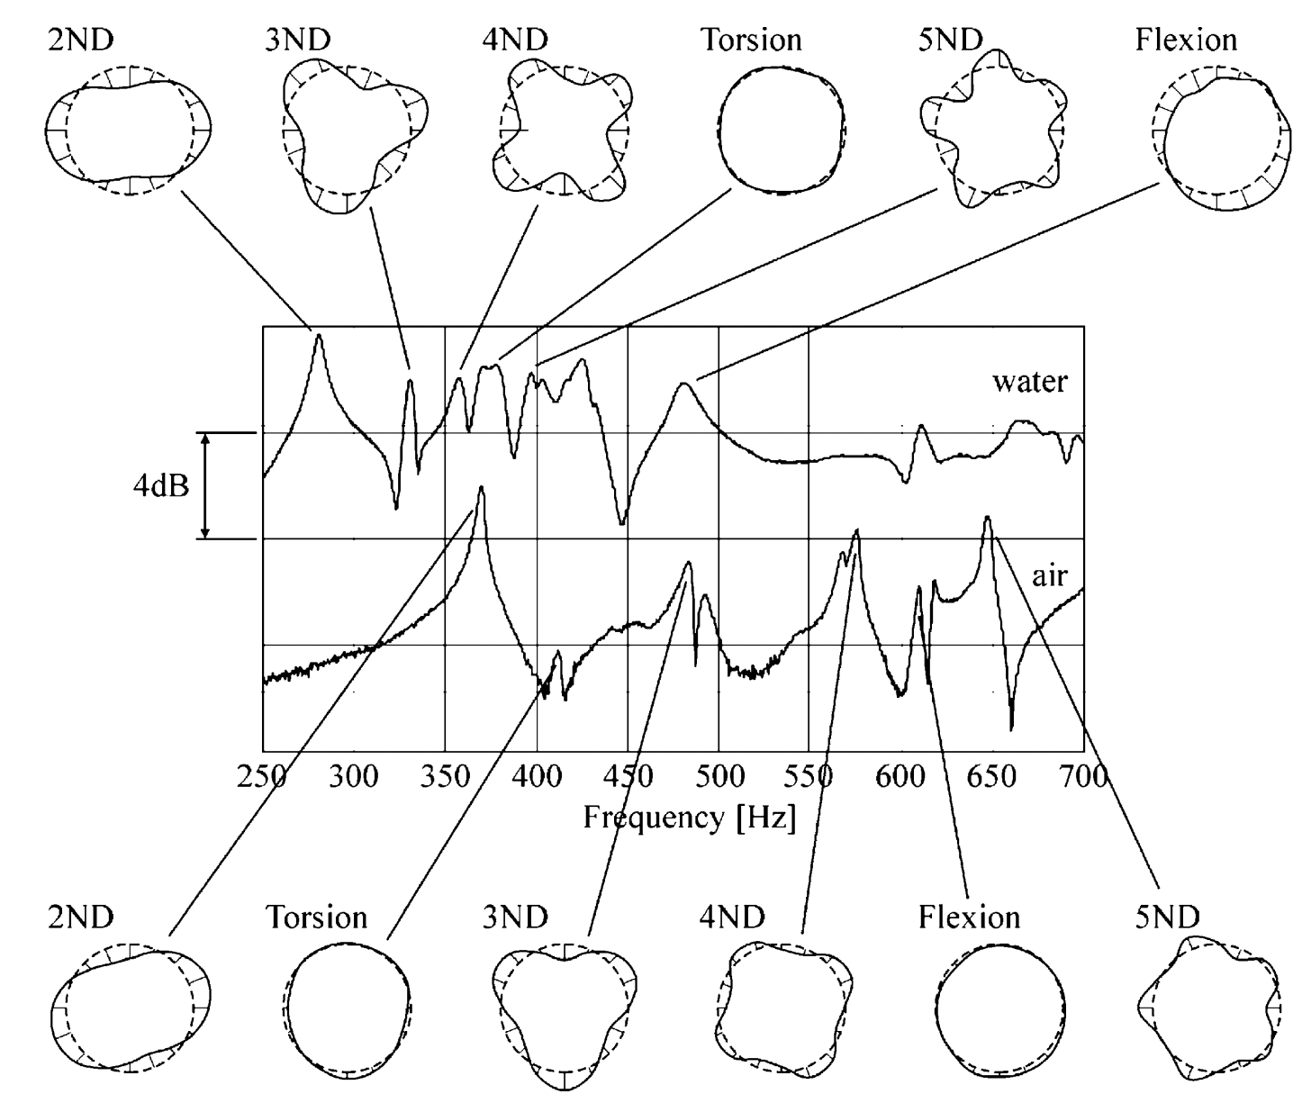
Figure 4 Natural frequencies and corresponding mode-shapes of a pump-turbine runner observed in air and water (Rodriguez et al., 2006). The runner was manufactured using bronze; the Young’s modulus, density Poisson’s ratio and weight were 110 GPa, 8300 kg m⁻³ 0.34 and 55 kg, respectively.
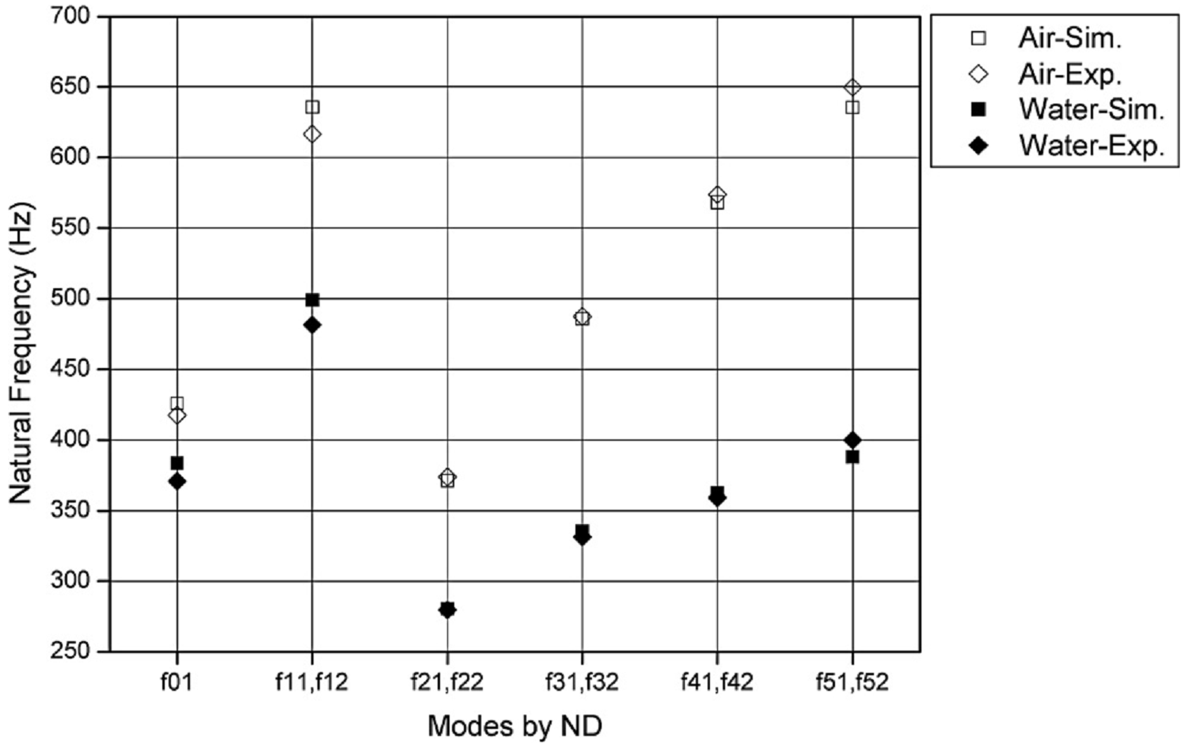
Figure 5 Comparison of the experimental and numerical values of the runner natural frequencies (Liang et al., 2007). The Young’s modulus, density and Poisson’s ratio of the runner are 110 GPa, 8300 kg m⁻³ and 0.34, respectively. On the x-axis, ND is the nodal-diameter and f is the natural frequency; the first subscript is the nodal-diameter and the second subscript is the measurement number.
Another numerical study conducted on a prototype runner showed that the added mass effect is dependent on the operating condition of the hydraulic turbine (Llu et al., 2008; Yao et al., 2014). Reduction in natural frequency at part load, best efficiency point and high load was 37%, 20% and 30%, respectively. The relative deformation in the runner was 1.3 mm that appeared at the blade trailing edge joining the crown for part load operating condition. Both experimental and numerical studies revealed that the relative (out-of-phase) deformation between the runner parts at a specific mode-shape causes significant reduction of the natural frequencies. Apart from the relative deformation, influence of nearby structure is equally important (Egusquiza et al., 2009; Hübner et al., 2010). When one of the walls experience vibration, high amplitude pressure waves are developed, strike to the nearby wall and reflect back. As reflection distance decreases added mass effect increases. Liang et al. (Liang et al., 2007) in their study, role of labyrinth seals was investigated and they concluded that the proximity of nearby surfaces plays significant role in changing the natural frequency. Because, runner deformation in the radial direction fills the air gap in the seals and increase surface to surface contact, consequently, drastic reduction of the natural frequency (Rodriguez et al., 2012).
Overall, the studies conducted on the added mass effects showed that the frequency reduction is dependent on the blade profile, thickness and proximity of the nearby structure. There are several concerns that warrant a detailed investigation such as the effects of flow conditions, materials, scale, gap between the runner and nearby components, pressure wave propagation/reflection, cavitation, coupled response of the main shaft/bearings and RSI.

Hydrodynamic damping
When a vibrating structure is surrounded by a viscous fluid, it experiences reacting force. The force may be interpreted as added mass and hydrodynamic damping which is dependent on the local flow condition (Chen et al., 1976). Hydraulic turbine is a complex structure that includes both rotating and stationary components. Runner is an important component which is surrounded by the stationary vanes and the labyrinth seals. While designing the runner, a certain amount of added mass and damping effect is assumed. This is based on decade old empirical relations and the experience from the past design parameters. However, such approximation is no longer trustable following the current trend of turbine operation and related damages. To make safe design, which can cope with the current electricity demand, estimation of hydrodynamic damping is as important as the turbine efficiency. Some efforts have been made to investigate the damping and how damping can be useful during resonance in the recent years. The reviewed literature indicates that the hydrodynamic damping can be an important parameter to reduce the vibration amplitudes.
Damping is divided in three categories: (1) fluid added (hydrodynamic) damping, (2) structural (friction) damping and (3) material damping. Hydrodynamic damping is dependent on change in mode-shape due to fluid pressure, convection through vortex shedding, viscous effect within the boundary layer, flow velocity, surface roughness, proximity of nearby structure and submergence level. Structural damping is dependent on the surface to surface contact between the structure and induced friction. Material damping is dependent on the material properties and its microstructure. Structural and material damping are very small as compared to the hydrodynamic damping, particularly when structure interacts with the dense fluid such as water (Jeary, 1996, 1997; Kareem and Gurley, 1996). Both structural and material damping are not discussed as the current article focuses on hydrodynamic damping.

Effect of mode-shape
The damping capacity is defined as the ratio of the energy dissipated in one cycle of oscillation to the maximum amount of energy accumulated in the structure during that cycle. When a structure experience vibration at the natural frequency, it undergoes different mode-shapes and the damping changes correspondingly (Crawley, 1983). The turbine runner experiences bending, torsional, and flexion modes during the resonance (Rodriguez et al., 2006). Runner is a complex geometry (assembly of band, crown and several blades) and it is difficult to recognize that what caused to change in damping; for example, relative deformation between blade and crown/band, inter-blade phase change, or diffusion of released energy by runner to the water. Therefore, it important to understand what exactly is happening when a structure subjects to different environment and how damping varies with mode-shapes?
During resonance condition, structure undergoes deformation and shape of the structure changes according to active number of nodal-diameter and nodal-circle. The damping parameter varies along the length and width of the structure, i.e., aspect ratio. For example, Vandiver and Chung (Vandiver and Chung, 1989) have conducted experiments on a long circular cylinder that was submerged in flowing water. They estimated the vibration amplitudes along the longitudinal axis of the cylinder. The amplitudes were following sinusoidal pattern which were coupled with the local pressure gradient. The frequencies, associated with local lift force, tend to power flow into the cylinder while other frequencies, not associated with the local lift force, tend to increase the damping.
Figure 6 shows velocity vectors during out-of-phase deformation for the bending mode-shape of the two circular plates. In the center, fluid is compressed and deaccelerates towards outward. The adverse pressure gradient is developed towards outward which causes flow separation and reduction in hydrodynamic damping. Damping effect for out-of-phase and in-phase mode-shapes is different. The added mass effect for out-of-phase mode-shape is around 10% less than that of the in-phase mode shape and, further, damping effect decreases with increase in nodal-diameters of the plates (Jeong, 2003; Jeong and Kim, 2005). Another study conducted on a rectangular cantilever plate showed a direct link between the aspect ratio, nodal-diameter and damping (Yadykin et al., 2003). Keeping same aspect ratio, damping is high for low nodal-diameter and it decreases as nodal-diameter increases.
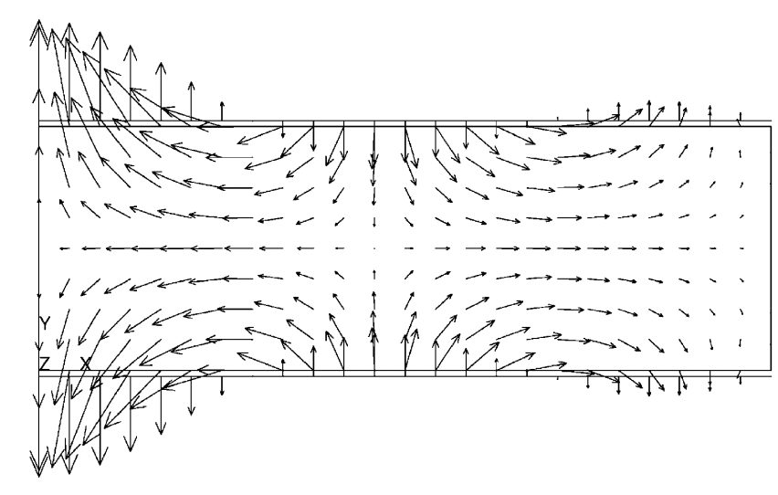
Figure 6 Velocity vector during out of phase deformation of the plates with zero nodal-diameter and two nodal circles. Two circular aluminum plates subject to hydrodynamic pressure exerted by water; thickness=0.002m, distance between plates=0.04mm, radius of the plate=0.06m, E=69 GPa, the ν=0.3 and ρ=2700 kg/m³ (Jeong, 2003).
In plate and disc type structure, damping decreases with increase in nodal-dimeters while, in the actual runner, damping increases with the nodal-diameters of the corresponding mode-shape. The increase in damping is associated with the relative deformation between the blade and the band/crown. For example, during flexion mode (see Figure 4), runner crown and band deforms in opposite direction and the blades experience shear from the mid-section. In this situation, part of the blade meridional section will have high velocity. The other part will have low velocity and this will modify the damping. The change in damping is related to the change in local velocity and exchange of energy between the structure and the surrounding fluid. At a particular mode-shape or nodal-diameter/circle, the exchange of kinetic energy increases dramatically, which results in increase of damping at that location.

Role of boundary layer
We have seen that when a structure subject to a specific mode-shape, it deforms. The deformation affects the flow field, particularly close to the antinode boundary of the vibrating structure. This results in rapid change of pressure and velocity. It is important to understand that what happens in the boundary layer when a structure vibrates at resonant frequency and undergoes different mode-shapes, e.g., how viscosity, inertia and shear stress changes within the boundary layer.
During resonance, amplitudes close to the vibrating wall follows sinusoidal pattern; small amplitudes at the node-point and high amplitudes at the antinode-point. Thus, pressure gradient constantly changes from favorable to adverse; similarly, Reynolds stresses and viscous effect (Vandiver, 2012). When viscosity is high enough, it plays critical role to enhance damping effect and reduce the amplitudes (Green and Sader, 2002; Sader, 1998; Volfson and Vinals, 2001). Turbine runner is in contact with the water and there are negligible chances of improving damping due to change in viscous effect. In the runner, boundary layer is not fully developed and the flow field is largely dominated by vortex breakdown where the pressure gradient is changing constantly from blade leading edge to the trailing edge. As vibration amplitude increases, more flow separates and the vortical flow structure develops near the vibrating wall. The boundary layer breaks further which begins with incipient detachment then intermittent transitory detachment and transitory detachment finally detachment where the time-averaged wall shear stress τ_{w}=0 (Simpson, 1989).
In the boundary layer, a three-dimensional fluid element will travel upstream and downstream as flow accelerate and decelerate depending on mode-shape. The reverse flow occurs in regions of low kinetic energy (near to vibrating node point) and the large eddies, which bring outer-region momentum toward the wall, supply some downstream flow. Generally, three regions are created when backflow occurs (Simpson et al., 1977):
- A viscous layer nearest the wall that is dominated by the turbulent-flow unsteadiness.
- An intermediate layer with a semi logarithmic mean velocity profile that seems to act as an overlap region between the viscous wall and outer regions.
- The outer backflow region that is mainly part of the large-scale outer-region flow.
Further author stated, “The largest pressure fluctuations are not at the wall in a detached flow, but rather they must be near the middle of the shear layer. These large pressure fluctuations strongly influence the near-wall flow.” When a structure like two plates experience out of phase deformation (we have seen in Figure 6), the plates either converge or diverge. In case of divergence, Reynolds stresses and turbulent-energy diffusion is low, thus energy and momentum exchange near the wall is less. This may be associated with the slow response time from large-energy containing turbulent eddies (Simpson et al., 1987). In case of convergence, exchange of kinetic energy is fast and the boundary layer receives energy from the free-stream flow that helps to increase damping. The exchange of kinetic energy can be expressed as:
;
where, m_{a} is the added mass and V_{s} is the velocity of a reference point on the structure.
To understand the relation between pressure fluctuation and vibration amplitudes in the boundary layer, Ducoin et al. (Ducoin et al., 2009b) have conducted studies on a flexible hydrofoil (NACA 0066, chord=0.15m, span=0.191m, E=3000 MPa, ρ=1480 kg m⁻³ and ν=0.35). The flow velocity was 10 m s⁻¹ and the angle of attack was 6°. During resonance, the hydrofoil deformation was function of square of the velocity and the highest deformation (~10 mm) was at the leading edge. Results of pressure measurements on the similar hydrofoil (rigid) are shown in Figure 7 (Ducoin et al., 2009a). The pressure fluctuation can be seen from 6° angle of attack. At 13° angle of attack, stall sets on and high amplitude fluctuations (frequency=6 Hz) develop, which are associated with the inception of flow separation, i.e., laminar separating bubble (LSB). As LSB grows, boundary layer modifies and the pressure amplitudes increase. Development of LSB is shown in Figure 8 as hydrofoil pitching up. The development of LSB influence the induced drag in the boundary layer and the damping effect changes (Akcabay et al., 2014; Ducoin et al., 2012a; Ducoin et al., 2012b; Ducoin et al., 2009a; Huang et al., 2013a). Moreover, change in center of pressure strongly influence the location of flow separation (Ducoin and Young, 2013) and transition to turbulent boundary layer takes place from the LSB downstream, i.e., point of LSB destabilization. The process leads to the breakdown of coherent structures into smaller vortices triggering turbulence (Leehey, 1988). The developed vortices convect downstream and interact with the trailing edge vortex, Von Kármán. At the same time, separation from leading edge results in Kelvin–Helmholtz instability (Ducoin et al., 2016). Figure 9 shows observed mode-shapes of the hydrofoil and amplitudes at different angle of attack. Total six modes of the hydrofoil were recorded and the transition of LSB is linked to high amplitudes (f=450 Hz) at fourth nodal-diameter of bending mode (Ducoin et al., 2012a). At the stage of final detachment, the oscillatory boundary layer develops quasi-coherent structures over a range of K (K=2πA/D, A is the amplitude and D is the characteristic length) values before giving rise to Honji-type coherent structures (Sarpkaya, 2001). However, the study showed that no linear relation between velocity, Reynolds stresses, pressure amplitudes and amplitude of vibration.
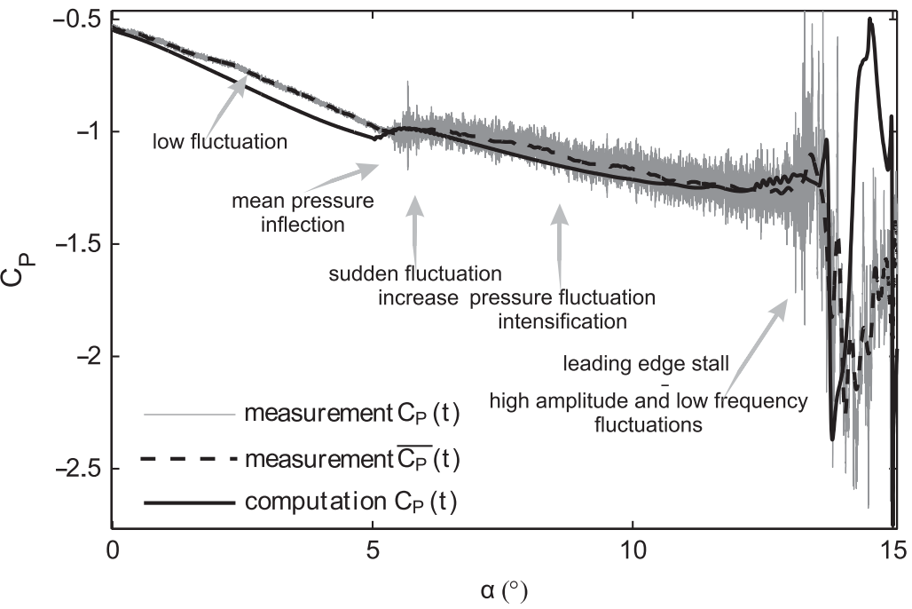
Figure 7 Pressure fluctuation at upper surface of the hydrofoil for different angle of attack. The measurement location corresponds maximum thick ness of the hydrofoil (≈ 30% of chord from leading edge). The flow velocity is 5 m s⁻¹ (Ducoin et al., 2009a).
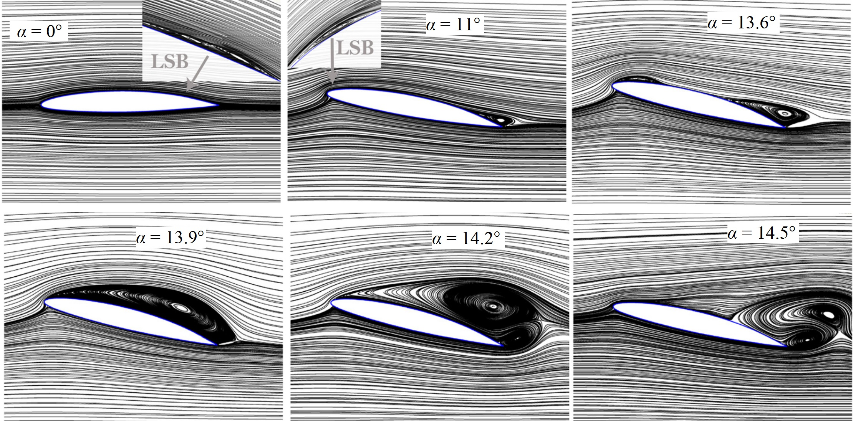
Figure 8 Inception of laminar separation bubble (LSB) for different values of angle of attack, Re= 750 000 (Ducoin et al., 2009a).
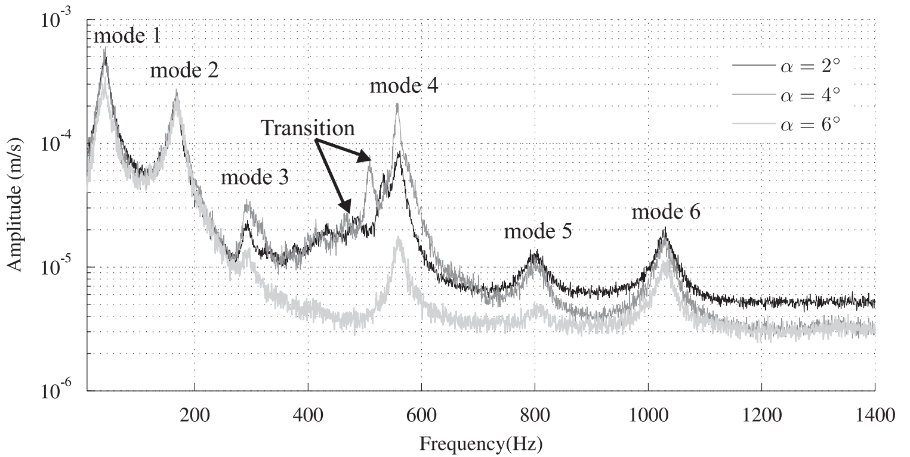
Figure 9 Velocity spectra of a flexible hydrofoil (NACA66312, E=3x10⁹ Pa) at Re= 800 000 (Ducoin et al., 2012a); α corresponds to angle of attack of the hydrofoil; modes 1, 3 and 5 are bending mode-shapes; modes 2, 4 and 6 are torsional mode-shapes.
Venkat et al. (Venkat and Spaulding, 1991) have studied the effect of vibrating flat plate on the boundary layer for different mode-shapes. A term was used to model the nonlinearity near the vibrating wall; where υ is vertical velocity of vibration which is function of plate osculation frequency, is the gradient of the horizontal velocity u in y-direction which is a function of plate oscillation amplitude, mode-shape and Reynolds number. The study showed source/sink (Rankine half/full oval) type flow pattern above the vibrating section of the plate. The pattern is driven by corresponding mode-shape and it repeats at each vibration cycle. Pressure gradient and amplitudes over the vibrating section is dependent on the combination of source-sink pairs (Venkat and Spaulding, 1992). In the absence of sink at the end of vibrating section, the separated flow in the boundary layer does not reattach. For full oval situation, the pressure coefficient decreases for the first half of the vibrating section where the fluid is accelerated and partially recovers for the second half where the flow is decelerated. Damping can be improved when a mode-shape correspond to full Rankine oval; i.e., added energy during first half cycle by vibrating source is dissipated during second half cycle by sink. This allows reattachment of the boundary layer and pressure recovery after passing over the vibrating section. The challenge comes when not all mode-shapes have source-sink pair and thus energy does not dissipate effectively; hence, amplitude of propagating pressure wave downstream significantly increases. The source-sink pair generally exists for even nodal-diameters, whereas either source or sink exists for the odd nodal-diameters of the vibration (Venkat and Spaulding, 1992, 1993).
During the deformation, surface becomes wavy (sinusoidal) corresponding to the mode-shape, consequently, boundary layer disturbs and the pressure gradient changes in accordance with the vibration amplitude. In the wavy surface (trough), recirculating zone is developed and that fluctuates rapidly as it receives energy from freestream flow. The boundary layer undergoes constant changes; sometimes it is suppressed, growing large, and breaks as well (Calhoun and Street, 2001; Calhoun et al., 2001). When structure deforms in out-of-phase pattern, crests of two opposite walls come close and freestream velocity increases. A boundary layer region forms after reattachment of the flow. After the crest/hill, the boundary layer thickness changes and the adverse pressure gradient develops as the flow cross-section increases. Study within the boundary layer showed that a thin shear layer between the outer flow, which has a large downstream velocity, and the slow moving fluid in the trough is developed. The shear layer begins in the stream wise direction after separation and may continue at a higher level over the next crest where a new layer may form beneath it. Further stream wise velocity showed ejection of slow moving fluid (bursts) within boundary layer into the outer layer. The study showed that the bursts to be accountable for up to 70 or 80% of production of turbulence. In a flow over a wavy wall, however, the lifting happens periodically, after the crest when the surface undulates downward. The effect of wavy wall to organize bursts so that they occur mainly over the trough.

Effect of freestream velocity
“The term hydrodynamic damping is used to signify mechanical energy dissipation associated with the motion of a solid through a fluid. The hydrodynamic damping force is a drag force that is velocity-dependent rather than acceleration dependent” De Santo (De Santo, 1981).
We have seen that flow field within the boundary layer is influenced by freestream kinetic energy and the kinetic energy released by the vibrating structure. As convection effect increases, the amplitude of vibrating structure reduces, thus damping effect improves. The damping is dependent on energy exchanged during the complete vibration cycle. The damping increases as the flow velocity (Chen and Jendrzejczyk, 1981). An experiments performed on a hydrofoil showed quite useful characteristics of damping with respect to flow velocity (Coutu et al., 2012). Three hydrofoils of different geometrical dimensions were investigated near the resonance condition. The material characteristics and profile of the hydrofoils were close to those used for prototype runner blades. Figure 10 shows an arrangement of one of the hydrofoils on the mounting block. For such investigations, one of the main challenges is the excitation system, which should excite the structure at the required frequency without obstructing the flow field. Piezoelectric patches composed of a macro fiber composite (Jeffers et al., 2000; Wilkie et al., 2006) were used to excite the hydrofoil. This technology was originally developed by NASA Langley Research Center (Wilkie et al., 2000). However, the patches sometimes stemmed from the existence of cross talk between the high-voltage excitation signals and the low-voltage strain gage signals (Kielb and Abhari, 2001). The patches were mounted on the trailing edge of the hydrofoil, two on each side.
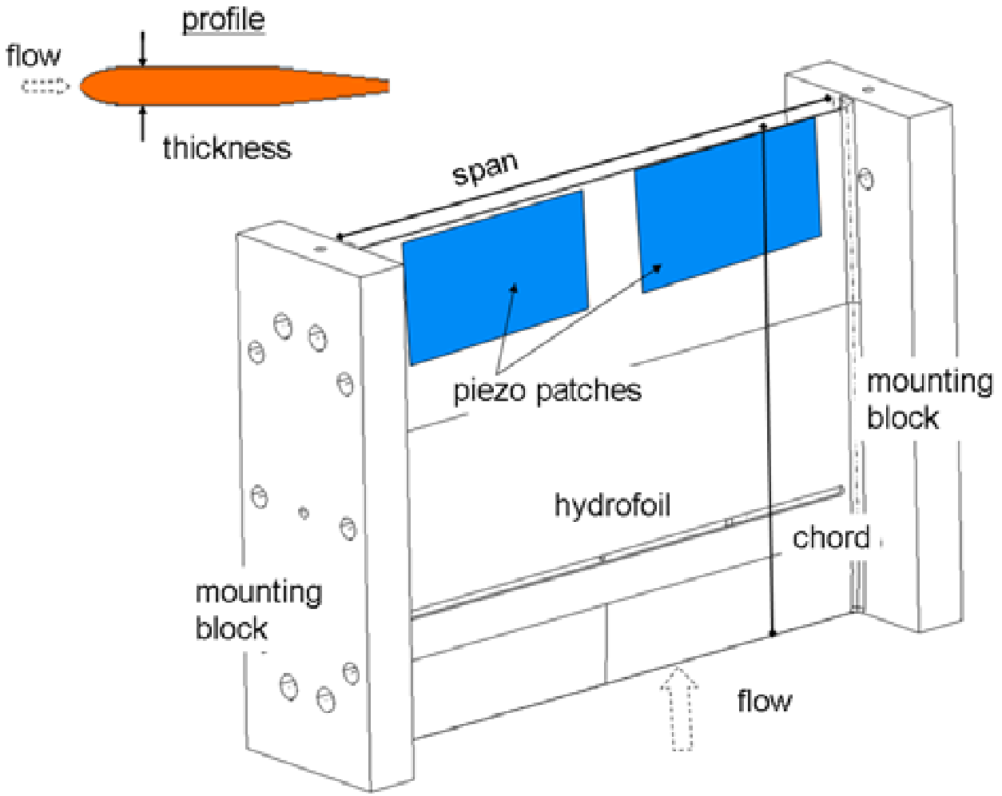
Figure 10 Mounting block arrangement for the hydrofoils and locations of the piezoelectric patches for exciting the hydrofoil at the natural frequency (Coutu et al., 2012).
Figure 11 shows the observed natural frequency (left) and damping ratio (right) during the measurements on the three hydrofoils, i.e., H0, H1 and H3. The observed natural frequencies of the H0, H1 and H3 hydrofoils in still water were 74.9, 71 and 74.1 Hz, respectively. The natural frequencies are 33.1, 32.7 and 37.1% lower than the natural frequencies observed in air for the H0, H1 and H3 hydrofoils, respectively. The natural frequencies decreased with increasing flow velocity. An approximately 10% reduction was observed at a flow velocity of 22 m s⁻¹ compared to the steady water condition. However, the variation is within the estimated uncertainty band and the study did not show the direct relations between the natural frequency and flow velocity. The right side of the figure shows variations in the damping ratio with the flow velocity and it is almost linearly increasing with the flow velocity. The maximum damping can be observed at a flow velocity of 22 m s⁻¹. The small variation in the slop may be related to the different profiles of the hydrofoils. The test-case clearly shows that the damping is function of flow velocity. The linear correlation between the damping and flow velocity is attributed to some mechanism based on the dynamic flow condition in the transition layer, inside the boundary layer and the structure (Chen and Jendrzejczyk, 1981; Eagleson et al., 1964; Gruber and Carstens, 2001).
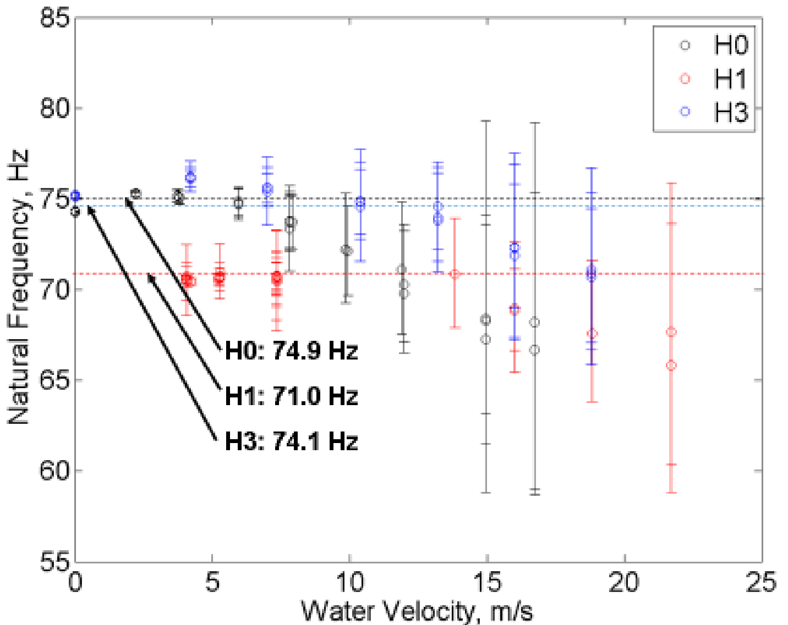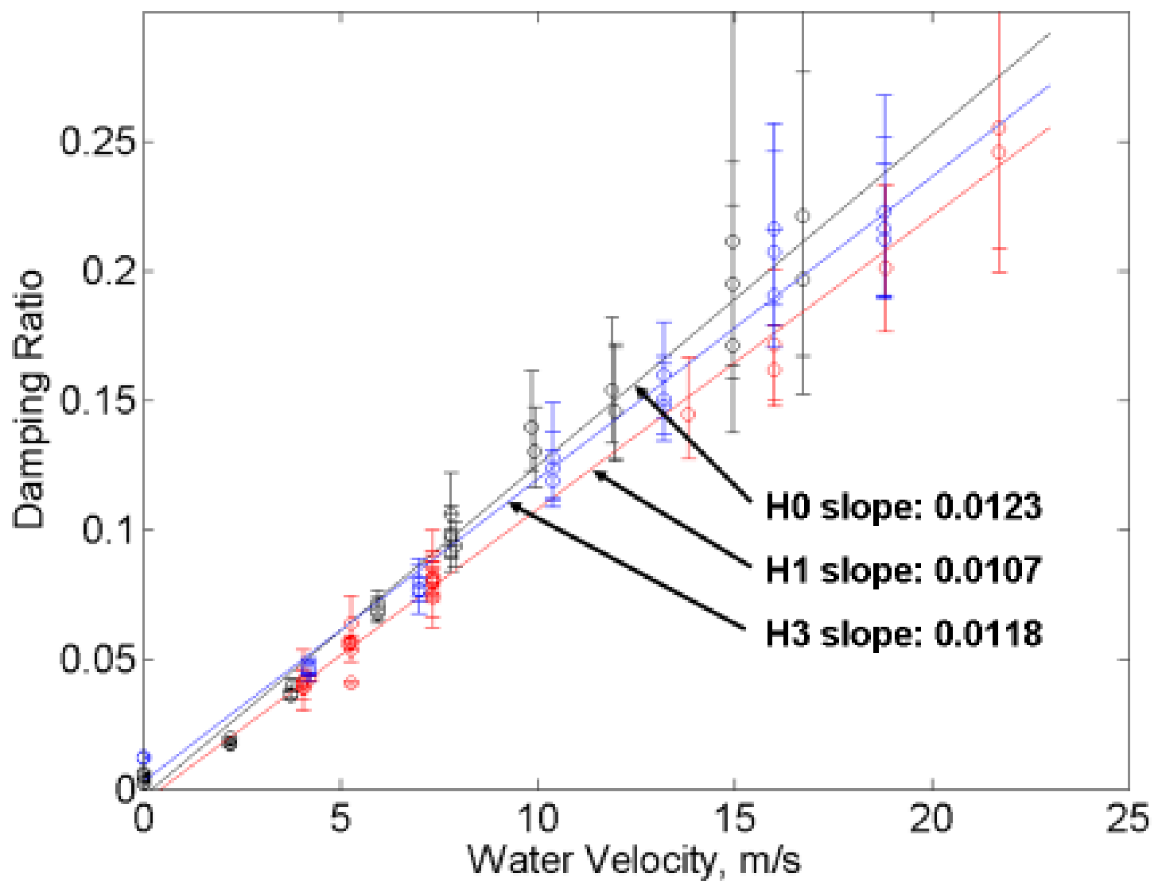
Figure 11 Natural frequency in flowing water (left) and damping ratio (right) of three hydrofoils, H0, H1 and H3 (Seeley et al., 2012).
The damping effect may directly be identified from the flow-induced vibrations, but, the turbulent noise level is too high at high velocity which makes difficult to properly distinguish the structure response and damping identification. Roth et al. (Roth et al., 2009) have applied another technique called a spark-generated bubble to investigate the damping effect on a hydrofoil, see Figure 12. The hydrofoil was installed in the 0.15 x 0.15 x 0.75 m test section where a maximum inlet velocity of 50 m s⁻¹ and static pressure up to 1.6 MPa can be achieved to develop cavitation. A spark-plug was mounted at the bottom of the test section, 56 mm from the hydrofoil trailing edge. When the spark is generated, a vapor bubble grows in an explosive way generating strong shock waves travelling towards the hydrofoil and providing an impulse excitation. The bubble then collapses and rebounds several times. The hydrofoil vibration is measured with a Laser Doppler Vibrometer. Figure 13 shows change in damping effect with the flow velocity. The flow induced vibrations are caused by the turbulence in the boundary layer and mainly by vortex shedding in the wake. The lock-in phenomena was observed at 3 m s⁻¹, 12 m s⁻¹ and 13 m s⁻1 for both first and second nodal-diameter. The hydrodynamic damping of the first nodal-diameter was varied linearly with the flow velocity, whereas the one relative to the second nodal-diameter remained constant. The proposed procedure for hydrodynamic damping identification is appropriate in so far as the flow-induced vibration does not perturb the blade response to the spark-generated bubble (Hübner et al., 2010).
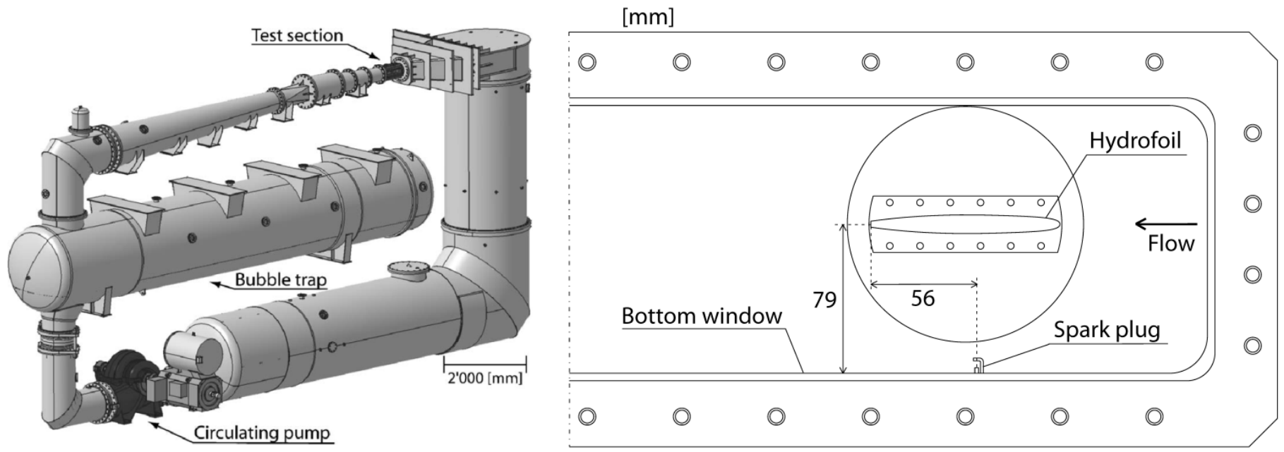
Figure 12 High speed cavitation tunnel (left) and detail of test-section with hydrofoil and location of spark plug (Roth et al., 2009).
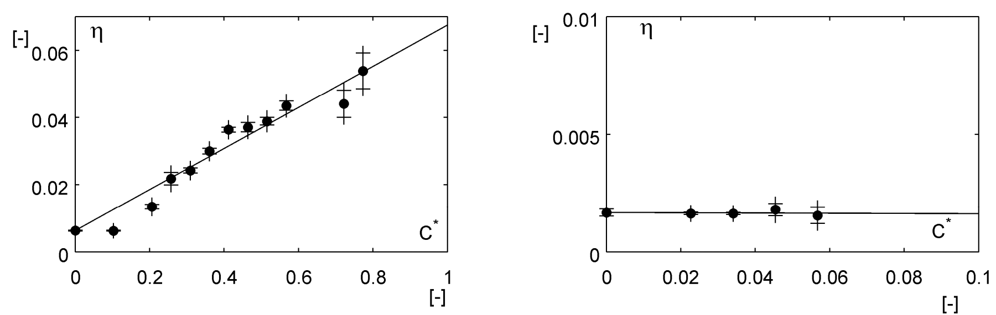
Figure 13 Damping with respect to flow velocity in (1) first bending mode (left) and (2) torsion mode (right) (Roth et al., 2009). C* = v/(f∙l); v is flow velocity in m s⁻¹, f is the hydrofoil oscillation frequency in Hz, l is the hydrofoil chord length in m and η is the damping ratio.
To investigate the effects of the trailing edge profiles and flow separation on the hydrodynamic damping, a study on the hydrofoils was conducted (Yao et al., 2014). Two hydrofoils (NACA 0009) with different shapes for the trailing edge, namely, Donaldson and Blunt, were selected (Torre et al., 2013). The measurements were conducted with a maximum flow velocity of 21 m s⁻¹ and the corresponding static pressure was 250 kPa. The hydrofoils were made of aluminum; the Young modulus=69 GPa, density=2700 kg m⁻³ and Poisson's ratio=0.3. The hydrofoil was fixed at one side and the other side was left free to vibrate within a 0.1 mm gap. The reduction in natural frequency of the hydrofoils was approximately 43%–60% in still water compared to the natural frequencies observed in air. Figure 14 shows the values of the hydrodynamic damping for the first bending and torsion modes in both steady and flowing water. Referring to the first bending mode, hydrodynamic damping linearly increases with the flow velocity. At the dimensionless velocity C*=0.15, the resonance condition in the hydrofoil was observed. Referring to the first torsion mode, up to C*=0.15, hydrodynamic damping remains almost constant, above which it increases linearly. Overall, the hydrodynamic damping is at least 3-times larger for the bending mode than for the torsion mode. At a flow velocity of less than 0.3 m s⁻¹, damping with the Donaldson trailing edge hydrofoil is larger than that with the Blunt trailing edge hydrofoil for the torsion mode. It was noted that the resonance in the torsion mode might be harmful to the mechanical structure because of the lock-in phenomena. Further, vortex shedding and the boundary layer transition from laminar to turbulent might be enhancing the vibrations characteristics of the hydrofoil, especially close to lock-in condition. At a particular mode-shape, e.g., torsion, there might be strong interaction among separating flow, boundary-layer and the hydrofoil. When the vortex shedding frequency gets closer to the natural frequency of the hydrofoil, a resonance occurs, which produces a response with higher order modes resulting in a further complex fluid structure interaction process as indicated by Ducoin et al. (Ducoin et al., 2012a).
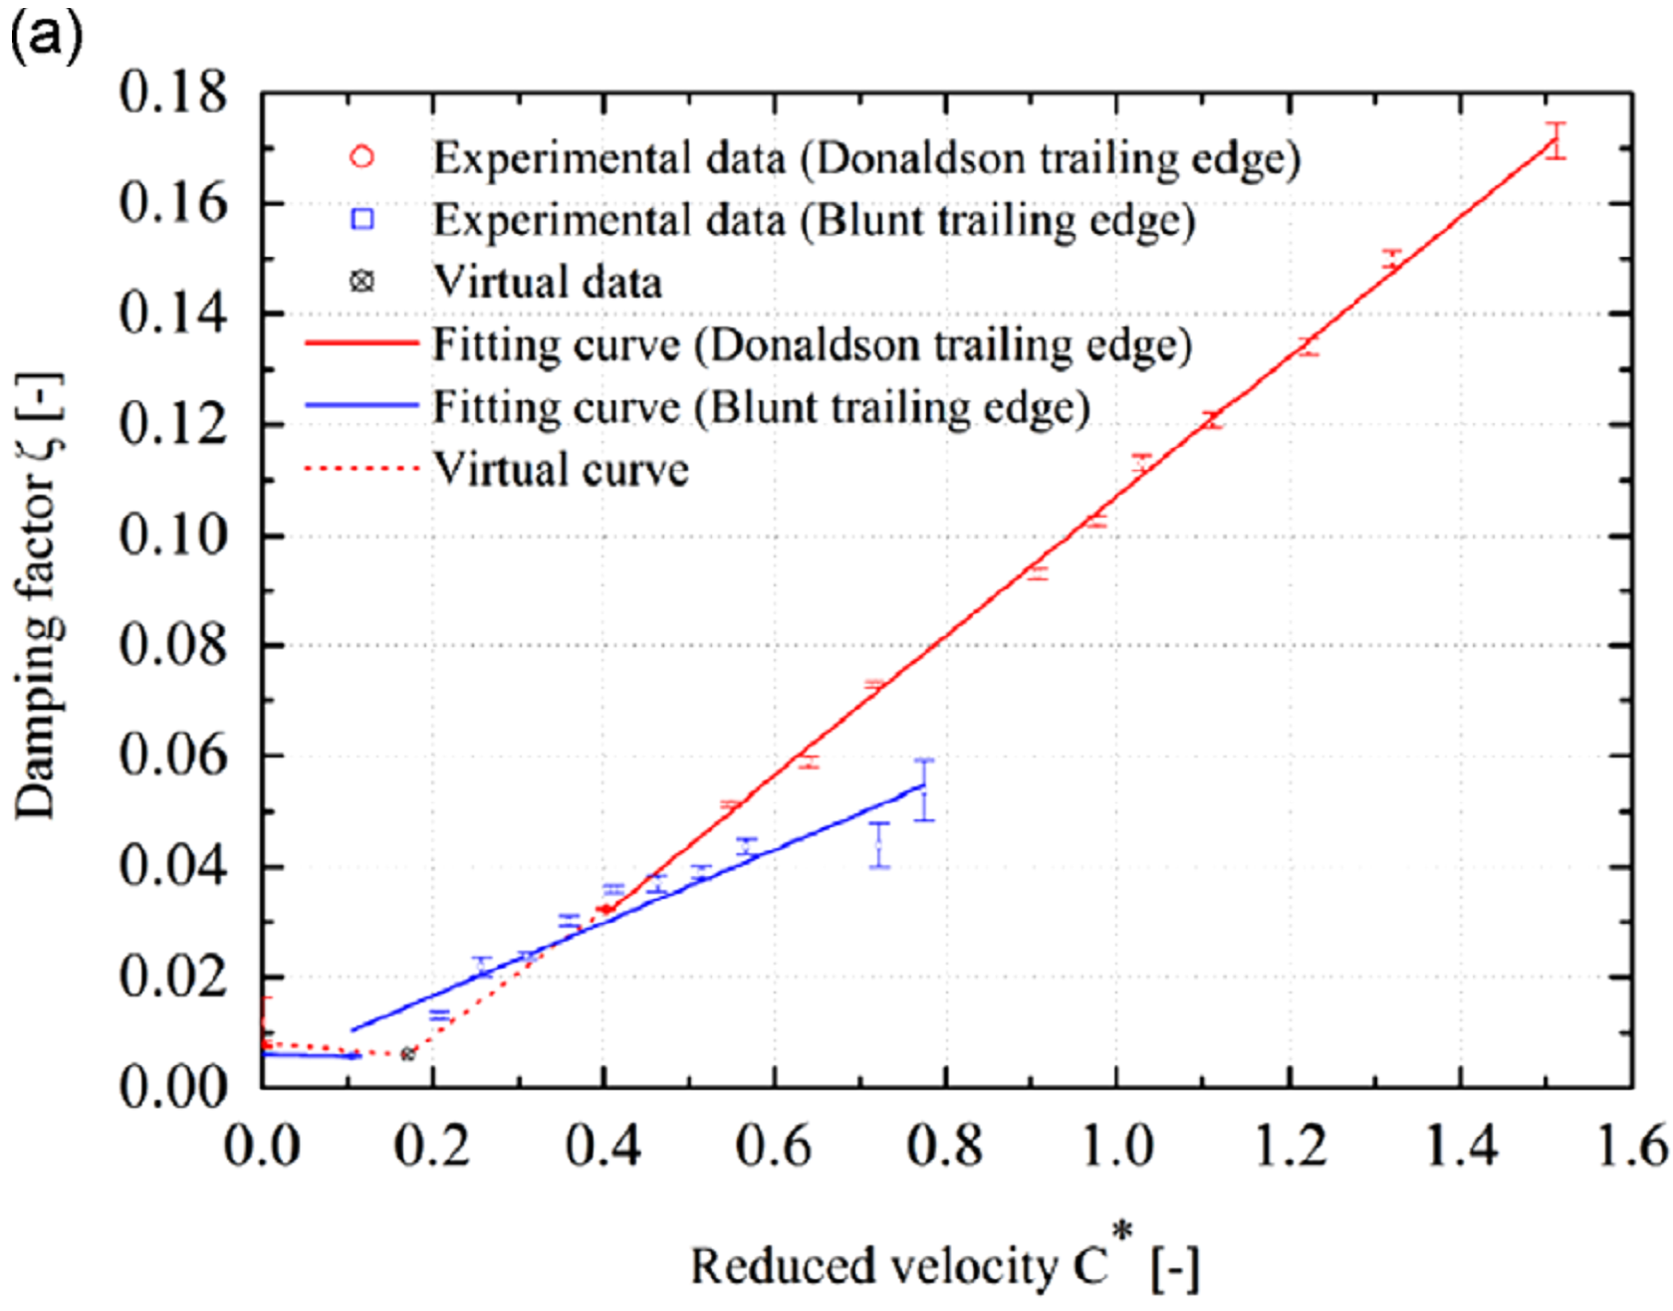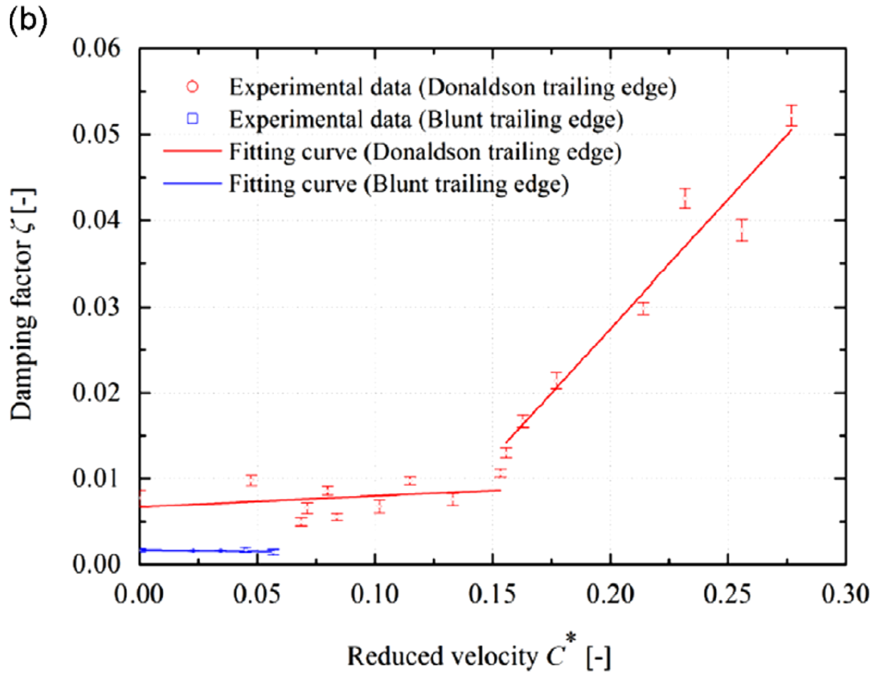
Figure 14 The damping factors of the first bending mode (a) and the first torsion mode (b) vs. reduced velocity (Yao et al., 2014). C* = v/(f∙l), v is flow velocity in m s⁻¹, f is the hydrofoil oscillation frequency in Hz and l is the hydrofoil chord length in m; damping factor ζ = fluid damping/critical damping.

Damping effect during cavitation
Cavitation is a common phenomenon in hydraulic turbines and it is regarded as one of challenging conditions as it affects the operating life (Ausoni et al., 2007; Cencîc et al., 2014; Escaler et al., 2006; Escaler et al., 2015; Kumar and Saini, 2010; Rus et al., 2007). Pressure at the runner outlet and in the draft tube often drops below vapor pressure, mainly at part load operating conditions. The cavitation results in disturbance of boundary layer and causing high amplitude pressure pulsations (Amromin, 2014). The critical area for cavitation is blade trailing edge welded to the crown/band (IEC 60193, 1999). Both cavitation and trailing edge vortex shedding affects the damping (Alligné, 2011). The damping is dependent on local velocity at that location, local density, amplitude of pressure waves developed by collapsing of cavitation bubble and the Reynolds stresses on cavitating surface (Ausoni et al., 2005).
Figure 15 shows on sets of cavitation when a hydrofoil subjects to high velocity flow (Dreyer, 2015). At the cavitation location bubbles are filled with small gas pockets. Energy released from the structure interacts with the boundary layer which has variable density due to presence gas pockets than the freestream fluid. Further collapsing bubbles develop high amplitude pressure waves (hydro acoustic wave) which propagate in all directions and also strikes to the vibrating wall (Arpe et al., 2009) and resulting in further amplification of the vibration amplitudes, whenever frequency locks-in. The amplitudes are as high as 15% with respect to the normal flow condition and the cavitation is function of the square root of the Reynolds number (Ausoni et al., 2007). In addition, vortical flow is developed beneath the separating boundary layer that causes adverse pressure gradient and further cavitation, i.e., super-cavitation (Akcabay and Young, 2014). The authors (Ausoni et al., 2007) have emphasized that the transverse velocity at the trailing edge increases the vortex strength linearly. This effect is important in the context of the fluid structure interaction, since it implies that the high velocity at the trailing edge increases the fluctuating forces on the body. Experiments on the hydrofoil at 14 m s⁻¹ freestream velocity showed that the damping decreases as cavitation increases (Torre et al., 2013). Decrease in damping effect is attributed to developed aircushion near the vibrating wall by cavitating bubbles.
When a hydrofoil experience deformation related to the mode-shape, at some locations cavitation effect is strong and causes significant damage. At these locations, dramatic amplification of the vibration amplitudes takes place; consequently, fatigue load increases and develops crack. As compared to the amplitudes of resonant frequency, hydrodynamic damping is extremely small therefore it is difficult to completely damp out the amplitudes during the strong cavitating effect. Amromin (Amromin, 2014) has stated that the cavity stabilization and adjusting pressure gradient can help to reduce the cavitation effect in his new design concept. However, the new design approach is yet to validate for fluid structure interaction.
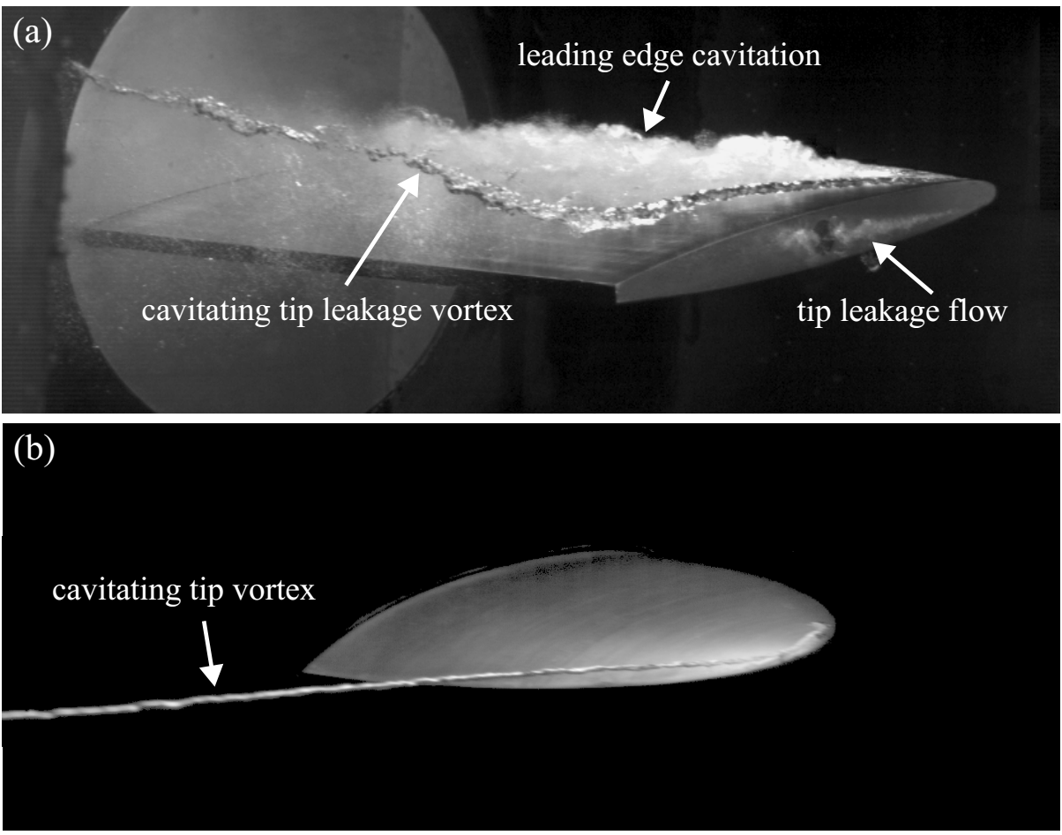
Figure 15 Cavitation inception on a hydrofoil (NACA 0009) at high flow velocity (Dreyer, 2015).

Effect of submergence level and proximity of nearby structure
Hydraulic turbine runner is surrounded by several stationary components, e.g. guide vanes at the runner inlet, labyrinth seals, main shaft and bearings. Moreover, inside the runner, blades, crown and band are located very close. The added mass effect changes significantly when a distance between two nearby structures reduces. The total damping is sum of hydrodynamic, friction and material damping. Runner contact with stationary labyrinth seals is considered as surface to surface contact and thus damping due to friction. In the runner, hydrodynamic and friction damping are dominating. Therefore, while estimating the damping effect in the runner, hydrodynamic and friction damping play vital role at the resonant frequency. The most importantly, when runner undergoes shape change at resonant frequency, surface to surface contact between the rotating and stationary labyrinth seals becomes strong. This increases the friction damping, sometimes, more than the hydrodynamic damping. However, to improve the efficiency, gap between the seals is kept less than a millimeter and this results in material damage due to rigid-lock-in between the seals as material expands (Mare et al., 2010). Proper study and estimation of damping effect due to closeness between the structure is necessary to achieve reliable and safe runner design.
When a gap between two surfaces (a distance similar to a blade-to-blade passage in the runner) is small and it is filled with dense fluid such as water, added mass effect is more than double as compared to the air (Jeong and Kim, 2005; Kerboua et al., 2008). Kinetic energy released by one of the vibrating surface propagates to the other surface through dense fluid. Thus, released kinetic energy does not dissipate sufficiently and the resonant amplitudes amplifies. The added mass effect reduces as the distance between the wall increases and one point the added mass effect remains constant (Jeong et al., 2009). During resonance, the wet and dry mode-shapes may be different because the mode-shapes are dependent on wet contact area and the material thickness (Askari et al., 2013; Jeong et al., 2004). Figure 16 shows change in mode-shapes as water level increases between two circular discs. The frequencies are normalized with corresponding natural frequency in air (=0% water level). The mode-shapes correspond to zero nodal-circle and second nodal-diameter (Jeong et al., 2009). Change in mode-shape with submergence level evident that the added mass and hydrodynamic damping effects are coupled wetted contact areas. This is associated with change in density and local flow condition as submergence level increases. Figure 17 shows velocity vectors for four nodal-diameters of a circular disc submerged in a water filled container (Askari et al., 2013). Flow velocity changes as the mode-shape. For bending mode-shape of two nodal-diameter, velocity in the center of the plate high where the plate deformation is maximum (see figure (a)). A recirculating region is created at the edge of the plates. A flow whirling edge changes flow velocity abruptly and it reduces the natural frequencies as added mass effect increases. For three nodal-diameters, velocity varies rapidly along the wavy surface and create source-sink type pattern as we have seen in the section 4.2. When a gap between two opposite walls decreases, flow accelerates and decelerates according to the change of mode shape. At a particular mode-shape, damping effect is maximum. Because, flow acceleration allows fluid medium to dissipate the energy by convection and thus amplitudes of resonant frequency decrease. However, at the location where convection is low and fluid is confined in small area, amplitudes of resonance frequency are significantly high and the hydrodynamic damping is almost negligible (Kimber et al., 2009).
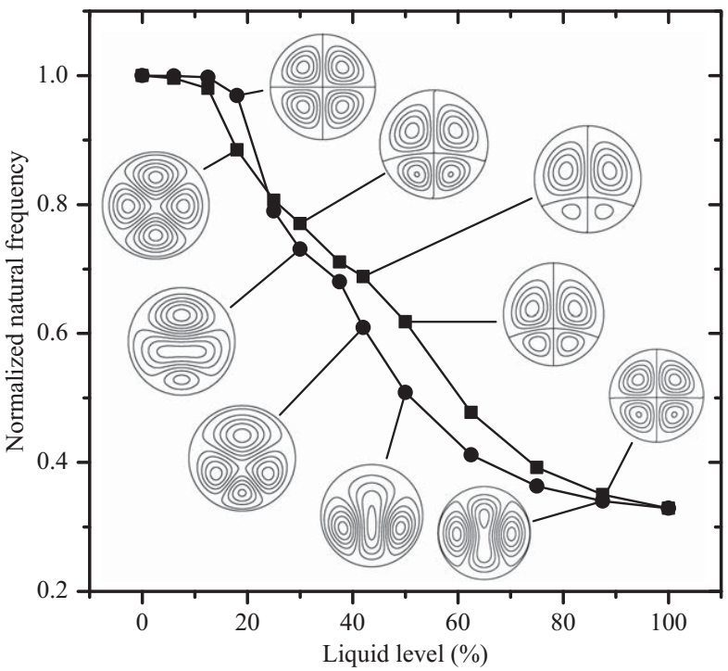
Figure 16 Transition of natural frequencies as water level between two confined plates increases (Jeong et al., 2009). 100% liquid level corresponds to full submergence of the discs. Square and circular black dots correspond to fourth and fifth bending mode-shapes, respectively. Plate radius and thickness are 240 mm and 3 mm, respectively; E=69 GPa, ν=0.3 and ρ=2700 kg m⁻³.
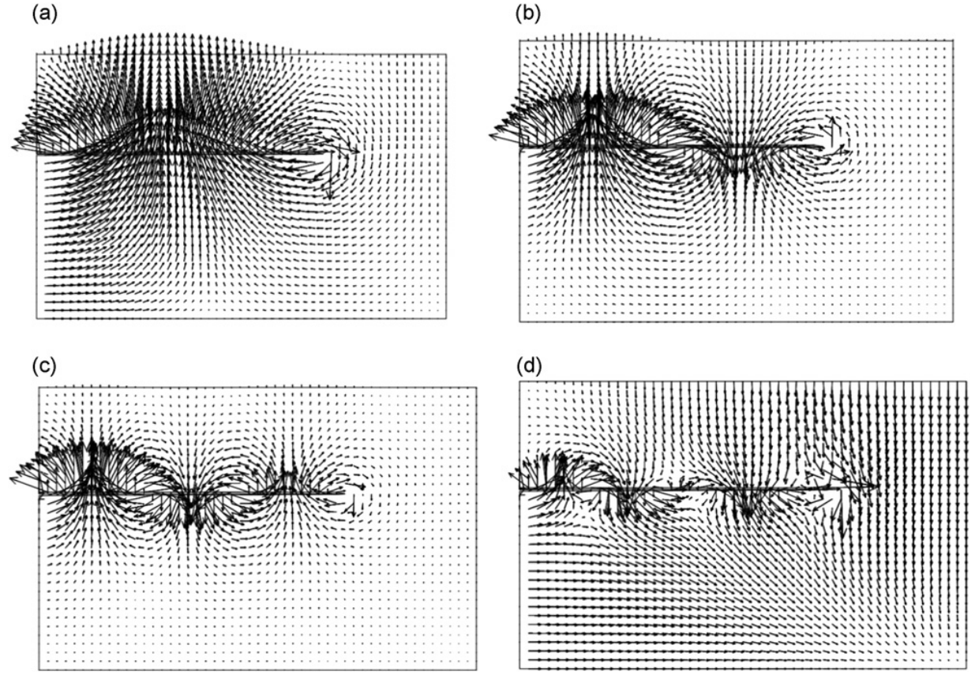
Figure 17 Vector of flow field when a circular plate experience different mode shapes, nodal-diameter=1. Distance from the top free surface and bottom solid wall is 60 mm and 100 mm, respectively. Diameter of the disc is 500 mm. Figures (a), (b), (c) and (d) correspond to first (130.9 Hz), second (472.6 Hz), third (1068.2 Hz) and fifth (2840.2 Hz) mode-shapes, respectively (Askari et al., 2013).
In hydraulic turbines, there are still some concerns which need attentions for future research. For example, in a hydraulic turbine, vaneless gap where blade leading edge is very close to the guide vane trailing edge. At this location amplitude of rotor stator interaction is very high. When a runner experience resonant condition, amplitudes of rotor stator interaction are further amplified. Hydrodynamic damping constantly varies with the runner angular movement. However, the experiments on compressible turbomachines suggested that the sinusoidal variation of the damping is not related with the change in vaneless gap (Li and He, 2005). As blade approaches the guide vane, gap between the blade and guide vane reduces, and the flow velocity increases. The high velocity helps to improve the damping effect. Thus sinusoidal variation of hydrodynamic damping is observed in the turbine. During the resonant condition, this damping effect is driven by the in-phase and out-of-phase variation of the runner blades as well as radial distance between the blades (Hengstler, 2013). In order to achieve, effective hydrodynamic damping, analysis of work done by different sections of the blades from leading edge to the trailing edge should be analyzed for different mode-shapes (Vasanthakumar, 2011).

Damping dependency on a frequency parameter (β) and KC number
Strong effect of vortex breakdown in the hydraulic turbines at off-design condition is one of the main challenges. Vortex shedding from the guide vanes and stay vanes convects energy to the runner and the vortex shedding from the blade trailing edges convects energy to the draft tube. Combination of different swirling mechanisms and strength develops vortex rope in the draft tube that causes dynamic instability in the turbine. Hydraulic turbine generally experiences instablity at off-design and/or transient (Trivedi et al., 2015a; Trivedi et al., 2014a, b, c; Trivedi et al., 2016a; Trivedi et al., 2015b) conditions where the effect of vortex shedding is strong. Therefore, it is important to understand the role of vortex shedding in improving the damping effect, particularly at off-design conditions, and how vortical flow dissipates the kinetic energy developed by fluid structure interaction.
A bluff body oscillating in water, the phase shift between the fluid force and the structural acceleration gives rise to the vortex induced damping. Furthermore, increasing the oscillatory flow velocity causes both the strength of the shed vortices and increases the magnitude of velocity in other direction, which subsequently cause the fluid force to increase in a nonlinear fashion (Bidkar et al., 2009). As the KC number increases, vortex shedding and convection dominate the flow field and this linear theory is inadequate in estimating fluid forces opposing the vibration (Aureli et al., 2012; Facchinetti et al., 2004).
When a vortex induced frequency is close enough to the natural frequency of the hydrofoil, lock-in occurs resulting in high amplitude pressure pulsations. Vortex induced vibrations and lock-in conditions are not discussed in the current section because both have been extensively discussed in the literature over the last three decades (Khalak and Williamson, 1999; Sarpkaya, 1963; Sarpkaya, 1995, 2004, 2005; Sarpkaya, 2006; Williamson and Govardhan, 2008). It is helpful to understand that how mechanism of vortex shedding changes the damping effect by dissipating the energy.
Frequency parameter (β) and Keulegan–Carpenter (KC) number have been extensively used to normalize the parameters related vortex induced vibrations and fluid structure interaction over the last five decades (Sarpkaya, 2005).
,
,
;
where, mean velocity and time , D is the diameter of the circular cylinder, ν is the kinematic viscosity and f is the frequency. Frequency variation in a hydraulic turbine is large starting from vortex rope frequency (0.2-0.3 times the runner angular speed) to the RSI frequency. β may be interpreted at rate of vorticity diffusion (Sarpkaya, 2001). Chaplin and Subbiah (Chaplin and Subbiah, 1998) have conducted experiments for the very low KC (0.001-0.2) and high β (166 900) value to investigate the hydrodynamic damping in ocean current. The measurements were performed on a cylinder (D=0.323 m) subject to cross flow condition, situation similar to tension-leg-platform in oil-rig (Chaplin and Retzler, 2001). They studied that, for KC>0.1, damping is function of KC number. Another study in still water showed that the surface roughness improved the damping effect. Later, study (β=650 000 and 1 250 000) performed by Chaplin (Chaplin, 2000) showed that, in a slowly varying transverse current, the damping of the cylinder increases with the reduced velocity at a rate which appeared to depend on the mean Reynolds number of the current.
Experimental study performed by Tao and Thiagarajan (Tao and Thiagarajan, 2003a, b) provided quite useful information on how vortex shedding can affect the hydrodynamic damping. The investigated range of KC number and β is 7.5x10⁻⁴-0.75 and 1.585x10⁵, respectively. The experiments were performed on a circular disc connected to a cylinder at the center which oscillates in a water filler container. Thickness of the disc was 0.0254 m. Figure 18 shows vortical flow as disc moves axially (y-axis). Vortex located at the bottom of the disc slowly moves upward as disc travels down. This vortex, however, does not convect far away from the lower edge but instead it remains in the vicinity of the edge. As disc moves down, vortex slowly pass by lower edge pushed up. After sometime, the vortex crosses the upper edge sets on the upper surface of the disc. In this case, far-field flow velocity is small and the flow disturbances are associated with the vibration of the disc and the axial movement. Authors suggested in their article that “the diffusion process is predominant; convection is weak and occurs only to the extent of transporting the vortices over short distance”. This might be explained as, since there is no independent vortex shedding from the upper and lower edges of the disc, no interaction between them as well as with the main flow. When there is vortex shedding, vortices are convected over long distances, mix into the mainstream flow. Under such conditions, while convection is very weak, damping changes correspond to the viscous effect (Phan et al., 2013). Both viscous and convection effects can be important contributors to the damping in the interactive vortex shedding regime. Moreover, thickness of the structure where the vortex shedding occurs can also have the striking effect on vortex shedding and the damping (as we have seen in Figure 14). Convection driven damping can be useful when KC number and β are simultaneously increased. However, one should be careful while estimating the vibration amplitudes because of included nonlinearity. For example, as the KC number increases the fundamental harmonic is increasingly damped and such damping is more evident for large oscillatory Reynolds numbers. The induced discrepancy can be drastically reduced by accounting for the nonlinear hydrodynamic damping produced by convection-driven phenomena associated to the fundamental harmonic. Conversely, hydrodynamic damping increases with the KC number and the rate of increase depends on β (Facci and Porfiri, 2012).

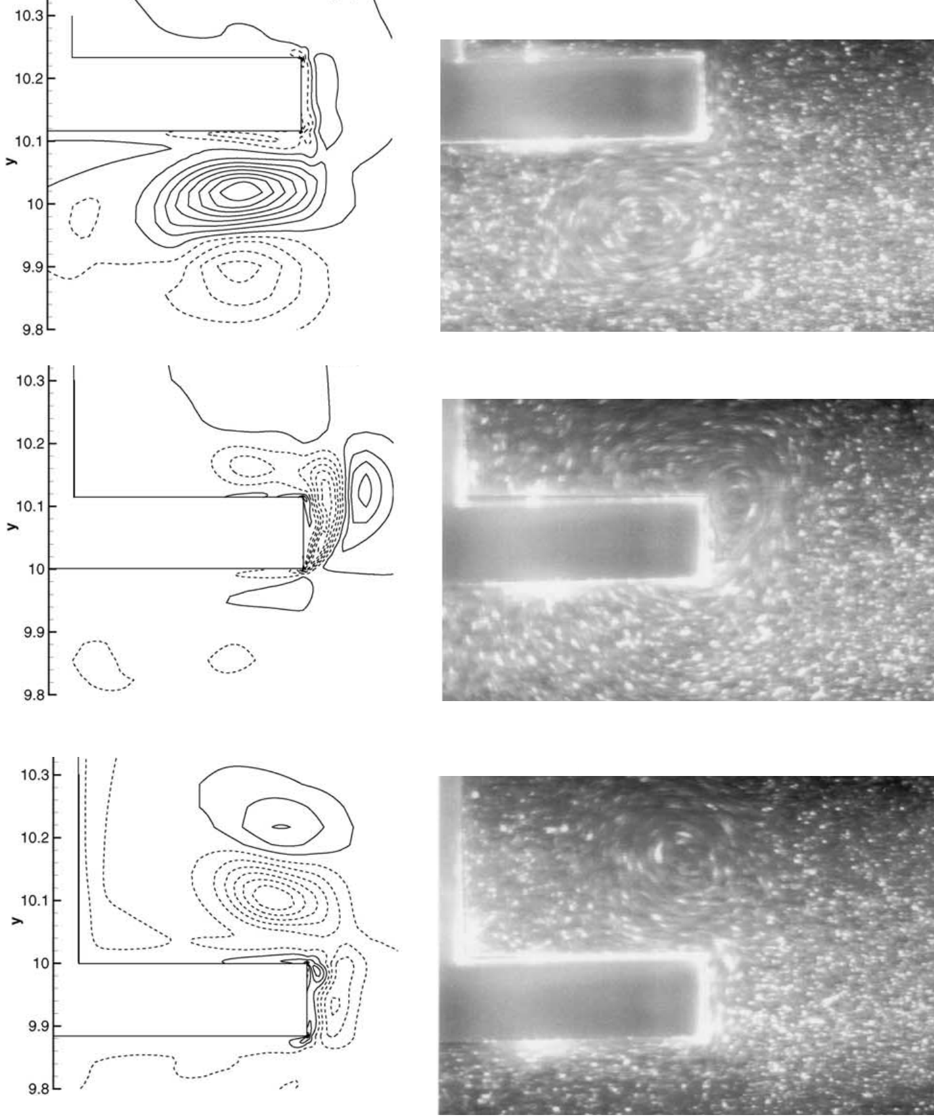
Figure 18 Vortical flow structure around the moving disc; KC=0.197, β=13 320 and thickness to diameter ratio of the disc is 0.00417; dashed lines indicate negative vorticity (Tao and Thiagarajan, 2003a).

Effect of rotational speed
So far we have discussed investigations conducted on steady structures. The damping is generally constant over the period of time. During unsteady, rotating, condition, damping effect varies (Kareem and Gurley, 1996) and in fact it decreases as rotational speed increases because the damping is inversely proportional to the acting centrifugal force on the structure (Kielb and Abhari, 2001). Hydraulic turbines are generally operated at constant speed therefore damping effect over the period is nearly same. For transient conditions, where the runner speed changes with time, the vibration amplitudes may have profound effect in the absence of sufficient damping. Increasing runner speed increases the flow velocity in the blade passages and thus increased damping effect. On the other hand, as the runner speed increases, frequency and amplitudes of RSI increase. Sometimes RSI frequency reaches close to the runner natural frequency (or harmonic) and produce resonant amplitudes. Thus, small improvement in damping can be very much useful during rotating condition.
At high rotational speed, strong vortical flow in the blade passages is developed and causes high amplitude pressure pulsations (Trivedi et al., 2016b). The developed vortices in the freestream flow disturbs the boundary layer when flow achieves Reynolds number greater than its critical value (Kobayashi et al., 1983). This causes further breakdown of the boundary layer near the vibrating wall. The spiral vortices are appeared in the transition region which can be co-rotating, when the cross-flow instability is dominant, and counter-rotating, when centrifugal instability is dominant (Kobayashi, 1994). Kinetic energy released from the structure is not able dissipate completely before the next vibration cycle begins thus amplitudes increases as rotational speed. Due to slow diffusion, damping effect is negligible during that cycle. However, detailed study during the transient conditions and more experimental data would explain such phenomena in detail.

Challenges and concerns in damping measurement
In a hydraulic turbine, three types of damping effects are mainly observed: material damping, structure damping and hydrodynamic damping.
Material damping is associated with complex molecular interactions within the material; thus, this damping is dependent on the type of material and manufacturing and final finishing processes (Kareem and Gurley, 1996). Turbine runner and blades are manufactured using steel (damping ratio ≅ 0.01–0.04) and a mixture of the other hard metals, for example, nickel, chromium and carbon (<0.035%) to improve welding characteristics and magnetic particles (~100%) and are subject to heat treatment to improve the hardness (<325 Brinell), with Von Mises stress levels of 200 MPa–360 MPa being obtained, assuming a fatigue life of at least 50–70 years (Coutu et al., 2008). In general, metals exhibit linear damping in the case where the stress amplitude is less than the fatigue limit. The blades are made of materials with different layers and are then welded to the band and crown; therefore, it is difficult to estimate the exact damping effect during the design phase.
The structural damping is associated with the interaction between the runner and nearby components, i.e., the distributor, labyrinth seals, generator rotor and bearings. There is no surface-to-surface contact between the runner and distributor; therefore, a damping effect may not exist. For the labyrinth seals, the runner seals are in direct contact with the stationary seals. The seals experience both friction and deformation due to the movement of the runner and high-amplitude vibrations. The behavior of the seals during the bending, torsional and flexion mode of the runner under resonance conditions is not known (Rodriguez et al., 2012). Friction and surface-to-surface contact between the seals may induce damping and it requires further investigation along with the effects of the nearby structure on the runner natural frequency. The runner is directly attached to the main shaft, which is connected to the generator rotor and supported on the thrust block. The combined effect of the complete assembly on the added mass and damping would be different. Structural damping may have different characteristics when part of the structure (runner) is submerged in water and another part (shaft) is in air.
Material damping and structural damping are considered to be small with respect to hydrodynamic damping. The studies showed that the damping effect increases with the flow velocity. However, the investigated maximum flow velocity was 22 m s⁻¹. The flow velocity is lower than the flow velocity generally observed in high-head Francis turbines where the RSI effect is predominant and it becomes dangerous if it matches a natural frequency. Therefore, damping at high velocity is yet to investigate and more importantly, with increasing flow velocity, errors in damping measurement increase due to noise and turbulent flow conditions. Because the damping is related to the flow velocity and viscous effects on the surface of the materials, the role of the material roughness on the damping would be quite useful information.
The investigation of hydrodynamic damping within the context of hydropower presents several challenges because conditions when an actual turbine operates are completely different from those during laboratory testing. Unless all of the characteristics of the damping effects are well understood, it would be difficult to make predictions for the prototype runner. So far, studies have been conducted on a simple hydrofoil-type structure, which is usually manufactured using one material and does not include welding or joints as observed between the runner crown and blade. Damping measurements on T-joints and/or I-sections may provide further useful information about the hydrodynamic damping in the runner. The main limitation is the lack of robust measurement techniques and availability of instruments. Currently, damping effects are investigated using either spark-generated bubbles or piezoelectric patches made of macro fiber composite material. Piezoelectric patches are widely used; however, this technique has limitations, including uncertainty at high velocity (Jeffers et al., 2000). Moreover, this technique disturbs the flow where the patches are mounted on the surface and the disturbed flow might change the damping effects. Importantly, fluid damping in the runner may be different at each location, for example, at the leading edge, band and crown junction to the blade trailing edge and runner cone; further, the damping may be dependent on the local flow condition as observed on the blades of compressible turbomachines (Vasanthakumar, 2011).
The prospective study should focus on the relations among RSI amplitude, natural frequency, added mass and damping for prototype operating conditions. The measurements indicate that the maximum damping is observed at BEP load and the low damping is observed at part-load operating conditions. However, flexible power generation trends force turbines to operate at off-design conditions where the damping is low and RSI effect is high.
Numerical techniques are widely applied to investigate the added mass and damping effect in the turbine runners. These techniques have certain limitations and fail to provide reliable estimates of the fluid damping if correct boundary conditions are not applied. The numerical results are dependent on several parameters such as mesh type, quality, mesh density, selected flow physics, degrees of freedom, size of time steps and modeling approaches. The coupled two-way techniques are expensive and time consuming. A single-degree-of-freedom approach is widely used because it requires only one simplifying assumption (mode-shape unchanged by flow) and reveals the dynamic behavior of the system in a straightforward manner. However, one disadvantage of this approach lies in the difficulty in extracting modal parameters at high flow velocities when high damping is present and numerical stability issues arise (Monette et al., 2014). Damping in turbomachinery blades has been an important parameter in the study of forced response and high cycle fatigue, but the physical nature of damping is yet to be fully understood. There is a minimal amount of published data on hydrodynamic damping in blades operating at variable speed.
Practical application to determination of hydrodynamic damping raises many open questions: (1) How effective the damping is when a turbine operates at BEP, off-design, runaway and SNL conditions? (2) What is the difference between damping estimated on an isolated one-blade structure to the complete runner? (3) Runner blades mainly experience bending and torsional mode shapes, can damping be improved for these two mode-shapes, if not for all mode-shapes? (4) Experimental study on a circular disc/plate showed the vortex shedding from upper and lower edge affect the damping at resonance condition. Considering geometrical similarity with the blade/guide vane trailing edge thickness where vortex shedding occurs at off-design load, can modification on blade/guide vane trailing edge help to quickly dissipate the energy and help to improve the damping? (5) During turbine operation, runner is in contact with upper and lower labyrinth seals. Can improving the seal design help to dissipate the kinetic energy released by runner through friction? (6) It is now known that the increasing flow velocity improves the damping effect. Can these characteristics and coupling mechanism help to increase the damping on the blade surface during resonance? (7) Flow velocity and boundary layer thickness is varying across the length of the blade. Thus, damping characteristics along the blade length are varying. Can damping effect be improved by improving the blade design, particularly where the damping is low? (8) Relative deformation of the structure has significant effect on the damping. Detailed study of blade deformation along the meridional plane is needed to understand local damping.

Summary
Hydropower is an important and stable source of electricity. Francis-type hydraulic turbines are widely used to meet electricity demands. Most are mid-head to high-head turbines. In Francis turbines, the main concern is the interaction of the runner blades and guide vanes under off-design conditions. High-amplitude pressure pulsations induced by RSI cause HCF damage to the runner. The frequency of RSI is sometimes close to the natural frequency of the runner under that operating condition, thereby producing resonance in the runner. Erroneous prediction/estimation of the runner natural frequency have sometimes resulted in catastrophic failure of the blades. Therefore, during the design phase, the RSI effect is seriously considered and efforts are made to avoid resonance conditions in the turbine. In case of resonance, damping is the key factor to be used to decrease vibrations and reduce HCF. Thus, hydrodynamic damping could be the very useful parameter when attempting to minimize the damage during resonance.
A majority of studies have investigated the added mass effect and change in natural frequency of the runner under different conditions. The results from the literature indicate that the frequency reduction ratio varies from 0.2 to 0.8 and is dependent on several parameters, mainly mode-shapes. The mode-shapes of the runner do not change when the runner is in contact with steady or flowing water. However, the order of the nodal-diameter varies and the cause is not known. The strongest effect of added mass was observed for the higher nodal-diameters. The study showed that the added mass effect varies with the blade profile and thickness of the band/crown. Overall, the study was conducted on a primary level; a more detailed investigation is required to understand the causes and to estimate the change in natural frequency when the runner is applied to power generation. Future study should consider the effect of operating conditions, cavitation, the role of labyrinth seals and blade profiles including trailing edge joined to the band and crown.
A proper study and understanding of the damping and its effect on the blades is needed during the resonance condition. Limited work has been conducted to investigate damping in hydraulic turbines, although it is an important parameter that can reduce the vibration amplitudes during resonance. Such work has been conducted on simple structures such as hydrofoils and thin plates. Conducted measurements indicated that the damping effect increases linearly with the flow velocity. However, the study did not discuss the dependency on the mode-shape, nodal-diameter or the flow condition. An understanding of how turbine structures behave under hydraulic loads is critical for estimating machine life. In addition to mass and stiffness, it is essential to understand damping and its contributing mechanisms to obtain accurate lifetime predictions; however, these are yet to be thoroughly investigated. One of the main concerns are the reliable prediction/estimation of the runner natural frequencies for prototypes under various operating conditions and avoiding catastrophic damage as observed at Hydro-Québec unit 1 of Ste-Marguerite 3 during April 2003 (Coutu et al., 2008).

References
Akcabay, D.T., Chae, E.J., Young, Y.L., Ducoin, A., Astolfi, J.A., 2014. Cavity induced vibration of flexible hydrofoils. J Fluid Struct 49, 463-484. doi:10.1016/j.jfluidstructs.2014.05.007.
Akcabay, D.T., Young, Y.L., 2014. Influence of cavitation on the hydroelastic stability of hydrofoils. J Fluid Struct 49, 170-185. doi:10.1016/j.jfluidstructs.2014.04.010.
Alligné, S., 2011, "Forced and self oscillations of hydraulic systems induced by cavitation vortex rope of Francis turbines,"Ph. D., École Polytechnique Fédérale de Lausanne, Lausanne.
Amromin, E.L., 2014. Design approach for cavitation tolerant hydrofoils and blades. J Fluid Struct 45, 96-106. doi:10.1016/j.jfluidstructs.2013.11.014.
Arpe, J., Nicolet, C., Avellan, F., 2009. Experimental evidence of hydroacoustic pressure waves in a Francis turbine elbow draft tube for low discharge conditions. J Fluid Eng-T Asme 131, 081102. doi:10.1115/1.3155944.
Askari, E., Jeong, K.-H., Amabili, M., 2013. Hydroelastic vibration of circular plates immersed in a liquid-filled container with free surface. J Sound Vib 332, 3064-3085. doi:10.1016/j.jsv.2013.01.007.
Aureli, M., Basaran, M.E., Porfiri, M., 2012. Nonlinear finite amplitude vibrations of sharp-edged beams in viscous fluids. J Sound Vib 331, 1624-1654. doi:10.1016/j.jsv.2011.12.007.
Ausoni, P., Farhat, M., Avellan, F., Escaler, X., Egusquiza, E., "Cavitation effects on fluid structure interaction in the case of a 2D hydrofoil," Proc. ASME Fluids Engineering Division Summer Conference, Houston, TX, USA, ASME, p. 6.
Ausoni, P., Farhat, M., Escaler, X., Egusquiza, E., Avellan, F., 2007. Cavitation influence on von kármán vortex shedding and induced hydrofoil vibrations. J Fluid Eng-T Asme 129, 966-973. doi:10.1115/1.2746907.
Bidkar, R.A., Kimber, M., Raman, A., Bajaj, A.K., Garimella, S.V., 2009. Nonlinear aerodynamic damping of sharp-edged flexible beams oscillating at low Keulegan-Carpenter numbers. Journal of Fluid Mechanics 634, 269-289. doi:10.1017/S0022112009007228.
Blevins, R.D., 2001. Flow-induced vibration, Second ed. Kriger Publishing Company, Florida, USA.1575241838.
Calhoun, R.J., Street, R.L., 2001. Turbulent flow over a wavy surface: Neutral case. J Geophys Res-Oceans 106, 9277-9293. doi:10.1029/2000jc900133.
Calhoun, R.J., Street, R.L., Koseff, J.R., 2001. Turbulent flow over a wavy surface: Stratified case. J Geophys Res-Oceans 106, 9295-9310. doi:10.1029/2001jc900002.
Carpinteri, A., Ronchei, C., Scorza, D., Vantadori, S., 2015. Fracture mechanics based approach to fatigue analysis of welded joints. Eng Fail Anal 49, 67-78. doi:10.1016/j.engfailanal.2014.12.021.
Cencîc, T., Hocevar, M., Sirok, B., 2014. Study of erosive cavitation detection in pump mode of pump–storage hydropower plant prototype. J Fluid Eng-T Asme 136, 051301. doi:10.1115/1.4026476.
Chaplin, J.R., 2000. Hydrodynamic damping of a cylinder at beta approximate to 10^6. J Fluid Struct 14, 1101-1117. doi:10.1006/jfls.2000.0318.
Chaplin, J.R., Retzler, C.H., 2001. Hydrodynamic damping of the vertical motion of a horizontal cylinder beneath waves at large scale. J Fluid Struct 15, 929-940. doi:10.1006/jfls.2001.0391.
Chaplin, J.R., Subbiah, K., 1998. Hydrodynamic damping of a cylinder in still water and in a transverse current. Appl Ocean Res 20, 251-259. doi:10.1016/S0141-1187(98)00023-6.
Chen, C., Nicolet, C., Yonezawa, K., Farhat, M., Avellan, F., Tsujimoto, Y., 2008. One-dimensional analysis of full load draft tube surge. J Fluid Eng-T Asme 130, 041106. doi:10.1115/1.2903475.
Chen, S.S., Jendrzejczyk, J.A., 1981. Flow Velocity Dependence of Damping in Tube Arrays Subjected to Liquid Cross-Flow. J Press Vess-T Asme 103, 130-135. doi:10.1115/1.3263377.
Chen, S.S., Wambsganss, M.W., Jendrzejczyk, J.A., 1976. Added Mass and Damping of a Vibrating Rod in Confined Viscous Fluids. Journal of Applied Mechanics 43, 325-329. doi:10.1115/1.3423833.
Conca, C., Osses, A., Planchard, J., 1997. Added mass and damping in fluid-structure interaction. Comput Method Appl M 146, 387-405. doi:10.1016/S0045-7825(96)01246-7.
Coutu, A., Proulx, D., Coulson, S., Demers, A., "Dynamic assesment of hydraulic turbines-high head Francis," Proc. Hydrovision 2004, Montreal, Canada, p. 13.
Coutu, A., Roy, M.D., Monette, C., Nennemann, B., "Experience with rotor-stator interactions in high head Francis runner," Proc. Proceedings of 24th IAHR symposium on hydraulic machinery and systems, Foz do Iguassu, Brazil, p. 10.
Coutu, A., Seeley, C., Monette, C., Nennemann, B., Marmont, H., "Damping measurements in flowing water," Proc. IOP Conference Series: Earth and Environmental Science, p. 062060. doi:10.1088/1755-1315/15/6/062060.
Crawley, E.F., 1983. Aerodynamic Damping Measurements in a Transonic Compressor. J Eng Power-T Asme 105, 575-584. doi:10.1115/82-GT-287.
De Santo, D.F., 1981. Added Mass and Hydrodynamic Damping of Perforated Plates Vibrating in Water. J Press Vess-T Asme 103, 175-182. doi:10.1115/1.3263384.
Dörfler, P., Sick, M., Coutu, A., 2013. Flow-induced pulsation and vibration in hydroelectric machinery, First ed. Springer-Verlag, London.978-1-4471-4251-5. doi:10.1007/978-1-4471-4252-2.
Dreyer, M., 2015, "Mind The Gap: Tip Leakage Vortex Dynamics and Cavitation in Axial Turbines,"PhD, Ecole Polytechnique Federale de Lausanne, Lausanne.
Ducoin, A., André Astolfi, J., Gobert, M.-L., 2012a. An experimental study of boundary-layer transition induced vibrations on a hydrofoil. J Fluid Struct 32, 37-51. doi:10.1016/j.jfluidstructs.2011.04.002.
Ducoin, A., André Astolfi, J., Sigrist, J.-F., 2012b. An experimental analysis of fluid structure interaction on a flexible hydrofoil in various flow regimes including cavitating flow. European Journal of Mechanics - B/Fluids 36, 63-74. doi:10.1016/j.euromechflu.2012.03.009.
Ducoin, A., Astolfi, J.A., Deniset, F., Sigrist, J.-F., 2009a. Computational and experimental investigation of flow over a transient pitching hydrofoil. European Journal of Mechanics - B/Fluids 28, 728-743. doi:10.1016/j.euromechflu.2009.06.001.
Ducoin, A., Deniset, F., Astolfi, J.A., Sigrist, J.F., 2009b. Numerical and Experimental Investigation of Hydrodynamic Characteristics of Deformable Hydrofoils. J Ship Res 53, 214-226.
Ducoin, A., Loiseau, J.C., Robinet, J.C., 2016. Numerical investigation of the interaction between laminar to turbulent transition and the wake of an airfoil. European Journal of Mechanics - B/Fluids 57, 231-248. doi:10.1016/j.euromechflu.2016.01.005.
Ducoin, A., Young, Y.L., 2013. Hydroelastic response and stability of a hydrofoil in viscous flow. J Fluid Struct 38, 40-57. doi:10.1016/j.jfluidstructs.2012.12.011.
Eagleson, P.S., Noutsopoulos, G.K., Daily, J.W., 1964. The Nature of Self-Excitation in the Flow-Induced Vibration of Flat Plates. Journal of Basic Engineering 86, 599-606. doi:10.1115/1.3653181.
Egusquiza, E., Valero, C., Huang, X.X., Jou, E., Guardo, A., Rodriguez, C., 2012. Failure investigation of a large pump-turbine runner. Eng Fail Anal 23, 27-34. doi:10.1016/j.engfailanal.2012.01.012.
Egusquiza, E., Valero, C., Liang, Q., Coussirat, M., Seidel, U., "Fluid added mass effect in the modal response of a pump-turbine impeller," Proc. Proceedings of the ASME 2009 International Design Engineering Technical Conference & Computers and Information in Enginneering Conference IDETC/CIE 2009, San Diego, California, USA, pp. 715-724. doi:10.1115/DETC2009-86830.
Escaler, X., Egusquiza, E., Farhat, M., Avellan, F., Coussirat, M., 2006. Detection of cavitation in hydraulic turbines. Mechanical systems and signal processing 20, 983-1007. doi:10.1016/j.ymssp.2004.08.006.
Escaler, X., Ekanger, J.V., Francke, H.H., Kjeldsen, M., Nielsen, T.K., 2015. Detection of draft tube surge and erosive blade cavitation in a full-scale Francis turbine. J Fluid Eng-T Asme 137, 011103. doi:10.1115/1.4027541.
Facchinetti, M.L., de Langre, E., Biolley, F., 2004. Coupling of structure and wake oscillators in vortex-induced vibrations. J Fluid Struct 19, 123-140. doi:10.1016/j.jfluidstructs.2003.12.004.
Facci, A.L., Porfiri, M., 2012. Nonlinear hydrodynamic damping of sharp-edged cantilevers in viscous fluids undergoing multi-harmonic base excitation. J Appl Phys 112 doi:10.1063/1.4769307.
Flores, M., Urquiza, G., Rodríguez, J.M., 2012. A fatigue analysis of a hydraulic Francis turbine runner. World Journal of Mechanics 02, 28-34. doi:10.4236/wjm.2012.21004.
Frunzǎverde, D., Muntean, S., Mǎrginean, G., Campian, V., Marşavina, L., Terzi, R., Şerban, V., "Failure analysis of a Francis turbine runner," Proc. IOP Conference Series: Earth and Environmental Science, 25th IAHR Symposium on Hydraulic Machinery and Systems, IOP Publishing, p. 012115. doi:10.1088/1755-1315/12/1/012115.
Gagnon, M., Tahan, S.A., Bocher, P., Thibault, D., "The role of high cycle fatigue (HCF) onset in Francis runner reliability," Proc. IOP Conference Series: Earth and Environmental Science, p. 022005. doi:10.1088/1755-1315/15/2/022005.
Green, C.P., Sader, J.E., 2002. Torsional frequency response of cantilever beams immersed in viscous fluids with applications to the atomic force microscope. J Appl Phys 92, 6262-6274. doi:10.1063/1.1512318.
Gruber, B., Carstens, V., 2001. The impact of viscous effects on the aerodynamic damping of vibrating transonic compressor blades - A numerical study. J Turbomach 123, 409-417. doi:10.1115/2000-GT-0383.
Guillaume, R., Deniau, J., Scolaro, D., Colombet, C., "Influence of the rotor-stator interaction on the dynamic stresses of Francis runners," Proc. IOP Conference Series: Earth and Environmental Science, 26th IAHR Symposiumon Hydraulic Machinery and Systems, IOP Publishing, p. 052011. doi:10.1088/1755-1315/15/5/052011.
Hasmatuchi, V., 2012, "Hydrodynamics of a pump-turbine operating at off-design conditions in generating mode,"Ph. D., École polytechnique fédérale de Lausanne, Lausanne.
Hasmatuchi, V., Farhat, M., Roth, S., Botero, F., Avellan, F., 2011. Experimental evidence of rotating stall in a pump-turbine at off-design conditions in generating mode. J Fluid Eng-T Asme 133, 051104. doi:10.1115/1.4004088.
Hasmatuchi, V., Roth, S., Botero, F., Avellan, F., Farhat, M., "High-speed flow visualization in a pump-turbine under off-design operating conditions," Proc. IOP Conference Series: Earth and Environmental Science, 25th IAHR Symposium on Hydraulic Machinery and Systems, IOP Publishing, p. 012059. doi:10.1088/1755-1315/12/1/012059.
Hengstler, J., 2013, "Influence of the Fluid-Structure Interaction on the Vibrations of Structures,"Ph. D., ETH Zurich, Switzerland.
Huang, B., Ducoin, A., Young, Y.L., 2013a. Physical and numerical investigation of cavitating flows around a pitching hydrofoil. Phys Fluids 25 doi:10.1063/1.4825156.
Huang, X., Chamberland-Lauzon, J., Oram, C., Klopfer, A., Ruchonnet, N., "Fatigue analyses of the prototype Francis runners based on site measurements and simulations," Proc. 27th IAHR Symposium Hydraulic Machinery and systems, Montreal, Canada, p. 8. doi:10.1088/1755-1315/22/1/012014.
Huang, X.X., Egusquiza, E., Valero, C., Presas, A., "Dynamic behaviour of pump-turbine runner: From disk to prototype runner," Proc. Iop Conf Ser-Mat Sci, p. 022036. doi:10.1088/1757-899x/52/2/022036.
Hübner, B., Seidel, U., Roth, S., "Application of fluid-structure coupling to predict the dynamic behavior of turbine components," Proc. IOP Conference Series: Earth and Environmental Science, 25th IAHR Symposium on Hydraulic Machinery and Systems, IOP Publishing, p. 012009. doi:10.1088/1755-1315/12/1/012009.
Huth, H.-J., 2005, "Fatigue design of hydraulic turbine runners,"Ph. D., Norwegian University of Science and Technology (NTNU), Trondheim.
IEC 60193, 1999. Hydraulic turbines, storage pumps and pump-turbines: Model acceptance tests, International standard, Second ed. International Electrotechnical Commission, 3, rue de Varembé, PO Box 131, CH-1211 Geneva 20, Switzerland. 16 November, p. 578.
Jeary, A.P., 1996. The description and measurement of nonlinear damping in structures. Journal of Wind Engineering and Industrial Aerodynamics 59, 103-114. doi:10.1016/0167-6105(96)00002-5.
Jeary, A.P., 1997. Damping in structures. Journal of Wind Engineering and Industrial Aerodynamics 72, 345-355. doi:10.1016/S0167-6105(97)00263-8.
Jeffers, T.R., Kielb, J.J., Abhari, R.S., "A novel technique for the measurement of blade damping using piezoelectric actuators," Proc. ASME Turbo Expo 2000: Power for Land, Sea, and Air, Munich, Germany, p. 11. doi:10.1115/2000-GT-0359.
Jeong, K.-H., 2003. Free vibration of two identical circular plates coupled with bounded fluid. J Sound Vib 260, 653-670. doi:10.1016/S0022-460X(02)01012-X.
Jeong, K.-H., Kim, K.-J., 2005. Hydroelastic vibration of a circular plate submerged in a bounded compressible fluid. J Sound Vib 283, 153-172. doi:10.1016/j.jsv.2004.04.029.
Jeong, K.-H., Yoo, G.-H., Lee, S.-C., 2004. Hydroelastic vibration of two identical rectangular plates. J Sound Vib 272, 539-555. doi:10.1016/S0022-460X(03)00383-3.
Jeong, K.H., Lee, G.M., Kim, T.W., 2009. Free vibration analysis of a circular plate partially in contact with a liquid. J Sound Vib 324, 194-208. doi:10.1016/j.jsv.2009.01.061.
Kareem, A., Gurley, K., 1996. Damping in structures: Its evaluation and treatment of uncertainty. Journal of Wind Engineering and Industrial Aerodynamics 59, 131-157. doi:10.1016/0167-6105(96)00004-9.
Keck, H., Sick, M., 2008. Thirty years of numerical flow simulation in hydraulic turbomachines. Acta Mech 201, 211-229. doi:10.1007/s00707-008-0060-4.
Kerboua, Y., Lakis, A.A., Thomas, M., Marcouiller, L., 2008. Vibration analysis of rectangular plates coupled with fluid. Appl Math Model 32, 2570-2586. doi:10.1016/j.apm.2007.09.004.
Khalak, A., Williamson, C.H.K., 1999. Motions, forces and mode transitions in vortex-induced vibrations at low mass-damping. J Fluid Struct 13, 813-851. doi:10.1006/jfls.1999.0236.
Kielb, J.J., Abhari, R.S., "Experimental study of aerodynamic and structural damping in a full-scale rotating turbine," Proc. ASME Turbo Expo 2001: Power for Land, Sea, and Air, Louisiana, USA, p. 9. doi:10.1115/2001-GT-0262.
Kimber, M., Lonergan, R., Garimella, S.V., 2009. Experimental study of aerodynamic damping in arrays of vibrating cantilevers. J Fluid Struct 25, 1334-1347. doi:10.1016/j.jfluidstructs.2009.07.003.
Kobayashi, R., 1994. Review: Laminar-to-Turbulent Transition of Three-Dimensional Boundary Layers on Rotating Bodies. J Fluid Eng-T Asme 116, 200-211. doi:10.1115/1.2910255.
Kobayashi, R., Kohama, Y., Kurosawa, M., 1983. Boundary-Layer-Transition on a Rotating Cone in Axial-Flow. Journal of Fluid Mechanics 127, 341-352. doi:10.1017/S002211208300275x.
Kumar, P., Saini, R.P., 2010. Study of cavitation in hydro turbines—A review. Renewable and Sustainable Energy Reviews 14, 374-383. doi:10.1016/j.rser.2009.07.024.
Leehey, P., 1988. Structural Excitation by a Turbulent Boundary-Layer - an Overview. J Vib Acoust 110, 220-225. doi:10.1115/1.3269502.
Li, H.D., He, L., 2005. Blade aerodynamic damping variation with rotor-stator gap: A computational study using single-passage approach. J Turbomach 127, 573-579. doi:10.1115/1.1928932.
Liang, Q.W., Rodriguez, C.G., Egusquiza, E., Escaler, X., Farhat, M., Avellan, F., 2007. Numerical simulation of fluid added mass effect on a Francis turbine runner. Comput Fluids 36, 1106-1118. doi:10.1016/j.compfluid.2006.08.007.
Llu, D., Liu, S., Wu, Y., Liu, X.-b., "Numerical simulation of hydraulic turbine based on fluid-structure coupling," Proc. The 4th International Symposium on Fluid Machinery and Fluid Engineering, Beijing, China, Xu, J., Wu, Y., Zhang, Y., Zhang, J., eds., Springer, p. 6.
Luo, Y., Wang, Z., Zhang, J., Zeng, J., Lin, J., Wang, G., 2013. Vibration and fatigue caused by pressure pulsations originating in the vaneless space for a kaplan turbine with high head. Engineering Computations 30, 448-463. doi:10.1108/02644401311314376.
Magnoli, M.V., 2014, "Numerical simulation of pressure oscillations in large Francis turbines at partial and full load operating conditions and their effects on the runner structural behaviour and fatigue life,"Ph. D., Technische Universitat Munchen.
Mare, L., Imregun, M., Green, J.S., Sayma, A.I., 2010. A numerical study of labyrinth seal flutter. Journal of Tribology 132, 022201-022201. doi:10.1115/1.3204774.
Monette, C., Nennemann, B., Seeley, C., Coutu, A., Marmont, H., "Hydro-dynamic damping theory in flowing water," Proc. IOP Conf. Series: Earth and Environmental Science, IOP Publishing, pp. 32044-32053. doi:10.1088/1755-1315/22/3/032044.
Nicolet, C., 2007, "Hydroacoustic modelling and numerical simulation of unsteady operation of hydroelectric systems,"Ph. D., Ecole Polytechnique Federale de Lausanne, Lausanne.
Phan, C.N., Aureli, M., Porfiri, M., 2013. Finite amplitude vibrations of cantilevers of rectangular cross sections in viscous fluids. J Fluid Struct 40, 52-69. doi:10.1016/j.jfluidstructs.2013.03.013.
Poll, H.G., Zanutto, J.C., Ponge-Ferreira, W., 2006. Hydraulic power plant machine dynamic diagnosis. Shock and Vibration 13, 409-427. doi:10.1155/2006/203834.
Presas, A., Valentin, D., Egusquiza, E., Valero, C., Seidel, U., 2015a. Influence of the rotation on the natural frequencies of a submerged-confined disk in water. J Sound Vib 337, 161-180. doi:10.1016/j.jsv.2014.10.032.
Presas, A., Valentin, D., Egusquiza, E., Valero, C., Seidel, U., 2015b. On the detection of natural frequencies and mode shapes of submerged rotating disk-like structures from the casing. Mechanical Systems and Signal Processing 60-61, 547-570. doi:10.1016/j.ymssp.2015.01.013.
Rodriguez, C.G., Egusquiza, E., Escaler, X., Liang, Q.W., Avellan, F., 2006. Experimental investigation of added mass effects on a Francis turbine runner in still water. J Fluid Struct 22, 699-712. doi:10.1016/j.jfluidstructs.2006.04.001.
Rodriguez, C.G., Egusquiza, E., Santos, I.F., 2007. Frequencies in the vibration induced by the rotor stator interaction in a centrifugal pump turbine. J Fluid Eng-T Asme 129, 1428-1435. doi:10.1115/1.2786489.
Rodriguez, C.G., Flores, P., Pierart, F.G., Contzen, L.R., Egusquiza, E., 2012. Capability of structural–acoustical fsi numerical model to predict natural frequencies of submerged structures with nearby rigid surfaces. Comput Fluids 64, 117-126. doi:10.1016/j.compfluid.2012.05.011.
Roth, S., Calmon, M., Farhat, M., Muench, C., Huebner, B., Avellan, F., "Hydrodynamic damping identification from an impulse response of a vibrating blade," Proc. 3rd IAHR International Meeting of the Workgroup on Cavitation and Dynamic Problems in Hydraulic Machinery and Systems, Brno, Czech Republic, p. 8.
Roth, S., Hasmatuchi, V., Botero, F., Farhat, M., Avellan, F., "Advanced instrumentation for measuring fluid-structure coupling phenomena in the guide vanes cascade of a pump-turbine scale model," Proc. ASME 2010 3rd Joint US-European Fluids Engineering Summer Meeting collocated with 8th International Conference on Nanochannels, Microchannels, and Minichannels, Montreal, Canada, American Society of Mechanical Engineers, pp. 585-597.
Roth, S., Hasmatuchi, V., Botero, F., Farhat, M., Avellan, F., "Fluid-structure coupling in the guide vanes cascade of a pump-turbine scale model," Proc. IOP Conference Series: Earth and Environmental Science, IOP Publishing, p. 012074. doi:10.1088/1755-1315/12/1/012074.
Roth, S., Hasmatuchi, V., Botero, F., Farhat, M., Avellan, F., "Influence of the pump-turbine guide vanes vibrations on the pressure fluctuations in the rotor-stator vaneless gap," Proc. 4th International Meeting on Cavitation and Dynamic Problems in Hydraulic MAchinery and Systems, Belgrade, Serbia, p. 11.
Rus, T., Dular, M., Sirok, B., Hocevar, M., Kern, I., 2007. An investigation of the relationship between acoustic emission, vibration, noise, and cavitation structures on a Kaplan turbine. J Fluid Eng-T Asme 129, 1112-1122. doi:10.1115/1.2754313.
Sader, J.E., 1998. Frequency response of cantilever beams immersed in viscous fluids with applications to the atomic force microscope. J Appl Phys 84, 64-76. doi:10.1063/1.368002.
Saeed, R.A., Galybin, A.N., Popov, V., 2010. Modelling of flow-induced stresses in a Francis turbine runner. Advances in Engineering Software 41, 1245-1255. doi:10.1016/j.advengsoft.2010.09.001.
Sarpkaya, T., 1963. Lift, Drag, and Added-Mass Coefficients for a Circular Cylinder Immersed in a Time-Dependent Flow. Journal of Applied Mechanics 30, 13-15. doi:10.1115/1.3630062.
Sarpkaya, T., 1995. Hydrodynamic Damping, Flow-Induced Oscillations, and Biharmonic Response. Journal of Offshore Mechanics and Arctic Engineering 117, 232-238. doi:10.1115/1.2827228.
Sarpkaya, T., 2001. Hydrodynamic damping and quasi-coherent structures at large Stokes numbers. J Fluid Struct 15, 909-928. doi:10.1006/jfls.2001.0384.
Sarpkaya, T., 2004. A critical review of the intrinsic nature of vortex-induced vibrations. J Fluid Struct 19, 389-447. doi:10.1016/j.jfluidstructs.2004.02.005.
Sarpkaya, T., 2005. On the parameter β=Re/KC=D^2/νT. J Fluid Struct 21, 435-440. doi:10.1016/j.jfluidstructs.2005.08.007.
Sarpkaya, T., 2006. Force on a circular cylinder in viscous oscillatory flow at low keulegan—carpenter numbers. Journal of Fluid Mechanics 165, 61. doi:10.1017/s0022112086002999.
Sawin, J.L., Sverrisson, F., Rickerson, W., 2015. Renewables 2015 global status report, in: Mastny, L. (Ed.). Renewable Energy Policy Network for 21st Century, REN21 Secretariat, Paris, France, p. 251.
Seeley, C., Coutu, A., Monette, C., Nennemann, B., Marmont, H., 2012. Characterization of hydrofoil damping due to fluid–structure interaction using piezocomposite actuators. Smart Materials and Structures 21, 035027. doi:10.1088/0964-1726/21/3/035027.
Seidel, U., Mende, C., Hübner, B., Weber, W., Otto, A., "Dynamic loads in Francis runners and their impact on fatigue life," Proc. IOP Conference Series: Earth and Environmental Science, Montreal, Canada, p. 9. doi:10.1088/1755-1315/22/3/032054.
Simpson, R.L., 1989. Turbulent Boundary-Layer Separation. Annu Rev Fluid Mech 21, 205-234. doi:10.1146/annurev.fl.21.010189.001225.
Simpson, R.L., Ghodbane, M., Mcgrath, B.E., 1987. Surface Pressure-Fluctuations in a Separating Turbulent Boundary-Layer. Journal of Fluid Mechanics 177, 167-186. doi:10.1017/S0022112087000909.
Simpson, R.L., Strickland, J.H., Barr, P.W., 1977. Features of a Separating Turbulent Boundary-Layer in Vicinity of Separation. Journal of Fluid Mechanics 79, 553-594. doi:10.1017/S0022112077000329.
Tao, L.B., Thiagarajan, K., 2003a. Low KC flow regimes of oscillating sharp edges I. Vortex shedding observation. Appl Ocean Res 25, 21-35. doi:10.1016/S0141-1187(03)00031-2.
Tao, L.B., Thiagarajan, K., 2003b. Low KC flow regimes of oscillating sharp edges. II. Hydrodynamic forces. Appl Ocean Res 25, 53-62. doi:10.1016/S0141-1187(03)00046-4.
Thibault, D., Gagnon, M., Godin, S., "Bridging the gap between metallurgy and fatigue reliability of hydraulic turbine runners," Proc. IOP Conference Series: Earth and Environmental Science, p. 012019. doi:10.1088/1755-1315/22/1/012019.
Torre, O.D.L., Escaler, X., Egusquiza, E., Farhat, M., 2013. Experimental investigation of added mass effects on a hydrofoil under cavitation conditions. J Fluid Struct 39, 173-187. doi:10.1016/j.jfluidstructs.2013.01.008.
Trivedi, C., Cervantes, M., Dahlhaug, O., Gandhi, B., 2015a. Experimental investigation of a high head Francis turbine during spin-no-load operation. J Fluid Eng-T Asme 137, 061106. doi:10.1115/1.4029729.
Trivedi, C., Cervantes, M., Gandhi, B., Dahlhaug, O., 2014a. Experimental investigations of transient pressure variations in a high head model Francis turbine during start-up and shutdown. J Hydrodyn 26, 277-290. doi:10.1016/S1001-6058(14)60031-7.
Trivedi, C., Cervantes, M., Gandhi, B., Dahlhaug, O., 2014b. Pressure measurements on a high-head Francis turbine during load acceptance and rejection. J Hydraul Res 52, 283-297. doi:10.1080/00221686.2013.854846.
Trivedi, C., Cervantes, M., Gandhi, B., Dahlhaug, O., 2014c. Transient pressure measurements on a high head model Francis turbine during emergency shutdown, total load rejection, and runaway. J Fluid Eng-T Asme 136, 121107. doi:10.1115/1.4027794.
Trivedi, C., Cervantes, M., Gandhi, B., Dahlhaug, O.G., 2013a. Experimental and numerical studies for a high head Francis turbine at several operating points. J Fluid Eng-T Asme 135, 1111021-1111017. doi:10.1115/1.4024805.
Trivedi, C., Cervantes, M.J., Dahlhaug, O.G., 2016a. Numerical techniques applied to hydraulic turbines: A perspective review. Applied Mechanics Reviews 68, 29. doi:10.1115/1.4032681.
Trivedi, C., Cervantes, M.J., Gandhi, B.K., 2016b. Numerical investigation and validation of a Francis turbine at runaway operating conditions. Energies 9, 22. doi:10.3390/en9030149.
Trivedi, C., Gandhi, B., Cervantes, M., 2013b. Effect of transients on Francis turbine runner life: A review. J Hydraul Res 51, 121-132. doi:10.1080/00221686.2012.732971.
Trivedi, C., Gandhi, B., Cervantes, M., Dahlhaug, O., 2015b. Experimental investigations of a model Francis turbine during shutdown at synchronous speed. Renewable Energy 83, 828-836. doi:10.1016/j.renene.2015.05.026.
Trudel, A., Sabourin, M., "Metallurgical and fatigue assessments of welds in cast welded hydraulic turbine runners," Proc. IOP Conference Series: Earth and Environmental Science, p. 012015. doi:10.1088/1755-1315/22/1/012015.
Vandiver, J.K., 2012. Damping parameters for flow-induced vibration. J Fluid Struct 35, 105-119. doi:10.1016/j.jfluidstructs.2012.07.002.
Vandiver, J.K., Chung, T.Y., 1989. Hydrodynamic Damping on Flexible Cylinders in Sheared Flow. J Waterw Port C-Asce 115, 154-171. doi:10.1061/(ASCE)0733-950X(1989)115:2(154).
Vasanthakumar, P., "Computation of aerodynamic damping for flutter analysis of a transonic fan," Proc. ASME 2011 Turbo Expo: Turbine Technical Conference and Exposition, American Society of Mechanical Engineers, pp. 1429-1437. doi:10.1115/GT2011-46597.
Venkat, N.K., Spaulding, M., 1991. A Numerical-Model to Predict the Nonlinear Response of External Flow over Vibrating Bodies (Planar Flow). J Fluid Eng-T Asme 113, 544-554. doi:10.1115/1.2926513.
Venkat, N.K., Spaulding, M., 1992. Nonlinear Response of Planar Laminar-Flow over a Flat-Plate Vibrating in Different Modes. J Fluid Eng-T Asme 114, 577-584. doi:10.1115/1.2910070.
Venkat, N.K., Spaulding, M., 1993. Influence of Vibration Amplitude on Laminar-Flow over a Plate Vibrating at Low Strouhal Number. J Fluid Eng-T Asme 115, 411-419. doi:10.1115/1.2910154.
Volfson, D., Vinals, J., 2001. Flow induced by a randomly vibrating boundary. Journal of Fluid Mechanics 432, 387-408.
Wang, X.F., Li, H.L., Zhu, F.W., "The calculation of fluid-structure interaction and fatigue analysis for Francis turbine runner," Proc. IOP Conference Series: Earth and Environmental Science, p. 052014. doi:10.1088/1755-1315/15/5/052014.
Wilkie, W.K., Bryant, R.G., High, J.W., Fox, R.L., Hellbaum, R.F., Jalink, J.A., Little, B.D., Mirick, P.H., "Low-cost piezocomposite actuator for structural control applications," Proc. Smart Structures and Materials 2000: Industrial and Commercial Applications of Smart Structures Technologies, CA, USA, Jacobs, J.H., ed., pp. 323-334. doi:10.1117/12.388175.
Wilkie, W.K., Inman, D.J., Lloyd, J.M., High, J.W., 2006. Anisotropic laminar piezocomposite actuator incorporating machined pmn–pt single-crystal fibers. Journal of Intelligent Material Systems and Structures 17, 15-28. doi:10.1177/1045389X06055891.
Williamson, C.H.K., Govardhan, R., 2008. A brief review of recent results in vortex-induced vibrations. Journal of Wind Engineering and Industrial Aerodynamics 96, 713-735. doi:10.1016/j.jweia.2007.06.019.
Wu, Y., Li, S., Liu, S., Dou, H.-S., Qian, Z., 2013. Vibration of hydraulic machinery. Springer Netherlands.978-94-007-6422-4
978-94-007-6421-7. doi:10.1007/978-94-007-6422-4.
Yadykin, Y., Tenetov, V., Levin, D., 2003. The added mass of a flexible plate oscillating in a fluid. J Fluid Struct 17, 115-123. doi:10.1016/S0889-9746(02)00100-7.
Yan, J., Koutnik, J., Seidel, U., Huebner, B., "Compressible simulation of rotor-stator interaction in pump-turbines," Proc. IOP Conference Series: Earth and Environmental Science, IOP Publishing, p. 012008. doi:10.1088/1755-1315/12/1/012008.
Yang, S.S., Kong, F.Y., Chen, H., Su, X.H., 2012. Effects of blade wrap angle influencing a pump as turbine. J Fluid Eng-T Asme 134, 061102. doi:10.1115/1.4006677.
Yao, Z., Wang, F., Dreyer, M., Farhat, M., 2014. Effect of trailing edge shape on hydrodynamic damping for a hydrofoil. J Fluid Struct 51, 189-198. doi:10.1016/j.jfluidstructs.2014.09.003.
Yexiang, X., Zhengwei, W., Zongguo, Y., 2011. Experimental and numerical analysis of blade channel vortices in a Francis turbine runner. Engineering Computations 28, 154-171. doi:10.1108/02644401111109204.
Yin, J., Wang, D., Wang, L., Wu, Y., Wei, X., "Effects of water compressibility on the pressure fluctuation prediction in pump turbine," Proc. IOP Conference Series: Earth and Environmental Science, 26th IAHRSymposiumonHydraulicMachineryandSystems, IOP Publishing, p. 062030. doi:10.1088/1755-1315/15/6/062030.
Zobeiri, A., 2009, "Investigations of time dependent flow phenomena in a turbine and a pump-turbine of Francis type: Rotor-stator interactions and precessing vortex rope,"Ph. D., École Polytechnique Fédérale de Lausanne, Lausanne.
Zuo, Z., Liu, S., Sun, Y., Wu, Y., 2015. Pressure fluctuations in the vaneless space of high-head pump-turbines—a review. Renewable and Sustainable Energy Reviews 41, 965-974. doi:10.1016/j.rser.2014.09.011.

