Electrochemical impedance spectroscopy of a porous graphite electrode used for Li-ion batteries with EC/PC based electrolytes

Carl Erik Lie Foss ª, Ann Mari Svensson ^{b}, Svein Sunde ª, and Fride Vullum-Bruer ^{a,}*
ª Department of Material Science and Engineering, Norwegian University of Science and Technology ,N-7491 Trondheim, NORWAY
^{b} SINTEF Materials and Chemistry, Norwegian University of Science and Technology, N-7491 Trondheim, NORWAY

Electrochemical impedance spectroscopy has been employed to investigate different electrolyte compositions used for lithium-ion batteries. Diffusion coefficients in ethylene carbonate (EC) was estimated to be in order of 10⁻⁷-10⁻¹¹ cm²/s, depending on the state of charge (SOC), and propylene carbonate (PC) based electrolytes has been estimated to be in the order 10⁻¹⁰-10⁻¹¹ cm²/s. Lithium bis(oxalato) borate (LiBOB) was used as an additive in the PC electrolytes to prevent exfoliation

Introduction

Lithium-ion batteries (LIB) are and have been an important power source for portable electronic applications for many years, but they have not been widely used for large scale applications like electrical vehicles (EV). The main reasons for this are safety issues, cycle life, cost, irreversible capacity loss (ICL), and poor thermal stability. Graphite has been the main choice for anode material in lithium ion batteries mainly because of its low cost and availability. It is therefore the material of choice for the current investigations.
Many of the problems of LIB are related to the formation of a solid electrolyte interface (1)(also called SEI layer) on the anode. SEI is a passivating film that forms during the first cycle of operation and consists mainly of decomposed species from the electrolyte. Its formation is important, as it protects the graphite from exfoliation. However, SEI is also the reason for most of the ICL since electrolyte species are trapped in the SEI film, and it can slow down or partially hinder diffusion of Li ions to and from the anode. In addition, the exothermic decomposition of the SEI at elevated temperatures contributes to decreased thermal stability of the battery and can cause thermal runaway.
With regards to thermal stability the choice of electrolyte is very important. Ethylene carbonate (EC) based electrolytes are often a common choice. Unfortunately, EC does not work well at low temperatures as it solidifies and the conductivity drops to practically zero (2). Propylene carbonate (PC) based electrolytes on the other hand, can operate at much lower temperatures than EC. The drawback of using PC is that it does not protect the graphite as well as EC against exfoliation, which causes a large capacity loss of the anode. LiBOB was therefore used as an electrolyte additive to help protect the graphite against exfoliation (3).
In this study, electrochemical impedance spectroscopy has been employed to find values for the diffusion coefficient estimated from the high frequency area. We have used a mathematical model previously developed by Meyers et al. (4), describing porous intercalation electrodes.
The goal has been to optimize this method to make it a valuable tool for quick characterization of different LIB systems with special attention towards electrolyte composition and its effect on SEI formation, which again influences the thermal stability.

Experimental

Graphite SLP30 was used as received from TIMCALTM. The SLP30 graphite electrodes were prepared by tape casting a slurry consisting of 37 g SLP30, 2 g PVDF (Kynar), 1 g Super P (TIMCALTM), and 60 g 1-methyl-2-Pyrrolidinone (Aldrich) onto a 10 μm thick Cu-foil current collector from Circuit foil Luxembourg. The tape caster was a “K Control Coater” from Printcoat instruments. The casts were then dried in a vacuum oven at 120 ºC overnight. The thickness of the casts was about 60 µm.
The electrolytes were made using varying amounts (see Table I) of ethylene carbonate (Sigma-Aldrich), diethyl carbonate (Aldrich), vinylene carbonate (VC) (Aldrich) and propylene carbonate (Sigma-Aldrich) with either 1 M LiPF₆ (Aldrich, >99.99%) or 1 M (0.95 LiPF₆ + 0.05 LiBOB) where Lithium bis-(oxalato) borate (Chemetall) contributed 5 wt% and LiPF₆ 95 wt%.
The electrochemical measurements for the impedance and cyclic voltammetry were performed using a three- electrode cell of the model “HS-3E test cell” by Hohsen Corp. The cells assembled in inert atmosphere inside an argon-filled glove-box (O₂ and H₂O < 0.1 ppm). The cells consisted of a graphite working electrode (8.04 cm²) with a loading of about 3 mg/cm², separator (Celguard® 2320), 0.75 mm thick lithium foil (6.16 cm²) as counter electrode, and a lithium strip as a reference electrode. All potentials are reported vs. Li/Li⁺ unless otherwise specified.
Cyclic and linear voltammetry, and electrochemical impedance were performed using a Reference 600 potentsiostat from Gamry instruments. The initial intercalation processes were performed by cyclic voltammetry at 0.2 mV/s between 0.005 and 1.5 V. Impedance measurements were performed at 100 and 1500 mV. The frequency was varied from 10 mHz to 1 MHz with an amplitude of 5 mV. All experiments were performed at room temperature (18-24 ºC) unless otherwise specified

Results and discussion

Fig. 1 illustrates a typical Nyquist plot from impedance measurements at 1500 mV before cycling.

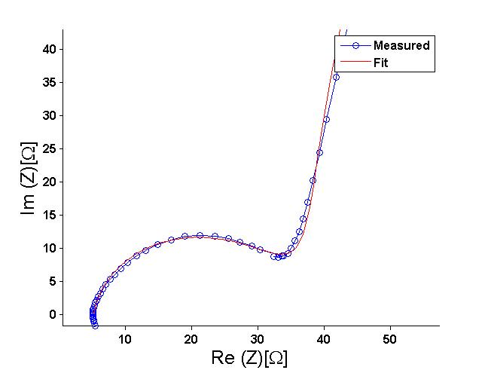
Figure 1: Electrochemical impedance spectroscopy of graphite SLP30 at 1500 mV before cycling (made by TIMCALTM). The fit is based on the single particle model presented by Meyers et al.(4).

The diffusion coefficients are estimated from the high frequency area of the impedance plots. From Meyers et al. (4) it was found that the faradaic impedance for a single particle with a resistive film formation in the high frequency area can be described by Eq. 1.

Z_{faradaic}≈R_{ct,1}+R_{part}/√(2Ω)(1-j)=R_{ct,1}+(-∂U/∂c_{s})(1/F)(2ωD_{s})^{-1/2}(1-j) [1]

From Eq. 1 it becomes clear that a plot of either the real or the imaginary part of the impedance vs. ω^{-1/2} will give a straight line for the high frequency area. Fig. 2 is a plot of the real and imaginary part of the impedance vs. ω^{-1/2} for graphite SLP30 in in 1:1 EC:DEC 1M LiPF₆ electrolyte at 1500 mV.

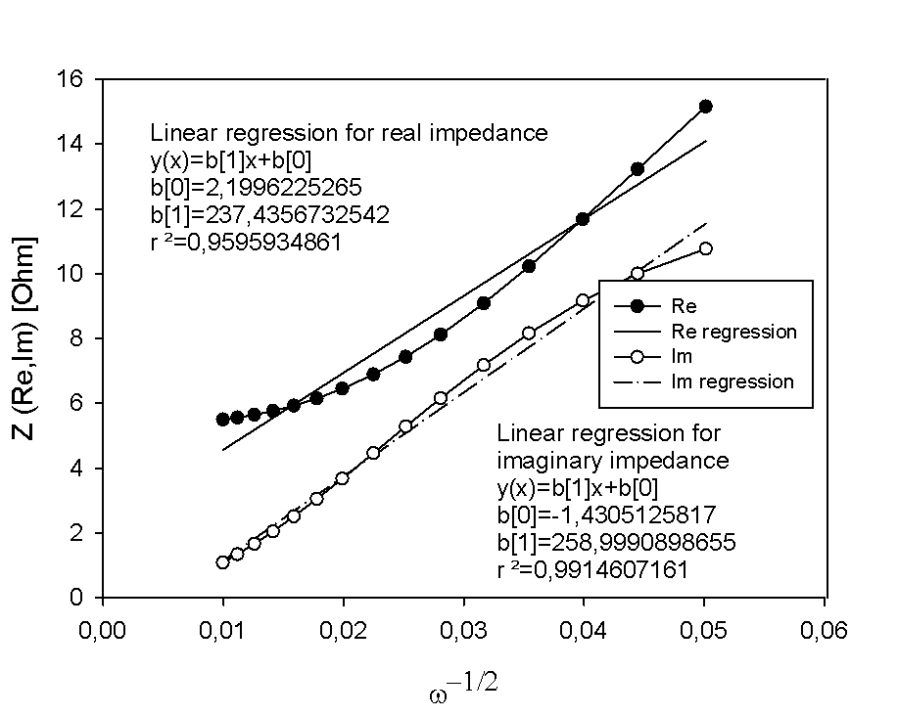

Figure 2: Electrochemical impedance spectroscopy of graphite SLP30 at 1500 mV in 1:1 EC:DEC 1M LiPF₆ electrolyte at 1500 mV.

According to Eq. 1 the data points for the real and imaginary part should be linear. It is clear from Fig. 2 that this is not the case. The imaginary part is in general more linear than the real part and was therefore used as the basis of our analysis. Sunde et al. (5) argues that it is better to base the impedance results on the imaginary part rather than the real part but that it is necessary to estimate the magnitude inductances disturbing the data at high frequency. In future work these inductances should be estimated and consequently subtracted.
With knowledge of how the concentration of intercalating species varies with the open circuit potential we can extract the diffusion coefficients from the slopes in Fig. 2 by combining it with Eq. 1. Table I summarizes different diffusion coefficients found by this approach. The measurements are done with three different electrolyte compositions and at two different potentials to investigate the difference in a sample with low and high state of charge (SOC).

TABLE I. Diffusion coefficient with various electrolytes at 1500 and 100 mV
Potential/  Electrolyte | 1:1 EC:DEC 1M LiPF₆ | 1:1 EC:DEC 1M LiPF₆ + 1% VC | 1:1 PC:DEC + 1 M (0.95 LiPF₆ + 0.05 LiBOB)
1500 mV | 9.38∙10-7 cm2/s | 1.9∙10-8 cm2/s | 1.69∙10-10 cm2/s
100 mV | 6.95∙10-11 cm2/s | 1.51∙10-10 cm2/s | 5.02∙10-11 cm2/s

From Table I we see that for all the samples the diffusion coefficients are lower for high SOC (100mV). This is reasonable since the lithium ions will face greater resistance in a lithiated sample compared to a de-lithiated sample. The sample with PC electrolyte shows considerably lower diffusion coefficients both at high and low SOC. Here, the addition of LiBOB did not protect the graphite completely from exfoliation. This can be seen in Fig. 3, where the area under the CV curve during the second cycle is far smaller than the initial cycle, indicating significant charge loss (most likely due to exfoliation).

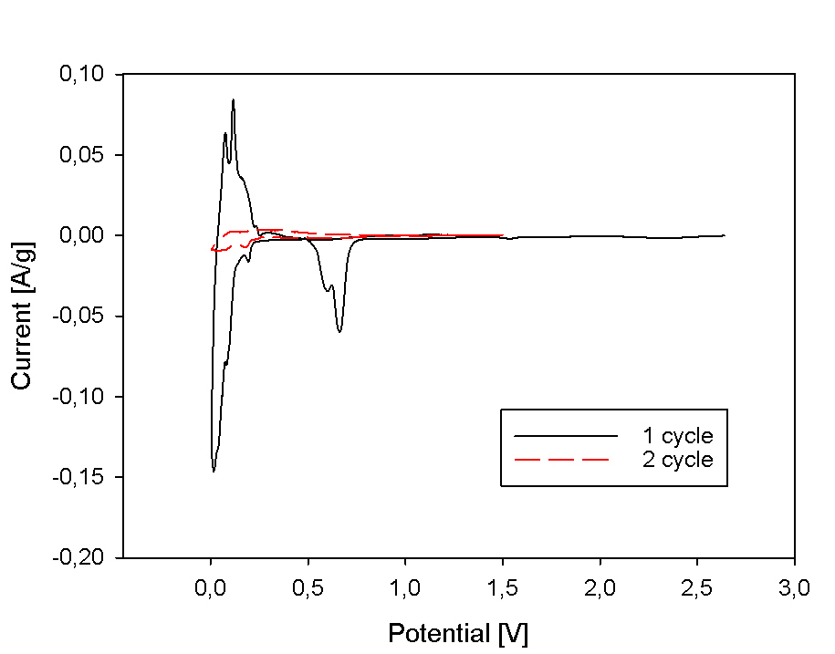
Figure 3. CV of graphite SLP30 for 1 M (0.95 LiPF₆ + 0.05 LiBOB) dissolved in 1:1 PC:DEC cycled at 0.01 mV/s.

The addition of VC yields a slightly lower diffusion coefficient at low SOC than the electrolyte without VC, but a higher diffusion coefficient at high SOC. This may be explained by VC initially adsorbing on the surface of the graphite, inhibiting the diffusion slightly, but as we go down in potential and the SOC is increasing, VC helps the diffusion indirectly by creating a more stable SEI layer and a more ordered structure. It is however difficult to conclude anything since these values are very similar and could be within experimental uncertainties
It should be mentioned that the extraction of diffusion coefficients by this method is very sensitive to the rate of change of the potential as a function of Li concentration in the graphite (-∂U/∂c_{s} in Eq. 1). This value will naturally be very large when the graphite is de-lithiated and become smaller as the SOC is increasing. In addition, since we are extracting the data from the high frequency area, we are only investigating the outer surface of the graphite particles and not the solid state diffusion to the centre of the particle. This may cause complications since at the surface we also have the SEI layer. Further investigations are therefore needed to take this into account and separate these effects.

Conclusion

Diffusion coefficients estimated from the high frequency area of the impedance plots for graphite SLP30 in various electrolytes has been presented. The value for how the open circuit potential varies with lithium concentration (∂U/∂c_{s}) is very dependent on SOC and therefore may cause uncertainties in the data, especially at low SOC where this value is very large and may change rapidly. Disturbances in the impedance data due to inductances should be estimated and corrected for in future work to ensure higher accuracy of the calculations.
Reasonable diffusion coefficients have been found for graphite SLP30. This method proves to be a useful tool when the goal is to compare different electrolyte compositions and perhaps also how various additives affect the transport mechanism at different SOC. In conclusion this is a useful technique that allows us to study the surface diffusion of graphite particles. However care must be taken when interpreting the data as inductances and the ∂U/∂c_{s} slope may cause erroneous results. Therefore the calculated diffusion coefficients should be regarded as estimates rather than exact values.

Acknowledgments

The Norwegian Research Council, SINTEF, and NTNU. The industrial partners, Elkem Carbon AS, Miljøbil Grenland AS and Carbontech Holding AS are acknowledged for their co-funding of the project.

References

1. E. Peled, Journal of the Electrochemical Society, 126, 2047-2051 (1979).
2. A. Ohta, H. Koshina, H. Okuno, and H. Murai, Journal of power sources, 54, 6-10 (1995).
3. C. Taubert, M. Fleischhammer, M. Wohlfahrt-Mehrens, U. Wietelmann, and T. Buhrmester, Journal of the Electrochemical Society, 157, A721-A728 (2010).
4. J.P. Meyers, M. Doyle, R.M. Darling, and J. Newman, Journal of the Electrochemical Society, 147, 2930-2940 (2000).
5. S. Sunde, I.A. Lervik, M. Tsypkin, and L.-E. Owe, Electrochimica Acta, 55, 7751-7760 (2010).

