PVA-assisted combustion synthesis and characterization of porous nanocomposite Li₂FeSiO₄/C
Haitao Zhou, Mari-Ann Einarsrud, Fride Vullum-Bruer*
Department of Materials Science and Engineering
Norwegian University of Science and Technology
7491 Trondheim, Norway

Abstract
Porous Li₂FeSiO₄/C nanocomposites were synthesized by a PVA-assisted combustion method, and phase pure Li₂FeSiO₄ was produced for samples prepared with 20 and 30 wt% starch. The electrochemical properties of the Li₂FeSiO₄/C composite were assessed using coin cells. The PVA-assisted combustion method gave materials with surface areas up to 37.7 m²/g and initial discharge capacity of 135 mAhg⁻¹ at a discharge rate of C/16 (C = 160 mAg⁻¹). Both phase purity and discharge capacity were highly sensitive to the amount of carbon precursor used in the synthesis, and a nominal carbon content of 20 % was found to give the best performance with respect to charge and discharge capacity.

Keywords: Lithium orthosilicate; carbon coating; combustion; nanostructuring; lithium ion battery
1 Introduction

Polyanion materials have attracted a great deal of interest as cathode material for lithium ion batteries. A silicate material such as Li₂MSiO₄ (M = Fe, Mn, Co, Ni) would in principle allow reversible extraction of two lithium ions, thus it should deliver higher capacity (333 mAhg⁻¹). This material also fulfills the need for potentially lower costs, high thermal stability through strong Si–O bonding, increased safety, and environmental friendliness [1], making the material attractive as cathode material for lithium ion batteries. Unfortunately, the Li₂FeSiO₄ cathode materials reported in literature have shown low rate capability, resulting from low electronic and ionic conductivities [2]. Carbon coating is an efficient way to enhance the charge transfer [3]. Nytén et al. and Gong et al. have developed a carbon coating process by mixing a Li-Fe-Si precursor with a carbon source, followed by heat treatment at high temperature [1, 4]. Although a high purity Li₂FeSiO₄/C composite can be obtained by this method [1], it still suffers from incomplete C-coating of the oxide. This is mainly due to agglomeration of the Li-Fe-Si precursor particles prior to the mixing with the carbon source [5, 6]. To obtain better electrochemical performance, nanostructured and porous Li₂FeSiO₄/C composites have more recently been synthesized by one-step sol-gel methods [7-10]. In this study, a two-step process using a PVA-assisted combustion method has been employed. A porous Li-Fe-Si precursor with large surface area has been synthesized and then mixed homogeneously with a carbon source in order to adjust the phase purity and achieve complete carbon coating. The performance of this composite material as cathode in Li-ion batteries has been explored.

2 Experimental

2.1 Synthesis
Li₂FeSiO₄ was synthesized by a wet chemical method, using aqueous acetate and nitrate solutions as metal precursors. The lithium precursor solution (5 M) was prepared by dissolving 0.1 mol Li(CH₃COO)·2H₂O (Sigma-Aldrich, reagent grade) in 20 ml distilled water. The iron precursor solution (1 M) was prepared by dissolving Fe(NO₃)₃·9H₂O (0.05 mol) (Sigma-Aldrich, >98%) in 50 ml distilled water. The concentration of metal cations in the aqueous Fe-solution was determined by thermogravimetry (weight of oxide after thermal treatment), while the concentration of Li cations was based on the mass and molecular weight of the salt. The silicon precursor solution was prepared by dissolving 0.05 mol tetraethyl orthosilicate (TEOS) (Aldrich, >99%) in 50 ml ethanol. Polyvinylalcohol (PVA) solution was prepared by dissolving 17 g PVA (Aldrich, Mowiol 10-98, Mw = 61000) in 50 ml distilled water at 150 °C.

A flow chart of the synthesis route for Li₂FeSiO₄ is shown in Fig. 1. The standardized Li and Fe precursor solutions were weighed and mixed. Ethanol (50 ml) was then added to the solution. The TEOS solution was added to this mixture under vigorous stirring to produce a transparent solution. Finally, the PVA solution was added and stirred at 70 °C for 5 h to ensure complete complexing of the metal cations. All the solutions displayed a red color after addition of the nitrate, which turned darker upon heating.

The homogenous solution of metal cations was poured into a tall insulated beaker, which was placed on a hot plate at 120 °C while stirring with a magnetic stirrer. After 5 h a transparent gel was formed. The gel was then heated on a hotplate to about 250 °C. After 1 h the dried gel self ignited and transformed into a fluffy powder. The powder was calcined at 500 °C for 2 h in synthetic air, in order to remove organic residue. This powder was then mixed with an aquesous starch (Sigma-Aldrich, reagent grade) solution and ground into a paste in an agate mortar. The powder mixtures (starch content = 1, 10, 20, 30, 40, and 50 wt%) were heat treated in a flowing argon atmosphere at 650 °C for 10 h.

Li₂FeSiO₄/C composite powder without PVA-assisted combustion was also prepared using the same precursors and wet chemical route. The gel was formed from the mixture of metal precursors and TEOS solutions without adding PVA. The gel was calcined at 500 °C for 2 h in synthetic air. The as-prepared powder mixed with 20 wt% starch was heat treated in flowing Ar atmosphere at 650 °C for 10 h.

2.2 Characterization
All the powders were analyzed by X-ray diffraction (XRD) using Cu Kα radiation (Bruker AXS D8 FOCUS diffractometer with a LynxEye PSD). Lattice parameters were calculated by the software TOPAS R (Bruker AXS) version 2.1. The crystallite size was calculated by the Scherrer equation:
(1)
where d_{XRD} is the crystallite size, λ is the X-ray wavelength (λ = 0.15406 nm), β is the full width at half maximum (FWHM) of the XRD peak in radians, and θ is the angle of the chosen XRD peak. Thermogravimetric analysis (TGA) of the as-prepared Li-Fe-Si powder was performed with a Netzsch STA 449 C Jupiter (Selb, Germany) in synthetic air using a 2 °C/min heating rate up to 900 °C. The surface area of the samples was determined by nitrogen adsorption (Tristar 3000). The morphology of the products was studied using scanning electron microscopy (SEM, Hitachi S- 3400N), and field emission scanning electron microscopy (FESEM, Hitachi S-4300SE)
The electrochemical properties of the Li₂FeSiO₄/C composite were assessed using CR2025 coin cells. The cathode was prepared by mixing 85 wt% of the Li₂FeSiO₄/C composite with 10 wt% Supper-P carbon black and 5 wt% poly-vinylidene fluoride (PVDF) (Kynar, reagent grade). A slurry was made by ball milling, using N-methyl-2-pyrrolidene (NMP) (Sigma-Aldrich, > 99%) as the solvent. The electrodes were formed by tape casting the slurry onto Al foil, followed by drying overnight at 120 °C in a vacuum furnace. A typical cathode loading was 3-5 mg/cm². Coin cells were assembled with the cathode, lithium metal as the anode and a Celgard 2400 film as the separator. The electrolyte used was 1 M LiPF₆ (Aldrich, ≥ 99.99%) dissolved in ethylene carbonate (Sigma, 99%) /diethyl carbonate (Aldrich, ≥ 99%) (3:7 volume ratio). Cell assembly was carried out in an argon-filled glove box, where water and oxygen concentrations were kept bellow 0.1 ppm. Charge-discharge analysis was performed galvanostatically between 1.5 and 4.5 V at room temperature. All reported capacities are quoted with respect to the mass of the Li₂FeSiO₄/C composite.

3 Results and Discussion

3.1 TG analysis of as-prepared Li-Fe-Si powder
In order to ensure complete removal of the carbon residue in the Li-Fe-Si powder after combustion, the calcination temperature was determined by thermogravimetric analysis. The results are shown in Fig. 2, and the weight loss curve can be divided into two stages. The first weight loss occurs around 80 °C and is due to the dehydration of physically absorbed water in the precursor. In the temperature range from 300 to 450 °C, decomposition and combustion of residual PVA in addition to decomposition of acetate, nitrate, and organosilicon compounds occur. The weight of the sample remains nearly constant above 500 °C and the total weight loss is 13 %. Based on these results, it was determined to calcine the as-prepared Li-Fe-Si powder at 500 °C for 3 h.

3.2 Effects of varying amounts of starch on the phase purity of the Li₂FeSiO₄/C composite
The XRD pattern of the Li-Fe-Si powder calcined in air at 500 °C for 3 h without using starch is provided in Fig. 3 (a) and shows that a mixture of Li_{0.5}Fe_{2.5}O₄ and Li₂SiO₃ is obtained. XRD patterns of the products prepared from the mixture of calcined Li-Fe-Si powder with varying starch amounts (1, 10, 20, 30, 40, and 50 wt%) calcined at 650 °C in argon atmosphere are also included in Fig. 3 (b-g). Fe₃O₄ and Li₂SiO₃ impurities were found in the products when the starch content was 1 wt% (b), which indicates that both Fe³⁺ and Fe²⁺ are present. Li₂FeSiO₄ could not be detected by XRD. Using 10 wt% starch (c), produced a powder which contained mostly Li₂FeSiO₄, but also significant amounts of Li₂SiO₃ and Fe₃O₄. Increasing the starch amount to 20 and 30 wt% (d and e) resulted in high purity Li₂FeSiO₄. However, when the amount of starch was increased even further, to 40 wt% (f), Li₂SiO₃ appeared in the product. At 50 wt% starch (g), Fe together with Li₂SiO₃ were found in the products, indicating that Fe²⁺ was reduced to metallic iron. An overview of the carbothermal reduction syntheses and products identified by XRD are presented in Table 1.

When the Li-Fe-Si powder mixed with starch was heat-treated in flowing Ar atmosphere, the starch pyrolysed, involving dehydration, formation of carbonyl groups, evolution of CO and CO₂, and formation of carbonaceous residue [11]. Carbon and CO produced by the starch pyrolysis could then react with the Li-Fe-Si powder to form a phase pure Li₂FeSiO₄/C composite for 20 and 30 wt% starch. Based on the Boudouard equilibrium [12], the reduction process is very sensitive to the oxygen partial pressure [13] and hence the amount of starch used. In this work, the pO₂ around the Li-Fe-Si particle was controlled by the amount of starch in the mixture. Lower starch mass ratios gave higher pO₂ and weakly reducing conditions, while higher starch mass ratios gave lower pO₂ and strongly reducing conditions. As shown in Fig. 3, when the starch mass ratio was between 20 and 30 wt%, high purity Li₂FeSiO₄ products were obtained. The Fe₃O₄ impurity was found when the starch mass ratio was 1 wt%, while metallic iron was formed at 50 wt%.

Fig. 4 shows the XRD patterns of the two Li₂FeSiO₄/C samples obtained by the wet chemical route with (a) and without (b) the PVA-assisted combustion process. Both powders were mixed with 20 wt% starch and calcined at 650 °C for 10 h in Ar atmosphere. The XRD patterns are nearly identical apart from one peak appearing at approximately 43° in Fig. 4a. This peach is most likely due to a small LiFeO₂ impurity. However, further studies are needed to verify this. The remaining diffraction peaks can be identified and indexed according to the P2₁/n space group [14]. The calculated lattice parameters were found to be a = 0.82287(5) nm, b = 0.5022(5) nm, c = 0.8228(9) nm, and β = 99.25(7)º. The mean crystallite size of sample (a) and sample (b) calculated using the Scherrer equation were found to be approximately 28 and 50 nm, respectively.

3.3 Effects of the PVA-assisted combustion on the morphology of Li₂FeSiO₄/C composite powders
The SEM image of the calcined Li-Fe-Si powder obtained from the PVA-assisted combustion is shown in Fig. 5 (a). The foam-like structure contained a large amount of pores interconnected in three dimensions with uniform pore morphology and distribution. Most of the pores are open and the pore sizes are about 1 μm. The loose and porous structure of the powder can be attributed to a significant gas evolution during the combustion reaction. The surface area of this powder was 37.7 m²/g. The Li₂FeSiO₄/C composite produced without using the PVA-assisted combustion process (Fig. 5 (b)), formed hard aggregates with low porosity after calcination in Ar atmosphere.

Fig. 5 (c) shows that the Li₂FeSiO₄/C composite produced using PVA-assisted combustion, maintained the porous morphology of the calcined Li-Fe-Si powder after the carbothermal reduction and carbon coating process. However, the surface area of the composite was somewhat reduced (23.4 m²/g) compared to that of the calcined Li-Fe-Si starting powder. The foam-like structure was broken down during the mixing of the calcined Li-Fe-Si powder and starch solution. The FE-SEM image of the Li₂FeSiO₄/C composite shown in the insert of Fig. 5 (c) indicates that the pore walls are composed of nano-sized primary crystallites. This is in agreement with the values calculated from the XRD data (Fig. 4), which gave an average grain size of 28 nm.

3.4 Electrochemical characterization
Fig. 6 shows the results of the initial specific charge/discharge capacity at a current density of C/16 (C = 160 mA g⁻¹) for the Li₂FeSiO₄/C composite prepared with PVA-assisted combustion and different starch contents. The discharge capacities of the samples with 10, 15, 20, 30, and 40 wt% starch were 25, 51, 135, 89, and 58 mAhg⁻¹, respectively.
It can be seen that the Li₂FeSiO₄/C sample prepared with 20 wt% starch has the highest specific charge/discharge capacity. This is partially due to the high phase purity obtained at this specific mass ratio, which was shown previously from the XRD pattern (Fig. 3). In addition, the amount of carbon coating on the pore walls will also affect the conductivity of the cathode material, which will influence the specific capacity of the system. The sample with 30 wt% starch which was of similar purity to the sample prepared with 20 wt% starch, also has a high specific discharge capacity. However, the charge capacity is inferior to the former, which might be explained by higher carbon residue contents, meaning that the relative amount of active material to carbon residue is decreased. The samples with 10, 15, and 40 wt% starch all have significantly lower specific discharge capacities. This is mostly due to the secondary phases and impurities present in the powder. In summary from Fig. 6, it can be stated that the discharge capacity increases up to 20 wt% starch, and then somewhere between 20 and 30 wt% there is a maximum at which the discharge capacity starts to decrease. It should be noted that the starch mass ratios referred to here are nominal values. Exact carbon content has not yet been established, and further studies are needed to find a correlation between the amount of starch used and the actual amount of residual carbon.

Fig. 7 shows results of the first and second cycle specific charge/discharge capacity at a current density of C/16 for the Li₂FeSiO₄/C powders prepared with and without the PVA-assisted combustion process. Both of the powders were mixed with 20 wt% starch and calcined at 650 °C for 10 h in Ar atmosphere. The sample prepared by the combustion process can deliver a discharge capacity of 135 mAhg⁻¹ during the first and second cycle, while the sample prepared without combustion can only deliver a discharge capacity of 70 mAhg⁻¹. This is mainly due to the morphology and increased surface area of the Li₂FeSiO₄/C composite powders.

The cycling performance of the Li₂FeSiO₄/C sample prepared with the PVA-assisted combustion process and 20 wt% starch is shown in Fig. 8. For the slowest rates (C/16, C = 160 mA g⁻¹), the discharge capacity maintains a value of 135 mAhg⁻¹ during the first five charge/discharge cycles. The Li₂FeSiO₄/C composite cathode can deliver a discharge capacity of 105 mAhg⁻¹ at a discharge rate of C/4 and a discharge capacity of 74 mAhg⁻¹ at a discharge rate of C.

The high capacity and cycling performance shown here can be attributed to the large surface area of the highly porous structure in addition to the carbon coating which improves the electronic conductivity of the composite. The high porosity allows the electrolyte to easily flow into the structure and cover the pore walls, ensuring a large contact area with the active Li₂FeSiO₄ nanocrystals. This effect induces fast lithium ion diffusion.

Conclusions
A PVA-assisted combustion method was developted to prepare porous Li₂FeSiO₄/C nanocomposites with high surface area. Carbon is assumed to cover the Li₂FeSiO₄ pore walls which are composed of nano-sized primary crystallites after the pyrolysis with starch. The phase purity and carbon-coating of the Li₂FeSiO₄/C composite was optimized by adjusting the starch content. The sample prepared by the PVA-assisted combustion method using 20 wt% starch can deliver a value of 135 mAhg⁻¹ at a discharge rate of C/16 (C = 160 mAg⁻¹) during the first and second charge/discharge cycles, which was much higher than the sample prepared without the combustion process. This improved result can be attributed to the high surface area, enhanced electronic conductivity, and nano-sized particles of the composite.
References
- A. Nytén, A. Abouimrane, M. Armand, T. Gustaffson, J.O. Thomas, Electrochem. Commun. 7 (2005) 156–160.

- R. Dominko, J.M. Goupil, M. Bele, M. Gaberscek, M. Remskar, D. Hanzel, J. Jamnik, J. Electrochem. Soc. 152 (2005) A858–A863.

- X. B. Huang, X. Li, H. Y. Wang, Z. L. Pan, M. Z. Qu, Z. L. Yu, Solid State Ionics. 181 (2010) 1451-1455.

- Z. L. Gong, Y. X. Li, G. N. He, J. Li, Y.Yang, Electrochem. Solid-State Lett. 11 (2008) A60-A63.

- R. Dominko, D. E. Conte, D. Hanzel, M. Gaberscek, J. Jamnik, J. Power Sources. 178 (2008) 842–847.

- A. A. Salah, A. Mauger, K. Zaghib, J. B. Goodenough, N. Ravet, M. Gauthier, F. Gendron and C. M. Julien, J. Electrochem. Soc.153 (2006) A1692-A1701.

- S. Zhang, C. Deng, S. Yang, Electrochem. Solid-State Lett. 12 (2009) A136-A139

- X. Y. Fan, Y. Li, J. J. Wang, L. Gou, P. Zhao, D. L. Li, L. Huang, S. G. Sun, J. Alloys Compd. 493 (2010) 77–80.

- K. C. Kam, T. Gustafsson, J. O. Thomas, Solid State Ionics 192 (2011) 356–359.

- D. P. Lv, W. Wen, X. K. Huang, J. Y. Bai, J. X. Mi, S. Q. Wu,Y. Yang, J. Mater. Chem. 21 (2011) 9506–9512.

- S. Zhao, C. Y. Wang, M. M. Chen, J. H. Sun, Carbon. 47 (2008) 313-347.

- M. Audier, M. Coulon, L. Bonnetain. Carbon, 21 (1983) 93-97.
- H. Wang, P. Hua, D. Pan, J. J. Tian, S. G Zhang, A. A. Volinsky, J. Alloys Compd. 502 (2010) 338-340.

- G. Mali, C. Sirisopanaporn, C. Masquelier, D. Hanzel, R. Dominko, Chem. Mater., 23 (2011) 2735–2744.

Table:

Table 1: Syntheses parameters and phase composition of materials before and after pyrolysis with starch.

Figures:

Fig. 1: Flow chart of PVA-assisted combustion synthesis routes for Li₂FeSiO₄/C composite.

Fig. 2: Thermogravimetric analysis (TGA) of the as-prepared Li-Fe-Si powder.

Fig. 3: XRD patterns of the calcined Li-Fe-Si powder (a) and the Li₂FeSiO₄/C composite (b-g) prepared from the mixture with varying starch contents (1, 10, 20, 30, 40, and 50 wt%) calcined at 650 °C in argon atmosphere.

Fig. 4: XRD patterns of two Li₂FeSiO₄/C samples obtained by the wet chemical route using 20 wt% starch with (a) and without (b) the PVA-assisted combustion process.

Fig. 5: (a) SEM images of Li-Fe-Si powder obtained from the PVA-assisted combustion process and calcined at 500 °C. (b) SEM image of Li₂FeSiO₄/C composite prepared by wet chemical methods without PVA-assisted combustion. (c) Back scattered electron (BSE) and FE-SEM images (insert) of Li₂FeSiO₄/C composites prepared by the PVA-assisted combustion method with 20 wt% starch.

Fig. 6: Initial specific charge/discharge capacity for the Li₂FeSiO₄/C powder prepared from different starch contents at a current density of C/16 (C = 160 mAg⁻¹).

Fig. 7: First and second cycle specific charge/discharge capacity for the Li₂FeSiO₄/C powders prepared with and without the PVA-assisted combustion process.

Fig. 8: Cycling performance of the Li₂FeSiO₄/C composite prepared by the PVA-assisted combustion process with 20 wt% starch.

Table 1

Synthesis | Phase composition after calcination | Phase composition after addition of starch
PVA-assisted synthesis
Calcined Li-Fe-Si powder | Li_{0.5}Fe_{2.5}O₄ ,Li₂SiO₃
1 wt% starch |  | Fe₃O₄, Li₂SiO₃
10 wt% starch |  | Li₂FeSiO₄, Li₂SiO₃, Fe₃O₄
20 wt% starch |  | Li₂FeSiO₄
30 wt% starch |  | Li₂FeSiO₄
40 wt% starch |  | Li₂FeSiO_{4,} Li₂SiO₃
50 wt% starch |  | Li₂FeSiO_{4,} Fe
No PVA
Calcined Li-Fe-Si powder | Li_{0.5}Fe_{2.5}O₄ ,Li₂SiO₃
20 wt% starch |  | Li₂FeSiO₄

TEOS ethanol
Fe (NO₃)₃·9H₂O
Stirring at room temperature
Li acetate (aq)
Fe nitrate (aq)
TGA
Adding ethanol into the solution
Li acetate and Fe nitrate solution
TEOS
LiCH₃COO·2H₂O
Li-Fe-Si transparent solution
PVA solution (aq)
Stirring at 70 °C
Li Fe Si-PVA complexed solution
Heating at 120 °C
Li-Fe-Si gel
Starch solution
Calcined Li-Fe-Si powder and starch
Heat treatment in Ar atmosphere at 650 °C for 10 h
Li₂FeSiO₄/C composite
Mix and grind in a mortar
Heating 250 °C
As-prepared Li-Fe-Si powder
Calcined Li-Fe-Si powder
Calcination at 500 °C for 2 h
TGA
Fig. 1

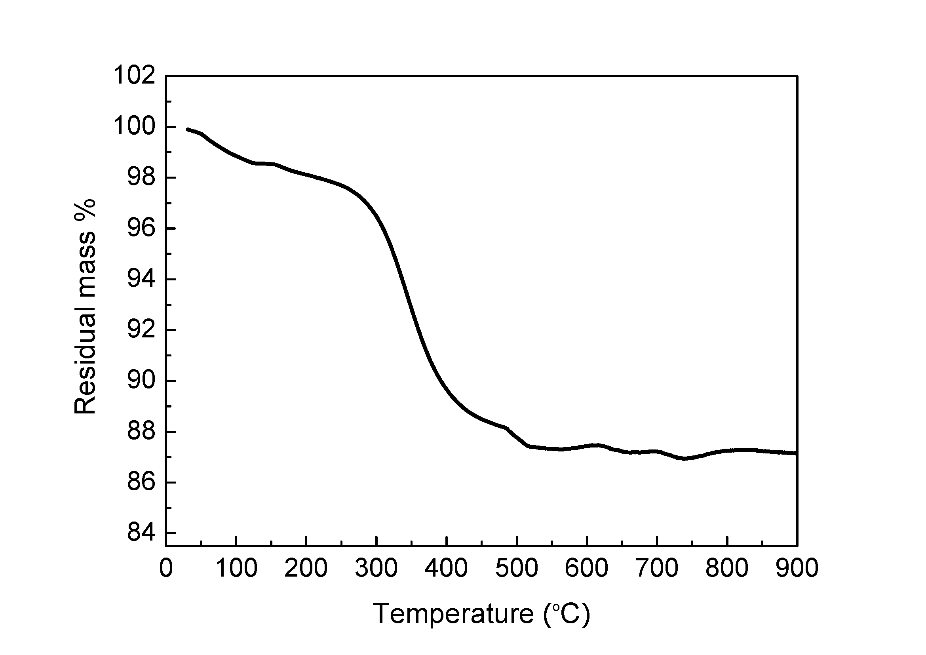

Fig. 2
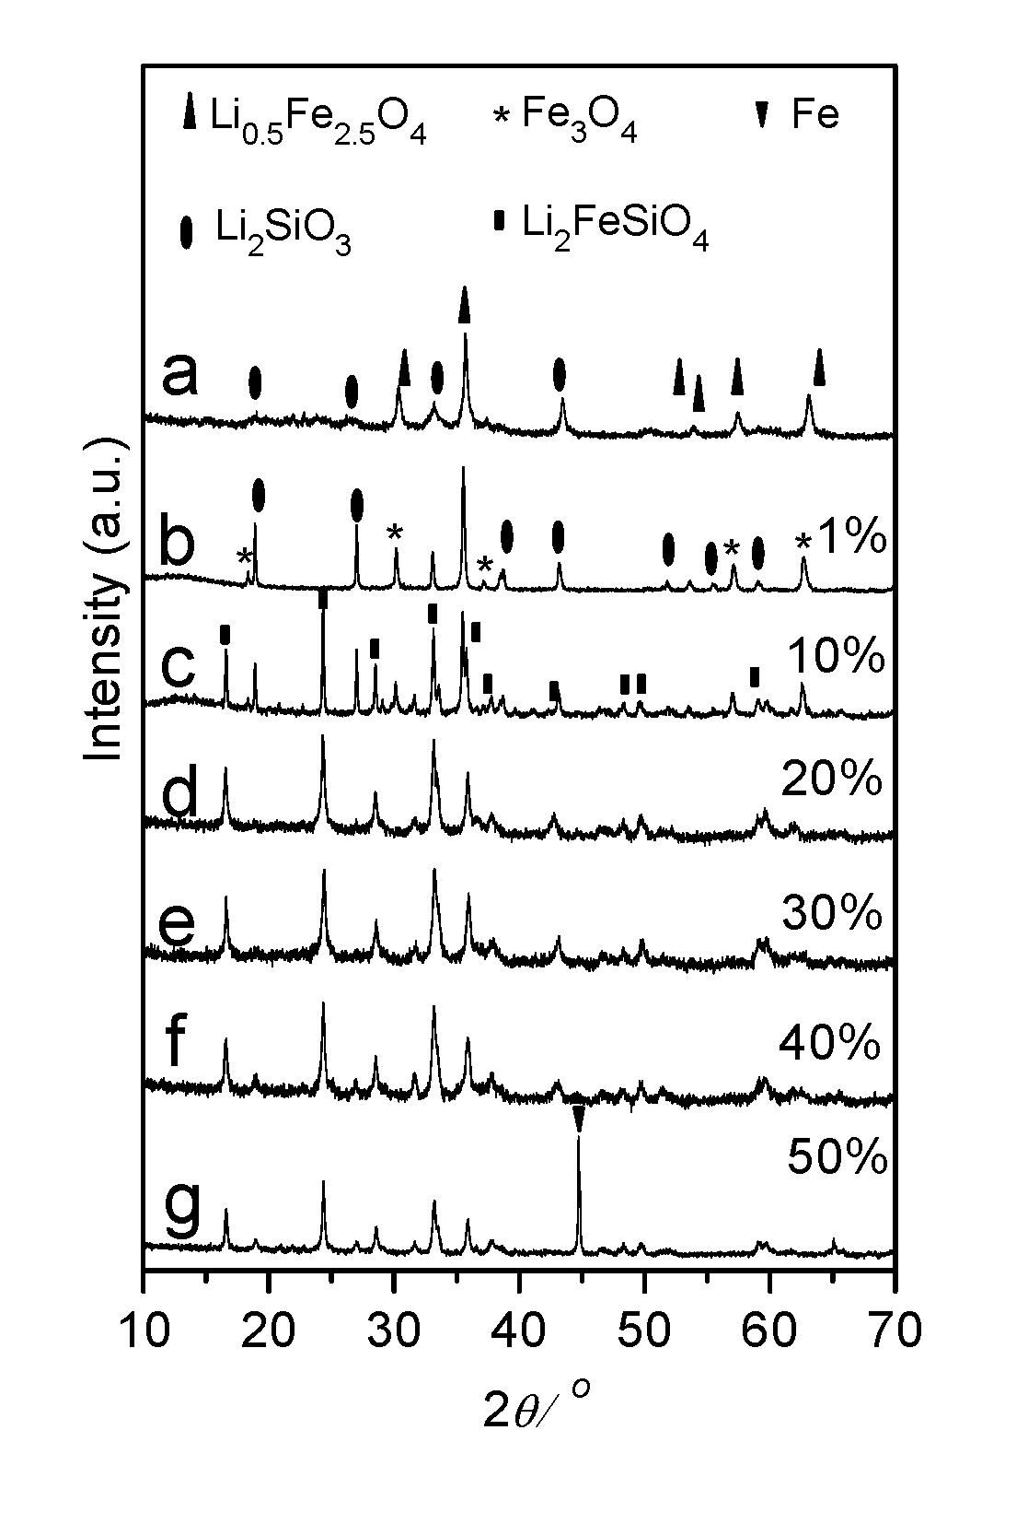

Fig. 3
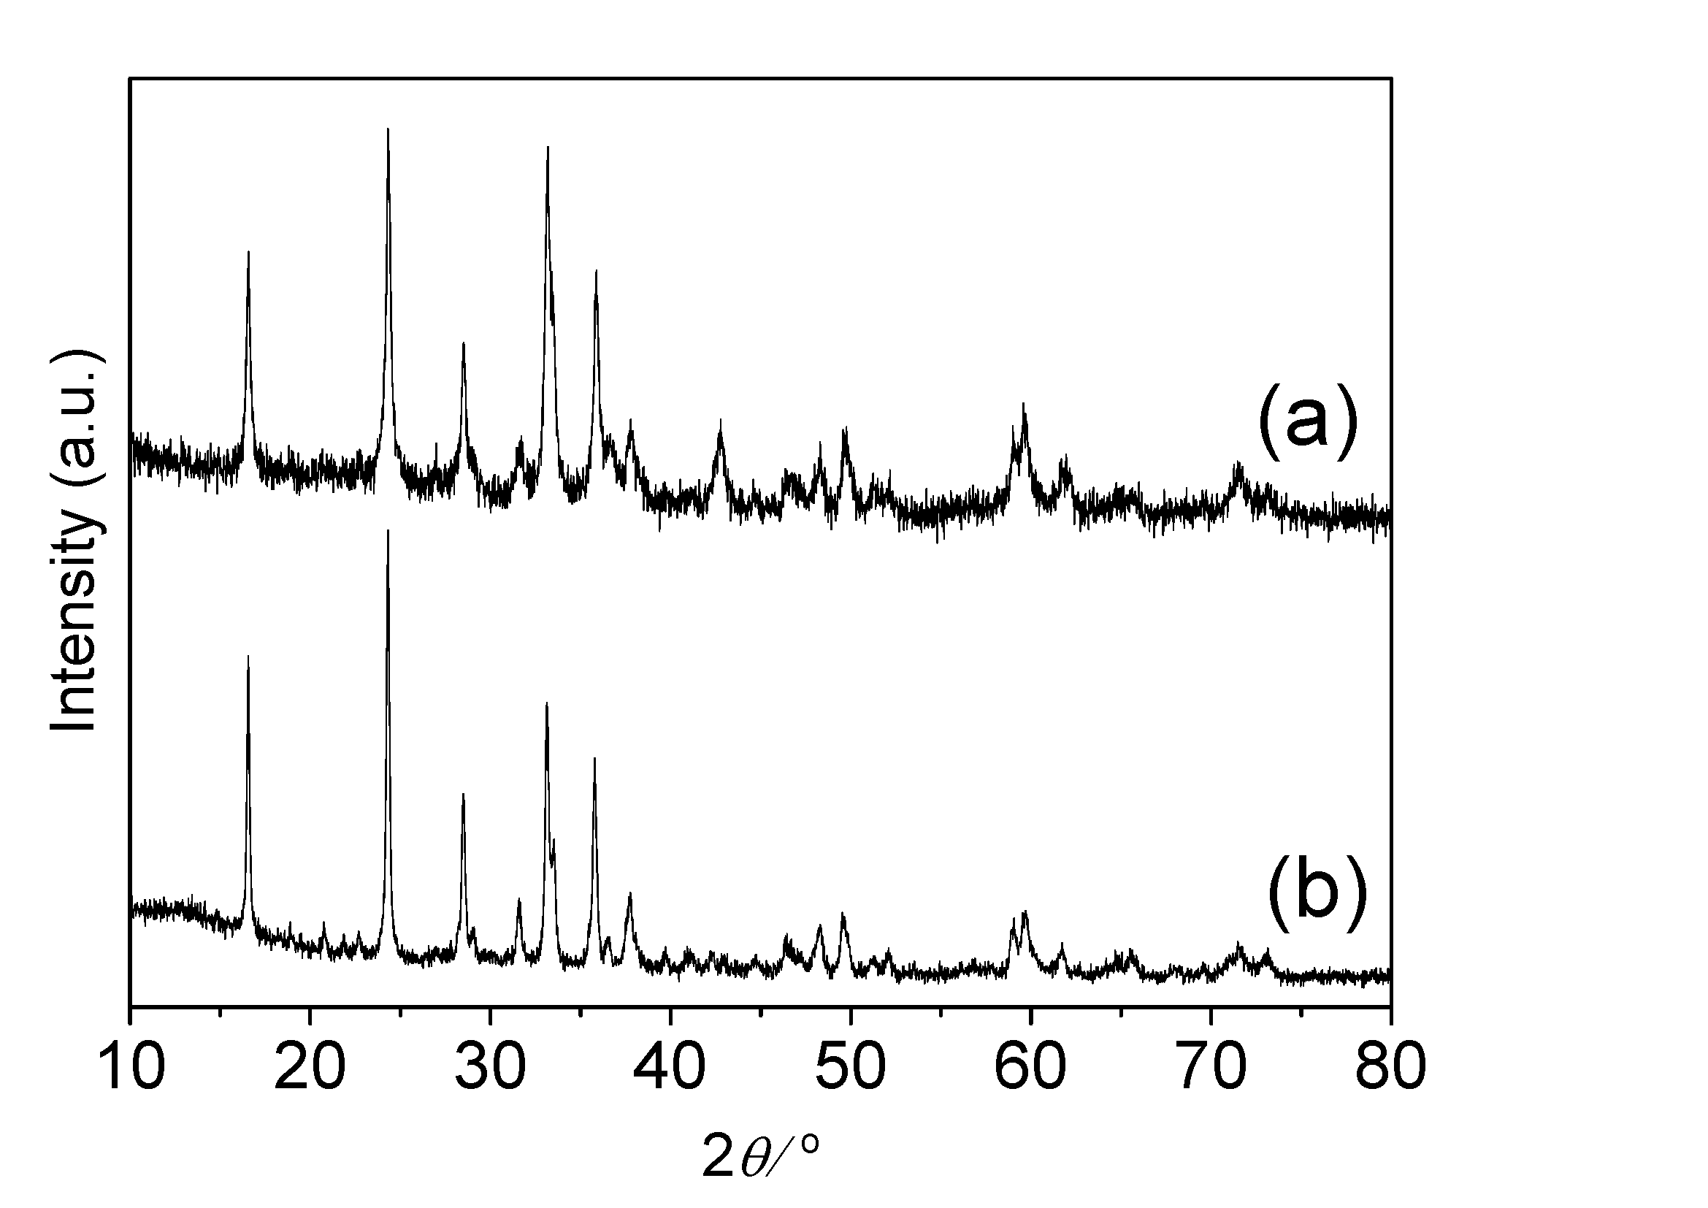

Fig. 4
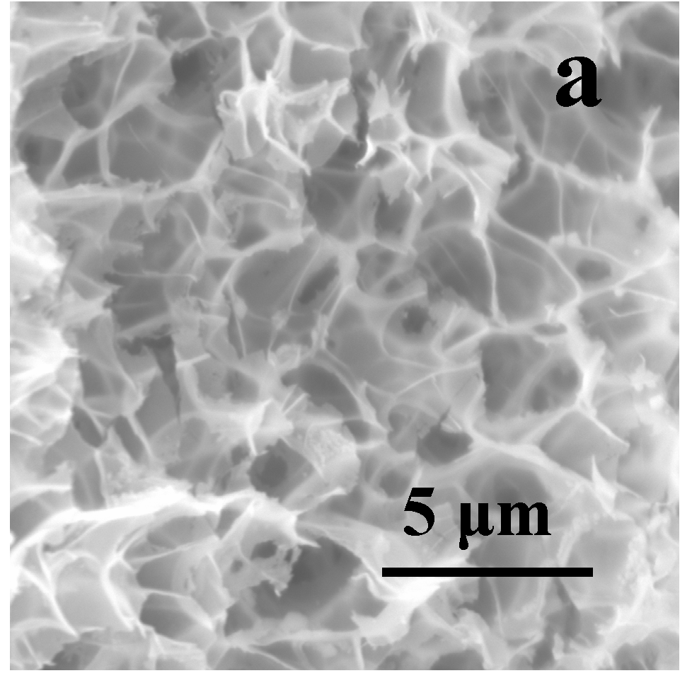
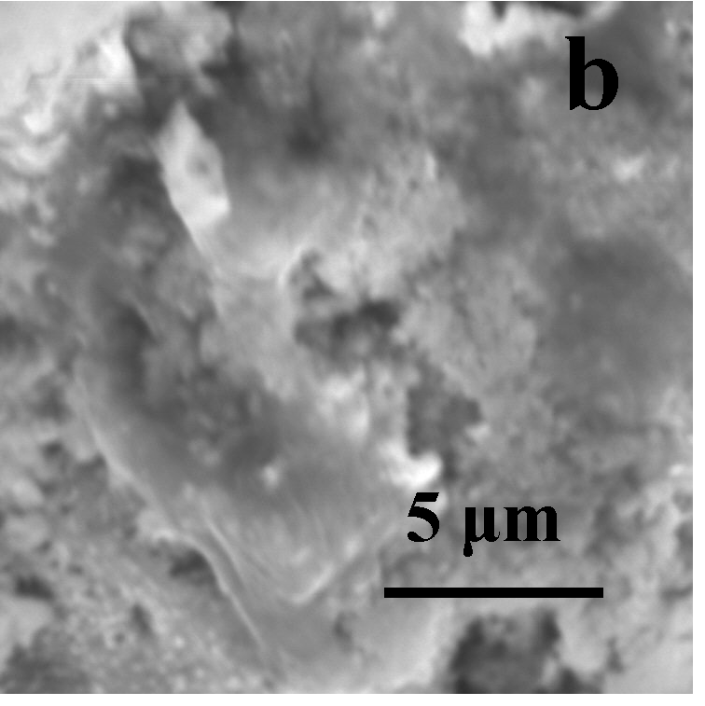
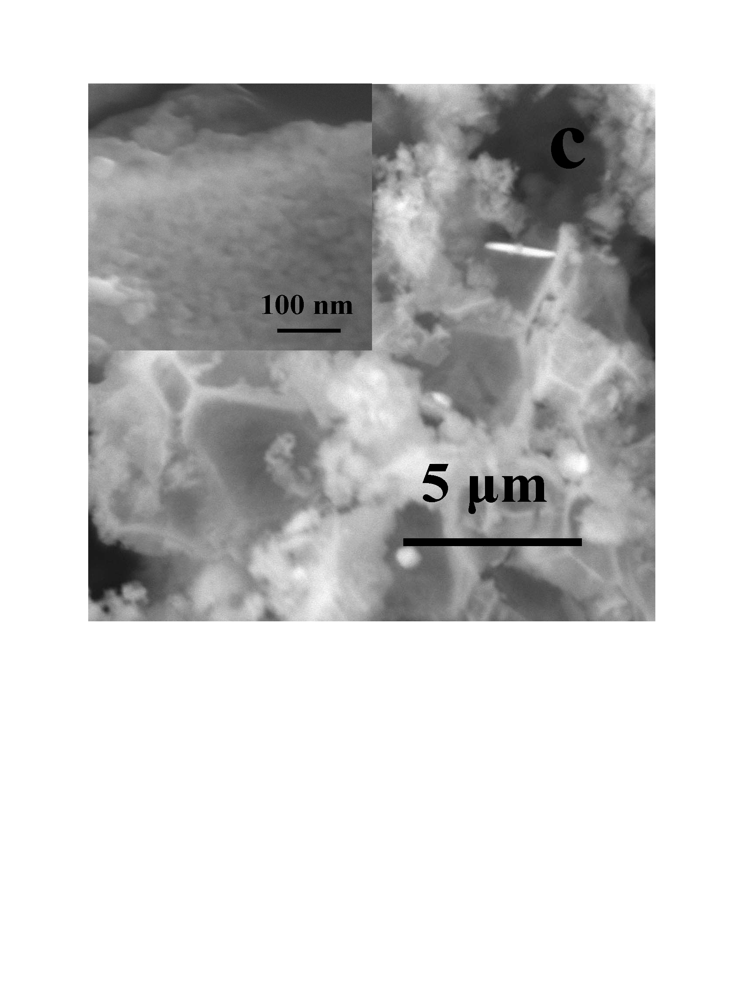

Figure 5

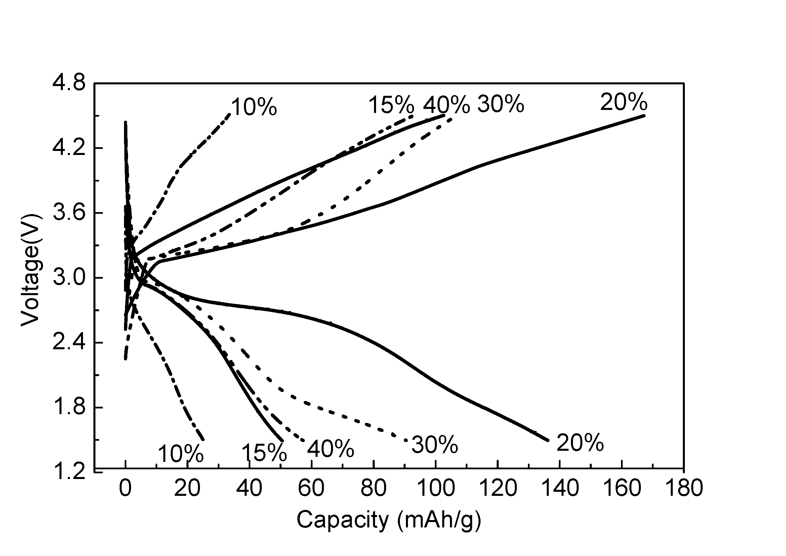

Fig. 6
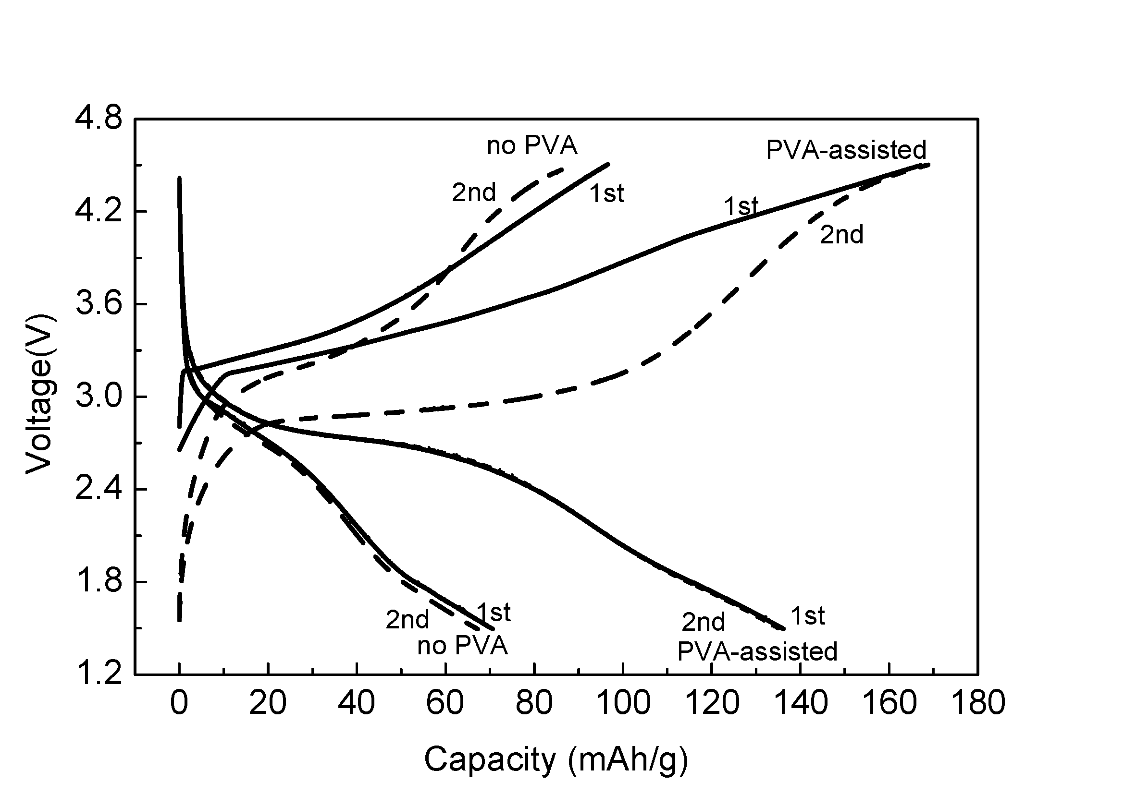

Fig. 7
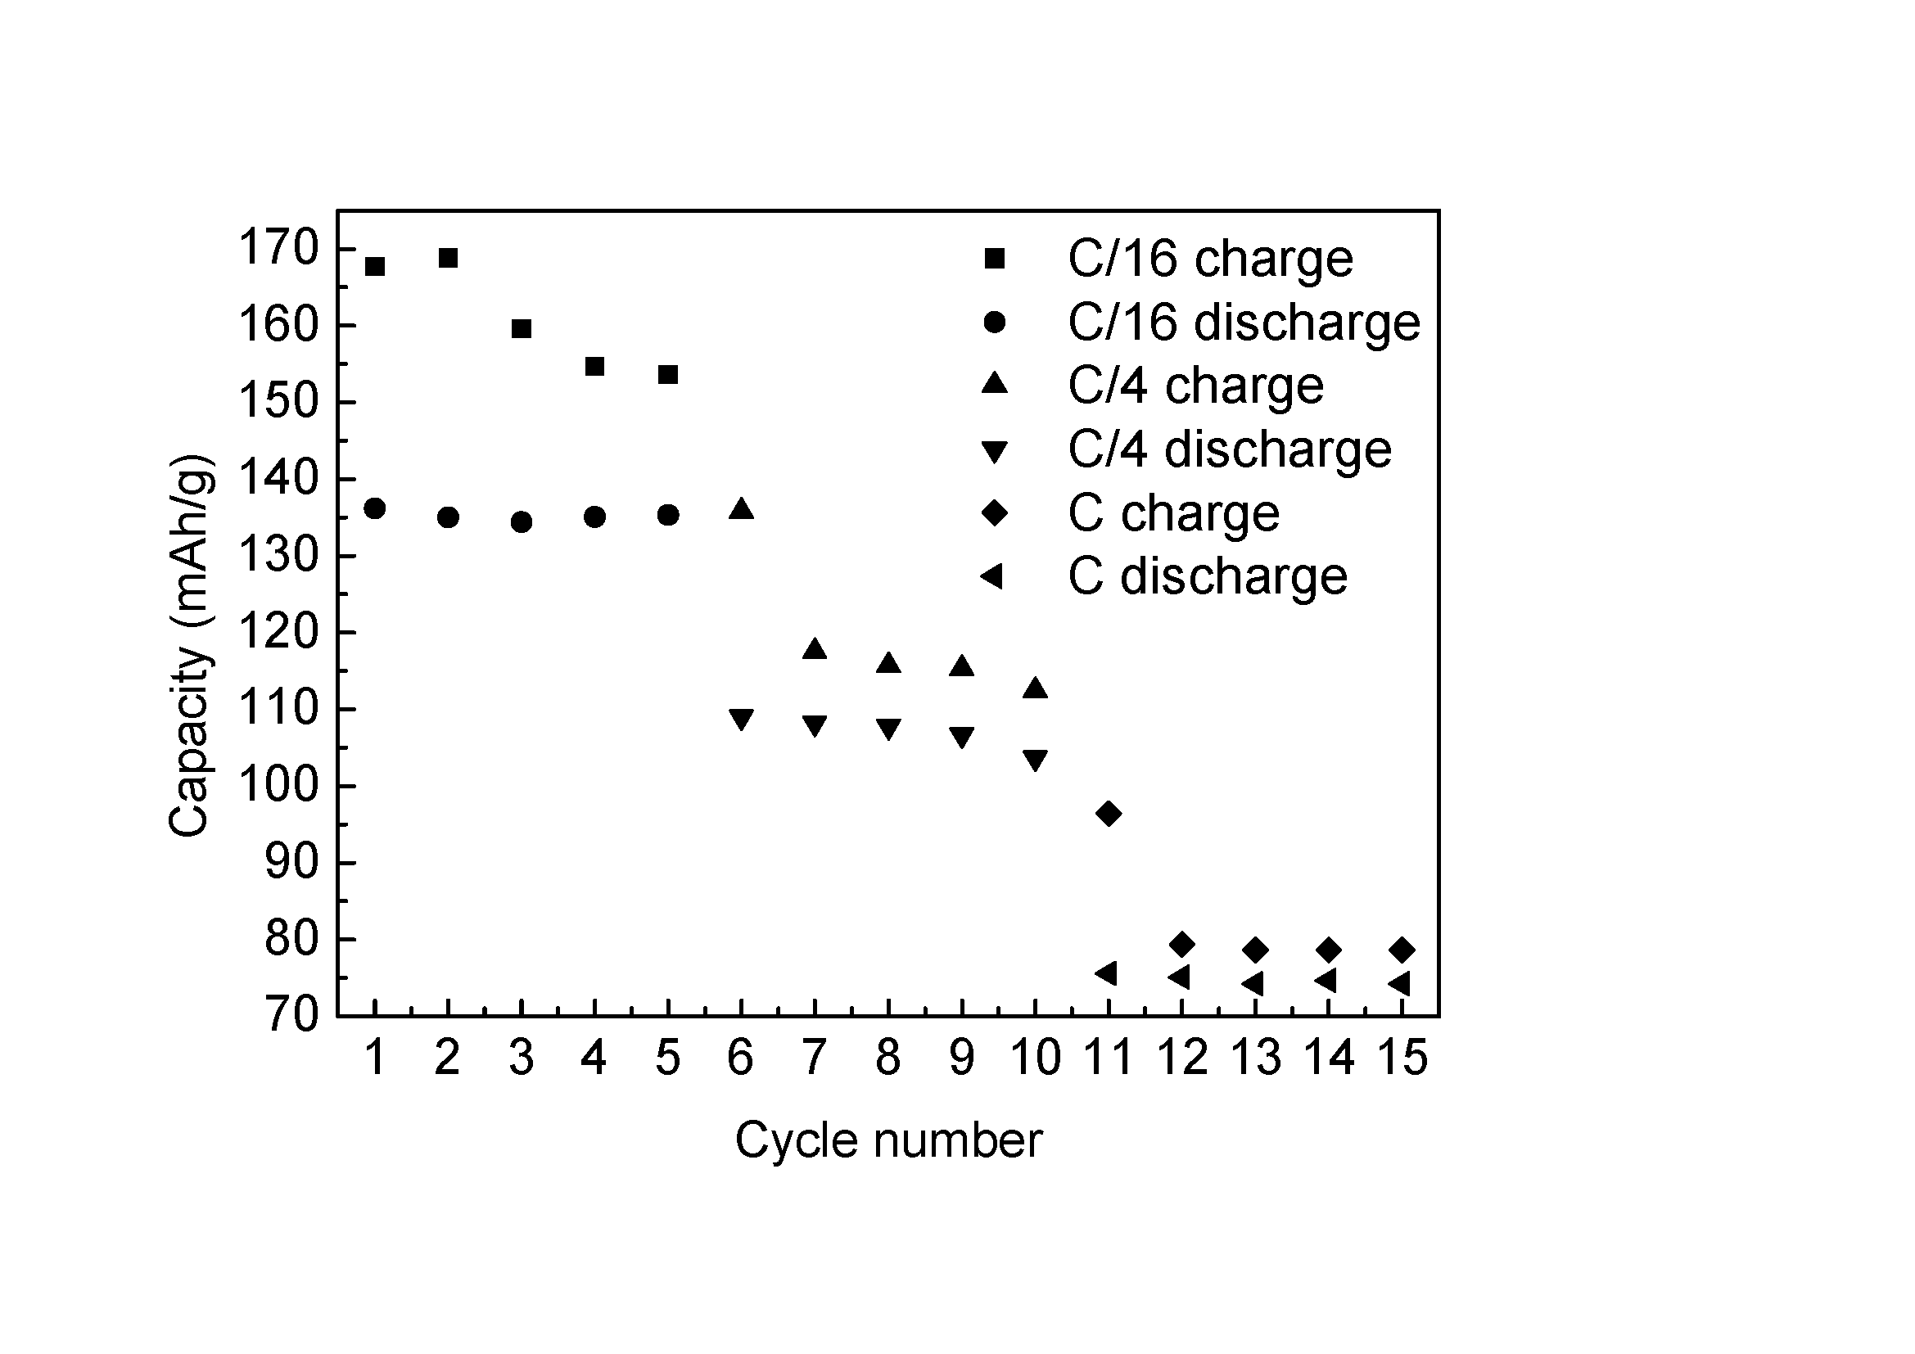

Fig. 8

* Email: vullum@nt.ntnu.no Postal address: Department of Materials Science and Engineering, Alfred Getzv.2, 7491 Trondheim, Norway Tel. +47 735 93976 Fax: +47 735 50203

