Towards Carbon-Free Mobility: The Feasibility of
Hydrogen and Ammonia as Zero Carbon Fuels in Spark Ignition Light-Duty Vehicles
Ducduy Nguyen^{1,2*}, James W.G. Turner²
1. Department of Marine Technology (IMT), Norwegian University of Science and Technology, Trondheim, Norway
2. Clean Combustion Research Center, King Abdullah University of Science and Technology (KAUST), Thuwal, Saudi Arabia

* Corresponding author:
Ducduy Nguyen
Department of Marine Technology (IMT),
Norwegian University of Science and Technology (NTNU)
NTNU, 7491 Trondheim
E-mail address: duc.d.nguyen@ntnu.no
Phone: +47 486 20 493
Abstract
Global warming is a major environmental issue caused by the release of greenhouse gases, such as carbon dioxide into the atmosphere. Light-duty vehicles (LDVs) including passenger cars and light-duty trucks, are a significant contributor to greenhouse gas emissions. The transportation sector is responsible for approximately 23% of global CO₂ emissions, with LDVs accounting for a substantial portion of these emissions. This paper aims to investigate the feasibility of zero-carbon fuels with focus on hydrogen and ammonia in spark ignition internal combustion engines for light-duty vehicles. With the increasing demand for sustainable and carbon-free mobility, alternative fuels such as hydrogen and ammonia are gaining attention as potential solutions. The properties and characteristics of these fuels and their potential for utilising them as a fuel in internal combustion engines are also reviewed. Current challenges and opportunities associated with the use of these fuels, including production, storage, and distribution, will be discussed. While there are still technical and infrastructural challenges that need to be addressed, hydrogen and ammonia have the potential to provide clean and efficient energy sources for light-duty vehicles. The development of these fuels, along with advancements in internal combustion engine technology, can help pave the way towards a carbon-free future for mobility.

Keywords
Internal combustion engine, Zero carbon fuel, Spark ignition, Decarbonisation, Transportation.

Introduction
Global warming has become a serious environmental issue caused by the build-up of greenhouse gases in the atmosphere, mostly from the carbon dioxide emissions from the combustion products of fossil fuels. Among the major contributors, transportation is a significant contributor to this problem, responsible for 23% of global energy-related carbon dioxide emissions, according to the International Energy Agency¹. Internal combustion engines (ICE) powered by fossil fuels, such as gasoline and diesel, are the primary source of carbon emissions in transportation. Road transportation alone accounts for 71.7% of carbon emissions from the transportation sector, as indicated by the European Environment Agency^{2, 3}. With the growth in the number of vehicles on roads worldwide, the level of carbon emissions is increasing, further compounding the challenges of climate change.
Battery electric vehicles (BEV) have emerged as a crucial technology to reduce emissions from road vehicles particularly in light-duty automotive applications, owing to their low refuelling and maintenance costs. However, some challenges of BEVs such as the high cost of the battery, long charging time and limited driving range present significant challenges to the widespread adoption of BEVs. Furthermore, it is essential to develop renewable energy sources and reduce coal and fossil power consumption for the future of BEVs, considering their life cycle⁴⁻⁷.
Charging infrastructure holds a crucial role in the electrification of transportation sector, given the costs of high-power charging infrastructure. There are two major types of charging system for BEVs, conductive and wireless charging. Currently, the majority of charging infrastructure is conductive charging, which requires a physical connection. Wireless charging offers a promising solution to enhance the efficiency and range of electric fleets. Catenary, traditionally linked with rail electrification, utilises overhead wires that supply electric power to vehicles. By delivering continuous electric power directly from the infrastructure to the vehicle, catenary systems eliminate the need for large, heavy batteries, therefore reduce the overall weight of the vehicle and optimising energy consumption. This technology holds particular significance for urban settings, where frequent stops and starts can hinder the efficiency of traditional electric vehicles.
Currently, catenary charging infrastructure is especially relevant for road freight where load demand is higher⁸. Dynamic charging systems embedded in the road pavement or running along the side of the road, through overhead catenary power lines can also be used to directly power or charge BEVs⁹. However, the technology of dynamic charging is still in a developmental stage and requires considerable time before it can be implemented as a practical application.
In addition, low-carbon electricity is vital for charging BEVs, as it leads to lower lifecycle greenhouse gas (GHG) emissions compared to vehicles powered by internal combustion engines¹⁰⁻¹². These disadvantages of electric vehicles point out the continued dominance of ICE vehicles in the road transportation sector.
The vehicles used for transportation of passengers and goods can be separated into light-duty (LDV) and heavy-duty vehicles. LDVs are a significant contributor to the demand for fuel and therefore, GHG emissions. In the USA, LDVs are responsible for nearly half of the existing petroleum consumption and contributed approximately 1,000 million metric tonnes of CO₂-equivalent GHG emissions in 2015, which accounted for approximately 16% of the country's overall GHG emissions¹³. Typically, most LDVs use gasoline fuel and spark ignition (SI) engines. With the global light-duty vehicle stock still increasing, alternative fuels became a key technology for a zero-carbon emission mobility future¹⁴.
To address the significant role of the transportation sector in carbon emissions, a transition towards cleaner and more sustainable forms of transportation is necessary. This includes the utilisation of zero-carbon fuels in light-duty SI systems for automotive applications¹⁵. Zero-carbon fuels, which are generated from renewable sources, result in little to no net carbon emissions during their lifecycle, making them a cleaner alternative to fossil fuels^{16, 17}. Zero-carbon fuels include biofuels, which are derived from biomass such as crops, waste materials, or algae, as well as hydrogen and ammonia that can be produced using renewable energy sources or from natural gas with carbon capture and storage technology¹⁸. These fuels hold the potential to substantially reduce carbon emissions in various industries, including transportation, where they can be used in ICEs, fuel cells, or other advanced propulsion systems. As a result, research and development efforts are focused on scaling up the production of zero-carbon fuels to meet the increasing demand for sustainable and low-carbon energy sources. Figure 1 provides a summary of the major pathways for low-carbon transport technology¹⁹.
Zero-carbon fuels have the potential to significantly reduce greenhouse gas emissions from LDVs, which are typically powered by ICEs fuelled by gasoline. In recent years, many advanced technologies have indicated the possibility of operating zero-carbon fuels in ICEs, make it feasible to use them in existing vehicles without requiring significant modifications. Nevertheless, challenges remain in terms of the cost and scalability of producing and distributing these fuels. Significant investments in infrastructure and technology development are required for producing zero-carbon fuels, as well as the availability of renewable energy sources at a large scale. Moreover, the limited availability of refuelling infrastructure for these fuels poses a barrier to their widespread adoption. Ultimately, the adoption of zero-carbon fuels in LDVs will depend on a range of factors, including technologies, policy support, and consumer acceptance. However, given the urgency of addressing climate change, the potential benefits of zero-carbon fuels make them a promising option for decarbonising the transportation sector and achieving a more sustainable future.
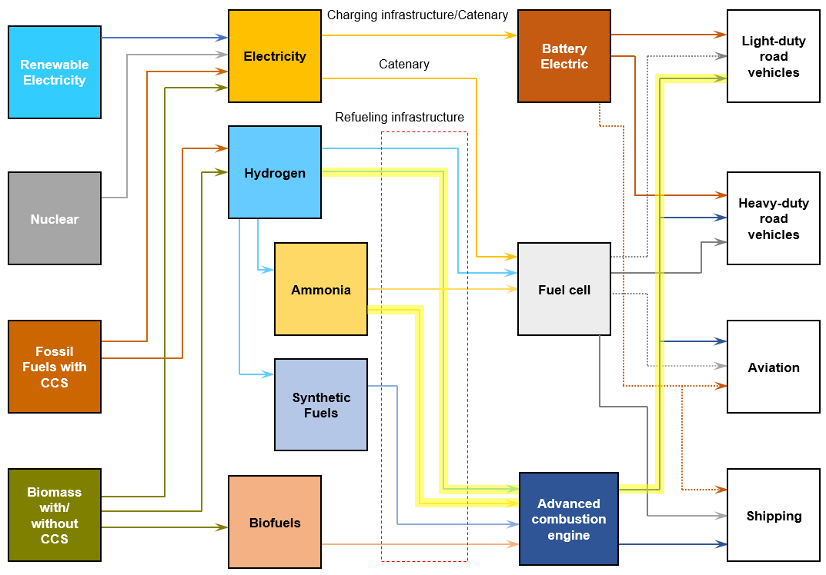
Figure 1. The energy pathway toward a net zero carbon mobility scenario, the highlighted lines indicating the central aspects to be addressed in this study (Recreated from IPCC¹⁹)
This paper provides an assessment of the current state of zero-carbon fuels, specifically hydrogen and ammonia, and their viability for use in light-duty spark-ignition vehicles. The combustion properties and comparison of hydrogen and ammonia with common hydrocarbon fuels for LDVs are summarised in Table 1. An overview of the various types of zero-carbon fuels and their potential applications in the transportation industry is also provided. Some challenges and opportunities linked to the production, distribution, and adoption of these fuels are also discussed. Overall, the article aims to enhance our understanding of the feasibility of zero-carbon fuels and emerging clean technologies for LDVs and emphasises the need for further research and development in the field.

Table 1. Combustion properties of hydrogen and ammonia with other hydrocarbon fuels for LDVs²⁰, ²¹.
Property | Ammonia | Hydrogen | Gasoline | Diesel
Chemical Formula | NH₃ | H₂ | C₈H₁₈ | C₁₂H₂₃
Energy Density (MJ/kg) | 18.6 | 120.1 | 44.4 | 42.8
Energy Density (MJ/L) | 11.2†  12.5‡ | 0,010 – 0.011†  8.49§ | 32.8 | 35.8
Autoignition Temperature (°C) | 651 | 572 | 246 | 210
Flame Speed (m/s) | 0.32 - 0.40 | 1.5 - 2.1 | 0.3 - 0.5 | 0.25 - 0.3
Density (kg/m³) | 0.771†  600‡ | 0.0899†  70.8§ | 750 | 835
Flammable Limit in Air (%) | 15 – 28 | 4 - 75 | 1.4 - 7.6 | 0.6 - 5.5
Minimum Ignition Energy (mJ) | 0.22 - 0.36 | 0.02 - 0.04 | 0.2 - 0.3 | 0.3 - 0.6
† Gaseous form under atmospheric pressure and 20°C
‡ Liquified at 0.99 MPa temperature of 25°C
§ Liquified at –252.9°C under atmospheric pressure

Hydrogen
Hydrogen is a clean energy source that holds great promise²². Theoretically, hydrogen fuel generates no carbon emissions during combustion and can be produced from renewable energy sources such as solar and wind power. Hydrogen can be used in various transportation applications, including cars, buses, and trucks²³. While some challenges remain, the use of hydrogen fuel has the potential to promote sustainable and low-carbon transportation.

Hydrogen production
Hydrogen has been widely classified into different colour, depending on the production method used and its environmental impact. To ensure scientific precision in this article these main colours are supplemented with quantitative carbon intensity figures, as summarised in Table 2. Currently the most common form of hydrogen is produced from fossil fuels such as coal or natural gas without carbon capture technology, rendering it a non-zero-carbon fuel with the highest carbon intensity of 11.57 kg CO₂/kg H₂^{24, 25}. Blue hydrogen also delivered from fossil fuels also; however, it incorporates carbon capture technology, resulting in a carbon footprint of 6.87 kg CO₂/kg H₂.
Table 2. Common hydrogen types, sources and the level of carbon emissions associated with the production method.
Hydrogen Type | Resource | Method | Technology | Carbon Emissions Level
Grey | Fossil fuels (natural gas, coal) | Steam methane reforming | No carbon capture technology | High
Blue | Fossil fuels (natural gas, coal) | Steam methane reforming | Carbon capture and storage | Moderate
Turquoise | Natural gas | Methane pyrolysis | Carbon capture and storage | Low
Green | Renewable energy (solar, wind) | Electrolysis | No carbon emissions | Zero
Turquoise hydrogen utilises methane pyrolysis, splitting methane into hydrogen and solid carbon without releasing carbon dioxide. The carbon intensity of this type of hydrogen ranges from 3.94 to 9.91 kg CO₂ /kg H₂ depending on the heat source for the process. Green hydrogen, produced using renewable energy sources such as solar or wind power, is considered the most environmentally friendly option²⁶. However, green hydrogen production is still in its early stages and is not yet widely available. Furthermore, it is noteworthy that if the current grid electricity is used in electrolyser hydrogen production, it results in significant carbon intensity of 34.85 kg CO₂/kg H₂²⁷.
Figure 2 illustrates the process of generating and storing hydrogen through blue and green hydrogen pathways, which are both promising methods for producing zero-carbon hydrogen fuel²⁸. Blue hydrogen is produced from fossil fuels such as natural gas but utilises carbon capture and storage technology to capture and store the carbon emissions. Green hydrogen, on the other hand, is produced by electrolysing water into hydrogen and oxygen using renewable energy sources such as wind or solar power. Both blue and green hydrogen have potential to be used as a fuel for transportation, and there are ongoing projects aimed at producing and storing these fuels for use in LDVs.
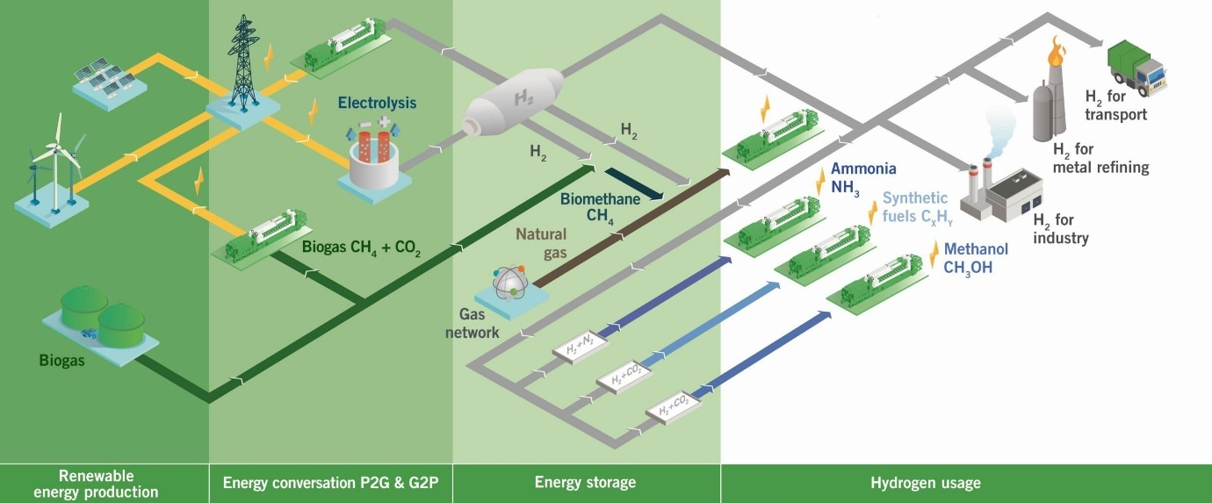
Figure 2. Hydrogen pathway toward sustainable energy production and utilisation (copyright Innio Jenbacher, license no: 5619221468745, reproduced from ref.²⁸)
The H2future project, supported by the European Union’s Horizon 2020 research programme, is constructing the largest green hydrogen pilot facility in the world at the Voestalpine site in Linz. The facility aims to produce CO₂-free hydrogen for use in industry, transportation, and energy. The system includes an electrolytic capacity of 6 MW, and the ultimate goal is to produce hydrogen from electrolysed water with an efficiency of over 80%²⁹. In the UK, investments in hydrogen technology are being made to reduce carbon emissions in the transportation sector. Projects such as the hydrogen mini-grid system, Gigastack, and Dolphyn demonstrate the entire industrial chain from hydrogen production to energy utilisation, and the UK plans to produce green hydrogen through offshore wind farms. The Gigastack project aims to deliver green hydrogen through a 5 MW electrolyser, and its first phase has successfully developed the design and explored the industrial application of the technology³⁰. These projects demonstrate the potential of blue and green hydrogen as a viable zero-carbon fuel for the transportation sector.

Hydrogen as a fuel in internal combustion engines
Hydrogen has a long history of being used as a fuel in transportation. One of the earliest examples of a hydrogen powered ICE was De Rivaz’s engine, invented by Francois Isaac de Rivaz in 1807. This engine utilised a mixture of hydrogen and oxygen, which ignited via an electric spark to produce power³¹. In 1820, Reverend W. Cecil introduced the Cecil gas engine, which used hydrogen and oxygen combustion to create a partial vacuum inside a cylinder. Although it was not very efficient and reliable, the Cecil engine demonstrated the potential of hydrogen as an alternative energy source³². Another notable example of a hydrogen vehicle was the Hippomobile, a three-wheel car powered by hydrogen gas invented by Etienne Lenoir in 1860³³. Despite its potential, the development of hydrogen engines for transportation did not receive much attention until recently, due to the popularity of gasoline and diesel as fuels. The detail research of hydrogen as a fuel for ICE prior to 1990s was fully reviewed and reported in^{34, 35}.
In recent years, interest in hydrogen internal combustion engines (H2ICEs) has been renewed due to the need for cleaner transportation options. Hydrogen offers a promising substitute for traditional hydrocarbon fuel, given its ability to generate no greenhouse gas emissions, particularly when produced from renewable energy sources. One of the earliest examples was the Ford P2000, based on the Ford Focus model and using a modified internal combustion engine designed to run on hydrogen. The P2000 had a range of around 160 miles on a single tank of hydrogen and could reach a top speed of 85 miles per hour, with engine out NOx emissions ranging from 0.37 - 0.74 g/mile³⁶. BMW produced the Hydrogen 7, a limited quantity car available for lease in select markets between 2006 and 2008³⁷. Emission results demonstrated that BMW Hydrogen 7 was probably the most environmentally friendly vehicle ever tested at the Argonne laboratory at that time³⁸. Similarly, Mazda produced the RX-8 Hydrogen RE in 2006, which also used a hydrogen-powered ICE³⁹. However, both cars were expensive, had limited range, and required specialised refuelling infrastructure, limiting their practicality for most consumers.
Toyota has recently announced plans to develop H2ICE versions of two popular models: the Corolla Sport and GR Yaris. The modified Corolla Sport was released in Japan in 2021 ⁴⁰, while the modified GR Yaris followed in 2022⁴¹. Yamaha and Toyota are collaborating to develop a 5.0-liter V8 engine that runs on hydrogen fuel. This engine is based on the one used by the Lexus RC F coupe, but with modifications to its cylinder heads and fuel injectors, among other components. The engine is expected to deliver up to 450 hp of power at 6,800 rpm and a torque of 540 Nm at 3,600 rpm⁴². This development highlights the potential for using hydrogen in high-performance vehicles that are also more environmentally friendly.
However, one of the major challenges in utilising H2ICEs in LDVs is the low density of hydrogen, which requires large storage tanks⁴³. Nevertheless, there is still significant interest in hydrogen as a fuel for LDVs, as numerous ongoing research and development initiatives strive to improve the efficiency, cost-effectiveness, and sustainability of internal combustion engine vehicles⁴⁴⁻⁵¹.
To fully capitalise on the potential of hydrogen as a fuel for LDVs, significant advances in fuel injection strategies must be made to optimise engine performance and reduce emissions⁵². This is because the unique properties of hydrogen, such as its high combustion speed and wide flammability range, require careful attention to the injection process to ensure efficient combustion and minimise emissions. Therefore, developing and implementing effective fuel injection strategies is essential for the successful integration of H2ICEs in LDVs.

Injection strategy
H2ICEs require different injection strategies due to hydrogen’s high reactivity and different combustion characteristics compared to gasoline or diesel⁵³. One commonly used strategy is port fuel injection (PFI), where fuel is injected into the intake port and mixed with the air before entering the combustion chamber. PFI systems are economical and straightforward to produce but have restricted control over the amount and timing of fuel injection. Another strategy is direct injection (DI), where fuel is directly introduced into the combustion chamber. DI systems allowing for more precise control over the fuel injection process resulting in higher fuel efficiency. However, DI systems are more complex and expensive to manufacture than PFI. Figure 3 illustrates a summary of hydrogen injection strategies ranged from low to high pressure as well as their advantages and disadvantages in ICEs⁵⁴. With further research and development, hydrogen injection strategies can be optimised to improve engine performance, reduce emissions, and make hydrogen-fuelled LDVs more practical and cost-effective for consumers.
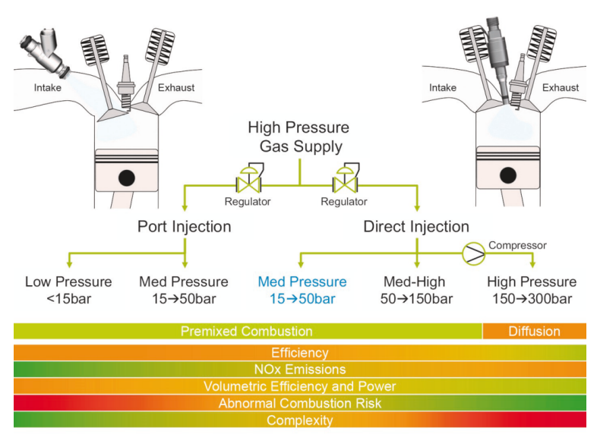
Figure 3. Hydrogen injection strategies (copyright Borg-Warner, license no: 5619230489053, adapted from ref.⁵⁴).

Port-fuel injection
Port fuel injection is the primary mixture injection strategy for H2ICE and is similar to a traditional gasoline LDV engine. One advantage of hydrogen PFI is that it can utilise existing engines, making the conversion to hydrogen combustion relatively easy⁵⁵. Lee et al. used a solenoid-driven gas valve to supply hydrogen to the PFI system, which can be easily adopted in a conventional SI engine with simple modifications⁵⁶.
To control the PFI of hydrogen in a H2ICE, Mathur and Das introduced timed manifold injection. Their results indicated that a timed manifold injection system ensures the effective functioning of a hydrogen engine across the wide range of speeds and loads without any abnormal combustion⁵⁷. By implementing a suitable control system, the peak brake thermal efficiency (BTE) of 27% (versus 25% for gasoline) under a wide range of operation can be reached for hydrogen-fuelled engine (Figure 4)⁵⁸. H2ICE with PFI can reach a peak indicated efficiency of 45%, while the brake efficiency was 35%. Efficiency levels exceeding 30% could be achieved over a wide range of operation conditions, presenting an improvement of 7-9% compared to gasoline within the same load range⁵⁹. However, NOx emissions level is significantly higher than that of gasoline operation.
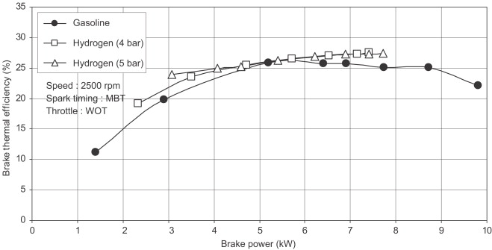
Figure 4. Brake thermal efficiency of hydrogen combustion compared to base gasoline combustion (License no: 5619230633788, reproduced from ref.⁵⁸)
Pandey and Kumar conducted a study on the performance of PFI H2ICE with variable compression ratio (VCR) technology. They found that under high compression ratio (CR) and moderate equivalence ratio, brake power and BTE improved compared to gasoline. However, as the lean limit decreased and CR increased, NOx emissions increased rapidly⁶⁰. One way to reduce NOx emissions from H2ICE is to control the throttle and excess air ratio. By applying these measures, NOx emissions can be reduced to below 15 ppm in a naturally-aspirated (NA) hydrogen engine, but this can limit torque and power due to backfire⁶¹. To achieve backfire-free and low emissions without affecting engine performance, water injection, lean burn technology and exhaust gas recirculation (EGR) can be utilised^{62, 63}.
Combining PFI with water injection technology can result in a maximum power output of 78% compared with gasoline due to the reduction in of the amount of intake air displaced by the hydrogen. Water injection also significantly reduces NOx levels without affecting BTE or cyclic variation. However, it may cause adverse effects such as corrosion and lubricant contamination⁶⁴. Furthermore, lean burn and EGR strategies have been examined in the cooperative fuel research (CFR) engine. The lean burn strategy was found to be more effective in reducing NOx emissions under low load conditions, while both strategies were equally effective for mid-load conditions^{65, 66}.
Overall, a combination of PFI with water injection, lean burn and EGR strategies, can effectively reduce NOx emissions while maintaining stable combustion in the H2ICE. However, each strategy comes with its inherent advantages and disadvantages, and the optimal combination may vary depending on the specific application and operating conditions. Table 3 summarises the various strategies and their effectiveness in reducing NOx emissions from the H2ICE.
Table 3. Summary of various operating strategies for hydrogen PFI engines^{65, 66}.
Strategy | Advantages | Disadvantages
Water injection | - Significantly reduces NOx emissions without affecting BTE and causes a small reduction in hydrocarbon (HC) emissions.  - Effective in controlling knock.  - Does not affect cyclic variation. | - May cause corrosion and lubricant contamination.
Lean burn | - Better efficiency than EGR strategy for low load conditions.  - Very low NOx emissions; almost zero emissions when λ ≥ 3.  - Nearly the same indicated power and indicated efficiency for mid-load conditions as stoichiometric with EGR. | - Poor efficiency of TWC under lean burn conditions.
EGR | - Highest indicated power output at mid and high load conditions.  - Lower NOx emissions than lean burn strategy for all load conditions.  - Possible to combine with supercharging for power increase.  - Can be varied to control NOx emissions. | - Combustion instability at high EGR rates.  - Poor efficiency of TWC under EGR strategy with a stoichiometric mixture and variable EGR rates, due to lack of unburned hydrogen, which is used as a reductant.  - Only efficient under slightly rich conditions.

Direct injection
Direct injection of hydrogen in the ICEs is a promising technology for reducing greenhouse gas emissions and improving fuel efficiency. By directly injecting hydrogen into the combustion chamber, a more precise air-fuel mixture can be achieved, resulting in improved engine efficiency and lower emissions. The DI system also enables the use of higher CR, which can further improve engine efficiency⁶⁷.
Gaseous hydrogen used in DI mode for LDV has shown great potential, particularly when high power density and instant power availability are required. Power output of hydrogen DI operation can potentially improve by approximately 17% higher than the PFI of gasoline⁶⁸. Under part load operation with lean mixture, it was observed that 40% indicated thermal efficiency (ITE) with zero engine out emissions can be achieved, while a stoichiometric mixture allows for high power density, but a catalyst is required to avoid NOx emissions. Compared to PFI, hydrogen DI results in a higher energy contained of the mixture in the cylinder, which can be used to produce higher power output⁶⁹.
Despite its potential for improving fuel efficiency, the adoption of hydrogen DI technology in LDV is limited by the lack of widely available direct injectors for hydrogen. This is due to the unique properties of hydrogen that require different injector designs than those used for conventional gasoline or diesel fuel injection⁷⁰. Furuhama and Kobayashi⁷¹ demonstrated the potential of DI by showing that injecting low temperature liquid hydrogen into an engine can increase its maximum output by 20-25% compared to gasoline engines and backfire can be completely prevented.
Yamane et al.⁷² have successfully developed compact hydrogen gas injectors with high-pressure, highly responsive, and capable of injecting at high rates. Figure 5 illustrates the structure and working mechanism of the developed gaseous hydrogen direct injector. However, further research is required to evaluate the reliability and durability of these injectors for practical vehicle application⁷³.
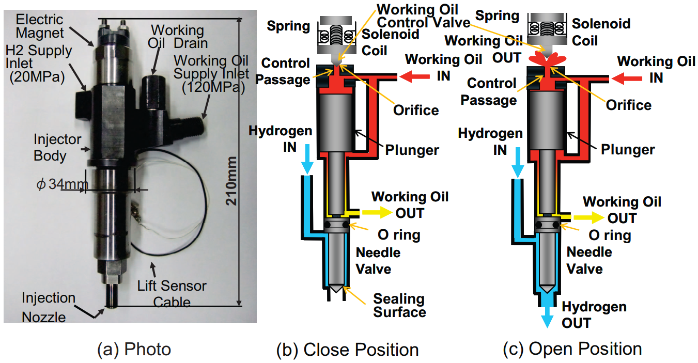
Figure 5. Gaseous hydrogen direct injector design and working mechanism (License ID: 1392081-1, adapted from ref.⁷²).
BorgWarner has designed a direct injector specifically for hydrogen, which is able to operate at high pressures and handle the unique characteristics of hydrogen fuel, such as its low density and high flammability (Figure 6). The hydrogen direct injector has been successfully used in a 1.6 L Hyundai SI engine made for a commercial vehicle, achieving a maximum BTE of 40.7% at 2000 rpm and 140 Nm. Furthermore, NOx emissions were found to be lower than 15 ppm and 0.2 g/kWh throughout the entire range of operation (Figure 7)^{74, 75}. The hydrogen direct injector has also evaluated by Atkins et al. in a modified Ricardo Proteus single cylinder research engine. The results demonstrated that with lean combustion and cooled EGR, engine out NOx emissions could be kept very low, with levels below 10 ppm⁷⁶. Moreover, Liebherr has introduced new injection concepts specifically designed for hydrogen engines, which can be utilised in both on and off-road applications⁷⁷⁻⁷⁹.
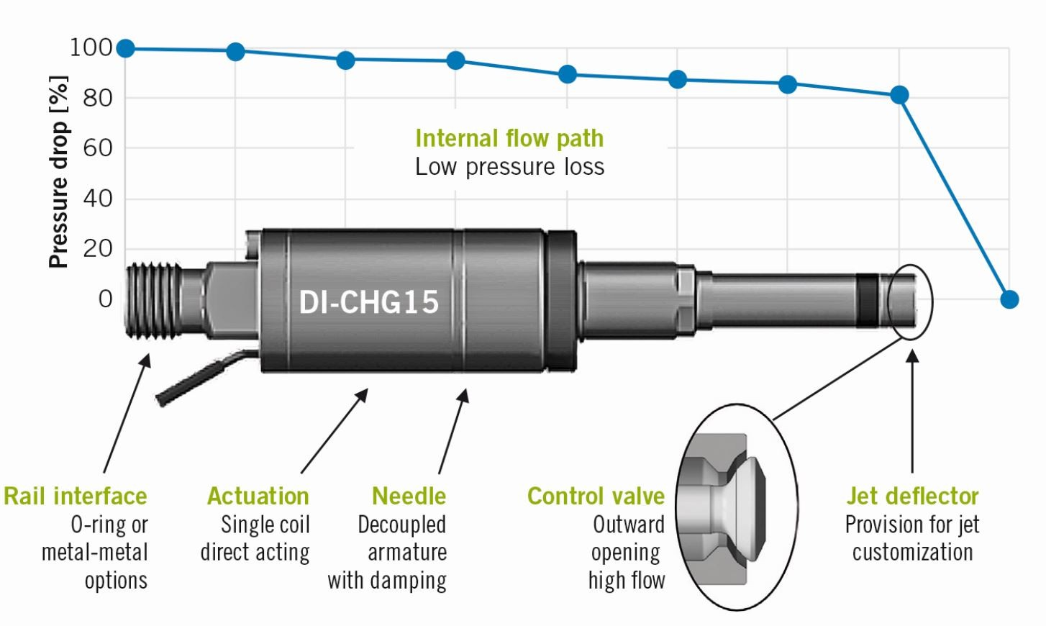
Figure 6. High pressure direct injector and its structure for hydrogen application (copyright Borg-Warner, license no: 5619231423986, adapted from ref.⁵⁴).
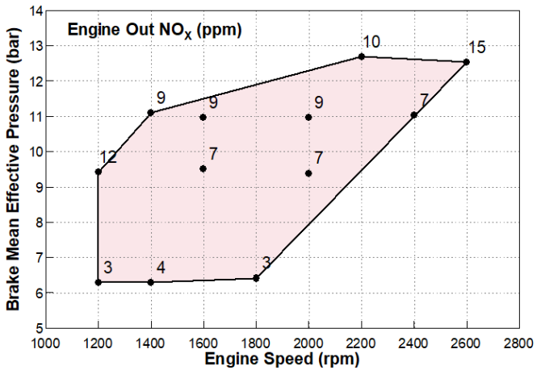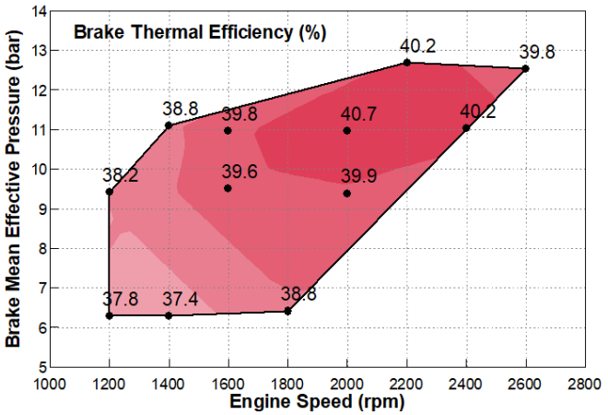
Figure 7. The engine out emissions and brake thermal efficiency of 1.6 L Hyundai hydrogen SI engine (Reproduced from ref.⁷⁵, CC-BY)
The mixture formation is a critical factor in DI systems, as it directly impacts engine performance and emissions. However, due to the high reactivity of hydrogen, it is susceptible to pre-ignition and backfire, which can be managed through injection control. Injection of hydrogen during the intake stroke prevents backfire but reduces power out and thermal efficiency due to engine knock. Injection during the compression stroke prevents knock and increases thermal efficiency and maximum output power. Late injection during the compression stroke results in noteworthy emissions reduction, primarily attributed to lean operation during instances of high load conditions⁸⁰.
Moreover, the nozzle design and the injector location for DI have a significant impact on ITE at low load conditions. Injectors located on the side show higher efficiency compared to central locations. However, at high loads, the impact of injector location and nozzle design is much smaller. The NOx emissions exhibit contrasting patterns when comparing low loads to high loads, but the general trends relative to the start of injection timing remain consistent across a range of load points, regardless of injector nozzle design, as indicated in Figure 8⁸¹.
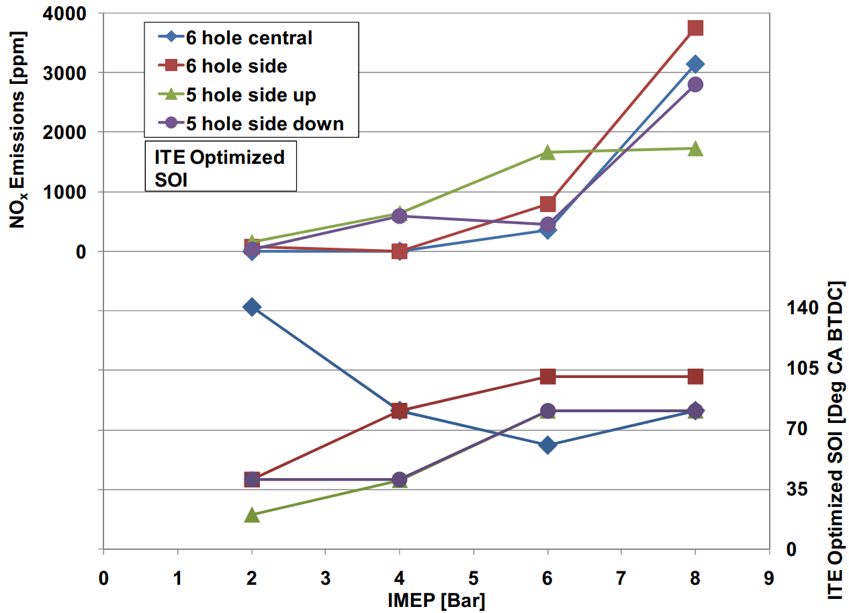
Figure 8. NOx emissions and the optimised start of injection timing as a function of engine load for various injector nozzle design in a hydrogen DI engine (License ID: 1392085-1, reproduced from ref.⁸¹).
Various injection strategies have been investigated to further improve the potential of hydrogen DI. It is possible to maintain engine efficiency while reducing NOx emissions by using multiple injection strategies in a single-cylinder hydrogen engine with high-pressure direct injection^{82, 83}. Injection timing also plays a significant role in combustion and emissions of H2ICE. Retarding the fuel injection timing can increase the intake air flow rate, decrease NOx emissions, and potentially improve efficiency. Increasing the fuel injection pressure may allow for further retardation, but it may also increase combustion speed and temperature, decreasing efficiency. The optimal injection timing may also depend on the air-to-fuel ratio and combustion conditions, with a mixture near the stoichiometric ratio potentially providing the highest torque⁸⁴.

Challenges with hydrogen fuel
As mentioned above, while hydrogen fuel offers many potential benefits but there are also several challenges that need to be addressed for widespread adoption.
First of all, the producing cost of green hydrogen fuel is higher than conventional hydrocarbon fuels such as gasoline and diesel, primarily due to the high cost of electricity required for the electrolysis process. Additionally, the infrastructure required for producing, transporting, and storing hydrogen is not yet widely available.
Secondly, the density of hydrogen gas is only 0.090 kg/m³ at standard temperature and pressure, which is much lower than traditional fuels. This results in hydrogen taking up more space and requiring high pressure storage or extremely low temperatures for efficient storage. This makes it difficult to store and transport large quantities. Several solutions are being explored to address the problem of hydrogen storage such as compressed gas storage which is the most common method of storing hydrogen⁸⁵ and liquid storage, which can store hydrogen as a cryogenic liquid at extremely low temperatures (–253°C). However, the cost of liquefying hydrogen and the need for cryogenic storage equipment make this option less practical⁸⁶. Solid-state hydrogen storage using materials such as metal hydrides is also being investigated⁸⁷. One promising method is using ammonia or methanol as a hydrogen carrier, which can be easier to handle and transport, but requires additional processing to release the hydrogen.
While hydrogen fuel itself produces no carbon emissions, the current production process of hydrogen heavily relies on fossil fuels (i.e., grey hydrogen). Until renewable energy sources can be used to produce green hydrogen more efficiently, the overall carbon emissions associated with hydrogen fuel may not be significantly lower than traditional fuels. In addition, due to the high combustion temperature, H2ICE produce NOx emissions, which leads to the formation of thermal NOx. To reduce NOx emissions, various methods such as EGR, lean-burn combustion, and catalytic converters can be applied.
Moreover, hydrogen has a low density and a high diffusivity, which means it tends to mix with air quickly but can also easily separate from the air, resulting in a non-uniform mixture. This can lead to combustion instability, which can cause engine knock, misfire, and reduced power output. To enhance the power output of H2ICE, one approach is to increase the CR of the engine. The low energy density and higher octane rating under lean combustion compared to gasoline allows a high CR in the engine to be used⁸⁸.
Another approach to increase H2ICE power output is to use boosting devices to increase the air mass flow rate entering the engine, allowing for a larger amount of hydrogen to be burned. The Ultra Boost for Economy project demonstrated that the fuel consumption of the boosted engine can be reduced by 23% with the same power output as baseline engine⁸⁹. Boosting a hydrogen engine with a turbocharger can increase torque and power by 41% compared to a NA engine (Figure 9)⁹⁰. Further improvements could be achieved by boosting the engine with supercharger, which can result in a 30% of BTE and 50% of ITE^{63, 91-93}.
The pre-chamber is a promising method for enhancing power output, as demonstrated in conventional engines⁹⁴⁻⁹⁷. Simulation results show that a SI engine with a pre-chamber installed operating under lean conditions provides higher ITE compared to the normal SI mode⁹⁸. Adding hydrogen to a single cylinder engine with a pre-chamber increased the efficiency, gross work, and indicated mean effective pressure (IMEP), while also improving combustion quality and reducing CO and UHC emissions by 20% and 15%. However, NOx emissions increased by approximately 14%⁹⁹. While the pre-chamber has shown promising results, it is a relatively new concept for H2ICE that requires further investigation to fully understand its potential benefits and limitations.
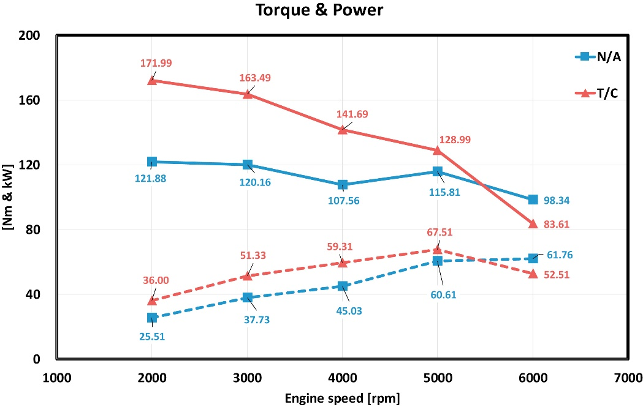
Figure 9. Effect of turbocharger on hydrogen engine torque and power output (License no: 5619240462019, reproduced from ref.⁹⁰).
Another challenge associated with H2ICE is the risk of backfire or flashback. Hydrogen has a wide flammability range and a low ignition energy making it easy to ignite in the intake manifold or the injector, leading to a flame that propagates back into the injector. This can cause damage to the injector, resulting in engine damage or failure. Figure 10 shows a correlation between the injection configuration and potential occurrence of backfire¹⁰⁰. One method to prevent backfire in a hydrogen engine is to adjust the air-fuel ratio to a lean mixture, reducing the risk of unburned hydrogen igniting in the intake manifold or exhaust system¹⁰¹. Another method to prevent backfire is to use a cold-rated spark-plug with proper ignition timing and ensuring proper fuel injection¹⁰²⁻¹⁰⁴. Optimising spark timing in combination with water injection can also reduce the chances of backfire and improve the power output of H2ICE^{62, 105, 106}.
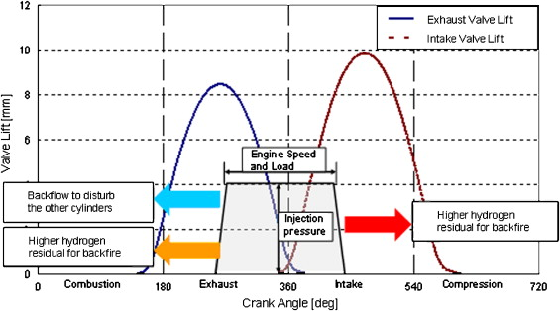
Figure 10. The correlation between the hydrogen injection configuration and the potential occurrence of backfire (License no: 5619240658087, adapted from ref.¹⁰⁰)
Finally, the injection of hydrogen requires a highly pressurised fuel system to deliver the fuel to the injectors, which can be complex and costly to design and maintain. The high pressure also increases the risk of leaks and can lead to safety concerns.

Ammonia
Ammonia is an alternative fuel that has gained interest due to its zero-carbon emissions and potential for production from renewable sources such as wind and solar power. It is a colourless gas with a pungent odour and can be conveniently stored and transported in liquid form under moderate pressure. Owing to its significant hydrogen content, ammonia holds promises as a fuel for internal combustion engines. Nevertheless, utilising ammonia as fuel comes with challenges including its toxicity, corrosiveness, and the requirements for specialised handling and storage infrastructure¹⁰⁷.

Ammonia production
At present, ammonia is primarily produced through the Haber-Bosch process. This technique includes the combining of nitrogen and hydrogen reaction with an iron-based catalyst under high pressure (typically around 200 atm) and temperature (around 450°C)¹⁰⁸. The nitrogen is typically obtained from the atmosphere by means of air separation, while hydrogen can be produced from a variety of sources including natural gas, coal, or electrolysis of water. However, the Haber-Bosch process is energy-intensive, requiring a significant amount of fossil fuel input and contributing to around 2% of global GHG emissions¹⁰⁹⁻¹¹¹.
Therefore, there is a need for greener methods of ammonia production that are more energy-efficient and environmentally friendly. Some alternative production methods include electrochemical synthesis, which uses renewable electricity to convert nitrogen and water into ammonia¹¹², and biological processes that utilise microorganisms to produce ammonia¹¹³. Another method of ammonia production is the hydrogenation of atmospheric nitrogen which uses renewable energy sources to produce hydrogen and then combines it with nitrogen in the presence of a catalyst to produce ammonia¹¹⁴. This process holds the potential to diminish GHG emissions associated with ammonia production, as it relies solely on renewable energy sources and thus avoids the need for fossil fuel inputs. Plasma-assisted synthesis involves the use of an electrical discharge to break apart nitrogen and hydrogen molecules, which then recombine to form ammonia¹¹⁵. Table 4 provides a concise overview and comparison of different methods for NH₃ production.
Table 4. Comparison of various ammonia production methods
Production Method | Advantages | Disadvantages
Haber-Bosch process | Mature technology, large-scale production capability. | Energy-intensive, and thus conventionally requires fossil fuel input, contributes to greenhouse gas emissions.
Hydrogenation of N₂ | Uses renewable electricity as a power source, low carbon footprint. | Technology still in development, low production capacity, high capital and operational costs.
Plasma-assisted synthesis | Can use renewable electricity, high production rate. | High energy consumption, requires additional equipment, expensive catalysts.
Electrochemical synthesis | Low energy consumption, can use renewable electricity. | Technology still in development, low production capacity, expensive catalysts.
Biomass gasification | Uses renewable feedstock, potential for carbon neutral production. | Requires significant amounts of biomass, low production rate, impurities in feedstock can affect catalysts.
Alternative methods of ammonia production offer several advantages over the traditional Haber-Bosch process in terms of production rate without relying on fossil fuel. Nevertheless, they encounter significant challenges, including the high expenses associated with selective and efficient catalysts. Therefore, the production of ammonia still heavily depends on the traditional process but with a transition towards more advance, sustainable and environmentally-friendly approaches, such as switching from methane-based hydrogen source to renewable ones¹¹⁶. The “green Haber-Bosch” approach, which utilises electrolysis to produce hydrogen from water using renewable electricity sources¹¹⁷. Figure 11 provides a simplified schematic of traditional and converted ammonia production process¹¹¹.
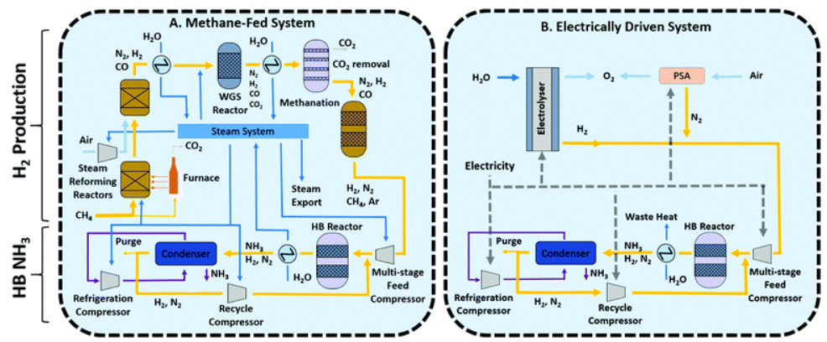
Figure 11. Schematic diagram of the traditional Haber Bosch process (A) utilising methane and (B) an electric-powered alternative (Reproduced from ref.¹¹¹ with permission from the Royal Society of Chemistry).

Ammonia as a fuel for internal combustion engines
Ammonia for some time has been considered as a promising alternative fuel for ICEs due to its high hydrogen content, and high octane rating. One of the advantages of ammonia as a fuel is that it can be easily stored and transported, making it a more practical from hydrogen¹¹⁸. In fact, ammonia powered buses were introduced and used in Belgium in 1943 due to the shortage of hydrocarbon-based fuel during World War II¹¹⁹. A military application of an ammonia vehicle was introduced in the US in 1965¹²⁰.
In the mid-1960s, research focused on modifying existing engines to operate on ammonia fuel and developing new engines specifically for ammonia. Garabedian and Johnson discussed the challenges of converting engines to operate solely on ammonia, as well as the potential benefits of savings in weight, volume, cost, and complexity¹²¹. Although the results of these experiments were generally positive, ammonia faced significant challenges to widespread adoption as a fuel. One major challenge was the need for costly and impractical modifications to existing engines. Another challenge was the increased fuel requirements for ammonia, which would have required larger and heavier fuel tanks, compromising vehicle performance¹²²⁻¹²⁶. Additionally, the availability of cheap gasoline and the lack of infrastructure for producing and distributing ammonia led to the decline of ammonia-powered vehicles.
Utilising ammonia as a fuel in spark ignition engines for LDV has some challenges due to its low energy density and high autoignition temperature. Achieving stable combustion is one of the main challenges of ammonia SI engines due to its low flame speed and narrow flammability range¹²⁷. To overcome these challenges, several modifications are necessary to the fuel, ignition, and exhaust system. Ammonia must be stored in a high-pressure tank, and the fuel system must be adapted to accommodate the different fuel properties of ammonia compared to conventional fuel. The ignition system must be modified to provide a high-energy spark to initiate the combustion process, and the exhaust system must be modified to handle the different exhaust gases produced by ammonia combustion¹²⁸.
One approach to using ammonia in SI engines involves using it as a partial replacement for conventional fuel, by mixing with gasoline or natural gas in varying ratios and tuning the engine to operate on this fuel mixture. Although this approach can reduce emissions and improve fuel efficiency, it requires modifications to the fuel and ignition system. Another approach is to use hydrogen as a combustion promoter in dedicated SI engines that are designed specifically to operate on ammonia. These operation modes allow higher CR, advanced ignition timing, and other parameters to be optimised to improve the engine combustion process and overall performance¹²⁹.
Ongoing research on ammonia as a fuel in SI engines is making it more feasible with advances in technology and engine design¹³⁰. The following section will discuss the feasibility of ammonia fuel in different operation modes including ammonia-only and dual-fuel with focuses on ammonia and hydrogen blends.

Ammonia-only engines
There have been only a few studies conducted on spark ignition engines operating solely on ammonia. Starkman et al.¹²⁶ found that little modification is needed to use ammonia in SI combustion if it is introduced in vapour form and undergoes partial decomposition into hydrogen and nitrogen. The engine maximum output reached 70% of gasoline-fueled engines and could exceed that if the ammonia were introduced as a liquid. However, Cornelius et al. reported that the use of ammonia only as a fuel resulted in unstable and poor performance. Nevertheless, increasing the spark energy, compression ratio, and applying a supercharger can significantly improve engine combustion and power output, as indicated in Figure 12. The peak brake power achieved with an ammonia engine was approximately 10% lower than the maximum engine power attained with gasoline¹²². Additionally, Pearsall successfully developed an ammonia burning engine with a 10.26:1 CR by modifying the ignition coil, spark plug, fuel delivery system and cylinder head. When operated at 4000 rpm the engine provided 53 hp while it generated 68 hp on gasoline. However, it was not possible to use a higher compression ratio because peak cylinder pressures were too high, resulting in crankshaft failure¹³¹.
The limited research in this area is partly due to the lower energy density of ammonia compared to conventional fuels. Additionally, the combustion of ammonia in a spark-ignition engine presents challenges related to ignition timing and combustion stability. However, with the growing focus on zero-carbon transportation, there has been a revived interest in exploring the potential of ammonia as a viable alternative fuel for SI engines.
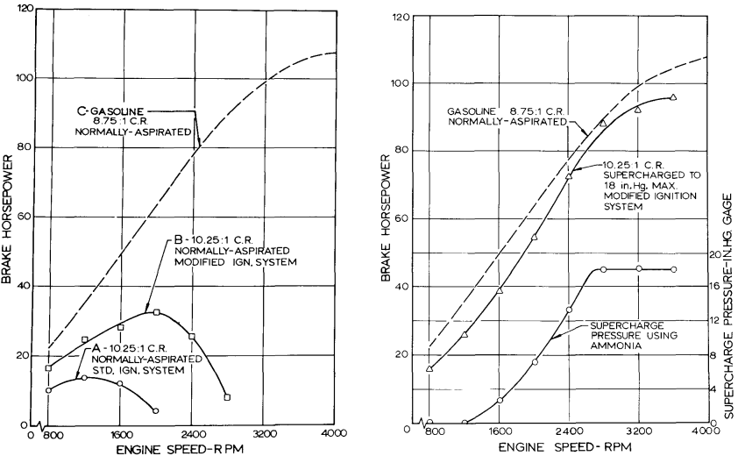
Figure 12. Performance of a multi-cylinder engine operating on ammonia and gasoline, under full-throttle with normally aspirated conditions and modified ignition systems (left); the same engine with supercharging and a modified ignition system (right) (License ID: 1392090-1, reproduced from ref.¹²²)
In order to utilise the direct injection in ammonia applications and achieve similar spray characteristics to gasoline, certain conditions must be met, including an atmospheric temperature and pressure at 20°C and 7 bar, as well as the injection duration is well below 1.2 ms, due to the ammonia reaches the wall after this certain duration ¹³². To achieve ammonia combustion without engine modifications and preheating the air, the engine must be warmed up before gradually introducing ammonia. This has been achieved by using methanol as a fuel first ¹³³. Eventually, a full shift transition from methanol to ammonia could be achieved and the highest power output of engine with a CR of 15:1 using liquid ammonia was approximately 60% compared to that achieved with gasoline at 9:1 CR¹³³. However, Mørch et al. ¹³⁴ found that it was possible to operate the engine with CR varied from 6.23 to 13.58 using pure ammonia fuel but this resulted in unstable combustion and a tendency to cut out. Lhuillier et al.¹³⁵ conducted a study on the performance of ammonia in a GDI engine, and their results suggested that near-stoichiometric lean operation is recommended to mitigate NOx and NH₃ emissions while maintaining satisfactory power output and efficiency. The operating limit of ammonia in SI engines was also investigated and results indicate that a minimum intake pressure of 0.75 bar (equivalent to 4.8 bar of IMEP) is sufficient for ammonia combustion under conditions of low engine speeds and loads (as shown in Figure 13)¹³⁶.
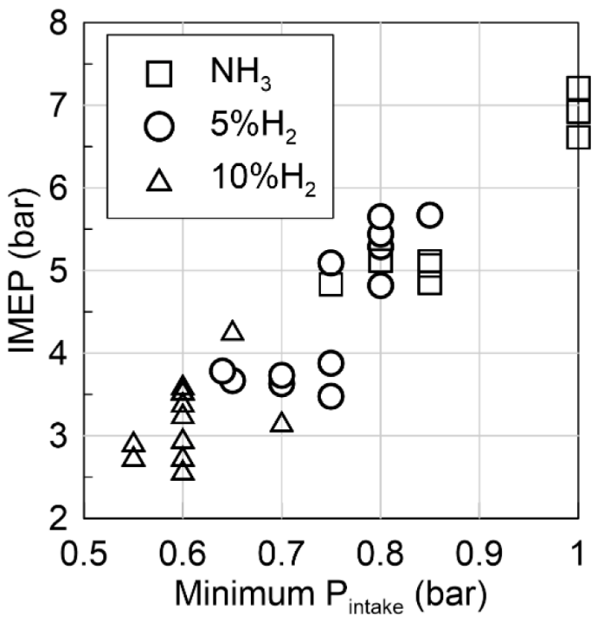
Figure 13. Operating limit and IMEP of an ammonia engine with various amounts of hydrogen addition (Adapted from ref.¹³⁶, CC-BY)
Due to the slow laminar burning rate of ammonia, operating an engine at higher speed (above 2000 rpm) without boosting or modifying is not possible¹³⁶. Laminar burning velocity and turbulent expanding flame measurements were conducted and presented in the study by Lhuillier et al. study, but this was insufficient to explain the engine combustion behaviour. Therefore, further investigations, including experimental and simulation works, are needed to gain a deeper understanding of pure ammonia combustion and to optimise practical combustion systems¹³⁷.

Ammonia dual fuel engines
There is a widespread belief that operating SI engines on ammonia alone would not result in satisfactory combustion¹³³. However, Starkman et al.¹²⁶ discovered that it is possible to achieve satisfactory combustion by using some type of combustion promoter. Common fuels used in ICEs such as gasoline and diesel, as well as alternative fuels like hydrogen, biodiesel, methanol can be used as combustion promoter¹³⁸. Among them, hydrogen is considered the best promoter because it has characteristics that are opposite and supplement those of ammonia. Hydrogen possesses a rapid combustion rate, low ignition energy, and an extensive range of flammability^{139, 140}. Research has demonstrated that adding even a small amount of hydrogen can significantly enhance the stability of ammonia combustion, resulting in more stable engine operation^{131, 141}.
The experimental study of ammonia and hydrogen mixtures in SI engines is completely reported in¹³⁴. Their results indicate that blends of ammonia and hydrogen are a viable fuel option for SI engines. The peak efficiency and IMEP were achieved when using a mixture encompassing 10% of hydrogen volume. The study of Sawyer et al.¹⁴² found that 8% volume of hydrogen in the mixture was sufficient. Frigo and Gentili found that the minimum hydrogen to ammonia energy ratio to achieve the same engine behaviour as gasoline was 7% at full load and 11% at part load. Figure 14 shows the engine BTE with respect to the engine speed for ammonia – hydrogen combustion and for gasoline combustion at full load¹⁴³. Furthermore, adding less than 10% H₂ to NH₃ (of the total mixture volume) ensured the combustion stability of the engine¹³⁶. However, excessive hydrogen addition results in decreasing ITE and IMEP of the engine as well as increasing NOx emissions due to the formation of thermal NOx¹⁴¹. Based on these experimental results, the optimal hydrogen addition to ammonia is around 10%. Nevertheless, the hydrogen ratio may vary depending on the specific engine design and operating conditions, and further research is needed to determine the optimal hydrogen-to-ammonia ratio for different engine configurations.
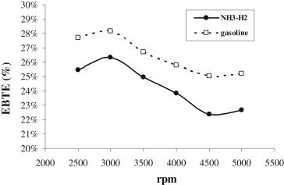
Figure 14. Comparison of engine brake thermal efficiency (EBTE) versus engine speed with NH₃ – H₂ and with gasoline at full load (License no: 5619241458175, reproduced from ref.¹⁴³)
Furthermore, optimal performance of an engine operating on ammonia and hydrogen mixture is achieved with an excess air ratio around stoichiometry and MBT timing, resulting in high ITE and mean effective pressure^{134, 141}. It has been found that operating near stoichiometric conditions results in lower nitric oxide emissions than in hydrocarbon combustion. However, the ammonia slip level is high (in the range of 1000 ppm) under these condition¹³⁴. The amount of ammonia slip from the engine may seem like a concern; it can actually be beneficial in reducing NOx emissions by optimising the selective catalytic reduction (SCR) catalyst¹⁴⁴. Also, the ammonia slip level is dependent on CR rather than excess air ratio and ignition timing, which is in contradiction to hydrocarbon-fuelled combustion engine.

Ammonia as a hydrogen carrier
One of the main problems with hydrogen is its low density, high storage pressure and the difficulty of storing it on board a vehicle. To address these challenges, ammonia can be used as a carrier for storage and transportation of hydrogen. By facilitating this hydrogen is extracted from the ammonia using a catalyst, and then used as fuel^{145, 146}. This approach can provide an efficient and clean energy source while utilising existing infrastructure for ammonia production and distribution. Moreover, using ammonia as a hydrogen carrier can enable the use of dual-fuel engines that can run on both ammonia and hydrogen, providing flexibility and redundancy in the fuel supply^{140, 144, 147}.
There are several onboard technologies that can be utilised to convert NH₃ into H₂. One approach is the use of an ammonia decomposition reactor, which typically contains a metal catalyst such as ruthenium or nickel¹⁴⁸. Another approach is the utilisation of an ammonia reformer, where ammonia is mixed with air or oxygen and passed over a catalyst, which promotes partial oxidation and steam reforming reactions to produce H₂ and N₂¹⁴⁹.
Simulation results of a hydrogen reforming system showed an increase in the peak value of in-cylinder pressure and heat release rate with an increase in H₂ enrichment. The maximum ITE of 44.3% was achieved at λ = 1.2 and 12.5% hydrogen addition¹⁵⁰. Also, experimental results of a hydrogen generation system (illustrated in Figure 15), which uses a cracking reactor with a ruthenium-based catalyst in an NH₃/H₂ engine, showed a trend in BTE and brake power similar to that of a gasoline engine. However, due to the poor mixture heating value, engine power output is reduced by 10% at low engine speed and 25% at high speed compared to gasoline engine’s power output. Additionally, the only significant pollutant detected from the ammonia/hydrogen engine exhaust emissions was NOx, with a peak value of 1700 ppm at 3000 rpm under full load conditions and 1500 ppm under low load^{143, 147}.
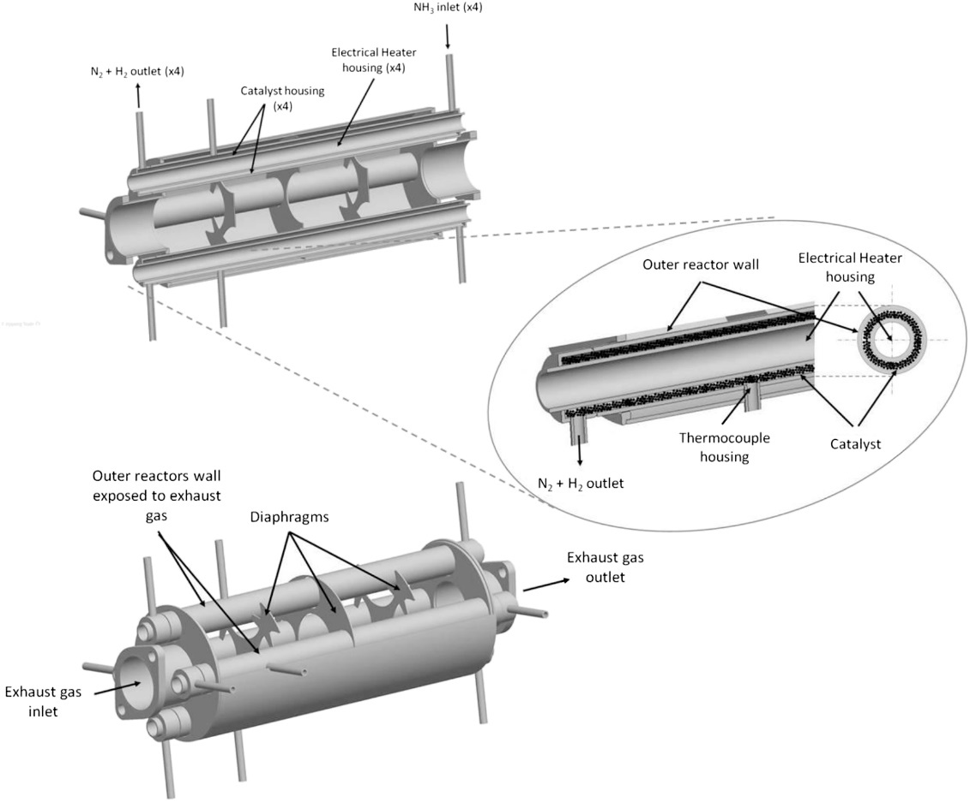
Figure 15. Design and illustration of the catalytic cracker reactor and integrated heat exchangers for hydrogen generation system (License no: 5619250191091, reproduced from ref.¹⁴⁷)
Cold start is a challenge for ammonia engines because the chemical reactions required to convert ammonia to hydrogen are only effective within a certain range of temperature range. Currently, commercially catalysts must be heated to a temperature of 450°C or above to facilitate the dissociation of ammonia into its constituent elements, nitrogen and hydrogen. Therefore, during cold start, a higher hydrogen flow rate and engine speed are required and maintained for a few seconds. Then, the H₂/NH₃ ratio and engine speed is gradually reduced to reach the controlled operating condition¹⁴³. Autothermal reforming is reported to be suitable for engine’s cold-start performance in ammonia combustion. During the warm-up process NH₃-free emissions were obtained using a Cu-zeolite catalyst for adsorption. The ratio of air to NH₃ introduced into the reformer was identified as a crucial factor in controlling the proportion of H₂ in the fuel. Moreover, the combustion of an ammonia engine could be initiated with a mixture containing H₂-NH₃ ratio of less than 10%. Additionally, a stable fast-idle combustion could be achieved by using a hydrogen to ammonia ratio of around 2:1 by volume¹⁵¹.

Challenges with ammonia
While ammonia is a promising fuel for LDVs, there are still several challenges that need to be addressed before it can become a mainstream fuel. One of the main challenges is the high cost of ammonia production. Currently, the most common method of producing ammonia is the Haber-Bosch process, which is energy-intensive and conventionally relies heavily on fossil fuels. In order for ammonia to be considered as a green fuel, production must shift towards renewable energy sources.
Another challenge is the infrastructure needed to support ammonia fuelling stations. Currently, there are very few ammonia fuelling stations, and building a new infrastructure network would require significant investment. Additionally, ammonia is highly toxic and requires special safety measures when handling and storing it.
Furthermore, ammonia has a lower energy density than gasoline or diesel fuel, which means that it requires larger fuel tanks to provide the same driving range. This could limit the amount of space available for passengers or cargo in LDVs. One possible method for storing ammonia is a metal amine complex system (Mg(NH₃)₆Cl₂) ¹⁵². Figure 16 shows a potential configuration for a fuel system utilising the metal amine complex as a carrier for ammonia. Due to the high exhaust gas temperature it becomes feasible to fulfill a significant portion of the heat required for extracting ammonia and hydrogen from a metal amine complex, through the use of residual heat in the exhaust gas¹³⁴.
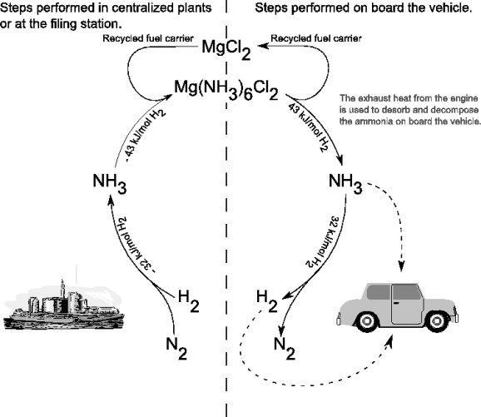
Figure 16. Method of using metal amine complex system (Mg(NH₃)₆Cl₂) as ammonia/hydrogen carrier in light-duty vehicles (License no: 5619250329448, reproduced from ref.¹³⁴)
In addition, the efficiency of the ammonia-based fuel system needs to be improved. One approach is to develop more efficient catalysts that can convert ammonia into hydrogen at lower temperatures. Another approach is to operate ammonia in combination with other fuels, such as hydrogen to increase the overall energy density of the fuel. Also, due to the slower combustion rate of ammonia, this can result in slower acceleration and a reduced maximum speed, which can be a significant drawback for certain applications. Various strategies such as improving the combustion process by using more efficient combustion technologies, optimising the engine design, and developing new ammonia-based fuels with higher energy densities could be used. Nevertheless, there exists a scarcity of data concerning the performance of vehicles fuelled by ammonia, and further research is imperative to comprehensively grasp their capabilities and constraints.
Another challenge associated with ammonia as a fuel is the design of the fuel injector. Currently there are no ammonia injectors available on the market. Furthermore, ammonia is corrosive to certain materials, which can limit the choice of materials that can be used in the injector and other fuel system components. As a result, there is a need for research and development of fuel injectors that are optimised for ammonia fuel, with improved atomisation and mixing capabilities, and that can withstand the harsh conditions associated with ammonia combustion.
Finally, there are concerns about the emissions of nitrogen oxides (NOx) from ammonia-fuelled vehicles. While ammonia can be acted as a reductant for SCR in diesel-powered engines, in SI engines ammonia combustion can lead to higher NOx emissions. This is because of the nitrogen content in the ammonia molecule and high combustion temperature which prompts NOx formation. Also, thermal NOx formation is the primary mechanism for NOx formation in ammonia combustion. At high temperatures N₂ and O₂ react to form NO through the Zeldovich mechanism. The presence of oxygen in the combustion process further promotes the conversion of NO to NO₂. One approach to reducing NOx emissions is to use EGR and lean combustion, which can reduce the combustion temperature and reduce the formation of NOx. Additionally, SCR systems can be used to reduce NOx emissions by converting NOx into nitrogen and water vapor, these could use NH₃ as the reductant agent. However, more in-depth research is needed to optimise the use of ammonia as a fuel and to develop new technologies to further reduce emissions.

Techno-economics analysis
From the results above, it can be seen that hydrogen and ammonia are potential alternative fuels for LDVs, that could contribute to a carbon free mobility future. However, a comprehensive assessment of their viability and adoption necessitates an exploration of the entire value chain from production to end-use. Key factors include the technical limitation, economy impacts such as capital and operating costs of production through various primary energy sources and processes, delivery and distribution infrastructure requirements, utilisation technologies and associated costs, as well as the value proposition and competitiveness in LDVs applications. Additionally, understanding the potential risks associated with hydrogen and ammonia fuels is crucial for scaling up and realise its widespread application.
Technical limitation:
Given the technical feasibility of hydrogen and ammonia fueled LDVs is well-established, infrastructure development is needed to allow its benefits. Figure 17 illustrates the general hydrogen pathways of hydrogen supply chain, it can be categorised by the production sources (e.g. natural gas, biomass, water electrolysis) or by distribution method like delivered or on-site production via renewable electricity. However, the technology and status of deployment hydrogen infrastructure have lagged behind¹⁵³. Hydrogen produced through various methods contributes to a cleaner and more sustainable production process. Moreover, hydrogen storage and transportation technologies have seen considerable progressed, addressing challenges related to density and safety¹⁵⁴.
To overcome the challenge of low density associated with hydrogen, ammonia can be served as a carrier for hydrogen storage and transportation. Using ammonia as the sole fuel onboard allows for higher energy density without requiring cryogenic temperatures or pressure. The Haber-Bosch process, traditionally used for ammonia production, is well-established. Furthermore, ongoing research explores advanced methods, including green ammonia production through electrochemical synthesis and biological processes. Also, studies have proposed using ammonia as the only onboard fuel stream, avoiding the need for complex fuel distribution infrastructure of two fuels^{134, 152}.
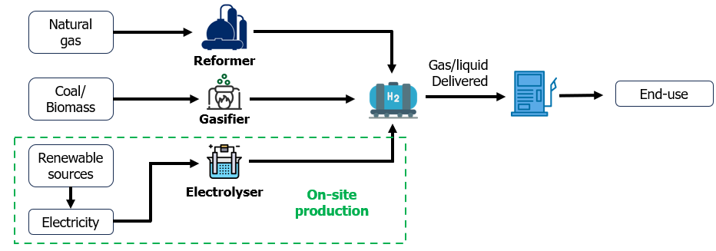
Figure 17. General hydrogen distribution pathways.
Economic feasibility:
Commercialisation of hydrogen vehicles faces challenges due to high costs of building hydrogen stations. However, the average capital costs of for hydrogen stations have significantly decreased, from over $20,000 per kg daily capacity in 2009 to ~$5000 per kg daily capacity in 2015, and further to approximately $1,200 and $3,000 per kilogram of hydrogen dispensed per day¹⁵⁵. This reduction is attributed to the development of hydrogen production methods and decreasing costs of renewable energy sources, such as solar and wind, contributing to the economic viability of hydrogen production. Additionally, advancements in electrolysis and other production methods aim to enhance the competitiveness of hydrogen with conventional fuels. In contrast, ammonia production currently relies on traditional Haber-Bosch process which is energy-intensive and require fossil fuels. Green ammonia production methods, utilising renewable energy, aim to enhance economic viability. When produced on a large scale, ammonia might replace a significant portion of today's liquid fuel usage.
Competitiveness with fossil fuel:
While the performance of H2ICE LDVs can be comparable with traditional vehicles, hydrogen faces competition from traditional fossil fuels due to the cost parity with fossil fuels. Currently the cost of hydrogen is about $10 – $16 per gge (where the energy of 1 kg of hydrogen is approximately equivalent to the energy of one gallon of gasoline). This is significantly higher than the target competitive price for alternative fuels, which is $5/gge¹⁵⁶. However, studies have reported that the cost of hydrogen fuel could be competitive with traditional fuel such as gasoline or diesel by reducing infrastructure-related costs¹⁵⁷.
On a source-to-tank basis, a study by Wright et al. ¹⁵⁸ indicates that the manufacturing cost of hydrogen could be about $6.55 per gge. In the same scenario, ammonia costs $4.50 per gge, representing a 31% cost advantage over hydrogen, highlights a clear economic advantage of ammonia. However, for a comprehensive assessment, the efficiency of the power source and drivetrain should be considered to provide per-km costs. Assuming a hydrogen vehicle fuel efficiency of 90 km per gge the hydrogen fuel cost is $0.072 per km while ammonia is $0.075 per km¹⁵⁹. Ammonia's perceived higher cost in the model is influenced by the assumed lower efficiency, impacting its overall economic comparison with hydrogen.
Market analysis:
The market for both hydrogen and ammonia is expanding rapidly, driven by a growing interest in decarbonisation. Industries such as transportation, manufacturing, and energy are increasingly adopting these fuels as cleaner alternatives to fossil fuel. The widespread adoption of hydrogen fueled vehicle technology in zero-carbon mobility are directly linked to the advancement and cost reduction of hydrogen technology. Furthermore, scaling up the production and charging stations is a critical aspect of the widespread adoption of these vehicles. Investments in large-scale production facilities and infrastructure are essential¹⁶⁰. While ammonia offer more advantages such as less space is required for the same energy content and having more competitive on current market prices, scaling up ammonia production involves addressing challenges related to energy efficiency and environmental impact¹⁶¹.
Risk Analysis:
While the potential benefits of hydrogen are substantial, there are inherent risks, including technological challenges, market uncertainties, and regulatory changes. The investment required for infrastructure development poses financial risks. Additionally, ensuring safety in hydrogen production, storage, and transportation is a key consideration. Due to hydrogen is being easy to leak and diffuse, which is difficult to detect after leakage, it can accumulate in confined spaces, posing a potential threat of fire and explosion accidents. However, the number of literatures on hydrogen vehicles safety is limited. From the hydrogen stations aspect, majority of the public safety reports involve minor leakage, demonstrating an excellent safety record¹⁵⁷.
In terms of safety, ammonia is not flammable in the air and is therefore less likely to cause fires and explosions. The primary concern with ammonia is its toxicity, which poses risks to human health. Accidental releases or exposure incidents must be carefully managed to prevent adverse health effects and widespread public adoption.

Concluding remarks
Overall, zero-carbon fuels such as hydrogen and ammonia have the potential to play a crucial role in achieving sustainable mobility and reducing carbon emissions. While each fuel type presents its unique advantages and challenges, continued research and development will be necessary to improve their feasibility and realise a zero-carbon economy. While hydrogen offers high energy density and zero carbon emissions, it presents challenges in storage, transportation, and infrastructure development. Ammonia, on the other hand, can be stored and transported more easily but has lower energy density and poses challenges in emissions reduction and overall engine performance.
In addition, there is also the possibility of using combinations of ammonia and hydrogen in an engine. This approach can potentially provide the benefits of both fuels while mitigating their individual drawbacks. For example, using ammonia as the primary fuel and hydrogen as the secondary fuel can help to overcome some of the challenges associated with using ammonia as a standalone fuel, such as high NOx emissions and a limited performance envelope by speeding up the flame front propagation and stabilising the combustion. However, further research and development is needed to optimise the use of ammonia and hydrogen as dual fuels in light-duty vehicles. This includes investigating the most effective fuel injection strategies, combustion control, and emissions control technologies.
Clearly, the environmental benefits of using ammonia and hydrogen as fuel in LDVs are only fully realised if these fuels are derived from renewable sources. While both ammonia and hydrogen hold the promise of reducing greenhouse gas emissions and improve air quality, their production from fossil fuels may actually increase emissions and exacerbate climate change. Therefore, it is essential to prioritise the advancement of renewable sources based methods for producing ammonia and hydrogen, such as through electrolysis using renewable electricity or biomass gasification. This not only makes their use in transportation more sustainable but also ensures that the overall energy system is decarbonised.
In addition to renewable production, there is also a need to address the technical and infrastructural challenges associated with their use as fuel sources in LDVs. Furthermore, safety concerns will arise when using hydrogen and ammonia as fuel in LDVs. Hydrogen is a highly flammable gas and storing it at high pressures can increase the risk of explosions and fires in the event of a collision or leak. Proper safety measures, such as reinforced fuel tanks and advance storage technology must be implemented to prevent accident ignition and ensure public safety. Similarly, ammonia is a toxic gas that can cause serious harm if inhaled or exposed to the skin or eyes. Special care must be taken during the handling, transport, and storage of ammonia to prevent leaks or spills that could endanger public health and the environment.
Overall, the use of ammonia and hydrogen as alternative fuel sources in LDVs has significant potential to contribute to a more sustainable and decarbonised transportation sector. However, their full potential can only be realised through a comprehensive approach that includes renewable production, technical development, and infrastructure deployment, as well as must consideration of the safety aspect associated with the gases.
References
1. IEA. The role of CCUS in low-carbon power systems. 2020. IEA, Paris.
2. SZYMANSKI P, CIUFFO B, FONTARAS G, et al. The future of road transport in Europe. Environmental implications of automated, connected and low-carbon mobility. Combustion Engines 2021; 186: 3-10. journal article. DOI: 10.19206/ce-141605.
3. Parliament E. CO2 emissions from cars: facts and figures (infographics), https://www.europarl.europa.eu/news/en/headlines/society/20190313STO31218/co2-emissions-from-cars-facts-and-figures-infographics (2019, accessed 09.03 2023).
4. Koroma MS, Costa D, Philippot M, et al. Life cycle assessment of battery electric vehicles: Implications of future electricity mix and different battery end-of-life management. Science of The Total Environment 2022; 831: 154859. DOI: https://doi.org/10.1016/j.scitotenv.2022.154859.
5. Shafique M and Luo X. Environmental life cycle assessment of battery electric vehicles from the current and future energy mix perspective. Journal of Environmental Management 2022; 303: 114050. DOI: https://doi.org/10.1016/j.jenvman.2021.114050.
6. Xia X and Li P. A review of the life cycle assessment of electric vehicles: Considering the influence of batteries. Science of The Total Environment 2022; 814: 152870. DOI: https://doi.org/10.1016/j.scitotenv.2021.152870.
7. Luk JM, Kim HC, De Kleine R, et al. Review of the Fuel Saving, Life Cycle GHG Emission, and Ownership Cost Impacts of Lightweighting Vehicles with Different Powertrains. Environ Sci Technol 2017; 51: 8215-8228. 2017/07/18. DOI: 10.1021/acs.est.7b00909.
8. Gielen D, Castellanos G, Ruiz C, et al. Study Navigating the Way to a Renewable Future–Solutions to Decarbonise Shipping: Preliminary findings for the UN Climate Action Summit 2019. 2019.
9. Nguyen DM, Kishk MA and Alouini MS. Toward Sustainable Transportation: Accelerating Vehicle Electrification With Dynamic Charging Deployment. IEEE Transactions on Vehicular Technology 2022; 71: 9283-9296. DOI: 10.1109/TVT.2022.3180495.
10. Ambrose H, Kendall A, Lozano M, et al. Trends in life cycle greenhouse gas emissions of future light duty electric vehicles. Transportation Research Part D: Transport and Environment 2020; 81: 102287. DOI: https://doi.org/10.1016/j.trd.2020.102287.
11. Bauer C, Hofer J, Althaus H-J, et al. The environmental performance of current and future passenger vehicles: Life cycle assessment based on a novel scenario analysis framework. Applied Energy 2015; 157: 871-883. DOI: https://doi.org/10.1016/j.apenergy.2015.01.019.
12. Hawkins TR, Singh B, Majeau-Bettez G, et al. Comparative Environmental Life Cycle Assessment of Conventional and Electric Vehicles. Journal of Industrial Ecology 2013; 17: 53-64. https://doi.org/10.1111/j.1530-9290.2012.00532.x. DOI: https://doi.org/10.1111/j.1530-9290.2012.00532.x.
13. Heywood J, MacKenzie D, Akerlind IB, et al. On the road toward 2050: Potential for substantial reductions in light-duty vehicle energy use and greenhouse gas emissions. Massachusetts Institute of Technology 2015.
14. Zhu Y, Skerlos S, Xu M, et al. Reducing Greenhouse Gas Emissions from U.S. Light-Duty Transport in Line with the 2 °C Target. Environmental Science & Technology 2021; 55: 9326-9338. DOI: 10.1021/acs.est.1c00816.
15. Andersson Ö and Börjesson P. The greenhouse gas emissions of an electrified vehicle combined with renewable fuels: Life cycle assessment and policy implications. Applied Energy 2021; 289: 116621. DOI: https://doi.org/10.1016/j.apenergy.2021.116621.
16. Pehl M, Arvesen A, Humpenöder F, et al. Understanding future emissions from low-carbon power systems by integration of life-cycle assessment and integrated energy modelling. Nature Energy 2017; 2: 939-945. DOI: 10.1038/s41560-017-0032-9.
17. Wong EY, Ho DC, So S, et al. Life Cycle Assessment of Electric Vehicles and Hydrogen Fuel Cell Vehicles Using the GREET Model—A Comparative Study. Sustainability 13. DOI: 10.3390/su13094872.
18. Pörtner H-O, Roberts DC, Adams H, et al. Climate Change 2022: Impacts, Adaptation and Vulnerability. Cambridge University Press, 2022.
19. Jaramillo P, Ribeiro SK, Newman P, et al. 2022: Transport. In: Shukla PR, Skea J, Slade R, et al. (eds) IPCC, 2022: Climate Change 2022: Mitigation of Climate Change Contribution of Working Group III to the Sixth Assessment Report of the Intergovernmental Panel on Climate Change. Cambridge, UK and New York, NY, USA: Cambridge University Press, 2022.
20. Andersson J and Grönkvist S. Large-scale storage of hydrogen. International Journal of Hydrogen Energy 2019; 44: 11901-11919. DOI: https://doi.org/10.1016/j.ijhydene.2019.03.063.
21. Makepeace JW, He T, Weidenthaler C, et al. Reversible ammonia-based and liquid organic hydrogen carriers for high-density hydrogen storage: Recent progress. International Journal of Hydrogen Energy 2019; 44: 7746-7767. DOI: https://doi.org/10.1016/j.ijhydene.2019.01.144.
22. Bockris JOM. The hydrogen economy: Its history. International Journal of Hydrogen Energy 2013; 38: 2579-2588. DOI: https://doi.org/10.1016/j.ijhydene.2012.12.026.
23. Sharma S and Ghoshal SK. Hydrogen the future transportation fuel: From production to applications. Renewable and Sustainable Energy Reviews 2015; 43: 1151-1158. DOI: https://doi.org/10.1016/j.rser.2014.11.093.
24. Hermesmann M and Müller TE. Green, Turquoise, Blue, or Grey? Environmentally friendly Hydrogen Production in Transforming Energy Systems. Progress in Energy and Combustion Science 2022; 90: 100996. DOI: https://doi.org/10.1016/j.pecs.2022.100996.
25. Newborough M and Cooley G. Developments in the global hydrogen market: The spectrum of hydrogen colours. Fuel Cells Bulletin 2020; 2020: 16-22. DOI: 10.1016/S1464-2859(20)30546-0.
26. Boretti A. There are hydrogen production pathways with better than green hydrogen economic and environmental costs. International Journal of Hydrogen Energy 2021; 46: 23988-23995. DOI: https://doi.org/10.1016/j.ijhydene.2021.04.182.
27. Mehmeti A, Angelis-Dimakis A, Arampatzis G, et al. Life Cycle Assessment and Water Footprint of Hydrogen Production Methods: From Conventional to Emerging Technologies. Environments 2018; 5: 24.
28. Laiminger S, Url M, Payrhuber K, et al. Hydrogen as Future Fuel for Gas Engines. MTZ worldwide 2020; 81: 64-69. DOI: 10.1007/s38313-020-0212-z.
29. Zhang X, Jiao K, Zhang J, et al. A review on low carbon emissions projects of steel industry in the World. Journal of Cleaner Production 2021; 306: 127259. DOI: https://doi.org/10.1016/j.jclepro.2021.127259.
30. Wan L, Zhang W and Xu Z. Overview of Key Technologies and Applications of Hydrogen Energy Storage in Integrated Energy Systems. In: 2020 12th IEEE PES Asia-Pacific Power and Energy Engineering Conference (APPEEC) 20-23 Sept. 2020 2020, pp.1-5.
31. Wróbel K, Wróbel J, Tokarz W, et al. Hydrogen Internal Combustion Engine Vehicles: A Review. Energies 2022; 15: 8937.
32. Cecil W. On the application of hydrogen gas to produce a moving power in machinery; with a description of an engine which is moved by the pressure of the atmosphere, upon a vacuum caused by explosions of hydrogen and atmospheric air. Trans Cambridge Philos Soc 1822; 1: 217.
33. Boretti A. Advantages of the direct injection of both diesel and hydrogen in dual fuel H2ICE. International Journal of Hydrogen Energy 2011; 36: 9312-9317. DOI: https://doi.org/10.1016/j.ijhydene.2011.05.037.
34. Escher WJD and Ecklund EE. Recent Progress in the Hydrogen Engine. SAE Technical Papers 1976. DOI: 10.4271/760571.
35. Das LM. Hydrogen engines: A view of the past and a look into the future. International Journal of Hydrogen Energy 1990; 15: 425-443. DOI: 10.1016/0360-3199(90)90200-I.
36. Szwabowski SJ, Hashemi S, Stockhausen WF, et al. Ford Hydrogen Engine Powered P2000 Vehicle. SAE Technical Papers 2002. DOI: 10.4271/2002-01-0243.
37. Kiesgen G, Klüting M, Bock C, et al. The New 12-Cylinder Hydrogen Engine in the 7 Series: The H2 ICE Age Has Begun. SAE Technical Papers 2006. DOI: 10.4271/2006-01-0431.
38. Wallner T, Lohse-Busch H, Gurski S, et al. Fuel economy and emissions evaluation of BMW Hydrogen 7 Mono-Fuel demonstration vehicles. International Journal of Hydrogen Energy 2008; 33: 7607-7618. DOI: https://doi.org/10.1016/j.ijhydene.2008.08.067.
39. Wakayama N. Development of Premacy Hydrogen RE Hybrid. 31 international Vienna motor symposium. Vienna (Austria): 31th international Vienna motor symposium, 2010, p. 254-262.
40. Butcher L. Toyota successfully completes Fuji 24-hour race with hydrogen engine, https://www.automotivepowertraintechnologyinternational.com/news/fuel-cells-technologies/toyota-successfully-completes-fuji-24-hour-race-with-hydrogen-engine.html (2021, accessed Mar 18 2023).
41. TOYOTA. 'Morizo' Puts Hydrogen-Engine GR Yaris Through Its Paces on Belgian Roads, https://global.toyota/en/newsroom/toyota/37888377.html (2022, accessed Mar 18 2023).
42. YAMAHA. Tapping the Potential Within 100% Hydrogen-Powered Engines, https://www.yamaha-motor.eu/gb/en/news/tapping-the-potential-within-100--hydrogen-powered-engines/ (2022, accessed Mar 18 2023).
43. Rajesh Jesudoss Hynes N, Sankaranarayanan R, Senthamarai Kannan P, et al. 14 - Solid-state hydrides for hydrogen storage. In: Sen F, Khan A and Asiri AM (eds) Nanomaterials for Hydrogen Storage Applications. Elsevier, 2021, pp.249-264.
44. Shadidi B, Najafi G and Yusaf T. A Review of Hydrogen as a Fuel in Internal Combustion Engines. Energies 2021.
45. White CM, Steeper RR and Lutz AE. The hydrogen-fueled internal combustion engine: a technical review. International Journal of Hydrogen Energy 2006; 31: 1292-1305. DOI: https://doi.org/10.1016/j.ijhydene.2005.12.001.
46. Verhelst S, Verstraeten S and Sierens R. A comprehensive overview of hydrogen engine design features. Proceedings of the Institution of Mechanical Engineers, Part D: Journal of Automobile Engineering 2007; 221: 911-920. DOI: 10.1243/09544070JAUTO141.
47. Fayaz H, Saidur R, Razali N, et al. An overview of hydrogen as a vehicle fuel. Renewable and Sustainable Energy Reviews 2012; 16: 5511-5528. DOI: https://doi.org/10.1016/j.rser.2012.06.012.
48. Kumar V, Gupta D and Kumar N. HYDROGEN USE IN INTERNAL COMBUSTION ENGINE: A REVIEW. International Journal of Advanced Culture Technology 2015; 3: 87-99. DOI: 10.17703/IJACT.2015.3.2.87.
49. Verhelst S, Sierens R and Verstraeten S. A Critical Review of Experimental Research on Hydrogen Fueled SI Engines. SAE Technical Papers 2006. DOI: 10.4271/2006-01-0430.
50. Dash SK, Chakraborty S, Roccotelli M, et al. Hydrogen Fuel for Future Mobility: Challenges and Future Aspects. Sustainability 14. DOI: 10.3390/su14148285.
51. Teoh YH, How HG, Le TD, et al. A review on production and implementation of hydrogen as a green fuel in internal combustion engines. Fuel 2023; 333: 126525. DOI: https://doi.org/10.1016/j.fuel.2022.126525.
52. Das LM. Fuel induction techniques for a hydrogen operated engine. International Journal of Hydrogen Energy 1990; 15: 833-842. DOI: https://doi.org/10.1016/0360-3199(90)90020-Y.
53. Sun Z, Hong J, Zhang T, et al. Hydrogen engine operation strategies: Recent progress, industrialization challenges, and perspectives. International Journal of Hydrogen Energy 2023; 48: 366-392. DOI: https://doi.org/10.1016/j.ijhydene.2022.09.256.
54. Dober G, Hoffmann G, Doradoux L, et al. Direct Injection Systems for Hydrogen Engines. MTZ worldwide 2021; 82: 60-65. DOI: 10.1007/s38313-021-0720-5.
55. Sopena C, Diéguez PM, Sáinz D, et al. Conversion of a commercial spark ignition engine to run on hydrogen: Performance comparison using hydrogen and gasoline. International Journal of Hydrogen Energy 2010; 35: 1420-1429. DOI: https://doi.org/10.1016/j.ijhydene.2009.11.090.
56. Lee SJ, Yi HS and Kim ES. Combustion characteristics of intake port injection type hydrogen fueled engine. International Journal of Hydrogen Energy 1995; 20: 317-322. DOI: https://doi.org/10.1016/0360-3199(94)00052-2.
57. Mathur HB and Das LM. Performance characteristics of a hydrogen fuelled S.I. engine using timed manifold injection. International Journal of Hydrogen Energy 1991; 16: 115-127. DOI: https://doi.org/10.1016/0360-3199(91)90038-K.
58. Hari Ganesh R, Subramanian V, Balasubramanian V, et al. Hydrogen fueled spark ignition engine with electronically controlled manifold injection: An experimental study. Renewable Energy 2008; 33: 1324-1333. DOI: https://doi.org/10.1016/j.renene.2007.07.003.
59. Sun D and Liu F. Research on the Performance and Emission of a Port Fuel Injection Hydrogen Internal Combustion Engine. In: 2010 International Conference on Digital Manufacturing & Automation 18-20 Dec. 2010 2010, pp.299-302.
60. Pandey JK and Kumar GN. Effect of variable compression ratio and equivalence ratio on performance, combustion and emission of hydrogen port injection SI engine. Energy 2022; 239: 122468. DOI: https://doi.org/10.1016/j.energy.2021.122468.
61. Park C, Kim Y, Oh S, et al. Effect of the operation strategy and spark plug conditions on the torque output of a hydrogen port fuel injection engine. International Journal of Hydrogen Energy 2021; 46: 37063-37070. DOI: https://doi.org/10.1016/j.ijhydene.2021.08.229.
62. Dhyani V and Subramanian KA. Control of backfire and NOx emission reduction in a hydrogen fueled multi-cylinder spark ignition engine using cooled EGR and water injection strategies. International Journal of Hydrogen Energy 2019; 44: 6287-6298. DOI: https://doi.org/10.1016/j.ijhydene.2019.01.129.
63. Verhelst S, Maesschalck P, Rombaut N, et al. Increasing the power output of hydrogen internal combustion engines by means of supercharging and exhaust gas recirculation. International Journal of Hydrogen Energy 2009; 34: 4406-4412. DOI: https://doi.org/10.1016/j.ijhydene.2009.03.037.
64. Subramanian V, Mallikarjuna JM and Ramesh A. Effect of water injection and spark timing on the nitric oxide emission and combustion parameters of a hydrogen fuelled spark ignition engine. International Journal of Hydrogen Energy 2007; 32: 1159-1173. DOI: https://doi.org/10.1016/j.ijhydene.2006.07.022.
65. Verhelst S and Sierens R. Combustion Studies for PFI Hydrogen IC Engines. SAE Technical Papers 2007. DOI: 10.4271/2007-01-3610.
66. Yao H, Sun B, Tian H, et al. A Study of Hydrogen Internal Combustion Engine EGR System. SAE Technical Papers 2014; 1. DOI: 10.4271/2014-01-1071.
67. Yip HL, Srna A, Yuen AC, et al. A Review of Hydrogen Direct Injection for Internal Combustion Engines: Towards Carbon-Free Combustion. Applied Sciences 9. DOI: 10.3390/app9224842.
68. Wimmer A, Wallner T, Ringler J, et al. H2-direct injection - A highly promising combustion concept. SAE Technical Papers 2005. DOI: 10.4271/2005-01-0108.
69. Rottengruber H, Berckmüller M, Elsässer G, et al. Direct-Injection Hydrogen SI-Engine - Operation Strategy and Power Density Potentials. SAE Technical Papers 2004. DOI: 10.4271/2004-01-2927.
70. Welch A, Mumford D, Munshi S, et al. Challenges in Developing Hydrogen Direct Injection Technology for Internal Combustion Engines. SAE Technical Papers 2008. DOI: 10.4271/2008-01-2379.
71. Furuhama S and Kobayashi Y. Hydrogen Cars with LH2-Tank, LH2-Pump and Cold GH2-Injection Two-Stroke Engine. SAE Technical Papers 1982. DOI: 10.4271/820349.
72. Yamane K, Nogami M, Umemura Y, et al. Development of high pressure H2 gas injectors, capable of injection at large injection rate and high response using a common-rail type actuating system for a 4-cylinder, 4.7-liter total displacement, spark ignition hydrogen engine. SAE Technical Papers 2011. DOI: 10.4271/2011-01-2005.
73. Yamane K. Hydrogen Fueled ICE, Successfully Overcoming Challenges through High Pressure Direct Injection Technologies: 40 Years of Japanese Hydrogen ICE Research and Development. SAE Technical Papers 2018; 2018-April. DOI: 10.4271/2018-01-1145.
74. Kim C, Park C, Kim Y, et al. Power characteristics with different types of turbochargers for lean boosted hydrogen direct injection engine in NOx-free operation. Heliyon 2023; 9: e14186. DOI: https://doi.org/10.1016/j.heliyon.2023.e14186.
75. Chi YH, Shin BS, Hoffmann S, et al. Hydrogen Internal Combustion Engine: Viable Technology for Carbon Neutral Mobility. In: Valencia UPd, (ed.). THIESEL 2022 Conference on Thermo- and Fluid Dynamics of Clean Propulsion Powerplants. Universitat Politècnica de València: Editorial Universitat Politècnica de València, 2022, p. 195-206.
76. Atkins P, Fox N, Saroop A, et al. Examining Trade-offs between NOx Emissions and Hydrogen Slip for Hydrogen Combustion Engines. In: Valencia UPd, (ed.). THIESEL 2022 Conference on Thermo- and Fluid Dynamics of Clean Propulsion Powerplants. Universitat Politècnica de València: Editorial Universitat Politècnica de València, 2022, p. 164-177.
77. Seba B and Weiss U. Hydrogen Combustion Engine – A Suitable Concept for Decarbonisation in Offroad Sector. In: Heavy-Duty-, On- und Off-Highway-Motoren 2021 (ed Liebl J), Wiesbaden, 2022// 2022, pp.100-117. Springer Fachmedien Wiesbaden.
78. Pirkl R, Herrmann D, Kapusta L, et al. H2 Injection System for Heavy-duty Applications. ATZheavy duty worldwide 2022; 15: 28-33. DOI: 10.1007/s41321-022-0493-z.
79. Nolde A. Liebherr’s H2 direct injection solutions for heavy-duty engines, https://www.liebherr.com/en/ind/latest-news/news-press-releases/detail/liebherr%E2%80%99s-h2-direct-injection-solutions-for-heavy-duty-engines.html (2022, accessed Mar 21 2023).
80. Mohammadi A, Shioji M, Nakai Y, et al. Performance and combustion characteristics of a direct injection SI hydrogen engine. International Journal of Hydrogen Energy 2007; 32: 296-304. DOI: https://doi.org/10.1016/j.ijhydene.2006.06.005.
81. Wallner T, Nande AM and Naber J. Evaluation of Injector Location and Nozzle Design in a Direct-Injection Hydrogen Research Engine. SAE Technical Papers 2008. DOI: 10.4271/2008-01-1785.
82. Wallner T, Scarcelli R, Nande AM, et al. Assessment of multiple injection strategies in a direct-injection hydrogen research engine. SAE Technical Papers 2009. DOI: 10.4271/2009-01-1920.
83. Li Y, Gao W, Zhang P, et al. Effects study of injection strategies on hydrogen-air formation and performance of hydrogen direct injection internal combustion engine. International Journal of Hydrogen Energy 2019; 44: 26000-26011. DOI: https://doi.org/10.1016/j.ijhydene.2019.08.055.
84. Park C, Kim Y, Oh S, et al. Effect of fuel injection timing and injection pressure on performance in a hydrogen direct injection engine. International Journal of Hydrogen Energy 2022; 47: 21552-21564. DOI: https://doi.org/10.1016/j.ijhydene.2022.04.274.
85. Elberry AM, Thakur J, Santasalo-Aarnio A, et al. Large-scale compressed hydrogen storage as part of renewable electricity storage systems. International Journal of Hydrogen Energy 2021; 46: 15671-15690. DOI: https://doi.org/10.1016/j.ijhydene.2021.02.080.
86. Valenti G. 2 - Hydrogen liquefaction and liquid hydrogen storage. In: Gupta RB, Basile A and Veziroğlu TN (eds) Compendium of Hydrogen Energy. Woodhead Publishing, 2016, pp.27-51.
87. Rusman NAA and Dahari M. A review on the current progress of metal hydrides material for solid-state hydrogen storage applications. International Journal of Hydrogen Energy 2016; 41: 12108-12126. DOI: https://doi.org/10.1016/j.ijhydene.2016.05.244.
88. Poursadegh F, Brear M, Hayward B, et al. Autoignition, knock, detonation and the octane rating of hydrogen. Fuel 2023; 332: 126201. DOI: https://doi.org/10.1016/j.fuel.2022.126201.
89. Turner JWG, Popplewell A, Patel R, et al. Ultra Boost for Economy: Extending the Limits of Extreme Engine Downsizing. SAE International Journal of Engines 2014; 7: 387-417. DOI: 10.4271/2014-01-1185.
90. Lee J, Park C, Kim Y, et al. Effect of turbocharger on performance and thermal efficiency of hydrogen-fueled spark ignition engine. International Journal of Hydrogen Energy 2019; 44: 4350-4360. DOI: https://doi.org/10.1016/j.ijhydene.2018.12.113.
91. Nguyen D, Choi Y, Park C, et al. Effect of supercharger system on power enhancement of hydrogen-fueled spark-ignition engine under low-load condition. International Journal of Hydrogen Energy 2021; 46: 6928-6936. DOI: https://doi.org/10.1016/j.ijhydene.2020.11.144.
92. Oikawa M, Kojiya Y, Sato R, et al. Effect of supercharging on improving thermal efficiency and modifying combustion characteristics in lean-burn direct-injection near-zero-emission hydrogen engines. International Journal of Hydrogen Energy 2022; 47: 1319-1327. DOI: https://doi.org/10.1016/j.ijhydene.2021.10.061.
93. Verhelst S, Demuynck J, Martin S, et al. Investigation of supercharging strategies for PFI hydrogen engines. SAE Technical Papers 2010. DOI: 10.4271/2010-01-0582.
94. Alvarez CEC, Couto GE, Roso VR, et al. A review of prechamber ignition systems as lean combustion technology for SI engines. Applied Thermal Engineering 2018; 128: 107-120. DOI: https://doi.org/10.1016/j.applthermaleng.2017.08.118.
95. Hlaing P, Echeverri Marquez M, Cenker E, et al. Effects of volume and nozzle area in narrow-throat spark-ignited pre-chamber combustion engines. Fuel 2022; 313: 123029. DOI: https://doi.org/10.1016/j.fuel.2021.123029.
96. Tang Q, Sampath R, Marquez ME, et al. Optical diagnostics on the pre-chamber jet and main chamber ignition in the active pre-chamber combustion (PCC). Combustion and Flame 2021; 228: 218-235. DOI: https://doi.org/10.1016/j.combustflame.2021.02.001.
97. Shah A, Tunestal P and Johansson B. Effect of Pre-Chamber Volume and Nozzle Diameter on Pre-Chamber Ignition in Heavy Duty Natural Gas Engines. SAE Technical Papers 2015; 2015-April. DOI: 10.4271/2015-01-0867.
98. Aljabri H, Silva M, Houidi MB, et al. Comparative Study of Spark-Ignited and Pre-Chamber Hydrogen-Fueled Engine: A Computational Approach. Energies 15. DOI: 10.3390/en15238951.
99. Kakoee A, Bakhshan Y, Aval SM, et al. An improvement of a lean burning condition of natural gas/diesel RCCI engine with a pre-chamber by using hydrogen. Energy Conversion and Management 2018; 166: 489-499. DOI: https://doi.org/10.1016/j.enconman.2018.04.063.
100. Liu X-h, Liu F-s, Zhou L, et al. Backfire prediction in a manifold injection hydrogen internal combustion engine. International Journal of Hydrogen Energy 2008; 33: 3847-3855. DOI: https://doi.org/10.1016/j.ijhydene.2008.04.051.
101. Gao J, Wang X, Song P, et al. Review of the backfire occurrences and control strategies for port hydrogen injection internal combustion engines. Fuel 2022; 307: 121553. DOI: https://doi.org/10.1016/j.fuel.2021.121553.
102. Kondo T, Iio S and Hiruma M. A Study on the Mechanism of Backfire in External Mixture Formation Hydrogen Engines -About Backfire Occurred by Cause of the Spark Plug. SAE Technical Papers 1997. DOI: 10.4271/971704.
103. Dhyani V and Subramanian KA. Fundamental characterization of backfire in a hydrogen fuelled spark ignition engine using CFD and experiments. International Journal of Hydrogen Energy 2019; 44: 32254-32270. DOI: https://doi.org/10.1016/j.ijhydene.2019.10.077.
104. Park C, Kim Y, Choi Y, et al. The effect of engine speed and cylinder-to-cylinder variations on backfire in a hydrogen-fueled internal combustion engine. International Journal of Hydrogen Energy 2019; 44: 22223-22230. DOI: https://doi.org/10.1016/j.ijhydene.2019.06.058.
105. Yang Z, Wang L, Zhang Q, et al. Research on optimum method to eliminate backfire of hydrogen internal combustion engines based on combining postponing ignition timing with water injection of intake manifold. International Journal of Hydrogen Energy 2012; 37: 12868-12878. DOI: https://doi.org/10.1016/j.ijhydene.2012.05.082.
106. Duan J, Liu F and Sun B. Backfire control and power enhancement of a hydrogen internal combustion engine. International Journal of Hydrogen Energy 2014; 39: 4581-4589. DOI: https://doi.org/10.1016/j.ijhydene.2013.12.175.
107. Brohi EA. Ammonia as fuel for internal combustion engines? An evaluation of the feasibility of using nitrogen-based fuels in ICE. CHALMERS UNIVERSITY OF TECHNOLOGY, Gothenburg, Sweden, 2014.
108. Pattabathula V and Richardson J. Introduction to ammonia production. Chem Eng Prog 2016; 112: 69-75.
109. Schiffer ZJ and Manthiram K. Electrification and Decarbonization of the Chemical Industry. Joule 2017; 1: 10-14. DOI: https://doi.org/10.1016/j.joule.2017.07.008.
110. Liu X, Elgowainy A and Wang M. Life cycle energy use and greenhouse gas emissions of ammonia production from renewable resources and industrial by-products. Green Chemistry 2020; 22: 5751-5761. 10.1039/D0GC02301A. DOI: 10.1039/D0GC02301A.
111. Smith C, Hill AK and Torrente-Murciano L. Current and future role of Haber–Bosch ammonia in a carbon-free energy landscape. Energy & Environmental Science 2020; 13: 331-344. 10.1039/C9EE02873K. DOI: 10.1039/C9EE02873K.
112. Kyriakou V, Garagounis I, Vasileiou E, et al. Progress in the Electrochemical Synthesis of Ammonia. Catalysis Today 2017; 286: 2-13. DOI: https://doi.org/10.1016/j.cattod.2016.06.014.
113. Andersson J and Lundgren J. Techno-economic analysis of ammonia production via integrated biomass gasification. Applied Energy 2014; 130: 484-490. DOI: https://doi.org/10.1016/j.apenergy.2014.02.029.
114. Pool JA, Lobkovsky E and Chirik PJ. Hydrogenation and cleavage of dinitrogen to ammonia with a zirconium complex. Nature 2004; 427: 527-530. DOI: 10.1038/nature02274.
115. Peng P, Chen P, Schiappacasse C, et al. A review on the non-thermal plasma-assisted ammonia synthesis technologies. Journal of Cleaner Production 2018; 177: 597-609. DOI: https://doi.org/10.1016/j.jclepro.2017.12.229.
116. Lee B, Lim D, Lee H, et al. Which water electrolysis technology is appropriate?: Critical insights of potential water electrolysis for green ammonia production. Renewable and Sustainable Energy Reviews 2021; 143: 110963. DOI: https://doi.org/10.1016/j.rser.2021.110963.
117. Nowicki DA, Agnew GD and Irvine JTS. Green ammonia production via the integration of a solid oxide electrolyser and a Haber-Bosch loop with a series of solid electrolyte oxygen pumps. Energy Conversion and Management 2023; 280: 116816. DOI: https://doi.org/10.1016/j.enconman.2023.116816.
118. Zamfirescu C and Dincer I. Using ammonia as a sustainable fuel. Journal of Power Sources 2008; 185: 459-465. DOI: https://doi.org/10.1016/j.jpowsour.2008.02.097.
119. Koch E. Ammonia–a fuel for motor buses. Journal of the Institute of Petroleum, 1945; 31: 213-223.
120. Rosenthal AB. Energy Depot - A Concept for Reducing the Military Supply Burden. SAE Technical Papers 1965. DOI: 10.4271/650050.
121. Garabedian CG and Johnson JH. The theory of operation of an ammonia burning internal combustion engine. 1966. ARMY TANK-AUTOMOTIVE CENTER WARREN MI.
122. Cornelius W, Huellmantel LW and Mitchell HR. Ammonia as an Engine Fuel. SAE Technical Papers 1965. DOI: 10.4271/650052.
123. Pearsall TJ and Garabedian CG. Combustion of Anhydrous Ammonia in Diesel Engines. SAE Technical Papers 1967. DOI: 10.4271/670947.
124. Starkman ES, James GE and Newhall HK. Ammonia as a Diesel Engine Fuel: Theory and Application. SAE Technical Papers 1967. DOI: 10.4271/670946.
125. Gray JT, Dimitroff E, Meckel NT, et al. Ammonia Fuel - Engine Compatibility and Combustion. SAE Technical Papers 1966. DOI: 10.4271/660156.
126. Starkman ES, Newhall HK, Sutton R, et al. Ammonia as a Spark Ignition Engine Fuel: Theory and Application. SAE Technical Papers 1966. DOI: 10.4271/660155.
127. Dimitriou P and Javaid R. A review of ammonia as a compression ignition engine fuel. International Journal of Hydrogen Energy 2020; 45: 7098-7118. DOI: https://doi.org/10.1016/j.ijhydene.2019.12.209.
128. Han D, Liu Y and Huang Z. The Use of Ammonia as a Fuel for Combustion Engines. In: Kalghatgi G, Agarwal AK, Leach F, et al. (eds) Engines and Fuels for Future Transport. Singapore: Springer Singapore, 2022, pp.233-256.
129. Xu X, Liu E, Zhu N, et al. Review of the Current Status of Ammonia-Blended Hydrogen Fuel Engine Development. Energies 15. DOI: 10.3390/en15031023.
130. Angeles DA, Tan RR, Aviso KB, et al. Fuzzy optimization of the automotive ammonia fuel cycle. Journal of Cleaner Production 2018; 186: 877-882. DOI: https://doi.org/10.1016/j.jclepro.2018.03.143.
131. Pearsall T. Ammonia application to reciprocating engines. 1967. Continental Aviation and Engineering Corp., Detroit, MI (USA).
132. Pelé R, Mounaïm-Rousselle C, Bréquigny P, et al. First Study on Ammonia Spray Characteristics with a Current GDI Engine Injector. Fuels 2: 253-271. DOI: 10.3390/fuels2030015.
133. Mozafari-Varnusfadrani A. Predictions and measurements of spark-ignition engine characteristics using ammonia and other fuels. Queen Mary University of London, 1988.
134. Mørch CS, Bjerre A, Gøttrup MP, et al. Ammonia/hydrogen mixtures in an SI-engine: Engine performance and analysis of a proposed fuel system. Fuel 2011; 90: 854-864. DOI: https://doi.org/10.1016/j.fuel.2010.09.042.
135. Lhuillier C, Brequigny P, Contino F, et al. Combustion Characteristics of Ammonia in a Modern Spark-Ignition Engine. SAE Technical Papers 2019. DOI: 10.4271/2019-24-0237.
136. Mounaïm-Rousselle C, Bréquigny P, Dumand C, et al. Operating Limits for Ammonia Fuel Spark-Ignition Engine. Energies 14. DOI: 10.3390/en14144141.
137. Lhuillier C, Brequigny P, Contino F, et al. Experimental investigation on ammonia combustion behavior in a spark-ignition engine by means of laminar and turbulent expanding flames. Proceedings of the Combustion Institute 2021; 38: 5859-5868. DOI: https://doi.org/10.1016/j.proci.2020.08.058.
138. Klüssmann JN, Ekknud L, Ivarsson A, et al. Ammonia application in IC engines. Special report, a report from the advanced motor fuels technology collaboration programme 2020.
139. Frigo S, Gentili R and De Angelis F. Further Insight into the Possibility to Fuel a SI Engine with Ammonia plus Hydrogen. SAE Technical Papers 2014; 2014-November. DOI: 10.4271/2014-32-0082.
140. Chiong M-C, Chong CT, Ng J-H, et al. Advancements of combustion technologies in the ammonia-fuelled engines. Energy Conversion and Management 2021; 244: 114460. DOI: https://doi.org/10.1016/j.enconman.2021.114460.
141. Lhuillier C, Brequigny P, Contino F, et al. Experimental study on ammonia/hydrogen/air combustion in spark ignition engine conditions. Fuel 2020; 269: 117448. DOI: https://doi.org/10.1016/j.fuel.2020.117448.
142. Sawyer RF, Starkman ES, Muzio L, et al. Oxides of Nitrogen in the Combustion Products of an Ammonia Fueled Reciprocating Engine. SAE Technical Papers 1968. DOI: 10.4271/680401.
143. Frigo S and Gentili R. Analysis of the behaviour of a 4-stroke Si engine fuelled with ammonia and hydrogen. International Journal of Hydrogen Energy 2013; 38: 1607-1615. DOI: https://doi.org/10.1016/j.ijhydene.2012.10.114.
144. Westlye FR, Ivarsson A and Schramm J. Experimental investigation of nitrogen based emissions from an ammonia fueled SI-engine. Fuel 2013; 111: 239-247. DOI: https://doi.org/10.1016/j.fuel.2013.03.055.
145. Caballero LC, Thornburg NE and Nigra MM. Catalytic ammonia reforming: alternative routes to net-zero-carbon hydrogen and fuel. Chem Sci 2022; 13: 12945-12956. 2022/11/26. DOI: 10.1039/d2sc04672e.
146. Lucentini I, Garcia X, Vendrell X, et al. Review of the Decomposition of Ammonia to Generate Hydrogen. Industrial & Engineering Chemistry Research 2021; 60: 18560-18611. DOI: 10.1021/acs.iecr.1c00843.
147. Comotti M and Frigo S. Hydrogen generation system for ammonia–hydrogen fuelled internal combustion engines. International Journal of Hydrogen Energy 2015; 40: 10673-10686. DOI: https://doi.org/10.1016/j.ijhydene.2015.06.080.
148. Badescu V. Optimal design and operation of ammonia decomposition reactors. International Journal of Energy Research 2020; 44: 5360-5384. https://doi.org/10.1002/er.5286. DOI: https://doi.org/10.1002/er.5286.
149. Wang W, Herreros JM, Tsolakis A, et al. Ammonia as hydrogen carrier for transportation; investigation of the ammonia exhaust gas fuel reforming. International Journal of Hydrogen Energy 2013; 38: 9907-9917. DOI: https://doi.org/10.1016/j.ijhydene.2013.05.144.
150. Zhang H, Li G, Long Y, et al. Numerical study on combustion and emission characteristics of a spark-ignition ammonia engine added with hydrogen-rich gas from exhaust-fuel reforming. Fuel 2023; 332: 125939. DOI: https://doi.org/10.1016/j.fuel.2022.125939.
151. Koike M, Suzuoki T, Takeuchi T, et al. Cold-start performance of an ammonia-fueled spark ignition engine with an on-board fuel reformer. International Journal of Hydrogen Energy 2021; 46: 25689-25698. DOI: https://doi.org/10.1016/j.ijhydene.2021.05.052.
152. Christensen CH, Sørensen RZ, Johannessen T, et al. Metal ammine complexes for hydrogen storage. Journal of Materials Chemistry 2005; 15: 4106-4108. 10.1039/B511589B. DOI: 10.1039/B511589B.
153. Kim C, Cho SH, Cho SM, et al. Review of hydrogen infrastructure: The current status and roll-out strategy. International Journal of Hydrogen Energy 2023; 48: 1701-1716. DOI: https://doi.org/10.1016/j.ijhydene.2022.10.053.
154. Qureshi F, Yusuf M, Arham Khan M, et al. A State-of-The-Art Review on the Latest trends in Hydrogen production, storage, and transportation techniques. Fuel 2023; 340: 127574. DOI: https://doi.org/10.1016/j.fuel.2023.127574.
155. Mariya K and Marc M. Hydrogen fueling stations cost. DOE Hydrog Progr Rec 2020.
156. Saur G, Spencer G and Sprik S. Next Generation Hydrogen Station Composite Data Products: Retail Stations – Summer 2022: Data Through Quarter 2 of 2022. 2023. National Renewable Energy Lab.(NREL), Golden, CO (United States).
157. Kurtz J, Sprik S and Bradley TH. Review of transportation hydrogen infrastructure performance and reliability. International Journal of Hydrogen Energy 2019; 44: 12010-12023.
158. Wright MM, Daugaard DE, Satrio JA, et al. Techno-economic analysis of biomass fast pyrolysis to transportation fuels. Fuel 2010; 89: S2-S10. DOI: https://doi.org/10.1016/j.fuel.2010.07.029.
159. Zhao Y, Setzler BP, Wang J, et al. An Efficient Direct Ammonia Fuel Cell for Affordable Carbon-Neutral Transportation. Joule 2019; 3: 2472-2484. DOI: https://doi.org/10.1016/j.joule.2019.07.005.
160. Miele A, Axsen J, Wolinetz M, et al. The role of charging and refuelling infrastructure in supporting zero-emission vehicle sales. Transportation Research Part D: Transport and Environment 2020; 81: 102275. DOI: https://doi.org/10.1016/j.trd.2020.102275.
161. McKinlay CJ, Turnock S and Hudson D. A comparison of hydrogen and ammonia for future long distance shipping fuels. 2020.

Abbreviations
BEV | Battery electric vehicles
BTE | Break thermal efficiency
CFR | Cooperative fuel research
CR | Compression ratio
DI | Direct injection
EGR | Exhaust gas recirculation
GDI | Gasoline direct injection
GHG | Greenhouse gas
H2ICE | Hydrogen internal combustion engine
HC | Hydrocarbon
ICE | Internal combustion engines
IMEP | Indicated mean effective pressure
ITE | Indicated thermal efficiency
LDV | Light-duty vehicle
NA | Naturally aspirated
PFI | Port fuel injection
SCR | Selective catalytic reduction
SI | Spark ignition
VCR | Variable compression ratio

