Projecting and Forecasting Stochastic Volatility Characteristics

for the Nasdaq OMX Nordic/Baltic Financial Electricity Markets

**Abstract:** This paper builds, implements and interprets multifactor stochastic volatility models for the Nordic/Baltic electricity markets. The main objective is step ahead volatility projections followed by volatility forecasts and market implications. From conditional moments and a long-simulated state vector realization the paper establishes a functional form of the conditional distribution (non-linear Kalman Filter), which is evaluated on observed data convenient for step ahead volatility projections. For the front year and quarter financial electricity contracts, the SV model report one persistent and slowly moving factor and one choppy mean reverting factor. From these factors, static volatility forecasts using optimal and generous lags, report a Theil covariance portion well above 98% for the front year and 92% for the front quarter contracts.

**Keywords:** Stochastic Volatility, Markov Chain Monte Carlo (MCMC) Simulations, Projection-Reprojection, Forecasting volatility

***Data Availability Statement:***

The article uses two freely available datasets (2442 observations).

The first file “001-Electricity_Front_Year_prices_returns_2011-2020.txt” contains daily close financial contract prices (front year) in Euro freely downloadable from Nordpoolgroup.com

(<https://www.nordpoolgroup.com/Market-data1/#/nordic/table>)

The second file “002-Electricity_Front_Quarter_prices_returns_2011-2020.txt” contains daily close financial contract prices (front quarter) in Euro freely downloadable from Nordpoolgroup.com

(<https://www.nordpoolgroup.com/Market-data1/#/nordic/table>)

The Nordic/Baltic Electricity market consists of the following countries: Denmark, Estonia, Finland, Latvia, Lithuania, Norway, Sweden.

The Nord Pool Group has authorized the use of the data set. The consent is given under cite agreements and that the data should not be used without authorization.

The [https://www.nordpoolgroup.com/Market-data1/#/nordic/table](https://www.nordpoolgroup.com/Market-data1/#/nordic/tabler) reference gives free and direct access to contract prices for the relevant period 2011-2020.

The paper encloses the two daily datasets for the period 2010-2020:

1. *001-Electricity_Front_Year_Contract_ prices_returns_2011-2020.txt*
2. *002-Electricity_ Front_Quarter_Contract_prices_returns_2011-2020.txt*

1 Introduction

### This paper builds and assesses multifactor scientific stochastic volatility (SV) models for step ahead electricity market volatility renowned for extremity and unpredictability. Knowing that electricity markets are influenced by a range of factors including weather, local economic activity, global financial outlook,, international prices, resource availability, investment in future resources, government policies, and the physical and mechanical constraints on plant or infrastructure, periods of high volatility is often the rule rather than the exception, making it difficult to manage budgets and control costs. For all market participants, understanding and anticipating the impact of key market fundamental risk factors are therefore important for the expected continuation of volatility[1]. Volatility is a measure of dispersion around the mean returns of electricity contracts. When the daily price movements are tightly bunched together (or spread apart), the volatility is small (large). Volatility measures entail prediction characteristics for future returns and volatility models have therefore been used internationally to predict the absolute magnitude of returns, quantiles and entire densities. For example, a simple and often used proxy for volatility is squared price movements.

### A special feature of market volatility is that it is not directly observable. The unobservability of volatility makes it difficult to evaluate the forecasting performance of volatility models. However, knowledge of the empirical properties of future prices is important when constructing risk management strategies, i.e. portfolio selection, derivatives and hedging, market-making and market timing. For all these market activities, the predictability of volatility is essential for success. Hence, a volatility model able to forecast volatility will be beneficial to electricity market participants. Today a risk manager must know the likelihood that his portfolio will decline in the future. Generally, for hedging, a risk manager will want to know the contract volatility approaching maturity. The only parameter that requires estimation in the Black-Scholes Model is the volatility. An option trader will want to know the volatility that can be expected over the future life of the contract. The use of derivatives suggests risk-reduction technique known as hedging, which requires a sound understanding of how to value derivatives and an understanding of which risks should and should not be hedged. To hedge a contract, he will also want to know the forecast volatility. The volatility estimates may also be of use in estimating parameters (*u* and *d*) in a binomial model. Ceteris paribus, higher (lower) volatility increases (decreases) derivative prices. Therefore, market participants will sell (buy) both call and put option contract positions that are not part of speculative or hedge positions, if predicted volatility is declining (increasing).A portfolio manager may want to sell a stock or a portfolio before it becomes too volatile. Portfolio and asset studies have shown that when volatility increases, risk increases, and portfolio and asset movements decrease. If a portfolio manager adds more assets to his portfolio, the additional assets diversify the portfolio if they do not covary (correlation less than 1) with other assets in the portfolio. Hence, generally, portfolios imply diversification showing asset allocation importance. A market maker can change his bid-ask spread believing future volatility changes. Normally, markets show that the bid-ask spread increases (decreases) when volatility rises (falls).

Stochastic volatility models have an intuitive and simple structure and can explain the major stylized facts of asset, currency and commodity price changes [28]. The motivation for stochastic volatility is the observed frequently changing volatility. Time-varying volatility is endemic in financial markets and market participants who understand the dynamic behaviour of volatility are more likely to have realistic expectations about future prices and the risks to which they are exposed [26]. The SV implementation is an attempt to specify how the volatility changes over time. Bearing in mind that volatility is a non-traded instrument, which suggests imperfect estimates, the volatility can be interpreted as a latent variable that can be modelled and predicted through its direct influence on the magnitude of returns. Risks may change through time in complicated ways, and it is natural to build multifactor stochastic models for the temporal evolution in volatility. The motivation for the use of SV models are therefore mainly threefold. Firstly, the number of events is unpredictable on day *t* [29]. The SV methodology is proportional to the number of day *t* everts. Secondly, the trading clock runs at different intensities on different days (time deformation) where the clock is often represented by trading volume [3]. Finally, Hull and White [8] show that SV models are good approximation to diffusion processes for continuous volatility variables (closely related to realized variance). In comparison, general autoregressive conditionally heteroscedasticity (GARCH) processes, often described as SV, does not follow this nomenclature. These models explicitly model the conditional variance given past returns observed by the econometrician.

The implementation adapts the MCMC estimator proposed by Chernozhukov and Hong [2], claimed to be substantially superior to conventional derivative based hill climbing optimizers for this stochastic class of problems. Moreover, under correct specification of the structural models the normalized value of the objective function is asymptotically c2 distributed (and the degrees of freedom is specified). The paper focuses on the Bayesian Markov Chain Monte Carlo (MCMC) modelling strategy used by Gallant and McCulloch [15] and Gallant and Tauchen [4], [5] implementing multivariate statistical models derived from scientific considerations. The method is a systematic approach to generating moment conditions for the generalized method of moments (GMM) estimator [7] of the parameters of a structural model. Moreover, the implemented Chernozhukov and Hong [2] estimator keeps model parameters in the region where predicted shares are positive for every observed price/expenditure vector. Moreover, the methodology supports restrictions, inequality restrictions, and informative prior information (on the model parameters and functions). This rest of the article is organized as follows. Section 2 describes the methodology and explicitly describe the non-linear Kalman filter. Section 3 characterizes the Nasdaq OMX front year and quarter contracts. Section 4 reports the empirical results. Section 5 discusses findings for the electricity market and section 6 summarizes and concludes.

2 Theory and Methodology

**2.1 Stochastic Volatility Models[2]**

The SV approach specifies the predictive distribution of price returns indirectly, via the structure of the model, rather than directly. The SV model has its own stochastic process without worries about the implied one-step-ahead distribution of returns recorded over an arbitrary time interval convenient for the econometrician. The starting point is the application of Andersen et al. [9] considering the familiar stochastic volatility diffusion for an observed stock price *St* given by



where the unobserved volatility processes *Vi,t* , *i* = 1,2, are either log linear or square root (affine). The *W1,t* and *W2,t* are standard Brownian motions that are possibly correlated with corr(*dW1,t*, *dW2,t*) = **. Andersen et al. [9] estimate both versions of the stochastic volatility model with daily S&P500 stock index data, 1953-December 31, 1996. Both SV model versions are sharply rejected. However, adding a jump component to a basic SV model greatly improves the fit, reflecting two familiar characteristics: thick non-Gaussian tails and persistent time-varying volatility. An SV model with two stochastic volatility factors show encouraging results in Chernov et al. [10]. The authors consider two broad classes of setups for the volatility index functions and factor dynamics: an affine setup and a logarithmic setup. The models are estimated using daily data on the Dow Jones Index, January 2, 1953-July 16, 1999. They find that models with two volatility factors do much better than do models with only a single volatility factor. They also find that the logarithmic two-volatility factor models outperform affine jump diffusion models and provide acceptable fit to the data. One of the volatility factors is extremely persistent and the other strongly mean reverting.

The paper applies the logarithmic model with two stochastic volatility factors [10]. The model facilitates correlation between the factors applying the Cholesky decomposition for consistence. The main argument for the correlation modelling is to introduce asymmetry effects (correlation between return and volatility innovations).

**2.2 The unobserved state vector using the nonlinear Kalman filter**

A Kalman filter is an algorithm for sequentially updating a projection for the dynamic system. The algorithm provides a way to calculate exact finite-sample forecasts. From conditional moments and the prior SV model estimation, a by-product is a long simulated realization of the volatility state vector  and the corresponding returns for the optimal estimated parameters . Hence, by calibrating the functional form of the conditional distribution of volatility functions  given the simulated returns; evaluating the result on observed returns ; generating predictions for volatilities  through Kalman filtering returns *yt* , very general functions of can be used and a huge dataset is available. An SNP model is re-estimated on the simulated returns , remembering that the model provides a convenient representation of the one-step ahead conditional variance of simulated returns given the long simulated returns . Regressions are run of on ,   and lags (generously long) of these series. These functions are evaluated on the observed return series , which give volatility values  for the two volatility factors at the original data points [28]. That is, the available data set now consists of , and , where *t* is the length of the original data set.

3. Nordic/Baltic Electricity Market’s Front Year and Quarter Contracts

The daily analyses cover the period from the end of 2010 until December 2020, a total of 11 years giving 2,443 daily price movements for the front year and front quarter series. Price series are non-stationary and stationary logarithmic price changes from the two series are therefore used in the analysis. Any signs of successful SV-model implementations for the markets indicate random price change features and a minimum of weak-form market efficiency. Consequently, the markets are applicable for both enhanced risk management activities and volatility (derivatives) measures.

**3.1 Summaries.** Summary statistics for the two time-series are presented in Table 1. Figure 1 report time series, distributions and correlograms. Both the front year and the front quarter series have negative average price changes (negative drift). The standard deviation for the front year (1.521) is naturally lower than the front quarter (2.668), reporting lower risk. The maximum (9.6) and minimum (-9.7) numbers confirm lower risk for the front year relative to the front quarter (a maximum of 27.9 and a minimum of -14.5) contracts. The front year contracts report a negative skewness coefficient indicating that the return distributions are skewed negatively. In contrast, the front quarter contracts report a positive skewness suggesting a positively skewed distribution (more extreme positive price movements). The kurtosis coefficients are relatively high positive for the front quarter series (> 0), indicating a relatively peaked distributions with heavy tails. The front quarter contract series is peakier than the front year suggesting that the quarter series has more observations close to the unconditional mean. The JB normal test statistics [2525] suggest non-normal return distributions. In contrast, the quantile normal test statistics suggest more normal distributed returns. Figure 1 plots (top and middle parts) visually support and display these findings. Serial correlation in the mean equation is strong and the Ljung-Box *Q*-statistic[19] is significant for both series. Volatility clustering using the Ljung-Box test statistic for squared returns (*Q2*) and ARCH statistics seems to be present. The ADF [14] and the Phillips-Perron test statistics reject non-stationary series and the KPSS [20] statistic (12 lags) cannot reject the stationary series. The RESET [21] test statistic, covering any departure from the assumptions of the maintained model, is significant (instability). Finally, the BDS [22] test statistics report highly significant data dependence for all integrals (*m*). Figure 1 (bottom) reports correlograms up to lag 20 for the daily price and squared/absolute price movements. The correlograms for daily price changes show only weak dependence while the correlogram for squared and absolute returns indicate substantial data dependence mainly in the form of serial correlation. The price change (log returns) data series show that the level of volatility seems to change randomly but shows a time varying nature typically for financial markets.



**Table 1.** Nordic/Baltic Electricity Market Characteristics

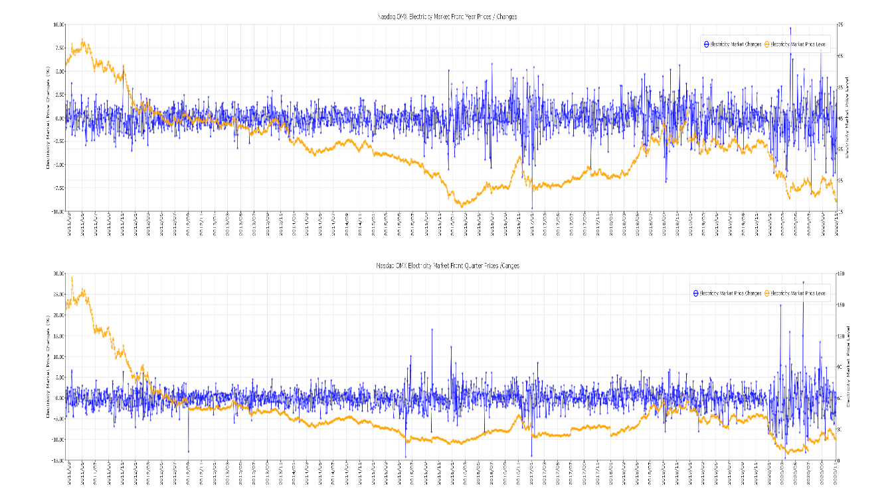



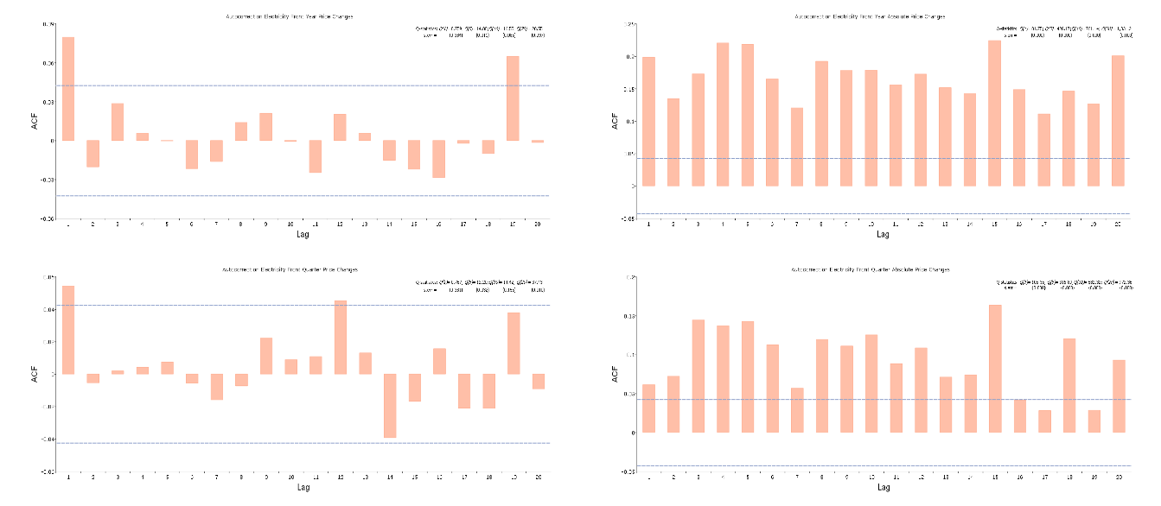

**Fig. 1.** Nasdaq OMX Front Year and Front Quarter contracts for the period 2011 – 2020

**4. Empirical Results**

The conditional moments are estimated using a statistical model for the  density, where *y* is the price movements and *x* represent lags of the series. Using there conditional moments, the stochastic volatility model (SV) from equation 1 is estimated using efficient method of moments (EMM). Table 2 reports the conditional moments (panel A) and the BIC [23] optimal SV model coefficients (Panel B). Columns for the mode, the mean and the standard errors are reported. The SV model produces acceptable model test statistics, reported at the bottom of Table 2. The objective function accuracy is -2.3 and -2.7 for the front year and the front quarter contracts, respectively, with associated *2* test statistics of 0.51 (3 *df*) and 0.44 (3 *df*). The MCMC log-posterior paths are reported in Figure 2. The model does not fail the test of over identified restrictions at the level of 10%, the chains are choppy, and the densities are close to normal, all factors suggesting that the SV model is appropriate for the two electricity market time series. The long-simulated realization of the state vector, as a by-product of the estimated SV model, establishes a functional form of the conditional distribution. The SNP methodology obtains a convenient representation of one-step ahead conditional variance . Running simple regressions for  on  and a generous number of lags of these series, the calibrated functions that give predicted values of  on the observed data series, are constructed. Figure 3 reports factor 1 (*V1*), factor 2 (*V2*) and the  for the observed data points. Interestingly, *V1* is a slow moving, persistent volatility factor while *V2* is fast moving and the mean reverting factor. From these plots, the re-projected volatility , seems more influenced by the *V1* factor than *V2*. For a clearer and more interpretative evaluation of the factors, Figure 4 reports the last 60 days of this series in 2020 for the two latent volatility factors for observed data points. The plots indicate that  is slowly moving while  is moving considerably faster. It is quite clear that the slowly persistent factor *V1*, leads the re-projected yearly volatility for both series. Figures 3 and 4 also report the ordinary least square number for *R2* for front year and front quarter at a level of *Vi*, where *i*=1,2. For *V1* (*V2*) the *R2* is 95.4% (4%) and 95.7% (5.7%) for the front year and front quarter, respectively. Obviously, the slow moving *V1* factor, showing persistence, is the main contributor to yearly volatility. *V2* moves much faster showing strong mean reversion, absorbing shocks.





**Table 2.** NASDAQ OMXScientific Stochastic Volatility Characteristics: -parameters

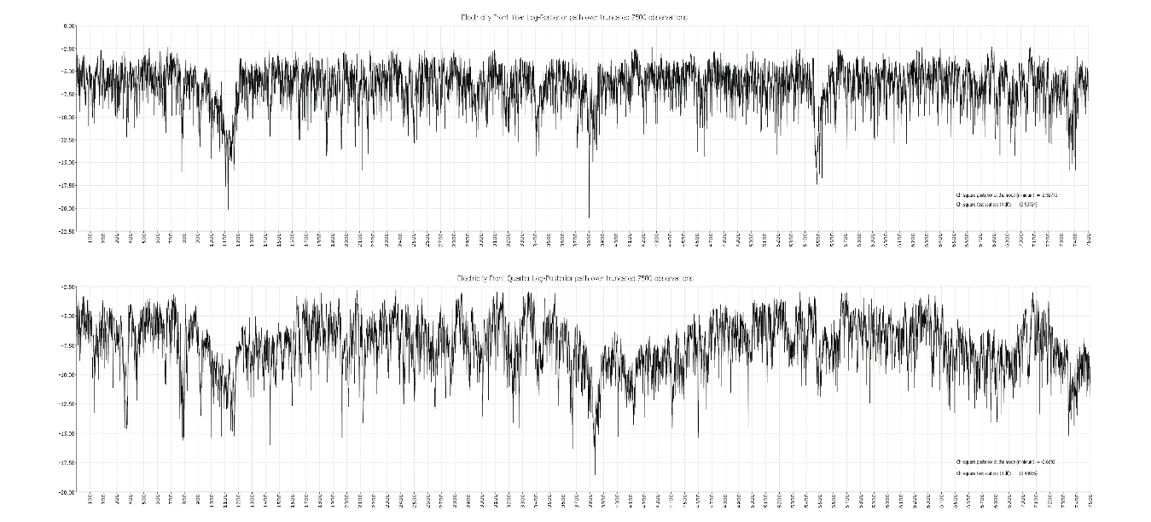

**Fig 2.** MCMC Posterior Chain from 250 *k* Optimal SV Model (R = 75.000)

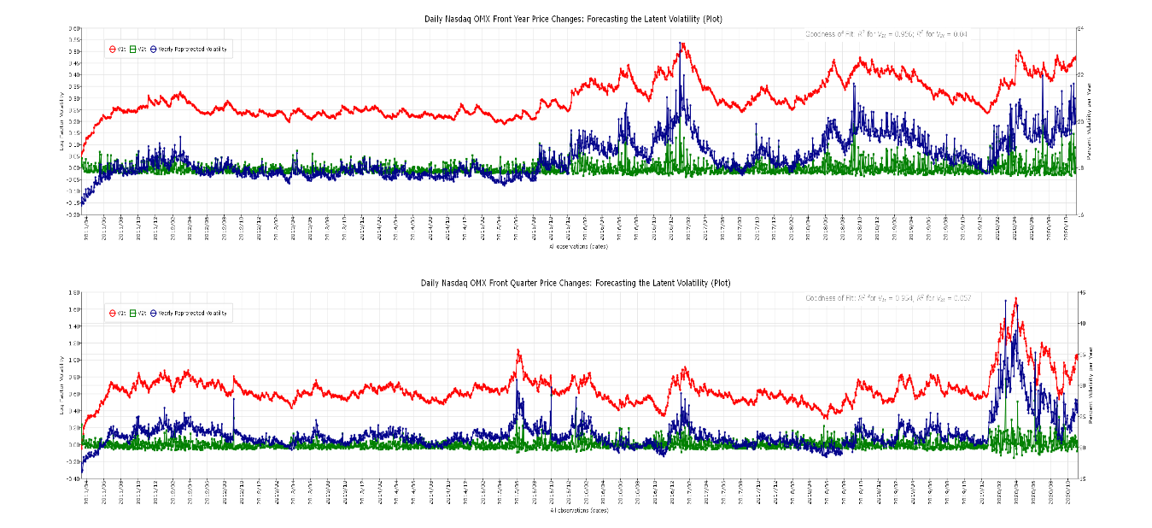

**Fig. 3.** Conditional Volatility from Observables and Kalman Filtered Volatility (daily)

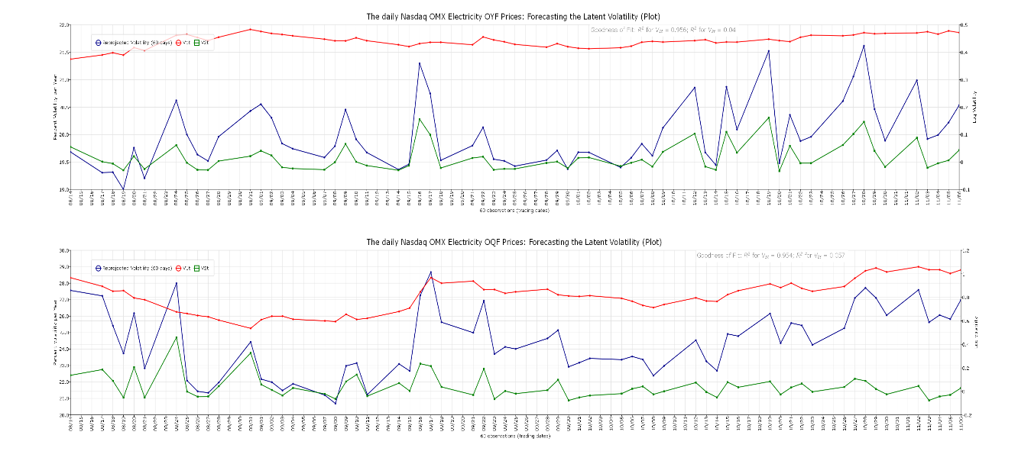

**Fig. 4.** Front Year (top) and Front Quarter (bottom) Factor Volatility Paths (last 60 days)

**5. Projecting and Forecasting Volatility**

The volatility factors in Figure 3 and 4 seem to model two different flows of information to the electricity market and the market participants. One slowly means reverting factor provides volatility persistence and one rapidly mean reverting factor provides for the tails [10]. For the period 2011 to 2020 the *V1* front year factor is clearly moving slower than the front quarter contract (stronger serial correlation). For both *V1* and *V2* there is no large realization. However, the Covid-19 period from March 2020 to November 2020 report increases in both factors. However, these plots show slow and persistent changes to volatility, with the front quarter contracts showing the highest contributions to volatility. For example, the shock in March 2020 is not temporary and the volatility from the shock, shows persistence and only modest mean reversion ().

Comparing Figure 1 and 3, the two synchronous plots show that when returns become wider (narrower) volatility increases (decreases). Moreover, turbulent (wide returns) days tend to be followed by other turbulent days, while tranquil (narrow returns) tend to follow other tranquil days (clustering). As expected, the volatility is clearly higher for the front quarter than for the front year contracts. Furthermore, the volatility seems to increase more from negative than from positive price changes. Volatility densities for the front year and the front quarter contract series suggest lognormal densities. As suggested above, the density for front quarter versus the front year price changes show both narrower and higher volatility densities. Furthermore, the power law  providing an alternative to the normal distributions, seems approximately true for the volatility. Table 3 reports characteristics for the volatility series and Figure 5 reports distributions (top) and serial correlations (correlograms bottom) for the Nasdaq OMX front year and the front quarter contracts. Table 3 shows for both front series that the volatility is non-normal, right skewed with a substantial data dependence (serial correlation). The distributions in Figure 5 (top) strengthen these arguments suggesting a more log-normal distribution for volatility. The correlograms in Figure 5 (bottom) strengthen the arguments for substantial data dependence suggesting both clustering and persistence. Together the results in Table 3 and Figure 5 make volatility predictions worthwhile and more relevant.



**Table 3**. Nasdaq OMX Front Year and Quarter Volatility Characteristics



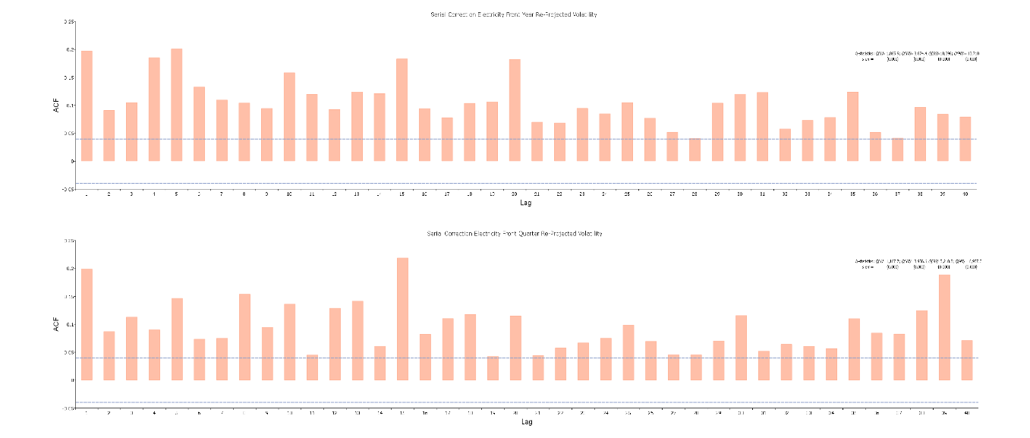

**Fig. 5.** Conditional Volatility from Observables and Kalman Filtered Volatility (daily)

**Tail properties, the Power law and Extreme values.** The power law, an alternative to assuming normal distributions, is applied to the re-projected volatility for the front year and front quarter contracts. The power law asserts that, for many variables, it is approximately true that the value of the variable, , has the property that when x is large  where *K* and ** are constants. The relationship implies that , and a test of whether it holds is plotting  against . The values for *ln(x)* and *ln[Prob(v > x)]* for the two front contracts show that the logarithm of the probability of a change by more than *x* standard deviations is approximately linearly dependent in *ln(x)* for *x* ≥ 3. Hence, for both contracts the power law holds for the re-projected volatility. Regressions show the estimates of *K* and ** are as follows: for front year (front quarter) contracts  and  ( and ). A probability estimate of a volatility greater than 3 (6) standard deviations is   and   for the front year and the front quarter contracts, respectively. The extreme value theory takes us another step [16]. The *u* is set to the 95 percentiles of the filtered volatility series of front year (*u*=20.007) and front quarter *(u*=26.999). The front year reports optimal ** = 0.484 and ** = 0.0093 with an associated maximum value for the log-likelihood function of -34.72. The front quarter series reports optimal ** = 3.715 and ** = 0.0 with an associated maximum value for the log-likelihood function of -282.11. The probability that the front year re-projected volatility will be greater than 20 (25) is 5.11% (0.0003%). The VaR with 99% (99.9%) confidence limit is 20.80 (21.94). Hence, the 99.9% VaR estimate is about 0.9385 times lower than the highest historic re-projected volatility. The 99% (99.9%) expected shortfall (ES) estimate is 21.29 (22.45). Furthermore, for the front year contracts, the unconditional probability for a volatility greater than 20.01 (*u*) is equal to 2.03%. Similarly, the probability that the front quarter contracts re-projected volatility will be greater than 20 (25) is 33.15% (8.63%). The VaR with 99% (99.9%) confidence limit is 33.01 (41.56). Hence, the 99.9% VaR estimate is about 0.9528 times higher than the highest historic filtered volatility for the front quarter contracts. The 99% (99.9%) ES estimate is 36.72 (45.28). Finally, for the front quarter contracts, the unconditional probability for volatility greater than 26.99 (*u*) is equal to 0.269%. As Var and ES are attempts to provide a single number that summarizes the volatility tails giving the market participants an indication of the risk to which they are exposed. The front year contracts show that a daily volatility greater than 20 is only 5.11%. The front quarter contracts show that a daily volatility greater than 20 is 33.01%. Hence, EVT and the power law, reporting VaR and ES values, summarizes tail properties that indicate the risk for the market participants. For market participants, inverting the unconditional probability for the volatility and setting a 1% limit for the change of the unconditional probability, will list accessible investment alternatives.

**Volatility clustering.** The BDS independence test statistic [24] is a portmanteau test for time-based independence in a series. The probability of the distance between a pair of points being less or equal to epsilon (**) should be constant (*cm()*). The BDS test statistics, where ** is one standard deviation and the number of dimensions is 10, report that for both the front year and front quarter contracts, the data strongly reject the hypothesis that the observations are independent. The front year contracts show higher BDS z-statistic dependence than for the front quarters. However, a simple correlogram show similar values for the q-statistics. An indication of similarity is the SV-model’s serial correlation volatility report for the coefficient *b1* in Table 2. The table show that the correlation is quite similar for the front year (*b1* =0.977) and for the front quarter (*b1* =0.973) contracts. Results showing *b1* > 0.8 will indicate a form of volatility clustering. This is also visible in the above Figure 3 showing longer periods of high/low volatility (choppy).

**Persistence in Volatility.** Figure 5 reports the autocorrelation and partial autocorrelation functions up to 20 lags for the front year and front quarter contracts. The pattern of temporal dependence is different for the two volatility factors, *V1* and *V2*. *V1* shows strong temporal dependence while *V2* shows close to zero temporal dependence. The re-projected volatility  has inherited the temporal dependence from *V1*, suggesting strong persistence in volatility. The correlograms for the re-projected volatility show that front year show only marginal higher correlation for the first lags, 0.897 versus 0.892 for the front quarter contracts. Moreover, higher correlograms lags show higher persistence for the front year contracts. The Breusch-Godfrey serial correlation LM test [17] also report strong serial correlation up to lag 20 of 784.2 *(2*(20)={0.000}) and 719.9 (*2(*20)={0.000}) for the front year and the front quarter contracts, respectively. Hence, the re-projected volatility for both the front year and the front quarter, show heavy volatility persistence.

**Volatility is mean reverting.** A battery of unit root tests together with a variance ratio test (martingales) are used to test for mean reversion for the re-projected volatility. For example, the front year (front quarter) contracts report an ADF statistic of -4.12 (-4.05). Hence, the ADF statistics report significant mean reversion at 1% for both contracts. Furthermore, all unit-root test statistics suggest stationary and mean reverting series. The overlapping variance ratio test [25] examines the predictability of time series data by comparing variances of differences in the data (volatility) calculated over different intervals. If we assume the data follow a random walk, the variance of a period difference should be times the variance of the one-period difference. The front year (8.92) and the front quarter (6.67) contracts both reject that the volatility as a martingale, suggesting mean reversion.

**Asymmetry in Volatility.** The asymmetry and the leverage effects are the negative/positive correlation between the shocks of price changes and the subsequent shocks on volatility. Hence, after a negative price change, we expect volatility to show a change and after a positive price change, we should observe a different change in volatility. Studying the volatility changes following price changes gives some information regarding this proposition. Dividing the volatility from positive and negative returns show for the front year (front quarter) contracts an average increase in volatility from positive price changes of 0.56 (-0.23) and from negative price changes of -0.56 (0.26). Hence, the two contracts report opposing results. To statistically test for the change in volatility from negative and positive price changes, we ran an OLS regression on the changes in daily volatility on returns and lagged returns. For the front year (front quarter) the regression reports a coefficient from price changes equal to -0.426 (-0.258) and 0.505 (-0.189) for lagged returns, all significant at the 5% level. That is, for the front year contracts synchronous negative price changes seem to increase volatility. However, lagged price changes seem to have the opposite effects on volatility. For the front quarter both coefficients are negative suggesting that negative (positive) price changes seem to reduce (increase) volatility. Furthermore, the correlation coefficients between price changes and synchronous (and lagged) re-projected volatility is -0.291 (0.363), and -0.166 (-0.129) for the front year and the front quarter contracts, respectively, suggesting a different and changing asymmetry for the two series.

**Long memory.** Long memory is associated with both clustering and persistence. By using fractional differencing with traditional ARMA specifications, the ARFIMA model allows for flexible dynamic patterns for the re-projected volatility. For the front year contracts, the ARFIMA (2,*d*,0) model specification estimate *d* =- 0.409 suggesting slow autocorrelations and partial autocorrelations decay (hyperbolically). For the front quarter contracts, the ARFIMA (2*,d*,0) model specification estimate *d* = -0.342 suggesting the same slow autocorrelations and partial autocorrelations decay. The ARFIMA model therefore specifies two slowly decaying series with long-run negative dependence (long memory).

**Forecasts.** The SNP methodology obtained a convenient representation of one-step ahead conditional variance by running regressions for  on  and a generous number of lags of theses series. Table 3 summarizes the volatility measures of electricity series. From Table3, both series report a BDS-statistic suggesting strong data dependence together with persistence, skew and long memory. The paper uses static forecasts to perform a series of one-step ahead forecasts of the dependent variable. For each observation in the forecast sample the paper uses the actual value of the lagged endogenous variable requiring that data for both the exogenous and any lagged endogenous variables be observed for every observation in the forecast sample. Forcasting a realization of a stochastic process is difficult because the process will be influenced of random events that happen in the future. In case of a large market movement at any time before the risk horizon the forecast needs to take this into account. The estimation period is from 2010 to January 1st, 2020 and the forecasting period from January 1st, 2020 to January 8th, 2021. The RMSE and MAE are dependent on the scale of the dependent variable. However, the smaller the error, the better the forecasting ability. The MAPE and Theil measures are scale invariant. For a perfect fit Theil’s inequality coefficient is zero. For a “good” measure of fit, using the Theil inequality coefficient (bias, **v**ariance, and covariance portions) the bias and variance should be small so that most of the bias has its focus on the covariance proportion. The covariance proportion for re-projected volatility for the front year (front quarter) is 0.985 (0.924), indicating a reasonably good fit[3]. For the main contributor to re-projected volatility for both series, factor *V1*, the covariance portion of the Theil inequality coefficient is even higher. For the front year (front quarter) the *V1* factor show a Theil’s inequality coefficient close to zero (zero) and the covariance portion is as high as 0.983 (0.978). Finally, Figure 6 plots static forecast (one-step ahead) for the front year (top panel) and the front quarter (bottom panel) contracts for the re-projected volatility as well as the two stochastic volatility factors *V1* and *V2*. Moreover, an extension can be used for step ahead distribution forecasts (not reported). Sup-norm bands are constructed by bootstrapping, using simulations to consider the sampling variation in the estimation of  . That is, changing the seed that generates densities and then to perform an impulse-response analyses. A 95% sup-norm confidence band is an *e*-band around the mean profile that is just wide enough to contain 95% of the simulated profiles.



**Table 4.** Nasdaq OMX Front Year and Quarter Static forecast evaluation statistics

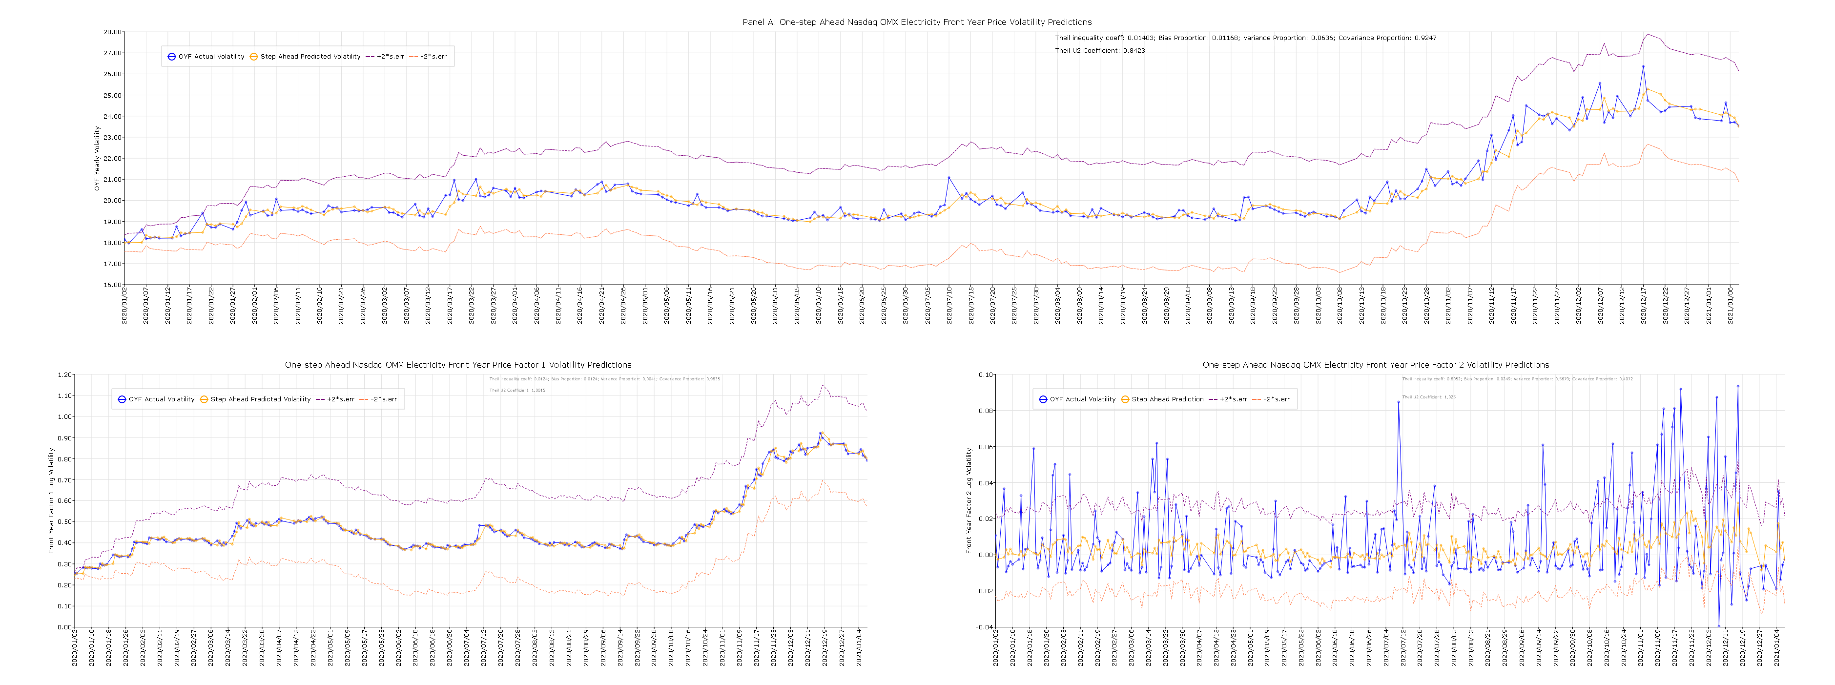

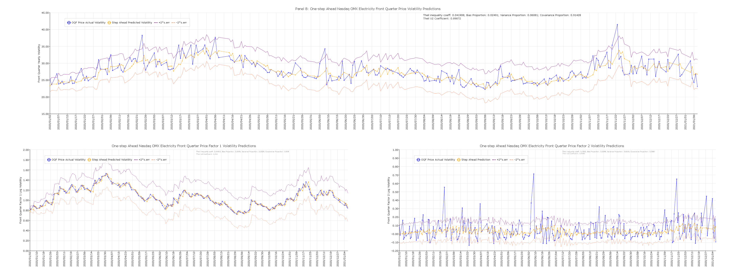

**Fig. 6.** Nasdaq OMXFront Year and Front Quarter Contract Static Forecasts for 2020

6. Summaries and Conclusions

The main objective of this paper has been to characterize a good volatility model by its ability to forecast and capture the commonly held stylized facts about financial market volatility. The paper extends the use of SV model applications in Solibakke [28]. The stylized facts include such things as heavy tails, persistence, mean reversion, asymmetry (negative return innovations suggest higher volatility), and long memory. The characteristics indicate substantial data dependence in the volatility. The paper shows that electricity market volatility has all these characteristics and that this data dependence suggests an ability for volatility predictions to enhance risk management, portfolio timing and selection, market making and derivative pricing for speculation and hedging.

This paper applies stochastic models relating volatility to risks that change through time in complicated ways. The departure from Black-Scholes-Merton option prices and occasional dramatic moves in markets is possible to explain (factors, correlation, data dependence). This paper shows that the stochastic volatility model separates into two distinct factors: a very persistent factor, *V1t*, showing low mean reversion, and a strong mean-reverting factor, *V2t*. The persistent factor, *V1t*, provides for the main distribution and the rapidly mean reverting factor, *V2t,* provides for the tails. The two-factor stochastic volatility model reflect also on the shortcomings of single-factor stochastic volatility models. Moreover, a closer look at the two Nasdaq OMX Front year stochastic factors show that the persistent factor move smoothly with an increase in level towards the end of 2020, while the strongly mean reverting factor reacted quite choppy to new information for the whole 2020 with an increase towards the end of 2020. The covid-19 pandemic in March 2020 is not visible in these plots. To interpret these results, the persistent factor suggests a stable volatility with an increase for the winter in 2020/21. The mean reverting signals surprises for the whole 2020 and especially towards the winter in 2020/21 (more noise).

Furthermore, using an MCMC implementation of a stochastic volatility model with an associated Kalman filter procedure for projection, report a Theil covariance volatility portion close from 92% for electricity contracts. Trading volatility swaps may therefore become less risky for market participants. Although price processes in electricity markets are hardly predictable, the variance of the forecast errors is clearly time dependent and seems able to be estimated by means of observed past variations. Hence, the results suggest that volatility can be forecasted. The static predictions of the re-projected volatility for the front year and front quarter electricity market contracts show a Theil’s inequality coefficient close to zero and covariance portion of 98.5% and 92.4%, respectively. Moreover, these measures of fit may be further improved by using continuous prediction updates (i.e. daily). Furthermore, the main factor for the re-projected volatility, *V1* for the front year (quarter), shows a Theil inequality coefficient close to zero and an impressive covariance portion of 98.9% (99.1%). For market participants a continuous SV model with associated volatility trading strategies (i.e. swaps) may be applied to obtain superior financial positions for the Nasdaq OMX commodity markets[4].

**References**

1. Andersen, T.G., T. Bollerslev, F.X. Diebold and P. Labys, 2003, Modelling and Forecasting realized volatility, Econometrica 71, pp. 579-625.
2. Chernozhukov, V., and Han Hong, An MCMC Approach to Classical Estimation, Journal of Econometrics 115, pp. 293-346 (2003)
3. Clark, P.K., 1973, A subordinated stochastic process model with fixed variance for speculative prices, Econometrica 412, pp. 135-156.
4. Gallant, A.R. and G. Tauchen, Reprojecting Partially Observed Systems with Application to Interest Rate Diffusions, Journal of the American Statistical Association, 93 (441), pp. 10-24 (1998)
5. Gallant, A.R. and G. Tauchen, A Nonparametric Approach to Nonlinear Time Series Analysis., Estimation and Simulation, in David Brillinger, Peter Caines. John Geweke, Emanuel Parzan, Murray Rosenblatt, and Murad S.Taqqu eds. New Directions in Time Series Analysis, Part II. New York: Springer-Verlag, pp. 71-92 (1992)
6. Gallant, A.R. and G. Tauchen, Simulated Score Methods and Indirect Inference for Continuous Time Models, in Yacine Aït-Sahalia, Lars Petter Hansen, eds. Handbook of Financial Econometrics, North Holland, Chapter 8, pp. 199-240 (2010)
7. Hansen, L.P., Large Sample Properties o Generalized Method of Moments Estimators, Econometrics 50, pp. 1029-1054 (1982)
8. Hull, J. and A. White, 1987, The pricing of options on assets with stochastic volatilities, Journal of Finance 42, pp. 281-300.
9. Andersen, T.G., L. Benzoni, and J. Lund, Towards an empirical foundation for continuous-time models, Journal of Finance, 57, pp. 1239-1284 (2002)
10. Chernov, M., A.R. Gallant, E. Ghysel, and G. Tauchen, Alternative models for stock price dynamics, Journal of Econometrics, 56, PP. 225-257 (2003)
11. Gallant, A.R., D.A. Hsieh and G. Tauchen, Estimation of stochastic volatility models with diagnostics, Journal of Econometrics, 81, pp. 159-192 (1997)
12. Gallant, A.R. and G. Tauchen, EMM: A Program for Efficient Methods of Moments Estimation, Duke University (<http://econ.duke.edu/webfiles/arg/emm>) (2010)
13. Andersen, T.G., Stochastic autoregressive volatility: a framework for volatility modelling, Mathematical Finance, 4, pp. 75-102 (1994)
14. Dickey. D.A. and W.A. Fuller, Distribution of the estimators for autoregressive time series with a unit root, Journal of the American Statistical Society (74),(366), pp. 427-431 (1979)
15. Gallant, A. R. & R.E. McCulloch, GSM: A Program for Determining General Scientific Models, Duke 84, University (<http://econ.duke.edu/webfiles/arg/gsm>) (2011)
16. Gnedenko, D.V., 1943, Sur la Distribution limité du terme d’une série aléatoire, Annals of Mathematics (44), pp. 423-453
17. Godfrey, L.G., 1998 Misspecification tests in econometrics. Cambridge University Press, Cambridge, 1988
18. Jarque, J.B. and A-K. Bera, Efficient tests for normality, homoscedasticity and serial independence of regression residuals, Economic Letters, 6, (3), pp. 255–259 (1980)
19. Ljung, G.M. and G.E.P. Box, On a Measure of Lack of Fit in Time Series Models, Biometrika, 65, 297-303 (1978)
20. Kwiatowski, D., P.C.B. Phillips, P. Schmid and T. Shin, Testing the null hypothesis of stationary against the alternative of a unit root: How sure are we that economic series have a unit root, Journal of Econometrics, Vol. 54, pp 159-178 (1992)
21. Ramsey, J. B., "Tests for Specification Errors in Classical Linear Least Squares Regression Analysis". Journal of the Royal Statistical Society, Series B. 31 (2), pp. 350–371 (1969)
22. Brock, W. A., W.D. Dechert, J.A. Scheinkman, and B. LeBaron, A test for independence based on the correlation dimension, Econometric Reviews, 15,197-235 (1996)
23. Schwarz, G., Estimating the Dimension of a Model, Annals of Statistics, 6, pp. 461-464 (1978)
24. Brock, W. A., W.D. Dechert, J.A. Scheinkman, and B. LeBaron, A test for independence based on the correlation dimension, Econometric Reviews, 15,197-235 (1996)
25. Lo, A.W. and C. MacKinlay, Stock Market Prices Do Not Follow Random Walks: Evidence from a Simple Specification Test, The Review of Financial Studies, 1 (1), pp. 41–66 (1988)
26. Shephard N., Andersen T.G. (2009) Stochastic Volatility: Origins and Overview. In: Mikosch T., Kreiß JP.,

Davis R., Andersen T. (eds) Handbook of Financial Time Series. Springer, Berlin, Heidelberg.

https://doi.org/10.1007/978-3-540-71297-8_10

1. Solibakke, P. B., Scientific stochastic volatility models for the European carbon markets: Forecasting and extracting conditional moments. International journal of business 2014, Volume 19 (1) pp. 63-98
2. Solibakke, P. B., 2020, Stochastic Volatility Models Predictive Relevance for Equity Markets, in Valenzuela, O., Rojas, F., Herrera, L. J., Pomares, H., & Rojas, Ignacio. (2020). Theory and Applications of Time Series Analysis: Selected Contributions from ITISE 2019 (1st ed. 2020., p. 1 online resource (XIV, 460 p. 195 illu, 141 illu in color.)). Springer International Publishing: Imprint: Springer.
3. Taylor, S.J., 1982, Financial returns modelled by the product of two stochastic processes – a study of daily sugar prices 1961-79. In Andersen, O.D: (Ed.): Time series Analysis: Theory and Practice 1, 203-226, North-Holland, Amsterdam.

**Supplementary Materials:** The following are available online at nordpoolspot.com. Data sets for the front year and Front quarter from the Nordic/Baltic Electricity Market for the period 2011-2020 are found in the following data files:

1. *001-Electricity_Front_Year_Contract_ prices_returns_2011-2020.txt*
2. *002-Electricity_ Front_Quarter_Contract_prices_returns_2011-2020.txt*

**Funding:** “This research received no external funding”.

**Conflicts of Interest:** “The author declares no conflict of interest.”

1. Risk factors as supply-demand balance, relationship with other energy markets, and impact of spot market volatility and trends on the forward curve, are critical.
2. See [28] for a detailed definition and specification of a two-factor stochastic volatility model. See also [27].
3. Sub-periods 2019 (2018) covariance portions for the reprojected volatility are for the front year 99.23% (98.77%). Similar covariance portions for the front quarter are 91.2% and 93.2% for 2019 and 2018, respectively.
4. Trading volatility as an asset class provides market participant among other things with excellent diversification. For example, equity volatility is strongly negatively correlated with the equity price (insurance against market crashes).