SAFETY-D-20-00638
Assessment of Risk Tolerance for Future Autonomous Offshore Installations
Jan Erik Vinnem
Department of Marine Technology, NTNU, 7491 Trondheim, Norway, jan.erik.vinnem@ntnu.no

The future normally unmanned production concepts for offshore petroleum installations in the North Sea and associated waters are briefly outlined. A case study is summarised for a fictitious normally unmanned facility, and risk results are presented for three different cases with varying extents of safety systems. The case study results are discussed with respect to the risk levels for personnel for the three cases. Risk tolerance criteria are discussed in general and for unmanned production installations in particular. Also risk reducing evaluations are discussed briefly, in general as well as for unmanned production concepts. Individual and societal risk are discussed, together with some regulatory challenges from the risk management point of view for normally unmanned installations. There are no applicable risk tolerance criteria for unmanned facilities, and the criteria for manned facilities are not suitable. There is a strong need for the authorities to focus on the use of risk tolerance criteria for manned as well as unmanned facilities.

Keywords: Unmanned production platform, risk assessment, risk tolerance, ALARP.

1. Introduction and Background
There is a need to reduce field development costs in the Norwegian offshore sector in the future, so that smaller reservoirs may be developed economically (Bye et al., 2018). Several studies have indicated that the use of simpler, normally unmanned facilities (NUI) with minimal equipment is expected to increase with simpler facilities. This need was initially triggered by the fall of the oil price in 2014 from about 110 USD to about 30 USD. With the new fall of the oil price in 2020 due to the Corona virus and other factors, it is expected that the focus on simplification will become even more intense. Recent plans have confirmed this (AkerBP, 2020), and oil companies are also giving out contracts for engineering studies in order to develop their plans further.

Walk-to-work vessels (W2W vessels) will provide the accommodation facilities for the crew and workshop facilities for unmanned facilities. The vessel will be connected to the NUI through a telescopic gangway, which will allow connection to be maintained up to a certain sea-state.

Future production concepts will extend the present concepts with simple wellhead installations to more complex installations, where separation of oil, gas and water may take place, as well as drying, cooling and compression of gas for export or injection (Samuelsberg, 2017). These are often referred to as Unmanned Production Platforms (UPPs). This was described in some detail in Vinnem and Budde (2019), which also described the regulatory status, indicating that the requirements are general and vague, and mainly applicable to so-called ‘simpler installations’ without living quarters on the installation.

Risk assessment studies for offshore petroleum installations are never in the public domain, unlike for several other industries, such as marine, nuclear, etc. A fictitious case study was therefore presented by Vinnem and Budde (2019), in order to illustrate typical solutions and risk aspects. The present paper is based on that same case study.

Normally unmanned installations are supposed to be manned for only a few periods each year, for maintenance purposes, and possibly for restarting in the case of shutdown due to the occurrence of incidents or accidents. This implies that installations need to be designed and constructed with the minimum maintenance requirements in order to comply with the limited periods available for maintenance work.

The main safety protection philosophy of normally unmanned installations which has been adopted by the industry so far was also outlined in Vinnem & Budde (2019), as follows:
- Manned mode:
- Get people off the installation as quickly as possible using the gangway to the W2W vessel, with protection of the routes to the gangway if needed.
- After removal of people, the installation may be treated as unmanned.

- Unmanned mode:
- Protect against environmental spills and escalation of asset damage.

Such philosophy is very different from the current philosophy for manned installations, which under Norwegian regulations is focused on extensive protection of personnel, at least for a period up to two hours after the start of the accident to allow safe rescue and evacuation of survivors. This is achieved through application of several layers of protection with the aim to avoid exposure of personnel to the effects major hazards. The application of several layers of protection of personnel on manned installations is often referred to as ‘defence in depth’ (Rasmussen, 1997). ‘Simpler facilities’ imply at present quite basic wellhead installations without any treatment of the well-stream. These installations are very basic and therefore not in need of prevention or protective systems beyond the most basic systems.

Some safety systems will be needed in order to protect personnel before leaving and during the abandonment of the installation and to protect the environment and assets in unmanned mode. In this case, however, safety systems with lower reliability may be acceptable, such as with less robustness and redundancy. The degree of simplification of safety systems is particularly crucial, because safety systems with high maintenance needs have a strong influence on the number of manhours needed, and simplification is thus vital for the manning level and the frequency of manned periods. Some of the maintenance work is also a potential source of incidents during execution (Okoh et al., 2016).

The Norwegian legislation for offshore petroleum facilities has been under scrutiny for several years, starting with a study by an expert group (ASD, 2013) which looked at the regulations adopted by the Petroleum Safety Authority (PSA) [Norway] on behalf of the Ministry of Labour and Social Affairs (ASD). The Ministry of Labour and Social Affairs issued a white paper to the parliament (‘Storting’) on petroleum health, environment and safety (ASD; 2018) in 2018, which also reiterated the official goal for Norway to be world-leading on offshore health, environment and safety, which was first formulated in 2001. The Auditor General in Norway issued an independent study of the performance of supervisory activities by the PSA in 2019 (Auditor General, 2019). All relevant reports have concluded that the Norwegian system is basically good but needs some minor improvements.

A more general comparison of Brazilian and Norwegian offshore legislation is presented by Almeida and Vinnem (2020). This study found significant challenges in both Brazil and Norway with respect to learning from previous accidents and incidents, especially for prevention of reoccurrence of hydrocarbon (HC) leaks from process components.

The objective of the paper is to consider principles for risk tolerance assessment of future autonomous offshore installations under the present Norwegian legislation, which is strongly based on risk-informed decision-making in all life cycle phases. Secondly, the objective is to establish if the risk tolerance principles and practices are suitable for efficient risk tolerance assessments of future unmanned production installations.

Following the introduction, Chapter 2 presents an overview of the case study (Vinnem and Budde, 2019). Chapter 3 presents risk tolerance criteria and the requirements in Norwegian legislation in general and discusses the suitability of present criteria. Chapter 4 presents case study risk results and an evaluation of the results. Chapter 5 considers RTC for unmanned installations and potential principles for improvements. This is followed by a general discussion of the findings in Chapter 6, and conclusions in Chapter 7.

2. Case Study Overview
The case study (Vinnem & Budde, 2019) was performed for a fictitious unmanned oil and gas processing installation in the Norwegian offshore sector under Norwegian legislation. As concerns safety systems, there are three cases which have been quantified in this case study for comparison, as follows:
- Case max: all safety systems as if it was manned, fulfilling all regulatory requirements
- Case min: an absolute minimum set of safety systems
- Case limited: limited extent of safety systems, but more than minimum

The well control barrier elements are included in all three cases according to regulations and accepted practice worldwide, but there are significant differences when it comes to barrier elements in the process area. The ‘Case min’ has very few safety systems (barrier elements). The ‘Case limited’ has several additional safety systems. The case study was limited to hazards related to the process area, i.e. fire and explosion risk due to HC leaks from process components, which may have effects for personnel if the leaks occur during manned periods. Table 1 is adapted from Vinnem and Røed (2020).

Table 1 Overview of study cases for risk quantification with barrier elements included (Adapted from Vinnem And Røed, 2020)
Safety system/ element | Case max | Case min | Case limited
Well control (MV, WV, DHSV) | Yes | Yes | Yes
Prevent LoC
RP14C (PSH, PSL, PSV, etc) | Yes | Yes | Yes
Blowdown and flare systems | Yes | Flare | Flare
Drain system | Yes | Yes | Yes
Process ESD valves | Yes
Gas detection | Yes |  | Yes
Gas riser ESV | Yes | Yes | Yes
Prevent ignition
Ex-protected equipment | Yes | Yes | Yes
Hot work activities | Yes
Fire detection | Yes |  | Yes
Prevent escalation
Fire water systems | Yes |  | Yes
Fire water supply | Yes | Yes | Yes
Deluge system | Yes |  | Yes
Foam system | Yes
Monitors and hoses | Yes | Yes | Yes
Water curtains | Yes | Yes | Yes
Fire protection in electric rooms | Yes | Yes | Yes
Fire and blast walls | Yes
Structural fire protection | Yes
Prevent fatalities
Lifeboats | Yes
Liferafts | Yes
Selantic | Yes |  | Yes
Escape routes | Yes | Yes | Yes

Manning levels will depend on the need for interventions and maintenance tasks, but the barrier elements will be designed for minimum maintenance or quick replacement. The frequency of manning is therefore closely correlated with the number of systems needing maintenance. Offshore work in Norway is conducted in two-week activity periods, with the following pattern; two weeks on-duty, followed by four weeks off-duty, followed by two weeks on-duty, etc. The term ‘period’ in the following is to be interpreted as ‘two-week period’. The unmanned production platform is assumed to be manned as shown in Table 2.

Table 2 Overview of manning levels for the study cases for risk quantification with barrier elements included

Parameters | Case min | Case limited | Case max
Duration of manned periods | 2 weeks | 2 weeks | 2 weeks
Planned number of manned periods per year | 4 | 5 | 10
Average manning level when manned | 10 | 20 | 20
Shifts | Dayshift only | Dayshift only, except process personnel | Dayshift only, except process personnel
Number of manhours on installation | 6,160 | 15,400 | 26,400

Case max corresponds to one full shift having full-time employment on the installation, two weeks on-duty, four weeks off-duty, etc. according to normal work schedules for the Norwegian Continental Shelf. The difference is that a fully manned installation has three persons per position (three shifts) in order to have continuous manning, whereas only one shift is needed for the manning for Case max. Case limited corresponds to about 60% of a shift’s time being spent on the installation, with some additional work periods spent on other installations. Another alternative for Case limited is if a reduced crew (11.7 persons on average) spends all their offshore periods on the installation.

Figure 1 shows the assumed hydrocarbon (HC) leak frequencies for the different manning cases, with contributions from manned and unmanned phases, reflecting the fraction of leaks caused by operations according to statistics for the Norwegian sector (Vinnem and Røed, 2020). The leftmost bar is the leak frequency when continuously manned, and the remaining cases are for NUI with different assumptions regarding the manning and extent of safety systems. The values are based on the following crude assumptions: 40% of the HC leaks are assumed not to be associated with manned operations in the process area (Vinnem and Røed, 2020). For the HC leaks during manned periods, a reduction of 30% has been assumed for the Case max due to assumed more modularised and less maintenance intensive equipment, whilst reductions for Case lim and Case limited are adjusted according to the number of days manned. This is a crude manner to reflect the possibility of introducing latent errors during manned periods.

The installation is assumed not to be shut down when manned. Shutting down during the manned period would reduce the risk significantly, but would imply a significant reduction in production regularity, and would also increase the duration of the manned periods.
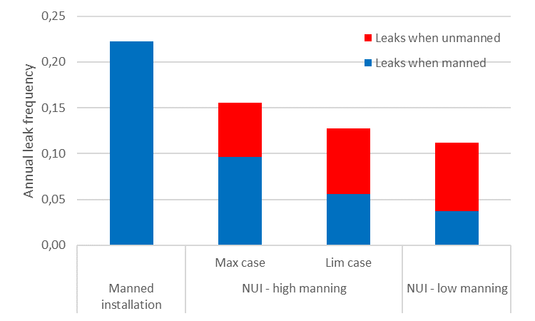
Figure 1 Annual leak frequency for NUI production installation, with different manning and safety system assumptions
Figure 1 shows that less manning implies fewer leaks during manned periods. Less manning also means longer unmanned periods, so the contributions during unmanned periods increase with lower manning.

3. Risk Tolerance Criteria
This chapter aims to develop the background to RTC for unmanned installations. It therefore presents a review of RTC for manned installations in the Norwegian sector, as background for the discussion of possible RTC for unmanned installations in Chapter 5.

3.1 Tolerance Criteria for Manned Offshore Installations
Risk Tolerance Criteria (RTC) have been discussed in the past by Hokstad et al. (2003) and the Health and Safety Executive (HSE, 2001; 2003a; 2003b; 2005). An anonymous survey of RTC for Norwegian oil companies operating on the Norwegian Continental Shelf (NCS) has been carried out by Vinnem and Fossan (2019).

Table 3 shows values for eight anonymous Norwegian oil companies (NOC), and their values for average FAR and FAR for the most exposed group on the installation. It is clearly shown that almost all companies have FAR=10 as the risk tolerance limit for the average Fatal Accident Rate (FAR), when expressed per exposure hours (sum of on-duty hours and off-duty hours on the installation and during transportation). Equinor (the Norwegian energy company with Norwegian state as majority owner) is publicly known for having this limit and has had the same RTC for more than 20 years (Vinnem and Røed, 2020).

Table 3 Comparison of different anonymised companies’ use of RTC for individual risk for offshore installations in the Norwegian sector
Company | Individual risk tolerance limit expressed as
 | FAR average | FAR most exposed group | ALARP upper tolerance limit
NOC1 | FAR_{av}<10 | FAR_{group}<25
NOC2 | FAR_{av}<10 | FAR_{group}<20
NOC3 | FAR_{av}<10 | FAR_{group}<20
NOC4 |  |  | 10⁻³/yr
NOC5 | FAR_{av}<10 | FAR_{group}<20
NOC6 | FAR_{av}<10 | FAR_{group}<20
NOC7 |  | (included in ALARP) | 10⁻³/yr (av./ most exposed group)
NOC8 | FAR_{av}<10

There is a regulatory requirement (PSA, 2019a) for operators and owners of offshore installations on NCS to seek additional risk-reducing measures once the RTC are complied with, a process normally referred to as an ALARP process or ALARP evaluation. This requirement is often interpreted in practice as a relatively ‘narrow-minded’ cost‒benefit calculation, where certain investments in risk-reduction actions with well-defined cost estimates are compared with uncertain reduced accident costs (benefits), in the case of an accident. Thus, the data basis for the benefits is very limited, and will be quite dependent on assumptions and subjective evaluations. The virtual absence of data about changes in accident costs gives ample opportunities for unconscious and conscious manipulation of cost‒benefit calculations. There are very few cases known where such ALARP evaluations have resulted in decisions in favour of further risk reductions.

ALARP evaluations should have an equally important qualitative component, not only a quantitative assessment, in accordance with Vinnem et al. (2006) and Aven et al. (2006). But this is often a challenge to achieve, as the quantitative element is very often dominant.

It should also be considered that ALARP according to Norwegian regulations does not have a lower tolerability limit (PSA, 2019b; Vinnem et al., 2006). This implies that the need to find good risk-reducing measures is even stronger. The upper tolerability limit is equal to the risk tolerance limit.

ALARP evaluations are supposed to give more extensive risk reduction, in an ideal context (Aven and Vinnem, 2007). Practice on the other hand demonstrates that this does not happen, and the context is not sufficiently ideal.

3.2 Assessment of Suitability of Present Risk Tolerance Criteria
During the period of more than 20 years, the average FAR value on the NCS has been reduced very significantly, from 4.2 fatalities per 100 mill manhours [worked] to 0.2 fatalities per 100 mill manhours (Vinnem & Røed, 2020). This applies to production installations, where it is more than 10 years since the last fatal accident. Helicopter transportation is not included in these values, which in practice are limited to occupational accidents. Major accidents with fatalities on production installations in the Norwegian sector have not occurred since 1978. The statistical data are in effect limited to occupational risk, and the values would be reduced by a factor of two if transformed to a ‘per exposure hour’ basis.

It is therefore challenging to justify that the risk tolerance limit for production installations has not been reduced during this long period, when the statistical fatality rates have been reduced by more than a factor of 20 during this period.

If, as an independent approach, we look at worldwide operations, there are two sources of statistical data, neither of them complete, and certainly overlapping:
- International Regulators Forum (IRF, irfoffshoresafety.com)
- International Oil and Gas Producers (IOGP, iogp.org)
Neither of these sources is fully complete, because not all companies are members of IOGP and not all regulators are members of IRF. For the last 10 years, the international average varies as follows (Vinnem and Fossan, 2019):

- IRF, FAR: 1.0–4.6/manhours
- IOGP, FAR: 1.2–6.3/manhours

These values include occupational fatality risk and major hazard fatality risk and would be reduced by a factor of two if expressed on a ‘per exposure hours’ basis, as is done in Figures 2 and 4. The relationship between the different sources of fatality risk on installations (production and mobile units) and helicopter transportation risk, is illustrated in Figure 2, based on IRF fatality data, based on exposure hours.
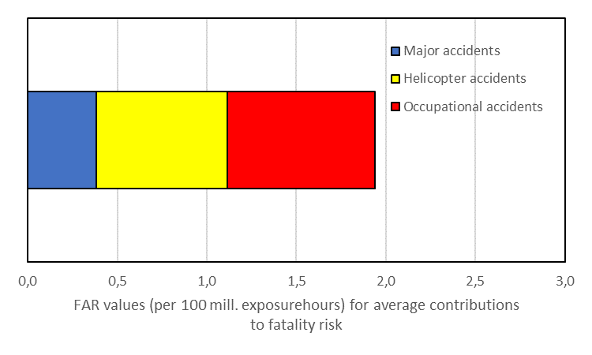
Figure 2 Average FAR values for all IRF countries, major and occupational accidents on installations, as well as helicopter accidents, 2007–2017, based on exposure hours (on-duty and off-duty hours)

Norway has had the ambition since 2001 to be world-leading in offshore safety, environment and health, as noted above. The fatality statistics demonstrate clearly that fatality rates in the Norwegian sector are significantly lower than for other countries. This is indicated by comparing the average value for the Norwegian sector (see above), 0.2 fatalities per 100 million manhours, with the values presented for worldwide average from IRF and IOGP, which range from 1.0 to 6.3 fatalities per 100 million manhours. Further illustration of fatality rates worldwide are presented in Vinnem and Røed (2020).

Both these approaches lead to the same conclusion that the FAR risk tolerance limit of 10 adopted by Norwegian companies should in principle be reduced by a factor of 10, to FAR=1.0, also in line with what is argued in Vinnem & Røed (2020).

The failure to perform such reduction is not consistent with the obligation for oil companies under Norwegian jurisdiction to work for continuous improvement. It is therefore incomprehensible why the Petroleum Safety Authority (PSA) has accepted this position, especially in view of the significant focus on improvement over the last few years.

The PSA was recommended to focus on this aspect in a report by an expert group in 2013 to the Ministry of Labour and Social Affairs (ASD, 2013). Most of the recommendations in the report have been addressed by the PSA, but not the aspect associated with RTC. This lack of attention is impossible to comprehend, given the high importance placed on risk tolerance and risk-informed decision-making in the regulations. This appears to undermine the PSA’s authority in the view of many experts. The PSA has been reminded on several occasions and in several ways about this but appears to have ignored over several years to act in this regard.

It is also noteworthy that one international operator with a background in Norwegian operations, when faced with the need to decide on RTC for a new field development (outside the Norwegian sector), decided on these values:

Average individual risk: | 2 10⁻⁴ per year
Individual risk for most exposed group: | 5 10⁻⁴ per year

These values correspond to FAR values of 4.6 and 11.4 respectively (2 persons per position). They are thus significantly above FAR = 1.0, but it should be considered that the field development is planned for a sector with significantly higher fatality statistics compared to the Norwegian sector. Still, the value chosen for the average FAR (4.6) is significantly below what Norwegian companies have adopted.

4. Case Study Risk Results and Assessment of Risk
4.1 Personnel Risk Results
The personnel risk results for the case study as outlined in Chapter 2 were calculated on the basis of the adjusted leak frequencies as presented above, as well as the revised node probabilities according to details discussed in Vinnem and Røed (2020) and Vinnem and Budde (2019). The risk levels presented for personnel are obviously only relevant in the periods when the installation is manned. The risk results presented here only reflect fire and explosion hazards due to process systems on the topsides of the installation.

Individual risk for personnel is presented as Fatal Accident Rate, i.e. fatalities per 100 million exposure hours. Societal risk is presented as Potential Loss of Life (PLL) values, expressing the total number of expected fatalities for the installation per year.

Figure 3 presents the different cases for individual risk (FAR values) with different manning levels and extent of safety systems.
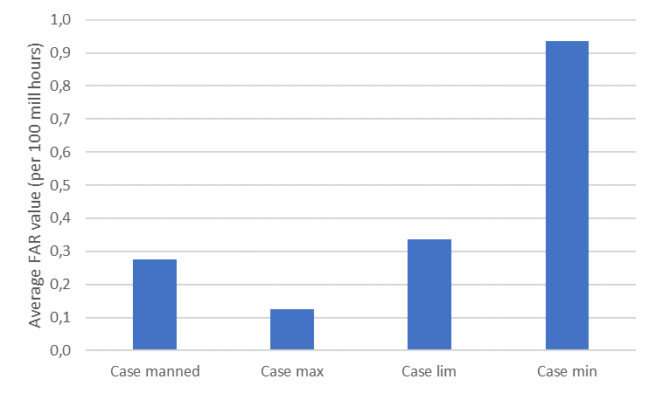
Figure 3 Fatality risk results for NUI production installation (process risk only), with different manning and safety system assumptions
The first bar in the diagram is for reference only, indicating what the fatal accident rate (FAR, i.e. fatalities per 100 million exposure hours) value would be if the installation was constantly manned (with a higher manning level); this may be used for comparison with the results for the different cases. Case max is an UPP with all the barrier (safety) systems and elements of a manned installation.

Case lim is an UPP with a reduced extent of barrier systems and elements, but not to the lowest level. Figure 2 shows that the FAR level is more than double that of the Case max, but only marginally increased from the level for a manned installation.

Case min is an UPP with a very limited extent of barrier systems and elements, and thus a quite limited extent of manning for maintenance purposes. Figure 2 shows that the FAR level for this case is almost triple that of the Case lim, and almost an order of magnitude higher than for the Case max lowest level. This is a very significant increase, but it is worth noting that the value is still lower than a FAR = 1.0.

Potential Loss of Life (PLL) results represent the societal risk, which is also important for risk evaluation in addition to FAR values. PLL values are shown in Table 4.
Table 4 PLL values for NUI production installation (process risk only) with different manning and safety system assumptions
Case | PLL  (fatalities per year)
Case manned | 2.2 10-4
Case max | 3.3 10-5
Case lim | 5.2 10-5
Case min | 5.8 10-5

The changes when comparing Case max and Case min are quite extensive when social risk is compared with individual risk in Figure 2. For instance, the FAR value of Case min is 7.4 times higher than for Case max in Figure 3. This implies that the risk levels for personnel in the Case min should be considered as quite high, both relatively speaking and when seen in isolation.

On the other hand, the PLL value of Case min is only 1.7 times higher than the PLL value of Case max. This reflects the significantly lower

It may be noted that the FAR values are virtually constant if the number of manhours spent on the installation is changed from what was assumed for the case study. Therefore, even if it may be considered by some that the assumed manhours are too high, the high values in Figure 2 will still be largely applicable. The PLL values will on the other hand be reduced correspondingly.

4.2 Evaluation of Risk for Case Study
The differences between the FAR and PLL values are demonstrated by referring to Figure 3, which shows that Case min has a significantly higher FAR value compared to Case manned. Table 4 shows that the PLL value of the Case min is still significantly lower than for Case manned. It has to be observed that these values only apply to fire and explosion hazards from leaks of flammable gas or oil.

Figure 4 is an attempt to illustrate the differences between manned and normally unmanned installations, when all the contributions to major accident risk on the installation as well as during personnel transportation are included.
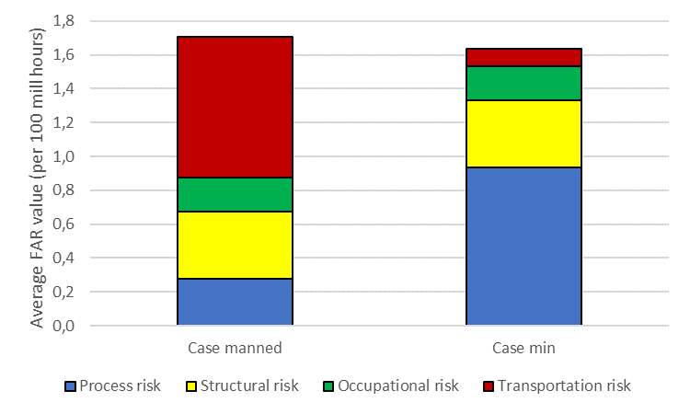
Figure 4 Fatality risk results for NUI production installation, comparison of cases with assumed contributions from structural, occupational and transportation hazards
It is demonstrated that the numbers in the present case imply that the Case manned has a 5% higher equivalent FAR value than the Case min, when all major accident risk contributions are included. It is on the other hand clear from Figure 4 that only minor changes to some of the contributions may result in the reverse relationship between the two cases. It is therefore obvious that even though Case min has a significantly lower PLL value when compared to Case manned (see Table 4), we may easily end up with the average total FAR values for the Case min being slightly higher (or in fact lower, as here) than the Case manned, depending on the details. The obvious observation from this brief discussion is that only considering PLL values for comparison is too limited a scope of comparison. Societal risk (PLL values) as well as individual risk (FAR values or similar) should both be considered for an extensive comparison of risk in these cases.
These results also show that RTC are needed for UPP installations, if consistent and systematic evaluations of risk to personnel on UPP installations shall be possible. This is discussed in the following chapter.

5. Risk Tolerance Criteria for UPP Installations
This chapter outlines some possibilities for RTC for unmanned installations and discusses some of the difficulties involved with such RTC. The basis for this discussion is the general description of RTC for manned installations in Chapter 3. The basis is further from the results of the case study (Chapter 4), where it is for example illustrated how different extent of safety systems may have significant influence on the risk levels for personnel.

5.1 Possibilities for Risk Tolerance Criteria for UPP Installations
The present situation may be characterized as a combination of very relaxed RTC for manned installations and no specific RTC for unmanned installations. Such a combination may give extensive flexibility for companies with very little commitment with respect to risk exposure for personnel on unmanned installations.
This does not appear to be a good situation when also the vagueness of the regulatory requirements is considered. It would be extremely challenging in a regulatory context to ensure fair treatment and consistent safety levels between different projects and applications. Such consistency could be achieved if the authorities plan to require that unmanned installations comply with all the requirements for manned installations. This is on the other hand completely unrealistic because the industry would not accept such a high investment cost for unmanned installations, and it would if implemented stop the development of unmanned installations. It would therefore be useful if additional guidelines of some form could be stated from a regulatory point of view.
The following alternatives could be implemented with respect to RTC for unmanned installations:

- Stricter RTC in general
- Specific [strict] RTC for unmanned installations
- Adhere to upper limit for main safety function impairment irrespective of manning duration

Stricter RTC in general has been discussed in Subsection 3.1 for offshore installations in general. If such a limit was sufficiently strict it would be sensible to use it for any type of installation in any operational mode.

An alternative would be to define specific RTC for unmanned installations. One example from about 25 years ago was introduced in Vinnem & Budde (2019), where an additional 25% add-on for the FAR value of the parent installation was tolerated for personnel visiting an unmanned wellhead installation.

There may not be a ‘parent’ installation for future unmanned developments. The ‘parent installation’ may be replaced in these cases by the average for all installations operated by the same company, calculated in a suitable and realistic manner, based on statistics and risk assessment studies.

The example cited (Vinnem & Budde, 2019) reflected the use of helicopter transportation of personnel between the parent installation and the unmanned wellhead installation and could as such be considered as a consistent comparison (comparing ‘apples with apples’). W2W vessels are much more likely to be used for personnel transportation in the future, which gives a not completely consistent comparison (comparing ‘apples with oranges’).

One way to formulate the challenge in this regard is as follows: is it reasonable to tolerate higher risks on the installations when the risk exposure from helicopter transportation is eliminated?

This would be challenging to accept under the ‘continuous improvement’ imperative in the Norwegian regulation (see Subsection 3.2), in particular for those persons who only work on unmanned installations.

It is considered more in line with the duty for all to seek ‘continuous improvement’ if no significant increase was accepted on the installations, even if risk exposure from helicopter transportation is eliminated.

The last option above is associated with the impairment frequency for scenarios that impair the main safety functions according to §7 in the PSA facilities regulations (PSA, 2019c), which according to regulation shall be below 10⁻⁴ per year for any main safety function and applicable area, as defined by the regulations. With the relaxed RTC used by most companies, the impairment frequencies are usually the only criteria that have an impact on the design of manned installations (Vinnem and Røed, 2020).

If the impairment frequency shall be used to control risk for unmanned installations, it will be essential to establish how the frequencies shall be calculated and applied. Shall the frequencies be calculated for a calendar year without distinguishing between manned or unmanned periods? Alternatively, the frequencies may be calculated only for the manned periods.

The latter could be argued to be applicable if only the risk exposure of personnel is considered. But on the other hand it may be argued that also protection against risk exposure of the marine environment is essential, and the need to protect the environment is continuous, not only limited to the manned periods. If so, the impairment frequencies should not be fractioned with the presence of manning on the installation.

5.2 ALARP for UPP
The same regulatory requirement would apply for operators and owners of unmanned offshore installations on NCS to seek additional risk-reducing measures, once the RTC have been complied with.

The ALARP requirement is not strictly limited to personnel risk but is often assumed to focus mainly on personnel risk. In principle, however, it also applies, for instance, to environmental risk, which may be more important for an unmanned installation.

As discussed above, the industry has expressed the intention that unmanned installations shall have fewer safety systems. The need to reinstall those omitted systems would obviously be recommended from the perspective of an ALARP evaluation, especially if qualitative arguments are given weight. This implies that if ALARP evaluations are taken seriously for unmanned concepts, they would end up with more or less the same safety systems as a manned installation. This is not realistic and is actually not intended. This topic is discussed in more depth in Vinnem (2020).

It may therefore be that the ALARP evaluation for an unmanned concept should be limited to environmental risk only. This would apply to manned as well as unmanned phases.

6. Discussion
6.1 Case Study Applicability
The differences in risk levels for personnel are quite extensive when only the fire and explosion hazards are considered on NUI production facilities. This is one of the findings of the case study, which is considered to be reasonably realistic, even though it is fictitious. There is almost an order of magnitude of difference between a case with all safety systems on manned installations and the case with the barest minimum of safety systems provided. Since the amount of manhours spent on the installation roughly corresponds with the extent of safety systems (due to maintenance requirements), the difference in PLL values is much less.

The case study (see further details in Vinnem and Budde, 2019) illustrates important aspects of the design of an unmanned production installation. It is known that some oil companies in Norway are conducting studies of UPP concepts, but as always, none of these are in the public domain. This has been the case since the early days of this industry and has never been challenged. A study some years ago (Vinnem, 2015) demonstrated that there are weaknesses in the management of safety, environment and health in early concept phases, which would be easier to overcome if the system was more transparent.

6.2 Risk Evaluation Principles
One of the most used arguments from the industry for normally unmanned installations is that risk exposure is reduced. The argument builds on working fewer manhours offshore, implying that fewer people will be exposed to hazards of offshore employment and helicopter transportation to and from offshore installations. The values presented for the case study in Chapter 4 confirm that this is the case.

This argument is true as long as we consider risk to personnel in a societal context. If we reduce the number of people working offshore by 50%, then the societal risk is also reduced by 50% if the risk exposure per person is the same. But if, in theory, the risk exposure per person is doubled, then the societal risk is probably unchanged.

Even if the societal risk is reduced by 50%, does that imply that each person’s risk exposure is also reduced? No, in this case the risk per person is in theory unchanged, because the entire effect of societal risk reduction is due to the reduction in the number of persons exposed to hazards of working offshore. What is good in a societal context is not necessarily good for the persons still exposed to the same (or increased?) hazards.

Another aspect should also be considered in this context. Helicopter transportation, according to Vinnem & Røed (2020), is the source of 44% (see Figure 2) of the total fatality risk exposure for employees on manned production installations. Personnel transport to normally unmanned installations is normally carried out on W2W vessels. This is in principle not completely risk-free, but the risk exposure from such personnel transportation is very low when compared to helicopter transportation. The replacement of helicopters by vessels for personnel transportation therefore significantly reduces the risk exposure for each person individually, not only in a societal context. But the risk exposure on the installation is obviously not affected.

When oil companies have argued in recent years that the reduction of manning offshore implies risk reduction for personnel, they are taking a societal consideration automatically, neglecting entirely that other considerations could (and should) be made. More openness in this regard would have ensured better insight and the possibility of discussing these aspects in a constructive manner.
6.3 Regulatory Requirements
This paper has painted an unclear picture with respect to the regulatory requirements for normally unmanned production concepts in the Norwegian sector. The technical requirements are virtually non-existent, or at least so vague that the industry can take no directions from them.

The natural risk management process could, to some extent, according to Norwegian regulatory principles, replace concrete technical requirements by solutions developed through a risk management process, which would actually be in accordance with normal practice.

But the PSA has for virtually 20 years allowed the industry to apply RTC which can only be characterised as meaningless, because they have been allowed to remain at a level which had some meaning more than 20 years ago, but which do not have any real meaning at present, because they are still at a level where even the most hazardous worldwide conditions are significantly below them. This was discussed in Section 3.2 above.

The PSA has not addressed how it foresees RTC for unmanned installations to be formulated and used, in view of the special circumstances for unmanned installations. There is no input on the reflection that generic RTC for offshore installations in the Norwegian sector have become completely outdated as argued in this paper.
6.4 Responsibility for RTC for UPP
It is clear that operators and owners of offshore installations have the responsibility for the development of RTC for offshore petroleum installations and the responsibility for the implementation of continuous improvement. It is equally clear that the Petroleum Safety Authority has the responsibility to supervise the work by the operators and owners. Thus it is clear that the operators and owners as well as the authorities (PSA mainly) have not complied with their obligations in this case.

Operators and owners have not developed RTC which are in accordance with the development of the operations and their standards and have not complied with the obligation to look for continuous improvement according to the Management regulations (PSA, 2019a).

The PSA has not complied with its obligations to supervise the efforts made (or not made!) by the operators and owners. The PSA was recommended by an expert group (ASD, 2013), reporting to the Ministry of Labour and Social Affairs, to place more focus on the further development of RTC, but in spite of several informal reminders, has chosen not to focus any attention on this topic.

The PSA was severely criticised by the Norwegian Auditor General (Auditor General, 2019) in a report published in January 2019, where it was pointed out that the supervisory activities did not have the expected effect on safety, environment and health. The lack of supervisory activities referred to here was not within the mandate of the report, so this lack of supervisory activities is an additional failure of the PSA.

7. Conclusions
Operators and owners need to be challenged on how they express risk for personnel on UPP. They are consistently expressing societal risk and disregarding individual risk. Whereas societal risk is usually reduced by fewer exposure hours, individual risk may not always be reduced, and in some cases may even be increased. Therefore both aspects need to be addressed.

There are no suitable Norwegian technical regulations for UPP; the requirements that could possibly be applicable are very vague and not really helpful in practice in any respect.

A risk assessment approach should be used in accordance with regulations, but such an approach is impossible to use due to the status of RTC for offshore installations. The general RTC for offshore installations have not been updated for more than 20 years and are at a level which is inapplicable in the current conditions. No specific RTC for UPPs have been developed. The following alternatives could be implemented with respect to RTC for unmanned installations:

- Stricter RTC in general
- Specific [strict] RTC for unmanned installations
- Adhere to upper limit for main safety function impairment irrespective of manning duration

The authorities’ lack of focus on RTC is in stark contrast to the importance placed on the use of RTC in current Norwegian regulations. From the regulations (PSA, 2019a; 2019b; 2019c) there is a high importance placed on the use of RTC in the management of major hazards in all phases, from concept design to decommissioning. With this as background, it becomes totally inexplicable why there is no interest from the PSA in following up the development of RTC from operators and owners, in order to ensure that the current level of general RTC is in accordance with the development of risk levels in the offshore industry, worldwide as well as specifically for the Norwegian sector.

Acknowledgement
The contributions from Silje J. Budde, Safetec Nordic AS, to the analysis of the case study on which the paper is based are gratefully acknowledged. The contribution from the anonymous reviewer is gratefully acknowledged.

References
AkerBP (2020). Capital Markets Update, Aker BP ASA, 11 February 2020 https://www.akerbp.com/wp-content/uploads/2020/02/Aker-BP-CMU-2020-web.pdf
Almeida, A.G. and Vinnem, J.E. (2020). Major accident prevention illustrated by hydrocarbon leak case studies: A comparison between Brazilian and Norwegian offshore functional petroleum safety regulatory approaches. Safety Science, 121, 625-665.
ASD (2013). Supervisory strategy and HES regulations in Norwegian petroleum activities, Report from an expert group to Ministry of Labour and Social Affairs 27.8.2013 (in Norwegian only), Ministry of Labour and Social Affairs
ASD (2018). Health, safety and environment in the petroleum industry, Report to the Storting (white paper), Meld. St. 12 (2017–2018), 6.4.2018
Auditor General (2019). Study of the Petroleum Safety Authority’s follow-up of health, environment and safety, 15.1.2019.
Aven, T., Vinnem, J.E. and Vollen, F. (2006). Perspectives on risk acceptance criteria and management for off-shore installations – application to a development project. Int. J. of Materials and Structural Reliability, 4, 15-25.
Aven, T. and Vinnem, J.E. (2007). Risk management, with applications from the offshore petroleum industry. Springer.
Bye, J. et al. (2018). Study of New Operational Concepts in the Petroleum Industry (in Norwegian only), Safetec report ST-12578-2, 8.2.2018
Hokstad, P., Vatn, J., Aven, T., Sørum, M. (2003). Use of risk acceptance criteria in Norwegian offshore industry. Dilemmas and challenges. ESREL 2003;15–18/6-03.
HSE (2001). UK HSE: Principles and guidelines to assist HSE in its judgements that duty-holders have reduced risk as low as reasonably practicable, www.hse.gov.uk/risk/theory/alarp1.htm
HSE (2003a). UK HSE: Assessing compliance with the law in individual cases and the use of good practice, www.hse.gov.uk/risk/theory/alarp2.htm
HSE (2003b). UK HSE: Policy and guidance on reducing risks as low as reasonably practicable in design, www.hse.gov.uk/risk/theory/alarp3.htm
HSE (2005). Guidance on ALARP for Offshore Division Inspectors making an ALARP demonstration, SPC/Enf/38, http://www.hse.gov.uk/offshore/circulars/enf38.htm
Okoh, P., Haugen, S., Vinnem, J.E. (2016). Optimization of recertification intervals for PSV based on major accident risk. Journal of Loss Prevention in the Process Industries, 44, 150-157.
PSA (2019a). Regulations relating to health, safety and the environment in the petroleum activities and at certain onshore facilities, last amended 26.4.2019.
PSA (2019b). Regulations relating to management and the duty to provide information in the petroleum activities and at certain onshore facilities, last amended 26.4.2019.
PSA (2019c). Regulations relating to design and outfitting of facilities, etc. in the petroleum activities, last amended 18.12.2019.
Rasmussen, J. (1997). Risk management in a dynamic society: A modelling problem. Safety Science, 27 (2), 183-213.
Samuelsberg, A. (2017). Statoil Remotely Operated Factory (ROFTM) safe, high value & low carbon intensity concepts. Equinor, 8.8.2017.
Vinnem, J.E. (2015). Evaluation of the Norwegian major hazard risk management approach for offshore installations in the concept selection phase. Journal of Risk and Uncertainty in Engineering Systems, Part B, Mechanical Engineering, 1(1), (12 pages).
Vinnem, J.E. (2020). Preventive vs mitigation barriers on Norwegian offshore petroleum installations – Future concepts call for reconsideration? (submitted for publication)
Vinnem, J.E., Witsø, E. and Kristensen, V. (2006). Use of ALARP evaluations and risk acceptance criteria for risk informed decision-making in the offshore petroleum industry. Presented at ESREL2006, 18‒22 September 2006, Estoril, Portugal.
Vinnem, J.E. and Budde, S.F. (2019). Challenges for risk on future autonomous offshore installations. ESREL 2019, 22–26 September 2019, Hannover, Germany.
Vinnem, J.E. and Fossan, I. (2019). Risk Tolerance Criteria for (confidential client), Benchmarking & Review. Preventor report 2019107-01, rev1, 10.04.2019.
Vinnem, J.E. and Røed, W. (2020). Offshore Risk Assessment, 4th Edition. Springer.

See www.equinor.com

