Scaling effect on the fracture toughness of bone materials using MMTS criterion
Javad Akbardoost ª, Reza Amirafshari ª, Omid Mohsenzade ª, Filippo Berto^{b}
ª Department of Mechanical Engineering, Faculty of Engineering, Kharazmi University, Mofatteh Avenue, P.O. Box 15719-14911, Tehran, Iran.
^{b} department of mechanical engineering, Norwegian university science and technology, Richard birkelands vei 2b, 7491 Trondheim, Norway.
Abstract
The aim of this study is to present a stress based approach for investigating the effect of specimen size on the fracture toughness of bone materials. The proposed approach is a modified form of the classical fracture criterion called maximum tangential stress (MTS). The mechanical properties of bone are different in longitudinal and transverse directions and hence the tangential stress component in the proposed approach should be determined in the orthotropic media. Since only the singular terms of series expansions were obtained in the previous studies, the tangential stress is measured from finite element analysis. In this study, the critical distance is also assumed to be size dependent and a semi-empirical formulation is used for describing the size dependency of the critical distance. By comparing the results predicted by the proposed approach and those reported in the previous studies, it is shown that the proposed approach can predict the fracture resistance of cracked bone by taking into account the effect of specimen size.
Key words: Size effect, fracture toughness, bone, critical distance, orthotropic media.

Abbreviations
Fracture toughness | K_{Ic}
Sample width | w
Mode I stress intensity factor | K_{I}
Material tensile strength | f_{t}
Critical distance | r_{c}
Polar coordinates at the crack tip | r, θ
Roots of specific equations | s₁ , s₂
Fracture load | P_{f}
Applied load | P
Length of crack | a
Span of bottom support | S
Sample thickness | t
Young’s moduli in directions 1 and 2 | E₁ , E₂
Shear module | G₁₂
Tangential stress | σ_{θθ}
Poisson’s ratios in directions 1 and 2 | ν₁₂ , ν₂₁
Maximum tangential stress | MTS
Modified MTS | MMTS
Single edge notched beam specimen | SENB
Compact tension | CT
Double cantilever beam | DCB

1. Introduction
The main motional component in the body is bone. Bones are systematically located near each other to make skeleton system. This component makes a rigid and tight structure to join other organs and body members. In some parts of body, including brain and chest, bones enclose vital organs and protect them. Several loading conditions such as car accident, falling from height, sliding on unsafe surfaces and overuse in the sport activities may cause to break or shatter bones. In some cases, the subjected load is not sufficient to break bone completely into two pieces and just generates one or more cracks in bone. These generated cracks not only make feeling pain in the bone members, but also cause the bone to become more vulnerable. Understanding the fracture behavior of cracked bones helps developing better orthopedic treatments and improving the design and production of the biocompatible implants of bones. Therefore, resistance analysis of bones against the crack growth is a very interesting topic for researchers, either biologists or engineers. For this purpose, the fracture mechanics as a branch of mechanical engineering science have been frequently used in the previous studies. There is a mechanical parameter in the fracture mechanics named fracture toughness to describe the resistance of materials against the crack propagation. Usually, the fracture toughness of materials is determined from experiments conducted on the laboratory samples under opening mode or pure mode I loading. Several studies can be found in the literature for investigating the fracture behavior of bone which some of them are briefly explained here. Libonati and Vergani (Libonati and Vergani, 2014) determined experimentally the fracture toughness of bone extracted from 18-months old bovine femur using single edge notched bend (SENB) and compact tension (CT) specimens. Zimmermann et al. (Zimmermann et al., 2010) investigated the fracture resistance of human cortical bone under tensile-shear loading using symmetrical and asymmetrical notched four-point bend samples. They also assessed the crack growth path in fractured bone samples. Lucksanasombool et al. (Lucksanasombool et al., 2002) studied experimentally the effects of storage media (alcohol and saline media) and fracture orientation (longitudinal and transverse) on the fracture resistance of femur and tibia bones. Kataruka et al. (Kataruka et al., 2017) determined the fracture parameters of bone using scratching test at the microscopic scale. Launey et al. (Launey et al., 2010) also obtained the fracture toughness of elk antler bone which grows extremely fast primary bone using SENB specimens. Using three different methods (reference point microindentation, atomic force microscope and fracture toughness experiments on SENB samples), Katsamenis et al. (Katsamenis et al., 2015) investigated the mechanical behavior of cortical bone samples extracted from young and elderly donors. De Moura and his co-workers (de Moura et al., 2016; Pereira et al., 2014; Pereira et al., 2017; Silva et al., 2015) carried out several studies on the fracture resistance of bone in mode I, mode II and mixed mode loading by means of double cantilever beam (DCB) and single leg beam (SLB) specimens. They also proposed an inverse method for constructing the parameters of cohesive zone model in bone using DCB and SLB samples in conjunction with digital image correlation (DIC) technique. the Similar theoretical and experimental fracture investigations can be found in the studies carried out by Makowski et al. (Makowski et al., 2014), Nalla et al. (Nalla et al., 2005), Nalla et al. (Nalla et al., 2004), Zdero (Zdero, 2017), Gauthier et al. (Gauthier et al., 2017), Woodside and Willett (Woodside and Willett, 2016), Carpinteri et al. (Carpinteri et al., 2017), Granke et al. (Granke et al., 2016), Koester et al. (Koester et al., 2011), etc. In almost all of the previous studies, the bone has been considered as an orthotropic material and the fracture analyses were performed according to relations dealt with orthotropic media. This is mainly because the mechanical properties of bone are significantly different in longitudinal and transverse directions. The fracture toughness has been also determined from relations derived according to orthotropic properties of bone (Kim et al., 2013).
On the other hand, the bones in the skeleton of human body have different sizes from ossicles as the smallest bone to femur as the largest bone. It is expected that the values of fracture toughness obtained from laboratory samples with different sizes are nearly constant and hence an identical value can be used for predicting the onset of fracture in real size of cracked bones. However, the experimental results have shown that there is a meaningful relationship between the fracture toughness of bone and the size of specimen (Kim et al., 2013; Raetz, 2011). For example, Kim et al. (Kim et al., 2013) showed that the fracture resistance of bones samples extracted from bovine femur with various sizes are significantly different. Therefore, the influence of specimen size on the fracture behavior of bone should be known for accurate prediction of fracture initiation conditions of cracked bones. The size-dependency of fracture toughness has been observed in the other quasi-brittle engineering materials such as rocks, concrete, graphite, etc. and hence several criteria have been proposed for justifying the size effect on the fracture toughness of quasi-brittle materials (Ayatollahi and Akbardoost, 2012; Bazant, 1984; Bocca et al., 1990; Hu and Duan, 2005; Karihaloo, 1999; Mindess, 1984; Saouma et al., 2003; Wittmann et al., 1990). As the most well-known criterion, Bazant's size effect law (SEL) (Bazant, 1984) has been used for exploring the dependency of specimen size for both engineering materials and bones (Bazant et al., 1991a; Guan et al., 2018; Kazemi et al., 2017; Kim et al., 2013). For instance, the variations between the fracture toughness of bones and specimen size observed by Kim et al. (Kim et al., 2013) was justified using SEL. Since the Bazant’s size effect criterion is an energy-based criterion, it needs to calculate some complicated parameters such as dimensionless form of energy release rate for predicting the fracture toughness of bones with different sizes. Moreover, the orthotropy of bone materials causes the use of SEL to be more difficult (see Ref. (Kim et al., 2013) for more details). Therefore, a simple stress-based criterion for describing the size-dependency of fracture toughness in bone can be more interesting and useful for biomedical engineers and researchers.
In this paper, a simple stress-based approach is presented for investigating the size effects on the fracture toughness of bones. The proposed approach is based on the classical fracture criterion named maximum tangential stress (MTS) criterion. For using the MTS approach in bones, the stress field around the crack tip should be first determined for orthotropic media. Review on literature reveals that only the first or singular terms of stress series expansion were determined using complex function method (Bao et al., 1992; Bowie and Freese, 1972). Recently, it is good established that using more accurate stress field around the crack tip in the MTS criterion improves the predictions of size-dependent fracture resistance of quasi-brittle materials especially for small specimens (Awaji et al., 1999; Ayatollahi et al., 2016; Chao et al., 2001; Karihaloo, 1995). Therefore, in the present study, the tangential stress component is determined from finite element analysis. As another important parameter in the proposed approach, the critical distance from the crack tip r_{c} is assumed to be dependent on specimen size and a formulation used previously for rocks, concrete and other quasi-brittle materials is employed here. The proposed approach is also evaluated by experimental results obtained from the SENB specimens reported in Ref. (Kim et al., 2013). The evaluation shows that the proposed approach is able to provide good estimations for size-dependent fracture toughness of bone relative to the experimental results.

2. Size effect fracture theory in pure mode I
Pure mode I or opening mode loading causes to generate a localized damage zone called the fracture process zone (FPZ) including an enormous number of microcracks ahead of the crack tip in quasi-brittle materials such as bone. This is mainly because the stresses at the crack tip exceed the material tensile strength. By increasing the applied load, the microcracks accumulate in FPZ and then final fracture take place in the cracked specimen. The generated microcracks lead to the material within FPZ becomes soft. Linear elastic fracture mechanics (LEFM) ignores the softening behavior within FPZ. In result, the classical fracture criteria such as maximum tangential stress (MTS) which were proposed according to the concepts of LEFM, cannot provide an adequate prediction for the onset of fracture in quasi-brittle materials. These criteria takes into account only the first term or singular term of stress series expansion including the stress intensity factor K_{I} for characterizing the stress field near the crack tip. In such a case, there are two main approaches in the previous studies to improve the prediction of fracture onset. The first one is consideration of the softening behavior of damaged material within FPZ. The well-known cohesive zone model in which the softening behavior of materials within FPZ is modeled by traction-separation curves is among this approach used frequently for predicting the fracture conditions of bone (de Moura et al., 2016; Pereira et al., 2014; Pereira et al., 2017; Silva et al., 2015) and other quasi-brittle materials (Barenblatt, 1962; Dugdale, 1960; Guo and Gilbert, 2000; Khoramishad et al., 2014). The second approach is modification of the classical fracture criteria using more accurate stress components at the critical distance r_{c} from the crack tip (Awaji et al., 1999; Ayatollahi and Sistaninia, 2011). In the present section, a modified form of the MTS criterion employed previously for rock materials (Ayatollahi and Akbardoost, 2012; Ayatollahi and Sistaninia, 2011) is explained for describing the dependency of specimen size on the fracture toughness of bones.
Bone materials are usually assumed to have brittle manner and hence the fracture occurs in the maximum tensile principle direction (Bazant and Pfeiffer, 1986; Carpinteri, 1989; Hillerborg et al., 1976). This is mainly because the brittle materials are vulnerable to tension. According to previous studies, the direction of fracture initiation in brittle materials is often predicted by maximum tangential stress (MTS) criterion which is a classical fracture criterion in the fracture mechanics (Bazant and Pfeiffer, 1986; Carpinteri, 1989). The MTS criterion proposed first by Erdogan and Sih (Erdogan and Sih, 1963) for mixed mode analysis of brittle materials states that the crack propagates from the crack tip perpendicular to the direction of maximum tangential stress. Also, the fracture occurs when the maximum tangential stress at the critical distance from the crack tip reaches to a critical value σ_{θθc}.
On the other hand, bone consists of different biological structures such as Osteons, Haversian canal, lamellae and cement line which make the meaningful difference between the mechanical properties of bone in longitudinal and transverse directions. Therefore, the bone has been considered as an orthotropic material. In order to use the MTS criterion for bone, the tangential stress should be written for orthotropic media. When the crack flanks under loading are opened without any sliding, i.e. pure mode I, the crack grows along its direction because of symmetry. In such a case, the maximum tangential stress is along the crack line and is the same as the normal stress σ_{yy} (see Fig. 1). Using the complex function method, the Cartesian stress components at the vicinity of the crack tip for orthotropic materials under pure mode I are obtained from (Bao et al., 1992):
(1) | $$σ_{x}=\frac{K_{I}}{{\left(2r\right)}^{\frac{1}{2}}}Re\left[\frac{s_{1}s_{2}}{s_{1}-s_{2}}\left(\frac{s_{2}}{{(\cos{θ+s_{2}\sin{θ)}}}^{\frac{1}{2}}}-\frac{s_{1}}{{(\cos{θ+s_{1}\sin{θ)}}}^{\frac{1}{2}}}\right)\right]+…$$
(2) | $$σ_{y}=\frac{K_{I}}{{\left(2r\right)}^{\frac{1}{2}}}Re\left[\frac{1}{s_{1}-s_{2}}\left(\frac{s_{1}}{{(\cos{θ+s_{2}\sin{θ)}}}^{\frac{1}{2}}}-\frac{s_{2}}{{(\cos{θ+s_{1}\sin{θ)}}}^{\frac{1}{2}}}\right)\right]+…$$
(3) | $$τ_{xy}=\frac{K_{I}}{{\left(2r\right)}^{\frac{1}{2}}}Re\left[\frac{s_{1}s_{2}}{s_{1}-s_{2}}\left(\frac{1}{{(\cos{θ+s_{1}\sin{θ)}}}^{\frac{1}{2}}}-\frac{1}{{(\cos{θ+s_{2}\sin{θ)}}}^{\frac{1}{2}}}\right)\right]+…$$

in which r , θ are the conventional crack tip coordinate as shown in Fig. 1, K_{I} and K_{II} are the coefficients of singular terms called respectively the mode I and mode II stress intensity factors, s₁ and s₂ are the roots of the characteristic equation:
(4) | $$a_{11}s^{4}-2a_{16}s^{3}+\left(2a_{12}+a_{66}\right)s^{2}-2a_{26}s+a_{22}=0$$
The coefficients a₁₁, a₁₂, a₂₂, a₁₆, a₂₆ and a₆₆ in Eq. (4) are the elastic constants according to generalized Hook’s law. For orthotropic materials, these coefficients are written as (Suo et al., 1991):
$$a_{11}=\frac{1}{E_{1}} ; a_{12}=\frac{-ν_{12}}{E_{1}}=\frac{-ν_{21}}{E_{2}} ; a_{22}=\frac{1}{E_{2}} ; a_{66}=\frac{1}{G_{12}} ; a_{16}=a_{26}=0$$
in which E₁ and E₂ are respectively the Young’s moduli in directions 1 and 2 (see Fig. 1), G₁₂ is shear modulus, ν₁₂ and ν₂₁ are the Poisson’s ratios in directions 1 and 2.
Fig. 1: The conventional crack tip coordinates in orthotropic media.
According to MTS criterion, mode I brittle fracture takes place when the stress component σ_{yy} at a critical distance r_{c} reaches to a critical value that can be the tensile strength f_{t} for brittle materials (Ayatollahi et al., 2016; Erdogan and Sih, 1963), i.e. :
(5) | $$σ_{yy}\left(r_{c},0\right)=f_{t}$$
In the classical studies dealt with the MTS criterion, only the first or singular terms of stress series were used and the higher order terms were often ignored (Erdogan and Sih, 1963). However, it has been recently established that using more accurate stress field improves the predictions of the conventional fracture criteria especially when the critical distance r_{c} is relatively large and non-negligible (Awaji et al., 1999; Ayatollahi and Sistaninia, 2011; Chao et al., 2001; Smith et al., 2001). For isotropic materials, the more accurate stress description can be achieved by using higher order terms of the stress series expansion around the crack tip derived by Williams (Williams, 1957). Since there are no relations for these higher order terms in the orthotropic media, it is proposed in the present study to use the finite element (FE) analysis for obtaining the more accurate stress field. In other words, the bone specimens made of as orthotropic material are simulated by FE method and then normal stress component σ_{yy} at the critical distance r_{c} from the crack tip is calculated from FE results. Based on MTS, fracture of bone samples initiates when the normal stress measured from FE attains to the tensile strength of bone. Since the linear elastic condition is considered in FE analysis, the stress components are proportional to the applied load. Therefore, the fracture load can be predicted by setting a proportion between tensile strength, measured stress from FE and applied load as follows:
(6) | $$P_{f}=f_{t}\frac{P_{FEM}}{{\left.σ_{θθ}(r_{c},0)\right|}_{FEM}}$$
As described earlier, the critical distance r_{c} is an effective parameter in the classical MTS criterion and is also in the proposed approach. It has been recently shown by Akbardoost and his co-workers (Akbardoost and Ayatollahi, 2014; Ayatollahi and Akbardoost, 2012; Ayatollahi et al., 2016) that the value of r_{c} can be the elastically equivalent of the length of the fracture process zone (FPZ) around the crack tip. Several relations have been formulated up to now to characterize the length of FPZ (Bazant et al., 1991b; Bazant and Planas, 1998; Karihaloo, 1999; Schmidt, 1980). One of these relations used frequently for predicting the fracture of quasi-brittle materials based on MTS criterion is the Schmidt’s equation (Schmidt, 1980). Schmidt (Schmidt, 1980) derived an equation to characterize the length of FPZ using the maximum principal stress theory as:
(7) | $$r_{c}=\frac{1}{2π}{(\frac{K_{IC}}{f_{t}})}^{2}$$
where K_{Ic} and f_{t} are the fracture toughness and tensile strength of materials, respectively.
Moreover, the experimental observations reported in the literature (e.g. (Ayatollahi and Akbardoost, 2012; Bazant et al., 1991a; Karihaloo, 1995)) revealed that the value of r_{c}(or the size of FPZ) depends on the size of the specimen. Therefore, the size dependency of r_{c} should be taken into account to assess the size effect on the fracture behaviour of bone. A simplified form of two well-established relationships derived by Karihaloo (Karihaloo, 1999) and Bazant et al.(Bazant et al., 1991b) is used for the proposed approach in this study:
(8) | $r_{c}=\frac{A}{1+B/w}$

where the coefficients A and B are determined by using a linear regression on the mode I fracture resistance of material obtained from specimens of different sizes. The parameter w in Eq. (8) is also a characteristic dimension of cracked sample like the width of specimen for three-point bending test or the sample radius in circular specimens such as cracked Brazilian disk, holed-cracked Brazilian disk, holed- cracked flattened Brazilian disk, semi-circular bend (SCB), etc. For this purpose, the value of r_{c} corresponding to each specimen size is first determined by substituting the mode I fracture resistance (K_{Ic}) obtained from the mode I experiments into Eq. (7). Then a linear regression based on y=c₀+c₁x, in which:
$y=\frac{1}{r_{c}} , x=\frac{1}{w} , c_{0}=\frac{1}{A} , c_{1}=\frac{B}{A}$

is used. Since the proposed approach is a modified form of the classical MTS criterion, hereafter, it will be named modified MTS (MMTS) approach.

3. Experimental investigations
In order to evaluate the MMTS approach, the experimental results reported by Kim et al. (Kim et al., 2013) on the bovine femur from a 6 month old cow are used. The tested specimens were the single-edge notched beam (SENB) samples under three-point bending containing an edge crack, as shown in Fig. 2. The widths (w) of the specimens were 3, 7.35 and 18 mm and the thickness (t) was a fixed value of 4 mm. For all specimens, the span to width ratio (S/w) was 4 and the initial crack length ratio (a/w) was 0.2. The details of specimen dimensions and the averaged fracture loads for each tested samples are tabulated in Table 1. As reported in Ref. (Kim et al., 2013), specimens have been extracted from bovine femur in which the long side of specimens is along the fiber direction and initial cracks have been generated normal to fiber direction. For the sake of clarity, notations L and T (Longitudinal and Transverse directions) are used afterward instead of notations 2 and 1 shown in Fig. 1, respectively.

Fig. 2: The schematics of three-point bend samples containing an edge crack.

Table 1: The dimensions of specimens and their averaged fracture loads tested by Kim et al. (Kim et al., 2013).
In order to investigate the fracture resistance of bone materials, the value of fracture toughness is determined. For tested bone samples, the fracture toughness K_{Ic} can be calculated from relations derived by Bao et al. (Bao et al., 1992) for the edge notched bend specimen in the orthotropic media as:
(9) | $K_{I}=\frac{3P_{f} S}{2 w^{2} t}\sqrt{πa} F\left(a/w\right) Y(ρ)$
where P_{f} is fracture load, S is the distance between the bottom supports (span), a is the crack length, w and t are the width and thickness of sample, respectively. F(a/w) is also a function of crack length ratio α=a/w similar to the isotropic materials as (Bao et al., 1992):
(10) | $F\left(α\right)= \frac{1.9-α\left[-0.089+0.603\left(1-α\right)-0.441{\left(1-α\right)}^{2}+1.223{\left(1-α\right)}^{3}\right]}{\sqrt{π}\left(1+2α\right){\left(1-α\right)}^{3/2}} , α=a/w$
Y(ρ) in Eq. (9) is a function of orthotropic properties given by Bao et al. (Bao et al., 1992) as:
(11) | $Y\left(ρ\right)=\left[1+0.1\left(ρ-1\right)-0.015{\left(ρ-1\right)}^{2}+0.002{\left(ρ-1\right)}^{3}\right]{\left[\left(ρ-1\right)/2\right]}^{-1/4}$
in which
(12) | $ρ=\frac{\sqrt{E_{1}E_{2}}}{2G_{12}}-\sqrt{ν_{12}ν_{21}}$
The constants of elastic properties for tested bone are listed in Table 2 as reported in Ref. (Kim et al., 2013).
Table 2: The elastic constants for bovine femur given in Ref. (Kim et al., 2013).
By substituting the specimen dimensions, the fracture load P_{f} given in Table 1 and the other required parameters from Table 2, Eq. (10), Eq. (11) and Eq. (12) into Eq. (9), the values of fracture toughness for tested bone are determined as listed in Table 3. It is found from Table 3 that the fracture toughness of bone is size-dependent and increases by increasing the size of specimens. The aim of the next section is to justify this size dependency of fracture toughness for tested bone using the MMTS approach.
Table 3: The values of fracture toughness for bovine femur bone obtained from crack specimens with different sizes.
4. Results and discussions
The first parameter which should be calculated in the MMTS approach is the critical distance r_{c}. For this purpose, Schmidt’s formula (Eq. (7)) is used. The value of tensile strength f_{t} has been reported in Ref. (Kim et al., 2013) as 60 MPa. Substituting the values of fracture toughness K_{Ic} given in Table 3 and tensile strength f_{t} = 60 MPa into Eq. (7), the values of r_{c} for each tested samples are obtained. Table 3 shows the values of r_{c} in term of width w.
The second step in the MMTS approach is determination of A and B parameters in Eq. (8) for describing the size dependency of r_{c}. The linear regression between 1/r_{c} and 1/w shown in Fig. 3 gives A=3.06 mm and B=6.72 mm. After calculating parameters A and B, the variations of r_{c} with the size of specimen can be obtained from Eq. (8) as displayed in Fig. 4.

Fig. 3: Linear regression on results of tested bone reported in Ref. (Kim et al., 2013) for calculating A and B.

Fig. 4: The variations of r_{c} versus the specimen width w related to the experimental bone results reported in Ref. (Kim et al., 2013).
In the next step, the normal stress σ_{yy} at the critical distance r_{c} is determined from FE analysis. The FE model for each size of tested specimens was created in a commercial finite element software (ABAQUS 6.9.1). Also, the created models were meshed by means of the 8-node isoparametric plane-stress elements (CPS8). Moreover, for the sake of more accurate results, the singular collapsed elements were utilized at the vicinity of crack tip. The number of elements was different from 5000 to 7000 related to size of specimens. Fig. 5 shows a typical mesh pattern used for simulating the SENB specimen, loading and boundary conditions. The linear elastic orthotropic model was also considered for each analysis in which the constants of material properties were inserted as given in Table 2. An arbitrary load of 100 N was applied to each FE model. Finally, the stress component σ_{yy} along the crack line was measured from the FE results. It should be noted that the coordinate system in the FE model may be different from the conventional coordinate system at the crack tip (see Fig. 1) and the transformation of coordinate systems should be done for calculating the stress component σ_{yy}. Fig. 6 presents the variations of σ_{yy} versus the distance from the crack tip along the crack orientation, i.e. θ =0, for each sizes obtained from both FE and Eq. (2). It can be seen in Fig. 6 that the discrepancy between the values obtained from FE and Eq. (2) increases by increasing the distance from the crack tip. It means that the first or singular terms including K_{I} and K_{II} (stress intensity factor for mode II loading) cannot characterize the stress field at larger distance r and the higher order terms should be taken into account for more accurate stress components.

Fig. 5: A typical meshed pattern for SENB sample together with loading and boundary conditions.

Fig. 6: The variations of normal stress σ_{yy} along the crack orientation versus distance from the crack tip obtained from FE and Eq. (2).

Now, the fracture load can be predicted by substituting the stress σ_{yy} extracted from Fig. 6 at the critical distance r_{c} for each specimen size, tensile strength and 100 N into Eq. (6). Table 4 shows the values of fracture loads predicted by MMTS approach in comparison with those measured from experiments. It can be found from Table 4 that the proposed method is able to estimate the fracture load of cracked bone specimens with discrepancy less than 10%. Therefore, the MMTS criterion can be used for predicting the fracture resistance of bone materials by taking into account the effect of specimen size.
Table 4: The fracture loads of cracked bone samples predicted by the proposed approach in comparison with the experimental results.

It is noteworthy that the curves of normal stress σ_{yy} shown in Fig. 6 become independent of specimen size when the values of σ_{yy} are divided by $\frac{3PS}{2tw^{2}}\sqrt{w}$ . Fig. 7 illustrates the variations of $\overline{σ}=σ/\left(\frac{3PS}{2tw^{2}}\sqrt{w}\right)$ with respect to r for three specimen sizes. It is shown in Fig. 7 that the curves of $\overline{σ}$ are nearly identical and therefore, one can use this size-independent curve for calculating the value of σ_{yy} in any desired size of specimen. Since the SENB specimen has been employed frequently for determining the fracture properties of bone in pure mode I, the size-independent curves of σ_{yy} are obtained for SENB specimens with different crack length ratios a/w from FE analysis. Fig. 8 displays the variations of $\overline{σ}$ versus the distance from crack tip r for SENB samples with crack length ratios of 0.3, 0.4, 0.5, 0.6, 0.7 and 0.8. In order to cover a large range of r, the values of $\overline{σ}$ depicted in Fig. 8 were obtained from FE analysis for SENB specimens with w=100 mm. Moreover, when width of specimen is small, the specimen outer boundary has influence on the stress field around the crack tip. This point has been well established numerically by Dourado et al. (Dourado et al., 2011) using the cohesive zone model for SENB specimens made of wood with different sizes from w=140 mm to w=4480. In such a case, the stress component at the critical distance obtained from FE is not accurate and leads to wrong results in prediction of fracture loads. Based on several FE analyses, the minimum width of SENB specimens in which the stress field around the crack tip (especially at the critical distance r_{c}) is affected by specimen outer boundary is 2 mm. On the other hand, the raw material for manufacturing the cracked bone is limited and hence the test samples have often small sizes. Following the results found in the present study, it is proposed that the size-independent curves of $\overline{σ}$ obtained from FE for large specimens (such as those shown in Fig. 8 for SENB samples). Then, the stress component in very small specimens is obtained from curves of $\overline{σ}$.
Fig. 7: The size-independent curves shown in Fig. 6.

Fig. 8: The variations of $\overline{σ}$ with r for SENB specimens with various crack length ratios.
It is worthy to noting here that the proposed approach (MMTS) is a stress-based criterion. The stress-based criteria have been frequently employed to investigate the fracture behavior of quasi-brittle material because of two main advantages of this type of criteria. First one is the simplicity of stress-based criterion in which only the stress field around the crack tip is needed (contrary to energy-based criteria in which both stress and strain components are required). The second advantage is that the stress based criteria is independent of the elastic material properties such as elastic modulus E and Poison’s ratio ν. Therefore, improving and extending the stress-based criteria are often interesting for researchers studied the fracture behavior of quasi-brittle materials.
For the sake of convenience, the procedure of MMTS for predicting the size dependency of fracture resistance of bone is described briefly here:
- Testing similar cracked specimens with different sizes (at least 3 sizes) made of bone.
- Obtaining the fracture toughness of bone by substituting the measured fracture load into Eq. (9) or similar formula corresponding to test configuration (see Ref. (Bao et al., 1992)).
- Determining the value of r_{c} from test results using Eq. (7) for each size of specimen.
- Finding A and B in Eq. (8) by means of linear regression.
- Performing the FE analysis for the cracked specimen with desired size and measuring the tangential stress component at critical distance r_{c} calculated from Eq. (8) corresponding to size of specimen. The applied load in this step is arbitrary.
- Predicting the fracture load using Eq. (6).

5. Conclusion
A stress based approach was proposed to investigate the dependency of specimen size on fracture toughness of bone. The proposed approach is a modified form of the maximum tangential stress (MTS) criterion in which the tangential stress component is calculated according to orthotropic media. In orthotropic media, the singular terms were only formulated for characterizing the tangential stress component. Therefore, the value of $σ_{θθ}$ at the critical distance was obtained from FE analysis. The critical distance r_{c} was also assumed to depend on the size of specimen and a semi-empirical formulation used previously for quasi-brittle materials was employed to describe the size dependency of r_{c}. Comparison between the fracture loads predicted by MMTS and those obtained from fracture tests on SENB sample of bovine femur (reported in Ref. (Kim et al., 2013)) showed that the MMTS approach can provide good estimates for fracture resistance of cracked bone by taking into account the size effect. Also, the size-independent curves of tangential stress for SENB samples with different crack length ratios were obtained using a series of FE analyses.

6. References
Akbardoost, J., Ayatollahi, M.R., 2014. Experimental analysis of mixed mode crack propagation in brittle rocks: The effect of non-singular terms. Engineering Fracture Mechanics 129, 77-89.
Awaji, H., Kato, T., Honda, S., Nishikawa, T., 1999. Criterion for combined mode I-II of brittle fracture. Nippon Seramikkusu Kyokai Gakujutsu Ronbunshi/Journal of the Ceramic Society of Japan 107, 918-924.
Ayatollahi, M.R., Akbardoost, J., 2012. Size effects on fracture toughness of quasi-brittle materials – A new approach. Engineering Fracture Mechanics 92, 89-100.
Ayatollahi, M.R., Akbardoost, J., Berto, F., 2016. Size effects on mixed-mode fracture behavior of polygranular graphite. Carbon 103, 394-403.
Ayatollahi, M.R., Sistaninia, M., 2011. Mode II fracture study of rocks using Brazilian disk specimens. International Journal of Rock Mechanics and Mining Sciences 48, 819-826.
Bao, G., Ho, S., Suo, Z., Fan, B., 1992. The role of material orthotropy in fracture specimens for composites. International Journal of Solids and Structures 29, 1105-1116.
Barenblatt, G.I., 1962. The Mathematical Theory of Equilibrium Cracks in Brittle Fracture, pp. 55-129.
Bazant, Z.P., 1984. Size Effect in Blunt Fracture: Concrete, Rock, Metal. Journal of Engineering Mechanics 110, 518-535.
Bazant, Z.P., Gettu, R., Kazemi, M.T., 1991a. Identification of nonlinear fracture properties from size effect tests and structural analysis based on geometry-dependent R-curves. International Journal of Rock Mechanics and Mining Sciences and 28, 43-51.
Bazant, Z.P., Gettu, R., Kazemi, M.T., 1991b. Identification of nonlinear fracture properties from size effect tests and structural analysis based on geometry-dependent R-curves. International Journal of Rock Mechanics and Mining Sciences & Geomechanics Abstracts 28, 43-51.
Bazant, Z.P., Pfeiffer, P.A., 1986. Shear fracture tests of concrete. Materials and Structures 19, 111-121.
Bazant, Z.P., Planas, J., 1998. Fracture and size effect in concrete and other quasibrittle materials. CRC Press in LLC.
Bocca, P., Carpinteri, A., Valente, S., 1990. Size effects in the mixed mode crack propagation: Softening and snap-back analysis. Engineering Fracture Mechanics 35, 159-170.
Bowie, O.L., Freese, C.E., 1972. Central crack in plane orthotropic rectangular sheet. International Journal of Fracture Mechanics 8, 49-57.
Carpinteri, A., 1989. Decrease of apparent tensile and bending strength with specimen size: Two different explanations based on fracture mechanics. International Journal of Solids and Structures 25, 407-429.
Carpinteri, A., Berto, F., Fortese, G., Ronchei, C., Scorza, D., Vantadori, S., 2017. Modified two-parameter fracture model for bone. Engineering Fracture Mechanics 174, 44-53.
Chao, Y.J., Liu, S., Broviak, B.J., 2001. Brittle fracture: Variation of fracture toughness with constraint and crack curving under mode I conditions. Experimental Mechanics 41, 232-241.
de Moura, M.F.S.F., Gonçalves, J.P.M., Silva, F.G.A., 2016. A new energy based mixed-mode cohesive zone model. International Journal of Solids and Structures 102-103, 112-119.
Dourado, N., de Moura, M.F.S.F., Morais, J., 2011. A numerical study on the SEN-TPB test applied to mode I wood fracture characterization. International Journal of Solids and Structures 48, 234-242.
Dugdale, D.S., 1960. Yielding of steel sheets containing slits. Journal of the Mechanics and Physics of Solids 8, 100-104.
Erdogan, F., Sih, G.C., 1963. On the crack extension in plates under plane loading and transverse shear. Journal of Basic Engineering, Transactions of ASME 85, 519-525.
Gauthier, R., Follet, H., Langer, M., Meille, S., Chevalier, J., Rongiéras, F., Peyrin, F., Mitton, D., 2017. Strain rate influence on human cortical bone toughness: A comparative study of four paired anatomical sites. Journal of the Mechanical Behavior of Biomedical Materials 71, 223-230.
Granke, M., Makowski, A.J., Uppuganti, S., Nyman, J.S., 2016. Prevalent role of porosity and osteonal area over mineralization heterogeneity in the fracture toughness of human cortical bone. Journal of Biomechanics 49, 2748-2755.
Guan, J.F., Hu, X.Z., Xie, C.P., Li, Q.B., Wu, Z.M., 2018. Wedge-splitting tests for tensile strength and fracture toughness of concrete. Theoretical and Applied Fracture Mechanics 93, 263-275.
Guo, X.H., Gilbert, R.I., 2000. Effect of specimen size on the fracture energy and softening function of concrete. Materials and Structures/Materiaux et Constructions 33, 309-316.
Hillerborg, A., Modéer, M., Petersson, P.E., 1976. Analysis of crack formation and crack growth in concrete by means of fracture mechanics and finite elements. Cement and Concrete Research 6, 773-781.
Hu, X., Duan, K., 2005. Size effect on fracture of MEMS materials. Journal of Materials Science and Technology 21, 47-50.
Karihaloo, B.L., 1995. Tension Softening Diagrams and Longitudinally Reinforced Beams, in: Karihaloo, G.B.a.B.L. (Ed.), Fracture of brittle disordered materials: concrete, rock and ceramic, pp. 35-50.
Karihaloo, B.L., 1999. Size effect in shallow and deep notched quasi-brittle structures. International Journal of Fracture 95, 379-390.
Kataruka, A., Mendu, K., Okeoghene, O., Puthuvelil, J., Akono, A.-T., 2017. Microscopic assessment of bone toughness using scratch tests. Bone Reports 6, 17-25.
Katsamenis, O., Jenkins, T., Thurner, P., 2015. Toughness and damage susceptibility in human cortical bone is proportional to mechanical inhomogeneity at the osteonal-level.
Kazemi, M.T., Golsorkhtabar, H., Beygi, M.H.A., Gholamitabar, M., 2017. Fracture properties of steel fiber reinforced high strength concrete using work of fracture and size effect methods. Construction and Building Materials 142, 482-489.
Khoramishad, H., Akbardoost, J., Ayatollahi, M., 2014. Size effects on parameters of cohesive zone model in mode I fracture of limestone. International Journal of Damage Mechanics 23, 588-605.
Kim, K.T., Bažant, Z.P., Yu, Q., 2013. Non-uniqueness of cohesive-crack stress-separation law of human and bovine bones and remedy by size effect tests. International Journal of Fracture 181, 67-81.
Koester, K.J., Barth, H.D., Ritchie, R.O., 2011. Effect of aging on the transverse toughness of human cortical bone: Evaluation by R-curves. Journal of the Mechanical Behavior of Biomedical Materials 4, 1504-1513.
Launey, M.E., Chen, P.Y., McKittrick, J., Ritchie, R.O., 2010. Mechanistic aspects of the fracture toughness of elk antler bone. Acta Biomaterialia 6, 1505-1514.
Libonati, F., Vergani, L., 2014. Bone Toughness and Crack Propagation: An Experimental Study. Procedia Engineering 74, 464-467.
Lucksanasombool, P., Higgs, W.A.J., Higgs, R.J.E.D., Swain, M., 2002. Fracture toughness of bovine bone: Influence of orientation and storage media.
Makowski, A.J., Uppuganti, S., Wadeer, S.A., Whitehead, J.M., Rowland, B.J., Granke, M., Mahadevan-Jansen, A., Yang, X., Nyman, J.S., 2014. The loss of activating transcription factor 4 (ATF4) reduces bone toughness and fracture toughness. Bone 62, 1-9.
Mindess, S., 1984. The effect of specimen size on the fracture energy of concrete. Cement and Concrete Research 14, 431-436.
Nalla, R.K., Kruzic, J., Kinney, J., Ritchie, R., 2005. Mechanistic Aspects of Fracture and R-curve Behavior in Human Cortical Bone.
Nalla, R.K., Kruzic, J.J., Ritchie, R.O., 2004. On the origin of the toughness of mineralized tissue: microcracking or crack bridging? Bone 34, 790-798.
Pereira, F.A., de Moura, M.F., Dourado, N., Morais, J.J., Dias, M.I., 2014. Bone fracture characterization under mixed-mode I+II loading using the single leg bending test. Biomechanics and modeling in mechanobiology 13, 1331-1339.
Pereira, F.A.M., de Moura, M.F.S.F., Dourado, N., Morais, J.J.L., Xavier, J., Dias, M.I.R., 2017. Direct and inverse methods applied to the determination of mode I cohesive law of bovine cortical bone using the DCB test. International Journal of Solids and Structures 128, 210-220.
Raetz, M., 2011. Osteon Size Effect on the Dynamic Fracture Toughness of Bone. Springer New York, New York, NY, pp. 167-168.
Saouma, V., Natekar, D., Hansen, E., 2003. Cohesive stresses and size effects in elasto-plastic and quasi-brittle materials. International Journal of Fracture 119, 287-298.
Schmidt, R.A., 1980. A microcrack model and its significance to hydraulic fracturing and fracture toughness testing. Proc. 21st US Symp. On Rock Mech., 581-590.
Silva, F., de Moura, M., Dourado, N., Xavier, J., Pereira, F., Morais, J., Dias, M., Lourenco, P., Judas, F., 2015. Fracture Characterization of Human Cortical Bone Under Mode I Loading. Journal of biomechanical engineering 137, 121004.
Smith, D.J., Ayatollahi, M.R., Pavier, M.J., 2001. The role of T-stress in brittle fracture for linear elastic materials under mixed-mode loading. Fatigue and Fracture of Engineering Materials and Structures 24, 137-150.
Suo, Z., Bao, G., Fan, B., Wang, T.C., 1991. Orthotropy rescaling and implications for fracture in composites. International Journal of Solids and Structures 28, 235-248.
Williams, M.L., 1957. On the stress distribution at the base of a stationary crack. Journal of Applied Mechanics 27, 109-114.
Wittmann, F.H., Mihashi, H., Nomura, N., 1990. Size effect on fracture energy of concrete. Engineering Fracture Mechanics 35, 107-115.
Woodside, M., Willett, T.L., 2016. Elastic–plastic fracture toughness and rising JR-curve behavior of cortical bone is partially protected from irradiation–sterilization-induced degradation by ribose protectant. Journal of the Mechanical Behavior of Biomedical Materials 64, 53-64.
Zdero, R., 2017. Experimental Methods in Orthopaedic Biomechanics. Elsevier.
Zimmermann, E.A., Launey, M.E., Ritchie, R.O., 2010. The significance of crack-resistance curves to the mixed-mode fracture toughness of human cortical bone. Biomaterials 31, 5297-5305.

Table 1: The dimensions of specimens and their averaged fracture loads tested by Kim et al. (Kim et al., 2013).
P_{f}  (N) | a  (mm) | t  (mm) | w  (mm) | S  (mm) | Sample category
891 | 3.6 | 4 | 18 | 72 | Large (L)
400.4 | 1.47 | 4 | 7.35 | 29.4 | Medium (M)
217.6 | 0.6 | 4 | 3 | 12 | Small (S)

Table 2: The elastic constants for bovine femur given in Ref. (Kim et al., 2013).
ν ₂₁=ν_{LT} | ν ₁₂=ν_{TL} | G₁₂=G_{LT} (GPa) | E₂=E_{L} (GPa) | E₁=E_{T} (GPa)
0.206 | 0.103 | 12.5 | 30 | 15

Table 3: The values of fracture toughness for bovine femur bone obtained from crack specimens with different sizes.
r_{c}  (mm) | K_{Ic}  (MPa√m) | P_{f}  (N) | w  (mm) | Sample category
2.73 | 7.86 | 891 | 18 | Large (L)
1.35 | 5.525 | 400.4 | 7.35 | Medium (M)
0.98 | 4.699 | 217.6 | 3 | Small (S)

Table 4: The fracture loads of cracked bone samples predicted by the proposed approach in comparison with the experimental results.
Error  (%) | P_{f}  (N)  (predicted) | P_{f}  (N)  (Exp. (Kim et al., 2013)) | w  (mm) | Sample category
9.6 | 805.4 | 891 | 18 | Large (L)
8.8 | 435.7 | 400.4 | 7.35 | Medium (M)
2 | 214 | 217.6 | 3 | Small (S)

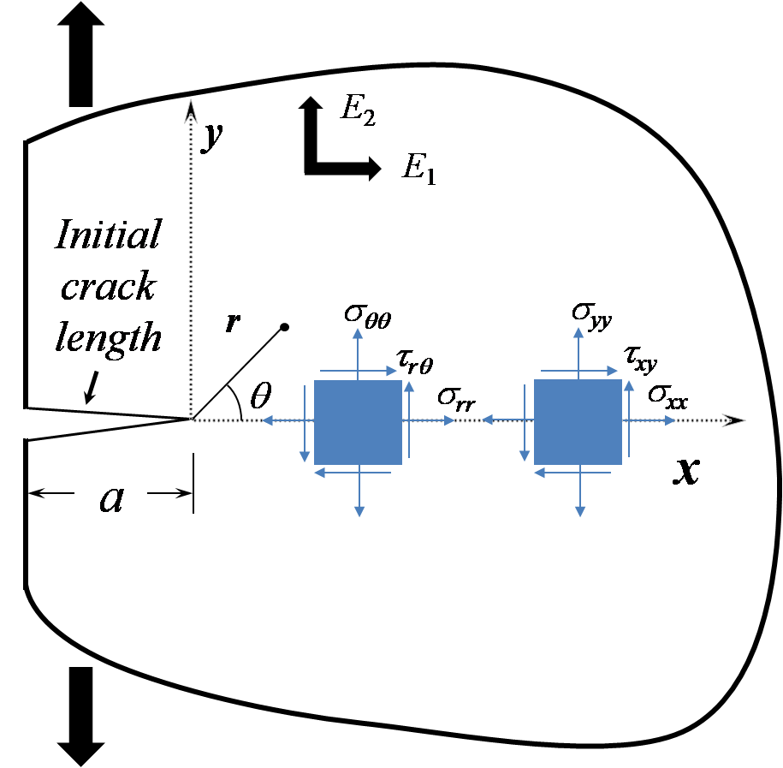
Fig. 1: The conventional crack tip coordinates in orthotropic media.

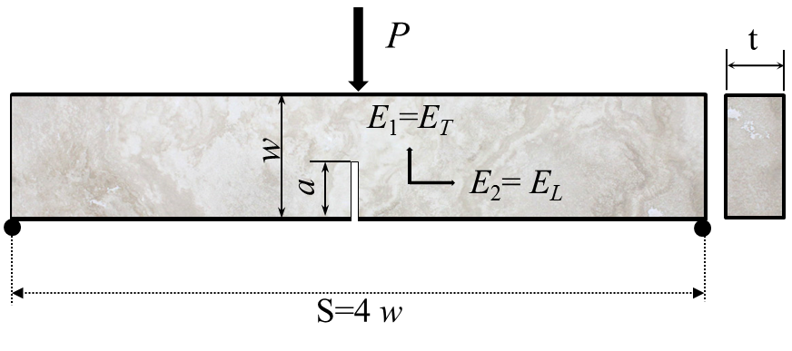
Fig. 2: The schematics of three-point bend samples containing an edge crack.

Fig. 3: Linear regression on results of tested bone reported in Ref. (Kim et al., 2013) for calculating A and B.

Fig. 4: The variations of r_{c} versus the specimen width w related to the experimental bone results reported in Ref. (Kim et al., 2013).

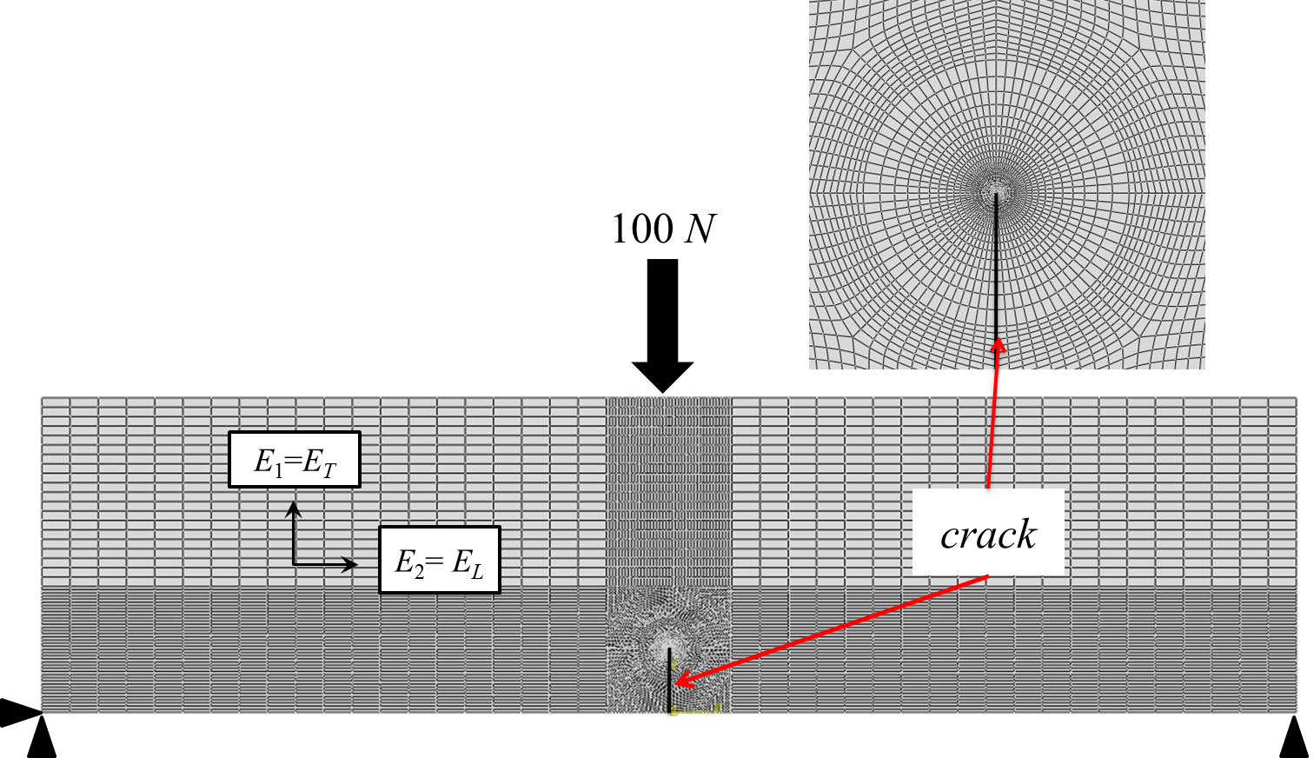
Fig. 5: A typical meshed pattern for SENB sample together with loading and boundary conditions.

Fig. 6: The variations of normal stress σ_{yy} along the crack orientation versus distance from the crack tip obtained from FE and Eq. (2).

Fig. 7: The size-independent curves shown in Fig. 6.

Fig. 8: The variations of $\overline{σ}$ with r for SENB specimens with various crack length ratios.

Corresponding author: J. Akbardoost, Email: Akbardoost@khu.ac.ir, Tel./Fax: +98 26-4569555.

