**Novel method for the fatigue strength assessment of heavy sections made by ductile cast iron in presence of solidification defects**

T. Borsatoa, P. Ferroa, F. Bertob

a University of Padova, Department of Engineering and Management, Stradella S. Nicola 3, 36100, Vicenza, Italy

b NTNU, Department of Engineering Design and Materials, Richard Birkelands vei 2b, 7491, Trondheim – Norway

Corresponding author: Dr. Thomas Borsato

E-mail: [borsato@gest.unipd.it](mailto:borsato@gest.unipd.it)

Tel.: +39 338 9405316

**Abstract**

The fatigue strength of ferritic, pearlitic and solution strengthened ferritic ductile irons taken from heavy sections and characterized by long solidification times has been assessed. Starting from the idea of Murakami and co-workers, a new model for the prediction of the fatigue strength is proposed. It allows a sound fatigue assessment of the fatigue strength of as-cast ductile irons containing solidification defects, such as low nodule count, exploded, chunky and spiky graphite or microshrinkage porosities. The new developed equation validated by means of an extensive benchmarking with data taken from the literature has shown a very high potential for applications to thick walled components.

**Keywords:** Fatigue; Defect assessment, Nodular iron, Mechanical properties, Fatigue life prediction.

**Nomenclature**

= geometrical parameter of the defect

= dimension of the maximum defect occurring in the material

Floc = parameter that takes into account the position of the defects in the specimens

HB = Brinell Hardness

HV = Vickers Hardness

R= nominal stress ratio

= material parameter

= threshold Stress Intensity Factor range

εR = elongation at fracture

a  = stress amplitude

= experimental fatigue strength

= ultimate tensile strength

= yield stress

A = first estimation parameter

B = second estimation parameter

**1. Introduction**

Over the last years, the production of heavy section ductile cast iron components with structural functions increased thanks to the relatively low manufacturing cost, excellent castability and good combination of mechanical properties. Examples of the use of these materials are windmill parts, automotive and agricultural parts, big engine blocks, parts of hydraulic presses.

The typical microstructure of ductile cast irons is characterized by spheroidal graphite particles dispersed within a metal matrix that can be, depending on the chemical composition of the alloy, ferritic, pearlitic or ferritic/pearlitic. It is well known that the ferritic matrix gives higher ductility and toughness, while the pearlitic one is characterized by a higher strength. Recently, ductile irons with ferritic matrix strengthened by solid solution through the addition of balanced amount of silicon have been introduced in the standard UNI EN 15631. The new types of materials are characterized by a good combination of strength and ductility and a high ratio between yield stress and ultimate tensile stress.

By increasing the thickness of the components, the solidification times will increase with the increased risk of finding coarse grains and anomalous structures2. In particular, the nodularity and the nodule count will decrease, while the dimensions of graphite particles will increase. Furthermore, the greater the casting dimensions, the greater the probability of finding degenerated graphite (exploded, chunky or spiky), large microshrinkage porosities, non-metallic inclusions or undesired segregations3,4.

These defects, which negatively affect the mechanical properties of the materials, can be avoided only partially through the optimization of the production process (casting temperature, spheroidization or inoculation process, addition of balanced amount of elements (Sb, Bi, Ce, etc.))5-7. Consequently, in thick walled components, some defects are unavoidable.

In many works found in literature8-12, various types of solidification defects have been studied, in order to evaluate their influence on the static and fatigue resistance of the components. The ultimate tensile strength and the elongation at failure are lowered by solidification defects, while hardness and yield stress are less affected. Moreover, it was found that the more the graphite deviates from the spheroidal shape, the lower is the strength and the ductility. Finally, it was demonstrated that defects are preferential crack initiation sites during fatigue loadings.

Canzar13 showed experimentally that size, shape and distribution of the graphite nodules play a major role in the crack initiation and propagation process. It was also shown that the largest irregularly shaped nodules reduce the fracture toughness and the fatigue strength.

Iacoviello et al.14-20 studied the influence of microstructure on the fatigue crack propagation resistance of different types of ductile cast iron with various matrix structure. They found that graphite particles do not only act as crack arresters but, depending on matrix microstructure, they can also increase the fatigue crack propagation resistance by means of an increase of the crack closure effect.

Nadot et al.21,22 observed that crack initiation point is a single microporosity in proximity of the specimen surface. They also found that in uniaxial fatigue tests, the fatigue limit is much more sensitive to surface defects than internal defects. These results were confirmed in other works23,24 where it was observed that microshrinkage cavities strongly influence the fatigue behaviour of ductile cast irons.

In Ref.25-30 several fatigue tests have been performed on specimens taken from different zones within a wind turbine component. It has been found that crack initiation is influenced above all by microshrinkage porosities while crack propagation is influenced by the microstructure.

Some researchers investigated the effect of chunky graphite on the mechanical and fatigue properties of heavy section ferritic ductile cast irons31-33. They found that this type of degenerated graphite morphology negatively affects the mechanical properties of the material; in particular it reduces the ultimate tensile strength and mostly the elongation to failure, without affecting the yield strength and the hardness. Moreover, it was found that also the fatigue strength is lowered by the presence of chunky graphite; while the graphite spheroids act as crack arresters, in the presence of chunky graphite, the cracks passes easily through the branched and interconnected graphite particles, lowering the fatigue strength of the material. Similar conclusions have been achieved when solution strengthened ferritic ductile cast irons have been investigated34.

In other works35,36, it was observed that microshrinkage cavities, near the surface of the specimens, were the cause of the fatigue failure of heavy section pearlitic ductile iron castings. It was also shown that a combined effect between microshrinkage and degenerated graphite (spiky) could exist when they are both present in the alloy.

One of the most used method for the estimation of the fatigue strength of specimens containing defects is the criterion proposed by Murakami and Endo37,38. According to this model, the fatigue limit of materials containing small defects can be evaluated by using an equation that takes into account a material parameter and a defect parameter.

Starting from the relationship , the fatigue resistance (a) was proposed to have the following expression:

|  |  |  |
| --- | --- | --- |
|  |  | (1) |

In Eq. (1) HV is the Vickers Hardness of the matrix and √area is a parameter representative of the material defects and cracks. √area is defined as the square root of the area obtained by projecting small defect or crack onto a plane perpendicular to the maximum principal stress. is a parameter that takes into account the position of the defects in the specimens. It is equal to 1.43 for a surface defect, 1.41 for a defect just below the surface and 1.56 for an interior defect. R is the load ratio, and is a material parameter that can be calculated by using the following equation38 (for steels): .

In the case of ductile cast irons39, has been defined as .

It was found that the largest defect, such as the maximum size of graphite particle, artificial notches, or casting defect (e.g., micro-shrinkage cavity) play a dominant role in determining fatigue strength of ductile cast irons39-43. It was also found that the fatigue limit is not a limit stress for nucleation but rather the threshold stress for non-propagation of a small crack emanating from a graphite particle or defect. For this reason, small defects are similar to cracks.

Deguchi et al.44-45 investigated the effects of artificial small defects on the ferritic/pearlitic ductile cast irons. They observed that, in the case of two phases matrix, the measurement of the correct Vickers hardness of the matrix is quite difficult. It follows that the previous equation (Eq. 1) could not be used in order to evaluate the fatigue resistance of ferritic/pearlitic ductile irons. In this case, the following new expression has been proposed:

|  |  |  |
| --- | --- | --- |
|  |  | (2) |

Where the ultimate tensile strength is used as material parameter. is the dimension of the artificial defect, which is not related to the solidification conditions, microstructure and mechanical properties of the material. Two values of parameter were found: 0.557 (by using circumferential notched specimens46) and 0.476 (by using specimens with drilled holes47). Moreover, the fatigue strength of smooth specimens was described by using the following expression:

|  |  |  |
| --- | --- | --- |
|  |  | (3) |

It was also observed that exists a minimum critical size of the defect below which the fatigue strength is not affected. The concept of a minimum critical size of defect, below which the fatigue strength is not affected, has been extensively discussed by Atzori and Lazzarin48.

It is important to observe that the proposed methods consider as-cast ductile irons with artificial defects (notches or holes) that have been intentionally machined on the specimens; really, they are not intrinsic material defects. As described above, with increasing the dimensions of the castings, the solidification time increases with a much higher probability of finding solidification defects of larger dimensions. Consequently, the casting defects are intrinsically linked with the matrix microstructure arising from the solidification.

In this study, the fatigue resistance of ferritic, pearlitic and solution strengthened ferritic ductile irons, characterized by long solidification times has been assessed. It is proposed a new model, based on the parameter, for the prediction of the fatigue resistance of as-cast ductile irons containing solidification defects, such as low nodule count, exploded, chunky and spiky graphite or microshrinkage porosities. It takes into account the strong linking between solidification microstructure and fatigue resistance lowering defects.

**2. Materials and Methods**

Different grades of ductile irons have been considered in the analysis; traditional ferritic (GJS 400-18), pearlitic (GJS 700-2) and new generation solution strengthened ferritic ductile irons (SSF DI) with silicon contents greater than 3.2wt%. Heavy section castings with various solidification times have been analysed. In particular, experimental data have been taken from both authors’ works in literature7,12,32,34-36 and a new set of experimental measurements. Castings were Y-shape cast samples with thickness of 50 and 75 mm (geometry according to UNI EN 1563), blocks 300x250x300 mm3 with feeders on the top surfaces, cylinders (diameter, 300 mm; height, 520 mm), a cube 600x600x600 mm3 and a cast cylinder with diameter equal to 650 mm. Specimens for mechanical tests have been taken from the zone with the longest solidification time inside each geometry, as described in the previous work 35. For each casting, tensile tests have been carried out at room temperature on at least 5 smooth specimens with gauge diameter of 14 mm (geometry according to UNI EN 1563). Brinell hardness (HBW 5/750) tests according to UNI EN ISO 6506:200649 have been also performed on samples. Uniaxial tension fatigue tests have been carried out at room temperature on smooth specimens, by using two testing machines: a universal MTS machine (250 kN) with load frequency of about 15 Hz and a resonant testing machine Rumul Testronic 150 kN running with a sinusoidal pulsating load at a frequency of about 120 Hz. The load ratios were R = 0 and R = -1. Only in the case of a casting, rotating bending fatigue tests (R = -1) have been carried out under load control at a frequency of about 100 Hz using specimens with a net diameter of 6.5 mm. The geometries of the specimens are shown in Figure 1; both cylindrical specimens with a net diameter of 10 mm and specimens with 15x10 mm2 rectangular cross section have been used. The results of fatigue tests have been statistically elaborated and the curves relative to survival probability of 10, 50, and 90% were calculated using log-normal distribution. The experimental fatigue resistance (σa exp) of each casting has been considered as the mean stress amplitude relative to a survival probability of 50% at 2 million cycles.



a)

b)

Figure 1. Fatigue specimens geometries. Dimensions in mm.

The microstructure of the specimens has been also investigated by means of an optical microscope using polished samples taken from a section near the fracture surfaces of fatigue specimens. The microstructural parameters, such as nodule count and nodule diameter, have been evaluated. After fatigue tests, the fracture surfaces of broken specimens have been analysed by means of a Field Emission Gun – Environmental Scanning Electron Microscope (FEG-ESEM) (FEI, Quanta 250 FEG) in order to identify crack initiation zones. In particular, the fatigue crack initiation defects have been detected and their dimensions have been measured using an image analysis software. Subsequently, statistical analysis of extreme values has been conducted in order to estimate the dimension of the maximum defect occurring in the materials, 38,50,51. In Table 1, the castings codes, the dimensions of the components and the chemical compositions are summarized. The new experimental data (indicated as “new data” in Table 1) concerns a pearlitic ductile iron casting (P-C), a traditional GJS 400-18 LT (F-F) and solution strengthened ferritic ductile irons (S-I, S-Y III, S-Y IV). Different castings geometries and thicknesses, and hence different solidification times, have been considered.

Table 1. Dimensions and chemical composition of the analysed castings.

|  |  |  |  |  |  |  |  |  |
| --- | --- | --- | --- | --- | --- | --- | --- | --- |
| Material | Casting code | Reference  Number | Dimensions [mm] | C | Si | Mn | Cu | Mg |
| GJS 700-2  Pearlitic | P-A | [7] | 300x300x250 | 3.65 | 1.95 | 0.30 | 1.25 | 0.059 |
| P-B | [7] | 300x300x250 | 3.75 | 2.25 | 0.30 | 1.20 | 0.063 |
| P-E | [35,36] | 300x300x250 | 3.58 | 2.50 | 0.36 | 1.12 | 0.054 |
| P-C | new data | 600x600x600 | 3.70 | 1.94 | 0.31 | 1.18 | 0.068 |
| GJS 400-18 LT Ferritic | F-F | new data | 300x300x250 | 3.79 | 2.06 | 0.22 | 0.07 | 0.064 |
| GJS 400-18  Ferritic | F-Chunky | [32] | cast cylinder ø650 | 3.50 | 2.45 | 0.12 | 0.13 | 0.055 |
| F-Good | [32] | cast cylinder ø650 | 3.50 | 2.45 | 0.12 | 0.13 | 0.055 |
| SSF DI  Solution strengthened ferritic | S-D | [12] | 300x300x250 | 3.18 | 3.22 | 0.19 | 0.25 | 0.043 |
| S-G | [34] | 300x300x250 | 3.14 | 3.50 | 0.19 | 0.10 | 0.058 |
| S-H | [34] | 300x300x250 | 3.10 | 3.55 | 0.19 | 0.10 | 0.060 |
| S-I | new data | ø 300 H520 | 3.30 | 3.19 | 0.20 | 0.16 | 0.047 |
| S-Y III | new data | Y-shape (50) | 3.31 | 3.25 | 0.13 | 0.16 | 0.050 |
| S-Y IV | new data | Y-shape (75) | 3.31 | 3.25 | 0.13 | 0.16 | 0.050 |

**3. Analysis of Results**

In Figure 2, examples of the micrographs of the new experimental data are shown. In particular, the microstructure of the GJS 400-18 LT (casting F-F) is characterized by spheroidal graphite nodules within a ferritic matrix, with areas of pearlite due to the segregation of undesired carbide promoting element present in the alloy. In the GJS 700-2 (casting P-C), the pearlitic matrix is predominant, with small amount of ferrite at the grain boundaries and around the graphite nodules. Finally, the solution strengthened ductile iron (S-I) shows a fully ferritic matrix with limited traces of pearlite. The mechanical properties of specimens taken from the castings are collected in Table 2. It can be observed that, considering pearlitic GJS 700-2 ductile irons, the actual values of ultimate tensile strength and yield strength are much lower than the nominal ones. In the case of ferritic matrix, the reduction of mechanical properties is lower. It is also important to note that, due to the presence of chunky graphite, the ultimate tensile strength and more markedly, the elongation at failure, showed a considerable reduction compared to chunky-free castings32,34.

Tensile test results confirmed, as reported in Borsato et al.12, that ferritic ductile irons are less affected by the wall thickness and cooling rate, compared to pearlitic ductile irons.

Axial fatigue tests with load ratio equal to 0 were carried out, until the total separation of the two parts of the samples. In the case of casting F-F and S-I, load ratio equal to -1 was also adopted. Finally, only in the case of casting F-F, rotating bending (RB) fatigue tests were performed. The results of fatigue tests have been statistically analysed using a log-normal distribution. The run out specimens that have passed two million cycles were not included in the statistical re-analysis. Details and results of fatigue tests are shown in Table 3.

The analysis of the fracture surfaces of some of the broken specimens revealed that the fatigue crack initiated at solidification defects that could be microshrinkage porosities, exploded or spiky graphite particles or a combination of multiple defects (Figure 3).

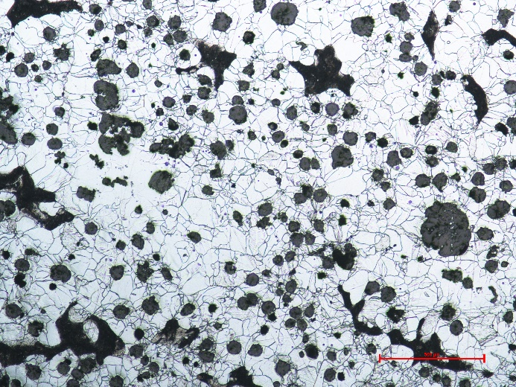

a

500µm

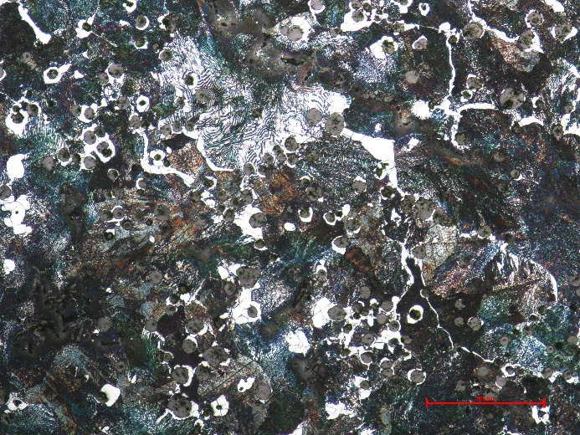

500µm

b

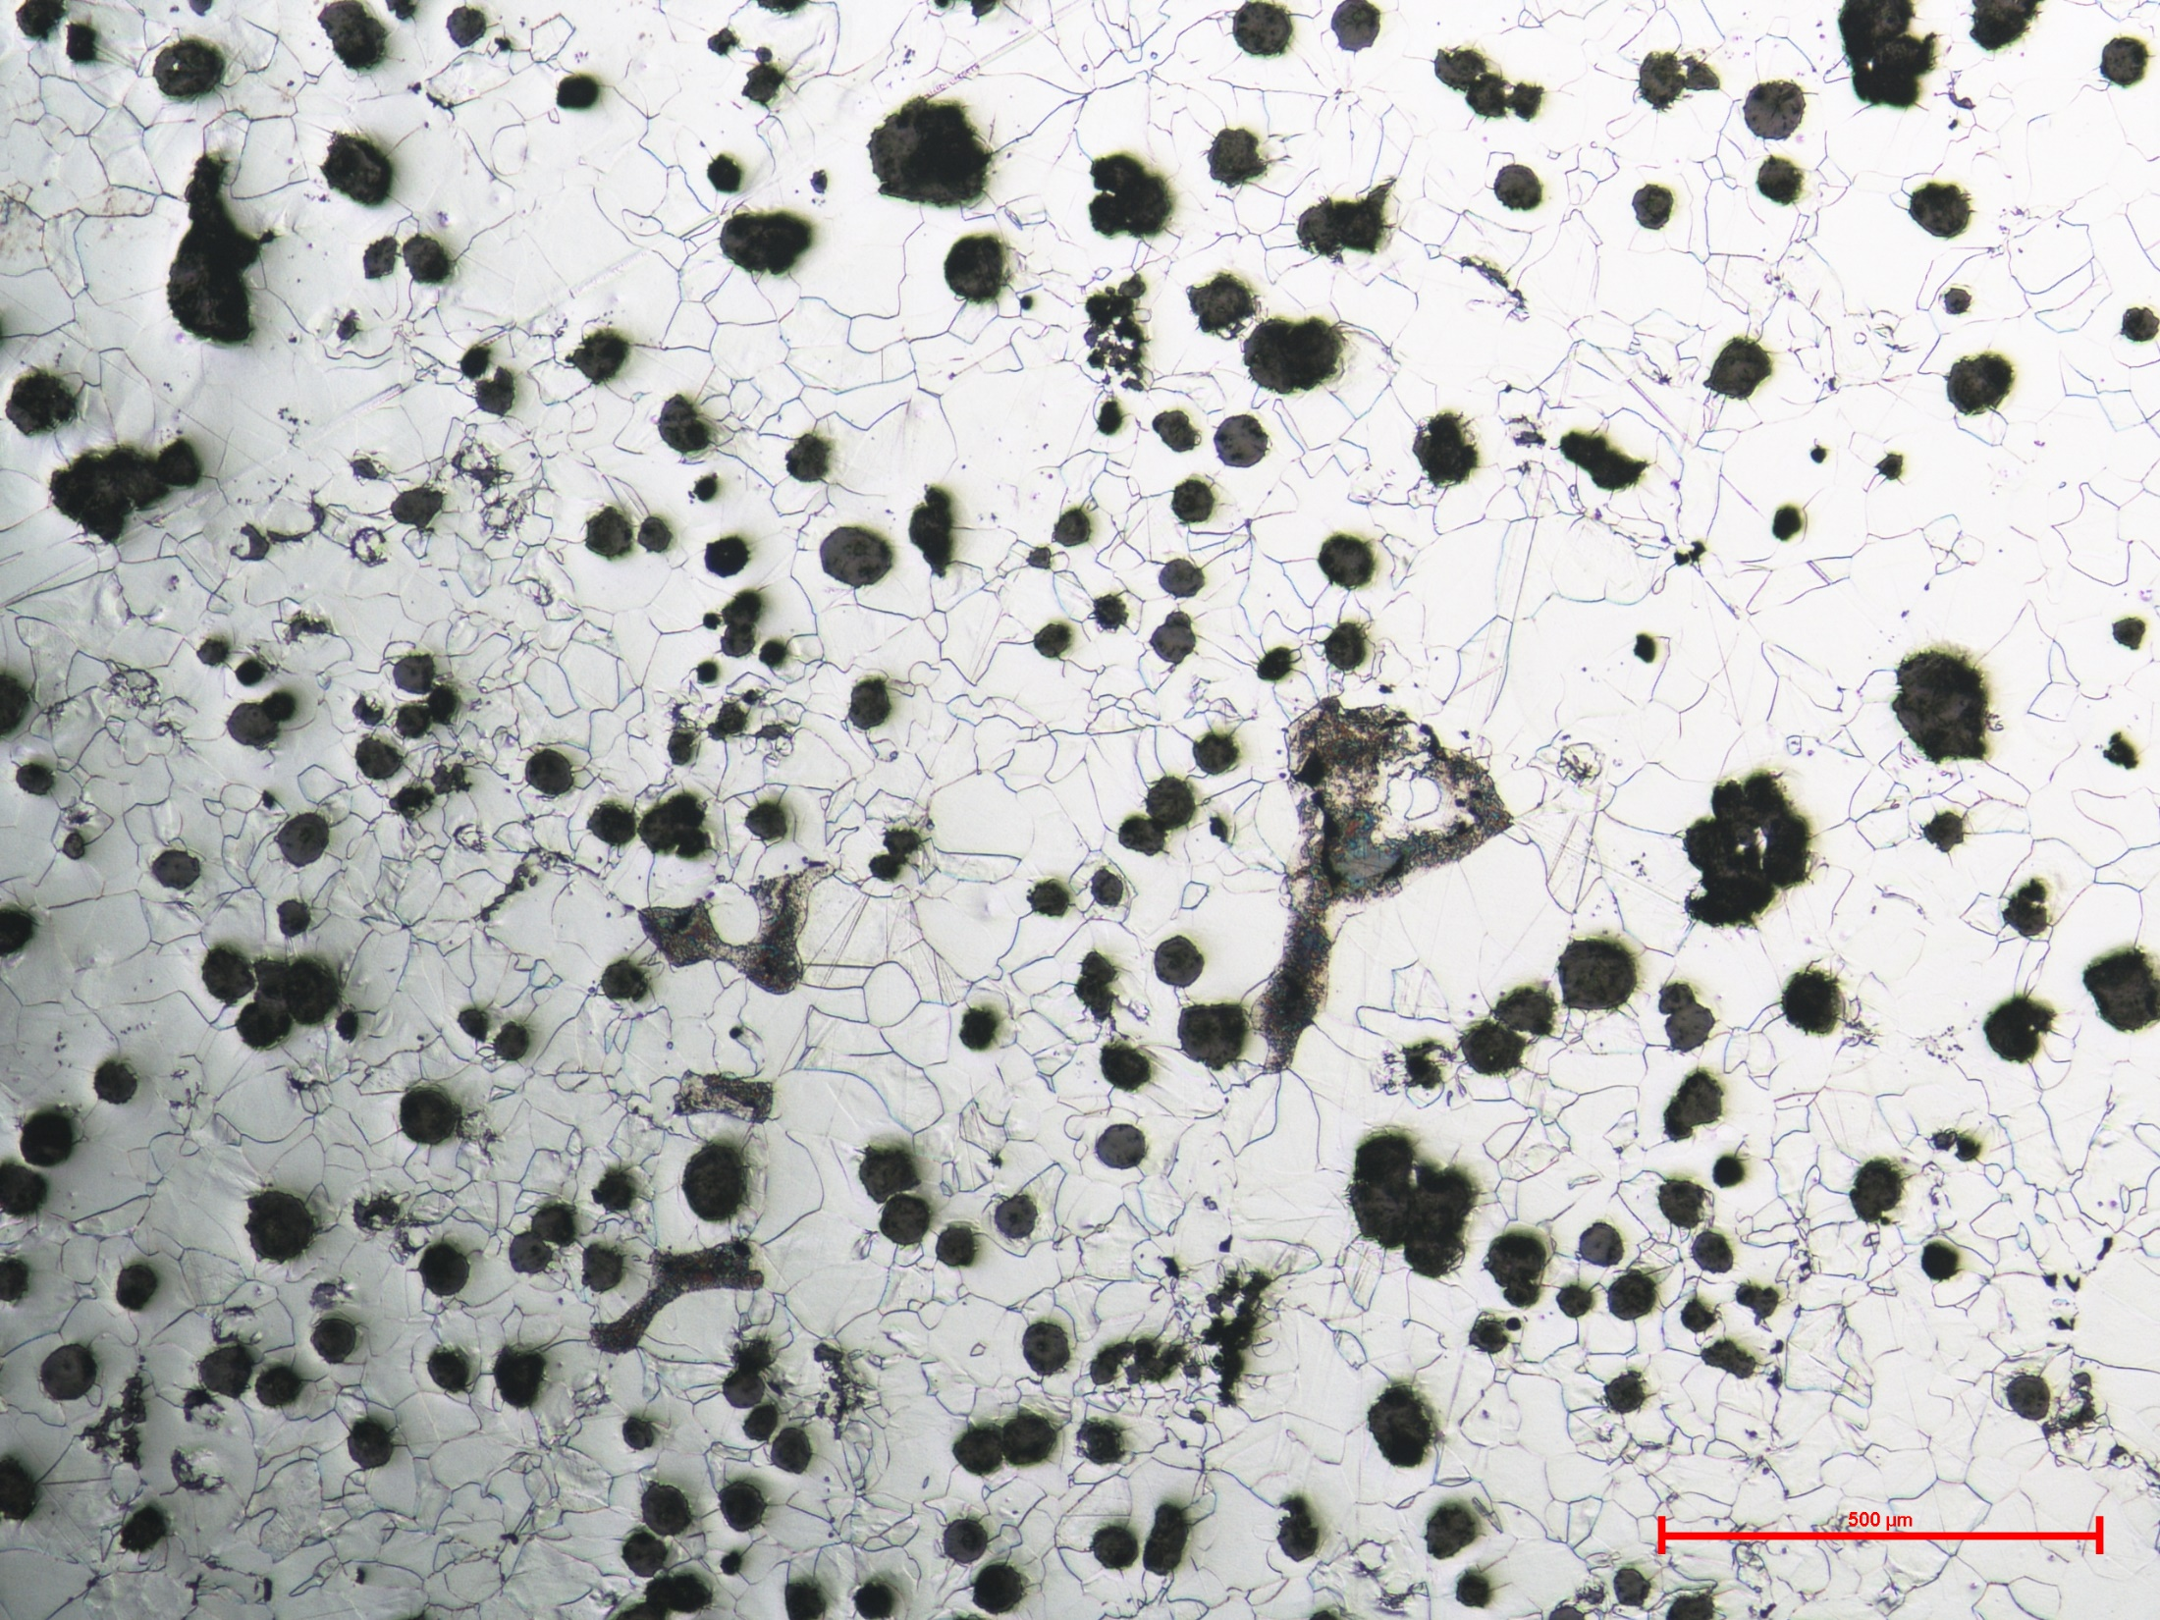

c

500µm

Figure 2. Examples of micrographs of specimens taken from casting F-F (a), P-C (b) and S-I (c) etched with Nital 5%.

Table 2. Mechanical properties of the castings.

|  |  |  |  |  |  |
| --- | --- | --- | --- | --- | --- |
| Material | Casting code | σUTS [MPa] | σy 0.2%  [MPa] | εR % | Hardness  HB |
| GJS 700-2  Pearlitic | P-A | 579 | 364 | 2.6 | 220 |
| P-B | 513 | 368 | 1.9 | 220 |
| P-E | 511 | 410 | 2.0 | 220 |
| P-C | 472 | 320 | 3.1 | 200 |
| GJS 400-18 LT Ferritic | F-F | 383 | 250 | 19.9 | 150 |
|
|
| GJS 400-18  Ferritic | F-Chunky | 321 | 265 | 3.4 | 145 |
| F-Good | 378 | 267 | 11.5 | 145 |
| SSF DI  Solution strengthened ferritic | S-D | 485 | 381 | 17.8 | 190 |
| S-G | 511 | 412 | 15.4 | 195 |
| S-H | 488 | 430 | 5.2 | 195 |
| S-I | 489 | 384 | 17.8 | 190 |
|
| S-Y III | 492 | 389 | 17.2 | 190 |
| S-Y IV | 487 | 384 | 17.1 | 190 |

Table 3. Details of test procedures and fatigue properties of the castings.

|  |  |  |  |  |  |  |  |
| --- | --- | --- | --- | --- | --- | --- | --- |
| Material | Casting code | Specimen geometry | Number  of tests | Load  Ratio | Load  Frequency  [Hz] | σa exp 50%  2·106 cycles  [MPa] | Scatter  Index  Tσ |
| GJS 700-2  Pearlitic | P-A | Fig. 1a | 22 | 0 | 15 | 120 | 1.5 |
| P-B | Fig. 1a | 16 | 0 | 15 | 134 | 1.1 |
| P-E | Fig. 1a | 24 | 0 | 15 | 140 | 1.2 |
| P-C | Fig. 1a | 17 | 0 | 15 | 95 | 1.5 |
| GJS 400-18 LT Ferritic | F-F | Fig. 1a, b | 20 | 0 | 15-120 | 100 | 1.27 |
| 20 | -1 | 140 | 1.3 |
| 25 | -1 (RB) | 175 | 1.15 |
| GJS 400-18  Ferritic | F-Chunky | Fig. 1b | 10 | 0 | 15 | 79 | 1.24 |
| F-Good | Fig. 1b | 16 | 0 | 15 | 91 | 1.27 |
| SSF DI  Solution strengthened ferritic | S-D | Fig. 1a | 21 | 0 | 15 | 132 | 1.11 |
| S-G | Fig. 1b | 26 | 0 | 120 | 131 | 1.15 |
| S-H | Fig. 1b | 23 | 0 | 120 | 127 | 1.27 |
| S-I | Fig. 1b | 20 | 0 | 120 | 135 | 1.15 |
| 21 | -1 | 184 | 1.3 |
| S-Y III | Fig. 1b | 27 | 0 | 120 | 151 | 1.21 |
| S-Y IV | Fig. 1b | 27 | 0 | 120 | 142 | 1.25 |

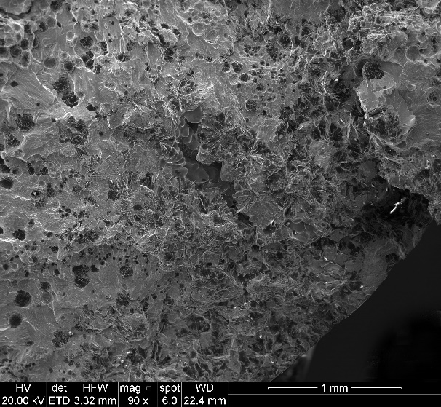

a

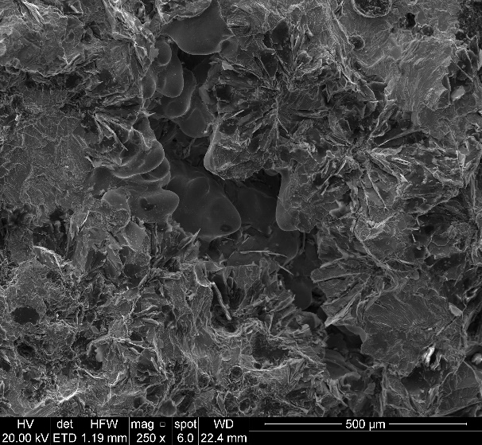

b

Figure 3. SEM macrograph of a fatigue crack initiation site (a) and particular of the simultaneous presence of microshrinkage porosity and spiky graphite (b).

In order to estimate the maximum dimensions of the initiating defects, the projected surface of microshrinkage porosities, degenerated graphite particles or inclusions that acted as crack initiators has been measured, as shown in Figure 4. Using the statistical analysis of extreme values, the was estimated, for each casting, by considering the dimension of the defect corresponding to the upper bound of the 95% confidence interval of the distribution.

In Figure 5 it is shown an example of defect distribution, where both the microshrinkage and degenerated graphite particles acted as crack initiators.

The maximum values of the estimated defects dimensions () are reported in Table 4 together with the mean nodule count evaluated on polished samples. It can be observed in Figure 6 a good correlation between the nodule count and the maximum defect dimension. As already discussed in a previous work7, through the optimization of the production process it is possible to increase the microstructural properties of the materials. In particular, it was found that the in-mould inoculation treatment could improve the nodule count and decrease the nodule diameter and the microshrinkage porosities.

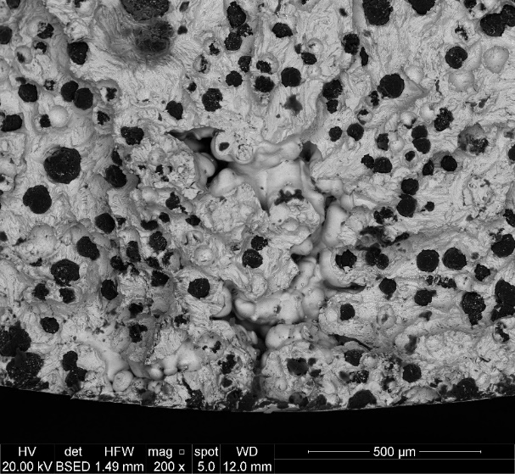

√area = 463 µm

a

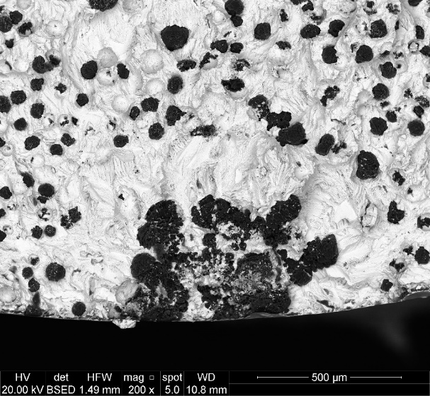

√area = 486 µm

b

Figure 4. SEM images of fracture surfaces showing the dimensions () of microshrinkage cavity (a) and degenerated graphite particle (b) that act as crack initiation sites.

Figure 5. Extreme values distributions of initiating defects (microshrinkage and degenerated graphite particle) found in casting F-F.

Table 4. Castings microstructural properties.

|  |  |  |  |
| --- | --- | --- | --- |
| Material | Casting code | Nodule count  [mm-2] | √areamax [µm]  95% confidence band |
| GJS 700-2  Pearlitic | P-A | 26 | 1959 |
| P-B | 52 | 946 |
| P-E | 46 | 806 |
| P-C | 15 | 3051 |
| GJS 400-18 LT Ferritic | F-F | 31 | 1243 |
| GJS 400-18  Ferritic | F-Chunky |  | 1350 |
| F-Good | 31 | 1350 |
| SSF DI  Solution strengthened ferritic | S-D | 38 | 1188 |
| S-G | 48 | 1082 |
| S-H | 40 | 1212 |
| S-I | 40 | 1150 |
| S-Y III | 105 | 300 |
| S-Y IV | 85 | 430 |

Figure 6. Correlation of graphite nodule count and maximum initiating defect dimensions.

As shown in Figure 7, it is important to note that, also in the case of heavy section castings with large solidification defects, the relationship between the experimental fatigue resistance (stress amplitude σa at 2·106 cycles) and the maximum defect size can be still expressed, as reported in Murakami37,38, according to the following equation:

|  |  |  |
| --- | --- | --- |
|  |  | (4) |

Figure 7. Relationship between the experimental fatigue resistance σa exp and the maximum dimension of the fatigue crack initiation defects.

**4. Fatigue resistance prediction of as-cast heavy section ductile irons with solidification defects**

The methods proposed in Murakami38 and Deguchi46 have been applied to the new experimental data in order to evaluate their applicability on heavy section castings with solidification defects. In order to use Murakami’s equation, the measured Brinell hardness has been converted according to ASTM A370:201552 standard into the Vickers hardness.

The results obtained using the two models are shown in Figure 8, where the comparison of the predicted and experimental fatigue resistance is plotted for each casting. It can be observed that both the methods underestimate the experimental fatigue resistance. It could be explained by considering that the two models have been developed by analysing specimens with small intrinsic defects, fine structures and high nodule count or artificial defects. It is shown in Fig. 6 that and solidification microstructure are strictly coupled each others. The dimensions of the machined notches or holes are instead not related to (or coupled with) the real or intrinsic microstructure and thus mechanical properties of the material. In heavy section castings, the microstructure is not homogeneous and various type of detrimental defects can be present into the material (microshrinkage, degenerated, chunky or spiky graphite). These intrinsic defects, which are directly related to the production process and solidification conditions, affect the material behaviour.

Figure 8. Comparison between experimental and predicted fatigue resistance according to the equations proposed by Murakami38 and Deguchi46.

In order to estimate the fatigue resistance of different types of as-cast ductile cast irons, characterized by solidification defects, the following expression, based on the is proposed herein:

|  |  |  |
| --- | --- | --- |
|  |  | (5) |

Compared to Deguchi’s model (2) where only σUTS was considered as representative of the material properties, the new equation takes into account the actual mechanical properties in terms of both the ultimate strength σUTS and yield strength σy 0.2% combined with the maximum value of the square root of the area of the initiating defect. The reason behind the choice of considering both the ultimate tensile strength and the yield strength in the fatigue assessment is to include in the fatigue strength evaluation the influence of the microstructural degeneration existing in the material.

As shown in some works31-34, when degenerated chunky graphite is present, the yield stress is not much affected, while ultimate tensile strength and fatigue resistance are strongly influenced and characterized by a detrimental effect. Moreover, it has been demonstrated that, when chunky graphite is present in the microstructure, it has a limited influence on the fatigue crack initiation compared with the effects due to microshrinkage porosities or spiky graphite, but it strongly affects the crack propagation stage.

It is not uncommon that two different materials, with different matrices and microstructures, one with and the other without degenerated graphite, may have the same ultimate tensile strength and the same size of defects () but different yield and fatigue strength, due to the different nature of the matrices.

Consequently, the yield strength (σy 0.2%) is more representative of the mechanical properties of the base material microstructure without any solidification defect while the ultimate strength (σUTS) is more connected with the mechanical properties of the real material fully including the solidification defects. Finally, the considers only the dimensions of the fatigue crack initiating defect.

In order to estimate the parameters A, B and (Eq. 5), the least square method was applied to the data shown in Tables 2 - 4. Eq. 5 can therefore be rewritten as follows:

|  |  |  |
| --- | --- | --- |
|  |  | (6) |

In order to validate the proposed model, further experimental data were taken from the literature9-11,25,26,28,29,33 where mechanical and fatigue properties (load ratio equal to 0 or -1) of as-cast ferritic ductile cast irons with long solidification times have been investigated. These works reported the actual mechanical properties of the materials and the dimension of the intrinsic initiating defects. In Table 5, the mechanical and fatigue properties are shown. It is also important to highlight that the analysed materials are characterized not only by microshrinkage porosities but also by different types of microstructural defects, such as low nodularity and nodule count, chunky or spiky graphite.

In those cases10,11,33 were rotating bending fatigue tests were carried out, a conversion factor has been used in order to obtain an equivalent axial tension-compression stress at load ratio R = -1. In particular, as shown in Table 3, in the case of casting F-F, axial tension-compression tests and rotating bending tests have been carried out using specimens taken from the same position inside the blocks. The obtained fatigue resistances were 140 MPa and 175 MPa for axial tension-compression and rotating bending respectively. The factor was defined as .

It can be observed in Figure 9 that also in the case of data taken from the literature, the fatigue resistance decreases following a power law with the maximum initiating defect index of about -1/6.

The fatigue resistance estimation of the analysed castings is shown in Figure 10, where the predicted fatigue resistance (σa predicted) is normalised with respect to the experimental value σa exp. It can be observed that the estimation is in very good agreement with the experimental data, with about 80% of the data within a ±5% scatter band, and almost all the points in ±10%.

Table 5. Mechanical and fatigue properties of castings taken from the literature.

|  |  |  |  |  |  |
| --- | --- | --- | --- | --- | --- |
| Reference  number | σUTS  [MPa] | σy0,2%  [MPa] | Load  Ratio | σa exp 50%  (Tension) | σa exp 50%  (RB) |
| 10 | 295 | 275 | -1 |  | 138 |
| 33 | 412 | 275 | -1 |  | 198 |
| 33 | 355 | 276 | -1 |  | 163 |
| 25-26 | 410 | 250 | -1 | 160 |  |
| 25-26 | 410 | 250 | -1 | 175 |  |
| 25-26 | 410 | 250 | -1 | 190 |  |
| 25-26 | 410 | 250 | -1 | 215 |  |
| 28-29 | 375 | 250 | -1 | 110 |  |
| 28-29 | 400 | 230 | 0 | 130 |  |
| 28-29 | 400 | 230 | -1 | 180 |  |
| 9 | 341 | 240 | -1 |  | 160 |
| 9 | 375 | 242 | -1 |  | 200 |
| 9 | 370 | 236 | -1 |  | 170 |
| 9 | 371 | 235 | -1 |  | 200 |
| 11 | 329 | 286 | -1 |  | 145 |
| 11 | 353 | 298 | -1 |  | 167 |
| 11 | 295 | 275 | -1 |  | 138 |
| 11 | 249 | 249 | -1 |  | 130 |

Figure 9. Relationship between fatigue resistance of data taken from literature and the maximum dimension of the fatigue crack initiation defects.

Figure 10. Comparison of experimental and predicted fatigue resistance according to equation (6), with ±5% and ±10% scatter band.

**5. Conclusions**

In this paper, a model able to predict the fatigue resistance of different as-cast ductile irons containing different kinds of solidification defects has been proposed.

The model takes into account the effect of the initiating defects through the dimension that has been evaluated by means of an accurate analysis of the fatigue crack initiation defects. It is important to note that microshrinkage porosities and degenerated graphite particles have been considered all together in the study.

The proposed equation takes also into account the actual mechanical properties of the materials (σUTS and σy 0.2%). In particular, the yield strength (σy 0.2%) is representative of the mechanical properties of the base material without microshrinkage porosities or degenerated graphite particles while σUTS takes into account the mechanical properties of the real material fully including the solidification defects due to the long time of solidification.

The method has been validated by using both data taken from the literature and a new set of experimental measurements.

Compared to the models previously proposed in the literature, the present equation allows a more reliable estimation of the fatigue strength of different types of as-cast heavy section ductile irons containing various types of solidification defects.

**Acknowledgments**

The authors would like to thank VDP Fonderia SpA for the material supply, financial and technical support to the project.

**References**

1. UNI EN 1563:2012, Founding - Spheroidal graphite cast irons.

2. Minnebo P, Nilsson K-F, Blagoeva D. Tensile, compression and fracture properties of thick walled ductile cast iron components. *J Mater Eng Perform.* 2007;16:35-45.

3. C.M. Ecob, A review of common metallurgical defects in ductile cast iron, Oslo, Norway; 2005. <http://www.elkemfoundry.com.cn/pdf/dfa48df95b.pdf.

4. Källbom R, Hamberg K, Wessén M, Björkegren L-E. On the solidification sequence of ductile iron castings containing chunky graphite. *Mater Sci Eng A.* 2005;413:346-351.

5. Pan E N, Chen C Y. Effects of Bi and Sb on graphite structure of heavy-section ductile cast iron. *AFS Trans*. 1996;104:845–858.

6. Ferro P, Fabrizi A, Cervo R, Carollo C. Effect of inoculant containing rare earth metals and bismuth on microstructure and mechanical properties of heavysection near-eutectic ductile iron castings. *J Mater Process Technol.* 2013;213:1601–1608.

7. Borsato T, Berto F, Ferro P, Carollo C. Effect of in-mould inoculant composition on microstructure and fatigue behaviour of heavy section ductile iron castings. *Procedia Struct Integr.* 2016;2:3150–3157.

8. Bleicher C, Wagener R, Kaufmann H, Melz T. Fatigue strength of nodular castiron with regard to heavy-wall applications. *Mater Test.* 2015;57:723–31.

9. Shiraki N, Yuki U, Toshitake K. Effects of Number of Graphite Nodules on Fatigue Limit and Fracture Origins in Heavy Section Spheroidal Graphite Cast Iron. *Materials Transactions*. 2016;57:379-384.

10. Benedetti M, Torresani E, Fontanari V, Lusuardi D. Fatigue and Fracture Resistance of Heavy-Section Ferritic Ductile Cast Iron. *Metals*. 2017;7:88.

11. Foglio E, Gelfi M, Pola A, Lusuardi D. Effect of Shrinkage Porosity and Degenerated Graphite on Fatigue Crack Initiation in Ductile Cast Iron. *Key Eng Mat*. 2017;754:95-98.

12. Borsato T, Ferro P, Berto F, Carollo C. Mechanical and fatigue properties of heavy section solution strengthened ferritic ductile iron castings. *Adv Eng Mater*. 2016;18:2070-2075.

13. Čanžar P, Tonković Z, Kodvanj J. Microstructure influence on fatigue behaviour of nodular cast iron. *Mater Sci Eng A*. 2012;556:88-99.

14. Iacoviello F, Di Bartolomeo O, Di Cocco V, Piacente V. Damaging micromechanisms in ferritic–pearlitic ductile cast irons. *Mater Sci Eng A.* 2008;478:181-186.

15. Cavallini M, Di Bartolomeo O,Iacoviello F. Fatigue crack propagation damaging micromechanisms in ductile cast irons. *Eng Fract Mech.* 2008;75:694-704.

16. Di Cocco V, Iacoviello F, Cavallini M. Damaging micromechanisms characterization of a ferritic ductile cast iron. *Eng Fract Mech.* 2010;77:2016-2023.

17. Iacoviello F, Di Cocco V, Cavallini M. Ductile cast irons: microstructure influence on fatigue crack propagation resistance. *Frattura ed Integrità Strutturale.* 2010;13:3-16.

18. Di Cocco V, Iacoviello F, Rossi A, Iacoviello D. Macro and microscopical approach to the damaging micromechanisms analysis in a ferritic ductile cast iron. *Theor Appl Fract Mec.* 2014;69:26-33.

19. Di Cocco V, Iacoviello F, Rossi A, Cavallini M, Natali S. Graphite nodules and fatigue crack propagation micromechanisms in a ferritic ductile cast iron. *Fatigue Fract Eng Mater Struct.* 2013;36:893-902.

20. Iacoviello F, Di Cocco V. Degenerated graphite nodules influence on fatigue crack paths in a ferritic ductile cast iron. *Frattura ed Integrità Strutturale.* 2015;34:406-414.

21. Nadot Y, Mendez J, Ranganathan N, Beranger S. Fatigue life assessment of nodular cast iron containing casting defects*. Fatigue Fract Eng Mater Struct*. 1999;22:289-300.

22. Nadot Y, Mendez J, Ranganathan N. Influence of casting defects on the fatigue limit of nodular cast iron. *Int J Fatigue.* 2004;26:311–319.

23. Collini L, Pirondi A, Bianchi R, Cova M, Milella PP. Influence of casting defects on fatigue crack initiation and fatigue limit of ductile cast iron. *Procedia Eng.* 2011;10:2898–2903.

24. Collini L, Pirondi A. Fatigue crack growth analysis in porous ductile cast iron microstructure. *Int J Fatigue*. 2014;62:258–65.

25. Kainzinger P, Guster C, Severing M, Wolf A. Influence of micro-shrinkage on the fatigue behaviour of ductile iron. In: 13th International Conference on Fracture, 2013, June 16–21, Beijing, China.

26. Kainzinger P, Wohlfahrt M, Grün F. Einfluss der lokalen Gefügeausbildung auf die Schwingfestigkeit von Gusseisen mit Kugelgraphit. *BHM Berg-und Hüttenmännische Monatshefte*. 2015;160:2-8.

27. Shirani M, Härkegard G. A review on fatigue design of heavy section EN-GJS-400-18-LT ductile iron wind turbine castings. *Energy Equip Syst*. 2014;2:5–24.

28. Shirani M, Härkegard G. Damage tolerant design of cast components based on defects detected by 3D X-ray computed tomography. *Int J Fatigue.* 2012;41:188-198.

29. Shirani M, Härkegard G. Fatigue life distribution and size effect in ductile cast iron for wind turbine components. *Eng Fail Anal.* 2011;18:12–24.

30. Shirani M, Härkegard G. Large scale axial fatigue testing of ductile cast iron for heavy section wind turbine components. *Eng Fail Anal*. 2011;18:1496–510.

31. Mourujärvi A, Widell K, Saukkonen T, Hänninen H. Influence of chunky graphite on mechanical and fatigue properties of heavy-section cast iron. *Fatigue Fract Eng Mater Struct*. 2009;32:379-390.

32. Ferro P, Lazzarin P, Berto F. Fatigue properties of ductile cast iron containing chunky graphite. *Mater Sci Eng A*. 2012;554:122–8.

33. Foglio E, Lusuardi D, Pola A, La Vecchia GM, Gelfi M. Fatigue design of heavy section ductile irons: influence of chunky graphite. *Mater Des.* 2016;11:353–361.

34. Borsato T, Ferro P, Berto F, Carollo C. Fatigue properties of solution strengthened ferritic ductile cast irons in heavy section castings. *La Metallurgia Italiana.* 2017;10:25-32.

35. Borsato T, Ferro P, Berto F, Carollo C. Mechanical and fatigue properties of pearlitic ductile iron castings characterized by long solidification times. *Eng Fail Anal.* 2017;79:902-912.

36. Borsato T, Ferro P, Berto F, Carollo C. Fatigue strength improvement of heavy-section pearlitic ductile iron castings by in-mould inoculation treatment. *Int J Fatigue*. 2017;102:221-227.

37. Murakami Y, Endo M. Effects of hardness and crack geometries on ∆Kth of small cracks emanating from small defects. In: Miller KJ, de los Rios ER, editors. The behaviour of short fatigue cracks, MEP, London; 1986, p. 275–94.

38. Murakami Y. Metal fatigue: effects of small defects and nonmetallic inclusions. 1st ed. Elsevier, Oxford, 2002.

39. Endo M, Iseda K. Prediction of the fatigue strength of nodular cast irons under combined loading. *Int J Mod Phys B.* 2006;20:3817-3823.

40. Endo M. Effects of graphite shape, size and distribution on the fatigue strength of spheroidal graphite cast irons. *J Soc Mater Sci.* 1989;38:1139-1144.

41. Endo M, Wang X B. Effects of Graphite and Artificial Small Defect on the Fatigue Strength of Current Ductile Cast Irons*. J Soc Mater Sci*. 1994;43:1245-1250.

42. Endo M. Fatigue strength prediction of ductile irons subjected to combined loading. In: Proceedings of the 13th European conference on fracture (ECF13). Amsterdam: Elsevier; 2000.

43. Endo M, Yanase K. Effects of small defects, matrix structures and loading conditions on the fatigue strength of ductile cast irons. *Theor Appl Fract Mec*. 2014;69:34-43.

44. Deguchi T, Matsuo T, Takemoto S, Ikeda T, Endo M. Effects of graphite and artificial defects on the fatigue strength of ferritic-pearlitic ductile cast iron. *Int J Fract Fatigue Wear*, Volume 4, Proceedings of the 5th International Conference on Fracture Fatigue and Wear 2016;4:93-98.

45. Deguchi T, Matsuo T, Kim H, Ikeda T, Endo M. Fatigue Strength Evaluation of Ferritic-Pearlitic Ductile Cast Iron with Notches and Holes of Various Sizes. *Advanced Experimental Mechanics.* 2017;2:87-91.

46. Deguchi T, Kim H J, Ikeda T. Fatigue limit prediction of ferritic-pearlitic ductile cast iron considering stress ratio and notch size. In: 12th International Conference on Damage Assessment of Structures. *Journal of Physics: Conference Series*. 2017;842:012067.

47. Deguchi T, Kim H J, Ikeda T, Yanase K. Influence of mean stress on fatigue strength of ferritic-pearlite ductile cast iron with small defects. In: 6th International Conference on Fracture Fatigue and Wear. *Journal of Physics: Conference Series*. 2017;843:012049.

48. Atzori B, Lazzarin P. Notch Sensitivity and Defect Sensitivity under Fatigue Loading: Two Sides of the Same Medal. *Int J Fract.* 2001:107, 1–8.

49. UNI EN ISO 6506-1:2006, Metallic materials – Brinell hardness test - Part 1: Test method.

50. Murakami Y. Inclusion rating by statistics of extreme values and its application to fatigue strength prediction and quality control of materials*. J Res Natl Inst Stand Technol.* 1994;99:345-351.

51. Beretta S, Murakami Y. Statistical analysis of defects for fatigue strength prediction and quality control of materials. *Fatigue Fract Eng Mater Struct*. 1998;21:1049-1065.

52. ASTM A370-15, Standard Test Methods and Definitions for Mechanical Testing of Steel Products, ASTM International, West Conshohocken, PA, 2015.