Abstract
Forest ecosystems provide a variety of services, from climate regulation to biodiversity conservation. Temporary land cover variations such as those related to forest management can contribute to climate change through both biogeochemical (carbon, warming) and biophysical (albedo, cooling) mechanisms. As global rising demand for biomass for energy and materials can contribute to biodiversity losses, there is an evident need for integrated assessments of climate and biodiversity impacts to investigate possible trade-offs and synergies. We explore the integration of impacts on climate change and biodiversity from forest harvest for three case studies based on forest plantations in Norway. We focus on impacts from land disturbance after clear-cutting using three plots of one ha each of homogeneous forest in two ecoregions in Norway involving three different tree species: spruce, pine and birch. We use existing ecoregion specific characterization factors (CFs) to quantify occupation, short-term and long-term transformation impacts of land use on biodiversity loss for five taxonomic groups: mammals, birds, amphibians, reptiles and plants at regional and global level. For climate change impacts, we quantify the contributions of CO₂ fluxes and changes in albedo. We estimate CFs for two complementary climate metrics, namely global warming potential (GWP) and global temperature change potential (GTP) for time horizons of 20 and 100 years and quantify impacts in CO₂ equivalents. We pursue the integration of impacts on climate and biodiversity from a time perspective: very short (GWP20 and land occupation), medium (GWP100 and land transformation within 100 years) and long (GTP100 and land transformation after 100 years). We find CFs from -0.21 to 1.6 kg CO₂-eq./kg CO₂ for carbon emissions, and from -0.03 to -1.4 kg CO₂-eq./kg CO₂ for albedo changes, while net characterized impacts range from -44.8 t CO₂-eq./ha (GTP100, spruce) to 93.25 t CO₂-eq./ha (GWP20, spruce). Damages to biodiversity range from 4.76*10⁻¹³ to 6.24*10⁻⁸ global species eq. lost per ton of carbon harvested. Our results reinforce the notion that spatially and temporally explicit analyses are vital when assessing life-cycle impacts from land derived products. We show that the existing set of multiple and complementary indicators for climate change and biodiversity impacts can be integrated into a common framework to better inform about the complex heterogeneities of the forest ecosystem response to disturbances. We argue for a more frequent consideration of integrated impacts on biodiversity and climate change from forestry operations to better highlight possible co-benefits or adverse side-effects of forest management strategies.
Keywords: LCA, climate change, biodiversity loss, forestry management, albedo
- Introduction
Anthropogenic greenhouse gas (GHG) emissions are driving increasing trends in annual average surface temperature that are threatening species and ecosystems (Stocker et al., 2013). The energy sector accounts for the majority of these GHG emissions (35%), mainly due to consumption of fossil fuels (Bruckner et al., 2014). Limiting global warming thus requires a large transformation of the energy sector, and the latest assessment report of the United Nation’s Intergovernmental Panel on Climate Change (IPCC) identifies bioenergy as part of the solution for climate change mitigation (IPCC, 2014). Nevertheless, there are growing concerns that an increased demand for biomass from forests for energy production can have adverse effects on a variety of ecosystem services (e.g. water chemistry, soil stability), and especially biodiversity where some species living in forests could decline (Cornwall, 2017).
Life cycle assessment (LCA) is a commonly used methodology for evaluating the total environmental impacts of products or systems during their entire lifecycle (Hellweg and i Canals, 2014). LCA is frequently used to assess bioenergy production systems, but there are methodological challenges related to the complexity of climate and ecosystem services involved in land-derived products. Terrestrial ecosystems interact with the climate in many different ways (Bonan, 2008). Land use and land cover changes, like those from forestry operations, directly alter the global radiation balance through two mechanisms: biogeochemical effects (the release and absorption of GHGs like CO₂) and biophysical effects (such as those from changes in the surface energy budget) (Liu et al., 2011; Myhre et al., 2013a; Schimel et al., 2001; Zhao et al., 2009). Among the biophysical effects, changes in surface albedo are dominating at high latitude or in areas affected by seasonal snow cover (Davin and de Noblet-Ducoudré, 2010). Albedo, which indicates the reflectivity of a surface, varies with the type of land cover and local climate. For instance, in forests it is lower than in open land, especially when covered with snow (Jackson et al., 2008). The biogeochemical and biophysical contributions to the global radiative forcing (RF) from historical land use changes have similar magnitudes but opposite signs (Cherubini et al., 2017; Myhre et al., 2013a). Deforestation causes warming through release of CO₂ emissions stocked in the biomass and cooling from increased surface albedo (Bala et al., 2007; Davin and de Noblet-Ducoudré, 2010). On the other hand, afforestation leads to cooling effects on climate due to CO₂ sequestration during biomass growth while masking the ground with forest canopy progressively reduces albedo and hence leads to a warming effect (Arora and Montenegro, 2011; Lohila et al., 2010). Land cover changes can have a significant impact on climate also when they are temporary, such as in the case of stand-replacement disturbances in forest management (Cherubini et al., 2012; Luyssaert et al., 2014). Changes in land cover have a third direct effect on the global radiation balance by altering emissions of biogenic organic compounds that rapidly oxidize in the atmosphere generating multiple warming and cooling climate pollutants like ozone and secondary organic aerosols, whose impact can be of the same order of magnitude of surface albedo or carbon fluxes (Arneth et al., 2010; Unger, 2014). These compounds also affect cloud formation patterns and properties, thereby indirectly influencing climate through changes in cloud albedo, but these contributions are still subject to large uncertainties and under continuous refinement (Carslaw et al., 2013).
Many articles argue for the importance to go beyond a simple carbon accounting framework when assessing the impacts of land activities on climate (Cherubini et al., 2016; Jackson et al., 2008; Zhao and Jackson, 2014). Over the recent years, an increasing number of studies attempted to include biophysical effects in LCA (Caiazzo et al., 2014; Cherubini et al., 2012; Cherubini et al., 2016; Guest et al., 2013a; Guest et al., 2013c; Muñoz et al., 2010). These studies generally conclude that quantification of biophysical and biogeochemical impacts from land cover changes can have large influence on the results, and are highly dependent on local specific factors. Some studies directly compute the response of the global carbon cycle and climate systems and derive emission metrics for forest bioenergy explicitly taking into account carbon and albedo dynamics, thus facilitating a consistent assessment of biogenic and fossil CO₂ emissions in LCA (Bright et al., 2012; Cherubini et al., 2012; Cherubini et al., 2016). The latest IPCC Assessment Report applies this approach to quantify climate impacts from forest bioenergy (Bruckner et al., 2014; Smith et al., 2014).
Whereas GWP100 is the most common option, impacts on climate can be assessed through a variety of indicators, including GTP and the use of multiple time horizons (TH). GWP is the radiative forcing (RF) from a pulse emission at time zero integrated until a chosen TH and divided by the result of an equivalent integration for CO₂. GTP represents the impact of an emission pulse on global temperature at the chosen TH, again relative to that of CO₂ (Myhre et al., 2013a; Shine et al., 2005). Given the complementary essence of these metrics, the recent guidelines from the Global Warming Task Force of the UNEP/SETAC life-cycle initiative recommends the use in LCA of GWP100 to target shorter-term impacts (using GWP20 in a sensitivity analysis) and GTP100 to assess long-term impacts (Levasseur et al., 2017).
Land use and land use change are identified as the main global drivers for terrestrial biodiversity loss (Millennium Ecosystem Assessment, 2005). Biodiversity stabilizes ecosystem productivity over time (Hautier et al., 2015; Isbell et al., 2015; Naeem and Li, 1997) and has an intrinsic value for humans. In 2005, 28% of the word’s land surface registered a 20% net reduction in local species richness (Newbold et al., 2016). Productive forest in Norway represents an abundant resource, respectively one quarter of the country’s land area (Statistics Norway, 2016), and it is the main habitat for most species (Henriksen and Hilmo, 2015). At the same time, the pressure from forestry operations accounts for 41% of threatened species in Norway while land-use change is considered to be a serious pressure on 90% of the species classified as threatened (Henriksen and Hilmo, 2015). In addition, almost half of the species (48%) on the Norwegian Red List are forest species (Henriksen and Hilmo, 2015) and 50% of all species in Norway depending on dead wood are on this list (Michelsen, 2008). The recent study from Liang et al. (2016) shows that a 10% loss in tree biodiversity also leads to a 3% loss in forest productivity. In general, previous studies indicate that intensive forest management leads to a reduction in habitat quality for many species (Berg et al., 1994; Paillet et al., 2010) beyond vascular plants. Clear-cut boreal forests have been pointed out as bottlenecks for the survival of biodiversity (Rudolphi and Gustafsson, 2011; Stenbacka et al., 2010; Widenfalk and Weslien, 2009). The largest number of threatened species in forest are specialist species, usually found on dead wood, mainly from large deciduous broad-leaved trees. Most of the Norwegian red-listed species are associated with rich broad-leaved forest (Henriksen and Hilmo, 2015). Fauna has been pointed in previous studies to be sensitive to logging intensity (Bicknell and Peres, 2010; Burivalova et al., 2015).
Although land use has an essential impact on biodiversity loss, there is no clear consensus on how to assess this in LCA (De Baan et al., 2013; Koellner et al., 2013; Michelsen et al., 2012). During the last years, several studies proposed methodological improvements and computed different biodiversity loss indicators (Chaudhary et al., 2015; Michelsen, 2008; Teixeira et al., 2016). Recently, the UNEP/SETAC life cycle initiative has made preliminary recommendations for a biodiversity loss indicator for terrestrial ecosystems (Milà i Canals et al., 2016), which is based on the method of Chaudhary et al. (2015). The impact from land use on biodiversity depends on the ecoregion and site-specific assessments should always be conducted due to the differences in local species richness and species vulnerability.
Joint consideration of impacts from land use and land use change such as biodiversity loss, changes in surface albedo and biogenic CO₂ fluxes are rare (Jørgensen et al., 2014; Michelsen et al., 2012). Some of the challenges to combine both climate change and biodiversity impacts in a common framework arise from the complex interplay between the different effects and their temporal distribution. For instance, uncurbed biodiversity loss can threaten long-term climate change mitigation efforts due to alterations of ecosystem functions and services, among which biomass production (Cardinale et al., 2012; Newbold et al., 2016) and a loss of intrinsic values. In this study, we select three case studies of bioenergy production from forest biomass in Norway where we simultaneously estimate post-harvest carbon flows, changes in albedo and biodiversity loss impacts. We chose the three main local species of trees, Norwegian spruce, pine and birch. Our aim is to provide an integrated platform to assess in a common framework impacts on climate and biodiversity from land cover disturbances. We apply the recent UNEP/SETAC guidelines (Frischknecht et al., 2016; Frischknecht and Jolliet, 2017) to compute three alternative climate indicators (GWP20, GWP100 and GTP100) and Potential Disappeared Fractions of Global Species (PDF) to quantify impacts on biodiversity for five taxonomic groups (mammals, birds, amphibians, reptiles and plants). We use empirical site-specific data for forest dynamics and integrate the characterized results from the different metrics under a time perspective based on short-, medium, or long-term impacts.
- Materials and method
  - Study area
Norway comprises the western part of Scandinavia in Northern Europe. The southern and western parts of the country experience more precipitation and have milder winters than the eastern and northern parts. The total forested area amounts to about 12 million hectares (about 38% of the surface area in Norway), of which more than 7 million hectares are productive forest. The most important tree species are coniferous, mostly Norway spruce (Picea abies) (47%) and Scots pine (Pinus sylvestris) (33%), and deciduous species (mostly Betula pubescens and Betula pendula) (18%). Spruce is mainly located in southern and central regions, pine in the south and coastal areas, while deciduous trees are abundant at higher elevations and northern latitude.
Our case studies are square plots of one ha of managed stands with assumed homogenous, even aged forests (either spruce, pine or birch). The first plot is in the corresponding Scandinavian and Russian taiga ecoregion (PA0608) (Olson et al., 2001), at 60:35 N 12:00 E, and contains spruce with an approximate harvest age of 100 years. The pine stand is within the Scandinavian Montane Birch forest and grasslands ecoregion (PA1110) at 59:34 N 5:43 E where the average rotation period is 90 years. The birch stand is located in the same ecoregion, PA1110, and has a 70-year harvest age. See Figure S1 in Supplementary Information for the map with the two ecoregions and selected locations. We assume a single clear-cut and stand-replacing event for each case, i.e., there is an immediate replantation of the same tree species. We assume that the stem is harvested and extracted for bioenergy production while the wood residues are left on the forest floor, a common practice in Norwegian forest management (Guest et al., 2013d).
According to IUCN data (IUCN, 2017), in the Scandinavian and Russian taiga ecoregion there are 207 bird species and 53 mammal species while the Scandinavian Montane Birch forest and grasslands ecoregion is the habitat for 178 bird species and 46 mammal species (for more information see Table S1).
  - Post-harvest carbon dynamics
Post-harvest carbon (C) flows between forest and atmosphere include dead wood decomposition, C sequestered by growing biomass, C dynamics in the soil and stems harvested for energy production. First, we model the post-harvest net ecosystem productivity (NEP) which represents the rate of change in ecosystem C storage over time (Caspersen et al., 2000). We model the site-specific NEP as the difference between the net primary productivity (NPP) and the heterotrophic respiration (R_{h}).
NPP is the net amount of C captured by the trees through photosynthesis (Melillo et al., 1993). We retrieve the stem volumes under bark for the selected stands and species of trees from the Norwegian National Forest Inventory, which provides spatial explicit information on tree species relative abundancy, volumes, age, site-class, and distance to forest road of the forest plot with 16 m resolution (Gjertsen and Nilsen, 2012; Tomter, 2010). We gather information on forest plots within a radius of 0.1° around the coordinates specified above. We then filter the forest plots and select only those with high productivity classes and pure forest where 90% of the trees are from the same species (thus, we leave out plots of mixed forest). We then sort average forest volumes as a function of stand age to average a chronosequence of the post-harvest volume re-growth in the different case studies (see Figure S2 in Supplementary Information). We calculate tree biomass components using age-dependent and species-specific biomass expansion factors (BEF) with the method reported by Lehtonen et al. (2004) for spruce and pine. For birch we use a combination of the methods proposed by Ilomäki et al. (2003) for foliage estimation, de Wit et al. (2006) for stump and roots estimation and Lehtonen et al. (2004) for stem, branches and bark estimation (see Table S2 in Supplementary Information).
We use the semi-empirical parameters of growth increments and BEF to calibrate the biomass growth rate after harvesting with the Schnute function (Schnute, 1981), a growth model frequently used in forestry (Bright et al., 2011; Cherubini et al., 2011b; Guest et al., 2013b). The corresponding function provides the profiles of the net sequestration of atmospheric CO₂ in the growing biomass (the NPP), and it is calibrated on the biomass increments of the chronosequence (which includes all tree components). Equations of the growth model are available in the Supplementary information, together with parameters used for the calibration (see Equations S1-S4 and Table S3). We present the normalized growth curves for all tree species in Figure S3 in the Supplementary information.
We model the R_{h} from the decay of forest residues left on the forest floor after harvest using a statistical reduction (Cherubini et al. (2016)) of the Yasso07 model (Tuomi et al., 2011). We estimate the decomposition rate of residues using climate-explicit variables such as the mean annual temperature, average annual precipitation, and mean amplitude of average monthly minimum and maximum temperature using the WorldClim database for global climate parameters that are representative of current conditions (interpolation of observed data from 1950) (Hijmans et al., 2005). We divide the wood residues components in fine woody debris (FWD), which includes foliage, small roots with the diameter less than 5 cm and bark, and coarse woody debris (CWD), which includes dead wood, branches, stump and coarse roots with diameters of more than 5 cm. For the FWD we use an exponential decay function and we assume that the fine residues will completely decay on the forest floor within 5 years after harvesting. For the CWD we use a decay function with site-specific parameters (Cherubini et al., 2016) (see Supplementary Information Equation S5 and Table S4). The sum of the CO₂ emissions from oxidation of the forest residues provides the R_{h} flux.
We estimate post-harvest net CO₂ flows by combining NPP and R_{h} profiles to obtain NEPs (see Supplementary Figure S4), which represent the ecosystem carbon response to the logging event and are the basis for the computation of emission metrics. Positive NEPs denote that the ecosystem is a carbon sink, while negative NEPs indicate that the ecosystem acts as a carbon source.
We assess the impacts from vegetation dynamics on atmospheric CO₂ concentration following harvest using the impulse response function (IRF) method. IRF is a simplified carbon-cycle climate model which considers the interactions of the atmosphere with the ocean and the biosphere (Caldeira and Kasting, 1993). This has been previously used to estimate the fraction of CO₂ from bioenergy remaining in the atmosphere (Bright et al., 2012; Cherubini et al., 2012; Cherubini et al., 2016; Cherubini et al., 2011b). We compute the IRFs of bioenergy CO₂ emissions after the integration with the global C cycle through a mathematical convolution (Cherubini et al., 2012) of the specific NEP profiles of each case and the generic IRF for a pulse emission of CO₂ to the atmosphere, simulated using a multi-model mean (Joos et al., 2013b). The IRF (available in Supplementary Figure S5) describes the case-specific change in CO₂ atmospheric concentration from bioenergy CO₂ emissions and the associated site-specific NEP profiles.
  - Post-harvest albedo dynamics
Monthly-mean differences in surface albedo from the forested plots and the clear-cut areas are available in Supplementary Figure S6. They are gathered from a site-pair analysis which scans multi-year MODIS albedo retrievals (Schaaf et al., 2002) for adjacent sites (within 11 km) with two contrasting vegetation types (cropland and forest) in southern and coastal Norway (Cherubini et al., 2017). We use albedo differences specific for the transitions of interest in our study: spruce forest to cropland in the south of Norway and pine/birch forest to cropland in the western coastland area. Site-pair analysis is an approach widely used in land surface studies and climate science to isolate vegetation control on surface albedo and mimic the effects of land cover changes following human disturbances (Lee et al., 2011; Vanden Broucke et al., 2015). As the forest regrows, the albedo gradually returns to the pre-harvest level and the associated climate forcing decreases (see Figure S7 in Supplementary Information). We calculate the time evolution of the site-specific albedo change forcing following the harvest disturbance using a simple first-order decay model with the mean lifetime at 1/5 of the rotation period for each species.
  - Radiative forcing, temperature impacts and emission metrics
We use the radiative forcing (RF) as a common measure for accounting the climate forcing from both carbon fluxes and albedo changes (Betts, 2011). RF describes the perturbation of the earth energy balance at the top of the atmosphere (TOA) under the influence of a climate change mechanism (Knutti and Hegerl, 2008). RF is quantified as the product between the specific IRF for CO₂ from bioenergy and CO₂ radiative efficiency (defined as the radiative forcing per kg increase in atmospheric burden of the gas), under the common assumption that for sufficiently small emissions and approximately constant background conditions the radiative efficiency can be approximated as time-invariant (Myhre et al., 1998). According to the latest IPCC assessment report, the background atmospheric CO₂ concentration is held constant to the average concentration in 2010 (389 ppmv) (Myhre et al., 2013a).
RF from changes in surface albedo are computed according to a simplified 1-layer atmospheric transfer model (Bright et al., 2012; Cherubini et al., 2012), which is found to perform reasonably well when compared with more sophisticated models (Bright and Kvalevåg, 2013). A change in albedo translates into a change in global RF at TOA after combination with the monthly-mean incoming solar radiation at the surface and a global average atmospheric transmittance parameter (see Figure S8 in Supplementary Information). Spatial explicit mean incoming solar radiation per month and latitudinal/longitudinal degree for the locations of the plots is gathered as the 22-year mean of the down welling solar radiation flux at surface level from the NASA Power Project (NASA, 2013). A global average value of 0.854 is assumed for the global atmospheric transmittance parameter (Lenton and Vaughan, 2009). Figure S9 in the Supplementary Information shows the RF profiles per month the first year after harvest for the different case studies.
The global surface temperature responds to changes in RF on a spectrum of timescales. We use a temperature response function that is the sum of two exponential terms which corresponds to an equilibrium climate sensitivity of 1.06 °C/(W/m²) (or 3.9 °C for CO₂ doubling) and is representative of two different timescales (Boucher and Reddy, 2008). The temperature response to a RF pulse, called the Absolute Global Temperature change Potential (AGTP), is then computed via a mathematical convolution between the RF from the different bioenergy cases and the temperature response function. We compute the emission metrics by following the standard protocol from the 5th IPCC Assessment Report (Myhre et al., 2013a). We quantify the absolute global warming potential (AGWP) for both albedo and C for all three cases by integrating the corresponding RFs, which is then used to calculate the GWP metric with a TH of 20 and 100 years (Myhre et al., 2013a). For albedo, the AGWP is the ratio of the time-integrated RF from the albedo change per m² of harvested area and normalized to the C harvested (in kg biogenic CO₂/m²) in the same land area. This will attribute the forcing from albedo to the unit of wood products that is used for bioenergy. In Table S5 from Supplementary Information, we gather the information regarding the carbon yields. The GTP metric (defined in Shine et al. (2005) and computed for bioenergy CO₂ emissions as described in Cherubini et al. (2016)) is the ratio between the AGTP of the temperature response to the bioenergy CO₂ emission pulse of the specific case study and the AGTP for CO₂ at a given TH. For albedo, the temperature impact is again normalized to the amount of carbon harvested to express the impact in terms of product units.
  - Biodiversity
We model the land use impacts on biodiversity following the approach recommended in the recently published global guidance report on environmental life cycle impact assessment by UNEP/SETAC (Frischknecht and Jolliet, 2017). We use the regional characterization factors (CFs) from Chaudhary et al. (2015) for land occupation and short-term transformation impacts calculated using the countryside Species-area relationship (SAR) and an average approach. The regional CFs quantify the regional species loss per unit of land use change while the average assessment presented by Chaudhary et al. (2015) is representative for conversion of the natural pristine habitat to the current land use mix. We select the CFs specific to the investigated land use type (intensive forestry) and biomes (11 for tundra and 6 for Boreal forests/taiga) and corresponding to the ecoregions Scandinavian and Russian taiga (PA0608) and Scandinavian Montane Birch forest and grasslands (PA1110) for all five taxonomic groups (mammals, amphibians, birds, reptiles and plants).
We use the regional CFs for occupation to derive the long-term transformation impacts according to Verones et al. (2016) and using the mean recovery times reported by Chaudhary et al. (2015). Short-term transformation CFs correspond to a period of 100 years, while the long-term ones correspond to the time after 100 years until full recovery.
We then calculate global CFs for all five taxonomic groups and for all three impacts: occupation, short-term and long-term transformation. We use the vulnerability scores (VS) for mammals, birds, amphibians and reptiles taxa from Chaudhary et al. (2015) while for plants we use the VS reported by Verones et al. (2016). We compute global normalized impacts in Global species eq. lost/t C for occupation and Global species eq. lost*year/t C for the two transformation impacts. The global CFs estimate the global species loss (extinction). The regional CFs capture the loss of species on a local (ecoregion) level, while the global CFs upscale the impacts of the same taxonomic groups to the global level.
We use the total global species richness (S_{t,world}) for each taxonomic group from Wildfinder (2006) and the world average vulnerability scores (VS_{t,world}) reported in Verones et al. (2016) to derive the weighted factors for animal taxa (W_{t}) and for plants (W_{plants}). We then compute the taxa-aggregated global potentially disappeared fraction (PDF_{global}) for occupation, short-term and long-term transformation following the method from Verones et al. (2016). Finally, we calculate normalized taxa-aggregated global impacts on biodiversity corresponding to each plot from our study for occupation in global PDF/t C and core and long-term transformation impacts in global PDF* year/t C.
The two different impacts, occupation and transformation, give the time dimension for the biodiversity loss. We assume the occupation period to be very short, i.e. one year, which is the year the forest is intensively harvested. During the time of occupation, the level of biodiversity decreases and no recovery can take place. After that, we assume that a certain recovery is taking place until the next logging event. This is thus referring to the transformation impact. However, the rotation period may be shorter than the recovery time needed for full recovery from a biodiversity perspective and we may thus end up with a permanent impact. Biodiversity recovery time after the abandonment of anthropogenic land use can vary from approx. 80 years to approx. 1200 years depending upon the ecosystem, taxa or the prior land use (Curran et al., 2014). The reason why we use both global and regional CFs is that while global CFs describe the irreversible extinction, regional CFs present the local loss of species and thus a local loss of ecosystem functionality.
- Results and discussion
  - Climate change impacts
Figure 1 shows the time-depending profiles of the climate change impacts from harvesting one ha of managed forest using two absolute indicators, AGWP and AGTP. The profiles show the impact dynamics from carbon fluxes and the associated impacts from land surface albedo changes. We provide a breakdown on the individual contributions from CO₂ and albedo and the net impact for all three trees species.

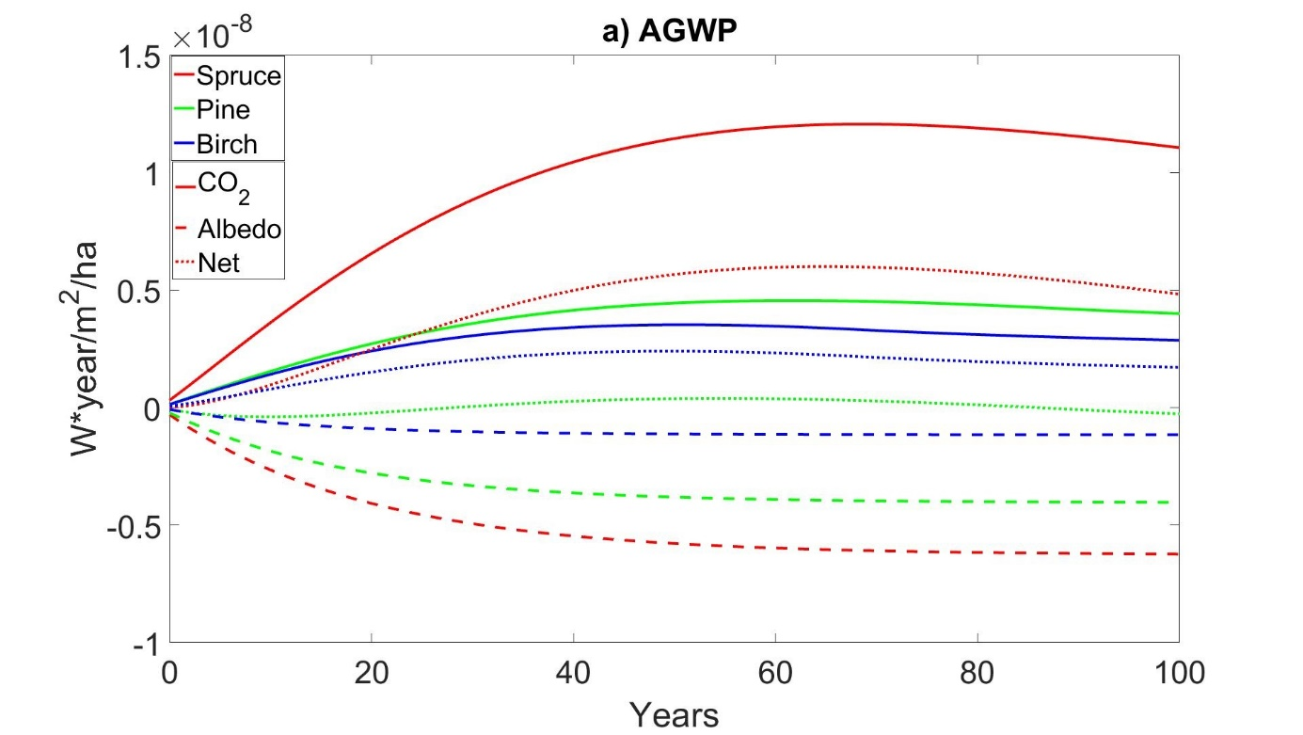
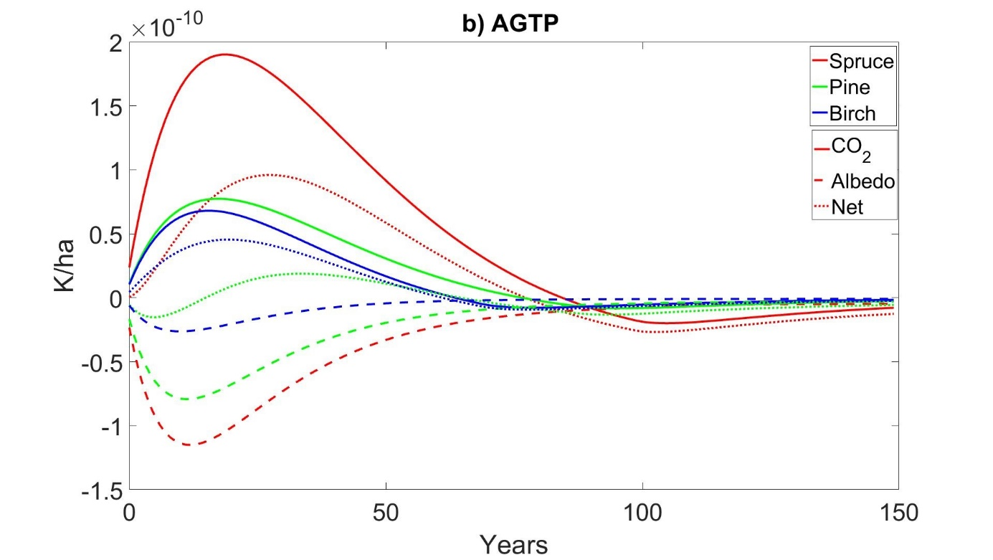
Figure 1: Absolute metrics representing the time-depending profiles of the integrated radiative forcing (AGWP) in W* year/m²/ha and the global average temperature change (AGTP) in K/ha for all three species: spruce (red), pine (green) and birch (blue) for CO₂ (solid line), albedo (dashed line) or net impact (dotted line).
In Figure 1a, the AGWP shows the evolution of the emissions based on the integrated radiative forcing. The cooling contribution from albedo is reducing the impact from CO₂ emissions. Spruce has the highest productivity and therefore impacts from carbon are larger than those from pine and birch. In addition to high emissions of CO₂ from the harvested materials, the spruce case is also affected by larger emissions from R_{h}, as forest residues are about 50% of total biomass at harvest (they are about 45% for pine and 40% for birch). For the pine plot (in green), the changes in the albedo are almost offsetting the warming effect of CO₂ emissions shortly after harvest and towards longer TH. Spruce has the largest values for albedo and CO₂ and the highest net impact both in a short and a medium-term. When comparing only the albedo profiles, birch, which is a deciduous species, has the lowest impact. As it has seasonal defoliation, the albedo change since pre-harvest time is smaller than the other species, which have a larger snow masking effect from the canopy in winter. In the case of the CO₂ emission profiles, all species present an increase during the first decades followed by a stabilization of the impacts. AGWP is an indicator based on temporal integration and therefore keeps memory of the forcing in the early years after submission. Because of the temporary essence of the carbon and albedo perturbations (carbon is sequestered again in new vegetation and a nearly carbon neutral balance is achieved over time and albedo returns to the pre-harvest level), the long-term trends of these impacts under integrative metrics tend to stabilize over time.
Figure 1b presents the AGTP profiles based on the instantaneous global average surface temperature change. In general, the dynamics of the curves for both albedo and CO₂ fluxes show large variations in the first 2-3 decades after the harvest event followed by a stabilization towards zero in longer TH. In the short-term, the coniferous species spruce and pine present strong cooling contribution from albedo, while in the case of birch, a deciduous species, the effect is rather small. Spruce has the most sustained perturbations over time. Despite the strong cooling effect of the albedo in the short-term, spruce has the largest net warming impact due to the high contribution from CO₂ fluxes. In contrast to AGWP, AGTP is not an integrative metric but an instantaneous indicator, i.e. the impact on temperature is not integrated over time. Thanks to the characteristics of this metric, it is possible to better appreciate the temporary dynamics of the impacts on surface albedo and CO₂ from forest bioenergy. Temperature change impacts achieve a maximum (or minimum, in the case of albedo) after a few years and then progressively dissipate over time as the forest re-grows. The temperature perturbation is therefore temporary and reversible within a few decades. In the long-term (after 100 years), temperature changes asymptotically tend to zero. In the time period close to the rotation period of the biomass feedstock, temperature impacts become slightly negative (cooling), and asymptotically approach zero on the negative side of the domain. This is due to complex interactions with the global carbon cycle, mainly the outgassing from the oceans that have originally absorbed excess CO₂, as observed and discussed in previous studies (Cao and Caldeira, 2010; Cherubini et al., 2011a).
Figure 2 presents the CFs (Figure 2a) and the net characterized impacts (Figure 2b) for the three selected indicators and case studies: GWP20 for a short-term, GWP100 for a medium-term and GTP100 for the long-term perspective. GWP is an integrated metric and represents the cumulative impact up to the TH considered (20 or 100 years) while GTP is an instantaneous metric which reflects the instantaneous effect at the specific TH (100 years) without taking into considerations contributions until this point in time. Because GWP100 is numerically similar to GTP40, it can be interpreted as an indicator targeting surface temperature impacts at about four decades after emissions (Allen et al., 2016). Although using the same TH, GWP100 and GTP100 thus greatly differ in terms of timescale of temperature impacts they address. In GWP100, the TH indicates the upper limit until which the radiative forcing is integrated, whereas in GTP100 it indicates the point in time in the future at which temperature impacts are measured. Similarly, GWP20 is numerically equivalent to use GTP with a TH of just a few years. It is thus possible to interpret results with the different metrics using a timescale of temperature impacts that goes from temperature impacts in the very short-term (GWP20), in the medium term (GWP100), and in the long term (GTP100).

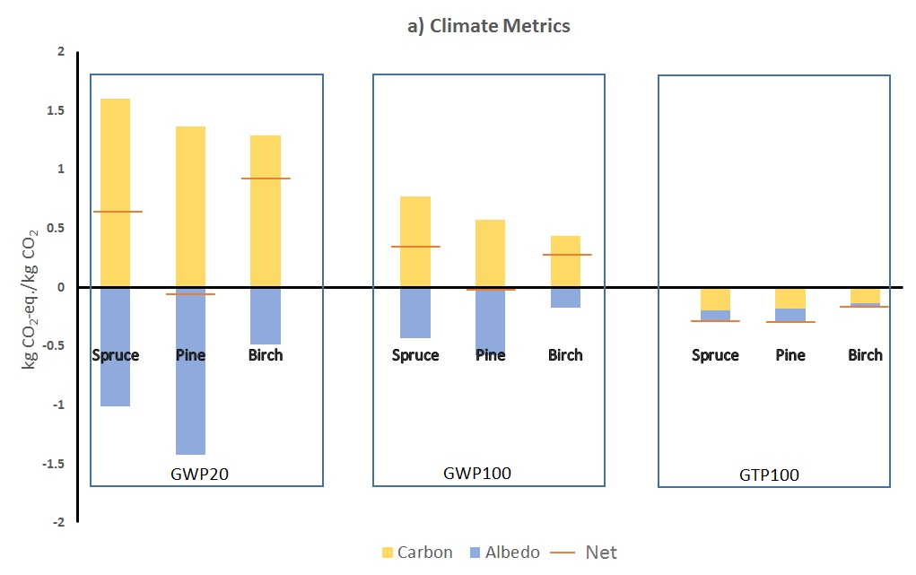
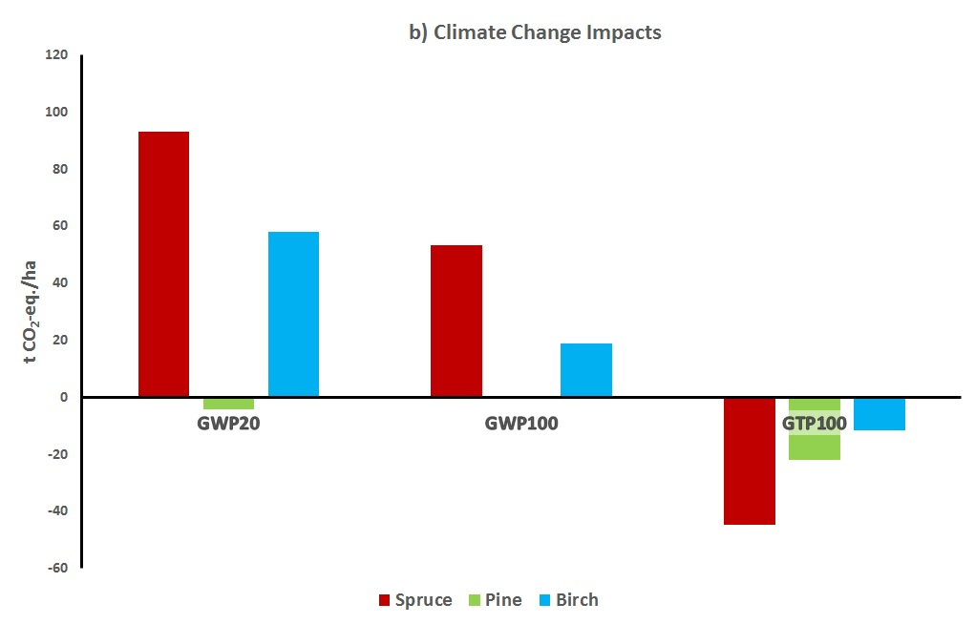
Figure 2: Climate metrics (upper panel) and net climate impacts (lower panel) for GWP20, GWP100 and GTP100 for the three tree species (spruce, pine and birch). Climate metrics are expressed in kg CO₂-eq. /kg CO₂ with a breakdown on the individual contribution of carbon and albedo and with the representation of the net impact (red line). Climate impacts are in t CO₂-eq./ha. Results for GWP100 of pine are not detectable in the lower panel because individual contributions from carbon and albedo nearly cancel out each other (see upper panel).
For GWP20, metrics for CO₂ fluxes are higher than one due to the additional emissions from the decay of the wood residues left on the forest floor. The largest value is for spruce, which has the highest fraction of forest residues at harvest (46 t C/ha), followed by pine (17 t C/ha) and birch (15 t C/ha). Post-harvest forest stands are a source of carbon for the following years after the disturbance because CO₂ emissions from Rh exceed carbon sequestration in new trees via NPP. Once the residues have decomposed and NPP increases and becomes positive, the forest ecosystem acts as a net carbon sink. The transition from carbon source to carbon sink usually occurs within the first two or three decades following stand replacement, and largely depends on the amount and decay rate of post-harvest forest residues remaining in the forest to decompose.
In the case of GTP100, the values for CO₂ emissions are negative, with the lowest for spruce. This is because the individual AGTP of the carbon responses are negative at TH = 100, as shown and discussed above. Metrics for GWP100 lie in between and follow the same trend, largest for spruce, then pine and birch. In the case of CFs for albedo, pine has the largest values across all three indicators. The net CFs (marked by the red line) indicate high positive values for short TH (GWP20), lower but still positive values for the medium term (GWP100) and negative values for the long TH (GTP100), where contributions from carbon and albedo are both negative. In the case of the pine stand, all three indicators are negative since CFs for albedo are higher than those for carbon.
Previous studies estimate GWP100 for bioenergy CO₂ emissions between 0.34 and 0.62 kg CO₂-eq./kg CO₂ for slow-growing spruce forest stands with turnover times of 100 years (Bright et al., 2012; Cherubini et al., 2012; Cherubini et al., 2011b; Guest et al., 2013d; Pingoud et al., 2012). Our result for the same species and climate indicator is higher, 0.77 kg CO₂-eq./kg CO₂. This difference can be attributed to three main reasons: i) the high forest residues ratio at harvest age (52% in our case), ii) the site-specific biomass volume harvested (219 m³/ha) and iii) the local climate conditions, which directly influence the residue decay rate. Nevertheless, our factor is closer to the ones reported by Guest et al. (2013d) for high forest residues fractions and no extraction scenario: 0.7 for 55% forest residues ratio and 0.76 for 60% forest residues fraction. Our CF for GWP20 for spruce is 1.6 kg CO₂-eq./kg CO₂, very close to the one reported by Guest et al. (2013d) for a 60% forest residue fraction, 1.58 kg CO₂-eq./kg CO_{2.}
Figure 2b shows that the net characterized impacts are very sensitive to the type of indicator. The results for GWP20 (a cumulative metric with a very short TH) are highly sensitive to the type of tree species: the spruce case causes a net warming effect, 38% bigger than the one from birch, while the net impact from pine has a cooling effect. For GWP100, the net effect from harvesting the pine stand is nearly climate neutral (-0.14 t CO₂-eq./ha) while spruce is inducing the largest warming effect, 65% higher than the one from birch. The results for GTP100 (an instantaneous indicator) are all indicating negative contributions which means that in the long-term all three harvest events are inducing a net cooling effect.
Using different metrics with different TH for characterizing climate forcing agent yields different results and sometimes even contrasting, e.g. GWP20 and GTP100 for spruce and birch. The climate perturbations following the harvest operations are larger for short TH and decrease with longer THs. This analysis underlines the importance of considering multiple and complementary indicators to better disentangle the complex temporal heterogeneities of the climate system response to land disturbances.
  - Regional and global biodiversity loss

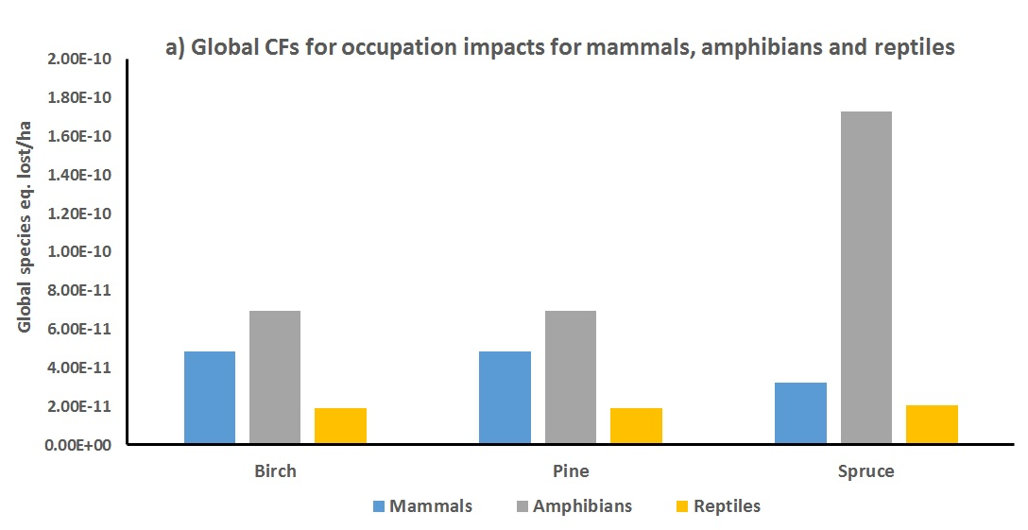
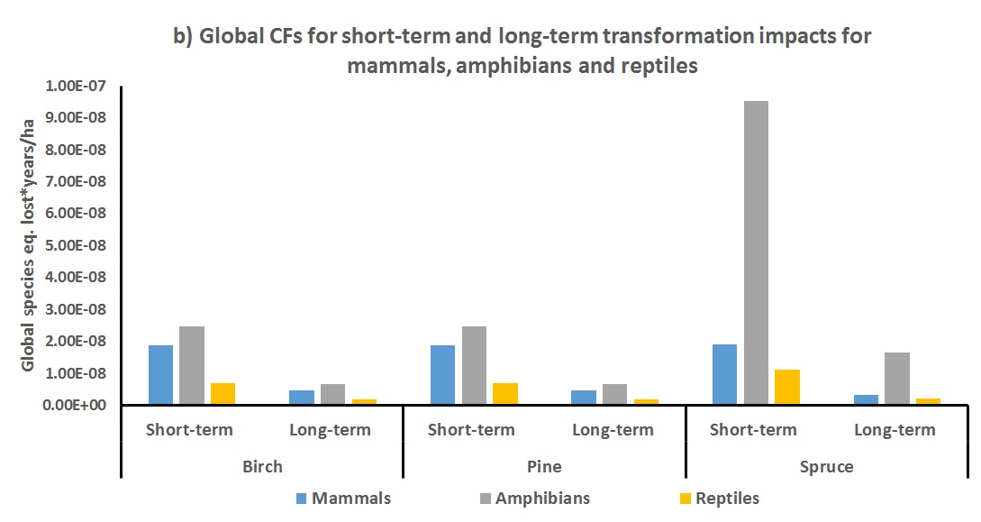
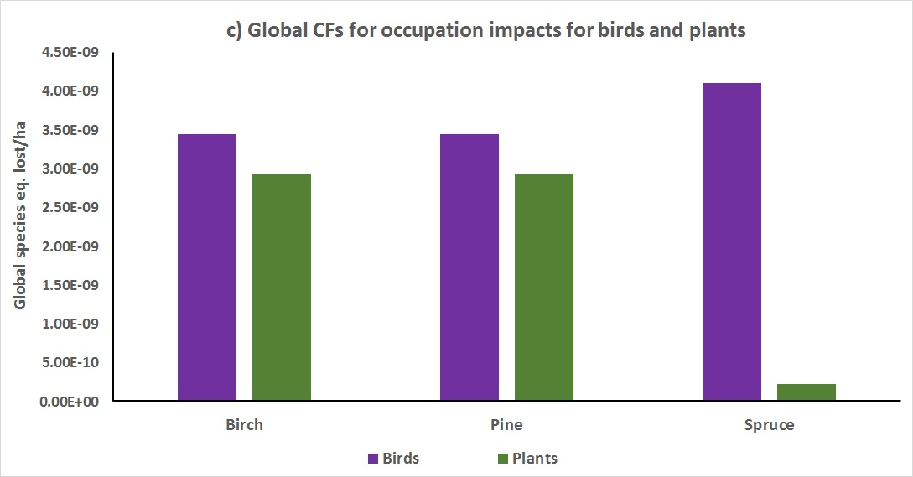
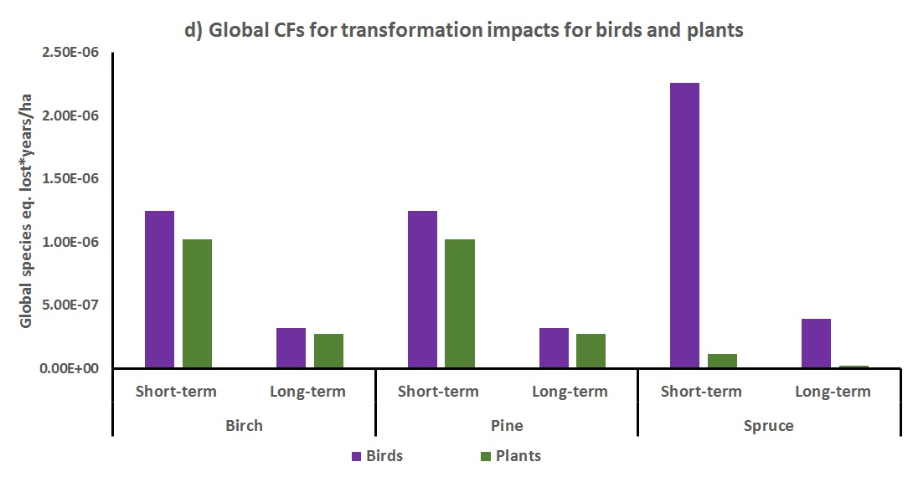

Figure 3: Global CFs for biodiversity impacts due to land use associated with the harvesting of 1 ha of forest with a breakdown on occupation, short-term transformation and long-term transformation for all three tree species (spruce, pine, birch) and all 5 taxonomic groups (mammals, birds, amphibians, reptiles, birds and plants)
Figure 3 shows the calculated global CFs for biodiversity impacts due to the land use from harvest operations. Birds are the most affected taxonomic groups across all impact types and ecoregions with the largest CF corresponding to the Scandinavian and Russian taiga ecoregion, whereas the reptiles are the least affected group. In general, our results are in line with those from Chaudhary et al. (2015), where plants and birds are identified as the most vulnerable taxa.
Figure 3a and Figure 3c show great variation among the global CFs for occupation impacts across all five taxonomic groups. The factors among the taxonomic categories differ by two orders of magnitude.
Figure 3b and Figure 3d present the global CFs for short-term and long-term transformation impacts. As expected, the long-term transformation CFs are smaller than the ones for the short-term transformation, which has a cut-off at a TH of 100 years. The long-term CF for plants in the Scandinavian and Russian taiga ecoregion is the highest one, likely because species dependent on forest cover continuity, deadwood and large trees are negatively affected by forest management (Paillet et al., 2010).
CFs for transformation impacts are in general two orders of magnitude higher than the CFs for occupation because of the regeneration times, which for boreal ecoregions are the highest among all ecoregions (Curran et al., 2014). For the ecoregions considered in our study, the regeneration times are on average 732 years for the PA1110 ecoregion and 1122 years for the PA0608 ecoregion. The difference of two orders of magnitude between the occupation and transformation impacts is similar to the average one reported by Chaudhary et al. (2015).
Bird populations are negatively affected by reduction in tree cavities for nesting and absence of leaf-litter micro fauna in the logged forest (Lammertink, 2004). In addition, since the study case plots are harvested, another reason could be that not allowing the trees to grow to sufficient sizes suitable for nesting (Chaudhary et al., 2016).
The relatively high VS of species cause the difference in regional and global CFs. Table S6 in Supplementary Information shows that the CF rankings change significantly depending upon whether regional or global species loss is considered.
The global CFs are higher for the ecoregion that is the habitat for more threatened species, namely the Scandinavian and Russian taiga ecoregion (spruce stand). This is in accordance with Henriksen and Hilmo (2015) which indicates that the number of threatened species is higher in the southeaster parts of Norway, where there is a wider variety of rare habitats. The IUCN data indicate as well that the region PA0608 (Scandinavian and Russian taiga) hosts more species than PA1110 (Scandinavian Montane Birch forest and grasslands) and that a higher number of globally threatened species have their habitat here. For example, out of 207 bird species in PA0608, 7 are threatened, while in PA1110 ecoregion, 4 out of 178 bird species are threatened (for more information see Table S1 and Table S7 from Supplementary Information).
  - Integrated framework and interpretation
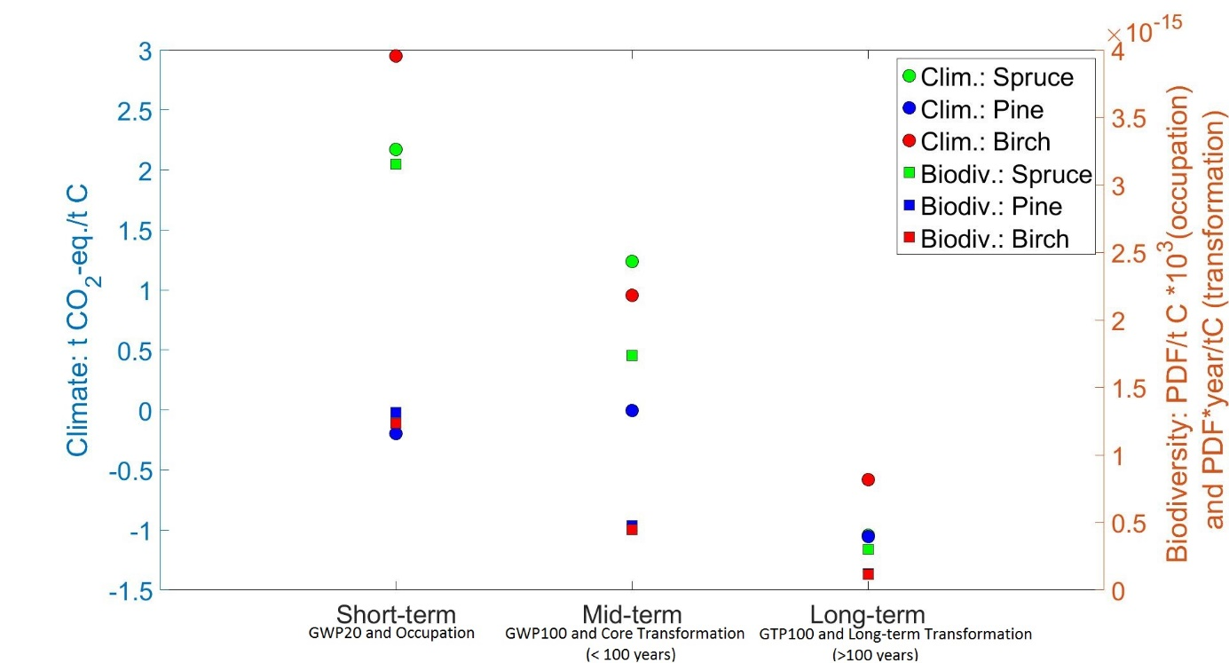

Figure 4: Biodiversity and Climate Change Impacts from harvesting one ha of managed forest grouped by different time-horizons: short-term, medium-term and long-term. Results for climate change are presented in t CO₂-eq./t C harvested and for the biodiversity loss in PDF/t C for occupation impacts and in PDF*year/t C for both core and long-term transformation impacts.
Figure 4 shows the integrated results for both biodiversity loss and climate change using three indicators for each impact category grouped in timeframes. We normalized the results for climate change and biodiversity discussed above to the tons of C harvested in the different cases. The short-term perspective indicates the impacts within the first years and groups the results for GWP20 and occupation indicators. The medium-term timeframe includes results for GWP100, which assesses temperature impacts after about 4 decades, and core transformation impacts. The long-term perspective targets the impacts on temperature at 100 years (GTP100) and on biodiversity after 100 years (long-term transformation impacts).
The general trend indicates for both biodiversity loss and climate change the highest impacts shortly after the logging operations followed by a reduction in intensity towards long-term TH. Results shows some opposing trends in impacts when analysing the individual performance of each tree species across the time perspectives. In the short-term, birch has the largest (warming) climate impact but the lowest biodiversity loss. In the mid-term, harvesting spruce leads to the biggest impacts on both climate and biodiversity. For the long-term, birch has the biggest cooling impact on the climate as well as the lowest impact on the biodiversity loss. In the short and mid-term, the impacts on both climate and biodiversity from harvesting spruce are the most relevant for both categories, which indicates a greater vulnerability of the ecoregion PA0608 in comparison with the PA1110.
In this study, we assume that the wood harvested is used entirely for bioenergy production. Carbon-based climate change impacts would differ if instead of bioenergy production, the harvested wood is used for example as a source for manufacturing material products, or a combined material and energy use. Previous studies indicate that climate change indicators such as GWP20 and GWP100 from the carbon cycle tend to decrease when wood is used as a material product with longer storage periods before being oxidized back to the atmosphere, and as a rule of thumb climate neutrality is achieved when the storage period is equal to half the rotation period (Guest et al., 2013a; Guest et al., 2013c). The wood use is only affecting the indicators for the carbon flows, and not those for biodiversity and albedo, because these impacts starts immediately after the disturbance independently of the utilization pattern of the harvested biomass.
This analysis is based on simplified scenario for the forest management: the same species which are harvested are immediately replanted. A diversification of scenarios for forest management can lead to different results regarding impacts on both climate change and biodiversity loss (Michelsen et al., 2012). Radiative forcing impacts and associated metrics are evaluated under a constant background climate and in the absence of potentially important biophysical feedbacks, as defined in (Myhre et al., 2013b). However, future changes in climate can have two contrasting effects on the emission metrics used in our study. On the one hand, carbon metrics may decrease as boreal areas experience more favourable growing conditions (Cherubini et al., 2016). At the same time, future growth in CO₂ atmospheric concentrations will increase the fraction of CO₂ remaining airborne over time because of saturation in ocean and land carbon stocks (Joos et al., 2013a), and decrease the marginal radiative efficiency of CO₂ (Andy and et al., 2011; Caldeira and Kasting, 1993). On the other hand, albedo metrics may decrease owing to expected reduced snowfall, although the majority of the climate forcing from albedo is exerted in the first couple of decades after harvest. These contrasting effects tend to compensate for each other and are found to have small influence on net results (Bright et al., 2014).
In general, our results support the need for spatially differentiated assessments given the high differences in impacts between the two ecoregions and tree species. Equally important is the temporal perspective, because results are highly sensitive to the time horizon of the selected indicator. In this work, we show that the existing set of indicators available for analysis of climate change and biodiversity impacts can provide the necessary insights to discern the spatial and temporal variability of ecosystem responses. They can also be combined in an integrated framework that allows analysts to spell out the meaning and temporal dimension of different impact categories, thereby facilitating selections of indicators that are spatially and temporally consistent. Grouping indicators for climate change and biodiversity loss according to the temporal scale of the impact is a first step in this direction, and future research, in addition to further improve the resolution and accuracy of the different indicators, can prioritize integrated assessments based on multi-dimensional perspectives. With such an integrated framework, future assessments can identify possible trade-offs between the two impact categories as well as possible win-win situations.
- Conclusions
In this study, we explore the possibility to integrate environmental impact assessment of forest disturbances in terms of both climate change and biodiversity loss impacts. We provide results for changes in atmospheric CO₂ concentration, surface albedo, regional and global potentially disappeared fraction. We analyse the trends in the results from a time perspective: very short (GWP20 and land occupation), medium (GWP100 and land core transformation) and long (GTP100 and land transformation after 100 years) term. The climate performance is highly dependent on biomass species, local climate variables, TH and the climate metric considered, whereas taxonomic group and TH affect biodiversity impacts. Impacts on both climate change and biodiversity are higher for short TH, and tend to decrease over time. The metric choice can have a large influence on the results.
The impacts calculated for biodiversity are based on current state-of-the-art models. However, uncertainty in these models is still large, for example due to a lack of data availability and non-uniform distribution of data. We therefore support the conclusion of Chaudhary et al. (2015) that the CFs should be regularly updated, as more information (e.g. on sensitivities to different land use types) becomes available.
Our results reinforce the notion that spatially and temporally explicit analysis are vital when assessing life-cycle impacts from land derived products. We conclude that integrated impacts on biodiversity and climate change should be more thoroughly included in the environmental assessments, and interpreted in ways that are spatially and temporally consistent with the meaning of the indicator. Indicators for both climate change and biodiversity impacts are available to serve this purpose, and inform about possible dependencies of the results on biomass species, geographical locations, temporal boundaries and metrics.
Acknowledgments
Authors acknowledge the Norwegian Research Council for funding this work with the Ecoservice (233641) and Bio4Clim (244074) projects.
References
Allen, M.R., Fuglestvedt, J.S., Shine, K.P., Reisinger, A., Pierrehumbert, R.T., Forster, P.M. (2016) New use of global warming potentials to compare cumulative and short-lived climate pollutants. Nature Clim. Change 6, 773-776.
Andy, R., et al. (2011) Future changes in global warming potentials under representative concentration pathways. Environmental Research Letters 6, 024020.
Arneth, A., Harrison, S.P., Zaehle, S., Tsigaridis, K., Menon, S., Bartlein, P.J., Feichter, J., Korhola, A., Kulmala, M., O'donnell, D. (2010) Terrestrial biogeochemical feedbacks in the climate system. Nature Geoscience 3, 525.
Arora, V.K., Montenegro, A. (2011) Small temperature benefits provided by realistic afforestation efforts. Nature Geoscience 4, 514-518.
Bala, G., Caldeira, K., Wickett, M., Phillips, T., Lobell, D., Delire, C., Mirin, A. (2007) Combined climate and carbon-cycle effects of large-scale deforestation. Proceedings of the National Academy of Sciences 104, 6550-6555.
Berg, Å., Ehnström, B., Gustafsson, L., Hallingbäck, T., Jonsell, M., Weslien, J. (1994) Threatened plant, animal, and fungus species in Swedish forests: distribution and habitat associations. Conservation biology 8, 718-731.
Betts, R.A. (2011) Mitigation: A sweetener for biofuels. Nature Clim. Change 1, 99-101.
Bicknell, J., Peres, C.A. (2010) Vertebrate population responses to reduced-impact logging in a neotropical forest. Forest Ecology and Management 259, 2267-2275.
Bonan, G.B. (2008) Forests and Climate Change: Forcings, Feedbacks, and the Climate Benefits of Forests. Science 320, 1444-1449.
Boucher, O., Reddy, M. (2008) Climate trade-off between black carbon and carbon dioxide emissions. Energy Policy 36, 193-200.
Bright, R.M., Antón-Fernández, C., Astrup, R., Cherubini, F., Kvalevåg, M.M., Strømman, A.H. (2014) Climate change implications of shifting forest management strategy in a boreal forest ecosystem of Norway. Global Change Biology 20, 607-621.
Bright, R.M., Cherubini, F., Strømman, A.H. (2012) Climate impacts of bioenergy: inclusion of carbon cycle and albedo dynamics in life cycle impact assessment. Environmental Impact Assessment Review 37, 2-11.
Bright, R.M., Kvalevåg, M.M. (2013) Technical Note: Evaluating a simple parameterization of radiative shortwave forcing from surface albedo change. Atmospheric Chemistry and Physics 13, 11169-11174.
Bright, R.M., Strømman, A.H., Peters, G.P. (2011) Radiative forcing impacts of boreal forest biofuels: a scenario study for Norway in light of albedo. Environmental science & technology 45, 7570-7580.
Bruckner, T., Bashmakov, I., Mulugetta, Y., Chum, H., De la Vega Navarro, A., Edmonds, J., Faaij, A., Fungtammasan, B., Garg, A., Hertwich, E., (2014) Energy systems, in: O. Edenhofer, e.a. (Ed.), Working Group III contribution to the IPCC 5th Assessment Report "Climate Change 2014: Mitigation of Climate Change". Intergovernmental panel on climate change (IPCC), Genevea.
Burivalova, Z., Lee, T.M., Giam, X., Şekercioğlu, Ç.H., Wilcove, D.S., Koh, L.P., (2015) Avian responses to selective logging shaped by species traits and logging practices, Proc. R. Soc. B. The Royal Society, p. 20150164.
Caiazzo, F., Malina, R., Staples, M.D., Wolfe, P.J., Yim, S.H., Barrett, S.R. (2014) Quantifying the climate impacts of albedo changes due to biofuel production: a comparison with biogeochemical effects. Environmental Research Letters 9, 024015.
Caldeira, K., Kasting, J.F. (1993) Insensitivity of global warming potentials to carbon dioxide emission scenarios. Nature 366, 251-253.
Cao, L., Caldeira, K. (2010) Atmospheric carbon dioxide removal: long-term consequences and commitment. Environmental Research Letters 5, 024011.
Cardinale, B.J., Duffy, J.E., Gonzalez, A., Hooper, D.U., Perrings, C., Venail, P., Narwani, A., Mace, G.M., Tilman, D., Wardle, D.A. (2012) Biodiversity loss and its impact on humanity. Nature 486, 59-67.
Carslaw, K., Lee, L., Reddington, C., Pringle, K., Rap, A., Forster, P., Mann, G., Spracklen, D., Woodhouse, M., Regayre, L. (2013) Large contribution of natural aerosols to uncertainty in indirect forcing. Nature 503, 67.
Caspersen, J.P., Pacala, S.W., Jenkins, J.C., Hurtt, G.C., Moorcroft, P.R., Birdsey, R.A. (2000) Contributions of land-use history to carbon accumulation in US forests. Science 290, 1148-1151.
Chaudhary, A., Burivalova, Z., Koh, L.P., Hellweg, S. (2016) Impact of Forest Management on Species Richness: Global Meta-Analysis and Economic Trade-Offs. Scientific reports 6.
Chaudhary, A., Verones, F., de Baan, L., Hellweg, S. (2015) Quantifying land use impacts on biodiversity: combining species–area models and vulnerability indicators. Environmental science & technology 49, 9987-9995.
Cherubini, F., Bright, R.M., Strømman, A.H. (2012) Site-specific global warming potentials of biogenic CO2 for bioenergy: contributions from carbon fluxes and albedo dynamics. Environmental Research Letters 7, 045902.
Cherubini, F., Huijbregts, M., Kindermann, G., Van Zelm, R., Van Der Velde, M., Stadler, K., Strømman, A.H. (2016) Global spatially explicit CO(2) emission metrics for forest bioenergy. Scientific reports 6, 20186.
Cherubini, F., Peters, G.P., Berntsen, T., STRØMMAN, A.H., Hertwich, E. (2011a) CO2 emissions from biomass combustion for bioenergy: atmospheric decay and contribution to global warming. GCB Bioenergy 3, 413-426.
Cherubini, F., Strømman, A.H., Hertwich, E. (2011b) Effects of boreal forest management practices on the climate impact of CO2 emissions from bioenergy. Ecological Modelling 223, 59-66.
Cherubini, F., Vezhapparambu, S., Bogren, W., Astrup, R., Strømman, A.H. (2017) Spatial, seasonal, and topographical patterns of surface albedo in Norwegian forests and cropland. International Journal of Remote Sensing 38, 4565-4586.
Cornwall, W. (2017) The burning question. Science 355, 18-21.
Curran, M., Hellweg, S., Beck, J. (2014) Is there any empirical support for biodiversity offset policy? Ecological Applications 24, 617-632.
Davin, E.L., de Noblet-Ducoudré, N. (2010) Climatic impact of global-scale deforestation: radiative versus nonradiative processes. Journal of Climate 23, 97-112.
De Baan, L., Alkemade, R., Koellner, T. (2013) Land use impacts on biodiversity in LCA: a global approach. The International Journal of Life Cycle Assessment 18, 1216-1230.
de Wit, H.A., Palosuo, T., Hylen, G., Liski, J. (2006) A carbon budget of forest biomass and soils in southeast Norway calculated using a widely applicable method. Forest Ecology and Management 225, 15-26.
Frischknecht, R., Fantke, P., Tschümperlin, L., Niero, M., Antón, A., Bare, J., Boulay, A.-M., Cherubini, F., Hauschild, M.Z., Henderson, A. (2016) Global guidance on environmental life cycle impact assessment indicators: progress and case study. Volume 1. The International Journal of Life Cycle Assessment 21, 429-442.
Frischknecht, R., Jolliet, O.e. (2017) Global guidance on environmental life cycle impact assessment indicators. Volume 1. United Nations Environmental Programme Paris.
Gjertsen, A., Nilsen, J. (2012) Rapport fra Skog og landskap, SAT-SKOG Et skogkart basert på tolkning av satelittbider. Ås: Skog og landskap.
Guest, G., Bright, R.M., Cherubini, F., Strømman, A.H. (2013a) Consistent quantification of climate impacts due to biogenic carbon storage across a range of bio-product systems. Environmental Impact Assessment Review 43, 21-30.
Guest, G., Cherubini, F., Strømman, A.H. (2013b) Climate impact potential of utilizing forest residues for bioenergy in Norway. Mitigation and Adaptation Strategies for Global Change 18, 1089-1108.
Guest, G., Cherubini, F., Strømman, A.H. (2013c) Global Warming Potential of Carbon Dioxide Emissions from Biomass Stored in the Anthroposphere and Used for Bioenergy at End of Life. Journal of Industrial Ecology 17, 20-30.
Guest, G., Cherubini, F., Strømman, A.H. (2013d) The role of forest residues in the accounting for the global warming potential of bioenergy. GCB Bioenergy 5, 459-466.
Hautier, Y., Tilman, D., Isbell, F., Seabloom, E.W., Borer, E.T., Reich, P.B. (2015) Anthropogenic environmental changes affect ecosystem stability via biodiversity. Science 348, 336-340.
Hellweg, S., i Canals, L.M. (2014) Emerging approaches, challenges and opportunities in life cycle assessment. Science 344, 1109-1113.
Henriksen, S., Hilmo, O., (2015) Norsk rødliste for arter 2015, Artsdatabanken, Norge.
Hijmans, R.J., Cameron, S.E., Parra, J.L., Jones, P.G., Jarvis, A. (2005) Very high resolution interpolated climate surfaces for global land areas. International journal of climatology 25, 1965-1978.
Ilomäki, S., Nikinmaa, E., Mäkelä, A. (2003) Crown rise due to competition drives biomass allocation in silver birch. Canadian Journal of Forest Research 33, 2395-2404.
IPCC, (2014) Climate Change 2014: Synthesis Report. Contribution of Working Groups I, II and III to the Fifth Assessment Report of the Intergovernmental Panel on Climate Change [Core Writing Team, R.K. Pachauri and L.A. Meyer (eds.)]. IPCC, Geneva, Switzerland, 151 pp.
Isbell, F., Craven, D., Connolly, J., Loreau, M., Schmid, B., Beierkuhnlein, C., Bezemer, T.M., Bonin, C., Bruelheide, H., De Luca, E. (2015) Biodiversity increases the resistance of ecosystem productivity to climate extremes. Nature 526, 574-577.
IUCN, I.U.f.C.o.N.a.N.R., (2017) Spatial Data Download, http://www.iucnredlist.org/technical-documents/spatial-data.
Jackson, R.B., Randerson, J.T., Canadell, J.G., Anderson, R.G., Avissar, R., Baldocchi, D.D., Bonan, G.B., Caldeira, K., Diffenbaugh, N.S., Field, C.B. (2008) Protecting climate with forests. Environmental Research Letters 3, 044006.
Joos, F., Roth, R., Fuglestvedt, J.S., Peters, G.P., Enting, I.G., von Bloh, W., Brovkin, V., Burke, E.J., Eby, M., Edwards, N.R., Friedrich, T., Frölicher, T.L., Halloran, P.R., Holden, P.B., Jones, C., Kleinen, T., Mackenzie, F.T., Matsumoto, K., Meinshausen, M., Plattner, G.K., Reisinger, A., Segschneider, J., Shaffer, G., Steinacher, M., Strassmann, K., Tanaka, K., Timmermann, A., Weaver, A.J. (2013a) Carbon dioxide and climate impulse response functions for the computation of greenhouse gas metrics: a multi-model analysis. Atmos. Chem. Phys. 13, 2793-2825.
Joos, F., Roth, R., Fuglestvedt, J.S., Peters, G.P., Enting, I.G., von Bloh, W., Brovkin, V., Burke, E.J., Eby, M., Edwards, N.R., Friedrich, T., Frölicher, T.L., Halloran, P.R., Holden, P.B., Jones, C., Kleinen, T., Mackenzie, F.T., Matsumoto, K., Meinshausen, M., Plattner, G.K., Reisinger, A., Segschneider, J., Shaffer, G., Steinacher, M., Strassmann, K., Tanaka, K., Timmermann, A., Weaver, A.J. (2013b) Carbon dioxide and climate impulse response functions for the computation of greenhouse gas metrics: a multi-model analysis. Atmospheric Chemistry and Physics 13, 2793-2825.
Jørgensen, S.V., Cherubini, F., Michelsen, O. (2014) Biogenic CO 2 fluxes, changes in surface albedo and biodiversity impacts from establishment of a miscanthus plantation. Journal of Environmental Management 146, 346-354.
Knutti, R., Hegerl, G.C. (2008) The equilibrium sensitivity of the Earth's temperature to radiation changes. Nature Geosci 1, 735-743.
Koellner, T., de Baan, L., Beck, T., Brandão, M., Civit, B., Margni, M., i Canals, L.M., Saad, R., de Souza, D.M., Müller-Wenk, R. (2013) UNEP-SETAC guideline on global land use impact assessment on biodiversity and ecosystem services in LCA. The International Journal of Life Cycle Assessment 18, 1188-1202.
Lammertink, M. (2004) A Multiple‐Site Comparison of Woodpecker Communities in Bornean Lowland and Hill Forests. Conservation biology 18, 746-757.
Lee, X., Goulden, M.L., Hollinger, D.Y., Barr, A., Black, T.A., Bohrer, G., Bracho, R., Drake, B., Goldstein, A., Gu, L. (2011) Observed increase in local cooling effect of deforestation at higher latitudes. Nature 479, 384-387.
Lehtonen, A., Mäkipää, R., Heikkinen, J., Sievänen, R., Liski, J. (2004) Biomass expansion factors (BEFs) for Scots pine, Norway spruce and birch according to stand age for boreal forests. Forest Ecology and Management 188, 211-224.
Lenton, T.M., Vaughan, N.E. (2009) The radiative forcing potential of different climate geoengineering options. Atmospheric Chemistry and Physics 9, 5539-5561.
Levasseur, A., De Schryver, A., Hauschild, M., Kabe, Y., Sahnoune, A., Tanaka, K., Cherubini, F., (2017) Chapter 3: Greenhouse gas emissions and climate change impacts in: Frischknecht, R., Jolliet, O. (Eds.), Global Guidance for Life Cycle Impact Assessment Indicators. Volume 1. UNEP/SETAC Life Cycle Initiative Paris pp. 59-75.
Liang, J., Crowther, T.W., Picard, N., Wiser, S., Zhou, M., Alberti, G., Schulze, E.-D., McGuire, A.D., Bozzato, F., Pretzsch, H., de-Miguel, S., Paquette, A., Hérault, B., Scherer-Lorenzen, M., Barrett, C.B., Glick, H.B., Hengeveld, G.M., Nabuurs, G.-J., Pfautsch, S., Viana, H., Vibrans, A.C., Ammer, C., Schall, P., Verbyla, D., Tchebakova, N., Fischer, M., Watson, J.V., Chen, H.Y.H., Lei, X., Schelhaas, M.-J., Lu, H., Gianelle, D., Parfenova, E.I., Salas, C., Lee, E., Lee, B., Kim, H.S., Bruelheide, H., Coomes, D.A., Piotto, D., Sunderland, T., Schmid, B., Gourlet-Fleury, S., Sonké, B., Tavani, R., Zhu, J., Brandl, S., Vayreda, J., Kitahara, F., Searle, E.B., Neldner, V.J., Ngugi, M.R., Baraloto, C., Frizzera, L., Bałazy, R., Oleksyn, J., Zawiła-Niedźwiecki, T., Bouriaud, O., Bussotti, F., Finér, L., Jaroszewicz, B., Jucker, T., Valladares, F., Jagodzinski, A.M., Peri, P.L., Gonmadje, C., Marthy, W., O’Brien, T., Martin, E.H., Marshall, A.R., Rovero, F., Bitariho, R., Niklaus, P.A., Alvarez-Loayza, P., Chamuya, N., Valencia, R., Mortier, F., Wortel, V., Engone-Obiang, N.L., Ferreira, L.V., Odeke, D.E., Vasquez, R.M., Lewis, S.L., Reich, P.B. (2016) Positive biodiversity-productivity relationship predominant in global forests. Science 354.
Liu, S., Bond‐Lamberty, B., Hicke, J.A., Vargas, R., Zhao, S., Chen, J., Edburg, S.L., Hu, Y., Liu, J., McGuire, A.D. (2011) Simulating the impacts of disturbances on forest carbon cycling in North America: Processes, data, models, and challenges. Journal of Geophysical Research: Biogeosciences 116.
Lohila, A., Minkkinen, K., Laine, J., Savolainen, I., Tuovinen, J.P., Korhonen, L., Laurila, T., Tietäväinen, H., Laaksonen, A. (2010) Forestation of boreal peatlands: Impacts of changing albedo and greenhouse gas fluxes on radiative forcing. Journal of Geophysical Research: Biogeosciences 115.
Luyssaert, S., Jammet, M., Stoy, P.C., Estel, S., Pongratz, J., Ceschia, E., Churkina, G., Don, A., Erb, K., Ferlicoq, M. (2014) Land management and land-cover change have impacts of similar magnitude on surface temperature. Nature Climate Change 4, 389-393.
Melillo, J.M., McGuire, A.D., Kicklighter, D.W., Moore, B., Vorosmarty, C.J., Schloss, A.L. (1993) Global climate change and terrestrial net primary production. Nature 363, 234-240.
Michelsen, O. (2008) Assessment of land use impact on biodiversity. The International Journal of Life Cycle Assessment 13, 22-31.
Michelsen, O., Cherubini, F., Strømman, A.H. (2012) Impact assessment of biodiversity and carbon pools from land use and land use changes in life cycle assessment, exemplified with forestry operations in Norway. Journal of Industrial Ecology 16, 231-242.
Milà i Canals, L., Antón, A., Bauer, A., de Camillis, C., Knuchel, R.F., Grant, T., Michelsen, O., Stevenson, M., (2016) Chapter 6: Land use related impacts on biodiversity [TF 5 Land use], in: Frischknecht, R., Jolliet, O. (Eds.), Global Guidance for Life Cycle Impact Assessment Indicators pp. 126-143.
Millennium Ecosystem Assessment (2005) Millennium ecosystem assessment. Ecosystems and human wellbeing: a framework for assessment Washington, DC: Island Press.
Muñoz, I., Campra, P., Fernández-Alba, A.R. (2010) Including CO2-emission equivalence of changes in land surface albedo in life cycle assessment. Methodology and case study on greenhouse agriculture. The International Journal of Life Cycle Assessment 15, 672-681.
Myhre, G., Highwood, E.J., Shine, K.P., Stordal, F. (1998) New estimates of radiative forcing due to well mixed greenhouse gases. Geophysical research letters 25, 2715-2718.
Myhre, G., Shindell, D., Bréon, F.-M., Collins, W., Fuglestvedt, J., Huang, J., Koch, D., Lamarque, J.-F., Lee, D., Mendoza, B., Nakajima, T., Robock, A., Stephens, G., Takemura, T., Zhang, H., (2013a) Anthropogenic and Natural Radiative Forcing, Climate change 2013: The Physical Science Basis. Contribution of Working Group I to the Fifth Assessment Report of the Intergovernmental Panel on Climate Change (eds. Stocker, T.F. et al.) Ch. 8, 659–740, Cambridge University Press, Cambridge, United Kingdom and New York, NY, USA.
Myhre, G., Shindell, D., Bréon, F.-M., Collins, W., Fuglestvedt, J., Huang, J., Koch, D., Lamarque, J.-F., Lee, D., Mendoza, B., Nakajima, T., Robock, A., Stephens, G., Takemura, T., Zhang, H., (2013b) Anthropogenic and Natural Radiative Forcing, in: Stocker, T.F., Qin, D., Plattner, G.-K., Tignor, M., Allen, S.K., Boschung, J., Nauels, A., Xia, Y., Bex, V., Midgley, P.M. (Eds.), Climate Change 2013: The Physical Science Basis. Contribution of Working Group I to the Fifth Assessment Report of the Intergovernmental Panel on Climate Change. Cambridge University Press, Cambridge, United Kingdom and New York, NY, USA, pp. 659–740.
Naeem, S., Li, S. (1997) Biodiversity enhances ecosystem reliability. Nature 390, 507-509.
NASA, (2013) Langley Research Center. Prediction of Worldwide Energy Resource (POWER).
Newbold, T., Hudson, L.N., Arnell, A.P., Contu, S., De Palma, A., Ferrier, S., Hill, S.L.L., Hoskins, A.J., Lysenko, I., Phillips, H.R.P., Burton, V.J., Chng, C.W.T., Emerson, S., Gao, D., Pask-Hale, G., Hutton, J., Jung, M., Sanchez-Ortiz, K., Simmons, B.I., Whitmee, S., Zhang, H., Scharlemann, J.P.W., Purvis, A. (2016) Has land use pushed terrestrial biodiversity beyond the planetary boundary? A global assessment. Science 353, 288-291.
Olson, D.M., Dinerstein, E., Wikramanayake, E.D., Burgess, N.D., Powell, G.V., Underwood, E.C., D'amico, J.A., Itoua, I., Strand, H.E., Morrison, J.C. (2001) Terrestrial Ecoregions of the World: A New Map of Life on Earth: A new global map of terrestrial ecoregions provides an innovative tool for conserving biodiversity. BioScience 51, 933-938.
Paillet, Y., Bergès, L., Hjältén, J., Ódor, P., Avon, C., BERNHARDT‐RÖMERMANN, M., BIJLSMA, R.J., De Bruyn, L., Fuhr, M., Grandin, U. (2010) Biodiversity differences between managed and unmanaged forests: meta‐analysis of species richness in Europe. Conservation biology 24, 101-112.
Pingoud, K., Ekholm, T., Savolainen, I. (2012) Global warming potential factors and warming payback time as climate indicators of forest biomass use. Mitigation and Adaptation Strategies for Global Change 17, 369-386.
Rudolphi, J., Gustafsson, L. (2011) Forests regenerating after clear-cutting function as habitat for bryophyte and lichen species of conservation concern. PLoS One 6, e18639.
Schaaf, C.B., Gao, F., Strahler, A.H., Lucht, W., Li, X., Tsang, T., Strugnell, N.C., Zhang, X., Jin, Y., Muller, J.-P. (2002) First operational BRDF, albedo nadir reflectance products from MODIS. Remote sensing of Environment 83, 135-148.
Schimel, D.S., House, J.I., Hibbard, K.A., Bousquet, P., Ciais, P., Peylin, P., Braswell, B.H., Apps, M.J., Baker, D., Bondeau, A. (2001) Recent patterns and mechanisms of carbon exchange by terrestrial ecosystems. Nature 414, 169-172.
Schnute, J. (1981) A versatile growth model with statistically stable parameters. Canadian Journal of Fisheries and Aquatic Sciences 38, 1128-1140.
Shine, K.P., Fuglestvedt, J.S., Hailemariam, K., Stuber, N. (2005) Alternatives to the global warming potential for comparing climate impacts of emissions of greenhouse gases. Climatic Change 68, 281-302.
Smith, P., Bustamante, M., Ahammad, H., Clark, H., Dong, H., Elsiddig, E.A., Haberl, H., Harper, R., House, J., Jafari, M., Masera, O., Mbow, C., Ravindranath, N.H., Rice, C.W., Abad, C.R., Romanovskaya, A., Sperling, F., Tubie, F., (2014) Agriculture, Forestry and Other Land Use (AFOLU), Climate Change 2014: Mitigation of Climate Change. Contribution of Working Group III to the Fifth Assessment Report of the Intergovernmental Panel on Climate Change (eds. Edenhofer, O. et al.) Ch. 11, 811–922, Cambridge University Press, Cambridge, United Kingdom and New York, NY, USA.
Statistics Norway, (2016) The National Forest Inventory 2011-2015 - Commercial roundwood removals by species of tree, Oslo.
Stenbacka, F., Hjältén, J., Hilszczański, J., Dynesius, M. (2010) Saproxylic and non‐saproxylic beetle assemblages in boreal spruce forests of different age and forestry intensity. Ecological Applications 20, 2310-2321.
Stocker, T., Qin, D., Plattner, G., Tignor, M., Allen, S., Boschung, J., Nauels, A., Xia, Y., Bex, V., Midgley, P., (2013) IPCC, 2013: summary for policymakers in climate change 2013: the physical science basis, contribution of working group I to the fifth assessment report of the intergovernmental panel on climate change. Cambridge University Press, Cambridge, New York, USA.
Teixeira, R.F.M., Maia de Souza, D., Curran, M.P., Antón, A., Michelsen, O., Milà i Canals, L. (2016) Towards consensus on land use impacts on biodiversity in LCA: UNEP/SETAC Life Cycle Initiative preliminary recommendations based on expert contributions. Journal of Cleaner Production 112, Part 5, 4283-4287.
Tomter, S.M., et al., (2010) Development of Norway's National Forest Inventory, in: Tomppo, E., Gschwantner, T., Lawrence, M., McRoberts, R.E., Gabler, K., Schadauer, K., Vidal, C., Lanz, A., Ståhl, G., Cienciala, E. (Eds.), National forest inventories. Pathways for Common Reporting. European Science Foundation, Heidelberg, Springer: 411-424, pp. 541-553.
Tuomi, M., Rasinmäki, J., Repo, A., Vanhala, P., Liski, J. (2011) Soil carbon model Yasso07 graphical user interface. Environmental Modelling & Software 26, 1358-1362.
Unger, N. (2014) Human land-use-driven reduction of forest volatiles cools global climate. Nature Climate Change 4, 907-910.
Vanden Broucke, S., Luyssaert, S., Davin, E.L., Janssens, I., Lipzig, N. (2015) New insights in the capability of climate models to simulate the impact of LUC based on temperature decomposition of paired site observations. Journal of Geophysical Research: Atmospheres 120, 5417-5436.
Verones, F., Hellweg, S., Azevedo, L.B., Chaudhary, A., Cosme, N., Fantke, P., Goedkoop, M., Hauschild, M., Laurent, A., Mutel, C., Pfister, S., Ponsioen, T., Steinmann, Z., Van Zelm, R., Vieira, M., Huijbregts, M., (2016) LC-IMPACT Version 0.5- A spatially differentiated life cycle impact assessment approach http://www.lc-impact.eu/, pp. 1-10.
Widenfalk, O., Weslien, J. (2009) Plant species richness in managed boreal forests—effects of stand succession and thinning. Forest Ecology and Management 257, 1386-1394.
Wildfinder, W., (2006) World Wildlife Fund WildFinder: Online database of species distributions, version January 2006, http://www.worldwildlife.org/.
Zhao, K., Jackson, R.B. (2014) Biophysical forcings of land-use changes from potential forestry activities in North America. Ecological Monographs 84, 329-353.
Zhao, S., Liu, S., Li, Z., Sohl, T. (2009) Ignoring detailed fast-changing dynamics of land use overestimates regional terrestrial carbon sequestration. Biogeosciences 6, 1647-1654.

