Supplementary materials

Effect of (111)-oriented strain on the structure and magnetic properties of La_{2/3}Sr_{1/3}MnO₃ thin films

T. Bolstad, ¹ E. Lysne,¹ I. Hallsteinsen,^{1,2} E. Arenholz,² U. L. Österberg,¹ and T. Tybell¹
1) Department of Electronic Systems, NTNU Norwegian University of Science and Technology, 7491 Trondheim, Norway
2) Advanced Light Source, Lawrence Berkeley National Laboratory, Berkeley, California 94720, USA

X-ray magnetic circular dichroism
Element specific x-ray magnetic circular dichroism (XMCD) spectroscopy was done at beamline 4.0.2 at the Advanced Light Source (ALS). The XMCD spectra were measured in total-electron-yield mode by monitoring the sample drain current. The x-rays were incident at 30° to the sample surface. The hysteresis measurements were performed by a sweeping field, using an eight-pole electromagnet, between ±0.3 T parallel to the x-ray beam, and probing at element specific dichroism from the two circular polarizations.

Figure S1 and S2 shows hysteresis curves acquired from XMCD measurements for La_{0.7}Sr_{0.3}MnO₃ (LSMO) on NdGaO₃ (NGO) and DyScO₃ (DSO), respectively, which are consistent with the other magnetic measurements presented.

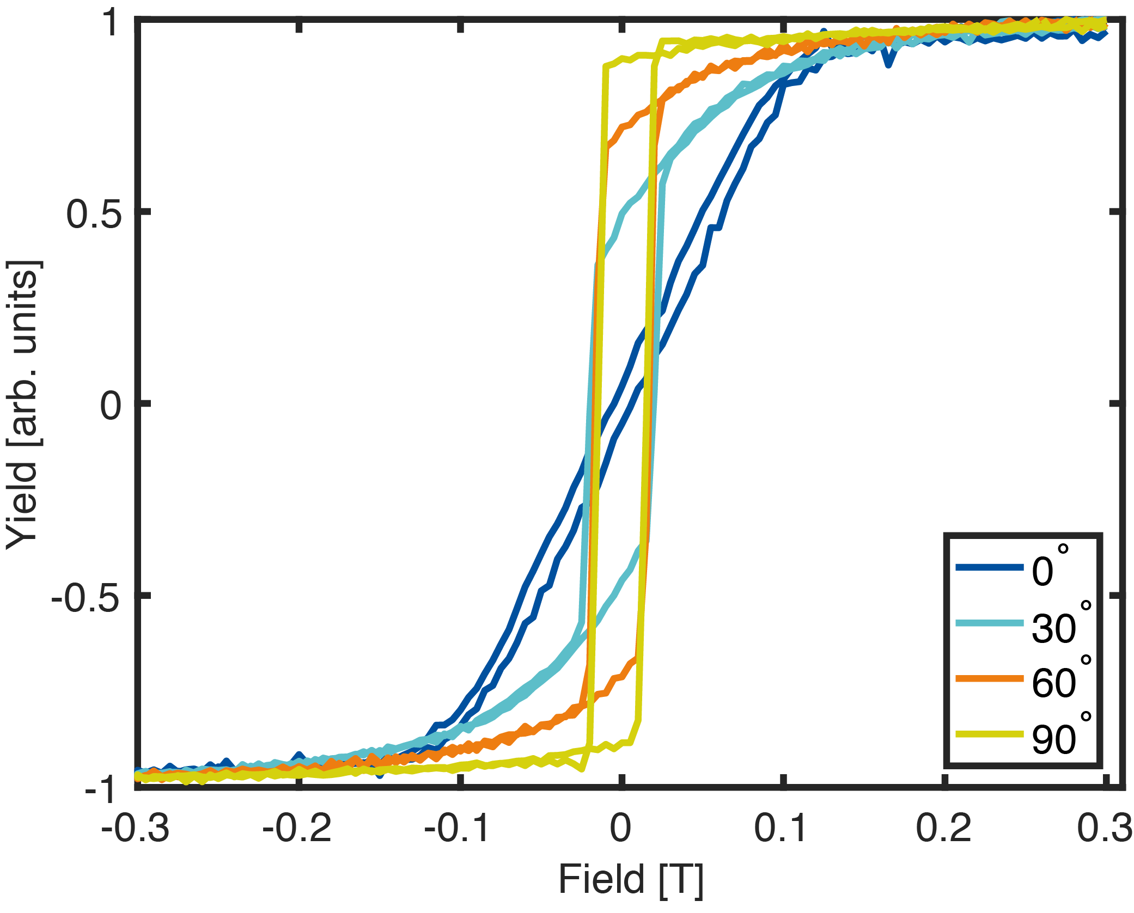
Figure S1: Magnetization data for LSMO on NGO obtained by XMCD. $0°$ corresponds to the [100]_{o} lattice direction.
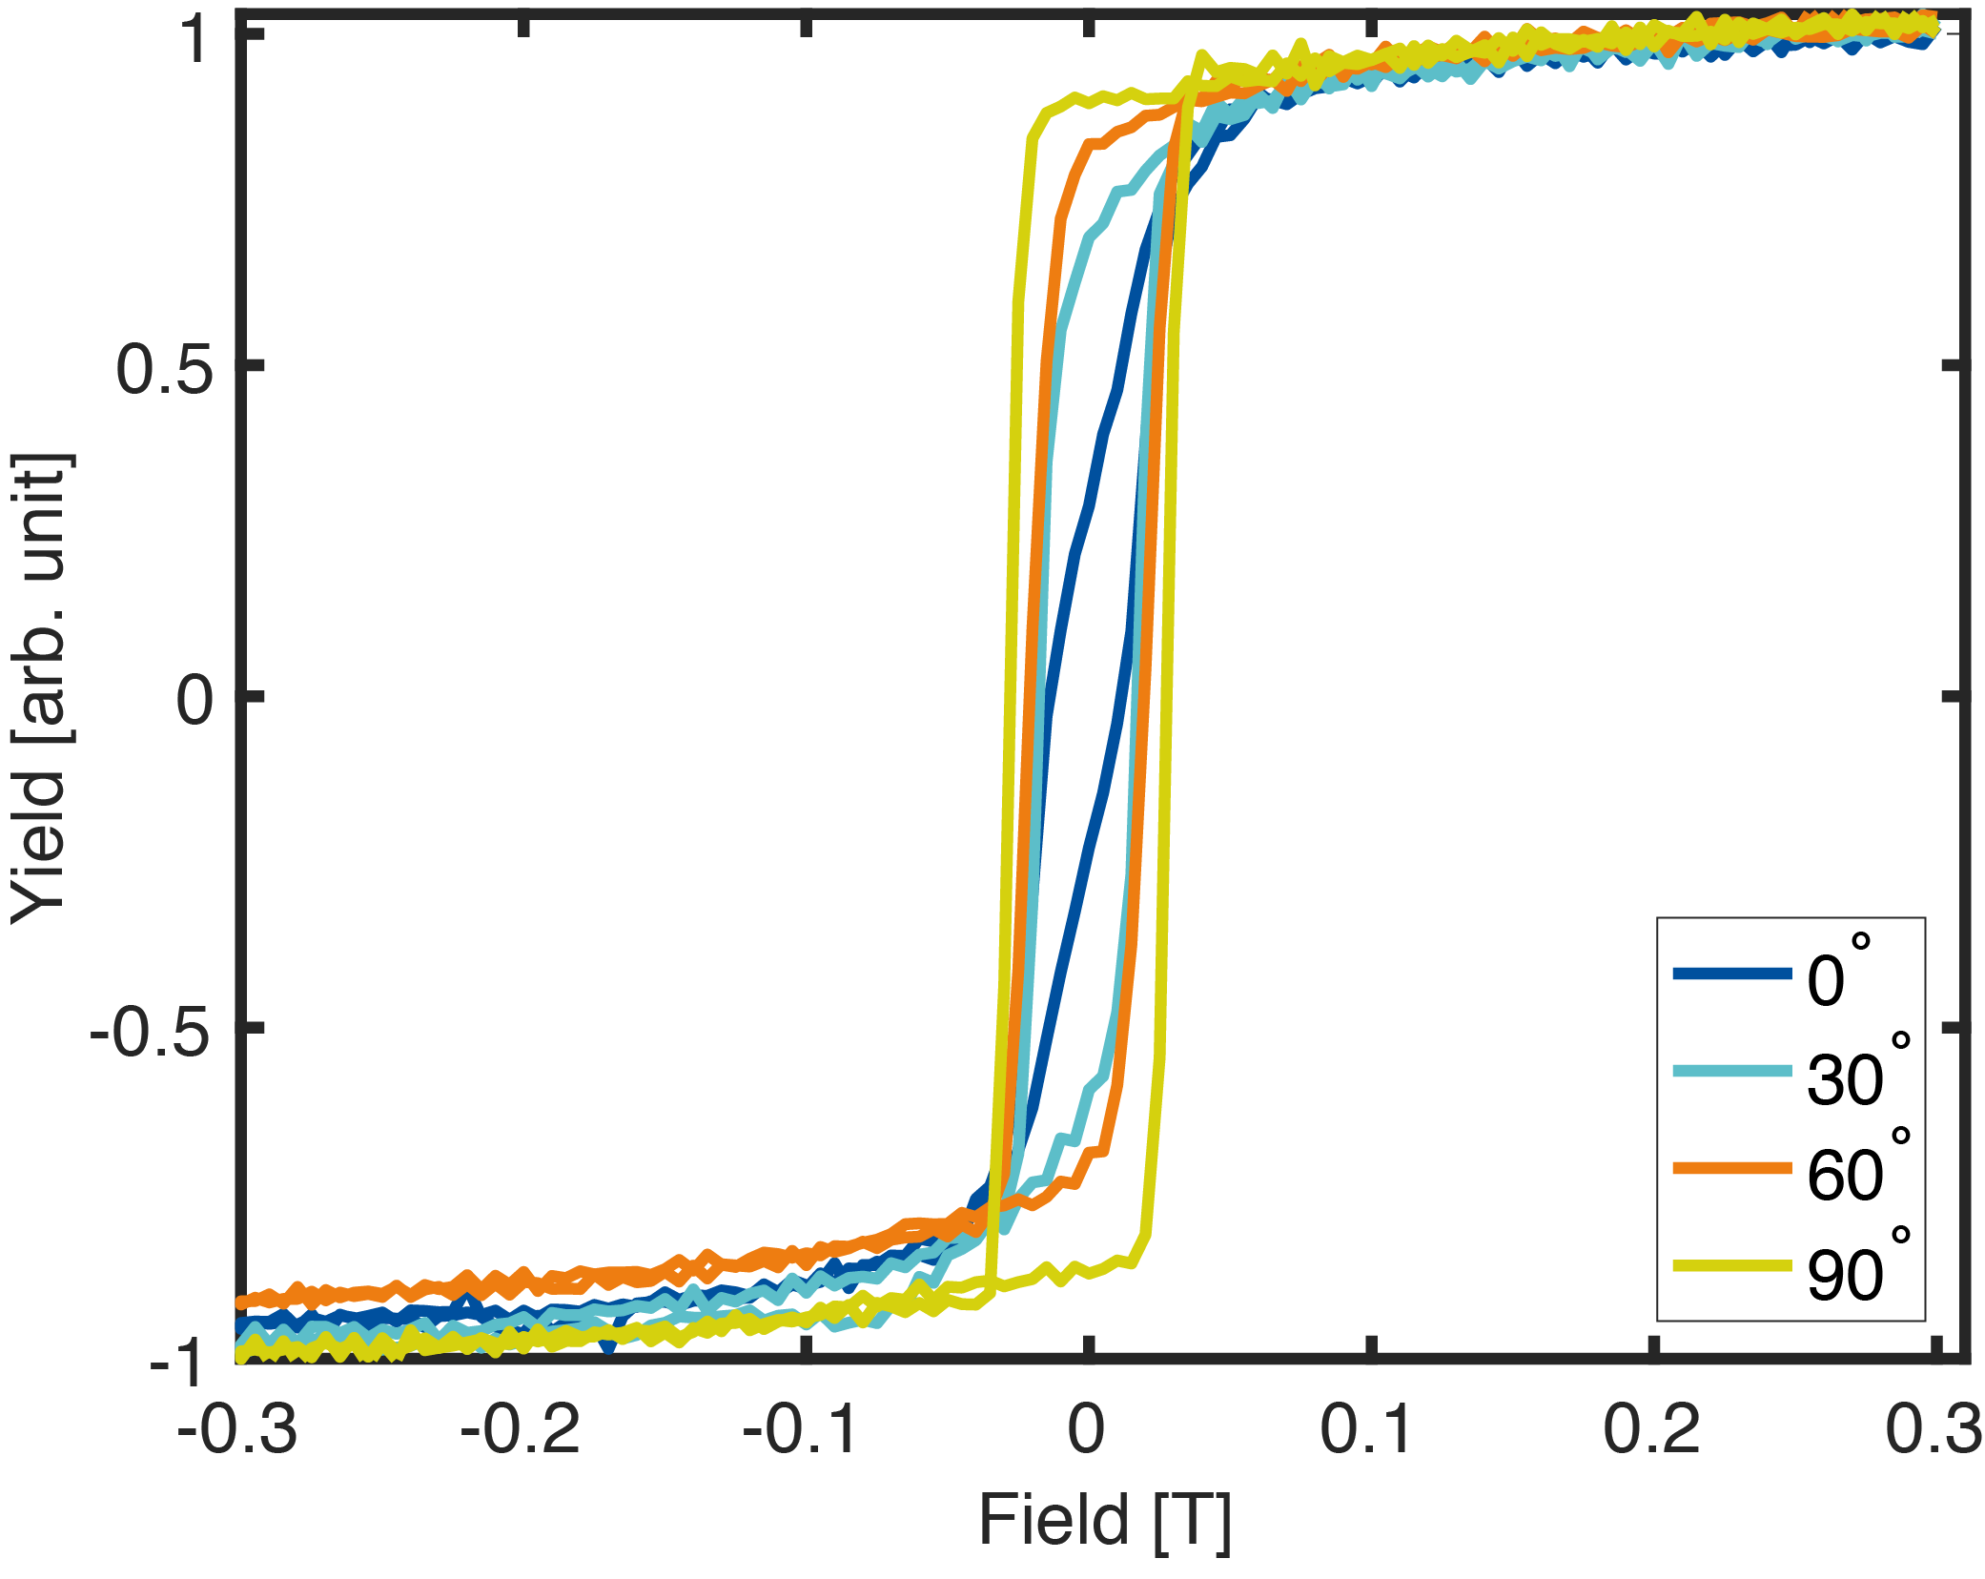Figure S2: Magnetization data for LSMO on DSO obtained by XMCD.$0°$ corresponds to the [010]_{o} lattice direction.

Notes on structure refinement
Structure refinement was done by finding the symmetry elements through the positions of $Q_{⊥}$ and $Q_{||}$. For example an epitaxial thin film on a cubic substrate, equal $Q_{⊥}$ positions indicate a rhombohedral/hexagonal or cubic unit cell. Only one value of $Q_{⊥}$ results in a cubic unit cell ($Q_{⊥film}=Q_{⊥substrate}$), other values indicate a rhombohedral/hexagonal unit cell, which is the case for LSMO on SrTiO₃ (STO). With regards to the DSO substrate, the in-plane symmetry removes the possibility of a cubic unit cell and a hexagonal unit cell in the (001)_{h} orientation (the subscripts h and o refers to the hexagonal and orthorhombic symmetry, respectively) for the LSMO thin film. A (101)_{h}-oriented hexagonal or orthorhombic unit cell is also possible, though not consistent with the measured $Q_{⊥}$ values, leaving a monoclinic unit. For the LSMO film on NGO, the same possible unit cell symmetries must be considered, though here only a triclinic unit is coherent with the $Q_{⊥}$ values. Knowing the symmetry, the parameters were found through minimization of the equations for the interplanar distance of the relevant planes.

Alternative unit cell structure of LSMO on (011)-oriented NGO
By changing the deposition laser fluence, the structure of LSMO on (011)_{o}-oriented NGO can change from a triclinic to a monoclinic unit cell. Figure S3 shows linear scans of a 21 nm LSMO film on (011)_{o}-oriented NGO. The overlapping peak positions of (-136)_{o} and (-336)_{o} along with the unequal positions of (152)_{o} and (352)_{o} indicate a monoclinic unit cell.
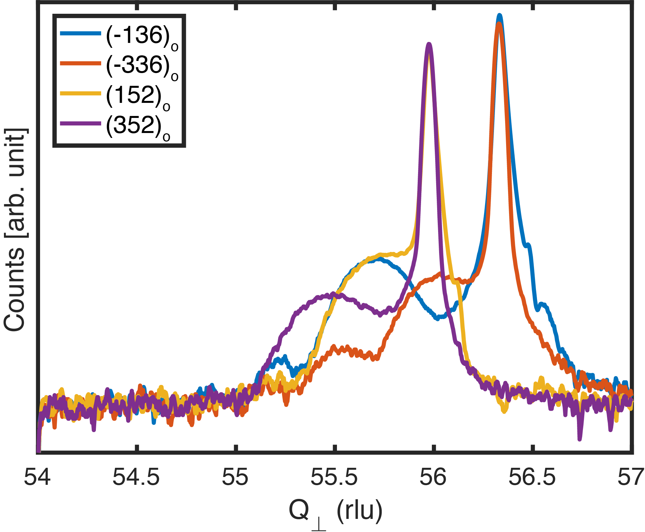
Figure S3: Linear scans of (-136)_{o}, (-336)_{o}, (152)_{o}, and (352)_{o} peaks of a 21 nm LSMO film on NGO(011). The film peak positions indicate a monoclinic LSMO unit cell.

Anisotropy energy calculated using the Néel model
Figures S4 and S5 shows the calculated anisotropy energy obtained from the Néel model of magnetic anisotropy for triclinic LSMO on (011)_{o}-oriented NGO and monoclinic LSMO on (101)_{o}-oriented DSO, respectively. In the same figures are the squareness of the hysteresis curves are plotted. The squareness is here defined as $1-M_{r}/M_{s}$ where $M_{r}$ is the remanent magnetization and $M_{s}$ is the saturation magnetization. In the case of LSMO on (011)_{o}-oriented NGO, the experimental data follows Néel model. However, that is not the case for LSMO on (101)_{o}-oriented DSO, where the peaks of the experimental data and results from the Néel model are shifted 90° with respect to each other.

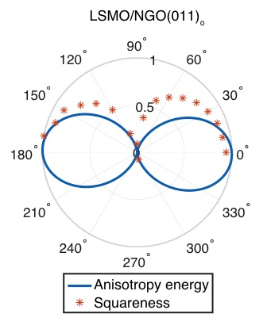
Figure S4: The in-plane anisotropy (blue line) calculated from the Néel model of triclinic LSMO on (011)_{o}-oriented NGO with the squareness of the experimentally obtained hysteresis curves. $0°$ corresponds to the [100]_{O} lattice direction.
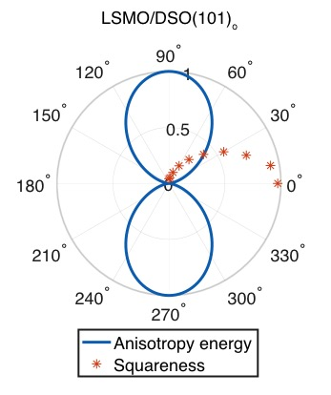
Figure S5: The in-plane anisotropy calculated from the Néel model of monoclinic LSMO on (101)_{o}-oriented DSO with the squareness of the experimentally obtained hysteresis curves. $0°$ corresponds to the [010]_{o} lattice direction.

