Microfluidic Study on the Attachment of Crude Oil Droplets to Gas Bubbles
Marcin Dudek¹ and Gisle Øye^{1,†}
¹ Ugelstad Laboratory, Department of Chemical Engineering, Norwegian University of Science and Technology (NTNU), Trondheim, Norway
† Corresponding author: gisle.oye@chemeng.ntnu.no; Sem Sælandsvei 4, 7491 Trondheim, Norway

ABSTRACT
Gas flotation is often used during treatment of the oilfield produced water. It relies on the generation of gas bubbles and their attachment to oil drops, for example by forming an oil film on the surface of a gas bubble. In this paper we present a microfluidic technique for investigating the attachment of crude oil drops to gas bubbles through the spreading mechanism. The developed method allowed us to systematically study the effect of the oil, water and gas phases, where the investigated parameter was the amount of oil droplets attached to gas bubbles through spreading. The highest attachment efficiency was observed at low or neutral pH. By reducing the salinity, the electrostatic repulsion increased, which had a negative effect on the attachment. The presence of dissolved components stabilized the oil drops and gas bubbles, which decreased their attachment through spreading. Replacing nitrogen with methane improved the attractive interactions between bubbles and oil droplets, enhancing the attachment of oil. The results confirm the potential of microfluidics in studying bubble-droplet interactions, relevant for industrial processes.

INTRODUCTION
Produced water (PW) is a major by-product during crude oil and natural gas production. It is composed of both dissolved and dispersed components¹, of which some need to be removed for the water to be discharged to the sea or re-injected to an underground formation². The commonly targeted pollutant during PW treatment is the dispersed crude oil. After initial treatment processes, the water typically contains between 200-500 ppm of crude oil droplets that are smaller than 25 µm². These oil droplets are meta-stable in water due to their size and the presence of indigenous surfactants in the petroleum. The target is to reduce the concentration at least down to 30-40 ppm, which are limits for discharge to the sea¹.
Gas flotation is one of the common produced water treatment processes, and uses the dispersed or nucleated gas bubbles to enhance the density difference between oil and water. The generated bubbles can attach to oil drops and form aggregates that are both bigger and less dense, and thereby easier to remove. This attachment can occur through different mechanisms³, such as formation of an oil film or lens, point attachment, entrapment in a turbulent wake or physical lifting of oil droplets by flocculated gas bubbles. The oil film on the gas bubble provides the most stable bubble-drop aggregate. Generally, it can be divided into three stages⁴: (1) approach and thin film formation, (2) film drainage and (3) film rupture and spreading of oil over the surface of a gas bubble. These processes are depicted in Figure 1.
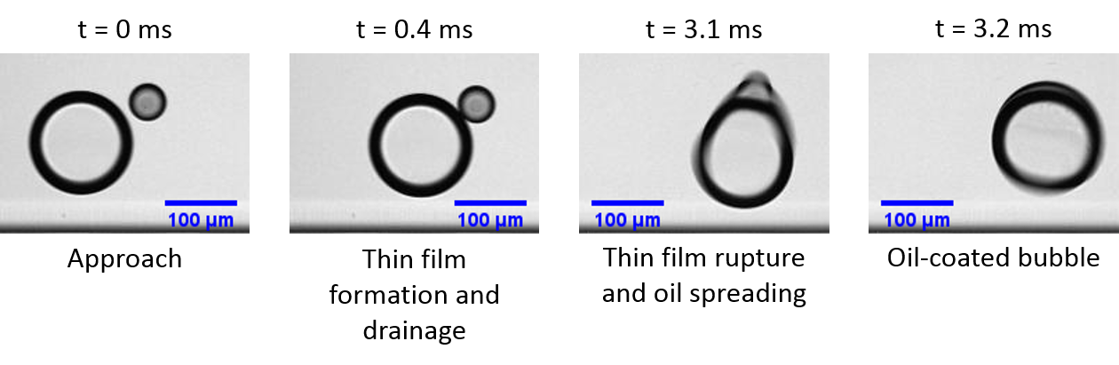
Figure 1 The stages of bubble-drop interactions, leading to formation of an oil film on a gas bubble. A short movie from which the frames were taken is available in SI.
The collisions between bubbles and drops, together with the characteristic drainage time, govern the total attachment efficiency through this mechanism⁵. The thin film drainage is a complicated process, which depends on the interfacial properties of all three phases (gas, oil and water) and on the hydrodynamic forces inside the process unit.
Crude oil is a complex mixture of hydrocarbons and other organic species. Certain fractions of crude oil, like resins, asphaltenes or naphthenic acids, are surface-active and can influence the interfacial behaviour of crude oil drops in water⁶⁻⁷. Furthermore, water-soluble components can partition to the water phase and affect the gas-water interfaces⁸. For the water produced at the Norwegian Continental Shelf, these dissolved species are predominantly of acidic nature⁹. These crude oil-indigenous amphiphilic molecules can affect the stability of the thin film and the drainage process during bubble-droplet interactions. They give raise to additional repulsive forces (electrostatic or steric), and can also retard the film drainage time through the Marangoni effect¹⁰, where the interfacial concentration gradient causes a flux of liquid in the opposite direction of the drainage process.
The role of interactions between gas bubbles and crude oil droplets during gas flotation has scarcely been reported in the literature. Nikolov et al. studied the thin film stability between crude oil droplets and air bubbles¹¹. Another study, conducted by Oliveira et al., tried to relate the fundamental interactions between gas bubbles and oil droplets to the flotation efficiency with the use of well-defined systems¹². The effect of solvent on the induction time in bitumen-air systems was studied by He et al.¹³. Recently, Chakibi et al. reported the role of salinity on induction time and laboratory flotation performance of crude oil emulsions¹⁴. Our group has also contributed to the field by studying the film drainage times between bubbles and crude oil drops¹⁵, which was later related to the performance of a pilot-scale flotation¹⁶. Overall, these papers underlined the importance of fundamental phenomena on the process of gas flotation.
Microfluidics has recently emerged as a new tool for studying the fundamental aspects of dispersions and their stability¹⁷. It has been extensively used to investigate coalescence in emulsions¹⁸⁻²⁰, recently also in the petroleum field²¹⁻²². While three-phase systems were studied with microfluidic tools²³⁻²⁵, the application of these systems was limited to foam flooding in petroleum research²⁶⁻²⁸. No reports on the microfluidic studies of crude oil droplet spreading on gas bubbles were found.
In this work we present a new, microfluidic method to probe the interactions between bubbles and crude oil droplets that normally occur during gas flotation processes, by investigating the spreading of oil drops over the gas bubble surface inside a microchannel. The relative amount of free-flowing drops attached through spreading was used to compare the influence of different parameters. We systematically varied the water and oil composition, as well as the droplet number and size. The effect of the gas phase on the spreading efficiency by using both nitrogen and methane bubbles was also reported.

EXPERIMENTALS
Chemicals.
Brines. Two types of brine were used as the continuous phase during most experiments. The first brine (later referred to as Na-Brine) was composed of 3.5% wt. sodium chloride (p.a., Merck Millipore, USA). The second brine was a mixture of sodium chloride and calcium chloride (p.a., Sigma-Aldrich, USA), with a Ca/Na molar ratio of 1:35. The salt concentrations are similar to seawater conditions, which closely resembles the produced water from the Norwegian Continental Shelf²⁹, whereas the chosen Ca/Na molar ratio is similar to that of North Sea produced water³⁰. Both solutions had the same ionic strength and were prepared with deionized water (Millipore Simplicity Systems, Darmstadt, Germany). They were adjusted to pH 4 and 10 by using solutions of diluted HCl (AnalaR, VWR, USA) and dissolved NaOH (AnalaR, VWR, USA). The natural pH of the brines, later referred to as pH 6, ranged from 5.8 to 6.6. The low salinity brine, used in the Brine Effect section, consisted of 20 mM of sodium chloride.
Dissolved components. The water phase with dissolved naphthenic acids (Fluka, Sigma Aldrich, USA; later denoted as Fluka acids) was prepared through partitioning from heptane (HPLC ≥99%, Sigma-Aldrich, USA). Buffered Na-Brines at pH 6 and 9, and solutions of Fluka acids in heptane were poured into Schott bottles and mixed on a horizontal shaker for 12 hours. After shaking, the water phase was extracted and centrifuged (30 min, 11 000 rpm). Some of the water was acidified to pH <2 with hydrochloric acid and mixed with heptane to back-extract the acids for concentration measurement. The samples were silanized with N-tert-Butyldimethylsilyl-N-methyltrifluoroacetamide (MTBSTFA) with 1% tert-Butyldimethylchlorosilane (Sigma-Aldrich, USA) and then analysed with GC/MS. With the known concentration, the samples were diluted with Na-Brine to contain 100 ppm of acids and re-adjusted to pH 6 and 10.
The solution of 4-heptylbenzoic acid (4-HBA, 99+%, Alfa Aesar, USA) was prepared by dissolving 100 ppm of the acid in Na-Brine at high pH. After dissolution, the solution was readjusted to pH 10.
The surface tension measurements of brines, with and without the dissolved components, were conducted with a Du Noüy ring tensiometer (Sigma 70, KSV, Finland) at room temperature. The reported values were noted after 24 hours of measurement to make sure that the values were near-equilibrium.
Crude oils. Three crude oils, produced at the Norwegian Continental Shelf and with the addition of 200 ppm of a de-emulsifier, were used as the dispersed phase. The summary of the physical (density, viscosity) and chemical properties (Total Acid Number – TAN; Total Base Number – TBN; Saturates, Aromatics, Resins, Asphaltenes – SARA) is presented in Table 1. The full characteristics of the crude oils and description of experimental methods were reported elsewhere³¹⁻³².
Table 1 Physicochemical properties of the crude oils.
Crude oil |  | Density  [g/cm³]  @20°C | Viscosity  [mPa s]  @20°C | TAN  [mg KOH/  g oil] | TBN  [mg KOH/  g oil] | SARA [% wt.]
 |  |  |  |  |  | Saturates | Aromatics | Resins | Asphaltenes
 | B | 0.841 | 14.2 | ND | 1.0 | 84.0 | 13.4 | 2.3 | 0.3
 | E | 0.831 | 8.3 | 0.5 | 0.4 | 74.8 | 23.2 | 1.9 | 0.1
 | F | 0.822 | 7.5 | 0.1 | 0.6 | 78.5 | 18.9 | 2.5 | 0.1

Gas phase. Most experiments were performed with nitrogen (grade 5.0). The measurements in the Gas Phase Effect section also included methane (grade 3.5).
Microfluidic chips and setup.
The design of the chips and the microfluidic setup used during the microfluidic gas flotation experiments is illustrated in Figure 2.
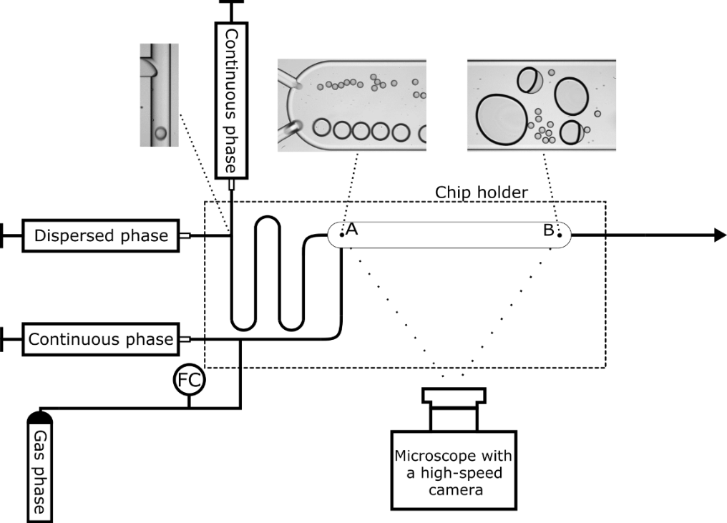
Figure 2 Microfluidic setup and chips. Droplets and bubbles, generated at two T-junctions, enter a wider channel (point A) and interact with each other, leading to attachment of some freely flowing drops to bubbles at the end of the channel (point B).
Custom-designed glass microfluidic chips were purchased from Micronit Microtechnologies B.V. (The Netherlands). They had two T-junctions, where the simultaneous generation of gas bubbles and oil droplet took place. The inlet channels, leading to and from the T-junctions, had a width of 100 µm. The wider channel, where the bubbles and droplets met, was 750 µm wide and 33 mm long.
All channels had a uniform depth of 45 µm. After entering the wider channel, the fluid particles started to intermingle, which resulted in some of the oil droplets spreading on the gas bubble surface. During the measurements, the chip was placed in a chip holder (Fluidic Connect PRO, Micronit Microtechnologies B.V., The Netherlands) and connected to the flow setup with FFKM ferrules and PEEK tubing (inner diameter 250 µm, Sigma-Aldrich, USA). After the experiment, the chips were cleaned through sonication in three different solvents: toluene/acetone mixture (3:1 v/v), isopropanol and deionized water. Each cleaning step lasted 15 min. Finally, the chips were baked in an ashing furnace for six hours at 425°C. Shortly before the experiments, the chips were treated in low-pressure oxygen plasma chamber (Zepto, Diener electronic GmbH, Germany) for 10 minutes.
The liquids were pumped with syringe pumps (neMESYS mid-pressure module V3, Cetoni GmbH, Germany). The flow of gas was controlled with a gas flow controller (EL-Flow Prestige, Bronkhorst High-Tech B.V., The Netherlands). The flow conditions in the respective experiments are presented in Table 2. All measurements were performed at room temperature.
Table 2 Overview of experimental conditions of the respective subsections in the paper.
Experimental conditions | Droplet generation |  |  | Bubble generation
 | Continuous phase flow [µl/min] | Dispersed phase flow [µl/min] | Droplet diameter [µm] | Continuous phase flow [µl/min] | Dispersed phase flow [µl/min] | Bubble diameter [µm]
Brine Effect | 160 | 6 | 55 | 120 | 43 | 150
Concentration Effect | 160 | 4  6  8 | 55 |  |  | 150
Drop Size Effect | 120  160  200 | 8  6  4 | 70  55  40 |  |  | 150
Dissolved Components Effect | 160 | 6 | 55 |  |  | 100-110
Gas Phase Effect | 160 | 6 | 55 |  |  | 150

The provided value of the bubble diameter in all sections except the Dissolved Components Effect was a result of quick coalescence between the generated 110 µm bubbles in the beginning of the channel. During the experiments with dissolved components, the bubbles were stabilized against coalescence by the acidic species present in the water phase. The number of droplets generated in unit time was proportional to the dispersed flow rate. In the Concentration Effect section, the lowest flow rate allowed production of ca. 1000 drops/s, 6 µl/min produced around 1400 drops/s, whereas the highest flow rate resulted in approx. 1800 droplets/s. In all other sections, the flow rates were set so the number of droplets entering the wider channel in unit time was similar (approx. 1400 drops/s).
The droplet velocity was typically around 10 cm/s. The free bubbles travelled in the channel almost twice as fast (ca. 18 cm/s), whereas the coated bubbles were generally slower (ca. 8 cm/s) due to the additional drag forces acting on the bubble. Therefore, the residence time ranged from approx. 0.25 to 0.4 second for the fastest and slowest fluid particles, respectively. Although the individual bubble-droplet interactions were not in the scope of this study, the time needed for a droplet to spread over a bubble was typically less than 10 ms, whereas in general it took longer for a droplet to merge with an already coated bubble (>10 ms). It is also worth to notice that not all collisions between bubbles and droplets lead to spreading.
The droplets were observed with a high-speed camera (AX100, Photron, Japan), connected to an inverted microscope (Ti-U Eclipse, Nikon, Japan) with an external LED light source (HDF7010, Hayashi, Japan) at a constant framerate speed of 8500 frames per second.
Data acquisition and image analysis.
The image analysis method was based on the one reported before³²⁻³³, with a few modifications. Two sets of ca. 16000 frames at the inlet and outlet of the chip (points A and B in Figure 2, respectively) were taken for each of the experiment. The images from the inlet were used to retrieve the number and size of the generated droplets. The number of the remaining drops, not attached to the gas bubbles, was determined from the outlet images. Both image sequences were processed with ImageJ software. The frames were first converted into a binary mask and then the areas and the centre of masses coordinates of droplets were retrieved with the Analyse Particle feature, available in the ImageJ software. Due to the limited coalescence between oil drops (compared to a system without gas bubbles present³², at least 3 times lower), the remaining drops were always significantly smaller than the gas bubbles. This made it possible to differentiate them from the bubbles with the use of a size limitation feature, as shown in Figure 3.
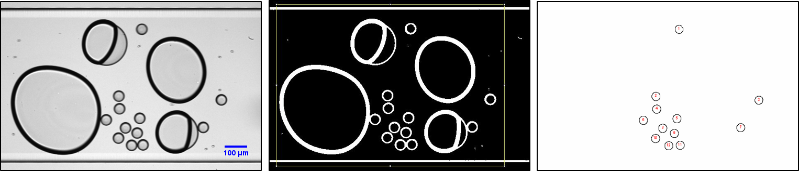
Figure 3 The stages of image analysis. From left: original image, frame converted to a binary mask and detected objects.
Subsequently, the data was copied to a Microsoft Excel spreadsheet. Even though the coalescence between drops was very low, the detected droplets at the end of the channel were sorted into several size classes. The droplet area increased proportionally with the number of coalescence events, which allowed recalculating the drops of different sizes to the number of drops of the initial size that formed them. Since the same droplets were detected several times within the detection frame, the actual number of droplets (N_{i}) in each size class was calculated with the use of the average droplet velocity (v_{drop} in µm/frame unit), the width of the detection box (w) and the mean droplet diameter in each size class (d_{i}):
$$N_{i}=\frac{N_{tot,i}*v_{drop}}{w-d_{i}}$$ | (1)
where N_{tot,i} is the total number of detected objects in each size class.
A fraction of the free-flowing droplets attached to the gas bubbles and spread over their surface during the experiment. Therefore, in this paper the term "attachment" will refer to the aqueous film rupture, followed by spreading of oil droplets on bubbles, and the attachment efficiency (AE) will be the main parameter used to compare different experimental conditions. It was calculated with Equation 2:
$$Attachment efficiency [\%]=\frac{{drops}_{in}-{drops}_{out}}{{drops}_{in}}$$ | (2)
where drops_{in} and drops_{out} are the number of drops detected in the inlet and outlet of the chips in unit time. In the Drop Size Effect section, the attachment efficiency was normalized with respect to the residence times, in order to eliminate its effect on the final result. The normalization was done by multiplying the number of droplets attached to the bubbles during the experiment by the ratio between the average residence time for the middle-sized drops and the calculated residence time for the specific experiment. All values are reported as the average of three measurements and the standard deviation.
RESULTS AND DISCUSSION
Brine Effect.
The oil attachment efficiencies on gas bubbles through spreading for three crude oils in two different brines are presented in Figure 4.
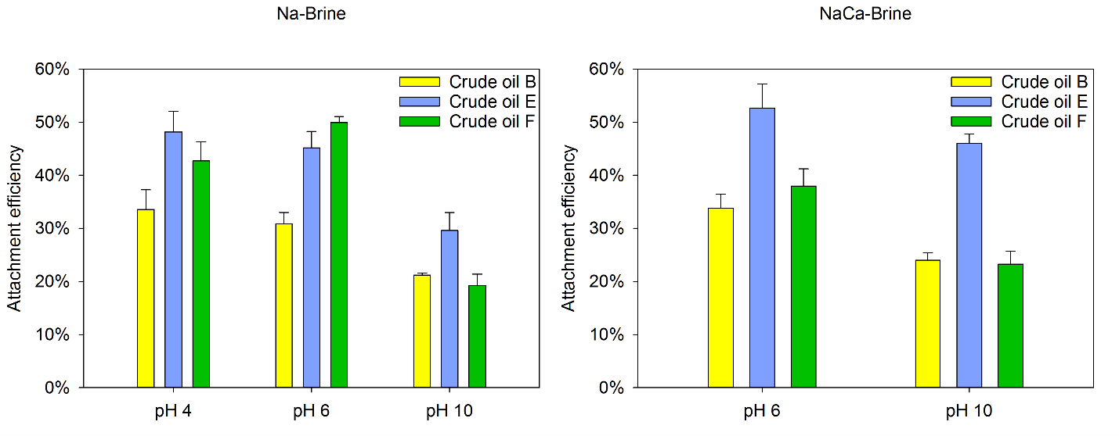
Figure 4 Attachment efficiencies of three crude oils in Na- and NaCa-Brine at three pH levels.
The highest attachhment efficiencies (AE) were found in the two lowest pH levels. All the oils gave a significant decrease of AE when the pH was raised to 10. When comparing brines with and without divalent ions at pH 6, more droplets were attached for two of the oils (B, E), whereas less droplets spread on the gas bubbles in the case of crude oil F. At pH 10 in NaCa-Brine, the attachment efficiency improved compared to the systems without calcium ions. In many cases crude oil B had the lowest AE.
The pH level of the aqueous phase will determine the type of surface-active components present at the crude oil-water³⁴ and the gas-water³⁵ interface. Crude oil is a complex mixture of hydrocarbons and various organic species. Some of them, typically found in the resin and asphaltene fractions, are polar due to high aromaticity and the presence of heteroatoms, such as nitrogen, oxygen and sulphur³⁶. These components can accumulate at interfaces, reduce the interfacial tension and also lead to the formation of viscoelastic interfacial layers³⁷ that can retard the drainage process. At low pH, the basic components diffuse to the interface and become protonated, whereas at neutral and higher pH the acids control the crude oil interfacial activity. In general, the acidic species in crude oil are considered to be more surface-active because of their less complex structure and higher affinity to the water phase in the wider range of pH³⁸. Their presence at oil-water-gas interfaces could explain the significantly lower attachment efficiencies achieved at higher pH levels through changes in the interfacial rheology and oil film properties³⁹. Furthermore, at high pH some water-soluble crude oil components may partition from the oil to the water phase³⁸. These dissolved components can then accumulate at the surfaces of bubbles and will be an additional factor in the reduction of attachment efficiency at high pH¹⁶. The detailed mechanisms involving dissolved components are explained later.
When calcium was present at high pH, the attachment efficiency increased in all cases. This effect can be attributed to the complexing ability of divalent ions with the dissociated naphthenic acids⁴⁰. The formed complexes are less hydrophilic than the charged species, and may partition from the interface and back to the oil phase. This phenomenon may effectively reduce the interfacial concentration of surfactants at both oil-water and gas-water interfaces and lead to an increase of the interfacial tension⁴¹, which explains the improved attachment efficiency in the NaCa-Brine at pH 10. He et al., who studied the induction time of bitumen on gas bubbles, made similar observations¹³.
The slightly higher viscosity of crude oil B might explain the overall lower attachment efficiency of this oil. The drainage and rupture process of the thin film between oil droplet and gas bubble is sometimes divided into induction (drainage) time and coverage (spreading) time. Some authors reported a dependence of the oil viscosity on the latter¹⁴⁻¹⁵, where it was shown that the increase in the viscosity of the dispersed phase can lead to longer spreading of oil over the surface of the gas bubble. Efterkhadkhah et al., however, showed that the there is no clear connection between the viscosity of the oil phase and the flotation efficiency¹⁶. It is entirely possible that the interfacial properties are more prominent when studying attachment of oil in microfluidic channels.
The effect of salinity level on the attachment efficiency of two crude oils is presented in Figure 5.
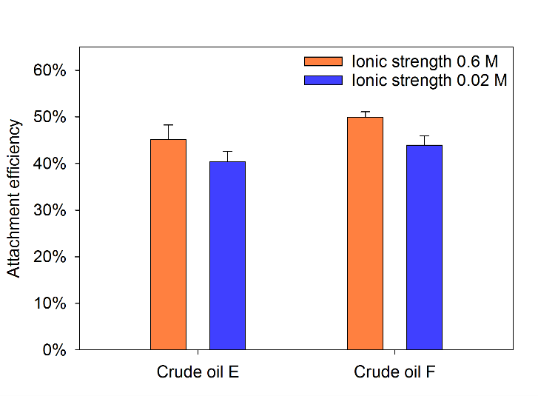
Figure 5 Comparison of attachment efficiencies of two oils in high and low salinity brines.
Both oils experienced a decrease in the attachment efficiency upon reduction of the salinity. The level of salinity plays an important role for the interfacial properties of both air-water and oil-water interfaces during gas flotation. In the case of oil droplets, high salinity (HS) can screen negative charges acquired by crude oil drops in the water phase⁴², thus decreasing the repulsion between them. At the same time, the abundant presence of an electrolyte will also promote packing of surface-active species at the interface, which will have a negative effect on the bubble-drop interactions, as more surfactants can be present at the interface. Similar to the oil droplets, gas bubbles in water are also negatively charged due to the preferential adsorption of hydroxyl ions and adsorbed components at the vicinity of gas/water interfaces⁴³. In HS brine, the electrical double layer is significantly compressed by the electrolyte, however in low salinity (LS) the overlapping electrical double layers will provide repulsive interactions between droplets and bubbles. In addition, it has been reported that the coalescence of gas bubbles greatly depends on the concentration of salt in the solution⁴⁴⁻⁴⁵. A recent microfluidic study confirmed that the amount and type of the electrolyte influences the coalescence between bubbles⁴⁶. It showed that the concentration of salt above the critical coalescence concentration leads to an increased stability of bubbles, despite increased surface tension. The salinity level in our system could also have an effect on the bubble size distribution in the microfluidic channel which, as discussed later, can affect the spreading of oil droplets on gas bubbles. Nevertheless, the trends agree with other reports demonstrating the decreased induction time and improved flotation performance with increased salinity^{12, 14-15}.
Concentration Effect.
The effect of the droplet generation rate (i.e. oil concentration) on the attachment efficiency of two crude oils is depicted in Figure 6.
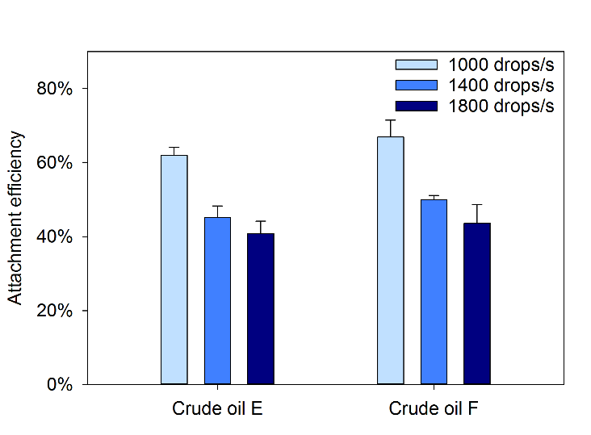
Figure 6 Effect of droplet production rate (i.e. oil concentration) on the attachment efficiencies of two crude oils.
Both oils showed similar, declining trend of the attachment efficiency when increasing the number of produced drops. In general, flotation units underperform when the influent has more than 500-1000 mg/L of dispersed oil and the droplets are larger than 200 µm in diameter⁴⁷, and they are typically preceded by hydrocyclones. Therefore, the tendencies observed here are reasonable. Interestingly, if the absolute number of attached drops is considered, the trend is reversed. The experiment at the highest concentration (ca. 1800 drops/s) yielded between 700 and 750 droplets of attached drops per second, whereas at the lowest concentration (1000 drops/s), the amount of attached drops was close to 600 droplets per second. This was most likely due to the mechanism, speculated by Strickland⁵, in which the oil coated bubbles are more probable to merge with free oil droplets than the non-coated bubbles. Indeed, upon visual inspection of the recorded images, we observed bigger bubbles for the lower concentration (Figure 7A), whereas smaller bubbles with thicker oil films were seen when the concentration was higher (Figure 7B). As outlined before, the already coated bubbles move significantly slower than the free bubbles. This probably lead to increased contact time between droplets and coated bubbles within the channel, which resulted in larger amount of oil on the bubbles.
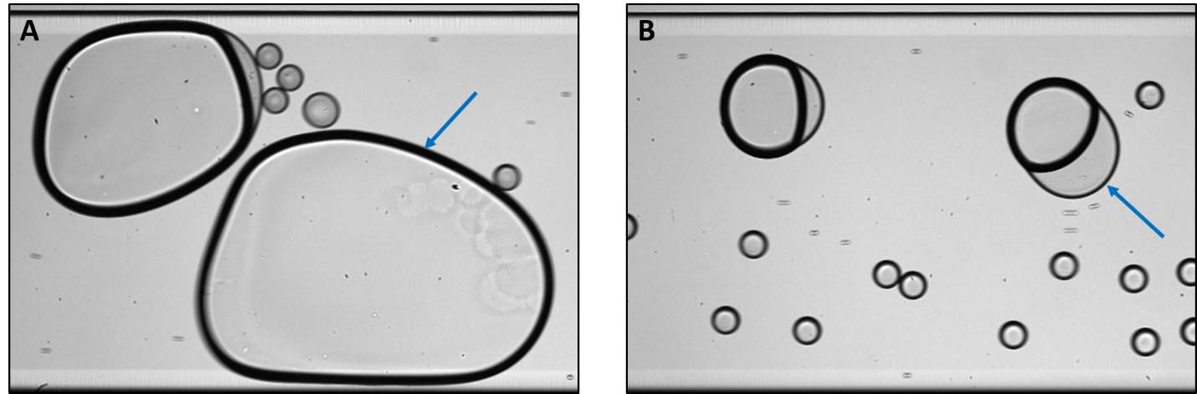
Figure 7 Snapshots from low (A) and high (B) oil concentration experiments. Arrows in the figure point to the differences in thickness of the oil film.
Bubbles with more oil on their surface were more prone to detachments events, which led to the formation of relatively big oil droplets. While they could have been excluded with the size limitation of the detection tool, this would only decrease the attachment efficiency, therefore the observed trends would be unaffected. Less collisions with smaller amount of oil drops could also lead to more extensive coalescence between gas bubbles, as oil film inhibits bubble-bubble coalescence. The change in the bubble size distribution can affect the spreading of oil droplets over the gas bubbles. According to Rawlins, if the droplet-bubble ratio is smaller than approx. 0.5 (this value will probably vary in different systems), then the droplets are not likely to spread over gas bubbles and might attach through different mechanisms³. Similarly, the droplet sizes can also affect the attachment efficiency and this is discussed next.

Oil Droplet Size Effect.
The attachment efficiency of the droplets of different sizes for two crude oils is shown in Figure 8.
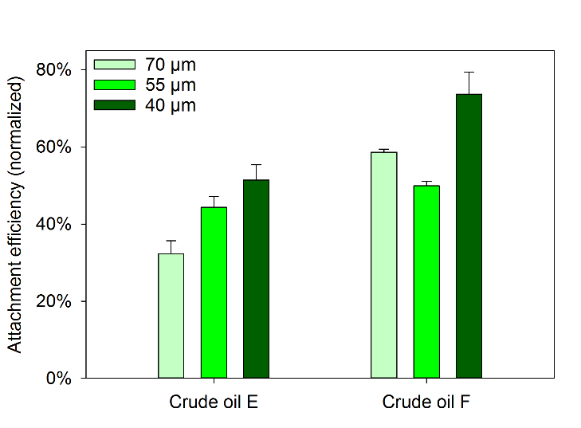
Figure 8 The influence of drop size on the attachment efficiencies of two crude oils.
The smallest droplets (approx. 40 µm) had the highest AE in both cases. The trend was not consistent in the remaining two sizes (ca. 55 and 70 µm). Noteworthy, the number of drops produced in unit time was kept constant. The results were normalized to include the effect of the differences in the residence times caused by the changes in the total flow rates.
Typically, gas flotation treatment follows a gravity-based separator (e.g. hydrocyclone), which removes the largest drops from the water phase. For this reason, the PW entering a flotation unit usually contains drops below 25 µm in diameter². However, in some cases the flotation system may consist of several cells, which makes it capable of being a single-step water treatment process⁴⁸. Nevertheless, the effect of the droplet size on the performance of gas flotation can be quite convoluted. On the one hand, bigger droplets should be easier to encounter and consequently be removed by the gas bubbles during the flotation process, which was confirmed by several experimental studies^{5, 49}. In addition, larger drops experience higher buoyancy forces that increase their rising velocity, consequently adding the gravity separation effect to the overall efficiency. On the other hand, the bubble-droplet size ratio is also important for determining the mechanisms, with which the dispersed particles are being removed³. In our system, the 'removal' of drops depended solely on the spreading of oil over gas bubbles, so the comparison with the total flotation performance might not be very accurate. The fact that the smallest drops attached more efficiently in our system could be explained by the differences in drainage time. During a collision, a thin water film is formed between a bubble and a droplet. Its initial thickness is proportional to the droplet radius⁵⁰⁻⁵¹ and is an important parameter determining the film drainage rate⁵². If all other parameters, such as physicochemical properties, bubble numbers and sizes, and hydrodynamic forces (the total flow rate in the channel was only slightly different for each drop size), are kept constant, then the decrease in the film thickness should also reduce the drainage time. Consequently, smaller droplets needed less time to spread over the surfaces of gas bubbles, which increased the AE, as observed in our case.
Dissolved Components Effect.
The effect of the dissolved components was studied in Na-Brine at pH 6 and 10, and compared to the results obtained with Na-Brine only. The results are presented in Figure 9.
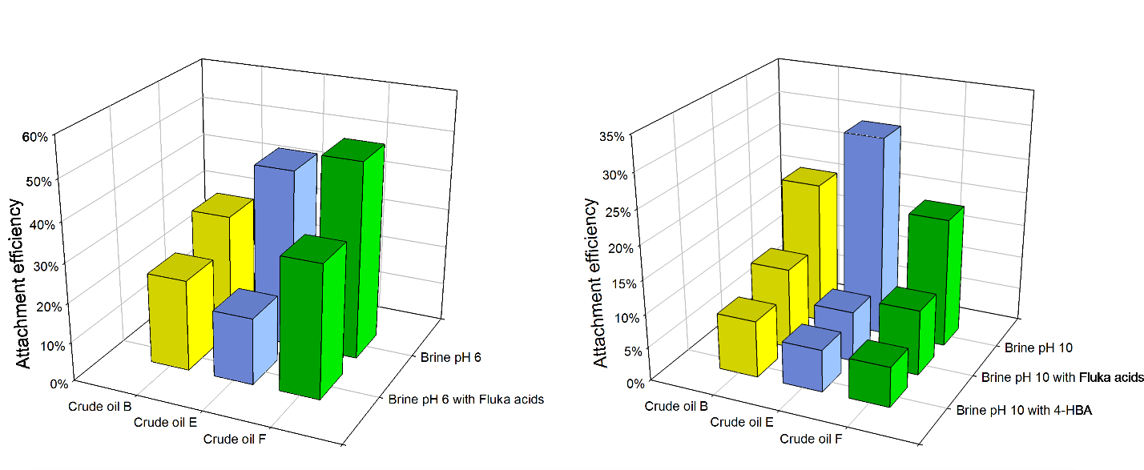
Figure 9 Comparison the attachment efficiencies in Na-Brines with and without dissolved components at pH 6 (left) and pH 10 (right).
The presence of dissolved components caused a reduction of the attachment efficiency in all cases, and the decrease of spreading of oil on bubbles was found to be both oil- and water-dependent. The dissolved Fluka acids at pH 6 reduced the attachment efficiency 1.5-2.5 times, whereas the same concentration of acids at pH 10 decreased the attachment efficiency by a factor of 2-4. The results obtained with the 4-HBA were similar for all of the oils (AE of 6-8%). The attachment efficiency of crude oil B was least affected by the presence of the dissolved components, while crude oil E had the highest decrease of the attachment efficiency.
The dissolved components also had a visible effect on the bubble stability. Compared to the standard brines, where the coalescence between bubbles was extensive, the dissolved acidic species reduced the bubble growth. The stability of bubbles depended on the type of the dissolved matter (Figure 10). The snapshots from the outlet are shown in Figure S1 in SI.
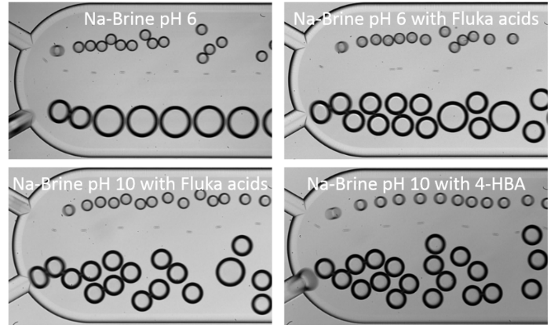
Figure 10 Snapshots of the channel inlet in different brine compositions.
In standard brine at pH 6, the generated 110 µm bubbles coalesced quickly in the beginning of the channel to form bubbles of 150 µm in diameter. Upon addition of Fluka acids, the bubbles were more stable, but coalescence still occurred. The Fluka acids at pH 10 provided more extensive stabilization against merging of bubbles and slightly reduced the size of generated bubbles (to ca. 100 µm). While the size of bubbles at the end of the channels was only somewhat different from the standard brine for the brine with Fluka acids at pH 6, the effect of the Fluka acids at pH 10 was more substantial. Many bubbles were still of initial size and only some of them coalesced to form bigger bubbles. Even more stable bubbles were obtained with the 4-HBA. In this case the generated bubbles had similar size to the bubbles formed in Fluka pH 10 and virtually all of them retained their original size at the end of the channel. The enhanced stability of bubbles is supported by the surface tension values for different brines (Table 3).
Table 3 Surface tension measurements of the brines with and without dissolved components.
Brine | Na-Brine at pH 6 | Na-Brine with Fluka acids at pH 6 | Na-Brine with Fluka acids at pH 10 | Na-Brine with  4-HBA at pH 10
Surface Tension [mN/m] | 72.5 ±0.7 | 69.1 ±1.5 | 62.3 ±0.5 | 37.4 ±0.5
The Fluka acids at pH 6 were not very surface-active and only slightly reduced the surface tension, compared to the brine without any dissolved components. Naphthenic acids extracted at higher pH have a higher affinity to the air-water surface, providing a larger reduction of surface tension. The largest surface pressure was obtained for 4-HBA, which confirmed its high surface activity, reported by others⁵³. The difference between the two Fluka acid solutions can be explained by their composition. The acidic species extracted at pH 6 have generally shorter carbon chains and less aromatic structure, compared to the acids from the other solution (Figures S2 and S3 in SI).
The presence of the dissolved organic components in produced water is a result of partitioning of water-soluble crude oil components and the addition of production chemicals to the petroleum fluids⁹. The adsorption of these components on the air-water interface was studied in our group by Eftekhardadkhah et al.^{8, 35, 54}. Further, drop-bubble micromanipulator studies showed that the presence of dissolved components increases the drainage time between a crude oil droplet and a gas bubble¹⁵, which agrees with our findings. The dissolved components adsorbing at interfaces can increase the potential energy barrier originating from steric and electrostatic stabilization forces, which makes the thin film more resistant against rupture.
One of the parameters often used to describe the spreading of oil in gas-oil-water systems is the spreading coefficient^{3, 5, 12, 47, 55}. It relates the surface tension of the water and gas to the sum of interfacial tensions between gas-oil and oil-water phases. If the former is larger, the spreading of oil will be favourable from the thermodynamic point of view, as it leads to reduction of the free energy in the system. The presence of the dissolved components will mostly affect the values of the oil-water and gas-water interfacial tensions, as the acids used are predominantly water-soluble, and probably have a larger influence on the latter (in absolute values). If we assume the surface tension of gas-oil to be around 30 mN/m ⁵⁶, only in the case of 4-HBA the spreading coefficient could be negative or close to zero. Notably, however, considerations of the spreading coefficient only make sense after rupture of the thin aqueous film formed between approaching bubbles and droplets (i.e. when the three phases are in contact). Prior to this, other phenomena play a more important role, i.e. Marangoni effect. When a bubble and a droplet approach each other, an interfacial tension gradient is formed in the thin film region as a result of the surface concentration changes. The molecules will diffuse from the low interfacial tension region towards the high, creating a flux acting in the opposite direction of the film drainage process. Then, the drainage time can become longer than the contact time, which will decrease the attachment efficiency as observed in our case. Furthermore, the 4-HBA reduced the AE for all oils to more or less the same value. Previously, we have reported the effect of this component on the coalescence of crude oil drops³², where it completely stabilized the droplets against merging. The 4-HBA had a similar effect on the oil drops, and in addition stabilized the gas bubbles. This single component can greatly increase the efficiency of packing at both oil-water and gas-water interfaces, especially compared to quite polydisperse of Fluka acid solutions (Figure S2 and S3 in SI). As a result, it stabilized the system to a greater extent than both Fluka acids solutions.
Gas Phase Effect.
During offshore separation processes using gas flotation, natural gas is predominantly used as the gas phase due to its availability and compatibility with the dispersed oil phase. However, in some cases nitrogen or carbon dioxide are also utilized⁴⁸. To bring our studies closer to real systems, we also investigated the effect of the gas phase. Figure 11 compares the attachment efficiencies of crude oil E when using nitrogen and methane, with and without Fluka acids in the water phase.
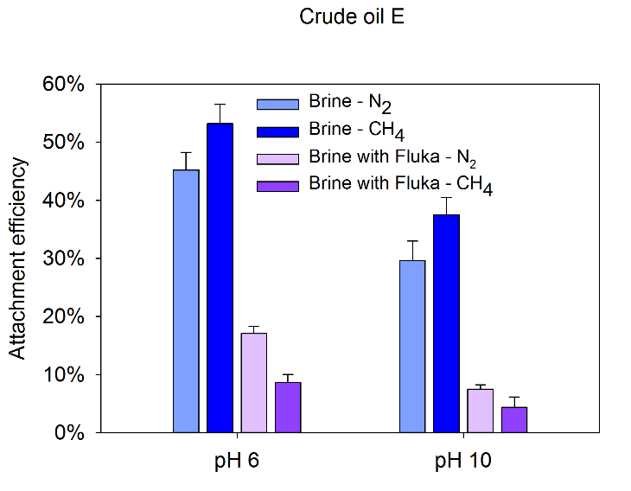
Figure 11 Comparison of attachment efficiencies for crude oil E when using nitrogen and methane, with and without the dissolved components.
Using methane led to higher attachment efficiency in almost all cases (the results for the remaining oils are presented in Figures S4 and S5 in SI). No significant changes in the initial bubble size nor coalescence between them were observed, when nitrogen was replaced by methane. For two of the oils (E, F), we performed tests with methane and dissolved Fluka acids at pH 6 and 10. When the dissolved components were added to the system containing methane bubbles, the AE decreased dramatically and were lower than in the analogous system with nitrogen.
The surface tensions of nitrogen and methane against seawater are comparable, both being around 72-73 mN/m ⁵⁷. Nevertheless, methane, being the simplest hydrocarbon, will probably have higher affinity to the hydrocarbon structure of crude oil. The interaction between the two might be more favourable due to the increased mutual solubility, which could have been promoted by the slightly higher pressure in the microchannel. The hydrocarbon gas is also less dense than nitrogen (0.7 kg/m³ and 1.2 kg/m³, respectively). All these factors might have contributed to the enhanced spreading of oil droplets over gas bubbles. However, upon addition of the dissolved Fluka acids, the attachment efficiency dropped significantly. The naphthenic acids, present in the water phase, typically consisted of a long hydrocarbon chain (>C10), sometimes with an aromatic moiety in their structure. It could be argued that these molecules, originally coming from the crude oil, will adsorb more readily to the methane-water surface than to nitrogen-water surface and thereby inhibit attachment. Still, we have not observed increased stability of methane bubbles at the inlet nor significant changes in the bubble size distribution at the end of the channel.
CONCLUSIONS
We have presented a new, microfluidic method for studying the attachment of oil droplets through spreading of oil the surfaces of gas bubbles. Crude oil was used as one of the dispersed phases, as similar bubble-drop interactions would be expected to occur in a gas flotation treatment of the petroleum produced water. We have systematically investigated the effect of various parameters on the oil attachment efficiency by spreading. It was shown that the attachment efficiency was highest at low or neutral pH, and lowest at highest pH, which was explained by the increased interfacial activity of acidic species in crude oils. The reduction of salinity increased the electrostatic repulsion between bubbles and drops, and resulted in decreased spreading. The smallest drops and the lowest concentration of oil drops were found to improve the attachment efficiency. The dissolved components in the water phase had a dramatic effect on the stability of oil drops and gas bubbles, which probably increased the drainage time and greatly reduced the spreading of oil over the gas surfaces. In addition, the effect of the gas phase was studied, where it was found that methane bubbles increased attachment of oil drops in pure brine, but decreased it in the presence of dissolved components.
We believe that this microfluidic method can be very useful in studying fundamental aspects of gas flotation in the petroleum industry. Oil films on gas bubbles is the most stable aggregate out of all flotation mechanisms. The knowledge about the parameters promoting the spreading or the effect of various additives on this process may be valuable and provide a deeper mechanistic understanding of the bubble-droplet interactions.

ACKNOWLEDGMENTS
This work was carried out as a part of SUBPRO, a Research-based Innovation Centre within Subsea Production and Processing. The authors gratefully acknowledge the financial support from SUBPRO, which is financed by the Research Council of Norway, major industry partners and NTNU.

REFERENCES
1. Fakhru'l-Razi, A.; Pendashteh, A.; Abdullah, L. C.; Biak, D. R.; Madaeni, S. S.; Abidin, Z. Z., Review of technologies for oil and gas produced water treatment. J. Hazard. Mater. 2009, 170 (2-3), 530-51.
2. Judd, S.; Qiblawey, H.; Al-Marri, M.; Clarkin, C.; Watson, S.; Ahmed, A.; Bach, S., The size and performance of offshore produced water oil-removal technologies for reinjection. Sep. Purif. Technol. 2014, 134, 241-246.
3. Rawlins, C. H., Flotation of Fine Oil Droplets in Petroleum Production Circuits. Recent Advances in Mineral Processing Plant Design 2009, 232.
4. Niewiadomski, M.; Nguyen, A. V.; Hupka, J.; Nalaskowski, J.; Miller, J. D., Air bubble and oil droplet interactions in centrifugal fields during air-sparged hydrocyclone flotation. Int. J. Environ. Pollut. 2007, 30 (2), 313-331.
5. Strickland, W. T., Jr., Laboratory Results of Cleaning Produced Water by Gas Flotation. Soc. Pet. Eng. J. 1980, 175-181.
6. Poteau, S.; Argillier, J.-F.; Langevin, D.; Pincet, F.; Perez, E., Influence of pH on Stability and Dynamic Properties of Asphaltenes and Other Amphiphilic Molecules at the Oil−Water Interface†. Energy Fuels 2005, 19 (4), 1337-1341.
7. Spiecker, P. M.; Gawrys, K. L.; Trail, C. B.; Kilpatrick, P. K., Effects of petroleum resins on asphaltene aggregation and water-in-oil emulsion formation. Colloids Surf. Physicochem. Eng. Aspects 2003, 220 (1), 9-27.
8. Eftekhardadkhah, M.; Reynders, P.; Øye, G., Dynamic adsorption of water soluble crude oil components at air bubbles. Chem. Eng. Sci. 2013, 101, 359-365.
9. Røe Utvik, T. I., Chemical characterisation of produced water from four offshore oil production platforms in the North Sea. Chemosphere 1999, 39 (15), 2593-2606.
10. Chevaillier, J. P.; Klaseboer, E.; Masbernat, O.; Gourdon, C., Effect of mass transfer on the film drainage between colliding drops. J. Colloid Interface Sci. 2006, 299 (1), 472-485.
11. Nikolov, A. D.; Randie, M.; Shetty, C. S.; Wasan, D. T., Chemical Demulsification of Oil-in-Water Emulsion using Air-Flotation: The Importance of Film Thickness Stability. Chem. Eng. Commun. 1996, 152-153 (1), 337-350.
12. Oliveira, R. C. G.; Gonzalez, G.; Oliveira, J. F., Interfacial studies on dissolved gas flotation of oil droplets for water purification. Colloids Surf. Physicochem. Eng. Aspects 1999, 154 (1), 127-135.
13. He, L.; Lin, F.; Li, X.; Xu, Z.; Sui, H., Effect of solvent addition on bitumen–air bubble attachment in process water. Chem. Eng. Sci. 2015, 137, 31-39.
14. Chakibi, H.; Hénaut, I.; Salonen, A.; Langevin, D.; Argillier, J. F., Role of Bubble–Drop Interactions and Salt Addition in Flotation Performance. Energy Fuels 2018, 32 (3), 4049-4056.
15. Eftekhardadkhah, M.; Øye, G., Induction and Coverage Times for Crude Oil Droplets Spreading on Air Bubbles. Environ. Sci. Technol. 2013, 47 (24), 14154-14160.
16. Eftekhardadkhah, M.; Aanesen, S. V.; Rabe, K.; Øye, G., Oil Removal from Produced Water during Laboratory- and Pilot-Scale Gas Flotation: The Influence of Interfacial Adsorption and Induction Times. Energy Fuels 2015, 29 (11), 7734-7740.
17. Bremond, N.; Bibette, J., Exploring emulsion science with microfluidics. Soft Matter 2012, 8 (41), 10549-10559.
18. Baret, J.-C.; Kleinschmidt, F.; El Harrak, A.; Griffiths, A. D., Kinetic Aspects of Emulsion Stabilization by Surfactants: A Microfluidic Analysis. Langmuir 2009, 25 (11), 6088-6093.
19. Krebs, T.; Schroen, K.; Boom, R., A microfluidic method to study demulsification kinetics. Lab Chip 2012, 12 (6), 1060-1070.
20. Krebs, T.; Schroën, K.; Boom, R., Coalescence dynamics of surfactant-stabilized emulsions studied with microfluidics. Soft Matter 2012, 8 (41), 10650-10657.
21. Nowbahar, A.; Whitaker, K. A.; Schmitt, A. K.; Kuo, T.-C., Mechanistic Study of Water Droplet Coalescence and Flocculation in Diluted Bitumen Emulsions with Additives Using Microfluidics. Energy Fuels 2017.
22. Lin, Y.-J.; Perrard, A.; Biswal, S. L.; Hill, R. M.; Trabelsi, S., Microfluidic Investigation of Asphaltenes-Stabilized Water-in-Oil Emulsions. Energy Fuels 2018.
23. Xu, J.-H.; Chen, R.; Wang, Y.-D.; Luo, G.-S., Controllable gas/liquid/liquid double emulsions in a dual-coaxial microfluidic device. Lab Chip 2012, 12 (11), 2029-2036.
24. Yang, L.; Wang, K.; Mak, S.; Li, Y.; Luo, G., A novel microfluidic technology for the preparation of gas-in-oil-in-water emulsions. Lab Chip 2013, 13 (17), 3355-3359.
25. Yue, J.; Rebrov, E. V.; Schouten, J. C., Gas-liquid-liquid three-phase flow pattern and pressure drop in a microfluidic chip: similarities with gas-liquid/liquid-liquid flows. Lab Chip 2014, 14 (9), 1632-1649.
26. Conn, C. A.; Ma, K.; Hirasaki, G. J.; Biswal, S. L., Visualizing oil displacement with foam in a microfluidic device with permeability contrast. Lab Chip 2014, 14 (20), 3968-3977.
27. Almajid, M. M.; Kovscek, A. R., Pore-level mechanics of foam generation and coalescence in the presence of oil. Adv. Colloid Interface Sci. 2016, 233, 65-82.
28. Xiao, S.; Zeng, Y.; Vavra, E. D.; He, P.; Puerto, M.; Hirasaki, G. J.; Biswal, S. L., Destabilization, Propagation, and Generation of Surfactant-Stabilized Foam during Crude Oil Displacement in Heterogeneous Model Porous Media. Langmuir 2018, 34 (3), 739-749.
29. Produced Water: Technological/Environmental Issues and Solutions. Springer US: 1992; Vol. 46, p 632.
30. Somerville, H. J.; Bennett, D.; Davenport, J. N.; Holt, M. S.; Lynes, A.; Mahieu, A.; McCourt, B.; Parker, J. G.; Stephenson, R. R.; Watkinson, R. J.; Wilkinson, T. G., Environmental effect of produced water from North Sea oil operations. Mar. Pollut. Bull. 1987, 18 (10), 549-558.
31. Dudek, M.; Kancir, E.; Øye, G., Influence of the Crude Oil and Water Compositions on the Quality of Synthetic Produced Water. Energy Fuels 2017, 31 (4), 3708-3716.
32. Dudek, M.; Bertheussen, A.; Dumaire, T.; Øye, G., Microfluidic Tools for Studying Coalescence of Crude Oil Droplets in Produced Water. Chem. Eng. Sci. 2018, 191, 448-458.
33. Dudek, M.; Muijlwijk, K.; Schroen, C. G. P. H.; Øye, G., The effect of dissolved gas on coalescence of oil drops studied with microfluidics. J. Colloid Interface Sci. 2018, 528, 166-173.
34. Farooq, U.; Simon, S.; Tweheyo, M. T.; Øye, G.; Sjöblom, J., Interfacial Tension Measurements Between Oil Fractions of a Crude Oil and Aqueous Solutions with Different Ionic Composition and pH. J. Dispersion Sci. Technol. 2013, 34 (5), 701-708.
35. Eftekhardadkhah, M.; Kløcker, K. N.; Trapnes, H. H.; Gaweł, B.; Øye, G., Composition and Dynamic Adsorption of Crude Oil Components Dissolved in Synthetic Produced Water at Different pH Values. Ind. Eng. Chem. Res. 2016, 55 (11), 3084-3090.
36. Gaweł, B.; Eftekhardadkhah, M.; Øye, G., Elemental Composition and Fourier Transform Infrared Spectroscopy Analysis of Crude Oils and Their Fractions. Energy Fuels 2014, 28 (2), 997-1003.
37. Nenningsland, A. L.; Simon, S.; Sjöblom, J., Influence of Interfacial Rheological Properties on Stability of Asphaltene-Stabilized Emulsions. J. Dispersion Sci. Technol. 2014, 35 (2), 231-243.
38. Bertheussen, A.; Simon, S.; Sjöblom, J., Equilibrium partitioning of naphthenic acids and bases and their consequences on interfacial properties. Colloids Surf. Physicochem. Eng. Aspects 2017, 529 (Supplement C), 45-56.
39. Strassner, J. E., Effect of pH on Interfacial Films and Stability of Crude Oil-Water Emulsions. 1968.
40. Brandal, Ø.; Sjöblom, J.; Øye, G., Interfacial Behavior of Naphthenic Acids and Multivalent Cations in Systems with Oil and Water. I. A Pendant Drop Study of Interactions Between n‐Dodecyl Benzoic Acid and Divalent Cations. J. Dispersion Sci. Technol. 2004, 25 (3), 367-374.
41. Tichelkamp, T.; Teigen, E.; Nourani, M.; Øye, G., Systematic study of the effect of electrolyte composition on interfacial tensions between surfactant solutions and crude oils. Chem. Eng. Sci. 2015, 132, 244-249.
42. Farooq, U.; Simon, S.; Tweheyo, M. T.; Sjöblom, J.; Øye, G., Electrophoretic Measurements of Crude Oil Fractions Dispersed in Aqueous Solutions of Different Ionic Compositions—Evaluation of the Interfacial Charging Mechanisms. J. Dispersion Sci. Technol. 2013, 34 (10), 1376-1381.
43. Yoon, R.-H.; Yordan, J. L., Zeta-potential measurements on microbubbles generated using various surfactants. J. Colloid Interface Sci. 1986, 113 (2), 430-438.
44. Marrucci, G.; Nicodemo, L., Coalescence of gas bubbles in aqueous solutions of inorganic electrolytes. Chem. Eng. Sci. 1967, 22 (9), 1257-1265.
45. Firouzi, M.; Howes, T.; Nguyen, A. V., A quantitative review of the transition salt concentration for inhibiting bubble coalescence. Adv. Colloid Interface Sci. 2015, 222, 305-318.
46. Wang, J.; Tan, S. H.; Nguyen, A. V.; Evans, G. M.; Nguyen, N.-T., A Microfluidic Method for Investigating Ion-Specific Bubble Coalescence in Salt Solutions. Langmuir 2016, 32 (44), 11520-11524.
47. Moosai, R.; Dawe, R. A., Oily Wastewater Cleanup by Gas Flotation. West Indian J. Eng. 2002, 25 (1), 17.
48. Saththasivam, J.; Loganathan, K.; Sarp, S., An overview of oil–water separation using gas flotation systems. Chemosphere 2016, 144, 671-680.
49. Sylvester, N. D.; Byeseda, J. J., Oil/Water Separation by Induced-Air Flotation. Soc. Pet. Eng. J. 1980.
50. Ivanov, I. B.; Danov, K. D.; Kralchevsky, P. A., Flocculation and coalescence of micron-size emulsion droplets. Colloids Surf. Physicochem. Eng. Aspects 1999, 152 (1–2), 161-182.
51. Boyson, T. K.; Pashley, R. M., A study of oil droplet coalescence. J. Colloid Interface Sci. 2007, 316 (1), 59-65.
52. Chesters, A. K., The modelling of coalescence processes in fluid-liquid dispersions: a review of current understanding. Chem. Eng. Res. Des. 1991, 69 (A4), 259-270.
53. Spildo, K.; Høiland, H., Interfacial Properties and Partitioning of 4-Heptylbenzoic Acid between Decane and Water. J. Colloid Interface Sci. 1999, 209 (1), 99-108.
54. Eftekhardadkhah, M.; Øye, G., Dynamic Adsorption of Organic Compounds Dissolved in Synthetic Produced Water at Air Bubbles: The Influence of the Ionic Composition of Aqueous Solutions. Energy Fuels 2013, 27 (9), 5128-5134.
55. Grattoni, C.; Moosai, R.; Dawe, R. A., Photographic observations showing spreading and non-spreading of oil on gas bubbles of relevance to gas flotation for oily wastewater cleanup. Colloids Surf. Physicochem. Eng. Aspects 2003, 214 (1–3), 151-155.
56. Harvey, E. H., The Surface Tension of Crude Oils. Industrial & Engineering Chemistry 1925, 17 (1), 85-85.
57. Sachs, W.; Meyn, V., Pressure and temperature dependence of the surface tension in the system natural gas/water principles of investigation and the first precise experimental data for pure methane/water at 25°C up to 46.8 MPa. Colloids Surf. Physicochem. Eng. Aspects 1995, 94 (2), 291-301.

