Kinetics of crystallization of aqueous droplets in water-in-crude oil emulsions at low temperatures
Derkach S.R.¹, Kolotova D.S.^{1*}, Simonsen G.², Simon S.C.², Sjöblom J.²,
Andrianov A.V.³, Malkin A.Ya.⁴

¹ Murmansk State Technical University, Sportivnaya 13, 183010 Murmansk, Russia
² Norwegian University of Science and Technology, Department of Chemical Engineering, Ugelstad Laboratory, N-7491 Trondheim, Norway
³ M.V. Lomonosov Moscow State University, Physical Faculty, Department of Low Temperatures, Vorobyovy Gory 1, Moscow 119991, Russia
⁴ Institute of Petrochemical Synthesis, Russian Academy of Sciences, Leninsky pr. 29 Moscow 119991, Russia
*Corresponding author: kolotovads@gmail.com

Abstract
This study focused on the examination of the isothermal crystallization of aqueous droplets in water-in-crude oil emulsions with water concentrations in the range of 5 to 20 wt%. Experiments were carried out using differential scanning calorimetry (DSC) with temperatures ranging from −36 °C to −41 °C. The experimental results were approximated using a mathematical kinetic model including the effect of self-acceleration. The rate of crystallization increases with decreasing temperature, and the final accepted degree of crystallinity also increases along with a decrease in temperature. Correlation was observed between the kinetics of isothermal and non-isothermal crystallization. Furthermore, the complete crystallization in the isothermal process is reached at −40 °C, however, at high rates of cooling (10 to 20 °C /min), complete crystallinity is not achieved even at −50 °C. Complete crystallinity in the non-isothermal process can only be reached at cooling rates lower than 5 °C/min.

Keywords: crude oil, water-in-oil emulsions, differential scanning calorimetry, crystallization, kinetics, isothermal, non-isothermal conditions

- Introduction
The formation of hydrate deposits during the flow of oil through pipelines is one of the major flow assurance problems for the oil industry¹. Emulsions, such as water-in-crude oil (i.e. inverse emulsions, W/O), are formed in the oil production and transportation process from a mixture of crude oil and water as a result of mixing at high speeds^{2–4}. Typically, oil contains a certain amount of dissolved low molecular weight gases. As a consequence, when transporting a three-component mixture under conditions of high pressure and low temperature, gas hydrates can form. Due to their chemical structure, hydrate crystals have the ability to agglomerate, which can lead to pipeline blockage or even rupture. The problem of hydrate formation is particularly important for the Arctic region, which is currently one of the most promising regions for oil production.
Stability of water-in-crude oil emulsions is the most important factor in preventing hydrate formation during the transportation of oil produced in the offshore shelf in the Far North. Knowledge of the factors that affect the stability of these emulsions makes it possible to optimize the parameters for crude oil transportation through pipelines⁵ and also to predict the behavior of liquid flows upon cooling^{1,6}.
The stability of the emulsion depends on the formation of ice-like crystals from the water component of the emulsion. This process has previously been investigated using differential scanning calorimetry (DSC)². It was shown that there are two key factors responsible for the stability of emulsions: the composition of the hydrocarbon phase and the type of stabilizer. Less stable emulsions are obtained using a liquid emulsifier and an oil dispersion medium, which solidifies at higher temperatures than the dispersed phase (water). Emulsions resistant to crystallization and melting processes are obtained when either, the emulsifier crystallizes at the oil-water interface or when the dispersed phase freezes at lower temperatures than the dispersion medium.
Formation of ice-in-oil dispersions as a result of the crystallization of water droplets also influences the rheological behavior of emulsions. Thus, at a concentration of water-in-oil emulsions exceeding 25% by volume, the viscosity of ice-in-oil dispersions formed during the crystallization process is approximately 26 times greater than the viscosity of the corresponding water-in-oil emulsion⁷.
The study of ice-in-oil dispersion formation as a process of crystallization can serve as a model for the formation of hydrate nuclei in real crude oil systems. In order to compare these systems a study was devised. A quantitative study was performed to examine the kinetics of water droplet crystallization when emulsions are cooled, using different temperature profiles, for isothermal and non-isothermal processes. The most convenient method for the study of crystallization in emulsion systems is DSC. The main advantages of the DSC method are high accuracy, sensitivity to phase transitions of various kinds, and the possibility of carrying out research with very small amounts of material (tens of milligrams). In addition, DSC makes it possible to determine the type of emulsion, the water content of the sample, and the emulsion stability.
Thus, the DSC method has been successfully used to study the non-isothermal crystallization of droplets in reverse water-in-crude oil emulsions with a wide variation in parameters, such as, emulsion concentration, electrolyte content in the aqueous phase, and droplet size^{8–9}. The method was also used to study the effect of the cooling rate on the destabilization of direct emulsions in relation to the volume of the oil phase¹⁰. A joint analysis of emulsions by the DSC method and X-ray analysis showed that the quantity of hydrates formed, and the temperature of their dissociation, was dependent on the salt concentration in the dispersed phase¹¹.
The kinetics of crystallization of water droplets in emulsion systems are usually considered in the dynamic conditions of a non-isothermal process, although the determination of the equilibrium characteristics of the process is of fundamental interest. Only one previous study has examined the kinetics of droplet crystallization in emulsions (although different to those in this study) under isothermal and non-isothermal conditions¹². As expected, at the lower cooling rate, there was greater accuracy in the quantification of parameters such as the temperature of the phase transition and the heat of crystallization, as well as the number of crystallized water droplets, as a function of time and temperature.
The present study focuses on obtaining a quantitative description, and a mathematical model, for the process of isothermal crystallization of the aqueous phase in inverse water-in-oil emulsions. Although a similar system had been investigated in previous studies by X-ray diffraction¹³, limited knowledge was available because those studies were conducted for a completely different purpose.
Earlier in our work¹⁴, the process of non-isothermal crystallization of water droplets in water-in-crude oil emulsions with a water concentration ranging between 1 wt% and 30 wt% had been studied. Water and aqueous electrolyte solutions were used as the dispersed phase. Pure water in emulsion droplets with average diameter of 4 μm crystallized at a temperature of approximately −38 °C; the concentration of the aqueous phase did not affect both the crystallization temperature and the heat of crystallization. However, the increase in dispersion of the droplets, as well as the type and concentration of the electrolyte, led to a shift in the crystallization temperature of the droplets toward lower temperatures down to −46 °C.
In this paper, as a continuation of the previous research, the kinetics of the crystallization of water droplets in water-in-crude oil emulsions, under isothermal conditions, was studied in order to obtain equilibrium characteristics of the thermodynamic process. These details were subsequently used to construct a mathematical model of the kinetics of crystallization, and to compare the results of isothermal and non-isothermal crystallization of the same objects.

- Materials and methods
2.1. Materials
The North Sea heavy crude oil (19.0 °API gravity) was used as an oil phase (Table 1). Deionized MQ water (18.2 MΩ at 25 °C) purified on “Milli-Q” system (Millipore, France) was used as an aqueous phase.

Table 1. Physical and chemical characteristics of the crude oil used¹⁵.

Characterization parameter | Content
Saturates (wt%) | 37.4 ± 0.5
Aromatics (wt%) | 44.1 ± 0.5
Resins (wt%) | 16.1 ± 0.6
Asphaltenes (wt%) (hexane-insoluble) | 2.54 ± 0.03
Emulsified water (wt%) | 0.06 ± 0.01
Density (°API) | 19.0 ± 0.1
Density (g/cm³, 20 °C) | 0.934 ± 0.001
Total acid number, TAN (mg KOH/g) | 2.15 ± 0.02
Total base number, TBN (mg/g) | 2.81 ± 0.04
Dynamic viscosity (mPa·s, 20 °C) | 317.5 ± 0.1

2.2. Methods
2.2.1. Emulsion preparation and characterization
Water-in-oil (W/O) emulsions were prepared using a T25 digital IKA disperser with a four-blade propeller at 2000 rpm and emulsification time of 5 min. The emulsion concentrations used were 5 wt%, 10 wt%, and 20 wt%.
The water droplet sizes were measured using a Digital Video Microscope (Eclipse ME600, Nikon, Japan) mounted with a CoolSNAP-Pro camera, immediately after preparation, at 50X amplification. Average droplet diameter size was calculated using Image-Pro Plus 5.0 (Media Cybernetics) software and was based on the analysis of 300 droplets. Average droplet diameter size, denoted by $\overline{d }$, had a value of approximately 4 μm for each emulsion sample (Table 2).

2.2.2. Differential scanning calorimetry
The DSC measurements (DSC Q2000, TA Instruments, USA) were performed at standard atmospheric pressure using two different modes:
- Isothermal “scanning” mode.
- Non-isothermal “scanning” mode.
In the first type of measurement, the emulsion sample was heated up to 40 °C and held at this temperature for 10 minutes in order to establish thermal equilibrium of the sample, and to dissolve all solid components of the continuous phase and then cooled to 20 ºC. The sample was then cooled quickly from 20 °C to the temperature of analysis (ranging from −36.6 °C to −40.1 °C) at a constant cooling rate of 20 °C/min and held at the analysis temperature for 20 minutes to enable full droplet crystallization. The heat flux (dQ/dt) signal was recorded as a function of time immediately after reaching the analysis temperature.
The crystallization temperature (T_{cr}), the temperature at which crystallization of droplets occurs, was obtained by DSC (as the maximum on the crystallization thermograms).¹⁴ The values of the temperatures chosen were based on experimental data obtained from our previous work¹⁴ and correspond to the crystallization temperatures of droplets for each specific sample (Table 2). Furthermore, measurements were taken at a range of temperatures, above and below T_{cr}, where sample crystallization occurs.
In the second type of measurement, the sample was cooled from 20 °C to −90 °C at constant cooling rates. The cooling rates (or temperature ramps) used were 1, 2, 5, 10, and 20 °C /min. The heat flow was recorded as a function of temperature.
For both mode types, sample masses of approximately 10–12 mg were used. Nitrogen gas was used as a purge gas at a constant rate of 50 mL/min. An empty vessel was used as a control to calculate the signal originating from the sample.The experimental results were analyzed using TA Universal Analysis 2000 software.
Table 2. Characteristics of emulsions
Emulsion concentration  φ, wt% | Average droplet diameter  $\overline{d}$, μm | Number of droplets  N in 1 mg | Crystallization temperature¹⁶  T_{cr}, °C | Peak width (temperature range) of crystallization thermograms¹⁴, °C
5 | 4.1 | 1.3 × 10⁶ | −37.7 | −36.0 to −43.4
10 | 4.2 | 2.7 × 10⁶ | −38.0 | −35.8 to −43.1
20 | 4.8 | 5.3 × 10⁶ | −38.0 | −35.5 to −43.9

- Results and discussion
3.1. Isothermal crystallization
Isothermal crystallization of aqueous droplets in water-in-crude oil emulsions was carried out in temperatures ranging from −36.6 °C to −41.1 °C. At higher temperatures, there was no crystallization for at least 10 min. At lower temperatures, experiments could not be performed as the rate of crystallization rate was too high, and crystallization occurred at least partly before the isothermal conditions were met.
The transition time before the given temperature was reached was approximately 1 s. Thus, data for shorter time intervals are not reliable. However, the process of crystallization continued for several minutes. Therefore, the data used to create the curves below are predominantly trustworthy.
The kinetic data for the emulsions at three different concentrations is presented in Fig. 1, the analysis temperature of each experiment is indicated on the curves.

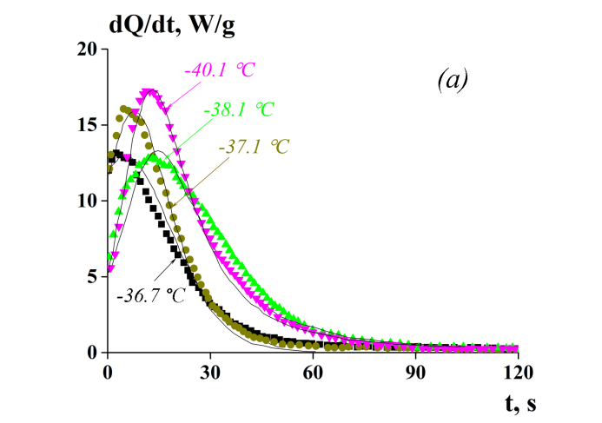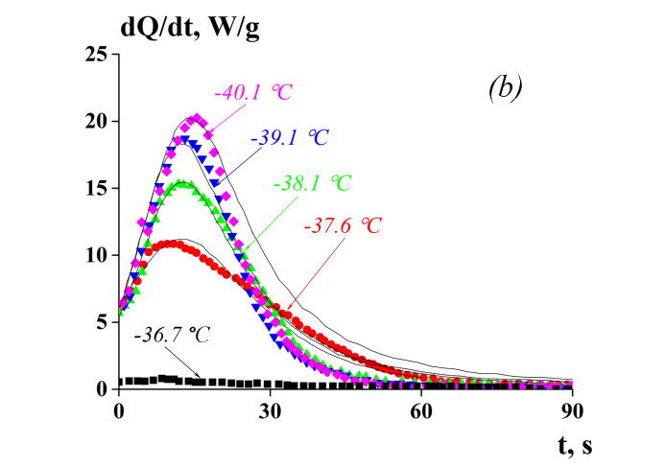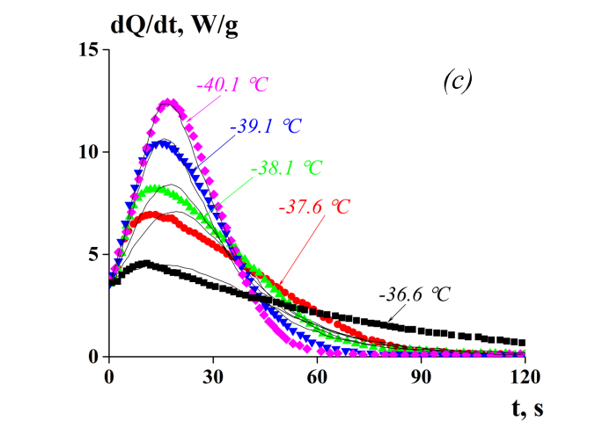
Figure 1. Kinetics of isothermal crystallization of the samples studied. Concentration of emulsions were (a) 5 wt%, (b) 10 wt%, and (c) 20 wt%. The temperature of each experiment is shown on the curves. Experimental data is plotted as points and the data calculated from Eq. 1 are shown by curves.
The kinetic curves were constructed using experimental data and the following equation¹⁶⁻¹⁷:
$\frac{dQ}{Q_{0}dt}=\frac{1}{t_{0}}(1-α)(1+Cα)(α_{∞}-α)$ (1)

where dQ/dt is the heat flux; t is time; Q₀ is the full heat; t₀ is a time component; α is the degree of crystallinity; α∞ is α for t→∞; C is constant.
This kinetic equation shows the rate of crystallization is characterized by the heat flux, dQ/dt, it is determined using three factors. The exclusion of still uncrystallised matter is described by the (1 − α) component. The effect of self-acceleration is described by the (1 + Cα) component, where C is a measure of this effect. This factor reflects the effect of the increase in the rate of the process obliged to the mechanism of the crystal growth. Finally, the limit of attainable degree of crystallinity is described by the (α∞ − α) component, where α∞ is the limit because if α = α∞ the rate of the process becomes zero, thus, dQ/dt = 0. In addition, the kinetic equation contains the time component of the process t₀.
The important point here is the definition of the degree of crystallinity, α. This parameter corresponds to the full heat output observed in the experiment, Q₀. Full heat is the amount of heat released during crystallization throughout the entire time interval in which crystallization occurs up to the end. It corresponds to the total thermal effect of the phase transition and 100% crystallinity, i.e. α = 1. Then the current value of α(t) is defined as Q(t)/Q₀. Assuming that Q₀ is equal to the enthalpy of water crystallization in the equilibrium conditions, thus, Q₀ = Q_{eq} = 330 J/g.¹⁶ However, this value may vary in our studies, as crystallizations did not occur at 0 °C or in non-equilibrium conditions, though the change in the value is not considered to be great.
The scale in Fig. 1 is rather limited. If the graphs were extended along the x-axis, for longer time periods, then the curves would look significantly different. This is demonstrated by the integral curves presented in Fig 2.
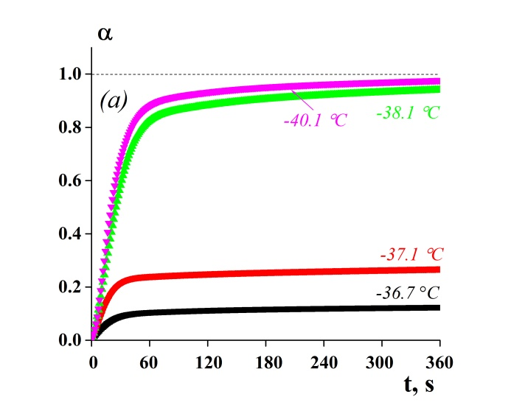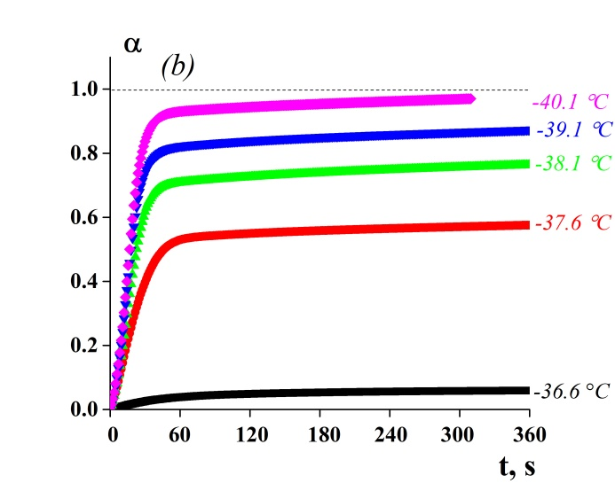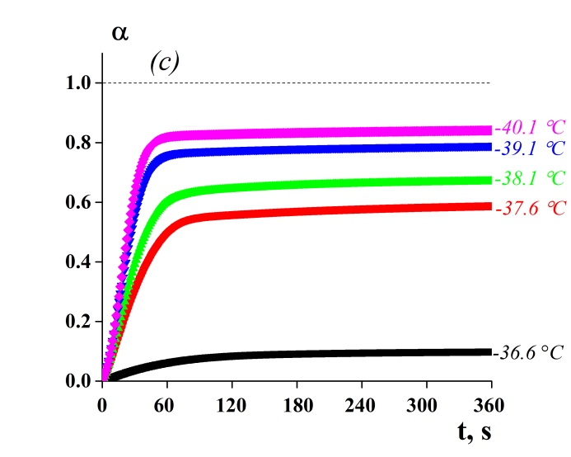
Figure 2. Integral time dependencies of the degree of crystallinity. Concentration of emulsions were (a) 5 wt%, (b) 10 wt%, and (c) 20 wt%. Temperatures of the experiments are shown on the curves.

From the experimental data presented in Figs. 1 and 2, the following conclusions can be drawn. Crystallization of water in emulsions can occur only at temperatures below −36 °C and the process is very slow or incomplete when nearing this limit. The rate of crystallinity grows monotonically with decreasing temperature down to –41 °C and at lower temperatures occurs at a very high rate. Thus, from a kinetic point of view, only temperatures in the range of −37 °C to −41 °C are of significant interest.
The analytical approximation of the kinetic curves is based on the general Eq. 1. Fitting of the experimental data with Eq. 1, produced the values of the constants shown in Table 3. The quality of the line fitting is shown in Fig. 1, where the experimental data are plotted as points and the calculated data is represented by the curves. It is observed that all the approximations are quite good in the vicinity of the maxima of the curves, though they are less good for the tails of the curves.

Table 3. Constants derived from Eq. 1.
Concentration  of emulsion, wt% | Temperature, °C | α∞ | C | t₀, s
5 | −40.1 | 0.97 | 20 | 101.8
 | −38.1 | 0.92 | 15 | 87.4
 | −37.1 | 0.25 | 15 | 7.5
 | −36.7 | 0.13 | 15 | 3.2
10 | −40.1 | 0.97 | 20 | 102.8
 | −38.1 | 0.90 | 22 | 85.5
 | −37.1 | 0.85 | 18 | 72.2
 | −36.7 | 0.55 | 15 | 31.4
20 | −40.1 | 0.85 | 25 | 113.0
 | −39.1 | 0.75 | 22 | 82.5
 | −38.1 | 0.65 | 17 | 65.0
 | −37.1 | 0.55 | 20 | 51.2
 | −36.7 | 0.10 | 26 | 6.5

Examination of the data collected in Table 3 allows the following conclusions to be drawn. Firstly, the crystallization process in the full temperature range occurs with strong self-acceleration. It seems reasonable to assume that the value of the parameter C is fairly constant and its value is in the order of 20 (a large value when compared to the other parameters). Secondly, the limit of crystallinity decreases with the shift in temperature from −40.1 °C to –36.7 °C. Finally, the characteristic time of crystallization t₀ systematically decreases with the shift in temperature from −40.1 °C to −36.7 °C. According to Eq. 1, this corresponds to an acceleration of the process because dQ/dt is proportional to 1/t₀.

3.2. Comparison with non-isothermal crystallization
The experimental data related to the non-isothermal crystallization, obtained using the DSC method in the scanning temperature mode, was published in our previous paper¹⁴. The new data is available from the present study. It is interesting to compare the correlation between isothermal and non-isothermal experimental results. This correlation can be established using a modified version of the kinetic Eq. 1, written in the following form:
$$\frac{dα}{dt}=\frac{1}{t_{0}\left[T\left(t\right)\right]}\left(1-α\right)\left\{1+C\left[T\left(t\right)\right]\right\}\left\{α_{∞}\left[T\left(t\right)\right]-α\right\}$$
(2)

where T(t) is the time dependence of temperature.
It is interesting to compare the rate of crystallization obtained from this equation, using the experimental data for non-isothermal crystallization, with the calculated values detailed in Table 3. The cooling rates (or temperature ramps) of 1, 2, 5, 10 or 20 °C/min were used. The above discussion about the data for isothermal crystallization showed that the temperature dependence of α∞ is roughly proportional to , when T ranges from T = −36.7 °C (where α = 0) to T = −40.5 °C (where α∞ = 1). In this temperature range, the t₀/α∞ ratio changes are only minor, thus, the ratio can be considered as a constant. Subsequently, to decrease the number of parameters considered in further calculations, this ratio was assumed to be equal to 100 s (± 40%). Also, for simplification of the calculations, the constant C = 20 was used as an average for all the experiments. In temperatures below −40.5 °C, where α∞ = 1, the role of temperature was explored as a function in the temperature range between −36.7 °C and −40.5 °C. Function presents a smoothly transitions to α∞ = 1 with a further decrease in temperature. These approximations are intended to obtain clear qualitative results, concerning the role of the temperature ramp, rather than provide quantitative data. The numerical solution of the dimensionless form of Eq. 2 was realized using the Mathematica software.
The kinetics of the non-isothermal crystallization for emulsion samples with a concentration of 20 wt%, using different cooling rates, is shown in Fig. 3. It can be observed that crystallization continues to occur at temperatures below −40 °C, and also occurs over a wider temperature range.

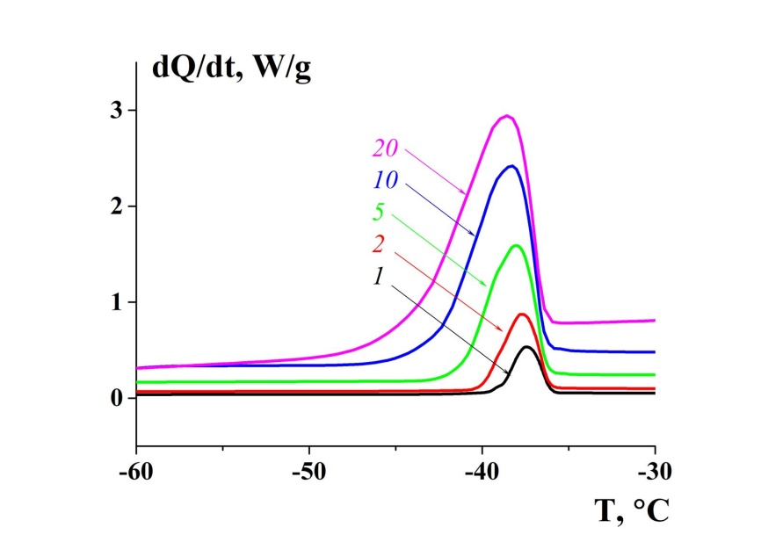
Figure 3. The kinetics of non-isothermal crystallization of emulsion samples with a concentration of 20 wt%. Cooling rates, in °C/min, are shown on the curves.

The predicted set of solutions based on the calculated isothermal data for the integral crystallinity, in parallel with experimentally observed temperature dependencies of the degree of crystallinity, for different temperature ramps are shown in Fig. 4.
At least qualitative similarity is observed between the computer model and the experimental data for non-isothermal crystallization. The model correctly predicts the trends of the temperature ramp, the position of the kinetic curves, as well as the final values of the achieved degree of crystallinity. The main difference between the experimental and calculated curves lie in the curvature of the variations of α as a function of the temperature for temperatures close to -40 C; the experimental variations of α being steeper than the calculated ones.
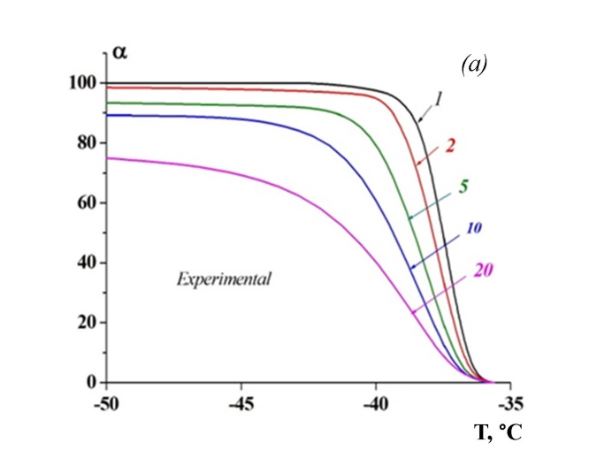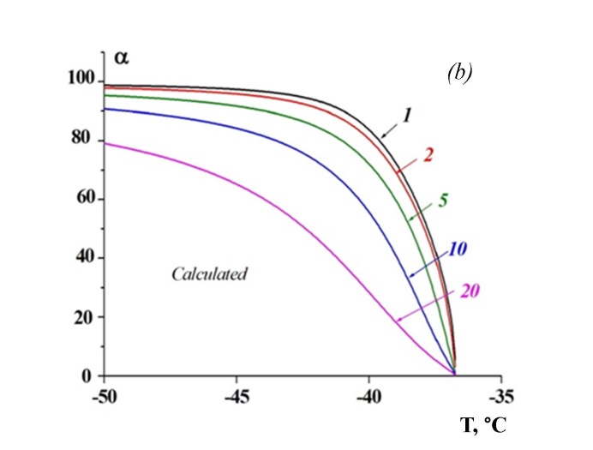
Figure 4. Comparison of (a) experimental data of non-isothermal crystallization for different temperature ramps and (b) numerical modeling. Concentration of the emulsion sample is 20 wt%. Cooling rates, in °C/min, are shown on the curves.

A more visual comparison of the calculated and experimental data is presented in Fig. 5, it shows the integral degree of crystallinity for only the fastest and slowest cooling rates. The data for the intermediate cooling rates has been omitted for simplification.

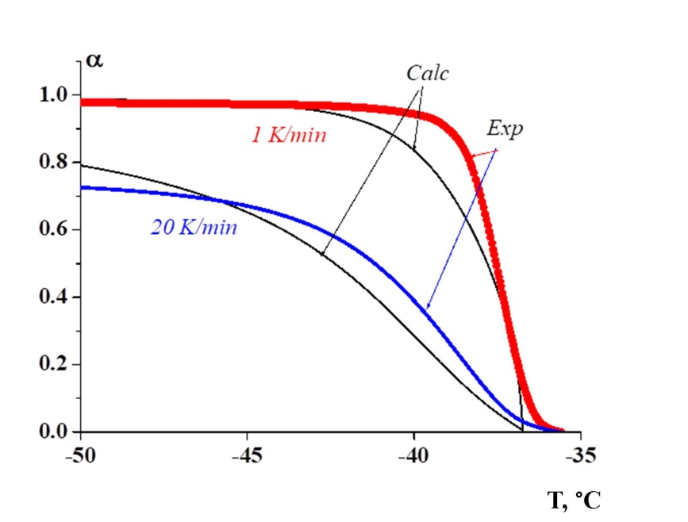
Figure 5. A comparison of the experimental and calculated dependencies of the degree of crystallinity for the fastest and slowest cooling rates.

It can be observed that the numerical model provides quite reliable results. There is quite an acceptable correlation between the two different methods of following the kinetics of low temperature crystallization of water in W/O emulsions, obtained from underwater sea oil fields. A lack of perfect alignment of the two curves is related to the rather rough analytical approximation of the isothermal data, which was implemented to simplify the numerical procedure. Indeed, the most interesting point in this study was the qualitative understanding of the role of the temperature ramp in non-isothermal experiments.
Another interesting point of note from the obtained results is the absence of complete crystallization at faster cooling rates, even at temperatures of the order of −50 °C, which is 10 °C lower than the temperature at which the isothermal process ends with complete crystallization. In addition, the cooling rate should be not higher than 5 °C/min and ideally not lower than 2 °C/min.

- Conclusions
This study of the kinetics of isothermal crystallization of water droplets in reverse water-in-crude oil emulsions, with concentrations between 5 wt% and 20 wt%, and at temperatures ranging from −36 °C to −41 °C, was conducted using the DSC method. The results made it possible to propose a mathematical model of the process, which approximates the experimental data sufficiently accurately. This model describes the kinetics of crystallization as an autocatalytic process, and at lower temperatures the process of droplet crystallization occurs at a higher rate. Using the proposed model, the degree of crystallinity of the emulsion samples can be calculated.
The final degree of crystallinity increases monotonically with decreasing temperature from −37 °C to −41 °C. There is a correlation between the data of isothermal and non-isothermal crystallization of droplets in reverse water-in-crude oil emulsions. The limiting degree of droplet crystallinity in non-isothermal crystallization depends on the cooling rate. At a high cooling rate, complete crystallinity is not achieved, even at temperatures on the order of −50 °C. In contrast, in the isothermal process complete crystallization occurs at –40 °C. In order to complete the crystallization under non-isothermal conditions, the cooling rate should be in the range of 2 °C/min to 5 °C/min.

ACKNOWLEDGMENTS
The authors are grateful for the financial support of the work by The Russian Foundation for Basic Research, project No. 16-58-20008; by NORRUS project of The Research Council of Norway No. 254959, and Vista project: a basic research program in collaboration between The Norwegian Academy of Science and Letters, and Statoil (grant number 6461). A. Malkin is grateful to the Russian Science Foundation for financial support (project No. 15-19-00072).

REFERENCES
- Sloan, E. D.; Koh, C. A.; Sum, A.; Ballard, A. L.; Creek, J. L.; Eaton, M.; Lachance, J.; McMullen, N.; Palermo, T.; Shoup, G.; Talley, L. Natural Gas Hydrates in Flow Assurance; Gulf Professional Publishing (Elsevier): New York, 2010; pp 13-36.
- Ghosh, S.; Rousseau, D. Freeze-thaw stability of water-in-oil emulsions. J. Colloid Interface Sci. 2009, 339, 91–102.
- Wong, S. F.; Lim, J. S.; Dol, S. S. Crude oil emulsion: a review on formation, classification and stability of water-in-oil emulsions. Journal of Petroleum Science and Engineering 2015, 135, 498–504.
- Montenegro, R.; Antonietti, M.; Mastai, Y.; Landfester, K. Crystallization in miniemulsion droplets. J. Phys. Chem. B 2003, 107, 5088–5094.
- Lachance, J. W.; Sloan, E. D.; Koh, C. A. Effect of hydrate formation/dissociation on emulsion stability using DSC and visual techniques. Chemical Engineering Science 2008, 63, 3942–3947.
- Creek, J. L. Efficient hydrate plug prevention. Energy & Fuels 2012, 26, 4112–4116.
- Rensing, P. G.; Liberatore, M. W.; Sum, A. K.; Koh, C. A.; Sloan, E. D. Viscosity and yield stresses of ice slurries formed in water-in-oil emulsions. Journal of Non-Newtonian Fluid Mechanics 2011, 166, 859–866.
- Clausse, D.; Dalmazzone, C. Freezing within emulsions: theoretical aspects and engineering applications. Oil & Gas Science and Technology 2014, 69, 415–434.
- Dalmazzone, C.; Noïk, C.; Clausse, D. Application of DSC for emulsified system characterization. Oil & Gas Science and Technology 2009, 64, 543–555.
- Tippetts, M.; Martini, S. Effect of cooling rate on lipid crystallization in oil-in-water emulsions. Food Research International 2009, 42, 847–855.
- Komunjer, L.; Ollivon, M.; Fouconnier, B.; Luong, A. T.; Pezron, I.; Clausse D. Influence of sodium chloride on the melting of ice and crystallization and dissociation of CCl₃F hydrate in water in oil emulsion. J. Therm. Anal. Calorim. 2009, 98, 125.
- Dumas, J. P.; Clausse, D.; Broto, F. A study of thermograms obtained through differential scanning calorimetry of an emulsion of supercooled liquid. Thermochimica Acta 1975, 13, 261–275.
- Masalova, I.; Malkin, A. Ya.; Ferg, E.; Kharatiyan, E.; Taylor, M.; Haldenwang, R. Evolution of rheological properties of highly concentrated emulsions with aging – emulsion-to-suspension transition. Journal of Rheology 2006, 50, 435.
- Kolotova, D.; Brichka, K.; Simonsen, G.; Simon, S. C.; Derkach, S.; Paso, K. G.; Sjöblom, J. Droplet crystallization in water-in-crude oil emulsions: influence of salinity and droplet size. Energy & Fuels 2017, 31, 7673–7681.
- Rodionova, G.; Pettersen, B.; Kelesoğlu, S.; Sjöblom, J. Preparation and characterization of reference fluid mimicking behavior of North Sea heavy crude oil. Fuel 2014, 135, 308–314.
- Malkin, A. Ya.; Beghishev, V. P.; Keapin, I. A.; Andrianova, Z. S. General treatment of polymer crystallization kinetics — Part 2. The kinetics of nonisothermal crystallization. Polymer Engineering & Science 1984, 24, 1402–1408.
- Malkin, A. Ya.; Beghishev, V. P.; Keapin, I. A. Macrokinetics of polymer crystallization. Polymer 1983, 24, 81–84.

