A study of anode baking gas composition

Thor A. Aarhaug¹, Trond Brandvik², Ole S. Kjos³, Heiko Gaertner¹, Arne P. Ratvik¹

¹SINTEF Materials and Chemistry, 7465 Trondheim, Norway
²NTNU Department of Materials Science and Engineering, 7491 Trondheim, Norway
³SINTEF Information and Communication Technology, 0314 Oslo, Norway

Abstract
A method has been developed to measure gas composition inside the pit in open anode baking furnaces. The gas composition can be used to understand attack on and degradation of the refractory lining, baking behavior and combustion energy contribution through the baking cycle. A probe was installed in the packing coke near the bottom of the pit while extracting gas over several days with continuous analysis with an FTIR spectrometer. The results show a clear temperature dependence of CO and CO₂ composition. Methane was found to be the dominating gas species at the beginning of the measuring cycle. Fluoride gases was also present, indicated by reactions with the glass wool filter to yield SiF₄ that was detected in small amounts. PAH condensates were observed but not systematically determined in the present campaign. Earlier results from PAH measurements before the scrubbing, showing large fluctuations, will be discussed in relation to present findings.

Introduction
The production of prebaked carbon anodes for the modern aluminum electrolysis industry is carried out in anode baking furnaces. Green anodes, made from petroleum coke, anode butts and coal tar pitch, are heat treated at temperatures cycling from room temperature to ~1200 °C. The temperature in the furnace is controlled by the flow of heated flue gas, which is separated from the anodes by refractory flue walls. Over time, the refractory flue walls are shown to degrade in several ways, reducing the operational properties of the materials. Investigations on refractory degradation in anode baking furnaces has been carried out over the last decades, indicating gaseous corrosion by sodium fluorides and reducing atmosphere being major causes of degradation [1-5].
Detailed knowledge of the gas composition in the furnace pits is thus of great interest to understand phenomena that cause degradation and to suggest possible preventive actions or materials improvements that may prolong the lifetime. Due to the high costs of replacing flue walls, less degradation and longer lifetime will improve the economics of the anode baking as well as reduce the need for maintenance. However, there has not been carried out any measurements on the gas atmosphere in a furnace pit during anode baking, and the gas composition as a function of time and temperature is largely unknown.
Gas analysis in the aluminum industry is not a new field of activity. Production of anodes for primary aluminium production is one of the major sources of PAH emissions to air [6] and analysis of PAH in the anode furnace off-gas is performed before, but more frequently after, a gas treatment center. The PAH emission levels are balanced between formation and cracking mechanisms. It is expected that due to the higher temperature of the flue gas than that of the pit, there is a difference in PAH distribution between pit and flue gas.
Methods for analyzing exhaust gas from an anode baking furnace both before and after dry scrubbing has proved to be feasible [7]. In addition, there has been experiments measuring the off-gas from the electrolysis cell, both with respect to formation mechanisms for certain gas components, but also as an emission control step before release to the surroundings [7-10].
The baking furnace is constructed with baking sections connected in series, where the anode baking process is at various stages simultaneously throughout the sections in the furnace. Due to the large variations in temperature, the gas composition in each section relates to where in the baking cycle the given section is. By analyzing the exhaust gas from the entire furnace, the gas composition will be an average of all sections in the furnace, resulting in no specific information from the individual sections during the baking process. The average measurements from the exhaust gas is important when related to atmospheric emissions, but less important when considering material degradation of the flue walls. In order to describe the gas composition in a given section throughout the baking cycle, a new setup had to be devised. Based on previous knowledge on gas analysis, an experimental setup for gas sampling in an anode baking furnace was designed. The main idea was to use a probe to sample gas from the lower part of pit while operating the anode baking furnace, and subsequently analyze the composition by Fourier transformed infrared spectroscopy (FTIR). Due to the novelty of this approach, an open pit baking furnace was chosen due to easier access than is the case with a closed furnace with section covers.

Experimental
Access to the pit was done by insertion of a probe in the packing coke while setting the anodes. A double-probe construction was designed so that the inner probe could be removed and reinserted in the pit after anode setting. In addition, this would better protect the suction pipe from being clogged by packing coke. The OD and ID of each probe was 40/34 mm and 26.7/20.9 mm, respectively. A high temperature FeCrAl alloy, Kanthal™, was used in the probe material. The probes were both 4500 mm long, but the inner tube was offset approximately 300 mm with respect to the outer. A connector made from stainless steel (SS) connected the two probes by threads on the pit side and provided a 1/4" SS tube connector to the outside tube reaching over the pit from the sampling equipment. With a pit depth of 5 meters, the top side connector is protruding from the packing coke covering the top of the pit (see Figure 1 ).
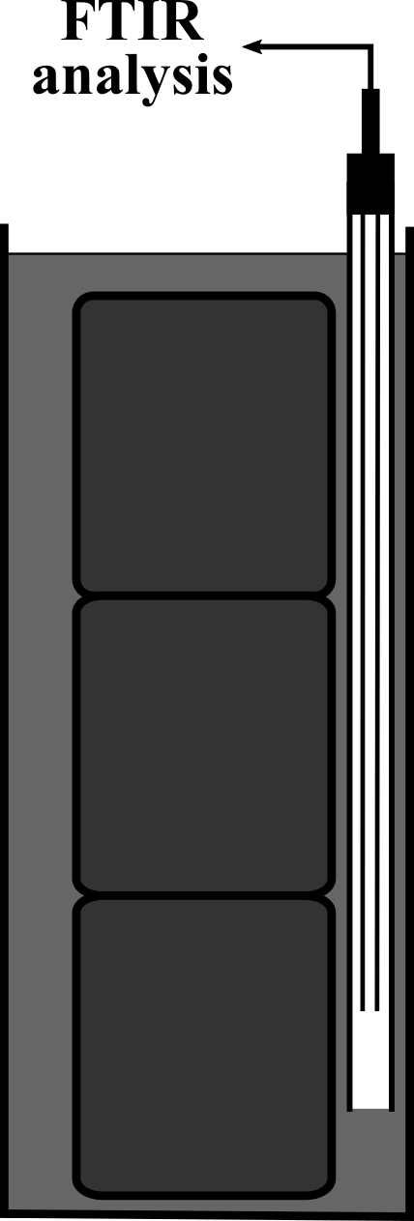
Figure 1. Sketch of the probe inserted into the pit (left), and a picture of the probe coming up from the packing coke (right). The blue pipe contains the thermocouple used during the experiment.

A ¼" SS tube of ca. 5000 mm length was used to connect the probe to the gas analyzing equipment. A 20 meter, heated ¼" Teflon tube was used to connect the probe with the gas analyzer. In order to protect the analyzer from condensing gas species, a 6.67 mm Ø by 28.89 mm column packed with glass wool was placed upstream the heated Teflon tube. The gas analyzer used was a Protea LTD ProtIR 204M. Spectral data was recorded at 1 cm⁻¹ resolution, and spectra averaged to produce a new spectrum every minute. Instrument and 20 meter Teflon tube was heated to 180 °C. Spectral interpretation was performed by manual evaluation of the spectral information and comparison with library spectral data. Quantitation was for most cases performed by linear regression of peak height values of library spectra. Extrapolation beyond the absorbance range of the library spectral data was only applied when necessary and, when used, explicitly mentioned. In cases where the Protea built in calibration models were applicable, they were used. The partial least squares modelling applied in these models comes with error estimation, and thus prediction goodness can be evaluated.
Gas was sampled from the pit in two intervals: the first interval at around 700 °C for a few hours to test the integrity of the instrumentation and, subsequently, over a week where temperature was dropping from the peak value.

Results and Discussions

Initial sampling
The instrument setup was tested for a short period at a furnace temperature slightly below 700 °C. The obtained gas spectra were busy, and ideally a dilution of the gas should have been applied. Observation of the glass wool inside the transparent column containing glass wool revealed condensation of water as well as a yellow coloring of the glass wool.
The result of the quantitation of the main gas constituents is summarized in Table 1.
Table 1. Main gas constituents from initial sampling. The results were obtained from averaging spectra from one hour of gas sampling. Extrapolated results indicated by red.
Constituent | Concentration
CO | 1.5 %
CO₂ | 0.15 %
H₂O | 2.2 %
CH₄ | 29 %
NH₃ | ~ 1 %
C₆H₆ | > 1000 ppm mol

The concentration estimates were found to be stable within the one hour sampling interval. For water, the condensation in the glass wool could influence the concentration estimate. For ammonia, an identification was made. However, as only spectral data up to 987 ppm mol was available, linear extrapolation was performed for the 1 % estimate. As the absorbance at 3333 cm⁻¹ is higher than 2, this means that this is very likely to be an underestimate of the actual ammonia concentration.
A very high concentration of methane was observed for the sample interval. Given the much lower water concentration, this means that the elemental hydrogen in the anode reacts mainly to form methane at this stage of the baking process. By analogy, the elemental nitrogen in the anode reacts to form ammonia: there are significant amounts of nitrogen in the anode raw materials [11].
A positive identification of benzene was made. Quantification was difficult because of overlapping patterns from other gas species. Since comparison with a 1000 ppm mol library spectrum was made, it was concluded that the benzene concentration was higher than this value. Naphthalene was not identified in the spectra. Neither were any sulfurous gas species like SO₂ and COS identified. This is possibly because no desulfurization takes place at these temperatures.

Long term sampling
Based on the busy spectra obtained from the initial sampling, it was decided to postpone further sampling until higher temperatures. The sampling interval was started approximately at the peak baking temperature in the flue gas at about 1150 °C. The gas composition was monitored for one week.
In contrast to the initial sampling, the methane concentrations were much lower. The concentration time series is shown in Figure 2. A fast decline to low levels were also observed.
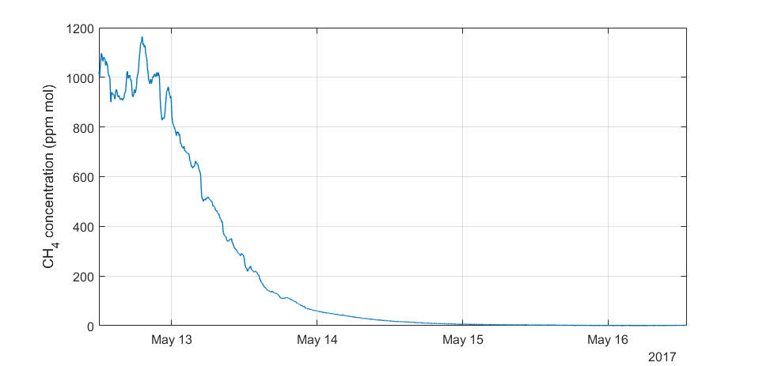
Figure 2. Methane concentration profile.

The concentration profiles for CO, CO₂, as well as the furnace temperature, is shown in Figure 3. Simultaneously with the drop in methane concentration, there is an increase in CO concentration from approx. 3 to 12 %. A rapid shift from 12 % to 14 % is observed five hours into May 14. At this point is also an increase in CO₂ concentration observed.
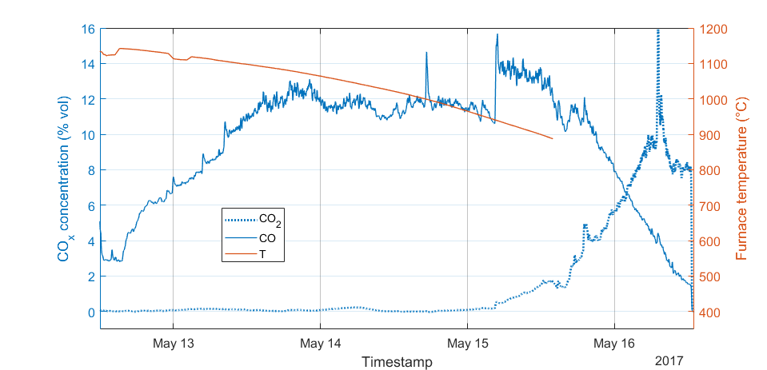
Figure 3. Time series for CO, CO₂ concentrations and furnace temperature.

The formation of carbon oxides in the pit gas is expected to source from air present by a slight underpressure in the open pit. The reactions are given by:
$C\left(s\right)+O_{2}\left(g\right)= {CO}_{2}\left(g\right)$ (1)
${C\left(s\right)+O}_{2}\left(g\right)= 2CO\left(g\right)$ (2)

Whereas the gibbs free energy change for the first reaction is almost constant at -400 kJ, the second reaction becomes favorable at temperatures higher than about 700 °C [12]. The produced CO₂ can also react with carbon to form CO in accordance with:
${CO}_{2}\left(g\right)+ C\left(s\right)=2CO\left(g\right)$ (3)
This CO₂ reactivity is also called carboxy gasification [13] or reverse boudouard reaction.
The shift from CO to CO₂ in the gas with lower temperatures could be caused by either a shift from reaction 2 to reaction 1 as well as a chemical equilibrium temperature dependence (eq. 3).
No SO₂ was observed during the sampling period. COS was however identified. COS and CO are confounded [8], but in this case the COS was observed after the decrease of CO to levels lower than the initial level of 3 % vol.
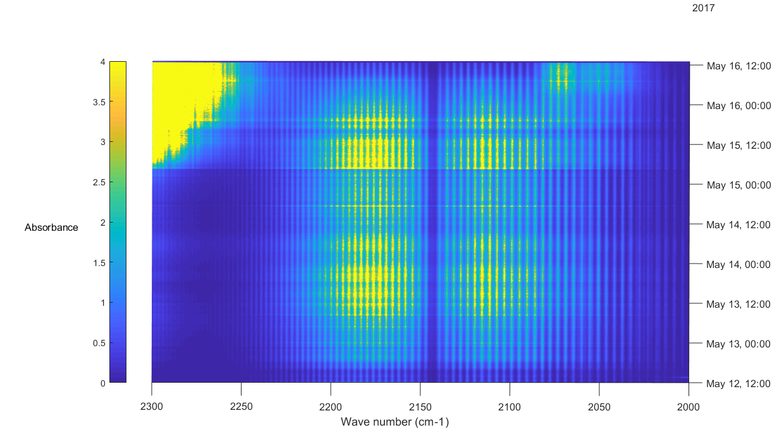
Figure 4. Contour plot of spectral information in the 2000-2300 cm⁻¹ spectral range. CO signature between 2050 and 2230 cm⁻¹. COS signature at ~ 2080 cm⁻¹ for the last spectra. The CO₂ increase is observable from 2230-2300 cm⁻¹.
A plot of the COS concentration time series is shown in Figure 5. Here the Protea PLS model was applied, simply because there were no single wave number with low interference from CO to apply for manual quantification. Modelling performance was poor, and the highest concentration of the COS library spectra was 20 ppm mol. The highest COS absorbance was more than 10 times that of the 20 ppm mol library spectrum. It is therefore assumed that the COS concentration estimates are low.
It is nevertheless clear that the COS evolution is highest when temperature is lowest. There are many proposed reaction mechanisms involving COS [14]. The FTIR instrument applied would identify a presence of CS₂, SO₂, and SO₃ species. High concentrations of H₂S would have to be present for this species to be detected. The authors can currently not propose a mechanism for the COS formation at the lowest temperatures.

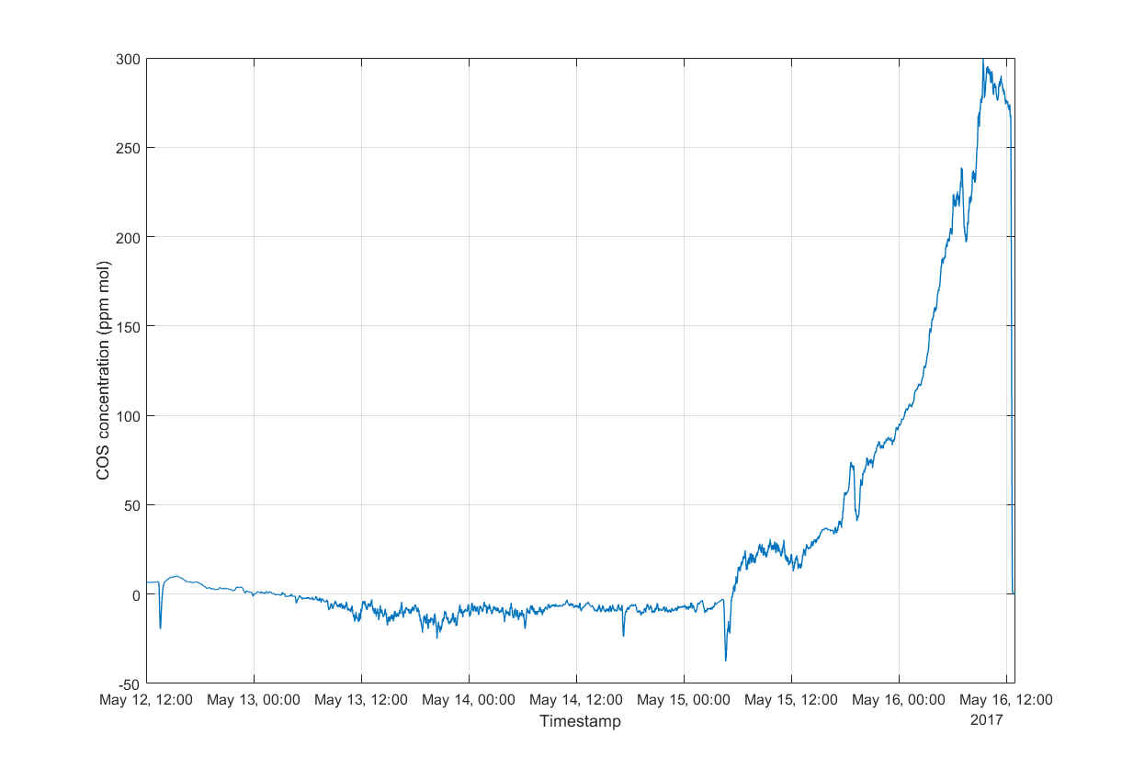
Figure 5. COS concentration time series. Protea PLS model was used for concentration estimation.

Variance in flue gas composition
The results of gas sampling from the pit indicate a large variation in the gas composition, with periods dominated by methane, CO and CO₂. The flue gas composition should therefore be influenced by the composition variation from the anode pits.
No measurements of the flue gas for the anode have been performed, but assessment of the polycyclic aromatic hydrocarbons (PAH) have previously been performed at the anode baking plant. Four samples were collected from the riser upstream the gas treatment center by using an isokinetic sampling line, and the PAH trapped in four impingers, connected in series, and filled with isopropanol. The four samples were collected over two days, two samples each day. During the sampling, these bottles were cooled to below -10 °C to avoid evaporation of solvent. This sampling strategy has previously been described [7]. Analysis was performed by GC-MSD analysis. The absolute PAH loading and distribution is shown in Figure 6.

Figure 6. PAH distribution of most prominent species.

The total amounts were 606 µg Nm³, 119 µg Nm⁻³, 29 µg Nm⁻³ and 458 µg Nm⁻³ respectively for the four samples collected, suggesting large variations in the PAH loading of the flue gas. The distribution among the different components also varies significantly. The variations in total loading can mainly be explained by the variations in the amount of anthracene and fluoranthene and to some extent chrysene and pyrene.
The relative distribution of PAH species is shown in Figure 7.

Figure 7. Relative PAH distribution amongst samples 1-4.
The relative amount of naphthalene increases with a decrease in PAH loading even if the absolute naphthalene loading follows the same trend as the total PAH loading. Other dominating PAH species are anthracene, fluoranthene, chrysene and pyrene. Benzo(b) fluoranthene has a fairly stable relative content in all samples.

Conclusions and further work
The analysis of the gas extracted revealed a dramatic change in gas composition over a few days. At the beginning of the cycle, at around 700 °C, the gas was dominated by around 30 % methane. Three days later, and at a peak temperature of about 1150 °C, the methane levels was drastically reduced to about 1000 ppm mol. During the next day, the methane was further reduced to about 10 ppm mol. In this interval, a strong increase in CO from 3 to 12 % vol was observed. At the end of the sampling period a shift in CO to CO₂ was observed. This is consistent with the reactions proposed for reactivity of anodes in air and CO₂ as a function of temperature.
At the initial sampling period, ammonia and benzene was quantified. It is suspected that heavier hydrocarbons than benzene are trapped in the glass wool filter. The yellow coloring of the filter is in support of this argument.
At the end of the sampling, COS evolution was observed. COS is the main sulfurous species formed at the anode during aluminium electrolysis [9], and it is expected to be the dominant species in a reducing gas atmosphere. It is not understood why the COS evolution appears late in the cycle, when temperature is dropping, and where a shift in dominance from CO to CO₂ is also observable.
The investigations have given some insight in how the gas environment in an anode baking furnace evolve during anode baking. In order to verify and expand the current investigations, further investigations of the anode pit atmosphere are to be conducted. The time period for investigations must be expanded to comprise larger parts of the baking cycle, in addition to systematic sampling of VOC, SVOC and PAH and, possibly, in connection with online analysis of some of these hydrocarbons.

Acknowledgement
Financial support from the Norwegian Research Council and the partners Hydro Aluminium, Alcoa, Elkem Carbon and Skamol through the project ”Reactivity of Carbon and Refractory Materials used in Metal Production Technology” (CARMA) is acknowledged. Technical support from Roger Moen and Morten Aanvik at Alcoa Mosjøen during the measuring campaign is acknowledged and highly appreciated.

References
[1] Brandvik, T., et al., Light Metals, 2017: p. 1281-1288.
[2] Bunk, F., Light Metals, 1995: p. 641-646.
[3] Prigent, P. and M.L. Bouchetou, Interceram, 2009. 58: p. 202-209.
[4] Prigent, P. and M.L. Bouchetou, Interceram, 2009. 58: p. 121-126.
[5] Oumarou, N., D. Kocaefe, and Y. Kocaefe, Ceramics International, 2016. 42: p. 18436-18442.
[6] Sentralbyrå, S. Emissions to air of hazardous substances and particulate matter, 1990-2015. 2015.
[7] Kjos, O.S., et al., Light Metals, 2014: p. 541-546.
[8] Aarhaug, T.A., et al., Light Metals, 2014: p. 647-652.
[9] Aarhaug, T.A., et al., Light metals, 2016: p. 533-536.
[10] Thorne, R.J., et al., Light Metals, 2013: p. 1207-1210.
[11] Aarhaug, T.A. and A.P. Ratvik, Journal of Metals, (submitted).
[12] Outotec, HSC Chemistry. Outotec.
[13] Chevarin, F., et al., Light Metals, 2015: p. 1147-1152.
[14] Clark, P.D., et al., Industrial Engineering Chemistry Reseach, 2001. 40: p. 497-508.

