THE JOURNEY OF ORGANIZATIONAL UNLEARNING:
A conversation with William H. Starbuck
By Nhien Nguyen

Purpose
– This paper provides an overview of the concept organizational unlearning and its development since it was first introduced to the management literature, and presents a useful perspective that can help to advance the conceptual development of this topic.

Design/methodology/approach
– Through a conversation with celebrated scholar William H. Starbuck, the paper discusses several topics that are still up for debate in the organizational unlearning literature, and argues for a number of viewpoints relevant to the application of this concept.

Findings
– Unlearning is an important requirement for organizational learning and adaptation. Change cannot occur in organizations until old knowledge and practices are replaced by new ideas and methods. Researchers and managers should pay attention to the distinction between individual behavior and organizational behavior regarding unlearning.

Originality/value
– The discussion of the contested topics of unlearning and its implications for organizational learning and adaptation will be of value to academic researchers as well as managers working in a context of environment change.

Organizational unlearning is an important metaphor that helps to describe the phenomenon of firms getting into and dealing with crises, and explain why some firms still survive while others fail (Starbuck and Nystrom, 1997). Bo Hedberg, Paul C. Nystrom, and William H. Starbuck were among the first scholars to introduce this concept to the management literature in the late 1970s. Defined as the process of “discarding obsolete and misleading knowledge” (Hedberg, 1981, p. 3), unlearning acts as a counterbalance to the positive side of organizational learning by serving as a reminder that old ideas can be detrimental for the survival of firms.
Although there is a growing body of literature in this area, researchers still have not reached consensus on several dimensions of the concept ‘organizational unlearning’. Some major topics that remain subjects of debate are: (1) Unlearning and learning: is unlearning subsumable under learning (Huber, 1991), or is unlearning a precondition for learning (Nystrom and Starbuck, 1984), or are these distinct types of organizational change processes (Tsang, 2008)? (2) Unlearning and forgetting: should unlearning be categorized as one type of organizational forgetting (De Holan and Phillips, 2011) or are they distinct notions that involve different mechanisms and generate different consequences (Tsang and Zahra, 2008)? (3) Unlearning and value judgment: is it pertinent to define unlearning as discarding ‘obsolete and misleading’ knowledge (Hedberg, 1981) or simply as abandoning knowledge “without making any judgment on the status of the knowledge or behaviors being unlearned” (Hislop et al., 2014, p. 542)? and (4) Unlearning and its contribution: is unlearning a dysfunctional model (Klein, 1989) or is it one of the “seven major contributions that have been influential since 1978” in the field of organizational learning (Easterby-Smith et al., 2004, p. 373)? These conflicting views result in the lack of a clear conceptual and operational definition of ‘organizational unlearning,’ which hinders theoretical development and empirical research in this field (Tsang and Zahra, 2008).
Which viewpoints are beneficial for advancing the conceptual development of organizational unlearning? Few people are more qualified to answer that question than William H. Starbuck, who, together with Bo Hedberg and Paul C. Nystrom, laid the foundation for this concept in the management literature. William H. Starbuck is a visiting professor at the Lundquist College of Business of the University of Oregon and professor emeritus at New York University. He received his M.S. and Ph.D. in industrial administration at Carnegie Institute of Technology, after receiving an A.B. in physics at Harvard. Having unusually wide-ranging interests, he has published over 170 articles on accounting, bargaining, business strategy, computer programming, computer simulation, forecasting, decision making, human-computer interaction, learning, organizational design, organizational growth and development, perception, scientific methods, and social revolutions. In the following conversation, William H. Starbuck provides us with an overview of the organizational unlearning journey and explains how the concept was coined and developed. His perspective might help us to refresh our views of this topic.

Nhien Nguyen (NN): Many studies have addressed that organizational unlearning was first introduced to management literature by Hedberg (1981) which is a chapter in the Nystrom and Starbuck handbook on organizational design (1981). Could you tell us a little bit about how it was coined, how it was developed, and your role as well as others’ in coining and shaping the concept?

William H. Starbuck (WS):
Bo Hedberg and I were colleagues in Berlin in the early 1970s, and around 1973, we decided to collaborate in studies of how businesses run into crises. When I moved to Milwaukee, Wisconsin, in 1974, Bo came there also as a visitor for one year and Paul Nystrom joined us. Paul and I co-edited the Handbook of Organizational Design, which included Bo’s chapter that you cited above. However, Bo’s chapter was not the first time we wrote about unlearning.

Unlearning derived from our case studies of companies that got into very serious crises. This concept helped us to explain why companies did not adapt to changes in their environments – they became so locked into their current ways of operating that they often did not even see the changes looming in their futures, and when they encountered the environmental changes, they could not see how to react to them.

One of our first papers that discussed unlearning was our 1976 paper “Camping on Seesaws”, which has been cited more than eight times as often as Bo Hedberg’s 1981 chapter. However, I doubt that “Camping” was the first paper in which we discussed unlearning. Here is a list of papers that talked about unlearning before Bo’s chapter appeared: "Camping on seesaws: Prescriptions for a self-designing organization" (Hedberg et al., 1976), "Interacting processes as organization designs" (Nystrom et al., 1976), "Designing organizations to match tomorrow" (Hedberg et al., 1977), "Saving an organization from a stagnating environment" (Starbuck and Hedberg, 1977), “Strategy formulation as a discontinuous process” (Hedberg and Jönsson, 1977), "Responding to crises" (Starbuck et al., 1978), "Designing semi-confusing information systems for organizations in changing environments” (Hedberg and Jönsson, 1978), and “How organizations learn and unlearn,” (Hedberg, 1979) which is probably a draft of Bo’s 1981 chapter.

NN: How has your interpretation on this topic changed over time, if any?

WS: From the beginning, I thought of unlearning as an organizational phenomenon, not a property of individual people. That is, I think unlearning is a prevalent requirement for organizational adaptation, especially adaptation of bureaucratic organizations. Bo, Paul, and I used the notion of unlearning to explain what we saw happening in organizations. Some of these organizations were not really bureaucratic, but bureaucracies have practices that make unlearning and adaptation more difficult.
Unlearning is a prevalent requirement for organization adaptation

Bo and I disagreed about the necessity of unlearning for adaptation by individual human beings: Bo thought and wrote that individuals need to unlearn explicitly, whereas I argued that individuals can learn new knowledge by recording on top of what they already know, essentially pushing their prior knowledge into the background. However, Bo and I agreed that individuals need to be willing to shed their reliance on knowledge that is growing obsolete.

We did not invent the term “unlearning”. Thought and discussion about unlearning by individual people long predated our usage of the term. John Dewey, who was a major American philosopher of education, used the term “unlearn” in his 1938 book “Experience and Education”. Dewey probably got this term from an earlier author. Google’s Ngram Viewer says that “unlearn” first appeared in a book just before 1650, and “unlearning” first appeared in a book around 1700.

NN: Could you share with us your thoughts on how important this concept is in the field of organizational theories, especially organizational learning?

WS: I can share with you a spreadsheet that graphs the frequencies with which academics have published papers in this area since 1975. Graph 1 shows the number of papers each year that include the words “organization” and “unlearn”. Graph 2 shows the logarithm of the number of papers each year that include the words “organization” and “unlearn”. The fact that this chart shows a very straight line indicates that the rate of growth in the number of papers has been increasing at a very steady rate. If the line were horizontal, the growth rate would have been constant. Since the line is going upward, the number of these papers has been growing faster and faster. The last graph shows the percentage of papers that mention “Starbuck” in addition to “organization” and “unlearn”. Adding my own name seems a simple way to identify papers that have given the term “unlearn” a meaning very similar to the meaning my colleagues and I have assigned it.

Since the line is going upward, the number of these papers has been growing faster and faster

Graph 1: Academic papers that include both "organization" and "unlearn" (Linear axis)
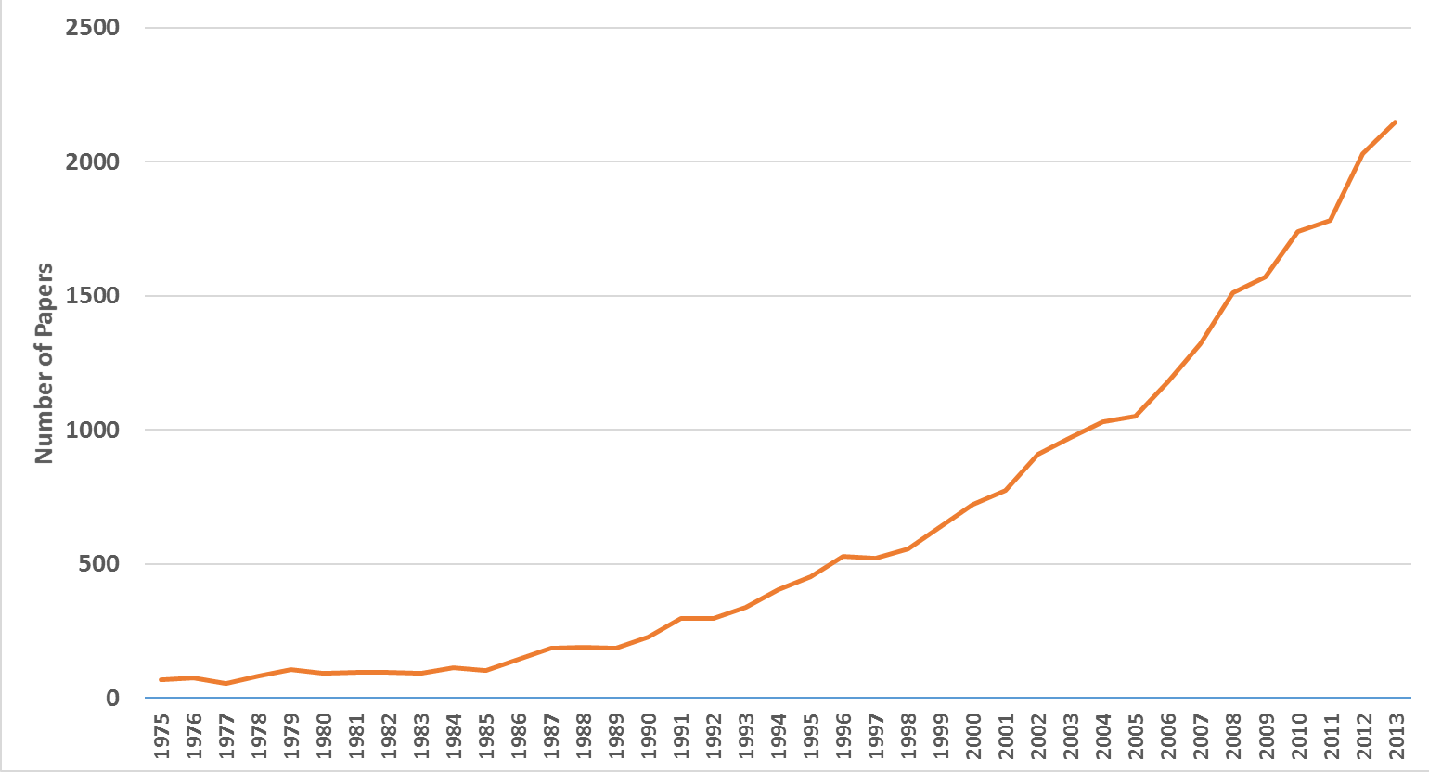

Graph 2: Academic papers that include both "organization" and "unlearn" (Logarithmic axis)
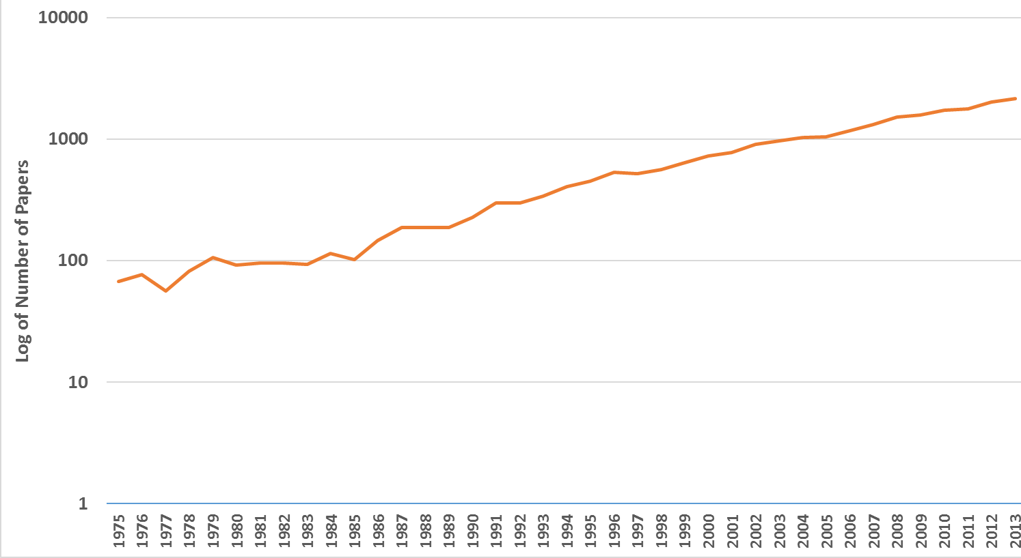

Graph 3: Percentage of academic papers that include "organization" "unlearn" and “Starbuck" (Linear axis)

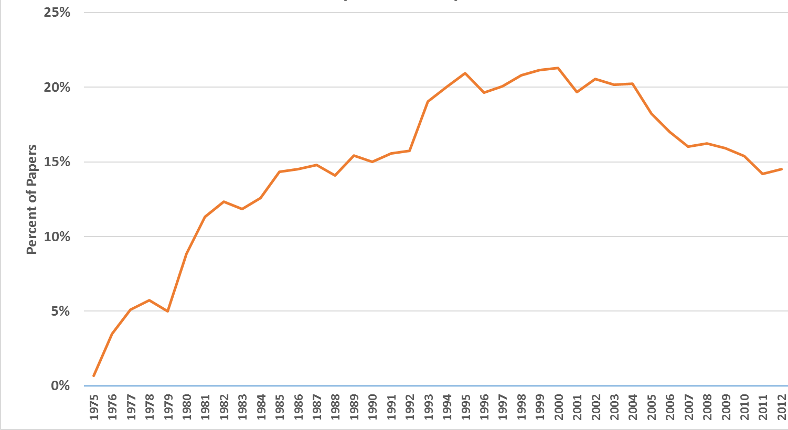

The charts show that such papers have increased at a steady growth rate since 1975. There is no evidence to believe that the growth rate is decreasing. I stopped gathering data in 2013 because a prior study indicated that Google Scholar tends to undercount citations during the most recent six years.

I tried to think of a relevant comparison for the counts of papers about unlearning, and I experimented with a couple of possibilities. But these experiments yielded either very large numbers of citations, which suggested that my categories were too broad, or very small numbers of citations, which suggested that my categories were too narrow.

NN: What might you want to respond to the claim in a recently published article about unlearning in which the authors (Howells and Scholderer, 2016) conclude that Nystrom and Starbuck (1984) incorrectly attached the authority of a review of the psychology literature to Hedberg’s book chapter (1981) and suggest dropping unlearning from scholarly discourse?

WS: I have read that article by Howells and Scholderer, and below are my reactions.

Reaction 1. I do not want to defend Bo’s chapter. He wrote it; I didn’t and I disagreed with him about his focus on psychology. I have not studied the psychological evidence about human memory, but seems likely that this evidence has changed since the late 1970s. I have read models of human memory that assume people never literally forget something they knew earlier, but newer learning gradually overwrites earlier knowledge and this process makes the earlier knowledge less accessible. One of my friends as a graduate student could provide us with detailed itemized bibliographies on many research topics; he appeared to have read very, very widely and he could provide titles, authors, abstracts, details of methodology, etc. for vast numbers of academic papers. Psychologists have recently studied a very few people (perhaps 6 in the whole US) who appear to be able to recall very tiny details of what happened on a specific day many years ago – what they ate for breakfast, what appeared in the newspapers, what the weather was, etc. It seems that different individuals differ greatly in the memory processes, and people with very exceptional memory recall seem to be able to live without unlearning. On the other hand, can you imagine how difficult it would be to live with someone who has accurate memory of EVERYTHING that you have experienced together?

Reaction 2. The authors of that article seem to make no distinction between individual behavior and organizational behavior. I think this is a serious mistake. Organizations are as diverse as individual people, but many organizations write down procedures in manuals and they teach new employees to follow the procedures in those manuals. Most organizations take on activities that are much too broad for any single person to perform, and they hire specialized personnel who have great expertise in specific technologies or practices that sometimes grow obsolete. Many organizations build specialized factories or machines that they cannot easily adapt to new uses, they take on large debts in order to make such investments, and they make predictions (that often prove wrong) about how long these investments will continue to be useful. Thus, organizations’ memories have different properties than the memories of individual people.
organizations’ memories have different properties than the memories of individual people

Reaction 3. The authors frame their argument in a very contentious way, which seems inappropriate given that Bo wrote his chapter 38 years ago and he might not say the same things if he were alive today.

I have noticed that contentious argumentation has become increasingly prevalent recently, and I wonder if this aggression is partly a consequence of the rapid increase in numbers of academic journals. Journal publishers are struggling to survive and to expand their domains, and one way to do this is to attract attention. Academics love to observe “mud wrestling” … not necessarily to engage in it themselves, and I have in fact advised a couple of editors to nurture debates in their journals so as to attract more readers.

NN: Talking about debate, it can be beneficial but can also be misleading. Therefore, regarding the topics that remain the subjects of debate mentioned in the introduction, can you offer us some advice on which viewpoints are beneficial for advancing the conceptual development of organizational unlearning?
(1) Unlearning and learning: is unlearning subsumable under learning, a precondition for learning, or are these distinct types of organizational change processes?
WS: Our studies of organizations facing crises revealed instances in which organizations were unable to adopt new strategies and behaviors because adoption was blocked by strategies and practices that were already in place. For example, some current top managers were very reluctant to resign and create openings for the hiring of new top managers. These current top managers realized that they did not know how to rescue their troubled companies, but they were in their fifties or sixties and they knew they were very unlikely to find new managerial positions of equally high status, so they hung on to power tenaciously. These periods of entrenched control usually involved the concealing of companies’ true problems by means such as deceptive financial reports. As a result, other people in the companies and outside them had to go through painful, expensive, and organizationally harmful periods when they gradually lost confidence in the current top managers. In some of these cases, the companies did not survive because the period of unlearning destroyed too many of their resources, so no new behaviors were learned, although one could say the people learned how not to go forward. In other cases, no changes occurred until the companies were taken over by outside investors, who brought in new ideas and methods.
no changes occurred until the companies were taken over by outside investors, who brought in new ideas and methods.

NN: (2) Unlearning and forgetting: should unlearning be categorized as one type of organizational forgetting, or are they distinct notions that involve different mechanisms and generate different consequences?
WS: Google defines “forget” as “fail to remember” with two subcategories: (a) “inadvertently neglect to attend to, do, or mention something,” or (b) “put out of one's mind; cease to think of or consider.” These alternatives do not seem to allow for very explicit efforts to stop acting as before, people learn behaviors as well as knowledge, and people crystallize some of their knowledge in physical objects such as factory designs, databases, and training courses, so we wanted a term that would encompass explicit actions. We included in “unlearning” acts such as selling manufacturing equipment, losing confidence in and firing of personnel, giving less influence to personnel whose expertise seems to have grown less relevant, terminating training programs, and destroying procedure manuals. You can decide whether such actions are merely forgetting.
we wanted a term that would encompass explicit actions

NN: (3) Unlearning and value judgment: is it pertinent to define unlearning as discarding ‘obsolete and misleading’ knowledge, or simply as abandoning knowledge “without making any judgment on the status of the knowledge or behaviors being unlearned”?
WS: We used the term “unlearning” to identify overt actions that people took to stop behaving in certain ways and to stop relying on specific knowledge. Explicit actions are necessary because organizations imbed their knowledge in factories, formal job descriptions, hierarchies, hiring criteria, machines, manuals, personnel assignments, routines, training, and other elements that are difficult to ignore. People usually assess the usefulness of the factories, job descriptions, et cetera before they stop using them. However, people often make faulty assessments. They often misjudge the value of their current resources, and they make incorrect predictions about the future.
People usually assess the usefulness of the factories, job descriptions, et cetera before they stop using them. However, people often make faulty assessments.

NN: Thank you very much for sharing your insights with us!

He has published over 170 articles on a variety of subjects. For the last few years, many of his papers have discussed the deficiencies of common statistical methods, ways to make better statistical analyses, the deficiencies of peer review, ways to improve editorial processes, and trends in the operation of universities, or topics that journal or book editors ask for his help to write about. He is currently co-authoring a book chapter about the evolution of business strategies.
William H. Starbuck has been the editor of Administrative Science Quarterly. He formerly served on the editorial boards of the Academy of Management Review; Accounting, Management and Information Technologies; Administrative Science Quarterly; the British Journal of Management; the Journal of Applied Social Psychology; the Journal of Leadership Studies; the Journal of Management Inquiry; the Journal of Socioeconomics; Knowledge Management and Information Studies; and Organization and he currently serves on the editorial boards of the Asian Case Research Journal; Information and Organization; the International Journal of Management Reviews; the Journal of Management Studies; Organization Management Journal; and the Scandinavian Journal of Management.

References
De Holan, P.M. and Phillips, N. (2011), "Organizational forgetting", in Handbook of organizational learning and knowledge management. John Wiley & Sons, Inc., pp. 433-451.
Dewey, J. (1938), Education and experience, Kappa Delta Pi, New York, NY.
Easterby-Smith, M., Antonacopoulou, E., Simm, D. and Lyles, M. (2004), "Constructing Contributions to Organizational Learning: Argyris and the Next Generation", Management Learning, Vol. 35 No. 4, pp. 371-380.
Hedberg, B. (1979), How organizations learn and unlearn, Arbetslivscentrum, Stockholm
Hedberg, B. and Jönsson, S. (1977), "Strategy formulation as a discontinuous process", International Studies of Management & Organization, Vol. 7 No. 2, pp. 88-109.
Hedberg, B. and Jönsson, S. (1978), "Designing semi-confusing information systems for organizations in changing environments", Accounting, Organizations and Society, Vol. 3 No. 1, pp. 47-64.
Hedberg, B., Nystrom, P.C. and Starbuck, W.H. (1976), "Camping on Seesaws: Prescriptions for a Self-Designing Organization", Administrative Science Quarterly, Vol. 21 No. 1, pp. 41-65.
Hedberg, B., Nystrom, P.C. and Starbuck, W.H. (1977), "Designing organizations to match tomorrow", in Prescriptive Models of Organizations. North-Holland, pp. 171 - 181.
Hedburg, B. (1981), "How organizations learn and unlearn", in Nystrom, P.C. and Starbuck, W.H. (Ed.) Handbook of organizational design, Oxford University Press, New York, pp. 3-27.
Hislop, D., Bosley, S., Coombs, C.R. and Holland, J. (2014), "The process of individual unlearning: A neglected topic in an under-researched field", Management Learning, Vol. 45 No. 5, pp. 540-560.
Huber, G.P. (1991), "Organizational learning: The contributing processes and the literatures", Organization science, Vol. 2 No. 1, pp. 88-115.
Howells, J. and Scholderer, J. (2016), " Forget unlearning? How an empirically unwarranted concept from psychology was imported to flourish in management and organisation studies," Management Learning, Vol. 47 No. 4, pp. 443-463.
Klein, J.I. (1989), "Parenthetic learning in organizations: Toward the unlearning of the unlearning model", Journal of Management Studies, Vol. 26 No. 3, pp. 291-308.
Nystrom, P.C., Hedberg, B. and Starbuck, W.H. (1976), "Interacting processes as organization designs", in Kilmann, R.H., Pondy, L.R. and Slevin, D.P. (Ed.) The management of organization design, Elsevier, North Holland, pp. 209-230.
Nystrom, P.C. and Starbuck, W.H. (1981), Handbook of Organizational Design: Remodelling organizations and their environments. Oxford University Press, USA.
Nystrom, P.C. and Starbuck, W.H. (1984), "To avoid organizational crises, unlearn", Organizational Dynamics, Vol. 12 No. Spring, pp. 53-65.
Starbuck, W.H., Greve, A. and Hedberg, B. (1978), "Responding to crises", Journal of business administration, Vol. 9 No. 2, pp. 111-137.
Starbuck, W. H. and Hedberg, B. (1977), "Saving an organization from a stagnating environment", in Thorelli, H. B. (Ed.) Strategy + Structure = Performance: The Strategic Planning Imperative. Indiana University Press, pp. 249-258.
Starbuck, W.H. and Nystrom, P.C. (1997), "Why many firms run into crises, and why some survive", Documento de trabajo. Stern School of Business Management and Organizational Behavior.
Tsang, E.W.K. (2008), "Transferring knowledge to acquisition joint ventures: An organizational unlearning perspective", Management Learning, Vol. 39 No. 1, pp. 5-20.
Tsang, E.W.K. and Zahra, S.A. (2008), "Organizational unlearning", Human Relations, Vol. 61 No. 10, pp. 1435-1462.

The Google Ngram Viewer or Google Books Ngram Viewer is an online search engine that displays a graph showing how search phrases have occurred in a corpus of books over the selected years (https://books.google.com/ngrams/info)

