Effects of heat-treatment on the plastic anisotropy of extruded aluminium alloy AA6063

M. Khadyko1, C. D. Marioara2, S. Dumoulin2, T. Børvik1, O.S. Hopperstad1

*1Structural Impact Laboratory (SIMLab), Department of Structural Engineering, Norwegian University of Science and Technology (NTNU), NO-7491 Trondheim, Norway*

*2SINTEF Materials & Chemistry, NO-7465 Trondheim, Norway*

# Abstract

The plastic anisotropy of aluminium alloys is known to depend not only on the crystallographic texture but also on the heat-treatment, and this effect has been studied on various alloys both experimentally and numerically. However, the 6000 series of aluminium alloys is not broadly represented in these studies. In this work, an extruded profile of the AA6063 alloy was investigated. Electron backscatter diffraction (EBSD) measurements revealed a strong cube crystallographic texture with a minor Goss component, which is typical for recrystallized aluminium alloys. The plastic anisotropy was studied by uniaxial tension tests in different material directions, using digital image correlation to measure the displacement field and thus to calculate the strain field. The tensile specimens were heat-treated to three different tempers: T6, T7 and O, in addition to the as-received T1 condition. Transmission electronic microscopy (TEM) was used to characterize the precipitate structure of the heat-treated material. A crystal plasticity finite element model of the tensile test was created and calibrated using some of the experimental data. The comparison of the experimental stress-strain curves, strain ratios and flow stress ratios with their simulated counterparts revealed that the crystallographic texture is dominating the anisotropy in all tempers. The accuracy of the CP-FEM predictions varies for different material orientations, and, in general, the simulated material exhibits a sharper anisotropy than the real material. The effect of the heat treatment on the anisotropy is found to be minor compared with the texture effect.

# Introduction

Aluminium alloys have been used in structural engineering applications for many decades due to the combination of low density and high strength, and other advantageous properties. What has been instrumental in their success is the possibility to control the plastic properties, such as yield stress, work-hardening rate and plastic anisotropy by changing the chemical composition, heat-treatment and mechanical processing. A precise control over the material properties and behaviour of Al alloys during all stages of their production and service could be very beneficial for the aluminium industry. Thus, extensive research on Al alloys has been carried out in two areas: firstly, the development of more accurate material models, ranging from phenomenological plasticity models [1] to physically based crystal plasticity models [2], and secondly, dedicated experimental studies on the various microstructural features of Al alloys and their connection with the alloys’ macroscopic behaviour. One of the facets of the macroscopic plastic behaviour of the Al alloys is the anisotropy, e.g. represented by the variation of the flow stress and the plastic strain ratio in uniaxial tension tests in different material directions. One of the main sources of the plastic anisotropy was established together with the whole field of crystal plasticity by Taylor in [3]. He demonstrated that the main plastic deformation mechanism in Al crystals is the slip on a set of crystallographic planes and directions, which naturally leads to the plastic anisotropy of the crystals. When the theory was applied to polycrystalline materials, the individual crystallographic orientations of the crystals were replaced with the statistical concept of crystallographic texture, which is directly responsible for the polycrystals’ anisotropy through the mechanism of plastic slip. The texture is considered to be the main and often the only source of the plastic anisotropy in Al alloys and various implementations of the crystal plasticity theory have been used to predict the anisotropy based only on the texture of the alloys in question [4-7].

Nevertheless, it was noticed as early as in the 1940s that the extruded heat-treated Al alloys exhibit some particular anisotropic behaviour. The German metallurgists who noticed this behaviour, called it “Presseffekt” and described their findings in [8, 9]. In those cases, the texture alone could not satisfactorily explain the anisotropy of the material. A new wave of interest in the issue arose in the 1970s. In several works, including [10-13], an attempt was made to study other microstructural features affecting anisotropy in a direct and comprehensive way. In [10-12] the Al 4 wt.% Cu alloy was used, both as single crystals and polycrystals (rolled sheets), and in [13] the Al 15 wt.% Ag alloy and an industrial Al-Mg-Si alloy were investigated. These works established a standard procedure for this type of studies: first, the alloy’s chemical composition and texture were characterised; then, specimens in several directions with respect to the material axes were produced and variously heat treated; and finally, mechanical tests were performed to reveal the mechanical behaviour as a function of the heat-treatment. The precipitates in the heat-treated alloys were characterized and sometimes an attempt to model the observed behaviour was made. In these early works, plane-strain compression tests were used, along with cup drawing in [12]. The specimens were treated to under-aged, peak-aged and over-aged conditions, as well as solid solution condition. The elastic inclusion model was used in conjunction with the experimental results in [13]. The conclusions of all these studies were similar. If the platelet precipitates that formed in the alloys lay on the (100) crystallographic plane, then they reduced the anisotropy of the alloy caused by the texture. On the other hand, the platelets lying on the (111) crystallographic plane strengthened some slip systems more than others and led to an intensified anisotropy, compared to the alloys with no precipitates. The effect of the precipitates was the strongest in the under-aged and peak-aged conditions and got significantly weaker in the over-aged condition.

In the 1990s, the research continued in the vein of these early works. Uniaxial tension and compression tests replaced the plane-strain compression test as the most widespread test configuration. The single crystal specimens were also abandoned in favour of rolled and extruded sheets. The materials used for these studies also tended toward the more industrially used alloys, like AA2090 in [14-17], AA2195 in [18], AA7075 in [19, 20], albeit the binary AlCu alloys were still the focus in [21-23]. The main results of the studies mostly agreed with the results from the previous decade. The platelet-shaped precipitate particles that form in the AA2000 and AA7000 series of alloys in the under-aged and peak-aged conditions can enhance or reduce the texture-induced anisotropy depending on their orientation in the crystal. Nevertheless, the consensus was not as uniform as before. In [18] the heat-treatment seemed to have no effect on the anisotropy of the AA2195 alloy. The works from the 1970-1980s were content with qualitative agreement between experiments and models, while [15] used the plastic inclusion model proposed in [11] and came to a conclusion that it could not explain quantitatively the deviations from the texture-induced anisotropy. In [16] the anisotropy of the AA2090 was studied not just for several heat-treatments, but for the whole aging range starting with the as-quenched condition. The conclusion made from those experiments was that the anisotropy was evolving in a complex and nonlinear way because of interactions between texture, grain morphology and precipitates. Another work that explored a whole spectrum of states instead of just a few points was presented in [24], where the influence of the alloying element concentration on the anisotropy of a baseline AA2195 was studied. It was demonstrated how the plastic anisotropy could be strongly affected by small variations of Li content.

The 2000s saw a number of articles where the binary AlCu alloys were revisited in an attempt to establish rigorous and predictive models for the precipitates’ influence on the plastic properties, including the anisotropy. AlCu binary alloys seemed to be a natural choice, as a relatively simple and controllable system compared to the multicomponent industrial alloys. Some works even returned to the single crystal specimens [25] and the plane-strain compression tests [26, 27]. In addition to the analysis of the stress-strain curves and flow stress anisotropy, Choi et al. [28] studied the anisotropy in plastic flow and found that the strain ratio was more affected by the precipitates than the flow stress ratio. The industrial alloy of the AA2090 type in the form of rolled sheets was used in [29] and AA2195 in [30]. Garmestani et al. [29] tried to separate the effects of the texture and the precipitates on the anisotropy into linearly additive contributions, but concluded that it was not possible.

In the 2010s the industrial alloys again returned to the forefront. The AA2000 series was explored further and more experimental data was produced and presented in [31] (2A12 alloy), [32, 33] (AA2099), [34] (AA2024) and [35, 36] (AA2090). The AA7000 series was explored in [37] (AA7050), [38] (AA7075) and [39, 40] (AA7010). In some cases the focus of the study was not directly on the anisotropy itself, but about the effect of the heat-treatment on formability, such as in [34, 38], or anisotropic fracture [37, 41]. Two consecutive works [32, 33] investigated the anisotropic properties of different parts of an extruded AA2099 component and concluded that the texture and precipitates contribute to anisotropy in a complex interacting way. Anisotropy of Al sheets has often been studied by using tension or compression tests in only 3 directions: 0°, 45° and 90° to the rolling (extrusion) direction (see e.g. [40]). In [38] it was demonstrated that these tests can be insufficient to characterise the anisotropy of the material in some cases.

The AA6000 series of alloys was until recently not investigated in this type of studies. AA6000 precipitates are typically rod or needle-like and oriented along the <100> crystallographic axes. In [42] the effect of this type of precipitates on the yield strength and work hardening was modelled and studied experimentally. The modelling showed that this type of precipitates should counteract the texture-induced anisotropy. Nevertheless, in [43] an investigation of rolled AA6061 alloy sheets revealed a more complex trend, where the precipitate effects on the anisotropy interacted with the texture effects. The more recent study by the same authors [44] investigated the influence of precipitate particles on the yield stress anisotropy of the rolled AA6061 alloy in three material directions (0°, 45° and 90° to the rolling direction) and modelled the effect of the precipitates with elastic and plastic inclusion models. Other works that dealt with the AA6000 series include [5], where the main focus was on the effects of pre-stretching of AA6016 rolled sheets on its anisotropy, and [45], where the effect of aging on the forming limit diagram of AA6063 alloy sheets was studied.

To the best of the authors’ knowledge the influence of heat-treatment on the plastic anisotropy of AA6000 alloys has not been investigated in a detailed and focused manner, as in the case of AA2000 and AA7000 alloys. In [43], only three material directions were used, and the texture variation was introduced as an additional parameter. In [44] only the yield stress in three material directions was investigated. Therefore, the objective of this article is to carry out a more detailed investigation of the plastic anisotropy of an extruded AA6063 alloy using multiple material directions and a constant crystallographic texture. To this end, uniaxial tension specimens in different material directions were produced from aprofile and heat-treated to the T6, T7 and O tempers in addition to the as-received T1 condition. Previous studies of the AA6000 series extruded alloys [46, 47] indicate that the 0° material direction shows behaviour deviating significantly from the crystal plasticity predictions and experiences some marked effects of the heat-treatment, so the specimens were cut at 0°, 5°, 10°, 15°, 22.5°, 45°, 67.5° and 90° to the extrusion axis. The crystallographic texture and grain morphology were characterized using electron backscatter diffraction (EBSD), while the precipitate density and structure for the undeformed material in T6, T7 and O tempers were investigated in a TEM study. The digital image correlation (DIC) method was used to measure the displacements and calculate strains. In addition, a series of crystal plasticity finite element simulations (CP-FEM) was run using the microstructural and mechanical data for the AA6063 alloy. The simulation results are presented alongside the experimental data for comparison, as an idealized case, in which the crystallographic texture defines the anisotropy of the material.

The article is organised as follows. Section 2 describes the AA6063 extruded profile, while Section 3 summarises the heat-treatment and testing methods. Section 4 presents the methods and results from the TEM study of the precipitates in the heat-treated material. The crystal plasticity theory and its numerical implementation in CP-FEM are briefly described in Section 5. Section 6 presents and compares the experimental and numerical results, which are further discussed in Section 7 in the context of the existing knowledge. Section 8 provides the conclusions of the study.

# Characterization of as-received material

DC-cast billets of the AA6063 alloy with a diameter of 203 mm were produced by Hydro Aluminium. The chemical composition of the alloy is specified in Table 1. The material was homogenized in a batch homogenization furnace: it was heated at a rate of 200°C/h to 585°C, kept at 585ºC for 5 hours and then cooled to room temperature at a rate larger than ~500°C/h. Billets were extruded to flat profiles with 205 mm width and 3 mm thickness using a billet temperature of 480°C, a container temperature of 440°C and a ram speed of 20 mm/s. All profiles were cooled with maximum water-spray cooling followed by forced air-cooling. The temperature after spray cooling was measured to 360ºC. Some information about the properties of the as-received material directly after production may be found in [48].

The microstructure of the profile was characterised with EBSD. The EBSD measurements were carried out in the plane defined by the extrusion direction (ED) and the thickness (or normal) direction (ND) of the profile, using 5 µm steps on a square grid. The 3040×2695 µm2 grid covered almost the whole thickness of the profile, providing 328860 measurement points. A total of 1147 grains were identified in the grid area. These measurements are presented in Figure 1. The results show a central layer consisting of smaller grains () with orientations scattered around the main cube component, the intermediate layers with randomly oriented large grains (), and the outer layers comprised of smaller grains with approximately Goss orientation. This type of distribution of the grain orientation and morphology is commonly found in extruded Al profiles with recrystallized microstructure [49].

The orientation distribution function (ODF) was calculated from pole figures in the EDAX TSL OIM software using a harmonic series expansion and triclinic sample symmetry [50]. The section plot of the ODF is presented in Figure 2. The ODF was calculated using the data for the whole extrusion, and both major cube and minor Goss components may be identified in the section plots. The texture is strong, with maximum intensity of 42.

# Heat-treatment and testing method

The uniaxial tensile test specimens were produced from the received extruded profiles. The specimens were of a “dog bone” type, with ends fixed by bolts in the test machine and with gauge part having the cross-section dimensions of 3 mm × 8 mm and length of 35 mm. The specimens’ tensile axes were oriented at 0°, 5°, 10°, 15°, 22.5°, 45°, 67.5° and 90° to the extrusion axis of the flat profile. Special attention was given to the 0° orientation because in previous studies, including [46, 47] on extruded AA6000 series alloys, this orientation demonstrated high yield strength and work-hardening compared to the predictions of the CP-FEM simulations.

Two specimens of each orientation were produced for each of the four tempers, giving in total 64 specimens. The as-received material of the extruded profile corresponded to the T1 temper. It was stored at room temperature for a prolonged period (several years) prior to the specimen production. After the specimens were cut out of the profile, they were heat-treated to T6, T7 and O tempers. For the T6 temper an oil bath at 185°C for five hours was used, while T7 was treated in the oil bath at the same temperature for one week. O temper was treated in a salt bath at 350°C for 24 hours. After the treatment, all three alloys were air cooled. Previous studies on the extruded AA6063 alloys [47] show that these heat-treatments do not lead to changes in the grain structure or somehow affect the crystallographic texture; therefore, it is assumed that the specimens of different tempers are practically identical in their crystallographic properties.

The displacement rate in the tests was 0.0167 mm/s for the T1 and O tempers, and 0.008 mm/s for the T6 and T7 tempers, which gives an approximate engineering strain rate before necking of  and , respectively. Considering the low rate sensitivity of Al alloys in a broad range of strain rates [51] and the lack of dynamic effects, the applied deformation may be considered quasi-static.

Before testing, each specimen had a speckle-pattern painted on one of the surfaces. The speckle-pattern was photographed with a Prosilica GC 2450 camera at 1 Hz frequency throughout the test. The displacement and strain fields were obtained by analysing the images, using the DIC software eCorr v4.0 [52, 53]. The DIC mesh was built from 25 × 25 pixels elements, with an element size of approximately 0.7 mm, corresponding to a resolution of about 0.03 mm/pixel. The size of the images used in the analysis was 2448 × 2050 pixels. The noise level estimated at the start of the test was not more than 0.05 pixels, or  mm for displacements and  for the strains. To calculate the in-plane strains, the following method was used. The deformation gradient tensor was calculated for the elements in the middle part of the specimen (the part deforming most homogeneously before necking), and the average deformation gradient tensor for these elements was found and used to calculate the Cauchy-Green deformation tensor. The eigenvalues and eigenvectors of the Cauchy-Green deformation tensor produced the logarithmic strain tensor in the principal axes of deformation, which was then rotated to the coordinate system based on the tensile axis of the specimen. This method is more complex than using virtual extensometers on the DIC mesh, but it produced more consistent results and, in addition, produced the logarithmic shear strain components, which for the anisotropic material are non-zero and serve as another anisotropic characteristic of the material.

1. **TEM study of the microstructure**

The main characteristics of the microstructures produced by different heat-treatments are known. Nevertheless, considering the general interest in modelling the effects of precipitates on the anisotropy and to obtain reliable quantitative data on the microstructure of the studied alloy, a TEM study was performed. The samples for the TEM study were produced from the undeformed parts of the specimens heat-treated to T6, T7 and O tempers after the tensile tests. The as-received T1 temper contains mostly aggregated solid solution, and it was therefore not included in the TEM study.

A Jeol 2100 TEM equipped with a LaB6 electron source and operated at 200kV was used for the quantification of precipitate parameters. The thicknesses of the analysed areas were measured with a Gatan Imaging Filter (GIF) that is attached to the microscope. The metastable precipitates in the AA6000 alloy system are needles/laths/rods with main growth direction along <100>Al, therefore the measurements in the T6 and T7 tempers were performed with the matrix oriented in an <001>Al zone axis. One grain was used for each temper, because the precipitate distribution was fairly homogeneous in both tempers. Two sets of images were recorded in each sample, one at lower magnifications for measuring needle lengths and counting precipitate numbers, and another set at higher magnifications for the measurement of precipitate cross-sections. Between 100 and 300 individual cross-sections and needle lengths were measured for each temper to quantify the size of the precipitates, while between 1000 and 3000 cross-sections (therefore 1/3 of the total precipitate numbers, assuming that the density of the precipitates lying along the three crystallographic axes of the FCC lattice is equal) were counted in about 10 images for each temper for the calculation of precipitate number density. The precipitate number density  was calculated as



where  is the counted precipitate number (only the cross-sections),  is the investigated area,  is the thickness of the material and  is the average measured needle length. The volume correction is necessary because some of the needles protrude out of the analysed slide (i.e., belong to a larger volume) and still having their cross-section visible. Precipitate volume fraction is calculated as



where  is the average cross-section of the needle. More information about the applied methodology can be found in [54] and [55]. The calculation results are given in Table 2.

The typical precipitate structure of the T6 temper is shown in the TEM image in Figure 3. A low density of large needle-shaped precipitates coexisting with a high density of small needle-shaped precipitates was found in the specimen with this heat-treatment. Thus, the results for the T6 temper in Table 2 are split into two precipitate populations. Defining to which phase these precipitates belong is difficult. A lot of disorder was observed in them, and one would need dedicated atomic resolution High Angle Annular Dark Field Scanning TEM imaging to know exactly the types. But it is possible to say that β" characteristics were observed in many precipitates in the T6 condition. The typical precipitate structure of the T7 temper is shown in Figure 4. It presents a coarse microstructure of mainly β' phase. The largest precipitate cross-sections (with oval shape) are etched during the electro-polishing. In addition to the needle-like precipitates, both T6 and T7 tempers contained large β phase precipitates, visible under low magnification, as presented in Figure 5. Both T6 and T7 tempers also contained precipitate free zones with average width of 150 nm and 300 nm, correspondingly.

The soft-annealed O temper contained a low number of large equilibrium Mg2Si β particles. Here SEM would be a more suitable technique to determine their volume fraction. However, an attempt was made with the TEM to determine their number density. For this, 23 images at low magnifications were recorded in random zone axis, with on average 10 β particles counted in each image. Based on the images, a plate-like shape was assumed for each particle with an average volume of 0.21 µm3. The number density was calculated as 0.024/ µm3. The typical precipitate structure for O temper is shown in Figure 6.

# Crystal plasticity simulations

## Single crystal plasticity formulation

The viscoplastic rate-insensitive finite-deformation formulation of the single crystal plasticity theory was used here. The detailed description of the approach may be found elsewhere [47, 56]. In this work, the Voce work-hardening model is utilized, and the evolution of the slip resistance  is defined by



where  is the hardening modulus, slip systems  and  vary from 1 to  for the FCC lattice,  is the matrix of self-hardening and latent-hardening coefficients,  are the slip rates, and the accumulated slip  is defined by the evolution equation



The hardening modulus  is defined as



where  and  are material parameters and  is the number of hardening terms. The initial slip resistance  is assumed equal for all slip systems and is further denoted as .

## Numerical implementation

The single crystal plasticity model has been implemented as a user-material subroutine in the nonlinear finite element code LS-DYNA [57], using the explicit temporal integration scheme by Grujicic and Batchu [58]. Eight-node linear brick elements with full integration were used. The explicit solver of LS-DYNA and correspondingly explicit integration of the momentum equations were employed. Mass-scaling was applied to reduce the computation time and the kinetic energy was controlled at every step to ensure that it was very small compared to the total energy and that the simulation remained quasi-static.

Two meshes were created: a coarser mesh with 1000 elements, each representing an orientation – or a grain – and a fine mesh of 125000 elements, generated with the Neper software [59]. The fine mesh also consisted of 1000 grains, which were generated using the Voronoi tessellation method. They were approximately equiaxial and of similar volume, which means that each grain was represented by 125 elements on average. This ensured that the non-uniform stress fields, which arose from the grain interactions, were represented in detail. The coarse mesh was used in the material parameter identification procedure, where the computational efficiency was most important. The fine and coarse meshes were both assigned the same set of 1000 orientations, which were picked randomly from the measured set of 1147 orientations. The meshes of the CP-FEM model are shown in Figure 7. The finer mesh had periodic grain morphology, while periodic boundary conditions were prescribed for both meshes. Uniaxial tension was simulated by applying a velocity to the appropriate nodes in the appropriate directions, while preserving the periodicity of the deformation. The velocity was smoothly ramped up to a constant small value. A more detailed description of the boundary conditions used for the simulations of uniaxial tension for the CP-FEM RVE is found in [60].

## Material parameters calibration

Some material parameters for the CP-FEM model are independent on the type of Al alloy used and may be found in literature, e.g. [56]. The initial slip resistance  and the slip system hardening parameters  and  were identified by fitting the true stress-strain curve of the different materials presented in Section 6 to the corresponding simulated curve. The optimization was performed by the LS-OPT software [61]. Based on previous studies of AA6000 series extruded alloys [46], the 90° specimen orientation was chosen as a reference direction and used in the fitting procedure. Only the part of the stress-strain curve up to diffuse necking was used. The results of the fitting procedure are presented in Figure 8. The stress-strain curves of the T1, T6 and T7 tempers could be reasonably well described by a Voce rule with  (see Equation ), while for the O temper  provided a satisfactory fit. The obtained parameters of the work-hardening model are presented in Table 3.

# Results

The force measurements and the DIC processing of the images were used to calculate true stress-strain curves until diffuse necking for the specimens. The results are presented in Figure 9. The first notable observation is the profound effect of the heat-treatment on the yield strength and work-hardening of the alloy. As expected, the T6 temper demonstrates the highest strength but low necking strain, the T7 temper is somewhat weaker and necks earlier, while the O temper is much softer with high work hardening and high necking strain. The T1 temper, stored for a prolonged period at room temperature, demonstrates levels of yield strength comparable to the T7 temper but with much higher work-hardening. Two repeat tests were conducted for each temper/direction combination, giving a total of 64 uniaxial tensile tests. For the T1 and O tempers, the stress-strain curves from the two repeat tests are virtually identical. The difference between the repeat tests is more noticeable for the T6 and T7 tempers, but it is still small compared with the difference due to material orientation. To compare the anisotropy between all different tempers and orientations, the data is plotted as true stress vs. plastic strain curves up to 5% plastic strain in Figure 10. For the T7 temper, the strain at necking is slightly above 5%, therefore this strain level was chosen as the cut-off point. The CP-FEM simulation results were plotted as true stress vs. plastic strain curves up to 5% strain as well in Figure 11. The CP-FEM simulations managed to reproduce the overall yield strength and the work-hardening behaviour of the different tempers quite well, despite the coarse mesh used in the material model calibration. On the other hand, the levels of the stress-strain curves in the different tensile directions differ notably between the experiments and simulations. In the orientations between 0° and 22.5°, the CP-FEM simulations demonstrate a common trend: the flow stress level gradually decreases with increasing orientation angle. The experimental stress-strain curves show the same trend, but the difference between the stress levels at 0° and 22.5° is higher than in the simulations for T1 and T6 tempers. The CP-FEM predictions are more accurate for the T7 and O tempers. In the orientations between 0° and 90°, the stress-strain curves obtained with the CP-FEM simulations are gathered in two groups: the curves in the 0° and 22.5° orientations are correspondingly slightly above and below the curve in the 90° orientation, while the curves in the 45° and 67.5° orientations are very close to each other and significantly higher than the curve in the 90° orientation. The experimental stress-strain curves in the 0°, 22.5° and 90° orientations demonstrate the same pattern, but again, the quantitative difference in the flow stress levels for tempers T1 and T6 is much higher than in the CP-FEM results, while the CP-FEM predictions are more accurate for O and T7 tempers. In the experiments, the stress-strain curves in the 45° and 67.5° orientations are for all tempers much closer to the curve in the 0° orientation than in the simulations.

If a coordinate system is defined, such that the *x*-axis is lying along the tension direction, the *y*-axis along the width direction (in the profile plane) and the *z*-axis in the thickness direction, then the strain ratio (or Lankford coefficient)  is usually calculated as



where  and  are strain increments. Accordingly, the strain ratio  represents the slope of the - curve. In this study, the DIC method allowed obtaining the in-plane displacement field directly by measurements, while the out-of-plane strain  may only be obtained by utilizing the assumption of negligibly small elastic strains and plastic incompressibility. In addition, the strain ratio  may sometimes take remarkably contrasting values for some material orientations, specifically very small values () for the 45° orientation and very high values () for the 90° orientation in a material with a similar global texture [46]. To ameliorate these issues, it was chosen to use a different strain ratio, denoted , and defined as



which only includes the in-plane strains calculated directly with the DIC method and takes values between 0 and 1. The strain ratio  may be found, again by assuming negligibly small elastic strains and plastic incompressibility, by the relation



The results are presented in Figure 12. For each temper and orientation (henceforth denoted as ), the plastic work was calculated as . The 90° orientation was used as a reference orientation. The plastic work corresponding to 0.2% plastic strain and 5% plastic strain was found for the reference orientation of each temper. Then the strain ratios for the other orientations at the points of deformation history with the same values of plastic work were found.

The left diagrams in Figure 12 present the strain ratios at yielding (0.2% equivalent plastic strain) and the ones to the right present the strain ratios at 5% equivalent plastic strain. The evolution of the strain ratio with strain is similar for experiment and CP-FEM: as the strain increases, the strain ratios shift towards , which corresponds to the isotropic case. The shift is small for most directions, but slightly more significant for the 0° and 90° directions. The difference between repeat tests is most often smaller than the variation introduced by orientation and heat-treatment. In the experiments, the highest spread of  between different tempers is found at the 45° orientation, while in the simulations the spread is small in all directions. In the experiments, the minimum value of  is found in the 22.5° direction for all tempers, except temper T1 for which it is found in the 45° direction. The overall trend though is the same for all tempers, with  at 0°, decreasing towards the 22.5° and 45° orientations and increasing to  towards the 90° orientation. The CP-FEM simulations managed to reproduce the general trend of a minimum in the middle and local maxima of the strain ratio in the 0° and 90° orientations. However, the strain ratio is consistently overestimated in the 0° and 90° orientations and underestimated in the 45° orientation, which represents a minimum for all tempers in the simulations. The strain ratio reflects the plastic flow anisotropy, and in the case of aluminium alloys, the slip system activity. In the idealized case of CP-FEM, the slip system activity is dominated by the strong cube texture component, which leads to the remarkably low strain ratio in the 45° orientation. The influence of heat-treatment on the plastic flow in the 45° orientation is significant. The T1 temper demonstrates the lowest strain ratio, , while the overaged T7 temper shows twice as large value, . When considering the other material orientations, the connection between the heat-treatment and the plastic flow anisotropy is much harder to establish. The spread of results between different tempers is noticeable, but much lower than the spread in the 45° orientation. While the strain ratio for the T7 temper is consistently slightly larger than for the T1 temper, no such trends can be traced for the T6 and O tempers.

To represent the in-plane flow stress anisotropy of the material, the flow stress ratio is defined as , where  is the true stress in the 90° direction and  is the true stress in the material direction  at given values of specific plastic work . The flow stress ratio is presented in Figure 13 and is seen to vary between 0.9 and 1.1. Within this range, the spread in results between the two repeat tests is again fairly low compared to the temper/orientation differences. At yielding the difference between the tempers is quite noticeable, although the same common trend may be traced: the stress ratio starts at around unity, decreases towards the 22.5° orientation, increases towards the 45° orientation and then gradually goes down to unity in the reference orientation. At 5% equivalent plastic strain, the spread in results between both the tempers and the repeat tests reduces considerably, revealing very similar behaviour of all tempers at the 45° and 67.5° orientations and varied trends between the 0° and 22.5° orientations. The T1 temper gives the largest variation in the flow stress ratio for  between 0° and 22.5°, closely followed by the T6 temper, while the T7 and O tempers exhibit significantly less variation in the flow stress ratio within this domain. The CP-FEM results reproduce the general trends seen in the experiments, but the differences between the tempers are mostly negligible. At yielding, the stress ratio for the O temper around the 0° orientation is slightly different from the other tempers, which could be a result of the two-term Voce law used only for this temper. The flow stress ratios for  equal to 45° and 67.5° are consistently overestimated in the simulations. In particular at 5% equivalent strain, the values around the 0° orientation are reproduced fairly accurately for the O and T7 tempers, whereas the higher flow stress ratio at the 0° orientation and the abrupt drop towards the 22.5° orientation found experimentally for the T1 temper, and partly for the T6 temper, are not reproduced. The flow stress ratio at yielding is more prone to errors, due to the small strain levels and the higher work hardening rate, but at 5% plastic strain the data is much less noisy and more consistent. At 5% plastic strain, it may be seen that for the orientations between 0° and 22.5° different heat-treatments led to significant differences in behaviour. Around the 0° orientation the soft annealed O temper behaves mostly as the CP-FEM model predicts, similarly to the overaged T7 temper, despite the difference in their precipitate content. The T6 temper demonstrates increased strength in this direction, whereas the T1 temper shows the strongest deviation from the flow stress ratio predicted by the CP-FEM. The difference in flow stress ratio between the four tempers is significantly diminished in the 45° and 67.5° directions.

The shear strain ratio was defined as



where  is the shear strain increment in the -plane. It was found that  only varied moderately with straining, and the average value is therefore presented both from the experiments and the simulations. The results are given in Figure 14 and show some clear trends. In the 0° and 90° directions, the principal strain axes coincide with the specimen’s axes and the shear strain ratio is close to zero. The 22.5°, 45° and 67.5° orientations have the largest difference between the principal axes and specimen’s axes and correspondingly the largest positive and negative shear strain ratios. For the T6 and T7 tempers, the shear strain components are so small that they are in principle below the noise threshold for the elements of the DIC mesh. However, they are calculated from the deformation gradient averaged over a multitude of elements, which should contribute to reducing the noise level. The CP-FEM simulations managed to predict the variation of the shear strain ratio with orientation in a qualitative way for all tempers, but the values are strongly overestimated (naturally except in the 0° and 90° orientations). This discrepancy may be at least partly the result of using rather short specimens and possible friction between the bolt fixings and the specimen during the test. If small additional stresses are introduced in the gauge section because the bolts were not allowed to rotate freely in the end fixtures, the shear strain component would be reduced compared with a friction-free set-up.

# Discussion

The first issue that needs to be addressed is the accuracy and relevance of the CP-FEM model. The coarse mesh used in the calibration procedure to determine the material parameters is a source of error. The resulting model has some artificial stiffness compared to the fine 125000 element model used in the simulations of the tensile tests. Nevertheless, the error in the yield stress and work-hardening predictions is moderate as seen from the results. Moreover, the CP-FEM simulations were used primarily to explore the plastic anisotropy. The small variations in the material parameters hardly influence the predicted plastic anisotropy. In fact, even large variations of the material parameters, e.g. between the T6 and T7 tempers, affected it only weakly. This is because in this model the texture and its evolution is the primary source of anisotropy. The slip resistance and its evolution can affect the activation of the slip systems and therefore influence the texture evolution, leading to variations in the anisotropy (see e.g. [46]), but in the present case these are minor effects.

Another issue, which follows from the simplified nature of the CP-FEM model, is the influence of the prior history of the material on the plastic response. Extruded profiles are stretched after extrusion to between 0.5% and 1% strain as a part of the standard production procedure. This deformation would lead to slip system activity, dislocation accumulation and formation of dislocation structures, that would in principle render the assumption of equal initial slip resistance on all slip systems incorrect. A previous study shows that the T1 temper contained significant number of dislocations after the production process [48]. The TEM images in this study show very little dislocations in the heat-treated material. However, for the T1 temper, which is only naturally aged after the extrusion and the subsequent stretching, this factor could remain influential for the plastic anisotropy.

The extruded aluminium profile used in the study possesses a somewhat complex structure with variations in texture and grain morphology throughout the thickness. The CP-FEM model is made of a Voronoi tessellation with random distribution of equiaxed grains with similar volumes. In a previous study on the same material [47], it was shown that the global stress-strain response of the CP-FEM model until localisation is virtually unaffected by the texture and grain morphology gradients, and is defined primarily by the global texture alone. Therefore, it is safe to assume that the results would only be marginally, if at all, improved by a more complex procedure of reproducing the real 3D grain structure. The discrepancies between the CP-FEM model and the experimental data could therefore hardly stem from these factors. Another indirect evidence supporting this conclusion is the study done in [62] on the anisotropy of the AA6063 alloy in the W temper. Only three material orientations were investigated in that study, but the influence of the texture gradients and their modelling was carefully explored. The work encountered similar inaccuracies in the CP-FEM predictions, tried to address them with advanced texture gradient modelling and came to a conclusion that modelling the gradients did not improve the predictions considerably.

The TEM study showed that the O temper has very large and widely spaced plate-like precipitates, which are non-shearable, but are too few and far apart to be effective dislocation obstacles and therefore should not have a noticeable effect on the plastic properties of the material. The T6 and T7 tempers contain needle-like precipitates, which are effective dislocation obstacles that give these tempers the superior yield strength. In temper T7, a large percentage of the hardening precipitates are assumed to be non-shearable, because of their larger cross-section, cf. Table 2. The effect of the precipitates on the yield strength in the T6 and T7 tempers is very strong, and therefore it can be expected that the flow stress anisotropy of these two tempers is also most strongly affected by the precipitates. On the other hand, the precipitates have only minor effect on the yield strength for the O temper while the T1 temper is without precipitates, thus the flow stress anisotropy of these two tempers should be defined mostly by the crystallographic texture. The predictions of the CP-FEM simulations should then be more accurate for the T1 and O tempers then for the two other tempers, but this is not what is found. The accuracy of the CP-FEM predictions of the flow stress ratio for orientations between 0° and 22.5° for the O and T7 tempers is rather good, while the predictions for the T1 and T6 tempers are less accurate. The predictions for the 45° and 67.5° directions are consistently further from unity than the experiments, independent of the temper.

The effect of precipitates on the slip system strength could lead to a different slip system activity in precipitate-reinforced alloys and thus to a different plastic flow anisotropy, which may be described by the strain ratio. The effect of precipitates on the strain ratio was observed in [28], where the precipitates reduced the plastic flow anisotropy, bringing the Lankford coefficient closer to unity. In the present study, the connection between the heat-treatment and strain ratio again proves to be complex. The strain ratio varies significantly with heat-treatment only in the 45° orientation, but all the measured values differ significantly from the ones predicted with texture-based CP-FEM. The effect of heat-treatment for all the other material directions is much weaker and all tempers show similar behaviour, independent of the precipitate contents. The variation of the shear strain ratio with orientation is also similar for all tempers.

A recent study [63] investigates the plastic anisotropy of a textured AA6016 alloy in O and T4 tempers. Based on the experimental results, the authors conclude that the GP zones could be responsible for the significant difference in plastic anisotropy in these two tempers. The T1 and O tempers in the present study demonstrate significant differences as well, which could possibly be the result of the aggregated solid solution in the T1 temper. What is remarkable is that this effect could be just as strong, or even stronger, than the influence of the precipitate particles in the T6 and T7 tempers.

In summary, the four tempers demonstrate similar overall plastic anisotropy, which is defined by their identical crystallographic texture. Even so, they also demonstrate some minor but noticeable differences in the plastic anisotropy and its evolution. Although these differences are clearly due to different heat-treatments, they cannot be explained by the presence (or absence) of the precipitates in the material, as was the case in the studies on the AA2000 and AA7000 series alloys. The CP-FEM model, which only takes the crystallographic texture into account, managed to predict the overall variation of the normal and shear strain ratios and the flow stress ratio, but the quantitative accuracy of the predictions varied a lot depending on the tensile direction. What causes the overall deviations between the tensile experiments and the corresponding CP-FEM simulations for this type of alloys remains a question [4, 46, 47, 62], but the present results do not indicate that it is the precipitate content or other microstructural features introduced during the heat-treatment.

# Conclusions

The plastic anisotropy of the recrystallized extruded AA6063 alloy after different heat-treatments was studied. The crystallographic texture and grain structure were characterized prior to testing using EBSD. The profile had a microstructure typical for recrystallized extruded profiles. The crystallographic texture was dominated by the cube component, with a noticeable minor Goss component. Uniaxial tensile specimens were produced for different material directions and heat-treated to T6, T7 and O tempers in addition to the as-received T1 temper with long term room temperature storage. The precipitate structure and density in the heat-treated specimens were characterized by a TEM study. The T6 temper contained two populations of smaller and larger needle-like precipitates with high number density of the smaller needles, the T7 temper had larger needle-like precipitates, and the O temper exhibited very large plate-like and widely spaced precipitates. In addition to the force measurements during the tests, digital image correlation was used to obtain the in-plane strains, and the results were presented in terms of flow stress, normal strain and shear strain ratios. Afterwards, a CP-FEM model was used to simulate the tests. The material parameters of the CP-FEM model were calibrated using the experimental stress-strain curve in the 90° direction and a coarser mesh than in the subsequent CP-FEM simulations.

The results show that the heat-treatment produced marked differences in the yield and work-hardening of the alloys. The <100> oriented needle-like precipitates in the T6 and T7 tempers reinforce the material and produce the highest yield strength. The T1 temper contains aggregated solid solution, which provides lower yield stress, but higher work-hardening. The large and widely spaced precipitates in the O temper do not provide enough dislocation obstacles and bind the solid solution, reducing the strength of the material. Therefore, the O temper is soft and ductile. The texture-based CP-FEM simulations predicted a stronger anisotropy in flow stress and plastic flow than what was experimentally observed. Even if the overall plastic anisotropy was governed by the crystallographic texture, the heat-treatment produced significant variations in the plastic strain ratio in the 45° direction and in the flow stress ratio between the 0° and 22.5° directions. Based on the results of the TEM study and the mechanical tests, it may be concluded that various microstructures, which arise in the AA6063 extruded alloy as a result of the various heat-treatments, and which include, but are not limited to precipitates, noticeably affect the plastic anisotropy of the material. However, these effects are minor compared to the texture effect.

# Acknowledgements

The authors gratefully appreciate the financial support from NTNU and the Research Council of Norway through the FRINATEK Programme, Project No. 250553 (FractAl).

# References

[1] F. Barlat, H. Aretz, J. Yoon, M. Karabin, J. Brem, and R. Dick, "Linear transfomation-based anisotropic yield functions," *International Journal of Plasticity,* vol. 21, pp. 1009-1039, 2005.

[2] J. Raphanel, C. Rey, and C. Teodosiu, "Finite Element Simulation of the Elastoplastic Deformation of Tricrystals: Comparisons with Experiments and Analytical Solutions," in *Anisotropy and Localization of Plastic Deformation*, ed: Springer, 1991, pp. 168-170.

[3] G. I. Taylor, "The Mechanism of Plastic Deformation of Crystals. Part I. Theoretical," *Proceedings of the Royal Society of London. Series A,* vol. 145, pp. 362-387, 1934.

[4] S. Dumoulin, O. Engler, O. Hopperstad, and O. Lademo, "Description of plastic anisotropy in AA6063-T6 using the crystal plasticity finite element method," *Modelling and Simulation in Materials Science and Engineering,* vol. 20, p. 055008, 2012.

[5] O. Engler, C. Schäfer, and O. R. Myhr, "Effect of natural ageing and pre-straining on strength and anisotropy in aluminium alloy AA 6016," *Materials Science and Engineering: A,* vol. 639, pp. 65-74, 2015.

[6] K. Zhang, B. Holmedal, O. Hopperstad, and S. Dumoulin, "Modelling the plastic anisotropy of aluminum alloy 3103 sheets by polycrystal plasticity," *Modelling and Simulation in Materials Science and Engineering,* vol. 22, p. 075015, 2014.

[7] K. Zhang, B. Holmedal, O. S. Hopperstad, S. Dumoulin, J. Gawad, A. Van Bael, and P. Van Houtte, "Multi-level modelling of mechanical anisotropy of commercial pure aluminium plate: crystal plasticity models, advanced yield functions and parameter identification," *International Journal of Plasticity,* vol. 66, pp. 3-30, 2015.

[8] G. Siebel, "Uber den presseffekt der aluminium-zink-magnesium-legierung HY-43, eine Al-legierung MIT 4, 5-percent Zn und 3, 5-percent Mn," in *Angewandte Chemie*, 1948, pp. 215-215.

[9] W. Bungardt and E. Osswald, "Presseffekt und biegedauerfestigkeit einiger aluminium-kupfer-magnesium-knetlegierungen mit verschiedenen mangangehalten," *Zeitskrift fur Metallkunde,* vol. 39, pp. 185-189, 1948.

[10] S. P. Agrawal and W. F. Hosford, "The anisotropy of Al-4 Wt Pet Cu single crystals tested in plane-strain compression," *Metallurgical Transactions A,* vol. 7, pp. 1867-1871, 1976.

[11] W. Hosford and R. Zeisloft, "The anisotropy of age-hardened Al-4 Pct Cu single crystals during plane-strain compression," *Metallurgical Transactions,* vol. 3, pp. 113-121, 1972.

[12] P. Jobson and W. Roberts, "Directionality in a precipitation-hardened alloy," *Metallurgical Transactions A,* vol. 8, pp. 2013-2014, 1977.

[13] P. Bate, W. Roberts, and D. Wilson, "The plastic anisotropy of two-phase aluminium alloys—I. Anisotropy in unidirectional deformation," *Acta Metallurgica,* vol. 29, pp. 1797-1814, 1981.

[14] N. J. Kim and E. W. Lee, "Effect of T 1 precipitate on the anisotropy of AlLi alloy 2090," *Acta Metallurgica et Materialia,* vol. 41, pp. 941-948, 1993.

[15] M. Lyttle and J. Wert, "The plastic anisotropy of an Al-Li-Cu-Zr alloy extrusion in unidirectional deformation," *Metallurgical and Materials Transactions A,* vol. 27, pp. 3503-3512, 1996.

[16] A. Vasudevan, M. Przystupa, and W. Fricke, "Texture-microstructure effects in yield strength anisotropy of 2090 sheet alloy," *Scripta Metallurgica et Materialia,* vol. 24, pp. 1429-1434, 1990.

[17] F. Barlat, D. Lege, J. Brem, and C. Warren, "Texture and anisotropy of an Al-Li alloy," *Texture, Stress, and Microstructure,* vol. 14, pp. 1013-1018, 1991.

[18] R. Crooks, Z. Wang, V. Levit, and R. Shenoy, "Microtexture, micro structure and plastic anisotropy of AA2195," *Materials Science and Engineering: A,* vol. 257, pp. 145-152, 1998.

[19] F. Barlat and A. Vasudevan, "Influence of precipitate microstructure on flow and forming properties of an aluminum alloy sheet," *Acta Metallurgica et Materialia,* vol. 39, pp. 391-400, 1991.

[20] F. Barlat and A. Vasudevan, "Influence of precipitate microstructure on flow and forming properties of a 7075 aluminum alloy sheet," *Texture, Stress, and Microstructure,* vol. 14, pp. 1025-1030, 1991.

[21] F. Barlat, J. Liu, and H. Weiland, "On Precipitate-Induced Anisotropy Modeling in Binary Al-Cu Alloys," in *Materials Science Forum*, 1996, pp. 635-640.

[22] F. Barlat and J. Liu, "Precipitate-induced anisotropy in binary Al-Cu alloys," *Materials Science and Engineering: A,* vol. 257, pp. 47-61, 1998.

[23] H. Hargarter, M. Lyttle, and E. Starke, "Effects of preferentially aligned precipitates on plastic anisotropy in Al-Cu-Mg-Ag and Al-Cu alloys," *Materials Science and Engineering: A,* vol. 257, pp. 87-99, 1998.

[24] F. W. Gayle, W. T. Tack, G. Swanson, F. H. Heubaum, and J. R. Pickens, "Composition and anisotropy in AlCuLiAgMgZr alloys," *Scripta Metallurgica et Materialia,* vol. 30, pp. 761-766, 1994.

[25] H. Sehitoglu, T. Foglesong, and H. Maier, "Precipitate effects on the mechanical behavior of aluminum copper alloys: Part I. Experiments," *Metallurgical and Materials Transactions A,* vol. 36, pp. 749-761, 2005.

[26] W. F. Hosford, "The anisotropy of aluminum and aluminum alloys," *JoM,* vol. 58, pp. 70-74, 2006.

[27] F. Barlat, J. Liu, and J. C. Brem, "Plastic anisotropy in precipitation-strengthened aluminium alloys deformed in uniaxial and plane strain deformation," *Modelling and Simulation in Materials Science and Engineering,* vol. 8, p. 435, 2000.

[28] S. Choi, F. Barlat, and J. Liu, "Effect of precipitates on plastic anisotropy for polycrystalline aluminum alloys," *Metallurgical and Materials Transactions A,* vol. 32, p. 2239, 2001.

[29] H. Garmestani, S. Kalidindi, L. Williams, C. Bacaltchuk, C. Fountain, E. Lee, and O. Es-Said, "Modeling the evolution of anisotropy in Al–Li alloys: application to Al–Li 2090-T8E41," *International Journal of Plasticity,* vol. 18, pp. 1373-1393, 2002.

[30] H.-Y. Li, L. Ou, and Z.-Q. Zheng, "Study on the Anisotropy of 2195 Al-Li Alloy," *Journal of Materials Engineering,* vol. 0 (10), pp. 31-34, 2005.

[31] L.-Y. Zhang, G.-B. Wan, S. Ngugi, and Y.-P. Zeng, "Influence of Aging Time on the Mechanical Properties and Bendability of 2A12 Aluminium Alloy," *International Conference on Material Science and Application (ICMSA 2015),* 2015.

[32] A. Bois-Brochu, C. Blais, F. A. T. Goma, D. Larouche, J. Boselli, and M. Brochu, "Characterization of Al–Li 2099 extrusions and the influence of fiber texture on the anisotropy of static mechanical properties," *Materials Science and Engineering: A,* vol. 597, pp. 62-69, 2014.

[33] A. Bois-Brochu, C. Blais, F. A. T. Goma, and D. Larouche, "Modelling of anisotropy for Al-Li 2099 T83 extrusions and effect of precipitate density," *Materials Science and Engineering: A,* vol. 673, pp. 581-586, 2016.

[34] C. K. Moy, M. Weiss, J. Xia, G. Sha, S. P. Ringer, and G. Ranzi, "Influence of heat treatment on the microstructure, texture and formability of 2024 aluminium alloy," *Materials Science and Engineering: A,* vol. 552, pp. 48-60, 2012.

[35] T. Tang, D. Yin, A. He, and X. Yu, "Study on Anisotropy of 2090+ Minor Ce Alloy by Different Aging Treatment," *Hot Working Technology,* vol. 20, p. 048, 2014.

[36] Z. L. Zhao, Z. Chen, and L. Liu, "The Effect of Precipitates on Anisotropy of Al-Li Alloys 2090 and 2090+ Ce," in *Advanced Materials Research*, 2010, pp. 496-499.

[37] H. Hu and X. Wang, "Effect of Heat Treatment on the In-Plane Anisotropy of As-Rolled 7050 Aluminum Alloy," *Metals,* vol. 6, p. 79, 2016.

[38] A. G. Leacock, C. Howe, D. Brown, O.-G. Lademo, and A. Deering, "Evolution of mechanical properties in a 7075 Al-alloy subject to natural ageing," *Materials & Design,* vol. 49, pp. 160-167, 2013.

[39] C. Mondal, A. Singh, A. Mukhopadhyay, and K. Chattopadhyay, "Effects of different modes of hot cross-rolling in 7010 aluminum alloy: Part II. Mechanical properties anisotropy," *Metallurgical and Materials Transactions A,* vol. 44, pp. 2764-2777, 2013.

[40] C. Mondal, A. Singh, A. Mukhopadhyay, and K. Chattopadhyay, "Tensile flow and work hardening behavior of hot cross-rolled AA7010 aluminum alloy sheets," *Materials Science and Engineering: A,* vol. 577, pp. 87-100, 2013.

[41] M. Fourmeau, T. Børvik, A. Benallal, and O. Hopperstad, "Anisotropic failure modes of high-strength aluminium alloy under various stress states," *International Journal of Plasticity,* vol. 48, pp. 34-53, 2013.

[42] N. Anjabin, A. Karimi Taheri, and H. Kim, "Crystal plasticity modeling of the effect of precipitate states on the work hardening and plastic anisotropy in an Al–Mg–Si alloy," *Computational Materials Science,* vol. 83, pp. 78-85, 2014.

[43] S. Mishra, K. Kulkarni, and N. Gurao, "Effect of crystallographic texture on precipitation induced anisotropy in an aluminium magnesium silicon alloy," *Materials & Design,* vol. 87, pp. 507-519, 2015.

[44] S. Mishra, M. Yadava, K. Kulkarni, and N. Gurao, "A modified Taylor model for predicting yield strength anisotropy in age hardenable aluminium alloys," *Materials Science and Engineering: A,* vol. 699, pp. 217-228, 2017.

[45] S. Hosseini, S. Hosseimpour, S. Nourouzi, A. Gorji, F. Chinesta, Y. Chastel, and M. El Mansori, "An Investigation into the Effect of Aging on the Forming Limit Diagram of 6063 Aluminum Alloy," in *AIP Conference Proceedings*, 2011, pp. 329-334.

[46] M. Khadyko, S. Dumoulin, G. Cailletaud, and O. Hopperstad, "Latent hardening and plastic anisotropy evolution in AA6060 aluminium alloy," *International Journal of Plasticity,* vol. 76, pp. 51-74, 2016.

[47] M. Khadyko, S. Dumoulin, and O. Hopperstad, "Texture gradients and strain localisation in extruded aluminium profile," *International Journal of Solids and structures,* vol. 97, pp. 239-255, 2016.

[48] H.-E. Ekström, T. Furu, O. V. Mishin, T. Pettersen, and B. Olsson, "Mechanical properties, texture and microstructure of flat AA6063 and AA6082 profiles," *Aluminium,* vol. 78, pp. 930-937, 2002.

[49] M. Luo and G. Rousselier, "Modeling of large strain multi-axial deformation of anisotropic metal sheets with strength-differential effect using a Reduced Texture Methodology," *International Journal of Plasticity,* vol. 53, pp. 66-89, 2014.

[50] O. Engler and V. Randle, *Introduction to texture analysis: macrotexture, microtexture, and orientation mapping*: CRC press, 2010.

[51] Y. Chen, A. Clausen, O. Hopperstad, and M. Langseth, "Stress–strain behaviour of aluminium alloys at a wide range of strain rates," *International Journal of Solids and Structures,* vol. 46, pp. 3825-3835, 2009.

[52] E. Fagerholt, "Field measurements in mechanical testing using close-range photogrammetry and digital image analysis," PhD, Department of Structural Engineering, Norwegian University of Science and Technology (NTNU), Trondheim, 2012.

[53] E. Fagerholt. (2017). *Ecorr v.4.0 documentation*. Available: <http://folk.ntnu.no/egilf/ecorr/doc/index.html>

[54] S. J. Andersen, "Quantification of the Mg2Si β ″and β′ phases in AlMgSi alloys by transmission electron microscopy," *Metallurgical and Materials Transactions A,* vol. 26, pp. 1931-1937, 1995.

[55] C. D. Marioara, S. J. Andersen, H. W. Zandbergen, and R. Holmestad, "The influence of alloy composition on precipitates of the Al-Mg-Si system," *Metallurgical and Materials Transactions A,* vol. 36, pp. 691-702, 2005.

[56] M. Khadyko, S. Dumoulin, T. Børvik, and O. Hopperstad, "An experimental-numerical method to determine the work-hardening of anisotropic ductile materials at large strains," *International Journal of Mechanical Sciences,* vol. 88, pp. 25-36, 2014.

[57] J. O. Hallquist, "LS-DYNA theory manual," *Livermore software technology corporation,* 2006.

[58] M. Grujicic and S. Batchu, "Crystal plasticity analysis of earing in deep-drawn OFHC copper cups," *Journal of Materials Science,* vol. 37, pp. 753-764, 2002.

[59] R. Quey, P. Dawson, and F. Barbe, "Large-scale 3D random polycrystals for the finite element method: Generation, meshing and remeshing," *Computer Methods in Applied Mechanics and Engineering,* vol. 200, pp. 1729-1745, 2011.

[60] L. Delannay, M. Melchior, J. Signorelli, J.-F. Remacle, and T. Kuwabara, "Influence of grain shape on the planar anisotropy of rolled steel sheets–evaluation of three models," *Computational Materials Science,* vol. 45, pp. 739-743, 2009.

[61] N. Stander, W. Roux, T. Goel, T. Eggleston, and K. Craig, "LS-OPT user’s manual," *Livermore software technology corporation,* 2008.

[62] S. K. Fjeldbo, "Studies of the influence of strong through thickness texture variation on the plastic flow properties of extruded AA6063-W aluminium strips and tubes, with application to the modelling and simulation of tube hydroforming of T-shapes," PhD, Department of Engineering Design and Materials, Norwegian University of Science and Technology (NTNU), Trondheim, 2008.

[63] T. Kuwabara, T. Mori, M. Asano, T. Hakoyama, and F. Barlat, "Material modeling of 6016-O and 6016-T4 aluminum alloy sheets and application to hole expansion forming simulation," *International Journal of Plasticity,* vol. 93, pp. 164-186, 2016.

# Tables

Table : Chemical composition of the AA6063 alloy.

|  |  |  |  |  |  |  |  |  |  |  |  |
| --- | --- | --- | --- | --- | --- | --- | --- | --- | --- | --- | --- |
| Element | Fe | Si | Mg | Mn | Ca | Cr | Cu | Ga | Na | Ti | Zn |
| wt. % | 0.19 | 0.44 | 0.46 | 0.03 | 0.0003 | 0.002 | 0.006 | 0.01 | 0.0003 | 0.01 | 0.008 |

Table : Precipitate parameters calculated from the TEM results.

|  |  |  |  |  |
| --- | --- | --- | --- | --- |
| Temper and precipitate type |  |  |  |  |
| T6, small precipitates | 185260 ± 18745 | 10.34 ± 0.79 | 3.03 ± 0.24 | 0.581 ± 0.087 |
| T6, large precipitates | 680 ± 206 | 138.11 ± 12.25 | 24.57 ± 1.26 | 0.231 ± 0.084 |
| T7 | 489 ± 64 | 280 ± 12 | 66 ± 5 | 0.901 ± 0.145 |

Table : Hardening parameters of the crystal plasticity model obtained by optimisation.

|  |  |  |  |  |  |
| --- | --- | --- | --- | --- | --- |
| Temper | , MPa | , MPa | , MPa | , MPa | , MPa |
| T1 | 55.0 | 40.0 | 236.0 | ― | ― |
| T6 | 80.0 | 20.5 | 125.0 | ― | ― |
| T7 | 53.0 | 16.0 | 230.0 | ― | ― |
| O | 13.0 | 11.5 | 258.0 | 12.0 | 38.0 |

# Figures

|  |
| --- |
|  |

Figure : EBSD scan showing the morphology, size and crystallographic orientation of the grains through the thickness of the profile in the ED-ND plane.

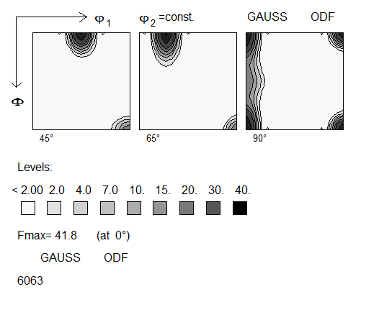

Figure : Orientation distribution function (ODF) for the extruded profile.

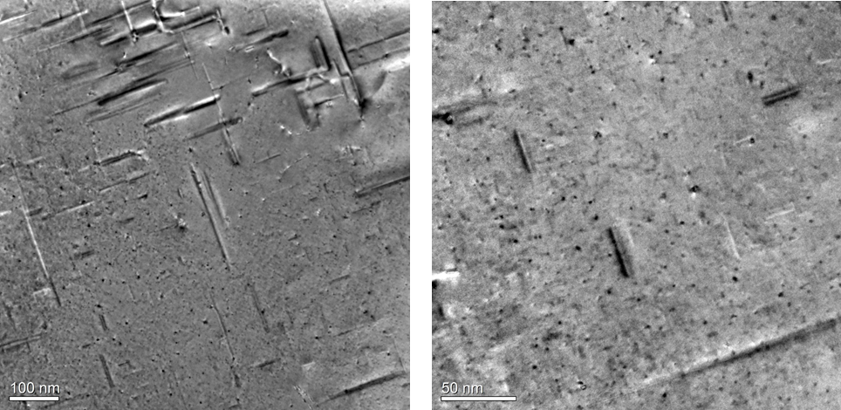

Figure : TEM images of the AA6063 alloy in T6 temper.

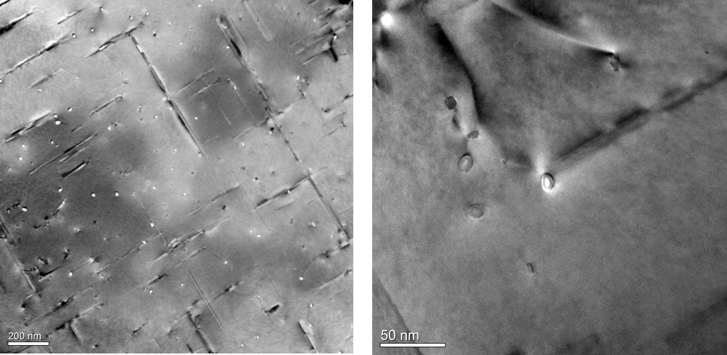

Figure : TEM images of the AA6063 alloy in T7 temper.

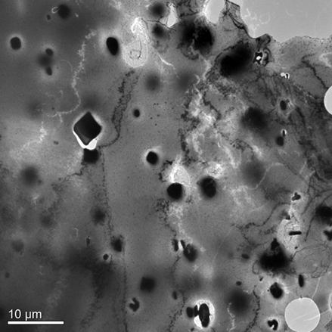

Figure : Large β phase particles in the T7 temper at low magnification. Similar β phase particles were observed in the T6 temper.

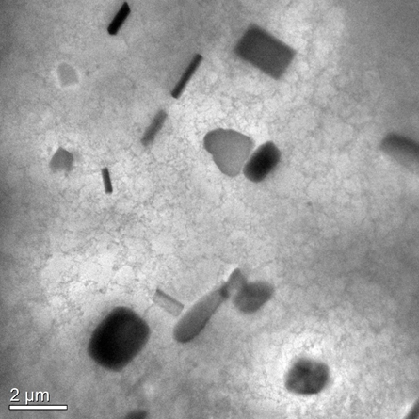

Figure : TEM image of the AA6063 alloy in O temper.

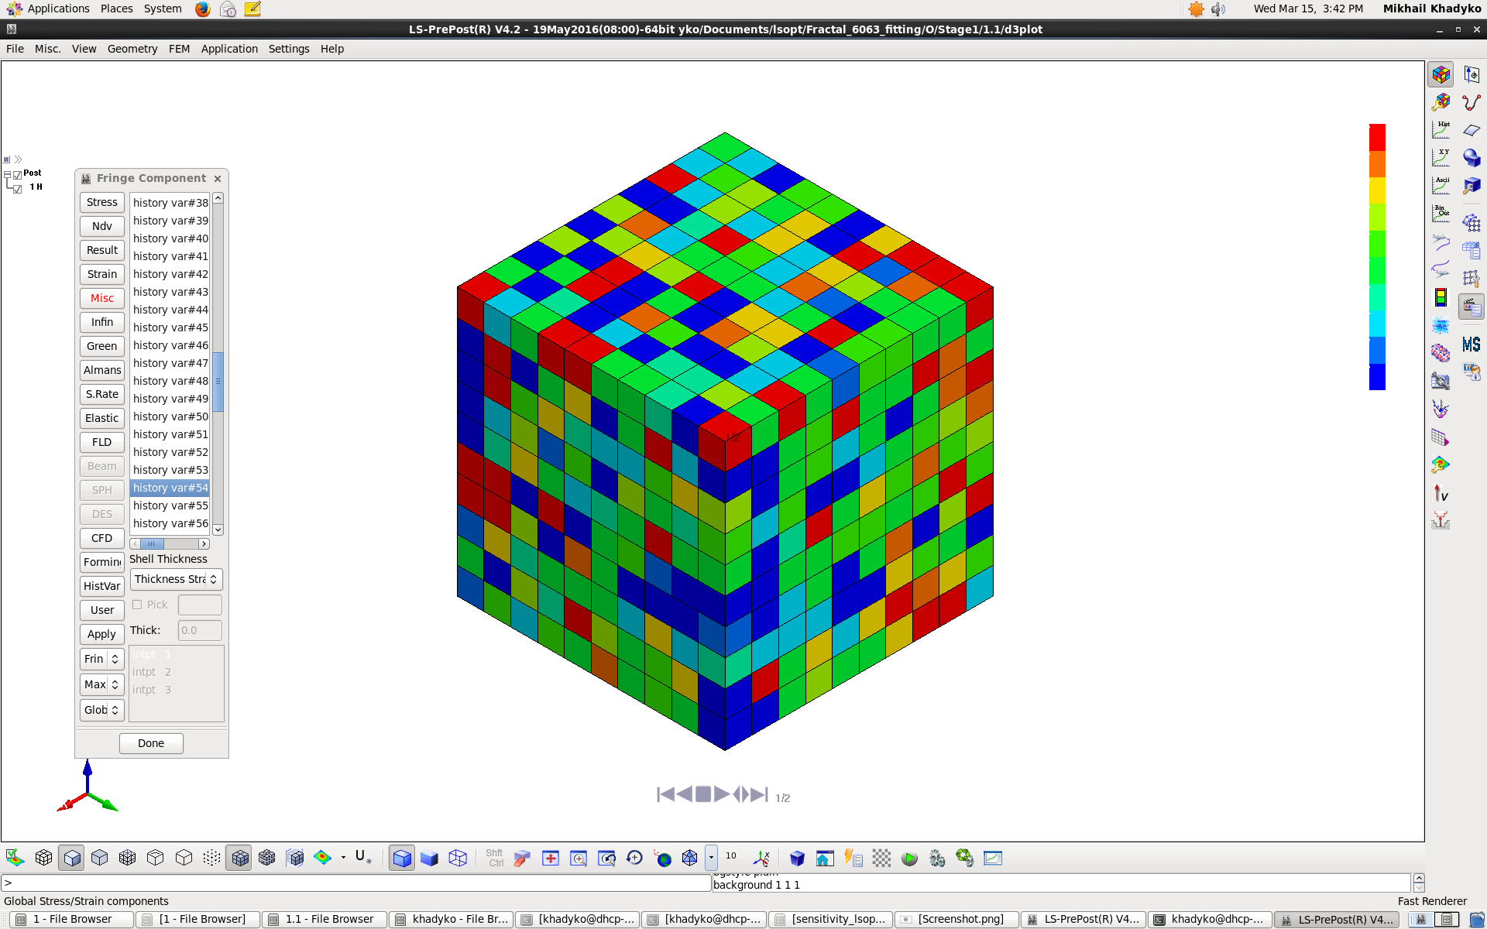 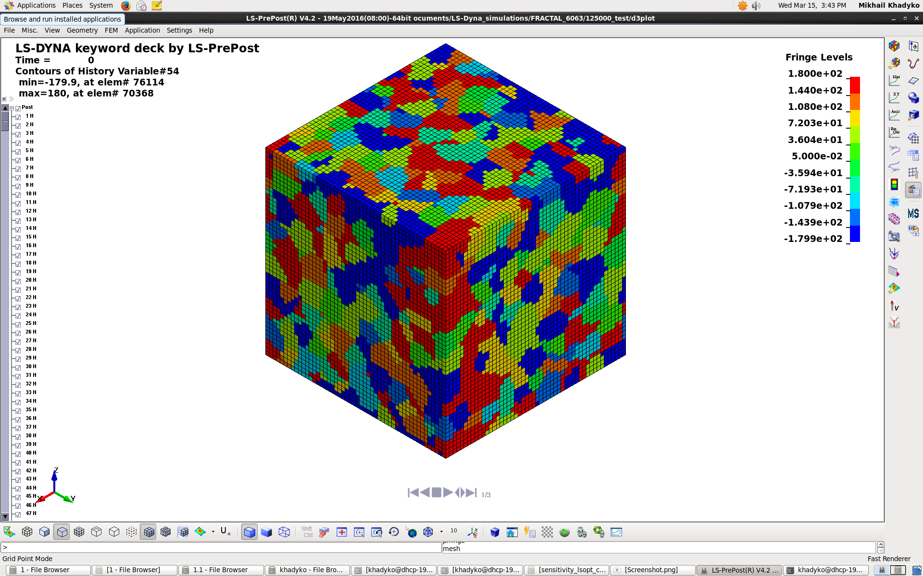

Figure : CP-FEM meshes used in the material parameter calibration (left) and tensile test simulations (right). The colour indicates the grain orientation.



Figure : True stress-strain curves obtained by fitting the CP-FEM model to the experimental data.









Figure : Experimental true stress-strain curves plotted up to maximum force. From top to bottom: tempers T1, T6, T7 and O. Tensile directions between 0° and 22.5° are presented in the left diagrams, whereas the right diagrams present tensile directions from 0° to 90° in 22.5° steps.





Figure : Representative experimental true stress vs. plastic strain curves plotted up to 5% strain. From top to bottom: tempers T1, T6, T7 and O. Tensile directions between 0° and 22.5° are presented in the left diagrams, whereas the right diagrams present tensile directions from 0° to 90° in 22.5° steps.



Figure : True stress vs. plastic strain curves from the CP-FEM simulations. From top to bottom: tempers T1, T6, T7 and O. Tensile directions between 0° and 22.5° are presented in the left diagrams, whereas the right diagrams present tensile directions from 0° to 90° in 22.5° steps.





Figure : Strain ratio  vs. material orientation at yield (0.2% equivalent plastic strain) to the left and at 5% equivalent strain to the right. The top row presents the experimental data and the bottom row the CP-FEM simulations.





Figure : Flow stress ratio vs. material orientation at yield (0.2% equivalent plastic strain) to the left and at 5% equivalent strain to the right. The top row presents the experimental data and the bottom row the CP-FEM simulations.



Figure : Shear strain ratio  vs. material orientation in the experiment (left) and CP-FEM simulations (right).