Gas Phase Amine Depletion Created By Aerosol Formation and Growth
Hammad Majeedª Hanna Knuutilaª Magne Hillestadª Hallvard F. Svendsenª*
ªNorwegian University of Science and Technology, Trondheim 7491, Norway
First Author:
Hammad Majeed
Norwegian University of Science and Technology
E-mail address: hammad.majeed@ntnu.no

Second Author:
Hanna Knuutila
Norwegian University of Science and Technology
E-mail address: hanna.knuutila@ntnu.no

Third Author:
Magne Hillestad
Norwegian University of Science and Technology
E-mail address: magne.hillestad@ntnu.no

Fourth and Corresponding Author:
*Hallvard F. Svendsen
Norwegian University of Science and Technology
E-mail address: hallvard.svendsen@ntnu.no
Corresponding author. Tel.: +47-95141784
Gas Phase Amine Depletion Created By Aerosol Formation and Growth
Hammad Majeedª Hanna Knuutilaª Magne Hillestadª Hallvard F. Svendsenª*
ªNorwegian University of Science and Technology, Trondheim 7491, Norway
Abstract:
Aerosols are systems of droplets or wet particles suspended in gases. In post combustion CO₂ absorption systems aerosols can be formed by spontaneous phase transitions in supersaturated gas phases or by droplets or particles entering the absorber with the gas to be treated. Micron and sub-micron mist droplets and fog formed in these processes cannot be removed by conventional demisting devices and because amine may be absorbed in the droplets this may increase dramatically the amine emissions from absorption columns as reported previously (Khakharia et al., 2015; Schaber et al., 2002). Thus, it is important to understand the mechanisms governing droplet growth and amine uptake through absorber as well as the effect large numbers of aerosol droplets can have on the bulk gas phase composition.

A model is developed and implemented in Matlab which predicts how the gas phase composition and temperature change along the absorber taking into account mass and heat transfer to and from both the bulk liquid and the droplet phase. The objective of this work is to study the possible effect of gas phase component depletion on the droplet growth and droplet internal variable profiles and how this varies with initial droplet size and composition, droplet number concentration and amine volatility.

For MEA, as a relatively volatile solvent it is seen that gas phase depletion already takes place at number concentrations above 10⁵droplets/cm³ with an initial droplet radius of 1.5µ and 5M MEA initial concentration.

Keywords: Post combustion CO₂ capture, Absorption columns, Aerosol formation, Amine emissions, Internal droplet profiles, Gas phase profiles, Orthogonal collocation method, Simulation

- Introduction:
Very rapid growth in energy consumption was experienced in the 20th century and with an increasing world population and per capita use, it is expected that significantly more energy will be needed in the 21st century. Meeting these demands by the use of fossil fuels in power production and industrial processes is one main contribution to climate change by accumulation of greenhouse gases (GHGs) and in particular CO₂ in the atmosphere.
Post combustion CO₂ capture (PCCC) by chemical absorption is one of the most developed technologies for capturing CO₂ from low pressure emissions (Abu-Zahra, 2009; MacDowell et al., 2010; Rochelle, 2009; Sanchez-Fernandez et al., 2013). Solvent emission in the form of aerosols is one of the main challenges for widespread implementation of such plants (Khakharia et al., 2015; Schaber et al., 2002) as amine emission to air may impose a potential risk to human health and produce possible negative effects on the environment, as indicated by studies reported in (Knudsen and Randall, 2009). In depth studies performed in the Gassnova CCM projects, see (“Fullskala Mongstad,” 2014), that possible consequences with full scale operation using MEA on environment will be very small.
Detailed experimental data on aerosol droplet growth and emissions do not yet exist. Analytical measurements techniques such as Fourier Transform Infrared Spectrometry (FTIR) and Phase Doppler interferometry (PDI) can be used to estimate overall emissions and particle size distributions (Fulk, 2016; Fulk and Rochelle, 2013). These methods give overall measurements but do not give insight into aerosol behavior inside the absorbers. Therefore, a detailed simulation tool is required that is able to predict aerosol formation and development as function of operational and chemical characteristics. Since the physical conditions in a gas–liquid contactor are very complex, it is necessary to use a somewhat simplified model to understand the behavior. A basic simulation tool for the description of a single aerosol droplet development in CO₂ absorption columns is already established and described in (Majeed et al., 2017). This model gives examples as to how an entering droplet grows or shrinks through an absorber and how the internal composition changes with respect to position. The present work is an extension of this model in which the effect of amine depletion in the gas phase is taken into account. There are publications indicating that large particle number concentrations of aerosols will affect the bulk gas phase concentrations in absorber columns (Zhang et al., 2017). This change in bulk gas phase concentration levels may affect the overall efficiency of the absorption system and also the amine transfer to aerosol droplets, the droplet growth and thereby the amine emissions.
- Modelling:
The system of equations consists of differential balance equations for component mass and energy inside the aerosol droplets and similarly for the gas phase. These equations are coupled by a reaction rate model, an equilibrium model and models for heat and mass transfer between, on one hand the gas phase and liquid phase assuming that the liquid bulk remains unaffected by the aerosol phase, and secondly between the gas phase and aerosol phase. This is shown in Figure 1.
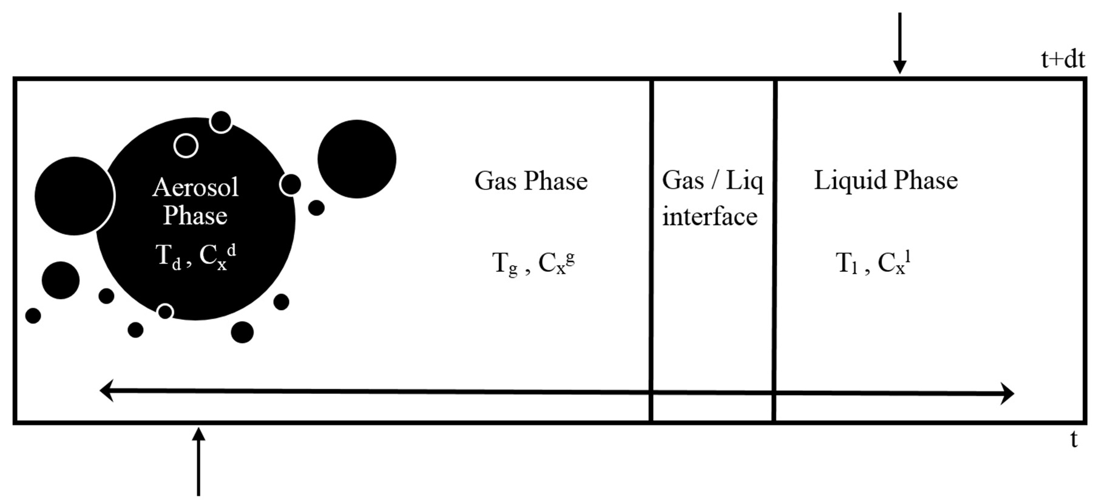

Figure 1: Schematic illustration of heat and mass transfer between all the phases in a differential volume element in the absorber (T and C are temperature and composition while subscript x is for constituent, d, g, l are droplet, gas and liquid)

  - Balance Equations for Aerosol Phase:
The combined transport and reaction equations for the aerosol phase are described in detail in (Majeed et al., 2017) including boundary conditions and solution procedure and are not repeated here.
  - Balance Equations for Gas Phase:
If the number concentration c_{N} of aerosol droplets is large, the bulk gas phase composition can be altered. This possible change and its effect on droplet growth is the focus of the present work. There are experimental investigations that give number concentrations of aerosol droplets in typical amine based PCCC plants (Khakharia et al., 2013; Mertens et al., 2014). The number concentration indicates how many droplets are present in a cm³ of gas. The change in number of moles in the associated gas phase (1 cm³) will then be given by a dynamic balance between the inflow of a component from the bulk fluid minus the flow rate of the same component from gas to the droplet phase.
$$\frac{∂n_{x}^{g}}{∂t}={\dot{n}}_{x}^{f}-{\dot{n}}_{x}^{d}$$ |  | (1)

$${\dot{n}}_{x}^{f}=a_{f}∙K_{g,x}^{overall}∙\left(P_{x}^{*}-P_{x}^{g}\right)$$ | (2)
$${\dot{n}}_{x}^{d}=N_{x}∙(c_{N}∙a_{d})$$ | (3)

Here n and $\dot{n}$ are number of moles in the gas volume and the molar flows into and out of the gas volume. f and d indicate bulk fluid and droplet respectively while x denotes component. K_{g,x}^{overall} is the overall mass transfer coefficient from bulk liquid to gas and P_{x}* and P_{x}^{g} are respectively the liquid phase equilibrium pressure and gas phase pressure. a_{f} and a_{d} are interfacial area for bulk fluid and droplet respectively. N_{x} and c_{N} are molar flux and particle number concentration in droplets/cm³ of gas.
Similarly, the thermal balance equation for the gas volume is:
$$ρ_{g}.V_{g}{∙C}_{p}\frac{∂T_{g}}{∂t}=h_{lg}^{f}\left(T_{f}-T_{g}\right)-h_{g}^{d}\left(T_{g}-T_{d}\right)$$ | (4)

$h_{lg}^{f}$ and $h_{g}^{d}$ depict bulk liquid side and droplet side heat transfer coefficients. T_{f}, T_{g} and T_{d} are respectively the bulk fluid, gas and droplet surface temperatures.

Growth of Droplet:
The growth of the droplet is the rate of change in volume with respect to time (Majeed et al., 2017);

$$\frac{dR}{dt}=\frac{N_{total}}{ρ_{droplet}}$$ | (5)

Where N_{total} is the total mass flux of transferring components, e.g. amine, CO₂ and water. R and${ ρ}_{droplet}$ represent varying droplet radius and density.

Reaction Model:
Ionization of water, dissolution of CO₂, dissociation of carbonate ion, amine protonation and carbamate formation are the reactions that may occur during CO₂ absorption in typical PCCC plants depending on solvent used.
In this work the kinetics of CO₂ and MEA solution is based on the termolecular or direct mechanism in which amine reacts with one molecule of a base and one molecule of CO₂ at the same time (Crooks and Donnellan, 1989; da Silva and Svendsen, 2007).
The concentration based rate equation for the carbamate formation reaction is given as:

$$r_{{CO}_{2}}=\left\{k_{MEA}^{T}\left[MEA\right]+k_{H_{2}O}^{T}\left[H_{2}O\right]\right\}\left\{\left[MEA\right]\left[{CO}_{2}\right]-\left(\frac{1}{K_{eq}^{T}}\right)\left[{MEAH}^{+}\right]\left[{MEACOO}^{-}\right]\right\}$$ | (6)

Where $k_{MEA}^{T}$ and $k_{H_{2}O}^{T}$ are the kinetic rate constants of MEA and water, while $K_{eq}^{T}$ is the equilibrium constant for the reversible reaction. The kinetic constants are defined with Arrhenius type temperature dependencies and the equilibrium reaction constant is expressed in terms of activities, see (Luo et al., 2015; Majeed et al., 2017; Putta et al., 2016).

Mass Transfer Model:
The models for mass and heat transfer between gas and aerosol phase and the droplet internal transport and reaction are the same as presented in (Majeed et al., 2017).
The mass and heat transfer between gas and bulk liquid phase are modelled by the equations presented in Table 1.
$$k_{l}a_{ph}=C_{l}{12}^{\frac{1}{6}}{\overline{u}}_{l}^{0.5}({\frac{D_{xl}}{d_{h}})}^{0.5}a(\frac{a_{ph}}{a})$$ | (Billet and Schultes, 1999)
$$k_{g}a_{ph}=C_{g}\frac{1}{{\left(ϵ-h_{L}\right)}^{0.5}}\frac{a^{\frac{3}{2}}}{d_{h}^{\frac{1}{2}}}D_{xg}({\frac{u_{g}}{a∙Kvis_gas})}^{\frac{3}{4}}({\frac{Kvis_gas}{D_{xg}})}^{\frac{1}{3}}(\frac{a_{ph}}{a})$$ | (Billet and Schultes, 1999)
$$\frac{a_{ph}}{a}=1.5(ad_{h})^{-0.5}{\left(\frac{u_{l}d_{h}}{Kvis_liq}\right)}^{-0.2}{\left(\frac{u_{l}^{2}ρ_{l}d_{h}}{σ_{l}}\right)}^{0.75}{\left(\frac{u_{l}^{2}}{gd_{h}}\right)}^{-0.45}$$ | (Billet and Schultes, 1999)
$$N_{Nu}=2+0.6∙{\left(N_{Re}\right)}^{0.5}∙{\left(N_{pr}\right)}^{1/3}$$ | (Geankoplis, 2003)
Table 1: Mass and Heat transfer coefficient models

Here $\overline{u}$_{l} is the effective liquid velocity, a_{ph} is the specific interfacial area and D_{x} is the diffusivity of component in gas and liquid. $σ_{l}$ is the surface tension, $ρ_{l}$ is the density of liquid, $u_{l}$ is the liquid velocity, d_{h} denotes hydraulic diameter of the packing while Kvis_liq is the liquid kinematic viscosity. The necessary data required to calculate these coefficients were adopted from (Billet and Schultes, 1999). Similarly Re, Pr and Nu represent the Reynolds number, Prandtl number and Nusselt number respectively.

Solution Methodology:
The whole system comprises a set of partial differential equations that needs to be solved by a suitable numerical method. In order to solve these PDE’s a discretized model is created in Matlab. This Matlab model is based on a subclass of weighted residuals for boundary value problems named the orthogonal collocation method.

Results and Discussions:
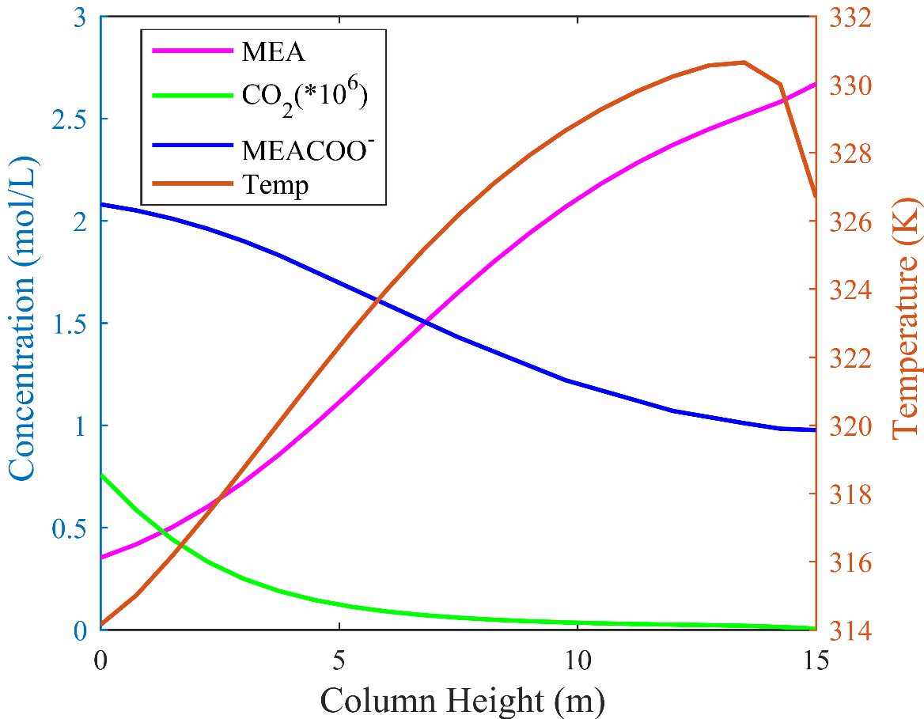
As described earlier, the current work is an extension of the model presented in (Majeed et al., 2017). In that model a single droplet follows the gas phase from bottom to top of the column with a velocity relative to the gas phase given by the droplet terminal velocity and under the assumption that the gas phase is not affected by absorption or desorption into or from the droplet. However, for large droplet number concentrations, as may occur in industrial columns, local depletion of components in the gas phase may occur due to the large surface area of the droplet swarm and the possibly significant capacity in the droplets. The present work started with an ASPEN simulation of a pertinent case using the ELECNRTL Rate Based MEA model (Aspen Plus, 2015). This results in gas and liquid phase absorber composition and temperature profiles without taking any aerosol present into account. In contrast to the previous work (Majeed et al., 2017), in the present work the bulk liquid phase profiles from the Aspen simulation are used assuming that the liquid composition and temperature profiles are not affected by the aerosol swarms. The assumption that the liquid phase remains as in the simulation is based on the aerosol phase being much smaller in volume than the liquid phase. In the worst case considered the liquid phase will be about 10 times larger than the aerosol phase. In addition, the transfer to or from the bulk liquid phase is much slower than from the aerosol droplets and will thus not follow the fast up-takes or releases from the droplets. This is in fact one reason for possible depletion to occur in the gas phase. The liquid phase profiles from the Aspen simulation are presented in Figure 2. The gas phase composition is determined by mass and heat balances taking into account mass and heat transfer from the liquid bulk phase and into the droplet swarm as shown by equations 1-4. In cases where the gas phase composition and temperature profiles are changed due to the presence of aerosol, this has an influence on the droplet growth as well.

Figure 2: Liquid phase composition and temperature profiles in column
Aerosol size distribution and particle number concentration are important parameters needed for the simulation. Several studies give indications on particle concentrations in typical PCCC systems. (Khakharia et al., 2015; Mertens et al., 2014; Moser et al., 2015; Saha and Irvin, 2017) report aerosol droplet sizes ranging from sub-micron size to 2µ along with particle number concentrations (c_{N}) of 10³ to 10⁷, and in extreme cases up to 10⁸ droplets per cm³ of gas, depending on foreign nuclei and sizes. Based on this, different cases are modelled to see the effect of number concentration, amine volatility and size of droplets on bulk gas phase. Modelled cases are presented in Table 2.

Table 2: Modelled Cases
Case 1(Base Case) | Droplet, initial radius 1.5μ, containing 5M MEA travelling from bottom to top of column (0-15 m)
Case 2 | Droplet, initial radius 1.5μ, containing 5M MEA travelling from bottom to top of column (0-15 m), c_{N}= 1-10⁷ drops/cm³
Case 3 | Droplet, initial radius 1.5μ, containing 0.0001M MEA travelling from bottom to top of column (0-15 m) , c_{N}= 1-10⁷ drops/cm³
Case 4 | Droplet, initial radius 0.15μ, containing 5M MEA travelling from bottom to top of column (0-15 m) c_{N}= 1-10⁷ drops/cm³
Case 5 | Droplet, initial radius 0.15μ, containing 0.0001M MEA travelling from bottom to top of column (0-15 m) c_{N}= 1-10⁸ drops/cm³
Case 6 | Droplet, initial radius 1.5μ, containing 5M amine travelling from bottom to top of column (0-15 m) having less volatility than base case amine (MEA) c_{N}= 1-10⁷ drops/cm³
Case 7 | Droplet, initial radius 1.5μ, containing 0.0001M amine travelling from bottom to top of column (0-15 m) having less volatility than base case amine (MEA) c_{N}= 1-10⁷ drops/cm³

The focus of the current work is not the droplet internal composition profiles but how the gas phase profiles are affected by the droplet number concentration and size. Thus, internal droplet profiles are only included in this work for the base case, unless they are needed to understand the results obtained. Otherwise, they are well explained in (Majeed et al., 2017).
In the base case, Case 1, droplets with radius 1.5µ containing 5M MEA are exposed to an atmosphere with changing gas phase composition and temperature. The base case profiles are modelled considering only a single droplet travelling with the gas phase, i.e. c_{N}=1. Droplet internal free MEA profiles are plotted in Figure 3, predicting an instant decrease in free MEA concentration at the bottom of the column both because of evaporation of MEA and reaction with CO₂. As the droplet moves up in column the driving forces toward the droplet increase because the gas phase MEA concentration increases and the free MEA concentration starts to rebuild inside the droplet. This build-up is slightly higher than what was observed in (Majeed et al., 2017). The reason for this is that in the present work an in-house E-NRTL model was used for modeling driving forces both between bulk liquid and gas phase (with basis in the Aspen based bulk liquid phase composition profile) and gas phase and droplet(s) (Putta et al., 2016). This gives a slightly higher gas phase concentration profile for MEA than predicted by Aspen. Droplet internal free CO₂ profiles are plotted in Figure 4a. Initial rapid mass transfer of CO₂ leads to strong radial gradients that decrease rapidly because of the reaction with MEA as reflected in the rapid buildup of carbamate shown in Figure 4b. This is very similar to what was found in (Majeed et al., 2017).
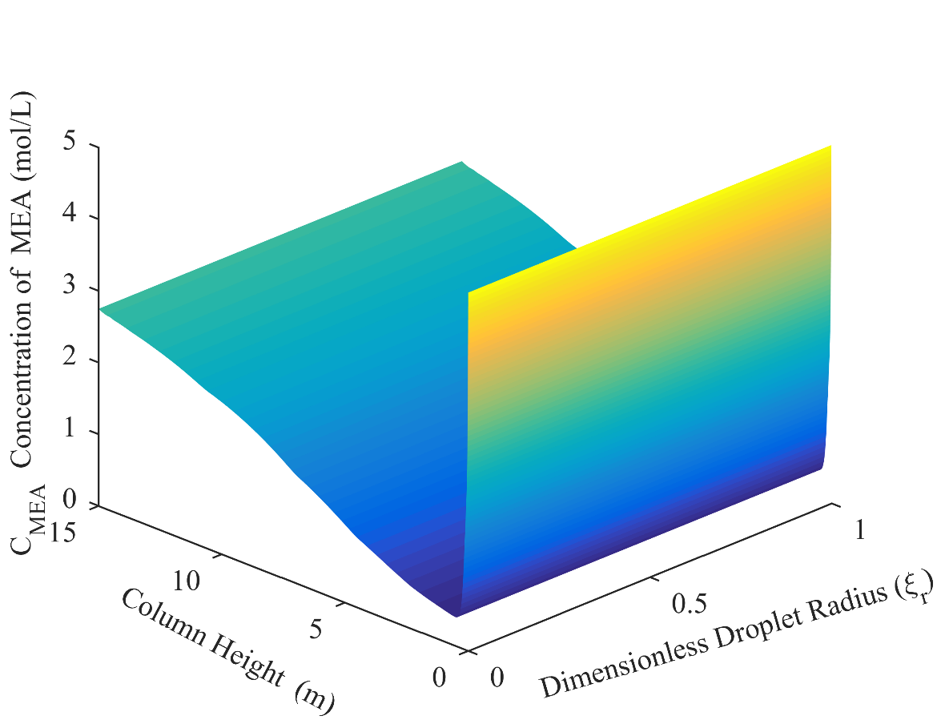

Figure 3: MEA concentration profile along column (Case 1)
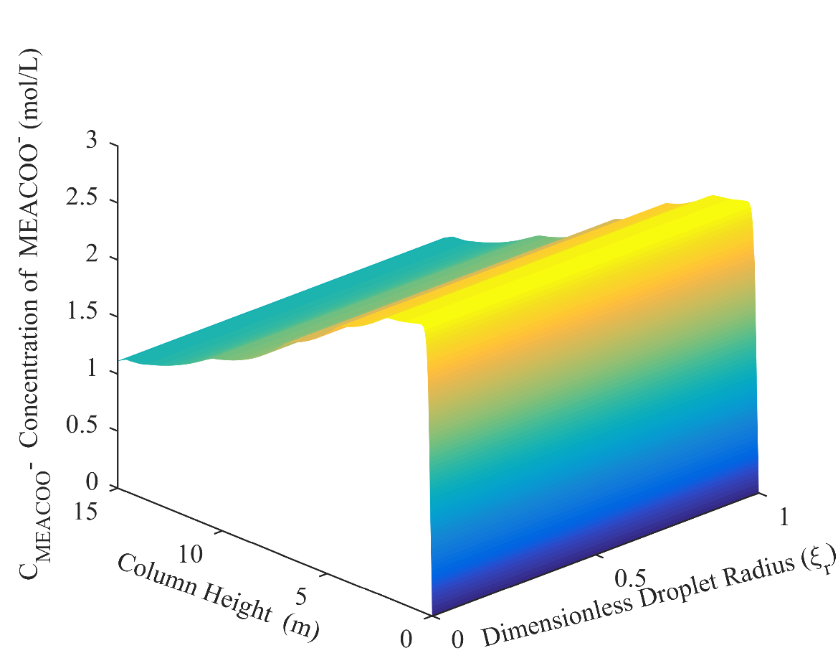
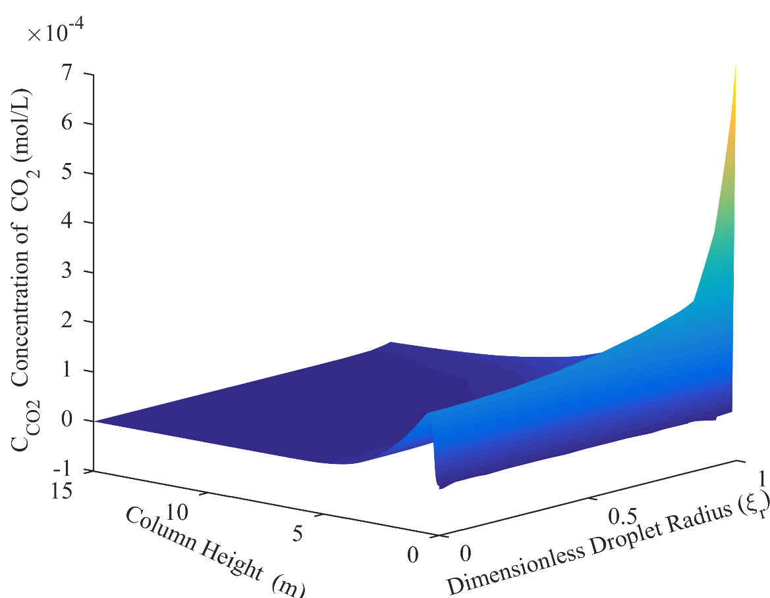
Figure 4 (a and b): CO₂ and carbamate concentration profile along column (Case 1)
The buildup of carbamate at the absorber top is slightly less than observed in (Majeed et al., 2017) and is also in line with the slightly higher free MEA present as shown in Figure 3.
  - Gas Phase Component Depletion:
In this section, how various droplet number concentrations of different size and initial composition affect the gas phase composition will be discussed.
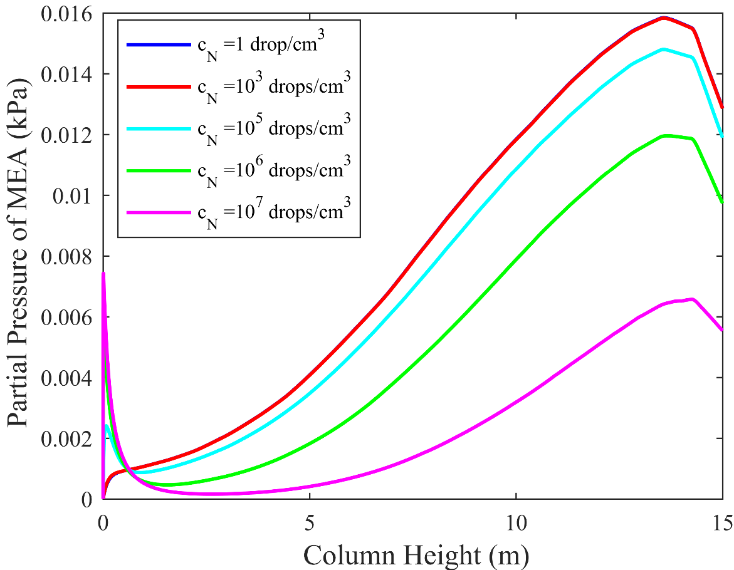
Case 2 is similar to case 1 except that the particle number concentrations vary from 1-10⁷ droplets/cm³ of gas, while the remaining parameters are the same. Entering MEA-free droplets may actually be a more realistic case than 5M MEA. The gas phase MEA partial pressure profiles for the different particle number concentrations are plotted in Figure 5. It is important to mention that mostly gas phase MEA profiles are shown for the various cases. The CO₂ and water partial pressure profiles are shown only when affected and important for the understanding; otherwise they are not altered significantly.

Figure 5: MEA partial pressure profiles along column (Case 2)
From Figure 5 it is seen that the droplet number concentration is an important parameter resulting in both gas phase MEA enrichment and depletion. Increasing the droplet number concentration from 1 to 10³ is seen not have any significant effect on the gas phase MEA partial pressure profile. Actually the plots for c_{N} = 1 and c_{N} = 10³ overlap each other. As the droplet number concentration increases further, the MEA partial pressure is increased in the bottom part of the column and reduced after about 1m into the absorber. The large droplet number results in both a large interfacial area and droplet volume. Initially, the droplet swarm entering with a 5M MEA concentration will give rise to rapid evaporation of MEA. The mass transfer of MEA into the liquid bulk phase is not rapid enough to keep up with the MEA from the droplets and the MEA gas phase partial pressure increases. This increase is stronger for higher droplet number concentrations. The MEA concentration in the droplet is rapidly reduced as seen in Figure 3 and MEA from the gas phase will eventually start transferring into the droplets. This process is also very rapid because of the large interfacial area and leads to a depletion of MEA in the gas phase. The changes seen for the gas phase partial pressures will of course also affect the droplet internal concentration profiles for both MEA, CO₂ and carbamate.
In Case 3, droplets having an initial radius of 1.5µ containing nearly pure water (0.0001M MEA) rather than 5M MEA, enter the absorber. The resulting gas phase MEA profiles are plotted in Figure 6 to see the effect of the changed droplet composition on the gas phase partial pressures.
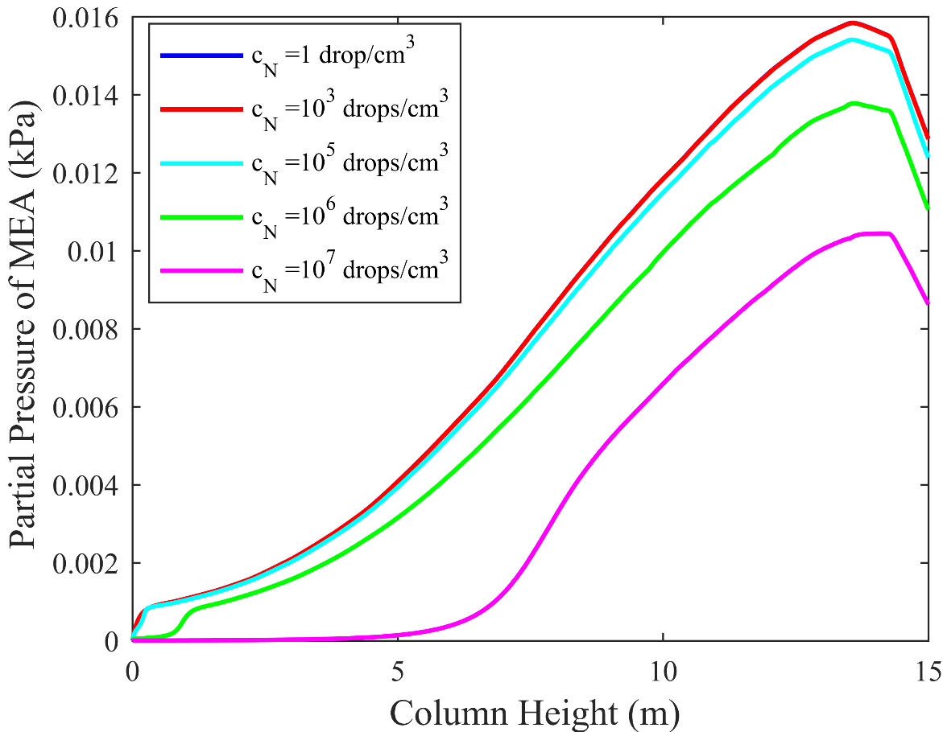

Figure 6: MEA partial pressure profiles along column (Case 3)
The profiles for c_{N} = 1 and c_{N} = 10³ shown in Figure 6 also overlap each other and are actually close to identical to the ones for droplets with initial concentration 5M MEA shown in Figure 5. This is in complete agreement with what was found for a single droplet in (Majeed et al., 2017). With increasing droplet numbers an MEA depletion effect is seen. At c_{N} = 10⁶ the gas phase MEA partial pressure is reduced to very low values initially as MEA is rapidly transferred into the almost pure water droplets entering the absorber. For the higher number concentration, i.e. c_{N}=10⁷ , MEA in the gas phase is almost zero up to a height of 5m in the absorber because of fast take up of MEA from gas to the large aerosol volume. Further up in the absorber the MEA partial pressures in the gas phase builds up again as the transfer to the aerosol droplet slows down and the transfer from the bulk liquid is better capable of keeping up with the transfer to the droplets. However, even in the upper part of the absorber a strong depletion effect is seen.
When comparing Figures 5 and 6 it can be concluded that the depletion of MEA in the upper part of the absorber is stronger for droplets with initial concentration 5M MEA compared to 0.0001M MEA.
This may seem surprising at a first glance, but can be explained when studying the build-up of carbamate in the droplets for the various cases as shown in Figures 7 and 8. Comparing Figures 7 and 8 for the case of c_{N} = 10³ we see that the carbamate profiles are for all practical purposes identical. This is then reflected in the partial pressure curves in figures 5 and 6 also being identical. For c_{N} = 10⁵ Figures 7 and 8 are slightly different. In Figure 7 the carbamate concentration shoots up immediately whereas in Figure 8 there is a small, hardly visible, period needed for MEA to transfer into the droplet and carbamate starts forming. At the absorber top there is also a small difference in the carbamate levels as in Figure 8 it is slightly lower that in Figure 7. These small differences result in visibly higher depletion in the case of 5M MEA initial concentration compared to 0.0001M shown by comparing Figures 5 and 6. For c_{N} = 10⁶ and c_{N} = 10⁷ these differences become larger. For c_{N} = 10⁷ Figure 8 shows that up to a height of about 5m hardly any carbamate is formed. The MEA present initially in the gas has depleted rapidly and the rate of carbamate formation is limited by the rate of MEA mass transfer from the bulk liquid phase. As the droplet passes up in the column the temperature increases and the volatility of MEA as well, leaving more MEA to be absorbed in the droplets and thereby giving faster carbamate formation. Because of this delay seen in carbamate formation for nearly pure water droplets, the carbamate concentration does not have enough time to reach the same level as for the 5M MEA initial concentration droplets. This is reflected in the significantly stronger depletion effect seen in Figure 5 compared to Figure 6 for the higher droplet number concentrations.
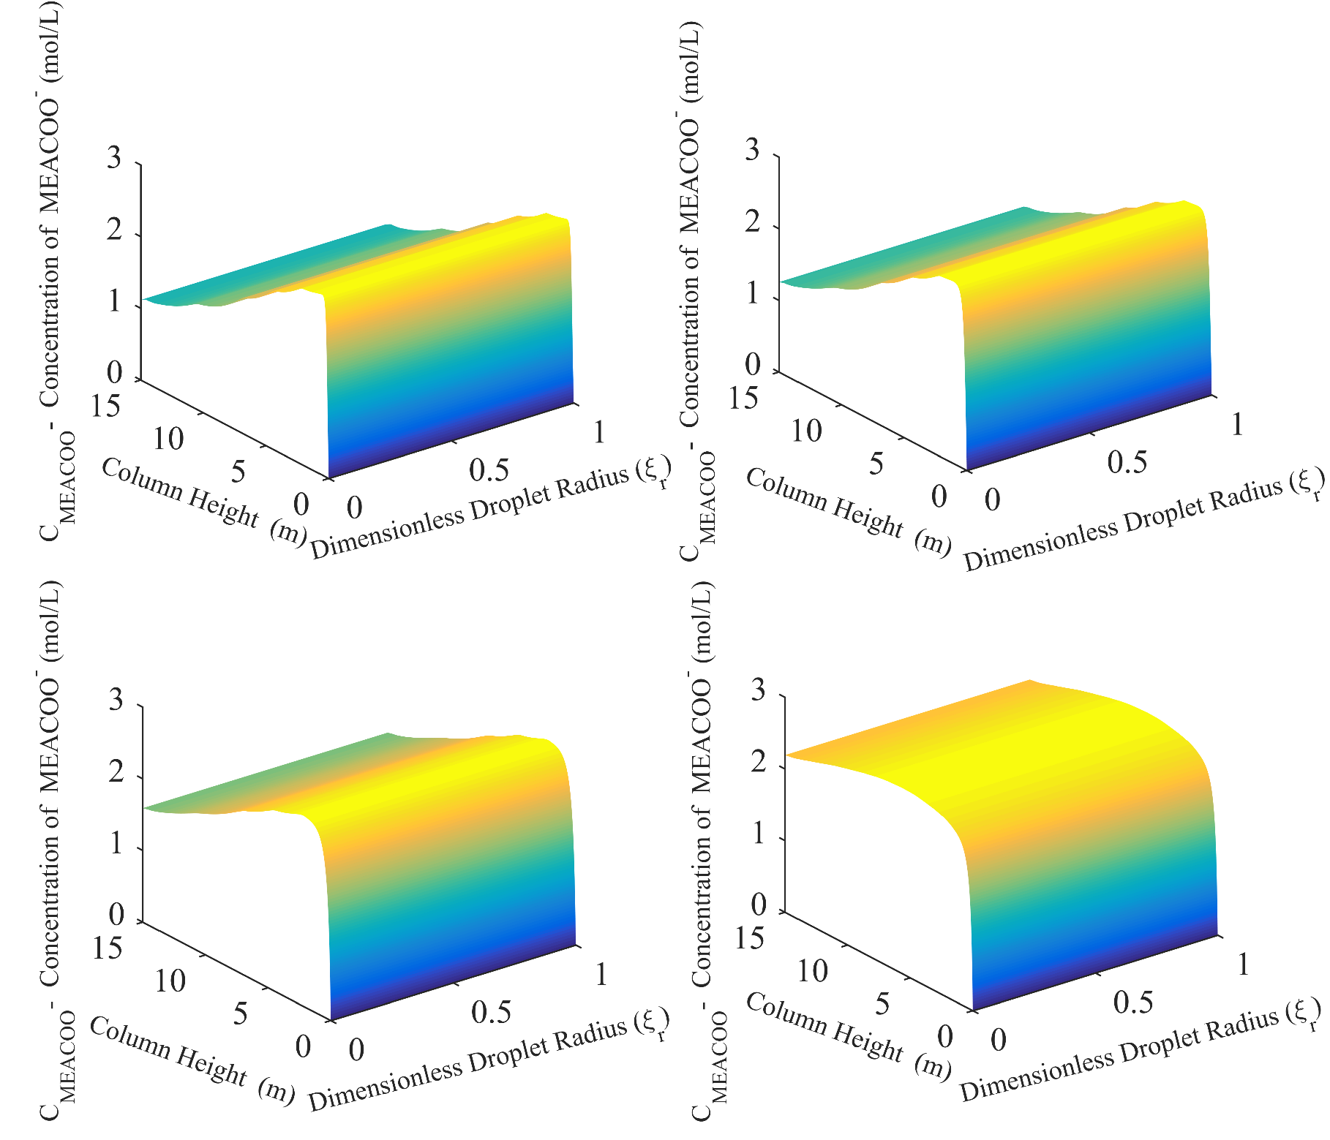

Figure 7 (a,b,c,d): Carbamate concentration profiles along column for c_{N}=10³,10⁵,10⁶,10⁷drops/cm³ (Case 2)
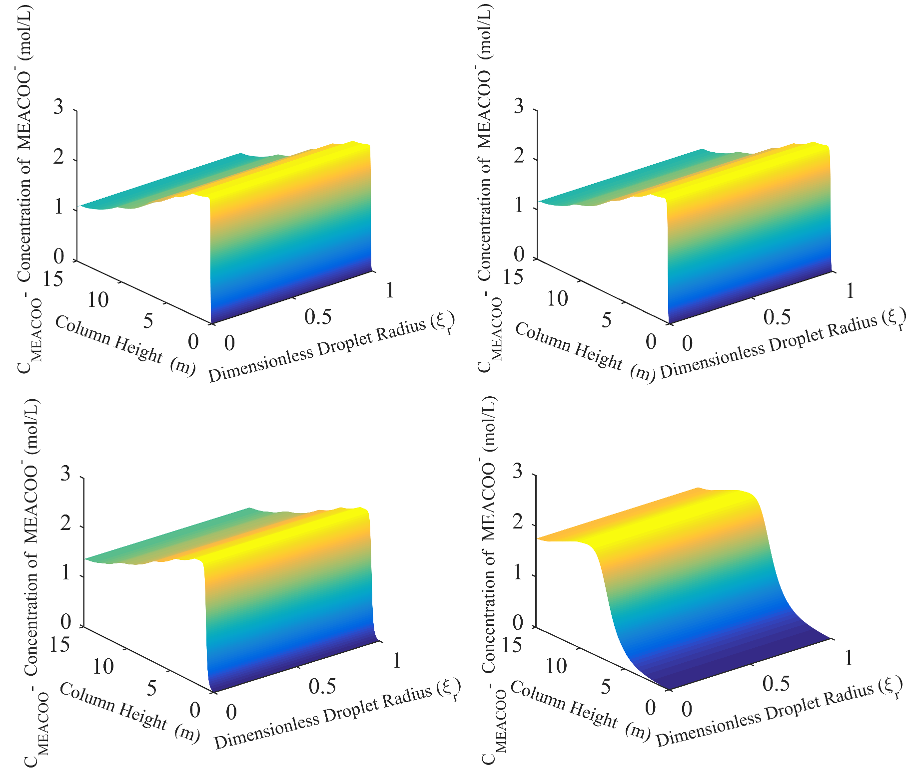

Figure 8 (a,b,c,d): Carbamate concentration profiles along column for c_{N}=10³,10⁵,10⁶,10⁷drops/cm³ (Case 3)
Cases 4 and 5 are generated to investigate the effect of initial droplet size on the gas phase composition. In Case 4, droplets having an initial radius of 0.15µ and an initial composition of 5M MEA travel from bottom to top of the absorber along with the gas phase. Resulting MEA partial pressure profiles are presented in Figure 9.

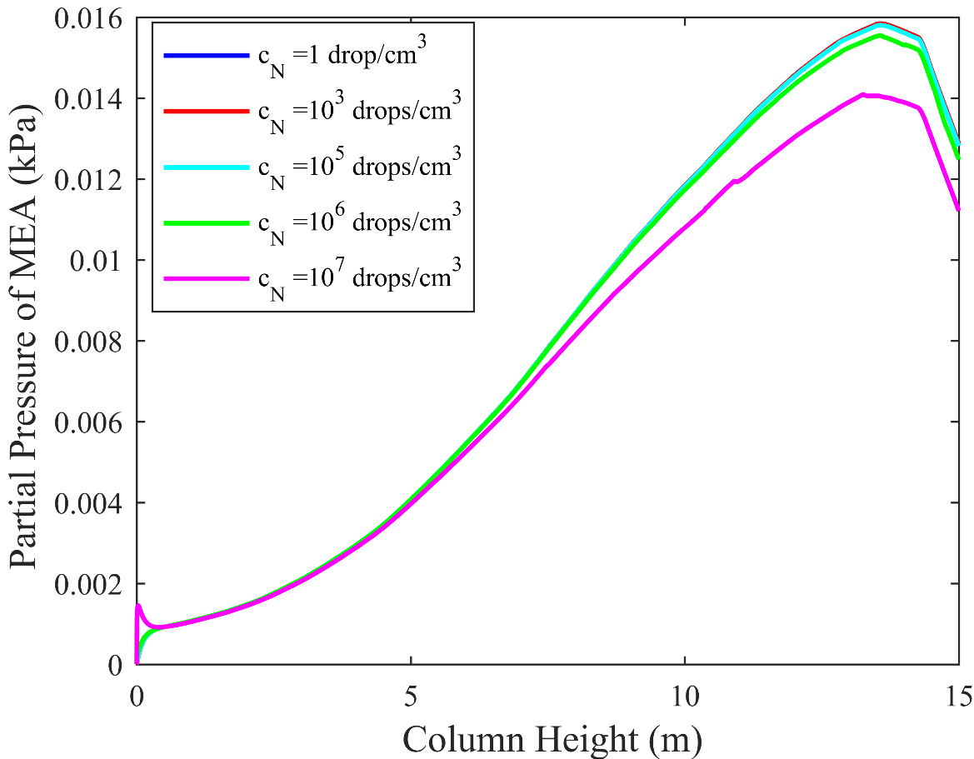

Figure 9: MEA partial pressure profiles along column (Case 4)

The profiles exhibit similar behavior as observed in Figure 5 for the larger droplets in the sense that varying droplet number concentrations will affect the bulk gas phase to a variable degree. However, when the droplets are very small the effects are weaker. The volume of the small droplets is 1000 times smaller than for the larger ones, reducing the capacity for MEA up-take by the same factor, whereas the interfacial area is reduced only be a factor of 100. In this case the depletion effect is invisible up to c_{N} = 10⁵ and the profiles overlap each other. Even at c_{N} = 10⁶ no initial buildup of MEA in the bottom of the absorber is seen and at the top only weak depletion is found. Only at c_{N} = 10⁷ can an initial peak in the MEA profile be seen together with a stronger depletion effect toward the absorber top.
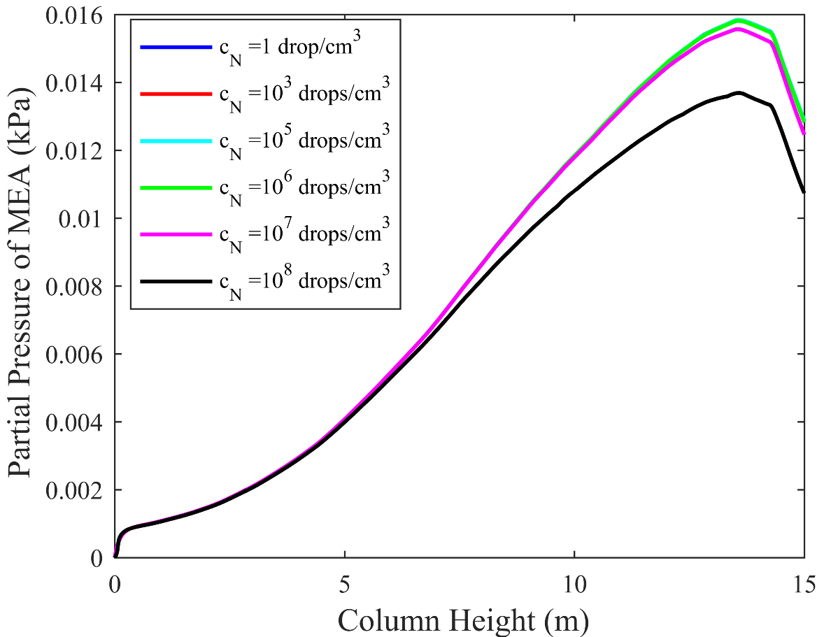

Figure 10: MEA partial pressure profiles along column (Case 5)

Case 5 is similar to case 3. A droplet with initial size reduced to 0.15µ and composition close to pure water (0.0001M MEA) travels with the gas phase. Profiles generated are presented in Figure 10. From c_{N} = 1 to 10⁶ the bulk gas phase is unaffected by the aerosol droplets. The MEA partial pressure profiles overlap signifying that little or no depletion of the gas phase takes place. At c_{N} =10⁷ a relatively weak depletion effect is seen and at c_{N} = 10⁸ the effect becomes significant. Volume or capacity wise a c_{N} = 10⁸ with 0.15µ sized droplets corresponds to c_{N} = 10⁵ with 1.5µ droplets. Comparing Figures 6 and 10 we see a much stronger depletion effect with the smaller droplets. This is reasonable since the interfacial area of the small droplets corresponds to c_{N} = 10⁶ for the large droplets and illustrates the dynamics of the mass transfer processes being a competition between what the bulk liquid phase can deliver and the rate of absorption into the droplet phase. As for the comparison between Figures 5 and 6 discussed earlier, the same trends are seen when comparing Figures 7 and 8 in current cases. The depletion effect is weaker when starting with nearly pure water droplets than with an initial droplet MEA concentration of 5M. The difference is smaller but the reason for the difference is the same.

  - Droplet Growth
The droplet growth is possibly the most important factor related to amine aerosol emissions and the possibility of removing droplets in conventional impingement demisters. It is thus very important to understand how the depletion effect influences the droplet size development. Growth is modelled for all the same cases as for gas phase profiles.
The development in droplet size for case 2 is presented in Figure 11.
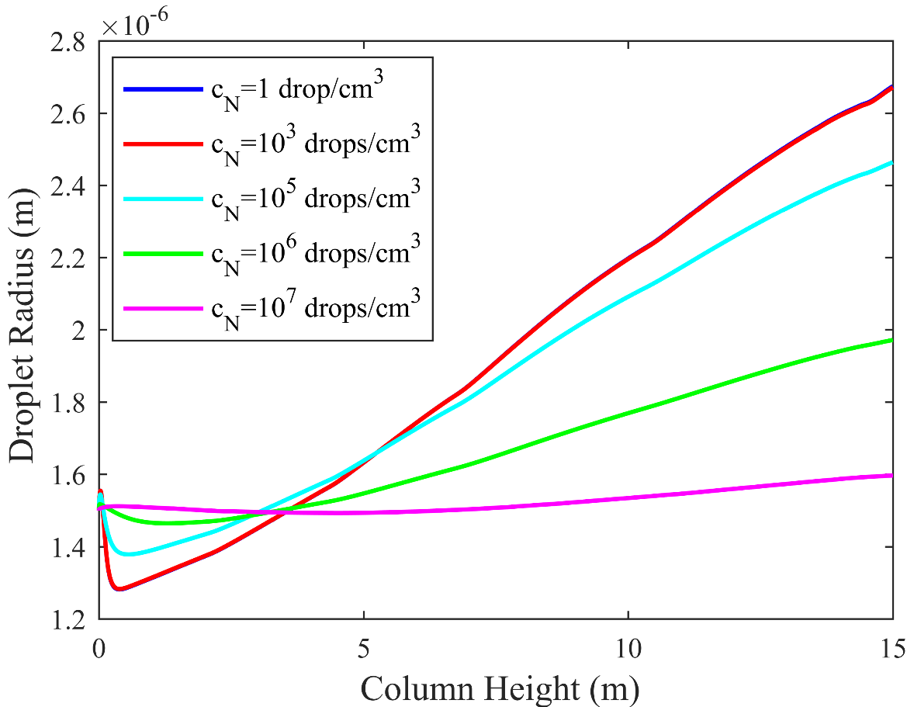

Figure 11: Growth of droplet (Case 2)
Starting with initial radius of 1.5µ and 5M MEA concentration, droplets grow in size for all number concentrations, indicating an up-take of amine and water into the aerosol. For the initial two number concentrations, c_{N} = 1-10³ , the droplet growth is almost exactly the same and this behavior is in line with the gas phase MEA profiles of case 2 in Figure 5. For these number concentrations, there is a rapid decrease in size initially because of water evaporation. As seen in the enlarged part of Figure 12a, the gas phase water partial pressure decreases when going up in the bottom part of the absorber. This gives a driving force for evaporation. As the droplets move further up the water partial pressure increases and water is transferred to the droplet and the droplet grows in size. The impact of the aerosol droplet on the gas phase water partial pressure profile is negligible in this case.
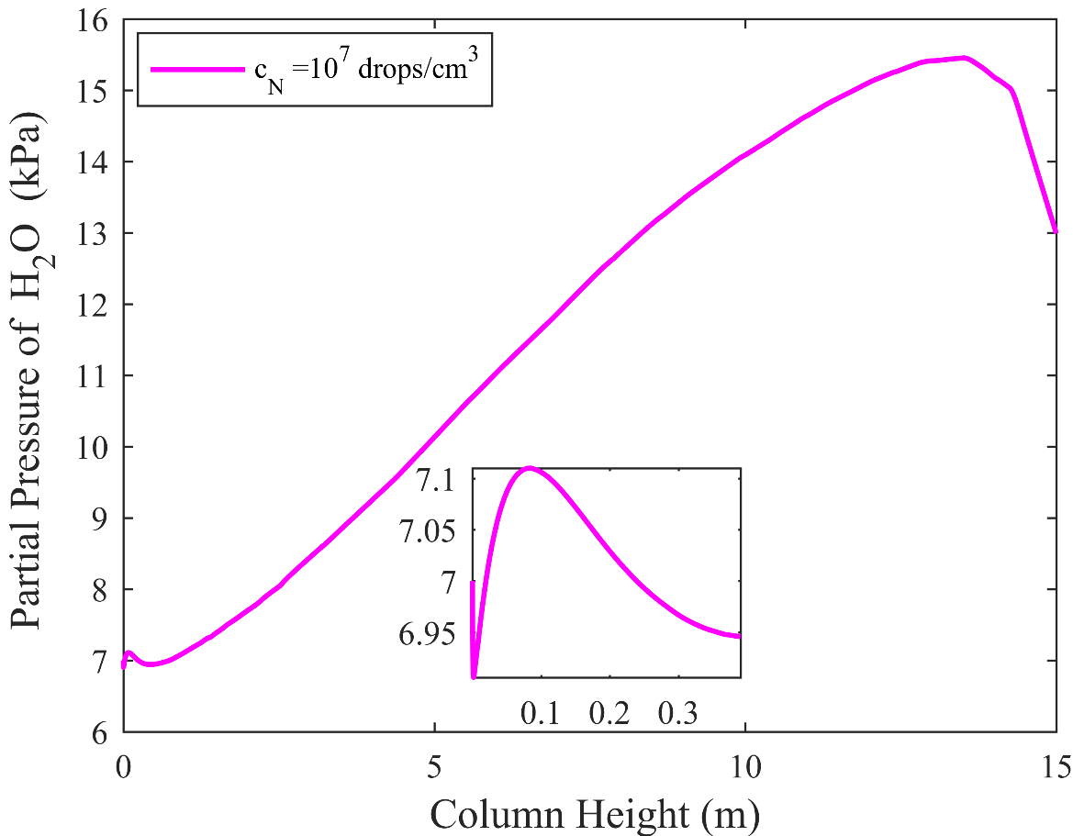
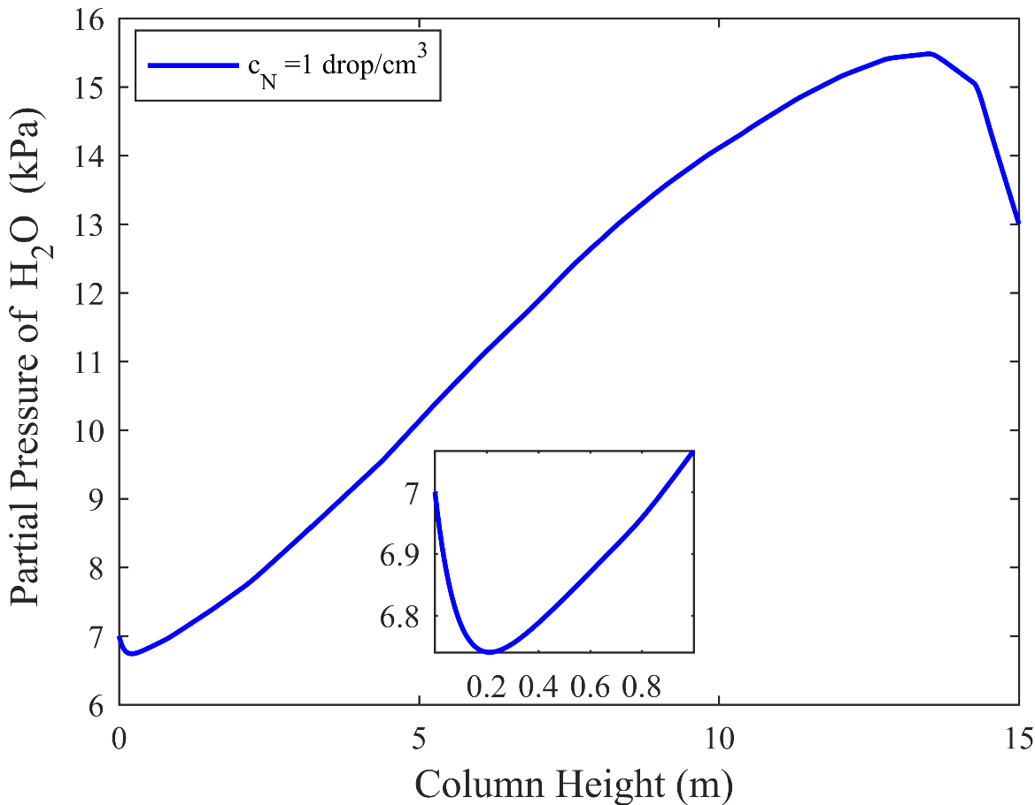

Figure 12: Water partial pressure profile along column (Case 2), (a) 1 droplet/cm³ whole absorber and bottom enlarged, (b) 10⁷ droplets/cm³ whole absorber and bottom enlarged
For c_{N} = 10⁵-10⁷, shown in Figure 11, there is a dramatic change in the droplet growth rate. This is caused by the depletion of MEA in the gas phase and a build-up of water. At c_{N} = 10⁷ the large number of injected (40ºC and 5M MEA) droplets rapidly condense water leading to a fall in water partial pressure, a small increase in droplet size and rapid heating of the droplets. This is seen at the very absorber bottom of Figure 12b. This fall in pressure, in turn leads to evaporation of water, and with the large number of droplets, the partial pressure of water in the gas phase increases (Figure 12b), thus hindering further evaporation and reduction in droplet size. Further up in the absorber the water partial pressure profile at c_{N} = 10⁷ is very close to the ones at the lower droplet number concentrations.
However, in the middle to upper section of the absorber the MEA partial pressure profile plays a role. Even though most of the droplet growth is due to transport of water to the droplet, this transport is very much dependent on the transport of MEA. With less transport of MEA into the droplet, as a consequence of the lower driving forces caused by depletion seen in Figure 5 for the middle absorber section, the concentrations of MEA and carbamate are low, as shown in Figure 8, and the water mole fraction will be high. This results in an increased vapor pressure of water on the droplet surface and lower driving forces also for water transport into the droplet. This effect is significant already at c_{N} = 10⁵ and at c_{N} = 10⁷ there is hardly any droplet growth. Because of the small driving forces for MEA, even in the case without depletion, the sensitivity of droplet growth toward MEA depletion and aerosol induced changes in water vapor pressure, is large as seen in Figure 11.
In Figure 13 are shown the growth results for Case 3 where the initial droplet size still is 1.5 micron whereas the initial MEA concentration is reduced to 0.0001M. For the cases with droplet number concentrations up to c_{N} = 10⁵ there is a very rapid and strong reduction in droplet size in the absorber bottom. The nearly pure water droplets entering will have high water vapor pressure causing rapid evaporation of water and thereby subsequent reduction in size without affecting the gas phase water vapor pressure as shown in Figure 14a. This is similar to what was found in (Majeed et al., 2017). At the same time, MEA and CO₂ transfer to the droplet and react, producing carbamate as seen in Figure 8a and 8b. This reduces the water vapor pressure and water starts moving into the droplet. This process continues throughout the absorber and gives an overall increase in droplet size.
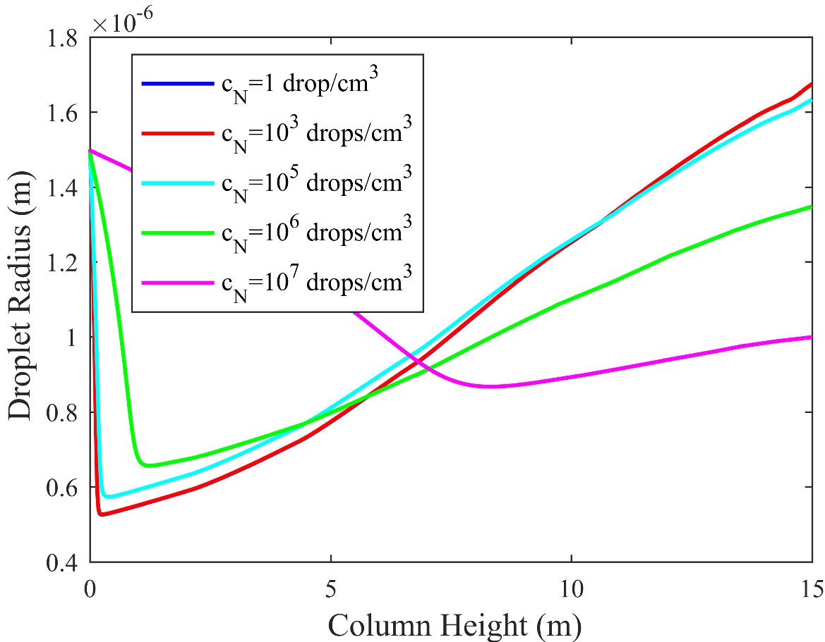

Figure 13: Growth of droplet (Case 3)
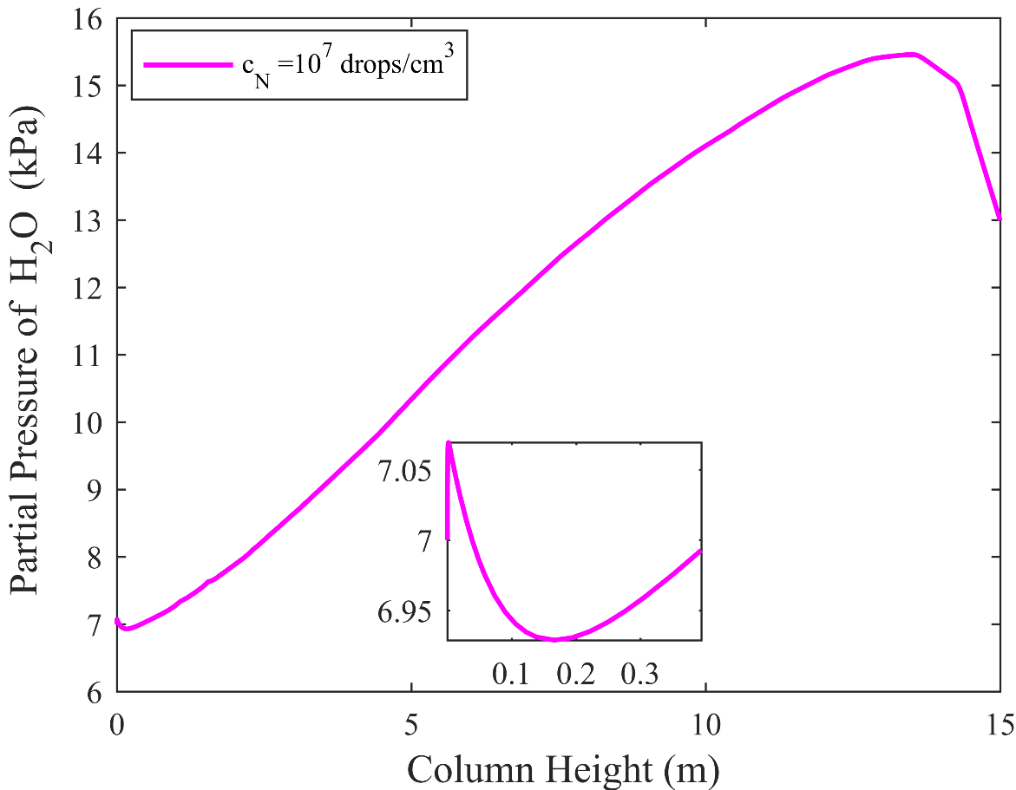
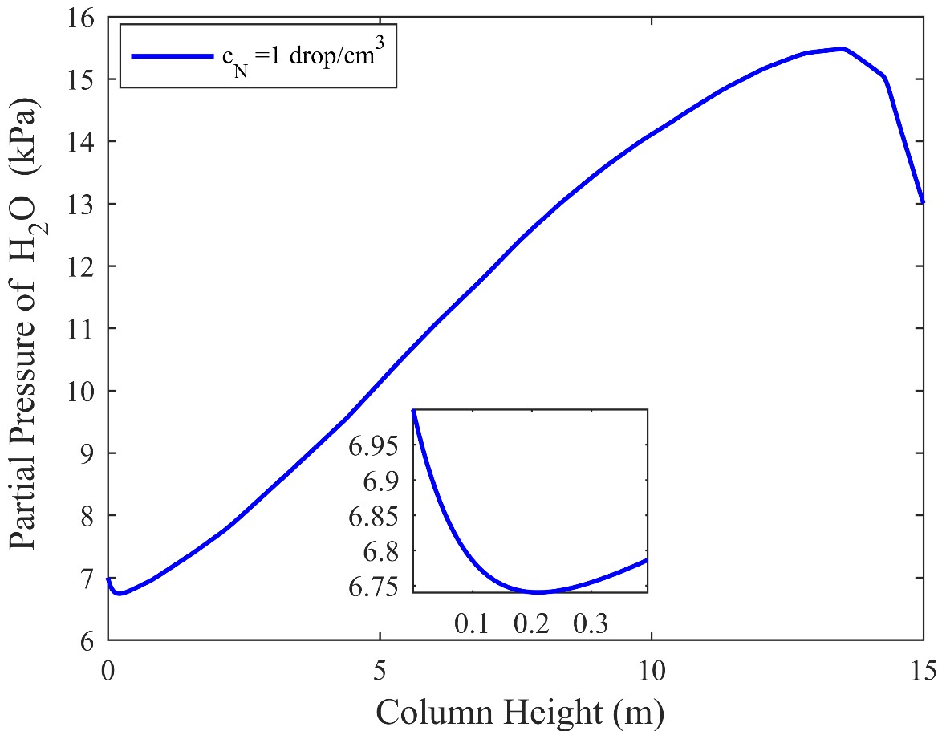

Figure 14: Water partial pressure profile along column (Case 3), (a) 1 droplet/cm³ whole absorber and bottom enlarged, (b) 10⁷ droplets/cm³ whole absorber and bottom enlarged
For c_{N} = 10⁶-10⁷, strong MEA depletion of the gas phase is found, see Figure 6, together with a rapid initial increase in water vapor pressure (Figure 14b). The reason for the difference between Figures 12b and 14b is the MEA content and the reduced equilibrium water vapor pressure because of MEA. Instead of a decrease in water vapor pressure as in Figure 12b, an increase is seen in Figure 14b. This shows the very strong sensitivity toward small variations in partial pressures. This is not surprising when taking into account the small driving forces present in the absorber for water and MEA. The increase in gas phase water vapor pressure signifies a higher water flux from the droplets compared to Case 2, resulting in a larger decrease in droplet size for c_{N} = 10⁶-10⁷ as seen in Figure 13 compared to Figure 11. The very strong depletion of MEA in the gas phase, see Figure 6, leads to very slow up-take of MEA and the subsequent growth in droplet size is decreased, resulting in an overall decrease in droplet size through the absorber in these cases.

In Case 4 the initial radius is reduced to 0.15µ but the initial MEA concentration is the same as for case 2. The predicted size development profiles are shown in Figure 15. It is seen that up to c_{N} = 10⁵ there is very little change in growth profile. This is reasonable since the depletion effects for these cases is negligible, as seen in Figure 9. It is also seen that the initial reduction in size, relative to the initial droplet size, is stronger than for the larger particles, se Figure 11. This is also in agreement with results from (Majeed et al., 2017). The droplet internal carbamate concentration profiles are very similar to the ones shown in Figure 7 for c_{N} up to 10⁵ i.e. for no depletion effect. The reason for the rapid size reduction is a combination of the faster dynamics for the smaller droplets, with 1000 times less volume and 100 times smaller interfacial area, and the negligible influence of the droplets on the water and MEA partial pressure profiles. The Kelvin effect is found not to play any role.
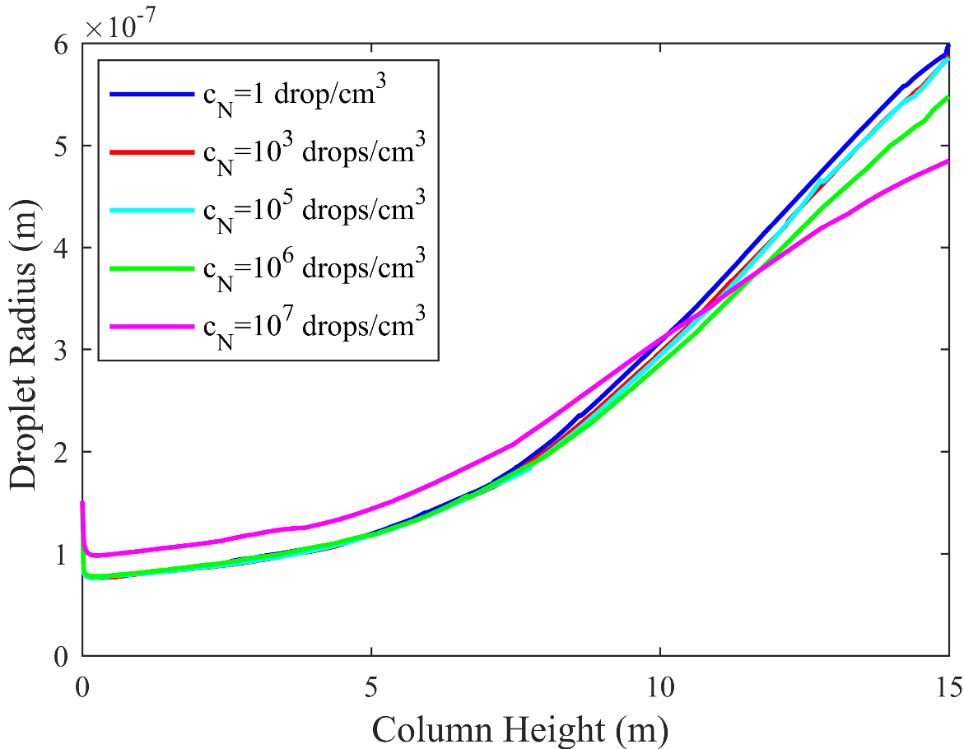

Figure 15: Growth of droplet (Case 4)
The droplet free MEA concentration drops rapidly similar to what is shown for the base case in Figure 3, mainly because of the reaction with CO₂ entering the droplet. The carbamate and protonated MEA concentrations shoot up and eventually the water concentration becomes low and up-take of water starts, thereby causing an increase in size. For c_{N} = 10⁷ the size reduction slows down. The droplet internal free MEA and carbamate profiles in this case are very similar to those for the smaller droplet numbers. However, in this case the free MEA evaporation is rapid, as witnessed by the initial increase in MEA gas phase partial pressure in Figure 9 for c_{N} = 10⁷. At the same time CO₂ reacts rapidly and the free MEA concentration falls as for the lower droplet number concentrations. The fact that the MEA gas phase partial pressure increases initially reduces the MEA evaporation and also the water evaporation, thus slowing down the reduction in droplet size as seen for c_{N} = 10⁷ in Figure 15. As the droplets move upwards both water and MEA gas phase pressures increase because of increasing temperature, and both start transferring into the droplets and the droplets increase in size. However, because of the large number of droplets, depletion of the gas phase results for c_{N} = 10⁷ and the droplet growth is slowed down.
Figure 16 shows the droplet growth for Case 5 with a droplet of initial radius 0.15 micron and 0.0001M MEA concentration. As expected from the small impact on the MEA partial pressure profiles of droplet concentrations all the way up to c_{N} = 10⁷ shown in Figure 10, there is very little change in the droplet growth curves as well. The profiles can be explained as for the large droplets, Case 3 and in Figure 13 we see that the initial droplet size reduction is larger than for Case 4, just as was observed when comparing Cases 3 and 2. It should be mentioned that the water partial pressure profiles are also unaffected by the droplets up to c_{N} = 10⁷. In order to see an effect, a droplet number concentration of c_{N} = 10⁸ was simulated. In this case a depletion effect is seen in Figure 10 which results also in a change in the droplet growth profile, similar to what we saw for c_{N} = 10⁷ in Figure 15.
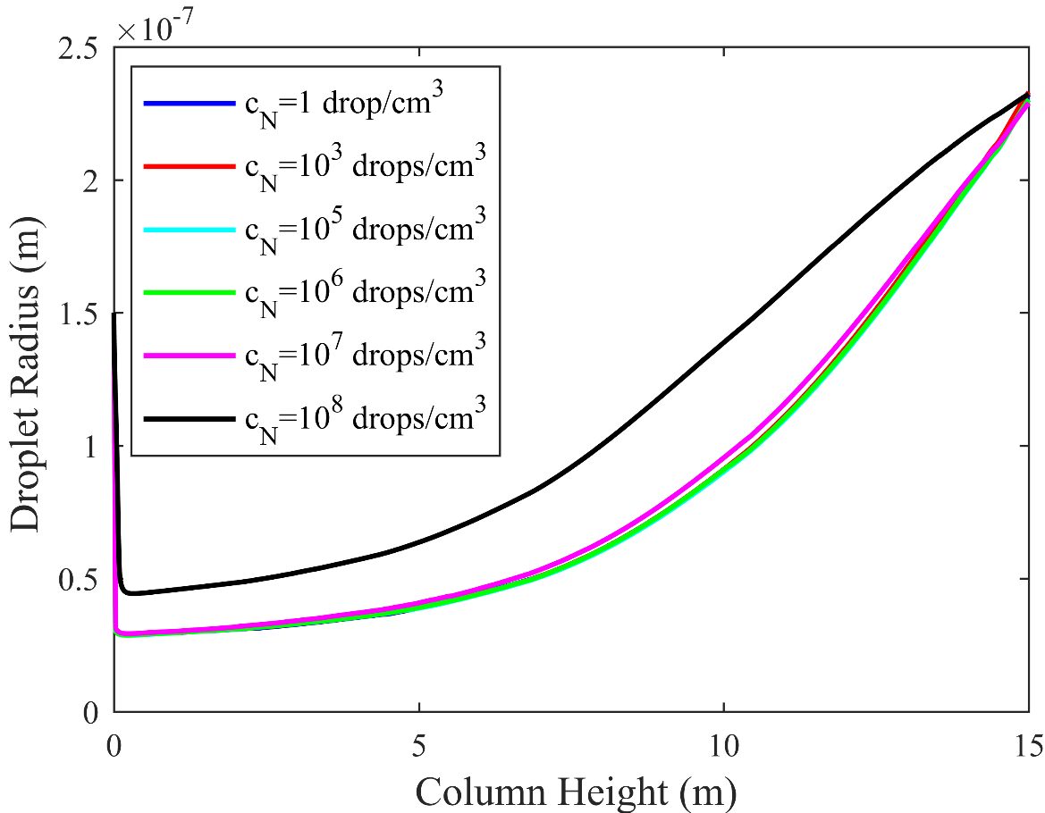

Figure 16: Growth of droplet (Case 5)

  - Effect of Amine Volatility (Partial Pressure Profiles and Depletion):
Cases 6 and 7 are unlike the previous cases as they assume an amine with a volatility only 10% of that of MEA. These cases are modelled to study what happens if the amine system is changed from the base case MEA to a non-volatile amine. In Cases 6 and 7 a fictitious amine is used with properties like MEA, but where the Henry’s law constant is increased by a factor of 10, thereby reducing the volatility by the same factor. The selected cases use a 1.5µ droplet radius with initial composition of 5M and 0.0001M amine.
In Case 6 a droplet with an initial radius of 1.5µ and having initial composition of 5M amine is travelling with the gas phase. The partial pressure profiles generated are presented in Figure 17. The partial pressure of amine in the gas phase behaves qualitatively similar to what is seen in Figure 5 but the absolute numbers are 10 times lower than for MEA. The varying droplet concentration has a significant effect on amine partial pressure. Initial peaks are seen in the higher droplet number concentration ranges because of rapid evaporation of amine and results in Figures 17 and 5 are almost identical in the initial part of the absorber. Up to c_{N} = 10³ the partial pressure curves in Figures 17 and 5 are almost exactly the same. However, for the higher number concentrations, where amine depletion occurs, it is seen that the depletion effect is significantly stronger in the case of low volatility than for MEA. The reason for the larger variations with low volatility is believed to be connected to the reduced gas phase capacity for amine, making the partial pressure profiles more sensitive to small changes in driving forces and thereby mass transfer rates.
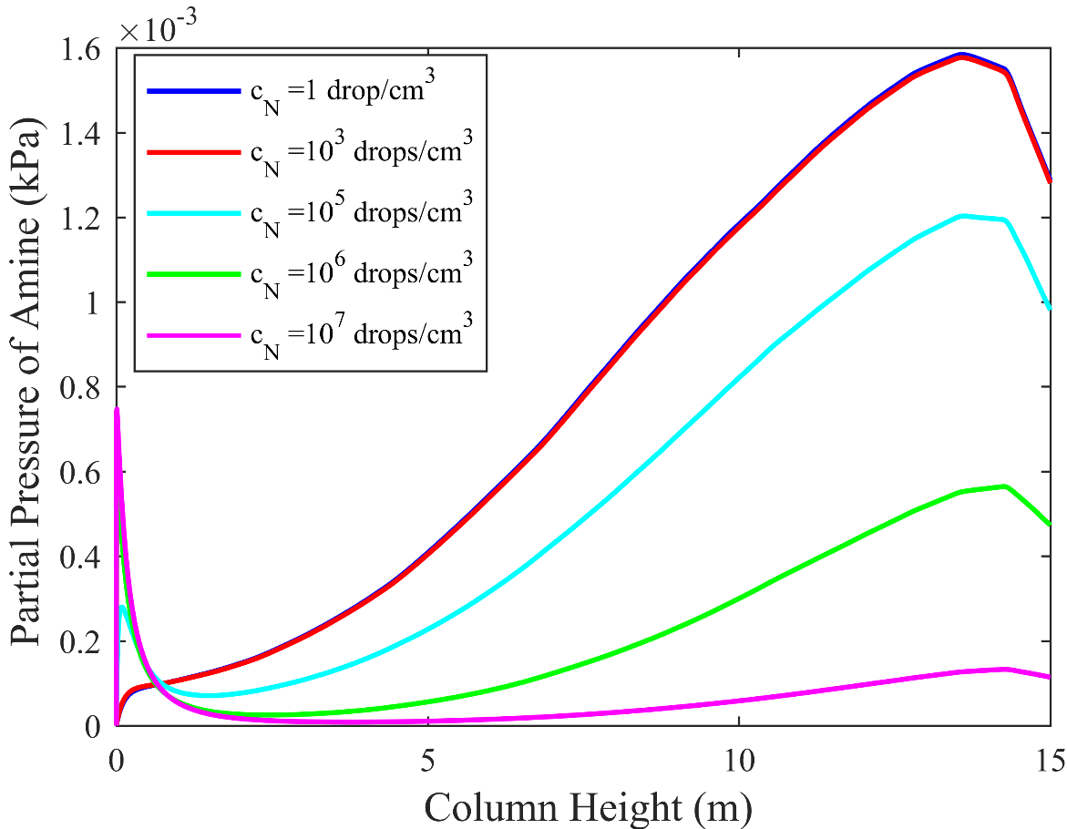

Figure 17: Amine partial pressure profiles along column (Case 6)
Case 7 is the analogue to case 3 but with 10 times lower amine volatility. The predicted amine partial pressure profiles are shown in Figure 18.

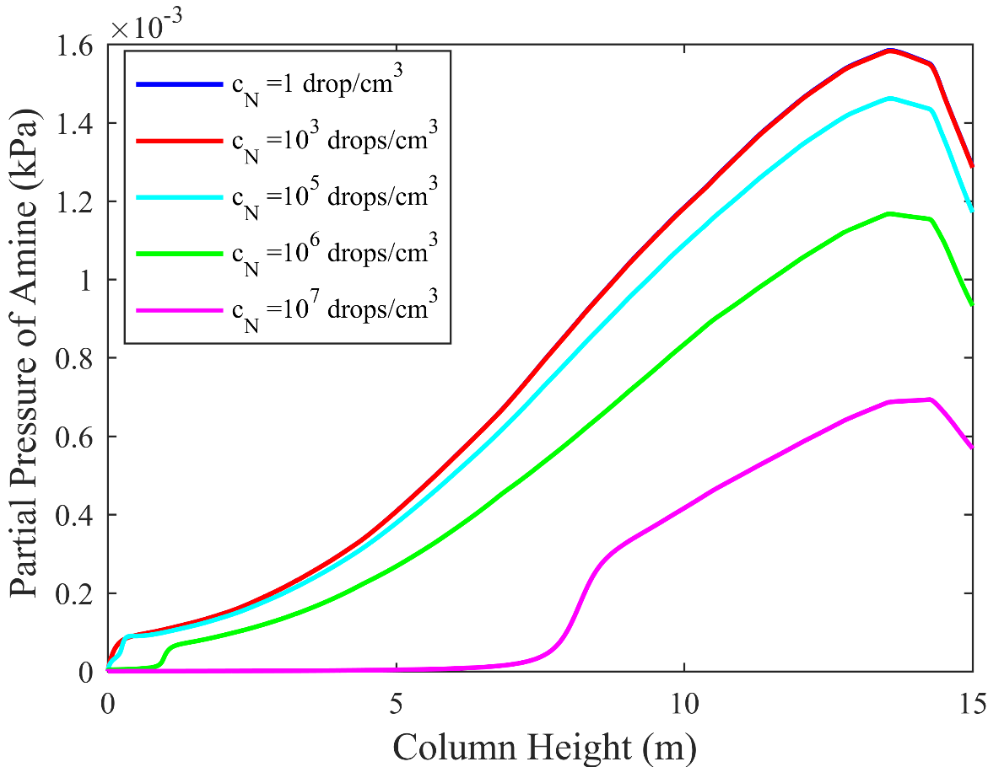

Figure 18: Amine partial pressure profiles along column (Case 7)
When comparing the low volatility system with MEA, the results are very similar to what was found for the 5M amine system in Case 6. On the other hand up to c_{N} = 10³ the partial pressure curves in Figures 18 and 6 are almost exactly the same. At higher number concentrations, also in this case the effect of increasing droplet number concentrations is larger than for MEA.

  - Droplet Growth:
The droplet growth profiles for Cases 6 and 7 are shown in Figures 19 and 20 respectively. The results in Figure 19 for 5M amine can be compared to Figure 11 for 5M MEA. It is seen that the initial reduction in droplet size is lower for the low volatility amine. In addition, the final droplet sizes are smaller than for MEA. This is in accordance with what was found earlier, that a stronger reduction in amine partial pressure by depletion leads to less growth because of the coupling between droplet total amine concentration and the water vapor pressure.
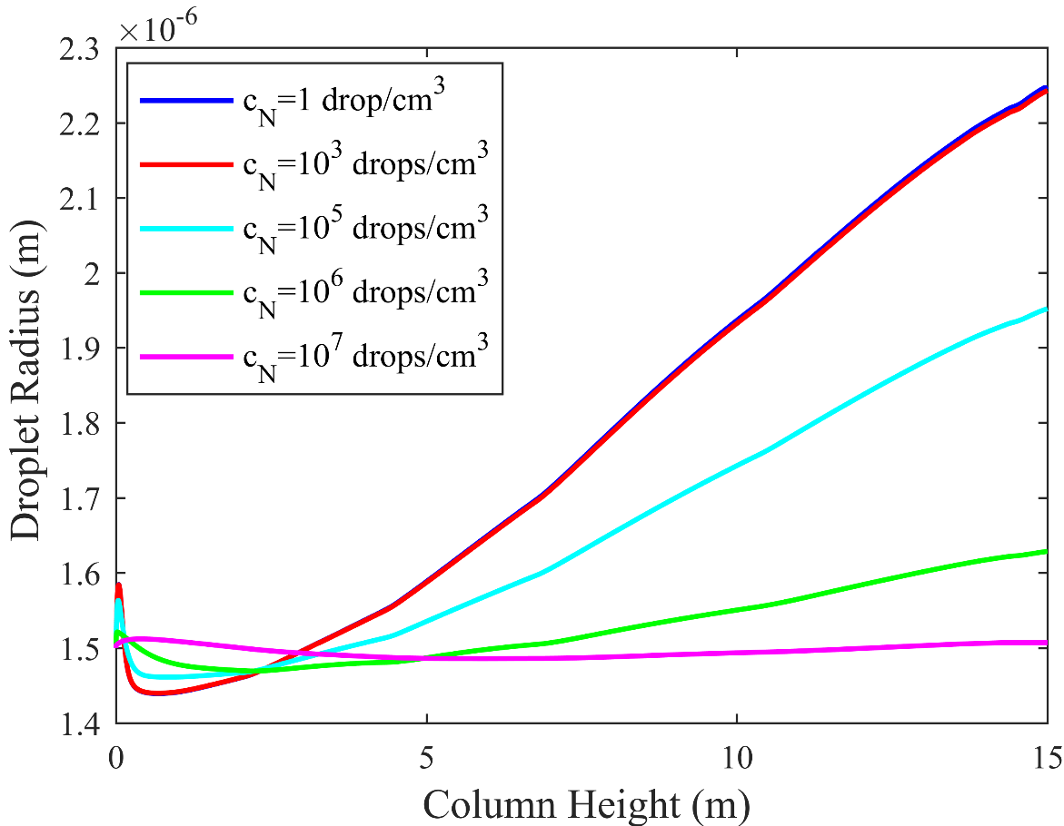

Figure 19: Growth of droplet (Case 6)
For Case 7, with low initial amine concentration, the effect of lower volatility is stronger than in Case 6. The initial reduction in size is larger for all droplet number concentrations and the final droplet sizes are significantly lower than with MEA. In fact, for all number concentrations the final droplet sizes were lower than the initial one.
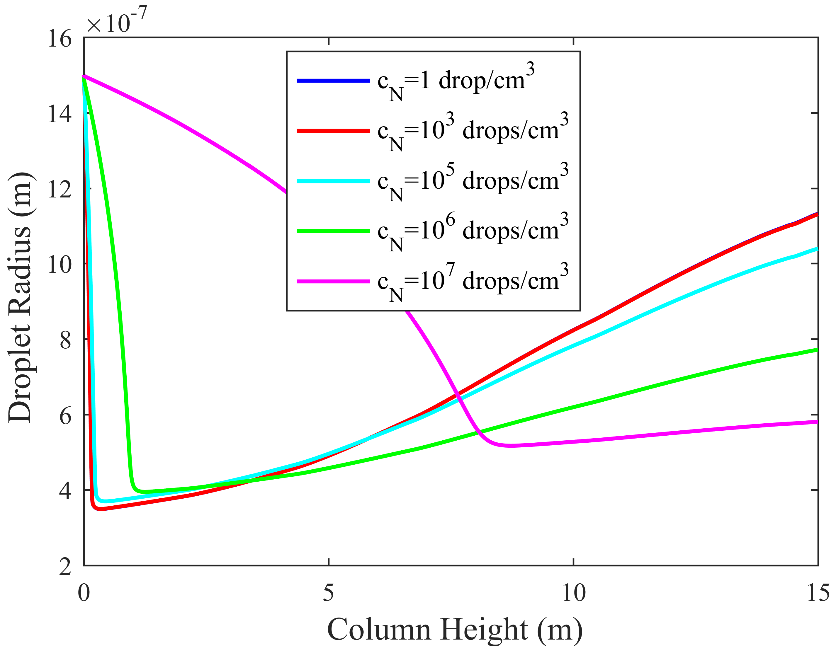

Figure 20: Growth of droplet (Case 7)
  - Changes in CO₂ and Water Gas Phase Profiles:
CO₂
Because of the high CO₂ partial pressure it may be intuitive to think that the gas phase pressure profiles will be unaffected by aerosol presence. For most cases this is true. For all cases with 0.15µ droplets there is no visible effect on the CO₂ profiles. Also for 1.5µ droplets only the highest droplet concentration shows an effect. For c_{N} = 10⁷ we see from Figure 21 that the CO₂ partial pressure drops faster than with less number of droplets.
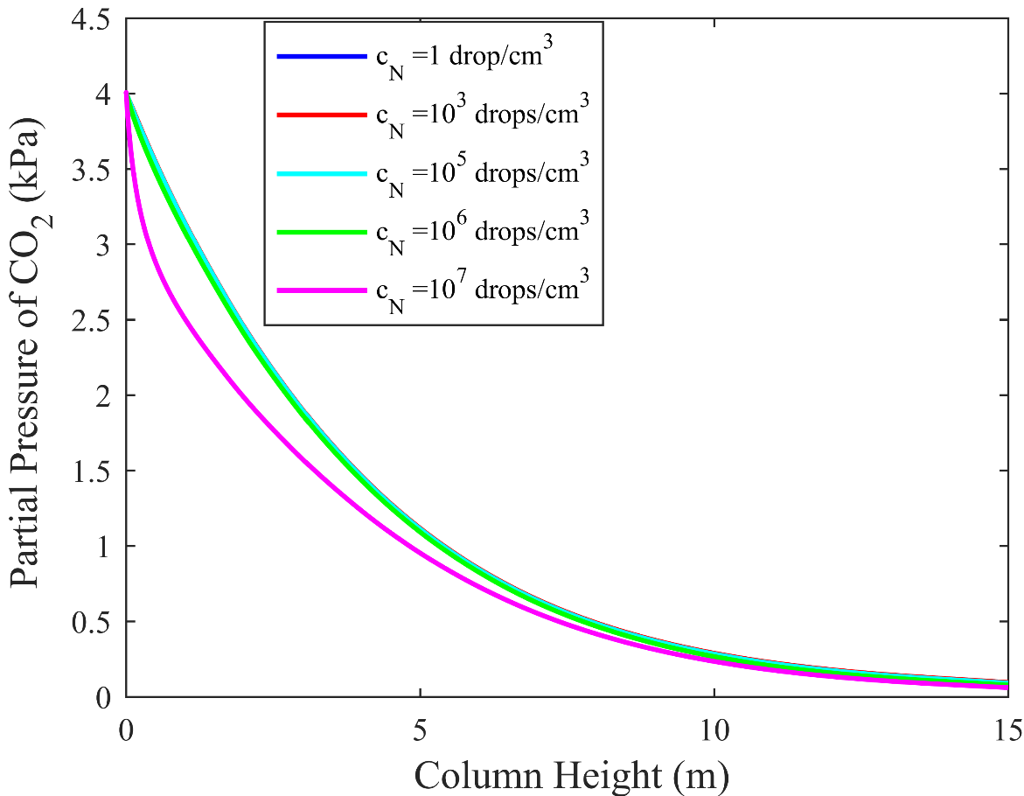

Figure 21: CO₂ partial pressure profiles along column (Case 2)
The reason for this is the significant capacity of the aerosol for CO₂ up-take, about 10% of the bulk liquid, combined with the large interfacial area providing fast transfer to the droplets. As is seen in Figure 21, this leads to lower CO₂ partial pressures in the absorber and therefor lower driving forces for absorption into the bulk liquid. Thus, if the CO₂ in the droplets leave the absorber as an aerosol, this implies a low recovery rate for CO₂.
Water
As mentioned in the beginning of section 4, in this work the gas phase composition profiles are calculated by a mass balance; with mass transfer to and from the liquid bulk and the aerosol droplets. The thermodynamic basis for the driving forces is an in-house E-NRTL model, (Putta et al., 2016). This is the same model as used for the gas-droplet mass transfer in (Majeed et al., 2017), but in this work it is used also for the gas-bulk liquid mass transfer. This leads to a small change in the water partial pressure profile compared to the ASPEN profile as shown in Figure 22.
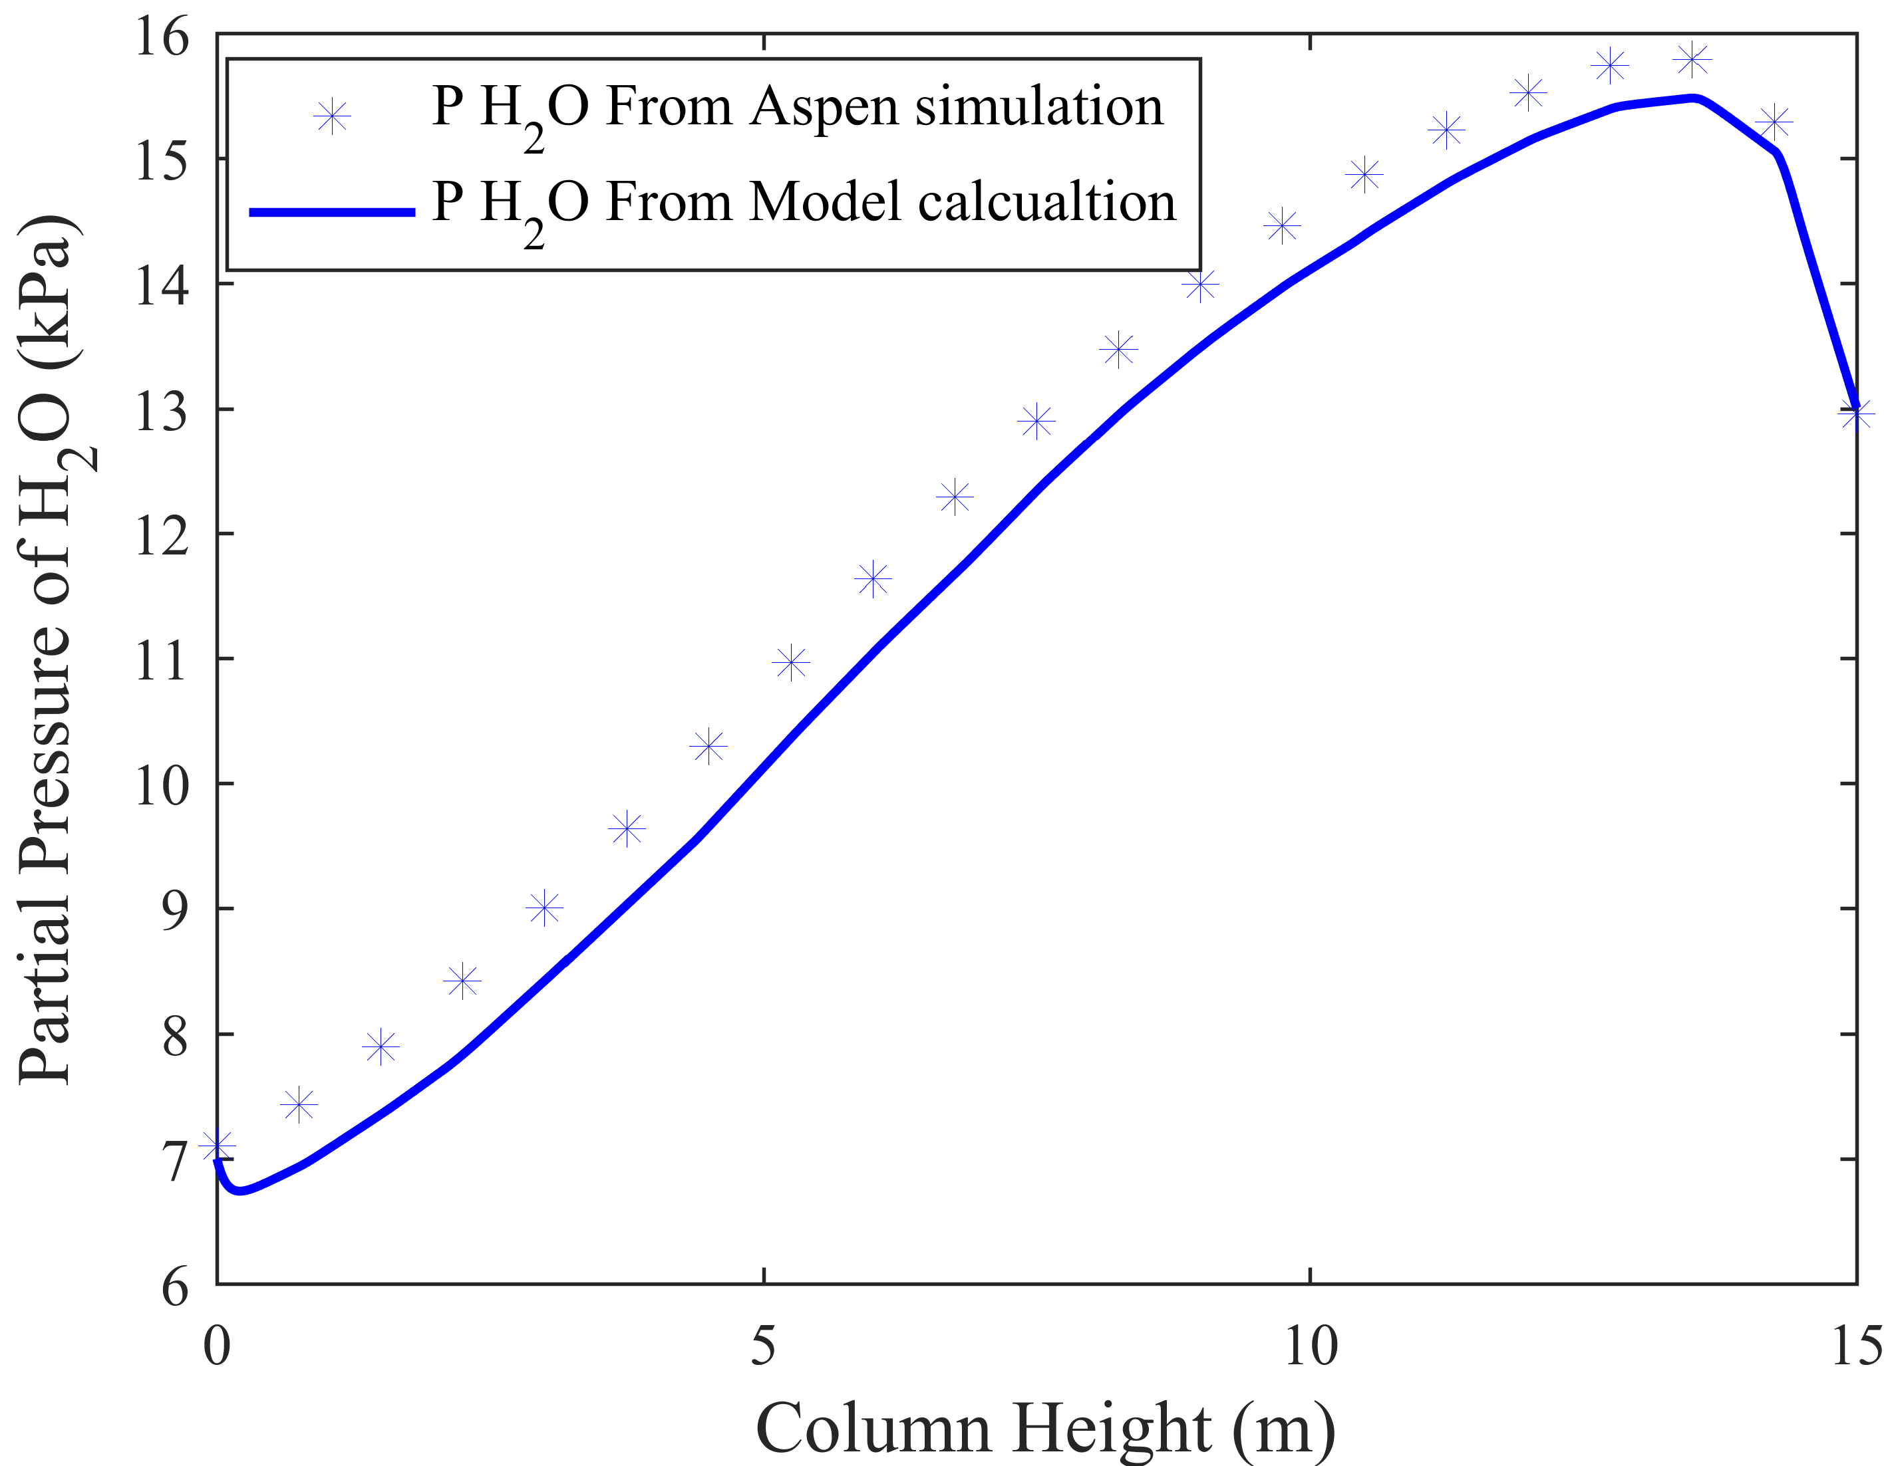

Figure 22: Water partial pressure profiles along column (Case 2, c_{N}=1 droplet/cm³)
Thus also the driving forces for water are affected and the droplet growth profiles as well. When comparing Fig 11 for the case of 1 droplet/cm³ with the similar case in (Majeed et al., 2017) we see that this leads to different growth profiles. The lower water partial pressure profile in this work leads to slower growth and a smaller final droplet size. This is natural since the driving forces in this work are smaller. At the absorber top this changes as the partial pressures in this work actually become very close to the ones in (Majeed et al., 2017) and at the end are larger. Thus the drop in water partial toward the absorber top seen in Fig. 22 is less pronounced in the present work leading to a continuous increase in droplet size, see Fig. 11, compared to the similar case in (Majeed et al., 2017) where a small drop in size toward the top is seen.

- Comparison with Campaign Results:
Different pilot plant campaigns reported in the literature, have been carried out in order to reduce or to understand the build-up of aerosol based emissions. Although none of the available papers report results on a level of detail directly comparable to the present simulations, they can still serve as an overall and more qualitative comparison with the model.
Amine emissions are reported in (Khakharia et al., 2013, 2014; Mertens et al., 2014), all based on various kinds of inlet foreign nuclei, e.g. sulfuric acid or soot. Ranges of droplet number concentrations and amine emissions reported were 10³-10⁷ droplets/cm³ with amine emissions of 100-200 mg/Nm³ in the case of soot particles, and 600-1100 mg/Nm³ in the case of sulfuric acid nuclei, see (Khakharia et al., 2013). Droplet size distributions or size ranges were not given, but it is believed that the most suitable cases for comparison are Case 4 and Case 5, as usually reported droplet sizes fall in the sub-micron size range. Instead of soot or sulfuric acid as foreign nuclei, pure water and 5M MEA is used in current work. This means that modelled results may not be directly comparable to pilot results, but can give an idea of amine emissions when depletion into or from the gas phase is also taken into account.
In the case of soot particles, these may be thought of as relatively inert and only acting as condensation kernels for water and MEA. They also go through a direct contact cooler for conditioning of the gas. In this way, a comparison with an aerosol consisting of nearly pure water droplets may give a fair comparison. In Case 5, with 0.15µ water droplets entering, the model MEA emission predictions with 10³-10⁷droplets/cm³ are in the range 0.02-310 mg/Nm³. If Case 3 with 1.5µ droplets is used, the predictions would be 7- 17000 mg/Nm³. The initial size range of the entering droplets is therefore very important. However, the model predictions are in the right range and better predictions could be made when knowing the entering droplet sizes more accurately.
A 5M MEA initial concentration could resemble more the sulfuric acid containing particles. However, with sulfuric acid, MEA will rapidly be absorbed in the droplets and neutralized. Thus, in cases with large droplet numbers, strong gas phase depletion of MEA could result. With droplets having an initial size of 0.15µ and with droplet number concentrations of 10³-10⁷droplets/cm³, the modelled emissions are in the range 0.3-1800 mg/Nm³. This is also in the similar range as given by (Khakharia et al. 2013).
The results are promising in the sense that they are in the same range as literature data reported. The predicated emission results in this work are lower than predicted in (Majeed et al., 2017) because of the assumption used earlier that the droplet(s) will not affect the bulk gas phase.

- Conclusions:
In order to minimize aerosol emissions from absorption based CO₂ capture plants a deep understanding of the mechanisms relating to droplet formation and growth is necessary. For this purpose rigorous theoretical models and detailed experimental research is required.
In this work droplet growth and internal composition profiles are modelled taking into account possible gas phase component depletion caused by dense droplet swarms.

For an MEA based absorption system it is found that no gas phase component depletion occurs with entering droplets of radius 0.15µ and 1.5µ, and with droplet number concentrations up to respectively 10⁵ and 10³ droplets/cm³ regardless of droplet initial composition. In these cases the droplet number concentration does also not influence the droplet growth
For the larger droplets, radius 1.5µ, and number concentrations from 10⁵ and upward, there is a strong interaction between the gas phase and droplet swarm. For an initial droplet MEA concentration of 5M, an initial increase in gas phase MEA partial pressure is seen, then it drops because of depletion and increases again toward the absorber top. With nearly pure water as initial droplet condition, a rapid and strong gas phase MEA depletion is seen lasting a third of the column length for the highest droplet number concentration. In addition, the gas phase water partial pressure is found to be affected in these cases and there is a complex interaction between the MEA and water transport to and from the droplets. It is found that droplet growth/shrinkage is very sensitive to small variations in MEA and water vapor pressure because of the small driving forces in the absorber. Thus, large variations in droplet size development is seen for the cases affecting the gas phase partial pressures.

The CO₂ partial pressure profiles were found to be nearly unaffected by the aerosol swarms. Only in the most extreme case with large droplets, radius 1.5µ, and high number concentration, 10⁷ droplets/cm³, could an effect be seen in the form of a reduction in gas phase CO₂ partial pressures.

The effect of a ten-fold reduction in amine volatility was found to increase the droplet growth sensitivity toward gas phase component depletion.

Emissions estimated from the current model are in reasonable agreement with data from studies published. On the other hand, more detailed experimental work is needed to further validate the models. Also, more work is needed including the characterization of droplet growth in the water wash sections and improved modelling of entering droplets with new constituents, e.g sulfuric acid.

Acknowledgement:
Financial support from the Faculty of Natural Sciences at the Norwegian University of Science and Technology, Trondheim and the CLIMIT Demo project Aerosolve (616125) with partners SINTEF Materials and Chemistry, NTNU, Technology Center Mongstad, Maasvlakte CCS project (ROAD), Uniper, Engie Laborelec and TNO is greatly appreciated.

Notations
C_{x} |  | Concentration of any component (mol m⁻³) |  | Greek letters
C_{p} |  | Heat capacity (kj kg⁻¹K⁻¹) |  | 𝝆_{x} | Density of any component (kg m⁻³)
Dx |  | Diffusivity of any component (m² sec⁻¹) |  | µ | Viscosity (kg m⁻¹ sec⁻¹)
Keq |  | Equilibrium kinetic rate constant
R | Gas constant (m³ pa⁻¹ mol⁻¹ K⁻¹)
 |  |  | Indices
h | Heat transfer coefficient (kW m⁻² K⁻¹)
k_{g} |  | Over all mass transfer coefficient (kmol m⁻² sec⁻¹ kPa⁻¹) |  | MEA | Monoethanol amine
N_{x} |  | Flux of any component (kmol m⁻² sec⁻¹) |  | d | Droplet/Aerosol
P |  | Partial pressure (kPa) |  | g | Gas
R |  | Initial droplet radius (m) |  | f | Film
r_{x} |  | Rate of reaction (kmol m⁻³ sec⁻¹) |  | l | Liquid
t |  | Time (sec)
T |  | Temperature (K)
u_{s} |  | Superficial velocity (m sec⁻¹)
v |  | Velocity (m sec⁻¹)

References
Abu-Zahra, 2009. Carbon dioxide capture from flue gas: development and evaluation of existing and novel process concepts (PhD Thesis). Technical University of Delft, The Netherlands.
Aspen Plus, 2015. ELECNRTL Rate Based Monoethanol amine Model. Aspen Plus.
Billet, R., Schultes, M., 1999. Prediction of Mass Transfer Columns with Dumped and Arranged Packings. Chem. Eng. Res. Des. 77, 498–504. doi:10.1205/026387699526520
Crooks, J.E., Donnellan, J.P., 1989. Kinetics and mechanism of the reaction between carbon dioxide and amines in aqueous solution. J. Chem. Soc. Perkin Trans. 2 331–333.
da Silva, E.F., Svendsen, H.F., 2007. Computational chemistry study of reactions, equilibrium and kinetics of chemical CO2 absorption. Int. J. Greenh. Gas Control 1, 151–157. doi:10.1016/S1750-5836(07)00022-9
Fulk, S.M., 2016. Measuring and modeling aerosols in carbon dioxide capture by aqueous amines (Thesis).
Fulk, S.M., Rochelle, G.T., 2013. Modeling Aerosols in Amine-based CO2 Capture. Energy Procedia, GHGT-11 Proceedings of the 11th International Conference on Greenhouse Gas Control Technologies, 18-22 November 2012, Kyoto, Japan 37, 1706–1719. doi:10.1016/j.egypro.2013.06.046
Fullskala Mongstad [WWW Document], 2014. URL http://www.gassnova.no/no/prosjekter52/fullskala-mongstad (accessed 4.6.17).
Geankoplis, C.J., 2003. Transport Processes and Separation Process Principles, 4 edition. ed. Prentice Hall, Upper Saddle River, NJ.
Khakharia, P., Brachert, L., Mertens, J., Anderlohr, C., Huizinga, A., Fernandez, E.S., Schallert, B., Schaber, K., Vlugt, T.J.H., Goetheer, E., 2015. Understanding aerosol based emissions in a Post Combustion CO2 Capture process: Parameter testing and mechanisms. Int. J. Greenh. Gas Control 34, 63–74. doi:10.1016/j.ijggc.2015.01.001
Khakharia, P., Brachert, L., Mertens, J., Huizinga, A., Schallert, B., Schaber, K., Vlugt, T.J.H., Goetheer, E., 2013. Investigation of aerosol based emission of MEA due to sulphuric acid aerosol and soot in a Post Combustion CO2 Capture process. Int. J. Greenh. Gas Control 19, 138–144. doi:10.1016/j.ijggc.2013.08.014
Khakharia, P., Mertens, J., Vlugt, T.J.H., Goetheer, E., 2014. Predicting Aerosol Based Emissions in a Post Combustion CO2 Capture Process Using an Aspen Plus Model. Energy Procedia 63, 911–925. doi:10.1016/j.egypro.2014.11.101
Knudsen, S., Randall, S., 2009. Amine Emissions to Air During Carbon Capture. Phase 1: CO2 and Amines Screening Study for Effects to the Environment. NILU Report. www.CO2.nilu.no.
Luo, X., Hartono, A., Hussain, S., F. Svendsen, H., 2015. Mass transfer and kinetics of carbon dioxide absorption into loaded aqueous monoethanolamine solutions. Chem. Eng. Sci. 123, 57–69. doi:10.1016/j.ces.2014.10.013
MacDowell, N., Florin, N., Buchard, A., Hallett, J., Galindo, A., Jackson, G., Adjiman, C.S., Williams, C.K., Shah, N., Fennell, P., 2010. An overview of CO2 capture technologies. Energy Environ. Sci. 3, 1645. doi:10.1039/c004106h
Majeed, H., Knuutila, H.K., Hillestad, M., Svendsen, H.F., 2017. Characterization and modelling of aerosol droplet in absorption columns. Int. J. Greenh. Gas Control 58, 114–126. doi:10.1016/j.ijggc.2017.01.006
Mertens, J., Brachert, L., Desagher, D., Thielens, M.L., Khakharia, P., Goetheer, E., Schaber, K., 2014. ELPI+ measurements of aerosol growth in an amine absorption column. Int. J. Greenh. Gas Control 23, 44–50. doi:10.1016/j.ijggc.2014.02.002
Moser, P., Schmidt, S., Stahl, K., Vorberg, G., Lozano, G.A., Stoffregen, T., Richter, T., 2015. The wet electrostatic precipitator as a cause of mist formation—Results from the amine-based post-combustion capture pilot plant at Niederaussem. Int. J. Greenh. Gas Control 41, 229–238. doi:10.1016/j.ijggc.2015.07.010
Putta, K.R., Pinto, D.D.D., Svendsen, H.F., Knuutila, H.K., 2016. CO2 absorption into loaded aqueous MEA solutions: Kinetics assessment using penetration theory. Int. J. Greenh. Gas Control 53, 338–353. doi:10.1016/j.ijggc.2016.08.009
Rochelle, G.T., 2009. Amine Scrubbing for CO2 Capture. Science 325, 1652–1654. doi:10.1126/science.1176731
Saha, C., Irvin, J.H., 2017. Real-time aerosol measurements in pilot scale coal fired post-combustion CO2 capture. J. Aerosol Sci. 104, 43–57. doi:10.1016/j.jaerosci.2016.11.005
Sanchez-Fernandez, E., Mercader, F. de M., Misiak, K., van der Ham, L., Linders, M., Goetheer, E., 2013. New Process Concepts for CO2 Capture based on Precipitating Amino Acids. Energy Procedia 37, 1160–1171. doi:10.1016/j.egypro.2013.05.213
Schaber, K., Körber, J., Ofenloch, O., Ehrig, R., Deuflhard, P., 2002. Aerosol formation in gas–liquid contact devices—nucleation, growth and particle dynamics. Chem. Eng. Sci. 57, 4345–4356.
Zhang, Y., Kang, J.-L., Fulk, S.M., Rochelle, G., 2017. Modeling Amine Aerosol Growth at Realistic Pilot Plant Conditions. Energy Procedia, 13th International Conference on Greenhouse Gas Control Technologies, GHGT-13.

