Managing innovation in eldercare: A glimpse into what and how public organizations are planning to deliver healthcare services for their future elderly.

Joseph S. Schultz BS, JD (PhD candidate)¹, Beate André RN, PhD (Associate Professor)², and Endre Sjøvold Msc, PhD (Associate Professor)³

¹Department of Industrial Economics and Technology, Norwegian University of Science and Technology (NTNU), Trondheim, Norway, and Sør-Trøndelag University College (HiST), Trondheim, Norway, ²Faculty of Nursing, HiST, and Research Centre for Health Promotion and Resource, HiST and NTNU, Trondheim, Norway, email: beat.andre@hist.no, and ³Department of Industrial Economics and Technology Management, Faculty of Social Sciences and Technology Management, NTNU, Trondheim, Norway, email: endre.sjovold@iot.ntnu.no.

Corresponding author: Joseph S. Schultz, Department of Industrial Economics and Technology, Norwegian University of Science and Technology (NTNU), Sentralbygg II, Alfred Getz veg 3, 7491 Trondheim, Norway. Telephone- +47 450 88 471. Email: joseph.schultz@iot.ntnu.no.

Funding: This research was funded entirely by HiST. The author was funded for his position as a researcher in general, not for this particular project.

Conflicting Interests: There are no conflicts of interest between the author(s) in this article with respect to the interpretation or presentation of information. The authors were not influenced by personal or financial relationships with other people or organizations. This research was funded by Høgskolen i Sør-Trøndelag. No conflict of interest exists between the author(s) and this university.

Acknowledgement statement: I would first like to thank HiST for their continued support of my research. Additionally, all the participants of this study for being so open and willing to further my research interests. Furthermore, I would like thank NTNU and the Norwegian Research School of Innovation - Program in Innovation Management and Innovation Strategy (NORSI-PIMS) for their help in further developing my research. A special thanks to my advisors: Endre Sjøvold, Beate André, and Roger Bergh. Lastly, I’d like to thank the NORSI-PIMS PhD candidates for their discussions and practical clarity they’ve provided me in my research.

Word Count: 5,682 (in text)

Page count: 20 pages (in text)

Abstract
Eldercare policies are being dramatically reshaped due to demographic shifts worldwide. The elderly are living longer and healthier, and their infrastructural impacts on society are well known amongst researchers. It is known that most countries will be experiencing unprecedented growths in their elder population, but what is less known is what and how public-entities are going to meet these upcoming challenges. The aim for this paper is to analyze eldercare innovations in light of the increasing numbers of elderly people, with the support of eldercare theory. This empirical study will deepen the understanding of eldercare by showing the strategic direction of leaders in this field. We found a clear lack of innovation strategy in formal innovation training, recruitment workers, and knowledge sharing channels between municipalities. It’s clear that Norway’s innovation strategy is to facilitate healthy aging for the elderly in their own homes as long as possible. Most developments have been smart in-home technology. Accordingly, eldercare theory would urge Norwegian municipalities to strive for more balance in their eldercare system, inter alia, by developing innovation processes, improving recruitment or reshaping social responsibility. We have enumerated, in the conclusion, how municipalities and other public-entities can learn from this study.

Keywords: eldercare, elderly, innovation, management, public organizations, strategy

Background
Global populations are currently rising at unprecedented rates. “Globally, the number of older persons is expected to more than double, from 841 million people in 2013 to more than 2 billion in 2050” (Nations, 2013). Some of the most developed countries are expected to be impacted most; the majority of Europe, the United States, Australia, Japan, and Korea, just to name a few (Kulik, Ryan, Harper, & George, 2014). For example, in the United Kingdom, it’s expected that their elder population (aged 65 and older) will approximately double from 10 million to 19 million, from 2013 to 2050 (Kulik et al., 2014). For England, this will mean that almost 1 in 4 persons will be aged 65 or older. Similarly, in the United States, the elder population is expected to more than double from 2009 to 2030 (Aging, 2014). This shift in social demographics has forced countries to reshape how they think of eldercare services.
Recently, eldercare theory has emerged as a tool for public-entities trying to manage this process. Eldercare theory breaks elderly needs down into three main categories; improving the quality of care, improving the working environment, and societal efficiency (see Figures 1-4) (Schultz, André, & Sjøvold, 2014). This theory states that public-entities need to maintain their appropriate balance between the three facets (Schultz et al., 2014). At the start and completion of each innovation project, the public-entity ought to consider the impact that the project will have on the three main categories. Eldercare theory will than become a continual re-evaluation of the impact an innovation project has on the existing eldercare system through the three main categories. However, this theory has not been supported by empirical evidence. This is the gap we hope to fill. Recently, the AMJ has stressed the importance of this issue and the need for research in the management of eldercare (Kulik et al., 2014).
The context for testing this eldercare theory is Norway. Norway is a good fit for this study for a couple reasons. First and foremost, for the last two years they have been considered the global leader in providing eldercare services (International, 2013, 2014). Second, they are experiencing similar infrastructural issues as most countries. Lastly, we have access to substantial data from this region.
In order to better understand the impact of this research, a review of the Norwegian eldercare system will be provided. The Norwegian health care system is best classified as semi-centralized. The central government (the State) is in charge of regulation and supervision of the health care system, but many tasks and responsibilities have been delegated to various subordinate agencies and municipalities. (Ringard, Sagan, Sperre Saunes, & Lindahl, 2013). Traditionally, municipalities have been responsible for primary care (including elderly care), while the State was responsible for specialty care and retirement pension. (Ringard et al., 2013). However, in 2012, the State passed legislation that transferred responsibility from the State to the municipalities for the following services: select specialty services, preventative care, and for discharging patients from the hospitals (Omsorgsdepartement, 2009). Eldercare health services are now, almost entirely provided for by the municipalities. Municipalities are responsible for having adequate nursing homes, providing adequate services for the elderly living in their own homes, and emergency response. An exception to municipal-responsibility is if the elderly opt for private care services.
The majority of the health care system is financed by the state (85%), while approximately 15% of health costs are privately financed; mainly from pharmaceuticals, dental care, or a €21 co-payment for visits to the primary care physician (Ringard et al., 2013). Primary care is financed by municipal taxes, block grants from the State, and earmarked grants (Ringard et al., 2013). Most specialist care is financed through block grants (60%), and activity based financing from the State to the Regional Health Authorities (40%) (Ringard et al., 2013).
Even though Norway’s health services are delivered almost entirely by the public, they’re experiencing similar infrastructural impacts as the rest of the world, such as an increasing elder population, a decreasing labor force, upcoming recruitment challenges, and dire financial impacts (due to generous retirement benefits and universal healthcare). Thus, the solutions they’re developing should be able to be applied (to some extent) to aid others experiencing similar infrastructural issues (e.g., improving quality of care to elderly or improving working environment for home-care nurses). In 2050, Norway’s elderly population is expected to nearly double from their population size in 2010 (Statistisk-Sentralbyrå, 2012, 2014). Additionally, their labor force is expected to decrease from 61% in 2010, to 56% in 2050 (Statistisk-Sentralbyrå, 2012). Furthermore, Norwegian municipalities have always struggled to fill home-nursing vacancies due to a poor perception of the working environment among newly-educated nurses (Mæle, 2014a, 2014b; Nordberg, 2013; Sundberg & Samdal, 2013; Ulstein, 2006). A recent survey of 3,600 newly graduated nurses, conducted by the Norwegian Nursing Association, showed that only 7% of nursing students could see themselves working for municipalities as a home-nurse (Mæle, 2014a). Moreover, when the vacant positions do get filled, they usually filled by unqualified workers. Trondheim, the third largest city in Norway, reported that only 1 in 4 nurses had a college education (Sundberg & Samdal, 2013). In 2035, it’s estimated that 30-35% of all the students that graduate from high school will need to be recruited into health services to be able to deliver the same type of service at the same standard today (Mæle, 2014b). Currently, only 10% are being recruited (Mæle, 2014b). When the current supply of labor is viewed in light of upcoming demands, a relatively dim picture is painted for Norway.
Review of the literature
Most research that has emerged in this field is quite segmented. Nursing schools are predominately focusing on improving the working environment for nurses, while private tech firms are promising to have developed the one size-fits-all solution to everyone’s problems (Behr, Sciegaj, Walters, Bertoty, & Dungan, 2011; Hayakawa et al., 2013). A relevant topic that has surfaced is eldercare theory. Eldercare theory states that municipalities need to appropriately balance their eldercare innovations in three main categories; improving the quality of care for the elderly, improving the working environment, and societal efficiency (see Figure 1) (Schultz et al., 2014). Schultz et al. state that “paramount to the success of managing eldercare innovation is the manager’s ability to continually evaluate the appropriate balance between these three categories” (2014). Balancing these three categories is critical for the organization managing this operation because the three categories can often have an inverse relationship to each other (Schultz et al., 2014). A further breakdown of each of the three categories will now be discussed to better understand which innovations fit within each category.
The quality of care for the elderly focuses on those developments that improve the quality of life for the elderly. This is a complicated issue, especially if healthcare is provided by the government. It’s complicated because the government wants to provide universal care for individual conditions. However, few elderly have the same aging conditions, and even fewer have the same treatment for that condition. Municipalities understand this, but are motivated to provide universal treatment so that the cost of care is more affordable (for both treatment and training costs). In improving the quality of care for the elderly, it’s important to recognize the distinction between two different elderly groups; the young-elderly and the elder-elderly (see Figure 2) (Schultz et al., 2014). The young-elderly are those elderly that are self-sufficient, living at home, and needing little to no assistance (see Figure 2) (Schultz et al., 2014). Generally, this group is most concerned with maintaining their independent lifestyle, having transportation available, needing assistance with groceries, and maintaining their social activities (Schultz et al., 2014). The type of assistance the young-elderly need is best classified as nonprofessional assistance. While the elder-elderly, are the elderly who aren’t self-sufficient and require significant assistance (for example, those with dementia). Generally, this group is most concerned with their safety and health (Schultz et al., 2014). Given their specific conditions, treatments, and individual reactions to both conditions and treatments, the elder-elderly will benefit most from professional assistance (e.g., geriatricians and nurses). These are two important distinctions for those managing elderly care so that they can improve the quality of care for that elderly group they’re targeting.
The working environment emphasizes managements need to focus on recruitment of new employees, managing current employees effectively, integrating volunteers into the system, and having organizational processes that create a culture open to innovation (see Figure 3) (Schultz et al., 2014). The working environment has continually struggled to recruit newly educated nurses into homecare nursing. Additionally, to deliver the same or better services given upcoming demands, home care nursing is going to need to significantly improve their management of employees, and need to figure out how to recruit and manage volunteers (Schultz et al., 2014). Lastly, organizational processes are described as innovation processes that enable organizations to be able to adapt and change quickly with the upcoming changes in the environment (Schultz et al., 2014).
The national government plays a significant role for some countries, and not as much for others. In Norway, the government has a very significant role (see Figure 4) (Schultz et al., 2014). Having recently passed the Coordination Reform, this law transfers a significant amount of responsibility from hospitals onto the municipalities (Omsorgsdepartement, 2009). Additionally, the national government is attempting to create a standardization of welfare technology for municipalities (Helsedirektoratet, 2014). Through reform, the national government is setting expectations for the elderly, the municipalities, and society with regard to how they are going to provide eldercare. This role aspect is important when we start considering shifting social responsibility (for example from municipalities onto individuals).
Eldercare theory is an analytical tool that can assist researchers or managers in understanding how municipalities manage innovation in eldercare, but it has yet to be tested. This is the aim of our study, to provide an empirical analysis of eldercare theory to determine what and how Norwegian municipalities are innovating. Through this empirical analysis, the reader will get a glimpse of what the leaders in eldercare are doing, and how to improve on this process.
Methods
Participants
The level of analysis is the municipality. The sample included 14 interviews with healthcare practitioners (9 municipal-managers, 4 academic or research institutions, and 1 an influential governmental organization). 8 of the respondents were women, while 6 were men. The roles of the respondents ranged from special innovation advisors to department leaders, project leaders, researchers, and professors in the school of nursing.
The inclusion criterion was limited to managers of Norwegian municipalities, and a municipality identified as being innovative in the field of eldercare. A municipality was classified as innovative based on their peer’s views. Municipalities referred to, more than once, as being innovative by their peers that we had contact with were in the initial inclusion criteria. Self-perceptions of being innovative were excluded due to bias results. These innovative municipalities were further refined by how many innovative projects they are working on and have completed, that are public or otherwise available, that address infrastructural impacts caused by the baby-boomers. Additionally, to be included, these projects needed to change the way that services or technology were previously being provided for in their municipality. However, the inclusion criterion was expanded when an actor’s view was deemed necessary. For example, if an independent governmental organization was named several times during our correspondence or interviews, they would than fit within the inclusion criteria, even though they weren’t a Norwegian municipality per se. Consideration was given to the size of the municipalities due to potential bias in funding; larger municipalities are given more resources by the government. In Norway, we defined a large municipality as having 120,000 residents or more. Given this limit, only five municipalities in Norway qualify as large municipalities, the others, having less than 120,000 residents are considered small municipalities. We interviewed two large municipalities and 4 small municipalities. Although this sample size is relatively small, we believe it accurately represents the aim of the study, which is to determine what and how Norwegian municipalities are innovating in eldercare with the support of eldercare theory. Accordingly, it is anticipated that lessons learned from this study can and will be transferrable to other public-entities providing eldercare services.
Qualitative Research Interview
Qualitative research interviews were used in gathering data for this research question. The interviews were held at the interviewees’ place of employment and we used a semi-structured interview guide. We were interested in how municipalities were managing innovation in eldercare. The more interviews that were conducted, the more categories or concepts that emerged. This is when we found eldercare theory so useful, in managing, organizing, and displaying results. The data obtained could vary substantially depending on the thoroughness of the interviewee’s response and the quality of the follow-up questions. Each interview generally ran one hour in length, with one interviewee, and each interview was recorded for quality assurance. Each interview begun with an introduction of the participants in the interview, an introduction of the purpose for the interview, a general overview of the main theme to be discussed, and confirmation that they understood that their response would be anonymous and the interview would be recorded, but deleted as soon as it was transcribed. Each interview was conducted with two goals in mind; what are current solutions the municipalities have developed to identify focus areas, and how were these solutions developed to understand municipal processes of innovation.
Analysis of the data
After each of the interviews, the interviewer would transcribe the interview within one week of the interview. The transcription was than reviewed by the transcriber at least two, but sometimes three times. As soon as the transcription was completed and reviewed, the recorded conversation was deleted. Additionally, at least two, but sometimes three researchers reviewed the interview data in relation to research interpretations for quality assurance (Kvale, 1996; Riessman, 1993).
Transcription of the interviews was conducted with a great deal of attention given to preserving the meaning of the text (Kvale, 1996; Riessman, 1993). To secure the validity of the material, at least two perspectives of each interview were made (Kvale, 1996). Reliability and validity are major factors in in understanding the implications of the study, and a large part of the effort was to examine these issues (Kvale, 1996). Five approaches were used for this purpose: categorization of meaning, condensation of meaning, structuring of meaning through narratives, interpretation of meaning, and ad hoc methods for generating meaning (Kvale, 1996). The respective categories were developed from the themes that emerged from the interview guide and a review of the literature on eldercare innovations (Schultz et al., 2014).
Ethical Issues
Each of the respondents received information about the study and the importance of their participation. Participation was voluntary, and the respondents could withdraw from participation in the study at any time. All registration of the respondent’s information was anonymous, and the low numbers of respondents made it important to give extra attention to avoid recognition of a single respondent in the presentation of the results. The municipal-leader of eldercare innovation for each municipality interviewed sanctioned the study. The researchers were independent of the municipalities and the implementers.
To the extent that it applies, this study was conducted in compliance with the Helsinki Declaration.
Results
The results from the study were organized and classified based on the eldercare theory framework; the quality of care for the elderly, the working environment for employees, and societal efficiency (Schultz et al., 2014). The results are shown in Table I (below).
The quality of care. Every municipality interviewed has invested in improving the quality of care for the elderly. Specifically, all of the municipalities have developed technology to assist the young-elderly, and four of those municipalities have taken their developments further to assist the elder-elderly.
Table I- Overview of Norwegian Municipalities Innovation Strategy
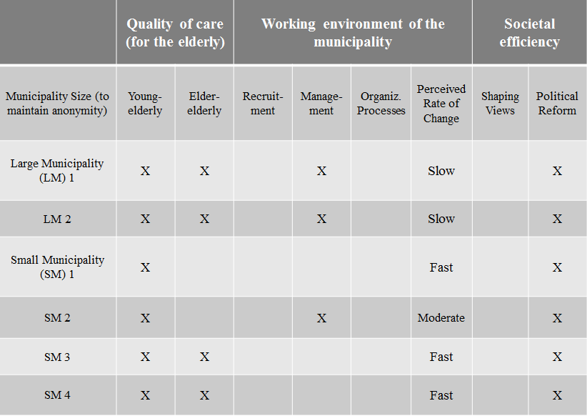
The quality of care. Every municipality interviewed has invested in improving the quality of care for the elderly. Specifically, all of the municipalities have developed technology to assist the young-elderly, and four of those municipalities have taken their developments further to assist the elder-elderly. A clear innovation strategy emerged, all Norwegian municipalities interviewed are facilitating for their elderly to live in their own homes as long as possible.
“We need to build houses that will allow people to stay at their homes longer without having to move.” (A municipal manager)
and
“We know that the solutions to upcoming problems are in homecare services and technology. No matter how many institutions we build, we never meet or even get closer to meeting the demand.” (A municipal manager)
The most common of these innovations has been technological developments, predominantly smart-homes or smart-living aimed at the young-elderly. These technological developments vary dramatically from basic safety alarms to quite advanced specialized care systems (see www.smartly.no/velferd, www.smart-control.no, www.verisure.no, www.moeller.no, www.xcomfort.no). Digital planners have also emerged, which essentially minimizes forgetfulness by keeping track of activities and appointments; reminding the user of upcoming birthdays, medication that needs to be taken, and clothes to wear (see MEMOplanner at www.abilia.no). Other municipalities have developed elder education programs. One small municipality started an everyday rehabilitation program. This program was unique because it’s voluntary and offered to the healthy, instead of only being provided to those who are recovering from an injury. This pilot program was a huge success. Some elderly have gone from needing 11.5 hours a week of home care to needing only 10 minutes a month (Landstad, 2012). Other types of elder education programs highlight computer anxiety, food handling and hygiene, nutrition, traveling safely, internet help, just to name a few. Lastly, there have been two user-driven innovations have emerged that improved the quality of care significantly; collective living and collective communities (Dommerud, 2012a, 2012b; Scharlach, Graham, & Lehning, 2012). Collective living is simple, getting a group of friends together to live in a large house that everyone shares together. The only private room is each person’s individual apartment -with a bathroom- that ranges in size from 50 to 70 square meters (540 to 760 square feet), the rest of the building is communal. The elderly then share their garden, hobby rooms, entertainment rooms, dining room, exercise room, and kitchen. When we look to two of the most important elderly needs; safety (for elder-elderly) and social interaction or independent lifestyle (for the young-elderly) are most commonly highlighted. This type of idea mitigates and potentially eliminates both of these concerns. There is much safety and social comfort in knowing you have many friends or family living all around you. This project was financed and executed by the elderly themselves. A Collective-community is a concept that was developed in the US. It is a membership to a network, which requires you pay annual dues and live within the geographic region. Once a member of the network, than you can sign up for all the services they provide. These services range from transportation and social activities to elder education courses. Any need the network has, it can be addressed by the staff. The staff is comprised almost entirely of the elderly members, thus the elderly remain at the focus of this network (Scharlach et al., 2012).
Working environment of the municipality. Half of the municipalities interviewed have invested in innovations that improve the management of their employees. No municipalities interviewed have recruitment improvements, formal innovation processes, nor a system for recruiting and managing volunteers. According to those interviewed:
“Approximately 7% of nurses want to work with elderly, the rest want to work in hospitals.” (A professor in nursing)
and
“A Geriatrics education requires 1 extra year in gerontology [from the traditional three year program]. As of now, these spots aren’t being filled, and those in the program are experiencing a high drop-out rate. Nurses with this education have a tough time finding jobs, and they can’t change their title to “a specialist in geriatrics”. Thus, there is very little motivation for nurses to pursue this field.” (A professor in nursing)
An equally important working environment factor that is lacking is innovation processes. No municipality interviewed has a formal process for innovation. There are no formal processes of innovation for the overall organization, product or service development, nor knowledge sharing. A municipal-manager stated:
“We know we need to be innovative to meet upcoming demands, we just don’t know exactly how to do that”.
Lastly, there was no sharing knowledge outside of existing networks. We found that in general most municipalities had geographic networks for their region, but outside of this network, sharing knowledge on innovative projects is nearly an impossible task.
The processes of innovation for municipalities are best characterized as haphazard, rather than originating from an organizational process. Their attitude is best described as:
“Innovation is about creativeness and creating an atmosphere of openness, and fewer boundaries is an important aspect of our innovativeness, which is why we decide not to have formal processes of innovation. The more formal processes and more boundaries, the more it will inhibit innovation.” (A municipal manager)
or
“We know we need to be innovative to meet upcoming demands, we just don’t know exactly how to do that”. (A municipal manager)
Even though no formal process exists within Norwegian municipalities, there are innovative projects that have been developed. The most common innovation that has emerged from this section is a technology that improves the management within the municipality. There are currently three different types of management developments; logistics planning of home nurses (Eveborn, Flisberg, & Ronnqvist, 2006), improved communication within the municipality (Dragland, 2013a; Enge, 2014), and safely dispensing medication at home (Dragland, 2013b).
The most successful of these is Gerica; the Swedish version is called Laps Care (Eveborn et al., 2006). This is a technological development that improves logistical planning and efficiency of home-nurses. A common problem that municipalities face is that nurses often call in sick, go on holiday, or do not want to work weekends, thus there tends to be quite a bit of temporary nurses that fill-in this gap. This technology speeds up that learning curve, by centralizing all keys electronically on handheld devices. Additionally, these devices clearly state which patient to visit, where they live, what tasks to perform, and what the elderly like to talk about. One small municipality with approximately 14,500 residents is saving approximately 1,5 million NOK annually (150,000 €). However, there is more potential for cost savings the larger and more dense the city. In a large municipality with approximately 800,000 residents, and a budget of 8.8 billion €, they have had an estimated savings of 165-250 million NOK annually (20-30 million €). As of 2014, only 140 of 430 Norwegian municipalities are using this technology (see www.tieto.no/bransjer/helse-og-velferd/kommunal-helse-og-omsorg-tieto).
Societal efficiency. This section is not influenced much by municipalities, but is focusing more on the national government and the impact their policies have on municipalities overall innovation. In Norway, there has been four important policies or programs that influence eldercare (Helse-og-Omsorgsdepartement, 2013; Helsedirektoratet, 2014; Offentlige-Utredninger, 2011; Omsorgsdepartement, 2009). All municipalities interviewed stated that national policies or programs play a significant role in their reasoning for innovating:
“Municipality attitudes are shaped heavily by (1) Municipality Reform, (2) Hospital Reform, and (3) the Coordination Reform. Those three documents knowingly or unknowingly point everyone in the direction of innovation in eldercare.”
(Municipal managers)
and
“In solving future demands, we need to reshape individual attitudes or accountability towards eldercare. As of now, all young-adults (those younger than 67) do not feel a sense of accountability for their elderly, they think, when my parents get old, the municipality will take care of them. This is an attitude that needs to be reshaped through policy because our infrastructure is not adequate to handle future demands. The demand from elderly is going to be higher, and policymakers are continually giving us [municipalities] more responsibility, rather than transferring some from us to the individuals or families. This is an important attitude that needs to be reshaped.”
(A municipal manager).There was also a notable correlation between innovation and the size of the municipality. The larger the municipality, the more innovative projects they have successfully implemented into their municipality. There was an exception to this, if a small municipality had an enthusiastic leader, that municipality had significantly more innovative behaviors and/or projects compared to municipalities of similar size. However, when we considered the length of the project, or how much time from start to finish these projects took (the speed of innovation), large municipalities performed the worst. There was a trend between the size of the municipality and the perceived rate of change. The two large municipalities perceived rate of change was slow, while three small municipalities perceived rate of change was fast, and one small municipality had a moderate rate of change.

Discussion
These findings spark an interesting debate, in each of the three main eldercare theory categories: quality of care, working environment, and societal efficiency. The most significant finding was that Norwegian municipalities’ innovation strategy is clearly to facilitate the elderly living at home as long as possible by developing smart in-home technology (improving the quality of care). For the elderly, this strategy has been a success. However, from a government and municipal perspective, there are significant resources being wasted here (an increase in societal inefficiency and possible strains on the working environment). As there is no formal knowledge-sharing channel for innovation projects between municipalities, no municipality knows how successful or unsuccessful other municipalities’ smart-living technology projects are, outside of their established geographic network. For example, If you take a small municipality in the middle of Norway (with a few hundred or thousand inhabitants), they’re likely a number of similar municipalities experiencing similar issues (if not the exact same) issues in the north and south of Norway. Unfortunately, these municipalities will likely never be able to learn from each other’s ventures due to lack of formal knowledge sharing channels. As a result, many small municipalities try to collaborate with larger municipalities, but these larger municipalities have very different interests (e.g., different financial positions, different social economic status of inhabitants, different infrastructures, and different resources). To compensate for this smaller municipalities try to attend annual or bi-annual eldercare conferences, but it’s the large municipalities that will get the most time allocated for presenting. Ultimately, each municipality ends up re-inventing the wheel. This creates a real problem for small municipalities trying to innovate effectively.
We found it equally intriguing that most municipalities stated that, “we need to be innovative to meet future infrastructural demands”; however, no municipality has formal innovation training or processes. Many municipalities believe that innovation is about creativeness. In order to create an atmosphere that is open and creative we need to have fewer boundaries. This is an important aspect of our innovativeness, which is why many decide not to have formal processes of innovation. This is an interesting argument. While it may be true that the more formal barriers an idea-creator must go through, the less likely he or she may be to come forward with their idea. Nevertheless, this doesn’t mean that the organization or management should do nothing. Management can still educate managers on how to manage and improve this process so that idea-creators can have better experiences in coming forward with their ideas. If an organization or managers do not have processes for managing their innovations, it becomes impossible to measure the success or failures of these innovations. If you cannot measure the success or failure, it makes improvements on these processes even more impossible. It is here, where there is a lot of unrecognized potential for learning and improving in the delivery of elder care services. Municipalities need to consider how they can incorporate formal innovation processes, so that they maximize organizational learning.
It is unclear as to why no Norwegian municipalities have focused on improving the working environment. Currently, there are serious issues of newly educated nurses not being interested in home-care, high levels of abseentism, and too small of a workforce. Notwithstanding, no municipality has developed an innovation strategy to address these working environmental issues.
In viewing these innovations with the support of eldercare theory, eldercare theory would strongly urge municipalities to consider setting innovation strategies that address the working environment (e.g., improve recruitment, improve management, develop formal innovation processes or competence, or develop knowledge sharing channels). If municipalities have been continually evaluating their innovation strategies, realized they have a lack of focus on the working environment, and determine the resources are best used in improving the quality of care for the elderly by further developing in-home technologies, than their current strategy is okay. This strategy is okay because they have determined what their appropriate balance is. However, after conducting this study, we know that the majority of municipalities haven’t been managing their eldercare innovation with the support of eldercare theory.

Conclusion
In this article we have empirically studied what and how leaders in eldercare (Norwegian municipalities) are innovating with the support of eldercare theory. The goal of this research was to give managers or researchers of eldercare a glimpse of the challenges and solutions that the leaders in eldercare are facing. This will hopefully provide Norwegian municipalities and/or other public organizations insight into how to have the best strategic positioning to handle upcoming healthy ageing issues. The lessons learned from the Norwegian leaders are:
- Building a smart in-home living infrastructure. This is a clear focus on Norwegian municipalities. This is no easy task. Many private companies offer different technology packages, but municipalities have to develop the infrastructure (e.g., having response centers, managing home visits during working hours, emergency calls during both working hours and nonworking hours, logistics for emergency situations, et cetera). Many municipalities have this infrastructure and now offer a wide range of smart in-home technology. However, to date, Norwegian municipalities haven’t found a way to share knowledge, outside of their existing geographic network, through a formal channel from their in-house developed innovations. Additionally, there is evidence that suggests that Norwegian municipalities haven’t done enough to improve the working environment (e.g., improve recruitment and having a system for managing volunteers).
- Municipalities need innovation training or competence. We have found that there is a lot of pressure on providers of eldercare services to be innovative to meet upcoming demands, but many of the municipalities we have met with haven’t been given the tools (formal innovation training) to meet the pressure and expectations of them. Those organizations, managers, or employees that have the responsibility for developing innovative solutions, need to be given the tools (e.g., innovation training or education on eldercare theory) for the job they are expected to perform.
- Recruitment in eldercare. There is very little discussion about recruitment in eldercare. I haven’t heard of any recent Norwegian initiatives or programs to improve recruitment. There is clearly an issue of supply and demand of qualified eldercare workers. In Norway, all we know is the elderly population is growing, work force is decreasing, and that there is little interest from newly educated nurses to be employed in eldercare. It appears that municipalities are investing in smart technologies and hoping that these technologies alleviate the demand on nurses. Perhaps this is an issue that has been addressed by municipalities, but is not as high of a priority as developing smart in-home technologies.
- Utilization of eldercare theory. Eldercare theory is a strategic management tool for managers of eldercare. It’s a tool that if used correctly, will allow managers to predetermine the impact that each innovation project will have on their eldercare system. The three elderly categories are: quality of care (for the elderly), the working environment (for the employed or volunteers), and societal efficiency. These three categories are often inversely related to each other; if the quality of care increases, it’s likely that the working environment or societal efficiency will decrease. In these cases, when the categories are inversely proportional, it’s all the more important to continually re-evaluate the organizational positioning relative to eldercare theory.
To meet upcoming demands, eldercare providers need to attack this elder-wave from all directions, rather than hope or rely on smart in-home technologies to solve all eldercare related issues.
Future Implications
Three issues emerged from this research that will require additional research; the lack of formal innovation processes, the untapped potential of user innovation in eldercare, and the development of Continuing Elder Education programs. It’s quite a paradox that all Norwegian municipalities have acknowledged that they know need to innovate if they’re to deliver a similar level of quality services, given existing systems, to meet future demands. However, no municipality has a formal process for innovation. It would be an interesting research question to test whether formal or informal innovation training would improve the innovativeness of municipalities. An equally interesting research question is whether regional or national governments are pursuing user innovations in eldercare. The two user innovations that have emerged in eldercare (collective living and collective communities) will seemingly have dramatic effects on how services are to be provided in the future, especially if they had political support. Lastly, there are certain challenges that all municipalities are facing. Thus, why the central or local governments haven’t developed a centralized Continuing Elder Education to address these nonlocal challenges should be explored. More research into these ideas could prove quite fruitful to the field of eldercare.
Limitations
There is a concern that the study of eldercare in Norway may be too specialized to be transferrable to the international community. It is true that Norway delivers their eldercare services differently than other countries. However, we think Norway is a good case study because they are experience similar eldercare issues as the rest of the world. They are the leaders in eldercare, and quite frankly, they are arguably one the most motivated country to innovate in eldercare. This is due to financial impacts from the elderly. Norway, like most countries will experience typical eldercare issues (too many elderly and an insufficient infrastructure). However, Norway is unique in how they give their elderly a generous retirement salary (which the elderly are dependent on) and how their government is responsible for providing care for the elderly. There few countries that have as much motivation as Norway to innovate. Even though many countries have varying health regimes, the infrastructural issues are similar, thus solutions should be transferrable to some extent.

Appendix
Figure 1 Demystifying eldercare: Overview
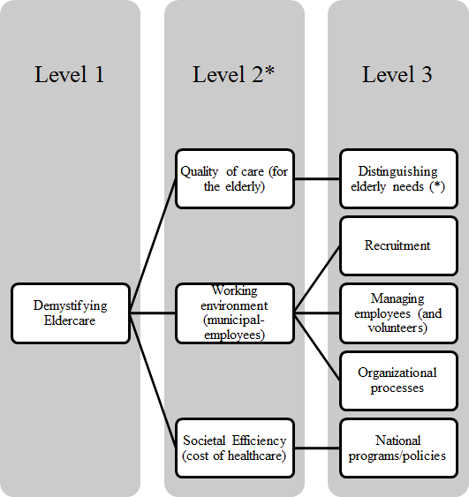
**(2, 4, 7-10, 12, 13, 25, 29-64)
**(3, 5, 6, 13-29)
**(1, 65-72)
(Schultz et al., 2014).
Figure 2 Analysis of Level 3: Distinguishing elderly needs
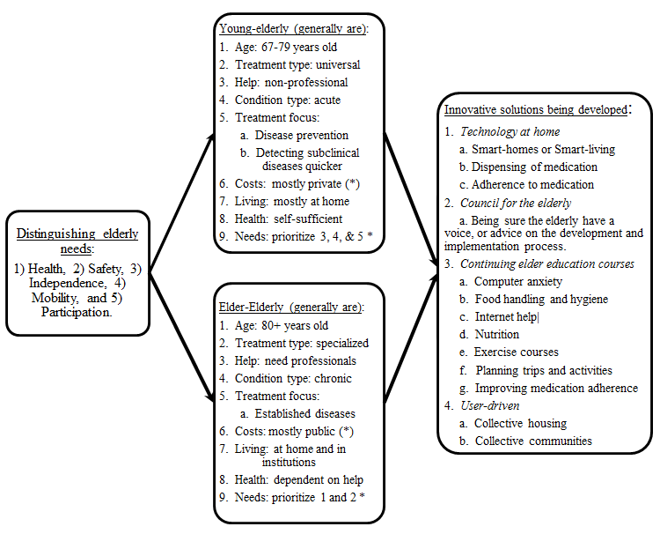(Schultz et al., 2014).
Figure 3 Analysis of Level 3: Working environment
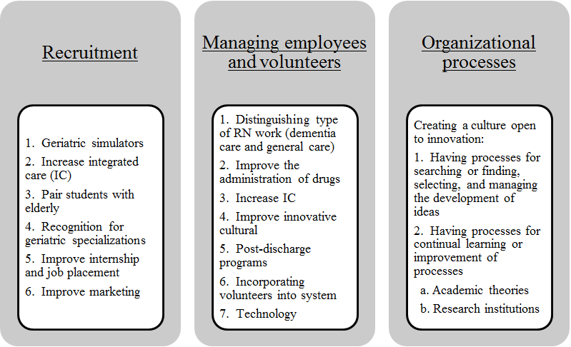
(Schultz et al., 2014).

Figure 4 Analysis of Level 3: Societal Efficiency
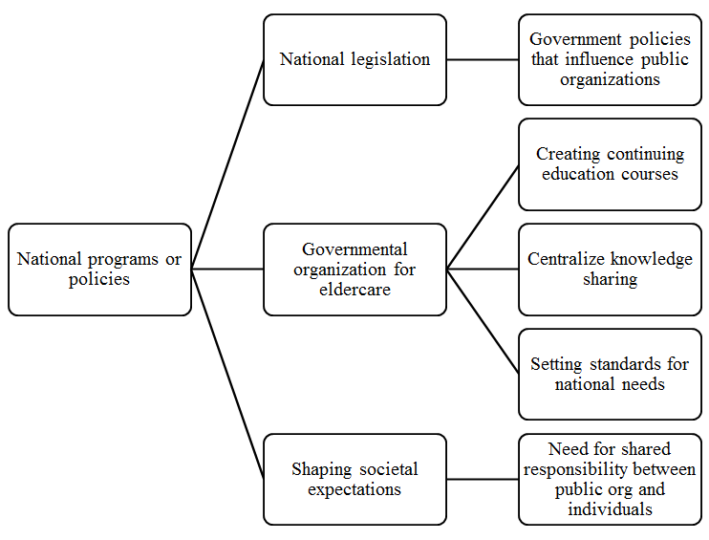
(Schultz et al., 2014).

References
Aging, Administration on. (2014). Aging statistics. Department of Health and Human Services. Retrieved from http://www.aoa.gov/Aging_Statistics/.
Behr, R., Sciegaj, M., Walters, R., Bertoty, J., & Dungan, R. (2011). Addressing the housing challenges of an aging population: Initiatives by Blueroof Technologies in McKeesport, Pennsylvania. Journal of Architectural Engineering, 17(Special Issue: Residential Construction), 162-169. doi: 10.1061/(ASCE)AE.1943-5568.0000033
Dommerud, T., & Westerveld, J. (2012a, 27-11-2012). Flere tusen vil bo i eldrekollektiv, Aftenposten.
Dommerud, T., & Westerveld, J. (2012b, 25-11-2012). Nå kommer eldre-kollektivene!, Aftenposten.
Dragland, Å. (2013a). Bedre eldreomsorg med et klikk. Gemini.
Dragland, Å. (2013b). Medisinering i hjemmet. Gemini.
Enge, C. (2014). Slik skal teknologien gjøre alderdommen enklere. E24: Norges største nettavis for økonomi og næringsliv.
Eveborn, P. , Flisberg, P. , & Ronnqvist, M. (2006). LAPS CARE - An operational system for staff planning of home care. European Journal of Operational Resarch, 171, 962-976.
Hayakawa, M., Uchimura, Y., Omae, K., Waki, K., Fujita, H., & Ohe, K. (2013). A smartphone-based medication self-management system with realtime medication monitoring. Applied Clinical Informatics, 4(1), 37-52. doi: 10.4338/ACI-2012-10-RA-0045
Helse-og-Omsorgsdepartement, Det Kongelige. (2013). Tomorrow's healthcare (Morgendagens omsorg). Oslo, Norway: The Norwegian Ministry of Health and Care Services (Det Kongelige Helse og Omsorgsdepartement).
Helsedirektoratet. (2014). Recommendations on choosing the standard/framework for welfare technology (Anbefaling på valg av standarder/rammeverk for velferdsteknologi). Oslo, Norway: The Health Director of Norway (Helsedirektoratet).
International, HelpAge. (2013). Global AgeWatch Index 2013: Insight report (pp. 1-52). HelpAge International: Nonprofit.
International, HelpAge. (2014). Global AgeWatch Index 2014. HelpAge International: Nonprofit.
Kulik, C. T., Ryan, S., Harper, S. , & George, G. (2014). From the editors: Aging populations and management. Academy of Management Journal, 57(4), 929-935. doi: 10.5465/amj.2014.4004
Kvale, S. (1996). InterViews: An introduction to qualitative research interviewing Thousand Oaks, CA: SAGE Publications.
Landstad, T. (2012, 22.10.2012). Før hadde hun 11,5 timer hjemmesykepleie i uka. Nå har hun ti minutter i måneden., An.no: Nordlands største nettavis.
Mæle, S. M. (2014a, 17.06.2014). No thank you to to Trondheim municipality (Takker nei til Trondheim kommune), Høgskoleavisa.
Mæle, S. M. (2014b, 28.08.2014). Several municipalities do not have enough nurses (Flere kommuner har sykepleiermangel), Høgskoleavisa.
Nations, United. (2013). World population ageing 1950-2050. United Nations, Department of Economic and Social Affairs, Population Division. Retrieved from http://www.un.org/en/development/desa/population/publications/pdf/ageing/WorldPopulationAgeing2013.pdf.
Nordberg, M. S. (2013, 26.09.2013). Competence and eldercare (kompetanse og eldreomsorg), Adressa.
Offentlige-Utredninger. (2011). Innovation in Healthcare (Innovasjon i omsorg). Oslo, Norway: Norway's Public Strategy (Norges Offentlige Utredninger).
Omsorgsdepartement, Det Kongelige Helse og. (2009). The Coordination Reform (Samhandlingsreformen). Oslo, Norway: The Norwegian Ministry of Health and Care Services (Det Kongelige Helse og Omsorgsdepartement).
Riessman, C. K. (1993). Narrative analysis (qualitative research methods). Newbury Park, CA: SAGE University Paper.
Ringard, Å., Sagan, A., Sperre Saunes, I. , & Lindahl, A. K. (2013). Norway: Health system review. Health Systems in Transition, 15(8), 1-162.
Scharlach, A. , Graham, C., & Lehning, A. (2012). The "Village" model: A consumer-driven approach for aging in place. The Gerontologist, 52(3), 418-427. doi: 10.1093/geront/gnr083
Schultz, J. S., André, B., & Sjøvold, E. (2014). Demystifying eldercare: Managing and innovating from a public-entity's perspective. International Journal of Healthcare Management, 8(1), 42-57.
Statistisk-Sentralbyrå. (2012). On the verge of coordination (På randen av samhandling) Oslo, Norway: Statistics Norway (Statistisk Sentralbyrå).
Statistisk-Sentralbyrå. (2014). Population projections, 2014-2100 (June 17, 2014 ed.). Oslo, Norway: Statistics Norway (Statistisk Sentralbyrå).
Sundberg, C.Ø., & Samdal, M. (2013, 28.08.2013). One of four in the nursing homes have a college education (Kun en av fire i sykehjemmene har høyskoleutdanning), Adressa.
Ulstein, K. (2006). Increased Knowledge of Elder Care in the Nordic Countries, The Research Council of Norway (Forskningsrådet).

