#### Boron Removal from Silicon Melts by H2O/H2 Gas Blowing – Mass Transfer in Gas and Melt

Øyvind Sunde Sortland1, Merete Tangstad1

1Norwegian University of Science and Technology; Alfred Getz vei 2; Trondheim; 7491; Norway

Keywords: Reactive gas refining, Metallurgical silicon refining, Impinging jet, Mass transfer coefficient, Rate determining step.

# Abstract

Metallurgical routes for solar grade silicon production are being developed as alternatives to chemical processes for their potential to achieve cost reductions, increased production volume and reduced environmental and safety concerns. An important challenge in the development of metallurgical routes relates to the higher impurity concentrations in the silicon product, particularly for boron and other elements that are not efficiently segregated in solidification techniques. The reactive gas refining process is studied for its potential to remove boron below the solar grade silicon target concentration in a single step by blowing steam and hydrogen gas jets onto the melt surface. Boron in a silicon melt is extracted to HBO gas in parallel to active oxidation of silicon. The literature is not unified regarding the rate determining step in this process. Relevant theories and equations for gas blowing in induction furnaces are combined and used to explain mass transfer in experiments. Mass transfer in the melt and gas is investigated by comparing resistance and induction heating of the melt, and varying gas flow rate, crucible diameter, diameter of the gas lance and the position of the gas lance above the melt surface. The rate of boron removal is found to increase with increasing gas flow rate and crucible diameter. A relatively high fraction of the reactive gas is utilized in the process and supply of steam in the bulk gas is the only identified rate determining step.

# I. INTRODUCTION

Metallurgical refining routes for solar grade silicon (SoG-Si) production are developed for their potential to supply the growing silicon photovoltaic (PV) market with a low-cost feedstock [1]. Reactive gas refining is an attractive process for boron removal due to its potential to refine silicon with high boron contents [2] to the SoG-Si target (0.3 ppmw boron) in a single step.

Extraction of boron from molten silicon to a reactive gas of steam in hydrogen was first demonstrated by Theuerer [3] in 1956. Development of a process for SoG-Si production started with plasma refining in the 1990s, which has reached pilot scale size [4, 5]. Khattak et al. [2] refined silicon with combinations of reactive gas, slag and vacuum refining in a pilot scale furnace in 2002.

In 2012, Nordstrand and Tangstad [6] used a lance with no active heating of the reactive gas, and achieved boron removal rates comparable to plasma refining by Altenberend [7] and Suzuki et al. [8]. Reactive gas refining thus shows potential for boron removal without the energy requirement of plasma generation, which represent a significant cost for plasma refining [7]. The highest rates of refining achieved in previous studies of plasma and reactive gas refining is presented in Fig. 1. The boron content in metallurgical grade silicon is typically a factor 100 higher than the SoG-Si target (0.3 ppmw), and the vertical axis is adjusted to represent this range.

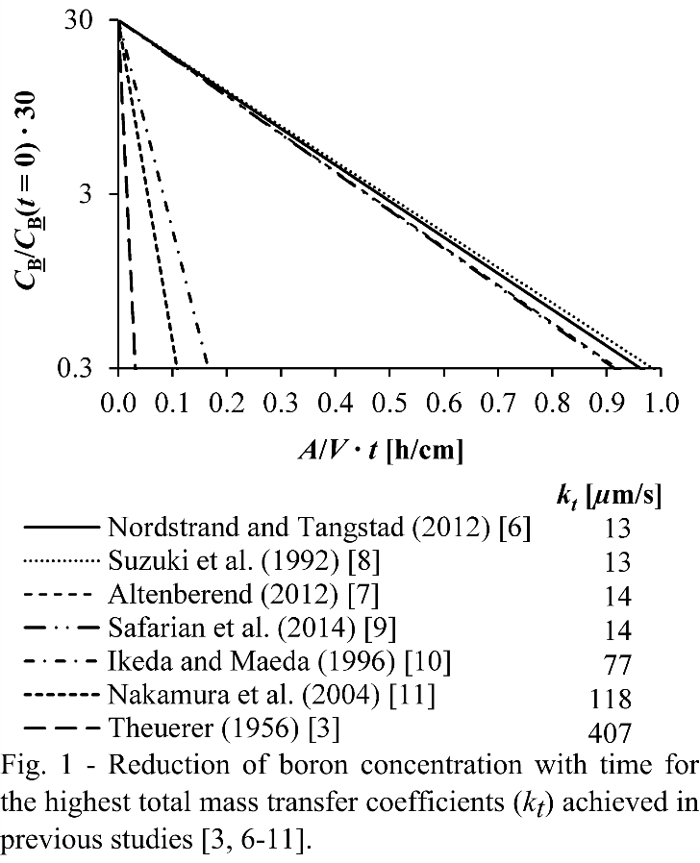

The concentration of boron in the melt (*C*B) decreases exponentially with time (*t*) according to the first order rate law in Eq. (1). *A* is the surface area available for reaction and is simplified to the crucible cross-section area in calculations of the total mass transfer coefficient (*kt*). *V* is the melt volume. The mass transfer coefficient can be used as a measure of kinetics.

 (1)

The reactive gas and plasma refining studies achieving total mass transfer coefficients of 13-14 µm/s [6-9] are considered representative for current experiments as the crucible cross-section area (*Ac*) is used in calculations and the experimental geometries for impinging jet gas flow are similar.

Eq. (1) is representative for the total process of boron removal out of the system, either by gas flow out of the crucible or by condensation from the gas. The total driving force for the boron removal process in this open system is the boron concentration in the melt (negligible boron contents is assumed in the environment).

## A. Reactions

Boron in the melt (B) is extracted to the gas by reactions at the interphase. Steam may oxidize the silicon melt in addition to boron impurities, represented by the global reactions in Eq. (2) and Eq. (3), respectively. Altenberend [7] proposed the reactions to be at equilibrium, as the rate of boron removal in representative experiments by Nordstrand and Tangstad [6] increases with hydrogen partial pressure as and decreases when only temperature is increased. An equilibrium equation between silicon and boron oxidation is constructed in Eq. (4).

 (2)

 (3)

 (4)

Thermodynamic modeling in HSC (Outotec Oyj, Espoo, Finland) with input of 3.2 pct steam in hydrogen at 1 bar and a surplus of silicon with 30 ppmw boron provides the partial pressures of gases in Fig. 2. Tang et al. [12] found the tabulated enthalpy of formation of HBO to be inaccurate, and an activity coefficient for HBO accounts for the difference between the standard enthalpy of formation in the HSC database and that recommended by Page [13] of. The model uses the activity coefficient by Yoshikawa and Morita [14] for boron diluted in silicon. HBO and SiO are the dominant boron- and oxygen containing gases in contact with the melt. Eqs. (4) and (5) summarizes the equilibrium between dominant species at the interface. In Eq. (5), , is molar fraction and  is the activity coefficient for boron in the melt. The equilibrium constant for Equation (4) is *K*(4) = 16.4 at 1773 K (1500°C) with present data. For a hydrogen partial pressure of , the enrichment ratio [7] calculates to , the distribution of boron between melt and gas becomes  assuming , and the ratio of silicon and boron oxidation is for [B] = 30 ppmw.

 (5)

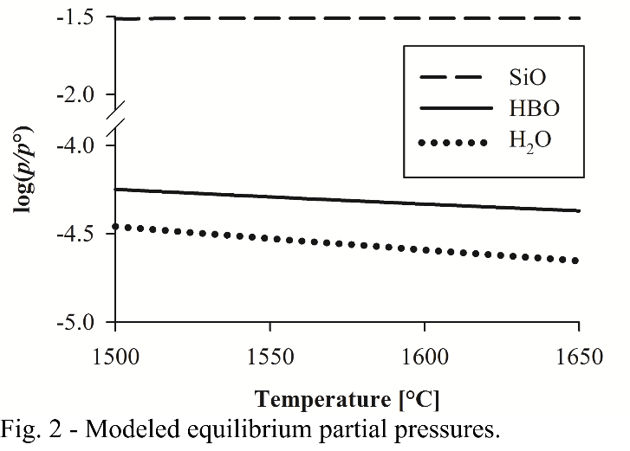

Silicon is lost from the melt as SiO diffuses into the gas from a clean silicon surface, which is maintained during active oxidation [15-17]. Steam is feed at relatively high partial pressures in the bulk gas (0.032 bar in present study), and reacts with SiO in the gas boundary layer [15] and/or the bulk gas [16] according to Eq. (6). At 1773 K (1500°C), the equilibrium partial pressure of SiO with 0.032 bar steam and 0.968 bar hydrogen is . The reaction in Eq. (6) is not expected to reach equilibrium in the gas boundary layer [17]. Steam is partially consumed before reaching the interface and SiO is converted to silica fume. Consumption of steam above the interface contribute to reduce the concentration gradient mass transfer of steam to the surface [17], and mass transfer correlations supply of steam is not readily available. The total reaction for silicon oxidation is shown in Eq. (7). Eq. (7) also describes passive oxidation, in which silica forms a passive surface layer that blocks boron removal to the gas [18].

 (6)

 (7)

## B. Mass transfer

The process of boron removal can be broken into steps. Steps 1-4 can be identified based on location as indicated in Fig. 3. Continuity requires the rate of mass transfer to be equal through all steps. The total mass transfer coefficient in Eqs. (8) and (1) is determined by the step with highest resistance (1/*k*) and lowest mass transfer coefficient (or several slow steps with non-negligible resistances).

1. Turbulent convection and diffusion of boron in the melt.
2. Chemical reactions at the interface.
3. Diffusion in a viscous gas boundary layer.
4. Laminar convection in bulk gas.

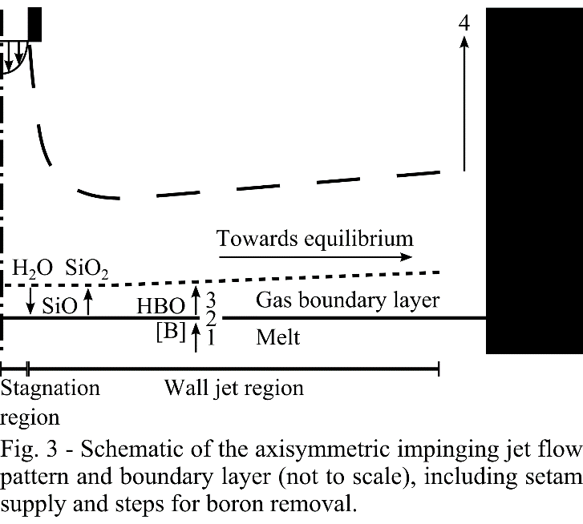

 (8)

The position of the rate determining step may be identified by the dependence convection in the melt and gas. The total mass transfer coefficient and boron removal rate is expected to depend on convection in the melt if a rate determining step is in the melt, and depend on convection in the gas if a rate determining step is in the gas phase. Gas flow rate affect mass transfer in both the bulk and boundary layer, while gas velocity along the surface is only expected to affect the removal rate if a rate determining step is in the gas boundary layer. If the rate of boron removal is only determined by chemical reactions, neither melt nor gas convection is expected to affect the total mass transfer coefficient.

The literature is not unified regarding the rate determining step, even when similar mass transfer coefficients are achieved in experiments. Suzuki et at. [8] suggested the rate determining step to be in the melt and used the plasma torch cross-section area to calculate a mass transfer coefficient of 1.4 ∙ 10-4 m/s, while 1.5 ∙ 10-5 m/s was calculated based on the entire crucible cross-section area and deemed too low for rate limitation in the melt. In pilot scale experiments, Nakamura et al. [11] reported passivation of the surface except in a dimple forming in the stagnation area due to jet impingement, as the applied plasma prevented passivation in this area. Total mass transfer coefficients up to 1.2 ∙ 10-4 m/s was reported in the dimple area, and was not found to directly depend on gas flow rate or melt agitation. They did however not conclude on rate determination by chemical reactions for mass transfer coefficients in this order of magnitude, as temperature effects were not studied. Altenberend [7] compared calculated half-lives for optimized induction frequency to experiments, for which half-lives converts to total mass transfer coefficients up to 1.4 ∙ 10-4 m/s as average over the crucible cross-section area, and did not consider mass transfer in the melt to be rate determining. He suggested supply of steam to be rate determining, which is also proposed for active oxidation represented by Eqs. (2) and (6) [16, 19].

Boron removal is described in Eq. (1) by combining theories of mass transfer for steps 1-4 in Eq. (8). Eq. (9) defines the flux of boron (*J*B)in step 1 to a driving force in form of a concentration difference between the bulk of the melt (, where *h* is height above the interface) and the interface ().

 (9)

Machlin [20] presented the rigid flow theory for quantitative prediction of the mass transfer from an inductively stirred melt to the interface. In Eq. (10) the melt mass transfer coefficient depends on melt convection through the velocity of streamline flow at the outer radius of the surface (*vm*). *D*B is the diffusion coefficient of boron in the melt and *dc* is the inner crucible radius. According to Eq. (10), the rate of boron removal is not expected to depend on composition of the reactive gas if mass transfer in the melt is rate determining.

 (10)

For equilibrium at the interface, which Altenberend [7] found consistent with experiments, chemical reactions are fast and their resistance to boron removal  is negligible. The reactive gas composition still affects the boron removal rate if either removal of HBO in steps 3-4 or steam supply is rate determining, due to shifting of equilibrium at the interface in Eq. (4). The HBO concentration at the interface drives diffusion of HBO from the interface in step 3. The driving force for step 3 is related the total driving force () in Eq. (1) through the ratio between the interface concentration of HBO in the gas () and boron in the melt (). This distribution coefficient is included in the mass transfer coefficient for step 3 in Eq. (11), where *kg* is the fluid dynamic mass transfer coefficient for diffusion of HBO in the gas boundary layer.

 (11)

For equilibrium at the interface, the distribution coefficient in Eq. (11) can be calculated by Eq. (5) for the conditions at the interface. The distribution coefficient of boron at the interface also takes part in *k4* due to a similar conversion of the driving force for step 4 to CB in Eq. (1). If supply of steam is rate determining, the removal rate of boron is depends on the fraction of steam that reacts with boron at the interface. For low boron contents in the melt, this fraction can be assumed small and equal to. For rate determination by any steps in the gas phase (removal of boron in the gas bulk or boundary layer, or supply of steam in the gas bulk or boundary layer), equilibrium at the interface provides the experimentally observed dependencies of and decreasing refining rate with increasing temperature (*K*(4) decreases with temperature).

The gas flow pattern outlined in Fig. 3 represents an ideal impinging jet flow. Neither dimple formation in the stagnation region, surface ripples, nor deflection by the crucible wall is taken into account. A vertical jet with parabolic velocity profile (laminar jet) exits the lance and impinges on the melt surface in the stagnation region, where it is deflected to flow along the surface in the wall jet region The long-dash line in Fig. 3 represent the free boundary of the impinging jet flow pattern.

The mass transfer coefficient for boundary layer diffusion (*kg*) increases with increasing gas velocity along the surface and decreasing boundary layer thickness. Scholtz and Trass [21, 22] developed theoretical correlations relating mass transfer in the viscous boundary layer of laminar impinging jets to the Reynolds number (*Re*) at the lance exit in a range of lance exit heights (*H*) above the surface. At the lance exit, the Reynolds number (*Re*) depends on the mean gas velocity (**), the flow rate (*Q*) and the inner diameter of the lance (*d*) as . In the wall jet region, the gas boundary layer mass transfer coefficient decreases radially away from the stagnation region directly beneath the lance [21]. The rate of boron removal may be found by integration of the flux over the interphase area.

The driving force is the concentration difference across the boundary layer, which in Eq. (12) is expressed by the concentration of HBO at the interface () and in the bulk (), the universal gas constant (*R*) and temperature (*T*). The rate of boron removal through the gas boundary layer has a limit at which HBO is saturated at the interphase and the bulk partial pressure is negligible. In such a situation, step 3 determines the rate of boron removal.

 (12)

The gas composition goes towards equilibrium as the gas flows along the surface in the wall jet. The driving force available for steps 1-3 decreases as HBO accumulates in the wall jet  increases towards equilibrium with radial distance from the stagnation region. Bulk convection contributes to determine the boron removal rate if the gas flow rate is not sufficient to achieve a negligible HBO partial pressure over the entire surface, and becomes fully rate determining if equilibrium is reached in the wall jet. Boron removal may then come to a halt beyond a certain radius, limiting the effective reaction area.

The flux of boron by bulk convection in step 4 is given by the gas flow rate and the concentration of HBO in the finally accumulated gas leaving the system (*C*HBO), as shown in Eq. (13).

 (13)

Mass transfer in the wall jet is tow-dimensional, that is horizontal convection in wall jet and vertical diffusion from/to interface, and is not directly in series with the numbered steps included in Eq. (8). in Eq. (14) accounts for accumulation of in the gas flow along the surface.

 (14)

Eqs. (9), (11), (12), (13) and (14) may be combined to Eq. (15). Eq. (15) is the differential form of Eq. (1) for boron removal in steps 1-4 assuming equilibrium at the interface (1/*k*2 ≈ 0 in Eq. (8)). Steam supply is not included as a separate step, but takes effect in  through the partial pressure of SiO formed at the interface.

 (15)

The highest possible reaction rate for a given gas flow rate, composition and temperature is achieved if the gas feed is fully utilized to establish equilibrium in the gas flow leaving the system. This feed rate limit () is a hypothetical maximum considering that part of steam is consumed above the surface (Eq. (6)) and can not be utilized to remove boron at the interphase. The ratio of experimental refining rates to the feed rate limit represents a measure of gas utilization.

Incomplete steam supply to the interface reduces the equilibrium partial pressure of HBO below 100 pct gas utilization. Supply of reactants in bulk gas is considered to include the flow rate and composition of the reactive gas feed, diffusive losses from the impinging jet flow pattern and the distribution of steam in the bulk wall jet in addition to consumption of steam in bulk gas according to Eq. (6). Steam may also be consumed in the gas boundary layer. Unlimited supply of hydrogen is assumed as it is a main constituent of the gas phase in experiments. Bulk gas mass transfer also includes mixing of HBO in the bulk gas. Incomplete mixing of HBO may limit the HBO partial pressure below equilibrium in parts of the gas leaving the system. For the gas flow rates in experiments, mixing phenomena within the impinging jet flow pattern are considered negligible as vertical concentration gradients of steam and HBO in the bulk wall jet are assumed negligible, and HBO is assumed uniformly distributed in the gas leaving the system.

# II. EXPERIMENTS and analyses

Fig. 4 shows the experimental setup with a cross-section of one of the induction furnaces used (Induction 1). Table I-VII lists the parameters used and the results obtained in each experiment. Typically, 200 g electronic grade silicon pieces (typical length of 0.5-3 cm) and 30 mg boron powder (99.6 pct, Goodfellow) was melted in a graphite crucible with inner diameter *dc* = 70 mm. After stabilization of temperature and steam concentration, the initial concentration in experiments was below 150 ppmw.

Experiment Furnace_Res in Table I used a resistance heated vertical alumina tube furnace with a 250 mm high MoSi2 heating element for comparison to induction furnaces. A 35 mm diameter Si3N4 coated quartz crucible was placed inside an alumina crucible. The thermocouple was placed in an alumina sheath directly beneath the crucibles, and the power was controlled for a stable reading of 1773 K (1500°C) in experiments. A temperature profile measured for this configuration in a hydrogen atmosphere with 4.5 pct steam found the thermocouple reading at the bottom of the melt to be 100 K (100°C) higher than the reading directly beneath the crucible assembly. In Furnace_Ind1, the same crucible assembly was placed inside a 70 mm diameter graphite crucible with a graphite ring spacer. In *dc*_38, a graphite crucible (*dc* = 38 mm) was used in an identical setup. The alumina crucible was necessary to prevent loss of the melt from the graphite crucible to the porous graphite spacer.

In the induction furnaces, the thermocouple and sheath was placed inside a thermowell of the crucible material fastened along the inside crucible wall, and measured the temperature near the bottom inside of the crucible. The measured temperature was held at 1773 ± 10 K (1500 ± 10°C) in all experiments. The temperature uncertainty is assumed based on temperature variations due to manual power control.

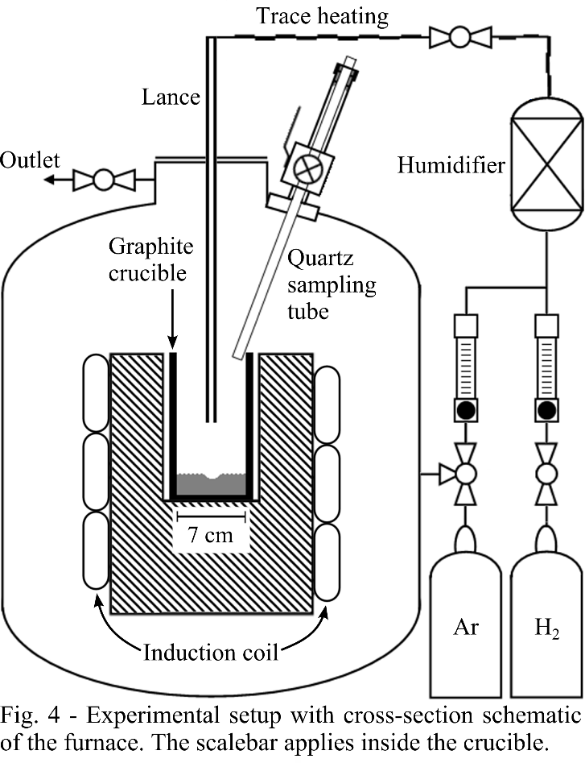

Induction 1 was used for experiments dated between September 9, 2012 and July 31, 2013, and later experiments used Induction 2. The geometries for the melt and gas flow pattern is assumed identical as the furnaces used identical crucibles. Compared to Induction I in Fig. 4, Induction 2 has a smaller coil with 10 turns. 8 mm insulation was fitted between crucible and coil in Induction 2 and 40 mm bottom insulation positioned the top of the crucible near the top of the coil.

Steam was saturating the gas flow in a humidifier (LF-HBA with 4 m Nafion tubes, Fuel Cell Technologies) with deionized water at a controlled temperature. Total flow rates were controlled within 4% accuracy by subtracting the flow rate of steam, and flowmeters for hydrogen and argon controlled the composition and combined flow rate into the humidifier.

Flowmeters controlled the flow rate and ratio of hydrogen and argon to the humidifier for a controlled total flow rate (*Q*) into the furnace. The accuracy of the total gas flow rate is considered to be within 4% in experiments. Normal liters (lN) is used to represent the amount of gas for the temperature 293 K (20°C) and atmospheric pressure. The gas line between the humidifier and furnace inlet was heated above 318 K (45°C) to prevent water condensation. The heat was supplied by a heated wire with controlled power supply and distributed by a wrapping of aluminium foil around the wire and the silicone gas hose. The temperature was measured with a thermocouple directly outside the silicone tube.

The lances were tubes of alumina for lance inner diameter *d* = 4.0 ± 0.1 mm or quartz glass for lances of different inner diameters. Softening of quartz glass was observed as bending of the lance tip in d_3.0, and less than 2 mm wall thickness is not recommended for the temperatures used. The lance exit was simply a perpendicular cut of the tube. *H* denotes the height of lance exit above the melt surface.

The lance diameter was verified to affect the gas velocity along the surface () by axisymmetric finite element modeling in COMSOL Multiphysics 4.4 (COMSOL, Stockholm, Sweden) using built-in material properties. Laminar, non-isothermal flow of hydrogen gas was modeled inside the crucible for the conditions and geometry of experiment in the Lance diameter series. The melt surface was simplified to a flat, no-slip wall at 1773 K (1500°C). Tests with different dimple geometries in small areas of the surface below the lance found reduced gas velocities at the surface in the dimple region, but the effect did not seem pronounced over the majority of the surface. The inlet gas temperature in the lance at the height of the crucible top was set to 373K (100°C). The outer diameter of the lances were 6 mm, or 41 mm for *d*_35. 3 kW heat was applied to the 124 mm high and 7.5 mm thick graphite crucible wall. Model geometry was cut off below the melt surface. Heat loss was modeled by surface-to-surface radiation, with ambient temperature of 343K (70°C), and conduction through 8 mm graphite felt insulation around the crucible, with 343K (70°C) on the outer surface. The gas flow pattern did not appear sensitive to the applied heat, and a realistic temperature profile was considered satisfactory.

Samples were periodically extracted from the melt and analyzed by inductively coupled plasma mass spectroscopy (ICP-MS). Quartz glass tubes (2 mm inner and 6 mm outer diameter) were inserted into the furnace through a sample chamber. A syringe connected to the sample tube was used to extract typically 0.7 g of the melt into the sampling tubes. The concentration of boron in silicon was calculated by normalizing the average concentration of boron from three replicate splits of the ICP-MS analysis to that of the high-purity silicon.

Total mass transfer coefficients for boron removal were calculated by regression of Eq. (1) to sample boron concentrations as function of the time of sampling and the *A*/*V* ratio like in Fig. 1. The crucible was weighted before and after experiments, and the melt mass was found to decreased slightly during experiments (typically <10%). Sample weights and the average melt loss between samples (assuming constant rate of SiO evaporation) were sequentially subtracted from the initial weight to compensate for the decreasing *A*/*V* ratio in calculations of the total mass transfer coefficient. In Lance height and Gas flow rate series, the weight of each sample was measured. For other experiments, the typical weight of 0.7 g was assumed for each sample.

Error estimates are presented as two times the standard deviation (*σ*). The standard deviation for three replicate splits of the ICP-MS analysis is the basis for error estimation of the mass fraction of boron ([B]). The standard deviations is propagated to ln([B]/[B](*t* = 0)) (vertical axis in Fig. 1). Errors in sampling time (0.2 min in Induction 2 and 0.3 in earlier experiments), crucible and thermowell diameters (0.5 mm), and weights of the crucible and samples (0.05 g) were propagated to (horizontal axis in Fig. 1). Estimation of the actual gas-melt interface area was not attempted, and total mass transfer coefficients are presented as averages over the available cross-section area in the crucible. The total mass transfer coefficient and its standard deviation was obtained by linear regression in a MATLAB (MathWorks, Natick, MA) script following the method by York [23]. The method takes into account the standard deviation in both the horizontal and vertical axis of Fig. 1 for each sample.

An estimate for the feed rate limit is calculated in an equilibrium model developed by Tang et al. [12]. Gas utilization in each experiment is estimated as . The model is constructed in MS Excel (Microsoft

Corporation, Redmond, WA) using the ChemSheet add-in (GTT-Technologies, Herzogenrath, Germany). The equilibrium model uses the database developed by Tang et al. [24] for the melt and NIST-JANAF [25] Thermochemical database for gases in the Si-B-H-C-O system, except for HBO. The data for HBO was modified according to the recommendation by Page [13], in order to account for present experimental removal rates. Flow rate and partial pressures of steam, hydrogen and argon are specified in addition to temperature and initial masses of boron and silicon. ChemSheet calculates the equilibrium amounts in gas, melt and possibly a slag of silica and B2O3 with the initial melt and one minute of gas flow as input. The resulting amount and composition of melt and slag are transferred to the next minute iteration. Regression according to Eq. (1) provides . Consumption of steam above the interface according to Eq. (6) is not accounted for, causing over-estimation of the feed rate limit and hence under-estimation of the gas utilization.

Passivation and surface coverage was assessed by visual observations of the solidified surface after all experiments, and direct observation of the melt surface during experiments in Induction 2. For earlier experiments, the onset of surface coverage was assessed by combining observations of significant surface coverage after the experiment stopped or significantly reduced boron removal between the last samples. Samples for which the effect of surface coverage was identified, was excluded in calculations of the total mass transfer coefficient. The melt surface is considered to be clean for the reported refining times and total mass transfer coefficients. In the *Q*_12-16, reduced refining times are reported and the last samples were excluded because the boron content was reduced below the detection limit for the ICP-MS analyses (represented by the final boron content in these experiments).

The amount of melt loss by SiO evaporation was roughly estimated in Lance height and Gas flow rate experiments, by subtracting the measured sample weights from the weight reduction of the crucible. The most important sources of error for estimation of loss of melt weight by SiO evaporation was considered to be remains of silica in the crucible after dust was blown out by pressurized air, possibly counteracted by oxidation of the graphite crucible. The standard deviation of experiments *H*_10-30 (1.4 g) was used for measurement of weight loss, as a constant rate of SiO evaporation can be expected in these experiments. Similar melt weight loss was found for most of experiments *H*_10-30, which is consistent with a constant total mass transfer coefficient for boron removal.

|  |  |  |  |  |  |  |  |  |
| --- | --- | --- | --- | --- | --- | --- | --- | --- |
| Table I. Parameters and results of experiments in the Furnace series. | | | | | | | | |
| **Furnace** | Furnace | *Ac*  [cm2] | Time [min] | Initial [B]  [ppmw] | Final [B] [ppmw] | *kt* ± 2*σ*  [µm/s] | [pct] | Date [yy.mm.dd] |
| Furnace_Res | Resistance | 9.62 | 180 | 64 ± 2 | 0.5 ± 0.5 | 8.2 ± 0.4 | 34 ± 2 | 12.08.21 |
| Furnace_Ind1 | Induction 1 | 8.98 | 90 | 80 ± 5 | 3.1 ± 0.2 | 10.0 ± 0.6 | 41 ± 3 | 13.01.10 |
| Constant parameters | *H* [mm] | *d*  [mm] | *Q* [lN/min] | [bar] | [bar] | [bar] | *dc*  [mm] | Mass [g] |
|  | 10 | 4.0 | 1.01 | 0.022 | 0.49 | 0.49 | 35 | 40 |

|  |  |  |  |  |  |  |  |
| --- | --- | --- | --- | --- | --- | --- | --- |
| Table II. Parameters and results of experiments in the Gas flow rate series, which also includes *H*_20 in Table V with *Q* = 2 lN/min. | | | | | | | |
| **Gas flow rate** | *Q* [lN/min] | Time [min] | Initial [B] [ppmw] | Final [B] [ppmw] | *kt* ± 2*σ*  [µm/s] | [pct] | Date [yy.mm.dd] |
| *Q*_4 | 4.00 | 60.0 | 109 ± 7 | 4.5 ± 0.3 | 19.0 ± 0.8 | 41 ± 2 | 13.12.18a |
| *Q*_6 | 6.00 | 60.0 | 80 ± 11 | 2.4 ± 0.2 | 21.0 ± 1.3 | 31 ± 2 | 13.12.10 |
| *Q*_8a | 8.00 | 60.3 | 106 ± 6 | 1.1 ± 0.08 | 28.1 ± 0.9 | 32 ± 1 | 13.12.16b |
| *Q*_8b | 7.99 | 57.8 | 84 ± 6 | 1.3 ± 0.07 | 26.3 ± 0.9 | 30 ± 1 | 13.12.17b |
| *Q*_10 | 10.0 | 60.0 | 62 ± 4 | 0.8 ± 0.02 | 33.7 ± 1.5 | 32 ± 2 | 13.12.11 |
| *Q*_12 | 12.0 | 36.5 | 60 ± 6 | 0.8 ± 0.03 | 41.5 ± 2.1 | 33 ± 2 | 13.12.16a |
| *Q*_14 | 14.0 | 36 | 74 ± 10 | 0.8 ± 0.06 | 44.6 ± 2.9 | 31 ± 2 | 13.12.18b |
| *Q*_16a | 16.0 | 35.7 | 36 ± 2 | 0.7 ± 0.03 | 40.8 ± 1.7 | 26 ± 2 | 13.12.17a |
| *Q*_16b | 16.0 | 37.4 | 80 ± 3 | 0.6 ± 0.03 | 51.1 ± 1.8 | 32 ± 2 | 13.12.19 |
| Constant parameters | *d*  [mm] | *H* [mm] | [bar] | [bar] | *dc*  [mm] | Mass [g] |  |
|  | 4.0 | 20 | 0.032 | 1.08 | 70 | 200 |  |

|  |  |  |  |  |  |  |  |  |
| --- | --- | --- | --- | --- | --- | --- | --- | --- |
| Table III. Parameters and results of experiments in the Lance diameter series, in which *d*_3 is an outlayer. | | | | | | | | |
| **Lance diameter** | *d*  [mm] | [m/s] | Time [min] | Initial [B] [ppmw] | Final [B] [ppmw] | *kt* ± 2*σ*  [µm/s] | [pct] | Date [yy.mm.dd] |
| *d*_1 | 1.05 | 6.0 | 150 | 127 ± 16 | 4.6 ± 0.4 | 8.0 ± 0.5 | 37 ± 2 | 13.07.30 |
| *d*_2 | 2.0 | 1.3 | 150 | 127 ± 29 | 3.6 ± 0.3 | 8.6 ± 0.8 | 40 ± 3 | 13.07.26 |
| *d*_3 | 3.0 | 0.46 | 150 | 103 ± 20 | 4.6 ± 0.3 | 7.0 ± 0.6 | 32 ± 3 | 13.07.29 |
| *d*_4 | 3.9 | 0.21 | 120 | 135 ± 13 | 5.2 ± 0.3 | 9.3 ± 0.4 | 44 ± 3 | 13.07.25 |
| *d*_35 | 35.0 | 0.0048 | 61.4 | 120 ± 4 | 38 ± 2 | 7.4 ± 0.4 | 31 ± 2 | 13.11.20 |
| Constant parameters | *H* [mm] | *Q* [lN/min] | [bar] | [bar] | *dc*  [mm] | Mass [g] |  |  |
|  | 10 | 2.01 | 0.032 | 0.95 | 70 | 200 |  |  |

|  |  |  |  |  |  |  |  |  |  |
| --- | --- | --- | --- | --- | --- | --- | --- | --- | --- |
| Table IV. Parameters and results of experiments in the Crucible diameter series. | | | | | | | | | |
| **Crucible  diameter** | *dc*  [mm] | *Ac*  [cm2] | Mass [g] | Time [min] | Initial [B] [ppmw] | Final [B] [ppmw] | *kt* ± 2*σ*  [µm/s] | [pct] | Date [yy.mm.dd] |
| *dc*_38 | 38.0 | 9.80 | 40 | 60 | 44 ± 3 | 6.0 ± 0.6 | 8.2 ± 0.8 | 11 ± 2 | 12.11.22 |
| *dc*_70 | 70.0 | 36.9 | 200 | 150 | 87 ± 9 | 10 ± 1 | 5.1 ± 0.4 | 22 ± 2 | 12.12.19 |
| Constant parameters | *H* [mm] | *d*  [mm] | *Q* [lN/min] | [bar] | [bar] | [bar] |  |  |  |
|  | 50 | 4.0 | 3.00 | 0.032 | 0.49 | 0.48 |  |  |  |

|  |  |  |  |  |  |  |  |
| --- | --- | --- | --- | --- | --- | --- | --- |
| Table V. Parameters and results of experiments in the Lance height series. | | | | | | | |
| **Lance height** | *H* [mm] | [bar] | Initial [B] [ppmw] | Final [B] [ppmw] | *kt* ± 2*σ*  [µm/s] | [pct] | Date [yy.mm.dd] |
| *H*_10a | 10 | 1.10 | 73 ± 5 | 17 ± 1 | 8.9 ± 0.7 | 37 ± 3 | 13.11.08 |
| *H­*­_10b | 10 | 1.10 | 83 ± 4 | 21 ± 1 | 8.1 ± 0.5 | 34 ± 3 | 13.11.11 |
| *H­­*_15 | 8-20 | 1.26 | 95 ± 4 | 20.4 ± 0.8 | 9.2 ± 0.5 | 39 ± 3 | 13.11.22 |
| *H*_20 | 20 | 1.07 | 84 ± 5 | 18.8 ± 0.5 | 9.1 ± 0.5 | 39 ± 3 | 13.11.19 |
| *H­*_24 | 24 | 1.07 | 109 ± 26 | 23.7 ± 0.5 | 8.9 ± 2.1 | 37 ± 8 | 13.11.15 |
| *H­_*30 | 30 | 1.07 | 115 ± 14 | 24 ± 2 | 9.1 ± 1.1 | 39 ± 5 | 13.11.14 |
| *H*_45 | 40-50 | 1.24 | 179 ± 44 | 66 ± 2 | 6.0 ± 2.1 | 25 ± 9 | 13.11.13 |
| Constant parameters | *d*  [mm] | *Q* [lN/min] | [bar] | Time [min] | *dc*  [mm] | Mass [g] |  |
|  | 4.0 | 1.99 | 0.032 | 60.0 | 70 | 200 |  |

|  |  |  |  |  |  |  |  |
| --- | --- | --- | --- | --- | --- | --- | --- |
| Table VI. Parameters and results of experiment *H*(*d*)_5 in the Lance height (*d* = 35 mm) series, which also includes *d­*­_35 in Table III with *H* = 10 mm. | | | | | | | |
| **Lance height**  **(*d* = 35 mm)** | *H* [mm] | [bar] | Initial [B] [ppmw] | Final [B] [ppmw] | *kt* ± 2*σ*  [µm/s] | [pct] | Date [yy.mm.dd] |
| *H*(*d*)_5 | 5 | 1.07 | 114 ± 8 | 35 ± 4 | 7.4 ± 1.0 | 32 ± 4 | 13.11.21 |
| Constant parameters | *d*  [mm] | *Q* [lN/min] | [bar] | Time [min] | *dc*  [mm] | Mass [g] |  |
|  | 35.0 | 1.99 | 0.032 | 60.0 | 70 | 200 |  |

|  |  |  |  |  |  |  |  |  |
| --- | --- | --- | --- | --- | --- | --- | --- | --- |
| Table VII. Parameters and results of experiments in the Gas flow rate (*H* = 50 mm) series, which also includes *dc*_70 in Table IV with *Q* = 3 lN/min. | | | | | | | | |
| **Gas flow  (*H* = 50 mm)** | *Q* [lN/min] | *H* [mm] | Time [min] | Initial [B] [ppmw] | Final [B] [ppmw] | *kt* ± 2*σ*  [µm/s] | [pct] | Date [yy.mm.dd] |
| *Q(H)_*0.5 | 0.50 | 50 | 150 | 113 ± 11 | 103 ± 9 | 0.1 ± 0.4 | 4 ± 10 | 12.11.28 |
| *Q(H)*_1 | 1.00 | 50 | 154 | 128 ± 10 | 33 ± 3 | 3.3 ± 0.4 | 41 ± 4 | 12.10.19 |
| *Q(H)*_2 | 2.00 | 50 | 150 | 81 ± 7 | 11 ±1 | 4.7 ± 0.4 | 30 ± 3 | 12.11.26 |
| *Q(H)*_3.5 | 3.49 | 46 | 150 | 81 ± 9 | 2.0 ± 0.1 | 8.0 ± 0.4 | 30 ± 2 | 13.07.24 |
| *Q(H)*_4 | 4.12 | 50 | 150 | 121 ± 4 | 5.4 ± 0.4 | 8.3 ± 0.2 | 27 ± 1 | 13.07.19 |
| *Q(H)*_6 | 5.95 | 50 | 91 | 38 ± 2 | 0.7 ± 0.07 | 15.5 ± 0.6 | 35 ± 2 | 13.07.23 |
| Constant parameters | *d*  [mm] | *dc*  [mm] | Mass [g] | [bar] | [bar] | [bar] |  |  |
|  | 4.0 | 70 | 200 | 0.032 | 0.48 | 0.48 |  |  |

# III. Results and discussion

The fastest boron removal rate in experiments was achieved with the highest gas flow rate of 16 lN/min in experiment Q_16b. Fig. 5 shows the concentration reduction in samples from 80 ± 3 ppm to 0.6 ± 0.03 ppm within 37.4 min. The sample concentration at 37.4 min is close to the detection limit of the ICP-MS analyzer, and samples at 47.3 min and 60 min are not included in Fig. 5 lower boron contents could not be measured. The total mass transfer coefficients used in further analyses is the negative slope of the solid regression line. The total mass transfer coefficient achieved in *Q*_16b (*kt* = 51.1 ± 1.8 µm/s) is the highest among the representative studies [6-9] in Fig. 1.

Results of the iterative equilibrium model for the temperature and initial boron content of the melt and the feed gas flow rate and composition in *Q_*16b are plotted as the dashed line. The feed rate limit in Fig. 5 represents the fastest possible concentration reduction, at 100 pct utilization of the gas feed. The negative slope of dashed line in Fig. 5 is the mass transfer coefficient for the feed rate limit (). Gas utilization is calculated as the ratio between the slope of the solid regression line and the dashed line for the feed rate limit, and the gas utilization is  for *Q*_16b. The relatively high gas utilization indicate that a large fraction of the equilibrium HBO partial pressure is achieved in the gas leaving the system, considering that consumption of steam above the surface limits the equilibrium HBO partial pressure below that calculated in the equilibrium model.

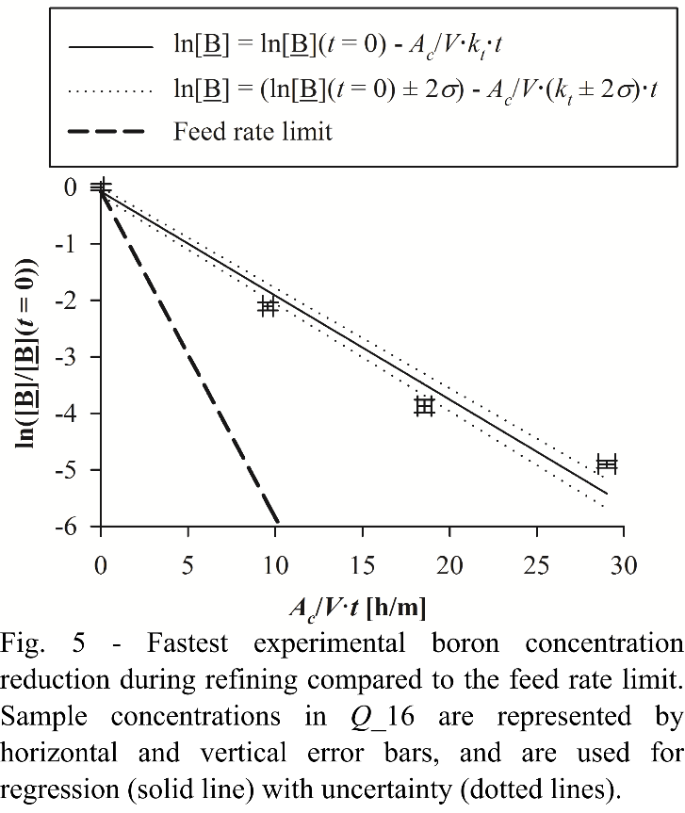

## A. Melt convection

The effect of mass transfer in the melt on the rate of boron removal was investigated experimentally by comparing experiments with similar parameters in induction and resistance heated furnaces (Table I). Different convection regimes are expected in the melt in these furnaces as electromagnetic forces provides forced convection in the induction furnace, as compared to natural convection in the resistance heated furnace. If mass transfer in the melt is rate determining, the effect of induction is expected to greatly improve the total mass transfer coefficient of boron removal. However, the total mass transfer coefficients in Funrace_Res (*kt* = 8.2 ± 0.4 µm/s) and Furnace_Ind1 (*kt* = 10.0 ± 0.6 µm/s) in Table I are in the same range. Consequently, mass transfer in the melt is not considered to be rate determining in neither the induction nor the resistance furnace for total mass transfer coefficients around 10 µm/s as found for Furnace_Ind1 and Furnace_Res.

The relatively low difference in mass transfer coefficients between Furnace_Res and Furnace_Ind1 is most likely caused by a higher temperature in Furnace_Res as the temperature was measured beneath the crucible as compared to inside the melt in Furnace_Ind1. This observation of decreasing removal rates at increasing temperature is consistent with equilibrium at the interphase as proposed by Altenberend [7]. The rate limit of chemical reactions generally increases with increasing temperature, and since this dependence is not observed experimentally, any chemical reaction can not be rate determining in the experiments.

The higher temperature in Furnace_Res shifts the equilibrium at the interface towards lower HBO partial pressures. The reduced mass transfer coefficient in Furnace_Res may thus be due to reduced utilization of the steam supplied to the interface and reduced driving force for removal of HBO in the gas phase. The effect of temperature on the boron removal rate is found to be large enough to explain the difference in mass transfer coefficients between Furnace_Res and Furnace_Ind1. Equilibrium modeling at 1873 K (1600°C) for Furnace_Res compared to 1773 K (1500°C) reveal a reduction in the mass transfer coefficient of . In comparison, the ratio of the total mass transfer coefficient for Furnace_Res to that for Furnace_Ind is 0.78.

Safarian et al. [26] successfully used Eq. (10) and Eq. (16) by Szekely et al [27] to predict mass transfer coefficients in silicon melts in the Induction 2 furnace. Their method is followed to estimate melt mass transfer coefficients in Table VIII for present experiments in the Induction 2 furnace. The melt surface velocity in Eq. (10) is set to . *U*0 is a characteristic velocity estimated in Eq. (16) from the coil current (*I*0), melt conductivity ( [28]), characteristic frequency (for Induction 2), melt density (at 1773 K (1500°C) [29]), the magnetic permeability of free space () and a characteristic length (*L*), which is set to the crucible diameter.

 (16)

The diffusion coefficient of boron in the silicon melt is calculated to  at 1773 K (1500°C). The diffusion coefficient at 1687 K (1414°C) recommended by Garandet [30] in the calculations for temperature correction by Safarian et al. [31].

|  |  |  |  |  |
| --- | --- | --- | --- | --- |
| Table VIII. Estimated surface velocity and mass transfer coefficient for the melt in the Induction 2 furnace. | | | | |
| Induction power | *I*0  [A] | *U*0[cm3/s] | *vm*  [cm/s] | *k*1  [µm/s] |
| 3.9 kW | 47.5 | 674 | 18 | 420 |
| 5.0 kW | 52.5 | 745 | 20 | 442 |

The high melt surface velocities in Table VIII are supported by visual observations of fast moving particles on the melt surface in experiments and ripples on the surface. The model indicated ripples on the melt surface, which also is visually observed in experiments in both induction furnaces.

The melt mass transfer calculated 3.9 kW power estimates a minimum for experiments in the Induction 2 furnace. At a flow rate of 16 lN/min, at least 5.0 kW power was applied to hold the melt at 1773 K (1500°C). For the fastest experimental boron removal in experiment Q_16b, the estimated minimum *k*1 = 442 µm/s is nearly an order of magnitude higher than the total mass transfer coefficient (). The estimated melt mass transfer coefficient contributes no more than 12% to the total resistance to boron removal in Eq. (8), and melt mass transfer is not considered rate determining for experiments in the induction furnace.

## B. Gas flow rate

Gas flow rate is the only varied parameters in the Gas flow rate series in Table II. Mass transfer in the bulk gas is promoted according to Eq. (13) as the amount of gas flowing through the crucible per time is increased. The mass transfer coefficient for the boundary layer (*kg* in Eq. (12)) is also expected to increase with increasing gas flow rate, as also *Re* and the gas velocity increases. Thus, if the total mass transfer coefficient in experiments depends on the gas flow rate, either (or both) mass transfer in the bulk of the gas or in the gas boundary layer is rate determining.

The Gas flow rate series in Fig. 6 shows that total mass transfer coefficients in experiments increases with increasing gas flow rate. A rate determining step is thus found to be in the gas phase (step 3 and/or 4) for total mass transfer coefficients at least up to 51.1 µm/s (experiment *Q*_16b). Mass transfer coefficients for the melt and chemical reactions at the interface do not directly depend on gas flow rate. Relatively constant total mass transfer coefficients would be expected in Fig. 6 if 1/*k*1 and/or 1/*k*2 were dominant in Eq. (8). The highest resistance to boron removal and the most important rate limitation is considered to be in the gas phase.

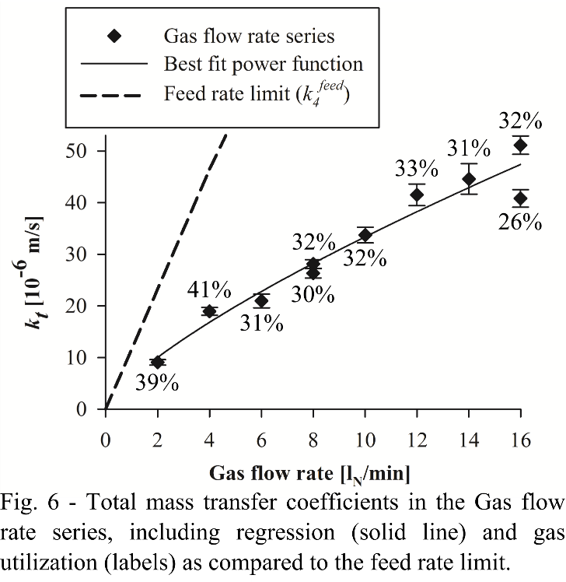

The estimated bulk gas rate limit is shown as the dashed line in Fig. 6 and the gas utilization in experiments is written next to the points. The calculations do not account for consumption of steam above the surface according to Eq. (6), and thus provide the highest possible estimate for the bulk gas rate limit. Incomplete supply of steam to the interface, including consumption above the interphase and potentially an unreacted fraction in the bulk gas leaving the system, limits the equilibrium HBO partial pressure below 100 pct gas utilization. According to the stoichiometry of Eqs. (6) and (7), up to half of the supplied steam may potentially be consumed above the interface, and down to 50 pct gas utilization may represent the actual equilibrium.

All experiments with all experiments with *dc* = 70 mm and *H* ≤ 30 mm in (Tables II-III and V-VI) achieve significant gas utilizations of 26-44%. According to Eq. (13), this indicates that a relatively high fraction of the equilibrium HBO partial pressure is reached in the wall jet, particularly if steam consumption above the interface is considered. As explained in Sec. I, the driving force available for all other steps are reduced by the fraction of equilibrium obtained in step 4. In this respect, bulk gas mass transfer contributes to limit the boron removal rate and is considered to be a rate determining step.

Experiments with 6 lN/min and higher gas flow rates in Fig. 6 retains remarkably constant gas utilizations. Constant gas utilization may be explained by equilibration in the wall jet. Accumulation of HBO to the equilibrium partial pressure (or a constant fraction of that) within the wall jet may provide a constant fraction of the modeled HBO equilibrium partial pressure in the gas flow leaving the system in step 4. Deviation from the estimated bulk gas rate limit may be accounted for by steam consumption above the surface according to Eq. (6).

The large fraction of equilibrium in experiments indicate that that the driving force available for boron removal across the melt surface diminishes to a large extent within the wall jet so that the surface area is not fully utilized as explained in Sec. I. The surface area is however expected to be better utilized with increasing gas flow rate. Part of the strategy for minimizing the effect of equilibration in the wall jet in experiments may be to employ higher gas flow rates. The relatively constant gas utilizations in the experiments reveals that the rate limit estimated by equilibrium modeling follows the same trend with increasing gas flow rate. The trends for the total mass transfer coefficient and the gas utilization show a potential to retain a high gas utilization and further increase the rate of boron removal by increasing the gas flow rates beyond 16 lN/min.

Regression of experimental results in Fig. 6 with a two-parameter power function provides Eq. (17). The uncertainties are expressed as two times the standard deviation of the regression.

 (17)

According to impinging jet theory [22], mass transfer in the gas boundary layer is expected to increase with gas velocity and flow rate as *kg* ∝ *v*0.75 ∝ *Q*0.75 in the wall jet region and as *kg* ∝ *v*0.5 ∝ *Q*0.5 in the stagnation region. Reynolds numbers at the lance exit in models of present experiments (*Re* < 6 for pure hydrogen) are below the range in which the correlation was verified experimentally (*Re* ≥ 300). Total mass transfer coefficient in experiments as well as the estimated bulk gas feed rate limit shows the same dependence as that for boundary layer mass transfer in the wall jet region (*kg* ∝ *Q*0.75). In the Lance diameter series (Sec. III D), the contribution of gas boundary layer mass transfer to the total resistance for boron removal is assessed separately from bulk gas mass transfer, and gas boundary layer mass transfer is not found to be rate limiting. Næss [16] studied active oxidation in a similar (although larger) impinging jet setup. The fuming rate in experiments, which is found to be determined by steam supply to the interface, was also found to fit with gas flow rate to the power of 0.75.

The exponent of 0.5 for the stagnation region dependence is below the estimated uncertainty interval of 0.59-0.91 for the exponent in Eq. (8), which indicates that boron removal occurs mainly outside the stagnation region. The uncertainty interval for the exponent in Eq. (17) also excludes a proportional trend.

The amount of gas supplied in the process is found to be an important consideration in process design. During 35.7 min refining at a flow rate of 16 lN/min in *Q*_16a, 571 lN gas was used to remove boron from 36 ppmw to 0.7 ppmw in a 200 g melt. The ratio of gas volume to initial melt mass is 2.86 lN/g. The magnitude of this ratio relates to the partial pressures of HBO in the gas leaving the system (Fig. 2). Considering  and gas utilizations of 26-44 pct, the fraction of HBO in the gas is in the same range as the fraction of boron in the melt, which means ppm levels for refining towards SoG-Si.

In the equilibrium model for experiment *Q*_16, boron is removed from 36 ppmw to the SoG-Si target of 0.3 ppmw for  and with a gas volume of 192 lN per 200 g melt at 1773 K (1500°C). Division by the gas utilization of 26% in *Q*_16a provides a gas volume per melt mass of 3.7 lN/g for removal of boron from 36 ppmw to 0.3 ppmw. Removal of the last 0.4 ppmw (0.7-0.3 ppmw to boron) would require 169 lN in *Q*_16a. As the concentration of boron in the melt decreases exponentially during refining, so does also the partial pressure of HBO in the gas. For each ppmw boron removed, the amount of gas needed to remove the next ppmw increases accordingly.

## C. Crucible diameter

Experiments in crucibles of different diameters are compared in the Crucible diameter series in Table IV. A total mass transfer coefficient of *kt* =8.2 ± 0.8 µm/s was found in experiment *d*_38 with a 38 mm inner diameter crucible, which represents a significant increase compared to *kt* =5.1 ± 0.4 µm/s in *d­*_70 with a 70 mm diameter crucible. The increased total mass transfer coefficient in the crucible with reduced inner diameter indicate that the mass transfer coefficient decreases with radial distance, as expected for mass transfer in the wall jet. The total mass transfer coefficient in the 70 mm diameter crucible is averaged over a larger area than that in the 38 mm diameter crucible. Mass transfer coefficients outside a radius of 19 mm contribute to reduce the average total mass transfer coefficient in the 70 mm diameter crucible below that in the 38 mm diameter crucible.

Mass transfer outside the 19 mm radius still removes boron in the 70 mm diameter crucible. The rate of boron removal is greater for the increased crucible diameter, as represented by  in *d*_70 and  in *d*_38. Correspondingly, the gas utilization of 11 ± 2 pct *d*_38 was significantly reduced compared to 22 ± 2 pct in *d*_70. The reduced gas utilization suggests that accumulation of HBO was reduced to a lower fraction of equilibrium in the smaller crucible. The experiments show that a large surface area is favorable both for increased removal rates and increased utilization of the reactive gas.

In order to investigate the reaction kinetics at the interphase by experimental measurements of reaction rates, the effect of gas phase mass transfer and equilibration in the wall jet must be made negligible. Also mass transfer in the melt must be fast compared to the chemical reactions. A strategy to achieve fast mass transfer in the gas phase over the entire melt surface is to use small crucibles, in which the lance and stagnation region cover the majority of the surface, in addition to high gas flow rates. This strategy was successfully employed by Sain and Belton [32] in an induction furnace, and allowed for an experimental study of interfacial reaction kinetics in decarburization of liquid iron using CO/CO2 mixtures in inert gas. At 1550°C, the rate became independent of gas flow rate and mass transfer in the gas phase was no longer rate determining above 30 lSTP/min through a 0.49 cm diameter lance in 1.63 cm diameter crucibles. On the other hand, larger crucible diameters may allow for better utilization of the reactive gas. Complete filling of the crucible may also be favorable for mass transfer in the gas because a crucible wall above the surface deflects the wall jet away and slows down the gas close to the wall.

A model of the gas flow provides insight for explaining the variation of total mass transfer coefficients and gas utilization with crucible diameter. Details of the model are described in Sec. II. Fig. 7 (and Fig. 8) shows model results in an axisymmetric cross-section of the crucible, with height above the surface on the vertical axis and radius from center of crucible to the crucible wall on the horizontal axis. A black rectangle marks the lance wall. The gas enters to the left and exits to the right of the lance wall. The contour lines map the gas velocities as each line track the position of constant velocity. The color scale of the contour lines is linear, while the spacing follows a logarithmic scale. Arrows in Fig. 7 show the direction of the gas velocity at the base of each arrow and the length represents the speed on a logarithmic scale.

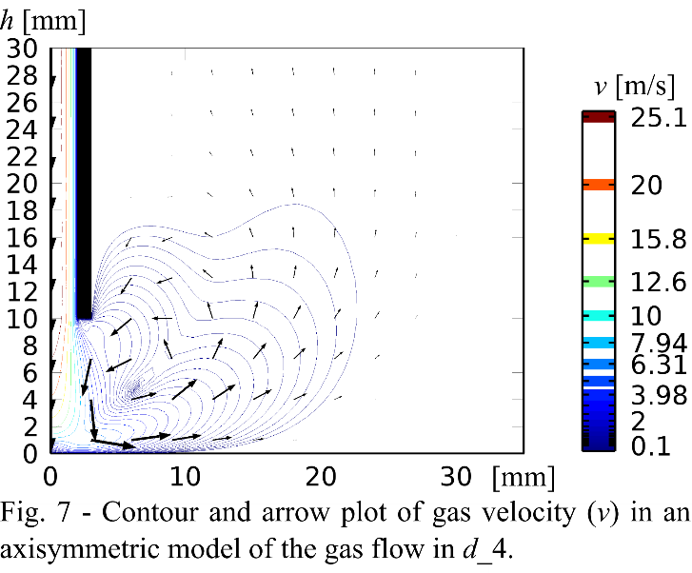

In Fig. 7. the jet out of the lance is slowed down above the stagnation region of the surface. The jet drags surrounding gas along towards the surface, but steam may still escape the jet by diffusion. The stagnation area in which the jet impinges on the surface is slightly larger than the inner lance diameter as expected for impinging jet flow. The gas flows radially along the surface outside the stagnation area. A vortex marks the end of the wall jet region. For the geometry and flow rate of 2 lN/min the model of *d*­_4used to create Fig. 7, the vortex is relatively close to the center and modeled gas velocities are below 0.1 m/s above the majority of the surface. The vortex is found to move away from the surface and the region of stagnant gas along the crucible wall is reduced in models with decreased lance diameters and increased gas flow rates.

Scholtz and Trass [21] observed formation of a vortex and virtually stagnant fluid outside the vortex, in a study of mass transfer in laminar wall jets. The vortex was only observed for low Reynolds numbers (*Re* < 500 in their study), which is also found in models of present experiments (*Re* < 6). Mass transfer coefficients were found as function of radial distance from the stagnation region. They developed equations relating mass transfer in the gas boundary layer to flow at the lance exit, and  in the wall jet agreed well with experimental measurements. Mass transfer coefficients dropped to relatively constant values outside the vortex.

Fresh reactive gas is supplied directly to the surface in this region and HBO is presumably not accumulated in the gas flow above the stagnation region. Supply and removal of reactants in the bulk gas flow is not expected to be rate determining in the stagnation region. The highest gas boundary layer mass transfer coefficients are in the stagnation region [22], and it is possible that mass transfer in the melt or the chemical reactions are rate determining in this region.

However, the experimental total mass transfer coefficients represent the average mass transfer across the crucible cross-section, and the wall jet and the stagnant region outside the vortex constitutes the majority of the surface area. The amount of boron removed outside a radius of 19 mm in *d*_70 represents a significant contribution to the average mass transfer as the gas utilization was doubled compared *d*_38, even though a large part of the gas above this area might be stagnant. Considering the large fraction of boron removed outside the 19 mm radius in *d*­_70, it is unlikely that the small stagnation region contributes significantly to the average mass transfer coefficients, particularly considering that mass transfer to the wall jet is promoted at reduced radial distances.

Both increased boundary layer mass transfer coefficients and increased distance from equilibrium promotes mass transfer at reduced radial distances in the wall jet. The variation of mass transfer across the surface is only observable in the experiments through the total amount of boron accumulated in the gas leaving the system. Mass transfer effects across the surface can only be studied in experiments in which equilibrium is not approached in the gas leaving the system.

## D. Lance diameter

Lances of different diameters are compared in the Lance diameter series in Table III in order to study the effect of gas velocity without changing the amount of reactive gases. The feed rate limit for mass transfer in bulk gas is constant (), while the rate limit for diffusion in the gas boundary layer is expected to increase with gas velocity.

Computational fluid dynamic modeling of the gas phase verifies that the gas velocity along the gas boundary layer depends on the lance diameter. The average radial gas velocity along the radius of the crucible 0.1 mm above the surface () increases with decreasing lance diameters in Table III. The gas flow in the wall jet beneath the lance is highlighted in plots of the radial velocity component for models of *d*_1, *d­*_4 and *d_*35 in Fig. 8. An impinging jet was not achieved in a 35 mm diameter lance at 2 lN/min flow rate in *d*_35. In the impinging jet flow patterns modeled for experiments *d*_1-4, the gas is forced closer to the surface with decreasing lance diameter. The length of the wall jet is also increased with decreasing lance diameter. In the model of *d*_1 in Fig. 8 (a), is increased by a factor 29 compared to *d*_4 in Fig. 8 (b) and a factor 1250 compared to *d*_35. The gas velocity in the model of *d*_35 does not exceed 0.3 m/s.

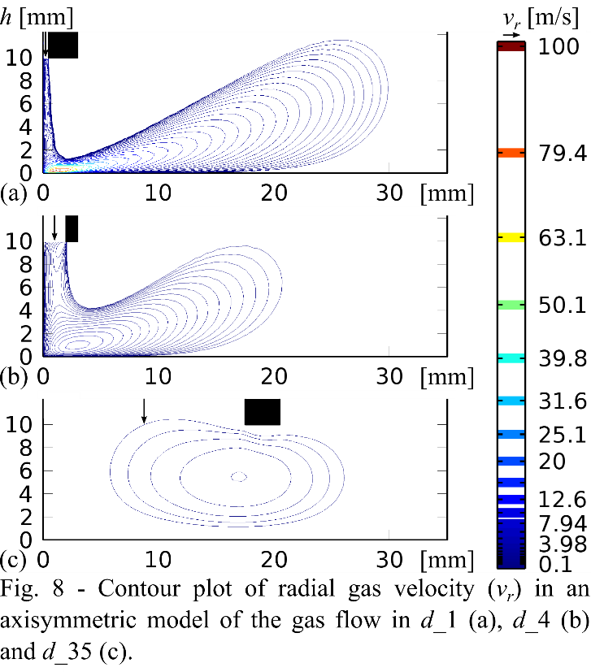

The total mass transfer coefficients in experiments with varying lance diameters at 10 mm height are plotted in Fig. 9, except *d­­*_3 in Table III. Experiment *d­*­_3 is considered to be an outlayer due to bending of the lance tip, which alters the impinging jet flow pattern and cause a slightly reduced total mass transfer coefficient of *kt* = 7.0 ± 0.6 µm/s. The total mass transfer coefficients are relatively constant (within 25% variation) considering the large variation of modeled gas velocities and do not increase with decreasing lance diameter. Accordingly, mass transfer in the gas boundary layer is not considered to be rate determining in the experiments. The only explanation for the effect of gas flow rate in Fig. 6 is thus rate limitation in the bulk gas. Even for the low gas velocities in *d*_35, mass transfer across the surface is sufficient for accumulation of HBO to a gas utilization that is comparable with that achieved by impinging jets.

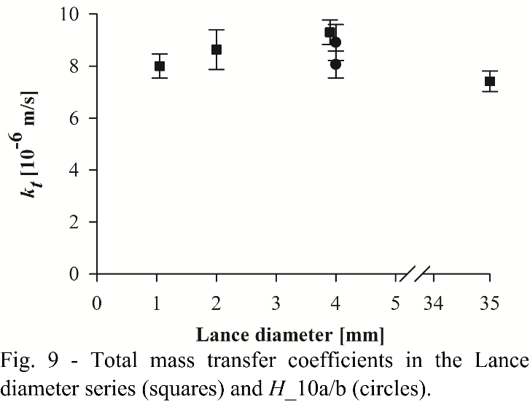

## E. Lance height

Supply of the reactive gas was investigated by variation of the lance height. Fig. 10 plots total mass transfer coefficients in experiments of the Lance height series (Table V), using 4 mm lance diameter, and the Lance height (*d* = 35 mm) series (Table VI and *d*_35 in Table III), with 35 mm lance diameter. Mass transfer coefficients achieved in the Lance height series with 2 lN/min and 4 mm lance diameter are constant for lance heights up to 30 mm, for which *H*/*d* = 7.5. The region of lance heights in which the total mass transfer coefficient is constant is considered to be optimal.

The constant removal rate and gas utilization for a three-fold increased lance height in the optimal region indicate that steam is not lost by diffusion out of the impinging jet. If significant amounts of steam was lost from the impinging jet, the gas utilization would be expected to decrease with an increasing distance at which the jet was exposed to surrounding gas. Diffusion out of the impinging jet is counteracted by the vortex flow modeled in Fig. 7, which recycles part of the gas in the wall jet back along the impinging jet. The observed region of constant mass transfer coefficients is consistent with studies of impinging jets [22].

Scholtz and Trass [22] observed a region of constant mass transfer within 0.25 ≤ *H*/*d* ≤ 6 for a laminar impinging jet, and expected deceleration of the velocity in the center of the jet for lance heights above this region [33]. In spite of large uncertainties in the determination of the mass transfer coefficient and the lance height in *H*_45, the mass transfer coefficient for around 45 mm lance height is considered to be below those for 10-30 mm lance heights in the Lance height series. The uncertainty in determining lance height for *H*_45 is because the lance gradually slipped from 50 mm to 40 mm during the experiment. The reduced mass transfer coefficient in *H*_45 relates to deceleration of the impinging jet above the stagnation region.

Fig. 10 includes the Lance height (*d* = 35 mm) series with a 35 mm diameter lance positioned 5 mm and 10 mm above the melt surface. *H*/*d* = 0.14 in *H*(­*d­*_35)_5 and *H*/*d* = 0.29 in *d*_35, respectively. The total mass transfer coefficients in Fig. 10 are constant also in this region of lance heights, even though it was found by computational fluid dynamic modeling in Fig. 8 (c) that an impinging jet was not formed in these experiments. Like in Fig. 9, the mass transfer coefficients obtained with a lance diameter of 35 mm in Fig. 10 are the lowest within the scatter of experimental values that are considered to represent a constant trend.

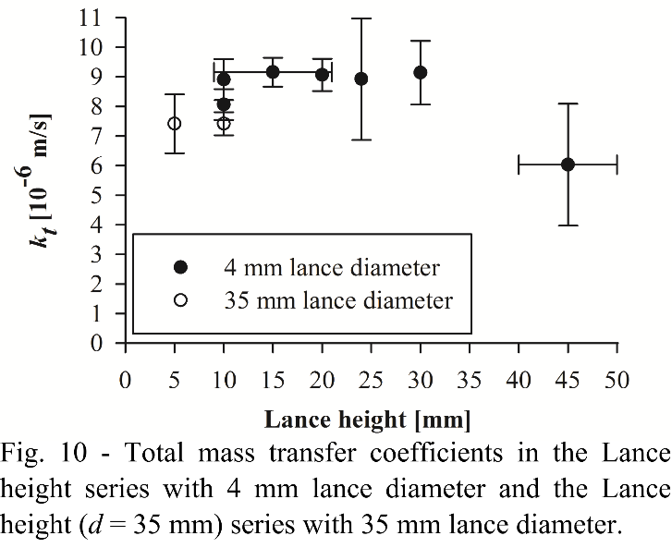

The optimal range of lance heights is found to depend on the gas flow rate through the lance. Fig. 11 compares the gas utilization in experimental series with varying gas flow rates through 4 mm diameter lances at heights of 20 mm and 50 mm. At 6 lN/min gas flow rate, experiments achieve similar gas utilizations at 20 mm and 50 mm lance heights, which indicate that the optimal range extends beyond 50 mm at 6 lN/min gas flow rate. As the gas flow rate is reduced, the gas jet is expected to decelerate within a shorter distance from the lance. The optimal range of lance heights is expected to moves closer to the surface with decreasing gas flow rate. The gas utilization decreases as the gas flow rate is reduced towards 3 lN/min for a lance height of 50 mm, but not for a lance height of 20 mm. The increasing difference between the two series relates to a decreasing optimal range, as the lance height of 50 mm is removed from the optimal range with decreasing gas flow rates. The lance height in *Q*(*H*_50)­_3.5 was 46 mm and closer to the optimal range than the other experiments in the Gas flow rate (*H* = 50 mm) series, which explains the slightly increased gas utilization compared to the trend between 3-6 lN/min at 50 mm lance height.

Between 1-3 lN/min, the gas utilization at 50 mm lance height is seen in Fig. 11 to increase with reducing gas flow rate, which can not be explained by jet impingement onto the surface. The rate of boron removal and the total mass transfer coefficients for experiments *Q*(*H*_50)­_1-2 in Table VII and *d*_70 in Table IV are relatively similar as compared to the feed rate limit. The trend of increased gas utilization may relate to increased residence time available for diffusion with reduced gas flow. A body of gas is expected to remain for a longer time in the vicinity of the surface at reduced gas flow rates, leaving more time for approaching equilibrium in the gas above the melt. The particularly low total mass transfer coefficient and gas utilization in experiment *Q*(*H_*50)_0.5 might indicate that the gas feed was not successfully supplied to the surface at 0.5 lN/min flow rate and 50 mm lance height.

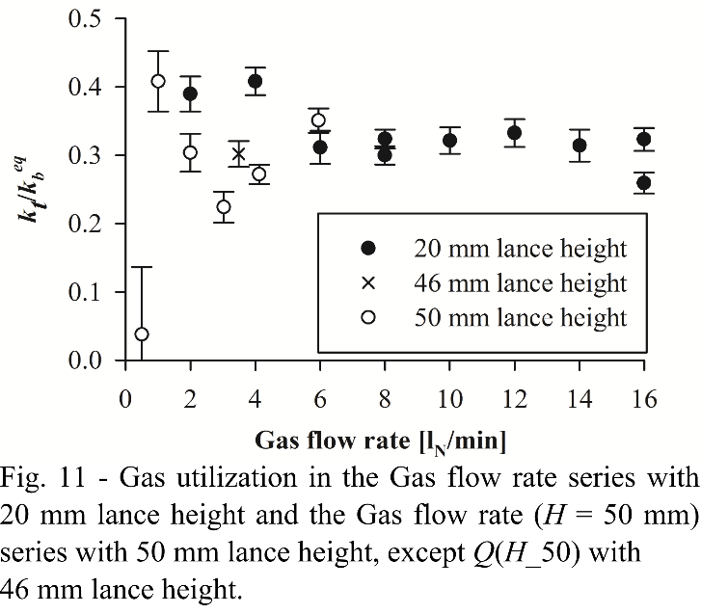

# IV. Conclusion

Boron is removed from silicon melts by blowing steam and hydrogen gas onto the melt surface. Mass transfer is studied experimentally through variation of melt convection, gas flow rate, crucible diameter, lance diameter and the height of the lance above the melt surface. The rate of boron removal increases with increasing gas flow rate, and a total mass transfer coefficient of 51.1 ± 1.8 µm/s is achieved at 16 normal l/min in a 70 mm diameter crucible. The fraction of the reactive gas utilized for formation of HBO at the melt surface remains relatively high at increased gas flow rates. Supply of reactants was found to be constant in a range of lance heights above the interface, and the effect of lance height was found to depend on the gas flow rate.

Both the rate of removal and the utilization of the reactive gas are found to increase with increasing crucible diameters, even though a region of stagnant gas is found towards the crucible wall by modeling the gas flow. The total mass transfer coefficient in experiments represents and average across the crucible cross-section area and is reduced in a 70 mm diameter crucible compared to a 38 mm diameter crucible. The gas utilization is decreased in the smaller diameter crucible. Kinetic investigations may utilize a combination of high gas flow rates in small diameter crucibles to minimize the effect of HBO accumulation in the wall jet flow along the surface. Mass transfer in the gas is reduced with radial distance in the wall jet, but the stagnation region where the jet from the lance impinges on the melt surface is not considered to contribute significantly to removal of boron in 70 mm diameter crucibles.

Neither mass transfer in the melt or in the gas boundary layer was found to be rate determining by comparing experiments in a furnaces with resistance and induction heating and varying the lance diameter. Estimated melt mass transfer coefficients for experiments in the Induction 2 furnace account for no more than 12% of the total resistance to boron removal in. Temperature variations between the furnaces are explained by assuming equilibrium at the gas-melt interface, and reactions at the interface are not considered rate determining. The dependence of total mass transfer coefficients on the gas flow rate is related to the increasing amounts of steam supplied in the bulk gas, and only bulk gas mass transfer was found to be rate determining in experiments. Assuming fast mixing in the bulk gas flow, supply of steam is considered to be rate determining. The gas utilization is considered to be limited at 30-40 pct in experiments mainly by consumption of steam above the interphase as part of active oxidation of the silicon melt, which is an important focus for further studying the mechanism of boron removal by steam and hydrogen.

# Acknowledgements

Kai Tang at SINTEF is gratefully acknowledged for support with the equilibrium model and modification of its database.

# References

[1]. D. Lynch: *Sol. Cell Silicon*, 2009, vol. 61, no. 11, pp. 41-48.

[2]. C.P. Khattak, D.B. Joyce and F. Schmid: *Sol. Energy Mater. Sol. Cells*, 2007, vol. 64, pp. 77-89.

[3]. H.C. Theuerer: *J. Metals*, October 1956, pp. 1316–1339.

[4]. A.F.B. Braga, S.P. Moreira, P.R. Zampieri, J.M.G. Bacchin and P.R. Mei: *Sol. Energy Mater. Sol. Cells*, 2008, vol. 92, pp. 418-424.

[5]. J. Kraiem, B. Drevet, F. Cocco, N. Enjalbert, S. Dubois, D. Camel, D. Grosset-Bourbange, D. Pelletier, T. Margaria and R. Einhaus: *2010 35th IEEE Photovoltaic Specialists Conference (PVSC 2010)*, pp. 1427-1431, IEEE, Honolulu, HI, 2010.

[6]. E.F. Nordstrand and M. Tangstad: *Metall. Mater. Trans. B*, 2012, vol. 43B, pp. 814–822.

[7]. J. Altenberend: Ph.D. Thesis, Universite de granoble, 2012.

[8]. K. Suzuki, T. Kumagai and N. Sano: *ISIJ Int.*, 1992, vol. 32, pp. 630-634.

[9]. J. Safarian, K. Tang, K. Hildal and G. Tranell: *Metall. Mater. Trans. E*, 2014, vol. 1E, pp. 41-47.

[10]. T. Ikeda and M. Maeda: *Mater. Tran.*, 1956, vol. 37, pp. 983-987.

[11]. N. Nakamura, H. Baba, Y. Sakaguchi and Y. Kato, *Mater. Trans.*, 2004, vol. 45, pp. 858-864.

[12]. K. Tang, S. Andersson, E. Nordstrand and M. Tangsta:, *JOM*, 2012, vol. 64, pp. 814-822.

[13]. M. Page, *J. Phys. Chem.*, 1989, vol. 9, pp. 3639-3643.

[14]. T. Yoshikawa and K. Morita: *Mater. Trans.*, 2005, vol. 46, pp. 1335-1340.

[15]. E. T. Turkdogan, P. Grieveson, and L.S. Darken.

*J. Phys. Chem.*, 1963, vol. 67, pp. 1647–1654.

[16]. M.K. Næss: Ph.D. Thesis, Norwegian University of Science and Technology, 2013.

[17]. M. Ratto, E. Ricci, E. Arato and P. Costa: *Metall. Mater. Trans. B*, 2001, vol. 32B, pp. 903-911.

[18]. C. Alemany, C. Trassy, B. Pateyron, K.-I. Li and Y. Delannoy: *Sol. Energy Mater. Sol. Cells*, 2002, vol. 72, pp. 41-48.

[19]. J.W. Hinze and H.C. Graham. *J. Electrochem. Soc.*, 1976, vol. 123, pp. 1066–1073.

[20]. E.S. Machlin: *Trans. TMS-AIME*, 1960, vol. 218, pp. 314-326.

[21]. M.T. Scholtz and O. Trass: *AIChE J.*, 1963, vol. 9, pp. 548-554.

[22]. M.T. Scholtz and O. Trass, *AIChE J.*, 1970, vol. 16, pp. 90-96.

[23]. D. York, N. Evensen, M. Martinez, J. Delgado, *Am. J. Phys.*, 2004, vol. 72, pp. 367-375.

[24]. K. Tang, E. Øvrelid, G. Tranell and M. Tangstad: *Mater. Trans.*, 2009, vol. 50, pp. 1978-1984.

[25]. M.W. Chase: *NIST-JANAF Thermochemical Tables*, 4th ed., National Institute of Standards and Technology, Woodbury, NY, 1998.

[26]. J. Safarian and M. Tangstad: *High Temp. Mater. Proc.*, 2012, vol. 31, pp. 73-81.

[27]. J. Szekely, C.W. Chang and W.E. Johnson: *Met. Trans. B*, 1977, vol. 8B, pp. 514-517.

[28]. L.N. Hjellming and J.S. Walker: *Fluid Mech.*, 1986, vol. 164, pp. 237-273.

[29]. K. Mukai and Z. Yuan: *Mat. Trans., JIM*, 2000, vol. 41, pp. 323-330.

[30]. J.P. Garandet: *Int. J. Thermophys.*, 2007, vol. 28, pp. 1285-1303.

[31]. J. Safarian and M. Tangstad: *Metall. Mater. Trans. B*, 2012, 43B, pp. 1427-1445.

[32]. G.R. Belton and D.R. Sain: *Met. Trans. B*, 1976, vol. 7B, pp. 235-244.

[33]. M.T. Scholtz and O. Trass, *AIChE J.*, 1970, vol. 16, pp. 82-90.