Climate change and coevolution in the cuckoo - reed warbler system

Daniel Berkowic¹ ● Bård G. Stokke² ● Shai Meiri¹ ● Shai Markman^{3*}
¹Department of Zoology, Tel Aviv University, Tel Aviv, Israel;
²Department of Biology, Norwegian University of Science and Technology (NTNU), Trondheim, Norway; and
³Department of Biology & Environment, University of Haifa –
Oranim, Tivon, 36006, Israel

Running title: Coevolution and climate change: cuckoos and warblers
* Correspondence author. E-mail: markmans@research.haifa.ac.il

Total word count (excluding references, tables and figures): 5170
Separate word counts for each section: Abstract: 300; Introduction: 1316; Materials and Methods: 930; Results: 660; Discussion: 2372; Acknowledgements: 162. Number of cited references: 71
Number of figures and tables: 4 figures, 2 tables.
A list of items to be published as online appendix (if applicable): 6 appendices (as tables).
Abstract
The evolution of traits in hosts may be influenced by their parasites and vice versa and a coevolutionary arms race often develops between the two. As part of such an arms race, the common cuckoo mimics the eggs of its hosts to avoid egg rejection. Traits related to this arms race may also be influenced by climatic conditions, such as temperature, affecting, for example, food availability and, thus, female condition and egg size (therefore may reflect Bergmann's rule or the resource rule). The potential interaction between coevolution and climate has rarely been studied. We investigated whether egg and body size of cuckoos and reed warblers from Britain and Denmark had undergone change between 1868 and 1956, and whether such changes were correlated with climatic factors. Cuckoo egg size decreased during the studied period while warbler egg size remained stable. Hence, cuckoo and warbler eggs have become more similar in size over time. Cuckoo egg volume decreased with increasing annual precipitation, but annual precipitation decreased over time. Warbler egg volume increased with spring temperatures (which could not reflect Bergmann's rule, but may support the resource rule). Hence, it seems that the measured climatic indices did not affect cuckoo egg size but may in part affect warbler egg size. Therefore, the decrease in cuckoo egg size may be the result of the coevolutionary arms race. Body and egg sizes in the cuckoos were negatively correlated whereas warbler body and egg sizes were uncorrelated, suggesting that selection probably acted on egg size directly and not via selection on body size. Taken together, these findings may indicate that climate change, the coevolutionary arms race, or both, affected egg sizes. It is suggested that drawing conclusions regarding the arms race without taking into account other selective pressures (e.g., climate) may confound conclusions regarding parasite-host systems.

Keywords Arms-race · Birds · Body size · Brood parasitism· Egg size · Climate change
Introduction
An evolutionary arms race often develops in host-parasite systems, in which the host evolves defences against the parasite and the latter evolves countermeasures to overcome these defences (Rothstein 1990; Davies 2000; Payne 2005; Kilner 2006). The arms race between brood parasitic birds and their hosts is thought to operate throughout all life-history stages (Grim et al. 2011; Feeney et al. 2014). Traits involved in such arms races include the ability of the host to identify and reject the egg of the parasite in tandem with improved parasite "trickery" (e.g., egg mimicry). Phenotypic changes resulting from these arms races may manifest within short time periods. For example, Spottiswoode and Stevens (2012) suggested that the cuckoo finch (Anomalospiza imberbis) and its host the African tawny-flanked prinia (Prinia subflava), have tracked the colour and pattern of each other’s eggs over a period of 40 years.
The traits under selection in a coevolutionary arms race can also be under selection pressure from factors unrelated to this process (e.g., Avilés et al. 2012). Climatic factors, for example, may independently influence the coevolved traits and blur the effect of selective pressure exerted by host defences and parasite countermeasures (Avilés et al. 2006a; Avilés et al. 2012). Body sizes of many species have been changing recently, perhaps in response to global warming – either directly ( e.g., size decrease as predicted under Bergmann’s rule ) or indirectly through, for example, consequent changes in food availability that may result increases in body size (Jarvinen 1994; Yom-Tov et al. 2006; Salewski et al. 2010; Yom-Tov and Geffen 2011, but see Meiri et al. 2009). Changes in body size, especially of females, may be reflected in egg size, because the two traits are often highly correlated (Rahn et al.1975; Blueweiss et al. 1978). As egg morphology may be under selection from the arms race and is additionally influenced by female size, selection pressures acting on the host and parasite egg sizes may be independent or even conflicting. Bird egg size is a labile character that responds to selection pressures even over short time periods (e.g., as demonstrated in selection experiments; Nordskog et al. 1974). Therefore, any change in egg size may occur in the context of an evolutionary arms race (Servedio and Lande 2003).
Common cuckoos (Cuculus canorus, hereafter: ‘cuckoos’) are obligate brood parasites. The reed warbler (Acrocephalus scirpaceus, hereafter: ‘warbler’) is one of the cuckoo’s main hosts in Europe (Brooke and Davies 1987; Moksnes and Røskaft 1995). The reed warbler was a relatively rare host in Northern Europe during the 19th century but became an increasingly common one during the 20th century (e.g., Avilés et al. 2006b). Cuckoo nestling eject warbler eggs and young from the nest, severely reducing the warblers’ fitness (Wyllie 1981; Anderson et al. 2009). Warblers have therefore evolved mechanisms to recognize and reject cuckoo eggs before they hatch (Davies 2000; Stokke et al. 2008). Cuckoos have, in turn, evolved eggs that mimic warbler eggs in colour, pattern and size (Davies and Brooke 1988; Moksnes and Røskaft 1995). Cuckoos lay relatively small eggs for a bird of their size but still larger than those of warblers (Darwin 1859; Rahn et al. 1975; Krüger and Davies 2004). Because relatively small cuckoo eggs most resemble the size of warbler eggs, such cuckoo eggs may be less likely to be recognized and rejected by the host, especially when egg spotting pattern and colour are similar between cuckoo and host.
We investigated whether egg sizes of cuckoos and warblers had undergone change during the first half of the 20th century, in response to one another, and/or to climatic factors. In order to tease apart the possible effects of the arms race from direct effects of adult body size on egg size, we examined both egg and adult size of cuckoos and warblers. We assessed the possible effects of temperature and precipitation at the time and place of egg collection on egg and body sizes of both species.
Even in the lack of parasitism in the host population, changes in warbler egg size may also be driven by environmental changes. However, in a parasitized population, the interpretation of changes in egg size is more complicated, as the presence of parasitism may also explain such changes (see below for more details). Further, if cuckoo eggs found in reed warbler nests become smaller over time this might be due to two possible scenarios. The first scenario is that cuckoos continue to lay eggs of similar size over time but warbler rejection abilities improve (but no apparent selection yet on cuckoo egg size). This may lead to the ejection of large cuckoo eggs, leaving human observers to find only the smallest cuckoo eggs (a sampling bias in terms of assessing the real size of the cukcoo eggs being laid). Importantly, this scenario only works if warblers reject cuckoo eggs by ejection and not desertion. The second scenario suggests that cuckoos actully laid smaller eggs over time, due in part to selective pressure exerted by the warblers (i.e., rejection of large cuckoo eggs). The main rejection response of reed warblers to cuckoo parasitism, however, is mostly by desertion, while ejection has been reported to be rare (e.g., see: Blaise 1965; Löhrl 1979; Wyllie 1981; Erlinger 1984; Davies and Brooke 1988; Stokke, personal observations). Such deserted clutches would still be collected by humans and eggs would be available for us to measure. Hence, possible biases due to sampling errors of cuckoo egg size by human collectors (as noted in scenario one) should be of minor importance.
If selection has improved the ability of the warblers to reject cuckoo eggs over time, we would expect both small and large cuckoo eggs to have been laid in warbler nests during the early periods studied here (i.e., during the late 19th and early 20th century). In later periods, as warblers evolved to progressively reject large cuckoo eggs (or desert nests with such eggs), only the smallest parasite eggs would successfully hatch. Hence, the frequency of cuckoos laying larger eggs may decrease with time. Therefore, we predict that the variation in cuckoo egg sizes will decline over time, because in later periods the largest cuckoo eggs will be rejected by the warblers.
If cuckoos lay progressively smaller eggs, warbler eggs too may become smaller over time. This is because those hosts laying the smallest eggs would most easily detect the progressively smaller cuckoo egg and hence the host population would eventually consist of individuals laying smaller eggs. To further complicate the situation, cuckoos may have evolved the ability to actively select host nests containing large warbler eggs (Cherry et al. 2007). If this is the case, we would expect cuckoo eggs to be found in host nests containing the largest host eggs in the later periods studied here.
Directional climate changes could be expected to produce changes in egg size. Hence, coevolutionary changes in egg size will be difficult to identify, especially during periods of warming. This is because environmental factors, for example those following Bergmann’s rule logic, such as increasing temperatures, may lead to a decline in egg size either through direct selection on egg size (but see Meiri and Dayan 2003) or, more likely, through a reduction in female body size. According to the resource rule (McNab 2010), however, body and egg sizes would increase with increasing temperatures and precipitation in temperate regions (such as Northern Europe) due to increased food quality and availability.
Adult cuckoos feed to a great extent on hairy caterpillars (del Hoyo 1997). If, for example, climatic changes mean that butterflies and moths are less abundant, then there will be fewer caterpillars for female cuckoos to consume during the breeding season. This may lead to lower investment in egg production and perhaps to smaller cuckoo eggs. Warblers feed on diverse insects and spiders (del Hoyo 1997) and the abundance of these invertebrates may likewise vary with local temperature and precipitation regimes.

Materials and Methods
Egg and body size measurements
To detect potential changes in egg and body size over time, we measured cuckoo and warbler eggs and cuckoo and warbler skins from the same areas in which the eggs were collected. Eggs and skins were measured using digital callipers at the Natural History Museum of Denmark, Copenhagen and the Natural History Museum, London (at Tring). We documented the year of collection of all eggs and skins and calculated mean warbler egg volume per clutch for the warblers and for the single cuckoo egg in each nest for each year (we averaged cuckoo egg volume in the 43 warbler nests that contained two cuckoo eggs). Egg volume (in cm³) was calculated as: (0.51×L) (mm)*B² (mm))/1000, where: L = maximum egg length, B = maximum egg breadth (Hoyt 1979). Cuckoo eggs in warbler nests found in the museum collections represent only those eggs that were not ejected by warblers. We defined "non-parasitized" warbler nests as nests that did not contain cuckoo eggs or parts of eggs. Clutches and skins were collected at sites in Denmark and Britain (see details in Appendix 1; Fig. 1). Fewer clutches had been collected during the first decade of the studied period. We therefore ran a senstivity analysis in which we removed eggs collected in this decade from the dataset. This omission did not qualitatively affect our results (i.e., we obtained similar slopes and significance levels). We therefore present the results of the analysis run over the entire dataset. We measured tarsus length as an index of adult body size, as it provides a good indicator of overall avian body size (Senar and Pascual 1997).
Climatic data
We used climatic data from the years when eggs and skins were collected in order to assess whether climatic changes were correlated with egg and body sizes of cuckoos and warblers. We assigned to each egg and skin the mean spring and early summer temperature and precipitation (from May to July, hereafter “spring”), and mean annual temperature and precipitation in the year and location of their collection. Cuckoos and warblers remain at the breeding sites in Denmark and Britain mainly from May to July (Joys and Crick 2004). Climatic conditions during this period are thus relevant for their thermoregulation and food availability. Temperature and precipitation during the rest of the year, however, may also be relevant, because these annual factors may affect food availability during the period that these birds spend at their European breeding sites (e.g., severe winters may affect insect abundance during the following spring and summer).
Temperature and precipitation data were retrieved from the Royal Netherlands Meteorological Institute (http://climpexp.knmi.nl/getstations.cgi) and from NASA (http://www.giss.nasa.gov). Climatic data were derived from the meteorological stations closest to collection localities. Stations were, on average, 27.8 km away from the collection localities and no more than 100 km away.
Statistical analysis
Egg volumes and tarsus lengths were log-transformed prior to all analyses to conform to the assumptions of parametric tests. We used linear models to concomitantly assess the effects of latitude, country (Britain or Denmark), spring and annual temperatures, spring and annual precipitation and the year in which eggs were collected, on the egg volumes of each of the two species. For the warblers, we also included whether eggs were from a parasitized or non-parasitized nest as a predictor. We examined the relationships between tarsus length and the same climatic factors that we used for egg volume, while controlling for bird gender. To examine whether changes in egg sizes reflected changes in adult body size, mean egg sizes within country for each year were regressed against the tarsus length of females collected during that year.
To test for collinearity of the predictor variables, we examined variance inflation factors (VIF). The best way to avoid collinearity is by dropping collinear covariates. The choice of which covariates to drop can be based on the degree of collinearity or have a basis in biological knowledge (Zuur et al. 2010). We dropped variables that were highly collinear with others and were likely to have little direct biological effect (e.g., longitude, VIF = 18.7, was highly correlated with country: longitude is also weakly correlated with body size in Europe; Meiri et al. 2005). We retained only factors with VIFs < 3 (following Zuur et al. 2010; see Appendix 2). Latitude (VIF = 2.03) was also included in the models because of the potential effects of Bergmann's rule. Statistical tests were performed with R (R development core team 2013). Model selection was based on AICc (corrected Akaike information criterion), where the best models were those with the lowest score. Since many models had similar AICc values (ΔAICc < 10, following Burnham and Anderson 2002), we used weighted average parameter estimates across the best models (Johnson and Omland 2004) to assess which parameters were most tightly related to egg volume. The parameters included in the best models (all ΔAICc < 10) and their model-selection statistics are shown in Appendices 3-6. Since we found that the variation in cuckoo egg volumes had increased over time (see below), we used a general linear model (GLM) with gamma error structure (Venables and Ripley 2002) to assess cuckoo egg size evolution. We did not find deviations from normality and homoscedasticity in the residuals of our other models and therefore used linear models to analyze warbler body and egg size and cuckoo body size. To examine whether egg size variability had changed over time, the within-year coefficient of variation (CV) of log egg volume was regressed against the year of collection of parasitized and non-parasitized nests.

Results
Egg volume
The model-averaged parameter estimates in the gamma regression models, for cuckoo egg volume across best models (ΔAICc < 10), suggest that cuckoo egg volume had decreased over time (Fig. 2), was larger in the UK than in Denmark, increased with increasing latitude and decreased with increasing mean annual precipitation (Table 1A, all interaction terms resulted in increased AICc scores).
The model-averaged parameter estimates in the regression models, for warbler egg volume across best models (ΔAICc < 10), suggest that warbler egg volume increased with spring temperature but did not change with time (Fig. 2) and was larger in the UK than in Denmark (Table 1B, all interaction terms resulted in increased AICc scores). The model-averaged parameter estimates for warbler egg volume further demonstrate that warbler eggs in parasitized clutches were, on average, 8% larger than eggs in non-parasitized clutches (parasitized: n = 1206 _{clutches}, mean egg volume = 0.26 ± 0.002_{SE} cm³; non-parasitized: n = 203 _{clutches}, mean egg volume = 0.24 ± 0.001 _{SE} cm³; Table 1A). Mean warbler egg volume was independent of clutch size (n _{clutches} = 1409, slope = -0.01 ± 0.009 _{SE}, t = 0.64, P = 0.5). The coefficient of variation (CV) of cuckoo egg volume increased over time (n = 50 _{years}, slope = 0.05 ± 0.02 _{SE}, R² = 0.12, P = 0.02, Fig. 3), while that of warbler egg volume remained stable (parasitized: n = 50 _{years}, slope = 0.04 ± 0.03 _{SE}, R² = 0.04, P = 0.16; non-parasitized: n = 39 _{years}, slope = 0.05 ± 0.05 _{SE}, R² = 0.03, P = 0.75, Fig. 3).
Surprisingly, egg volume of both species was larger in the UK than in Denmark. Because most warbler nests contained one cuckoo egg (except from 5 nests in the UK and 38 nests in Denmark) cuckoo clutch size was similar in Denmark and Britain (Denmark 1.035 eggs ± 0.034 _{SE}; UK 1.029 eggs ± 0.029 _{SE}; t ₁₂₉₆ = 0.357, P = 0.720). Warbler clutch size was significantly larger in non-parasitized nests from Denmark (4.25 eggs ± 0.63) than from the UK (3.89 eggs ± 1.18) (t₂₀₁ = 1.97, P = 0.007) (we used only non-parasitized nests as in parasitized nests, the adult cuckoo may eject or swallow some of the warbler eggs). This in part may explain why individual eggs were smaller in Denmark.

Body size and climate
Tarsus lengths of both female and male cuckoos were longer in Britain than in Denmark (n = 77 _{skins}, R² = 0.49, P < 0.001; Table 2A). The model-averaged parameter estimates for cuckoo tarsus length demonstrate that it was slightly larger in males than in females and increased slightly with annual precipitation (Table 2A). Warbler tarsus length increased with spring temperature, was larger in Britain than in Denmark and was slightly larger in males than in females (Table 2B). Despite no significant relationships between tarsus length and year, there was a significant (albeit weak) positive correlation between spring temperature and year (slope = 4.77 ± 0.43 _{SE}, multiple R² = 0.08, P < 0.001, Fig. 4a). However, there was no significant correlation between annual temperature and year (slope = 0.00007 ± 0.12 _{SE}, multiple R² = 0.001, P = 0.1; Fig 4a). Further, there was a significant (albeit weak) negative correlation between annual precipitation and year (slope = -0.0005 ± 12.2 _{SE,} multiple R² = 0.04, P = 0.001; Fig 4b) but no significant correlation between spring precipitation and year (slope = 0.0002 ± 1.61_{SE,} multiple R² = 0.001, P = 0.2; Fig 4b).
Female cuckoo tarsus length and egg size were negatively correlated (corrected for year and country of origin: slope = -0.018 ± 0.004 _{SE}, n = 13 _{years}, multiple R² = 0.64, P = 0.001). Female warbler tarsus length and egg size were uncorrelated (corrected for year and country of origin: slope = 0.007 ± 0.0003 _{SE}, n = 10 _{years}, multiple R² = 0.49, P = 0. 1).

Discussion

Cuckoo and warbler egg volume trends
The coevolutionary arms race between the cuckoo and its hosts is well documented (Darwin 1859; Dawkins and Krebs 1979; Rothstein 1990; Davies 2000; Payne 2005; Stevens 2013). We found that cuckoo egg volume decreased over time, whereas reed warbler egg volume did not change. Cuckoo body size and egg volume were negatively correlated, whereas warbler body and egg sizes were uncorrelated. Thus, selection probably acted directly on egg size of cuckoos and not via influences on body size. This may provide further evidence for the existence of a coevolutionary arms race between the cuckoo and its warbler host at the egg level. Climate change, however, probably also influences egg size making decoupling the effects of climate and coevolution challenging. We demonstrate here that climate change may play a role in the matching of egg volume between cuckoo and warbler. This is because the changes in egg volume, at least in warblers, were correlated with changes in certain climate variables (although not necessarily reflecting a cause and effect relationship).
A possible explanation for the apparent decrease in cuckoo egg size over time is that warblers simply improved their ability to discriminate eggs by size (i.e., they rejected the larger cuckoo eggs at a higher frequency), and thereby enforced a strong selective pressure on cuckoos to evolve smaller eggs. Alternatively, warblers may have improved their ability to eject larger cuckoo eggs without affecting changes in cuckoo egg size as yet, resulting in a bias towards small eggs amongst those retained in the nest and obtained for egg collections. This may produce a false impression that cuckoo eggs had become smaller. We find this second option unlikely given the low number of ejection events of cuckoo eggs by warblers (e.g., see: Blaise 1965; Löhrl 1979; Wyllie 1981; Erlinger 1984; Davies and Brooke 1988; Stokke, personal observations). An enhanced ability of warblers to eject (rather than to detect and desert) progressively smaller cuckoo eggs is therefore unlikely to be the main cause for the decline in cuckoo egg size.
If selection has improved the ability of the warblers to reject cuckoo eggs over time, one may predict that the variation in cuckoo egg sizes will decline over time, because in later periods the largest cuckoo eggs will be rejected by the warblers. However, contrary to this prediction, the coefficient of variation (CV) of cuckoo egg volume increased over time rather than decreased. One possible explanation is that different rates of parasitism in the host populations included in the current study resulted in different rates of selection exerted by warblers on cuckoo egg sizes.
Stokke et al. (2008) found that the rejection rates in 14 warbler populations throughout Europe varied between 5% and 69%, with higher rejection rates in heavily parasitized populations. We do not have data with regard to the parasitism rates and rejection rates during the studied period and therefore cannot assess the likelihood that our "non-parasitized" nests may initially have been parasitized.
Davies and Brooke (1988) found that large model eggs, about twice as large as cuckoo eggs, were more likely to be rejected than normally-sized cuckoo eggs. This suggests that warblers can detect and reject cuckoo eggs based on their size, although it is yet to be determined whether the differences in size that we have found between cuckoo and warbler eggs is sufficient for the hosts to detect alien eggs.
Important evidence in favour of a potential ability of warblers to detect cuckoo eggs and reject them is the fact that the average warbler egg volume in parasitized nests was ca. 8 % larger than the average warbler egg volume in non-parasitized nests. The average cuckoo egg volume across the studied period was ca. 86 % larger than the average warbler egg in parasitized nests. Therefore, there was a 94 % size difference between cuckoo egg volume and warbler egg volume in non-parasitized nests, which may have facilitated easier detection and rejection of cuckoo eggs by some reed warblers.
Another possibility is that cuckoos actively selected nests with large warbler eggs, to minimize the probability that the warblers would detect and reject the cuckoo eggs. Cuckoos are indeed more likely to parasitize nests close to vantage points (Moskat and Honza 2000). These areas are also likely to be better foraging sites for nesting warblers, which often leave the reeds to forage in nearby bushes for insects (Moskat and Honza 2000). Hence, hosts that are more likely to be parasitized may also be in better condition and may therefore lay larger eggs. There is some evidence that cuckoos actively search for suitable host nests, that is, selecting nests containing eggs with similar chromatic characteristics to cuckoo eggs (Honza et al. 2014), large nests and nests of relatively active host pairs (Cherry et al. 2007).

Climate change, body size and egg size
The impact of climate change on bird body and egg sizes has recently received much attention (Walther et al. 2002; Tryjanowski et al. 2004; Yom-Tov et al. 2006; Teplitsky et al. 2008; Yom-Tov and Geffen 2011; Sheridan and Bickford 2011). Many of these studies have reported correlative evidence for a decline in the body size of mammals, and especially of birds, in response to climate change (Tryjanowski et al. 2004; Parmesan 2006). Other studies have shown either no trend (Meiri et al. 2009) or a size increase (Yom-Tov et al. 2006), probably as a result of an increase in the availability of food following global warming over the last fifty years (Bolton et al. 1993; Rychlik and Jancewicz 2001).
Under Bergmann’s rule, body and egg sizes of both species are expected to decline with increasing temperatures. We found no decrease in either body or egg size with increasing temperature (Tables 1 and 2), and therefore cannot invoke Bergmann's rule to explain egg size changes. The increase in egg size with increasing spring temperature in warblers may reflect the resource rule (McNab 2010), if food quality and availability indeed increased with increasing temperature. There was a significant negative correlation between cuckoo egg volume and annual precipitation, namely cuckoo egg size decreased with increasing precipitation. However, we found that annual precipitation significantly (albeit weakly) decreased over time. This would mean that cuckoo egg volume was predicted to increase, if indeed egg volume is influenced by the amount of precipitation, rather than decrease over time as we found. Hence, it seems that annual precipitation did not directly affect cuckoo egg size over time. Therefore, it looks that other factors (e.g., the arms race) contributed to the significant negative correlation between cuckoo egg volume and year.
As to the differences in egg size between the countries, it is important to note that egg size was larger in the areas in the UK from which the eggs were collected despite them being, on average, southern to the areas in which the eggs were collected in Denmark. This seems to be opposite to what would be predicted as body size is expected to decrease with decreasing latitude following Bergmann's rule, and therefore egg size is predicted to be smaller rather than larger in the UK (although tarsus length was not affected by latitude in both species). These results may be in part due to the fact that in some cases, seasonality is related to clutch size (Lack 1946; Jetz et al. 2008). Seasonality increases with latitude, and in some cases (e.g., in Europe) also with longitude. Northern and Eastern Europe are more seasonal than Southern and Western Europe (Lack 1946, Bell 1996). Given the effects of seasonality on clutch size, birds in the former areas tend to have larger clutch sizes than birds in the latter areas. Given the potential trade-off between clutch size and egg size (Jetz et al. 2008), egg size in Western countries in Europe (e.g., UK) is predicted to be larger than in more Eastern countries (e.g., Denmark). Indeed, we found that warbler clutch size was significantly larger in Denmark than in the UK, whereas egg size was larger in the UK than in Denmark. Another possible explanation for the difference in egg size between the countries is that tarsus length of the warblers in the UK was larger than the warblers in Denmark. This may mean that warblers in the UK were larger and therefore laid larger eggs. However, other factors that either directly or indirectly related to seasonality (e.g. food availability) or unrelated to seasonality could act to result the pattern of smaller eggs in Denmark.
Warbler egg volume increased with spring temperatures, and spring temperatures increased over time. Egg size increase therefore could not reflect Bergmann's rule, as warbler body size also increased, but may support the resource rule (McNab 2010). Cuckoo egg volume decreased with increasing annual precipitation, but annual precipitation decreased over time. Hence, it seems that the measured climatic variables did not directly affect cuckoo egg size over time but may in part affect warbler egg volume. If both direct and indirect effects of climate change were affecting warblers and cuckoos in the same way, we would expect body size and/or egg volume to show the same trend (i.e., increasing or decreasing body size and/or egg size). However, these two species differ in their body size and to some extent also in their diet, and in other natural-history traits (see del Hoyo 1997). Therefore, it is possible that climate change affected these species in different ways. Differing effects of climate change can make detecting the arms race difficult, especially when it comes to the different trends in cuckoo and warbler egg or body sizes.
The percentage of warbler nests that were parasitized by cuckoos more than doubled during the 20th century (Brooke and Davies 1987). Cuckoo eggs became similar in size to warbler eggs in parasitized nests, and the variation in egg volume of both species did not decrease during the 20th century. Concomitantly, changes in egg size of both species were correlated with climatic conditions. The changes that we found in egg size might have occurred through both direct and indirect effects of climatic change and/or via selection pressure due to the arms race between the two species. As the effects of the arms race and climate change may result in similar changes in egg size, we cannot easily decouple the two factors. Future studies should consider the effects of climate change when studying coevolutionary arms race systems. Our findings suggest that the evolution of specific traits under selective pressures from coevolutionary arms races may also be influenced by factors unrelated to such interactions. Hence, environmental conditions should be taken into account in long-term coevolutionary studies, as the assumption that the observed patterns are only the outcome of coevolutionary events may be over-simplified.

Acknowledgements Comments made by four anonymous referees significantly improved the manuscript. This research received support from the SYNTHESYS Project: http://www.synthesys.info, which was financed by the European Community Research Infrastructure Action under the FP7 "Capacities" Program. BGS was funded by the Research Council of Norway (218144). The research was further funded by a seed money grant from Oranim College awarded to Shai Markman. We thank Arnon Lotem and Tamar Dayan for valuable comments on an earlier version of this manuscript. We also thank Rainee Kaczorowski, Oliver Tallowin and Naomi Paz for going over the final version of this manuscript. We are grateful to the collection managers and curators at the Natural History museums: in Tring, UK - to Robert Prys-Jones, Mark Adams, and especially to Douglas Russell, the curator of the egg collection; in Copenhagen - to Jon Fjeldså, and Jan Bolding Kristensen, and in Berlin - to Sylke Frahnert and Pascal Eckhoff. We thank Oliver Tallowin and Uri Obolski for statistical advice.

References
Anderson MG, Moskát C, Bán M et al (2009) Egg eviction imposes a recoverable cost of virulence in chicks of a brood parasite. PLoS One 4:e7725
Avilés JM, Stokke BG, Moksnes A et al (2006a) Environmental conditions influence egg color of reed warblers Acrocephalus scirpaceus and their parasite, the common cuckoo Cuculus canorus. Behav Ecol Sociobiol 61:475–485
Avilés JM, Stokke BG, Moksnes A et al (2006b) Rapid increase in cuckoo egg matching in a recently parasitized reed warbler population. J Evol Biol 19:1901-1910
Avilés JM, Vikan JR, Fossøy F et al (2012) Egg phenotype matching by cuckoos in relation to discrimination by hosts and climatic conditions. Proc R Soc B 279:1967–1976
Bańbura M, Sulikowska-Drozd A, Kaliński A et al (2010) Egg size variation in blue tits Cyanistes caeruleus and great tits Parus major in relation to habitat differences in snail abundance. Acta Ornithol 45:121–129
Bell C (1996) The relationship between geographic variation in clutch size and migration pattern in the Yellow Wagtail. Bird Study 43: 333–341.
Blaise M (1965) Contribution à l'étude de la reproduction du Coucou gris Cuculus canorus dans le nord-est de la France. L'Oiseau et R F O 35:87-116.
Blueweiss L, Fox H, Kudzma V et al (1978) Relationships between body size and some life history parameters. Oecologia 37:257–272
Bolton M, Monaghan P, Houston DC (1993) Proximate determination of clutch size in Lesser black-backed gulls: the roles of food supply and body condition. Can J Zool 71:273–279
Brooke MDL, Davies NB (1987) Recent changes in host usage by cuckoos. J Anim Ecol 56:873–883
Burnham KP, Anderson DR 2002. Model selection and multimodel inference : a practical information-theoretic approach. Springer, New York
Canale CI, Henry PY (2010) Adaptive phenotypic plasticity and resilience of vertebrates to increasing climatic unpredictability. Clim Res 43:135–147
Cherry MI, Bennett ATD, Moskat C (2007) Do cuckoos choose nests of great reed warblers on the basis of host egg appearance? J Evol Biol 20:1218-1222.

Darwin C (1859) On the origin of species. John Murray, London
Davies NB (2000) Cuckoos, cowbirds and other cheats. T. & A. D. Poyser, London
Davies NB, Brooke MDL (1988) Cuckoos versus reed warblers : adaptations and counteradaptations. Anim Behav 36:262–284
Davies NB, Brooke MDL (1989) An experimental study of co-evolution between the cuckoo, Cuculus canorus, and its hosts. J Anim Ecol 58:207–224
Dawkins R, Krebs JR (1979) Arms races between and within species. Proc R Soc B 205:489–511
del Hoyo J, Elliott A, Sargatal J (1997). Handbook of the birds of the world.vol. 4. Sandgrouse to Cuckoos. Lynx Edicions, Barcelona
Erlinger G (1984) Untersuchung zum Kuckucks-Brutparasitismus in einer Teichrohrsängerpopulation. Öko-L 6: 22-29.
Feeney WE, Welbergen JA, Langmore NE (2014) Advances in the Study of Coevolution Between Avian Brood Parasites and Their Hosts. Annu. Rev. Ecol. Evol. Syst. 45: 227-246
Grim T, Samas P, Moskat C et al (2011) Constraints on host choice: why do parasitic birds rarely exploit some common potential hosts? J Anim Ecol 80:508-518.
Honza M, Šulc M, Jelínek V et al (2014) Brood parasites lay eggs matching the appearance of host clutches. Proc R Soc B 281:1471–2954
Hoyt DF (1979) Practical methods of estimating volume and fresh weight of bird eggs. Auk 96:73–77
Igic B, Cassey P, Grim T et al (2012) A shared chemical basis of avian host-parasite egg colour mimicry. Proc R Soc B 279:1068–76
Jarvinen A (1994) Global warming and egg size of birds. Ecography 17:108–110
Jetz W, Sekercioglu CH, Böhning-Gaese K (2008) The Worldwide Variation in Avian Clutch Size across Species and Space". PLOS Biol 12:2650–2657
Johnson BJ, Omland KS (2004) Model selection in ecology and evolution. TREE 19: 101-108
Joys AC, Crick HQP (2004) Breeding periods for selected bird species in England. British Trust for Ornithology, Thetford, Norfolk
Kilner RM (2006) The evolution of egg colour and patterning in birds. Biol Rev Camb Philos Soc 81:383–406
Krüger O, Davies NB (2004) The evolution of egg size in the brood parasitic cuckoos. Behav Ecol 15:210–218
Lack D (1946) The Significance of Clutch-size – Part I and II. Ibis 89:302–352.
Löhrl H (1979) Untersuchungen am Kuckuck, Cuculus canorus (Biologie, Ethologie und Morphologie). J Ornithol 120:139-173
Lotem A, Nakamura H, Zahavi A (1995) Constraints on egg discrimination and cuckoo-host co-evolution. Anim Behav 49:1185–1209
Marchetti K (2000) Egg rejection in a passerine bird: size does matter. Anim Behav 59:877–883
McNab BK (2010) Geographic and temporal correlations of mammalian size reconsidered: a resource rule. Oecologia 164:13–23
Meiri S, Dayan T (2003) On the validity of Bergmann's rule. J Biogeogr 30:331–351
Meiri S, Dayan T, Simberloff D (2005) Biogeographic patterns in the Western Palearctic: the fasting-endurance hypothesis and the status of Murphy's rule. J Biogeogr 32:369-375
Meiri S, Guy D, Dayan T et al (2009) Global change and carnivore body size: data are stasis. Glob Ecol Biogeogr 18:240–247
Millien V, Lyons SK, Olson L et al (2006) Ecotypic variation in the context of global climate change: revisiting the rules. Ecol Lett 9:853–869
Moksnes A, Røskaft E (1995) Egg-morphs and host preference in the common cuckoo (Cuculus canorus): an analysis of cuckoo and host eggs from European museum collections. J Zool 236:625–648
Møller AP, Saino N, Adamík P et al (2011) Rapid change in host use of the common cuckoo Cuculus canorus linked to climate change. Proc R Soc B 278:733–738
Moskat C, Honza M (2000) Effect of nest and nest site characteristics on the risk of cuckoo Cuculus canorus parasitism in the great reed warbler Acrocephalus arundinaceus. Ecography 23:335-341
Moskat C, Honza M (2002) European Cuckoo Cuculus canorus parasitism and host's rejection behaviour in a heavily parasitized Great Reed Warbler Acrocephalus arundinaceus population. Ibis 144: 614-622
Nordskog AW, Tolman HS, Casey DW et al (1974) Selection in small populations of chickens. Poultry Sciences 53:1188-1219
Øien JI, Moksnes A, Røskaft E (1995) Evolution of variation in egg color and marking pattern in European passerines: adaptations in a revolutionary arms race with the cuckoo, Cuculus canorus. Behav Ecol 6:166–174
Parmesan C (2006) Ecological and evolutionary responses to recent climate change. Annu Rev Ecol Evol Syst 37:637–669
Payne RB (2005) The Cuckoos. Oxford University Press, Oxford, New York, USA.Rahn H, Paganelli CV, Ar A (1975) Relation of avian egg weight to body weight. Auk 92:750–765
R Development Core Team (2013). R: A language and environment for statistical computing. R Foundation for Statistical Computing, Vienna, Austria. ISBN 3-900051-07-0, URL http://www.R-project.org
Rahn H, Paganellai CV, Ar A (1975) Relation of avian egg weight to body weight Auk 92:750-765
Rothstein SI (1982) Mechanisms of avian egg recognition: Which egg parameters elicit responses by rejecter species? Behav Ecol Sociobiol 11:229–239
Rothstein SI (1990) A model system for coevolution: avian brood parasitism. Annu Rev Ecol Syst 21:481–508
Rychlik L, Jancewicz E (2001) Prey size, prey nutrition, and food handling by shrews of different body sizes. Behav Ecol 13:216–223
Salewski V, Hochachka WM, Fiedler W (2010) Global warming and Bergmann’s rule: do central European passerines adjust their body size to rising temperatures? Oecologia 162:247–60
Senar JC, Pascual J (1997) Keel and tarsus length may provide a good predictor of avian body size. Ardea 85:269–274
Servedio MR, Lande R (2003) Coevolution of an avian host and its parasitic cuckoo. Evolution 57:1164-1175
Sheridan JA, Bickford D (2011) Shrinking body size as an ecological response to climate change. Nat Clim Chang 1:401–406
Spottiswoode CN, Stevens M (2012) Host-parasite arms races and rapid changes in bird egg appearance. Am Nat 179:633–48
Stevens M (2013) Bird brood parasitism. Curr Biol 23:R909–R913
Stokke BG, Hafstad I, Rudolfsen G et al (2008) Predictors of resistance to brood parasitism within and among reed warbler populations. Behav Ecol 19:612–620
Stokke BG, Polacikova L,Dyrcz A et al (2010) Responses of Reed Warblers Acrocephalus scirpaceus to non-mimetic eggs of different sizes in a nest parasitism experiment. Acta Ornithol 45: 98-104
Teplitsky C, Mills JA, Alho JS et al (2008) Bergmann’s rule and climate change revisited: disentangling environmental and genetic responses in a wild bird population. PNAS 105:13492–13496
Thorogood R, Davies NB (2013) Reed warbler hosts fine-tune their defenses to track three decades of cuckoo decline. Evolution 67:3545–55
Tryjanowski P, Sparks TH, Kuczyński L et al (2004) Should avian egg size increase as a result of global warming? A case study using the red-backed shrike (Lanius collurio). J Ornithol 145:264–268
Venables WN. and Ripley BD. (2002) Modern Applied Statistics with S. Springer, New York
Walther G, Post E, Convey P et al (2002) Ecological responses to recent climate change. Nature 416:389–395
Wetzel DP, Stewart IRK, Westneat DF (2012) Heterozygosity predicts clutch and egg size but not plasticity in a house sparrow population with no evidence of inbreeding. Mol Ecol 21:406-420
Wyllie I (1981) The cuckoo. B. T. Batsford Ltd., London
Yom-Tov Y, Geffen E (2011) Recent spatial and temporal changes in body size of terrestrial vertebrates: probable causes and pitfalls. Biol Rev Camb Philos Soc 86:531–541
Yom-Tov Y, Yom-Tov S, Wright J et al (2006) Recent changes in body weight and wing length among some British passerine birds. Oikos 1:91–101
Zuur AF, Leno NE, Elphick SC (2010) A protocol for data exploration to avoid common statistical problems. Methods in Ecol Evol 1:3–14
Supplementary Material
The following Supplementary Material (appendices) is available for this article online.

Appendix 1 Number of reed warbler eggs and nests, first and last years of egg and nest collection. The eggs that were measured included only those where full climatic data were available for the period that they were collected (that is: May-July temperature, annual temperature, May-July precipitation and annual precipitation)
number of eggs | number of nests | last year | first year | Species
2565 | 1206 | 1952 | 1868 | Parasitized Reed warbler
829 | 203 | 1956 | 1870 | Non-Parasitized Reed warbler
1294* | 1294 | 1952 | 1868 | Common cuckoo

*Eighty-eight nests had a cuckoo egg but no reed warbler eggs. Omitting these 88 nests did not qualitatively change the results.

Appendix 2 Variance Inflation Factor (VIF)
Variance Inflation Factor (VIF) for all multiple regression models related to the cuckoos and reed warblers that were measured during the studied period. A VIF > 3 denotes that the predictor variable was correlated with other predictors (n = 50 _{years}, R²: 0.61, F = 72.57, P < 0.001)
Variable | VIF
Year | 1.57
Latitude | 2.03
Country | 2.09
May-July temperature | 1.56
Annual temperature | 1.52
May-July precipitation | 1.60
Annual precipitation | 1.67

Appendix 3 Cuckoo egg volumes: the parameters included in the four best models (i.e., models with ΔAICc < 10) and their model-selection statistics
 | df | Log Lik | AICc | Δ AICc | Weight
Year + Latitude + Country + Annual temperature + Annual precipitation | 7 | 2364.08 | -4714.07 | 0.00 | 0.41
Country + Annual precipitation + Latitude + Year | 6 | 2362.85 | -4713.63 | 0.44 | 0.33
Year + Latitude + Country + Annual temperature + Spring precipitation + Annual precipitation | 8 | 2364.35 | -4712.58 | 1.49 | 0.19
Annual precipitation + Annual temperature + Country + Latitude + Spring precipitation + Spring temperature + Year | 9 | 2364.36 | -4710.57 | 3.49 | 0.07

Appendix 4 Reed warbler egg volumes: the parameters included in the five best models (i.e., models with ΔAICc < 10) and their model-selection statistics
 | df | logLik | AICc | Δ AICc | Weight
Country + Parasitized + Spring temperature + Year | 6 | 2775.25 | -5538.43 | 0 | 0.57
Annual temperature + Country + Parasitized + Spring temperature + Year | 7 | 2775.45 | -5536.83 | 1.60 | 0.26
Annual temperature + Country + Parasitized + Spring precipitation + Spring temperature + Year | 8 | 2775.60 | -5535.09 | 3.34 | 0.11
Annual precipitation + Annual temperature + Country + Parasitized + Spring precipitation + Spring temperature + Year | 9 | 2775.82 | -5533.51 | 4.92 | 0.05
Annual precipitation + Annual temperature + Country + Latitude + Parasitized + Spring precipitation + Spring temperature + Year | 10 | 2775.84 | -5531.53 | 6.91 | 0.02

Appendix 5 Cuckoo tarsus lengths: the parameters included in the seven best models (i.e., models with ΔAICc < 10) and their model-selection statistics

 | Df | logLik | AICc | Δ AICc | Weight
Country (UK), Sex | 4 | -65.66 | 140.24 | 0 | 0.51
Annual precipitation, Country (UK), Spring precipitation, Sex, Spring temperature, Year | 8 | -61.31 | 142.31 | 2.07 | 0.18
Annual precipitation, Country (UK), Sex | 5 | -65.47 | 142.36 | 2.12 | 0.18
Annual precipitation, Country (UK), Sex, Year | 6 | -65.18 | 144.41 | 4.17 | 0.06
Annual precipitation, Country (UK), Latitude, Spring precipitation, Sex, Spring temperature, Year | 9 | -61.31 | 145.36 | 5.12 | 0.04
Annual precipitation, Country (UK), Spring precipitation, Sex, Year | 7 | -65.16 | 147.12 | 6.87 | 0.02
Annual precipitation, Country (UK), Latitude, Annual temperature, Spring precipitationn, Sex, Spring temperature, Year | 10 | -61.31 | 148.56 | 8.32 | 0.01

Appendix 6 Reed warbler tarsus lengths: the parameters included in the seven best models (i.e., models with ΔAICc < 10) and their model-selection statistics
Parameters | df | logLik | AICc | Δ AICc | Weight
Annual precipitation, Country (UK), Sex | 5 | -98.66 | 208.16 | 0.00 | 0.31
Country (UK), Sex | 4 | -99.87 | 208.30 | 0.14 | 0.29
Annual precipitation, Annual temperature, Country (UK), Sex | 6 | -97.78 | 208.76 | 0.59 | 0.23
Annual precipitation, Annual temperature, Country (UK), Sex, Spring temperature | 7 | -97.27 | 210.16 | 2.00 | 0.11
Annual precipitation, Annual temperature, Latitude, Country (UK), Sex, Spring temperature | 8 | -97.02 | 212.15 | 3.99 | 0.04
Annual precipitation, Country (UK), Latitude, Annual temperature, Sex, Spring precipitation, Spring temperature | 9 | -96.79 | 214.27 | 6.11 | 0.01
Annual precipitation, Country (UK), Latitude, Annual temperature, Sex, Spring precipitation, Spring temperature, Year | 10 | -96.70 | 216.74 | 8.57 | 0

Table 1 (A) Averaged gamma regression model (averaged over four models with
ΔAICc < 10) for cuckoo egg volume. The term in parentheses denotes the origin of
the larger eggs. Note that in these GLMs with gamma errors, negative slopes signify
positive relationships and vice versa. (B) Averaged linear regression model (averaged over five models with ΔAICc < 10) for reed warbler egg volume. The terms in
parentheses denote the origin of the larger eggs

Species |  | Estimate | Std. Error | Z value | Pr (>|z|)
(A)  Cuckoo | Intercept | 0.219 | 1.384 | 0.158 | 0.874
 | Year | 0.002 | 0.0005 | 4.831 | <0.001
 | Latitude | -0.05 | 0.018 | 2.733 | 0.006
 | Annual temperature | -0.009 | 0.006 | 1.518 | 0.129
 | Annual precipitation | 0.001 | 0.0007 | 1.981 | 0.048
 | Country (UK) | -0.33 | 0.075 | 4.391 | <0.001
 | Spring precipitation | -0.0003 | 0.0005 | 0.733 | 0.464
 | Spring temperature | -0.001 | 0.008 | 0.155 | 0.877
(B)  Reed Warbler | Intercept | -0.007 | 0.134 | 0.056 | 0.95
 | Year | 0.0001 | 0.00007 | 1.664 | 0.096
 | Parasitized (yes) | 0.005 | 0.003 | 1.869 | 0.062
 | Spring temperature | 0.002 | 0.001 | 1.997 | 0.046
 | Country (UK) | -0.01 | 0.003 | 2.997 | 0.003
 | Annual temperature | 0.0008 | 0.001 | 0.674 | 0.5
 | Spring precipitation | -0.0005 | 0.00007 | 0.624 | 0.533
 | Annual precipitation | 0.00008 | 0.0001 | 0.661 | 0.509
 | Latitude | -0.0006 | 0.003 | 0.202 | 0.84

n = 1294 _{cuckoo eggs}

*The intercepts are for reed warbler eggs in non-parasitized nests. Reed warbler eggs in parasitized nests are 0.02 ± 0.002cm³ larger.
n = 3394 _{reed warbler eggs}

Table 2 Averaged linear regression model (averaged over seven models with ΔAICc < 10) for (A) cuckoo and (B) reed warbler tarsus length. The terms in parentheses denote the origin of the longer tarsus lengths
Species |  | Estimate | Std. Error | Z value | Pr (>|z|)
(A)  Cuckoo | Intercept | 20.64 | 1.856 | 1.88 | < 0.001
 | Year | 0.002 | 0.006 | 0.391 | 0.656
 | Sex (M) | 0.415 | 0.231 | 1.795 | 0.072
 | Latitude | -0.05 | 0.07 | 0.711 | 0.47
 | Annual temperature | 0.195 | 0.16 | 1.22 | 0.222
 | Annual precipitation | 0.008 | 0.005 | 1.557 | 0.119
 | Country (UK) | -1.932 | 0.384 | 5.024 | < 0.001
 | Spring precipitation | -0.004 | 0.007 | 0.63 | 0.53
 | Spring temperature | -0.171 | 0.168 | 1.018 | 0.308
 | Intercept | 14.969 | 8.303 | 1.77 | 0.077
(B)  Reed Warbler | Sex (M) | 0.464 | 0.309 | 1.459 | 0.144
 | Country (UK) | -1.922 | 0.288 | 6.482 | <0.001
 | Spring temperature | 0.368 | 0.153 | 2.344 | 0.019
 | Annual precipitation | 0.012 | 0.013 | 0.948 | 0.343
 | Year | 0.008 | 0.01 | 0.796 | 0.426
 | Spring precipitation | -0.003 | 0.012 | 0.263 | 0.793
 | Annual temperature | -0.026 | 0.368 | 0.07 | 0.945
 | Latitude | -0.001 | 0.278 | 0.003 | 0.997

n = 77 _{cuckoo} _{skins}
n = 48 _{reed warbler skins}

Figure Legends:

Fig. 1 Locations from which reed warbler eggs were collected: Parasitized reed warbler nests containing a cuckoo egg (blue triangles), and non-parasitized reed warbler nests (red circles) (a) In Britain; (b) In Denmark
Fig. 2 Changes in egg volume (Log egg volume) in parasitized (red squares) and non-parasitized reed warblers (blue diamonds) and common cuckoos (green triangles), over time (mean ± SE values for each year are shown)
Fig. 3 Within-year coefficient of variation (% CV) of log egg volume over time for cuckoo eggs (green triangles and line), parasitized reed warbler eggs (red squares) and non-parasitized reed warbler eggs (blue diamonds)
Fig. 4 (a) Changes in spring temperature (Log spring temperature; blue diamonds) and annual temperature (Log annual temperature; red squares) over time (mean ± SE values for each year are shown); (b) Changes in spring precipitation (Log spring precipitation; blue diamonds) and annual precipitation (Log annual precipitation; red squares) over time (mean ± SE values for each year are shown)

Figures:
Fig. 1
(a)
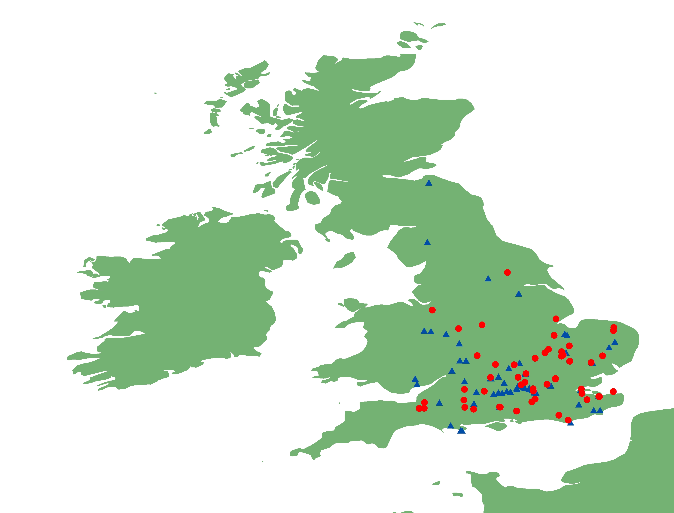
(b)
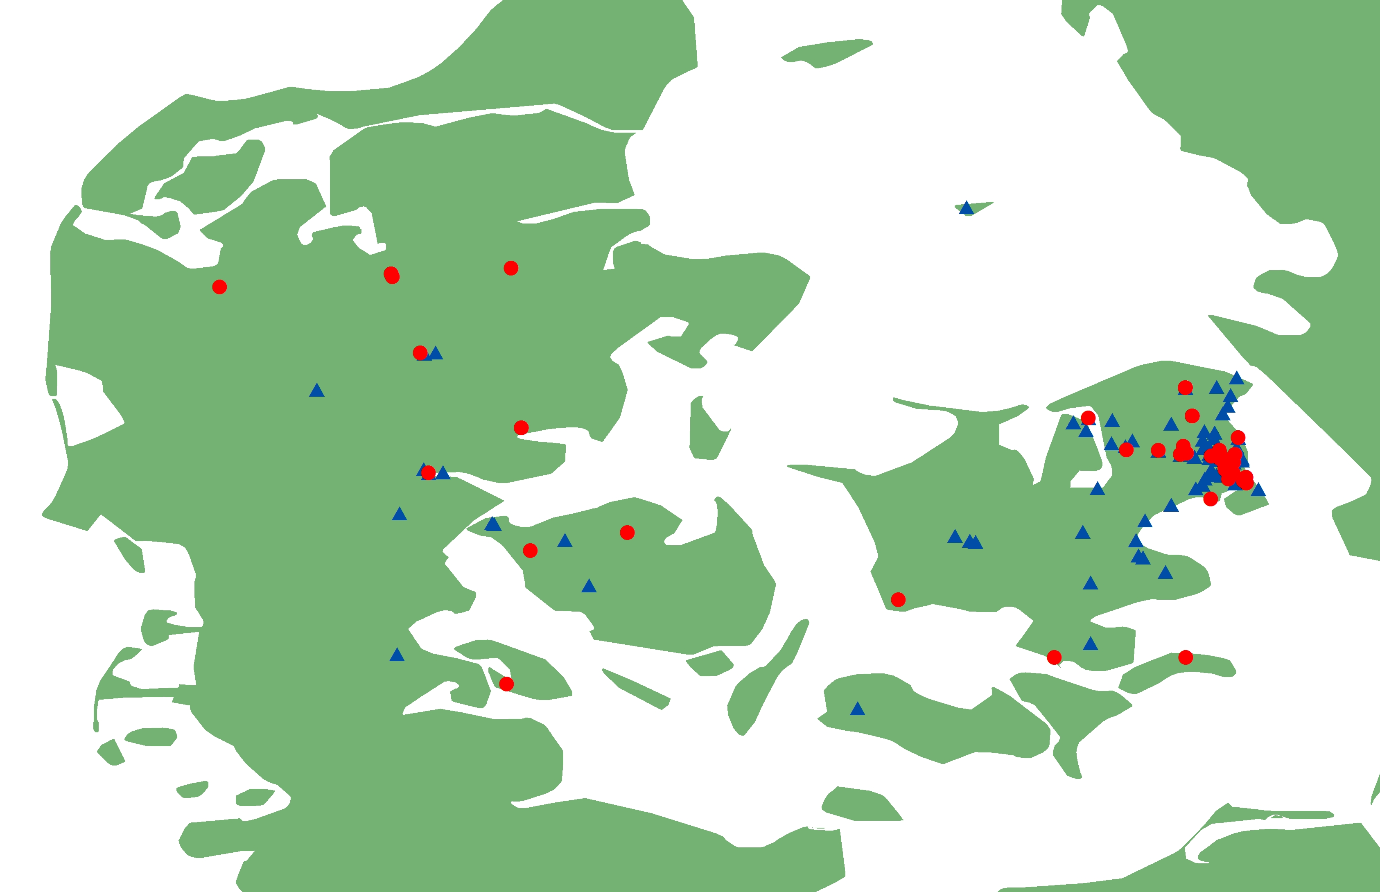

Fig. 2

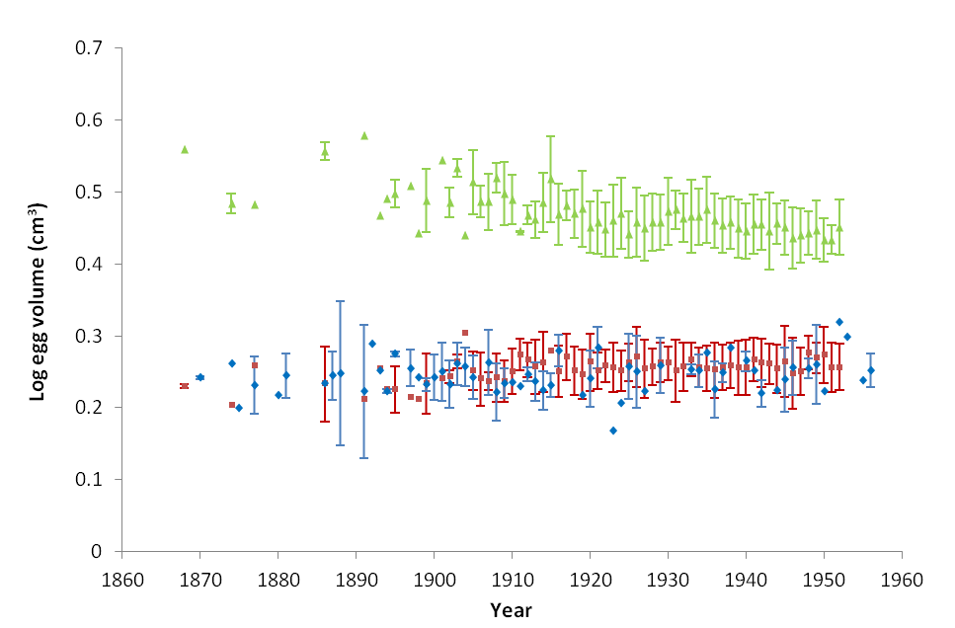

Fig. 3

Fig. 4
(a)

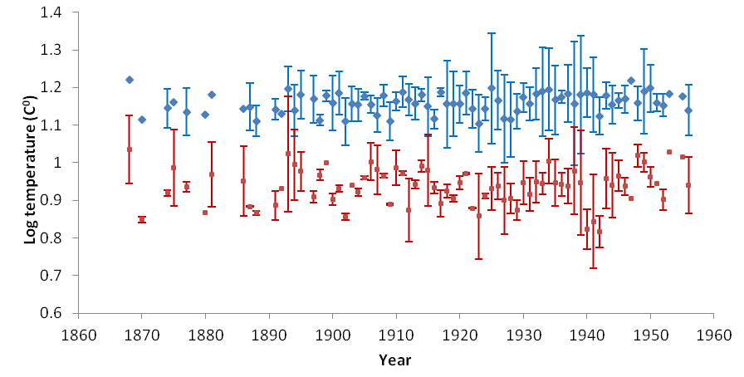
(b)

