**Influence of fragmentation upon the capacity of aluminum alloy plates subjected to ballistic impact**

Jens Kristian Holmen[1], Joakim Johnsen, Odd Sture Hopperstad and Tore Børvik

*Structural Impact Laboratory (SIMLab), Department of Structural Engineering,*

*Norwegian University of Science and Technology*

# ABSTRACT

In this paper, the perforation resistance of 20 mm thick aluminum plates subjected to moderate velocity impacts is examined experimentally and numerically. Plates made of four different tempers of aluminum alloy AA6070 were struck by ogive-nosed and blunt-nosed cylindrical projectiles with a diameter of 20 mm. We show that for this alloy material strength is not the decisive factor for the plates' resistance against perforation, but that a combination of ductility and strength, which inhibits fragmentation of the target plate, might be more important. Interpreting the results with previously obtained experimental data in mind sheds new light upon the role fragmentation plays for the capacity of metal plates undergoing impact loading. Increasing the material strength increases the probability of fragment ejection, which is unfavorable for the capacity. A novel 3D node-splitting technique which is available in the finite element code IMPETUS Afea Solver was employed to describe possible fragmentation and debris ejection in the numerical simulations. By using the node-splitting approach instead of element erosion, an improvement in the qualitative description of fracture for the least ductile tempers can be obtained without compromising the predicted component behavior for the more ductile tempers.

*Keywords: Ballistic impact; Fragmentation; Node-splitting*

# INTRODUCTION

For impacts by small-arms bullets it has been observed both experimentally and numerically that material strength is the single most important parameter when it comes to perforation resistance [1][2]. However, results from studies with larger projectiles at lower impact velocities suggest that the capacity of plates subjected to projectile impact is not only dependent upon material strength, but also upon the local ductility [3][4][5][6]. Consequently, structural materials with a balanced combination of strength and ductility may, under certain impact conditions, be equally good or even better energy absorbers than special alloys having high strength at the expense of ductility.

Accurate numerical descriptions of failure and fracture are important not only for ballistic impact, but also for analyses of events like metal forming operations and accidentally applied loads such as dropped objects, bird-strikes, explosions and collisions. Hence, criteria to predict the onset of failure are plentiful in the literature. Some models, like Gurson-type models [7][8], account explicitly for void growth in ductile materials, while others define a fracture surface [9] or assume that plastic straining amplified by a factor (e.g. depending on the stress state) drives the damage [10]. Having chosen a failure criterion, the next step is to introduce fracture into a numerical finite element model. To this end, element erosion is the most common method, but node separation, or node-splitting, is advantageous in many ways and has been applied to various problems in past studies [11][12][13][14][15][16]. For ballistic impact, fragmentation and debris ejection are poorly described by conventional methods and node-splitting appears to be a promising strategy to capture these phenomena.

Aluminum can through alloying and heat treatments obtain a great number of useful properties with respect to perforation resistance, but it is still not fully clear from the existing literature which properties are most crucial for the capacity under various impact conditions. The purpose of this study is therefore two-fold. In the experimental part the main objective is to investigate the effects of yield stress, strain hardening and ductility on the ballistic properties of 20 mm thick rolled plates made of the aluminum alloy AA6070. Four different heat treatments which emphasize variations in the above mentioned properties are applied to the plates. The plates are then struck by ogive-nosed and blunt-nosed cylindrical projectiles with a diameter of 20 mm and a mass of 197 g in the intermediate velocity regime, and the results are discussed in terms of their strength and ductility. In the numerical part the main objective is to evaluate and compare the predictive capabilities of a novel 3D node-splitting technique versus element erosion considering the current experimental results involving fragmentation for some of the tempers. The former numerical method has recently been implemented in the non-linear finite element code IMPETUS Afea Solver [17], and appears very appealing in situations where fragmentation and crack propagation in finite element models may occur. In this part we use a rather simple base model to be able to compare the different computational failure methods and to study how they capture fragmentation. We do not expect, or seek, a one-to-one relation between the experiments and the simulations.

The quasi-static material behavior and the perforation behavior of AA6070 aluminum plates struck by 7.62 mm armor piercing (AP) bullets were studied previously by the authors in Holmen et al. [2]. Herein, projectiles of diameter 20 mm have been used to strike the material plates. This provokes different perforation mechanisms compared to the smaller AP-bullets and it shows that perforation resistance is not a function only of material strength.

# MATERIAL

Table 1 shows the chemical composition of the aluminum alloy AA6070 which was delivered by Hydro Aluminium Rolled Products in Bonn, Germany. After hot-rolling to a thickness of 20 mm, the plates were heat treated as described in Table 2 to achieve the following tempers: temper O (annealed), temper T4 (naturally aged), temper T6 (peak strength) and temper T7 (over-aged). Micrographs showed that the grain structure was not significantly altered by the thermal processing [2].

Triplicate quasi-static tension tests were performed on smooth axisymmetric specimens taken from three different material directions to characterize the mechanical properties of the various tempers. A total of 36 quasi-static tension tests were carried out. The geometry can be found in Figure 1. All specimens were taken from the center of the plates and the tensile axes were oriented ,  and  with respect to the rolling direction. The tension tests were conducted in a 20 kN DARTEC servo-hydraulic universal testing machine at an initial strain rate of . Outputs from the testing include the force *F* and continuous measurements of the diameter reduction in two perpendicular directions by a laser micrometer [18]. Based on these measurements the average true stress-strain curves were calculated as follows



where  is the Cauchy (true) stress,  is the logarithmic (true) strain, and  is the current area.  and  are the current diameters in the thickness direction of the plate and the transverse direction of the sample, respectively.

Figure 2 shows the true stress-strain curves to failure for typical smooth tension tests from all tempers in different specimen orientations. No significant disparity in yield and flow stress can be identified between the tests for each temper, but the failure strain, here defined as the true strain at maximum true stress, is highly dependent upon the specimen orientation. This is illustrated by temper T6 for which the failure strain  in the rolling direction () is almost six times as high as in the transverse direction ().

Generally speaking, the mechanical behavior varies dramatically from the ductile annealed temper O with low yield stress, through the naturally aged temper T4 which exhibits considerable strain hardening, to the stronger and less ductile peak strength temper T6 and over-aged temper T7 with moderate strain hardening.

# COMPONENT TESTING

## Setup

The ballistic impact experiments were performed in a compressed gas-gun facility of which a detailed description can be found in Børvik et al. [19]. In the tests, the projectiles were accelerated by compressed air. The air was rapidly released by the rupture of membranes that were designed to withstand a certain pressure, making it possible to determine, in advance, the approximate striking velocity of the projectile. Accurate optical measurements of the initial velocity  and the residual velocity  of the projectile were obtained either by a Photron FASTCAM SA1.1 high-speed camera operating at 40,000 fps or a Phantom v1610 high-speed camera at 50,000 fps. These cameras were also used to capture high-resolution videos of the penetration and perforation process.

Ogive-nosed and blunt-nosed cylindrical projectiles as shown in Figure 3 were used in this study. The projectiles have diameter 20 mm and a nominal weight of 197 g. They are made of hardened tool steel with nominal yield stress  of about 1900 MPa (HRC 52). The ogive nose has a caliber radius head (CRH) of 3. Nine-piece sabots consisting of polystyrene with a hard polycarbonate outer shell were used to ensure satisfactory acceleration conditions inside the firing barrel.

The target plate dimensions were 300 mm × 300 mm × 20 mm, and one shot was fired at the center of each plate. We securely fastened the target plates to a rigid boundary by clamping the top and bottom parts of the plates with horizontal beams while keeping the vertical sides free. The free span between the clamps was 200 mm in the vertical direction in all tests.

## Experimental results

A summary of the experimental results is provided in Table 3. It should at this point be emphasized that the main objective of these experiments was not to find the ballistic limit velocity of the various tempers, but to investigate the effect of yield stress, strain hardening and ductility on the ballistic properties of the alloy at constant impact velocities. Still, Table 3 reports the estimated ballistic limit velocity  and the model parameters  and  found from a least-squared-error curve fit to the generalized Recht-Ipson model [20]:

 .

The ogive-nosed projectiles were accelerated to initial velocities  m/s and  m/s. The former proved to be very close to the ballistic limit velocity  for temper T4 and T7 for which the respective residual velocities  were 18 m/s and 39 m/s. The peak strength temper T6 has slightly lower capacity and temper O is the weakest, as expected from the yield stresses given in Table 4. High-speed camera images just after complete perforation of the plates in various tempers are shown in Figure 4. The pitch was measured by the high-speed cameras just before impact, and found to be below  in all tests. Thus, the small pitch is not expected to have any significant effect on the results [21]. Figure 5 shows the residual velocity  as a function of the initial velocity  for the impact tests with ogive-nosed projectiles. It is clearly seen that the estimated perforation resistance of the plates does not increase uniquely with the yield stress. This is in some contrast to the observations from other studies using small-arms bullets in the ordnance velocity regime [1][2].

The blunt-nosed projectiles were accelerated to initial velocities of  m/s and  m/s. High-speed camera images just after complete perforation can be seen in Figure 6. For this nose shape, temper T4 exhibited the greatest resistance against perforation followed by temper T7, temper O and temper T6, in that order. The inconsistent correlation between strength and perforation resistance is also evident for the blunt-nosed projectiles, see Figure 7. The ballistic velocities are lower for blunt-nosed than for ogive-nosed projectiles suggesting that blunt-nosed projectiles are more detrimental to plates of intermediate thicknesses than ogive-nosed projectiles [21][22].

Figure 8 shows close-up images of the bullet holes after perforation. The tiny petals that can be seen around the circumference of the entry holes in Figure 8(a) develop because the pointed tip of the ogive-nosed projectile pushes material aside perpendicular to the flight direction. The blunt-nosed projectiles in Figure 8(b), on the other hand, left flawless entry holes that are attributed to the plugging failure. It is clear that the amount of fragmentation increases as the failure strain decreases and the strength increases (see Figure 2). Increasing the velocity also results in increased fragmentation. Apart from the scarce petaling in Figure 8(a) the exit holes for the two nose shapes show the same trend. Temper O demonstrates ductile, but different, perforation mechanisms for the two nose-shapes: ejection of a clean plug by the blunt-nosed projectile and radial hole-growth for the ogive-nosed projectile. As the yield stress increases through temper T4 and T7, indications of fragmentation can be seen, and more so for increasing velocity. Temper T6 experienced severe fragmentation and a characteristic halo of ejected debris was seen for both nose shapes for this temper.

Sliced plates of temper O and T6 struck by ogive-nosed projectiles at approximately the same initial velocity are shown in Figure 9. The pictures confirm that the perforation process was ductile for temper O and that the perforation mode for temper T6 was a combination of ductile-hole growth and scabbing. Scabbing is in the literature also called discing and it involves tensile fractures in the plane of the plate initiated by for example local inhomogeneities. Further explanations can be found in Backman and Goldsmith [21] and Woodward [23]. A significant portion of the back part of the temper T6 plate has been detached and ejected as fragments. The start of the delamination process can be seen as distinct cracks emanating from the projectile’s path.

# MATERIAL MODELING

## Constitutive relation

A modified version of the Johnson-Cook constitutive model, in which the quasi-static strain hardening is described by an extended Voce rule, is employed in the following [24][25]. We assume associated flow and isotropic hardening, and the von Mises equivalent stress  is expressed as



where  is the initial yield stress,  and  are hardening parameters,  is the equivalent plastic strain and  is a dimensionless plastic strain rate, where  is a user-defined reference strain rate. The homologous temperature is given as a function of the current temperature , the melting temperature , and the ambient temperature  as . The model parameters  and  control the rate sensitivity and the thermal softening of the material, respectively. The deformation process is assumed to take place under adiabatic conditions. Plastic dissipation then leads to heating of the body and the temperature rate is estimated as

,

where  is the material density,  is the specific heat of the material and  is the Taylor-Quinney coefficient that represents the proportion of plastic dissipation converted into heat.

## Failure criterion

The empirical, one-parameter Cockcroft and Latham (CL) fracture criterion [10] is adopted here in the form



where  is the failure parameter,  is the major principal stress, and  for any real number . The parameters  and  are the stress triaxiality and the Lode parameter, respectively, defined by



where  are the ordered principal stresses and  is the hydrostatic stress. It transpires that the damage  is driven by plastic dissipation and amplified by a factor that depends on the stress state through the parameters  and . For sufficiently low stress triaxiality, damage will not develop. The failure parameter  is readily found by integrating the major principal stress  over the equivalent plastic strain path  to failure in a uniaxial tension test. The CL failure criterion has been successfully used to model perforation in cases of impact in several past studies, e.g., [1][2][3].

# FINITE ELEMENT MODELING

## Finite element code

The explicit finite element method is, regardless of its shortcomings, the most common simulation tool for ballistic impact. However, meshless methods like the discrete element method (DEM), smooth particle hydrodynamics (SPH) or element-free Galerkin methods (EFG) can also be employed to simulate problems with large deformations and failure. In the current study we compare element erosion to node-splitting. These computational failure methods are relevant for finite elements which have been used herein. The simulations were conducted with the 3D non-linear explicit finite element code IMPETUS Afea Solver [17]. This code is specifically designed to predict large deformations under extreme loading conditions and it is compatible with graphic processing units (GPUs). All simulations reported in the following were run on a NVIDIA Tesla Kepler K20c GPU.

## Higher order elements and node-splitting technique

In the impact simulations, 64-node hexahedral elements are applied. Such elements are historically not recommended for use in dynamic problems with large deformations due to noisy solutions [26]. However, in the IMPETUS Afea Solver their interpolation functions are not isoparametric, and they are designed to minimize the high frequency spectra on an element level. The dispersion in wave propagation is small. The elements are well suited for explicit solvers using the central difference scheme [27]. The main advantage in ballistic modeling is their capability to handle extreme deformations.

Node-splitting is a method for describing fracture and crack propagation in finite element models. Instead of removing failed elements from the simulations as conventional methods of element erosion do, the node-splitting method allows cracks to propagate between the elements as they separate at material failure. The technique permits use of larger elements than what is possible with element erosion since material failure is no longer analogous with deletion of an entire element, thus mass and energy loss can be reduced. However, the direction of the crack growth is dependent on both the mesh size and orientation so employing large elements is still associated with problems for penetration and perforation simulations.

The algorithm that is available in IMPETUS Afea Solver [17] splits the nearest exterior node into two nodes and creates new element faces perpendicular to either the direction of maximum principal strain or the direction of maximum principal stress when an integration point reaches its failure criterion (e.g.  in Eq. ). The interior nodes in the 64-node hexahedral elements cannot be split. In proportional loading, strain-based and stress-based node-splitting will give the same result [27]. The main advantage of strain-based node-splitting is that this method is less sensitive to numerical noise, while it may give completely erroneous results in some cases. One such case is spalling, where a compressive stress wave is followed by a tensile stress wave and the direction of maximum principal strain is often orthogonal to the maximum principal stress at the time of spalling. In this work, we have tried out and evaluated these two options for node-splitting already implemented in IMPETUS Afea Solver.

## Material model calibration and validation

Most of the material and model parameters for aluminum alloy AA6070 were determined in Holmen et al. [2] and they are given in Table 4 and Table 5. Note that only the tension tests performed in the rolling direction of the plate were used in the calibration although the failure strains are significantly lower in the  and  directions. Modeling of anisotropic fracture is not within the scope of this paper even though it might be important. All numerical models are isotropic in this study, and thus we do not expect to capture the exact crack pattern. In Børvik et al. [3] material parameter sets from various material orientations were applied in simulations of impacts by both ogive-nosed and blunt-nosed projectiles. For blunt-nosed projectiles the ballistic limit velocity was virtually unaffected by the parameter set, but for the ogive-nosed projectiles a threefold increase in the CL parameter increased the ballistic limit velocity by 13.5%. We expect similar results for temper T6 and T7 in this study.

The smooth tension tests were simulated to validate the calibration of the material model. The mesh can be seen in Figure 10. Cubic 64-node hexahedral elements of roughly the same size as those used in the subsequent ballistic simulations were used in the entire specimen. The analysis-time was scaled by a factor , and the kinetic energy that was present in the simulations was compared to the plastic dissipation and found to be negligible. Temperature and strain-rate effects were disregarded since the tests were conducted at a quasi-static strain rate. Figure 11 shows force-diameter reduction curves from the simulations compared to typical experiments. The correspondence is excellent, which was expected since the material model was in fact calibrated based on these experiments. Failure, on the other hand, initiates too early in the simulations. The CL failure parameters determined in Holmen et al. [2] were solely based on the experimental data where homogeneous stress and strain distributions over the cross section were presumed. In reality, failure initiates at the center of the neck where the stress triaxiality is most severe [28]. A more accurate calibration of the failure parameter can be achieved by using inverse modeling with a finite element model. With this approach  is found by numerically integrating the first principal stress at the central integration point over the equivalent plastic strain until the point of failure in the experiments. Failure is, as previously stated, defined as the true strain at the maximum value of the true stress in this study. The results can be seen in Figure 11. The CL failure parameters obtained using this approach are also provided in Table 4 where they are compared to the parameters obtained from a direct calibration of the experimental data. As seen, the experimental-numerical approach predicts a higher value of the CL failure parameter than the purely experimental approach.

## Ballistic impact modeling

Perforation simulations of the experiments with both the ogive-nosed and the blunt-nosed projectiles were conducted using the constitutive models described in Section 4 and the parameters provided in Table 4 and Table 5. The projectiles were undeformed after the experimental tests so in the numerical part of this study they were in most simulations assumed rigid with density  kg/m3. Contact was modeled with a penalty based node-to-surface algorithm and a penalty stiffness such that the contact penetrations were minimized while retaining a reasonable time step. Friction coefficients of ,  and  were considered in the simulations. The strain rate sensitivity for similar aluminum alloys has been shown to be almost negligible at ambient temperatures [29], but at higher temperatures the material behavior is markedly affected by the strain rate [30]. High temperatures are expected in this problem so values of *c* between 0.001 and 0.015 were investigated. A minimum time step of 3 ns was specified in every analysis to remove overly distorted elements that could cause error termination.

Most of the simulations were run with one symmetry plane. This saves computational time without unnecessarily constraining the solution. The base mesh shown in Figure 12 has 10 cubic hexahedral elements (with 64 nodes each) over the thickness in the impact zone which is equivalent to a node-spacing of 0.67 mm. This gave a total of 5020 elements in the plate, out of which 1700 where cubic hexahedral and 3320 were linear hexahedral. A finer mesh with 20 cubic hexahedral elements over the thickness is also shown in Figure 12. This corresponds to a node-spacing of 0.33 mm and it has a total of 7640 cubic hexahedral elements and 6872 linear hexahedral elements. Additional meshes with 5, 8 and 15 elements over the thickness were also created and used in a mesh-sensitivity study.

Although the CL failure criterion was used to identify the point of material failure in every simulation, the way failure was introduced into the finite element model was varied. Four methods were considered:

1. The standard element erosion algorithm where all the components of the stress tensor are set to zero when  in 16 out of 64 integration points of the element
2. An element erosion algorithm where the shear strength in an integration point vanishes when , but the element can still take compressive stresses and is not removed from the analysis until the minimum time step is violated
3. The strain-based node-splitting algorithm where new surfaces are created between elements perpendicular to the direction of maximum principal strain when  in one integration point.
4. The stress-based node-splitting algorithm where new surfaces are created between elements perpendicular to the direction of maximum principal stress when  in one integration point.

The failure methods are summarized in Table 6. Simulations corresponding to every experiment from Section 3 were run with the various numerical formulations of failure described above.

## Initial numerical study

The effects that the boundary conditions, symmetry condition, projectile material formulation, friction, strain rate sensitivity, and mesh refinement have on the perforation resistance were checked in a series of initial simulations. Temper O was chosen because it showed no signs of fragmentation in the experimental tests, which simplifies the numerical description. However, the mesh-sensitivity study also includes simulations with element erosion, strain-based node-splitting and the temper T6 material formulation. Both ogive-nosed and blunt-nosed projectiles were investigated.

First, the entire target plate, projectile, clamping beams and the pre-stressed bolts as shown in Figure 13 were modeled. Pre-stressing was done in a separate analysis in which the clamping length of the bolts was reduced until the stress in the bolts reached a prescribed value. Bolt stresses of 50 MPa and 100 MPa respectively did not alter the residual velocity of the projectile after perforation. By removing the clamps and constraining the top and bottom edges of the plate in *x*, *y*, and *z* directions we obtained the same residual velocity. Modeling only half the plate and introducing a plane of symmetry yielded the same residual velocity again and we conclude that the far-field boundary conditions are of minor importance in this particular problem. To further evaluate the artificial constraint imposed by the symmetry plane, simulations with node-splitting were run both with and without the symmetry condition. We used the material parameters for temper T6 and an ogival-nosed projectile. The overall fracture patterns are hardly affected by the imposed symmetry, and the residual velocity is not affected. Thus, we conclude that a model with one symmetry plane is sufficient for the application in this study.

Although the projectiles were inspected after the tests, and no permanent deformation was visible, the energy dissipation in both the ogive-nosed and blunt-nosed projectiles was checked. The projectiles were assigned rigid (), elastic (MPa, ) and elastic-perfectly plastic (MPa) material parameters. Changing the parameters did not significantly change the residual velocity of the ogive-nosed projectile, and only a slight difference was seen for the blunt-nosed projectile at the highest impact velocity. A rigid material formulation was therefore applied in all subsequent simulations.

The individual and combined effects of friction and strain rate sensitivity were also studied. Including Coulomb friction with a coefficient of  in the model slows the ogive-nosed projectile down significantly compared to the frictionless simulation; the frictional coefficient had almost no impact on the residual velocity for the blunt-nosed projectile. Increasing the strain-rate sensitivity parameter *c* affected the simulations with both nose shapes, but the ogive-nosed projectile the most. The parameter combination  and  represents a compromise and the values lie within the spread seen in available literature [31][32][33][34]. Hence, they are used in the rest of the simulations in this study.

Lastly, the influence of the mesh density was investigated. A substantial mesh-sensitivity study was undertaken where 5, 8, 10, 15 and 20 elements over the thickness were used, resulting in node spacings from 1.33 mm to 0.33 mm. The projectile was assumed rigid and the material parameters that were found in the preceding discussion were used. Both ogive-nosed (m/s) and blunt-nosed (m/s) projectiles striking plates in tempers O and T6 were checked. Conventional element erosion (1) and the strain-based node-splitting algorithm (3) were applied. Results from the mesh sensitivity study are shown in Figure 14. It seems that the residual velocity of the ogive-nosed projectile is not significantly influenced by the grid size, regardless of failure method. The fact that the results are not very sensitive upon the mesh size in 3D models has also been observed previously [3]. We believe that this is because the projectile is sufficiently large compared to the elements in the plate, which activates a larger portion of the plate than a smaller projectile would. Also the results for the blunt-nosed projectile exhibit low grid-size dependence. The exception is the simulation for temper T6 using strain-based node-splitting, where the residual velocity increases by 11.4% when the number of elements over the thickness increases from 8 to 10. We believe that this is caused by the node-splitting technique’s sensitivity to node placement and mesh orientation. In the mesh with 10 elements over the thickness, the perimeter of the projectile coincides with a row of nodes.

## Ballistic impact-simulation results

Results from the numerical simulations are first presented for the ogive-nosed projectiles and then for the blunt-nosed projectiles. The main focus in this study is the quantitative difference between the simulations employing the various failure methods and not the prediction of the estimated ballistic limit velocity. How well the methods predict the perforation mechanisms seen in the experimental tests is also emphasized. Since this study evaluates differences between numerical implementations of failure in finite element models, we have tried to keep the models as similar as possible and no further tuning has been done after the calibration.

Every ballistic test reported in Section 3 was simulated with the ogive-nosed projectile and a relatively coarse plate mesh, i.e., 10 cubic hexahedral elements over the thickness. This grid size was chosen because it seemed like a reasonable trade-off between accuracy and computational efficiency. The normalized ballistic limit velocities () from the simulations with ogive-nosed projectiles are shown as functions of temper configuration in Figure 15. Here we clearly see that for tempers that exhibited no or little fragmentation experimentally (temper O and temper T4), the four failure methods gave approximately the same results. A larger spread in results can be seen for temper T7 and especially temper T6. Figure 16 shows pictures from the perforation process for the annealed temper O and the peak-strength temper T6 taken from simulations employing element erosion and stress-based node-splitting. There are obvious differences between the predicted perforation mechanisms. The element erosion technique can only describe ductile-hole growth, and fragmentation is poorly described for the low-ductility temper T6. Node-splitting, on the other hand, captures the ejected fragments much better for temper T6, while predicting a relatively ductile perforation mechanism for temper O.

In the same manner as for the ogive-nosed projectiles, every experimental test with the blunt-nosed projectile was simulated with 10 elements over the thickness in the plate mesh. Figure 17 shows the normalized ballistic limit velocities () as functions of the temper configuration. Failure methods (1) *element erosion* and (2) *no erosion* predicted in general similar results for the simulations with blunt-nosed projectiles. Plugging failure is a shear dominated problem and whether an element is removed from the analysis or its shear resistance is removed makes hardly any difference on the final result. Analysis times were on the other hand significantly shorter for method (1) *element erosion*. *Strain-based node-splitting* (3) and *stress-based node-splitting* (4) generally predicted significantly higher residual velocities than methods (1) and (2). Node-splitting and element erosion are two fundamentally different ways of incorporating fracture in a finite element model; and where element erosion is generally recognized to be sensitive to the grid size, node-splitting seems sensitive to the node placement and mesh orientation. In the standard mesh, the perimeter of the projectile coincided with a row of nodes in the plate which facilitated fracture, especially at low impact velocities. We changed the node placement slightly from the standard mesh with 10 elements over the thickness (see Figure 18) to investigate the influence of mesh orientation. For the simulations with the ogive-nosed projectiles the results did not change. With the blunt-nosed projectiles with failure method (1) *element erosion* and (2) *no erosion* no change was seen in the results, but with method (3) *strain-based node-splitting* and (4) *stress-based node-splitting* the results were significantly different. The normalized ballistic limit velocities for (3) *strain-based node-splitting* are plotted in Figure 17 for comparison. This suggests that care must be taken when employing node-splitting and regular meshes, at least for impacts with blunt-nosed projectiles.

Figure 19 shows pictures from the simulations for temper O plates and temper T6 plates after complete perforation when using element erosion and stress-based node-splitting. We see from the shape and size of the plugs that the element erosion method predicts reasonably shaped plugs, but due to the relatively large elements employed and the fact that elements need to be removed to obtain perforation the plugs are too small. Node-splitting predicts plugs of correct size since virtually no elements have been removed from the analyses. Some fragmentation can be seen for the simulation of temper T6, but not as much as in the experiments shown in Figure 6.

Lastly, Figure 20 compares cross sections of simulations run with element erosion and strain-based node-splitting. The only difference in the input file from the simulation depicted in Figure 20(b) to that in (a) is that node-splitting was activated in the former. However, the fracture mechanisms are not similar at all. The cross section using element erosion looks like temper O in Figure 9(a), i.e., it looks completely ductile. This was the case for every simulation with element erosion. By activating node-splitting we see that the fragments are flying from the plate, and that the delamination shown for temper T6 in Figure 9(b) is reproduced with good accuracy in the numerical model, especially when considering the simplicity of the isotropic material model and the coarse element mesh.

# DISCUSSION

Blunt-nosed projectiles were in the experimental part of this paper found to cause failure by plugging, while ogive-nosed projectiles mainly perforated the plates by ductile-hole growth. This has frequently been observed in the literature [3][21][35], and it explains the differences in perforation capacity of the plates when they are struck by the different projectiles. A plate struck by a blunt-nosed projectile of the same approximate diameter as its thickness is susceptible to adiabatic shear banding which is a low-energy failure mode [36]. Ductile hole-growth requires, on the other hand, radial displacement of material that often induces large plastic strains, which in turn dissipates more energy than plugging [21][37].

Ballistic testing of five different high-strength steels by Børvik et al. [1] showed that material strength is the most important parameter for plates struck by small-arms bullets at ordnance velocity. The five steel types had comparable hardening curves and sufficient ductility to prevent significant fragmentation, thus the capacity was found to be a linear function of the yield stress. A similar relationship between strength and ballistic capacity was also shown by Holmen et al. [2] where small-arms bullets were fired at aluminum alloy plates of the same type as in the current paper. As shown in Figure 2, the hardening varied between the tempers, and some fragmentation was observed for tempers T6 and T7 at the highest impact velocities when struck by small-arms bullets. Forrestal et al. [4] and Børvik et al. [5] observed the same trend for the aluminum alloys AA7075-T651 and AA5083-H116, i.e., that strength governs the capacity for plates struck by small-arms bullets where the amount of fragmentation is limited.

The ratio between target thickness  and projectile diameter  in Refs. [1][2][4][5] discussed above was . If we consider impact conditions where the projectile diameter is large compared to the plate thickness, as it is in this study where , we see that strength does not necessarily determine the capacity. This was experimentally demonstrated by striking 20 mm thick AA7075-T651 and AA5083-H116 plates using both 7.62 mm AP-bullets and 20 mm ogive-nosed projectiles [4][5]. Limited plate fragmentation was seen when the relatively small AP-bullets struck the plates at ordnance velocity, and the capacity expressed as the ballistic limit velocity was in favor of the stronger AA7075 alloy: 628 m/s compared to 492 m/s. Even though their respective yield stresses were 520 MPa and 244 MPa, the ballistic limit velocities when the plates were struck by the large 20 mm ogive-nosed projectiles were 209 m/s and 244 m/s, i.e., a 20% difference in favor of the apparently weaker AA5083 alloy [3][5]. This is attributed to the quasi-brittle behavior of the AA7075 aluminum alloy under certain impact conditions [3]. The same type of behavior was observed in the experimental part of this paper; temper T6 has the highest yield stress, but it is the second weakest and weakest temper when it comes to preventing perforation by the ogive-nosed and blunt-nosed projectiles, respectively. This is in contrast to the results reported for 7.62 mm AP-bullets in Holmen et al. [2]. It appears that strength governs the capacity against perforation as long as the structural component is sufficiently ductile not to fragment, and the component ductility seems to be determined by the relationship between projectile size, target thickness, impact velocity, and material behavior. If the projectile diameter is small compared to the plate thickness, then the material is constrained and fragmentation is less severe. Revisiting the images in Figure 8 and Figure 9 while keeping in mind the failure strains (in the rolling direction) for the various tempers, i.e., , ,  and  we see that severe fragmentation indeed correlates with low failure strains.

The importance of accurately capturing the fragmentation in numerical simulations was highlighted in the preceding discussion, and to this end, the node-splitting methods described in Section 5.2 appear promising although more validation of the approach still is required. For the tests that exhibited ductile behavior, the results obtained using node-splitting were similar to the ones obtained with element erosion, but for the tests that behaved in a more quasi-brittle manner the delamination and fragmentation processes were more aptly described and the experimental trends were better captured particularly for the ogive-nosed projectile.

# CONCLUSIONS

**The** experimental test program presented in this paper includes material tests and ballistic impact tests of 20 mm thick AA6070 aluminum alloy plates that underwent four different heat treatments. It was shown that material strength is not the most important parameter for the capability of plates made of this alloy to resist penetration and perforation. Ductility is seen to be as important as the strength, since fragmentation occurs for the temper with the highest strength and the lowest ductility. The amount of fragmentation seems to be controlled by the relationship between the plate thickness and the projectile diameter/velocity, and the ductility of the material. The experiments further confirmed that the capacity of a plate when subjected to impact by blunt-nosed projectiles is lower than it is for ogive-nosed projectiles due to the formation of adiabatic shear bands.

A Johnson-Cook type plasticity model and the one-parameter Cockcroft-Latham failure criterion were used in the numerical part of this paper where methods of incorporating failure and fracture into a finite element simulation were compared. Element erosion and node-splitting in various forms were checked and it was found that although the methods predicted similar results when the plate material was ductile, node-splitting was able, at least qualitatively, to capture the effect of fragmentation with a rather coarse element mesh. Node-splitting also makes it possible to model failure and fracture quite accurately while employing relatively large elements, but this is not necessarily an advantageous strategy for penetration and perforation problems involving shear localization.

For small-arms bullets striking steel plates, the target material has sufficient ductility to avoid fragmentation, and strength governs the perforation resistance. Aluminum is commonly less ductile than steel, but strength remains the most important parameter as long as fragmentation is limited. When fragmentation is present, the yield stress, ductility and strain hardening behavior are important and have to be considered to predict the perforation behavior. It is thus important in the design of protective structures to consider all aspects of material behavior and the size and shape of the projectile; not only the apparent strength given by the material’s yield stress.

# ACKNOWLEDGMENTS

The financial support for this work comes from the Structural Impact Laboratory (SIMLab), Centre for Research-based Innovation (CRI) at the Norwegian University of Science and Technology and the Norwegian Defense Estates Agency. The authors would like to express their gratitude to Hydro Aluminium, in particular Dr. Simon Jupp, and to Dr. Lars Olovsson at IMPETUS Afea AB for valuable input.

# REFERENCES

1. Børvik T, Dey S, Clausen AH. Perforation resistance of five different high-strength steel plates subjected to small-arms projectiles. International Journal of Impact Engineering 2009; 36; 948-964
2. Holmen JK, Johnsen J, Jupp S, Hopperstad OS, Børvik T. Effects of heat treatment on the ballistic properties of AA6070 aluminium alloy. International Journal of Impact Engineering 2013; 57; 119-133.
3. Børvik T, Hopperstad OS, Pedersen KO. Quasi-brittle fracture during structural impact of AA7075-T651 aluminium plates. International Journal of Impact Engineering 2010; 37; 537-551.
4. Forrestal MJ, Børvik T, Warren TL. Perforation of 7075-T651 Aluminum Armor Plates with 7.62 mm APM2 Bullets. Experimental Mechanics 2010; 50; 1245-1251.
5. Børvik T, Forrestal MJ, Warren TL. Perforation of 5083-H116 Aluminum Armor Plates with Ogive-nose Rods and 7.62 mm APM2 Bullets. Experimental Mechanics 2010; 50; 969-978.
6. Rodríguez-Millán M, Vaz-Romero A, Rusinek A, Rodríguez-Martínez JA, Arias A. Experimental Study on the Perforation Process of 5754-H111 and 6082-T6 Aluminium Plates Subjected to Normal Impact by Conical, Hemispherical and Blunt Projectiles. Experimental Mechanics 2014; 54-729-742.
7. Gurson AL. Continuum theory of ductile rupture by void nucleation and growth – Part I. Yield criteria and flow rules for porous ductile media. Journal of Engineering Materials Technology 1977; 99; 2-15.
8. Nahshon K, Hutchinson JW. Modification of the Gurson Model for shear failure. European Journal of Mechanics A/Solids 2008; 27; 1-17.
9. Johnson GR, Cook WH. Fracture characteristics of three metals subjected to various strains, strain rates, temperatures and pressures. Engineering Fracture Mechanics 1985; 21; 31-48.
10. Cockcroft MG, Latham DJ. Ductility and the workability of metals. Journal of the Institute of Metals 1968; 96; 33-39.
11. Xu X-P, Needleman A. Numerical Simulations of fast crack growth in brittle solids. Journal of the Mechanics and Physics of Solids 1994; 42; 1397-1434.
12. Camacho GT, Ortiz M. Computational modeling of impact damage in brittle materials. International Journal of Solids and Structures 1996; 33; 2899-2938.
13. Komori K. Simulation of shearing by node separation method. Computers & Structures 2001; 79; 197-207.
14. Ruggiero A, Iannitti G, Testa G, Limido J, Lacome JL, Olovsson L, Ferraro M, Bonora N. High strain rate fracture behavior of fused silica. Journal of Physics: Conference series 2014; 500; 1-4.
15. Moxnes JF, Prytz AK, Frøyland Ø, Klokkehaug S, Skriudalen S, Friis E, Tetland JA, Dørum C, Ødegårdstuen G. Experimental and numerical study of the fragmentation of expanding warhead casings by using different numerical codes and solution techniques. Defence Technology 2014; 10; 161–76.
16. Olovsson L, Limido J, Lacome J-L, Hanssen AG, Petit J. Modeling fragmentation with new higher order finite element technology and node splitting. In: Proceedings of the 11th International Conference on the Mechanical and Physical Behaviour of Materials under Dynamic Loading. 2015. 04050, p. 1-6.
17. IMPETUS Afea AS. IMPETUS Afea Solver: <http://www.impetus-afea.com> [cited: 2015-02-01].
18. Fourmeau M, Børvik T, Benallal A, Lademo OG, Hopperstad OS. On the plastic anisotropy of an aluminium alloy and its influence on constrained multiaxial flow. International Journal of Plasticity 2011; 27; 2005-2025.
19. Børvik T, Langseth M, Hopperstad OS, Malo KA. Ballistic penetration of steel plates. International Journal of Impact Engineering 1999; 22; 855-886.
20. Recht RF, Ipson TW. Ballistic perforation dynamics. Journal of Applied Mechanics 1963; 30; 384-390.
21. Backman ME, Goldsmith W. The mechanics of penetration of projectiles into targets. International Journal of Engineering Science 1978; 16; 1-99.
22. Gupta NK, Iqbal MA, Sekhon GS. Effect of projectile nose shape, impact velocity and target thickness on deformation behavior of aluminum plates. International Journal of Solids and Structures 2007; 44; 3411-3439.
23. Woodward RL. The interrelation of failure modes observed in the penetration of metallic targets. International Journal of Impact Engineering 1984; 2; 121-129.
24. Johnson GR, Cook WH. A constitutive model and data for metals subjected to large strains, high strain rates and high temperatures. In: Proceedings of the 7th International Symposium on Ballistics. 1983, p. 541-547.
25. Børvik T, Hopperstad OS, Berstad T, Langseth M. A computational model of viscoplasticity and ductile damage for impact and penetration. European Journal of Mechanics – A/Solids 2001; 5; 685-712.
26. Belytschko T, Liu WK, Moran B. Nonlinear Finite Elements for Continua and Structures. 1st edition; John Wiley & Sons, Inc. 2000.
27. Olovsson L. IMPETUS Afea AB, Huddinge, Sweden. Private communication, 2015.
28. Mackenzie AC, Hancock JW, Brown DK. On the influence of state of stress on ductile failure initiation in high strength steels. Engineering Fracture Mechanics 1977; 9; 167-188.
29. Chen Y, Clausen AH, Hopperstad OS, Langseth M. Stress-strain behavior of aluminium alloys at a wide range of strain rates. International Journal of Solids and Structures 2009; 46; 3825-3835.
30. Vilamosa V, Clausen AH, Børvik T, Skjervold S, Hopperstad OS. Behaviour of Al-Mg-Si alloys at a wide range of temperatures and strain rates. International Journal of Impact Engineering; 2015; 86; 223-239.
31. Ravid M, Bodner SR. Dynamic perforation of viscoplastic plates by rigid projectiles. International Journal of Engineering Sciences 1983; 21; 577-591.
32. Zukas JA. High Velocity Impact Dynamics. 1st edition; John Wiley & Sons, Inc.; 1990.
33. Rusinek A, Rodriguez-Martinez JA, Zaera R, Klepaczko JR, Arias A, Sauvelet C. Experimental and numerical study on the perforation process of mild steel sheets subjected to perpendicular impact by hemispherical projectiles. International Journal of Impact Engineering 2009; 36; 565-587.
34. Chen EP. Finite element simulation of perforation and penetration of aluminum targets by conical-nosed steel rods. Mechanics of Materials 1990; 10; 107-115.
35. Børvik T, Langseth M, Hopperstad OS, Malo KA. Perforation of 12 mm thick steel plates by 20 mm diameter projectiles with flat, hemispherical and conical noses. Part I: Experimental study. International Journal of Impact Engineering 2002; 27; 19-35.
36. Dodd B, Bai Y. Introduction to Adiabatic Shear Localization. Revised edition; Imperial College Press; 2015.
37. Forrestal MJ, Luk VK, Brar NS. Perforation of aluminum armor plates with conical-nose projectiles. Mechanics of Materials 1990; 10; 97-105.

# TABLES

Table 1: Chemical composition of the aluminum alloy AA6070 (wt-%).

|  |  |  |  |  |  |
| --- | --- | --- | --- | --- | --- |
| Si | Mg | Fe | Cu | Mn | Al |
| 1.38 | 1.23 | 0.22 | 0.26 | 0.54 | Balance |

Table 2: Heat treatments of the aluminum alloy AA6070.

|  |  |  |  |  |
| --- | --- | --- | --- | --- |
| Temper | Solutionizing | Cooling | Annealing/Artificial aging | Cooling |
| AA6070-O | 90 min at 560 °C (+ 5 °C) | Water quench | 24 h at 350 °C (+ 5 °C) | Slow cooling |
| AA6070-T4 | 90 min at 560 °C (+ 5 °C) | Water quench | - | - |
| AA6070-T6 | 90 min at 560 °C (+ 5 °C) | Water quench | 64 h at 160 °C (+ 5 °C) | Slow cooling |
| AA6070-T7 | 90 min at 560 °C (+ 5 °C) | Water quench | 8 h at 200 °C (+ 5 °C) | Slow cooling |

Table 3: Results from the impact experiments on the four different tempers in this study, *vi* is the initial velocity, *vr* is the residual velocity, *mpl* is the mass of the ejected plug, *vbl* is the ballistic limit velocity, and *a* and *p* are the Recht-Ipson parameters.

|  |  |  |  |  |  |  |  |
| --- | --- | --- | --- | --- | --- | --- | --- |
| Temper | Test | *vi* (m/s) | *vr* (m/s) | *mpl* (g) | *vbl* (m/s) | *a* | *p* |
| AA6070-O | Ogive-1 | 248.2 | 163.0 | - | 201.5 | 1.00 | 2.30 |
| AA6070-O | Ogive-2 | 290.0 | 226.5 | - |
| AA6070-T4 | Ogive-1 | 246.5 | 18.2 | - | 246.0 | 1.00 | 2.11 |
| AA6070-T4 | Ogive-2 | 295.9 | 173.1 | - |
| AA6070-T6 | Ogive-1 | 247.4 | 107.6 | - | 216.7 | 1.00 | 1.84 |
| AA6070-T6 | Ogive-2 | 291.5 | 182.0 | - |
| AA6070-T7 | Ogive-1 | 250.0 | 39.4 | - | 248.0 | 1.00 | 2.19 |
| AA6070-T7 | Ogive-2 | 298.3 | 180.7 | - |
| AA6070-O | Blunt-1 | 186.5 | 95.3 | 13.54 | 155.1 | 0.92 | 2.00 |
| AA6070-O | Blunt-2 | 252.2 | 183.0 | 13.04[2] |
| AA6070-T4 | Blunt-1 | 195.5 | 84.3 | 11.62 | 173.9 | 0.92 | 2.00 |
| AA6070-T4 | Blunt-2 | 250.2 | 165.8 | 9.701 |
| AA6070-T6 | Blunt-1 | 198.9 | 120.9 | 12.64 | 144.4 | 0.89 | 2.00 |
| AA6070-T6 | Blunt-2 | 246.8 | 177.8 | 11.44 |
| AA6070-T7 | Blunt-1 | 197.2 | 98.6 | 13.02 | 166.5 | 0.93 | 2.00 |
| AA6070-T7 | Blunt-2 | 249.0 | 172.7 | 12.10 |

Table 4: The optimized model parameters for the extended Voce hardening rule and the CL failure criterion for the different tempers of aluminum alloy AA6070 found from the rolling direction.

|  |  |  |  |  |  |  |  |  |
| --- | --- | --- | --- | --- | --- | --- | --- | --- |
| Temper | (MPa) | (MPa) | (MPa) |  | (MPa) |  | (MPa)  Experiment | (MPa)  Simulation |
| AA6070-O | 50.5 | 38.8 | 79.5 | 56.9 | 88.2 | 4.0 | 151.0 | 179.0 |
| AA6070-T4 | 186.5 | 172.7 | 35.6 | 80.6 | 247.7 | 6.5 | 211.0 | 244.0 |
| AA6070-T6 | 372.5 | 350.0 | 30.1 | 185.9 | 72.8 | 7.7 | 115.0 | 130.0 |
| AA6070-T7 | 341.0 | 292.5 | 55.3 | 317.2 | 31.1 | 10.0 | 128.0 | 170.0 |

Table 5: Physical constants and model parameters that were used in the IMPETUS Afea Solver [2].

|  |  |  |  |  |  |  |  |  |  |
| --- | --- | --- | --- | --- | --- | --- | --- | --- | --- |
| *E* (MPa) |  | (kg/m3) | *c* | (s-1) | (J/kg K) | (K) | (K) | *m* |  |
| 70,000 | 0.3 | 2,700 | 0.0125 | 5 × 10-4 | 910 | 293 | 893 | 1.0 | 0.025 |

Table 6: Overview of the failure methods used in this study.

|  |  |  |
| --- | --- | --- |
|  | Initiation of failure at | Removes the element |
| (1) Element erosion | Removes the deviatoric strength of the integration point | When 16 of 64 integration points reach |
| (2) No erosion | Removes the deviatoric strength of the integration point | When |
| (3) Strain-based node-splitting | Creates new element faces in the direction of the maximum principal strain | When |
| (4) Stress-based node-splitting | Creates new element faces in the direction of the maximum principal stress | When |

# FIGURES

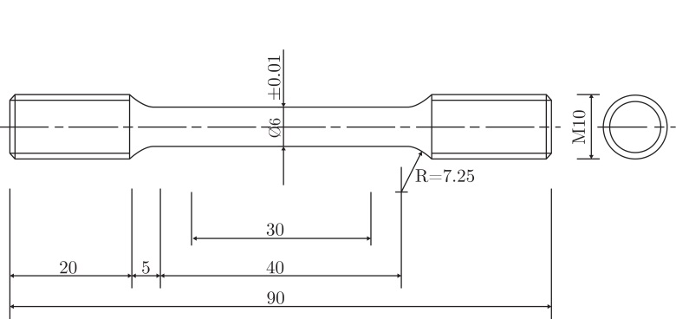

Figure 1: Specimens used to characterize the mechanical behavior. All measures are in mm.

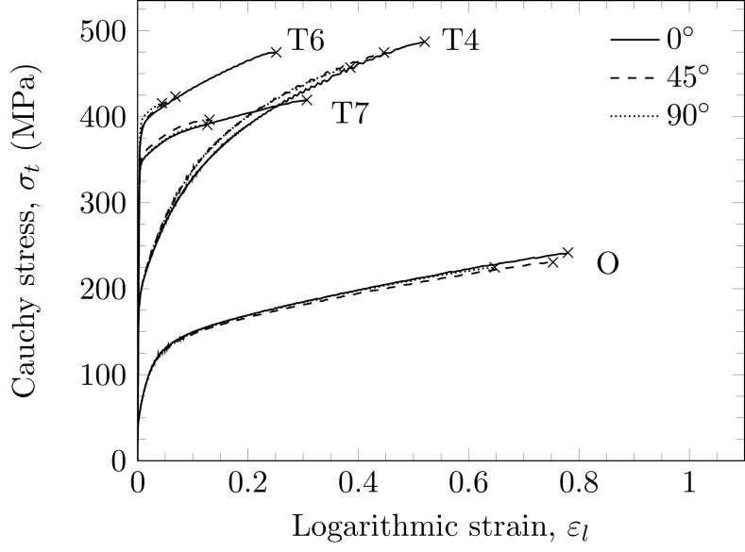

Figure 2: True stress-strain curves from tension tests in three directions for the different tempers, where  marks the point of failure in each test.

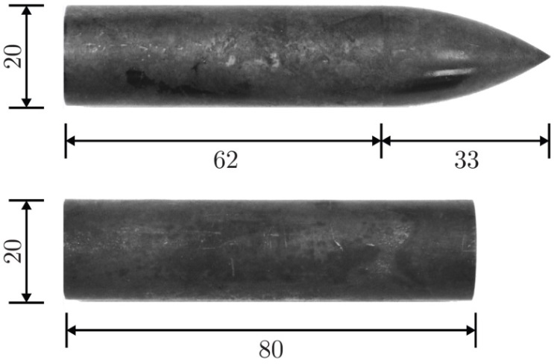

Figure 3: Pictures of the ogive-nosed projectile (top) and blunt- nosed projectile (bottom). All measures are in mm.

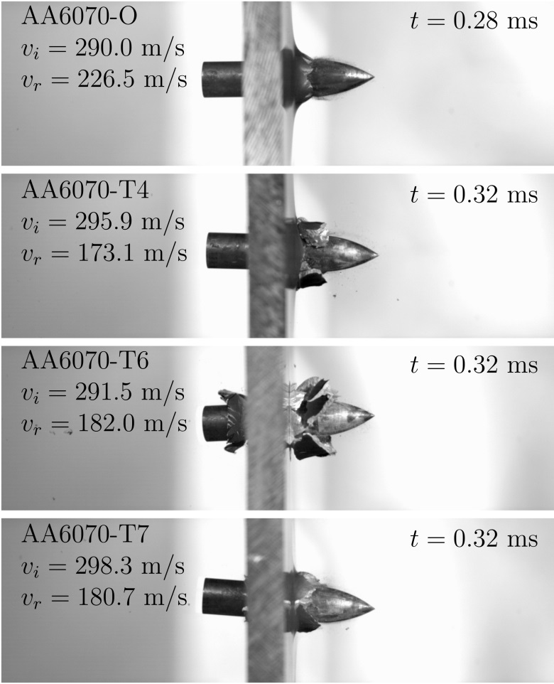

Figure 4: Pictures just after perforation for the four different tempers using the ogive-nosed projectiles fired at  m/s.

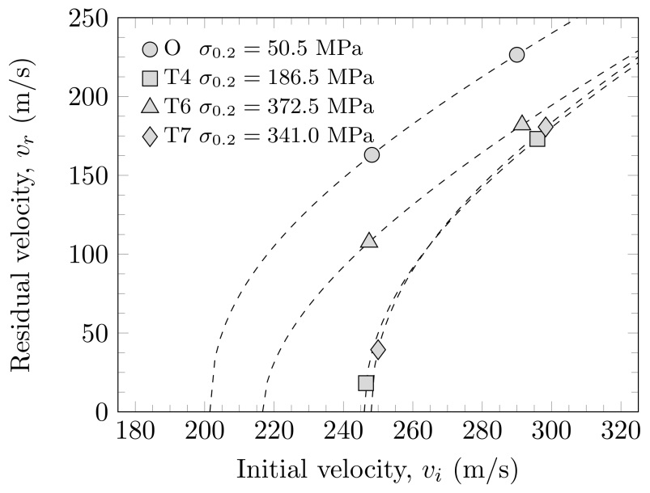

Figure 5: Residual velocity plotted against initial velocity for the tests with ogive-ended projectiles. The dotted lines are Recht-Ipson fits to the data.

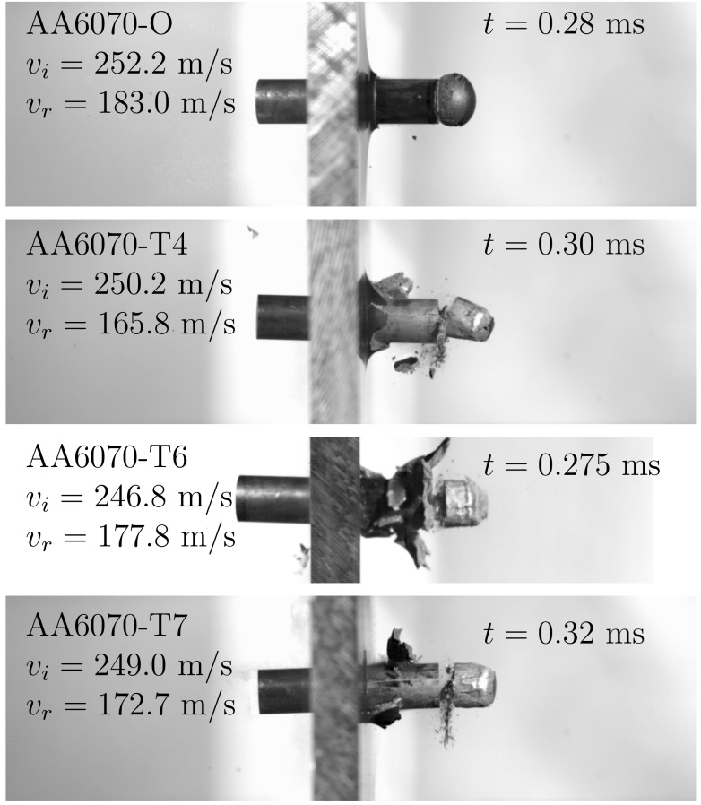

Figure 6: Pictures just after perforation for the four different tempers using the blunt-nosed projectiles fired at  m/s.

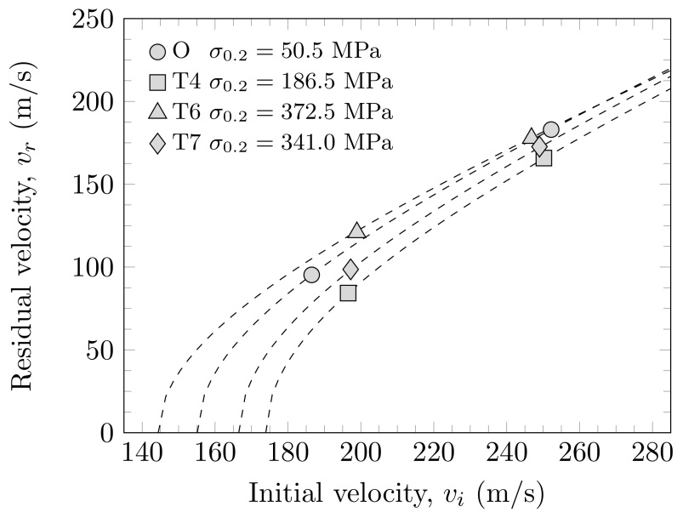

Figure 7: Residual velocity plotted against initial velocity for the tests with blunt-ended projectiles. The dotted lines are Recht-Ipson fits to the data.

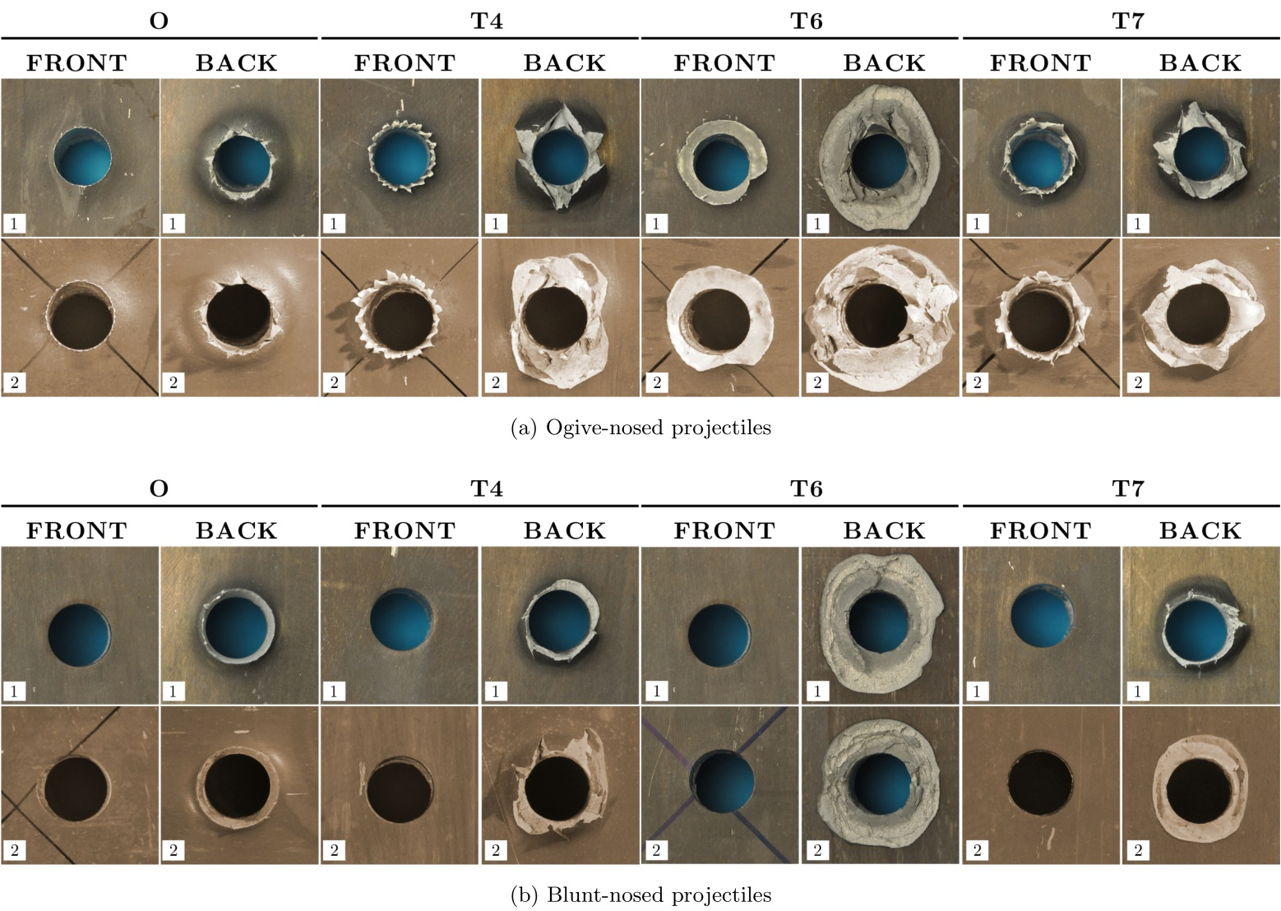

Figure 8: Close-ups of bullet holes from impacts by (a) ogive-nosed projectiles and (b) blunt-nosed projectiles.

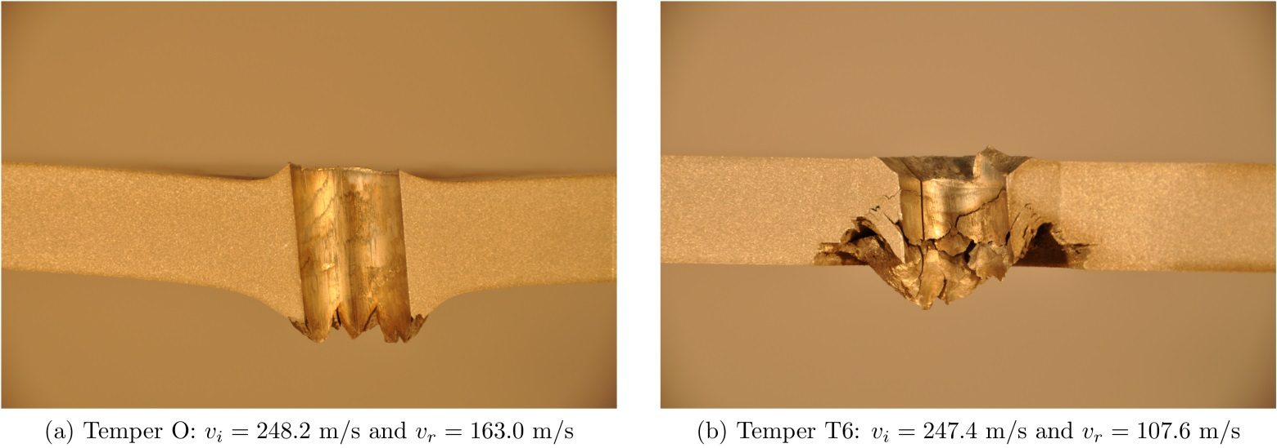

Figure 9: Pictures of cross sections of the 20 mm thick AA6070 aluminum alloy plates struck by ogive-nosed projectiles. (a) Shows temper O and (b) shows temper T6.

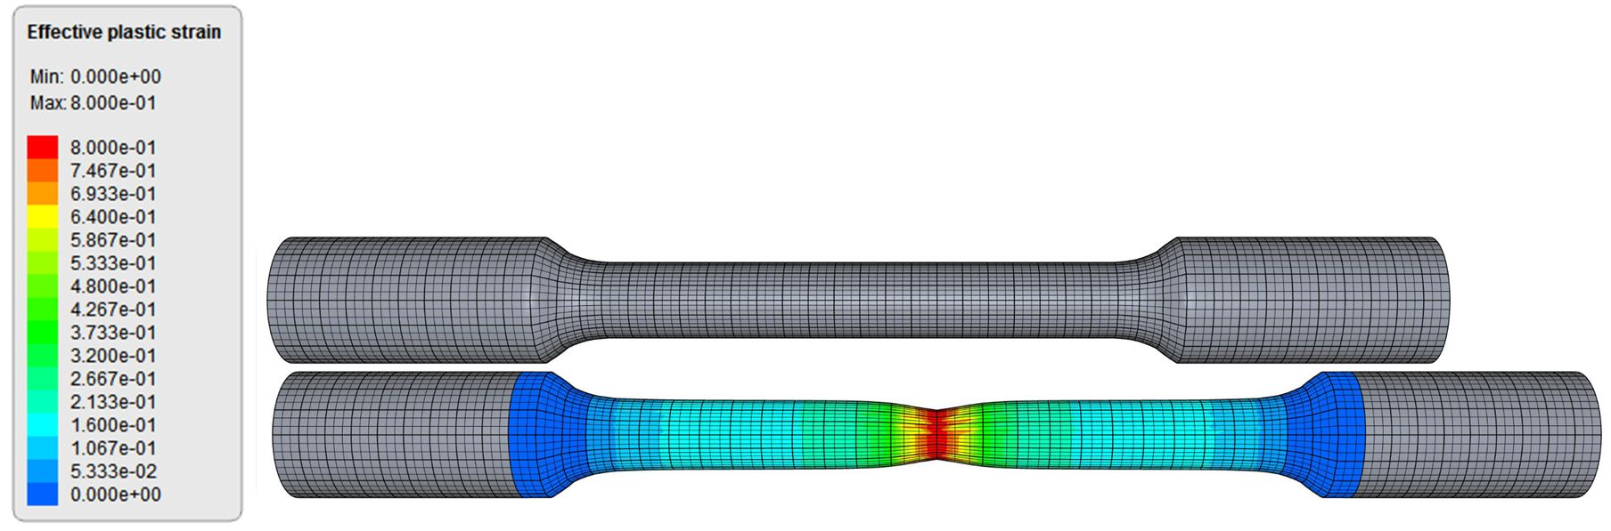

Figure 10: Validation simulation of tension test: initial mesh compared to the deformed mesh at the last state before failure. The fringes represent effective plastic strain.

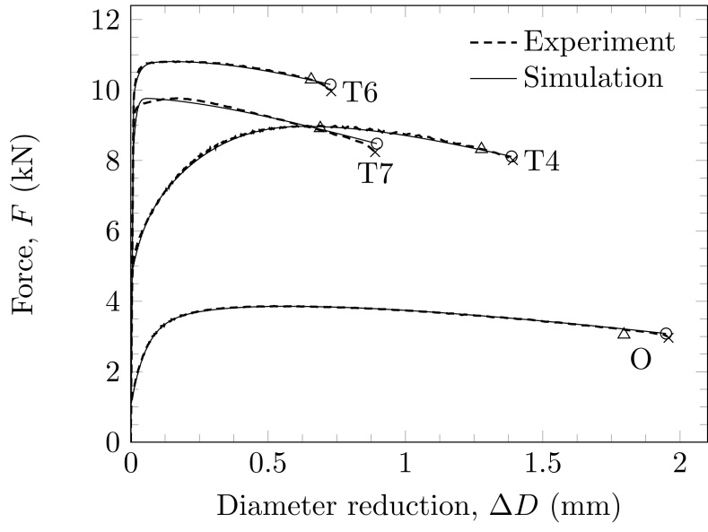

Figure 11: Numerical simulations of the tension test in the rolling direction compared to the experimental results. The crosses depict failure in the experiments, while the triangles and the circles depict failure in the numerical simulations with experimentally determined and numerically determined  respectively.

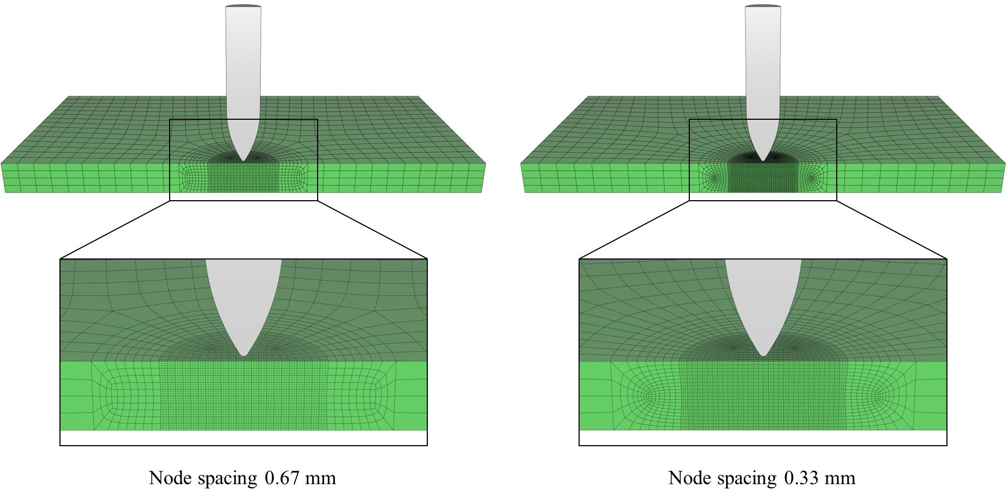

Figure 12: Solid element meshes used in the ballistic simulations with ogive-nosed and blunt-nosed projectiles.

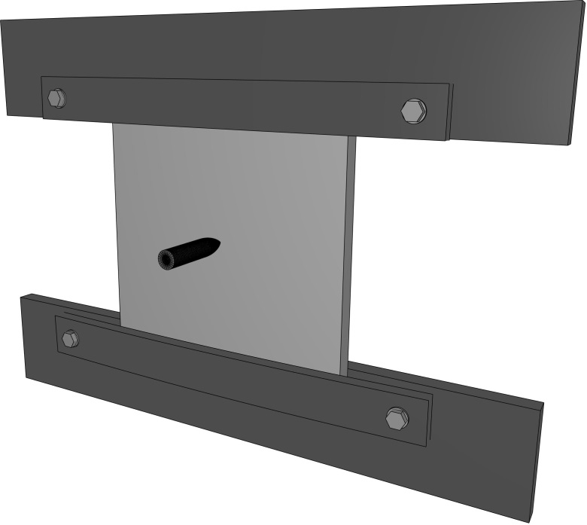

Figure 13: The complete model as seen in the IMPETUS Afea Postprocessor.

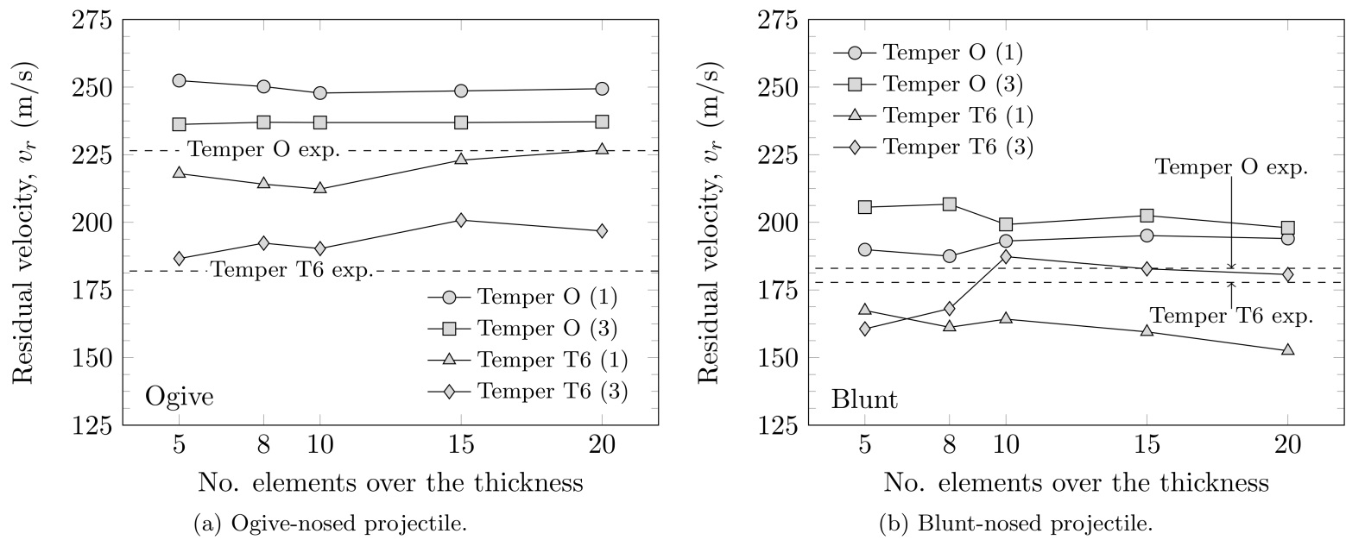

Figure 14: Results from the mesh sensitivity study. The initial velocity for the ogive-nosed projectile is approximately 300 m/s while the initial velocity for the blunt-nosed projectile is approximately 250 m/s.

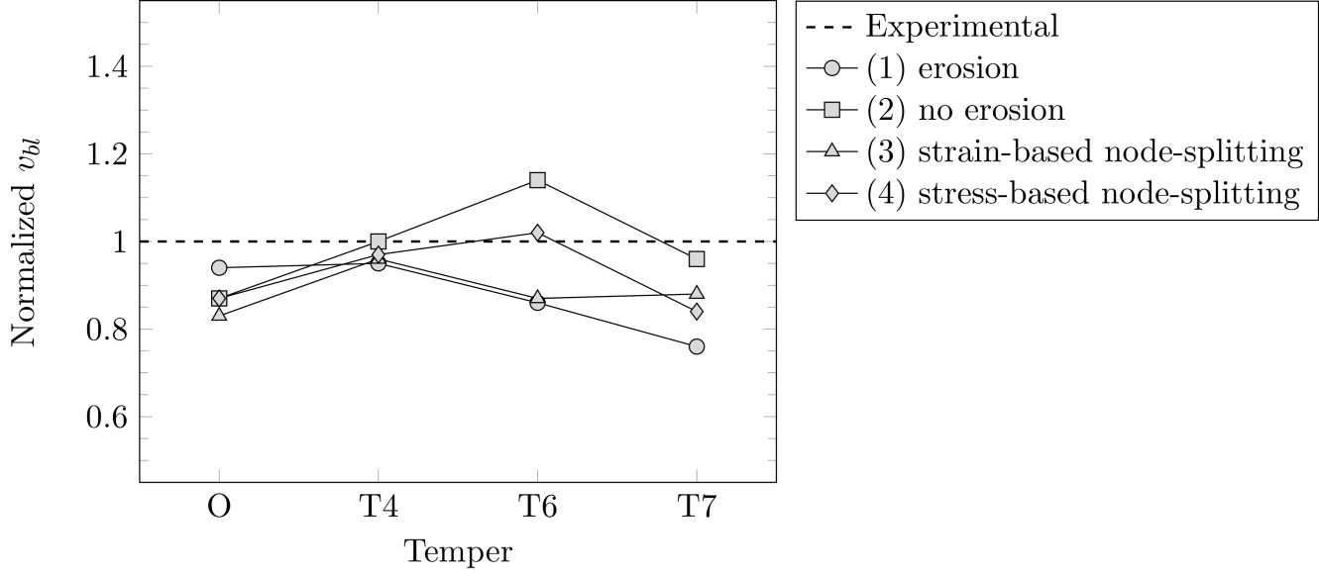

Figure 15: Normalized ballistic limit velocities  shown as functions of temper for impacts with the ogive-nosed projectiles and 10 elements over the plate thickness.

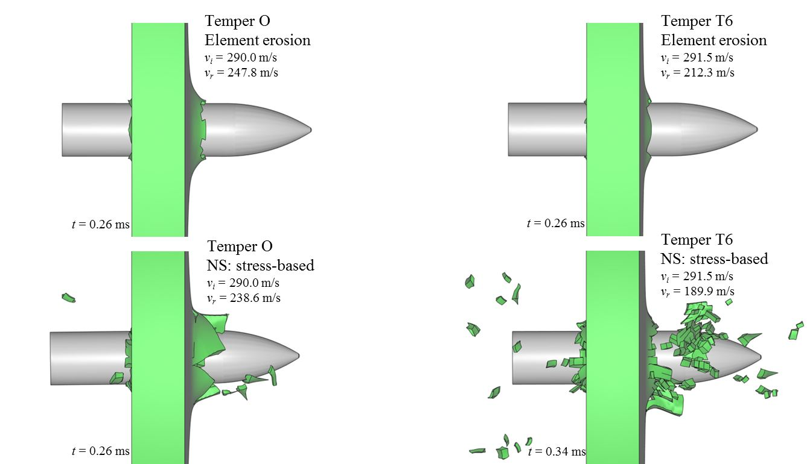

Figure 16: Images from after perforation by the ogive-nosed projectile for tempers O and T6 with conventional element erosion and stress-based node-splitting.

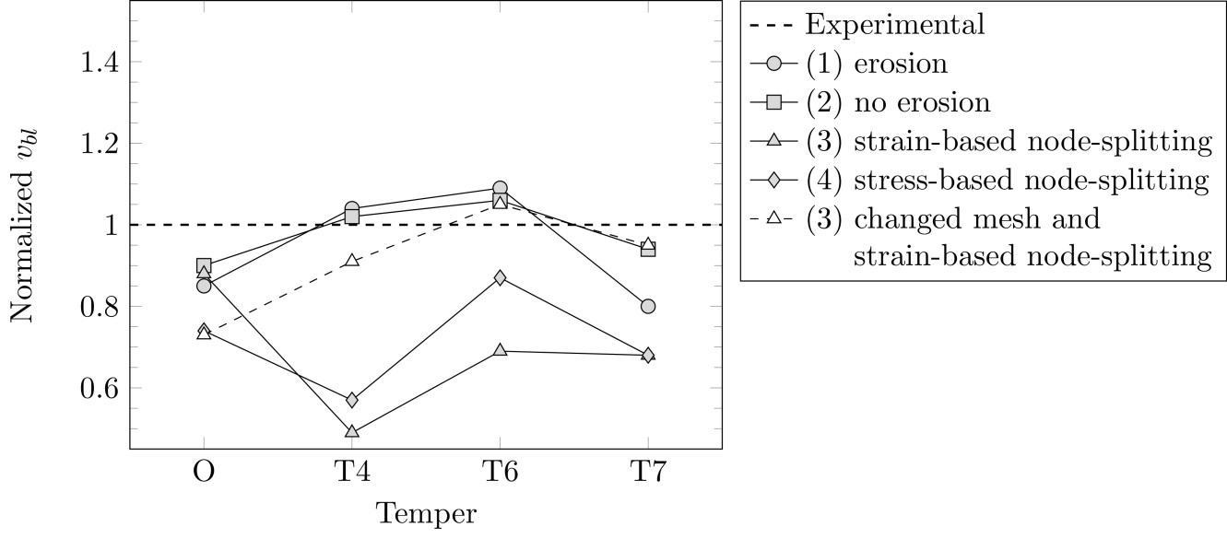

Figure 17: Normalized ballistic limit velocities  shown as functions of temper for impacts with the blunt-nosed projectiles and 10 elements over the plate thickness.

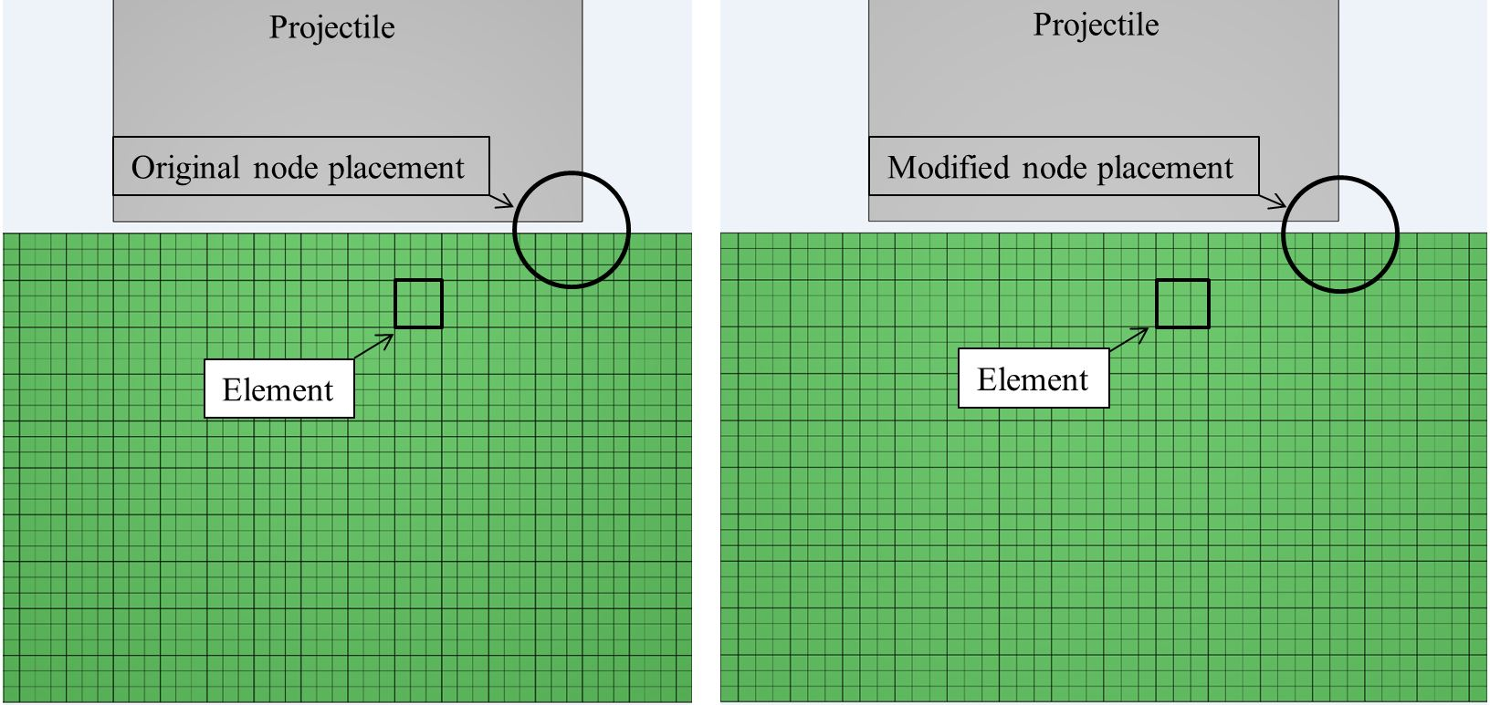

Figure 18: Illustration of the original and the modified node placements.

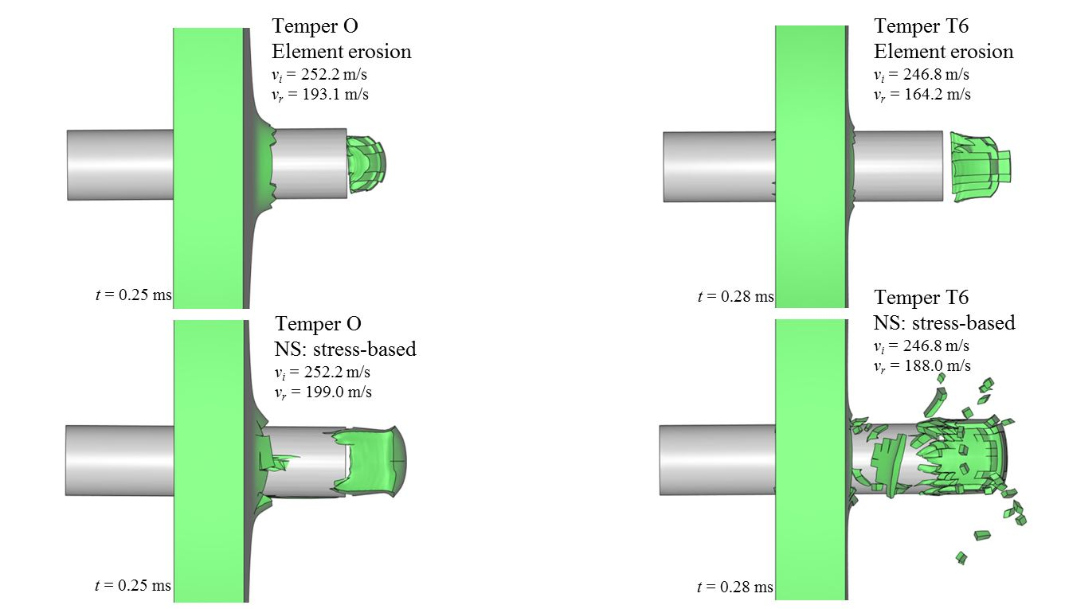

Figure 19: Images from after perforation by the blunt-nosed projectile for tempers O and T6 with conventional element erosion and stress-based node-splitting.

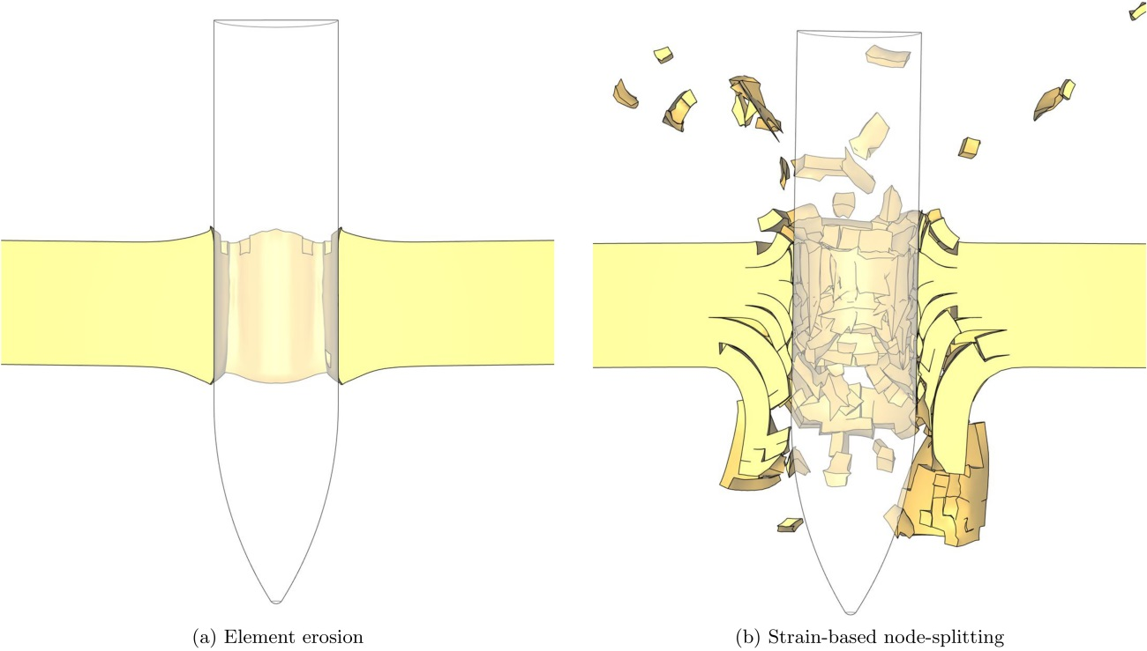

Figure 20: Images from simulations of temper T6 with (a) element erosion ( and ) and (b) strain-based node-splitting ( and )

1. Corresponding author: + 47 93 04 58 37 (Jens Kristian Holmen)

   Email address: [jens.k.holmen@ntnu.no](mailto:jens.k.holmen@ntnu.no) (Jens Kristian Holmen)

   URL: www.ntnu.edu/simlab
2. The entire plug was not located after the test.